Examining the Information Needs of Hearing-Impaired Students: A Case Study of Special Schools for the Hearing Impaired in Jodhpur

MRS. SANGEETA
Research scholar, Department of Library and Information Science
Shri Kaushal Das University, Hanumangarh, Rajasthan
Email: Sangeeta.m.panwar@gmail.com
Mo-7737877701

(PRO) DR. RAJ KUMAR BHAKAR
Associate Professor, Department of Library and Information Science
Shri Jagdishprasad Jhabarmal Tibrewala University, Rajasthan
Email: drrajkumarjjn@gmail.com

Abstract
The study was conducted to investigate the information-seeking behavior of hearing-impaired students in school libraries. The study was based on a questionnaire survey and data was collected from students from Special Schools for the Hearing Impaired in Jodhpur. The analysis revealed that the information needs of hearing-impaired students have become complex and problematic due to the insufficiency of adequate information sources and services and there are quite a number of challenges faced by hearing-impaired students in accessing information from libraries. It has been found that, even though assistive technologies play a vital role in the educational aspects of differentiable students, it does not play a role in the progress of library services for differentiable. Most of the students are not aware of the assistive technologies available to assist them in accessing information. The overall result of the study was that, though the library services provided in the school are useful for their studies, the respondents cannot make use of them because of barriers. The study comes out with some practical suggestions to improve library facilities for hearing-impaired students with the help of assistive technologies.
Keywords: Deaf, Hearing Impaired Students, Information Needs.
Introduction
There is ability to disability, if appropriate on and care is accorded to the special people in society. Libraries have different types of users, including people with special needs, also called special users of the library. Special users range from the visually impaired, deaf and hearing impaired, with mental disabilities among others. A special user or patron is an individual that cannot utilize the information resources in the library without adaptive equipment (augmented or assigned equipment or resources). It is also a situation where there is an inability to do what is considered 'normal' for a non-disabled person. Special-needs people or people with disabilities tend to pose some concern to society in that they have some difficulty in performing tasks, unlike non-disabled people. However, like the non-disabled, they too have some inherent alibis, aspirants, visions and dreams which, if given the proper ending and guidance, will be actualized. This is true in all areas of life, including the area of library and information services. Information is a unique and unavoidable attribute of sustainable development and self-education in all its totality. Much of human intellectual achievements, civilization and growth are related rebated to information materials made available, usually through libraries and information services or other information centers. It can therefore be said that information made available in a consistent and specific manner produces a professional or skilled man. It polishes and refines the potential for practice; it also serves as an integrating tool for people living with disabilities by incorporating them into the socio-cultural, socio-economic and general development of society. The Library is described as the collection of selected, acquired, organized and retrievable information resources made available for access and use. It is a potential tool to enhance and shape ability in disabilities, because libraries provide a wide range of services that are aimed towards changing the thinking and behavior as well as improving the productivity of all kinds of people, including hearing-impaired library users. According to Seth and Parida (2006), libraries perform an important function in enhancing disabled persons' intellect, mind and general understanding by making available to them information resources in an alternative format. While special library and information on services involve the provision of information on services in additional to, supplementary to and complementary to or different from those provided in the regular library services by a systematic modification on 71-Page Jennifer N.B. IGWELA & Vincent C. OPARA Provision of Library Resources and Services to the Hearing Impaired in Special School Libraries in South-South, Nigeria IJKD - Vol 1 No. 1 April 2020 and adaptati on of instructional techniques, resources and equipment to meet the needs of handicapped/special learners. It is to be borne in mind that the aim is to help them to become self-independent, and also less of a burden to their family and society.

2. Aacharya hasti vishesh avasiya vidhyalaya
Aacharya hasti vishesh avasiya vidhyalaya is co-educational. The Blind Development Institute, established on August 15, 2006, and inaugurated by Maharaja Gaj Singh, offers integrated education to children with disabilities. Serving 300 students, including 125 girls and 175 boys, the school provides free education and hostel services for students with hearing, visual, and intellectual impairments. It is the only school in Jodhpur division to offer such facilities. The hostel includes separate accommodations for boys and girls, equipped with modern amenities, and provide daily essentials free of charge. The school also focuses on diverse activities, such as music training for blind children and cultural performances by deaf and dumb students, including a notable performance at the national 'Divya Kala Shakti' program. Additionally, the school offers vocational training in industries like handicrafts, sewing, and web design, ensuring skill development for students, with courses run in collaboration with organizations like NSIC and Deen Dayal Upadhyaya Grameen Kaushal Yojana.

Literature Review
This literature review explores existing studies on the information needs and access to educational resources for hearing-impaired students, with a particular focus on special schools.

Assistive Technologies

Assistive technologies are critical in supporting hearing-impaired students by improving their access to learning materials and facilitating communication with teachers (Teknologi et al., 2024). However, research shows that many students are unaware of the available assistive technologies, limiting their ability to utilize resources effectively (Soman & Sudhier, 2015). Ensuring that students are aware of and can use these technologies is crucial for improving their academic performance and participation.

Learning Environment Design

The concept of "deaf space" emphasizes the importance of classroom design tailored to the needs of deaf students, such as appropriate furniture arrangement and sensory accessibility (AUTHOR_ID et al., 2024). Positive responses from students in specially designed classrooms suggest that such environments can significantly enhance learning motivation and communication (AUTHOR_ID et al., 2024). This design helps create spaces that are more conducive to learning, fostering better interaction and engagement among students and teachers.

Special Educational Needs

Hearing-impaired students require specialized educational approaches that differ from traditional methods. This includes unique organization of space and time for effective learning (O’ktamovna, 2022). Research suggests that identifying specific educational needs through assessments in inclusive schools is essential to develop appropriate curricula (Parhoon et al., 2014). Such tailored approaches help address the gaps in learning and ensure that the educational process is accessible and effective.

Communication Needs

Effective communication is a significant challenge for deaf students. Environments that facilitate communication, such as classrooms designed with the "deaf space" concept, are essential for supporting these needs (AUTHOR_ID et al., 2024). Additionally, parents of hearing-impaired students emphasize that communication needs are a priority, ranking them alongside audio logical rehabilitation (Movallali et al., 2015). Facilitating communication is integral to the overall educational success and well-being of hearing-impaired students.

Academic Needs

Adolescents with hearing loss often face difficulties in accessing academic materials due to language delays and limited literacy skills (Marx, 2010; Marx et al., 2011). These students may lack the necessary skills to comprehend academic content, highlighting the need for specialized information literacy programs to address these gaps (Marx, 2010). Tailored academic support can improve their ability to engage with and understand the curriculum, ultimately enhancing their educational outcomes.

Social and Emotional Needs

Hearing-impaired students often face challenges in social integration and emotional well-being (Movallali et al., 2015). Social and emotional support programs can significantly enhance their educational experience and personal development (Almeida et al., 2014). Addressing these needs ensures that students not only perform well academically but also develop positive social interactions and emotional resilience.

Conclusion

While progress has been made in addressing the information needs of hearing-impaired students, challenges remain. Particularly, raising awareness about assistive technologies and ensuring that educational environments are properly designed to support their unique learning needs are crucial areas for improvement. A comprehensive approach that includes specialized educational strategies, effective communication, and social-emotional support is essential to improving the overall educational experience of hearing-impaired students. Additionally, societal awareness and resource allocation play a critical role in providing equitable access to information and opportunities for this community.
- Relevance of the Study
This study is now relevant since it examines the information demands and search habits of students with hearing impairments. It will provide a more thorough grasp of the unique information needs of hearing-impaired patrons and throw light on the existing status of library services tailored to their needs. The findings of this study will help professionals already working in the field as well as those developing specialized libraries and Learning Resource Centers (LRCs). The ultimate goal of this study is to produce important data that will help scholars, librarians, sociologists, and legislators enhance the effectiveness and accessibility of library services for students with hearing impairments.
5. Objective of study
The primary objectives of this study were as follows:
• To examine the existing library provision for hearing-impaired students.
• To find out the adequacy of available facilities in meeting their requirements.
• To determine students awareness of the library.
• To identify the information needs of hearing-impaired students.
• To identify technologies available to mitigate barriers to information access.
• To investigate the utilization of available Assistive Technologies.
• To propose services to enhance library facilities.
6. Methodology
A survey instrument was used to collect data. Two hundred surveys were sent out and completed in full. Participants in the study were high school students. Only 200 of the 300 students who took the survey finished it, therefore they were excluded from the study. The study did not allow participation from younger youngsters and some students are not able to give answer.

7. Analysis and Discussion
7.1 Gender-wise Analysis of Respondents

Among the 200 students, there are only 80 female respondents and the 120 are male students. (Figure 1).
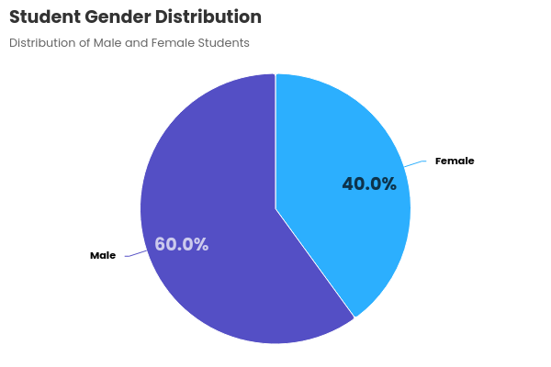
7.2 Frequency of Library Visit
Table 1 shows the different frequencies with which the students visit their school library.
Table 1. Frequency of library visit
s.no. | Frequency | Response | %
1 | Weekly | 120 | 60
2 | Once in a month | 68 | 34
3 | Often | 12 | 6
 | total | 200 | 100%
The analysis shows that 60% of students visit the library weekly, while only 34% visit it once a month. Additionally, no students use the library daily. This irregularity in library visits could be due to the absence of a designated library hour in the school timetable
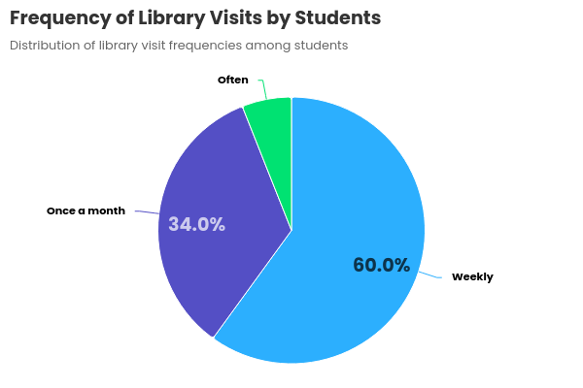
7.3 Purpose of Library Visit
Table 2. Purpose of visiting library

s.no | Purpose of visiting library | Response | %
1 | Educational purpose | 100 | 50
2 | complete assignments, and work on class projects | 40 | 20
3 | To obtain course related information | 24 | 12
4 | Knowledge purpose | 36 | 18
 | Total | 200 | 100%

Table 2 clearly, it shows that the majority of students50% of students, use it for academic purposes. Since the study is based in an academic library, only (20%) visit the library for seminar work, assignments, class projects, and similar tasks. Additionally, 18% of students use the library to expand their knowledge, while 12% visit to gather information related to their course studies.
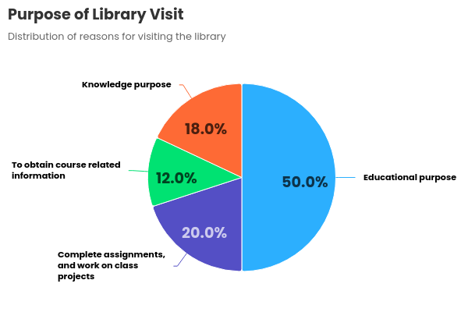

7.4 Opinion on Library Location
Table 3. Location and Seating Facilities
s.no | Location & Seating facility | Response | %
1 | Comfortable | 24 | 12
2 | Uncomfortable | 176 | 88
 | Total | 200 | 100

The students' opinions regarding the location and seating facilities of the school library were analyzed, and the results are presented in Table 3. All students agreed that the library's location is easily accessible. However, a majority (88%) expressed dissatisfaction with the seating arrangements. Every student felt that improvements are needed in the seating facilities of the library. Table 3 displays the findings of an analysis of the students' perceptions of the school library's location and seating arrangements. Every student concurred that the location of the library is convenient. Nonetheless, the majority (88%) said they were unhappy with the way they were seated. Every student believed that the library's sitting arrangements needed to be improved.

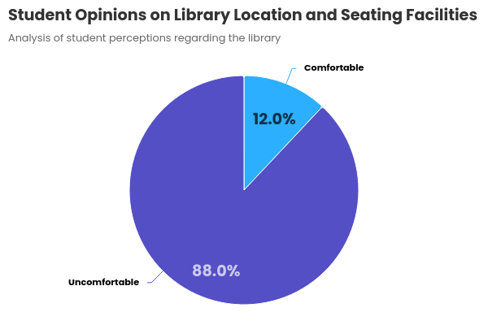

7.5 Use of Library Resources
Table 4. Resources available in the library
S.no | Resources | Response | %
1 | Books | 120 | 60
2 | Study materials | 128 | 64
3 | Story Books | 60 | 30
4 | Magazines | 40 | 20
5 | Newspaper | 100 | 50

The results in Table 4 show that most students (64%) are aware of the study resources the library has to offer. Books are preferred by 60% of them as the primary library resource. Fifty percent of those surveyed are aware that the school library has newspapers. While only 20% of students choose magazines, 30% of students favor storybooks. None of the pupils brought up resources like journals, laptops, CDs, and the internet, despite the survey asking about them. The survey also discovered that although the school has a separate IT lab, there are no computers available in the library. The majority of pupils are computer literate, as evidenced by the fact that all of them said they were familiar with computers and the internet

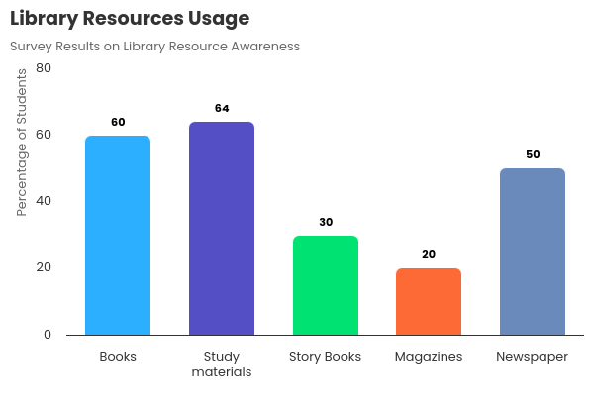

7.6 Barriers in Using School Library
The school library lacks assistive devices, making it difficult for many students to use. A significant number of students identified the absence of computers and internet access in the library as a major barrier to obtaining necessary information. According to Table 5, 84% of students reported that they are unaware of how to effectively use the library, and 60% indicated that they have not received any training on how to use the library's facilities. Many students also cited time constraints as a barrier, as the school does not allocate specific library hours in the timetable. Additionally, 80% of students pointed out the lack of subject-specific electronic resources as a major challenge. 36% mentioned the unavailability of assistive aids, and 30% identified difficulty in finding relevant information as a barrier. 12% of students expressed concern over the insufficiency of books in the library. Despite questions regarding the willingness of library staff to provide adequate services, no students responded.

Table 5. Barriers in using school library
s.no | Problems/ Barriers Response rate | response | %
1 | Lack of knowledge in using library facilities | 120 | 60
2 | Lack of training in using library facility | 168 | 84
3 | Difficulty in finding relevant information | 60 | 30
4 | No sufficient books available in the library | 24 | 12
5 | Information is not available with assistive aids | 72 | 36
6 | Lack of knowledge using assistive technology | 76 | 38
7 | Lack of time / library hour | 188 | 94
8 | Not enough subject related materials | 40 | 20
9 | Not enough subject related materials | 80 | 40
10 | Not enough subject related electronic sources | 160 | 80
11 | Computer/internet facility is not available | 200 | 100

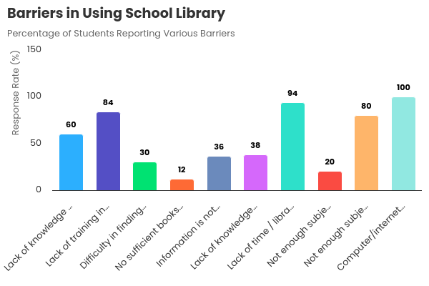

7.7 Opinion on Library Collection
Table 6 shows the students’ response about whether they are satisfied with the present library collection or not.
s.no | Library collection | excellent | good | average | poor
1 | Books | 20% | 25% | 30%
2 | Study material |  | 28% | 30%
3 | Story books |  | 79% | 10%
4 | newspaper |  | 86% | 14%
5 | Reference books |  |  |  | 75%
The study shows that the largest number of respondents (75%) rated the reference collection as poor. Most of the students (79%) rated the collection of storybooks available in the library as good, and 11% of respondents rated the storybook collection as average. A good number of students are satisfied with the newspapers available in the library (86%). Only 20 % of students rated the textbooks available in their library as excellent and any other collection in the library is not up to the expectations of the students. The majority of the students are unsatisfied with the reference collection in the library.

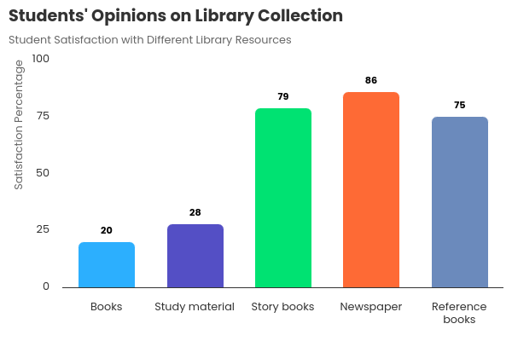
7.8 Preference of Source
Table 7. Preference of sources
S.no | Resources | Response | %
1 | Books | 152 | 76
2 | Study materials | 120 | 60
3 | Story Books | 60 | 30
4 | Newspaper | 100 | 50
5 | Other material | 40 | 20

From Table 7, it is clear that a good number of students (76%) prefer to borrow textbooks from the library, whereas 60% use library to get information on their study materials. 50% use libraries library to read newspapers, and 30% of students like to take story books from the library. 20% users prefer to take other types of material.
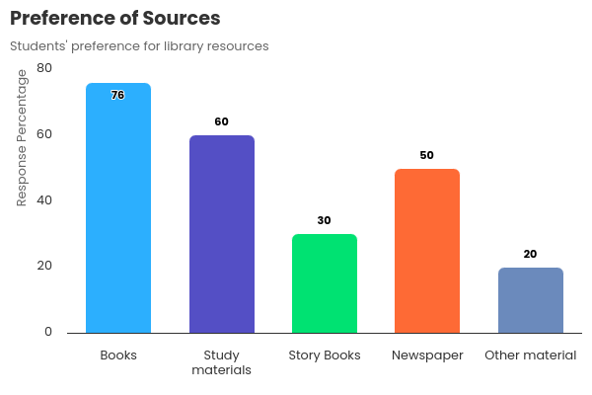

7.9 Satisfaction with the Present Library Services

Table 8. Satisfaction with the present library services
S.no | Library services | satisfied | average | Unsatisfied1
1 | Library area | 99% | 1%
2 | circulation | 40% | 18% | 32%
3 | Library training |  |  | 100%
4 | Other services |  | 20% | 80%

Table 8 displays how satisfied students are with the current library services. Each and every student is happy with the current library's convenient placement. Just 40% of all students are happy with the circulation service, while 80% of students are unhappy with the other service. They received no training from the authorities, thus nobody is happy with the library training service. According to the majority of pupils, they requested more services from the authorities. Every student indicated that having library hours in their school schedule would be more beneficial to them, and the majority of students are dissatisfied with the services that the library currently offers.
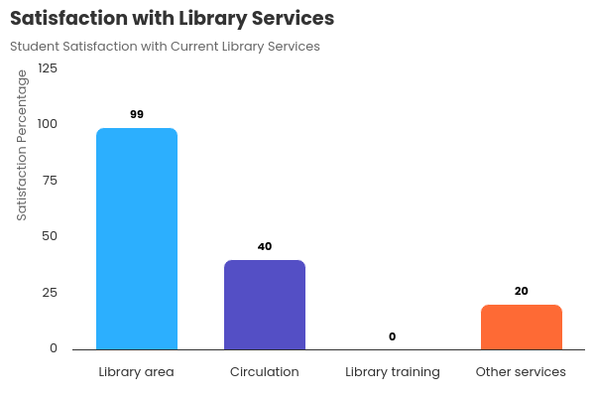

8. Assistive Technology for Hearing Impaired
Accommodations and assistive devices are required by students with hearing impairment to access the required information. Each learner’s needs must be individually evaluated, but following is a generic introduction to the main types of assistive technology for hearing impaired people.
8.1 Closed Captioning
Closed captioning is the text that goes on the bottom of the television screen to inform deaf people of what is being said. Look for a small box with letters ‘CC’ inside or a small box with a cartoon balloon dialogue marker, to verify if the programs are closed captioned.
8.2 Cochlear Implants
A cochlear implant is used in people with severe to profound hearing loss or those who show little or no benefit from hearing aids. It is a controversial device, especially when it is implanted in young children.
8.3 Hearing Aids
Hearing aids amplify sounds for the persons with hearing loss. They can come in different sizes and shapes and may vary in position from behind the ear to in-the-ear. Depending upon the type of hearing loss the person may have, the sounds may be distorted and be too loud.
8.4 Text Telephones
Text Telephones (TTYs) are the telephones that deaf people use to communicate with others on the telephone. These look like small typewriters and come with an LCD screen and a cradle for the telephone. In order for a deaf person to call on the TTY, the person on the other end must also have a TTY. There is a national relay system that the deaf person on the TTY can use to call anyone who does not have a TTY. Visual Alert Signalers are devices that use flashing lights to alert the deaf person to the ringing of a phone or fire alarm. Mobile phones and pagers also allow deaf users to send emails, faxes, pages and call people who have TTY and through relay.
8.5 Hearing Loop
A Hearing Loop is a coil of wire that amplifies sound and reduces background noise. Users of hearing aids with a loop can set their aids to a certain setting to receive the transmission. Hearing loops can be permanently installed or portable.
These are the most common assistive technologies available for hearing-impaired students. The researcher included a question to find out the awareness of assistive technologies among the students. Even though every student is equipped with hearing aid, most of them are not aware of any other assistive devices that are helpful to them. And from the study it is clear that no assistive device is available in the school library.
9. Suggestions to Improve Library Services
From the responses to questionnaires distributed to the students, it is found that they suffer a lot of barriers in accessing information from the libraries. The following are some suggestions to improve the library services for hearing-impaired students:
• Include library hours in the school timetable and allow students to use libraries to the maximum service with the help of assistive aids/ technologies which help to increase the confidence of students in using libraries.
• Libraries shall provide access to telecommunication devices (TTY’s) to assist the information needs of persons with hearing impairment.
• The students should be trained to use library services. Lack of training in using the library may become a barrier to accessing information in the future. Orientation programs shall be provided so that persons with hearing impairment become aware of the wide scope of library resources.
• Computer services should be included in the library, as the students will find it helpful to access the required information from the internet.
• Include journals in the library collection, which will help the students to get information on their subject.
• Seating facilities in the library should be made comfortable for every student.
• Libraries should provide alternative methods for the delivery of services to hearing-impaired persons who would otherwise be unable to use the library services independently.
• As the school library is a special library for hearing-impaired students, books and pamphlets on sign language, dictionaries of signs, signed books, etc. should be available.
• The library collection should include a full range of viewpoints on the education of the deaf.
• Services and materials shall be available to parents of children with hearing impairment.
• The authorities should consider their requirements as libraries play a major role in providing information to these students.
10. Conclusion
It is clear that the current library services are insufficient to satisfy the information requirements of students who are hard of hearing. Although there are many assistive technology available to help students with hearing impairments, they are not making the most of them. To satisfy their information needs, the services must be changed. Only by involving and collaborating with the authorities can the problem of providing fair library and information services to the hearing impaired be addressed. Since kids have the same rights as other children to education and information access, the government must establish regulations that remove the obstacles they confront. In order to further the progress of knowledge, libraries must not only provide resources but have to ensure that the resources are effectively utilized.

References
Abdullayeva, Nargiza, O’ktamovna. (2022). 3. Special educational needs children with hearing impairments. The American journal of social science and education innovations,doi: 10.37547/tajssei/volume04issue09-04
Beata, Ciupińska. (2016).10. Dziecko z wadą słuchu w roli ucznia. doi: 10.19265/KP.2016.2.7.123
Estelle, Maria, Magdalena, Marx., Maggi, E., Soer., Archie, L., Dick. (2011). 9. The ability of adolescents with hearing loss in special schools to access and use academic material in three provinces in south africa.
Guita, Movallali., Kamal, Parhoon., Abas, Mahvash. (2015). 6. Educational Needs Assessment of Student with Hearing loss from their parents' the point of view.
Guidelines for libraries serving persons with a hearing impairment. (1992). New York. Library Association. Library Trends. 41: 164–172. Retrieved from: http://www.ideals. illinois.edu/handle/2142/7828
Ilayaraja, M. and Manoharan, A. (2012). An empirical study on library and information services to (PCS) physically-challenged students in the University library, Thiruchirappalli District. TRANS Asian Journal of Marketing Management Research, 1:17–26.
Kamal, Parhoon., Saeid, Hassanzadeh., Hadi, Parhoon., Gita, Movallali. (2014). 5. Educational Needs Assessment of Student with Hearing Impairment in Inclusive School. International Journal of Academic Research in Progressive Education and Development, doi: 10.6007/IJARPED/V3-I2/910.
Midhula Soman, V.S. and Sudhier, K.G. Information needs and seeking behavior of hearing impaired students in NISH and the need for LRC. In International Conference on Trends in Knowledge and Information Dynamics (ICTK2012). Bangalore, India: 10-13 July 2012, DRTC (ISI), edited by Devika P. Madalli, Saiful Amin and Anila Sulochana, 2012, p. 327–338.

NULL, AUTHOR_ID., Shohibul, Kahfi., NULL, AUTHOR_ID., NULL, AUTHOR_ID., NULL, AUTHOR_ID., Moch.Rasyid, Rida. (2024). 2. Deaf space concept in designing classroom interior for learning motivation of deaf students in special schools. IOP conference series, doi: 10.1088/1755-1315/1356/1/012115\.
Paul, P.V. and Whitelaw, G.M. (2011). Hearing and deafness: An introduction for health and educational professionals. Massachusetts: Jones and Bartlett pub., 136p.
Pemanfaatan, Teknologi., D., Alat., Bantu, Untuk., M., Pembelajaran., Rungu, Di., Slb, Negeri., Bugih, Pamekasan., Mamlu'atur, Rohmah. (2024). 1. Pemanfaatan Teknologi dan Alat Bantu Untuk Meningkatkan Pembelajaran Anak Tuna Rungu Di SLB Negeri Bugih Pamekasan. doi: 10.55606/jcsr-politama.v2i3.3935
R.C.N., Almeida., R.S., Schiaffino., V.M., Rumjanek. (2014). 8. Access and comprehension of information by profound deaf youngsters in Brazil. doi: 10.5897/JMCS2014.0411
Singh, K.P. and Moirangthem, E. (2010). Are Indian libraries VIP- friendly? Information use and seeking behaviour of visually impaired people in Delhi libraries. Library Philosophy and Practice. (e-journal). Paper 374. Retrieved from: http://digitalcommons.unl.edu/libphilprac/374
V., S., Midhula, Soman., K., G., Pillai, Sudhier. (2015). 4. Information Needs of Hearing Impaired Students: A Case Study of Government VHSS for Deaf, Thiruvananthapuram. SRELS Journal of Information Management, doi: 10.17821/SRELS/2015/V52I2/61946

