MBA 5010 Week 3 Assignment (Rev 2)

The weekly assignments are intended to be completed individually. It is important in an online program that you pay careful attention to when it is and is not appropriate to work with peers. Misunderstandings can have significant consequences. By submitting this assignment, you are attesting that you completed this work without assistance from another current or former student of this class. Exceptions can be made for tutors, but only with prior consent from your instructor.

Your answer will be evaluated based on correctness, completeness, and clarity. Be attentive to your writing. You have until midnight CST Sunday to submit both parts of this assignment.

Part A (25 points)

The following companies and scenarios are fictional. In each case, you are to demonstrate graphically the change in the model and then provide a hypothetical explanation of what happened. If you have trouble with changing graphs in Word, reach out to your instructor. All assignments must be submitted as Word files.

Example – Capn’ Mark’s Seafood price is falling even while sales are growing.

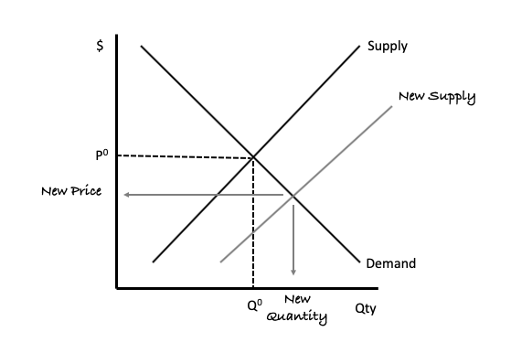

Capn’ Marks Seafood has developed a new technology that allows it to “grow” seafood chunks using genetic engineering. This new technology means Capn’ Marks can supply fast food restaurants with seafood patties at half the price of its competitors. The result is an increase in sales. ‘Technology’ is a determinant of supply/supply shifter.

Question 1 – Becky’s Bongos sales are falling even while they continue to decrease price.

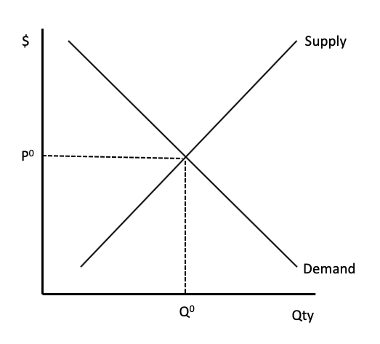
Respond here

Question 2 – Todd’s Tiaras has seen a significant uptick in same-store sales and has been able to completely eliminate discounting.

Respond here

Question 3 – Fast Freight, an interstate trucking company, has had to raise price three times in the past year, significantly reducing sales.

Respond here

For the following questions, utilize a diagram for each market to demonstrate the respective effects of the described event. Afterward, verbally describe your response.

Example – The appreciation of the Taiwanese currency has increased the price Foxconn must charge Apple and other clients for manufacturing electronics. This has benefited their Indian competitor, Majumdar Ltd, who has picked up Foxconn’s lost sales.

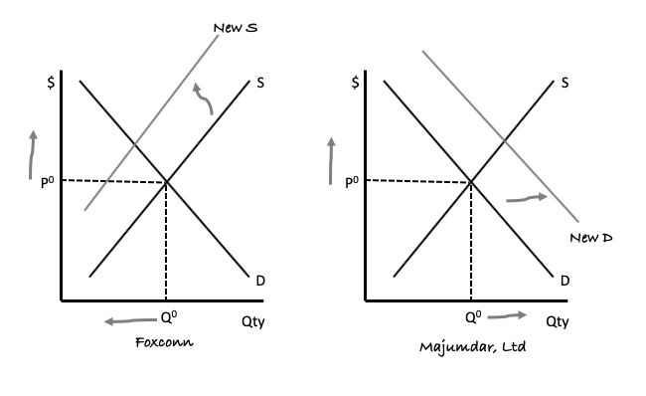
The currency appreciation increases Foxconn’s cost causing supply to shift leftward. Majumdar, Ltd sees an increase in demand as customers switch from Foxconn to Majumdar.

Question 4 – A substantial decrease in this year’s wheat crop has led to a sharp increase in sales of corn.
WHEAT
CORN
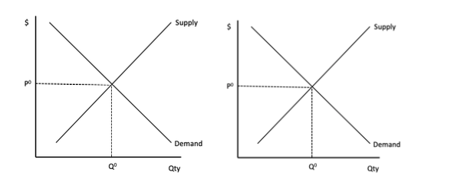
Respond here

Question 5 – The devastating effect of the Covid-19 virus on the cruise industry has decimated the economies of many Caribbean island nations.
Caribbean Island Nations
Cruise Industry

Respond here

Part B (25 points)

This week you are to complete a fully complete draft response to the following. You are to complete this draft without assistance from either current or former MBA 5010 students. This draft response will be evaluated on completeness and clarity but not graded for content. Next week you’ll be given an opportunity to collaborate with your peers to complete a final response.

Consider if there should be a market for organs -specifically kidneys. In the United States, it illegal to sell kidneys.
Explain how this is in essence like the government has imposed a price ceiling of zero on the market for kidneys, thus creating a shortage.
Discuss how a free market for organs such as kidneys might result in benefits.
What value might be created from a free market for kidneys. Specifically discuss how sellers might be better off and how buyers might be better off.
Would this lead to an efficient allocation of resources?
Are there any other issues to consider if there was a free market for kidneys such as fairness.(e.g., would only those most willing and able to pay for a kidney be the ones that benefit).

