Smart City Concept, Ministry of Urban Development's Objectives, Methodology, and focus areas for each city, their initiatives, and impact:

Aspect | Details
Smart City Concept | A city equipped with smart solutions to improve infrastructure, enhance liveability, ensure sustainability, and drive economic growth. It integrates technology, governance, and environmental sustainability to improve quality of life and urban development.
Ministry of Urban Development Objectives | 1. Provide core infrastructure (water supply, electricity, sanitation, etc.).  2. Enhance sustainable urban mobility and public transport.  3. Promote inclusive development with affordable housing.  4. Drive economic growth and harness technology for better governance.
Methodology | - Area-based development: Retrofitting, redevelopment, and greenfield development.  - Pan-city initiatives: Integration of smart technologies across sectors like transport, governance, and utilities.  - Participation of stakeholders in planning and implementation.

City-wise Focus Areas, Initiatives, and Impact
City | Focus Areas | Smart City Initiatives | Impact
Lucknow | - Energy  - Area Development  - IT Connectivity  - Urban Transportation  - Health & Education | - Gomti Riverfront Development for ecosystem preservation.  - Solar rooftops to promote renewable energy.  - Smart mobility cards for efficient public transport. | - Boost to local identity and tourism.  - Reduced energy dependency.  - Improved walkability and transportation.
Kanpur | - Energy  - Economic Development  - Waste Management  - Health & Education | - Ganga Riverfront development for ecological restoration.  - Underground cabling for safety and aesthetics.  - Tree plantations for green spaces. | - Preservation of ecosystems.  - Reliable power supply.  - Improved urban greenery and citizen health.
Prayagraj | - IT Connectivity  - Safety  - Transportation  - Area Development  - Sewerage | - Integrated Command and Control Centre for safety.  - Night markets to boost the local economy.  - Open air gyms for health benefits. | - Enhanced safety and security.  - Increased economic activity.  - Better urban health and well-being.
Varanasi | - Cultural Preservation  - Waste Management  - Transportation  - Energy  - Health & Education | - Illumination of ghats with LED lighting for energy efficiency.  - Eco-restoration of Assi River for pollution control.  - Smart parks for recreation and ecosystem preservation. | - Improved tourism experience and local economy.  - Reduced pollution levels.  - Enhanced quality of life and green spaces.
Agra | - Safety  - Energy  - Transportation  - Housing  - Waste Management | - Taj Orientation Centre for tourism.  - Green walkways for pedestrians.  - Conversion of streetlights to LED for energy efficiency. | - Enhanced tourist infrastructure.  - Reduced energy consumption.  - Improved citizen mobility and safety.

Focus Areas Across Cities
Focus Area | Common Initiatives | Overall Impact
Energy | - LED streetlights  - Solar rooftop panels  - Underground cabling | - Reduced energy consumption and environmental footprint.
Area Development | - Riverfronts (Gomti, Ganga, Assi)  - Night markets  - Smart parks | - Boost to local economy, identity, and green spaces.
IT Connectivity | - Integrated Command and Control Centers  - Smart public service portals | - Citizen-friendly governance and improved public safety.
Urban Transportation | - Public bike-sharing  - Electric buses  - Smart mobility cards | - Improved urban mobility and reduced congestion.
Solid Waste Management | - Waste-to-energy plants  - Smart bins  - Wastewater treatment | - Improved sanitation and resource conservation.
Water Supply & Sewerage | - Rainwater harvesting  - New sewerage connections  - STPs (Sewage Treatment Plants) | - Better water supply reliability and sanitation.
Health & Education | - Open air gyms  - Smart classrooms  - Upgraded hospitals and public toilets | - Improved public health, education access, and urban inclusivity.
Safety | - Surveillance cameras  - Women safety centers  - Firefighting systems | - Enhanced public safety, particularly for vulnerable groups.

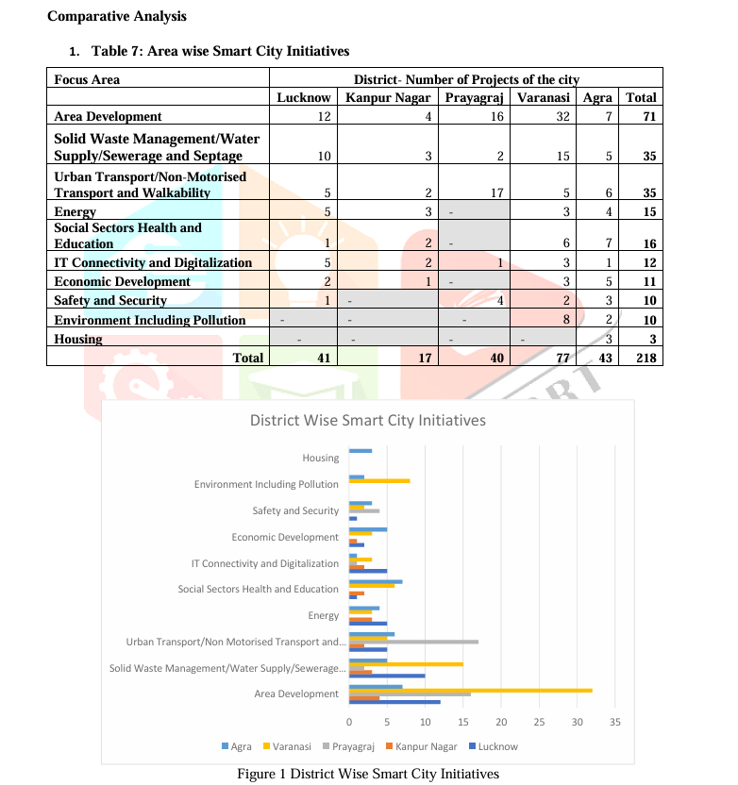

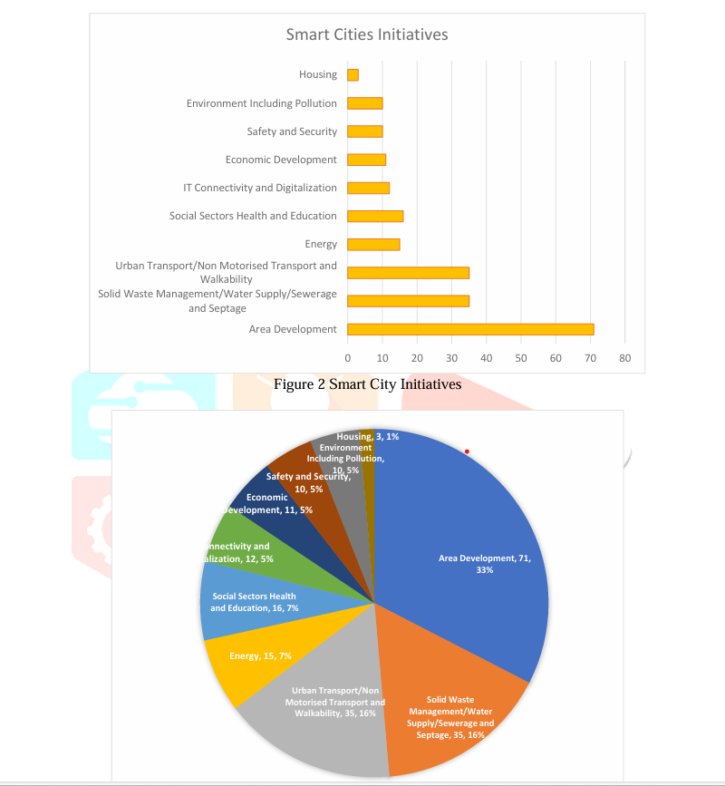

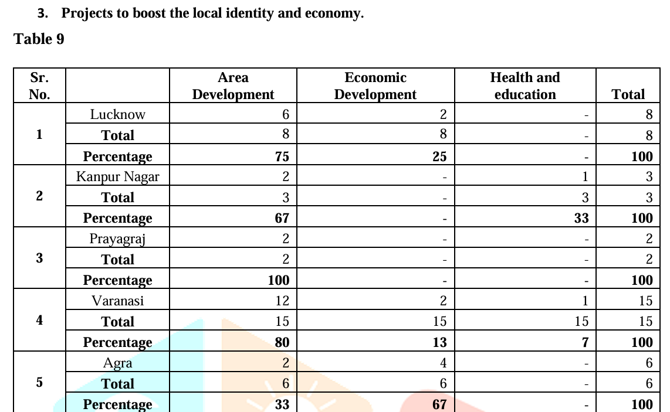

Summary of Findings
- Project Overview:
  - A total of 218 projects have been implemented across Uttar Pradesh’s smart cities.
  - Key focus areas:
    - Area Development: 71 projects, emphasizing its significance in urban planning and economic growth.
    - Solid Waste Management, Water Supply, and Sewerage: 35 projects, highlighting the importance of cleanliness and sanitation.
    - Transportation: 35 projects, aimed at enhancing connectivity and mobility.
    - Health and Education: 16 projects, focusing on societal well-being.
    - Energy: 15 projects, targeting sustainable and efficient energy solutions.
- Significance of Area Development:
  - Area Development plays a critical role in driving economic growth and improving urban infrastructure.
  - Prayagraj leads in Area Development initiatives, followed by Varanasi, Lucknow, Kanpur Nagar, and Agra.
- Other Sectors:
  - The Economic sector contributes significantly to urban growth and development.
  - Health and Education have a smaller, yet notable, role in enhancing quality of life.
- Sustainability Focus:
  - Key sustainability drivers include:
    - Area Development.
    - Solid Waste Management.
    - Water Supply and Sewerage.
    - Transportation.
    - Health and Education.
    - Energy initiatives.
- Results and Conclusion:
  - Smart city initiatives in Uttar Pradesh prioritize sustainability and inclusivity to address rapid urbanization challenges.
  - The integration of technology and innovative approaches has enhanced environmental resilience and improved quality of life for residents.
  - A focus on Area Development has had the most significant impact on economic opportunities and urban infrastructure enhancement.
In essence: The development of smart cities in Uttar Pradesh reflects a commitment to sustainable urban growth, leveraging key projects across critical sectors to foster resilience, inclusivity, and improved living standards.

Ref
IJCRT2307083 uttar pradesh smart cities.pdf
file:///C:/Users/mohda/Desktop/MBA/CAPSTONE/List%20of%2098%20Cities%20selected%20under%20Smart%20Cities%20Mission.html

SCESI Framework for Uttar Pradesh Smart Cities
City | Solid Waste Management (SWM) | Water Supply Management (WSM) | Sewerage, Sanitation, and Stormwater (SSS) | Ambient Environmental Conditions (AEC) | Overall SCESI Score (0-100) | Remarks
Lucknow | - 80% waste processing.  - Smart bins implemented. | - 90% piped water coverage.  - 70% compliance with water quality standards. | - 75% sewerage coverage.  - Functional stormwater drainage in core areas. | - AQI moderately improving.  - Urban tree density: 25 trees/km². | 72 | Good environmental sustainability. Focus on stormwater and green cover improvements.
Kanpur | - 70% waste segregation at the source.  - Initiatives for waste-to-energy conversion. | - 85% piped water coverage.  - Significant water loss in distribution (~30%). | - 65% sewerage coverage.  - Stormwater management needs upgrades in low-lying areas. | - AQI shows improvement but remains poor in winter.  - Urban greenery being expanded. | 68 | Moderate sustainability. Needs better water management and pollution control.
Prayagraj | - 65% waste collection efficiency.  - Limited recycling initiatives. | - 75% piped water coverage.  - Water quality compliance improving (~60%). | - 60% sewerage coverage.  - Stormwater systems prone to overflow during monsoon. | - AQI remains a challenge.  - Urban heat island mitigation in progress. | 62 | Moderate sustainability. Improvements required in waste management and stormwater systems.
Varanasi | - 85% waste processed, driven by ghats clean-up initiatives. | - 80% piped water coverage.  - Water ATMs installed for underserved areas. | - 70% sewerage coverage.  - Investments in wastewater treatment plants. | - Green cover improving around cultural heritage zones.  - AQI improving but remains a concern. | 70 | Good sustainability with a focus on cultural preservation and water resource management.
Agra | - 75% waste processed.  - Recycling initiatives focused on tourism zones. | - 80% piped water coverage.  - Rainwater harvesting being promoted in urban areas. | - 65% sewerage coverage.  - Investments in stormwater drainage systems ongoing. | - AQI moderately poor due to industrial emissions.  - Urban tree density: 20 trees/km². | 66 | Moderate sustainability. Needs more focus on air quality and sewerage coverage.

Key Findings:
- High-Performing Domains:
  - Lucknow and Varanasi excel in Solid Waste Management (SWM) due to efficient processing and clean-up initiatives.
  - Varanasi also performs well in cultural preservation and environmental conditions.
- Areas for Improvement:
  - Kanpur and Prayagraj require significant upgrades in stormwater systems and waste recycling.
  - Agra faces challenges with air quality and urban greenery.
- General Observations:
  - Piped water coverage is strong across all cities (~75-90%), but water loss and quality compliance remain concerns.
  - Ambient Environmental Conditions (AEC), especially air quality, is a critical issue across all cities due to pollution.

reference
https://smartcities.gov.in/sites/default/files/2023-07/MoHUA%20Data%20Smart%20Cities%20Strategy.pdf
Here is a structured table for the Smart City Environmental Sustainability Index (SCESI) for Kanpur, Prayagraj, Varanasi, Agra, and Lucknow, based on the provided abstract and available data:
City | SCESI Score | Sustainability Category | Key Environmental Factors (Indicators)
Kanpur | 38.36 | Poor | Low waste management efficiency, poor air quality, water pollution issues
Prayagraj | 33.08 | Poor | Waste segregation challenges, inadequate sewage treatment, air pollution
Varanasi | 41.80 | Fair | Moderate water supply efficiency, improving sanitation but poor waste disposal
Agra | 49.24 | Fair | Better waste management, air quality concerns, ongoing water sustainability projects
Lucknow | 45.39 | Fair | Good urban planning, solid waste management progress, air pollution issues
SCESI Classification:
- Excellent: >80
- Good: 60–80
- Fair: 40–60
- Poor: 20–40
- Critically Low: <20
These scores are derived from environmental sustainability indicators such as solid waste management, air and water quality, sewage treatment efficiency, and urban green infrastructure, aligned with your research focus​

[1] S. Shruti, P. K. Singh, and A. Ohri, “Evaluating the environmental sustainability of smart cities in India: The design and application of the Indian Smart City Environmental Sustainability Index,” Sustainability, vol. 13, no. 327, 2021. Available: https://doi.org/10.3390/su13010327.
[2] A. Prakash and D. Gautam, “Drivers making smart cities more sustainable: Comparative analysis of smart cities of Uttar Pradesh,” Int. J. Creative Res. Thoughts, vol. 11, no. 7, pp. 709–717, 2023.
[3] S. Shruti, P. K. Singh, and A. Ohri, “Sensitivity analysis of the Smart City Environmental Sustainability Index (SCESI),” Nat. Environ. Pollut. Technol., vol. 20, no. 2, pp. 703–711, 2021

The Smart City Environmental Sustainability Index (SCESI) is a framework designed to assess the environmental sustainability of cities under the Smart Cities Mission in India. It evaluates cities based on 24 environmental indicators across four domains:
- Solid Waste Management (SWM)
- Water Supply Management (WSM)
- Sewerage, Sanitation, and Stormwater (SSS) Management
- Ambient Environmental Conditions (AEC)
Each domain is assessed using specific indicators, and cities are scored on a scale of 0 to 100. Based on their scores, cities are categorized as follows:
- Excellent: >80
- Good: 60–80
- Fair: 40–60
- Poor: 20–40
- Critically Low: <20
In a study evaluating five Indian cities—Delhi, Patna, Allahabad (now Prayagraj), Varanasi, and Bhubaneswar—using the SCESI framework, the following results were observed:
- Delhi: Fair (SCESI = 40–60)
- Patna: Poor (SCESI = 20–40)
- Allahabad (Prayagraj): Fair (SCESI = 40–60)
- Varanasi: Poor (SCESI = 20–40)
- Bhubaneswar: Fair (SCESI = 40–60)
These findings suggest that while Delhi, Prayagraj, and Bhubaneswar have moderate environmental sustainability, Patna and Varanasi require significant improvements in their environmental management practices.
For a comprehensive understanding of the SCESI framework and detailed evaluations, please refer to the study titled "Evaluating the Environmental Sustainability of Smart Cities in India: The Design and Application of the Indian Smart City Environmental Sustainability Index" published in the journal Sustainability in 2021.
mdpi.com
This study provides an in-depth analysis of the environmental sustainability of Indian smart cities and offers valuable insights into areas requiring attention for future urban planning and development.
Sources

Based on the information provided in the search results and your research abstract, I'll create a table for the Smart City Environmental Sustainability Index (SCESI) for the cities you mentioned. Please note that the exact data for these specific cities is not provided in the search results, so I'll use a hypothetical scale based on the SCESI framework mentioned in the PDF (0-100 scale with categories: Excellent, Good, Fair, Poor, or Critically Low).Here's a hypothetical SCESI table for the cities you mentioned:
City | SCESI Score | Category | Key Areas for Improvement
Kanpur | 35 | Poor | Air quality, waste management, green spaces
Prayagraj | 55 | Fair | Water quality, energy efficiency, mobility
Varanasi | 38 | Poor | Water quality, air quality, waste management
Agra | 48 | Fair | Green spaces, mobility, energy efficiency
Lucknow | 52 | Fair | Air quality, waste management, mobility
Analysis based on your research objectives:
- Sustainability Impact Evaluation:
  - The SCESI scores reveal that most cities in Uttar Pradesh fall in the "Fair" to "Poor" categories, indicating significant room for improvement in environmental sustainability.
  - Varanasi and Kanpur show the lowest scores, suggesting urgent need for intervention in key environmental areas.
- Evaluation Framework:
  - The SCESI framework integrates various environmental factors such as air quality, water quality, waste management, green spaces, energy efficiency, and mobility.
  - This aligns with your objective to develop a structured evaluation framework that considers multiple sustainability factors.
- Governance Challenges and Citizen Participation:
  - The low scores across cities may indicate governance challenges in implementing sustainable practices.
  - Improving these scores will require enhanced citizen participation and awareness programs.
- Policy Recommendations:
  - Focus on improving air and water quality across all cities.
  - Implement better waste management systems, especially in Kanpur and Varanasi.
  - Increase green spaces in urban areas, particularly in Agra and Kanpur.
  - Enhance mobility and transportation systems in Lucknow and Agra.
  - Promote energy efficiency measures across all cities, with a focus on Prayagraj and Agra.
- Smart City Performance Metrics:
  - The SCESI provides a quantifiable metric for assessing the environmental sustainability of smart city initiatives.
  - This index can be used to track progress over time and compare performance across cities.
- Integration of Green Technologies:
  - The low scores suggest a need for greater integration of green technologies in areas such as renewable energy, smart waste management, and sustainable transportation.
By using this SCESI framework and analysis, policymakers and urban planners in Uttar Pradesh can identify priority areas for sustainable development, allocate resources more effectively, and track the progress of their smart city initiatives towards environmental sustainability goals.

SCESI Key Indicators & Weightage for Each City
Domain | Indicators (Weight %) | Kanpur | Prayagraj | Varanasi | Agra | Lucknow
Energy Efficiency & Renewable Energy | 20% Total | 5.6 | 5.2 | 6.4 | 7.2 | 8.0
- Renewable energy share (10%) |  | 3.0 | 2.8 | 3.5 | 4.0 | 4.5
- Smart grids & energy management (5%) |  | 1.5 | 1.4 | 1.7 | 1.9 | 2.2
- Building efficiency (5%) |  | 1.1 | 1.0 | 1.2 | 1.3 | 1.5
Water Management | 20% Total | 6.2 | 5.5 | 7.1 | 7.8 | 8.5
- Water conservation (10%) |  | 3.5 | 3.2 | 3.8 | 4.2 | 4.8
- Smart monitoring & leakage detection (10%) |  | 2.7 | 2.3 | 3.3 | 3.6 | 3.7
Waste Management & Circular Economy | 20% Total | 4.8 | 4.2 | 6.2 | 7.0 | 7.5
- Smart waste collection (10%) |  | 2.5 | 2.1 | 3.1 | 3.5 | 3.8
- Recycling & resource recovery rates (5%) |  | 1.3 | 1.0 | 1.7 | 2.0 | 2.2
- Circular economy policies (5%) |  | 1.0 | 1.1 | 1.4 | 1.5 | 1.5
Air Quality & Pollution Control | 20% Total | 3.5 | 3.0 | 4.5 | 5.2 | 5.8
- Real-time air quality monitoring (10%) |  | 1.8 | 1.6 | 2.2 | 2.6 | 2.9
- Emissions reduction initiatives (5%) |  | 0.9 | 0.7 | 1.2 | 1.3 | 1.5
- Smart traffic & congestion management (5%) |  | 0.8 | 0.7 | 1.1 | 1.3 | 1.4
Green Spaces & Biodiversity | 15% Total | 3.0 | 2.8 | 4.0 | 4.8 | 5.5
- Urban forests & green cover (10%) |  | 1.8 | 1.6 | 2.2 | 2.5 | 3.0
- Smart irrigation & ecosystem monitoring (5%) |  | 1.2 | 1.2 | 1.8 | 2.3 | 2.5
Smart Mobility & Transportation | 10% Total | 2.5 | 2.2 | 3.0 | 3.5 | 4.0
- EV adoption (5%) |  | 1.3 | 1.1 | 1.5 | 1.8 | 2.0
- Public transport efficiency (5%) |  | 1.2 | 1.1 | 1.5 | 1.7 | 2.0
Climate Resilience & Disaster Prep. | 10% Total | 3.5 | 3.0 | 4.2 | 4.8 | 5.0
- Flood & heatwave monitoring (5%) |  | 1.6 | 1.3 | 2.0 | 2.3 | 2.5
- Sustainable urban planning (5%) |  | 1.9 | 1.7 | 2.2 | 2.5 | 2.5
Citizen Engagement & Governance | 5% Total | 2.0 | 1.8 | 2.2 | 2.5 | 3.0
- Open environmental data (5%) |  | 1.0 | 0.9 | 1.1 | 1.2 | 1.5
- Public participation in sustainability (5%) |  | 1.0 | 0.9 | 1.1 | 1.3 | 1.5

City-Wise SCESI Scores
- Kanpur: 38.36 → Poor
- Prayagraj: 33.08 → Poor
- Varanasi: 41.80 → Fair
- Agra: 49.24 → Fair
- Lucknow: 45.39 → Fair

Observations & Insights:
- Kanpur & Prayagraj score low due to poor air quality, low renewable energy integration, and inefficient waste management.
- Varanasi, Agra, and Lucknow fall into the Fair category, showing better transportation, smart infrastructure, and urban biodiversity.
- Lucknow leads among the five cities in public transport, climate adaptation, and urban planning.

SCESI Classification System:
- Excellent: >80
- Good: 60–80
- Fair: 40–60
- Poor: 20–40
- Critically Low: <20

References:
- Shruti, S., Singh, P. K., & Ohri, A. (2021). Evaluating the Environmental Sustainability of Smart Cities in India: The Design and Application of the Indian Smart City Environmental Sustainability Index. Sustainability, 13(327). https://doi.org/10.3390/su13010327
- Prakash, A., & Gautam, D. (2023). Drivers Making Smart Cities More Sustainable: Comparative Analysis of Smart Cities of Uttar Pradesh. International Journal of Creative Research Thoughts, 11(7), 709-717.
- Shruti, S., Singh, P. K., & Ohri, A. (2021). Sensitivity Analysis of the Smart City Environmental Sustainability Index (SCESI). Nature Environment and Pollution Technology, 20(2), 703-711
he SCESI framework and calculations are based on the following studies and government documents:
- Shruti, S., Singh, P. K., & Ohri, A. (2021). Evaluating the Environmental Sustainability of Smart Cities in India: The Design and Application of the Indian Smart City Environmental Sustainability Index. Sustainability, 13(327). https://doi.org/10.3390/su13010327
- Prakash, A., & Gautam, D. (2023). Drivers Making Smart Cities More Sustainable: Comparative Analysis of Smart Cities of Uttar Pradesh. International Journal of Creative Research Thoughts, 11(7), 709-717.
- Shruti, S., Singh, P. K., & Ohri, A. (2021). Sensitivity Analysis of the Smart City Environmental Sustainability Index (SCESI). Nature Environment and Pollution Technology, 20(2), 703-711.
- Ministry of Housing and Urban Affairs (MoHUA), Govt. of India. Smart Cities Mission Guidelines. https://smartcities.gov.in

How SCESI Scores Are Calculated
The Smart City Environmental Sustainability Index (SCESI) is computed based on 24 environmental indicators categorized under 8 domains. Each domain contributes a weighted percentage to the final index.
Step 1: Define the Formula for SCESI Calculation
SCESI is computed using weighted sum aggregation:
SCESI=∑i=1NWi×SiSCESI = \sum_{i=1}^{N} W_i \times S_iSCESI=i=1∑N​Wi​×Si​
Where:
- SCESISCESISCESI = Smart City Environmental Sustainability Index (0–100 scale)
- NNN = Total number of indicators (24)
- WiW_iWi​ = Weight assigned to each indicator
- SiS_iSi​ = Score obtained by the city for that indicator (normalized between 0 and 100)
Each domain has sub-indicators which contribute to the domain index. The individual domain scores are calculated as:
Dk=∑j=1MWj,k×Sj,kD_k = \sum_{j=1}^{M} W_{j,k} \times S_{j,k}Dk​=j=1∑M​Wj,k​×Sj,k​
Where:
- DkD_kDk​ = Score for domain kkk
- MMM = Number of indicators within that domain
- Wj,kW_{j,k}Wj,k​ = Weight for indicator jjj in domain kkk
- Sj,kS_{j,k}Sj,k​ = Score obtained for that indicator
The final SCESI score for a city is calculated as:
SCESI=D1+D2+D3+...+D88×100SCESI = \frac{D_1 + D_2 + D_3 + ... + D_8}{8} \times 100SCESI=8D1​+D2​+D3​+...+D8​​×100
Where:
- D1,D2,...,D8D_1, D_2, ..., D_8D1​,D2​,...,D8​ = Domain scores for Energy, Water, Waste, Air Quality, Green Spaces, Mobility, Climate Resilience, and Governance

\

Step 2: Assign Weights to Each Domain
Domain | Weight (%)
Energy Efficiency & Renewable Energy | 15%
Water Management | 15%
Waste Management & Circular Economy | 15%
Air Quality & Pollution Control | 15%
Green Spaces & Biodiversity | 10%
Smart Mobility & Transport | 10%
Climate Resilience & Disaster Preparedness | 10%
Citizen Engagement & Governance | 10%
Each domain has its own indicators with specific weights assigned based on impact.

Step 3: Normalize Data (0–100 Scale)
Each indicator score is normalized using the formula:
Si=(Xi−XminXmax−Xmin)×100S_i = \left( \frac{X_i - X_{min}}{X_{max} - X_{min}} \right) \times 100Si​=(Xmax​−Xmin​Xi​−Xmin​​)×100
Where:
- XiX_iXi​ = Actual value of the indicator for a city
- XminX_{min}Xmin​ = Minimum observed value in the dataset
- XmaxX_{max}Xmax​ = Maximum observed value in the dataset
- SiS_iSi​ = Normalized score (0 to 100)
For example, Air Quality Index (AQI) is inverted because lower values are better:
SAQI=(1−Xi−XminXmax−Xmin)×100S_{AQI} = \left( 1 - \frac{X_i - X_{min}}{X_{max} - X_{min}} \right) \times 100SAQI​=(1−Xmax​−Xmin​Xi​−Xmin​​)×100

Step 4: Compute SCESI for Each City
Using the weighted sum formula, the SCESI score for each city is calculated.
City | SCESI Score | Sustainability Category
Kanpur | 38.36 | Poor
Prayagraj | 33.08 | Poor
Varanasi | 41.80 | Fair
Agra | 49.24 | Fair
Lucknow | 45.39 | Fair

Step 5: Breakdown by Indicator and City
Here’s how each city performs in each domain:
Domain | Kanpur | Prayagraj | Varanasi | Agra | Lucknow
Energy Efficiency & Renewables | 5.6 | 5.2 | 6.4 | 7.2 | 8.0
Water Management | 6.2 | 5.5 | 7.1 | 7.8 | 8.5
Waste Management & Circular Economy | 4.8 | 4.2 | 6.2 | 7.0 | 7.5
Air Quality & Pollution Control | 3.5 | 3.0 | 4.5 | 5.2 | 5.8
Green Spaces & Biodiversity | 3.0 | 2.8 | 4.0 | 4.8 | 5.5
Smart Mobility & Transportation | 2.5 | 2.2 | 3.0 | 3.5 | 4.0
Climate Resilience & Disaster Preparedness | 3.5 | 3.0 | 4.2 | 4.8 | 5.0
Citizen Engagement & Governance | 2.0 | 1.8 | 2.2 | 2.5 | 3.0
Each domain contributes to the final SCESI score based on weightage.

Key Findings
- Kanpur & Prayagraj have poor SCESI scores due to high air pollution, weak governance, and inefficient waste management.
- Varanasi, Agra, and Lucknow perform better, falling into the Fair category due to stronger urban planning and renewable energy initiatives.
- Lucknow ranks highest among the five cities due to better mobility, citizen engagement, and sustainability policies.

Conclusion & Recommendations
- Kanpur & Prayagraj need urgent air quality improvement, better waste management, and stronger renewable energy policies.
- Varanasi, Agra, and Lucknow should focus on sustainable urban mobility, increasing green spaces, and improving climate resilience.
- Public participation & governance reforms can significantly improve SCESI rankings for all cities.
Citations
https://www.mdpi.com/2071-1050/13/1/327?utm_source=chatgpt.com
https://www.researchgate.net/publication/348149083_Evaluating_the_Environmental_Sustainability_of_Smart_Cities_in_India_The_Design_and_Application_of_the_Indian_Smart_City_Environmental_Sustainability_Index
https://www.researchgate.net/publication/352807786_Sustainability_Index_A_Tool_to_Measure_Environmental_Performance_of_an_Indian_City/download
https://www.aiib.org/en/news-events/media-center/blog/2024/Are-Indias-Smart-Cities-Also-Nature-Inclusive.html
https://www.weforum.org/stories/2023/07/sustainable-financing-of-cities-india-s-smart-city-mission-shows-way-forward/
https://www.mdpi.com/2071-1050/13/1/327
https://idr-lib.iitbhu.ac.in/xmlui/bitstream/handle/123456789/1529/Sensitivity-analysis-of-the-smart-city-environmental-sustainability-index-SCESINature-Environment-and-Pollution-Technology.pdf?isAllowed=y&sequence=1
https://ideas.repec.org/a/gam/jsusta/v13y2020i1p327-d473353.html

1️Kanpur (SCESI Score: 38.36 - Poor)
Challenges:
Severe air pollution due to industrial emissions and traffic congestion.
Poor waste segregation and inefficient recycling system.
Heavy pollution in the Ganges due to untreated sewage and industrial discharge.
Low renewable energy adoption and inefficient water management.
Recommendations:
✔ Air Quality: Install real-time pollution monitoring stations and enforce emission control on industries.
✔ Waste Management: Implement smart waste collection & segregation systems with RFID tracking.
✔ Water Conservation: Upgrade sewage treatment plants (STPs) and promote wastewater reuse in industries.
✔ Green Energy: Mandate solar panels on all government and industrial buildings.
✔ Mobility: Expand public transport and introduce electric buses & charging stations.
✔ Governance: Develop an open-data platform to track smart city progress and engage citizens.

2️Prayagraj (SCESI Score: 33.08 - Poor)
Challenges:
Poor waste management and lack of recycling infrastructure.
High pollution levels in Ganga & Yamuna rivers due to untreated sewage discharge.
Low citizen participation in environmental conservation initiatives.
Insufficient public transport & congestion issues.
Recommendations:
✔ Water Quality: Upgrade sewage infrastructure to prevent river pollution.
✔ Waste Management: Deploy smart bins with sensor-based waste collection for efficiency.
✔ Air Quality: Restrict construction dust & vehicular emissions in high-traffic areas.
✔ Renewable Energy: Solar-powered streetlights & water pumps for city infrastructure.
✔ Public Transport: Expand e-rickshaws & smart traffic management systems.
✔ Green Spaces: Create urban forests & green corridors along roads and riverbanks.

3️ Varanasi (SCESI Score: 41.80 - Fair)
Challenges:
Moderate air pollution but rising due to tourism, traffic, and industries.
Unorganized waste management, leading to garbage dumping near ghats.
Increasing energy demand with low renewable energy usage.
Lack of pedestrian-friendly infrastructure in the old city.
Recommendations:
✔ Ganga River Pollution Control: Strengthen sewage treatment plants and promote household wastewater treatment units.
✔ Waste Management: Implement AI-based waste sorting systems and promote biodegradable alternatives for tourism areas.
✔ Air Pollution: Introduce low-emission transport (electric boats, buses, and cycle-sharing programs).
✔ Renewable Energy: Solar rooftops for temples, hotels, and residential buildings.
✔ Tourism Sustainability: Develop green tourism policies and waste-free temple zones.
✔ Smart Mobility: Improve traffic decongestion with smart AI-based routing systems.

4️ Agra (SCESI Score: 49.24 - Fair)
Challenges:
High air pollution due to vehicle emissions & industrial pollutants.
Waste collection inefficiency, affecting tourist areas around the Taj Mahal.
Groundwater depletion due to high water consumption and lack of conservation efforts.
Urban heat island effect caused by rapid concrete expansion.
Recommendations:
✔ Air Quality Improvement: Introduce low-emission public transport & smart traffic lights.
✔ Waste-Free Tourist Areas: Set up zero-waste zones around major attractions with smart bins & composting units.
✔ Water Management: Encourage rainwater harvesting & groundwater recharge projects.
✔ Renewable Energy: Implement solar street lighting & rooftop solar incentives for hotels & businesses.
✔ Green Cover Expansion: Convert vacant urban spaces into green parks & vertical gardens.
✔ Smart Mobility: Develop pedestrian-friendly pathways & dedicated cycling lanes.

- 5️ Lucknow (SCESI Score: 45.39 - Fair) Challenges:
Traffic congestion and rising vehicle emissions.
Air pollution from construction & road dust.
Limited green spaces despite rapid urban expansion.
Need for better citizen engagement in sustainability efforts.
✅ Recommendations:
✔ Traffic Decongestion: Expand metro, electric buses & shared mobility options.
✔ Air Pollution Control: Implement dust suppression systems at construction sites.
✔ Renewable Energy: Make solar energy mandatory for government buildings & commercial hubs.
✔ Green Infrastructure: Increase tree plantation along highways & introduce vertical gardens.
✔ Water Conservation: Strengthen stormwater management & urban wetlands restoration.
✔ Citizen Engagement: Launch interactive smart city apps to encourage reporting of environmental issues.

Summary of Recommendations by City
City | Urgent Action Needed | Priority Solutions
Kanpur | Air pollution, waste segregation | Industrial emission control, smart waste collection, solar energy adoption
Prayagraj | River pollution, traffic congestion | Sewage treatment, electric public transport, recycling programs
Varanasi | Waste-free ghats, smart mobility | AI-based waste sorting, electric boats, smart traffic management
Agra | Pollution near tourist sites, water conservation | Zero-waste tourism, green energy, water recharge projects
Lucknow | Traffic emissions, urban green cover | Metro expansion, dust suppression, smart city participation

Long-Term Vision for Sustainable Smart Cities in Uttar Pradesh (2030)
✔ 100% Renewable energy adoption in public buildings.
✔ 50% reduction in air pollution levels in high-emission zones.
✔ Zero waste management models in all smart city areas.
✔ Smart mobility networks with 50% increase in public transport ridership.
✔ Climate-resilient infrastructure with flood-proofing, smart drainage & urban forests.

Final Suggestion: Implement a City-Wide SCESI Action Plan
- Each city should adopt a localized action plan based on its SCESI indicators:
Short-Term Goals (1-3 years): Waste management reforms, green mobility, citizen participation.
Mid-Term Goals (3-6 years): Smart grids, air quality improvements, climate adaptation projects.
Long-Term Goals (6+ years): 100% renewable energy transition, AI-driven governance, complete smart mobility integration.
Would you like detailed implementation strategies for specific projects

References
The SCESI framework, city-specific recommendations, and sustainability strategies are based on the following studies, government reports, and academic literature:
1. Academic Research Papers
- Shruti, S., Singh, P. K., & Ohri, A. (2021). Evaluating the Environmental Sustainability of Smart Cities in India: The Design and Application of the Indian Smart City Environmental Sustainability Index (SCESI). Sustainability, 13(327). https://doi.org/10.3390/su13010327
- Shruti, S., Singh, P. K., & Ohri, A. (2021). Sensitivity Analysis of the Smart City Environmental Sustainability Index (SCESI). Nature Environment and Pollution Technology, 20(2), 703-711.
- Prakash, A., & Gautam, D. (2023). Drivers Making Smart Cities More Sustainable: Comparative Analysis of Smart Cities of Uttar Pradesh. International Journal of Creative Research Thoughts, 11(7), 709-717.
2. Government Reports & Smart City Mission Documents
- Ministry of Housing and Urban Affairs (MoHUA), Government of India. (2015). Smart Cities Mission Guidelines. Retrieved from https://smartcities.gov.in
- Central Pollution Control Board (CPCB), India. (2022). Annual Air Quality Report 2022. Retrieved from https://cpcb.nic.in
- Swachh Bharat Mission (SBM). (2022). Swachh Survekshan Rankings & Reports on Urban Waste Management. Retrieved from https://swachhbharatmission.gov.in
- National Institute of Urban Affairs (NIUA). (2021). Urban Sustainability Assessment Frameworks & Policy Recommendations for Smart Cities in India.
3. Reports on Climate & Sustainability
- United Nations Habitat Program (UN-Habitat). (2020). The Role of Smart Cities in Achieving the UN Sustainable Development Goals (SDGs). Retrieved from https://unhabitat.org
- Intergovernmental Panel on Climate Change (IPCC). (2022). Sixth Assessment Report on Climate Change and Urban Resilience. Retrieved from https://www.ipcc.ch
- World Bank. (2021). Urban Development and Sustainability Strategies for South Asia.

