Identifying Potentially Habitable Exoplanets Using Transit Method and Kepler dataset

Abstract- The search for potentially habitable exoplanets has become a paramount objective in the field of astronomy. In this study, we focus on utilizing the Kepler dataset to identify potentially habitable exoplanets through the transit method. An exoplanet is a planet that orbits a star outside of our solar system. We aim to utilize the Kepler dataset provided by NASA EXOPLANET ACRCHIEVE to identify and classify exoplanets that could potentially support life. We will analyse the dataset using machine learning techniques to classify exoplanets as potentially habitable based on their orbital period, size, distance from their host star, and other parameters. The findings of this research will greatly enhance our understanding of the frequency of life in the universe and the use of machine learning techniques on the Kepler dataset will be an essential tool in the quest for finding potentially habitable exoplanets. For finding an Exoplanet we have used the “transit method” which is predicated on the idea that an exoplanet's passage in front of its host star results in a brief decrease in the star's brightness. By monitoring the brightness of a star over time, scientists can detect these periodic dips and use them to infer the presence of an exoplanet.
Keywords: Exoplanets, Habitability, Kepler Space Telescope, Habitable Zone, Planetary System.

1 Introduction
The discovery of exoplanets, planets orbiting stars outside of our solar system, has revolutionized our understanding of the cosmos and sparked a profound interest in the search for potentially habitable worlds (Mendez 2022). The idea that Earth-like planets might exist elsewhere in the universe has captured the imagination of scientists and the general public alike (Wright and Blake 2021).Such discoveries could provide valuable insights into the prevalence and diversity of life in the cosmos and address one of the fundamental questions of humanity: Are we alone? Among the various techniques employed to detect and study exoplanets, the transit method has emerged as a powerful tool for identifying and characterizing these distant celestial bodies. The transit method is one of the most successful and widely used techniques for detecting exoplanets. When a planet passes in front of its host star from our vantage point, it causes a slight decrease in the star's brightness. This periodic dimming, or transit, provides crucial information about the exoplanet's size, orbital period, and distance from its star. The Kepler Space Telescope, launched by NASA in 2009, has been instrumental in the transit method's success, enabling the detection and confirmation of thousands of exoplanets.
The study of finding habitable exoplanets using the transit method and Kepler dataset is motivated by the quest for understanding life beyond Earth, advancing astrobiology, guiding future space missions, and gaining insights into the formation and dynamics of planetary systems. It has the potential to transform our understanding of the universe and humanity's place within it. In this study, we focus on harnessing the vast dataset obtained by the Kepler space telescope and utilizing the transit method to identify potentially habitable exoplanets. We will also discuss the potential for future discoveries and the implications of finding a truly habitable exoplanet. To detect or study an exoplanet, we have to work with the star. Scientist discovered these exoplanets by various method Transit, Direct Imaging, Radial Velocity, Gravitational Microlensing and Astrometry (Udry and Santos 2007) .The wobble method detects exoplanets via a Doppler shift in the star’s light frequencies gravitational micro lensing analyses the distortion of the background light (Cooke and Pollacco 2020).

The transit method is one of the most successful techniques used to detect exoplanets. It is based on the principle that when an exoplanet passes in front of its host star, it causes a temporary dip in the star's brightness (Santos 2008). By monitoring the brightness of a star over time, scientists can detect these periodic dips and use them to infer the presence of an exoplanet. One of the advantages of the transit method is that it can provide information about the exoplanet's size, orbital period, and distance from the host star. By analysing the periodic dimming patterns observed in the Kepler dataset, we can infer the presence of exoplanets and estimate their orbital parameters. By focusing on stars within the habitable zone, we narrow down our search to planetary systems that have the potential to host conditions suitable for life. The first goal of the project is to find an exoplanet and second goal is to take PHL data and exoplanet data as training data to build ML model which can predict whether the planet is habitable or non-habitable using PHL Data (Basak and Mathur 2021). In order to deploy the model, we must combine the datasets so that they can be used in the machine learning model.

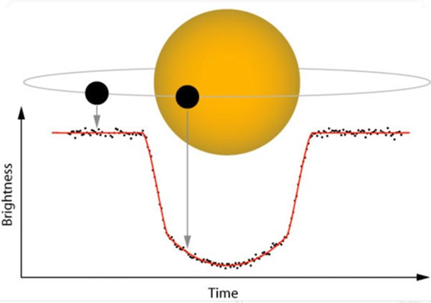

Figure 1 Exploring the Universe: Exoplanet Discovery through the Transit Method. Showing transit method looking for tiny dips in the brightness of a star when a planet orbiting it crosses in front of it, we say the planet transit the star. Key advantages of the transit method include its high sensitivity to small exoplanets and the ability to discern planetary atmospheres through spectroscopic analysis of starlight filtered through the exoplanet's atmosphere during transit.

The organization of the study on finding habitable exoplanets using the transit method and Kepler dataset would typically follow a structured research approach. The study can be organized into several key sections, each addressing specific aspects of the research. Section 1 explains an overview of the search for habitable exoplanets and its significance in astrobiology and space exploration. Introduce the transit method and its importance in exoplanet detection. State the objectives and research questions of the study. Section 2 summarizes relevant literature related to the transit method and its success in discovering exoplanets. Section 3 explains the methodology proposed in the paper. Section 4 explains present the findings of the study, including the number of habitable exoplanet candidates identified and their characteristics. Display relevant data visualizations and plots to support the results. Interpret the results and compare them with theoretical predictions and previous studies. Section 5 summarizes the main findings and their significance in the context of the broader field of exoplanet research and habitability.

2 Literature Review
The search for habitable exoplanets using the transit method and the Kepler dataset has been a focal point of exoplanetary research, revolutionizing our understanding of the cosmos and the potential for life beyond Earth. Numerous studies have contributed valuable insights into the methodology, discoveries, and implications of this line of research. This literature review provides an overview of key studies and findings related to the topic.
In [12], authors outline the objective of finding exoplanets by using machine learning methods. Used different datasets for conducting supervised learning and unsupervised learning approaches. In results, accuracy of 99.06%, 92.11%, 88.50% and 99.79%, in the supervised learning task and reasonable clusters in unsupervised learning (Jin, Yang and Chiang 2022)
In [13], Authors of this research had stated that the difficulty or the limitations of ML methods to deal with complex data. To overcome this problem faced by astronomers, this research has used deep learning techniques which are able to dealt with complex or enlarge data (Jagtap et al. 2021).

In [14], This paper introduces a method for automating the classification of transit signals into either exoplanets or non-exoplanets. The approach involves various signal preprocessing techniques, including the comparison of performance metrics for Savitsky Golay filters and Gaussian filters (Mathur, Sizon and Goel 2020).
The use of Gaussian filters is combined with normalization and standardization steps. Subsequently, a convolutional neural network model is trained to predict whether a given signal represents an exoplanet or is caused by astrophysical or instrumental phenomena.

In [15], The paper discusses the growing significance of data analysis in spatial missions, particularly focusing on light curve datasets gathered by missions such as Kepler and TESS, aimed at identifying planet transits and discovering exoplanets beyond our Solar System. The survey focuses on different machine learning-based algorithms designed for exoplanet transit discovery (Jara-Maldonado et al. 2020). These algorithms are crucial for characterizing transiting exoplanets, especially when both light curves and radial velocity curves are available. In conclusion, the paper underscores the importance of machine learning methods in automating the analysis of large and complex datasets from spatial missions.

In [16], The study aims to automatically classify Kepler Objects of Interest (KOIs) as either exoplanets or false positives by determining the importance of different data features in the classification process. The authors built five machine learning classification models, including logistic regression, support vector classifier, gradient boosting classifier, random forest classifier, and multilayer perceptron. These models were trained and tested using 15 selected features (Srivathsa and Assad 2022 ).

In [17], In essence, this project represents a collaborative effort between researchers and NASA to employ cutting-edge machine learning techniques for the analysis of data from the Kepler Space Telescope. The ultimate goal is to identify exoplanets with characteristics similar to Earth, particularly those located within the habitable zone of their parent stars (Khan and Dixit 2020).

In [18], the paper introduces an innovative anomaly detection method, the multi-stage memetic algorithm, extended to a clustering algorithm, for identifying potentially habitable exoplanets. This approach is distinct from previous methods, particularly modelling and supervised learning, and offers a novel perspective by considering Earth as an anomaly among a large dataset of exoplanets (Sarkar et al., 2022). The results are compared with established habitability catalogues, contributing to the ongoing exploration of exoplanetary habitability.

In [19], the paper underscores the advancements in space technology and the subsequent wealth of information about exoplanets. It emphasizes the significance of assessing habitability and introduces a machine learning model, with Stratified K-fold cross-validation identified as the most accurate predictor for exoplanet habitability in comparison to other models (Raminaidu et al., 2023).
In [20], The study explores the application of machine learning, specifically the XGBoost algorithm, to assess the presence of water on Earth-like exoplanets using broad-band filter reflected photometric flux. The research involves the analysis of 53,130 spectra of cold, Earth-like planets with various surfaces. The results indicate that XGBoost achieves high accuracy in detecting the existence of snow or clouds and performs reasonably well for liquid seawater (Pham and Kaltenegger 2022). Overall, the use of machine learning in identifying water on exoplanets through broad-band filter photometry shows promise for efficient initial characterization in the quest for potential extraterrestrial life.

The literature reviewed above highlights the significant progress made in finding habitable exoplanets using the transit method and the Kepler dataset. These studies have shaped our understanding of exoplanetary systems, informed habitability assessments, and guided the search for potential life beyond our solar system. Further research in this area will continue to advance our knowledge of exoplanets and their potential to host life.

3 Methodology
3.1 Dataset and Features
The Kepler dataset, a comprehensive collection of photometric data gathered by NASA's Kepler spacecraft for the first objective and the PHL dataset for the second and final goal, is the dataset used in this work to find potentially habitable exoplanets. The Kepler dataset, which includes entities like kepid, Kepler_name, koi_pdispoisition, and other planet characteristics, is composed of 9564 rows and 83 columns. For further creation models and EDA For this reason, I utilize the light curve library to extract time-series flux data using the kepid feature. We require the flux values for every star. At this point, all we need is the kepid column, therefore we made a new, smaller data frame. I was able to obtain a dataset with 7888 rows and 1626 columns after collecting flow data. Two datasets—the PHL data and the NASA exoplanet archive—are available for our second target. In order to exploit the habitability feature, we also require PHL data. We must combine datasets in order to deploy our model, since they can be used in machine learning models. All of my features—aside from habitability—are available in NASA's exoplanet repository. We removed it from the PHL dataset merging as a result. The Anaconda Jupiter notebook is one of the environments used to compile the project, which is entirely based on Python. Numerous libraries, including pandas, NumPy, matplotlib, TensorFlow, Keras, and Sklearn, are heavily utilized in the project. KNN, Linear SVC, Naive Bayes, Logistic Regression, and Decision Trees were among the machine learning techniques employed.

Figure 2 Navigating the Cosmos: Visualizing the Exoplanet Discovery Process Using the Transit Method and Kepler Dataset Flow Diagram. Flow diagram provides a more detailed breakdown of the subprocesses involved in finding likely habitable exoplanets using machine learning and the Kepler dataset. It helps illustrate the specific tasks and data flow within each major process.

3.2 Data Pre-Processing and Merging
The NASA EXOPLANET ACRCHIVE dataset, as is well known, has a large number of missing values. As the initial stage in data pre-processing, it is crucial to clean the data by eliminating all of the missing values (Akeson 2013). We eliminated the column data with a value more than 40% of the missing data after analysing the missing values. This is frequently required since different exoplanet-finding techniques may yield different datasets. After the data has been combined and pre-processed, it can be analysed using a variety of statistical techniques and algorithms to look for extraterrestrial evidence. The next predicament task in front of us is that we need numerical values for our final dataset that we are going to train, so we do Iterative Imputing using Random Forest Regressor. After the followed steps, we got a clean dataset with 132 entries, The next process is much easy now to merge the data as we described earlier. We have done some feature selection on some of the datasets before merging them as described in the Table 1. After combining the dataset, we again need to perform feature selection on the merged dataset for avoiding new relationships and redundancies between the features.

Table 1 Examples of Preserved Features after Feature Selection
Variable | Table Label | Meaning | Description
pl_radj | Planet Radius (Jupiter radii). | Planet Radius | Measured in Jupiter Radius
pl_pnum | Number of Planet Candidates. | Planet Number | Number of planet candidates in the planetary system.
pl_orbper | Orbital Period (days). | Planet Orbital period | Time the planet takes to make a complete orbit around the host star or system
pl_name | Confirmed Name | Planet Name | The planet name as used in the Exoplanet Archive Planetary Systems tables.
pl_rade | Planet Radius [R_Earth] | Planet Radius  [Earth Radius] | Length of a line segment from the center of the planet to its surface, measured in units of radius of the Earth.
koi_count | Kepler | No. of Planets | Number of exoplanet candidates identified in a solar system
kepler_name | Kepler Name | Unique Identifier | Kepler number name in the form "Kepler-N," plus a lower-case letter, identifying the planet. In general, these numbers are easier to remember than the corresponding KOI or KIC/KepID designations and are intended to clearly indicate a class of objects that have been confirmed or validated as planets—a step up from the planet candidate designation.
koi_period | Kepler | Orbital Period | The "koi_period" parameter is a numerical value that represents the time it takes for a candidate exoplanet to complete one orbit around its host star. It's typically measured in days.
st_dist | Stellar Distance [pc] | Distance | Distance to the planetary system in units of parsecs as reported in the TESS Input Catalog.
st_mass | Stellar Mass [Solar mass] | Mass of a Star | Amount of matter contained in the star, measured in units of masses of the Sun

3.3 Feature Engineering
Feature engineering is the next step in achieving our initial study goal, which is to locate an exoplanet. The dataset we utilized for this purpose employs timeseries, which is not suitable or acceptable for machine learning algorithms because it comprises 1626 columns. Feature engineering for the transit technique might entail drawing a star's light curve, which charts the star's brightness over time (Brownlee 2020) This can be used to determine the planet's size and orbital parameters, as well as to recognize the distinctive brightness dip that a planet causes when it passes in front of the star. Following their extraction, the features can be fed into a variety of statistical techniques and algorithms to perform analysis and determine whether exoplanets are present.
3.4 Exploratory Data Analysis
- The transit method involves detecting and confirming the presence of exoplanets based on the periodic dimming of a star's brightness caused by the transit event. Different transit detection algorithms and parameters will be evaluated to optimize the accuracy and reliability of the results. The study will utilize established habitability criteria, such as the habitable zone concept, which defines the range of distances from a star where a planet may have conditions suitable for liquid water to exist on its surface(Sturrock , Manry and Rafiqi 2019) These habitability criteria will be used to assess the potential habitability of the identified exoplanets. Several parameters are used in the EDA process for finding an exoplanet like Stellar Metallicity connections, Optical Magnitude Connections and Temperature-Mass Relation with Habitability. These parameters boil down to their strong influence on both the formation and detectability of planets, as well as their connection to conditions that might support life. Planet Formation: Stars with higher metallicity (abundance of elements heavier than hydrogen and helium) tend to have more material in their protoplanetary disks, the birthplace of planets. This can lead to the formation of larger planets, including gas giants, which while not habitable themselves, can influence the formation and location of smaller, rocky planets that might be and as described in Figure 3. Magnitude, along with other data like colour, helps determine the star's temperature, size, and age. These stellar properties are essential for calculating the habitable zone (the region around the star where liquid water could exist on a planet's surface) and understanding the environment in which any detected planet exists as described in Figure 4. Temperature-Mass Relation with Habitability: Liquid Water: The primary focus in the search for habitable exoplanets is often the potential for liquid water on the planet's surface. Temperature is a key factor in determining this, and it's influenced by both the star's properties and the planet's distance as mentioned in the Figure 5. Mass plays a role too, as more massive planets can retain heat better. We have performed RA/Dec plot for choosing the target stars for a transit survey and understanding the general distribution of stars as a background for exoplanet research Fig 6.
- "In the exploratory phase, we examined the relationship between distance to the star and minimum travel time using a scatter plot. The visualization clearly demonstrates a positive correlation, with a near-linear trend suggesting a direct relationship between these two variables. This observation aligns with expectations, as greater distances naturally imply longer travel times. Furthermore, the plot incorporates stellar mass (st_mass) as a third dimension, represented by the point size. This allows us to visually explore whether stellar mass plays a role in the distance-travel time relationship. While further analysis is needed to quantify this influence, the plot suggests that more massive stars (represented by larger points) might exhibit a different trend or distribution within the overall correlation Fig 7.
Flux data plays a crucial role in exoplanet detection and analysis, especially when using methods like the transit method. Flux refers to the amount of light received from a star, and the variations in flux can indicate the presence of exoplanets(Kroening 2023).

Some Images from EDA process are as follows: -
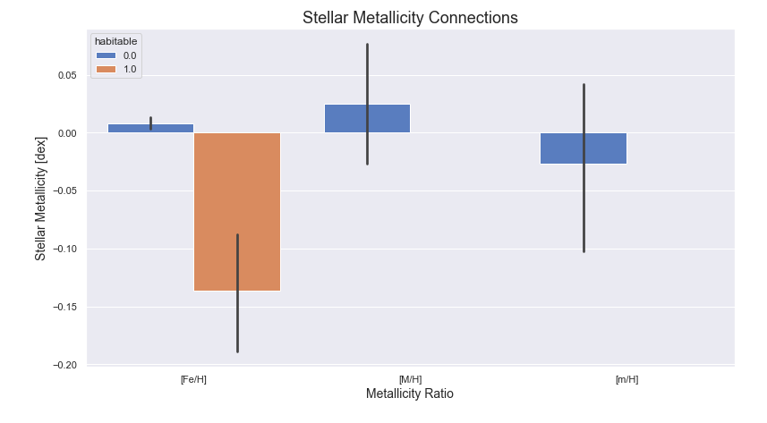
Figure 3: The Stellar Metallicity Connection: Unveiling the Cosmic Story in Elemental Abundances. Stellar metallicity, defined as the abundance of elements heavier than helium within a star's composition, serves as a pivotal indicator of a celestial body's history, evolution, and broader astronomical context. X-axis representing “Metallicity Ratio” with labels “[Fe/H]”, “[M/H]” and “[m/H]”. Notations like [Fe/H] is representing the ration of iron to the hydrogen in the star relative to the sun and [M/H] and [m/H] representing general notations for metallicity. Y-axis representing Stellar Metallicity[dex]. “[dex]” is the logarithmic unit used in astronomy for these ratios. The axis values are ranging from -0.20 to 0.05. Each bar represents the average stellar metallicity connection for a group of exoplanets categorised by habitability. Blue (0.0) represents exoplanets deemed non-habitable and Orange (1.0) represents exoplanets considered habitable.
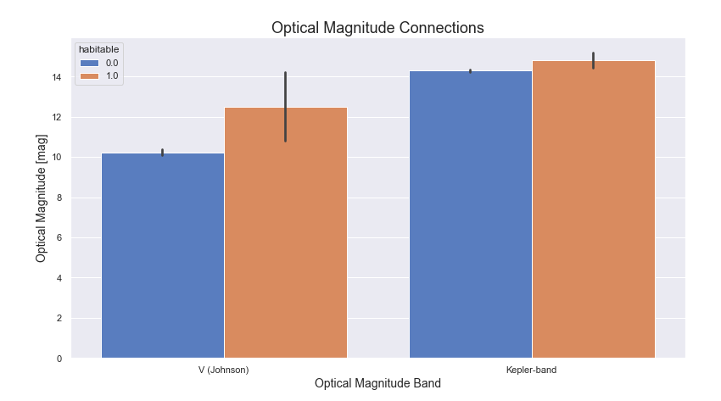
Figure 4: Optical Magnitude Connection: Unveiling the Cosmic Story in Elemental Abundances. “Optical Magnitude Connection” This immediately tells us the figure is exploring the relationship between optical magnitude (brightness as seen from Earth) and some other factor, likely related to exoplanet habitability. X-axis [Optical Magnitude Band] indicates the comparing measurements across two specific optical bands: V (Johnson) and Kepler-band. These are filters that allow specific wavelengths of light to be measured. V(Johnson) A standard filter in the visible light spectrum, centered in the yellow-green range. It's a common way to measure a star's visual brightness. Kepler-band A custom filter used by the Kepler Space Telescope, designed for its specific mission of detecting exoplanets by observing transit events (where a planet passes in front of its star). It's a broad bandpass, covering a range of visible wavelengths. Y-axis [Optical Magnitude [mag]] represents the apparent magnitude of the stars being measured. The above bars are coloured according to “habitable” as Blue is representing stars with a lower probability of hosting habitable exoplanets and Orange is representing stars with higher probability of hosting habitable exoplanets.
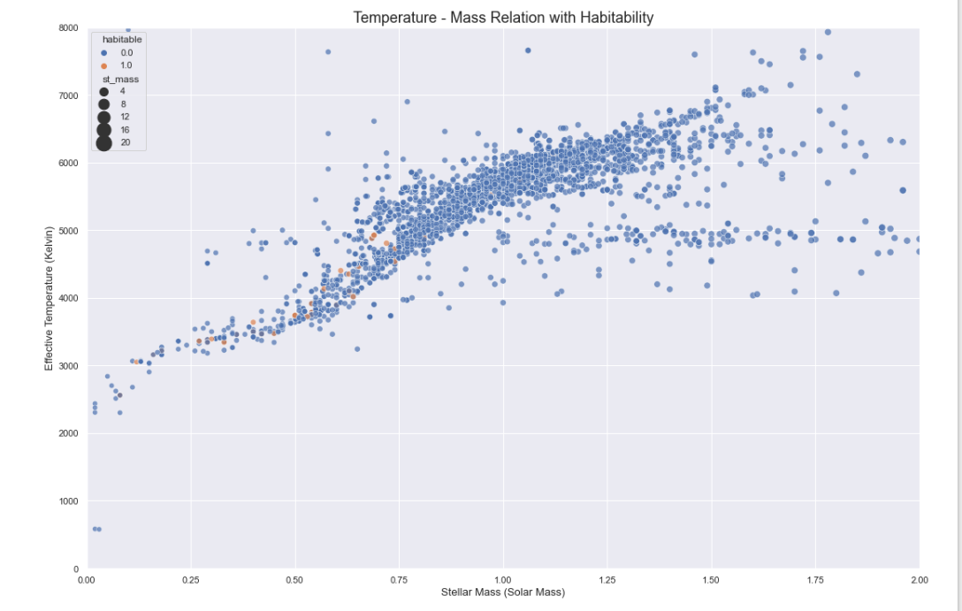
Figure 5: Exploring the Temperature-Mass Relation: Implications for Planetary Habitability. Temperature -Mass Relation with Habitability. The temperature-mass relation stands as a cornerstone in the quest to understand the potential habitability of planets across the cosmos. The above graph is depicting the connection between star’s temperature and the mass, and how it relates to the potential habitability of orbiting planets. X-axis: Stellar Mass (Solar Mass) represents the mass of the star, normalized to the mass of our Sun (Solar Mass = 1). Values greater than 1 indicate stars more massive than the Sun, and values less than 1 indicate less massive stars. Y-axis: Effective Temperature (Kelvin) represents the surface temperature of the star, measured in Kelvin. Kelvin is an absolute temperature scale, with 0 Kelvin being absolute zero. Uses color to distinguish between stars categorized as "habitable" (likely orange) and "non-habitable" (likely blue). Uses color to distinguish between stars categorized as "habitable" (likely orange) and "non-habitable" (likely blue).
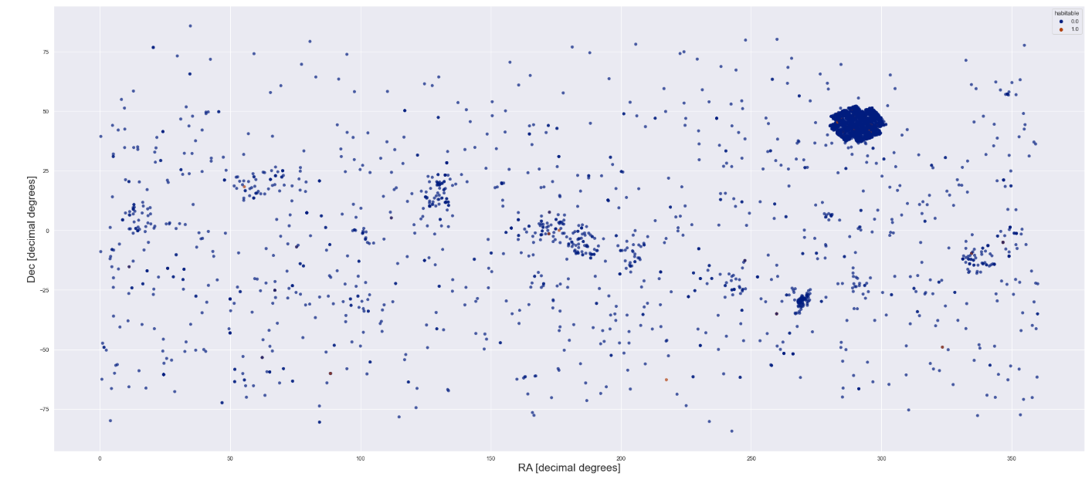
Figure 6: The above plot visualises the relationship between the Dec [decimal degree] and RA [decimal degrees], which are coordinates on the celestial sphere, similar to longitude and latitude on the earth. X-axis: RA (Right Ascension) in decimal degrees. RA is measured in degrees, hours, minutes, and seconds, but here it's converted to decimal degrees for plotting. It essentially tells you how far east an object is on the celestial sphere. Y-axis: Dec (Declination) in decimal degrees. Dec tells you how far north or south an object is on the celestial sphere relative to the celestial equator. Each blue dot represents the data point with specific RA and Dec values.
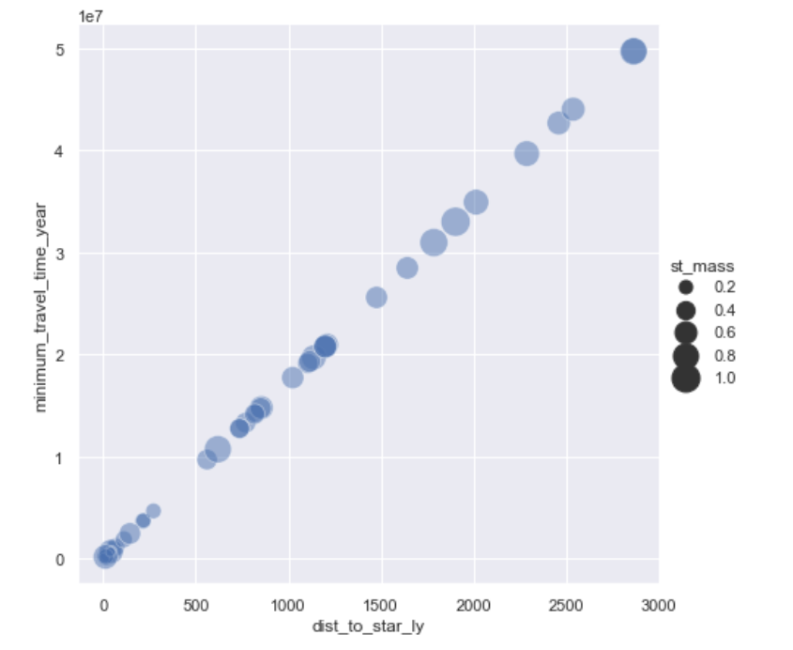
Figure 7: Navigating the Cosmos: The Distance-Time Relation and Its Implications for Habitability. In the quest to unravel the mysteries of habitable environments beyond our solar system, the relationship between distance and time emerges as a critical factor. X-axis: dist_to_star_ly - This represents the distance to the star, measured in light-years (ly). Y-axis: minimum_travel_time_year - This represents the minimum travel time to the star, measured in years. The size of each point corresponds to the value of st_mass, which represents the stellar mass. Larger points indicate more massive stars. Numbers (0.2, 0.4, 0.6, 0.8, 1.0): These numbers represent specific values of st_mass.

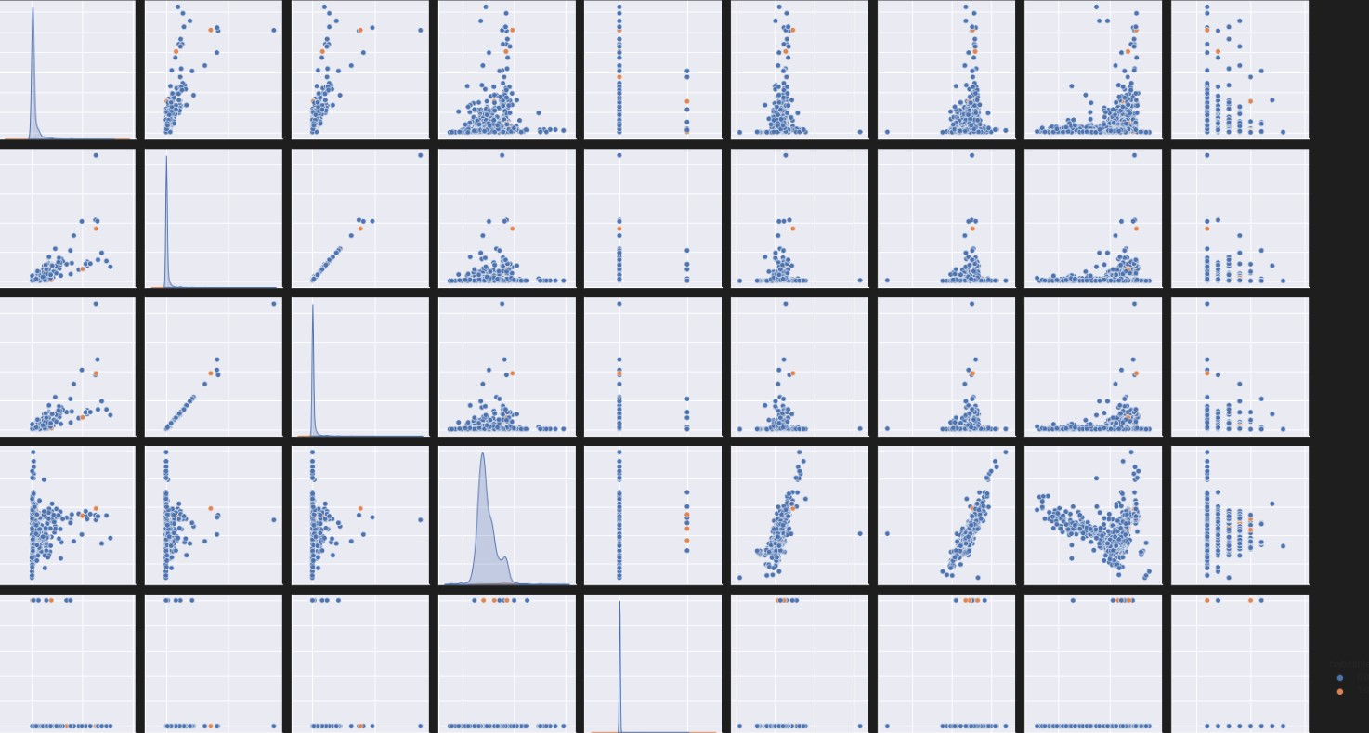

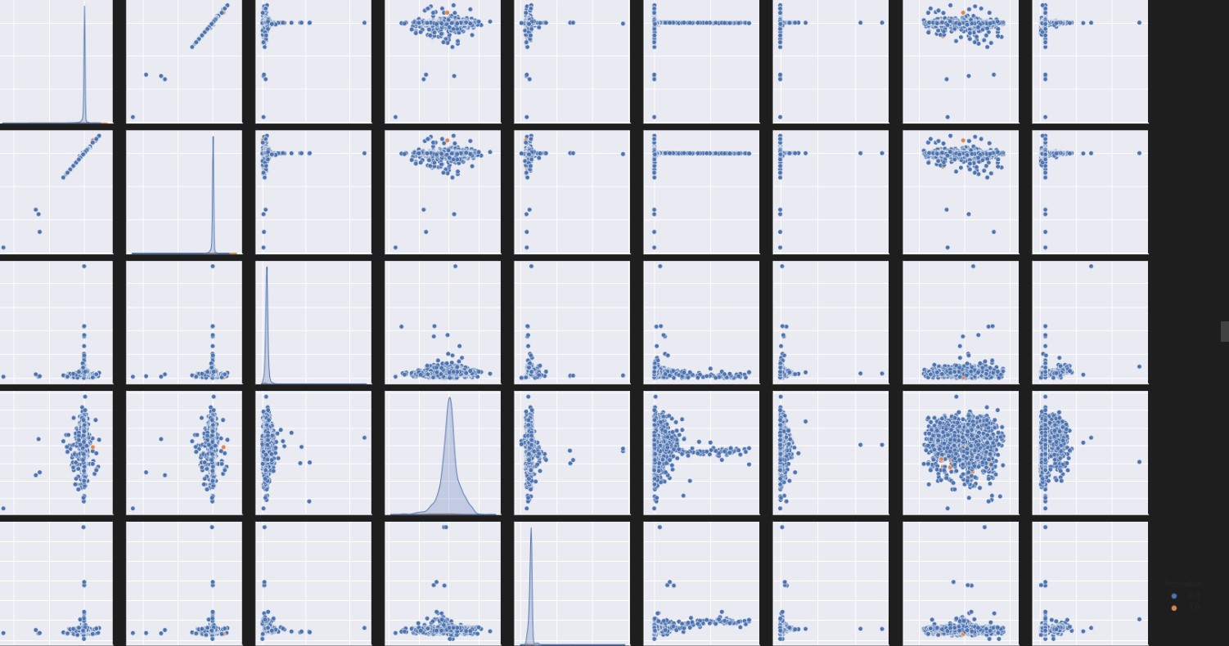

Figure 6 Unlocking the Secrets of the Universe: Analysis of Light Curves Including Transit Signals. Light curves, captured through photometric observations, provide invaluable insights into the dynamics of celestial systems. The detection of transit signals within these curves is indicative of an orbiting exoplanet or another astronomical object passing in front of its host star.
ample lightcurves containing transit signal(s). All of these curves are taken from our test set of the respective dataset. It can be observed that the
TESS (in blue) and Kepler (in green) data is a lot more noisy and likely to contain less number of transit’s.
Sample lightcurves containing transit signal(s). All of these curves are taken from our test set of the respective dataset. It can be observed that the
TESS (in blue) and Kepler (in green) data is a lot more noisy and likely to contain less number of transit’s.
Assuming the data set is D = {(xi, yi):i=1 . . .n, xi∈R m, yi ∈ R}, we have n samples with m features. Let yˆI be denied as the predict value by the model:
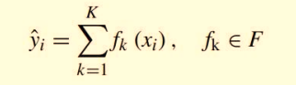
Where fk represents an independent regression tree and fk(xi) denotes the prediction score given by the k-th tree to the i-th sample. The set of functions fk in the regression tree model can be learned by minimizing the objective function:
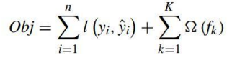
The l herein is a training loss function, which measures the difference between the prediction yˆ and the object yi . To avoid over-fitting, the term Ω penalizes the complexity of the mode.
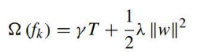
The next equation is obtained by using the second order Taylor expansion to simplify above equation and removes the constant terms.
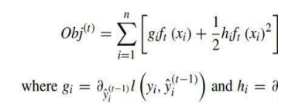
the first and the second order gradient on l. Then the objective is rewritten as:
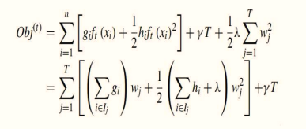
This formula is usually used in practice for evaluating the split candidates.
4) Evaluation and Optimization
After performing cleaning, merging and model selection, there are more steps to do to get data ready for machine learning. We don’t want overfitted results from the model and it’s important to fix the imbalance problem.
Above we can see we completed cleaning and merging process and model selection, but still there is a lot of work to do. There are more steps we must do for preparation step that We should do to get data ready for machine Learning. We have still so many features and we don’t want overfitted results from model and we have to fix the imbalance problem.
• SMOTE Oversampling: SMOTE (Synthetic Minority Over-sampling Technique) is a powerful oversampling method commonly used in machine learning to address class imbalance problems, where one class is significantly underrepresented compared to others (Singh and Kumbhare 2022). In the context of finding exoplanets using the transit method and the Kepler dataset, class imbalance may occur when the number of confirmed exoplanets is much smaller than the number of non-exoplanetary signals (false positives or noise).
SMOTE works by utilizing k-nearest neighbour algorithm to create synthetic data. SMOTE first start by choosing random data from the data are set. Synthetic data would then be made between the random data and the randomly selected k-nearest neighbour. It would help to overcome overfitting problem by random sampling.
• Dropping lowly correlated features and selected highly correlated features for model’s dataset.
• After some research we have decided to add features to our dataset: Planet mass, planet’s radial velocity amplitude[m/s], equilibrium, temperature[k], planet radius, orbital period and after that Normalization Well, we can define classification model now. We began by exploring basic models: KNN, Logistic Regression, Naïve bayes, Linear SVC and Decision Tree.

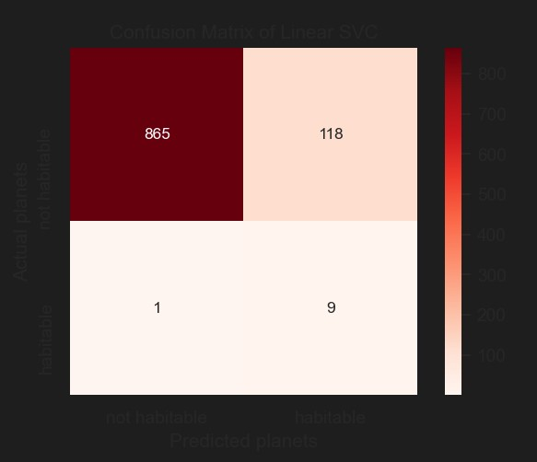
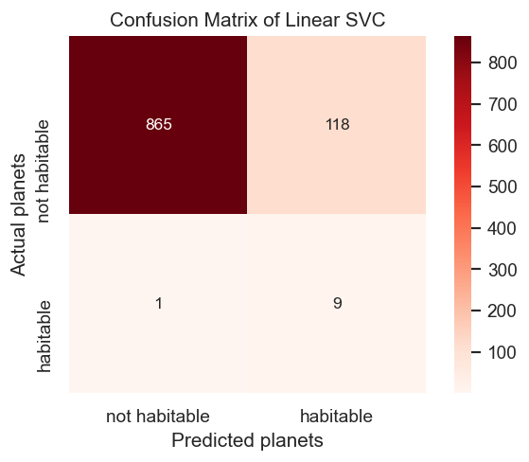

Figure 7 Analysing Classification Performance: Abstract of Confusion Matrix. Figure showing is a confusion matrix with all features selected Habitable and Non-Habitable. The analysis of a confusion matrix provides valuable insights into the strengths and weaknesses of a Linear SVC model

5 Results and Comparison

The best result that we got for is approximately 58.2% accuracy. That is not so good, but it isn’t a complete defeat though. The biggest factor that we achieved in determining exoplanet candidacy is the minimum flux. Decision Tree is successful in this task we get up to 98.29% accuracy. KNN is second successful model in terms of recall scores.
The reason why we chose the decision tree model is that it can split data with classification curacy
rules based on the highest information gain, Info Gain = Entropy parent - Entropy children. In a classification tree model, each internal node represents a sample to be split, and each leaf node represents a class label, or prediction.

Evaluation metrics including as precision, recall, and F1 score are frequently employed to appraise the effectiveness of classification models, especially when there is an imbalance between the classes. These measures shed light on how well the model predicts both positive and negative occurrences and how accurate, comprehensive, and balanced it is.

Below is a succinct explanation of every metric:
Accuracy: The precision metric quantifies the percentage of accurately predicted positive cases among all the cases that are projected to be positive. It aids in evaluating how well the model detects positive cases.

Recall: Recall quantifies the percentage of accurately predicted positive cases among all actual positive cases. It is sometimes referred to as sensitivity or true positive rate. It shows that the model can identify every positive case.

F1 Score: It offers a solitary measure that integrates recall and precision, enabling a comprehensive evaluation of the model's efficacy. Since the F1 score takes into account both false positives and false negatives, it is particularly helpful when the dataset is unbalanced.

Evaluation Metrics
The effectiveness of our model is assessed using the following assessment metrics in this study.
- Accuracy: The correct prediction is known as Accuracy.
Accuracy = (TP + TN) / (TP + TN + FP + FN)
- Precision: Precision is defined as the proportion of correctly predicted positive outcomes to total positive predictions.
Precision = TP / (TP + FP)
- Recall: The ratio of correctly predicted positive outcomes to total outcomes is referred to as recall.
Recall = TP / (TP + FN)
- F1-Score: The mean of precision and recall is referred as F1 Score. F1 Score gives output between a range from 0 to 1.
F1 Score = 2 × (recall × precision) / (recall + precision)

where FP stands for false positives, FN for false negatives, and TP for true positives.
You can obtain a more thorough grasp of the model's performance in terms of both positive and negative predictions by analyzing precision, recall, and F1 score.

Table 2. Showing accuracies of different ML Algorithms.

MODEL | Train Accuracy | Test Accuracy | Precision | Recall | F1 Score
Logistic Regression | 92.88 | 86.91 | 0.52 | 0.78 | 0.51
Linear SVC | 93.74 | 88.02 | 0.53 | 0.88 | 0.53
KNN | 98.94 | 96.07 | 0.57 | 0.83 | 0.62
Naïve Bayes | 85.87 | 88.62 | 0.52 | 0.79 | 0.52
Decision Tree | 100 | 98.29 | 0.67 | 0.89 | 0.73

6 Evaluation Graphs
Receiver Operating Characteristic (ROC) Curve:
Receiver Operating Characteristic (ROC) Curve: At different categorization thresholds, the ROC curve shows the trade-off between the true positive rate (sensitivity) and the false positive rate. Axis Labels: The genuine positive rate is shown by the y-axis, while the false positive rate is represented by the x-axis. The ROC curve is a line that illustrates how variations in the false positive rate affect the genuine positive rate. (Kroening 2023)
Precision-Recall Curve: At various categorization thresholds, the precision-recall curve illustrates the link between recall (true positive rate) and precision (positive predictive value) (Tey et al. 2023). Axis Labels: The precision is represented by the y-axis, and the recall by the x-axis. Curve: The curve shows how recall varies with precision.
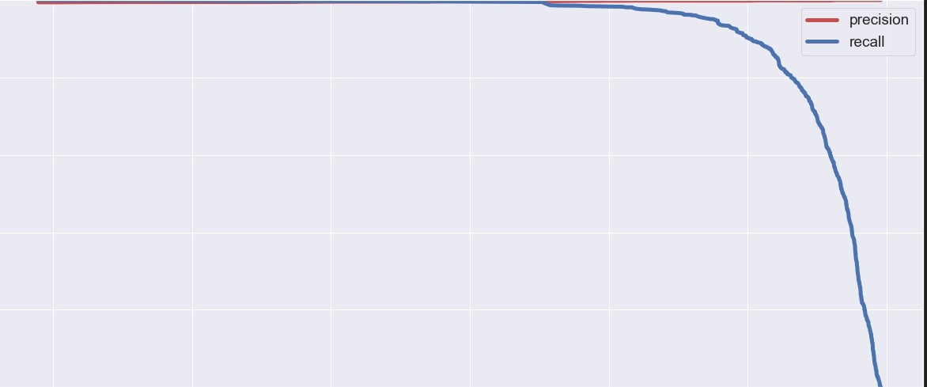
Figure 8 Precision and Threshold Scores: Abstract on Critical Metrics in Classification. In the realm of classification models and machine learning, precision and threshold scores are pivotal metrics that hold the key to evaluating and fine-tuning model performance. This abstract provides an overview of precision, threshold scores, and their interplay in the context of classification, emphasizing their importance in achieving accurate and reliable results.

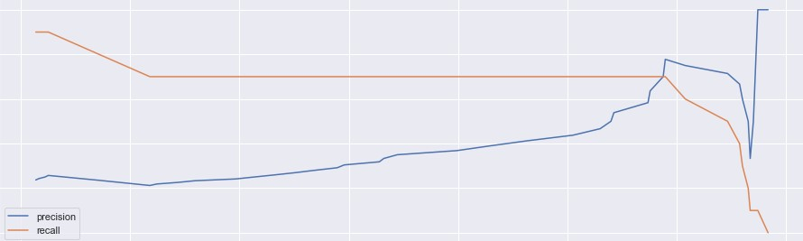

Figure 9 Precision and Recall scores. This abstract highlight the inherent trade-off between precision and recall—increasing one metric often leads to a decrease in the other. Striking the right balance between precision and recall is crucial, as the choice between them depends on the specific objectives and requirements of a classification task.

7. Conclusion and Future Work
In conclusion, the Kepler dataset analysis using machine learning approaches has yielded encouraging findings in identifying likely habitable exoplanets. By combining sophisticated computer techniques with the abundance of data from the Kepler mission, great progress has been made in locating exoplanetary candidates with traits that could lead to possible habitability. In this work, we investigated how different factors taken from the Kepler dataset could be used to determine an exoplanet's habitability using machine learning methods, such as the decision tree model. Our analysis's findings highlight how machine learning may be used to find patterns and relationships in large, complicated datasets, which can help find exoplanetary candidates that meet criteria for the habitable zone and other important considerations.
The conclusions of the study are based on a thorough assessment and optimization of the data, transit detection, and characterisation of exoplanet features. Additionally, a comparison with previous research and a discussion of the importance of the findings are included. The Kepler mission, NASA Archive, and PHL data were used to develop a successful machine learning model. Additionally, we were successful in predicting a planet that had the traits we would anticipate from a habitable world. The decision tree model proves to be an effective machine learning tool for the categorization task.
We could use data from TESS, JWST, and WFIRST in our study. While machine learning produces good results, deep learning may also be verified. Identifying the most crucial aspects of habitability by natural language processing (NLP) and, if feasible, adding chemical features at the end to improve the accuracy of our model. All things considered, the field of exoplanet study appears to have a bright future ahead of it. As we continue to refine our methods for identifying exoplanets and gain more insight into their characteristics and habitability, many new findings are anticipated in the years to come. All things considered, the field of exoplanet study appears to have a bright future ahead of it. As we continue to refine our methods for identifying exoplanets and gain more insight into their characteristics and habitability, many new findings are anticipated in the years to come.

9 References
Cooke,B.F. & Pollacco,D. (2020) ‘SPECPHOT: a comparison of spectroscopic and photometric exoplanet follow-up methods’ Monthly Notices of the Royal Astronomical Society, Volume 495 (Issue 1, June 2020) Pages 734–742, Available at: https://doi.org/10.1093/mnras/staa1194
Udry,S. & Santos,N.C. (2007) ‘Statistical Properties of Exoplanets’ Annual Review of Astronomy and Astrophysics, Vol. 45:397-439 (Volume publication date 22 September 2007) Available at: https://doi.org/10.1146/annurev.astro.45.051806.110529
Basak,S. & Mathur,A. (2021) ‘Habitability classification of exoplanets: a machine learning insight’ The European Physical Journal Special Topics 230(10):1-31, Available at: DOI:10.1140/epjs/s11734-021-00203-z
Mendez,A. (2022) ‘Habitable exoplanets’ New Frontiers in Astrobiology ( Chapter 8, Pages 179-192) Available at: https://doi.org/10.1016/B978-0-12-824162-2.00011-7
Akeson,R.L. et al (2013) ‘The NASA Exoplanet Archive: Data and Tools for Exoplanet Research’ Publications of the Astronomical Society of the Pacific, Volume 125, Number 930 Available at: https://iopscience.iop.org/article/10.1086/672273
Sturrock,G.C., Manry,B. & Rafiqi,S. (2019) ‘Machine Learning Pipeline for Exoplanet Classification’ SMU Data Science Review: Vol: No. 1, Article 9. Available at: https://scholar.smu.edu/cgi/viewcontent.cgi?article=1070&context=datasciencereview
Kroening,R. (2023) ‘Predicting flux data for exoplanet detection’ Honors College Theses. 373. Available at: https://digitalcommons.pace.edu/honorscollege_theses/373
Jin,Y.,Yang,L. & Chiang, C. (2022) ‘Identifying Exoplanets with machine learning methods: A Preliminary Study’, International Journal on Cybernetics & Informatics (IJCI 11 (1/2), pp. 31-42). Available at: https://doi.org/10.48550/arXiv.2204.00721
Jagtap,R. et al. (2021), ‘Habitility of Exoplanets Using Deep Learning’, 2021 IEEE International IOT, Electronics and Mechatronics Conference (IEMTRONICS). Available at: 10.1109/IEMTRONICS52119.2021.9422571
Mathur, S., Sizon, S. and Goel, N. (2020), “Identifying Exoplanets Using Deep Learning and Predicting their Likelihood of Habitality”, Advances in Machine Learning and Computational Intelligence (pp 369–379). Available at: 10.1007/978-981-15-5243-4_34
Jara-Maldonado,M. et al. (2020), ‘Transiting Exoplanet Discovery Using Machine Learning Techniques: A Survey’, Earth Science Informatics (volume 13, pages573–600). Available at: 10.1007/s1 2145-020-00464-7
Srivathsa, V. & Assad, R. (2022), ‘Using Machine Learning to determine the most important features in exoplanet verification’, Journal of Student Research Vol. 11 No. 3. Available at: https://doi.org/10.47611/jsrhs.v11i3.2821
Khan, M.,A. and Dixit, M. (2020), ‘Discovering Exoplanets in Deep Space using Deep Learning Algorithms’, 2020 12th International Conference on Computational Intelligence and Communication Networks (CICN). Available at: 10.1109/CICN49253.2020.9242636
Sarkar, J. et al. (2022), “Postulating exoplanetary habitability via a novel anomaly detection method”, Monthly Notices of the Royal Astronomical Society, Volume 510, Issue 4 (March 2022, Pages 6022–6032). Available at: https://doi.org/10.1093/mnras/stab3556
Raminaidu, Ch. et al. (2023), “Building Accurate Machine Learning Models for Predicting the Habitability of Exo-Planets”, 2023 5th International Conference on Smart Systems and Inventive Technology (ICSSIT). Available at: 10.1109/ICSSIT55814.2023.10061122
Pham,D. & Kaltenegger, L. (2022), “Follow the water: finding water, snow, and clouds on terrestrial exoplanets with photometry and machine learning”, Monthly Notices of the Royal Astronomical Society: Letters, (Volume 513, Issue 1, June 2022, Pages L72–L77.). Available at: https://doi.org/10.1093/mnrasl/slac025
Santos, N.,C. (2018) “Extra-solar planets: Detection methods and results”, New Astronomy Reviews, (Volume 52, Issue 2-5, p. 154-166). Available at: 10.1016/j.newar.2008.04.011
Brownlee, J. (2020), “Discover Feature Engineering, How to Engineer Features and How to Get Good at It”, Machine Learning Mastery.
Available at: https://machinelearningmastery.com/an-introduction-to-feature-selection/.
Wright, J. & Blake, C. (2021), “Atomically precise sensors could detect a planet much like our own: Earth 2.0: This artist's rendition shows how an Earth-like exoplanet might appear”, IEEE Spectrum (Volume: 58, Issue: 3, March 2021). Available at: 10.1109/MSPEC.2021.9370070
Tey, E. et al. (2023), “Identifying Exoplanets with Deep Learning. V. Improved Light-curve Classification for TESS Full-frame Image Observations”, The Astronomical Journal (Volume 165, Number 3). Available at: https://iopscience.iop.org/article/10.3847/1538-3881/acad85
Singh, A.,K. & Kumbhareb, V.,A. (2022), “Detection of Exoplanets using Machine Learning”, International Journal of Research Publication and Reviews (Vol 3, no 2, pp 1007-1015). Available at : https://doi.org/10.55248/gengpi.2022.3.2.12

