A survey on the practices of mobile application
testing
Research Questions

Testing tools: our study also identified which testing tools
are most commonly used to automate testing activity in the
context of mobile applications (Figure 10). Firstly, Cucumber
(30%), which is a tool used to perform automated testing,
based on behavior driven development (BDD). Selenium
(22%), which is a tool for testing web applications by the
browser on an automated basis and often can be used with
Cucumber. With fewer responses appeared the following tools:
Appium (17%) and TestCaf´e (11%). In other categories (20%),
there are several tools indicated by participants (e.g., Espresso,
Robotium, CyPress, MonkeyRunner, Syhunt, and XCTest).
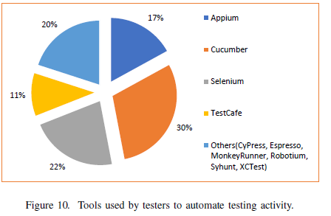
Another analysis made regarding the tools used by the
testers is presented in Figure 11, where we list which tools
are used according to the type of mobile development. We
can see that the Appium tool is more used to test native
iOS developed applications (23%), this tool support testing
to the other types of development it is used to automate
testing on physical devices as well as an emulator or simulator.
Cucumber (40 %) and Selenium (30 %) tools are more used
to testing hybrid applications. TestCafe tool is an end-to-end
solution used to testing web apps, it provides features related
to starting browsers, running tests, gathering testing results,
and generating reports. Results show that participants prefer
to use TestCafe to testing applications developed on the native
Android and Web platforms (15%).

Inclusion and Exclusion Criteria
Inclusion and exclusion criteria were established for the primary study selection step in order to pick out primary studies that had nothing to do with the specified context and only include those that were pertinent to that mapping.
Included:
- The study has to specifically include research on mobile application performance testing.
- The study needs to show how to do performance testing on mobile apps using a certain tool, technique, method, metric, or procedure.

Excluded:
- Less than four pages of research, such as an enlarged abstract.
- The study is not accessible for download.
- Research that isn't written in English.

Selection Criteria
The Applicability of Automated Testing Frameworks for
Mobile Application Testing: A Systematic Literature Review

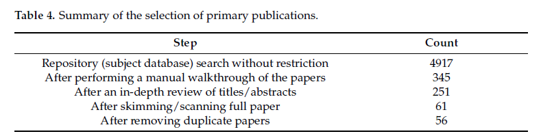
The repository search gave us a total of 4917 research papers without restriction. Then,
a manual walkthrough was conducted on the title and abstract of each publication to
exclude those that correspond with the exclusion criteria. After filtering out using the
exclusion criteria, the papers that satisfied the matching requirements dropped from 4917 to
345. After this step, we performed a second iteration on the abstract and introduction part
of the remaining paper, leading to the exclusion of 94 papers, which made the remaining
set of papers 251. Subsequently, we went through a full scan of the remaining papers to
exclude 190 papers. Lastly, duplicate papers were removed to obtain 56 articles considered
as relevant primary publications. The full list of investigated publications is shown in
Appendix A section.
As illustrated in Figure 2, almost 50% of the selected publications are found in IEEE
Xplore and Google Scholar. The rest of the papers are from ACM,Web of Science, and Scopus.
As shown in Figure 3, 30% of the 56 selected publications are journals, 63% are
conference papers, and the rest 7% are symposium publications.
We have also shown the distribution of selected articles by year. As shown in Figure 4,
45% of the 56 selected articles are published from 2014–2017, early publications before
2014 account for 35%, whereas recent publications from 2018 onwards account 20% of the
total publications.
Initially removed duplicate research. After that 1327 studies remain after the number of articles. All studies that did not fit the exclusion criteria and defined inclusion were eliminated by applying the selection criteria to the remaining studies and eliminating duplicates.
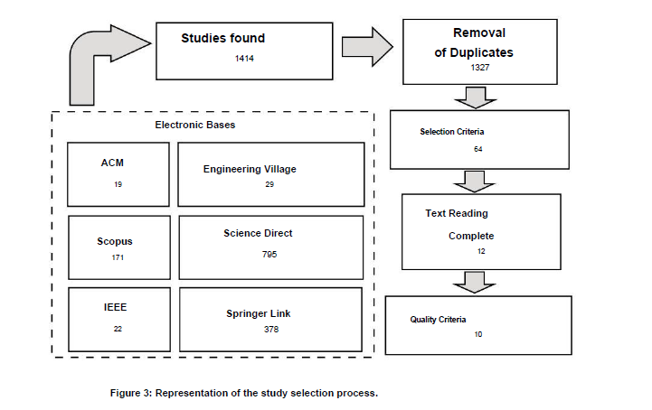

Systematic literature review of mobile application development
and testing effort estimation
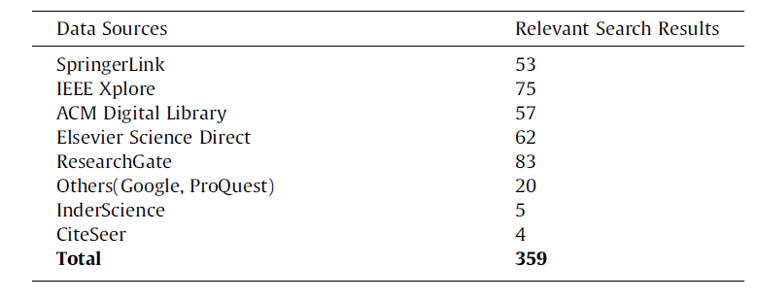
2.3.1. Selected studies overview
Fig. 2 shows the distribution of the chosen studies through the
published sources. Out of the 75 studies, 24(32%) came from IEEExplore,
11 studies (14%) came from SpringerLink, ACM Digital
Library 14(19%), 11(15%) from Research Gate, 3(4%) studies from
CiteSeer, 2(3%) from Elsevier ScienceDirect, 3(4%) from InderScience
and 7(9%) from others (ProQuest, GoogleScholar, TU/e
Repository, scielo.org.co, SemanticScholar, IGI Global). The distribution
of selected studies from different sources is shown in
Fig. 3. Maximum papers are referred to the year 2014, 2015,
2016 and one each from 1999, 2001 and 2005. The distribution
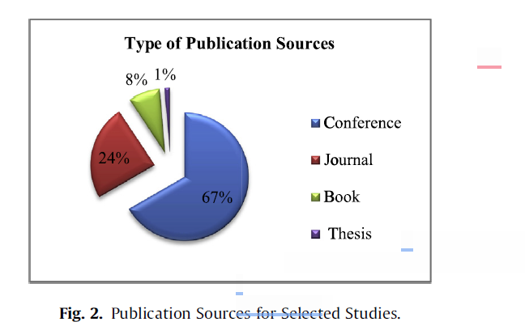
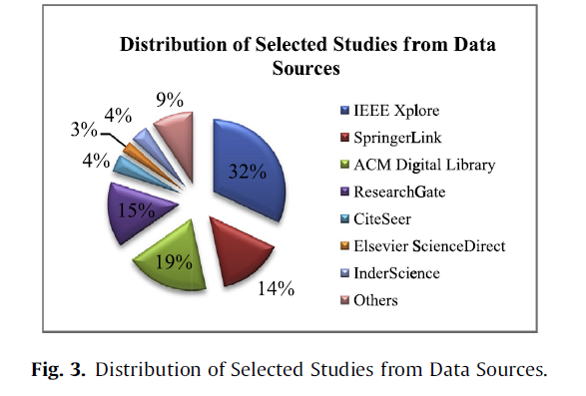

Research Questions

- Which frameworks have been established in the literature to facilitate mobile application performance testing?
- What challenges arise when mobile apps undergo performance testing?
- Which tools/Frameworks help in mobile application performance testing?
- What are the popular mobile app performance testing tools?

RQ1. Which frameworks have been established in the literature to facilitate mobile application performance testing?

This RQ1 aims to find procedures and frameworks that facilitate mobile application performance testing. Four (4) frameworks that facilitate performance testing in application furniture were found using this SLM. Additionally, it can be shown that the frameworks in their vast majority have several focuses, all of which are intended to determine how well applications run on cloud-based services or to verify compatibility. In reference to the presence of procedures that facilitate the performance test in mobile applications, no such procedures were found. Hence indicating the potential for unpublished research on this search topic.

RQ2.What challenges arise when mobile apps undergo performance testing?

This topic aims to identify the issues encountered when testing mobile applications' performance.
According to Kim et al. [11] and Kim et al. [12], implementing performance tests in mobile applications can be challenging. This problem is explained by the fact that this kind of test necessitates a high level of processing because of the numerous simultaneous executions. Aside from the fact that mobile devices, at their best, have a limited amount of hardware. The same author also points out that performance testing in mobile applications presents a challenge: an SLM determines a method's response time using traditional testing or debugging.
The study by Goel et al. [8] states that ensuring adequate resource capacity for the test cases is one of the difficulties measurement platforms in mobile networks have when attempting to gauge the performance of cellular networks. The limiting element mentioned is mobile data, the majority of which has monthly fees and caps. This kind of issue is supported by the study by Malini et al. [18], which reiterates the comparable challenges in assessing mobile device network traffic.
[20] Nandakumar et al. Despite the fact that a growing number of mobile applications results in a large number of test cases, mobile apps have shorter release cycles and frequent updates, necessitating frequent additional testing by the tester.
Similar issues are raised by writers Malini et al. [18], Nandakumar et al. [20], and Prathibhan et al. [22]. As a result, there are several device models and configurations available today, along with multiple platforms, due to the increased demand for mobile devices. Thus, it is essential to create performance test cases for a range of devices that are built using a variety of technologies and architectures. Consequently, it is frequently necessary to modify a single test case in order to get it to function on all devices.
Continuing in this vein, the issue presented by Will Lox et al. [27] illustrates the vast array of development technologies available for making furniture applications. This could suggest that a design phase should be completed before test case specifications. That Verifying the scope and selecting the most appropriate instrument to conduct the performance test would be the goals of this step. The primary reason for this is that the technology used to construct the application might frequently limit the tool that is designated for the generation and execution of test cases. As a result, depending on the decision, a particular tool may be required to do the performance test on the mobile app.

References

[8] Utkarsh Goel, Ajay Miyyapuram, Mike P Wittie, and Qing Yang. 2013. MITATE: Mobile Internet testbed for application traffic experimentation. In International Conference on Mobile and Ubiquitous Systems: Computing, Networking, and Services. Springer, 224–236.
[11] Heejin Kim, Byoungju Choi, and W Eric Wong. 2009. Performance testing of mobile applications at the
Unit test level. In 3rd IEEE International Conference on Secure Software Integration and Reliability Improvement. IEEE, 171–180.
[12] Heejin Kim, Byoungju Choi, and Seokjin Yoon. 2009. Performance Testing Based on Test-driven Development for Mobile Applications. In 3rd International Conference on Ubiquitous Information Management and Communication. ACM, 612–617.
[18] A. Malini, N. Venkatesh, K. Sundarakantham, and S. Mercyshalinie. 2014. Mobile application testing on smart devices using MTAAS framework in the cloud. In International Conference on Computing and Communication Technologies. IEEE
[20] Vikrant Nandakumar, Vijay Ekambaram, and Vivek Sharma. 2013. App instrumentation
A unified app instrumentation and automated playback framework for testing
Mobile applications. At International Conference on Mobile and Ubiquitous
Systems: Computing, Networking, and Services. Springer International Publishing, 474–486.
[22] C Mano Prathibhan, A Malini, N Venkatesh, and K Sundarakantham. 2014. An automated testing framework for testing Android mobile applications in the cloud.In 2014 IEEE International Conference on Advanced Communications, Control and Computing Technologies. IEEE, 1216–1219.
[27] Michiel Willocx, Jan Vossaert, and Vincent Naessens. 2016. Comparing Performance Parameters of Mobile App Development Strategies. In 2016 IEEE/ACM International Conference on Mobile Software Engineering and Systems. IEEE, 38–47.

RQ3.Which tools/Frameworks help in mobile application performance testing?

This topic aims to identify the resources that scientific research has suggested or utilized to assist with mobile application performance testing. We discovered six (6) tools that facilitate performance testing in mobile apps in order to respond to this research topic. Table 9 lists the tools that were discovered, the tools that support the main tool (which may be plugins), the test kinds that they support, and, lastly, where they came from (whether academic or commercial).
Analysis of the available tools revealed that there are currently few tools to support mobile device performance testing, which confirms a need previously noted by Zein et al. [29], who discuss the dearth of tools to conduct performance testing in mobile applications. Additionally, it can be seen that the great majority of the tools discovered are academic in nature, which was to be expected given the gap between the state of the art and practice. The lack of publication of frequently commercially supplied tools in events science. Therefore, more searches in the gray literature are required in order to potentially locate more tools relevant to the situation under study.
Along with the tools, pjunit, an Eclipse platform plugin created by Kim et al., might also be identified. [11] [12]. Its primary goal was to support unit-level performance through testing. According to the kinds of tests that each tool supports, the primary focus is on conducting performance testing generally. This is followed by performance tests that concentrate on network traffic, as presented by Goel et al. [8], and tests that target stress test techniques, as discussed by Amalfitano et al. [2].

References:

[2] Domenico Amalfitano, Anna Rita Fasolino, Porfirio Tramontana, and Bryan Robbins. 2013. Testing Android Mobile Applications: Challenges, Strategies, and Approaches. Vol. 89. Elsevier Inc. 1–52 pages.
[6] Jacob Cohen. 1960. A coefficient of agreement for nominal scales. Educational and Psychological Measurement 20 (1960), 37–46.
[8] Utkarsh Goel, Ajay Miyyapuram, Mike P Wittie, and Qing Yang. 2013. MITATE: Mobile Internet testbed for application traffic experimentation. In International Conference on Mobile and Ubiquitous Systems: Computing, Networking, and Services, Springer, 224–236.
[11] Heejin Kim, Byoungju Choi, and W Eric Wong. 2009. Performance testing of mobile applications at the unit test level. In In 3rd IEEE International Conference on Secure Software Integration and Reliability Improvement. IEEE, 171–180.
[12] Heejin Kim, Byoungju Choi, and Seokjin Yoon. 2009. Performance Testing Based on Test-driven Development for Mobile Applications. In 3rd International Conference on Ubiquitous Information Management and Communication. ACM, 612–617
[29] Samer Zein, Norsaremah Salleh, and John Grundy. 2016. A systematic mapping study of mobile application testing techniques. Journal of Systems and Software 117 (2016), 334–356.

RELATED WORK

Evaluating the Performance and Capabilities of Popular Android Mobile Application Testing Automation Frameworks in Agile/ devops Environment

Since the frameworks used have a significant impact on test automation performance, choosing the optimum framework based on the features and needs of the application is essential to achieving optimal performance.
Mobile application testing automation frameworks have been mentioned in a number of published studies. Three frameworks were identified in [10] as the most popular for functional user interface testing: Appium, Espresso, and Calabash. The best one was determined to be calabash, which was followed by espresso and appium. Execution time and element inspection were the primary criteria used to evaluate performance. The performance evaluation in the aforementioned research study was conducted using the DIA algorithm, which is a component of Multiple Attribute Decision Making (MADM) and seeks to choose the optimal option while guaranteeing no ranking irregularities [10].
The most popular frameworks that were compared in [11] were Appium, Robotium, and uiautomator. It was discovered that Appium could manage a variety of functional testing scenarios, including changing network modes, managing disruptions, launching other apps, etc. In a similar manner, uiautomator can manage every situation listed, however it is unable to manage launching additional programs. They were found to be partially handled by Robotium. It was discovered that UI Automator has the shortest execution time.
Numerous frameworks were covered in another research [12], but mostly Appium, Robotium, monkeyrunner, and Calabash. Basic details concerning frameworks were provided, and Appium was demonstrated to include additional features including support for built-in apps like the phone, calendar, and camera. Although monkeyrunner appears to be accessible for functional testing, given the variety of Android devices, creating distinct test cases for each device is not a wise choice. The difficulties that test automation frameworks have in enabling various testing types, including security, integration, and unit testing, were covered.
In [13], the Espresso and Eye-Automate frameworks were contrasted. According to a poll of participants, while comparing the frameworks, it was found that Espresso had less failures since it tested UI components directly and could test at a lower level than Eye-Automate.
Numerous frameworks were highlighted in the study [14], with Espresso, monkeyrunner, and Robotium being particularly well-liked. The bulk of research employ monkeyrunner for comparison since it requires almost minimal configuration work, according to the authors' case study on automating functional testing in mobile apps.
In addition to academic publications, various blogs that discussed mobile application testing automation frameworks were also examined. [15] made reference to Appium, Espresso, Calabash, Selendroid, and Robotium. Appium was demonstrated to be a highly well-liked framework with cross-platform (ios and Android) support. Espresso was cited as a popular framework with playback and recording capabilities. Espresso, uiautomator, and Appium were examined in [16], and the advantages and disadvantages of each framework were listed. Being a cross-language framework was one of Appium's advantages, but its delayed test case execution was a disadvantage. Although test cases can only be created in Java or Kotlin, Espresso can run them very quickly. Although uiautomator allows for interaction with system components, web elements are not supported.

References
[10] C. Merina, . N. Anggraini and N. Hakiem, "A Comparative Analysis of Test Automation Frameworks Performance for Functional Testing in Android-Based Applications using the Distance to the Ideal Alternative Method," in Third International Conference on Informatics and Computing (ICIC), IEEE, Palembang, 2018.
[11] A. M. Sinaga, P. A. Wibowo, A. Silalahi and N. Yolanda, "Performance of Automation Testing Tools for Android Applications," in 10th International Conference on Information Technology and Electrical Engineering, IEEE, Kuta,2018.
[12] K. S. Arif and U. Ali, "Mobile Application testing tools and their challenges: A comparative study," in 2nd International Conference on Computing, Mathematics and Engineering Technologies (icomet), IEEE, Sukkur, 2019.
[13] L. Ardito, R. Coppola, M. Morisio and M. Torchian, "Espresso vs. Eyeautomate: An Experiment for the Comparison of Two Generations of Android GUI Testing," Proceedings of the Evaluation and Assessment on Software Engineering, pp.13-22, 2019.
[14] P. Tramontana, D. Amalfitano, N. Amatucci and A. R. Fasolino, "Automated functional testing of mobile applications: a systematic mapping study," Software Quality Journal 27.1, pp. 149-201, 2019.
[15] A. R. Chowdhury and P. Krishnakumar, "Mobile Application Testing using Automation frameworks," July 2019. [Online].Available: https://www.browserstack.com/guide/mobile-application-testing-frameworks. [Accessed 28 February 2020].
[16] A. Zhukovich, "Android UI Testing Frameworks," 10 September 2019. [Online]. Available:
Https://proandroiddev.com/android-ui-testing-frameworks-b0b52187ceb. [Accessed 28 February 2020].

Performance Testing in Mobile Application: a Systematic
Literature Map

Applications for mobile cloud computing are increasingly being utilized to lessen the constraints of mobile devices. The research by Al-Ahmad et al. [1] examines the features and models of the three connected domains of mobile cloud application testing, cloud, and mobile in light of this motive. Because native mobile application test models and cloud application test models are different, it also highlights the necessity for a test model of mobile cloud computing apps. The authors' primary findings include a conceptual discussion of mobile cloud computing's characteristics and test models.
Zein et al.'s work [29] uses a methodical mapping process to classify and organize the available research findings on mobile application testing methods and the difficulties they highlight. A categorization system was used to map 79 empirical research. Specific test issues for industry specialists are revealed, along with a number of research gaps. In addition to attempting to broadly classify the many kinds of testing for apps in general, the investigation only discovered two publications that concentrated on tests for mobile devices.
Functional testing, performance, and load testing, coverage and acceptance testing, testing on cloud devices and analysis tools, and test measurement with user experience are the five categories into which Braun et al. [5] divide the tools for testing on mobile devices. 76 mobile application test tools were assessed and grouped based on their functionality for the categorization. Nevertheless, the study's exclusive focus was on tool classification. It is important to note that none of the tools that were discovered were evaluated through empirical research. Additionally, the study only found the tools in the gray literature, which is a good practice. In addition to being a supplemental study method, this approach is frequently employed in the study of practice.

References

[1] Ahmad Salah Al-Ahmad, Syed Ahmad Aljunid, and Anis Shobirin Abdullah Sani.2013. Mobile cloud computing testing review. (2013), 176–180.
[5] Susanne Braun, Frank Elberzhager, and Konstantin Holl. 2017. Automation Support for Mobile App. Quality Assurance–A Tool Landscape. Procedia Computer Science 110 (2017), 117–124.
[29] Samer Zein, Norsaremah Salleh, and John Grundy. 2016. A systematic mapping study of mobile application testing techniques. Journal of Systems and Software 117 (2016), 334–356.

