
Research Article
Indoor light environment testing and simulation of improvement measures for traditional cave dwelling architecture
Dequan Kong¹, Xiaoya Ma¹, Xiaolong Wu¹, Tengda Yue¹, Zhihua Gao^{1,}*, Rong Wan ^{1,}*, Yaqi Liu¹, Hui Cong², Huafei Xia¹, Yao Wang¹

- School of Civil Engineering, Chang’an University, 710061, Xi’an, China
- Xi’an Architectural Design and Research Institute Co, Ltd, 710061, Xi’an, China
*Correspondence: kongdequan@chd.edu.cn; 21690236@qq.com

Received:; Accepted:; Published:

Citation: Rong Wan, Xiaoya Ma, Xiaolong Wu, Tengda Yue, Dequan Kong,*, Zhihua Gao,*, Yaqi Liu, Hui Cong, Huafei Xia, Yao Wang (2025). Indoor light environment testing and simulation of improvement measures for traditional cave dwelling architecture. Revista de la Construcción. Journal of Construction, 21(1). https://doi.org/10.7764/RDLC.

Graphical Abstract:
Including a graphical abstract is highly recommended. The dimensions must be 5 x 15 cm, it must be legible, and the image resolution must be suitable for a scientific article.

Highlights:
- The indoor light environment of typical traditional cave dwellings in Northern China has been studied
- In existing traditional cave dwellings, both the illumination and uniformity of light are extremely poor.
- The factors and laws affecting the light environment in cave dwellings were analyzed and the improvement suggestions were given.
- Simulation analysis shows that the proposed suggestions can effectively improve and optimize the light environment of the cave dwellings.

Abstract: The indoor light environment in the traditional cave dwelling architecture that is still widely used today is generally poor, which seriously affects the comfort and health of residents. In order to examine the indoor light environment of cave dwellings, the parameters of indoor illuminance, daylighting coefficient and illuminance uniformity are investigated by illuminance tester. It is found that in natural lighting, the indoor illuminance and daylighting coefficient of cave dwellings at 12:00 P.M. are only 150.5 (lx) and 1.35%, respectively. The illuminance uniformity is very small, which must be improved to enhance the living standards of the inhabitants. By conducting simulation research for influencing factors (daylighting coefficient and window area, window sill height and glass transmission ratio, window-to-floor ratio) of the light environment in the cave dwelling with Ecotect Analysis software, the simulation results showed that the illuminance and daylighting coefficient of the kiln house during natural lighting were increased by 64.4% and 105%, respectively. However, the light uniformity is still low, and artificial light sources should be added as a supplement. The effect of surface-mounted artificial light sources was better, which could increase illuminance uniformity and mixed illuminance uniformity by 363.3% and 358.3%, respectively, ensuring the uniformity of indoor illuminance.

Keywords: Cave dwellings; Indoor light environment; Field test; Numerical simulation; Improvement measures

Abbreviation:
You must include a list of abbreviations. [Times New Roman 10].

- Introduction
As a natural energy-saving building, cave dwellings are warm in winter and cool in summer. This type of building can effectively use the heat energy and heat storage capacity of the soil layer in order to save energy and improve living comfort, which makes it a unique treasure of ancient Chinese architecture (Z. Zhao, 2010; Z. Zhi, 2009). The earliest cave dwellings in China appeared in 2200 BC, and today more than 40 million people still live-in cave dwellings (F. Wang, 2002). In western Henan, China, the climate is dry and cold in winter and hot in summer, and the loess cover is thick, which is very suitable for the use of cave dwellings. There are numerous caved dwellings in this area. Cave dwellings have the advantages of natural environmental protection, thermal insulation, energy conservation and sound insulation and so on. However, their unique structural form allows light to only enter from one side. As a result, natural light indoors is insufficient, leading to adverse effects on the physical and mental health of residents (M. Figueiro, 2014; G. McEnany, 2005). Therefore, it is necessary and important to conduct research on the indoor light environment of traditional cave dwellings. This work has significant practical significance for improving the living conditions in traditional cave dwellings, promoting the physical and mental health of the residents, and making better use of ancient architecture.
Scholars have conducted many studies on the indoor light environment of buildings. M.Canazei et al. (2017) studied the effect of artificial skylights in windowless office environments, suggesting that daylight replacement technology can profoundly affect people's emotional state. Z.Cui et al. ( 2020) constructed an experimental environment simulating natural light and found that indoor background brightness has a large impact on emotions. A.Kuijsters et al. (2015) found that a well-lit environment has a positive effect on negative emotions. J.Yi-kai et al. (2022) studied the influence of lighting and other factors on the classroom learning environment, pointing out that the change of lighting has a significant impact on the attention level of subjects, and is more likely to affect the anxiety level of subjects. J. Morales-Bravo & P. Navarrete-Hernandez (2022) found that the overall reduction of direct and indirect natural light entering the room would have a potentially harmful impact on emotional subjective well-being. They recommended that residential constructions should make the most of windows that face the equator. J.Xu et al. (2021) analyzed the influence of an artificial light source on night sleep and established a relationship between human health and the light environment of the building. J.Ju et al. (2021) found that the light environment has a significant impact on the health of human eyes based on the research of indoor light conditions and light use habits and presented suggestions for improving indoor light environment. The research mentioned above indicated that the indoor light environment of buildings is closely related to the physical and mental health of the residents. Therefore, it is important to study and improve the poor light environment in cave dwellings in order to improve the lifestyle of millions of people living there.
There are many factors that affect the indoor light environment of buildings. Z.Kong et al. (2018) has shown that the height of the window, the distance between the workstation and the window and the seat direction significantly influence the employees’ satisfaction with the light environment. J.Potonik et al. (2021) found that the window to wall ratio, the glass transmission and the window form are the most significant factors affecting the indoor light environment. I.Maachi et al. (2019) investigated the occupants of a building in Algeria and found that floor height, location and size of windows, and curtains can greatly affect indoor natural light. N.Abdollahzadeh et al. (2020) found that increasing the reflectance of a partition panel in an open office can compensate for the decrease in daylight caused by increasing the partition height. X.Niu et al. (2017) analyzed the influencing factors of the indoor light environment. By using evaluation indices such as daylighting coefficient, illuminance and brightness ratio they suggested that the regulation of illuminance, uniformity and glare should be strengthened in order to improve the quality of the indoor light environment. F.Soflaei et al. (2020) found in their parametric study of the courtyard residential design simulation model that the most ideal window type can improve the thermal comfort by 6.1%.
Modern architecture takes into account the impact of indoor light on the residents during the design phase. However, due to the limit of design and construction techniques at the time traditional buildings had poor natural lighting. Some scholars have conducted empirical research and studies on the improvement of indoor light environment in traditional dwellings. F.Xu et al. (2019) found that the deep design of traditional residential buildings resulted in insufficient natural lighting and proposed an active natural lighting system. L.Yu et al. (2017) conducted a numerical simulation of the indoor light performance of traditional dwellings in southern Shaanxi and found that large eaves lead to poor indoor light environment. R.Zheng et al. (2020) studied the climate responsiveness and indoor comfort of traditional buildings in the alpine area of Zhejiang province during the rainy season in early summer and found that indoor light quality and comfort were not up to standard. Z.Duan et al. (2019) studied the daylighting in the courtyard area of residential houses and found that the cleanliness of the interior wall and the reflection ratio of decoration materials are closely related to the indoor light environment. Y.Li et al. (2019) adopted a temporal test and proposed a strategy to optimize the indoor light environment in terms of daylight opening, interior decoration and light, roof daylighting and other aspects of traditional Hui-style architecture. L.Li (2017) analyzed daylighting in Hani dwellings across various Yunnan Environments and suggested improvements through window design and new materials Y.Li et al. (2012) analyzed the indoor light environment of traditional houses in Chongqing from the perspective of illuminance uniformity and daylighting coefficient and suggested a strategy for improving natural light performance. J.Tan et al. (2014) conducted lighting parameter experiments on Ming and Qing Dynasty residential buildings in Xiaogan, Hubei province. They investigated how courtyards affected the lighting conditions within buildings. Additionally, they investigated using this impact mechanism in atrium areas. There are currently few studies on the indoor light environment of cave dwellings. Y.Zhou et al. (2019) investigated the cave dwellings in the Luoyang area and proposed improvement measures such as adding a sunshine room on the entrance side of the cave dwellings and increasing the area of south-facing windows to facilitate daylighting at the rear of the cave dwellings. Z.Han et al. (2018) measured and simulated the indoor natural light environment of the cave dwellings and presented proposals for improving the quality of the indoor light environment in terms of the depth, height and form of windows. Y.Liu (2015) conducted a daylighting simulation of freestanding cave dwellings in the Weibei plain and made suggestions for improving the indoor light environment, such as reducing the depth or increasing the window-to-floor ratio. Y.Li et al. (2013) measured and simulated the light environment of stone arch cave dwellings in a small village of Diantou. Previous research has shown that traditional cave dwellings have small daylight openings, deep depths, and weak indoor lighting. These studies suggested increasing the size of openings, applying light colored paint on interior walls, increasing the height of windows, etc., to improve the lighting environment. Since the natural light environment of traditional dwellings can hardly meet the light standards, it is necessary to improve the indoor light environment by adding artificial light. X.Liao et al. (2012) studied indoor lighting in traditional dwellings in the rural areas of the Weihe plain. Researchers have found that the indoor light environment quality is poor, and residents generally do not give enough attention, which requires the use of artificial light for additional improvement. Y.Zhang (2019) studied the layout and interior decoration materials of traditional residential buildings in Lingnan area and proposed a reasonable improvement strategy for artificial light. R.Alelwani et al. (2020) found that adding shading devices to traditional residential buildings could optimize the use of artificial light.
In summary, many scholars have conducted research on the indoor light environment of residential buildings and have obtained fruitful results. However, research on the unique architectural form of cave dwellings is still relatively scarce, and existing studies have focused more on surveys and measurements of cave dwellings with insufficient discussion and analysis of improvement measures. There is also a lack of research on the artificial light environment of cave dwellings. Therefore, this study selected typical cave dwellings in western Henan as the research object, conducted on-site testing to understand the current situation and problems of indoor light environment, analyzed the main influencing factors and laws of indoor light, proposed improvement measures and suggestions, and conducted comparative verification. The aim is to provide guidelines and reference for the optimization and transformation of the indoor light environment of cave dwellings.
- Materials and methods
The test site is located in Hanzhai Village, Luoyang City, West Henan province. The test object is cliff cave dwelling, which is the most common cave dwellings style in that region. Due to the fact that the cave dwellings on steep cliffs can only be connected to the outdoor environment through one door, the area of light entry is limited, and the indoor lighting environment quality is generally poor, seriously affecting the comfort and even physical and mental health of residents. To address this issue, this study proposes suggestions for improving the indoor lighting environment of cave dwellings based on field research and measurement, and verifies the feasibility of these suggestions through simulations.
  - Research method of field measurement
The specific location of the test site is 112°25' E and 34°39' N, belonging to the transitional climate zone from the northern subtropical to the warm temperate zone, with significant seasonal, continental, and climatic diversity. The test site is in the third level daylighting area in China's light climate zoning (Standard for lighting design of buildings GB 50033-2013), and the average daylighting coefficient is 1.00.
The measured length, width and height of the cave dwelling are 5×3×3 m, respectively. A parapet is placed above the top of the cave, and the entrance to the cave is an iron gate with a strip window. There is an eave outside the entrance to the cave, and the inner wall of the cave is made of brick arch and white cement with a concrete bottom. The indoor environment of the cave dwelling is shown in Figure 1.
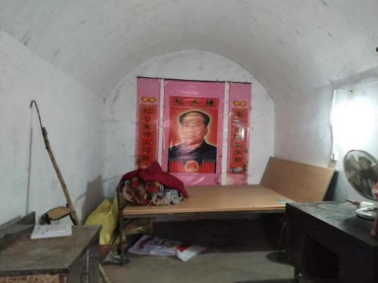
Figure 1. Inside the measured cave dwelling
Each measuring point is evenly distributed in the form of a network inside the cave dwelling, which is divided into four columns (K₁-K₄) along the direction of the cave dwelling, and five measuring points are distributed along the depth of each column, so that a total of 20 measuring points (K₁₋₁-K₄₋₅) are arranged. The distribution of the measuring points is shown in Figure 2. The test points were set 0.75 m above the floor. The illuminance tester was used to collect indoor illuminance at different measuring points. The data collection time was from 9:00 to 18:00, every three hours, and the test was repeated three times for each measuring point, and the average value was taken. During the test, data were collected under three different conditions, i.e., condition 1, condition 2 and condition 3 (see Table 1), for comparative analysis.
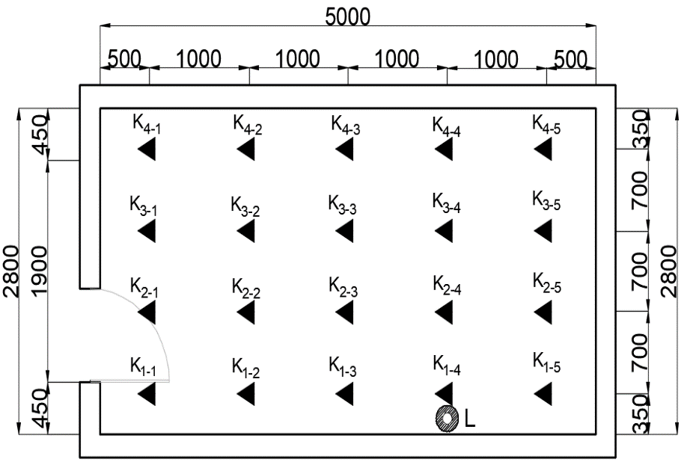
Figure 2. Distribution diagram of indoor test points
Table 1. Test conditions
Conditions | Test time | Working condition
1 | 9:00-18:00 | Natural light (open doors and turn off lights)
2 | 9:00-18:00 | Artificial light source (close the door and turn on the light)
3 | 9:00-18:00 | Natural light and artificial light source (open the door and turn on the light)
  - Simulation of the indoor light environment
Ecotect Analysis is a design aid tool for performance analysis and optimization of building technologies that simulates and analyzes photophysics. In this study, the Ecotect Analysis software was used to simulate the indoor light environment of the cave dwelling and analyze and study the factors that affect natural light and the light environment combined with artificial light.
    - Simulation of factors affecting natural lighting
In order to improve the light environment of cave dwellings, the factors and laws that affect lighting of cave dwellings should first be studied. The natural lighting of cave dwellings mainly relies on the door at the entrance of the cave, and with increasing depth, the lighting deteriorates sharply. According to the survey and analysis, the main factors affecting nature lighting are the depth of the cave dwellings, the window area, the window-to-floor ratio (the ratio of the window area to the floor area of the room), the height of the window sill and the visible light transmission of the glass.
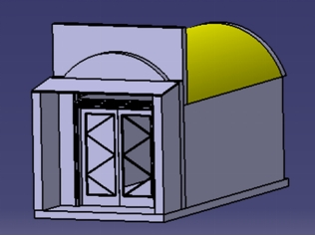
Based on the measured 3D model of cave dwelling, this paper studies the effect of window area (s), window-to-floor ratio (wf), window sill height (h), glass transmission (α) and depth (d) on the indoor daylighting coefficient through simulation, in order to provide a reference for the optimization and selection of light design. A 3D model of the measured cave dwelling constructed by Catia software is shown in Figure 3.
Figure 3. 3D model of the measured cave dwelling
The indoor light environment of cave dwellings is closely related to transmission (α) and reflection ratio (ρ₁) of window glass, pollution reduction coefficient (τ_{w}) of glass, light blocking reduction coefficient (τ_{c}) of window structure, and reflection ratio (ρ₂) of cave wall and floor materials, which is also a parameter required for simulation. Table 2 shows the values of the parameters determined in the survey.
Table 2. Values of parameters required for simulation
Structure categories | Parameter | Numerical value
Window glass | Ordinary glass reflectance ratio $ρ_{1}$ | 0.15
Window glass | Transmission $α$ | 0.64
Window glass | The pollution reduction factor $τ_{w}$ | 0.75
Window construction | The window light reduction factor$τ_{c}$ | 0.80
Inner wall and roof (White paint) | Reflectance ratio $ρ_{2}$ | 0.75
Floor (Concrete pavement) | Reflectance ratio $ρ_{2}$ | 0.20
The 3D model of the cave dwelling (Figure 3) was added into Ecotect Analysis software. The meteorological parameters and dates were loaded, and the setting values of relevant parameters such as glass, the inner wall of the cave dwelling, and the roof were kept consistent with the measured values. A plane was selected for analysis at a height of 0.75 m above the floor, and the plane was meshed with grids of 60×30×30 for the analysis of natural illuminance and daylighting coefficient.
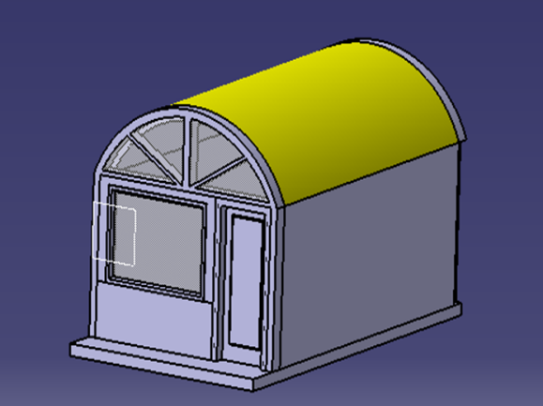
The Design code for residential buildings (GB 50096-2011) stipulates that the light level of Class III residential buildings must not be less than 14.3% of the wf of the light window openings of bedrooms, living rooms (halls) and kitchens. The measured wf of the cave dwellings is only 4.1% which is far less than the code requirements. To achieve the specified wf, combined with the Design code for residential buildings (GB 50096-2011) and the actual local situation, the cave dwellings were transformed into the form shown in Figure 4, the eaves and wall stacks were removed, and a semi-circular fixed upper window with an area of 2.716 m² was added, and the size of the door was set to 2.0×1.2 m. Due to the height limitation of the cave dwellings, the local value of the window height is generally fixed, the window sill height (h) is set to 1.2 m in this simulation, and the window area is adjusted by changing the window width for the different window areas of the study as given in table 7.
Figure 4. 3D model of the modified cave dwelling
    - Simulation of the light environment in combination with artificial light
According to the requirements of the Standard for lighting design of buildings (GB 50034-2013) for the limit of the light power density of each household in residential buildings, the standard value of light inside the cave dwellings is set as 100 lx. This simulation adopts a hanging bulb fluorescent lamp. The number of lamps is taken as 1, 2, 4, and 6, respectively, of which the lamp utilization coefficient (CU) is 0.7, the maintenance coefficient (K) is 0.8, and the light effect of fluorescent lamp is 60 (lm/W).

Table 3. Number of light sources, light flux and power
Quantity of lamps (unit) | Single luminaire flux (lm) | Single lamp power (W)
1 | 2500 | 40
2 | 1250 | 20
4 | 625 | 10
6 | 417 | 7
The analysis of the daylighting coefficient is based on natural light conditions and does not refer to the case of artificial light sources. Therefore, illuminance will be used to analyze the indoor light environment in combination with artificial light sources. According to the standard value of indoor light, working surface area, lamp utilization coefficient and maintenance coefficient, the luminous flux and light source power required in the cave dwelling are calculated to be 2500 lm and 40 W, respectively. The number, luminous flux and power of light sources are shown in Table 3, and the arrangement of artificial light sources of different power is shown in Figure 5.
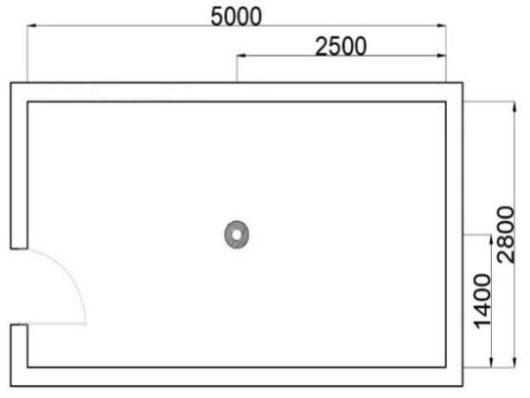  (a) Form 1: 40W artificial light source | 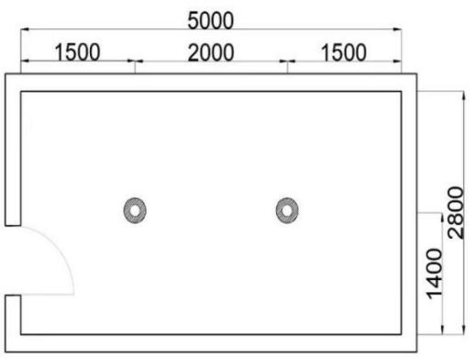  (b) Form 2: 20W artificial light source
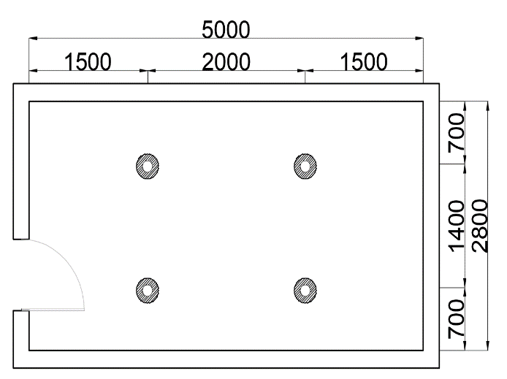  (c) Form 3: 10W artificial light source | 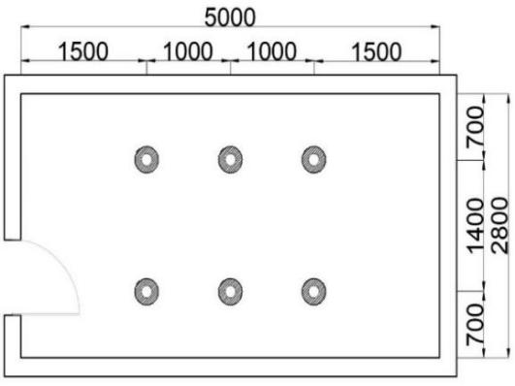  (d) Form4: 7W artificial light source
Figure 5. Arrangement of artificial light source (Dimension unit: mm)
- Results and analysis of actual measurement and simulations

  - Measurement results and analysis
Referring to the light standard for residential buildings in the Standard for lighting design of buildings, the indoor daylighting coefficient of cave dwellings should not be less than 2.0% (Qi, 2024). The minimum indoor natural illuminance should not be less than 300 lx, and the design goal should be 400 lx (Michael, 2020; Payedar-Ardakani, 2024).
    - Temporal analysis of the indoor light environment of the cave dwelling
The indoor light environment of the selected cave dwelling was tested within six days starting on July 16, 2020. The average indoor illuminance values for each condition at different times during the six days are shown in Table 4.
Table 4 Measured average illuminance in the cave dwelling (lx)
Time | Condition 1 | Condition 2 | Condition 3
9:00 | 100.6 | 27.1 | 126.6
12:00 | 150.5 | 27.1 | 172.7
15:00 | 125.0 | 27.1 | 154.7
18:00 | 25.5 | 27.1 | 51.4
As can be seen from Table 4, the average illuminance of condition 3 is approximately equal to the sum of the average illuminance of condition 1 and condition 2, which indicates that the illuminance value in the room follows the principle of linear superposition, and also proves that the measured data is accurate and reliable. In the condition 1, the average indoor natural illuminance is much lower than the standard value required by the indoor light specification. Even with the addition of artificial light sources (condition 3), the average indoor illuminance is less than 300 lx, which does not meet the light design standards of residential buildings, and the overall quality of the light environment is poor. This is due to better light conditions in summer and worse light conditions in winter.
The variation of average illuminance for different days at different depths in condition 1 is shown in Figure 6.
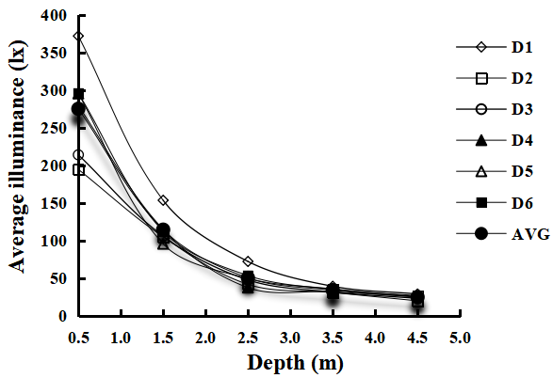  (a) 9:00 A.M. | 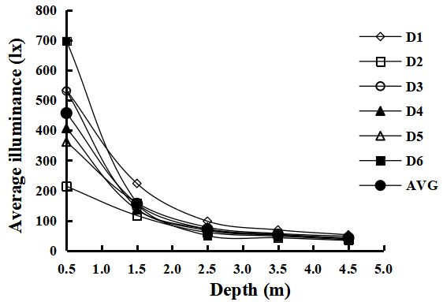  (b) 12:00 P.M.
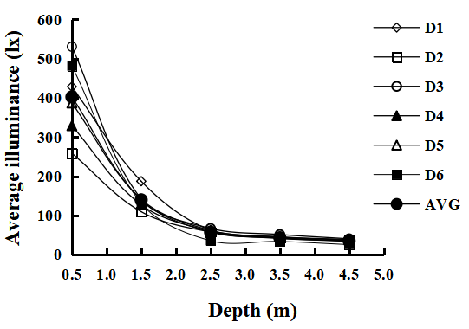  (c) 15:00 P.M. | 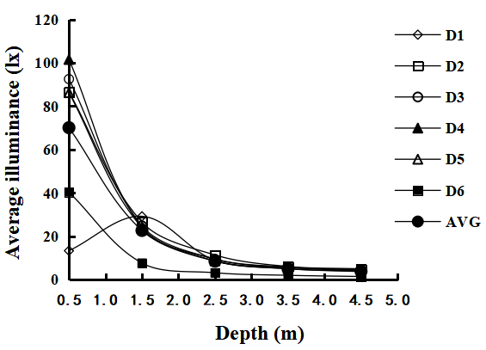  (d) 18:00 P.M.
Figure 6. The relationship between depth and average illuminance for each test date
Figure 6 shows that the average indoor illuminance is different during the test period, but the overall pattern of change is relatively similar. At a depth of about 1.5 m, the illuminance value at all times showed an obvious inflection point, changing from a sharp decline stage to a slow decline stage. When the depth reached 2.5 m, the illuminance value basically stabilized. Only when the depth of the cave dwelling is less than 1.5 m, the illuminance value can reach the minimum required value of 300 lx, which indicates the poor overall indoor daylighting, especially the middle and back parts of the cave dwelling, which cannot meet the minimum daylighting standard.
Because the declination and exact time difference of a certain day need to be calculated when analyzing the solar time angle, and the data on July 20 is close to the average value of the data during the testing period, the data of this day is taken as a representative. Furthermore, the condition 1 is used as an example for the analysis of the indoor light environment of the cave from the temporal perspective and the indoor illuminance is analyzed along the depth (d) and bay direction at four moments (Figure 7).
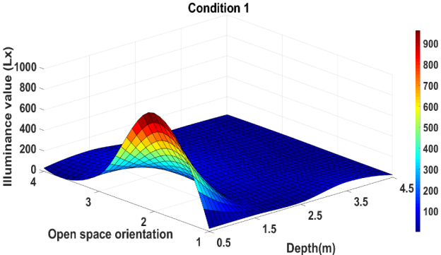(a) 9:00 A.M. | 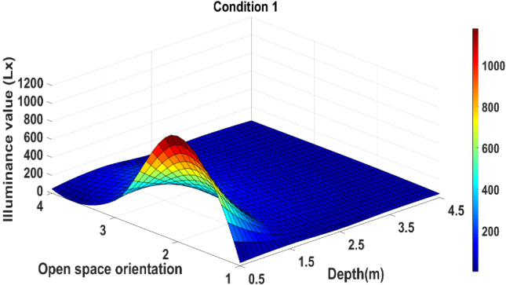  (b) 12:00 P.M.
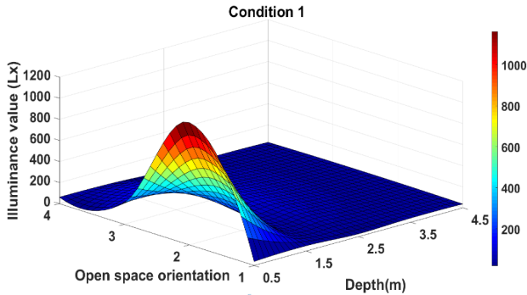  (c) 15:00 P.M. | 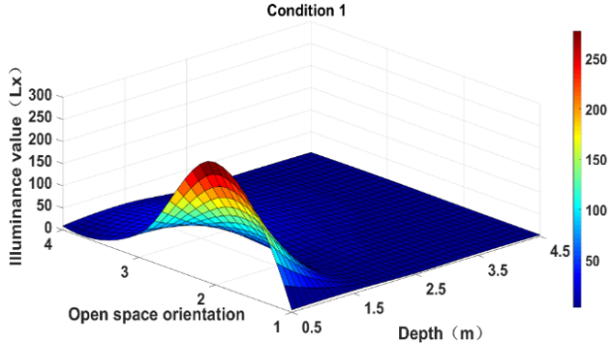  (d) 18:00 P.M.
Figure 7. Illuminance distribution at different times
Figure 7 shows that the illuminance distribution at different times is generally similar, showing a parabolic shape. Illuminance reaches its maximum value at the entrance of the cave dwelling, where it is located in the middle of measurement points K₂ and K₃ along the bay direction. The downward trend is shown along the depth and bay direction. The maximum illuminance during the day occurs at 12:00, then at 15:00, 9:00 and 18:00, which is related to the change in the solar altitude angle.
The true solar time (T) at a given location can be calculated using Equation (1) as follows：
 | $$T=T_{m}+\frac{L-L_{m}}{15}+\frac{e}{60} (h)$$ | (1)
Where;
T_{m} is the mean solar time of the time zone, in h.
L$-$L_{m} is the difference between the longitude of the local meridian and the longitude of the central meridian of that time zone (constant positive value), in deg.
e is time difference, in min.
When the true solar time (T) is expressed in angles, it is called the solar time angle, referred to as the time angle (h). It can be calculated using Equation (2) as follows:
 | $$h=\left(T_{m}+\frac{L-L_{m}}{15}+\frac{e}{60}-12\right)15 (deg)$$ | (2)
The solar altitude angle (β) can be calculated using Equation (3) as follows:
 | $$\sin{β=\cos{φ\cos{h\cos{δ+\sin{φ}\sin{δ}}}}}$$ | (3)
Where;
$φ$ is the local geographical latitude, in deg;
$δ$ is the solar declination of the day, in deg.
The test site (Hanzhai village) is located in Luoyang city and belongs to the eighth eastern district. Tm is Beijing time, longitude and latitude are 34°39′ and 112°25′, respectively, so L is 112.42°, Lm is 120°, and the time difference on July 20 is 6 minutes and 53 seconds. According to Equations (1-3), the solar altitude angle at different times can be calculated as shown in Table 5.
Table 5. Average values of solar altitude angle and natural light illuminance at different times
Time | $$\sin{β}$$ | Solar altitude angle $β$ | Indoor natural light illuminance average
9:00 | 0.685 | 43.24° | 100.6
12:00 | 0.965 | 74.80° | 150.5
15:00 | 0.786 | 52.75° | 125.0
18:00 | 0.277 | 16.08° | 25.5
The calculation results show that the natural light illuminance in the room at different times is positively correlated with the local solar altitude angle. At noon, when the solar altitude angle is the largest, the room receives the most natural light. The higher the solar altitude angle, the higher the natural light illuminance, and vice versa. Figure 8 shows the relationship between the average value of indoor natural illuminance and the angular β of the sun's altitude.
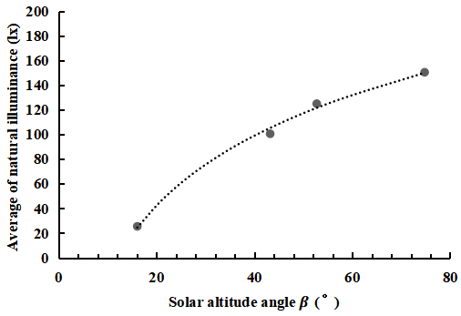
Figure 8. Average indoor natural light illuminance versus solar altitude angle
The average indoor natural light illuminance (AI) and the angle of the sun altitude (β) show a logarithmic function relationship AI=aln(β)+b, where a=81.643, b=-202.19, correlation coefficient R²=0.996, and the fitting error is small (Figure 8). This empirical formula can be used for the prediction of the illuminance value of indoor natural light based on the solar altitude angle.
    - Analysis of the indoor light environment of cave dwelling from the perspective of conditions
As an example, the illuminance distribution of each condition at 12:00 P.M. is shown in Figure 9. The illuminance curve of line K₃ at 12:00 P.M. under different conditions is shown in Figure 10.
 | 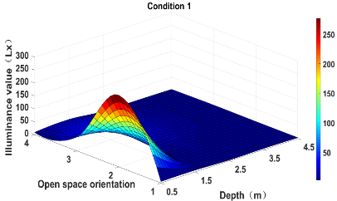  (a) Condition 1 | 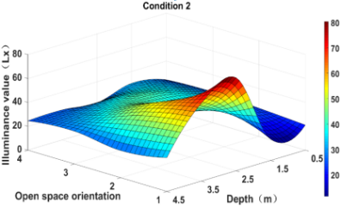  (b) Condition 2 | 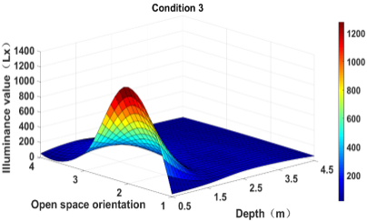  (c) Condition 3
Figure 9. Illuminance distribution of three conditions
The distribution of indoor light illuminance under all three conditions is extremely uneven (Figure 9). Conditions 1 and 3 have higher illuminance at the opening of the cave door, and with the increase in depth, the illuminance value drops sharply, far from reaching the daylighting standard. Since the indoor light source is set at about 3.5 m the depth of K₂₋₄ test point, the illuminance distribution of condition 2 is significantly different from the other conditions. In other words, the average illuminance of condition 2 is much lower than that of other conditions, indicating that natural light plays a major role in the indoor light environment at noon.
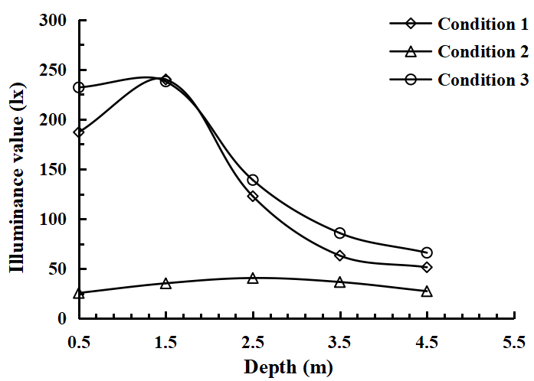
Figure 10. Illuminance curves under different conditions
As can be seen from Figure 10, even under sufficient sunlight at 12:00 P.M., the K₃ measuring line cannot meet the standard value of indoor lighting intensity for residential buildings under all three conditions. At a depth of about 1.5 m, the conditions 1 and 3 reach the inflection point, shifting from a slow increase to a sharp decline, and the illuminance value of condition 3 is stable at about 50 lx. The illuminance values for the three conditions in the same position show that the artificial light source has an additional superposition effect on the indoor illuminance, but the artificial light source is located at a single point, too concentrated, so the illuminance uniformity is not good and night lighting requirements cannot be satisfied. Therefore, it is necessary to pay attention to the optimization of the arrangement of artificial light sources in order to achieve better light.
In summary, on-site measurements show that at least 2/3 of the indoor space of the cave dwelling cannot meet the current national daylighting standards. Even if natural light is combined with artificial light sources, it still cannot meet the requirements of indoor illuminance. This can be due to that Artificial light source are overly concentrated and unevenly distributed, while natural light penetration is limited by deep interiors and small apertures. Moreover, non-reflective surfaces absorb light instead of dispersing it, and the low strength and quantity of light sources cannot make up for inadequate sunshine. Furthermore, the uniformity of indoor illuminance is relatively poor, and the indoor lighting environment needs to be improved.
  - Simulation results and analysis
To study the influencing factors and laws of the indoor light environment of cave dwellings, and to provide suggestions for improving the light environment, the simulation results and analysis conducted in this study are as follows.
    - Modeling and comparison with measured data
Taking the condition 1 as an example, a comparative analysis of the simulation and measurement is performed, i.e., the rationality of the model and the daylighting coefficient and illuminance results of the simulation are investigated and shown in Figures 11 and 12. The simulation results are compared with the measured data and the error between the two is calculated, and the results are shown in Table 6.
 | 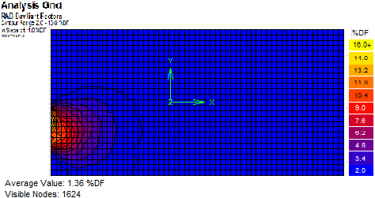  (a) Distribution of daylighting coefficient | 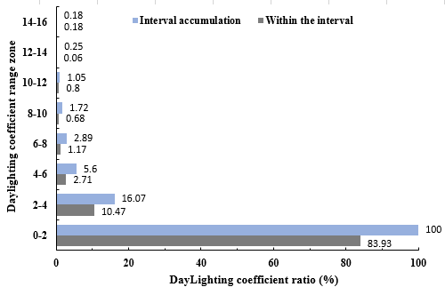  (b) Daylighting coefficient ratio
Figure 11. Simulated condition 1 daylighting coefficient distribution and percentage
 | 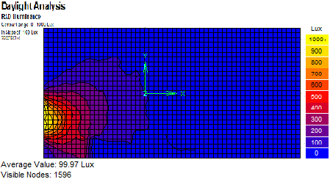  (a) 9:00 A.M. |  | 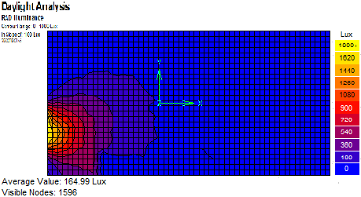  (b) 12:00 P.M.
 | 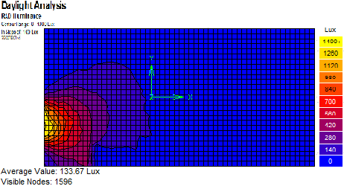  (c) 15:00 P.M. |  | 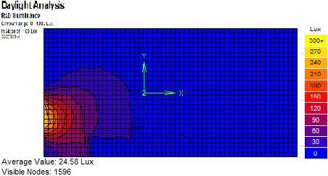  (d) 18:00 P.M.
Figure 12. Simulation of the illuminance distribution under different times of condition 1
Table 6 Error analysis table of measured and simulated errors
Time | Illuminance average (lx) |  |  |  | Daylighting coefficient (%)
 | Measured | Simulation | Error | Average error | Measured | Simulation | Error | Average error
9:00 | 100.6 | 99.97 | 0.63% | 5.18% | 1.27 | 1.36 | 7.1% | 4.89%
12:00 | 150.5 | 164.99 | 9.6% | 5.18% | 1.35 | 1.36 | 0.74% | 4.89%
15:00 | 125.0 | 133.67 | 6.9% | 5.18% | 1.29 | 1.36 | 5.4% | 4.89%
18:00 | 25.5 | 24.58 | 3.6% | 5.18% | 1.28 | 1.36 | 6.3% | 4.89%
The simulation results show that the indoor daylighting coefficient of the cave dwelling is small, and 83.93% of the daylighting coefficient is below 2%. The overall indoor light environment is poor, which does not meet the building’s daylighting standard. It can be seen from Table 6 that the average difference between the simulated value and the measured data of indoor daylighting illuminance and daylighting coefficient was 5.18% and 4.89%, respectively. Overall, the distribution law of the simulated indoor illuminance is basically consistent with the measured data, i.e., the difference values are relatively similar, and the simulation results are reasonable and reliable. Therefore, it is feasible to use the above-mentioned simulation method to investigate the light environment of cave dwelling.
    - Simulation analysis of factors affecting natural lighting
The window size and the depth of cave dwellings are key factors that affect daylighting. Therefore, this study will investigate the influence of each factor on the daylighting coefficient at different depths by changing the window area, window sill height, and window glass transmission of the cave dwelling.
(1) The effect of window area, window-to-floor ratio and depth on the daylighting coefficient
When the window sill height is 0.8 m and the glass transmission is 0.8, the simulation conditions for the influence of window area, the window-to-floor ratio and depth on the daylighting coefficient are shown in Table 7, and the simulation results are shown in Figure 13.
Table 7 Simulated conditions of the effect of window area, window-to-floor ratio and depth on daylighting coefficient
Window size (height×width) | Window area s（m²） | Window-to-floor ratio wf（%）
Window size (height×width) | Window area s（m²） | d=4.0 m | d=5.0 m | d=6.0 m | d=7.0 m | d=8.0 m
1.2m×0.8 m | 0.96 | 32 | 26 | 22 | 19 | 17
1.2m×1.0m | 1.20 | 35 | 28 | 23 | 20 | 18
1.2m×1.2m | 1.44 | 37 | 30 | 25 | 21 | 19
1.2m×1.4m | 1.68 | 39 | 32 | 26 | 22 | 20
1.2m×1.6m | 1.92 | 41 | 34 | 27 | 23 | 21
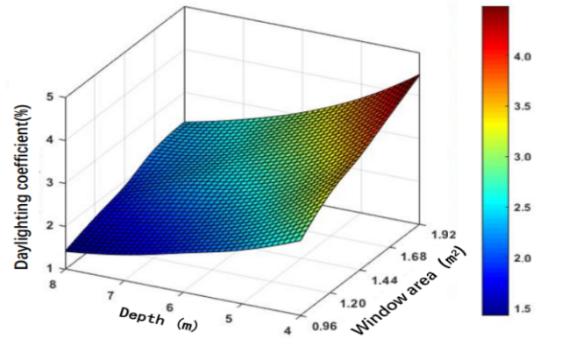(a) Distribution of daylighting coefficient at different window areas and depths | 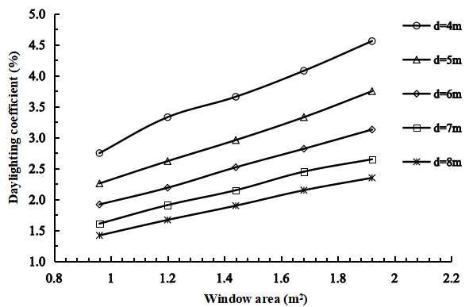  (b) Relationship between daylighting coefficient and window area at different depths
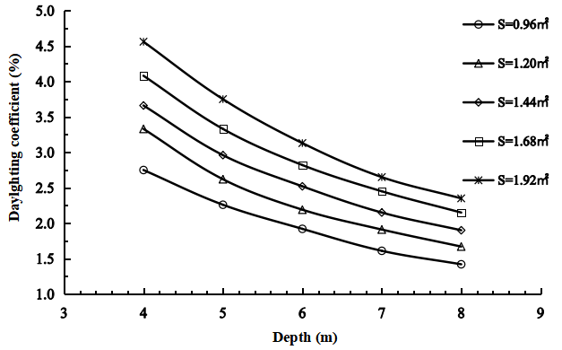  (c) Relationship between daylighting coefficient and cave depth at different window areas | 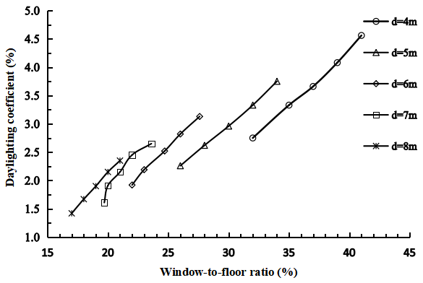  (d) Relationship between daylighting coefficient and window-to-floor ratio at different depths
Figure 13. Relationship between indoor daylighting coefficient and window area, depth and window-to-floor ratio
Figure 13(a) shows that the daylighting coefficient increases linearly with the increase of window area at different depths. As the depth decreases, the daylighting coefficient increases, and the slope of the relationship line increases from 0.117 to 0.219, indicating a faster increase in the daylighting coefficient. However, after a depth of over 7 m, the slope of the curve is almost parallel, and the increase in the daylighting coefficient remains constant. The daylighting coefficient decreases quadratically with the increase of depth at different window areas (s) (Figure 13(b)). However, when the window area (s) is 0.96 m², the curve becomes flat and the rate of decrease in the daylighting coefficient slows down (Figure 13(b)). Figure 13(c) shows that the daylighting coefficient increases linearly with the increase of the window-to-floor ratio at different depths. When the depth is between 4 and 6 m, the daylighting coefficient at different window-to-floor ratios can reach the minimum standard of 2%. If the window-to-floor ratio is less than 22% and the depth is between 7 and 8 m, the daylighting coefficient is between 1% and 2%, which is difficult to meet the indoor lighting requirements.
Under the joint influence of cave depth and window area (Figure 13(d)), the daylighting coefficient increases linearly with the increase of the window area. The greater the depth, the faster the daylighting coefficient increases with the increase of window area. This is more obvious when the depth is greater than 6 m. Considering the value and change rate of the daylighting coefficient, larger window area and window-to-floor ratio can be adopted, that is, the window area and the window-to-floor ratio should be greater than 1.44 m² and 20%, respectively.
(2) Effect of window sill height and cave depth on daylighting coefficient
Taking as an example the window size of 1.2×1.2 m and glass transmission α=0.8, the simulated conditions of daylighting coefficient under different window sill heights and cave depths are shown in Table 8. The relationship between window sill height, depth and daylighting coefficient is shown in Figure 14.
Table 8 Simulated conditions of the effect of window sill height and cave depth on the daylighting coefficient
Window sill height h (m) | 0.4 | 0.5 | 0.6 | 0.7 | 0.8
Cave depth d (m) | 4.0 | 5.0 | 6.0 | 7.0 | 8.0
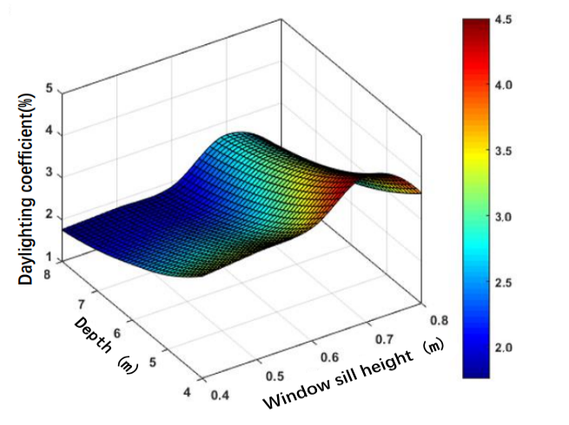
(a) Distribution of daylighting coefficient at different window sill heights and cave depths
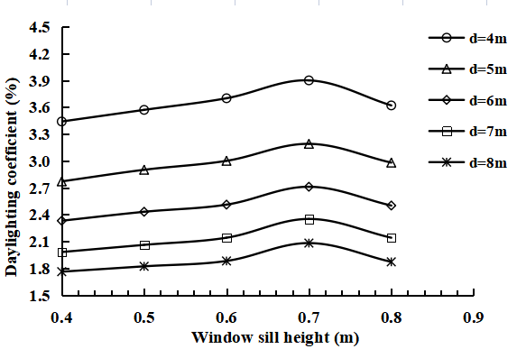  (b) Relationship between daylighting coefficient and window sill height at different depths | 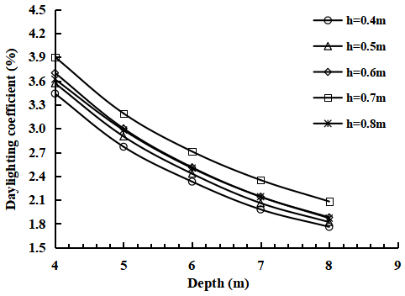  (c) Relationship between daylighting coefficient and cave depth at different window sill heights
Figure 14. Relationship between indoor daylighting coefficient and depth and window sill height
Figure 14(a) shows that as the window sill height increases, the daylighting coefficients of different cave depths show a cubic function trend of first increasing and then decreasing. When the window sill height is at 0.4-0.7 m, the daylighting coefficient increases monotonically and reaches its maximum value at 0.7 m, and then decreases. The daylighting coefficients of different window sill heights show a decreasing trend with the increase of depth (Figure 14(b)). The indoor daylighting coefficient is above 2% at depth of 4-6 m but decreases more rapidly; the decrease of daylighting coefficient becomes slower at the depth of 6-8 m, and the value fluctuates around 2%.
Under the joint influence of the depth and the window sill height (Figure 14(c)), the daylighting coefficient first increases and then decreases with the cubic function of the window sill height, and the greater the depth when the window sill height is fixed, the lower the daylighting coefficient. When the height of the window sill is 0.7 m at different depths, the indoor daylighting coefficient reaches the maximum. Accordingly, the window sill height of the cave dwellings should be set at about 0.7 m in order to achieve the best daylighting effect.
(3) Influence of glass transmission ratio and cave depth on the daylighting coefficient
Taking as an example the window size of 1.2×1.2 m and window sill height of 0.8 m, the simulated conditions of the daylighting coefficient with different glass transmission ratios and depths are shown in Table 9. Figure 15 shows the relationship between glass transmission ratio, depth and daylighting coefficient.

Table 9 Simulated condition of the effect of glass transmission ratio on the daylighting coefficient
Transmission ratio α | 0.65 | 0.68 | 0.75 | 0.80 | 0.85
Cave depth d (m) | 4.00 | 5.00 | 6.00 | 7.00 | 8.00
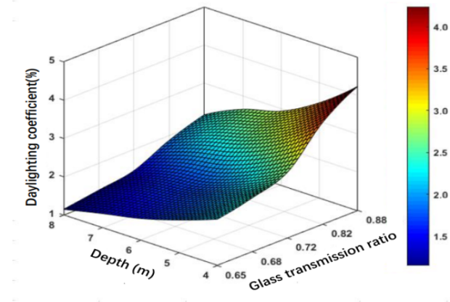
(a) Distribution of daylighting coefficient at different glass transmission ratios and depths
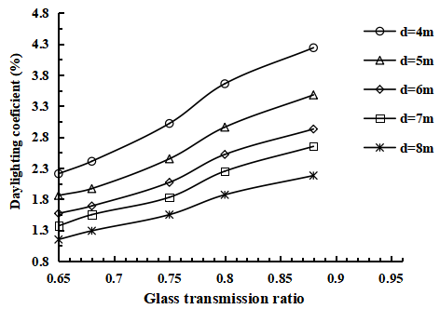  (b) Relationship between daylighting coefficient and glass transmission ratio at different depths | 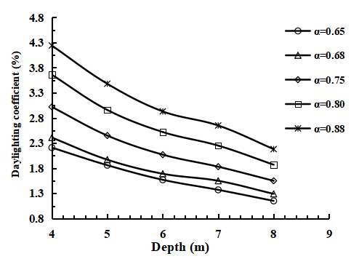  (c) Relationship between daylighting coefficient and depth at different glass transmission ratios
Figure 15. Daylighting coefficient of each transmission ratio at different depths
Figure 15(a) shows that the daylighting coefficient increases monotonically with the increase of glass transmission at different depths. The smaller the depth, the higher the rate of increase in the daylighting coefficient. When the glass transmission ratio is 0.75-0.8, there will be a more obvious steep increase of daylighting coefficient and then the growth rate will decrease. It can be seen from Figure 15(b) that, the daylighting coefficient decreases linearly with increasing depth under different glass transmission ratios, and the higher the transmission ratio, the higher the value of the daylighting coefficient. The daylighting coefficient of cave dwelling buildings with a depth of 4 m can reach more than 2% when the transmission ratio is 0.65-0.88. The daylighting coefficient of cave dwelling with depth greater than 8 m is less than 2% for all transmission ratios, which cannot meet the requirements.
The daylighting coefficient increases monotonically with the glass transmission ratio under the joint influence of depth and glass transmission ratio (Figure 15(c)). The greater the depth, the slower the rate at which the daylighting coefficient increases with the increase of glass transmission ratio. When choosing the glass transmission ratio for cave dwellings of different depth, we try to choose glass with a higher transmission ratio and take into account the daylighting coefficient change rate under suitable transmission ratio. Cave dwellings with depths of 4 m, 5 m and 6-7 m can prioritize the selection of glass with transmittance ratios of 0.65-0.7, 0.7-0.75, and 0.75-0.8, respectively. Due to the scarcity and high cost of glass types with a transmission ratio of 0.8 or higher, it is difficult to select glass with suitable transmittance for indoor lighting needs in kiln buildings with a depth greater than 8 m.
Taking into account the window area s, window sill height h, and glass transmission ratio α, it can be found that when the depth of the cave is less than 6m, the window area and window-to-floor ratio are greater than 1.44 m² and 20% respectively, the window sill height is about 0.7 m, and the glass transmission ratio is between 0.65-0.8, it is more conducive to obtaining a better indoor lighting environment.
(4) Simulation analysis of daylighting coefficient of renovated cave dwelling
Based on the above analysis, a model of renovated cave dwelling with a depth of 5 m, window area of 1.2×1.6 m (window-to-floor ratio of 34%), insulating glass transmission ratio of 0.75 and window sill height of 0.7 m was established in order to quantify the indoor daylighting of the renovated cave dwellings. The simulation results of the indoor daylighting coefficient and the illuminance of the renovated cave dwelling at 12:00 P.M. are shown in Figure 16. Furthermore, a comparison of the indoor illuminance and daylighting coefficient between the renovated and the initial cave dwelling (Figure 3) is shown in Figure 17.
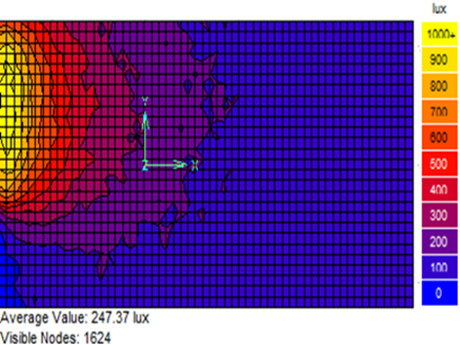  (a) Daylighting coefficient distribution |  | 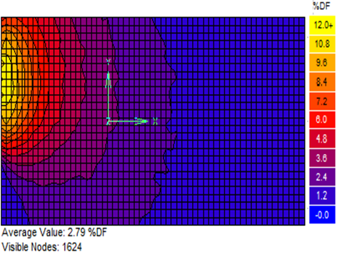  (b) Illuminance distribution
Figure 16. Distribution of illuminance and daylighting coefficient of the renovated cave dwelling
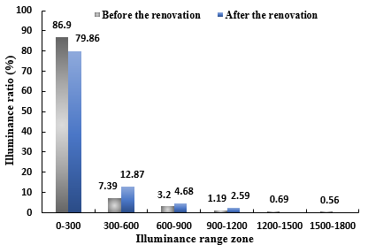  (a) Comparison of the percentage of illuminance intervals | 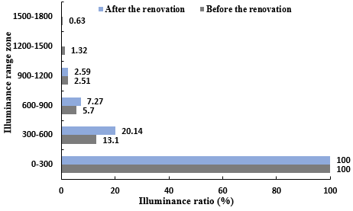  (b) Comparison of the cumulative percentage of illuminance intervals
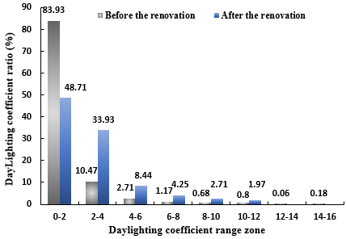  (c) Comparison of the percentage of daylighting coefficient intervals | 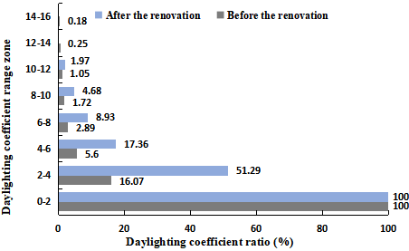  (d) Comparison of the cumulative percentage of daylighting coefficient intervals
Figure 17. Comparison of indoor illuminance and daylighting coefficient between the renovated cave dwelling and the initial cave dwelling
Figures 16 and 17 show that the average indoor daylighting coefficient of the renovated cave dwelling reaches 2.79%, which is 105% higher than the coefficient of the initial cave dwelling and can meet the daylighting coefficient requirements for residential buildings in the Standard for lighting design of buildings (GB 50033-2013). The distribution of the indoor daylighting coefficient of the renovated cave dwelling has been reduced from 0-16% of the initial cave dwelling to 0-12%, and the indoor daylighting coefficient is more uniform. The proportion of daylighting coefficient below 2% in the renovated cave dwelling has decreased from 83.93% to 48.71%, a decrease of 42%; the proportion of daylighting coefficient above 2% has increased from 16.07% to 51.29%, an increase of 219%, indicating an improvement in indoor daylighting coefficient. Meanwhile, the average indoor illuminance of the renovated cave dwelling increased from 150.5 lx to 247.37 lx, an increase of 64.4%, and the proportion of daylighting illuminance above 300 lx increased from 13.1% to 20.14%, an increase of 56.5%. In addition, the distribution range of illuminance was reduced from 0-1800 lx to 0-1200 lx, and the uniformity of illuminance was improved. Therefore, it can be seen that the indoor light environment of the renovated cave is more optimized and reasonable, and the quality has been better improved.
    - Analysis of the indoor light environment combined with artificial light
Although the indoor light environment of the cave residence has been improved, 48.71% of the indoor space still has a daylighting coefficient of less than 2%, and 79.86% of the indoor space illuminance has an illuminance of less than 300 lx. Thus, there is still room for further improvement. Artificial light is a common and important measure to improve indoor light environment. This study has investigated the effect of artificial light on indoor light environment and the effect of different arrangements of light sources on indoor lighting.
According to the arrangement of the light sources in Figure 5, the simulation results of the illuminance and the mixed illuminance of the indoor artificial light source at 12:00 P.M. are shown in Figure 18.
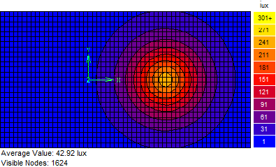  (a) 40W light source illuminance | 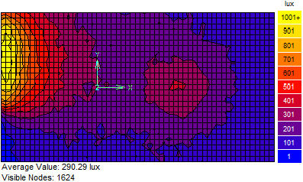  (b) 40W light source mixed illuminance
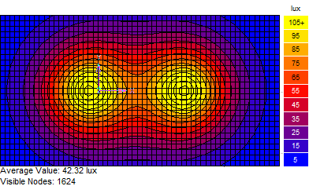  (c) 20W light source illuminance | 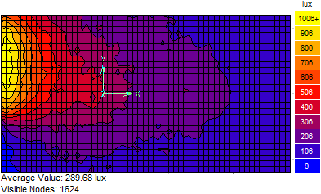  (d) 20W light source mixed illuminance
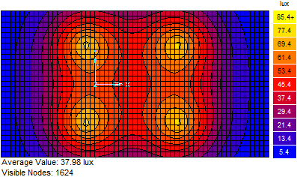  (e) 10W light source illuminance | 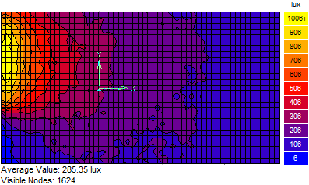  (f) 10W light source mixed illuminance
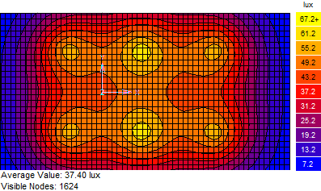  (g) 7W light source illuminance | 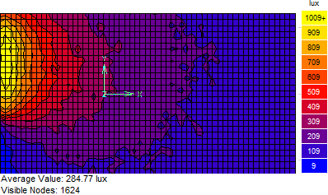  (h) 7W light source mixed illuminance
Figure 18. Artificial light source illuminance and mixed illuminance distribution
Figure 18 shows that when the total power of the indoor artificial light sources remains consistent, the number and distribution of the light sources basically do not change the average illuminance and mixed illuminance of the artificial light source. However, after adding the artificial light source, the average indoor mixed illuminance increased by 16.23% compared to the average natural light illuminance, and the proportion of indoor illuminance above 300 lx also increased by 28.7%.
Among the four forms of light arrangements, although the average illuminance is the same, there are significant differences in the illuminance uniformity within the room. The illuminance uniformity for each light source arrangement is shown in Figure 19.
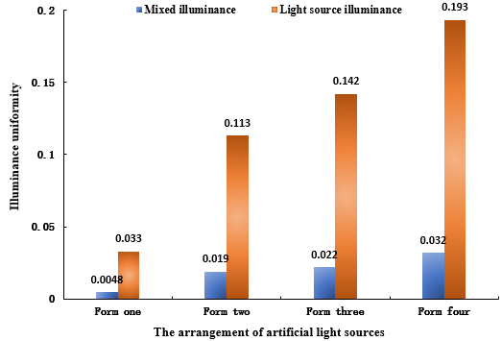
Figure 19. Comparison of the uniformity of indoor illuminance when different light source arrangement forms
Figure 19 shows that the illuminance uniformity is closely related to the arrangement form of the light sources when the total power of the light sources is the same. When the artificial light source adopts a single-point arrangement of form 1, the illuminance uniformity and mixed illuminance uniformity are only 0.033 and 0.0048, respectively. When the arrangement form is changed to form 2, form 3 and form 4, i.e., when the arrangement forms changes to two-point linear, four-point surface and six-point surface, the illuminance uniformity increases by 242.4%, 363.3% and 484.8%, respectively. In addition, the mixed illuminance uniformity increased by 295.8%, 358.3% and 566.7%, respectively. Therefore, the illuminance uniformity is significantly affected by the arrangement of the light sources. When the total power is constant, a surface layout with an increased number of artificial light sources should be adopted in the cave dwelling to improve the uniformity of illumination.
- Conclusion

- Through field investigation and analysis of the indoor light environment of cliff cave dwelling in western Henan province, China, this study explores the current situation and existing problems of indoor light environment in cave dwellings. The impacts of natural and artificial lighting on the indoor light environment were simulated, and proposals for improvement were suggested and verified. The main conclusions are as follows.

- Under the three conditions of natural lighting, artificial lighting, and a combination of natural and artificial lighting, most areas inside the cave dwelling cannot meet the light requirement of 2% daylighting coefficient and illuminance of 300 lx as specified in the Standard for lighting design of buildings (GB 50033-2013).

- A simulation analysis of the relationship between the daylighting coefficient and window area, window sill height and glass transmission ratio show that these factors have monotonically increasing linear function, upward convex cubic function and monotonically increasing relationship with the daylighting coefficient rate, respectively. When the depth of the cave dwelling is less than 6 m, it is easy to obtain a better indoor light environment if the window area and the window-to-floor ratio are greater than 1.44 m² and 20%, respectively, the window sill height is about 0.7 m, and the glass transmission ratio is about 0.65-0.8.
- The improved model of cave dwelling based on the recommended optimal parameters is established, and the indoor light environment is simulated. The illuminance increased by 64.4% and the daylighting coefficient increased by 105% under natural light in the improved cave dwelling. Combined with the surface-shaped artificial light form, the uniformity of the indoor light and mixed light illuminance can be improved by 363.3% and 358.3%, respectively. Therefore, the proposed suggestions can significantly improve the indoor light of the cave dwelling.

Author contributions: Rong Wan: Writing - review & editing, Writing-original draft, Visualization, Validation, Software, Methodology, Investigation, Data curation, Conceptualization. Xiaoya Ma: Writing - review & editing, Supervision, Validation, Formal analysis, Investigation, Methodology, Conceptualization. Xiaolong Wu: Writing - review & editing, Investigation, Software. Tengda Yue: Software, Investigation, Data curation. Dequan Kong: Validation, Resources, Methodology, Conceptualization, Funding acquisition, Project administration. Zhihua Gao: Resources, Conceptualization, Funding acquisition. Yaqi Liu: Validation, Resources, Methodology, Conceptualization. Hui Cong: Resources, Formal analysis. Huafei Xia: Resources, Formal analysis. Yao Wang: Resources, Formal analysis.

Funding: This work was supported by the Natural Science Foundation of Shaanxi Province (No. 2022JM-262, No. 2020JM-235 and No. 2021JQ-265).

Acknowledgments: Paragraph spacing multiple at 1.08 cm.

Conflicts of interest: The authors declare that they have no known competing financial interests or personal relationships that could have appeared to influence the work reported in this paper.

References

A. Kuijsters, J. R. B. R. e. a., 2015. Lighting to Make You Feel Better: Improving the Mood of Elderly People with Affective Ambiences. Plos One , 10(07)(https://doi.org/10.1371/journal.pone.0132732), pp. 1-22.
F. Soflaei, M. S. A. T. H. M. U. B., 2020. A simulation-based model for courtyard housing design based on adaptive thermal comfort. Journal of Building Engineering, 31(01)(https://doi.org/10.1016/j.jobe.2020.101335), p. 101335.
F. Wang, Y. L., 2002. Thermal environment of a courtyard style cave dwelling in winter. Energy and Buildings , 34(10)(https://doi.org/10.1016/S0378-7788(01)00145-1), pp. 985-1001.
F. Xu, Y. D. H. Q. L. L. Y., 2019. Research on active solar energy comprehensive utilization system for Tibetan rural dwelling. Materials Science and Engineering , Volume 609(06), pp. 2009-2015.
G. McEnany, K. L., 2005. Effects of light therapy on sleep, mood, and temperature in women with nonseasonal major depression. Issues in Mental Health Nursing, 26(7)(http://dx.doi.org/10.1080/01612840591008410), pp. 781-794.
I. Maachi, A. M. M. S., 2019. The natural lighting for energy saving and visual comfort in collective housing: A case study in the Algerian building context. Journal of Building Engineering, Issue https://doi.org/10.1016/j.jobe.2019.100760, p. 24.
J. Morales-Bravo, P. N.-H., 2022. Enlightening wellbeing in the home: The impact of natural light design on perceived happiness and sadness in residential spaces. Building and Environment, 223( https://doi.org/10.1016/j.buildenv.2022.1093).
J. Potonik, M. K., 2021. Influence of geometrical and optical building parameters on the circadian daylighting of an office. Journal of Building Engineering , Issue https://doi.org/10.1016/j.jobe.2021.102402, p. 42.
J. Tan, W. L. M. W., 2014. Research on the characteristic of patio and luminous environment in Xiaohe Town. Journal of Hunan City University (Natural Science), 23(02)(https://doi.org/10.3969/j.issn.1672-7304.2014.02.010), pp. 39-42.
J. Xu, X. Q. R. W., 2021. Research progress and enlightenment of healthy sleep-oriented building luminous environment from the perspective of artificial light at night. New Architecture, (02)(https://doi.org/10.12069/j.na.202102142), pp. 142-146.
J. Yi-Kai, Y. C., 2022. The influence of indoor environmental factors on learning: An experiment combining physiological and psychological measurements. Building and Environment, 221(http://dx.doi.org/10.1016/j.buildenv.2022.109299).
Ju, J., 2021. Effects of building light environment and lighting on eye health of the elderly. Sichuan Building Materials, 47(05)(https://doi.org/10.3969/j.issn.1672-4011.2021.05.122), pp. 237-238.
L. Yu, Y. L., 2017. Influence of the Traditional Residential Building Eaves on the Indoor Light Environment. Destech Publications, 162(54)(http://dx.doi.org/10.12783/dtetr/amsm2017/14888), pp. 454-458.
Li, L., 2017. Study on thermal environment and light environment of typical Hani dwellings in Yunnan. Journal of Yunnan Polytechnic University, Volume 53(4), pp. 69-74.
Liu, Y., 2015. Weihe plain area typical detached cave architecture research. Xi'an University of Architecture and Technology, Issue https://doi.org/10.7666/d.D714138.
Li, Y., 2013. Analysis of construction technology of stone kiln house in Taiyuan Diantou ancient Village.. Taiyuan University of Technology .
M. Canazei, W. P. H. B. M. M. E. W., 2017. Artificial skylight effects in a windowless office environment. Building and Environment, 124(https://doi.org/10.1016/j.buildenv.2017.07.045), pp. 69-77.
M. Figueiro, B. P. A. L. e. a., 2014. Light and health. 3rd. Boca Raton, US: CRC Press, Volume 138(298), pp. 521-548.
Michael, P. R. J. D. E. &. M. W., 2020. A conversion guide: solar irradiance and lux illuminance. Journal of measurements in engineering, Volume 8(4), pp. 153-166.
N. Abdollahzaded, M. T. Z. Z., 2020. A method of partition design for open-plan offices based on daylight performance evaluation. Journal of Building Engineering , Issue https://doi.org/10.1016/j.jobe.2020.101171, p. 29.
Niu, X., 2017. Evaluation of light environment for intelligent building. Sci-tech Innovation and Productivity, Volume 11, pp. 110-112.
Payedar-Ardakani, P. G.-M. Y. G. A. H. &. E. R., 2024. Daylight illuminance levels, user preferences, and cognitive performance in office environments Exploring an optimal illuminance range using virtual reality. Building and Environment, Volume 258, p. 111638.
Qi, Z. &. Y. X., 2024. Urban Spatial Form Optimization Strategies Based on the Principle of Climate Adaptability of Regional Architecture: A Case Study of Traditional Cave Dwelling Villages in Northern Shaanxi Province. Journal of Landscape Research, Volume 16(3), pp. 1-7.
R. Alelwani, M. A. Y. R., 2020. Public Perception of Vernacular Architecture in the Arabian Peninsula: The Case of Rawshan. Buildings, 10(9)(http://dx.doi.org/10.3390/buildings10090151), pp. 151-160.
R. Zheng, Y. Z. L. C. J. C. H. J., 2020. Climate Adaptive Design Improvement Strategies of Traditional Dwellings in Southern Zhejiang for the Plum Rain Season Considering Comfort Conditions. Energies, p. 13(6).
X. Liao, J. L. e. a., 2012. Lighting Environment Study on Rural Residential Buildings in Weihe Plain of China. Applied Mechanics and Materials, 193(194)(http://dx.doi.org/10.4028/www.scientific.net/AMM.193-194.1165), pp. 1165-1173.
Y. Li, S. H., 2012. Investigation on light environment of rural house in the southeast of Chongqing. Eco-City and Green Building , Volume 78(01), pp. 113-116.
Y. Li, Y. R. J. L., 2019. Research on the improvement strategy and technology of the light environment of Huizhou traditional dwellings—A Case of Youqing Hall in Pingshan Village. Urbanism Architecture , Volume 16(06), pp. 133-134.
Y. Zhou, Y. Z. W. L. Y. C. M. Y., 2019. Discussion on ventilation and lighting design strategy of cave dwelling buildings in Luoyang area. Journal of Shandong Industrial Technology, Volume (12), p. 108+71.
Z. Cui, Y. G. H. H. Q. S., 2020. Research on influence of interior luminous environment with simulated natural lighting on emotion. Housing Science, Volume 40(10), pp. 43-50.
Z. Duan, C. H. G. Y., 2019. Measurements and Radiance simulation analysis of the daylighting performance of Chinese traditional patio houses in Huizhou. Architectural Technology, Volume (01), pp. 119-121.
Z. Han, M. M., 2018. Test research on indoor lighting environment of independent cave dwellings in north of Weihe river. Brick and Tile, Volume (06), pp. 76-80.
Z. Kong, D. M. U. K. F. T. S., 2018. The impact of interior design on visual discomfort reduction: A field study integrating lighting environments with POE survey. Building and Environment, Issue https://doi.org/10.1016/j.buildenv.2018.04.025, p. 138.
Z. Zhao, S. Z. Y. H., 2010. Analysis on adaptability of loess Cave. Building Science , 28(76)(https://doi.org/10.13614/j.cnki.11-1962/tu.2010.12.007), pp. 345-350.
Z. Zhi, Y. L. B. J. G., 2009. Chinese Kang as a domestic heating system in rural northern China review. Energy and Buildings , 41(1)(https://doi.org/10.1016/j.enbuild.2008.07.013), pp. 111-119.
Zhang, Y., 2019. Research on Systematic Application Strategy of Green and Healthy Interior Design Materials in Lingnan Area. ICACEH , 62(9)(http://dx.doi.org/10.4028/www.scientific.net/AMM.193-194.1165), pp. 112-15.

.
Copyright (c) 2025 Author., Co-Author, Co-Author. This work is licensed under a Creative Commons Attribution-Noncommercial-No Derivatives 4.0 International License.

