Chapter 1: Introduction to Python

1.1 What is Python?
Python is a high-level, interpreted, and general-purpose programming language. It is widely used in web development, data science, artificial intelligence, automation, and more.

Key Features of Python:
✔️ Simple and Readable – Uses easy-to-understand syntax.
✔️ Dynamically Typed – No need to declare variable types.
✔️ Interpreted Language – Executes code line by line.
✔️ Cross-Platform – Works on Windows, macOS, and Linux.
✔️ Extensive Libraries – Large collection of built-in and third-party modules.

Python vs Other Languages
Feature | Python | Java | C++
Syntax Simplicity | ✅ Easy | ❌ Complex | ❌ Complex
Compilation | ❌ Interpreted | ✅ Compiled | ✅ Compiled
Speed | ⏳ Slower | 🚀 Faster | 🚀 Faster
Use Cases | Web, AI, Data Science | Enterprise Apps | Game Dev, System Programming

1.2 History and Evolution
- Created by Guido van Rossum between 1985-1990.
- Inspired by ABC language, emphasizing code readability.
- Open-source and community-driven development.
- Major versions:
  - Python 2 (2000) – Had limitations, now deprecated.
  - Python 3 (2008 - Present) – Actively maintained, improved syntax.

1.3 Why Choose Python?
Python is widely used in various fields due to its versatility and simplicity.

Who Uses Python?
✅ Web Developers – Django, Flask for building websites.
✅ Data Scientists – Pandas, NumPy, SciPy for data analysis.
✅ AI/ML Engineers – TensorFlow, PyTorch for machine learning.
✅ Cybersecurity Experts – Ethical hacking and penetration testing.
✅ Automation Engineers – Scripts to automate tasks.

1.4 Installing Python
To start coding in Python, install the latest version from:
🔗 Python Official Website

Installation Steps (Windows/macOS/Linux)
1️⃣ Download the installer from the website.
2️⃣ Run the installer and check ✅ "Add Python to PATH".
3️⃣ Click Install Now and wait for the process to complete.
4️⃣ Verify installation by running:
bash

python --version
or
bash

python3 --version

1.5 Running Python Code
Python code can be executed in multiple ways:

1️⃣ Using the Python Shell (IDLE)
- Python comes with IDLE, an interactive shell.
- Open IDLE and type:
python

print("Hello, Python!")
- Press Enter, and it prints:

Hello, Python!

2️⃣ Running Python in the Terminal (Command Line)
- Open Command Prompt (Windows) or Terminal (macOS/Linux).
- Type:
bash

python
- Now, write Python code directly in the shell.

3️⃣ Running Python Scripts (.py files)
- Create a file hello.py:
python

print("Hello, Python!")
- Run it in the terminal:
bash

python hello.py

4️⃣ Using an IDE (Integrated Development Environment)
- VS Code – Lightweight, supports Python extensions.
- PyCharm – Feature-rich, best for large projects.
- Jupyter Notebook – Ideal for data science and ML.

🔍 Chapter 1: Exercises
✅ Exercise 1: Check Your Python Version
Run the following command and note your Python version:
bash

python --version
✅ Exercise 2: Write and Run Your First Python Script
- Create a file my_script.py
- Write the following code inside:
python

name = input("Enter your name: ")
print("Hello,", name)
- Run it using:
bash

python my_script.py
✅ Exercise 3: Explore IDLE
- Open IDLE and try simple calculations:
python

10 + 5
3 * 4
20 / 4

Chapter 2: Core Concepts

2.1 Data Types in Python
Python has several built-in data types. These determine the kind of data a variable can hold.

Numeric Data Types
Data Type | Description | Example
int | Whole numbers | x = 10
float | Decimal numbers | y = 3.14
complex | Complex numbers | z = 2 + 3j
python

# Integer
a = 10
print(type(a)) # Output: <class 'int'>

# Float
b = 5.5
print(type(b)) # Output: <class 'float'>

# Complex
c = 2 + 3j
print(type(c)) # Output: <class 'complex'>

String Data Type (str)
A string is a sequence of characters enclosed in single ('') or double ("") quotes.
python

text = "Hello, Python!"
print(type(text)) # Output: <class 'str'>

# String concatenation
greeting = "Hello" + " " + "World"
print(greeting) # Output: Hello World

# String indexing
word = "Python"
print(word[0]) # Output: P
print(word[-1]) # Output: n
Common String Methods:
python

message = "hello python"

print(message.upper()) # HELLO PYTHON
print(message.lower()) # hello python
print(message.capitalize()) # Hello python
print(message.replace("python", "world")) # hello world
print(len(message)) # Output: 12

List Data Type (list)
A list is an ordered, mutable (changeable) collection of elements.
python

# Creating a list
fruits = ["apple", "banana", "cherry"]
print(fruits[0]) # Output: apple

# Modifying a list
fruits.append("orange") # Add item
fruits.remove("banana") # Remove item
print(fruits) # Output: ['apple', 'cherry', 'orange']

# List slicing
print(fruits[1:]) # Output: ['cherry', 'orange']

Tuple Data Type (tuple)
A tuple is an ordered, immutable collection of elements.
python

# Creating a tuple
coordinates = (10, 20, 30)
print(coordinates[0]) # Output: 10

# Tuples are immutable
# coordinates[0] = 40 # ❌ This will cause an error

Dictionary Data Type (dict)
A dictionary stores key-value pairs, allowing efficient lookups.
python

# Creating a dictionary
person = {"name": "Alice", "age": 25, "city": "New York"}
print(person["name"]) # Output: Alice

# Modifying a dictionary
person["age"] = 26
print(person) # Output: {'name': 'Alice', 'age': 26, 'city': 'New York'}

# Adding a new key-value pair
person["job"] = "Engineer"
print(person)

2.2 Variables & Naming Conventions
- Variables store data values.
- In Python, variables do not require explicit type declaration.
python

x = 10 # Integer
y = "Hello" # String
z = 3.14 # Float
✅ Variable Naming Rules:
- Must start with a letter (A-Z or a-z) or an underscore (_).
- Cannot start with a number.
- Can contain letters, numbers, and underscores.
- Case-sensitive (myVar and myvar are different).
python

# Valid variable names
name = "Alice"
_age = 25
first_name = "John"

# Invalid variable names
# 1name = "Error" ❌ Starts with a number
# my-name = "Error" ❌ Hyphens are not allowed
# class = "Error" ❌ "class" is a reserved keyword

2.3 Dynamic Typing and Type Conversion
Python uses dynamic typing, meaning a variable can change its type at runtime.
python

x = 10 # Integer
x = "Python" # Now it's a string

Type Conversion
You can convert between types using built-in functions:
python

# Converting between types
num_str = str(123) # "123" (int -> str)
num_int = int("456") # 456 (str -> int)
num_float = float(5) # 5.0 (int -> float)

print(type(num_str), type(num_int), type(num_float))

🔍 Chapter 2: Exercises
✅ Exercise 1: Identify Data Types
Write a Python program to print the type of the following variables:
python

x = 100
y = 3.14
z = "Python"
w = ["apple", "banana"]
v = {"name": "Alice", "age": 25}
✅ Exercise 2: List Manipulation
Create a list of 5 items.
- Add a new item to the list.
- Remove an item from the list.
- Print the updated list.
✅ Exercise 3: Dictionary Modification
Create a dictionary with three key-value pairs and modify one of the values.
✅ Exercise 4: Type Conversion Challenge
Convert:
- A string "100" to an integer.
- A float 99.99 to an integer.
- An integer 42 to a string.

Chapter 3: Control Flow
Control flow structures determine how the program executes different blocks of code based on conditions.

3.1 Conditional Statements (if-else)
Python uses if, elif, and else to control the flow of execution based on conditions.

Basic if statement
python

age = 18
if age >= 18:
print("You are an adult.")
✅ If the condition is True, the indented block runs.

if-else statement
python

age = 16
if age >= 18:
print("You can vote.")
else:
print("You cannot vote.")
✅ If the condition is False, the else block runs.

if-elif-else statement
When there are multiple conditions, use elif (else-if).
python

score = 85
if score >= 90:
print("Grade: A")
elif score >= 80:
print("Grade: B")
elif score >= 70:
print("Grade: C")
else:
print("Grade: F")
✔️ Only one condition executes.
✔️ The first True condition runs, and the rest are ignored.

Using Logical Operators (and, or, not)
Operator | Description | Example
and | Both conditions must be True | x > 5 and x < 10
or | At least one condition must be True | x > 5 or x < 3
not | Reverses the condition | not(x > 5)
python

x = 8
if x > 5 and x < 10:
print("x is between 5 and 10.")

3.2 Loops (for, while)
Loops are used to repeat a block of code multiple times.

for Loop (Iteration Over a Sequence)
A for loop iterates over lists, tuples, strings, or ranges.
python

fruits = ["apple", "banana", "cherry"]
for fruit in fruits:
print(fruit)
✔️ Iterates through each element in fruits.
✅ Looping with range(start, stop, step)
python

for i in range(1, 6): # 1 to 5
print(i)
python

for i in range(10, 0, -2): # Countdown by 2
print(i)

while Loop (Condition-Based Looping)
A while loop runs as long as the condition is True.
python

count = 0
while count < 5:
print("Count:", count)
count += 1 # Increment to avoid infinite loop
⚠️ Avoid infinite loops! If the condition never becomes False, the loop runs forever.
python

# Infinite loop (AVOID THIS!)
while True:
print("This will never stop!")

3.3 Loop Control Statements (break, continue)

break – Stop the loop early
python

for i in range(10):
if i == 5:
break # Stops when i == 5
print(i)
🔹 Output: 0 1 2 3 4

continue – Skip the current iteration
python

for i in range(5):
if i == 2:
continue # Skip 2 and go to next iteration
print(i)
🔹 Output: 0 1 3 4

3.4 Nested Loops
Loops inside loops are nested loops.
python

for i in range(3):
for j in range(2):
print(f"i={i}, j={j}")
✔️ The inner loop runs fully for each iteration of the outer loop.

🔍 Chapter 3: Exercises
✅ Exercise 1: Even or Odd?
Write a Python program that asks for a number and prints whether it is even or odd.
✅ Exercise 2: Grade Checker
Modify the grading system program so it also prints "Excellent" for A and "Needs Improvement" for F.
✅ Exercise 3: Loop Practice
Write a for loop that prints all numbers from 1 to 10, except 5 (use continue).
✅ Exercise 4: Countdown with while
Write a while loop that starts from 10 and counts down to 1, printing each number.
✅ Exercise 5: Multiplication Table
Write a nested loop that prints the multiplication table from 1 to 5.

Chapter 4: Functions
A function is a reusable block of code that performs a specific task. Functions reduce repetition, improve readability, and make programs more organized.

4.1 Built-in Functions
Python has several built-in functions that perform common operations.

Examples of Built-in Functions
Function | Description | Example
print() | Displays output | print("Hello")
len() | Returns length of a sequence | len("Python") → 6
type() | Returns type of a variable | type(10) → <class 'int'>
max() | Returns maximum value | max(3, 7, 2) → 7
min() | Returns minimum value | min(3, 7, 2) → 2
round() | Rounds a number | round(3.14159, 2) → 3.14
abs() | Returns absolute value | abs(-10) → 10
python

print(len("Python")) # Output: 6
print(type(3.14)) # Output: <class 'float'>
print(max(5, 10, 20)) # Output: 20

4.2 User-Defined Functions
Python allows you to define custom functions using def.

Basic Function Definition and Call
python

def greet():
print("Hello, Python!")

greet() # Calling the function
✔️ def defines the function.
✔️ The function is called using its name followed by ().

Function with Parameters
A function can accept input values called parameters.
python

def greet(name):
print("Hello,", name)

greet("Alice")
greet("Bob")
✔️ name is a parameter, "Alice" and "Bob" are arguments.

Function with Return Value
Use return to send a value back from the function.
python

def square(num):
return num * num

result = square(4)
print(result) # Output: 16
✔️ Functions with return can be used in expressions.

Multiple Parameters
python

def add(a, b):
return a + b

print(add(5, 3)) # Output: 8
✔️ Functions can have multiple parameters separated by commas.

4.3 Function Parameters & Default Values

Default Parameter Values
You can set default values for parameters.
python

def greet(name="Guest"):
print("Hello,", name)

greet() # Output: Hello, Guest
greet("Alice") # Output: Hello, Alice
✔️ If no argument is provided, Python uses the default value "Guest".

Keyword Arguments (Named Arguments)
You can pass arguments by name instead of position.
python

def describe_pet(animal, name):
print(f"{name} is a {animal}.")

describe_pet(animal="dog", name="Buddy")
describe_pet(name="Whiskers", animal="cat")
✔️ Order doesn’t matter when using keyword arguments.

Variable-Length Arguments (*args, **kwargs)
- *args allows any number of positional arguments.
- **kwargs allows any number of keyword arguments.
python

def add_numbers(*args):
return sum(args)

print(add_numbers(1, 2, 3, 4, 5)) # Output: 15
✔️ *args collects all values into a tuple.
python

def show_info(**kwargs):
for key, value in kwargs.items():
print(f"{key}: {value}")

show_info(name="Alice", age=25, city="New York")
✔️ **kwargs collects all key-value pairs into a dictionary.

4.4 Lambda Functions (Anonymous Functions)
A lambda function is a small, one-line function with no name.

Basic Lambda Function
python

square = lambda x: x * x
print(square(5)) # Output: 25
✔️ Syntax: lambda parameters: expression

Lambda with Multiple Parameters
python

add = lambda a, b: a + b
print(add(3, 4)) # Output: 7
✔️ Often used in short, simple operations.

4.5 Scope of Variables (Local & Global Variables)
A variable’s scope determines where it can be accessed.

Local Variables
Variables inside a function are local to that function.
python

def my_function():
x = 10 # Local variable
print(x)

my_function()
# print(x) # ❌ Error: x is not defined outside the function

Global Variables
A variable declared outside functions is global and accessible everywhere.
python

x = 20 # Global variable

def my_function():
print(x) # Accessing global variable

my_function()

Modifying Global Variables Inside Functions
Use global keyword to modify global variables inside a function.
python

x = 10

def update():
global x
x = 20 # Modifies global x

update()
print(x) # Output: 20
✔️ Use global variables cautiously to avoid unintended side effects.

🔍 Chapter 4: Exercises
✅ Exercise 1: Function Basics
Write a function multiply(a, b) that returns the product of two numbers.
✅ Exercise 2: Default Parameter
Modify the function greet(name="Guest") so that it prints:
bash

Hello, Guest!
Hello, Alice!
✅ Exercise 3: Lambda Function
Write a lambda function that returns the cube of a number.
✅ Exercise 4: Variable-Length Arguments
Write a function that accepts multiple numbers and returns their sum using *args.
✅ Exercise 5: Scope Challenge
Modify a global variable inside a function and print its new value.

Chapter 5: Object-Oriented Programming (OOP)

5.1 Introduction to OOP
Object-Oriented Programming (OOP) is a programming paradigm based on the concept of objects, which contain data (attributes) and behavior (methods).

Key OOP Concepts:
Concept | Description
Class | A blueprint for creating objects
Object | An instance of a class
Attributes | Variables that store object data
Methods | Functions that define object behavior
Inheritance | A class can inherit properties from another class
Polymorphism | Objects can take different forms based on context
Encapsulation | Hiding data to prevent direct modification

5.2 Defining Classes & Creating Objects
A class is defined using the class keyword, and an object is an instance of a class.

Creating a Simple Class
python

class Car:
def __init__(self, brand, model):
self.brand = brand # Attribute
self.model = model # Attribute

def display_info(self): # Method
print(f"Car: {self.brand} {self.model}")

# Creating objects
car1 = Car("Toyota", "Corolla")
car2 = Car("Honda", "Civic")

# Accessing object attributes and methods
print(car1.brand) # Output: Toyota
car2.display_info() # Output: Car: Honda Civic
✔️ __init__() is the constructor that initializes object attributes.
✔️ self represents the instance of the class.

5.3 Instance & Class Variables

Instance Variables (Unique to Each Object)
Each object has its own copy of instance variables.
python

class Person:
def __init__(self, name, age):
self.name = name # Instance variable
self.age = age # Instance variable

p1 = Person("Alice", 25)
p2 = Person("Bob", 30)

print(p1.name) # Output: Alice
print(p2.age) # Output: 30

Class Variables (Shared by All Objects)
A class variable is shared among all instances.
python

class Student:
school = "ABC High School" # Class variable

def __init__(self, name):
self.name = name # Instance variable

s1 = Student("Emma")
s2 = Student("Liam")

print(s1.school) # Output: ABC High School
print(s2.school) # Output: ABC High School
✔️ Changing school affects all instances.

5.4 Inheritance
Inheritance allows a child class to reuse attributes and methods of a parent class.

Creating a Child Class
python

class Animal:
def __init__(self, name):
self.name = name

def speak(self):
return "Animal Sound"

# Dog class inherits from Animal
class Dog(Animal):
def speak(self): # Overriding method
return "Bark!"

dog = Dog("Buddy")
print(dog.name) # Output: Buddy
print(dog.speak()) # Output: Bark!
✔️ The Dog class inherits from Animal and overrides the speak() method.

5.5 Polymorphism
Polymorphism allows the same method name to be used in different classes with different implementations.
python

class Cat:
def speak(self):
return "Meow"

class Dog:
def speak(self):
return "Bark"

# Using polymorphism
animals = [Cat(), Dog()]
for animal in animals:
print(animal.speak()) # Output: Meow, Bark
✔️ speak() behaves differently based on the object type.

5.6 Encapsulation (Data Hiding)
Encapsulation restricts direct access to object data to prevent unintended modification.

Private Variables (__variable)
python

class BankAccount:
def __init__(self, balance):
self.__balance = balance # Private attribute

def deposit(self, amount):
self.__balance += amount

def get_balance(self):
return self.__balance

account = BankAccount(1000)
account.deposit(500)
print(account.get_balance()) # Output: 1500

# print(account.__balance) # ❌ Error: Attribute is private
✔️ Private variables (__balance) cannot be accessed directly.
✔️ Use getter methods (get_balance()) to retrieve private values.

5.7 Method Overriding & Super()
A child class can override a parent class method and use super() to call the parent’s method.
python

class Parent:
def show(self):
print("Parent Method")

class Child(Parent):
def show(self):
super().show() # Call parent method
print("Child Method")

c = Child()
c.show()
✔️ Calls the parent's method before executing the child's method.

Chapter 6: Modules & Packages

6.1 What Are Modules?
A module in Python is a file that contains Python code (functions, variables, and classes) that can be reused in different programs.

Why Use Modules?
✔️ Code reusability – Avoid rewriting the same code.
✔️ Code organization – Keep related functions in one place.
✔️ Makes programs modular and scalable.

6.2 Importing Modules
Python provides many built-in modules that you can import using the import statement.

Basic Import Example
python

import math

print(math.sqrt(25)) # Output: 5.0
print(math.pi) # Output: 3.141592653589793
✔️ import math allows access to all functions in the math module.

Importing Specific Functions
Instead of importing the whole module, you can import only specific functions.
python

from math import sqrt, pi

print(sqrt(49)) # Output: 7.0
print(pi) # Output: 3.141592653589793
✔️ Saves memory by importing only what is needed.

Importing a Module with an Alias
You can rename a module while importing using as.
python

import math as m

print(m.sqrt(16)) # Output: 4.0
✔️ This makes the code shorter and easier to read.

6.3 Creating Custom Modules
You can create your own module by saving Python functions in a separate .py file.

Step 1: Create a Module (my_module.py)
python

# my_module.py
def greet(name):
return f"Hello, {name}!"

def add(a, b):
return a + b

Step 2: Import and Use the Module
python

import my_module

print(my_module.greet("Alice")) # Output: Hello, Alice!
print(my_module.add(3, 4)) # Output: 7
✔️ Python automatically searches for my_module.py in the same directory.

Finding Available Functions in a Module (dir())
You can use the dir() function to list all available functions in a module.
python

import math
print(dir(math))
✔️ This helps explore built-in modules.

6.4 Packages in Python
A package is a collection of multiple modules organized in a directory.

Creating a Package
A package is a folder containing multiple modules and a special file called __init__.py.
📂 mypackage/
├── __init__.py (Defines the package)
├── module1.py
├── module2.py

Step 1: Create a Package (mypackage)
📌 Inside mypackage/, create a file module1.py
python

# module1.py
def hello():
return "Hello from module1!"
📌 Inside mypackage/, create another file module2.py
python

# module2.py
def bye():
return "Goodbye from module2!"
📌 Inside mypackage/, create an empty file __init__.py
✔️ This tells Python that mypackage is a package.

Step 2: Import and Use the Package
python

from mypackage import module1, module2

print(module1.hello()) # Output: Hello from module1!
print(module2.bye()) # Output: Goodbye from module2!
✔️ Packages help organize large projects into multiple files.

6.5 Standard Python Modules
Python comes with several built-in modules.

Commonly Used Modules
Module | Description | Example
math | Mathematical functions | math.sqrt(25)
random | Generates random numbers | random.randint(1, 10)
datetime | Works with dates & time | datetime.datetime.now()
os | Interact with the operating system | os.getcwd()
sys | Access system functions | sys.version

Using the random Module
python

import random

print(random.randint(1, 10)) # Random number between 1 and 10
print(random.choice(["apple", "banana", "cherry"])) # Random choice

Using the datetime Module
python

import datetime

now = datetime.datetime.now()
print(now) # Output: Current date and time

Using the os Module
python

import os

print(os.getcwd()) # Get current working directory

Chapter 7: Advanced Topics
This chapter covers some of Python’s more advanced features, which help in writing efficient, robust, and elegant programs.

7.1 Error Handling (try-except)
Errors (also called exceptions) can cause programs to crash. Python provides a way to handle errors gracefully using try-except.

Basic try-except Block
python

try:
x = 10 / 0 # This will cause a ZeroDivisionError
except ZeroDivisionError:
print("Error: Cannot divide by zero!")
✔️ The program doesn’t crash, and an error message is shown instead.

Catching Multiple Exceptions
python

try:
num = int(input("Enter a number: "))
result = 10 / num
except ValueError:
print("Invalid input! Please enter a number.")
except ZeroDivisionError:
print("Error: Cannot divide by zero!")
✔️ Different error types are handled separately.

Using finally (Always Runs)
The finally block always executes, even if there’s an error.
python

try:
f = open("file.txt", "r")
content = f.read()
except FileNotFoundError:
print("File not found!")
finally:
print("Closing file...")
✔️ finally ensures cleanup actions (e.g., closing files).

7.2 File Handling (Reading & Writing Files)
Python allows reading and writing files using the open() function.

Opening a File (r Mode – Read)
python

f = open("example.txt", "r") # Open file in read mode
content = f.read() # Read entire file
print(content)
f.close() # Always close files after use!
✔️ If the file does not exist, an error occurs.

Writing to a File (w Mode – Write, Overwrites Content)
python

f = open("example.txt", "w")
f.write("Hello, World!") # Write content
f.close()
✔️ Existing content is deleted!

Appending to a File (a Mode – Append, Keeps Old Content)
python

f = open("example.txt", "a")
f.write("\nThis is a new line.") # Adds new content
f.close()
✔️ Does not delete existing content.

Reading Files Line by Line
python

f = open("example.txt", "r")
for line in f:
print(line.strip()) # strip() removes extra newlines
f.close()

Using with to Handle Files (Best Practice)
Using with automatically closes the file after reading/writing.
python

with open("example.txt", "r") as f:
content = f.read()
print(content)
✔️ No need for f.close()!

7.3 List Comprehensions
List comprehensions provide a compact and efficient way to create lists.

Basic List Comprehension
python

numbers = [x for x in range(5)]
print(numbers) # Output: [0, 1, 2, 3, 4]
✔️ Equivalent to:
python

numbers = []
for x in range(5):
numbers.append(x)

List Comprehension with Conditions
python

even_numbers = [x for x in range(10) if x % 2 == 0]
print(even_numbers) # Output: [0, 2, 4, 6, 8]
✔️ Only even numbers are included.

List Comprehension with Function Calls
python

def square(x):
return x * x

squares = [square(x) for x in range(6)]
print(squares) # Output: [0, 1, 4, 9, 16, 25]
✔️ Applies square() to each number in range(6).

7.4 Decorators (Functions That Modify Other Functions)
Decorators are used to extend functionality of functions without modifying them.

Basic Decorator Example
python

def decorator(func):
def wrapper():
print("Before function call")
func()
print("After function call")
return wrapper

@decorator
def say_hello():
print("Hello!")

say_hello()
✔️ @decorator modifies say_hello() to add extra behavior.

Decorator with Parameters
python

def repeat(times):
def decorator(func):
def wrapper(*args, **kwargs):
for _ in range(times):
func(*args, **kwargs)
return wrapper
return decorator

@repeat(3)
def greet(name):
print(f"Hello, {name}!")

greet("Alice")
✔️ The function runs 3 times because of @repeat(3).

Power BI

Chapter 1: Introduction to Power BI

1.1 Overview of Power BI

What is Power BI?
Power BI is a business intelligence (BI) tool developed by Microsoft that enables users to analyze data, create interactive dashboards, and generate reports with ease.
It provides a user-friendly interface and supports integration with various data sources, including Excel, SQL databases, SharePoint, and cloud services.

Why Use Power BI?
Power BI is widely used across industries for data-driven decision-making.
✔️ Business Intelligence – Helps organizations analyze and visualize data effectively.
✔️ Data-Driven Insights – Enables users to make informed decisions.
✔️ Automation & Integration – Supports live data updates and scheduled refreshes.

Components of Power BI
Component | Description
Power BI Desktop | A free application for creating and designing reports
Power BI Service | A cloud-based service for sharing and collaboration
Power BI Mobile | Mobile app for accessing reports on the go
Power Query | Data transformation tool for cleaning and shaping data
Power Pivot | Used for data modeling and calculations with
Power BI Gateway | Connects on-premises data to the cloud

1.2 Key Features and Benefits

🔹 Features of Power BI
- Data Connectivity – Connect to over 100+ data sources (Excel, SQL, Web APIs).
- Advanced Data Modeling – Define relationships and use functions.
- Interactive Visualizations – Create dynamic charts, graphs, and dashboards.
- Cloud-Based Sharing – Publish reports on Power BI Service for team collaboration.
- Scheduled Data Refresh – Automate updates for live data reporting.

🔹 Benefits of Using Power BI
✅ No Coding Required – User-friendly drag-and-drop interface.
✅ Real-Time Insights – Connects to live data sources.
✅ Data Security & Compliance – Supports Row-Level Security (RLS).
✅ AI & Machine Learning – Get AI-driven insights from datasets.

Chapter 2: Getting Started with Power BI

2.1 Installing Power BI Desktop
Power BI Desktop is the primary application used to create reports and dashboards.

Steps to Install Power BI Desktop
1️⃣ Go to the Official Website:
- Visit Power BI Download Page
- Click Download Free and install the Power BI Desktop application.
2️⃣ Install and Open Power BI Desktop:
- Follow the installation steps and launch Power BI after installation.
3️⃣ Sign in to Power BI:
- If you have a Power BI account, sign in to access online features.
- If you don’t have an account, you can still use Power BI offline.

2.2 Navigating the Power BI Interface

Main Sections of Power BI Desktop:
Section | Description
Home Ribbon | Quick access to data import, refresh, and visualizations
Report View | Design area for creating reports and dashboards
Data View | Displays raw data in a table format
Model View | Shows relationships between tables
Fields Pane | Lists all available data fields
Visualizations Pane | Drag-and-drop charts, graphs, and filters

Let’s understand Interface in details-
1- Ribbon: It displays common tasks like- Get data, Transform data, Add new visuals, Publish report etc. and that are associated with reports and visualizations.
2- Views: There are three types of views in Power BI-
- Report or Canvas view: Allows you to create & view the visualizations.
- Data view: You can see your all report data here, and you can quickly validate your data.
- Model view : Shows all of the tables, columns, and relationships in your model and you can set and mange the relationship between tables.
3- Pages tab: You can find this bottom of the page, allows you to add, select, remove the report page, also you can create a duplicate report page from here.
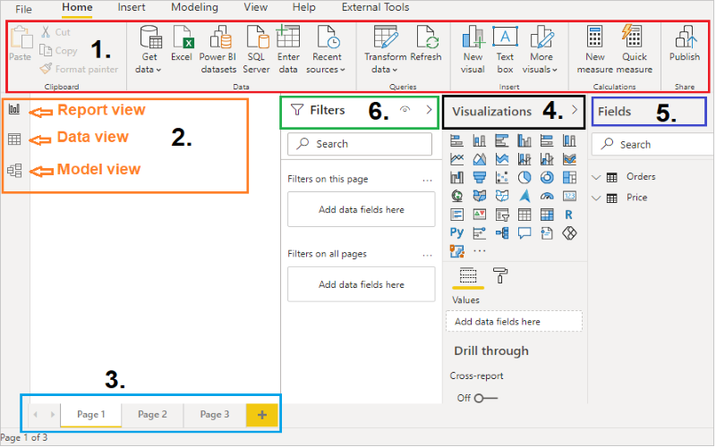Understand Power BI Desktop
4- Visualizations pane: Provides you 30+ visuals, where you can change visualizations, customize colors or axes, apply filters, drag fields, and more.
5- Fields pane: It displays the tables, folders, and fields in your data that are available for you to use to create visualizations.
6- Filter pane: Filter pane types-
- Visual level filters: This is visual level filter and applied directly on individual visualizations. Such filters are applied both on data and calculation conditions used within a visualization.
- Page level filters: This filters are used to filter the visuals present in the page.
- Report level filters: The report-level filters are the filters that you use to apply a filter condition on the entire report.

Chapter 3: Data Importing and ETL Process
In this chapter, we'll explore the process of importing data into Power BI and performing ETL (Extract, Transform, Load) operations using the actual interface. Power BI provides robust tools to connect to various data sources, transform data as needed, and load it into your reports for analysis.
3.1 Understanding the ETL Process
The ETL process involves three primary steps:
- Extract: Retrieving data from various sources.
- Transform: Cleaning and converting the data into a suitable format for analysis.
- Load: Importing the transformed data into Power BI for visualization and reporting.
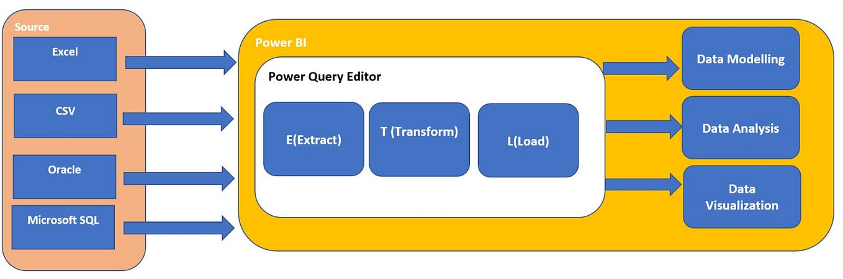
3.2 Importing Data from Excel
To import data from an Excel file:
- Open Power BI Desktop.
- Click on the Home tab.
- Select Excel from the Data section.
- Navigate to your Excel file and click Open.
- In the Navigator window, select the desired sheets or tables.
- Click Load to import the data.
3.3 Extracting Data from SQL Databases
To connect to a SQL Server database:
- Go to the Home tab.
- Click on SQL Server in the Data section.
- Enter the server name and database details.
- Choose the data connectivity mode (Import or DirectQuery).
- Click OK and select the tables to import.
3.4 Connecting to Web Data Sources
To import data from a web source:
- Click on the Home tab.
- Select Web from the Data section.
- Enter the URL of the web data source.
- Click OK and follow the prompts to connect and import data.
3.5 Loading Data from SharePoint and OneDrive
To load data from SharePoint or OneDrive:
- Click on SharePoint Folder or OneDrive in the Data section under the Home tab.
- Enter the URL of your SharePoint site or OneDrive account.
- Authenticate if prompted.
- Select the files or folders to import.

Chapter 4: Data Modeling in Power BI
In Power BI, data modeling is a critical step that involves structuring your data to facilitate efficient analysis and visualization. This chapter delves into essential components of data modeling, including understanding fact and dimension tables, creating relationships between tables, comprehending cardinality, and utilizing measures and calculated columns.
4.1 Understanding Fact and Dimension Tables
A robust data model often employs a star schema design, comprising fact and dimension tables:
- Fact Tables: These tables store quantitative data about business processes, such as sales amounts or transaction counts. Each record in a fact table is typically associated with foreign keys referencing related dimension tables.
- Dimension Tables: These tables contain descriptive attributes related to the facts, such as product names, dates, or customer details. Dimension tables facilitate filtering and grouping of data in analyses.
4.2 Creating Relationships Between Tables
In Power BI, establishing relationships between tables is crucial for accurate data analysis:
- Identifying Relationships: Determine how tables are related based on common fields. For example, a 'ProductID' field in both sales (fact) and product (dimension) tables can serve as a link.
- Defining Relationships: In Power BI Desktop's Model view, drag and drop fields to create relationships. Ensure that the correct cardinality and cross-filter direction are set to reflect the real-world data relationships.
4.3 Cardinality in Power BI
Cardinality defines the numerical relationship between rows of related tables:
- One-to-Many (1:*): A single record in one table relates to multiple records in another. This is common between dimension and fact tables, where a unique product in the dimension table relates to multiple sales records in the fact table.
- Many-to-One (*:1): Multiple records in one table relate to a single record in another. This is essentially the inverse of the one-to-many relationship.
- Many-to-Many (:): Records in both tables can have multiple corresponding records in the other. This requires careful modeling to avoid ambiguous results.
4.4 One-to-Many and Many-to-Many Relationships
Understanding these relationships is vital:
- One-to-Many (1:*): For example, one customer (dimension) can have multiple orders (fact). This is modeled by linking the primary key of the customer table to the foreign key in the orders table.
- Many-to-Many (:): For instance, a scenario where multiple students can enroll in multiple courses. Implementing this in Power BI requires an intermediary table to manage the relationships effectively.
Steps for Creating Relationships Between Tables in Power BI

Step 1: Open Power BI and Load Data
- Open Power BI Desktop.
- Click Home → Get Data and import your datasets (e.g., Excel, SQL, CSV).
- Click Load to bring the data into Power BI.

Step 2: Open the Model View
- Click on the Model View (third icon on the left sidebar).
- You will see all the imported tables displayed as boxes.

Step 3: Identify the Common Fields
- Look at the tables and find common fields (e.g., CustomerID, ProductID).
- These fields act as the key columns that link the tables.

Step 4: Create the Relationship
Option 1: Drag-and-Drop Method
- Drag the common field from one table and drop it on the matching field in another table.
- Power BI automatically creates the relationship.
Option 2: Using the Manage Relationships Dialog
- Click Modeling → Manage Relationships → New.
- Select the first table and the related table.
- Choose the common column in both tables.
- Set the cardinality (One-to-Many, Many-to-Many).
- Click OK to create the relationship.

Step 5: Verify and Edit the Relationship
- Click on the relationship line between tables.
- Check and adjust:
  - Cardinality (One-to-Many, Many-to-Many).
  - Cross-filter direction (Single or Both).
  - Make the relationship active if needed.

Step 6: Save and Test the Relationship
- Click Close & Apply to save changes.
- Go to Report View and drag fields from related tables to check if they work correctly.

Example Scenario
- Sales Table (OrderID, CustomerID, Amount).
- Customers Table (CustomerID, CustomerName, City).
- Create a One-to-Many relationship between Customers.CustomerID and Sales.CustomerID.
4.5 Utilizing Measures and Calculated Columns
Enhancing your data model involves adding calculations:
- Measures: Dynamic calculations used in data analysis, such as sums or averages. Created using (Data Analysis Expressions), measures are evaluated based on the context of the data in your reports.
- Calculated Columns: Static calculations added to tables, computed row by row during data refresh. They are useful for creating new data fields derived from existing data.

Difference Between Measures & Calculated Columns
Feature | Measures | Calculated Columns
Definition | Dynamic calculations performed at runtime | Static columns added to tables
Usage | Used in aggregations, KPIs, and reports | Used for filtering, sorting, and row-level calculations
Performance | Efficient, only calculated when used | Can slow performance as it adds to table storage
Example | Total Sales = SUM(Sales[Amount]) | Discounted Price = Sales[Amount] * 0.9

📌 Steps to Create a Measure in Power BI

Step 1: Open Power BI and Select a Table
- Open Power BI Desktop.
- In Report View, go to the Fields Pane.
- Click on the table where you want to create a measure.

Step 2: Create a New Measure
- Click on Modeling in the top ribbon.
- Click New Measure.
- Enter the formula in the formula bar.

Step 3: Write a Measure Formula
Example: Creating a total sales measure

Total Sales = SUM(Sales[Amount])

Step 4: Use the Measure in a Visualization
- Drag the measure Total Sales into a report visual (e.g., Table or Card).
- It will dynamically calculate Total Sales based on the filters applied.

📌 Steps to Create a Calculated Column in Power BI

Step 1: Open Power BI and Select a Table
- Open Power BI Desktop.
- Go to Data View (second icon on the left).
- Select the table where you want to add a calculated column.

Step 2: Create a New Calculated Column
- Click on Modeling in the ribbon.
- Click New Column.
- Enter the formula in the formula bar.

Step 3: Write a Calculated Column Formula
Example: Creating a Discounted Price column

Discounted Price = Sales[Amount] * 0.9

Step 4: Use the Calculated Column
- Go to Report View.
- Drag the new column into a table visual to display it.

Chapter 5: Data Transformation and Query Editor

5.1 Introduction to Power Query Editor
Power Query Editor is a data transformation tool in Power BI that allows users to clean, reshape, and prepare data before analysis. It enables Extract, Transform, Load (ETL) operations using a no-code interface and supports M language for advanced custom transformations.

5.2 Cleaning and Transforming Data

Steps to Open Power Query Editor
- Open Power BI Desktop.
- Click Home → Transform Data to launch Power Query Editor.
- The interface displays:
  - Query Pane (left) – Lists all loaded queries.
  - Data Preview Pane (center) – Displays the dataset.
  - Applied Steps Pane (right) – Tracks transformation steps.
  - Ribbon (top) – Provides transformation tools.

Steps for Cleaning Data
✅ Removing Unnecessary Columns
- Select the columns you don’t need.
- Click Remove Columns in the Ribbon.
✅ Renaming Columns
- Double-click a column name and enter a new name.
✅ Changing Data Types
- Click on the small icon in the column header.
- Choose the correct data type (e.g., Text, Number, Date).
✅ Filtering Rows
- Click the dropdown in a column header.
- Select Filter to keep specific values.
✅ Splitting Columns
- Select a column, go to Transform → Split Column.
- Choose By Delimiter (e.g., splitting "First Last" into "First" and "Last").

5.3 Appending and Merging Queries

Appending Queries (Stacking Data)
Appending combines two datasets with the same columns into one.

Steps to Append Queries
- Go to Home → Append Queries.
- Select the tables you want to append.
- Click OK, and Power BI will stack the data together.

Merging Queries (Joining Data)
Merging combines two datasets with a common column into one.

Steps to Merge Queries
- Click Home → Merge Queries.
- Select the tables to merge.
- Choose the common column (e.g., CustomerID).
- Choose the Join Type (Inner, Outer, Left, Right, Full).
- Click OK, and Power BI will create a new combined table.

5.4 Using the Advanced Editor
The Advanced Editor allows users to modify transformations using M language.

Steps to Open Advanced Editor
- In Power Query Editor, click View → Advanced Editor.
- The M code will display all the applied steps.
- Modify the code to apply custom transformations.

Example: Renaming Columns Using M Language
m

let
Source = Excel.Workbook(File.Contents("data.xlsx"), null, true),
RenamedColumns = Table.RenameColumns(Source, {{"OldColumn", "NewColumn"}})
in
RenamedColumns
✔️ Editing M code gives full control over data transformations.

5.5 Handling Missing and Duplicate Data

Removing Missing Values
- Select the column with missing values.
- Click Transform → Remove Rows → Remove Blank Rows.

Replacing Missing Values
- Select the column with missing values.
- Click Transform → Replace Values.
- Enter a replacement value (e.g., 0 for numbers, "Unknown" for text).

Removing Duplicates
- Select the column(s) to check for duplicates.
- Click Home → Remove Duplicates.
- Power BI will keep only the first occurrence of each value.

Chapter 6: Visualizations in Power BI
Power BI offers a robust set of tools for data visualization, enabling users to transform raw data into insightful and interactive reports. This chapter delves into the various visualization options available, guides you through creating interactive dashboards, discusses customization of visual elements, and outlines best practices for effective data visualization.

6.1 Available Visualizations
Power BI provides a wide range of visualization tools that help users present data in meaningful ways. Below are the most commonly used visual types and their best use cases.
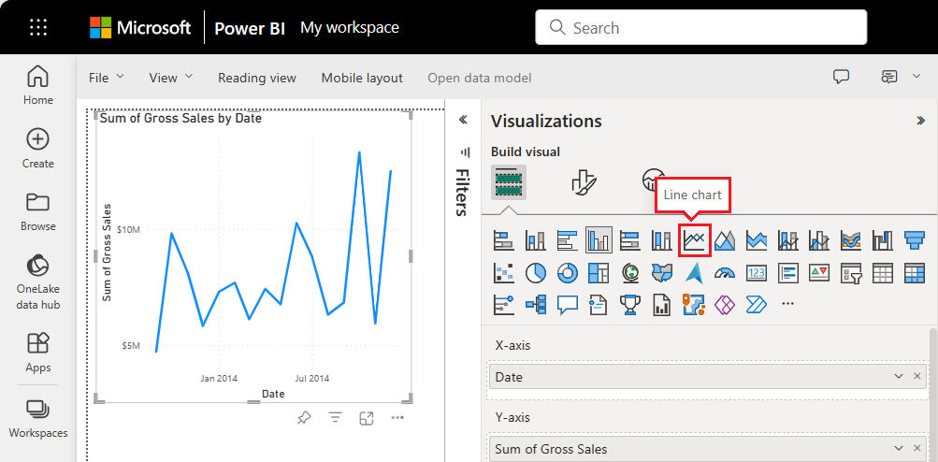

Common Power BI Visualizations and Their Uses
Visualization Type | Use Case
Bar & Column Charts | Compare values across categories (e.g., sales by region)
Line Charts | Show trends over time (e.g., stock prices, sales trends)
Pie & Donut Charts | Display proportions of a whole (e.g., market share)
Tables & Matrices | Show detailed data in tabular format
Scatter Plots | Analyze relationships between two numeric variables
Maps | Display geographical data (e.g., sales by country)
Cards | Highlight single key performance indicators (KPIs)
Slicers | Provide interactive filtering for reports

6.2 Creating Interactive Dashboards in Power BI

Step 1: Open Power BI and Load Data
- Open Power BI Desktop.
- Click Home → Get Data and import datasets (Excel, SQL, Web, etc.).
- Click Load to bring the data into Power BI.

Step 2: Add Visualizations
- Go to Report View (first icon on the left sidebar).
- Click on Visualizations Pane and select a visual type (e.g., Bar Chart, Table, Map).
- Drag and drop data fields from the Fields Pane into the selected visualization.

Step 3: Make the Dashboard Interactive
✅ Add Slicers: Allow users to filter data dynamically.
✅ Enable Drill-Throughs: Let users click on a chart to view detailed insights.
✅ Apply Cross-Filtering: Make visualizations interact with each other when clicked.

6.3 Customizing Visual Elements in Power BI

Step 1: Formatting Charts and Graphs
- Click on a visualization to select it.
- Go to Format Pane (paint roller icon).
- Customize the following settings:
  - Colors & Themes: Change chart colors to match branding.
  - Data Labels: Turn them on/off for clarity.
  - Titles & Legends: Modify font, size, and position.

Step 2: Using Conditional Formatting
Conditional formatting highlights important insights using color variations.
- Click a visualization (e.g., Table, Bar Chart).
- Open the Format Pane → Conditional Formatting.
- Set rules (e.g., Sales > $10,000 = Green, Sales < $5,000 = Red).

6.4 Best Practices for Data Visualization

✔️ Do’s for Effective Visualizations
✅ Use the right chart for the data (e.g., Line charts for trends, Pie charts for proportions).
✅ Keep dashboards simple and easy to read (avoid excessive visuals).
✅ Ensure proper labeling (titles, legends, and tooltips).
✅ Use filters and slicers for better interactivity.

❌ Don’ts for Data Visualization
❌ Avoid too many colors that make it hard to read.
❌ Do not use Pie Charts for too many categories (use Bar Charts instead).
❌ Avoid complex visuals that overwhelm users.

7.1 Introduction to (Data Analysis Expressions)
is a collection of functions, operators, and constants that can be used in formulas or expressions to calculate and return one or more values. It enables users to create new information from data already present in their model.
learn.microsoft.com
Key Characteristics of :
- Formula Language: is designed to work with relational data and perform dynamic aggregation.
- Excel-Like Functions: Many functions are similar to Excel functions, making it easier for Excel users to adapt.
- Context Awareness: formulas can adapt based on row context and filter context, allowing for intricate data analysis.
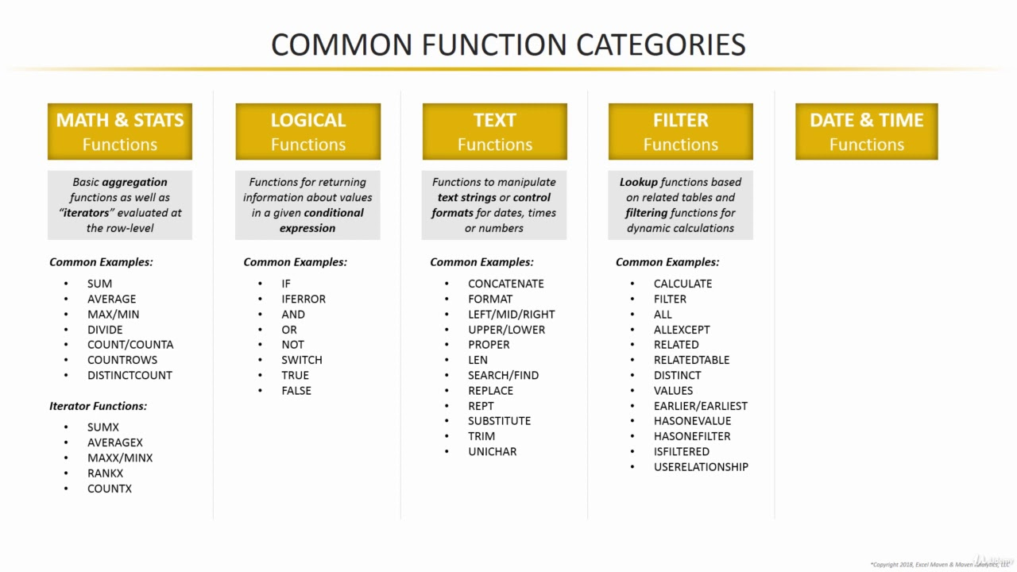

7.2 Functions and Calculations

Steps For Aggregation Functions
Steps:
- Open Power BI Desktop and load your dataset.
- Navigate to the 'Data' view by clicking on the data icon on the left pane.
- In the 'Fields' pane, select the table containing your sales data.
- Click on the 'New Measure' button in the toolbar.
- Enter the following DAX formula:(Aggregation Function Like: Sum, Average, Count, rtc)

1️. Aggregation Functions
These functions summarize data.
- SUM – Returns the sum of a column.

SUM(<column>)
Example:

Total Sales = SUM(Sales[Amount])
- AVERAGE – Returns the average of a column.

AVERAGE(<column>)
Example:

Average Sales = AVERAGE(Sales[Amount])
- COUNT – Counts the number of values in a column.

COUNT(<column>)
Example:

Total Orders = COUNT(Sales[OrderID])
- MAX / MIN – Returns the maximum or minimum value from a column.

MAX(<column>)
MIN(<column>)
Example:

Max Price = MAX(Products[Price])
Min Price = MIN(Products[Price])

2️⃣ Logical Functions
Used for conditional calculations.

Steps For Logical Functions
Steps:
- In the 'Data' view, select the sales table.
- Click on 'New Column' in the toolbar.
- Enter the DAX formula: (IF, SWITCH, AND / OR, etc)
- Press Enter to create the calculated column.
- To visualize the classification, insert a Table visualization in the 'Report' view.
- Add the 'Amount' and 'Sales Classification' fields to the table.

- IF – Returns one value if the condition is true, otherwise another.

IF(<condition>, <true_result>, <false_result>)
Example:

High Sales = IF(Sales[Amount] > 1000, "Yes", "No")
- SWITCH – Evaluates an expression and returns matching values.

SWITCH(<expression>, <value1>, <result1>, <value2>, <result2>, …, <else_result>)
Example:

Category Group = SWITCH(
TRUE(),
Sales[Amount] > 1000, "High",
Sales[Amount] > 500, "Medium",
"Low"
)
- AND / OR – Returns true if both (AND) or either (OR) conditions are true.

AND(<condition1>, <condition2>)
OR(<condition1>, <condition2>)
Example:

Valid Order = IF(AND(Sales[Amount] > 1000, Sales[Quantity] > 5), "Valid", "Invalid")

3️. Filter Functions
Filter tables and columns.
Steps:
- In the 'Data' view, select the sales table.
- Click on 'New Table' in the toolbar.
- Enter the Filter DAX formula: (Filter, ALL, RELATED)
- Press Enter to create the new table.
- To visualize the high sales records, insert a Table visualization in the 'Report' view.
- Add relevant fields from the 'High Sales' table to the table visualization.

- FILTER – Returns a filtered table based on a condition.

FILTER(<table>, <condition>)
Example:

High Sales Orders = FILTER(Sales, Sales[Amount] > 1000)
- ALL – Ignores filters on a column or table.

ALL(<table_or_column>)
Example:

Total Sales All = CALCULATE(SUM(Sales[Amount]), ALL(Sales))
- RELATED – Fetches values from a related table.

RELATED(<column>)
Example:

Customer Region = RELATED(Customers[Region])

7.3 Creating Date Tables with
A Date Table is essential for time-based analysis.
- CALENDAR – Generates a continuous range of dates.

CALENDAR(<start_date>, <end_date>)
Example:

DateTable = CALENDAR(DATE(2020, 1, 1), DATE(2025, 12, 31))
- YEAR, MONTH, QUARTER – Extracts time components.

YEAR(<date>)
MONTH(<date>)
QUARTER(<date>)
Example:

Year = YEAR(DateTable[Date])
Month = MONTH(DateTable[Date])
Quarter = "Q" & QUARTER(DateTable[Date])
- TODAY / NOW – Returns the current date/time.

TODAY()
NOW()
Example:

Current Date = TODAY()
- DATESYTD – Returns dates from the start of the year to the selected date.

DATESYTD(<date_column>)
Example:

YTD Dates = DATESYTD(DateTable[Date])

7.4 Implementing Time Intelligence Functions
Time Intelligence functions calculate year-over-year growth, moving averages, and period comparisons.

TOTALYTD Function
Objective: Calculate the year-to-date (YTD) total sales.
Steps:
- Ensure you have a Date table in your model with a continuous date range and mark it as a Date Table.
- In the 'Data' view, select the sales table.
- Click on 'New Measure' in the toolbar.
- Enter the following DAX formula:
DAX
CopyEdit
YTD Sales = TOTALYTD(SUM(Sales[Amount]), 'Date'[Date])
- Press Enter to create the measure.
- To visualize the YTD sales, insert a Line Chart visualization in

- TOTALYTD – Calculates the year-to-date total.

TOTALYTD(<expression>, <dates_column>)
Example:

YTD Sales = TOTALYTD(SUM(Sales[Amount]), 'Date'[Date])
- TOTALQTD – Calculates the quarter-to-date total.

TOTALQTD(<expression>, <dates_column>)
Example:

QTD Sales = TOTALQTD(SUM(Sales[Amount]), 'Date'[Date])
- TOTALMTD – Calculates the month-to-date total.

TOTALMTD(<expression>, <dates_column>)
Example:

MTD Sales = TOTALMTD(SUM(Sales[Amount]), 'Date'[Date])
- SAMEPERIODLASTYEAR – Returns the same period from the previous year.

SAMEPERIODLASTYEAR(<dates_column>)
Example:

Sales Last Year = CALCULATE(SUM(Sales[Amount]), SAMEPERIODLASTYEAR('Date'[Date]))
- DATEADD – Moves dates forward or backward by a specified interval.

DATEADD(<dates_column>, <number_of_intervals>, <interval>)
Example:

Sales Last Month = CALCULATE(SUM(Sales[Amount]), DATEADD('Date'[Date], -1, MONTH))
- PARALLELPERIOD – Returns a table of dates offset by a given period.

PARALLELPERIOD(<dates_column>, <number_of_periods>, <interval>)
Example:

Sales Previous Quarter = CALCULATE(SUM(Sales[Amount]), PARALLELPERIOD('Date'[Date], -1, QUARTER))

Chapter 8: Publishing and Sharing Reports in Power BI

8.1 Publishing Reports to Power BI Service

🔹 What is Power BI Service?
Power BI Service is a cloud-based platform where users can publish, share, and collaborate on reports and dashboards. It allows real-time data updates, making it a powerful tool for organizations.

🔹 Steps to Publish a Report to Power BI Service
1️⃣ Open Power BI Desktop
- Ensure your report is ready for publishing.
- Save your work before proceeding.
2️⃣ Sign in to Power BI
- Click Sign in (top-right corner).
- Enter your Power BI account credentials.
3️⃣ Click Publish
- Go to Home → Publish.
- If prompted, save your report first.
4️⃣ Select a Destination
- Choose a workspace in Power BI Service (e.g., "Sales Reports").
- Click Select to upload your report.
5️⃣ Verify in Power BI Service
- Open Power BI Service (https://app.powerbi.com).
- Navigate to Workspaces → Your report should be visible.

8.2 Sharing Dashboards with Collaborators

🔹 Methods to Share Reports and Dashboards
✅ Share directly from Power BI Service
✅ Publish reports to an App
✅ Embed reports in Microsoft Teams, SharePoint, or Websites

🔹 Steps to Share a Dashboard in Power BI Service
1️⃣ Open Power BI Service
- Go to https://app.powerbi.com
- Navigate to your workspace and open the dashboard.
2️⃣ Click on the "Share" Button
- Located top-right of the dashboard.
- Enter the email addresses of your team members.
3️⃣ Set Access Permissions
- ✅ Allow recipients to share the dashboard (optional).
- ✅ Enable editing (if collaboration is required).
- ✅ Send email notification to users.
4️⃣ Click "Share"
- The recipients will receive an email invitation to access the dashboard.

🔹 Sharing Reports via a Power BI App
1️⃣ Open Power BI Service
2️⃣ Go to Workspaces → Create App
3️⃣ Select Reports & Dashboards to Include
4️⃣ Customize the App Name & Logo
5️⃣ Assign Permissions (Users or Groups)
6️⃣ Click "Publish" to Share the App

8.3 Setting Up Row-Level Security (RLS)

🔹 What is Row-Level Security (RLS)?
Row-Level Security (RLS) restricts data access based on user roles, ensuring that users only see data relevant to them.
For example:
- A sales manager sees data for all regions.
- A sales rep only sees data for their assigned region.

🔹 Steps to Implement Row-Level Security in Power BI Desktop
1️⃣ Go to Modeling → Manage Roles
- Click "Manage Roles" in the Modeling tab.
2️⃣ Create a New Role
- Click "Create", enter a role name (e.g., "Sales_Region_Manager").
3️⃣ Apply a DAX Filter
- Use DAX expressions to restrict data for specific users.
DAX
CopyEdit
[Region] = "East"
- This ensures users only see data for "East" region.
4️⃣ Test the Role
- Click "View as Roles" to check data filtering.

🔹 Assigning RLS in Power BI Service
1️⃣ Publish the Report to Power BI Service
2️⃣ Go to "Security" in the Dataset Settings
3️⃣ Assign Users to Roles
4️⃣ Save and Test the Security Settings

8.4 Managing Permissions and Access

🔹 Setting Permissions for Workspaces
✅ Viewer – Can only see reports.
✅ Contributor – Can edit reports but not publish.
✅ Member – Can publish and edit reports.
✅ Admin – Full control of the workspace.

🔹 Steps to Manage Permissions
1️⃣ Open Power BI Service → Workspaces
2️⃣ Select "Settings" → "Permissions"
3️⃣ Assign Users and Define Access Levels
4️⃣ Save Changes

Chapter 9: Keyboard Shortcuts for Productivity in Power BI

9.1 General Shortcuts
These shortcuts help with common actions like opening, saving, and closing files.
Action | Shortcut
Open a file | Ctrl + O
Save file | Ctrl + S
Save As | Ctrl + Shift + S
Publish report | Ctrl + P
Undo last action | Ctrl + Z
Redo last action | Ctrl + Y
Copy selection | Ctrl + C
Paste selection | Ctrl + V
Cut selection | Ctrl + X
Delete selection | Delete
Select all | Ctrl + A

9.2 Navigating Reports and Data
These shortcuts allow you to quickly move between pages, visuals, and datasets.

Report Navigation
Action | Shortcut
Move to the next page | Ctrl + Page Down
Move to the previous page | Ctrl + Page Up
Switch between Report/Data/Model views | Ctrl + 1, Ctrl + 2, Ctrl + 3
Open the Field List | Ctrl + Shift + F

Table and Data Navigation
Action | Shortcut
Move to next cell in table | Tab
Move to previous cell in table | Shift + Tab
Refresh data | F5
Expand a table in Model View | Right Arrow
Collapse a table in Model View | Left Arrow

9.3 Formatting and Visualization Shortcuts
These shortcuts help in quickly formatting visuals, resizing elements, and aligning objects for better design efficiency.

Formatting Visuals
Action | Shortcut
Align objects to the left | Ctrl + Shift + L
Align objects to the right | Ctrl + Shift + R
Align objects to center | Ctrl + Shift + C
Resize visual (increase) | Ctrl + Shift + →
Resize visual (decrease) | Ctrl + Shift + ←
Duplicate a visual | Ctrl + D

Chart and Data Visualization Shortcuts
Action | Shortcut
Insert a new visual | Alt + Shift + V
Group selected visuals | Ctrl + G
Ungroup visuals | Ctrl + Shift + G
Bring visual to front | Ctrl + Shift + F
Send visual to back | Ctrl + Shift + B

Chapter 1: Introduction to Cryptography

1.1 What is Cryptography?
Cryptography is the art and science of securing information to protect it from unauthorized access. It involves mathematical techniques to encode (encrypt) and decode (decrypt) information, ensuring that only the intended recipient can access the original data.
Cryptography plays a crucial role in modern cybersecurity, enabling secure communication, data protection, user authentication, and digital transactions.

1.1.1 Core Principles of Cryptography
Cryptography is built upon four fundamental principles:
- Confidentiality – Ensures that only authorized users can access information.
  - Example: A password-protected email is encrypted so only the recipient can read it.
- Integrity – Guarantees that the data has not been altered during transmission or storage.
  - Example: Digital signatures verify that a document remains unchanged after signing.
- Authentication – Confirms the identity of the sender or receiver of a message.
  - Example: Logging into a website using a username and password.
- Non-Repudiation – Ensures that a sender cannot deny having sent a message.
  - Example: A legally binding digital signature on a contract.
Cryptography is used in everyday applications such as secure messaging (WhatsApp, Signal), online banking, credit card transactions, and government communications.

1.2 The Evolution of Cryptography
Cryptography has evolved significantly over time. Let’s explore its historical development:

1.2.1 Ancient Cryptography (Classical Ciphers)
Before computers, cryptography was mainly based on manual ciphers, which involved simple mathematical transformations. Some of the earliest cryptographic techniques include:
🔹 Caesar Cipher – A substitution cipher where letters in the message are shifted forward or backward by a fixed number of places in the alphabet.
Example:
- Original message: HELLO
- Shift by 3: KHOOR
- To decrypt, shift back by 3.
🔹 Atbash Cipher – A cipher that reverses the alphabet, replacing A with Z, B with Y, etc.
Example:
- Original: HELLO
- Atbash: SVOOL
🔹 Scytale Cipher (Used by Spartans) – A message is written on a strip of leather and wrapped around a rod of a specific diameter. The message becomes unreadable if the rod is not available.
🔹 Polybius Square – A grid-based cipher where letters are converted into numbers.

1.2.2 Medieval Cryptography
In the Middle Ages, cryptographic techniques became more sophisticated:
🔹 Vigenère Cipher – An improvement over the Caesar cipher that uses a keyword to shift letters, making it harder to break.
🔹 Cipher Machines – The Enigma Machine, used by Germany in WWII, was one of the most advanced encryption tools before modern cryptography.

1.2.3 Modern Cryptography
With the rise of computers, cryptography has become far more complex:
✅ Advanced Encryption Standard (AES) – The most widely used symmetric encryption algorithm today.
✅ Public Key Cryptography (RSA) – Introduced asymmetric encryption, using two different keys (public and private) for security.
✅ Elliptic Curve Cryptography (ECC) – A modern encryption method providing strong security with smaller key sizes.
Today, cryptography is essential for securing internet communications, banking systems, digital signatures, blockchain, and cloud security.

1.3 Applications of Cryptography
Cryptography is used in numerous real-world applications that require secure data exchange and protection.

1.3.1 Data Security
🔒 Protecting Sensitive Information
- Cryptography ensures that confidential data (e.g., credit card details, medical records) remains protected.
- Example: Databases store passwords in hashed form using SHA-256.
🔒 File Encryption
- Encrypting files ensures they cannot be accessed without the correct key.
- Example: VeraCrypt and BitLocker encrypt files and entire disks.

1.3.2 Secure Communication
📧 Email Encryption
- Tools like Pretty Good Privacy (PGP) encrypt emails to protect them from eavesdropping.
📡 Virtual Private Networks (VPNs)
- VPNs use encryption protocols (IPsec, OpenVPN, WireGuard) to secure internet traffic from hackers.
📱 Secure Messaging
- Apps like WhatsApp, Signal, and Telegram use end-to-end encryption (E2EE) to prevent unauthorized access.

1.3.3 Digital Transactions & Authentication
💳 Online Banking & E-Commerce
- Cryptography secures financial transactions using SSL/TLS protocols.
- Example: Online banking uses RSA encryption to protect login credentials.
📜 Digital Signatures & Certificates
- Cryptography enables secure e-contracts and digital signatures.
- Example: Government-issued digital certificates (PKI) validate identities.
🔐 Blockchain & Cryptocurrency
- Cryptographic hashing (SHA-256 in Bitcoin) ensures blockchain data integrity.
- Example: Cryptocurrency wallets use public and private keys for secure transactions.

Chapter 2: Symmetric vs. Asymmetric Encryption
Encryption is the core principle of cryptography that ensures data confidentiality by converting plaintext into ciphertext. Encryption techniques are broadly classified into two types: Symmetric Encryption and Asymmetric Encryption.
This chapter will cover:
- The fundamental differences between symmetric and asymmetric encryption.
- The advantages and disadvantages of each method.
- Real-world applications and examples.
- A detailed comparison table between symmetric and asymmetric encryption.

2.1 Symmetric Encryption

2.1.1 What is Symmetric Encryption?
Symmetric encryption is a method where a single secret key is used for both encryption and decryption. This means that both the sender and receiver must have access to the same key to communicate securely.
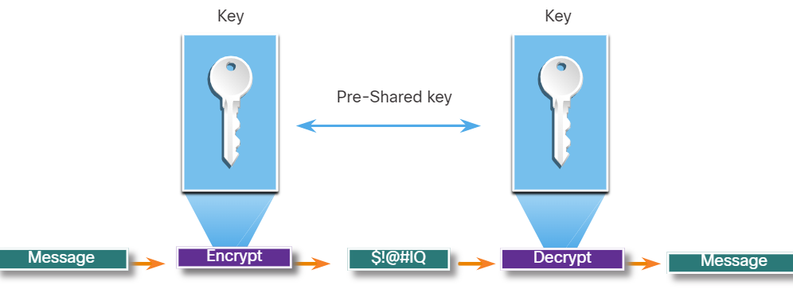
🔹 Example Process of Symmetric Encryption:
- Sender encrypts the message using a shared secret key.
- The encrypted message (ciphertext) is transmitted to the receiver.
- The receiver decrypts the message using the same key to obtain the original plaintext.

2.1.2 Examples of Symmetric Encryption Algorithms
- Advanced Encryption Standard (AES) – Most widely used encryption standard today, supports 128-bit, 192-bit, and 256-bit keys.
- Data Encryption Standard (DES) – Older encryption standard with a 56-bit key (considered weak today).
- Triple DES (3DES) – An improved version of DES that applies encryption three times for better security.
- Blowfish – A fast and flexible block cipher with variable-length keys, often used in VPNs and password storage.

2.1.3 Advantages of Symmetric Encryption
✅ Speed and Efficiency – Symmetric encryption is much faster than asymmetric encryption because it requires less computational power.
✅ Good for Large Data Encryption – Since symmetric encryption is faster, it is ideal for encrypting large amounts of data, such as files, databases, and disk storage.

2.1.4 Disadvantages of Symmetric Encryption
❌ Key Distribution Problem – Since both sender and receiver need the same key, securely sharing the key over an untrusted network is a major challenge.
❌ Scalability Issues – In a large network, each pair of users requires a unique key, leading to complex key management.
🔹 Example Use Case: VPNs use symmetric encryption (e.g., AES) to secure data transmission efficiently.

2.2 Asymmetric Encryption

2.2.1 What is Asymmetric Encryption?
Asymmetric encryption uses two mathematically related keys:
- A public key (used for encryption).
- A private key (used for decryption).
Unlike symmetric encryption, the private key is never shared, making it more secure for key exchange and authentication.
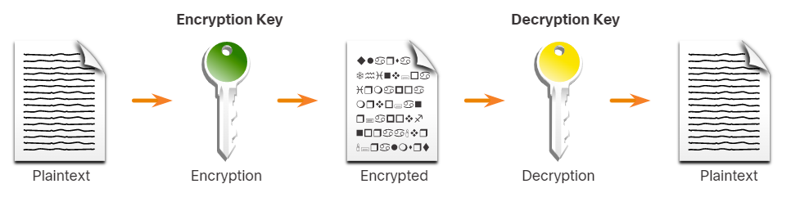
🔹 Example Process of Asymmetric Encryption:
- The sender encrypts a message using the recipient’s public key.
- The encrypted message is transmitted over the network.
- The recipient decrypts the message using their private key.

2.2.2 Examples of Asymmetric Encryption Algorithms
- RSA (Rivest-Shamir-Adleman) – One of the most widely used public-key encryption algorithms, often used in SSL/TLS certificates and email encryption.
- Diffie-Hellman Key Exchange – A method used for securely exchanging cryptographic keys over an insecure channel.
- Elliptic Curve Cryptography (ECC) – A highly efficient public-key encryption method that provides strong security with smaller key sizes.

2.2.3 Advantages of Asymmetric Encryption
✅ Secure Key Exchange – The public key can be shared openly, and the private key remains secret, making it ideal for secure communications.
✅ Scalability – Since each user only needs one key pair, asymmetric encryption is easier to manage in large-scale applications like digital signatures and SSL/TLS encryption.

2.2.4 Disadvantages of Asymmetric Encryption
❌ Slower than Symmetric Encryption – Asymmetric encryption requires complex mathematical computations, making it much slower than symmetric encryption.
❌ Not Ideal for Large Data Encryption – Due to its high computational cost, asymmetric encryption is mostly used for encrypting small pieces of data, such as keys and authentication processes, rather than large files.
🔹 Example Use Case: Secure web browsing (HTTPS) uses asymmetric encryption (RSA) to secure key exchanges before switching to faster symmetric encryption (AES).

2.3 Symmetric vs. Asymmetric Encryption: Comparison Table
Feature | Symmetric Encryption | Asymmetric Encryption
Key Type | Single secret key | Public & private key pair
Speed | Fast | Slow
Security Level | Moderate | High
Key Exchange | Difficult (must securely share the key) | Secure (only the public key is shared)
Use Cases | Encrypting large data files, VPNs, database encryption | Digital signatures, SSL/TLS certificates, key exchange
Example Algorithms | AES, DES, Blowfish | RSA, ECC, Diffie-Hellman

2.4 Real-World Applications of Symmetric and Asymmetric Encryption

When to Use Symmetric Encryption?
✅ Encrypting large amounts of data quickly.
✅ VPN traffic, file encryption, and securing databases.
✅ Wireless security protocols like WPA2/WPA3 use AES (symmetric encryption).

When to Use Asymmetric Encryption?
✅ Key exchange in secure connections (e.g., HTTPS).
✅ Digital signatures for document authentication.
✅ Blockchain transactions (Bitcoin uses ECC-based asymmetric encryption).

Chapter 3: Types of Ciphers
A cipher is a technique that is used in transforming the readable data (plain text) into coded data (ciphertext) and the other way round. In other words Ciphers are the mathematical algorithms used in cryptography to encrypt and decrypt data. Over time, various types of ciphers have been developed to enhance security, speed, and efficiency in data protection.
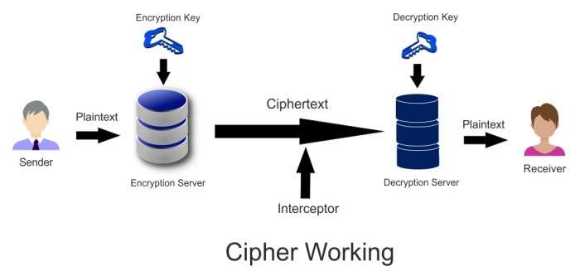

3.1 Classic Encryption Techniques
Before the rise of modern cryptography, classic ciphers were used for secure communication. These ciphers are divided into two categories:

3.1.1 Substitution Ciphers
In substitution ciphers, letters or symbols are replaced with others to disguise the message.
🔹 Caesar Cipher – One of the simplest substitution ciphers where each letter in the plaintext is shifted forward or backward by a fixed number of positions.
- Example (Shift by 3):
  - Plaintext: HELLO
  - Ciphertext: KHOOR
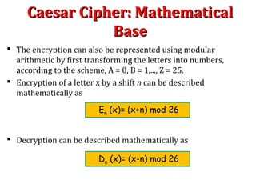
🔹 Atbash Cipher – A simple reversal cipher where A is replaced with Z, B with Y, etc.
- Example:
  - Plaintext: HELLO
  - Ciphertext: SVOOL
🔹 Vigenère Cipher – A polyalphabetic substitution cipher that uses a keyword to determine shifting values, making it harder to break than the Caesar Cipher.
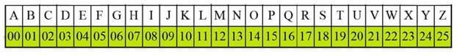

3.1.2 Transposition Ciphers
Instead of replacing characters, transposition ciphers rearrange the order of the characters in a message.
🔹 Rail Fence Cipher – The plaintext is written in a zigzag pattern and then read row by row.
Example (Rail Fence with 3 rows):
Plaintext: HELLO WORLD
Ciphertext: HLOOL ELWRD
🔹 Columnar Transposition Cipher – The message is written in a grid and then read column by column in a specific order.
Key Takeaway: Classic ciphers are no longer secure for modern use but provide a foundation for understanding cryptography.

3.2 Modern Ciphers
Modern cryptographic ciphers are designed to be resistant to brute-force attacks and mathematical analysis.
Modern ciphers are classified into two main types:
✅ Block Ciphers (Encrypts fixed-size blocks of data)
✅ Stream Ciphers (Encrypts data bit by bit)

3.2.1 Block Ciphers
Block ciphers encrypt data in fixed-size blocks (e.g., 64-bit or 128-bit blocks). If the plaintext is smaller than the block size, padding is added.
🔹 AES (Advanced Encryption Standard) – Encrypts 128-bit blocks using key sizes of 128, 192, or 256 bits.
🔹 DES (Data Encryption Standard) – Older block cipher that encrypts 64-bit blocks with a 56-bit key. (Now considered insecure.)
🔹 3DES (Triple DES) – Applies DES encryption three times for added security.
🔹 Blowfish – A fast, flexible block cipher that supports variable-length keys.
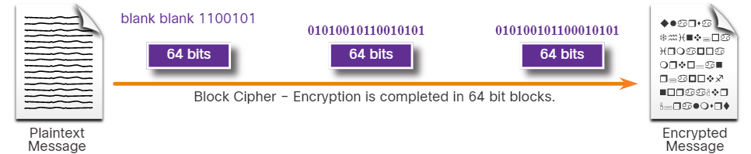
Example:
- The plaintext is split into 128-bit blocks.
- Each block is independently encrypted using an algorithm.
- The encrypted blocks are combined to form the ciphertext.
✅ Advantages of Block Ciphers:
- Stronger security compared to stream ciphers.
- Useful for encrypting large amounts of data (e.g., file encryption, disk encryption).
❌ Disadvantages:
- Slower than stream ciphers due to block processing.

3.2.2 Stream Ciphers
Stream ciphers encrypt data one bit or byte at a time, making them faster for real-time applications.
🔹 RC4 (Rivest Cipher 4) – A widely used stream cipher, though it is now considered weak.
🔹 ChaCha20 – A modern, secure stream cipher used in VPNs and secure messaging.
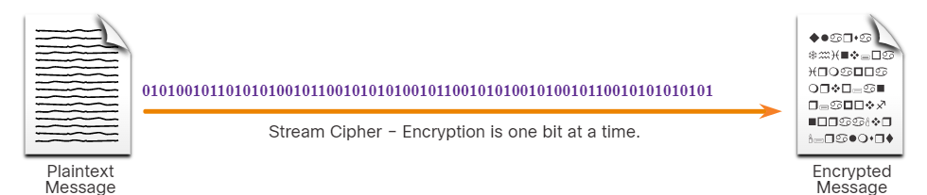
✅ Advantages of Stream Ciphers:
- Faster than block ciphers.
- Ideal for real-time communication (e.g., video calls, voice encryption).
❌ Disadvantages:
- Vulnerable to bit-flipping attacks if not implemented properly.

Chapter 4: Encryption Algorithms (AES, DES, RSA)
Encryption algorithms are the core of cryptographic security, allowing data to be encrypted (secured) and decrypted (retrieved). Different encryption algorithms serve various purposes, from securing communications to encrypting files and authenticating users.

4.1 AES (Advanced Encryption Standard)

4.1.1 What is AES?
AES is a symmetric block cipher that encrypts data in 128-bit blocks using key sizes of 128, 192, or 256 bits. It was developed to replace DES and is now the most widely used encryption standard globally.
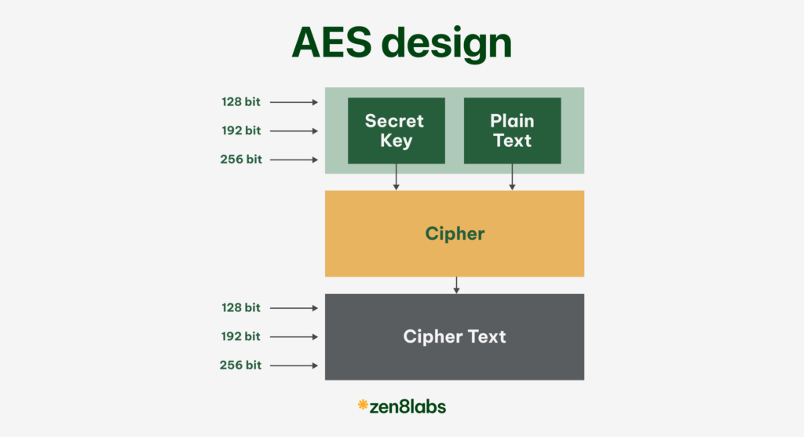

4.1.2 How AES Works
AES operates in multiple rounds of encryption, depending on the key size:
- 128-bit key → 10 rounds
- 192-bit key → 12 rounds
- 256-bit key → 14 rounds
Each round involves the following transformations:
- SubBytes – Byte substitution using an S-box.
- ShiftRows – Row shifting to increase diffusion.
- MixColumns – Mixing of data to enhance security.
- AddRoundKey – Applying the round key derived from the main key.

4.1.3 Key Features of AES
✅ Highly secure – Resistant to brute-force attacks.
✅ Fast and efficient – Works well on both software and hardware.
✅ Supports multiple key sizes – 128-bit, 192-bit, and 256-bit.
✅ Replaces DES – Provides better security than the older DES standard.

4.1.4 Uses of AES
🔹 VPNs – Secures virtual private network traffic.
🔹 Wireless Security – Used in WPA2 and WPA3 Wi-Fi encryption.
🔹 Cloud Encryption – Protects stored data in services like Google Drive and OneDrive.
🔹 Secure File Encryption – Used in full-disk encryption software like BitLocker and VeraCrypt.
4.2 DES (Data Encryption Standard)

4.2.1 What is DES?
DES is a symmetric block cipher that encrypts data in 64-bit blocks using a 56-bit key. It was the encryption standard for over two decades but is now considered insecure due to advancements in computational power.
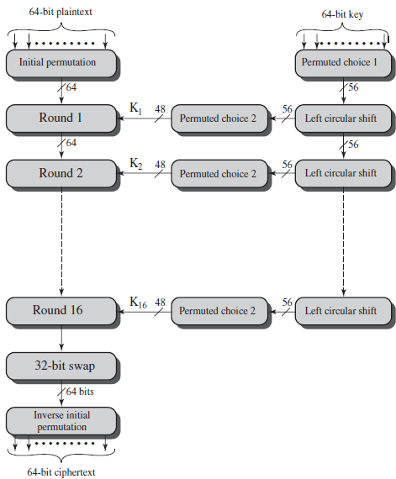

4.2.2 How DES Works
- The plaintext is divided into 64-bit blocks.
- Each block undergoes 16 rounds of encryption, including:
  - Permutation (Initial & Final Permutation)
  - Substitution using S-boxes
  - Bitwise operations with a 56-bit key
- The encrypted ciphertext is produced.

4.2.3 Why DES is No Longer Secure?
❌ Small key size (56-bit) – Can be broken with brute-force attacks.
❌ Vulnerable to modern cryptanalysis techniques.
❌ Supercomputers can crack DES in a few hours.

4.3 RSA (Rivest-Shamir-Adleman)

4.3.1 What is RSA?
RSA is an asymmetric encryption algorithm that uses a pair of keys:
- A public key for encryption.
- A private key for decryption.
Unlike AES and DES, which use a single secret key, RSA provides stronger security through mathematical complexity.
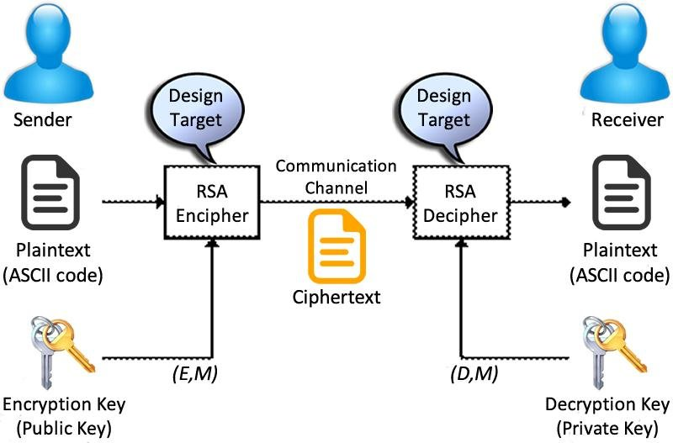

4.3.2 How RSA Works
- Key Generation
  - Choose two large prime numbers, p and q.
  - Compute n = p × q (used as part of the key).
  - Compute φ(n) = (p-1) × (q-1).
  - Choose e (public exponent) and compute d (private exponent).
- Encryption
  - The sender encrypts a message M using the recipient's public key (e, n).
  - Ciphertext (C) = M^e mod n.
- Decryption
  - The receiver decrypts the ciphertext C using the private key (d, n).
  - Plaintext (M) = C^d mod n.

4.3.3 Key Features of RSA
✅ Highly secure – Based on large prime factorization (difficult to break).
✅ Used for authentication – Digital signatures, certificates.
✅ Supports large key sizes – 2048-bit, 4096-bit, etc.

4.3.4 Uses of RSA
🔹 Secure Email Communication – Used in PGP (Pretty Good Privacy).
🔹 SSL/TLS Certificates – Protects websites from cyber threats.
🔹 Digital Signatures – Ensures document authenticity.
🔹 Cryptocurrency Transactions – Used in blockchain security.

4.3.5 Disadvantages of RSA
❌ Slower than AES – Due to complex mathematical operations.
❌ Not ideal for encrypting large amounts of data – Mainly used for secure key exchange.

Comparison Table: AES vs. DES vs. RSA
Feature | AES (Advanced Encryption Standard) | DES (Data Encryption Standard) | RSA (Rivest-Shamir-Adleman)
Type | Symmetric Block Cipher | Symmetric Block Cipher | Asymmetric Encryption
Key Size | 128-bit, 192-bit, 256-bit | 56-bit | 2048-bit, 4096-bit
Speed | Fast | Moderate | Slow
Security | Very High | Weak | Very High
Usage | VPNs, Wi-Fi, cloud security | Legacy banking, older systems | SSL/TLS, digital signatures
Replaced By | — | AES | ECC (Elliptic Curve Cryptography)

Chapter 5: Hashing & Its Types (MD, SHA, etc.)

5.1 What is Hashing?
🔹 Hashing is a one-way mathematical function that converts any input (text, file, password) into a fixed-length hash value (digest).
🔹 It is irreversible, meaning the original data cannot be recovered from the hash.
🔹 Key properties of hashing:
✅ Deterministic – The same input always produces the same output.
✅ Fixed Length – Output size is always the same, regardless of input size.
✅ Collision-Resistant – Two different inputs should not generate the same hash.
✅ Fast Computation – The algorithm should compute hashes quickly.
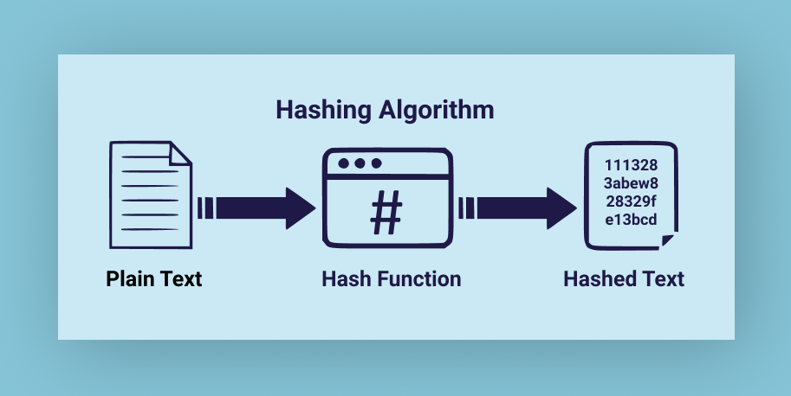

5.1.1 Uses of Hashing
🔹 Password Storage – Hashing protects stored passwords (e.g., databases).
🔹 Data Integrity Checks – Ensures files/data have not been altered (e.g., file verification).
🔹 Digital Signatures – Verifies the authenticity of messages/documents.
🔹 Cryptocurrency – Used in blockchain mining and transaction validation.

5.2 Common Hashing Algorithms
Different hashing algorithms provide varying levels of security. Some have become outdated due to vulnerabilities like collisions (two inputs producing the same hash).
Algorithm | Hash Size | Security Level
MD5 (Message Digest 5) | 128-bit | ❌ Weak (collisions possible, not secure)
SHA-1 (Secure Hash Algorithm 1) | 160-bit | ❌ Weak (deprecated due to vulnerabilities)
SHA-256 (Part of SHA-2) | 256-bit | ✅ Strong (used in modern security applications)
SHA-3 (Latest standard) | 256-bit+ | ✅ Stronger alternative to SHA-2, highly secure

5.3 Why Some Hash Algorithms Are Insecure
❌ MD5 and SHA-1 are no longer secure because they are prone to collision attacks, where different inputs generate the same hash.
✅ SHA-256 and SHA-3 are the current secure standards, used in applications like cryptocurrency (Bitcoin), SSL/TLS, and digital signatures.
5.4 Types of Hashing

5.4.1. Cryptographic Hash Functions
These are highly secure hash functions designed to be collision-resistant and one-way (irreversible).

5.4.1.1 Message Digest (MD) Algorithms
🔹 MD5 (Message Digest 5) – Produces a 128-bit hash.
- ❌ Weak – Vulnerable to collision attacks (two different inputs generating the same hash).
- ❌ Not recommended for secure applications.
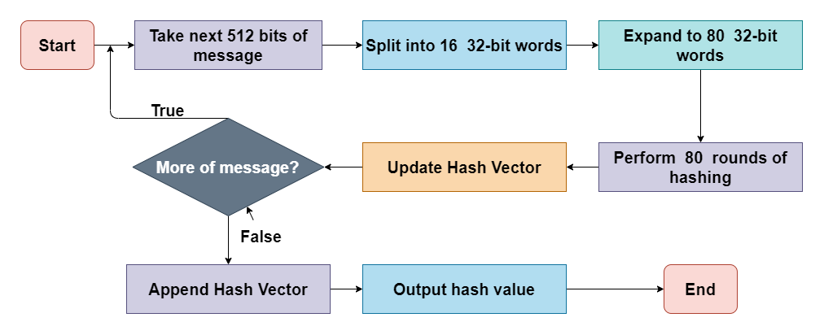

5.4.1.2 Secure Hash Algorithm (SHA) Family
🔹 SHA-1 – Produces a 160-bit hash.
- ❌ Weak – Considered insecure due to collision vulnerabilities.
🔹 SHA-2 (SHA-256, SHA-384, SHA-512)
- ✅ Secure – Used in modern security applications.
- SHA-256 (256-bit hash) – Used in SSL/TLS, digital signatures, blockchain.
- SHA-512 (512-bit hash) – Provides stronger security than SHA-256.
🔹 SHA-3 – Newest standard, designed as an alternative to SHA-2.
- ✅ Stronger security and performance.
- Used in cryptocurrency, authentication, and digital signatures.
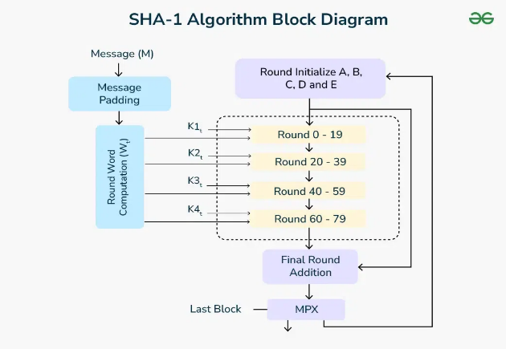

2. Non-Cryptographic Hash Functions
These are faster but less secure, often used for data indexing, checksums, and file integrity.
🔹 CRC (Cyclic Redundancy Check) – Used in error-detection for network transmissions.
🔹 MurmurHash – Fast, efficient hashing for database indexing.
🔹 CityHash & FNV (Fowler-Noll-Vo) – Used for non-secure data hashing.

3. Password Hashing Algorithms
Designed for secure password storage, these include salting (adding random values) to prevent attacks.
🔹 BCrypt – Secure, slow hashing method that resists brute-force attacks.
🔹 PBKDF2 – Uses multiple iterations to strengthen security.
🔹 Argon2 – The most secure, recommended for modern password hashing.
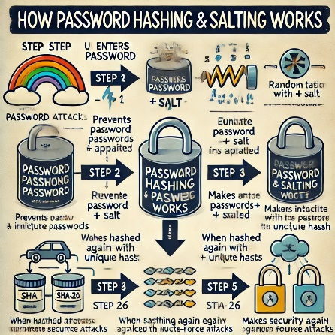

4. Uses of Hashing in Real-World Applications
✅ Password Storage – Securely stores passwords with salting (BCrypt, Argon2).
✅ Data Integrity – Verifies file integrity using SHA-256.
✅ Digital Signatures – Ensures authenticity in legal documents.
✅ Blockchain & Cryptocurrencies – Bitcoin mining uses SHA-256 hashing.
✅ Data Deduplication – Identifies duplicate files in storage systems.

Chapter 6: Public Key Infrastructure (PKI)
Definition of Public Key Infrastructure (PKI): The PUBLIC KEY INFRASTRUCTURE (PKI) is the set of hardware, software, policies, processes and procedures required to create, manage, distribute, use, store, and revoke digital certificates and public-keys.

6.1 Components of PKI
PKI consists of several components that work together to establish trust in digital communications.

6.1.1 Digital Certificates
🔹 Definition: A digital certificate is an electronic document that verifies the identity of an individual, website, or organization.
🔹 Contains:
- Name of the entity (e.g., website, company).
- Public Key.
- Certificate Authority (CA) signature.
- Expiry date and serial number.
🔹 Example: An SSL/TLS certificate ensures that a website is legitimate and encrypts user data.

6.1.2 Certificate Authority (CA)
🔹 Definition: A trusted organization that issues and manages digital certificates.
🔹 Role:
- Verifies the identity of individuals/organizations.
- Issues digital certificates.
- Revokes certificates when compromised (Certificate Revocation List - CRL).
🔹 Examples of CAs:
- DigiCert, Let's Encrypt, GlobalSign, Verisign.
Types of Digital Certificates
- 1.Code Signing Certificate 2.Client Certificate 3.User Certificates.
- 4. Certificate authority (CA) Certificates 5.Object-Signing Certificates
- 6. Signature-Verification Certificates

6.1.3 Registration Authority (RA)
🔹 Definition: A middleman between users and the CA, responsible for validating certificate requests.
🔹 Role:
- Ensures that the applicant’s identity is verified before a certificate is issued.
- Prevents fraudulent certificate issuance.

6.2 Digital Signatures
A digital signature is an electronic signature that verifies the authenticity and integrity of a digital message or document.

6.2.1 How Digital Signatures Work
- The sender creates a hash of the message.
- The sender encrypts the hash with their private key (creating a digital signature).
- The receiver decrypts the hash using the sender’s public key.
- The receiver compares the hash with the original message to ensure integrity.
✅ If the hashes match → The message is authentic.
❌ If the hashes don’t match → The message was altered.
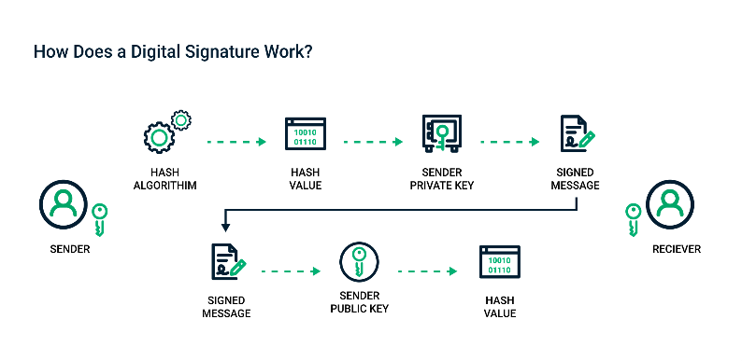

6.2.2 Uses of Digital Signatures
🔹 Electronic Contracts – Ensures documents are signed securely.
🔹 Secure Emails (PGP, S/MIME) – Verifies the sender’s identity.
🔹 Software Distribution – Guarantees that software updates are legitimate.
🔹 Blockchain Transactions – Used to sign and verify cryptocurrency transactions.
Chapter 7: Security Standards & Architecture

  - Security Standards
Security standards are a set of criteria that organizations use to protect sensitive and confidential information. Different organizations and agencies develop these standards, including:
- ISO 27001
A global standard for information management that helps organizations protect sensitive data and avoid security breaches. ISO 27001 is an information security standard that outlines the requirements for how a company should implement an INFORMATION SECURITY MANAGEMENT SYSTEM (ISMS).
- ISO/IEC 27017
A code of practice that provides guidelines for information security in cloud environments.
- ISO/IEC 27018
An international standard that establishes control objectives and protocols for personal data protection in cloud computing.
- ISO 22301
An international standard that outlines how organizations can ensure business continuity and protect themselves from disaster.

  - Architecture:
Security architectures protect data, networks, and communications from cyber threats. They define encryption, authentication, and secure data transmission mechanisms.

Key Security Standards & Protocols:
✅ HTTPS – Secure web browsing.
✅ SSL/TLS – Encrypts internet communication.
✅ Kerberos – Secure authentication for networks.
✅ IPsec – Secure VPN communication.
✅ PGP – Encrypts emails and files.

1. HTTPS (HyperText Transfer Protocol Secure)
🔹 What it does: Encrypts website data to protect user information.
🔹 How it works: Uses SSL/TLS to encrypt communication between a browser and a website.
🔹 Example: Online banking, e-commerce sites (https:// instead of http://).
✅ Prevents: Man-in-the-middle attacks, eavesdropping.

2. SSL/TLS (Secure Sockets Layer / Transport Layer Security)
🔹 What it does: Encrypts and secures internet communication.
🔹 TLS is the modern version of SSL, providing stronger encryption.
🔹 Example Use Cases:
- Websites (HTTPS uses SSL/TLS).
- Email encryption (SMTP, IMAP, POP3 over TLS).
- VPN security (TLS-based VPNs).
✅ Prevents: Data interception, tampering, and identity theft.

3. Kerberos (Network Authentication Protocol)
🔹 What it does: Provides secure authentication using a ticket-based system.
🔹 How it works:
- A user logs in and receives a ticket instead of sending passwords.
- This ticket is used for accessing multiple network resources securely.
🔹 Example: Used in Windows Active Directory, enterprise networks.
✅ Prevents: Password sniffing, replay attacks.

4. IPsec (Internet Protocol Security)
🔹 What it does: Encrypts network traffic for VPNs (Virtual Private Networks).
🔹 How it works: Uses two protocols:
- Authentication Header (AH) – Verifies data integrity.
- Encapsulating Security Payload (ESP) – Encrypts data packets.
🔹 Example: Used in secure remote access VPNs.
✅ Prevents: Data interception, IP spoofing.

5. PGP (Pretty Good Privacy) – Email & File Encryption
🔹 What it does: Encrypts emails, files, and digital communications.
🔹 How it works: Uses asymmetric encryption (public/private keys).
🔹 Example: Used for secure email communication (ProtonMail, encrypted messages).
✅ Prevents: Email tampering, unauthorized access.

Chapter 8: Disk Encryption
Disk encryption is a security measure that protects stored data by converting it into an unreadable format using encryption algorithms. This ensures that even if the physical device is lost or stolen, the data remains inaccessible without the correct key or password.

8.1 Importance of Disk Encryption
🔒 Protects Sensitive Data: Whether it's a laptop, external drive, or USB stick, disk encryption prevents data breaches if the device is lost or stolen.

8.1.1 How Disk Encryption Works
- Encryption Process:
  - All data on the disk is encrypted using an encryption key.
  - When data is saved, it is automatically encrypted.
  - When accessed, the data is decrypted in real-time using the correct password or key.
- Decryption Process:
  - Upon entering the correct password or key, the disk is unlocked.
  - Data is decrypted on the fly, allowing normal access to files and applications.
🔹 Encryption Types:
- Full Disk Encryption (FDE): Encrypts the entire disk, including the operating system.
- File-Level Encryption: Encrypts specific files or folders, offering flexibility.

8.2 Popular Disk Encryption Tools
Different tools provide various levels of security and features for Windows, Linux, and cross-platform environments.

8.2.1 BitLocker
Type | Full Disk Encryption
Platform | Windows (Pro and Enterprise versions)
Key Features
- Encrypts the entire disk, including system files and the OS.
- Uses AES encryption with 128-bit or 256-bit keys.
- Supports TPM (Trusted Platform Module) for enhanced security.
- Automatic login option with TPM or password/PIN-based access.
🔹 Example Use Cases:
- Enterprise Laptops: Automatically encrypts drives to prevent data breaches.
- Compliance with Regulations: Meets standards like GDPR, HIPAA, and PCI DSS.

8.2.2 VeraCrypt
Type | File & Full Disk Encryption
Platform | Cross-Platform: Windows, macOS, Linux
Key Features
- Open-source and free, with no backdoors.
- Encrypts individual files, partitions, and entire disks.
- Supports hidden volumes and plausible deniability.
- Allows creation of encrypted containers on existing file systems.
🔹 Example Use Cases:
- Personal Data Protection: Encrypting external hard drives and USBs.
- Advanced Security Features: Dual-factor authentication and pre-boot authentication.

8.2.3 LUKS (Linux Unified Key Setup)
Type | Full Disk Encryption
Platform | Linux-native encryption
Key Features
- Standard for full disk encryption in Linux.
- Integrated with dm-crypt, a kernel-level encryption module.
- Supports multiple user keys for accessing encrypted data.
- Ideal for server and workstation encryption.
🔹 Example Use Cases:
- Protecting Linux Servers: Encrypts drives on Linux-based servers to prevent data theft.
- Multi-User Environments: Supports key management and recovery.

8.3 How to Choose the Right Disk Encryption Tool
When choosing a disk encryption tool, consider:
Factor | BitLocker | VeraCrypt | LUKS
Operating System | Windows only | Cross-Platform | Linux only
Ease of Use | Very easy | Moderate | Advanced
Open Source | No | Yes | Yes
Best For | Enterprises | Personal & Advanced Users | Linux Environments
Advanced Features | TPM Integration | Hidden Volumes | Multiple Key Slots

Chapter 9: Code Breaking (Cryptanalysis)
Code breaking, also known as cryptanalysis, is the process of deciphering secret codes and ciphers. It involves analyzing encrypted messages to extract their original content without knowing the encryption key.
The art and science of both creating and breaking codes is called cryptology. A person who specializes in solving secret codes and ciphers without the key is known as a code breaker.

9.1 History of Code Breaking

Ancient Code Breaking
🔹 The first documented evidence of code breaking comes from the Arabic polymath Al-Kindi (9th century).
🔹 Al-Kindi developed frequency analysis, a method used to break substitution ciphers by analyzing the frequency of letters in a language.
🔹 Example: In English, the letter "e" is the most common, so code breakers often start with this letter.

World War II and Code Breaking
🔹 Code breaking became especially important during World War II, when Germany used several cipher machines (e.g., the Enigma machine).
🔹 Allied cryptanalysts, led by Alan Turing, developed techniques to break Enigma-encrypted messages, which helped shorten the war.

9.2 Methodology of Code Breaking
Cryptanalysis uses various mathematical and computational techniques to break encryption. The methodology typically involves the following steps:

9.2.1 Identifying the Cipher Type
🔹 The first step is determining the type of encryption used (e.g., substitution cipher, transposition cipher, block cipher).
🔹 Techniques used:
- Analyzing letter patterns.
- Checking for repeated sequences.
- Identifying key lengths and encryption methods.

9.2.2 Applying Cryptanalysis Techniques
Once the encryption method is identified, cryptanalysts use different techniques to break it:

1. Frequency Analysis
🔹 Definition: Analyzing letter frequencies to match them with common language patterns.
🔹 Example: In English, “E” is the most common letter, so the most frequent character in a cipher might correspond to “E”.
🔹 Used for breaking: Simple substitution ciphers.

2. Brute Force Attack
🔹 Definition: Trying every possible key combination until the correct one is found.
🔹 Example: Cracking a 4-digit PIN (0000–9999) by trying 10,000 combinations.
🔹 Used for breaking: Weak encryption keys, short passwords.

3. Dictionary Attack
🔹 Definition: Using a precomputed list of common words and passwords to guess the correct key.
🔹 Example: Testing passwords like “admin”, “123456”, “qwerty”.
🔹 Used for breaking: Poorly hashed passwords.

4. Side-Channel Attack
🔹 Definition: Analyzing hardware behavior (timing, power consumption, electromagnetic leaks) to extract encryption keys.
🔹 Example: Measuring power fluctuations while a device decrypts data to determine the key.
🔹 Used for breaking: Smartcards, hardware security modules (HSMs).

9.2.3 Validation and Interpretation
Once a decryption method succeeds, cryptanalysts:
✅ Verify the accuracy of the decrypted message.
✅ Refine the attack model for future use.
✅ Assess vulnerabilities to strengthen encryption against future attacks.

9.3 How Code Breaking Works
Code breaking techniques involve analyzing patterns, statistical methods, and computational power to break encryption. Some common methods include:

9.3.1 Frequency Analysis
🔹 What it does: Examines how often letters appear in an encrypted message.
🔹 Example: In English, "e" is the most common letter, so a high-frequency letter in ciphertext is likely to be "e".
🔹 Used for breaking: Simple substitution ciphers (e.g., Caesar cipher).

9.3.2 Brute Force Attack
🔹 What it does: Tries all possible keys until the correct one is found.
🔹 Example: Cracking a 4-digit PIN by trying 10,000 combinations (0000–9999).
🔹 Used for breaking: Weak passwords, short encryption keys.

9.3.3 Dictionary Attack
🔹 What it does: Uses precomputed common passwords to guess the correct key.
🔹 Example: Trying passwords like "password123", "admin", "qwerty".
🔹 Used for breaking: Weakly hashed passwords.

What is a Cyber Incident?
A cyber incident is any event that compromises the confidentiality, integrity, or availability of digital assets. These incidents can be intentional (hacking, malware attacks) or unintentional (accidental data leaks, misconfigurations).

Types of Cyber Incidents
- Malware Attacks (e.g., viruses, ransomware)
- Phishing Attacks (fraudulent emails to steal credentials)
- Denial-of-Service (DoS) Attacks (overloading a system to make it unavailable)
- Data Breaches (unauthorized access to sensitive information)
- Insider Threats (employees misusing data)

What is Malware?
Malware (short for malicious software) is any software designed to harm, exploit, or disable computers, networks, and devices. Attackers use malware to steal information, disrupt operations, or gain unauthorized access to systems.

Types of Malware

A. Viruses
📌 Definition: A virus is a malicious program that attaches itself to legitimate files and spreads when the infected file is executed.
📌 How it works:
- A user unknowingly downloads an infected file (e.g., from email attachments or USB drives).
- The virus activates when the file is opened, spreading to other programs.
- It can corrupt files, slow down the system, or steal data.

B. Ransomware
📌 Definition: A type of malware that encrypts a victim’s files, making them inaccessible until a ransom is paid to the attacker.
📌 How it works:
- The victim receives an email with a malicious attachment or link.
- Clicking the link downloads and executes the ransomware.
- The ransomware encrypts files and demands payment in cryptocurrency.
📌 Example:
- WannaCry Ransomware (2017): Infected over 200,000 computers worldwide, demanding Bitcoin payments to unlock files.
📌 Prevention Tips:
✅ Regularly back up important data.
✅ Avoid clicking on suspicious links.
✅ Keep your operating system updated.

C. Spyware
📌 Definition: Spyware secretly monitors and collects user activity without permission.
📌 How it works:
- Installed through deceptive software downloads.
- Tracks keystrokes, records browser activity, and captures login credentials.
- Sends stolen data to attackers.
📌 Example:
- Pegasus Spyware: Used to monitor journalists, activists, and politicians by infecting mobile devices.
📌 Prevention Tips:
✅ Avoid downloading software from untrusted sources.
✅ Use anti-spyware tools.
✅ Keep security software updated.

Steps to Respond to a Malware Attack

Step 1: Disconnect from the Network
- If you suspect malware infection, immediately disconnect the device from Wi-Fi or Ethernet to prevent further spread.

Step 2: Enter Safe Mode
- Restart your computer and enter Safe Mode (this prevents most malware from running).

Step 3: Scan for Malware
- Use a trusted antivirus or anti-malware program to perform a full system scan.

Step 4: Remove Suspicious Programs
- Check installed applications and uninstall any unknown or suspicious programs.

Step 5: Restore from Backup
- If your files are encrypted or corrupted, restore them from a clean backup (if available).

Step 6: Change Passwords
- If your system was compromised, change all important passwords, especially for banking and email accounts.

Step 7: Update Software and OS
- Update your operating system and security software to patch vulnerabilities.

Step 8: Monitor for Further Issues
- Keep an eye on your system for any unusual activity after the attack.

Tools Used for Malware Detection

A. Windows Defender (Microsoft Defender Antivirus)
📌 What it does:
- Built-in antivirus protection for Windows.
- Scans for viruses, ransomware, and spyware.
- Provides real-time protection against threats.
📌 How to Use:
- Open Windows Security → Virus & Threat Protection.
- Click Quick Scan or Full Scan for a deep check.
- Remove or quarantine any detected threats.
✅ Best for: Basic protection and system security for Windows users.

B. Malwarebytes
📌 What it does:
- Detects and removes malware, including spyware and ransomware.
- Provides real-time web protection and blocks malicious websites.
📌 How to Use:
- Download and install Malwarebytes.
- Click Scan Now to check for malware.
- Follow the prompts to remove threats.
✅ Best for: Advanced malware protection and removal.

Other Useful Tools
Tool | Purpose
Avast Antivirus | Free and premium virus protection.
Kaspersky Anti-Virus | High-level malware detection and removal.
Bitdefender | Advanced AI-based threat detection.
Spybot - Search & Destroy | Specifically detects and removes spyware.
Ransomware Decryption Tools | Free tools from cybersecurity firms to unlock encrypted files.

What is Phishing
Phishing is a type of cyber attack where attackers try to trick individuals into revealing sensitive information, such as login credentials, financial details, or personal data, by pretending to be a legitimate entity. This attack is usually carried out via email, text messages, social media, or fake websites.

How Does Phishing Work?
- Attackers Craft a Fake Message:
  - They create an email or message that looks like it’s from a trusted source (e.g., bank, social media, IT department).
- Tricking the Victim:
  - The email may create urgency (e.g., "Your account is compromised! Click here to reset your password").
  - It may ask for sensitive information like usernames, passwords, credit card details, or Social Security numbers.
- Malicious Links or Attachments:
  - Clicking the link leads to a fake login page that looks identical to the real one, tricking the user into entering their credentials.
  - An attachment may contain malware that infects the system upon opening.
- Information is Stolen & Misused:
  - Attackers capture login credentials and use them to access accounts, steal money, or launch further attacks.

How to Recognize Phishing Emails?

1. Check the Sender's Email Address
🚩 Red Flag: Phishing emails often use addresses that look similar to real companies but have slight changes.
✅ Example of a Real Email: support@paypal.com
❌ Example of a Fake Email: support@paypa1.com or paypal-security@xyzmail.com

2. Watch for Spelling & Grammar Mistakes
🚩 Red Flag: Legitimate companies send professionally written emails. Phishing emails often contain poor grammar and spelling errors.
🔍 Example of a Phishing Email:
"Dear Customer, Your acount have been compromise. Kindly click on below link for verification immediately."
✅ A real email would look professional and error-free.

3. Be Wary of Suspicious Attachments
🚩 Red Flag: Unexpected email attachments, especially from unknown senders, can contain malware.
✅ Legitimate companies rarely send attachments without warning.
❌ Dangerous Attachment Types: .exe, .zip, .js, .bat
✅ Safe Formats from Known Senders: .pdf, .docx, .xlsx

4. Hover Over Links Before Clicking
🚩 Red Flag: The displayed link text may be different from the actual link.
🔍 Example:
- The email says: Click here to reset your password → www.paypal.com/reset
- But hovering over the link shows: www.paypal.fake-site.com/reset
✅ A real link should match the official website of the company.

5. Beware of Urgent or Threatening Language
🚩 Red Flag: Scammers try to create urgency so you act without thinking.
❌ Examples of Phishing Messages:
- "Your account has been locked! Verify your identity within 24 hours to avoid permanent suspension."
- "You've won a lottery! Claim your prize now!"
✅ Legitimate companies do not use fear tactics or demand immediate action.

6. Check for Generic Greetings
🚩 Red Flag: Phishing emails often use general greetings instead of addressing you by name.
❌ Example of Phishing Email:
"Dear Customer/User,"
✅ Legitimate emails usually include your full name:
"Dear John Doe,"

7. Verify Company Contact Information
🚩 Red Flag: Phishing emails may include fake phone numbers or email addresses.
✅ To verify authenticity:
- Go to the official website and check their contact details.
- Do not call the number provided in the email—look up the company’s real support contact.

How to Protect Yourself from Phishing?
✅ Enable Two-Factor Authentication (2FA) – Even if attackers steal your password, they won’t be able to access your account without the second authentication step.
✅ Use Strong, Unique Passwords – Avoid using the same password across multiple accounts.
✅ Update Software Regularly – Security updates protect against phishing-related malware.
✅ Never Click on Suspicious Links – If unsure, visit the company’s website directly instead of clicking on email links.
✅ Report Phishing Emails – Most email services allow you to report phishing attempts (e.g., Gmail, Outlook).

Cyber Incident Management
Cyber Incident Management is the process of preparing for, detecting, responding to, and recovering from cyber incidents.

Steps in Cyber Incident Management
- Preparation – Develop policies, train staff, and set up monitoring tools.
- Detection & Identification – Identify potential threats using security tools.
- Containment – Isolate affected systems to prevent further damage.
- Eradication – Remove the threat from the system.
- Recovery – Restore systems and data to normal operations.
- Lessons Learned – Analyze the incident and improve security measures.
Cyber Incident Management is the structured approach organizations use to prepare for, detect, respond to, and recover from cyber threats and attacks. A well-planned incident management process helps minimize damage, prevent future incidents, and ensure business continuity.

📌 Why is Cyber Incident Management Important?
✅ Protects sensitive data from breaches.
✅ Reduces financial losses from cyberattacks.
✅ Ensures compliance with security regulations.
✅ Helps organizations recover quickly from security incidents.

🔹 Key Steps in Cyber Incident Management

1️⃣ Preparation (Proactive Defense Strategy)
📌 Goal: Establish a strong cybersecurity framework before an incident occurs.
🔹 Actions Taken:
- Develop a Cybersecurity Incident Response Plan (CIRP).
- Train employees on security best practices and social engineering attacks (e.g., phishing).
- Set up Intrusion Detection Systems (IDS) and Security Information and Event Management (SIEM) tools.
- Implement data backup strategies to protect critical data.
✅ Example: A company conducts phishing simulation exercises to train employees on identifying fraudulent emails.

2️⃣ Detection & Identification (Recognizing Threats Early)
📌 Goal: Quickly identify and confirm cyber threats.
🔹 Actions Taken:
- Monitor network traffic and system logs for anomalies.
- Use antivirus and endpoint detection tools (e.g., Windows Defender, CrowdStrike).
- Investigate suspicious activities, such as unauthorized access attempts or large data transfers.
✅ Example: A security team detects unusual login attempts from foreign locations, signaling a possible attack.

3️⃣ Containment (Stopping the Spread of the Attack)
📌 Goal: Isolate affected systems to prevent further damage.
🔹 Actions Taken:
- Disconnect compromised devices from the network.
- Block malicious IP addresses and update firewall rules.
- Change affected system credentials to lock out attackers.
✅ Example: After detecting a ransomware attack, IT immediately disconnects infected computers to stop further file encryption.

4️⃣ Eradication (Removing the Threat Completely)
📌 Goal: Eliminate the root cause of the incident and prevent reinfection.
🔹 Actions Taken:
- Remove malware, backdoors, or unauthorized accounts.
- Patch security vulnerabilities exploited in the attack.
- Scan all systems to ensure no remnants of the attack remain.
✅ Example: A company discovers that an attacker exploited an outdated VPN software vulnerability. They update the software and enforce multi-factor authentication (MFA) to prevent future attacks.

5️⃣ Recovery (Restoring Normal Operations)
📌 Goal: Resume normal business operations safely.
🔹 Actions Taken:
- Restore systems and data from backups if needed.
- Monitor the system closely for any signs of lingering threats.
- Conduct security audits to verify the environment is secure.
✅ Example: After a cyber attack, an organization restores encrypted files from cloud backups and resumes business with minimal downtime.

6️⃣ Lessons Learned (Improving Security for the Future)
📌 Goal: Analyze the incident to enhance security measures.
🔹 Actions Taken:
- Conduct a post-incident review to determine what went wrong.
- Update security policies and incident response plans based on findings.
- Provide additional employee training on emerging cyber threats.
✅ Example: After a phishing attack, an organization tightens email security filters and conducts staff training on identifying phishing emails.
PHASES OF COMPUTER FORENSICS
Digital forensics is the process of uncovering and interpreting electronic data. The goal of the process is to preserve any evidence in its most original form while performing a structured investigation by collecting, identifying, and validating the digital information to reconstruct past events. The context is most often for the usage of data in a court of law, though digital forensics can be used in other instances.

Phases of Computer Forensics Investigation
There are five phases of the digital or computer forensics investigation process that are as follows:
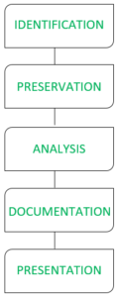
Phases of Digital Forensics Investigation Procedure

1. Identification
The first step is identifying where the data is stored. This could be on personal devices like mobile phones, tablets, laptops, or company servers. Once identified, these devices are seized and secured to prevent tampering.
🔹 Example: If an employee is suspected of leaking company data, their office computer and email logs will be identified for investigation.

2. Extraction & Preservation
Forensic experts extract relevant data without altering the original files. A forensic image (an exact digital copy) is created for analysis, while the original data is stored securely.
🔹 Example: If a suspect's hard drive is being analyzed, a digital copy is made to prevent any accidental modifications while reviewing the data.

3. Analysis
Investigators examine the extracted data using forensic techniques to uncover deleted, hidden, or encrypted information. Some methods include:
- Reverse Steganography – Finding hidden messages in images or files.
- Deleted File Recovery – Restoring erased documents.
- Live Analysis – Checking RAM and system logs for recent activities.
- Keyword Search – Searching for suspicious words in emails, chats, or files.
- Cross-Drive Analysis – Comparing multiple devices to find links.
🔹 Example: If a hacker deletes files after an attack, forensic experts can recover those files and track their activities.

4. Documentation
A detailed report is prepared with all findings, timelines, and evidence. This helps visualize how the incident happened, whether it's a cyberattack, data breach, or financial fraud.
🔹 Example: If a company faces a security breach, the report will show how hackers gained access, what data was compromised, and when it happened.

5. Presentation
The final step is presenting the evidence to legal authorities, company management, or a court. Investigators may testify as expert witnesses to explain their findings clearly.
🔹 Example: In a fraud case, a forensic expert may present recovered emails and transactions to prove the suspect’s involvement.

Seizing of Digital Evidence

What is Digital Evidence
Digital evidence is information stored or transmitted in digital form that can be used in cybercrime investigations.
🔹 Examples of Digital Evidence:
- Emails, chat logs, and text messages.
- Hard drives, USB devices, and SSDs.
- Network logs and firewall records.
- Browser history and cached data.
- Metadata from files and images.

Principles of Digital Evidence Handling
✔ Admissibility: Evidence should be collected legally and securely.
✔ Integrity: No unauthorized modifications should occur.
✔ Authenticity: Must be provable that evidence is genuine.
✔ Chain of Custody: Tracks who handled the evidence and when.

Steps in Seizing Digital Evidence

📌 Step 1: Identify & Secure the Scene
- Secure the location where the device is found.
- Prevent unauthorized access to the system.
- Photograph and document all digital devices before seizure.

📌 Step 2: Powering Down or Live Capture?
- If the device is ON: Perform live forensics to capture volatile data (RAM, running processes, network connections).
- If the device is OFF: Do NOT turn it on—create a forensic image instead.

📌 Step 3: Collection of Evidence
- Use forensic tools to create a bit-by-bit copy of storage devices.
- Label and store devices securely to maintain the chain of custody.

📌 Step 4: Transport & Storage
- Keep digital evidence in a secure environment (anti-static bags, Faraday cages).
- Maintain logs of who accessed the evidence.

📌 Step 5: Analysis & Reporting
- Extract data using forensic software.
- Prepare a forensic report with findings, timestamps, and logs.
Working with Digital Evidence at the Scene
One should be highly cautious while taking evidence in the collection, preservation, and transportation. First responders may track the steps given below to direct their management of digital evidence at an electronic scene of crime:
• Recognize, identify, seize, and secure all digital evidences at the scene.
• Document the complete scene and the detailed place of the evidence established.
• Gather, tag, and protect the digital evidence.
• Wrap up and move digital evidence in a protected way.
• Before gathering evidence at a scene of crime, first responders must make sure that—
1. Lawful authority is present to seize evidence.
2. The scene has been protected and documented.
3. Suitable special defensive tools are used.

Digital Evidence LAW
India has a well-defined legal framework for dealing with cybercrime and digital evidence under various laws, primarily the Information Technology Act, 2000 (IT Act, 2000) and the Indian Penal Code (IPC). Below is a detailed explanation of key legal provisions along with their sections.

Legal Framework for Digital Evidence in India

📌 Information Technology Act, 2000 (IT Act)
The IT Act, 2000 is the primary law governing cybercrime, digital transactions, and the admissibility of digital evidence in India. It was amended in 2008 to strengthen cybercrime enforcement.

📌 Indian Evidence Act, 1872 (IEA)
The Indian Evidence Act (IEA), 1872 was amended to include electronic records as evidence in courts.

📌 Indian Penal Code (IPC), 1860
The IPC covers various cyber offenses, including hacking, fraud, and identity theft.

Admissibility of Digital Evidence in Indian Law

📌 Section 65B – Indian Evidence Act, 1872 (Electronic Evidence)
✔ Recognizes electronic records as admissible evidence.
✔ Requires a certificate under Section 65B(4) for digital evidence to be valid in court.
✔ Example: If an email is presented as evidence, the person who retrieved it must certify it under Section 65B(4).

Seizure & Investigation of Digital Evidence (Forensic Process)

📌 Search & Seizure Powers – Section 80 of IT Act, 2000
✔ Law enforcement officers (Inspector rank & above) can search & seize digital evidence without a warrant if they suspect a cybercrime.
✔ Seized devices must be preserved without alteration to maintain legal validity.

Cyber Forensics Tools

Cyber forensics tools are the helper of cyber forensic teams that help investigate the electronic devices that are involved in crime so that forensic teams mention the proof in court.

Here are the tools that are helpful for the investigation of cyber forensic teams-

OS Forensics
It is the tool that deeply investigates the computer. It finds all the information on the computer that we need. This tool is helpful for the cyber forensic team to investigate deeply in the computer like the forensic team checking what cybercrime is going on in the device so that they mention the proof in the court as an investigator. Os Forensic is the best tool to search the contents in all the files in any type of file format. It also finds unknown files where the contents do not match the extension.

Advantages of OS forensics
- The speed is fast.
- It provides deep insights into user activities.

Disadvantages of OS forensics
- Some features are complex and require more knowledge and training.
- Some features are costly.

2. Autopsy
It is an open-source cyber forensic tool. It shows the deleted files and data on our computer. It can run on Windows, Linux, or Mac. Cyber forensic teams investigate the data involved in the crime make a digital copy of the evidence and mention it in the court as proof. Also, the cyber forensic team makes the presentation of the evidence found in data analysis. This tool gives 100% accurate results.

Advantages of Autospy
- It extracts the data from raw files and also extracts timestamps and geolocation data.
- It extracts camera information from JPEG or PNG files.
- It provides community support.

Disadvantages of Autospy
- It might be slow when working with complex datasets.
- The performance is slow.

Volatility Framework
It is a tool that extracts the RAM information or memory information. It is implemented in Python. It supports Windows, Mac, or Linux. It works in a command line interface. It is used for malware analysis and investigating cyber attacks. This tool helps work with large data sets. It also supports various types of file formats and extracts the data. It offers efficient algorithms that analyze the RAM dumps from complex data sets without the loss of memory.

Advantages of the Volatility Framework
- It also analyzes the RAM or memory information even computer shuts down.
- It supports various types of file formats.

Disadvantages of the Volatility Framework
- This tool has less number of Graphical user interfaces i.e. GUI options that are challenging for new users.
- It is required to work in the command line interface.

Openstego
It is a tool that extracts the hidden messages present in images, audio files, etc. It is made by the encryption algorithm and provides user-friendly features that are helpful for beginners. It also provides a command line interface for advanced users and its advanced encryption technique is to secure our information or data.

Advantages of Openstego
- It provides user user-friendly interface for beginners.
- Its strong encryption algorithm protects our data or information inside the messages.

Disadvantages of Openstego
- It provides complexity when working with large data to hide the information efficiently.

FTK
FTK stands for a forensic toolkit that provides advanced data analysis. It provides features to recover passwords, decrypt files and analyze the network data. FTkK provides the mechanism of verification and validation that verifies and validates the data. FTK also can recover lost or deleted data, and files in our system. FTK integrates with another cyber forensic tool to speed up the investigation and analysis.

Advantages of FTK
- It provides flexibility to support various file formats.
- It provides community support. so that investigation is going fast.

Disadvantages of FTK
- The cost is higher for premium features.
- There is no support for scripting features.

Hard Disk Drive Structure & Components

- Platters: Magnetic platters are disk-like in shape and used to store data. Typically, they are made from glass or aluminum and laid down on a spindle where layers of such disks are kept one after the other.
- Spindle: The spindle maintains the platters in place and rotates them as required. The Revolution Per Minute(RPM) rating controls how fast data can be written to and read from the hard drive.
- Actuator Arm: The actuator, also known as the head actuator, is a tiny motor that controls the movement of the read/write head and monitors data transfer between the platters. It is in charge of ensuring that the read/write heads are always in the proper direction.
- Read/write Head: The read/write arm controls the movement of the read/write heads, that perform the actual reading and writing on the disc platters.

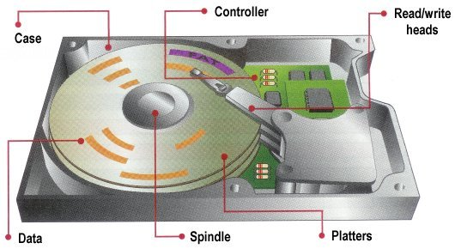

The performance of a hard disk drive (HDD) is determined by several factors, including:
- Speed
Measured in revolutions per minute (RPM), a higher RPM means faster data transfer.
- Cache size
A larger cache allows more data to be stored at once, which speeds up data transfer.
- Interface
The type of interface used to transfer data, such as SATA (Serial Advanced Technology Attachment) or USB (Universal Serial Bus), affects performance.
- Data density
The number of bits per inch (BPI) and tracks per inch (TPI) affects data throughput. Higher density means faster read and write speeds.
- Form factor
The size of the HDD, such as 3.5 in or 2.5 in, affects performance.

Working Principal
A hard disk drive (HDD) uses spinning magnetic disks to store and retrieve data. An actuator arm with read/write heads moves across the disks to read and write data.
How HDDs work
- The CPU and system board instruct the read/write heads where to move on the platters.
- The read/write head reads the charge information on the segments of the platters.
- The read/write head translates the charges into binary as 1s or 0s.
- The HDD technology uses the unique address of each track and sector to organize and locate data.

HDD features
- Random access: HDDs allow users to access data randomly.
- Permanent storage: HDDs store information even when the power supply is off.
- Large storage capacity: HDDs have a much larger storage capacity than volatile memory (RAM).

What is the difference between an HDD and an SSD?
An HDD (Hard Disk Drive) uses spinning disks to read and write data, while an SSD (Solid-State Drive) uses flash memory instead. SSDs are generally faster and more reliable than HDDs.

Feature | HDD (Hard Disk Drive) | SSD (Solid State Drive)
Technology | Uses spinning magnetic platters and a moving read/write head. | Uses NAND flash memory with no moving parts.
Speed | Slower due to mechanical parts (100–200 MB/s). | Faster due to electronic data transfer (500 MB/s to several GB/s).
Boot Time | Longer (30–60 seconds). | Much faster (10–20 seconds).
Durability | Prone to damage from shocks and drops due to moving parts. | More durable as it has no moving parts.
Noise & Heat | Generates noise and heat from spinning disks. | Silent and produces less heat.
Lifespan | Can last long but mechanical wear can lead to failure. | Has limited write cycles but better longevity in modern SSDs.
Power Consumption | Higher due to moving parts. | Lower, making it more energy efficient.
Capacity | Generally offers larger storage (up to 16TB or more). | Typically smaller capacities, but high-end SSDs reach up to 8TB+.
Cost | Cheaper per GB. | More expensive per GB.
Usage | Best for bulk storage, backups, and general computing. | Ideal for OS, gaming, and applications requiring speed.

HDD Partitioning (Primary, Extended & Logical Partitions)

Understanding HDD Partitioning
Partitioning a Hard Disk Drive (HDD) means dividing it into separate sections to manage data storage efficiently. It helps in organizing files, running multiple operating systems, and optimizing disk usage.
There are three main types of partitions:
- Primary Partition
- Extended Partition
- Logical Partition

Types of Partitions

A. Primary Partition
- This is the main partition that can hold an operating system.
- A hard disk can have a maximum of four primary partitions or three primary and one extended partition (on an MBR disk).
- Only a primary partition can be set as "Active" for booting an OS.
- Example: If a hard drive has a 1TB space, it can have four primary partitions of different sizes (e.g., 250GB each).

B. Extended Partition
- It acts as a container for logical partitions.
- Only one extended partition is allowed per disk.
- It does not store data directly but allows logical partitions inside it.
- Instead of creating four primary partitions, a user can create three primary partitions and one extended partition, which can contain multiple logical partitions.
#Example: Imagine you have a big box. You can’t use the box itself, but you can put smaller boxes (logical partitions) inside to store things.

C. Logical Partition
- Created inside an extended partition.
- Used for storing data, applications, or additional OS installations.
- A system can have multiple logical partitions within an extended partition.
- Example: A 500GB extended partition can contain three logical partitions of 200GB, 150GB, and 150GB.

Steps to Partition a Hard Drive
  - Using Windows Disk Management
Step 1: Open Disk Management
- Press Win + R, type diskmgmt.msc, and hit Enter.
- The Disk Management window opens, showing existing partitions.
Step 2: Create a New Partition
- Right-click on Unallocated space > Select New Simple Volume.
- Follow the wizard to create a Primary partition (if needed).
- Assign a drive letter and format it as NTFS (New Technology File System).
Step 3: Create an Extended Partition
- If you need more than four partitions, right-click on unallocated space.
- Select New Simple Volume and create an Extended Partition.
- After creating an extended partition, right-click on the remaining space inside it and create Logical Partitions.
  - Using Command Prompt (Diskpart)
Step 1: Open Diskpart
- Press Win + R, type cmd, and hit Enter.
- Type diskpart and press Enter.
Step 2: Select the Disk
list disk
select disk 0 (Choose the correct disk)
Step 3: Create a Primary Partition
create partition primary size=50000 (for 50GB)
Step 4: Create an Extended Partition
create partition extended size=100000 (for 100GB)
Step 5: Create Logical Partitions Inside Extended
create partition logical size=50000 (for 50GB)
Step 6: Format and Assign Drive Letter
format fs=ntfs quick
assign letter=D

4. Key Differences and Summary
Feature | Primary Partition | Extended Partition | Logical Partition
Bootable | Yes | No | No
Max Number | 4 (or 3 + 1 Extended) | 1 per disk | Multiple inside extended
Stores Data | Yes | No | Yes
OS Installation | Yes | No | No (in MBR)

If Need To Delete One Drive And Create An Extended Partition And Logical Partitions In Windows Disk Management Following Steps Need To Follow:

Step 1: Delete an Existing Partition (If Needed)
To create an Extended Partition, you need Unallocated Space. Since Disk 1 is fully partitioned, you must delete at least one partition.
⚠ WARNING: Deleting a partition will erase all data on it. Back up important files before proceeding!
- Open Disk Management (Win + R → type diskmgmt.msc → press Enter).
- Identify a partition on Disk 1 that you want to delete (e.g., E:).
- Right-click the partition and select Delete Volume → Click Yes to confirm.
  - Now, you should see Unallocated Space on Disk 1.

Step 2: Create an Extended Partition
- Right-click on the Unallocated Space → Select New Simple Volume.
- When the wizard opens, click Next.
- On the "Specify Volume Size" page, use the full available size (or any size you prefer) → Click Next.
- On the "Assign Drive Letter or Path" page, do not assign a letter yet → Click Next.
- On the "Format Partition" page, DO NOT format yet → Click Finish.
  - This creates an Extended Partition (you will see a green outline in Disk Management).

Step 3: Create Logical Partitions Inside the Extended Partition
Now that you have an Extended Partition, you can create Logical Partitions inside it:
- Right-click the Extended Partition → Click New Simple Volume.
- Follow the wizard to create a Logical Partition:
  - Specify Volume Size (e.g., 50GB).
  - Assign a Drive Letter (e.g., E:).
  - Format as NTFS (or your preferred file system) → Click Finish.
- Repeat the above steps to create more Logical Partitions inside the Extended Partition.

Notes:

*What is a Page File: A Page File (also called swap file or virtual memory) is a special system file that Windows uses when RAM is full. It acts as extra memory by storing temporary data on the hard drive.

*Why Does Windows Use Less Space?
- Binary vs. Decimal Calculation → Storage manufacturers advertise using the decimal system, while Windows calculates in binary.
- Reserved Space for Formatting → Some space is used by the file system (NTFS) and partitioning structure.
- Hidden Partitions → Some drives have factory recovery partitions or reserved system partitions, further reducing available space.
*NTFS stands for New Technology File System. It's a file system that stores and organizes files on hard disk drives and solid-state drives. Microsoft developed NTFS in the 1990s.

What is a File System
A file system is a method an operating system uses to store, organize, and manage files and directories on a storage device. Some common types of file systems include:
  - FAT32 (File Allocation Table 32)
  - exFAT (Extended File Allocation Table)
  - NTFS (New Technology File System)
  - ReFS (Resilient File System)

Advantages of File System
- Organization: A file system allows files to be organized into directories and subdirectories, making it easier to manage and locate files.
- Data Protection: File systems often include features such as file and folder permissions, backup and restore, and error detection and correction, to protect data from loss or corruption.
- Improved Performance: A well-designed file system can improve the performance of reading and writing data by organizing it efficiently on disk.

Disadvantages of File System
- Compatibility Issues: Different file systems may not be compatible with each other, making it difficult to transfer data between different operating systems.
- Disk Space Overhead: File systems may use some disk space to store metadata and other overhead information, reducing the amount of space available for user data.
- Vulnerability: File systems can be vulnerable to data corruption, malware, and other security threats, which can compromise the stability and security of the system.

Features of Windows File Systems

1️. FAT32 (File Allocation Table 32)
✔ Works on Windows, macOS, Linux, gaming consoles, and older devices.
✔ Ideal for USB drives and memory cards (but not modern hard drives).
❌ Limitations:
- Max file size: 4GB (can’t store large videos, ISOs, etc.).
- Max partition size: 2TB.
- No security features (no file permissions or encryption).
Best For: Small USB drives, memory cards, older systems.

2️. exFAT (Extended File Allocation Table)
✔ Designed for flash storage devices (USB, SSD, SD cards).
✔ Supports large files (over 4GB) unlike FAT32.
✔ Compatible with Windows, macOS, and Linux (with drivers).
❌ Limitations:
- No journaling (less protection against corruption).
- Not as widely supported on older systems as FAT32.
Best For: USB drives and external hard drives used on multiple OS.

3️. NTFS (New Technology File System)
✔ Default Windows file system (used for C: drive).
✔ Supports large files (up to 16TB) and partitions.
✔ Advanced features:
- File permissions & security (ACL).
- Compression (saves disk space).
- Journaling (prevents data corruption).
- Encryption (EFS) for security.
- Disk quotas (limit user storage).
❌ Limitations:
- Not fully supported by macOS (read-only without extra software).
Best For: Windows system drives, internal HDDs, SSDs.

4️. ReFS (Resilient File System)
✔ Advanced version of NTFS, designed for servers & storage spaces.
✔ Better error handling & self-repair (avoids corruption).
✔ Scalability – supports huge files and partitions.
❌ Limitations:
- Not supported for boot drives (only for data storage).
- Less compatible with consumer Windows versions.
Best For: Servers, enterprise storage, cloud applications.

Disk Management & Maintenance

Disk Management
Disk management is the process of organizing, maintaining, and optimizing storage devices such as hard drives (HDDs), solid-state drives (SSDs), and external storage to ensure efficient performance and data integrity.
Why is Disk Management Important?
🔹 Ensures data security and storage efficiency.
🔹 Prevents disk fragmentation for faster performance.
🔹 Helps detect and fix disk errors before failure.
🔹 Allows disk partitioning for better organization.

Key Disk Management Tasks

1. Disk Partitioning: Partitioning divides a physical disk into multiple logical sections (partitions) for better organization.
✅ Benefits of Partitioning:
- Keeps operating system (OS) files separate from personal data.
- Allows multiple operating systems on one disk.
- Improves backup and recovery strategies.
Steps for create a new partition on your Windows PC.
- Open Disk Management (Windows + R, type diskmgmt.msc, press Enter).
- Locate your disk, right-click unallocated space → New Simple Volume.
- Follow the wizard, assign a drive letter, and format the partition.

2. Formatting Disks: Formatting prepares a partition for data storage by setting up a file system (NTFS, FAT32, exFAT).
✅ When to Format a Disk:
- When setting up a new hard drive or SSD.
- Before installing a new operating system.
- To erase all data and start fresh.
Steps for format a USB drive in NTFS.
- Insert your USB drive.
- Open File Explorer, right-click the drive → Format.
- Select NTFS, uncheck Quick Format for a full format.
- Click Start.

3. Checking Disk Health: Disk health monitoring helps prevent data loss and hardware failure.
✅ Tools to Check Disk Health:
- Windows: chkdsk (Check Disk Utility).
- macOS: Disk Utility → First Aid.
- Third-party software: CrystalDiskInfo, Hard Disk Sentinel.
Steps to run a disk check on Windows.
- Open Command Prompt as Administrator.
- Type: chkdsk C: /f /r (Replace C: with your drive letter).
- Press Enter and follow the prompts.

4. Defragmentation & SSD Optimization
🔹 HDDs: Over time, files become fragmented, slowing down performance. Defragmentation reorganizes data for faster access.
🔹 SSDs: Do NOT defragment SSDs (they don’t suffer from fragmentation). Instead, use TRIM to optimize SSD performance.
Steps for Defragment a hard drive (HDD).
- Open Defragment and Optimize Drives (dfrgui in Run).
- Select your HDD, click Optimize.
- Wait for the process to complete.

5. Backup & Recovery: Regular backups protect against data loss due to hardware failure or accidental deletion.
✅ Backup Options:
- Full Backup: Entire system and files.
- Incremental Backup: Only changes since the last backup.
- Cloud Backup: Google Drive, OneDrive, Dropbox.
Steps for set up a Windows backup.
- Open Control Panel → Backup and Restore.
- Click Set up backup and choose a destination (external drive/cloud).
- Follow the wizard to complete the setup.

Disk Maintenance Best Practices
🔹 Monitor disk space – Avoid running a disk below 10% free space.
🔹 Run antivirus scans – Malware can slow down disks.
🔹 Enable TRIM for SSDs – Improves SSD lifespan.
🔹 Use disk cleanup tools – Remove junk files regularly.

Introduction to Windows Registry & Logs

1. Introduction to Windows Registry
The Windows Registry is a database that stores system settings, user preferences, and application configurations in Windows operating systems. It acts as a central hub for managing Windows functions and software behavior.
✅ Why is the Windows Registry Important?
- Stores system-wide and user-specific settings.
- Controls startup applications, services, and drivers.
- Helps in troubleshooting system errors.
- Allows manual tweaking of Windows settings for performance optimization.

2. Windows Registry Structure
The registry is divided into five main sections (hives), each serving a specific purpose:
Registry Hive | Description | Location in Registry Editor
HKEY_CLASSES_ROOT (HKCR) | Manages file associations and Object Linking and Embedding (OLE) information. | HKEY_CLASSES_ROOT
HKEY_CURRENT_USER (HKCU) | Stores settings for the currently logged-in user. | HKEY_CURRENT_USER
HKEY_LOCAL_MACHINE (HKLM) | Stores system-wide settings and configurations. | HKEY_LOCAL_MACHINE
HKEY_USERS (HKU) | Contains settings for all user accounts on the system. | HKEY_USERS
HKEY_CURRENT_CONFIG (HKCC) | Stores hardware configuration settings. | HKEY_CURRENT_CONFIG

3. Practical Exercises for Windows Registry
📌 Exercise 1: Opening the Windows Registry Editor
Steps:
- Press Windows + R, type regedit, and press Enter.
- Click Yes if prompted by User Account Control (UAC).
- Navigate through the registry hives to explore system settings.
📌 Exercise 2: Checking Installed Software
Steps:
- Open Registry Editor.
- Navigate to:
  - HKEY_LOCAL_MACHINE\SOFTWARE\Microsoft\Windows\CurrentVersion\Uninstall
  - This lists installed applications on the system.
- Check details like software name, version, and installation path.
📌 Exercise 3: Customizing Windows Appearance (Change Desktop Wallpaper Path Manually)
Steps:
- Open Registry Editor (regedit).
- Navigate to:
  - HKEY_CURRENT_USER\Control Panel\Desktop
- Find the key Wallpaper and modify its value to a new image path (e.g., C:\Users\Public\Pictures\Sample.jpg).
- Restart the system or log out and log back in to see the change.
📌 Exercise 4: Preventing Applications from Running at Startup
Steps:
- Open Registry Editor.
- Navigate to:
  - HKEY_LOCAL_MACHINE\SOFTWARE\Microsoft\Windows\CurrentVersion\Run
- Identify applications running at startup.
- Delete the unwanted application entry to stop it from launching at startup.

4. Introduction to Windows Logs
Windows logs are records of system activities, security events, and application errors stored in the Windows Event Viewer. They help monitor system health and troubleshoot issues.
✅ Why Are Windows Logs Important?
- Track system errors, crashes, and warnings.
- Monitor login attempts and security threats.
- Diagnose application issues.

4.1 Types of Windows Logs
Log Type | Description | Location in Event Viewer
Application Logs | Logs from installed applications (errors, warnings, or information). | Event Viewer > Windows Logs > Application
System Logs | Logs related to system services, drivers, and Windows components. | Event Viewer > Windows Logs > System
Security Logs | Logs for login attempts, user authentication, and security-related events. | Event Viewer > Windows Logs > Security
Setup Logs | Logs related to Windows installation and updates. | Event Viewer > Windows Logs > Setup
Forwarded Events | Logs forwarded from other computers in a network. | Event Viewer > Windows Logs > Forwarded Events

5. Practical Exercises for Windows Logs
📌 Exercise 1: Opening Windows Event Viewer
Steps:
- Press Windows + R, type eventvwr.msc, and press Enter.
- Expand Windows Logs and explore different log categories.
📌 Exercise 2: Checking System Errors
Steps:
- Open Event Viewer.
- Navigate to Windows Logs > System.
- Look for red error messages, indicating system failures or crashes.
- Double-click an error to view detailed information.
📌 Exercise 3: Tracking Login Attempts
Steps:
- Open Event Viewer.
- Navigate to Windows Logs > Security.
- Look for event ID 4624 (Successful login) and 4625 (Failed login attempt).
- Check timestamps and usernames to identify unauthorized access attempts.
📌 Exercise 4: Monitoring Application Crashes
Steps:
- Open Event Viewer.
- Navigate to Windows Logs > Application.
- Search for applications that recently crashed and note the error details.
Windows Registry Forensic Investigation

Introduction to Windows Registry Forensics
Windows Registry forensics is the process of analyzing registry data to investigate security incidents, unauthorized access, user activity, malware infections, and digital evidence in forensic investigations.
✅ Why Is Windows Registry Forensics Important?
- Stores user activity logs, software execution, network connections, and system configurations.
- Helps identify malicious software, unauthorized logins, and deleted files.
- Provides timestamp evidence for forensic investigations.
🚨 Note: Always use forensic tools and take a backup before analyzing or modifying the registry.

2. Tools Required for Registry Forensics
✅ Built-in Tools
🔹 Windows Registry Editor (regedit)
🔹 Windows Event Viewer (eventvwr.msc)
🔹 PowerShell (Get-ItemProperty)
✅ Forensic Tools
🔹 Registry Explorer – Advanced registry analysis.
🔹 RegRipper – Automates registry analysis for forensics.
🔹 FTK Imager – Captures forensic images of the registry.

3. Step-by-Step Windows Registry Forensic Investigation

Step 1: Create a Backup of the Registry (Before Investigation)
📌 Before analyzing the registry, create a backup to preserve the original state.
🔹 Steps:
1️⃣ Press Windows + R, type regedit, and press Enter.
2️⃣ Click File > Export.
3️⃣ Select "All" in the Export range.
4️⃣ Save the backup as Registry_Backup.reg.
✅ Now, you have a backup in case any modifications occur during investigation.

Step 2: Investigate User Account & Login Activity
📌 Check User Activity and Logins
🔹 Registry Key:
- HKEY_LOCAL_MACHINE\SAM\SAM\Domains\Account\Users
- HKEY_LOCAL_MACHINE\SOFTWARE\Microsoft\Windows\CurrentVersion\Authentication\LogonUI
🔹 Steps:
1️⃣ Open Registry Editor (regedit).
2️⃣ Navigate to: HKEY_LOCAL_MACHINE\SAM\SAM\Domains\Account\Users.
3️⃣ View user account information (forensic tools like RegRipper can decode it).
4️⃣ Check LogonUI to find last logged-in user.
✅ This helps identify unauthorized access and forensic timestamps.

Step 3: Check Recently Opened Files & Programs
📌 Find out what files and applications were accessed.
🔹 Registry Keys:
- HKEY_CURRENT_USER\Software\Microsoft\Windows\CurrentVersion\Explorer\RecentDocs
- HKEY_CURRENT_USER\Software\Microsoft\Windows\CurrentVersion\Explorer\RunMRU
🔹 Steps:
1️⃣ Open Registry Editor (regedit).
2️⃣ Navigate to: HKEY_CURRENT_USER\Software\Microsoft\Windows\CurrentVersion\Explorer\RecentDocs.
3️⃣ View recently opened documents (Office files, PDFs, images).
4️⃣ Navigate to RunMRU to check recently executed commands (via Run Dialog Box).
✅ This helps track a suspect’s activity on the system.

Step 4: Detect USB Device Connections (External Drives & Data Theft)
📌 Find USB devices connected to the system (useful for tracking data theft).
🔹 Registry Key:
- HKEY_LOCAL_MACHINE\SYSTEM\CurrentControlSet\Enum\USBSTOR
🔹 Steps:
1️⃣ Open Registry Editor (regedit).
2️⃣ Navigate to: HKEY_LOCAL_MACHINE\SYSTEM\CurrentControlSet\Enum\USBSTOR.
3️⃣ You will see a list of USB device names, manufacturer details, and serial numbers.
4️⃣ Cross-check timestamps to verify when the device was last connected.
✅ This helps track unauthorized USB access and possible data theft.

Step 5: Detect Installed & Uninstalled Applications
📌 Check which software was installed/uninstalled on the system.
🔹 Registry Keys:
- Installed Apps: HKEY_LOCAL_MACHINE\SOFTWARE\Microsoft\Windows\CurrentVersion\Uninstall
- Uninstalled Apps: HKEY_LOCAL_MACHINE\SYSTEM\CurrentControlSet\Services
🔹 Steps:
1️⃣ Open Registry Editor (regedit).
2️⃣ Navigate to: HKEY_LOCAL_MACHINE\SOFTWARE\Microsoft\Windows\CurrentVersion\Uninstall.
3️⃣ View installed software with timestamps, publisher names, and versions.
4️⃣ Check CurrentControlSet\Services for remnants of uninstalled applications.
✅ This helps detect unauthorized software installations or malware traces.

Step 6: Analyze Internet & Network Activity
📌 Check internet browsing history and network connections.
🔹 Registry Keys:
- Internet Explorer Browsing History: HKEY_CURRENT_USER\Software\Microsoft\Internet Explorer\TypedURLs
- Wi-Fi Connection History: HKEY_LOCAL_MACHINE\SOFTWARE\Microsoft\Windows NT\CurrentVersion\NetworkList\Profiles
🔹 Steps:
1️⃣ Open Registry Editor (regedit).
2️⃣ Navigate to: HKEY_CURRENT_USER\Software\Microsoft\Internet Explorer\TypedURLs.
3️⃣ View a list of websites visited through Internet Explorer.
4️⃣ Navigate to NetworkList\Profiles to view Wi-Fi connections and last connected timestamps.
✅ Useful for tracking online activity and network movements.

Step 7: Track Malware & Persistence Mechanisms
📌 Find registry changes made by malware or unauthorized software.
🔹 Registry Keys:
- Startup Entries: HKEY_LOCAL_MACHINE\SOFTWARE\Microsoft\Windows\CurrentVersion\Run
- Scheduled Tasks: HKEY_LOCAL_MACHINE\SOFTWARE\Microsoft\Windows NT\CurrentVersion\Schedule\TaskCache\Tasks
🔹 Steps:
1️⃣ Open Registry Editor (regedit).
2️⃣ Navigate to CurrentVersion\Run to check programs that run at startup.
3️⃣ Navigate to Schedule\TaskCache\Tasks for malicious scheduled tasks.
4️⃣ Delete suspicious entries (record details for forensic evidence first).
✅ Identifies malware persistence methods and hidden threats.

Forensic Analysis Framework & Offline Toolkits
Digital forensic analysis involves collecting, analyzing, and preserving digital evidence from computers, storage devices, and networks. A forensic framework provides structured methodologies and tools for investigations, even in offline environments where internet access is restricted.

1. What is a Forensic Analysis Framework?
A forensic framework is a structured approach that guides forensic investigators through:
🔹 Evidence collection – Gathering data from storage, RAM, logs, and devices.
🔹 Analysis – Examining files, logs, and system artifacts.
🔹 Preservation – Ensuring data integrity for legal admissibility.
🔹 Reporting – Documenting findings in a professional format.
✅ Why Are Offline Forensic Tools Important?
- Prevents tampering with evidence.
- Ensures secure analysis without external interference.
- Works on isolated systems for malware and incident response.

2. Key Phases in Digital Forensic Analysis
🔹 Phase 1: Identification
- Locate digital evidence (hard drives, USBs, logs, RAM, network data).
- Determine what forensic tools are needed.
🔹 Phase 2: Collection
- Create a forensic image (bit-by-bit copy) of storage devices.
- Use write-blockers to prevent accidental modification.
🔹 Phase 3: Examination
- Analyze file systems, registry keys, logs, and deleted data.
- Recover hidden or encrypted files.
🔹 Phase 4: Analysis
- Identify malware, unauthorized access, or data theft.
- Correlate timestamps, user activity, and logs.
🔹 Phase 5: Reporting & Documentation
- Record all findings with timestamps and evidence integrity checks.
- Generate reports for legal or organizational review.

3. Offline Forensic Toolkits & Frameworks
Toolkit | Features | Usage
Autopsy | Open-source forensic suite for file recovery, registry analysis, and logs. | Disk forensics, registry recovery.
FTK Imager | Creates forensic images and previews disk contents. | Disk imaging, evidence preservation.
EnCase Forensic | Industry-standard for law enforcement investigations. | Full forensic disk analysis.
CAINE (Linux Distro) | A bootable forensic OS with multiple offline tools. | Live forensics on infected systems.
SIFT Workstation | Digital forensic suite from SANS Institute. | Memory forensics, timeline analysis.
RegRipper | Extracts forensic evidence from Windows Registry. | Registry analysis.
Wireshark (Offline Mode) | Analyzes captured network packets. | Network forensics.
The Sleuth Kit (TSK) | Command-line disk analysis toolset. | File system forensics, deleted file recovery.
✅ Most of these tools work completely offline and do not modify the original data.

4. Practical Steps for Offline Forensic Analysis

Create a Forensic Disk Image
📌 Tool: FTK Imager (Windows) / dd command (Linux)
1️⃣ Connect the suspect’s hard drive or USB to a forensic workstation.
2️⃣ Open FTK Imager → Select Create Disk Image.
3️⃣ Choose Physical Drive or Logical Volume.
4️⃣ Save the image as E01 (EnCase format) or RAW (.dd format).
✅ This prevents modifying the original disk during analysis.

Examine the Registry for User Activity
📌 Tool: RegRipper
1️⃣ Open RegRipper in command-line mode.
2️⃣ Run:
bash
CopyEdit
rip.exe -r C:\Windows\System32\config\SOFTWARE -f software
3️⃣ Analyze output for:
- Recent file access
- Installed software
- Last logged-in user
✅ Great for tracking user actions and suspicious modifications.

Recover Deleted Files
📌 Tool: Autopsy / The Sleuth Kit (TSK)
1️⃣ Open Autopsy → Load the forensic image.
2️⃣ Navigate to Deleted Files section.
3️⃣ Recover accidentally deleted or hidden files.
✅ Useful for finding wiped data during investigations.

Analyze Network Traffic (Offline Mode)
📌 Tool: Wireshark (Load a PCAP file)
1️⃣ Open Wireshark → Import captured PCAP file.
2️⃣ Filter by:
- http.request → Web traffic
- dns.query → Domain lookups
- tcp.flags.syn == 1 → Suspicious connections
✅ Detects malware communication & data exfiltration attempts.

Perform Timeline Analysis
📌 Tool: SIFT Workstation (log2timeline)
1️⃣ Open SIFT Workstation.
2️⃣ Run:
bash
CopyEdit
log2timeline.pl timeline.plaso /mnt/forensic_image.dd
3️⃣ Generate timeline with all system activity:
- File modifications
- Logins & user sessions
- Malware execution
✅ Correlates evidence across different logs and artifacts.

Steps for Offline Registry Forensic Analysis

Step 1: Extract the Registry Files from the Target System
📌 Create a forensic copy of registry files to prevent modifications.
🔹 Using FTK Imager to extract registry files
1️⃣ Open FTK Imager → Click File > Add Evidence Item.
2️⃣ Select Logical Drive → Choose the suspect’s drive (e.g., C:\).
3️⃣ Navigate to C:\Windows\System32\Config\ and extract:
- SAM, SYSTEM, SOFTWARE, SECURITY
4️⃣ Navigate to C:\Users\{Username}\NTUSER.DAT and extract user-specific registry.
5️⃣ Save the extracted files to a forensic workstation.
✅ Now, you have an offline copy of the registry for analysis.

Step 2: Load Extracted Registry Files for Analysis
📌 Use regedit or Registry Explorer to open extracted registry files.
🔹 Steps to Open Registry Files in Registry Editor (regedit)
1️⃣ Open Registry Editor (regedit).
2️⃣ Click File > Load Hive.
3️⃣ Browse to the extracted registry files (e.g., SOFTWARE).
4️⃣ Give it a name (e.g., Offline_Analysis).
✅ You can now explore registry keys without modifying the original system.

Step 3: Investigate User Activity & Logins
📌 Check last logged-in users and login history.
🔹 Registry Key for Last Login User
📌 Path: HKEY_LOCAL_MACHINE\SOFTWARE\Microsoft\Windows\CurrentVersion\Authentication\LogonUI
🔹 Steps:
1️⃣ Open Registry Editor (regedit).
2️⃣ Navigate to HKEY_LOCAL_MACHINE\SOFTWARE\Microsoft\Windows\CurrentVersion\Authentication\LogonUI.
3️⃣ Look for the value "LastLoggedOnUser" – It contains the last user who logged in.
✅ Helps track unauthorized logins.

Step 4: Check Recently Opened Files & Commands
📌 Find files and applications accessed by the suspect.
🔹 Registry Key for Recent Documents
📌 Path: HKEY_CURRENT_USER\Software\Microsoft\Windows\CurrentVersion\Explorer\RecentDocs
🔹 Steps:
1️⃣ Open Registry Editor (regedit).
2️⃣ Navigate to HKEY_CURRENT_USER\Software\Microsoft\Windows\CurrentVersion\Explorer\RecentDocs.
3️⃣ View the list of recently accessed files.
✅ Useful for tracking what files the user opened last.

Step 5: Track USB Device History (External Storage)
📌 Find out if USB drives were connected to steal or transfer data.
🔹 Registry Key for USB Device Tracking
📌 Path: HKEY_LOCAL_MACHINE\SYSTEM\CurrentControlSet\Enum\USBSTOR
🔹 Steps:
1️⃣ Open Registry Editor (regedit).
2️⃣ Navigate to HKEY_LOCAL_MACHINE\SYSTEM\CurrentControlSet\Enum\USBSTOR.
3️⃣ Check the list of connected USB devices, including serial numbers.
✅ Helps detect unauthorized data transfer.

Step 6: Investigate Installed & Uninstalled Applications
📌 Find out what software was installed or removed.
🔹 Registry Key for Installed Applications
📌 Path: HKEY_LOCAL_MACHINE\SOFTWARE\Microsoft\Windows\CurrentVersion\Uninstall
🔹 Steps:
1️⃣ Open Registry Editor (regedit).
2️⃣ Navigate to HKEY_LOCAL_MACHINE\SOFTWARE\Microsoft\Windows\CurrentVersion\Uninstall.
3️⃣ View installed applications with installation date, publisher, and version.
✅ Useful for detecting malicious software installations.

Step 7: Analyze Internet & Network Activity
📌 Check browsing history and saved Wi-Fi connections.
🔹 Registry Key for Internet History (Internet Explorer)
📌 Path: HKEY_CURRENT_USER\Software\Microsoft\Internet Explorer\TypedURLs
🔹 Registry Key for Saved Wi-Fi Connections
📌 Path: HKEY_LOCAL_MACHINE\SOFTWARE\Microsoft\Windows NT\CurrentVersion\NetworkList\Profiles
🔹 Steps:
1️⃣ Open Registry Editor (regedit).
2️⃣ Navigate to TypedURLs to view visited websites.
3️⃣ Navigate to NetworkList\Profiles to check Wi-Fi networks.
✅ Useful for tracking online activity and suspect's network movements.

Step 8: Detect Malware Persistence in Startup Programs
📌 Check if malware or unauthorized applications auto-start on Windows boot.
🔹 Registry Key for Startup Programs
📌 Path: HKEY_LOCAL_MACHINE\SOFTWARE\Microsoft\Windows\CurrentVersion\Run
🔹 Steps:
1️⃣ Open Registry Editor (regedit).
2️⃣ Navigate to HKEY_LOCAL_MACHINE\SOFTWARE\Microsoft\Windows\CurrentVersion\Run.
3️⃣ Look for suspicious or unknown entries.
4️⃣ Cross-check with known malware signatures.
✅ Helps detect malware persistence techniques.

