Enhancing Acute Leukemia Classification Through Hybrid Fuzzy C Means and Random Forest Methods
K. Lakshmi Narayanan ¹ , R. Santhana Krishnan ² , Y. Harold Robinson ³ , S. Vimal ^{4*} , Tarik A. Rashid ⁵,
Chetna Kausha⁶, Md. Mehedi Hassan^{7*}

¹ Department of Electronics and Communication Engineering, Francis Xavier Engineering College,
Tirunelveli, India, klnarayanan@francisxavier.ac.in
² Department of Electronics and Communication Engineering, SCAD College of Engineering and Technology,
India, santhanakrishnan86@gmail.com
³ Department of Computer Science and Engineering, Francis Xavier Engineering College, Tirunelveli, India,
yhrobinphd@gmail.com
^{4*} Department of Artificial Intelligence and Data Science, Ramco Institute of Technology, Rajapalayam, India,
svimalphd@gmail.com,
⁵ Department of Computer Science and Engineering, University of Kurdistan Hewler, Erbil, Iraq,
tarik.ahmed@ukh.edu.krd
⁶Chitkara University Institute of Engineering and Technology, Chitkara University, Punjab, India;
chetnakaushal3558@gmail.com
^{7*}Computer Science and Engineering Discipline, Khulna University, Khulna 9208, Bangladesh; mehedihassan@ieee.org; anupam@cse.ku.ac.bd
* Correspondence authors: anupam@cse.ku.ac.bd, svimalphd@gmail.com
Abstract: Leukemia is a category of cancer that is normally found in blood and bone marrow, and which causes rapid abnormal development in the making of white blood cells than the required amount. The produced white blood cells could be ineffective to fight against harmful infections and can even prejudice or restrict the capability of the bone marrow to generate red blood cells and blood platelets. If this is not diagnosed in the earlier stage, it may start to affect the function of the internal organs and cause death. Normally, entire blood counts image analysis and diagnosis are done manually which is an inaccurate and time-intensive process. In this proposed method the classification is tested with two Machine Learning algorithms which are Hybrid Fuzzy C Means (FCM) and Random Forest algorithm (RF) and Support Vector Machine for the detection and classification of Acute Leukemia disease and their performance was evaluated. The dataset comprised of 8637 images which included infected images, normal images and augmented images from different dataset providers and RGB to CMYK conversion with histogram equalization is applied for pre-processing, K means for Image Segmentation. Experimental results convey that Hybrid FCM and RF Algorithm attained an accuracy of 99.06%, a sensitivity of 99.4%, and a specificity of 97.8% respectively, and the ROC (Receiver Operating Characteristic) curve shows that the result produced by the Hybrid FCM & RF based Classifier is best suitable in diagnosing the classification of the Acute Leukemia disease. The tool used for developing the proposed method was Matlab R2018 software.
Keywords: Acute lymphoblastic leukemia; Lymphocytes; Machine Learning; Image analysis; Random Forest classifier

1. Introduction
Acute lymphoblastic leukemia (ALL) is a type of cancer that affects the blood and bone marrow, resulting from the rapid proliferation of immature lymphocytes, which are a form of white blood cell. It is categorized as a type of acute leukemia, meaning it progresses quickly and requires immediate diagnosis and treatment. It reduces the creation of usual red blood cells and platelets consequently it leads to anemia [2]. The uncharacteristic leukocytes will spread to the normal human blood and will capture the different parts similar to the liver, grumpiness, kidney, and brain. Leukemia can either be mainly classified as acute or chronic Leukemia. The classification depends upon the progressing speed. Each of these two types of Leukemia has two subclasses [2] which are demonstrated in Figure 1.
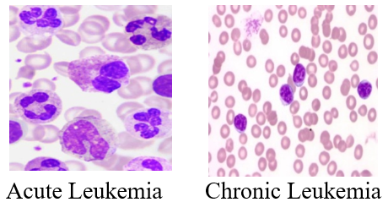
Figure 1. Acute and Chronic Leukemia.
Further, this Leukemia could be categorized into two types according to the size and shape of the White blood cells they are Lymphoblastic or Myelogenous. If the unhygienic cells are granulocytes and monocytes then they are classified as Myelogenous, if the affected cells are lymphocytes, then it is categorized as lymphoblastic [3]. Acute Lymphocytic Leukemia (ALL)is a kind of blood cancer that will form in the bone marrow which is the inner part of the bone [4]. This ALL will be formed on the lymphocytes a kind of RBC that takes care of the immune system There are three main types of lymphocytes, B Lymphocyte which is responsible for producing antibodies, T Lymphocytes which are involved in cell-mediated immunity and Natural Killer which play a key role in the innate immune response by targeting and destroying virus-infected cells and tumor cells. Acute Myeloid Leukemia (AML) is the next kind of blood cancer that will also form in the bone marrow but also moves faster into the blood cells. It occasionally spread into other body parts such as lymph nodes and the central nervous system. This AML is also called acute granulocytic leukemia [5]. Chronic Lymphocytic Leukemia (CLL) is another type that progresses very slowly when compared with any other type of Leukemia. This is the most common type of Leukemia which affects older adults. People with this Chronic Lymphocytic Leukemia will experience very frequent infections. This type of Leukemia will increase the risk of getting other forms of cancer [6]. Chronic Myeloid Leukemia (CML) will be found in blood-forming cells of bone marrow. This is also a common type of Leukemia that affects elder adults. This type of leukemia produces many white blood cells and slowly starts crowding in the bone marrow and interfering with the usual WBC [7]. All the subtypes of Leukemia are demonstrated in Figure 2.
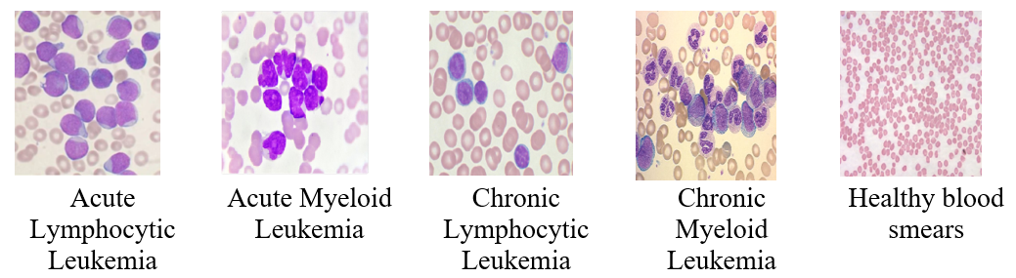
Figure 2. Sub-types of Leukemia.
Different types of medical image classifications using machine learning introduce a new research field of early detection of destructive diseases which reduces the manual system incorporation. The main objectives of this paper are
- The major objective of the proposed system is to apply a hybrid machine learning technique to distinguish Acute Lymphocytic Leukemia detection from the microscopic blood image.
- To incorporate feature extraction in SVM classification, VCC16 Convolutional Neural Networks (CNN) with ImageNet dataset is used[8].
- To incorporate feature extraction in Random Forest classification, A Fuzzy C Means Clustering is incorporated.
- The efficiency of both classification methods is compared based on classification parameters.
- The proposed system is compared with other state-of-the-art machine learning algorithms.

2. Related Works
A hybrid approach [9]has been implemented for classifying WBC Leukemia as the computational training and development cost of the Convolutional Neural Network is high. Here the features are extracted initially from WBC VGGNet which is an influential CNN Framework and pre-trained on ImageNet the features extracted are filtered through the Enhanced Slap Swarm Algorithm which removes the noise signals. This method was tested with two publicly available datasets which show enhanced accuracy and minimized computational complexity. An image processing technique [10] has been used to detect the white blood cells in Acute Myeloid Leukemia, Acute Lymphoblastic Leukemia, and Myeloma here they have used YCbCr for making the image suitable for segmentation, and for segmentation, they have used K means clustering algorithm the feature extraction is done through GLCM and the final classification of the disease was done using the Convolutional Neural network the overall accuracy obtained by their method is 97.3 %. The steps are involved in the classification of leukemia by comparing various image processing techniques and giving the pros and cons of various image processing techniques [11]. A Convolutional Neural Network based method [12] has been utilized for the identification of Leukemia and its subtypes. This method achieves an accuracy of 88% in disease detection and 81% in classifying its subtypes and shows its superior performance than other algorithms such as Naïve Bayes, KNN, and SVM.

A similar CNN-based classifier [13] for detection of the Leukemia archives an accuracy of 99% both with ROC and AUC. The enhanced technique [14] has been compared with several machine learning algorithms for identifying Acute Lymphoblastic Leukemia such as SVM, Logistic regression, decision tree, and random forest classifiers experimental results show all the algorithms show results higher than 90% of which SVM shows its superiority towards the detection of leukemia. But it is not possible to analyze the efficiency of the classifier based on the classification algorithm alone but it needs to have to look into how many datasets they have used how the features are extracted, what type of segmentation algorithm was been used etc. only after considering all these factors can estimate the efficiency of a method. Image segmentation and data mining algorithms-based detection of Acute Lymphoblastic Leukemia [15] has been involved the results classify the ALL into three different classifications they are L1, L2, and L3 which are normal peripheral and abnormal blood smears with an overall accuracy of 98%. A deep learning-enabled method [16] for the classification of Acute Lymphoblastic Leukemia has been utilized, the pre-trained Convolutional Neural Networks as a classifier for classifying leukemia and its subtypes. This method offers an accuracy of 99.00% for disease detection and offers 96.06% for classifying its subtypes. They also compared the results with various other deep learning algorithms such as SVM, KNN, and Hybrid Hierarchical Classifiers the results show the superior performance of CNN.

A Convolutional Neural Network based image classification method [17] has been used to distinguish the test image as a regular or abnormal blood image. Through this method, they have achieved an accuracy of 96.6% with an 1188 blood image dataset. A hybrid random forest-based image classification [18] is involved and suggests that the accuracy of the image classification should be enhanced effectively by selecting the optimal coefficients of the combined algorithm. And the proposed method was more stable and it is suitable for massive images. An improved method [19] has been used for detecting Acute Leukemia using a k-means clustering algorithm. This was implemented through basic image analysis, enhancement, and morphology-based techniques and achieved an accuracy of 92.8%. They also tested the same with other algorithms such as a K nearest Neighborhood algorithm and Naïve Bayes Classifier which shows a very low accuracy. Several related techniques have been surveyed for Leukemia detection such as Support Vector Machines, K Nearest Neighborhood, sequential Neural Networks, etc. Most of the methods show accuracy above 90% of which SVM shows quite higher accuracy than the other algorithms [20]. The image processing method [21] has been implemented for the identification of leukemia in human blood samples. Here the lab color spaced-based segmentation is used on the image to eliminate the unwanted portions in the image and extract the nucleus from the image. The extracted nucleus helps to take the shape-based feature and finally, KNN is used for classifier results showing the accuracy of this method is more than 90%.

A CNN-based Classification of Leukemia [22] has been used with features extracted by pre–a trained deep neural network which is a fine-tuned Alex Net with a dataset of 2820 images. A CNN-based enhanced system [23] has been used to detect Leukemia from the microscopic image analysis with seven different transformation techniques as data augmentation. Experimental results show the existing system has a very low accuracy of 88.25 and as the system is applied to the medical image for disease detection and classification the accuracy should be very high. From the literature survey, it is inferred that most of the research on the WBC blood sample classification was done majorly based on CNN, SVM, and KNN classification methods like MBAML [24], and HALM [18]. Research on the Random Forest and Fuzzy c means is relatively very less. This proposed system utilizes datasets and augmented datasets and altogether 8637 datasets and tested them with a Random Forest Classifier.

3. Materials and Methods
The various details on the dataset collection and various steps involved in processing the image and finally applying the Random Forest algorithm to classify Acute Lymphocytic Leukemia are given.

3.1. Dataset
In this proposed work the datasets are collected from three different sources they are ALL IDB, Cancer Imaging Archive, and locally available diagnostic centers which are freely available sources and which contain microscopic images of both Acute Lymphocytic Leukemia and Healthy Blood smear (See Table 1). The datasets provided from these sources are for research purposes in the field of identifying and classifying Acute Lymphocytic Leukemia images. In these sources, Cancer Imaging Archive provides images for all types of Leukemia and ALL IDB provides a dataset only for Acute Lymphocytic Leukemia which is also considered reliable as per the suggestions given by the oncologist about the locations of the lymphoblast. Few images collected locally are mostly healthy microscopic images. ImageNet dataset is used for the experiments, and it is publicly available in https://paperswithcode.com/dataset/imagenet [8] which are 96x96 pixel in size of which 80% of the images is used as training image and 20% for testing .
Table 1.Dataset collection report from various sources.
Data Set | Type | No. of  Infected | No. of  Healthy | Augmented  Image | Total
ALL IDB | ALL | 178 | 175 | 3532 | 3885
Cancer Imaging  Archive | ALL | 90 | - | 1985 | 2075
Local Diagnostic  Centre | General | 65 | 50 | 2562 | 2677
Total |  |  |  |  | 8637

3.2. Image Augmentation
For any type of Machine learning research, the most important part is the data collection. In this case the data is the image as the research is on a medical application the datasets will not be available and most of them will be confidential. On the other hand, less data for training will lead to overfitting problems which will impact the performance of the system. Data Augmentation is one way through which is used to increase the dataset for any Machine learning algorithms. A variety of image alteration methods such as mirroring, shifting, and rotating, were adopted to acquire the different versions of the real dataset images. The proposed system utilizes the function augmented Image Datastore to increase the training image data by resizing, mirroring, and rotating.
Image resizing is a transformation that changes the size of an image by applying a scaling factor > 1 (Increased by 150%) or <1(Reduced by 50%), Data Mirroring which is obtained by rotating the image from 0 to 360 degree to get additional training data. Image mirroring is done by both horizontal mirroring and vertical mirroring through which the image appear in left will be flipped to right and image in the top will be flipped to bottom [26]. Technically the original image data is transformed but for the system then it will be different data and that avoids the overfitting problem.

3.3. Image Pre-processing
To progress the eminence of the input image and to facilitate the next processing steps pre-processing is required. The microscopic blood images may contain various types of noise in them and at the same time there may be some blurred regions in the image that is significant for the detection. In the initial phase of image pre-processing the image is initially resized using a Matlab function imresize:
$$B= imresize(A, scale)$$ | (1)
Where image B will be scaled times that of A, in this case, the image can be either RGB or binary image, later the image is filtered using the function imfilter.
$$B= imfilter(A, H)$$ | (2)
This function filters the multi-dimensional array A with multi-dimensional filter H. Once the initial resizing and filtering are done the next phase is to convert the SRGB to CMYK and Histogram equalization. Convert the Standard RGB image to CMYK image to the best part of the WBC $n$ the blood image.
$$C = makecform ('srgb2cmyk')$$ | (3)
Histogram equalization is a most familiar technique to improve the dissimilarity of the image through which the contrast is improved and different lighting effects during the image acquisition will be overcome through this histogram equalization [27]. The image pre-processing steps are illustrated in Figure 3.
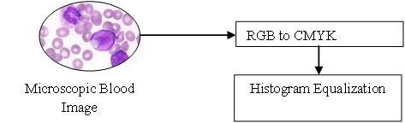
Figure 3. Image Pre-processing steps.

3.4. Image Segmentation
The next step of the classification process is image segmentation because segmentation is the progression of segregating the image into several parts called segments which helps in simplifying the representation of the image easy to understand and also provides meaningful information about the image to be classified. Some of the popular image segmentation techniques are edge detection-related functionality, thresholding technique cluster, and region-related methodologies. One of the very popular image segmentation techniques for medical images is the clustering technique. Clustering can be done in two different ways as Soft and Hard Clustering.
Hard clustering is a process of grouping the pixels in such a way that each pixel will be assigned to any one of the clusters. So that the member function fits into either zero or one to find whether the pixel fits into the cluster or not. Soft clustering is a development of grouping in such a way that data items can be available in multiple clusters at the same time when there is no need for binary memberships. This technique is more efficient than the other technique. The following are the different cluster-based image segmentation techniques available.
K means clustering belongs to the hard clustering category [32]. This is a type of clustering technique where the image is divided into k number of disjoint clusters. This clustering method has two phases. The initial phase is to find the k centroids. In the second phase, it obtains every point to the cluster that has the adjacent centroids from the corresponding data points. The most common method of finding the distance of the adjacent centroid is by Euclidean distance technique. Once the grouping was completed it re-computes the latest centroid of individual clusters based on the centroids and allocates the new points with the shortest distance to the cluster [28]. Thus, this algorithm is an iterative algorithm that reduces the overall distance from each object from the centroid, throughout the cluster in Figure 4.
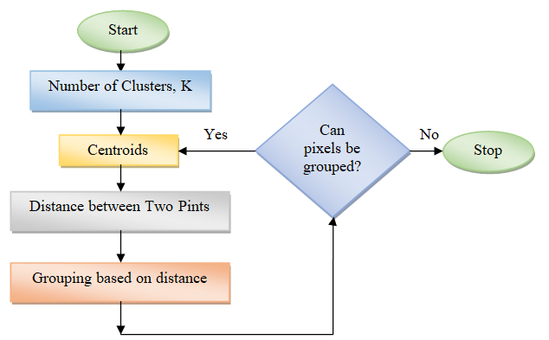
Figure 4. K-Means Clustering.
Fuzzy c means a process of clustering that allocates a single pixel of the image to belong to several clusters which come under the category of soft clustering. This clustering type is very common in pattern reorganization and soft medical image segmentation, the reduction of the subsequent object function.
$$J_{m} = \sum_{i=1}^{N}{\sum_{j=1}^{C}{u_{ij}^{m}}}{\left|\left|x_{i}-c_{j}\right|\right|}^{2}$$ | (4)
Here m is the real number, $u_{ij}$ is the membership degree,$x_{i}$ is the calculated data,$c_{j}$demonstrates the d-dimensional cluster.
Algorithm: FCM (Fuzzy C Means)
Step 1: Set U=[u_{ij}] matrix, U⁽⁰⁾
Step 2:Compute the centres vectors C^{(k)} = [c_{j}] with U^{(k)}
$$c_{j}= \frac{\sum_{i=1}^{N}{u_{ij}^{m}{.x}_{i}}}{\sum_{i=1}^{N}{u_{ij}^{m}}} (5)$$
Step 3: Modify U ^{(k)}, U ^{(k+1)}
$$u_{ij}= \frac{1}{\sum_{k=1}^{c}{{\left(\frac{\left\|x_{i}-\left.c_{j}\right\|\right.}{\left\|x_{i}-\left.c_{k}\right\|\right.}\right)}^{\frac{2}{m-1}}}} (6)$$
Step 4: If$\max_{ij}\left\{\left\|u_{ij}^{(k+1)}-\left.\left.u_{ij}^{(k)}\right\|\right\}\right.\right.<£$; then Exit; elsego to step 2.
Where
- u denotes the membership function
- x demonstrates centroids
- x illustrates the pixel intensity
- £ is the termination criteria
In this proposed system is implemented using this Fuzzy C-Means (FCM) clustering is a soft clustering technique where each data point belongs to multiple clusters with varying degrees of membership, represented by membership values [33]. The algorithm iteratively updates cluster centroids and calculates Euclidean distances to determine the degree of membership, minimizing the objective function based on these distances. Each centroid is computed as the weighted average of the data points, with the weights determined by the membership values it is illustrated in Figure 5. Through this, WBCs separates from other blood cells for the detection of lymphocytes.
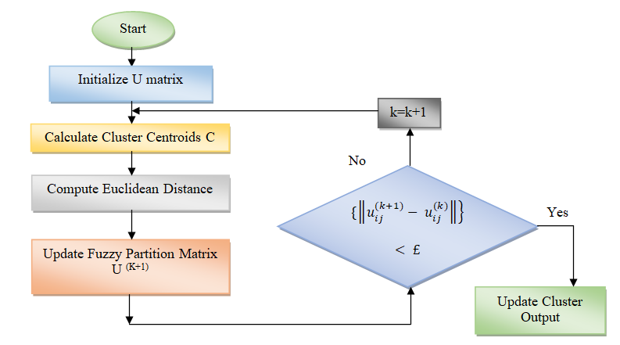
Figure 5. Flowchart of FCM (Fuzzy C Means) Clustering.

3.5. Feature Extraction
It is a significant point in the process of image classification. This helps in isolating the common properties of the image and converting the image into data so that it can process the data with the standard values which helps in identifying the infected image. Apart from the process of individual segmentation features required to train the models. The color features are extracted by converting the image to HSV then getting the values of HSV and then mean values of HSV can be calculated [29]. The Mean of the segmented image will be used as a threshold of the elements of a matrix.
$$Mean = mean2(Image)$$ | (7)
$$Standard_Deviation = std2(Image)$$ | (8)
The entropy is the state of concentration point that entity pixels can adapt which is used for qualitative analysis, evaluation, and comparison of image details.
$$Entropy = entropy(Image)$$ | (9)
For finding the similarities between the two images, if there is no difference between any two images then the result of the (5) above function is zero.
$$RMS = mean2(rms(Image))$$ | (10)
The mean value gives the individual pixel intensity of the whole image. Variance is used for identifying how each pixel varies from the neighboring pixel.
$$Variance = mean2(var(double(Image)))$$ | (11)
Contrast is the dissimilarity in the luminance that creates an object discernible from the other within the same ROI.
$$Contrast= \sum_{i,j=0}^{N-1}{{\left(i,j\right)}^{2} C\left(i,j\right)}$$ | (12)
$$Energy=\sum_{k=0}^{n}{\left(\begin{matrix}n \\ k\end{matrix}\right)}x^{k}a^{n-k}$$ | (13)

3.6. Image Classification
The final stage is to compare the features of the input images with the features of the infected image which is done in this image classification stage. For performing this operation, the classifier is trained with features extracted from the previous stage. In this proposed system the classification is tested with two different Machine Learning Algorithms which are Support Vector Machine and Hybrid FCM and Random Forest Classification and the results are compared with other Machine learning algorithms also to find an efficient classifier for detecting the Acute Lymphocytic Leukemia which is demonstrated in Figure 6.
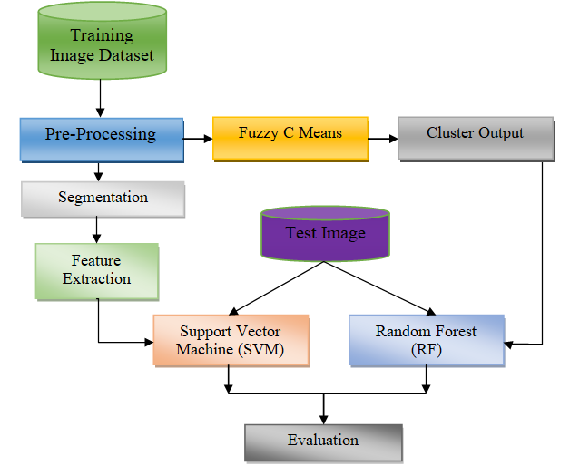
Figure 6. Flowchart for the proposed system.
SVM Support Vector Machine is the supervised Machine Learning Algorithm used for both the organization and regression of images. I perform well when have to perform binary classification. This falls under the machine learning category called kernel method and it is also called kernel machines. For performing this action feature extraction is done using Convolution Neural Networks (CNN) VGG 16 feature extraction. VGG 16 is a CNN that has sixteen layers deep, which is done by loading the pre-trained version of the trained network with millions of images through the ImageNet database. This network can classify the images into various categories such as cars, animals, humans, mouse, keyboards, etc. as the network has learned the features of various images [30]. Figure 7 represents the Support Vector Machine Classification; the main task is to find the hyperplane or the ideal line that separates the two classes.
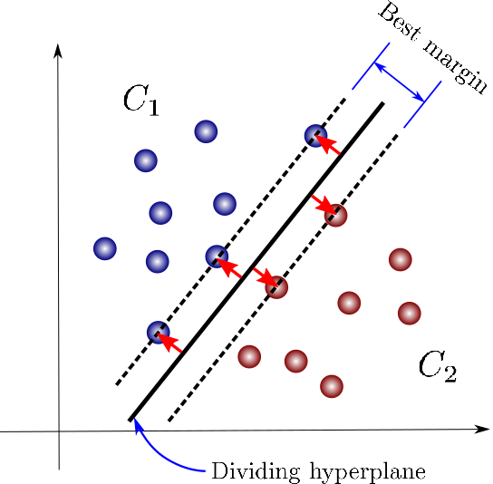
Figure 7. Support Vector Machine Classifier.
Random Forest is a powerful tool used mainly for solving classification problems [31]. The most important disadvantage of the decision tree algorithm is the overfitting problem when the tree is deep the Random Forest classifier can limit the overfitting problem if there are more trees. The Random Forest is made of many trees more trees mean more strong forest. The Random Forest classifier gets the images from the dataset and creates a decision tree. The system gets the prediction from each decision tree and finally selects the best prediction based on the majority voting. The working process of the Random process algorithm is by selecting L random data points from the training data set. Then it constructs a tree corresponding to the selected L data points which is the subset. Choose the number of trees that needs to be constructed. These steps are iterated, and the results of each tree are evaluated and compared by majority voting in Figure 8. The random forest is the combination of multiple numbers of trees to predict the class of the dataset. Some of the trees may give correct output and some may not, but when all the trees combine, they predict the class correctly. To make the random forest algorithm more efficient there should be the exact values in the dataset and the prediction results of each tree should have low correlations so that the random forest classifier can produce more accurate results than randomly predicted results this is achieved by Fuzzy C Mean Clustering algorithm which is used for extracting the actual values of the feature variable. The random forest classification algorithm is chosen for this proposed system because it takes very less time another major benefit of using a random forest classifier is it can maintain its accuracy when a large amount of data is unavailable or missing.
SVM was selected for its ability to handle high-dimensional data and find optimal classification boundaries, which is crucial for distinguishing between overlapping classes in leukemia detection. RF was chosen for its robustness in handling complex datasets and its ensemble approach, which improves classification accuracy by combining multiple decision trees. Together, RF generates a reliable feature set, and SVM enhances boundary precision, making the hybrid method highly effective for medical image classification. This combination provides better accuracy and stability than using either algorithm alone.
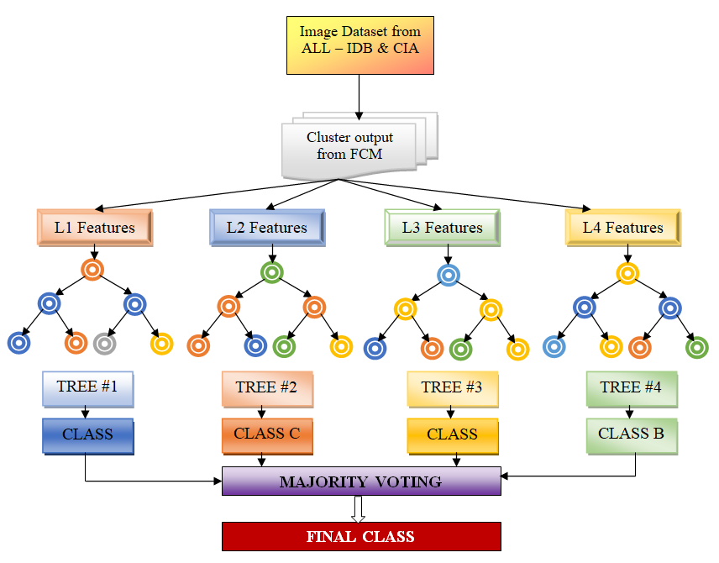
Figure 8. Flowchart of Random Forest Classifier.
Algorithm Random Forest Classifier
Step 1: Select Random L features from the features extracted from the image dataset.
Step 2: For Each y in L
- The Information gain is calculated as
- Gain (a, y) = E(a) – E(a,y) (14)
- $E\left(a\right)= \sum_{i=c}^{c}{-P_{i}\log_{2}P_{i}}$ (15)
- $E\left(a,y\right)= \sum_{c∈y}{P\left(c\right)E(c)}$ (16)
- Here E(a) is the entropy of two classes, and E(a,y) is the entropy of feature y.
- Select Node h which has the maximum information gain
- Divide the nodes into sub-nodes
- Iterate steps I, II, and III to build the tree until it achieves the least number of samples necessary to be divided.
Step 3: Reiterate steps 1 and 2 N time for building the forest with N trees.

4. Results and Discussion
The proposed method of classification of Acute Lymphocytic Leukemia was performed in Matlab R2018 tools. The proposed methodology is compared with the related methodologies of VCGNet [8], GLCM [11], CNN [13], MBAML [24], and HALM [25]. The images from various sources such as ALL IDB and cancer imaging archives are initially augmented to improve the classification accuracy and to avoid overfitting problems. The flow of operation is given below:
Step 1: The image is pre-processed for removing the unwanted noise in the image, exposure, and lighting effects while extracting the blood samples through the microscope. This process is done by converting the image from SRGB to CMYK and histogram equalization.
Step 2: The image is segmented using fuzzy c means clustering through this image is divided into various clusters.
Step 3: Image features like colour and texture feature are extracted from the segmented images to perform the complex training operation.
Step 4: Using the SVM and Hybrid FCM RF classifier and finally the image is classified.
Step 5: The performance of two classifiers is compared with their ROC (Receiver Operating Characteristics).
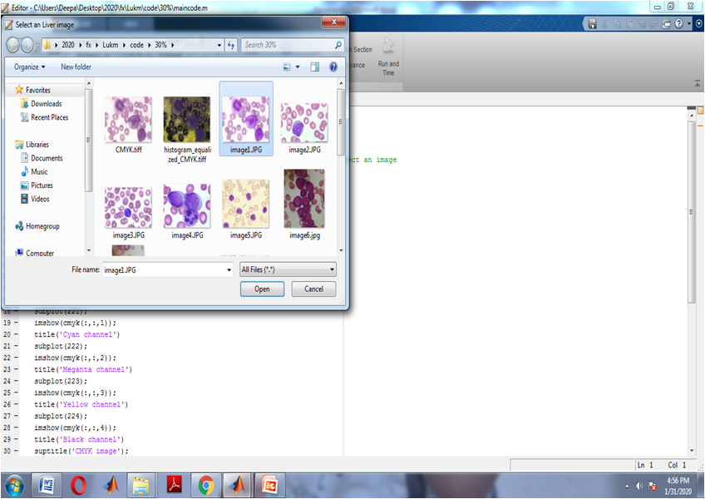
Figure 9. Image Selection from the dataset.
Figure 9 illustrates the image selected from the data set collected from various dataset libraries available online for performing the testing operation. Figure 10 shows that the microscopic image selected from the dataset is loaded into the software for performing the classification operation and Figure 11 illustrates the Image translation from RGB to CMYK format.
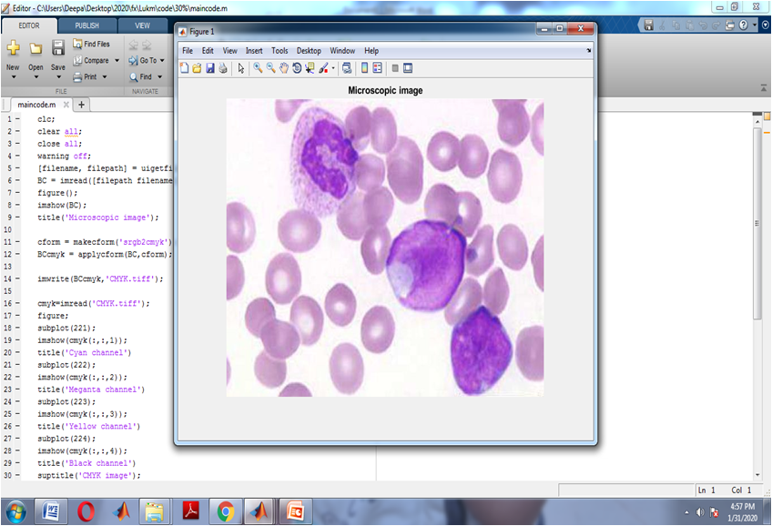
Figure 10. Microscopic image loaded from the dataset.
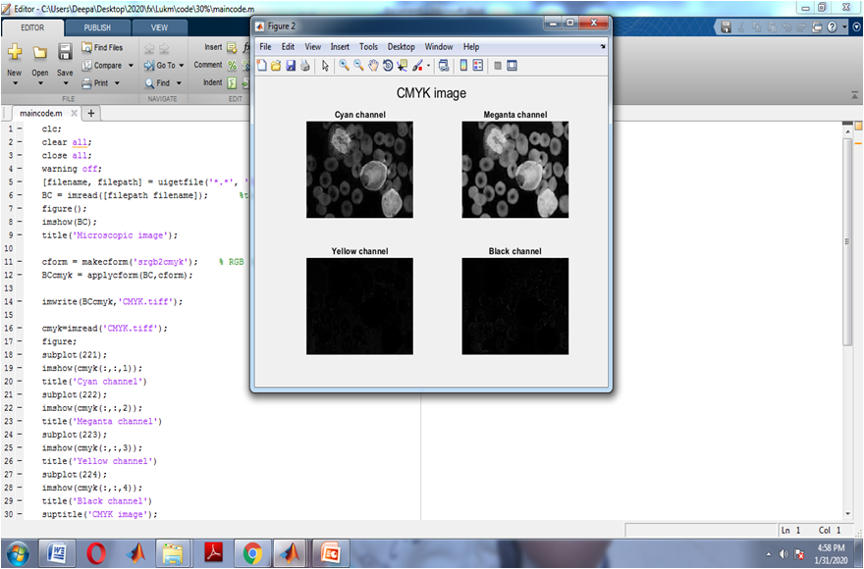
Figure 11. Image translation from RGB to CMYK format.
As the image in the dataset will be in the SRGB format it needs to be converted to CMYK format the purpose of this conversion is to differentiate WBC cells.As the image is a microscopic image there is a possibility of the image getting affected by needless noise and blurring. This could affect the quality of the image and at the same time, there is a possibility of a wrong diagnosis. For this purpose, the CMYK image is histogram equalized which is a very common technique to enhance the contrast of the image. This also overcomes all the lighting effects created during the image capture and Fig. 12 illustrates the Blood Microscopic Image Classified as Normal.
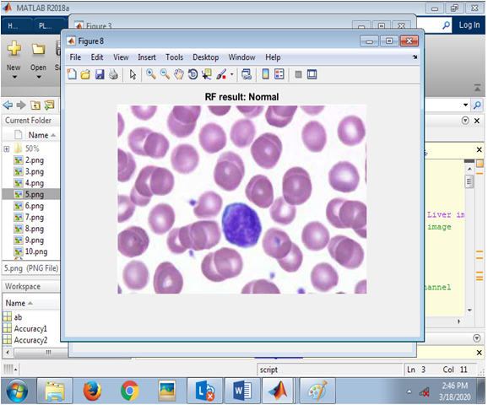
Figure 12. Blood Microscopic Image Classified as Normal.
Performance evaluation can be done through the confusion matrix in Table 2, which is comprised of the four possible outcomes the True Positive (TP) which expects true, the real classification is true, True Negative (TN)which expects False; and the real classification is False, False Positive (FP), which expects True; But the real classification is False, and False Negative (FN)which expects False; and the real classification is True.

Table 2. Confusion Matrix.
Actual Classification | Predicated: Normal | Predicted: Leukemia Infected
Normal | True Negative (TN) 8600.29 | False Positive (FP) 21
Leukemia Infected | False Negative (FN) 61 | True Positive (TP) 8562

The performance metrics like specificity, sensitivity, Accuracy and are calculated using the formula.
$$Accuracy= \frac{TN+TP}{TN+FN+TP+FP}×100$$ | (17)
$$Sensitivity=\frac{TP}{TP+FN}$$ | (18)
$$Specificity= TN/(TN+FP)$$ | (19)
Figure13 shows the ROC curve of the Random Forest classifier which is a graphical representation that shows the diagnostic capability of a classifier. ROC curve is created by plotting the curve of the True Positive against the False Positive at various thresholding settings. Similarly, the ROC curve is plotted for the Support vector machine classifier too. The curve is close to the top left corner of the test is more efficient; with this on comparing both the plots it conclude that the Random Forest classifier is more effective for detecting Acute Lymphocytic Leukemia as the area under the curve of Random Forest (ROC).
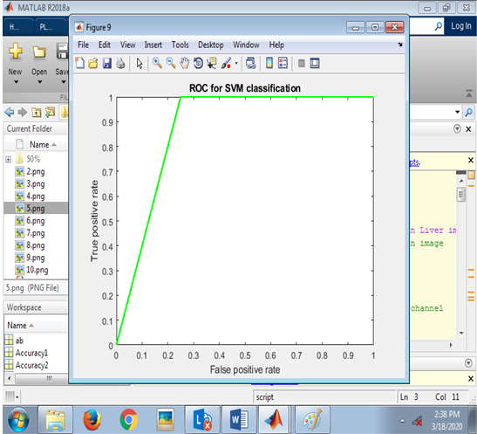
Figure 13. ROC of Support Vector Machine Classifier.
Similarly, the datasets were compared with the Accuracy, Sensitivity, and Specificity of other machine learning algorithms like K Nearest Neighborhood (KNN), Decision tree, Convolution Neural networks (CNN), and Naive Bayes Algorithms experimental results demonstrate the superior performance of Random Forest classifier with Fuzzy C Means segmentation. Figure14 illustrates the comparison of Random Forest with other machine learning algorithms for ALL classification. Figure 15 demonstrates the accuracy of dissimilar ratios of the training and testing dataset, and Figure16 illustrates the training and validation accuracy.
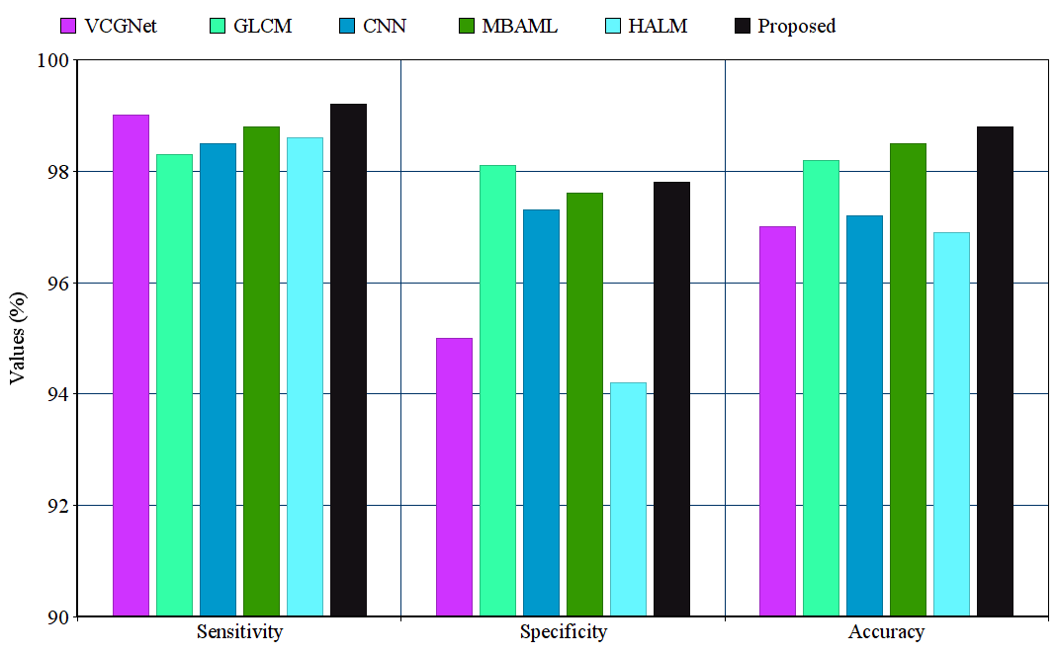
Figure 14. Comparison of Random Forest with other machine learning algorithms for ALL classification.
Fuzzy C-Means (FCM), Random Forest (RF), Support Vector Machine (SVM), and the hybrid RF+SVM offer different strengths in classification. FCM is a clustering algorithm that handles overlapping and ambiguous data well by assigning membership values, making it useful for medical images like leukemia detection. However, FCM is not a classifier and is sensitive to noise and initialization. RF, an ensemble classifier, combines multiple decision trees to provide strong classification performance, especially in complex datasets, but it can be computationally intensive. SVM is highly effective for high-dimensional data and finds an optimal hyperplane for classification, but it struggles with overlapping classes and is sensitive to outliers. The hybrid RF+SVM approach combines RF's ability to handle large, complex datasets with SVM’s strength in optimizing classification boundaries. By using RF to generate a robust feature set and SVM to refine classification, the hybrid method offers superior accuracy and stability compared to standalone FCM, RF, or SVM. This makes RF+SVM particularly effective in medical image analysis, where overlapping data and the need for precise boundaries, such as in leukemia detection, require both robust feature handling and precise classification.
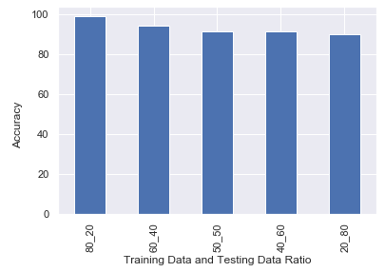
Figure 15. Accuracy of different ratios of the Training and Testing dataset.
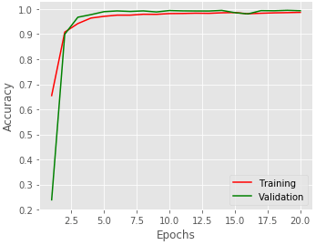
Figure 16. Training and Validation Accuracy.

5. Conclusions
Acute Lymphocytic Leukemia (ALL) is a critical form of cancer that necessitates early detection to prevent severe complications, including organ failure and increased mortality. This study presents a novel approach utilizing a Hybrid Fuzzy C Means (FCM) clustering-based Random Forest (RF) Classifier for the effective classification of Acute Lymphocytic Leukemia into infected and normal categories. The proposed method demonstrated remarkable performance metrics, achieving an accuracy of 99.06%, a sensitivity of 99.4%, and a specificity of 97.8%. These results indicate that the Hybrid FCM and RF Classifier not only surpass traditional manual diagnostic methods but also outperform several other machine learning algorithms, including Support Vector Machine (SVM), K-Nearest Neighbors (KNN), Artificial Neural Networks (ANN), Convolutional Neural Networks (CNN), and Naive Bayes.

The high sensitivity and specificity rates imply that the proposed model can reliably identify both affected and non-affected individuals, minimizing the risk of false negatives and false positives. This capability is crucial in clinical settings, where accurate diagnostics can lead to timely intervention and improved patient outcomes. Moreover, the Receiver Operating Characteristic (ROC) curve analysis reinforces the effectiveness of the Hybrid FCM and RF Classifier as a robust tool for diagnosing Acute Lymphocytic Leukemia, providing clinicians with a reliable method for early detection. Looking ahead, future work will focus on the development of user-friendly applications for mobile and Windows platforms that enable the detection of various diseases through microscopic imaging of blood smears. Such advancements could democratize access to accurate diagnostic tools, especially in resource-limited settings, ultimately enhancing patient care and outcomes in the fight against leukemia and potentially other hematological disorders.
Funding: This research received no specific grant from any funding agency in the public, commercial, or not-for-profit sectors.
Data Availability: The data used to support the findings of this study are available from the corresponding author upon request.
Dataset used: ImageNet dataset is used for the experiments and it is publicly available in https://paperswithcode.com/dataset/imagenet
Acknowledgment: The authors would like to express their appreciation to the Universities invloved. The authors would like to thank the participants for their time in contributing to this study.
Conflicts of Interest:The authors have no conflicts of interest to declare.

References
- Fameshwari, and Dey, A.K., (2018). Blood Leukemia Detection Using Neural Networks And Fuzzy Logic: A Survey And Taxonomy. i-manager’s Journal on Image Processing, 5(3), 34-39.
- J. Shijie, W. Ping, J. Peiyi and H. Siping, (2017) "Research on data augmentation for image classification based on convolution neural networks," Chinese Automation Congress (CAC), Jinan, 2017, pp. 4165-4170.
- Mikołajczyk, Agnieszka &Grochowski, Michał. (2018). Data augmentation for improving Machine learning in image classification problem, International Interdisciplinary PhDWorkshop 117-122. 10.1109/IIPHDW.2018.8388338.
- Jamila Harbi and Rana Ali, (2016), Acute Lymphocytic Leukemia Detection and Classification (ALLDC) System. International Journal of Computer Applications 147(4):47-57.
- Rehman, A, Abbas, N, Saba, T, Rahman, SIU, Mehmood, Z and Kolivand, H (2018) Classification of acute lymphoblastic leukemia using Machine learning. Microscopy Research and Technique, 81 (11). ISSN 1097-0029
- Dhivyaa, C.R., Sangeetha, K., Balamurugan, M. et al. (2020) Skin lesion classification using decision trees and random forest algorithms. J Ambient Intell Human Comput.
- Tiwari K., Patel M. (2020) Facial Expression Recognition Using Random Forest Classifier. In: Mathur G., Sharma H., Bundele M., Dey N., Paprzycki M. (eds) International Conference on Artificial Intelligence: Advances and Applications 2019. Algorithms for Intelligent Systems. Springer, Singapore.
- J. Deng, W. Dong, R. Socher, L. -J. Li, Kai Li and Li Fei-Fei, "ImageNet: A large-scale hierarchical image database," 2009 IEEE Conference on Computer Vision and Pattern Recognition, Miami, FL, USA, 2009, pp. 248-255, doi: 10.1109/CVPR.2009.5206848.
- Sahlol, A.T., Kollmannsberger, P. &Ewees, A.A. (2020) Efficient Classification of White Blood Cell Leukemia with Improved Swarm Optimization of Machine Features. Sci Rep 10, 2536.
- R. Agrawal, S. Satapathy, G. Bagla and K. Rajakumar, "Detection of White Blood Cell Cancer using Image Processing," 2019 International Conference on Vision Towards Emerging Trends in Communication and Networking (ViTECoN), 2019, pp. 1-6.
- Saif S Al-jaboriy, Nilam Nur Amir Sjarif, SuriayatiChuprat, "Segmentation and Detection of Acute Leukemia Using Image Processing and Machine Learning Techniques: A Review", REVISTA AUS, vol. 26, no. 2, pp. 511 - 531, 2019.
- TatdowPansombut, SiripenWikaisuksakul, KittiyaKhongkraphan, AniruthPhon-on, "Convolutional Neural Networks for Recognition of Lymphoblast Cell Images", Computational Intelligence and Neuroscience, vol. 2019, Article ID 7519603, 12 pages, 2019.
- Deepika Kumar, Nikita Jain, Aayush Khurana, Sweta Mittal, Suresh Chandra Satapathy, Roman Senkerik, Jude D. Hemanth, Automatic Detection of White Blood Cancer From Bone Marrow Microscopic Images Using Convolutional Neural Networks, IEEE Access, Vol. 8, pp. 142521 -31, 2020.
- Kokeb Dese, Hakkins Raj, Gelan Ayana, TilahunYemane, WondimagegnAdissu, Janarthanan Krishnamoorthy, Timothy Kwa, Accurate Machine-Learning-Based classification of Leukemia from Blood Smear Images, Clinical Lymphoma Myeloma and Leukemia, vol. 21, no. 11, 2021, pp. 903-914.
- Acharya, V., Kumar, P. Detection of acute lymphoblastic leukemia using image segmentation and data mining algorithms. Med Biol Eng Comput 57, 1783–1811 (2019).
- Sarmad Shafique, SamabiaTehsin, Acute Lymphoblastic Leukemia Detection and Classification of Its Subtypes Using Pretrained Deep Convolutional Neural Networks, Technology in Cancer Research & Treatment, vol. 17, pp. 1-7, 2018.
- Thanh, Caleb Vununu, SukhrobAtoev, Suk-Hwan Lee, Ki-Ryong Kwon, Leukemia Blood Cell Image Classification Using Convolutional Neural Network, International Journal of Computer Theory and Engineering, vol. 10, no. 2, pp. 54-58, 2018.
- Choudhary R.R., Sharma S., Meena G. (2018) Detection of Leukemia in Human Blood Samples Through Image Processing. In: Bhattacharyya P., Sastry H., Marriboyina V., Sharma R. (eds) Smart and Innovative Trends in Next Generation Computing Technologies. NGCT 2017. Communications in Computer and Information Science, vol 828. Springer, Singapore.
- Kumar S., Mishra S., Asthana P., Pragya (2018) Automated Detection of Acute Leukemia Using K-mean Clustering Algorithm. In: Bhatia S., Mishra K., Tiwari S., Singh V. (eds) Advances in Computer and Computational Sciences. Advances in Intelligent Systems and Computing, vol 554. Springer, Singapore.
- R. G. Bagasjvara, I. Candradewi, S. Hartati and A. Harjoko, "Automated detection and classification techniques of Acute leukemia using image processing: A review," 2016 2nd International Conference on Science and Technology-Computer (ICST), 2016, pp. 35-43.
- Chowdhury, A.R., Chatterjee, T. & Banerjee, S. (2019) A Random Forest classifier-based approach in the detection of abnormalities in the retina. Med Biol Eng Comput 57, 193–203.
- Kumar S., Mishra S., Asthana P., Pragya (2018) Automated Detection of Acute Leukemia Using K-mean Clustering Algorithm. In: Bhatia S., Mishra K., Tiwari S., Singh V. (eds) Advances in Computer and Computational Sciences. Advances in Intelligent Systems and Computing, vol 554. Springer, Singapore.
- Ahmed, N.; Yigit, A.; Isik, Z.; Alpkocak, A. (2019) Identification of Leukemia Subtypes from Microscopic Images Using Convolutional Neural Network. Diagnostics , 9, 104.
- Kumar, P., &Udwadia, S. M. (2017). Automatic detection of Acute Myeloid Leukemia from microscopic blood smear image. In 2017 International Conference on Advances in Computing, Communications and Informatics, ICACCI 2017 (Vol. 2017-January, pp. 1803-1808). Institute of Electrical and Electronics Engineers Inc.
- Santhakumar, D., Logeswari, (2020) S. Hybrid ant lion mutated ant colony optimizer technique for Leukemia prediction using microarray gene data. J Ambient Intell Human Comput.
- Awaluddin B-A, Chao C-T, Chiou J-S. Investigating Effective Geometric Transformation for Image Augmentation to Improve Static Hand Gestures with a Pre-Trained Convolutional Neural Network. Mathematics. 2023; 11(23):4783. https://doi.org/10.3390/math11234783
- Kwiek P, Jakubowska M. Color Standardization of Chemical Solution Images Using Template-Based Histogram Matching in Deep Learning Regression. Algorithms. 2024; 17(8):335. https://doi.org/10.3390/a17080335
- Patil, R. V. ., Aggarwal, R. ., Poddar, G. M. ., Bhowmik, M. ., & K. Patil, M. . (2024). Embedded Integration Strategy to Image Segmentation Using Canny Edge and K-Means Algorithm. International Journal of Intelligent Systems and Applications in Engineering, 12(13s), 01–08.
- Wamidh K. Mutlag et al 2020 J. Phys.: Conf. Ser. 1591 012028
- Sunardi Sunardi, Sri Winiarti, Ulaya Ahdiani, Agung Parmono; Image classification with support vector machine to identify Indonesian traditional building types. AIP Conf. Proc. 29 November 2023; 2702 (1): 060012. https://doi.org/10.1063/5.0181055
- Mohapatra, N., Shreya, K., Chinmay, A. (2020). Optimization of the Random Forest Algorithm. In: Borah, S., Emilia Balas, V., Polkowski, Z. (eds) Advances in Data Science and Management. Lecture Notes on Data Engineering and Communications Technologies, vol 37. Springer, Singapore. https://doi.org/10.1007/978-981-15-0978-0_19
- Nsugbe, E. (2022). A Pilot on the Use of Unsupervised Learning and Probabilistic Modelling Towards Cancer Extent Prediction. Artificial Intelligence and Applications, 1(3), 155–160. https://doi.org/10.47852/bonviewAIA2202308
- Nsugbe, E. (2024). Towards Unsupervised Learning Driven Intelligence for Prediction of Prostate Cancer. Artificial Intelligence and Applications. https://doi.org/10.47852/bonviewAIA42022210

