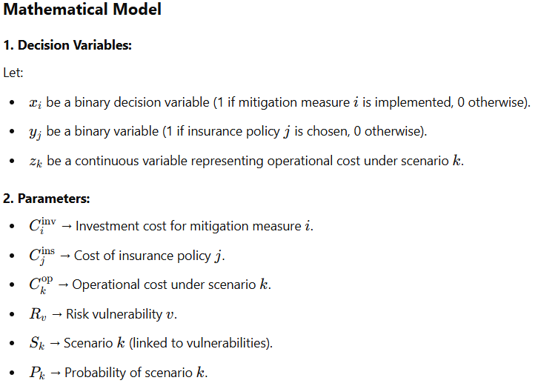
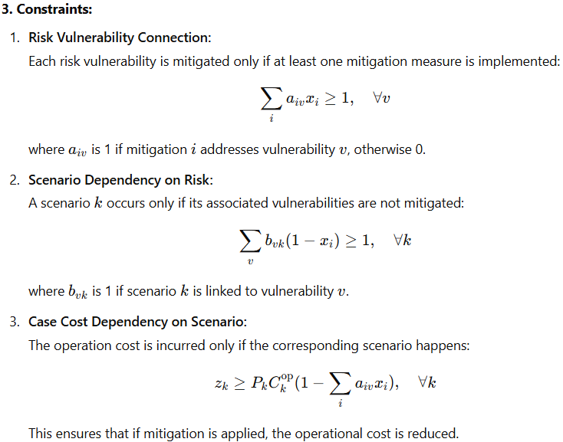
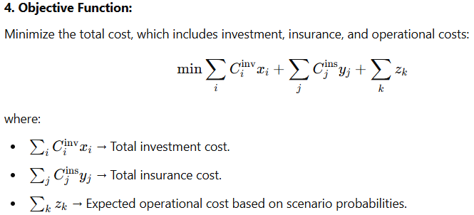
Risk Vulnerability Assessment Framework
You can use standard cybersecurity frameworks like:
- NIST Cybersecurity Framework (CSF)
- ISO 27001 Risk Assessment
- MITRE ATT&CK Framework
Each framework provides a structured way to identify, analyze, and prioritize vulnerabilities.

2. Metrics for Measuring Risk Vulnerabilities
To quantify vulnerabilities, consider these key factors:
A. Likelihood of Exploitation (L)
- How easy is it to exploit the vulnerability?
- Can be measured using Common Vulnerability Scoring System (CVSS) or historical attack frequency.
- Scale: Low (1), Medium (2), High (3)
B. Impact Severity (I)
- If exploited, what is the potential damage?
- Categories: Data loss, financial loss, operational disruption, reputation damage
- Scale: Low (1), Medium (2), High (3), Critical (4)
C. Exposure Level (E)
- How widespread is the vulnerability in the system?
- Based on number of affected assets, network exposure, or access level required
- Scale: Low (1), Medium (2), High (3)

3. Risk Vulnerability Score Calculation
A simple way to quantify risk is using a risk score formula:
Risk Score=L×I×E\text{Risk Score} = L \times I \times ERisk Score=L×I×E
- Higher scores indicate more critical vulnerabilities.
- Example: A vulnerability with L = 3 (High), I = 4 (Critical), E = 2 (Medium)
→ Risk Score = 3 × 4 × 2 = 24 (Severe Risk)

4. Mapping Risk to Cybersecurity Scenarios
Once risk scores are calculated, they can be used to define cyber risk scenarios in the supply chain:
- Scenario 1: Data breach in third-party logistics → Risk score 18
- Scenario 2: Ransomware attack on supplier’s IT system → Risk score 24
- Scenario 3: Phishing attack leading to credential theft → Risk score 12
These scenarios help in deciding which vulnerabilities to mitigate first.

5. Automated Risk Assessment Tools
To streamline vulnerability measurement, you can use:
Vulnerability Scanners (Nessus, Qualys, OpenVAS)
Penetration Testing Tools (Metasploit, Burp Suite)
Risk Management Platforms (RiskLens, FAIR model)

6. Linking Risk Scores to the Optimization Model
- The risk score can be an input to the operational cost function in your optimization model.
- If mitigation xix_ixi​ is applied, reduce the risk score and scenario probability.
- Helps in prioritizing cost-effective security investments.
This model now integrates:
- Expanded Cyber Threats (phishing, ransomware, insider threats, supply chain infiltration).
- Risk Management Factors (resilience, redundancy, monitoring, vendor compliance).
- Regulatory & Compliance Constraints (GDPR, NIST, ISO 27001).
- Financial Impacts (business continuity, insurance, IP theft).
- Advanced Technologies (AI-driven security, zero-trust architecture).
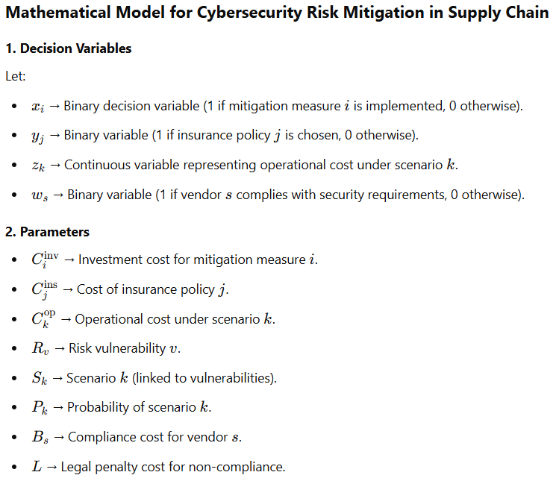
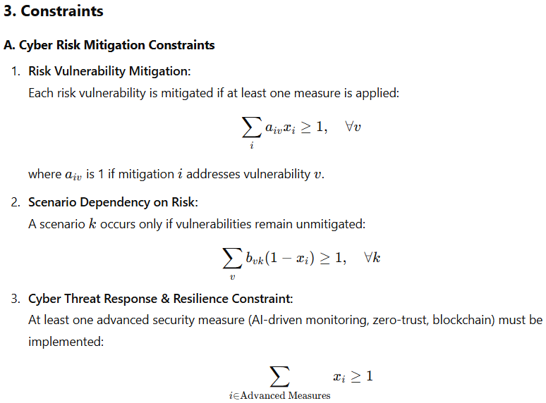
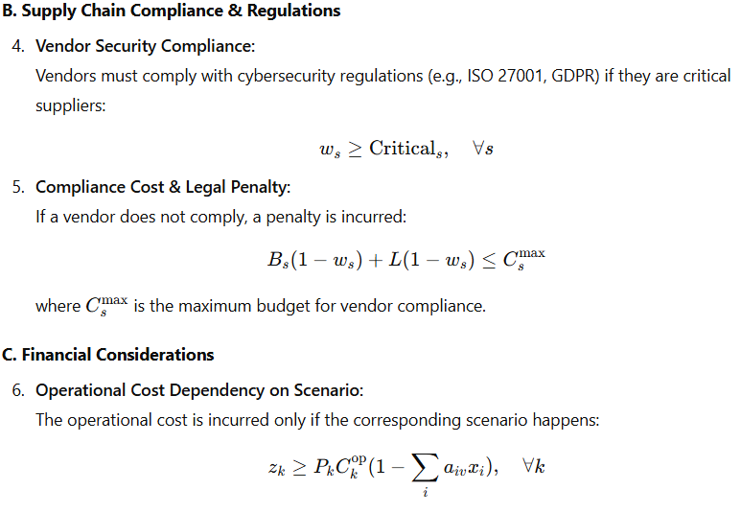
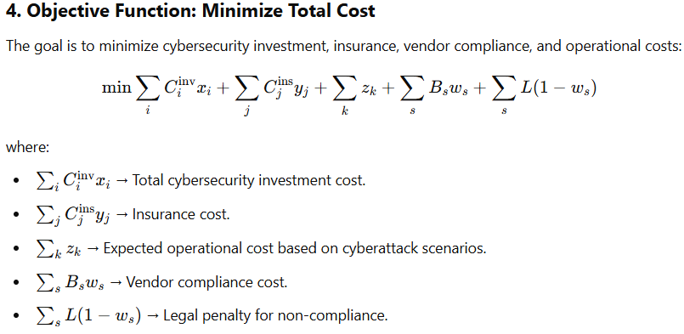
key Enhancements in This Model
Advanced Threat Coverage (DDoS, ransomware, insider threats, IoT vulnerabilities).
Resilience Considerations (blockchain, AI-driven threat detection, zero-trust).
Regulatory Compliance (GDPR, ISO 27001) with vendor penalties.
Economic Impact (business continuity, cyber insurance, risk-sharing).
Supply Chain Security & Risk Sharing (ensuring vendor compliance).
https://chatgpt.com/canvas/shared/67d11f1688248191add1a77f16259f5b
Summary of the Model in Simple Terms
- We select cybersecurity measures (xi)and insurance policies (yj).
- We check if our vendors comply with security standards (ws).
- If vendors do not comply, they face penalties.
- Cyberattack scenarios occur only if vulnerabilities are not mitigated.
- Operational costs depend on whether an attack happens.
- We aim to minimize total cybersecurity costs by balancing investments, insurance, operations, and compliance.
https://chatgpt.com/canvas/shared/67d1237f8fdc8191b0a55fef3cd3062d
Network Graph → Shows relationships between mitigation, risks, scenarios, and costs.
Pie Chart → Displays the cost breakdown of different cybersecurity measures.
Risk Impact Curve → Demonstrates how increasing cyberattack probability affects operational costs.
Heatmap → Maps which mitigation strategies address which cyber risks.
Optimization Convergence Graph → Illustrates cost reduction over optimization iterations.
Define Decision Variables → Choose mitigation measures, insurance, and vendor compliance.
Set Parameters → Define costs, risks, probabilities, and penalties.
Define Constraints → Ensure cybersecurity measures mitigate vulnerabilities, vendors comply, and cost rules hold.
Define Objective Function → Minimize total cybersecurity cost.
Solve the Optimization Problem → Find the best set of decisions to minimize cost while reducing cyber risk.
Display Results → Show which measures are implemented, insurance selected, and operational costs.
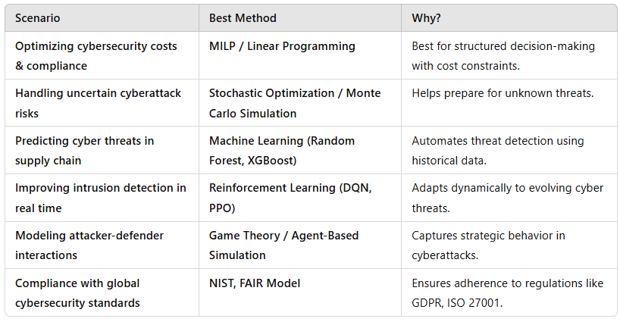
Uses MILP (Mixed-Integer Linear Programming) to optimize cybersecurity investments.
Ensures each vulnerability is mitigated by at least one security measure.
Models attack scenarios with probability-based cost impact.
Includes insurance policies for additional protection.
Ensures vendor compliance under a cost constraint.
Minimizes total cybersecurity cost while mitigating risks.
https://chatgpt.com/canvas/shared/67d126ef98988191809c611e98d66faa
Considerations for Cybersecurity Risk Mitigation in Supply Chain & Why They Matter
When designing the cybersecurity risk mitigation model, we need to consider multiple factors to ensure completeness, practicality, and efficiency. Below are the key considerations and their importance:

1. Cyber Threats & Attack Vectors
Consideration:
- Types of cyber threats (e.g., ransomware, phishing, DDoS, insider threats, supply chain infiltration).
- How threats spread across suppliers, vendors, and IT infrastructure.
Why?
- Different cyber threats require different mitigation strategies.
- Understanding threat vectors helps in prioritizing investments in cybersecurity measures.
- Attackers often target the weakest link in the supply chain, so identifying all vulnerabilities is crucial.

2. Risk Mitigation Measures
Consideration:
- Technical controls: Firewalls, intrusion detection, endpoint protection.
- Process controls: Security policies, audits, vendor compliance.
- Advanced technologies: AI-driven threat monitoring, blockchain for secure transactions.
Why?
- A mix of technical, procedural, and strategic controls improves overall resilience.
- Preventive security reduces long-term costs by avoiding incidents rather than responding to them.
- Advanced technologies provide real-time protection against evolving threats.

3. Regulatory Compliance & Legal Requirements
Consideration:
- Compliance with international cybersecurity regulations (e.g., GDPR, NIST, ISO 27001).
- Vendor security audits and certification requirements.
- Legal penalties for non-compliance.
Why?
- Regulatory non-compliance leads to fines and reputational damage.
- Customers and partners prefer working with companies that follow security best practices.
- Legal frameworks dictate minimum security standards that organizations must meet.

4. Supply Chain Complexity & Vendor Risks
Consideration:
- Number of third-party vendors and their cybersecurity maturity levels.
- Risk-sharing agreements (who is responsible for security breaches?).
- Dependency on critical suppliers (e.g., single-source vs. multi-source suppliers).
Why?
- Weak security at a vendor can compromise the entire supply chain.
- Some suppliers may not prioritize cybersecurity, requiring additional investment in vendor audits.
- Cyber risk should be shared contractually, so companies are not left absorbing all the damage.

5. Financial Impact of Cyberattacks
Consideration:
- Direct financial losses: Ransom payments, data recovery, regulatory fines.
- Indirect financial impact: Business disruption, reputational damage, customer loss.
- Insurance coverage options and premium costs.
Why?
- Cyberattacks can cost millions, so financial risk modeling is crucial.
- Cyber insurance can reduce risk but also comes at a cost.
- Decision-makers need to balance the cost of security vs. potential losses.

6. Operational Impact & Business Continuity
Consideration:
- How quickly operations can recover after an attack.
- Redundancy & backup systems to ensure business continuity.
- Disaster recovery plans & incident response strategies.
Why?
- Downtime is expensive and can affect the entire supply chain.
- Organizations must be prepared for rapid response to minimize damage.
- Backup systems reduce data loss and operational delays.

7. Cyber Insurance & Risk Transfer
Consideration:
- What risks are covered by cyber insurance?
- Cost of premiums vs. expected losses.
- Coverage for vendor-related breaches.
Why?
- Cyber insurance reduces financial risk but does not prevent cyberattacks.
- Insurance must align with the actual risks in the supply chain.
- Some policies exclude vendor-related breaches, creating a risk gap.

8. Decision Optimization: Cost vs. Security
Consideration:
- How much to invest in cybersecurity vs. potential savings?
- Trade-offs between insurance, security measures, and compliance.
- Multi-objective optimization (minimizing cost while maximizing security).
Why?
- Over-investing in security can be unnecessary and costly.
- Under-investing increases risk, leading to higher long-term costs.
- The best strategy balances cost, compliance, and risk reduction.

Conclusion: Why These Considerations Matter?
- Holistic Security → Cyber threats don’t operate in isolation; a comprehensive approach is needed.
- Risk Prioritization → Some risks are more critical than others and should be addressed first.
- Financial Sustainability → Investing wisely in cybersecurity saves money in the long run.
- Legal Protection → Regulatory compliance prevents lawsuits and reputational damage.
- Resilience & Business Continuity → Organizations must stay operational even during cyberattacks.


