American Elderberry (Sambucus nigra subsp. canadensis) Biomass as a Supplemental Feed Source for Ruminant Livestock
McKenzie, Eric, Andy Thomas, Harley Naumann, and Ashley Conway-Anderson

Introduction

Background
American elderberry (Sambucus nigra subsp. canadensis) is a hearty, fruit bearing species from the Viburnaceae family that is native to most of the continental United States and southeastern Canada. It thrives in a variety of soil types and soil moisture regimes (Bulatovic-Danilovich, 2022). American elderberry has been used by the Indigenous peoples of North America for centuries. These uses include food, fiber, fuel, medicine, tools, instruments, and toys (Charlebois et al., 2010). Contemporarily, American elderberry has grown in popularity for its use in juices, jams, jellies, baked goods, wines, and liqueurs. Additionally, the global market for nutraceutical products containing elderberry extracts is currently valued at 1.1 billion US dollars and is projected to expand by 8.9% year over year and reach a valuation of 2.9 billion US dollars in the next decade (FMI, 2023). With the anticipated market growth of elderberry products over the next decade, it is expected that there will be a corollary increase in the amount of acreage devoted to elderberry production.
The standard management practice for American elderberry is to coppice the plants after the growing season in preparation for spring regrowth (Byers et al., 2014). Leaves remain on the plant through the time of berry harvest until seasonal leaf abscission in the fall. While elderberry is browsed by the native ruminant, white tail deer (Shrestha & Lubell, 2015), it is also known to contain cyanogenic glycosides (CNG) (Appenteng et al., 2021; Buhrmester et al., 2000; Senica et al., 2017). Latent elderberry leaf biomass following berry harvest is potentially useful for livestock managers, yet the safety and utility as a feed supplement for ruminants has not been thoroughly analyzed. There are several outdated, anecdotal references in the body of literature that refer to domesticated livestock consuming elderberry as a forage source. A 1983 study on riparian plant communities reported that cattle heavily browsed blue elderberry (Sambucus nigra subsp. cerulea) and often consumed more than 100 % of seasonal plant growth (Kauffman et al., 1983). The 1963 book, California Range Brushlands and Browse Plants described blue elderberry as a seasonally palatable forage, and classified its browse rating as fair for cattle, good for goats, and good to fair for sheep (Sampson & Jeperson, 1963). While these testimonies may encourage producers to experiment with elderberry as a supplemental feed source, empirical data that verifies its nutritive value and safety is currently unavailable.
Forage quality considers the nutrient density, digestibility, palatability, intake, and anti-quality factors of a given forage (Ball, 2001; Buxton et al., 1995; Lee, 2018). Environmental factors such as precipitation (Patton et al., 2007; Perotti et al., 2021), soil fertility (Horrocks & Vallentine, 1999; Ward, 1959), altitude (Escobar et al., 2020; Melo et al., 2022), temperature (Hart et al., 2022; M. A. Lee et al., 2017), and light intensity related to latitude (Kumar et al., 2022) can cause variable rates of growth and overall forage quality in a given forage species. The same environmental factors of precipitation (Rolbiecki et al., 2018), soil fertility (Thomas et al., 2013), altitude (Senica, et al., 2017), temperature (Ferreira et al., 2023), and light intensity (Osman et al., 2023) have been demonstrated to affect growth characteristics in both American and European elderberry.

Objective and Hypothesis
The objective of this study is to determine the viability of utilizing American elderberry leaf biomass as a supplemental feed source for ruminant livestock by analyzing the nutrient constituents and CNG content over the course of two growing seasons across six different cultivars grown at two different locations. Considering previous research on the CNG content of American elderberry leaf biomass, we predict that detectable but minimal concentrations of CNGs will be found in the examined biomass. Additionally, past testimonials by field observation have shown that elderberry species might be a valuable forage for ruminant livestock. We predict that the nutritive value of American elderberry will be acceptable as a seasonal feed source for use in ruminant livestock production.

Methods

Study Site
This study utilized American elderberry grown at two locations. The first location is the Horticulture and Agroforestry Research Farm (HARF) in New Franklin, Missouri (39.01604, -92.75164). The Natural Resources Conservation Service (NRCS) has defined this Major Land Resource Area (MLRA) as Central Mississippi Valley Wooded Slopes, Western Part (115b), and the ecoregion is listed as River Hills (72f). This area is comprised of loess covered rolling hills that frequently form ravines as upland, low order streams that converge into the Missouri River. The Web Soil Survey shows that the location is primarily Menfro silt loam (USDA, 2023). HARF receives a mean annual precipitation of 1060 mm and has a freeze-free period of approximately 205 days (USDA, 2024; USDA, 2023). Temperatures at HARF were normal during the sampling months in both years compared to a 10 year average (University of Missouri Extension, 2024; Table 1). Precipitation totals at HARF were slightly above normal in 2021 (1224 mm) when compared to the 30 year average (1060 mm), but the month of June (298 mm) was much higher than the 30 year average for June (127 mm). In 2022 during the months of June, July, August, and September, precipitation totals were 55-65% lower than the 30 year average, and the yearly precipitation total for HARF (739 mm) was much lower than the 30 year average (USDA, 2024; Table 2).
The second growing location is the Southwest Research Center (SWC) in Mount Vernon, Missouri (37.07338, -93.87934). The Natural Resources Conservation Service (NRCS) has defined this Major Land Resource Area (MLRA) as Springfield Plain (116b), and the ecoregion is listed as Springfield Plateau (39a). This area is characterized as a savannah-like transition zone between the Cherokee Plain and the forested Ozark Highlands. The Web Soil Survey displays an approximately even distribution of Creldon, Hoberg, and Gerald silt loams, as well as Keeno gravelly silt loam soil types (USDA, 2023). SWC receives a mean annual precipitation of 1163 mm, and a freeze-free period of approximately 210 days (USDA, 2024; USDA, 2023). The mean temperatures during sampling months at SWC were normal compared to a 10 year average (Table 1). Precipitation totals at SWC were well below the 30 year average in August and September of 2021, and June, July, and September of 2022 (Table 2).

Experimental Design
This study utilized a completely randomized design for six different cultivars, and sampling design was randomized across both growing locations across regular time intervals. As such, treatments for this study included cultivar, sample date, and location. These plots were originally established in 2015 and 2016 at SWC and HARF, respectively. The plots in the initial study examined elderberry flower harvest and the subsequent effects on berry production (McGowan, 2017). Each of the six genotypes were derived from undomesticated varietals and bred to be the cultivars Bob Gordon, Kelly 7-14, Ozark, Pocahontas, Rogersville, and Wyldewood. Each location consisted of 96 total plots, with 16 plots for each cultivar. The individual plots were considered the experimental unit, and for each sample date, cultivar was replicated twice at each location. The plots were spaced at 3 m between the rows and 2.4 m between each plot.
During plot establishment in 2015 and 2016, the soil substrate at each location was amended to increase P and K levels as well as balance the soil pH for elderberry production (Byers et al., 2014). The plot management was intended to be comparable between each location in relation to fertilization, irrigation, pest management, weed control, and pruning as illustrated in the 2014 report, Growing and Marketing Elderberries in Missouri (Byers et al., 2014). However, significantly higher weed pressure was observed at HARF.

Sampling Procedure
Leaf biomass samples were collected each month at both locations from May through September in 4-week intervals during 2021 and 2022. American elderberry has a pinnately compound leaf structure with seven to eleven elliptic leaflets attached to a central rachis. Every four weeks from May through September, randomly assigned plots were harvested by clipping the rachis between the compound leaf and the petiole. The uppermost portion of the plant, the inflorescence, was not harvested in this procedure to avoid compromising berry production.
Each plot was composed of three separate parent plants and was subdivided into A, B, and C subplots. These sub-samples were to ensure a representative collection from each parent plant and were combined into one plot sample after initial dry matter analysis. The collected samples of four to ten leaves, depending on leaf size, were sealed in appropriately labeled plastic bags and stored in an iced cooler while in the field. An aggregate sample of approximately twenty leaves from the entire plot was collected for CNG analysis. Four extra plots of each cultivar were retained at both locations and were utilized as alternates if a particular plot was underproducing. Following collection, samples were then moved from cold storage in the field to a standard chest deep freezer and kept at or below -18°C at the HARF facility in preparation for analysis.

Forage Analysis
Each step in the forage analysis was conducted in duplicate to produce accurate data output. Samples for 60°C dry matter analysis were weighed on a balance scale (A&D Engineering, Model EK-30KL balance, Ann Arbor, MI, USA), and recorded to 0.1g at HARF. The samples were then dried in a mechanical convection horizontal air-flow oven (Blue M Electric, POM-1406F, Watertown, WI, USA) at 60°C for 48 hours and weighed back. The 60°C dry matter (DM) percentage was calculated as follows:
60°C DM% = ((dry weight/wet weight)*100)
A mean 60°C DM percentage for the entire sample plot was generated as an average of subplot samples A, B, and C. Following the drying process, subplot samples A, B, and C were aggregated and ground through a 1 mm screen in a laboratory mill (Thomas Scientific, Thomas-Wiley Model 4 mill, Chadds Ford Township, PA, USA). The samples were then stored in sterile sampling bags (Fisher Scientific, #14-955-186, Hampton, NH, USA) and transported to the University of Missouri-Columbia campus for further analysis.
Ground partial DM samples were used to analyze total DM by weighing sample material to 0.5g (+/- 0.05g) on a balance scale (Fisher Scientific, Accu-124 precision balance, Hampton, NH, USA) and recorded to 0.0001g. The samples were then placed in ceramic crucibles and dried at 100°C for 24 hours in a general-purpose drying oven (Fisher Scientific, Model 6925 isotemp oven, Hampton, NH, USA). After drying, the samples were weighed back. A 100°C DM% and total DM% was calculated using the equations:
100°C DM% = ((100° DM weight/60° DM weight)*100)
Total DM% = ((60° DM%/100° DM%)*100)

Following the total DM analysis, organic matter (OM) analysis was completed by moving the sample containing crucibles into a muffle furnace (Thermo Fisher Scientific, Lindberg/BlueM 5.3L B2 Moldatherm muffle furnace, Waltham, MA, USA). The temperature was set to 600°C for six hours. After allowing the oven to cool to less than 200°C, the samples were removed, cooled in a desiccator, and weighed to 0.0001 of a gram. Ash% and OM% were calculated as follows:
Ash% = ((ash weight/100°C DM weight)*100)
OM% = (100-ash percent)

The Van Soest method was used sequentially for all fiber analysis in this study. Neutral detergent fiber (NDF) analysis involves the removal of all plant cell components such as sugars, pectin, and lipids, but leaves behind cellulose, hemicellulose, and lignin (Van Soest et al., 1991). The sample material was weighed to 0.5g (+/- 0.05g) and sealed in filter bags (Ankom Technology, F57 filter bag, Macedon, NY, USA). The filter bags were placed into a fiber analyzer (Ankom Technology, A200 fiber analyzer, Macedon, NY, USA) and washed with a mild detergent. After rinsing with 80-100°C distilled water and acetone, the filter bags were air dried overnight to evaporate the acetone, and then placed in a 100°C oven for 2-4 hours. After weighing the bags, the NDF% was calculated as follows:
NDF% = ((washed bag weight/ initial bag weight)*100)
Following the removal of specific cell components through NDF analysis, the prepared bags were then used for the acid detergent fiber (ADF) procedure. The protocol used the same equipment and drying procedures as NDF analysis but used a stronger detergent with sulfuric acid. This process removed the hemicellulose that was left over from NDF analysis. After the filter bags were washed and dried, the ADF% was calculated as follows:
ADF% = ((washed bag weight/post-NDF bag weight)*100)
Following the removal of hemicellulose through ADF analysis, the filter bags were then used for the acid detergent lignin (ADL) procedure to remove cellulose. The prepared filter bags were placed in one-gallon jars and 500 ml of 72% sulfuric acid was added to cover the bags. The jars containing filter bags of sample material were placed in an in vitro agitator (Ankom Technology, Daisy Incubator, Macedon, NY, USA) for 3 hours. The jars were then drained, and the bags were rinsed in tap water until the pH was neutral. The bags were then rinsed with acetone and dried identically to the NDF and ADF procedures. After fully drying, ADL% was calculated as follows:
ADL% = ((washed bag weight/post-ADF bag weight)*100)
Sample materials were analyzed for crude protein (CP) content by Dairy One in Ithaca, NY. A nitrogen analyzer (Leco Corporation, CN628 elemental analyzer, St. Joseph, MI, USA) was used to determine crude protein content of the elderberry leaf biomass samples. This process utilized the combustion-based Dumas Method (Simonne et al., 1997) whereby samples are heated to between 800-900°C in the presence of pure oxygen. This produces nitrogen oxide, carbon dioxide, and water. The gases are then separated and removed to isolate and detect the concentration of elemental nitrogen.

Cyanogenic Analysis
Elderberry leaf biomass samples were analyzed for the CNGs amygdalin, linamarin, dhurrin, and sambunigrin at the Metabolomics Center on the University of Missouri-Columbia campus. Elderberry leaves were lyophilized and ground to a fine power using a mortar and pestle. The powder samples (10 ± 0.06 mg) were accurately weighed into glass vials. Extractions were carried out by adding 1.0 mL of 80% methanol/20% water containing internal standard umbelliferone (18 µg/mL). All samples were sonicated and then agitated for 18 h at room temperature. Afterward, the samples were centrifuged at 3500 rpm for 20 min. The supernatants (~900 µL) were transferred into Eppendorf tubes and centrifuged at 15000 rpm for 15 min in a benchtop high-speed microcentrifuge (2400-37, VWR, Radnor, PA). Supernatants were transferred into glass vials and dried using RapidVap evaporator (Labconco Corporation, Kansas City, MO). Extracts were reconstituted in methanol before solid-phase extraction (SPE) and LC-MS/MS analysis. Solid phase extraction (SPE) purifications were carried out using Oasis® HLB 1cc (30-mg) extraction cartridges.
Quantitative measurements of CNGs were performed using a Waters ACQUITY UPLC system coupled to a Xevo TQ-XS triple quadrupole mass spectrometer (UHPLC-MS/MS). Chromatographic separations were performed using an ACQUITY UPLC HSS T3 column (1.8 µM, 2.1 × 100 mm) and a flow rate of 0.5 mL/min. Mobile phases A and B were 2 mM ammonium formate in water and 100% acetonitrile, respectively. The column temperature was set at 45 ºC and the injection volume was 2 µL. The analysis time was 18 min and the elution gradient for mobile B was as follows: initially equilibrated at 1% B; 0-12 min, 1-12% B; 12-12.5 min, 12-95% B; 12.5-14.5 min, 95% B; 14.5-15 min, 95-5% B; 15-18 min, 5-1% B.
The mass spectra were acquired in positive electrospray ionization (ESI) mode. Detection of all analytes was performed using multiple reactions monitoring (MRM) mode. The source temperature and desolvation temperature were maintained at 150 °C and 500 °C, respectively. Nitrogen and argon were used as the desolvation gas (1000 L/h) and collision gas (0.14 ml/min), respectively. The MRM transitions were optimized as follows.
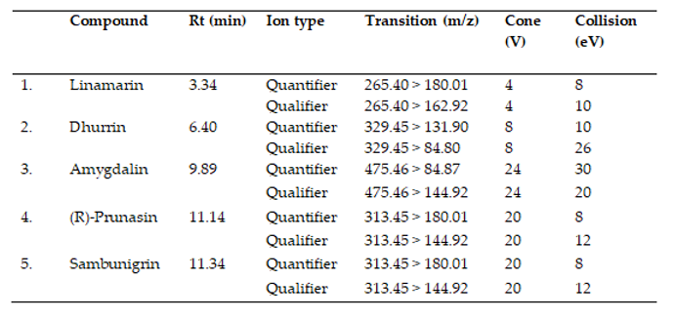
Calibration curves were generated using standard compounds purchased from Sigma and SCBY. MassLynx software (version 4.1, Waters, Milford, MA, USA) was used for instrument control and data processing. Data processing and quantification were processed using Waters QuanLynx software.

Data Analysis
This completely randomized design examined location (SWC, HARF), cultivar (Bob Gordon, Kelly 7-14, Ozark, Pocahontas, Rogersville, and Wyldewood) and sampling date (May, June, July, August, and September) as fixed effects, with sample year (2021, 2022) as a random effect. The overall effect of independent variables (location, cultivar, and sampling date) on mean DM, OM, NDF, ADF, ADL, and CP were tested using analysis of variance (ANOVA) using the GLIMMIX procedure of the SAS statistical software program (version 9.4). The four cyanogenic compounds were tested using analysis of variance (ANOVA) in R statistical software program (R version 3.6.2). Significant interactions (α = 0.05) were evaluated within all levels, and significance was determined if P ≤ 0.05, with tendencies toward significance declared when P ≤ 0.10 and > 0.05. A post hoc Tukey test was then conducted to identify significant differences among treatments.

Results

Forage Analysis
When analyzing the DM concentrations of elderberry leaf biomass, there were observed two-way interactions between location by date (P < 0.001; Figure 1) and location by cultivar (P < 0.001; Figure 2). When comparing interactions between location and date (P < 0.001), DM increases steadily throughout the growing season at both locations. The DM content was higher at HARF in May, not different in June, and higher at SWC in July, August, and September. The DM concentrations were different at SWC and HARF (P < 0.001) when comparing interactions between location and cultivar. The cultivars Wyldewood and Pocahontas were not different at SWC and HARF. Bob Gordon, Kelly 7-14, and Rogersville had higher DM content at SWC, and Ozark had higher DM content at HARF.
When analyzing OM concentrations, there was a three-way interaction (P = 0.017; Table 3) between location, sample date, and cultivar. The only difference for Kelly 7-14 between locations occurred in June (P = 0.047), where OM was higher at SWC (94.05 ± 0.41%) compared to HARF (92.97 ± 0.41%). Differences between locations in June were also observed in the Wyldewood cultivar (P = 0.012), with OM being higher at SWC (94.27 ± 0.41%). Differences in the Ozark cultivar between locations occurred in August (P = 0.012) with OM content at SWC being higher (92.34 ± 0.41%) than at HARF (90.69 ± 0.41%). The cultivars Bob Gordon (92.44 ± 0.35%) and Pocahontas (91.12 ± 0.35%) were different at HARF only in the month of May (P = 0.003). Those same cultivars were different at SWC only in June (P = 0.003), July (P < 0.001) and August (P =0.036). The OM content was higher at SWC for these two cultivars across all sampling dates except for Pocahontas in July where it was higher at HARF (90.09 ± 0.41%) than at SWC (89.74 ± 0.41%). Unlike the other cultivars, Rogersville was consistently higher in OM at SWC compared to HARF throughout the growing season (May: P = 0.010, June: P < 0.001, July: P = 0.003, August: P < 0.001, and September: P < 0.001).
When analyzing the NDF, ADF, and ADL, the means show that over the course of the growing season, NDF (P < 0.001; Figure 3), ADF (P < 0.001; Figure 4), and ADL (P < 0.001; Figure 5) all display a consistent increase in concentration through August, and a declining concentration following the completion berry production into September. The highest fiber concentrations were observed in August for NDF (27.3 ± 1.31%) and ADF (20.4 ± 1.43%), and the lowest in May for NDF (22.5 ± 1.30%) and ADF (15.8 ± 1.41%). The highest ADL concentration was observed in July (11.1 ± 1.01%), and the lowest in May (7.06 ± 1.00%).
When examining fiber constituents by cultivar, there was a difference in NDF concentrations (P < 0.001; Figure 6), ADF had a tendency towards difference between cultivars (P = 0.056; Figure 7) and ADL was not different between cultivars (P = 0.161; Figure 8). The highest NDF concentration was observed in Bob Gordon (26.6 ± 1.33%), and the lowest was found in Wyldewood (23.9 ± 1.32%). The highest ADF concentration was observed in Rogersville (19.6 ± 1.43%), and the lowest was found in Wyldewood (17.9 ± 1.43%). The highest ADL concentration was observed in Rogersville (9.9 ± 1.02%), and the lowest was found in Bob Gordon (8.7 ± 1.02%).
By location, only NDF was different (P < 0.001; Figure 10), while ADF (P = 0.197; Figure 11) and ADL (P = 0.607; Figure 12) showed no variation. The fiber constituent concentrations at SWC for NDF (25.9 ± 1.27%), ADF (18.7 ± 1.40%), and ADL (9.4 ± 0.98%) were higher than what was found at HARF for NDF (24.4 ± 1.27%), ADF (18.3 ± 1.40%), and ADL (9.3 ± 0.98%).
When analyzing CP, only location by date had a tendency to be different (P = 0.054; Figure 13). While observed CP was higher for each sampling date at SWC than at HARF, there was a progressive reduction in CP at both locations throughout the growing season. Crude protein content in August and September at HARF were not different, and July, August, and September at SWC were also not different from each other. The SWC had its highest CP concentration in May (24.8 ± 0.50%) and lowest (16.2 ± 0.57%) in September. The highest CP concentration at HARF was found in May (18.5 ± 0.49%) and lowest at (10.6 ± 0.54%) in September. The means for CP content show a difference (P < 0.001; Figure 9) between the six examined cultivars. Bob Gordon had the highest CP content (17.8 ± 0.47%) and was identical to Rogersville (17.2 ± 0.46%) and Pocahontas (16.5 ± 0.46%). Kelly 7-14 (16.4 ± 0.47%), Ozark (15.9 ± 0.46%), and Wyldewood (15.7 ± 0.45%) were different from Bob Gordon.
Cyanogenic Analysis
Elderberry leaf biomass from the cultivars Bob Gordon and Ozark was analyzed for the cyanogenic compounds amygdalin, linamarin, dhurrin, and sambunigrin. There was a location by cultivar interaction observed for dhurrin concentration (P = 0.007; Figure 14). At SWC, dhurrin content for Bob Gordon was 2.03 ± 0.88 µg/g, and Ozark was 4.43 ± 0.82 µg/g. At HARF, dhurrin content for Bob Gordon was 3.86 ± 0.82 µg/g, and Ozark was 11.32 ± 0.82 µg/g. The Ozark cultivar at HARF was different from Ozark at SWC and Bob Gordon at HARF and SWC.
When examining the means by date, there was no difference in amygdalin content (P = 0.464; Figure 15). Amygdalin concentration ranged between 4.93 ± 2.87 µg/g in September and 0.18 ± 2.87 µg/g in June. There was no difference in linamarin content (P = 0.487; Figure 16) by date. Linamarin content was numerically highest in June at 1.54 ± 0.86 µg/g and dropped to a low of 0.20 ± 0.86µg/g in July. There was no difference in sambunigrin content (P = 0.633; Figure 17) by date. Sambunigrin concentrations were spread between 9.92 ± 4.27 µg/g in September, and 3.31 ± 4.75 µg/g in August.
When examining the means by cultivar, there was no difference in amygdalin content (P = 0.320; Figure 18). The recorded values for amygdalin content were 1.90 ± 1.91µg/g in Bob Gordon, and 0.54 ± 1.82µg/g in Ozark. There was no difference in linamarin content (P = 0.321; Figure 19) by cultivar. The linamarin concentration in Bob Gordon was 0.79 ± 0.57µg/g, and 0.25 ± 0.55µg/g in Ozark. There was no difference in sambunigrin content (P = 0.636; Figure 20) by cultivar. Sambunigrin content was 5.55 ± 2.83µg/g in Bob Gordon, and 4.28 ± 2.70µg/g in Ozark.
When examining the means by location, there was no difference in amygdalin content (P = 0.398; Figure 21). Amygdalin concentration was 2.25 ± 1.91µg/g at SWC, and 0.66 ± 1.82 µg/g at HARF. There was no difference in linamarin content (P = 0.202; Figure 22) by location. Linamarin content at HARF was 0.88 ± 0.55 µg/g, and the 0.15 ± 0.57 µg/g at SWC. There was no difference in sambunigrin content (P = 0.479; Figure 23) by location. The documented sambunigrin concentrations were 5.91 ± 2.83µg/g at SWC, and 3.94 ± 2.70µg/g at HARF.

Discussion
Forage physiology and subsequent nutritive value changes continually throughout the growing season (Buxton & Redfearn, 1997; George et al., 2001; Mazis et al., 2023; Randall et al., 2023). Forages will typically have an increase in dry matter and fiber concentrations as the plant reaches reproductive maturity (Buxton & Redfearn, 1997). Conversely, crude protein concentrations in a forage will be highest early in the vegetative stage and will decrease throughout the growth cycle as the plant reaches reproductive maturity (Ball, 2001; Idan et al., 2023; Mazis et al., 2023). The analysis of nutrients in this study shows similar seasonal changes in nutrient constituents for American elderberry leaf biomass. While this seasonal change in nutrient content was expected, there was an observed difference between the nutrient constituents at HARF and SWC. While this difference could be caused by incongruent management practices between locations, it could also be environmental. The region where HARF is located experienced a severe drought in the summer of 2022 (Missouri Department of Natural Resources, 2024). The months of June, July, August, and September received 55-65% less precipitation than normal when compared to the 30 year average (University of Missouri Extension, 2024; USDA, 2024). As expected, crude protein concentration consistently decreases at each location over the five sample dates. Dry matter concentrations consistently increase at each location over the five sample dates. Fiber constituents (NDF, ADF, ADL) consistently increase over the first four sample dates (May, June, July, August), but then return to pre-July levels on the last sampling date in September following the completion of berry production. Considering that no live animal trials were performed in this study, it is necessary to closely compare the analyzed elderberry leaf biomass with other proven grasses, legumes, stored forages, and tree fodders in order to qualify its potential efficacy as a feed supplement.
During the dry season and in times of drought, it is possible to supplement pasture forages with plant biomass from tree and shrub fodder banks (Idan et al., 2023; Kubkomawa, 2019). This practice is more frequently used in the tropical and sub-tropical systems than in temperate areas (Franzel et al., 2014). Two popular species utilized for this purpose are mulberry (Morus sp.) and willow (Salix sp.). Mulberry has been shown to be a highly nutritive fodder source for ruminant livestock (Sanchez, 2000). A 2018 study from the Universidade Estadual de Londrina in Brazil analyzed the nutritive value of mulberry plant biomass as a supplemental feed source for ruminant livestock (Garcez et al., 2018). The mulberry biomass was analyzed as fresh fodder, silage, and a mixed ration. The fresh mulberry was sampled in the spring (October) at the Federal University of Paraná in Brazil. The nutrient content of fresh mulberry was 25.4% DM, 34.0% NDF, 26.1% ADF, and 17.0% CP. Elderberry leaf biomass sampled in the present study in May, a comparable seasonal date to October in Brazil, has higher CP and lower NDF and ADF than this mulberry biomass, indicating that elderberry leaf biomass is potentially higher in forage quality than this mulberry fodder.
A 2000 study from the College of Animal Sciences at Zhejiang University (Yao et al., 2000) reported nutrient concentrations of four cultivars of mulberry leaves in the spring and fall. The cultivars Tuantou Heyebai, Husang No.9, Tongxiangqing, and Nongsang No.8 are the primary cultivars used in China for silkworm production. Although the growing locations are not latitudinally identical, the China location is 31°N and the Missouri locations are 37 and 39°N, the most equitably comparable dates to the present study are May 29 and September 30. In May, the mulberry biomass contained 26.6% DM, 42.9% NDF, and 20.2% CP. In September, it contained 33.8% DM, 47.2% NDF, and 18.9% CP. Similar to the previous study on mulberry biomass, NDF content was much lower in elderberry leaf biomass and CP content was equal or slightly lower at both sampling dates. Again, this suggests that elderberry fodder has equitable or higher forage quality when compared to this mulberry fodder.
A report published by the Food and Agriculture Organization (FAO) of the United Nations in the World Animal Review journal concludes by stating that mulberry, “is comparable or better than many other forage plants in terms of nutritional value and yield of digestible nutrients per unit of area” (Sanchez, 2000). The cultivars that were fully reported showed average values of 28.5% NDF, 22.0% ADF and 18.4% CP, and is again reflective of the comparative similarity in nutrient content between American elderberry leaf biomass and mulberry biomass.
Willow is also known to be an excellent supplemental fodder source for ruminant livestock during times of short and long term drought when typical pasture and range forages are dormant or underproducing (Moore et al., 2003; Pitta et al., 2007). Feed supplementation with willow has shown positive benefits to the health and animal performance of ruminant livestock (Seidavi et al., 2020). A thorough nutrient analysis of six willow cultivars in the early season (June/July) and late season (August/September) provides data for use in comparison to elderberry leaf biomass (Martin, 2019). The mean nutrient concentrations in willow leaves during the early (June/July) sampling period was 39.5% DM, 35.4% NDF, 25.1% ADF, and 14.5% CP. Mean nutrient concentrations in willow leaves in the late (August/September) sampling period was 43.7% DM, 35.3% NDF, 25.0% ADF, and 14.5% CP. Elderberry biomass has lower NDF and ADF content and equitable or higher CP than willow leaves in both the early and late sampling periods. This demonstrates that elderberry biomass also has similar forage quality to the willow leaves sampled in this study.
A 2022 study exploring nitrogen uptake and nutritional composition of willow provides additional data for comparison to elderberry leaf biomass (Hussein et al., 2022). This study differed from the previously referenced studies on fodder species by combining leaf material with stems averaging 4 mm in diameter. The examined willow biomass mean nutrient concentrations were reported for both the unfertilized control plots and the fertilized plot treatments. The control plot willow contained 47.0% NDF, 40.3% ADF, and 4.5% CP. The fertilized plot willow contained 47.1% NDF, 38.8% ADF, and 19.5% CP. Again, this shows an equitable comparison between the nutritive values of elderberry leaf biomass and willow biomass.
Atypical of other studies on tree and shrub fodder, the Hussein et al. study also calculated relative feed value (RFV) of willow biomass. An estimate of dry matter digestibility and intake is calculated using NDF and ADF values to generate an RFV. It is a forage quality index that is based on the nutritive value of full bloom alfalfa where the RFV equals 100 (Rohweder et al., 1978). While this index was initially created to evaluate grass and legume hay and may not be directly applicable to tree and shrub fodders, it has been shown as a useful tool for evaluating unusual or atypical forages (Tassone et al., 2022). The formula for RFV calculation is as follows:
RFV = (DDM * DMI) /1.29
DDM = 88.9 - (0.779 * %ADF)
DMI = 120 / %NDF

The RFV of willow biomass in the Hussein study was reported as 114.4 RFV for the control plots and 117.8 RFV for the fertilized plots. The same formula can be applied to calculate the RFV of the first willow study, as well as two of the mulberry studies in which both NDF and ADF values were recorded. The first willow study (Martin, 2019) has an RFV of 182.6. The mulberry sampled and analyzed by Garcez et al. has an RFV of 187.6 (Garcez et al., 2018). The Sanchez report published by the FAO shows mulberry biomass to have an RFV of 234.2 (Sanchez, 2000). The mean RFV of elderberry leaf biomass in the current study was calculated to be 276.1. Overall, the nutrient composition of elderberry biomass, as specifically illustrated here through the RFV metric, compares favorably with other species of tree and shrub fodder utilized in ruminant livestock production.
American elderberry leaf biomass also compares favorably with traditional grass and legume pasture forages. A 2015 study examined the nutritive value of both tall fescue (Lolium arundinaceum) and perennial ryegrass (Lolium perenne). Samples were collected and analyzed in both May and November (Kaufononga, 2015). The average NDF (~45%) and ADF (25-30%) content in tall fescue and perennial ryegrass stayed relatively static through both sampling dates. Crude protein content was higher at the early sampling date (25-28%) than what was observed in the fall (~18%). Elderberry leaf biomass has much lower fiber content and slightly lower CP content than these C3 grasses, which indicates that elderberry fodder likely has equitable forage quality in comparison to this tall fescue and perennial ryegrass.
A 2022 study of five C4 warm season grasses examined the nutritive value of switchgrass (Panicum virgatum), bermudagrass (Panicum virgatum), eastern gamagrass (Tripsacum dactyloides), crabgrass (Digitaria sp.), and a big bluestem (Andropogon gerardii) mix (Keyser et al., 2022). Nutrient content of the collection of C4 grasses ranged between 60-68% NDF, 38-42% ADF, and 9-12% CP. For comparison, elderberry leaf biomass has much lower fiber content and higher CP, and likely has higher forage quality than these C4 grasses.
A 2019 study analyzed the nutrient concentration of alfalfa (Medicago sativa) at three separate stages of maturity (Guo et al., 2019). The alfalfa examined in this study during the bud stage had a nutrient composition of 32.4% NDF, 22.7% ADF, and 21.7% CP. During the initial bloom stage, this alfalfa contained 34.5% NDF, 24.4% ADF, and 20.1% CP. In full bloom, this alfalfa contained 37.3% NDF, 26.3 ADF, and 19.4% CP. Alfalfa and elderberry leaf biomass both exhibit progressive seasonal increase in fiber content and a decrease in CP content. Elderberry biomass contains lower fiber and slightly lower CP content than alfalfa, which indicates that these two species are potentially equitable in forage quality.
A report published by the College of Agricultural, Consumer and Environmental Sciences at New Mexico State University on hay quality listed the quality standards for grass, legume, mixed hay, and alfalfa only hay (Marsalis et al., 2009). The classification system for grass, legume, and mixed hay uses the term “prime” as its highest category. Elderberry leaf biomass qualifies as prime for the fiber and RFV components, but the CP content was 0.5% lower than necessary for the prime classification. The classification system for alfalfa only hay uses the term “supreme” as its highest category. Elderberry leaf biomass was ranked as supreme for NDF, ADF, and RFV. The CP content of elderberry biomass falls below the rank of supreme and was classified as “good” when compared to alfalfa only hay. Overall, the nutritive value of American elderberry leaf biomass compares favorably with other traditional cool and warm season grasses and legumes, whether analyzed as a fresh or stored forage.
The threat of acute cyanide toxicity in ruminants occurs when CNG concentration in consumed feed exceeds 220 µg/g on a wet weight basis and 500 µg/g on a dry weight basis (Cope, 2021). In a report from Purdue University Extension specifically related to sorghums, the threat of acute cyanide toxicity is increased when grazing new growth, grazing following a frost, over-fertilizing with nitrogen, and during drought conditions (Gruss et al., 2022). In order to minimize the threat to ruminant health, these conditions and circumstances must be accounted for when planning management practices. The threat of acute cyanide toxicity can be greatly reduced by providing the forage as green chop, hay, or silage, as this reduces cyanogenic potential through cell disruption and degradation of cyanogenic compounds. The threat of toxicity for ruminants can also be reduced in fresh forages by allowing animals to graze other forages known to be safe or by providing a grain ration prior to being allowed to graze plants containing CNGs. This prevents ruminant from overconsuming the forage and thereby reduces the g/kg of body weight that is consumed (Gruss et al., 2022).
A 2021 article in the journal Molecules examined the cyanogenic potential of American elderberry (Appenteng et al., 2021). This study was directly related to cyanogens contained in the ripe and unripe berries, seeds, skin, pulp, and juice, and did not analyze the leaf, rachis, or petiole material of the plant. The Appenteng et al. study chose to analyze for the cyanogens amygdalin, linamarin, and dhurrin. The study also analyzed prunasin, which is a diastereomer of sambunigrin (also referred to as (S)-prunasin). The Metabolomics Center at the University of Missouri used ultra-high-performance liquid chromatography (UHPLC) to examine the elderberry leaf biomass and was unable to differentiate between sambunigrin and prunasin in their analysis. The Appenteng et al. study identified the same issue of differentiating between sambunigrin and prunasin in their UHPLC analysis (Appenteng et al., 2021). The study showed that CNG concentrations of various fruit tissues ranged from 0.12 to 6.38 µg/g, with the highest content found in the stems (37.43 ± 9.19 µg CN− eq./g) and green berries (25.6 ± 5.07 µg CN− eq./g).
One study examined nine populations of wild, “roadside” American elderberry for the presence of cyanogenic compounds (Buhrmester et al., 2000). Seven of the nine populations did not reveal the presence of cyanogens when tested with Feigl-Anger paper strips (Feigl & Anger, 1966). Two of the populations tested positive for cyanogens. One population shows a distribution of readings between not present, weak, medium, and strong. The other population showed the present cyanogens as strong, which is classified as greater than 50 mg/kg HCN. Additional analysis with gas chromatography identifies the cyanogen to be sambunigrin. This study suggests considerable variability in cyanogenic compounds among uncultivated populations.
Statistical analysis of elderberry leaf biomass completed for the present study shows that a maximum aggregated mean of the highest individual plot readings for amygdalin (35.7 µg/g), linamarin (10.7 µg/g), dhurrin (19.5 µg/g), and sambunigrin (54.5 µg/g) has a potential maximum cyanogenic concentration of 117.4 µg/g. The average aggregated concentration of amygdalin (1.4 µg/g), linamarin (0.5 µg/g), dhurrin (5.4 µg/g), and sambunigrin (4.8 µg/g) was an order of magnitude lower at 12.1 µg/g. The observed spikes in cyanogenic glycoside concentrations could potentially be attributed to the drought that occurred at the HARF location in the summer of 2022. The months of June, July, August, and September saw rainfall totals 55-65% lower than the 30 year average (Missouri Department of Natural Resources, 2024; University of Missouri Extension, 2024; USDA, 2024). With the threat of acute cyanide toxicity being realized above 500 µg/g on a dry weight basis (Cope, 2021), the analysis in this study did not detect toxic levels of CNGs in cultivated American elderberry biomass grown under typical Missouri conditions. When compared with the previous work on wild populations, this study suggests that cultivated American elderberry could be safe for consumption by ruminant livestock.

Conclusion
The primary goal of this study is to determine the viability of utilizing American elderberry leaf biomass as a supplemental feed source for ruminant livestock. In order to qualify its viability for this purpose, the nutrient concentration, and concentrations of toxic compounds of American elderberry leaf biomass, was thoroughly analyzed. The nutrient analyses in this study show that the concentrations of dry matter, organic matter, neutral detergent fiber, acid detergent fiber, acid detergent lignin, and crude protein in elderberry biomass were equitable with other known and proven tree fodders used in ruminant livestock production. American elderberry biomass also compared favorably with other traditional cool and warm season grass and legume fresh and stored forages. Chemical analysis of the examined cultivars of American elderberry reveals the expected presence of CNGs. While the consumption of CNGs can be detrimental to ruminant health, the concentrations reported in this study suggest that American elderberry leaf biomass grown under the study conditions is likely safe for use as a ruminant feed supplement.

Literature Cited
Appenteng, M. K., Krueger, R., Johnson, M. C., Ingold, H., Bell, R., Thomas, A. L., & Greenlief, C. M. (2021). Cyanogenic Glycoside Analysis in American Elderberry. Molecules, 26(5). https://doi.org/10.3390/MOLECULES26051384

Ball, D. et al. (2001). Understanding Forage Quality. https://fyi.extension.wisc.edu/forage/files/2017/04/FQ.pdf

Buhrmester, R. A., Ebinger, J. E., & Seigler, D. S. (2000). Sambunigrin and cyanogenic variability in populations of Sambucus canadensis. Biochemical Systematics and Ecology, 28, 689–695. https://doi.org/10.1016/S0305-1978(99)00105-2

Bulatovic-Danilovich, A. (2022). A New Old Crop. https://extension.wvu.edu/agriculture/horticulture/elderberry

Buxton, D. R., Mertens, D. R., Moore, K. J., Boyd, L. J., & Oldfield, J. E. (1995). Forage Quality for Ruminants: Plant and Animal Considerations11This paper includes data presented by the senior author to the 28th Pacific Northwest Animal Nutrition Conference, Boise, ID, October 26–28, 1993. The Professional Animal Scientist, 11(3), 121–131. https://doi.org/10.15232/S1080-7446(15)32575-4

Buxton, D. R., & Redfearn, D. D. (1997). Plant Limitations to Fiber Digestion and Utilization1. The Journal of Nutrition, 127(5), 814S-818S. https://doi.org/10.1093/jn/127.5.814S

Byers, P. L., Thomas, A. L., Gold, M. A., Cernusca, M., & Godsey, L. (2014). Growing and Marketing Elderberries in Missouri. https://centerforagroforestry.org/wp-content/uploads/2021/05/2014GrowingElderberryGuide.pdf

Cope, R. B. (2021). Cyanide Poisoning in Animals. https://www.merckvetmanual.com/toxicology/cyanide-poisoning/cyanide-poisoning-in-animals

Escobar, M., Cárdenas, E., & Carulla, J. (2020). Effect of altitude and defoliation frequency in the quality and growth of Kikuyu grass (Cenchrus clandestinus). Revista Facultad Nacional de Agronomía Medellín, 73, 9121–9130. https://doi.org/10.15446/rfnam.v73n1.77330

Feigl, F., & Anger, V. (1966). Replacement of benzidine by copper ethylacetoacetate and tetra base as spot-test reagent for hydrogen cyanide and cyanogen. Analyst, 91, 282–284. https://doi.org/10.1039/an9669100282

Ferreira, S. S., Silva, P., Silva, A. M., & Nunes, F. M. (2023). Effect of cultivar, maturation stage, and year on sugar and phenolic composition of elderberries. Journal of the Science of Food and Agriculture, 103(4), 2023–2036. https://doi.org/10.1002/jsfa.12271

FMI. (2023). Elderberry Supplements Market Outlook (2023 to 2033). https://www.futuremarketinsights.com/reports/elderberry-supplements-market

Franzel, S., Carsan, S., Lukuyu, B., Sinja, J., & Wambugu, C. (2014). Fodder trees for improving livestock productivity and smallholder livelihoods in Africa. Current Opinion in Environmental Sustainability, 6(1), 98–103. https://doi.org/10.1016/J.COSUST.2013.11.008

Garcez, A. F., Da Silva, J., Do Nascimento, E. M., Lourenço, J. C. S., & Fernandes, S. R. (2018). Nutritional value and physical and chemical characteristics of white mulberry tree using different conservation methods for ruminant feed. Semina:Ciencias Agrarias, 39(2), 771–785. https://doi.org/10.5433/1679-0359.2018v39n2p771

George, M., Nader, G., McDougald, N., Connor, M., & Frost, B. (2001). Annual Rangeland Forage Quality. https://rangelandarchive.ucdavis.edu/files/244691.pdf

Gruss, S. M., Johnson, K. D., Johnson, S. K., Holman, J. D., Obour, A., Aiken, A. K., & Tuinstra, M. R. (2022). Managing the Prussic Acid Hazard in Sorghum. https://www.extension.purdue.edu/extmedia/AY/AY-378-W.pdf

Guo, G., Shen, C., Liu, Q., Zhang, S. L., Wang, C., Chen, L., Xu, Q. F., Wang, Y. X., & Huo, W. J. (2019). Fermentation quality and in vitro digestibility of first and second cut alfalfa (Medicago sativa L.) silages harvested at three stages of maturity. Animal Feed Science and Technology, 257, 114274. https://doi.org/https://doi.org/10.1016/j.anifeedsci.2019.114274

Hart, E. H., Christofides, S. R., Davies, T. E., Rees Stevens, P., Creevey, C. J., Müller, C. T., Rogers, H. J., & Kingston-Smith, A. H. (2022). Forage grass growth under future climate change scenarios affects fermentation and ruminant efficiency. Scientific Reports, 12(1), 4454. https://doi.org/10.1038/s41598-022-08309-7

Horrocks, R. D., & Vallentine, J. F. (1999). 2 - FORAGE QUALITY: THE BASICS (R. D. Horrocks & J. F. B. T.-H. F. Vallentine (eds.); pp. 17–47). Academic Press. https://doi.org/https://doi.org/10.1016/B978-012356255-5/50024-9

Hussein, M., Fabio, E. S., & Smart, L. B. (2022). Growth, Nitrogen Uptake, and Nutritional Value of a Diverse Panel of Shrub Willow (Salix spp.) Genotypes in Response to Nitrogen Fertilization. Agronomy, 12(11), 2678–2695. https://doi.org/10.3390/agronomy12112678

Idan, F., Adogla-Bessa, T., Sarkwa, F. O., Frimpong, Y. O., & Antwi, C. (2023). Effects of supplementing rice straw with two fodder tree leaves and their combinations on voluntary feed intake, growth, and nitrogen utilization in sheep. Translational Animal Science, 7(1). https://doi.org/10.1093/tas/txad004

Kauffman, J. B., Krueger, W. C., & Vavra, M. (1983). Effects of Late Season Cattle Grazing on Riparian Plant Communities. Journal of Range Management, 36(6), 685. https://doi.org/10.2307/3898185

Kaufononga, S. (2015). Fermentation quality and in vitro digestibility of first and second cut alfalfa (Medicago sativa) silages harvested at three stages of maturity. [Fermentation quality and in vitro digestibility of first and second cut alfalfa (Medicago sativa) silages harvested at three stages of maturity.]. https://mro.massey.ac.nz/server/api/core/bitstreams/96a6f227-c2d2-42bd-85ad-a0adeadec85a/content

Keyser, P., Zechiel, K. L., Bates, G., Ashworth, A. J., Nave, R., Rhinehart, J., & McIntosh, D. W. (2022). Evaluation of five C4 forage grasses in the tall Fescue Belt. Agronomy, 114(6), 3347–3357. https://doi.org/10.1002/agj2.21195

Kubkomawa, H. I. (2019). Fodder bank establishment and management for dry season maintenance of small scale livestock industry: A review. Nigerian Journal of Animal Production, 46(4). https://doi.org/10.51791/njap.v46i4.293

Kumar, U., Halling, M., Parsons, D., Bergkvist, G., Morel, J., Vogeler, I., Geladi, P., & Hetta, M. (2022). Dynamics and plasticity of agronomic performance and nutritive quality traits in forage maize at high latitudes. European Journal of Agronomy, 138, 126532. https://doi.org/https://doi.org/10.1016/j.eja.2022.126532

Lee, M. A., Davis, A. P., Chagunda, M. G. G., & Manning, P. (2017). Forage quality declines with rising temperatures, with implications for livestock production and methane emissions. Biogeosciences, 14(6), 1403–1417. https://doi.org/10.5194/bg-14-1403-2017

Lee, Mark A. (2018). A global comparison of the nutritive values of forage plants grown in contrasting environments. Journal of Plant Research, 131(4), 641–654. https://doi.org/10.1007/s10265-018-1024-y

Marsalis, M. A., Hagevoort, G. R., & Lauriault, L. M. (2009). Hay Quality, Sampling, and Testing. https://pubs.nmsu.edu/_circulars/CR641/index.html

Martin, B. (2019). The Suitability of Willow Trees as Animal Forage and their Application in Zoological Institutions [University of Guelph]. https://atrium.lib.uoguelph.ca/server/api/core/bitstreams/3492a25f-0d56-412b-ae7b-4eb622f88cf2/content

Mazis, A., Awada, T., Erickson, G. E., Wardlow, B., Wienhold, B. J., Jin, V., Schmer, M., Suyker, A., Zhou, Y., & Hiller, J. (2023). Synergistic use of optical and biophysical traits to assess Bromus inermis pasture performance and quality under different management strategies in Eastern Nebraska, U.S. Agriculture, Ecosystems & Environment, 348, 108400. https://doi.org/10.1016/j.agee.2023.108400

McGowan, K. G. (2017). Flower production and effect of flower harvest on berry yields within six American elderberry genotypes [University of Missouri-Columbia]. https://doi.org/10.17660/ActaHortic.2019.1265.14

Melo, C. D., Maduro Dias, C. S. A. M., Wallon, S., Borba, A. E. S., Madruga, J., Borges, P. A. V, Ferreira, M. T., & Elias, R. B. (2022). Influence of Climate Variability and Soil Fertility on the Forage Quality and Productivity in Azorean Pastures. In Agriculture (Vol. 12, Issue 3). https://doi.org/10.3390/agriculture12030358

Missouri Department of Natural Resources. (2024). Drought. https://dnr.mo.gov/water/alerts-hazards/drought#:~:text=2022 Drought&text=Missouri’s drought of 2022 impacted,in west and southwest Missouri.

Moore, K. M., Barry, T. N., Cameron, P. N., Lopez-Villalobos, N., & Cameron, D. J. (2003). Willow (Salix sp.) as a supplement for grazing cattle under drought conditions. Willow (Salix Sp.) as a Supplement for Grazing Cattle under Drought Conditions, 104(1/4), 1–11. https://doi.org/10.1016/S0377-8401(02)00326-7

Osman, A. G., Avula, B., Katragunta, K., Ali, Z., Chittiboyina, A. G., & Khan, I. A. (2023). Elderberry Extracts: Characterization of the Polyphenolic Chemical Composition, Quality Consistency, Safety, Adulteration, and Attenuation of Oxidative Stress- and Inflammation-Induced Health Disorders. Molecules (Basel, Switzerland), 28(7). https://doi.org/10.3390/molecules28073148

Patton, B. D., Dong, X., Nyren, P. E., & Nyren, A. (2007). Effects of Grazing Intensity, Precipitation, and Temperature on Forage Production. Rangeland Ecology & Management, 60(6), 656–665. https://doi.org/https://doi.org/10.2111/07-008R2.1

Perotti, E., Huguenin-Elie, O., Meisser, M., Dubois, S., Probo, M., & Mariotte, P. (2021). Climatic, soil, and vegetation drivers of forage yield and quality differ across the first three growth cycles of intensively managed permanent grasslands. European Journal of Agronomy, 122, 126194. https://doi.org/https://doi.org/10.1016/j.eja.2020.126194

Pitta, D., Barry, T., Lopez-Villalobos, N., & Kemp, P. (2007). Willow fodder blocks—An alternate forage to low quality pasture for mating ewes during drought? Animal Feed Science and Technology - ANIM FEED SCI TECH, 133, 240–258. https://doi.org/10.1016/j.anifeedsci.2006.04.006

Randall, K. J., Ellison, M. J., Yelich, J. V, Price, W. J., & Johnson, T. N. (2023). Changes in Forage Quality and Cattle Performance with Short-Duration Grazing of Mesic Meadows in the Intermountain West. Rangeland Ecology & Management, 87, 13–21. https://doi.org/10.1016/j.rama.2022.10.005

Rohweder, D. A., Barnes, R. F., & Jorgensen, N. (1978). Proposed Hay Grading Standards Based on Laboratory Analyses for Evaluating Quality. Journal of Animal Science, 47(3), 747–759. https://doi.org/10.2527/JAS1978.473747X

Rolbiecki, S., Rolbiecki, R., Jagosz, B., Ptach, W., & Figas, A. (2018). Water needs of elderberry ( Sambucus nigra L.) in first three years of growing in different regions of Poland. https://doi.org/10.22616/ERDev2018.17.N425

Sampson, A., & Jeperson, B. (1963). California range brushlands and browse plants. https://doi.org/10.5962/bhl.title.61204

Sanchez, M. D. (2000). Mulberry: an exceptional forage available almost worldwide. World Animal Review, 93(1). https://citeseerx.ist.psu.edu/document?repid=rep1&type=pdf&doi=80483ccd819586471d8e8a565a59a95411e7ceec

Seidavi, A., Tavakoli, M., Rasouli, B., & Salem, A. Z. M. (2020). Application of some trees/shrubs in ruminant feeding: a review. Agroforestry Systems, 94(4), 1353–1364. https://doi.org/10.1007/s10457-018-0313-8

Senica, M., Stampar, F., Veberic, R., & Mikulic-Petkovsek, M. (2017). The higher the better? Differences in phenolics and cyanogenic glycosides in Sambucus nigra leaves, flowers and berries from different altitudes. Journal of the Science of Food and Agriculture, 97, 2623–2632. https://doi.org/10.1002/jsfa.8085

Shrestha, P., & Lubell, J. D. (2015). Suitability of Eight Northeastern U.S. Native Shrubs as Replacements for Invasive Plants in a Difficult Landscape Site with White-tailed Deer Pressure. HortTechnology, 25(2), 171–176. https://doi.org/https://doi.org/10.21273/HORTTECH.25.2.171

Simonne, A., Simonne, E. H., Eitenmiller, R. R., & Mills, H. A. (1997). Could the Dumas Method Replace the Kjeldahl Digestion for Nitrogen and Crude Protein Determinations in Foods? Journal of The Science of Food and Agriculture, 73(1), 39–45. https://doi.org/10.1002/(SICI)1097-0010(199701)73:1<39::AID-JSFA717>3.0.CO;2-4

Tassone, S., Mabrouki, S., Barbera, S., & Glorio Patrucco, S. (2022). Laboratory Analyses Used to Define the Nutritional Parameters and Quality Indexes of Some Unusual Forages. Animals : An Open Access Journal from MDPI, 12(18). https://doi.org/10.3390/ani12182320

Thomas, A. L., Perkins-Veazie, P., Byers, P. L., Finn, C. E., & Lee, J. (2013). A comparison of fruit characteristics among diverse elderberry genotypes grown in Missouri and Oregon. Journal of Berry Research, 3(3), 159–168. https://doi.org/10.3233/JBR-130054

University of Missouri Extension. (2024). Missouri Historical Agricultural Weather Database. http://agebb.missouri.edu/weather/history/index.asp

USDA. (2023). Web Soil Survey. https://websoilsurvey.sc.egov.usda.gov/App/WebSoilSurvey.aspx

USDA. (2024). Missouri 30-Year Monthly and Annual Average Precipitation by District and County. https://www.nass.usda.gov/Statistics_by_State/Missouri/Publications/Weather_Data/MO 1981-2010 Precip Averages.pdf

Van Soest, P. J., Robertson, J. B., & Lewis, B. A. (1991). Methods for Dietary Fiber, Neutral Detergent Fiber, and Nonstarch Polysaccharides in Relation to Animal Nutrition. Journal of Dairy Science, 74(10), 3583–3597. https://doi.org/https://doi.org/10.3168/jds.S0022-0302(91)78551-2

Ward, G. M. (1959). Effect of Soil Fertility upon the Yield and Nutritive Value of Forages. A Review1, 2. Journal of Dairy Science, 42(2), 277–297. https://doi.org/https://doi.org/10.3168/jds.S0022-0302(59)90563-6

Yao, J., Yan, B., Wang, X. Q., & Liu, J. X. (2000). Nutritional evaluation of mulberry leaves as feeds for ruminants. Livestock Research for Rural Development, 12(2). https://www.lrrd.cipav.org.co/lrrd12/2/yao122.htm

Tables
Table 1: Mean monthly temperatures in °C for sampling dates at HARF and SWC in 2021-2022, with 10 year average monthly temperatures for comparison.

Mean Temperature 2021 | May | June | July | August | September
HARF¹ | 16.3 | 23.5 | 24.3 | 24.5 | 20.8
SWC² | 16.0 | 23.1 | 23.9 | 24.7 | 21.8
Mean Temperature 2022 | May | June | July | August | September
HARF | 19.0 | 23.6 | 25.7 | 24.2 | 19.3
SWC | 18.4 | 23.6 | 27.8 | 24.9 | 20.3
10 Year Avg Temperature | May | June | July | August | September
HARF | 18.2 | 23.4 | 24.9 | 23.6 | 20.5
SWC | 18.0 | 23.4 | 25.4 | 24.0 | 21.1
¹Horticulture and Agroforestry Research Farm (HARF), New Franklin, Missouri. ²Southwest Research Center (SWC), Mount Vernon, Missouri.

Table 2: Total year and monthly precipitation in mm for sampling dates at HARF and SWC in 2021-2022, with 30 year average monthly and yearly precipitation for comparison.

Total Precip. 2021 | May | June | July | August | Sept | Yr. Total
HARF | 121.7 | 297.7 | 109.2 | 42.9 | 58.9 | 1223.6
SWC | 184.2 | 136.4 | 89.7 | 45.7 | 32.0 | 1132.6
Total Precip. 2022 | May | June | July | August | Sept | Yr. Total
HARF | 125.5 | 42.7 | 47.8 | 40.4 | 34.5 | 739.4
SWC | 258.3 | 41.7 | 9.1 | 112.0 | 60.7 | 1051.8
30 Year Avg Precip. | May | June | July | August | Sept | Yr. Avg.
HARF | 126.7 | 127.0 | 111.0 | 118.1 | 99.1 | 1059.9
SWC | 132.3 | 139.2 | 92.7 | 92.2 | 122.7 | 1162.8
¹Horticulture and Agroforestry Research Farm (HARF), New Franklin, Missouri. ²Southwest Research Center (SWC), Mount Vernon, Missouri.

Table 3: Organic matter (OM)% three-way interaction between location, date, and cultivar of American elderberry at two Missouri locations in 2021-22 across the growing season.
Fixed Effect |  | Kelly 714
 | May | Jun | Jul | Aug | Sep | P value
HARF¹ | 91.70^{cd} | 92.97^{bc} | 91.71^{cd} | 91.60^{cd} | 91.49^{cd} | 0.017
SEM | 0.38 | 0.41 | 0.41 | 0.41 | 0.41
SWC² | 93.04^{bc} | 94.05ª | 92.69^{bc} | 92.32^{bc} | 92.53^{bc}
SEM | 0.41 | 0.41 | 0.41 | 0.47 | 0.41
 |  |  | Wyldewood
 | May | Jun | Jul | Aug | Sep | P value
HARF | 92.00^{bc} | 92.90^{bc} | 92.05^{c} | 92.25^{bc} | 92.55^{bc} | 0.017
SEM | 0.35 | 0.41 | 0.41 | 0.41 | 0.41
SWC | 93.80ª | 94.27ª | 92.59^{bc} | 92.73^{bc} | 92.61^{bc}
SEM | 0.35 | 0.41 | 0.41 | 0.41 | 0.41
 |  |  | Pocahontas
 | May | Jun | Jul | Aug | Sep | P value
HARF | 91.12^{cd} | 90.86^{d} | 90.09de | 89.83e | 89.64e | 0.017
SEM | 0.35 | 0.41 | 0.41 | 0.41 | 0.41
SWC | 93.88ª | 92.11^{bc} | 89.74e | 91.70^{bc} | 91.59^{cd}
SEM | 0.35 | 0.41 | 0.41 | 0.41 | 0.41
 |  |  | Bob Gordon
 | May | Jun | Jul | Aug | Sep | P value
HARF | 92.44^{bc} | 91.16^{cd} | 90.05de | 89.34e | 90.21de | 0.017
SEM | 0.35 | 0.41 | 0.41 | 0.41 | 0.41
SWC | 93.50ª | 94.14ª | 91.88^{cd} | 92.93^{bc} | 91.97^{c}
SEM | 0.38 | 0.56 | 0.41 | 0.47 | 0.41
 |  |  | Ozark
 | May | Jun | Jul | Aug | Sep | P value
HARF | 93.09^{b} | 93.46ª | 92.61^{bc} | 90.69^{d} | 90.90^{d} | 0.017
SEM | 0.38 | 0.41 | 0.41 | 0.41 | 0.41
SWC | 93.86ª | 93.65ª | 92.34^{bc} | 92.05^{c} | 91.66^{cd}
SEM | 0.35 | 0.41 | 0.41 | 0.41 | 0.41
 |  |  | Rogersville
 | May | Jun | Jul | Aug | Sep | P value
HARF | 92.87^{bc} | 91.24^{cd} | 90.32de | 90.39de | 90.00de | 0.017
SEM | 0.38 | 0.41 | 0.41 | 0.41 | 0.41
SWC | 94.07ª | 93.58ª | 91.96^{c} | 92.78^{bc} | 92.06^{c}
SEM | 0.35 | 0.41 | 0.41 | 0.41 | 0.41
¹Horticulture and Agroforestry Research Farm (HARF), New Franklin, Missouri. ²Southwest Research Center (SWC), Mount Vernon, Missouri.

Figures
Figure 1: Dry matter (DM)% two-way interaction between location and date from six genotypes of American elderberry at two Missouri locations in 2021-2022 across the growing season.
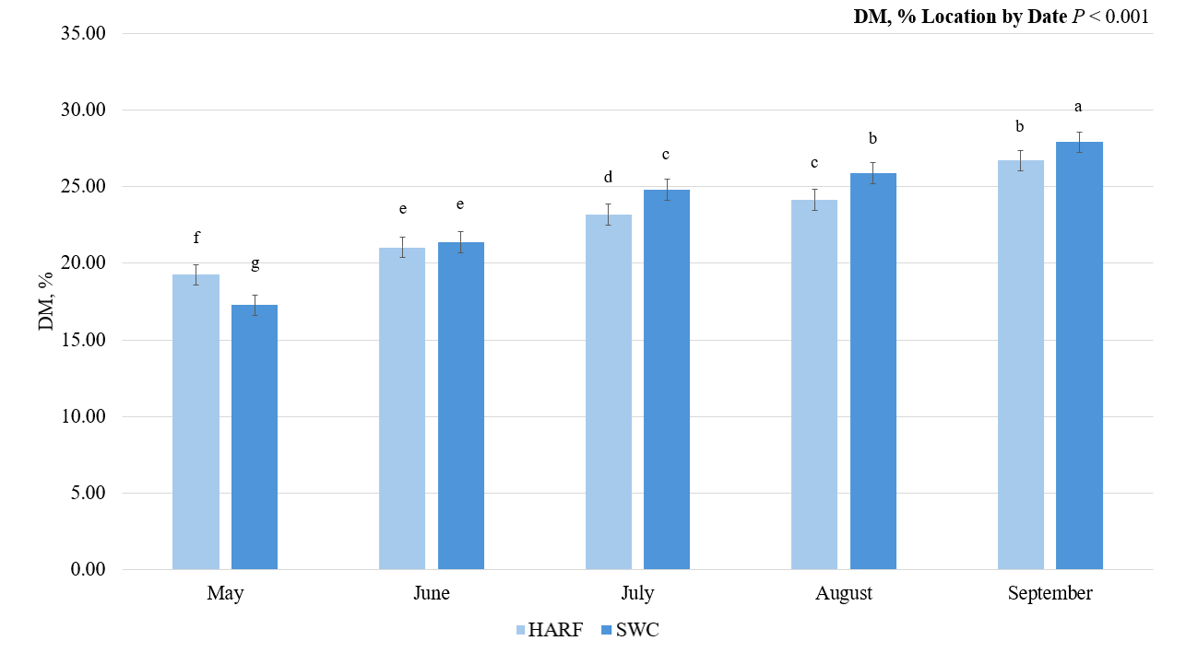
Figure 2: Dry matter (DM)% two-way interaction between location and cultivar in American elderberry at two Missouri locations in 2021-2022 across the growing season.
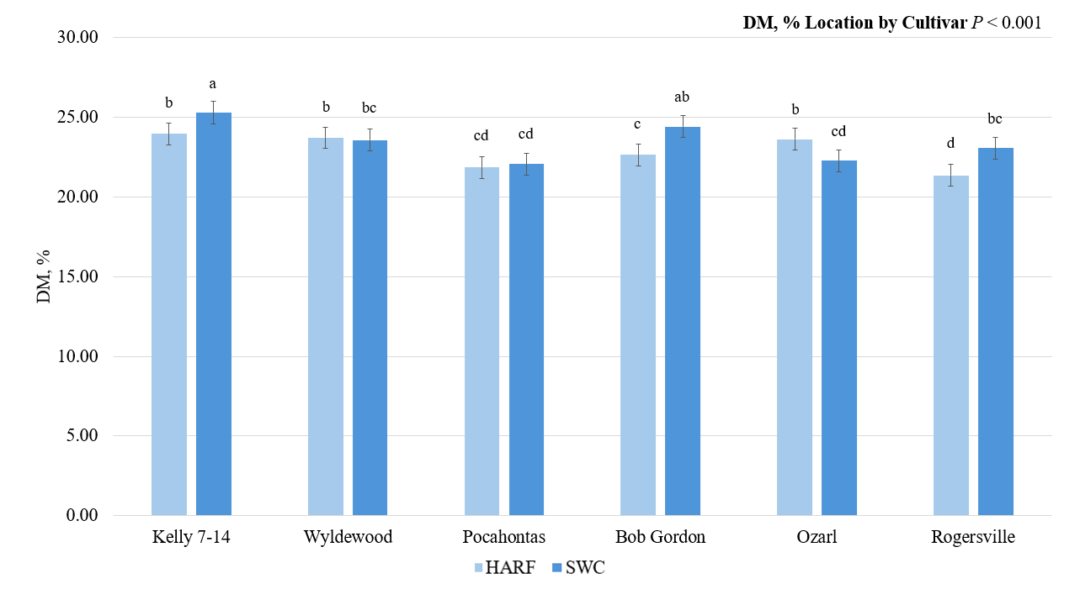

Figure 3: Neutral detergent fiber (NDF)% simple means by date from six genotypes of American elderberry at two Missouri locations in 2021-2022 across the growing season.
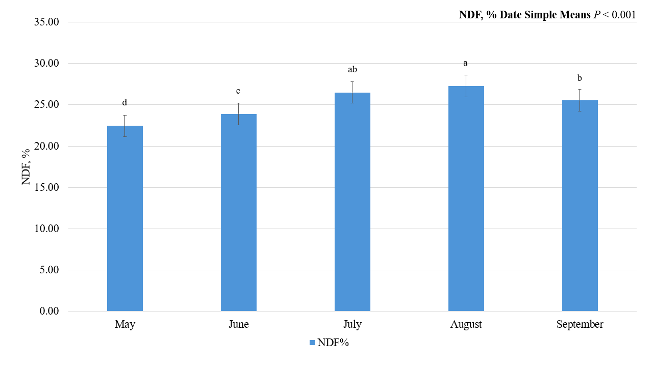
Figure 4: Acid detergent fiber (ADF)% simple means by date from six genotypes of American elderberry at two Missouri locations in 2021-2022 across the growing season.
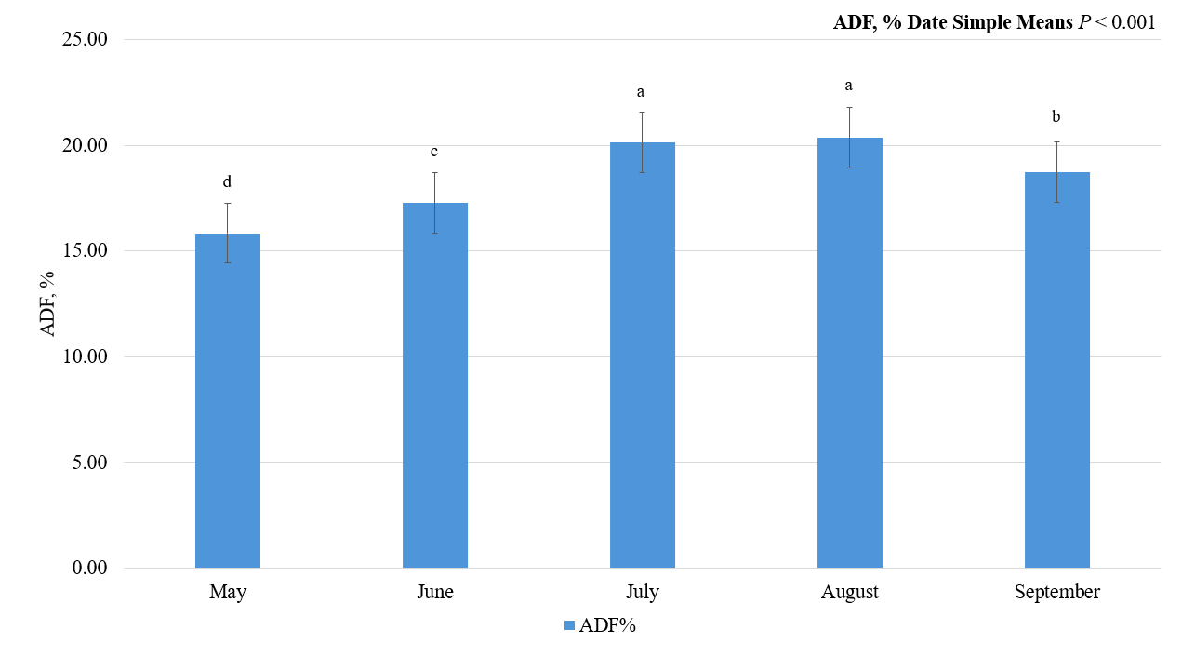

Figure 5: Acid detergent lignin (ADL)% simple means by date from six genotypes of American elderberry at two Missouri locations in 2021-2022 across the growing season.
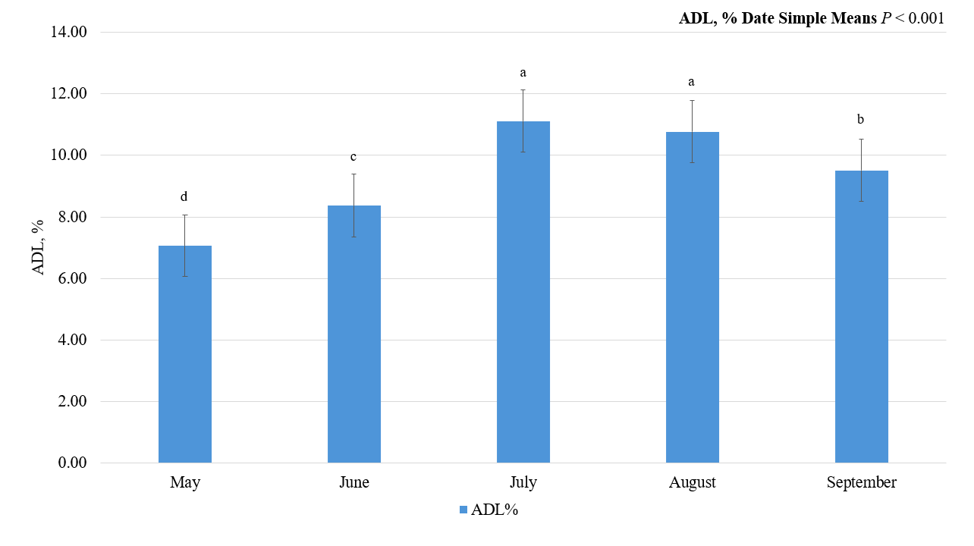
Figure 6: Neutral detergent fiber (NDF)% simple means by cultivar in American elderberry at two Missouri locations in 2021-2022 across the growing season.
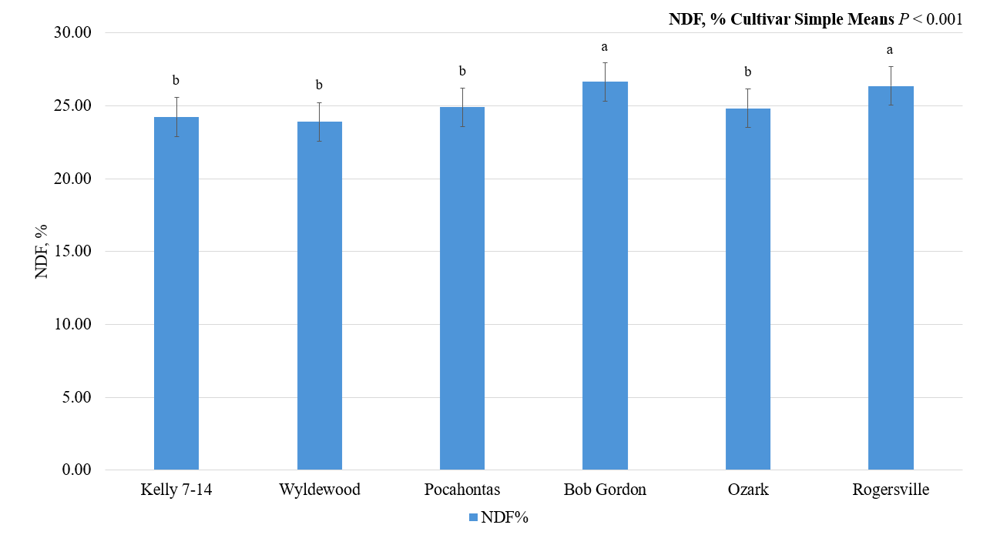

Figure 7: Acid detergent fiber (ADF)% simple means by cultivar in American elderberry at two Missouri locations in 2021-2022 across the growing season.
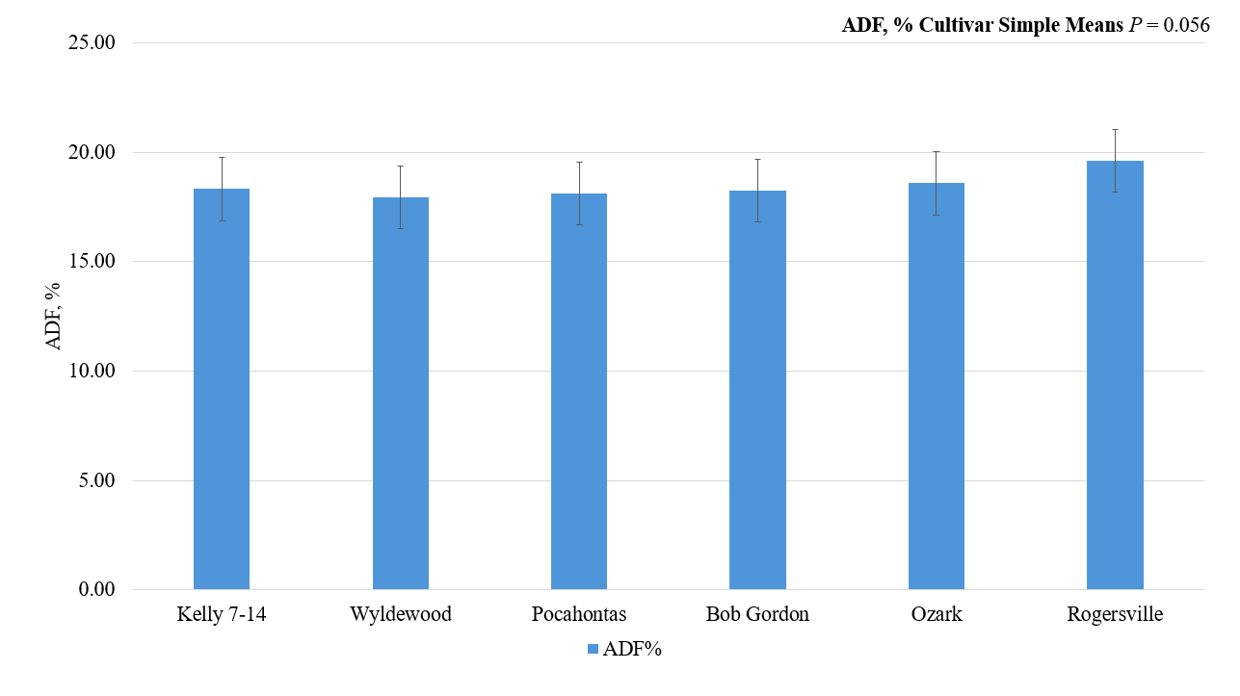
Figure 8: Acid detergent lignin (ADL)% simple means by cultivar in American elderberry at two Missouri locations in 2021-2022 across the growing season.
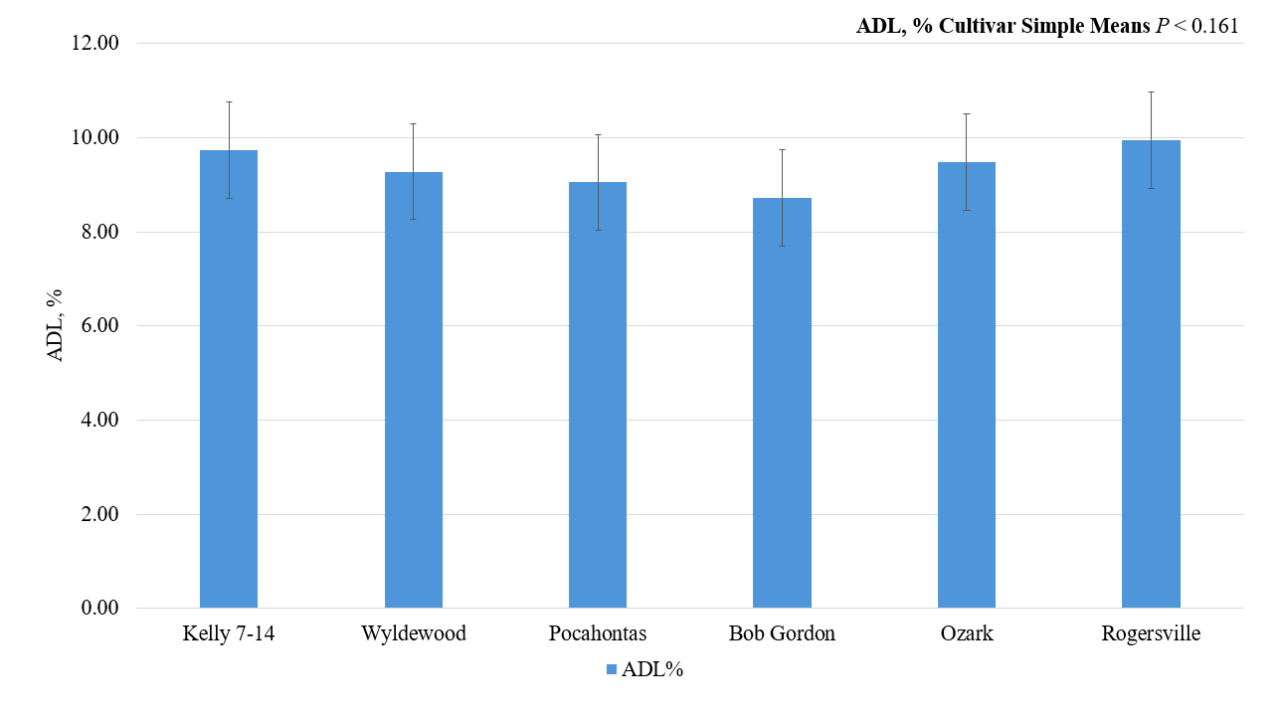

Figure 9: Crude protein (CP)% simple means by cultivar in American elderberry at two Missouri locations in 2021-2022 across the growing season.
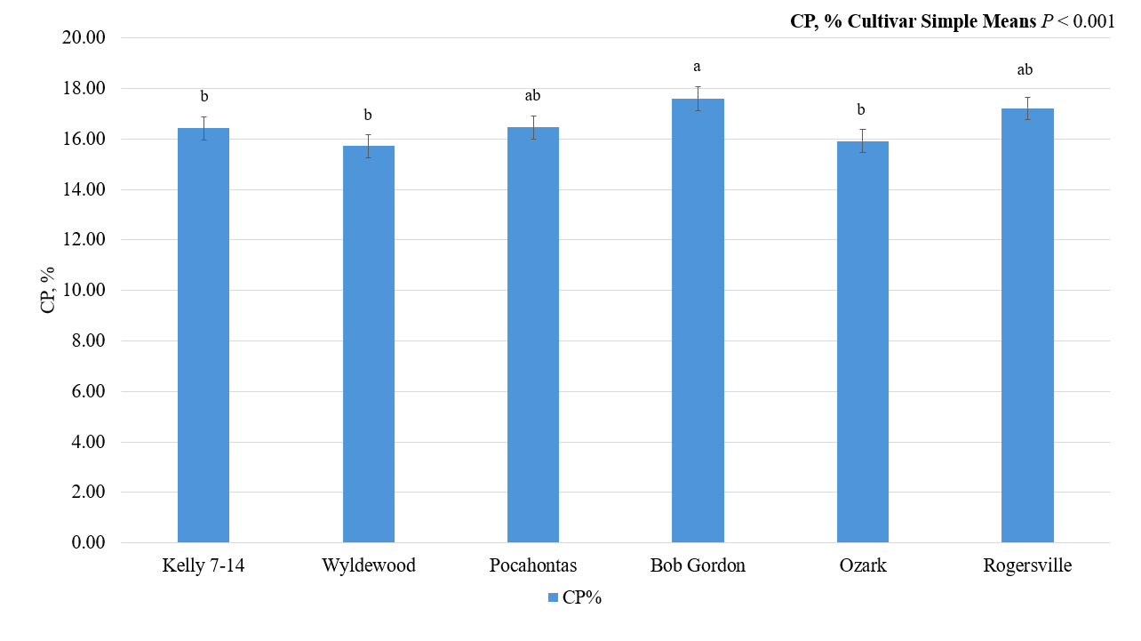
Figure 10: Neutral detergent fiber (NDF)% simple means by location from six genotypes of American elderberry at two Missouri locations in 2021-2022 across the growing season.
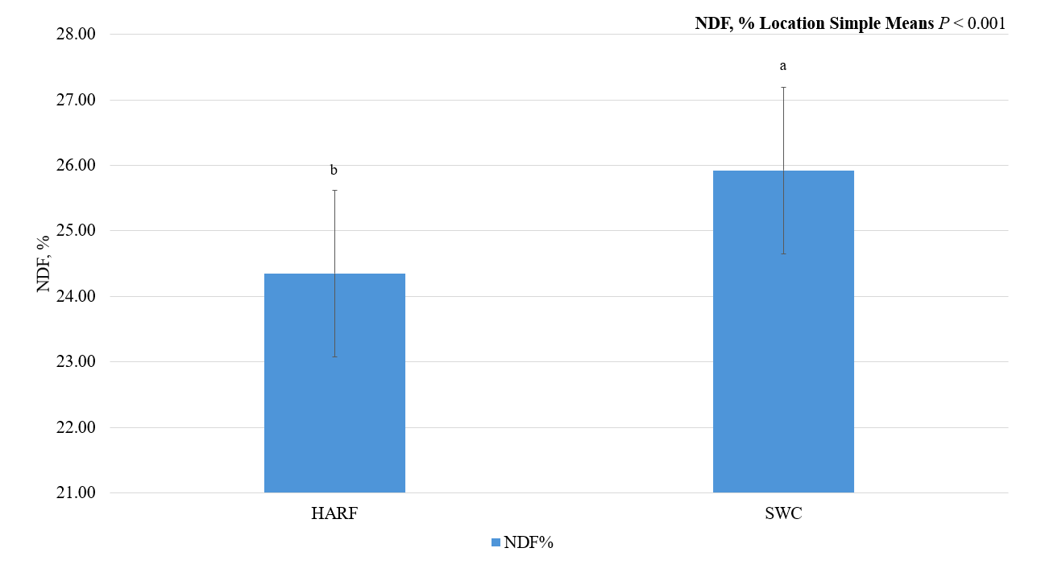

Figure 11: Acid detergent fiber (ADF)% simple means by location from six genotypes of American elderberry at two Missouri locations in 2021-2022 across the growing season.
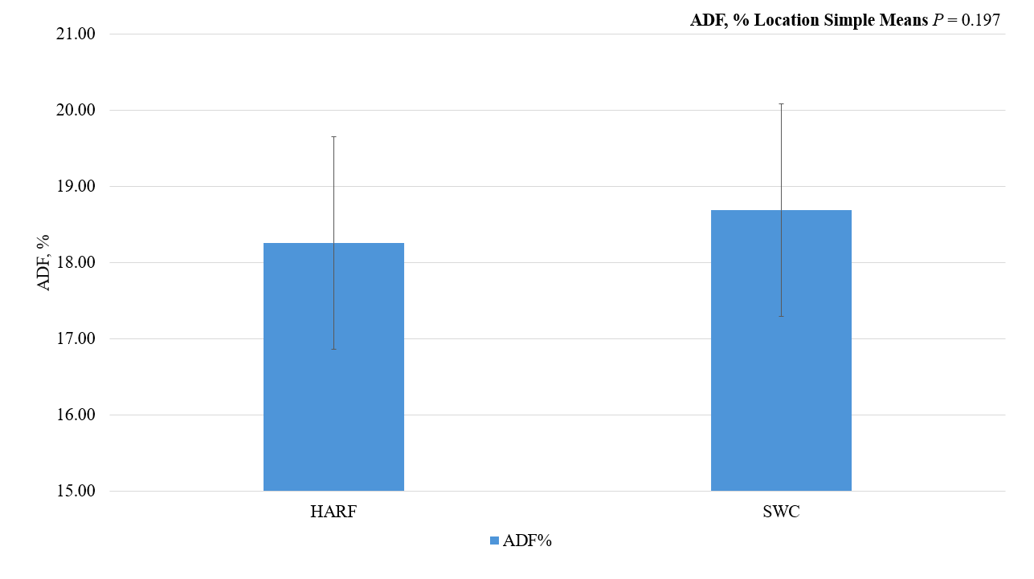
Figure 12: Acid detergent lignin (ADL)% simple means by location from six genotypes of American elderberry at two Missouri locations in 2021-2022 across the growing season.
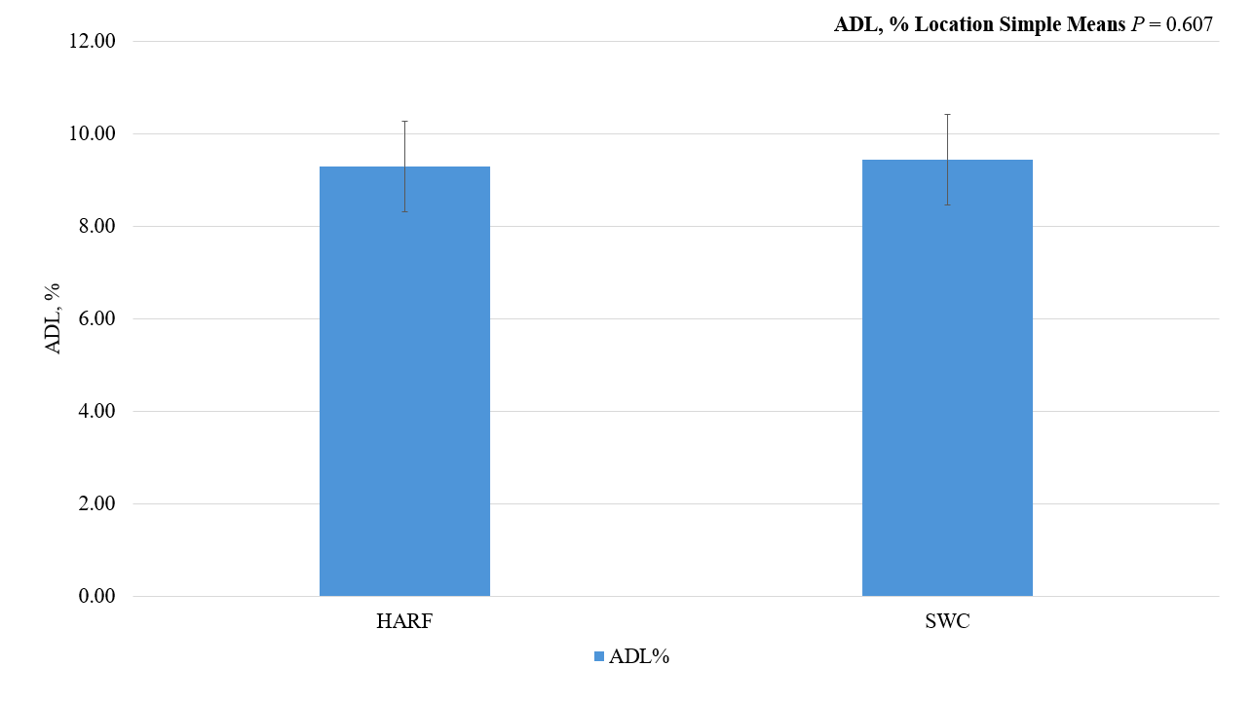

Figure 13: Crude protein (CP)% two-way interaction between location and date from six genotypes of American elderberry at two Missouri locations in 2021-2022 across the growing season.
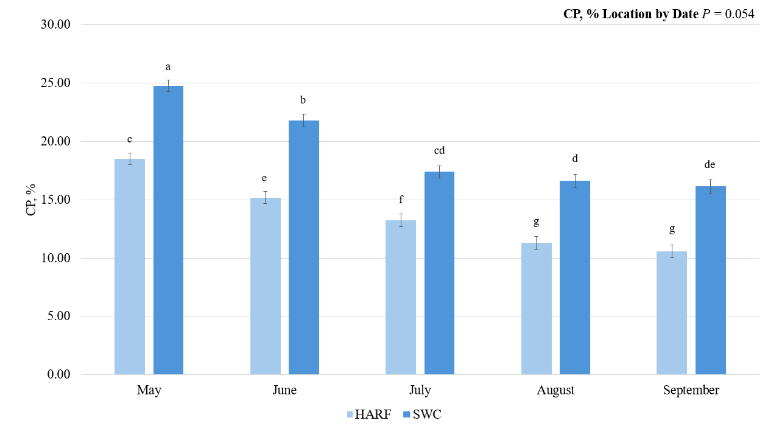
Figure 14: Dhurrin cyanogenic glycoside two-way interaction between location and cultivar in American elderberry at two Missouri locations in 2021-2022 across the growing season. 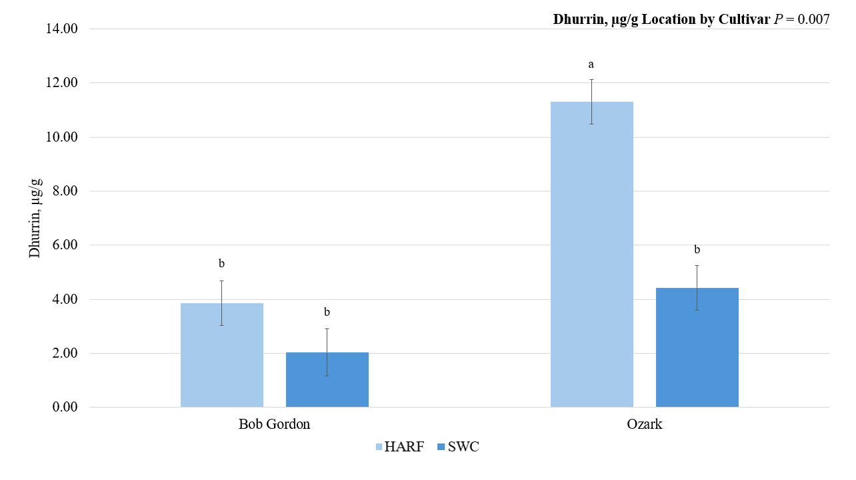

Figure 15: Amygdalin cyanogenic glycoside simple means by date from two genotypes of American elderberry at two Missouri locations in 2021-2022 across the growing season.
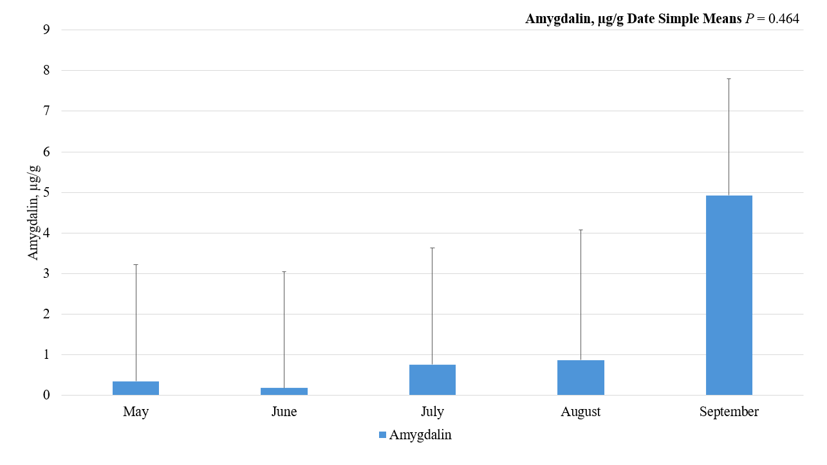
Figure 16: Linamarin cyanogenic glycoside simple means by date from two genotypes of American elderberry at two Missouri locations in 2021-2022 across the growing season.
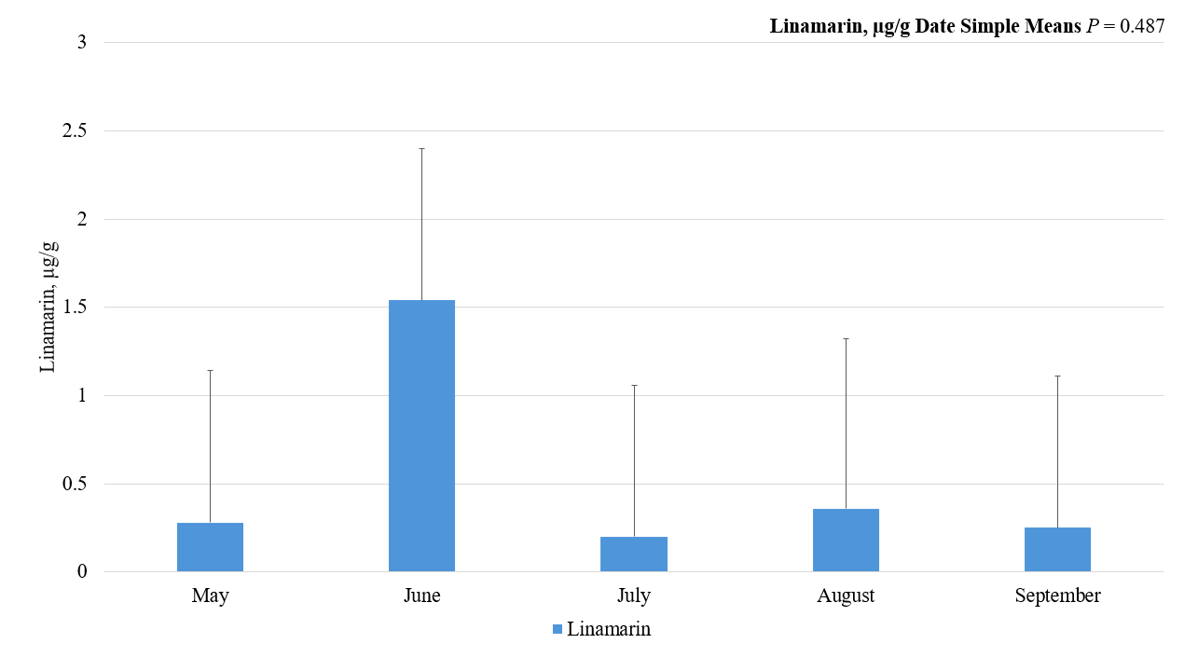

Figure 17: Sambunigrin cyanogenic glycoside simple means by date from two genotypes of American elderberry at two Missouri locations in 2021-2022 across the growing season.
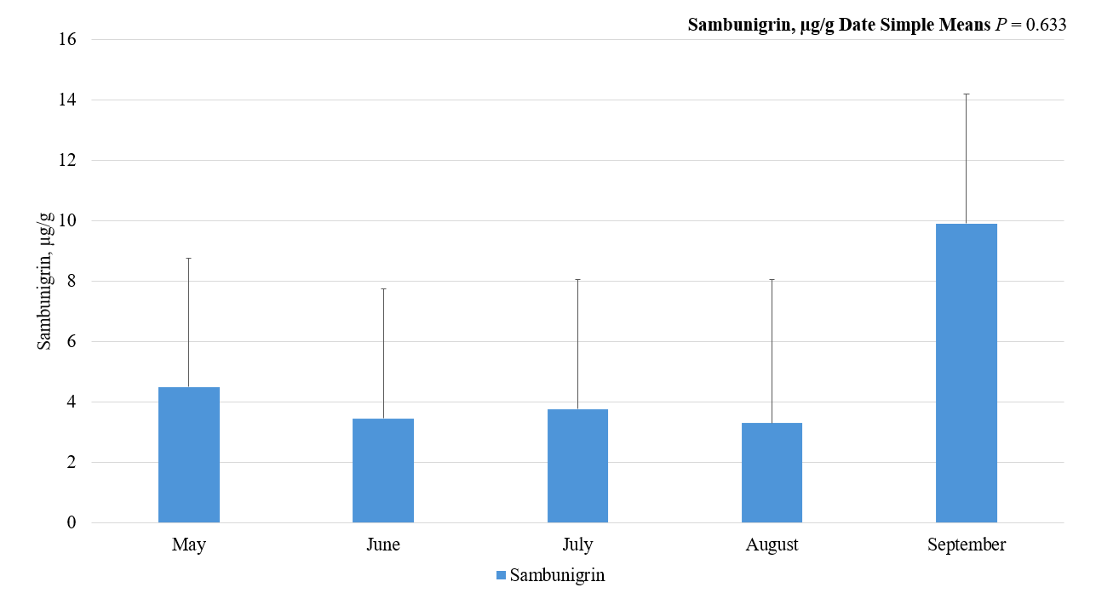
Figure 18: Amygdalin cyanogenic glycoside simple means by cultivar in American elderberry at two Missouri locations in 2021-2022 across the growing season.
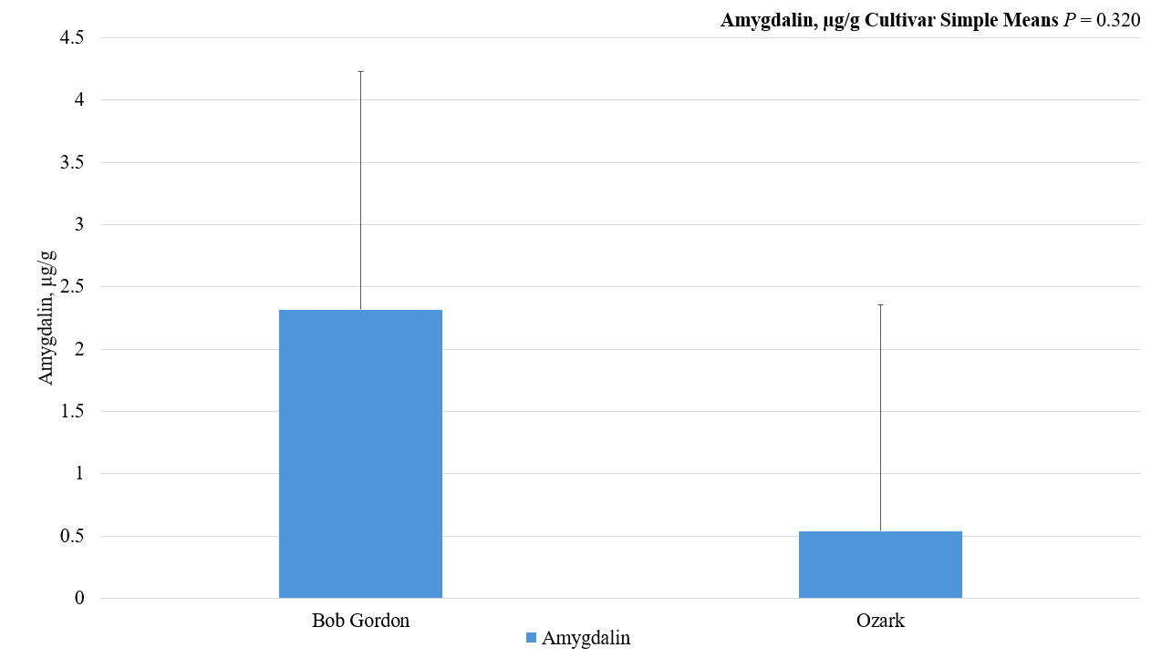

Figure 19: Linamarin cyanogenic glycoside simple means by cultivar in American elderberry at two Missouri locations in 2021-2022 across the growing season.
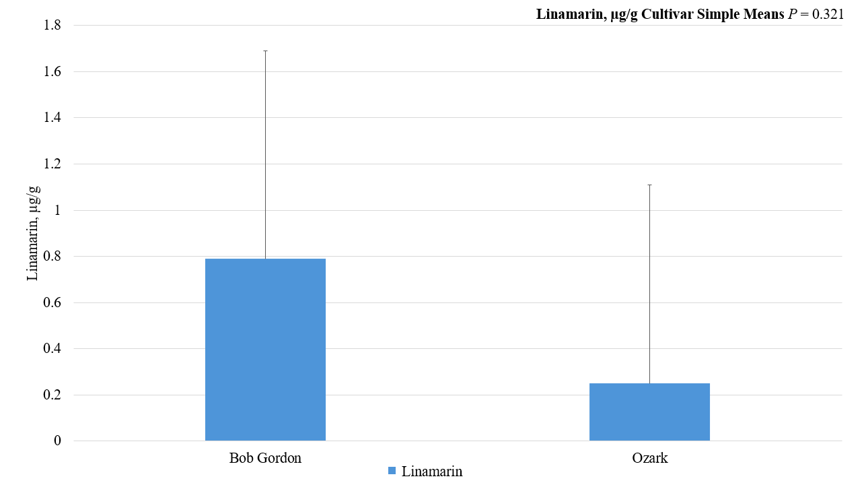
Figure 20: Sambunigrin cyanogenic glycoside simple means by cultivar in American elderberry at two Missouri locations in 2021-2022 across the growing season.
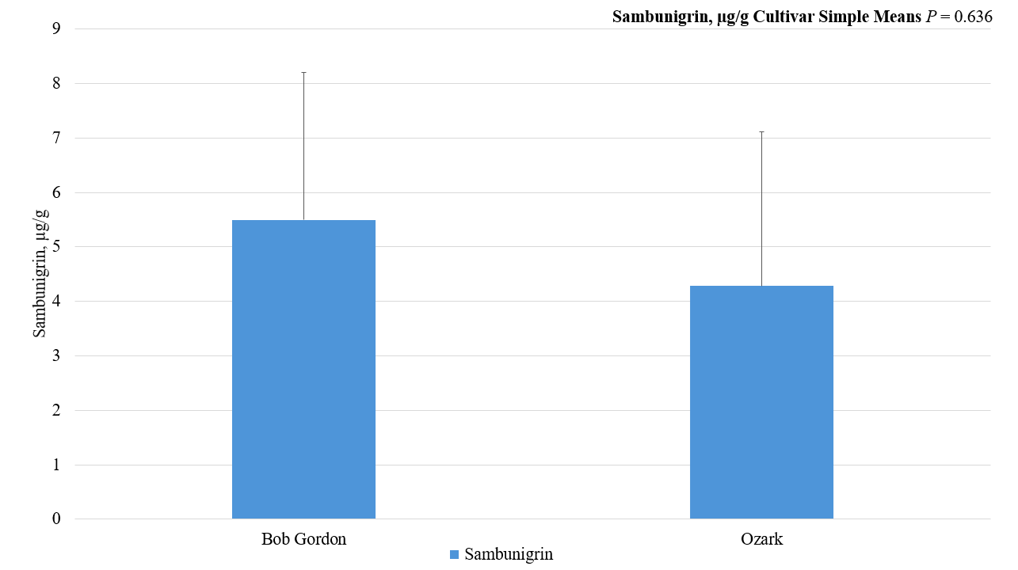

Figure 21: Amygdalin cyanogenic glycoside simple means by location from two genotypes of American elderberry at two Missouri locations in 2021-2022 across the growing season.
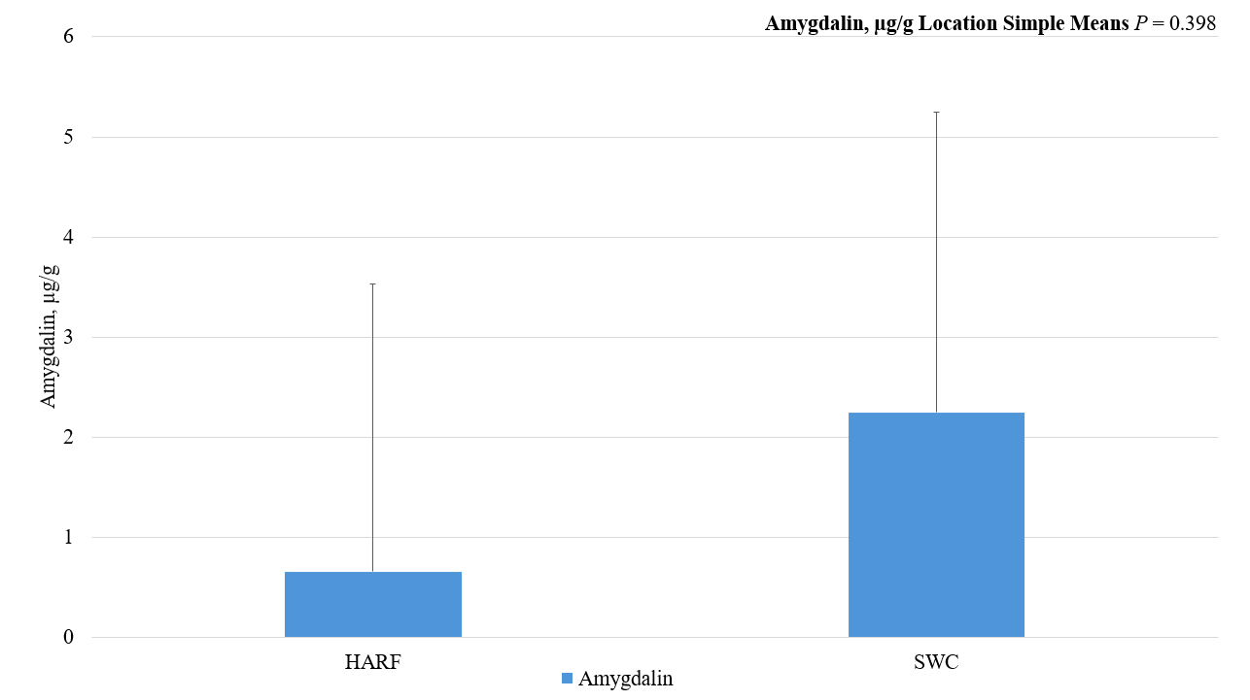
Figure 22: Linamarin cyanogenic glycoside simple means by location from two genotypes of American elderberry at two Missouri locations in 2021-2022 across the growing season.
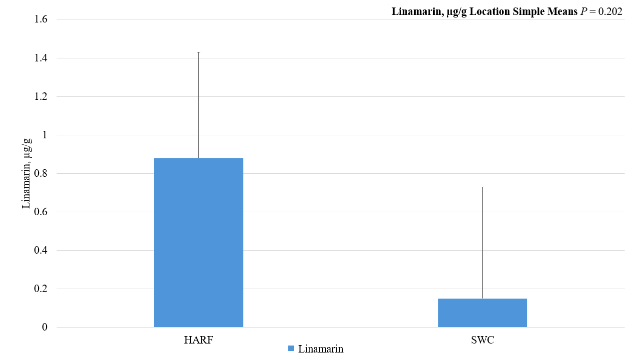

Figure 23: Sambunigrin cyanogenic glycoside simple means by location from two genotypes of American elderberry at two Missouri locations in 2021-2022 across the growing season.


