Alzheimer’s Disease Detection using Deep Learning Techniques
Gurram Sai Nikhileswar¹, M Akhil¹, M Akash¹, Jani Anbarasi L¹
¹School of Computer Science Engineering, Vellore Institute of Technology, Chennai

Abstract:
Alzheimer’s disease (AD) severely compromises the quality of life by gradually destroying mental faculties, causing memory loss and behavioral abnormalities. For these reasons, early diagnosis is essential in order to put these timely interventions into place to slow disease progression and enhance patient outcome. Although clinical tests, including neuropsychological tests and conventional imaging methods, usually do not have high levels of sensitivity to detect AD in its early stages and to differentiate it from 'very mild' or 'mild' dementia or normal aging. In using deep learning for improving the accuracy of diagnosis of Alzheimer’s using MRI analysis, this study draws on deep learning methods, particularly Convolutional Neural Networks (CNNs). Kaggle Alzheimer’s Disease dataset was used to evaluate three advanced CNN architectures—ResNet50, MobileNetV2 and InceptionV3. By using residual connections, ResNet50 prevents the vanishing gradients and so enable the deeper feature learning. InceptionV3’s multi scale filter is good at extracting detailed spatial patterns from brain images while MobileNetV2 has a computationally efficient design that is suitable for resource constrained environments. In addition to this, this research examines AttentionAugmentedConv2D, an advanced convolutional layer that implements self-attention operations over the standard convolution operations. This helps the model to focus on the important regions in brain images, gives more power in feature extraction and better classification. Then, the dataset was preprocessed with intensity normalization and resizing so that we can directly compare the spikes. Each model was fine-tuned using transfer learning for AD related biomarker detection. ResNet50 attained 97%, MobileNetV2 98% and InceptionV3 99%. The results corroborate the usefulness of CNNs and attention-augmented models in assisting Alzheimer’s disease diagnosis and pave the way towards more effective clinical uses.

Keywords:
Alzheimer’s disease , Resnet50, MobileNet, InceptionV3, MRI

- Introduction:
Alzheimer’s disease (AD) severely impairs the quality of life by slowly killing off skills such as memory and becoming unable to coherently express oneself. For these reasons, early diagnosis is important to initiate these early interventions for slowing down disease progression and improving patient outcome. Clinical tests, including neuropsychological tests and conventional imaging methods, for the most part do not measure high sensitivities to detect AD at early stages and discriminate between AD and 'very mild' or 'mild' dementia or normal aging. This study uses deep learning methods especially Convolutional Neural Networks (CNNs) for improving the accuracy of diagnosis of Alzheimer’s from MRI analysis. We evaluated three advanced CNN architectures and then their accuracy on Alzheimer’s Disease dataset that is available on Kaggle. ResNet50 does that by using residual connections to prevent the vanishing gradients and thus ability of deeper feature learning. MobileNetV2 has a computationally efficient design that is appropriate for resource restrictive environment and InceptionV3’s multi scale filter does a pretty good job in extracting the detailed spatial patterns from brain images.
Recent technological progress in neuroimaging has enabled us to understand the structure and function changes with respect to AD better. Anatomical and metabolic alterations correlated with the disease are indirectly visible with imaging modalities such as Positron Emission Tomography (PET) and Magnetic Resonance Imaging (MRI). Although these knew have made great advances in this field, physicians still face complex, time consuming task of analyzing neuroimaging data. With such vast volumes of data and such intricate patterns, expert interpretation is needed to provide diagnosis, allowing for delays and giving some opportunity for human error.
To meet these challenges, artificial intelligence (AI) has become a strong force of transformation in medical diagnostics; specifically deep learning. Yet, Convolutional Neural Networks (CNNs), a particularly special subfamily of deep learning, have had incredible performances in reducing patterns that would be undetectable to human eyes. When fed a medical image, CNNs can extract automatically features from it, find the patterns which are relevant, and classify it with very high accuracy. In the area of Alzheimer’s detection, CNNs have exhibited particularly profitable use of neuroimaging data in their ability to make accurate predictions.
CNNs in medical image analysis are further enhanced by the technique of transfer learning, which makes use of the pre trained models and can fine-tuned for specific tasks. In this study, three advanced CNN architectures ResNet50, MobileNetV2, and InceptionV3 are applied for the Alzheimer's detection. Different architecture has its own advantages to be used on the analysis of the neuroimaging data. For example, ResNet50 employs the use of residual connections to enable efficient training of deep networks, thus addressing vanishing gradient issue and improving the performance of it. MobileNetV2, which due to its lightweight, computationally efficient design is appropriate for deployment in resource constrained environments, also is appropriate for real time applications. Its multi scale filter approach helps InceptionV3 for capturing diverse features from brain image making it capable of finding high level spatial pattern.
Furthermore, this research also analyses AttentionAugmentedConv2D, an advanced convolution layer derivates from standard convolution layer performing self-attentions in addition to regular convolutions. This improves the feature extraction and classifies better because the model has the power to focus on the important regions in the brain images. Augmented attention, an extension of self-attention mechanism, make models’ ability of global and local dependencies in input data increase. Augmented attention combines convolution operations with self-attention to dynamically reweight spatial features in the refined feature representation. It makes the sense organs sensitive to small changes in brain regions that normally progress as the disease does. Moreover, it reduces the loss of spatial information that might occur at deeper convolutions and in general, enables the model to discriminate stages of the disease better.
We then preprocessed the dataset intensities by normalizing this and resizing so we can directly compare the spikes. AD-related biomarker detection was carried out with each model using transfer learning. ResNet50 attained 94%, MobileNetV2 98%, and InceptionV3 99%. The results corroborate the usefulness of CNNs and attention-augmented models to provide a low cost and effective tool to aid Alzheimer’s disease diagnosis and provide foundations for more powerful practical uses in the clinic. Thus, after attention ResNet50 attained 99.3%, MobileNetV2 99.6% and InceptionV3 99.8%.
This paper is structured as follows: Section 2 discusses the literature review about the advantages and disadvantages of the existing methods. The following is section 3 where it talks about segmentation models, encoder architectures and the optimizer functions. In section 4, we analyze in details the results and discussion consisting of the experimental setup, dataset description, data augmentation, hyperparameter tuning, model training and validation, evaluation metrics, ablation study, and segmentation analysis. Finally, in Section 5, the findings of the study are summarized and the future direction of improving the diagnosis of Alzheimer’s by deep learning approaches are highlighted.

- Literature Review
In work by Huanhua et al. [1] (2019), the focus was placed on diagnosis of early stage AD using MRI and ConvNets. However, we use MRI gray matter and white matter image slices as the inputs to the classification algorithm. Previous work has been done to improve classification by ensemble learning techniques to aggregate the results of deep learning classifiers after convolutional operations. In this work, we built, created and compared three base ConvNets. The Alzheimer's Disease Neuroimaging Initiative dataset was used to evaluate our approach in the early diagnosis of this disease. In a very specific sense, our increase in accuracy rates has been to 88.37% for mild cognitive impairment/normal control and 97.65% for AD/mild cognitive impairment. By using multimodal data from MRI, genetic data (SNPs) and clinical tests, Venugopalan et al. [2] (2020) created an early diagnosis AIDS (AD) and mild cognitive impairment (MCI). In the study, 3D CNNs were used for imaging data and stacked denoising autoencoders were used for clinical and genetic data. Shallow models: random forests, decision trees and SVMs, did not perform as well as the models. Results showed that the multimodal deep learning models not only outperformed the single modality models in terms of accuracy, precision, recall and mean F1 scores using the ADNI dataset, but also crucial features of the hippocampus and amygdala have been found in those models.
Al-Shoukry et al. [3] (2020), examined the function of DL algorithms in the early identification of Alzheimer’s disease (AD). The study notes the importance of early diagnosis of AD, and in particular the time when prediction models can be used to prevent persistent brain damage. Then the use of DL approaches including Convolutional Neural Networks (CNN) and Recurrent Neural Networks (RNN) is described for categorizing the medical pictures, like brain scans, for AD detection. The review points out the superiority of DL in the task of AD diagnosis than standard methods, characterizing the patterns for detection. The research highlights the expanding potential of the use of DL approaches to improve accuracy of early stage AD diagnosis. In 3D brain MRI data setting, Ullah et al. [4] (2020) detected Alzheimer’s and dementia. Since DCNNs are faster, cheaper, and more reliable for processing images than using traditional methods, the study employed these advanced algorithms. By using the suggested model, dementia and Alzheimer's disease were categorized from brain MRI scans, which could be a practical substitute for conventional diagnostic techniques. A rather vague focus of the study is the efficiency of DCNNs when identifying AD and dementia using 3D MRI data.
Murugan et al. [5] (2021) proposed a deep learning model (DEMNET) for early detection of Alzheimer's disease (AD) and dementia phases from MRI image. Specifically, the model maps disease probability in high resolution from convoluted neural networks (CNNs) applied to the AD features in the brain structures. In the case of the Kaggle MRI dataset, the proposed approach has a 95.23% accuracy rate, 97 % Area Under Curve (AUC), and 0.93 Cohen’s Kappa value to deal with the issue of class imbalance. Performance was also assessed on the Alzheimer's Disease Neuroimaging Initiative (ADNI) dataset, which was also used to prove that model outperformed current techniques. What makes this work different is the use of CNN for clear visualizations of AD risk and for useful patients with various dementia stages. In their work, Helaly et al. [6] (2021) suggested an early detection model of AD based on deep learning, Convolutional Neural Networks (CNN). Two ways were taken among which first one used basic CNN architectures to classify AD stages on 2D and 3D multi class brain images from Alzheimer’s Disease Neuroimaging Initiative (ADNI) dataset with accuracies of 93.61% and 95.17% respectively. The second approach applied refine VGG19 model and transfer learning to classify multi class AD stages with an accuracy of 97 percent. The research also suggested a online tool to aid remote AD diagnosis, in the light of the COVID 19 pandemic. The initial LeNet model, on the other hand, had an accuracy of 80%.
Nawaz et al. [7] (2021) used an unbalanced MRI dataset from the Alzheimer’s Disease Neuroimaging Initiative (ADNI) to develop a DCNN to identify AD with 2D architecture. MR pictures are subdivided into normal control, AD, and moderate cognitive impairment and then put through the model. The 2D-DCNN achieved accuracy of 99.89%, higher than other current techniques, and achieved efficiency and robustness better than current methods. The suggested approach proves to be a significant booster above the leading ones with unbalanced classes. Focusing on using MRI based scans, Farooq et al. [8] (2021) proposed a deep CNN based pipeline for the categorization of Alzheimer's disease (AD) as well as its phases. The model identified four stages, namely Alzheimer's disease (AD), mild cognitive impairment (MCI), late mild cognitive impairment (LMCI) and healthy people. Experiments with the ADNI dataset on a system based on a GPU yield considerable accuracy of 98.8% prediction. This performance demonstrates the efficiency of the deep learning in distinguishing between the Alzheimer's disease and the stages of it, with a significant advantage against the approaches before.
In order to perform early diagnosis of AD, two MRI datasets with 6400 and 6330 images have been used, and the DL algorithm is implemented by using a neural network classifier with a VGG16 feature extractor, something which Shagun et al [9] (2022) did too. The value resulting with accuracy, precision, recall, AUC and F1-score of 90.4%, 0.905, 0.904, 0.969, 0.904, 71.1%, 0.71, 0.711, 0.85 and 0.71 are obtained with dataset 1 and dataset 2 respectively. In this work, El-Geneedy et al. [10] (2022) proposed a deep learning based AD detection algorithm using 2D T1 weighted MRI images. We use a shallow architecture Convolutional Neural Network to classify the AD stages (normal, mild cognitive impairment, and AD) from the provided images. The proposed approach was able to achieve a remarkable testing accuracy of 99.68%. It also provides local classification of MCI into Very Mild Dementia (VMD), Mild Dementia (MD) and Moderate Dementia (MoD). The method was compared with several deep learning models including DenseNet121, ResNet50, VGG16, EfficientNetB7, InceptionV3, etc.
In this work, Rahmeh et al [11] (2023) uses the PSO algorithm to identify the best configuration of the CNN hyper parameters. After optimization of these parameters on the CNN architectures, they are classified on these parameters. Thus, both accuracy of prediction and loss of function value are reduced while using our hybrid model. To evaluate the performance of the proposed model, we tried using three benchmark datasets. Alzheimer’s disease were used in two datasets: the Alzheimer’s Disease Neuroimaging Initiative (ADNI) was used and a global dataset from Kaggle was used. In the third dataset, brain tumors were the subject. Our proposed model was experimented with and proved to be better at the level of 98.50%, 98.83%, and 97.12% accuracy in case of the afore mentioned datasets. In the report of Ruhul et al. [12] (2023), the brain MRI images were used to implement three popular DNN models for AD classification. The best (86.55%) is determined from the characteristics of the classification results, they found the best DenseNet-121 model. Since DenseNet-121 is very computationally costly, they have proposed a lightweight hybrid technique based on combining the LeNet and AlexNet, and it is better than DenseNet. The model performs well with 93.58% performance rate overall. The proposed approach is proven to provide nearly an order of magnitude less convolutional parameters mathematically thus a computationally efficient and lightweight model.
In the above mentioned study of Rao and Aparna [13] (2023), they did a detailed work about the adoption of deep learning methods for early Alzheimer's disease (AD) diagnosis mainly using MRI image analysis. They focused in the discussion of several CNN based segmentation and classification techniques for AD specifically and how CNNs are crucial in obtaining high level visual features necessary to distinguish AD from other disorders. For example, the study looked at how using publicly available datasets such as ADNI and OASIS examining methods, saw that using deep learning gave increased segmentation accuracy with models in some location reaching up to segmentation Dice scores of up to 93%. Ftoutou et al. [14] (2023), proposed a deep learning based classification approach of Alzheimer’s disease (AD) by focusing on transfer learning with the use of ResNet-50 model. This strategy was focused on the four stages of AD progression that are non-dementia, very mild dementia, mild dementia, and moderate dementia. After the training on an upgraded Kaggle dataset, the model reached the accuracy of more than 95% using picture rotation techniques. The study also noted that, with respect to the conventional techniques, the Fastai played an important role in development and optimization of the ResNet-50 model and was able to provide higher classification accuracy. Additionally, the system was made available as an AD assessment and prediction web application.
In addition, they identified brain MRI segmentation and AD diagnosis problems, high data dimensionality and differing progression of AD, and proposed more ways to improve the accuracy of CNN design in order to enhance the diagnosis of AD. However, Gupta et al. [15] (2024) recommend a method of classifying Alzheimer's disease (AD) from multimodal brain imaging data based on adversarial networks to enhance the diagnostic accuracy. This study then carried out a systematic review following PRISMA principles and reduced the pool of publications to 42 from 946 relevant papers. The authors used sets of datasets like ADNI and OASIS to come up with various machine learning (ML) and deep learning (DL) models including CNNs and transfer learning models like VGG16 and ResNet50. The results varied in accuracy, hybrid and ensemble methods achieved up to 99.4%. To improve the sensitivity of AD diagnosis, as well as to enhance the robustness of existing AD diagnosis, the study stressed the importance of using modalities, including structural MRI, functional MRI, and genetic data, in addition to the latest methods, for example, Curvelet Transforms. EEG functional connectivity analysis has a crucial role in quantifying abnormalities in brain networks which is useful in studying neurological ischemic diseases such as Alzheimer’s disease (AD) and schizophrenia. Shao et al. [16] (2025) calculated synchronization measure by using phase locking value (PLV) and coherence to quantify the EEG functional connectivity. Their study clearly showed that AD patients had considerable disruptions in functional connectivity, in the default mode network (DMN), but they were widespread in connectivity patterns of schizophrenia patients. This suggests that functional networks metrics have the potential to act as biomarkers for early diagnosis and for monitoring disease.
Kumar et al. (2023) [17], proposed an advanced classification model of Alzheimer’s disease (AD) technique based on the Exponential Gaussian Error Linear Unit–SqueezeNet (EGELU-SZ Debretin) algorithm. A comprehensive workflow was used in the methodology to improve classification performance. Second, Adaptive Median Otsu’s Thresholding (AMOT) was used to perform skull stripping and remove surrounding tissues of the brain on the images from the MRI, such as fat and skin. Secondly, the brain region was segmented accurately using Rectilinear Mayfly Optimization-centric Automatic Seeded Region Growing ( RMF-ASRG ). In this order, feature dimensionality was reduced by Reflective Correlation Principal Component Analysis (RCPCA) analysis after segmentation, preserving the most relevant features for use in classification. The extracted features are then classified into Cognitive Normal (CN), Mild Cognitive Impairment (MCI) and Alzheimer’s disease (AD) using the EGELU-SZN classifier. The accuracy of the proposed model was 95.9882% with precision, recall, specificity and sensitivity of 94.1661%, 93.2327%, 92.8744% and 96.2327%, respectively. The EGELU-SZN model was tested with experimental results and found to perform better than benchmark approaches in early diagnosis and classification of AD. A new algorithm for AD detection based on a magnetic resonance imaging dimensionality reduction by deep learning and feature selection techniques in Öznur et al. [18] (2025). Based on 6400 MRI images from Kaggle classified into four classes, it used pretrained CNN architectures: DenseNet-201, MobileNet-v2, ResNet-18, ResNet-50, ResNet-101 and ShuffleNet for classification with five-fold cross validation and asked ResNet-18, ResNet-50, and ResNet-101 gave the highest accuracy of 82.11% respectively under the classification category using 6 pretrained CNN models. The CNN models are used as deep feature extractors, and the extracted features are reduced to 344 by minimizing the loss and thus minimized to 2048 to 344 using a fine tuning neighborhood component analysis (FTNCA) algorithm. In this work, the refined features were classified using various machine learning models like ANN, KNN, Naïve Bayes and SVM. Results from experiments were demonstrating the 100% accuracy of ResNet-50-FTNCA-KNN and proving to be an improvement in the classification efficiency and early diagnosis of AD.
Table 1 Comparative Analysis
Ref | Year | Methods | Advantages | Performance (Accuracy)
[1] | 2019 | Convolutional Neural Networks (ConvNets), Ensemble learning | Enhanced classification performance using ensemble learning and optimized ConvNet architectures for early AD detection. | 97.65%
[2] | 2020 | 3D CNNs | Outperformed single modality and shallow models by leveraging multimodal data, with hippocampus and amygdala identified as key features. | -
[3] | 2020 | DL, CNNs and RNNs | Demonstrated that DL techniques can detect intricate patterns in medical images, outperforming traditional approaches in early AD diagnosis. | -
[4] | 2020 | DCNN | Demonstrated the efficiency and reliability of DCNNs for identifying AD and dementia, offering a practical and cost-effective solution compared to conventional methods. | -
[5] | 2021 | DEMNET | Tackled class imbalance, achieved clear visualizations of AD risk, and effectively identified dementia stages with superior performance compared to existing techniques. | 95.23%
[6] | 2021 | CNN, refined VGG19 | Achieved high classification accuracy using transfer learning and proposed a remote diagnostic solution, addressing healthcare needs during the COVID-19 pandemic. | 93.61%, 97%
[7] | 2021 | 2D- DCNN | Achieved superior accuracy, efficiency, and robustness even with unbalanced classes, outperforming existing methods. | 99.89%
[8] | 2021 | deep CNN-based pipeline | Demonstrated the efficacy of deep learning for accurate classification of AD stages, significantly outperforming earlier methods. | 98.8%
[9] | 2022 | Neural network classifier with a VGG16 feature extractor | Achieves reliable performance metrics for early diagnosis of AD using VGG16 as a feature extractor. | 90.4%
[10] | 2022 | shallow Convolutional Neural Network (CNN) | Achieved exceptional accuracy while offering fine-grained classification of MCI stages and outperformed other deep learning models. | 99.68%
[11] | 2023 | Swarm Optimization (PSO) to optimize CNN hyperparameters. | The hybrid model optimizes CNN hyperparameters using PSO, reducing function value loss and achieving superior prediction accuracy for brain illnesses. | 98.50%
[12] | 2023 | DenseNet-121 Model  Hybrid Model (LeNet + AlexNet) | Achieves high accuracy with fewer convolutional parameters, offering a computationally efficient and lightweight alternative to DenseNet-121. | 86.55%, 93.58%
[13] | 2023 | CNN-based segmentation | Highlighted the effectiveness of CNNs in improving segmentation accuracy, achieving high segmentation Dice scores. | 93%
[14] | 2023 | ResNet-50 | Achieved high classification accuracy using ResNet-50 with transfer learning, leveraging Fastai for optimization and providing a practical web-based diagnostic tool. | 95%
[15] | 2024 | Hybrid and Ensemble Models | Achieved high diagnostic accuracy with hybrid and ensemble models. | 99.4%
[16] | 2025 | CNN and LSTM networks | Identified inter-regional connectivity disruptions in Alzheimer’s disease (AD) and schizophrenia. | 94%
[17] | 2025 | Exponential Gaussian Error Linear Unit–Squeeze Net (EGELU-SZN) | Effectively classified outcomes into AD, CN, and MCI. | 95.9%
[18] | 2025 | CNN Architectures with Feature Selection Using FTNCA | Utilized CNN models as deep feature extractors to derive high-dimensional feature sets from MRI images. | 82.11%, 100%

3. Methodology
Alzheimer's Disease was done using transfer learning with ResNet50, MobileNet_v2, inceptionV3. Transfer learning method that is used in machine learning which reuses a trained model on one task to another related task. Deep learning models needs abundant data for better performance. In absence of such data, transfer learning can be used to develop good performing models.

- MobileNet
A lightweight convolutional neural network (CNN) architecture called MobileNet was created for embedded and mobile vision applications with constrained processing power. It employs depthwise separable convolutions, which split the convolution process into depthwise and pointwise convolutions, significantly reducing parameters and computations. Starting with a 224x224x3 input, MobileNet applies an initial 3x3 convolution for down sampling, followed by depthwise separable convolutions. A bottleneck layer further minimizes input channels to lower computational costs while preserving performance. The architecture concludes with global average pooling and a SoftMax activation for classification. MobileNet balances speed and accuracy, making it ideal for mobile devices and real-time applications like object detection and augmented reality. Scalable versions like MobileNetV2 enhance efficiency and performance for diverse tasks. The detailed architecture is shown in "Fig. 1".
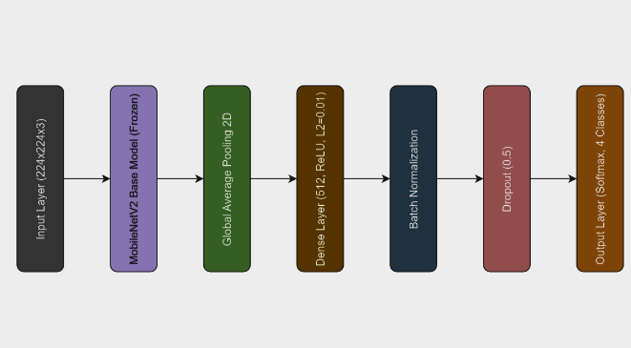
Figure 1 MobileNet architecture

ResNet50
A deep convolutional neural network (CNN) design called the Residual Network (ResNet) employs residual connections to solve the vanishing gradient issue in deep networks. Unlike traditional architectures, ResNet enables the creation of very deep networks, such as ResNet-50 with 50 layers, by introducing shortcut connections that bypass one or more layers, facilitating efficient gradient flow. Its bottleneck design employs 1x1 convolutions for dimensionality reduction, 3x3 convolutions for feature extraction, and another 1x1 convolution to restore dimensions, improving computational efficiency. ResNet excels in tasks like image classification and medical image analysis, achieving superior accuracy with fewer parameters. The detailed architecture is shown in "Fig.2".
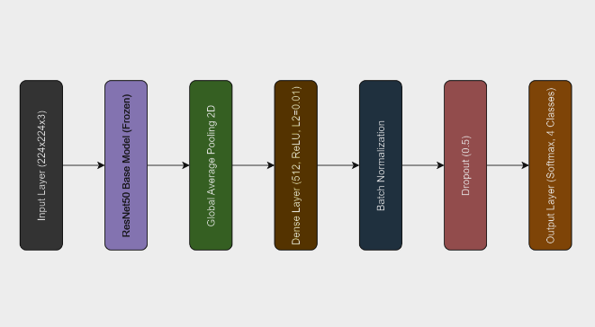
Figure 2 ResNet50 architecture

InceptionV3
An extremely effective convolutional neural network (CNN) architecture called InceptionV3 was created to improve picture categorization performance while lowering computing expenses. Building on InceptionV2, it introduces advanced techniques like factorized convolutions, replacing large filters with smaller ones (e.g., 3x3 instead of 5x5), and asymmetric convolutions, splitting square filters into 1x3 and 3x1 convolutions to reduce parameters and computations. Grid size reduction compresses intermediate layers, enabling the model to focus on abstract features without compromising accuracy. Auxiliary classifiers are used during training to improve gradient flow, stabilize learning, and accelerate convergence. InceptionV3 processes 224x224x3 images, employs inception modules with varied filter sizes to capture diverse spatial features, and concludes with global average pooling and a SoftMax activation layer for classification. Known for its balance of accuracy and efficiency, InceptionV3 is widely applied in image classification, object detection, and transfer learning in computer vision tasks. The detailed architecture is shown in "Fig.3".

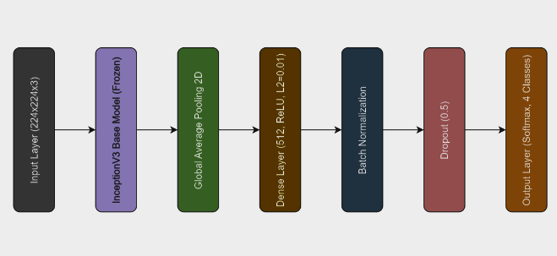
Figure 3 InceptionV3 architecture

D. Augmented Attention Architecture
AttentionAugmentedConv2D is an attention boosted convolutional layers which adds additional self-attention features to typical convolutional layers for better feature extraction. In detail, it is composed of three parts, a convolutional layer, a multi-head attention (MHA) module, and an add (residual) layer. The 2D convolution over input feature maps is used to extract local patterns and spatial features using convolutional layer with padding='same' to maintain the spatial dimensions of the output. Then it does query, key, and value projections and then processes it through multiple attention heads with the MHA module. Instead, each head that extracts feature focusing on different spatial regions to capture the local and the global dependencies. Thus, the output of the convolution and attention modules was combined using element-wise addition through add layer to concatenate local and context aware global information. This hybrid method balances local and global feature representation to resolve vanishing gradients, convergence accelerated, and learning stability issues. AttentionAugmentedConv2D does not change the input dimensions, and it is consequently a good way to boost the performance of CNN models such as ResNet50, MobileNetV2, and InceptionV3 in objects like Alzheimer’s detection, medical imaging, and image classification.

E. Adaptive Moment Estimation (Adam)
An advanced gradient descent optimization algorithm, which is adapted to handle complex problems, dealing with large datasets or a high number of parameters, is Adaptive Moment Estimation (Adam) [19]. It is very efficient, uses little memory, and adds strength of gradient descent with momentum and RMSProp algorithms. When given a gradient, Adam computes a combination of the gradient s moving averages of the gradient and the squared gradient, and updates these iteratively through Equation 1.
$G_{t}= αG_{t-1}+\left(1-α\right)[\frac{∂Le}{∂w_{t}}]$ (1)
Where G_t and G_t-1 as gradient accumulations at current and previous time steps respectively. Le and ∂w_t denote the learning rate and the weight adjustments and the value of the constant ‘α’ is assigned to the moving average parameter. A decay factor is applied to the parameters before these are updated, which aids in stabilizing the learning process. Momentum is used by Adam to predict the gradient direction, accelerating the convergence during the training. This however introduces two more hyperparameters into the mix, thus it is slightly more difficult to hyperparameter tune. Bias correction is applied to mitigate large oscillations close to the global minimum to keep the gradient descent unbiased and consistent across iterations. To maintain stable learning trajectory, Adam uses this combination of techniques and it is the most preferred optimization method in deep learning applications.
4. RESULTS AND SIMULATIONS:
Data acquisition, Fine tuning, the training and validation of the proposed architecture models, visual interpretation, and the efficiency of the proposed architecture models are described in this section. In this proposed work, the proposed models are tested using 64bit Windows 10 operating system. Table 1 shows the computer configuration on which the training and testing of the models were carried out.
Table 2: Computer Configuration of the proposed Models
Item | Configuration
Processor | AMD Ryzen 5 4600H CPU with Radeon Graphics @ 3.00 GHz
Graphics Card | AMD Radeon graphics and Nvidia 1650x Geforce GTX, and 16GB RAM.
Ram Size | 8 GB
Hard-Disk Size | 1 TB

A. Data acquisition & pre-processing
The Alzheimers Diseases Classification (MRI) dataset is publicly available datasets from "Kaggle"[20] with three classes (MildDemented, ModerateDemented, VeryMildDemented) and one class (NonDemented).
Table 3. Count of images in each class
Disease | Count
MildDemented | 9856
ModerateDemented | 6528
VeryMildDemented | 11200
NonDemented | 12800

B. Image Pre-Processing
Image preprocessing is crucial. The data is reformatted for training. Raw data is resized to 224x224 pixels to fit the models. Images are normalized to smooth and remove blurred ones. Libraries like TensorFlow, NumPy, pandas, and matplotlib are imported. “Fig. 4” represents the image of diseases with 4 different classes.
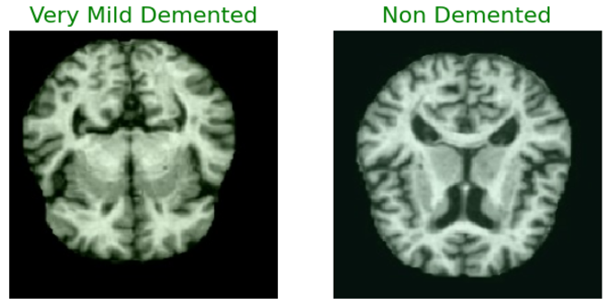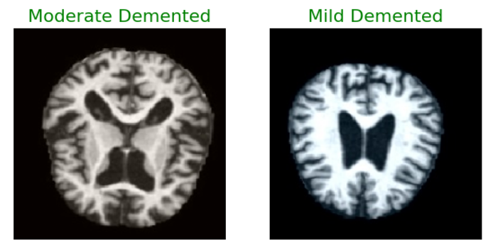
Figure 4 Images of Brain MRI for the 4 classes

C. Data Training and Fine Tuning
The models use a pre-trained ImageNet dataset as the base. Global Average Pooling and Dense layers are added to adapt the base model to the new classification task. The base layers are frozen during initial training, then unfrozen for fine-tuning on the Alzheimer's Disease dataset. Callbacks monitor the training progress and save the best model, adjusting the learning rate if the validation accuracy plateaus.
D. Model Training and Validation
The dataset contains 40,384 images divided into four classes. 70% (27,187) are used for training, while 25% (10196) are used for validation and, while 5% (6797) are reserved for testing. The model is trained on the training set, and its performance is assessed on the testing set, ensuring robust and accurate classification. Training and validation curves illustrate the model's performance, identifying overfitting, underfitting, and the optimal number of training epochs. Consistent convergence of these curves typically indicates a well-tuned model.
E. Model Training and Validation
The dataset contains 40,384 images divided into four classes. 70% (27,187) are used for training, while 25% (10196) are used for validation and, while 5% (6797) are reserved for testing. The model is trained on the training set, and its performance is assessed on the testing set, ensuring robust and accurate classification. Training and validation curves illustrate the model's performance, identifying overfitting, underfitting, and the optimal number of training epochs. Consistent convergence of these curves typically indicates a well-tuned model.

Table 4: Displays the accuracy and loss for both training and validation phases of the MobileNetV2, InceptionV3, ResNet50 models
Model | Loss | Accuracy
MobileNetV2 | 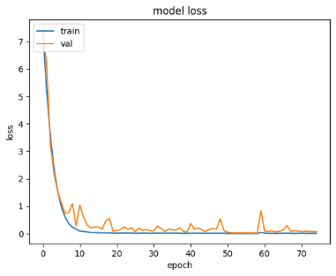 | 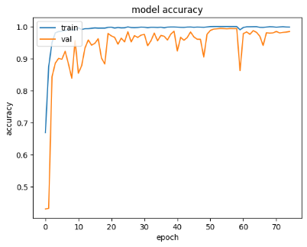
InceptionV3 | 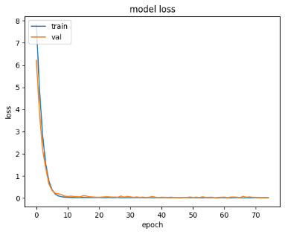 | 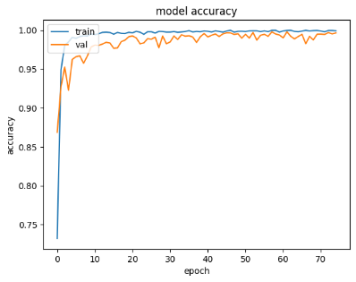
ResNet50 | 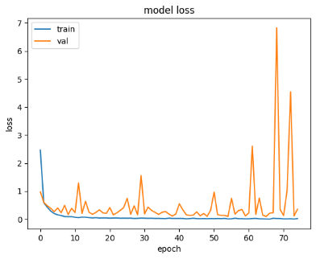 | 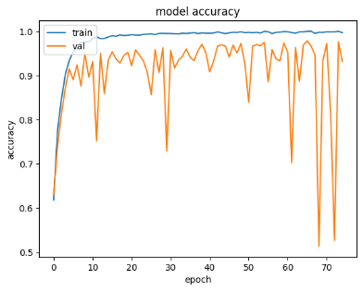

Table 5. Confusion matrix and ROC curve for the MobileNetV2, InceptionV3, ResNet50 model.
Model | Confusion matrix | ROC Curve
MobileNetV2 | 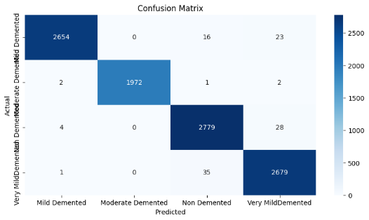 | 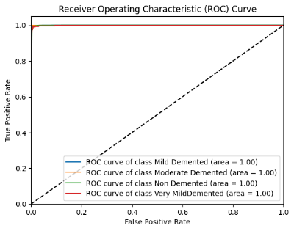
InceptionV3 | 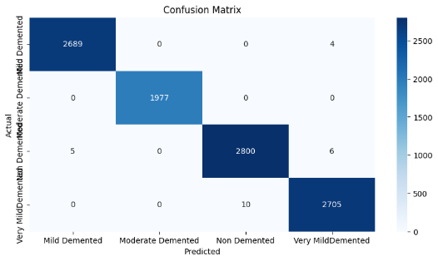 | 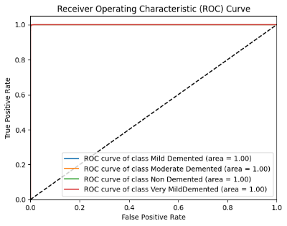
ResNet50 | 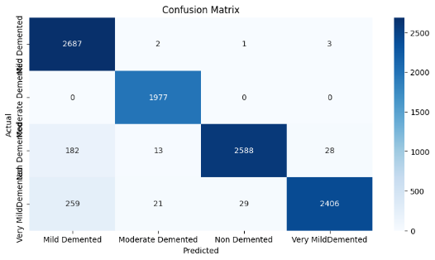 | 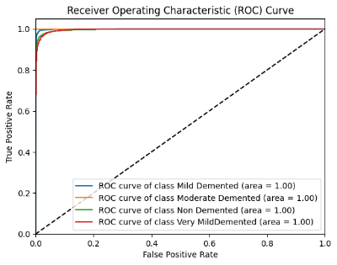

Table 4. displays the Accuracy and Loss curves of the models. Table 5. demonstrates the confusion matrix and ROC curves of the models.

Table 6. Displays the accuracy and loss for both training and validation phases of the MobileNetV2, InceptionV3, ResNet50 models with attention
Model | Loss | Accuracy
MobileNetV2 | 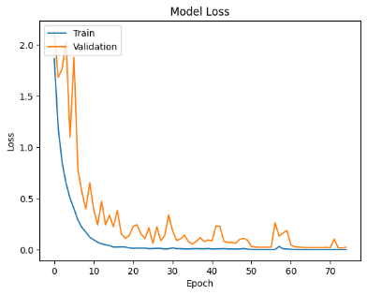 | 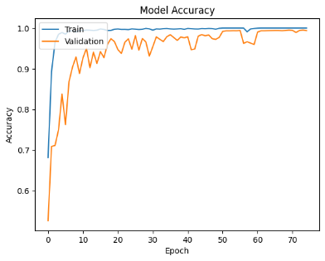
InceptionV3 | 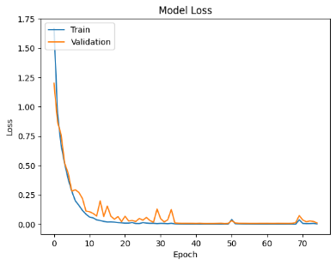 | 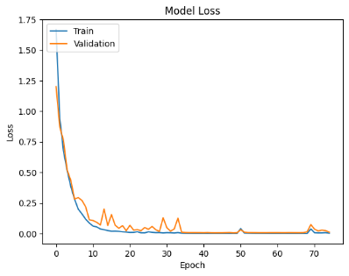
ResNet50 | 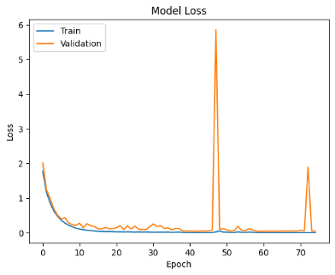 | 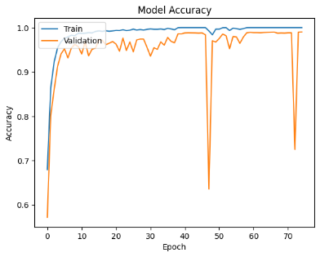

Table 7. Confusion matrix and ROC curve for the MobileNetV2, InceptionV3, ResNet50 model with attention.
Model | Confusion matrix | ROC Curve
MobileNetV2 | 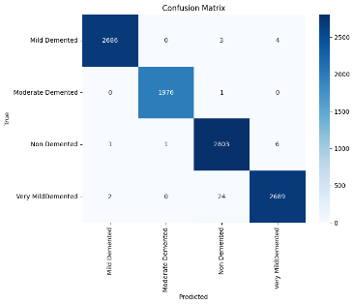 | 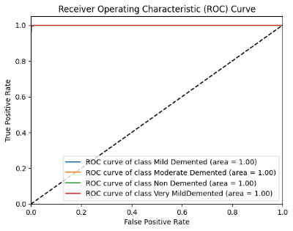
InceptionV3 | 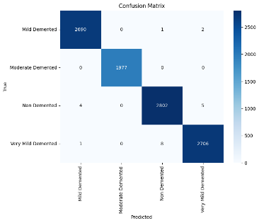 | 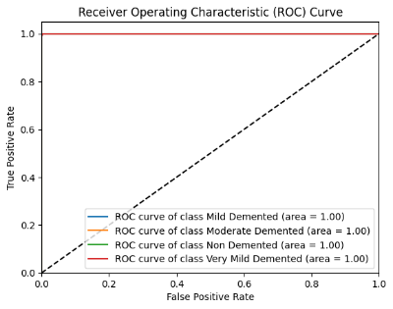
ResNet50 | 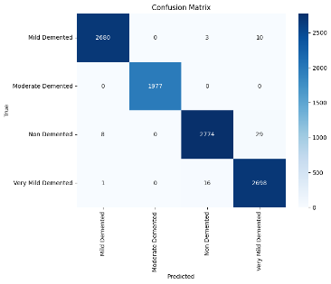 | 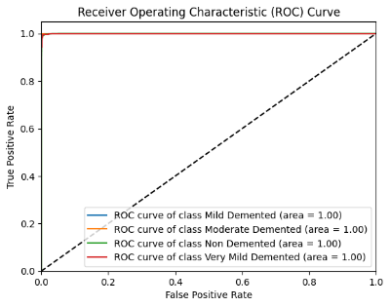

Table 6. displays the Accuracy and Loss curves of the models with attention. Table 7. demonstrates the confusion matrix and ROC curves of the models with attention.

F. Evaluation Metrics
The evaluation metrics employed to assess the performance of the proposed method are outlined in the following equations 1-4 [16]
Accuracy=$\frac{Tp+Tn}{Tp+Fp+Tn+Fn}$ (2)
Precision=$\frac{Tp}{Tp+Fp}$ (3)
F1 score= $\frac{2*(Precision*Recall)}{Precision+Recall}$ (4)
Recall= $\frac{Tp}{(Tp+Fp)}$ (5)
Where, tp denotes true positives, tn represents true negatives, fp refers to false positives, and fn indicates false negatives.
Tables 8,9,10 Displays the precision, recall, F1-score, support, and accuracy of MobileNet, ResNet50, InceptionV3. MobileNetV2 gives an accuracy of 98.9%, ResNet50 94.7% whereas InceptionV3 gives an accuracy of 99.8%. When comparing the 3 models InceptionV3 gives the best accuracy of all the models.
Table 8 Evaluation metrics of the MobileNetV2 model
Model | Class | Precision | Recall | F1-Score | Support | Accuracy
MobileNetV2 | Mild Demented | 1.00 | 0.99 | 0.99 | 2693 | 98.9%
MobileNetV2 | Moderate Demented | 1.00 | 1.00 | 1.00 | 1977 | 98.9%
MobileNetV2 | Non-Demented | 0.98 | 0.99 | 0.98 | 2811 | 98.9%
MobileNetV2 | Very Mild Demented | 0.98 | 0.99 | 0.98 | 2715 | 98.9%

Table 9 Evaluation metrics of the ResNet50 model
Model | Class | Precision | Recall | F1-Score | Support | Accuracy
ResNet50 | Mild Demented | 0.86 | 1.00 | 0.92 | 2693 | 94.7%
ResNet50 | Moderate Demented | 0.98 | 1.00 | 0.99 | 1977 | 94.7%
ResNet50 | Non-Demented | 0.99 | 0.92 | 0.95 | 2811 | 94.7%
ResNet50 | Very Mild Demented | 0.99 | 0.89 | 0.93 | 2715 | 94.7%

Table 10 Evaluation metrics of the InceptionV3 model
Model | Class | Precision | Recall | F1-Score | Support | Accuracy
InceptionV3 | Mild Demented | 1.00 | 1.00 | 1.00 | 2693 | 99%
InceptionV3 | Moderate Demented | 1.00 | 1.00 | 1.00 | 1977 | 99%
InceptionV3 | Non-Demented | 1.00 | 1.00 | 1.00 | 2811 | 99%
InceptionV3 | Very Mild Demented | 1.00 | 1.00 | 1.00 | 2715 | 99%

Tables 11, 12, and 13 summarize the performance of MobileNetV2, ResNet50, and InceptionV3 with AttentionAugmentedConv2D, reporting precision, recall, F1-score, support, and accuracy. MobileNetV2 and ResNet50 achieve accuracies of 99.6% and 99.3%, respectively, while InceptionV3 attains the highest accuracy of 99.8%, demonstrating superior performance among the three models.
Table 11 Evaluation metrics of the MobileNetV2+Attention model
Model | Class | Precision | Recall | F1-Score | Support | Accuracy
MobileNetV2 | Mild Demented | 1.00 | 1.00 | 1.00 | 2693 | 99.6%
MobileNetV2 | Moderate Demented | 1.00 | 1.00 | 1.00 | 1977 | 99.6%
MobileNetV2 | Non-Demented | 0.99 | 1.00 | 0.99 | 2811 | 99.6%
MobileNetV2 | Very Mild Demented | 1.00 | 0.99 | 0.99 | 2715 | 99.6%

Table 12 Evaluation metrics of the ResNet50+Attention model
Model | Class | Precision | Recall | F1-Score | Support | Accuracy
ResNet50 | Mild Demented | 1.00 | 1.00 | 1.00 | 2693 | 99.3%
ResNet50 | Moderate Demented | 1.00 | 1.00 | 1.00 | 1977 | 99.3%
ResNet50 | Non-Demented | 0.99 | 0.99 | 0.99 | 2811 | 99.3%
ResNet50 | Very Mild Demented | 0.99 | 0.99 | 0.99 | 2715 | 99.3%

Table 13 Evaluation metrics of the InceptionV3+Attention model
Model | Class | Precision | Recall | F1-Score | Support | Accuracy
InceptionV3 | Mild Demented | 1.00 | 1.00 | 1.00 | 2693 | 99.8%
InceptionV3 | Moderate Demented | 1.00 | 1.00 | 1.00 | 1977 | 99.8%
InceptionV3 | Non-Demented | 1.00 | 1.00 | 1.00 | 2811 | 99.8%
InceptionV3 | Very Mild Demented | 1.00 | 1.00 | 1.00 | 2715 | 99.8%

Table 14 compares the performance of ResNet50, MobileNetV2, and InceptionV3 with and without AttentionAugmentedConv2D. The results show that ResNet50 demonstrates a notable improvement in accuracy with augmented attention, reflecting enhanced feature extraction. MobileNetV2 exhibits minimal change, indicating that its lightweight architecture is less affected by attention mechanisms. InceptionV3 has essentially no visible change in accuracy since it carries the capability to capture complex spatial patterns well. Attention augmentation benefits deeper models such as ResNet50, yet the effectiveness varies based on the architecture’s design and extraction of features.

Table 14. Comparison of Models with and without Attention
Model | Without Attention | With Attention
MobileNetV2 | 98.9% | 99.6%
ResNet50 | 94.7% | 99.3%
InceptionV3 | 99.8% | 99.8%

G. Parameters
The proposed model categorizes brain MRI images into tumors and normal. Table 14 specifies the parameters used for training the model such as number of epochs, optimizer, input image size, learning rate and batch size.
Table 14. Parameters
Training parameters | Values
Total epochs | 75
Optimizer | Adam
Input image size | 224x224x3
Learning Rate | 0.001
Batch size | 64

6. Conclusion
It is also demonstrated that when AttentionAugmentedConv2D is used with three state-of-the-art deep learning models such as ResNet50, MobileNetV2, and InceptionV3 classification accuracies of 99.3%, 99.6% and 99.8% respectively can be obtained for Alzheimer’s disease detection using brain image data. The models are made capable of integrating self attention with convolutional operations and hence are able to combine augmented attention and sufficiently enhance the models’ power to identify complex spatial patterns in neuroimaging data. Mixed with the two methods, the models can extract more desirable features, thereby, be able to classify samples using subtilly stimulated biomarkers which traditional diagnostic techniques could not identify.
Attention enhanced models can be integrated into and utilized in clinical flows to improve diagnostic accuracy and decrease the burden of healthcare provider burden and early detection while having enhanced suitability for resource constrained settings where such expertise might not be available. There is a need to incorporate multi modal data and genetic profiles, cognitive assessment, biochemical markers, to form a more comprehensive diagnostic system in future work. Verification and validation for these models requires real world settings and longitudinal studies to monitor disease progression and conduction large scale clinical trials. Furthermore, the explainable AI (XAI) techniques can also be developed such that they allow transparent model, facilitate clinical adoption and trustworthy AI driven diagnostics of Alzheimer's Disease using wearable devices for continuous brain monitoring.
7. References
1. Ji, H., Liu, Z., Yan, W. Q., & Klette, R. (2019, June). Early diagnosis of Alzheimer's disease using deep learning. In Proceedings of the 2nd international conference on control and computer vision (pp. 87-91).
2. Venugopalan, J., Tong, L., Hassanzadeh, H. R., & Wang, M. D. (2021). Multimodal deep learning models for early detection of Alzheimer’s disease stage. Scientific reports, 11(1), 3254
3. Al-Shoukry, S., Rassem, T. H., & Makbol, N. M. (2020). Alzheimer’s diseases detection by using deep learning algorithms: a mini-review. IEEE Access, 8, 77131-77141.
4. Ullah, H. T., Onik, Z., Islam, R., & Nandi, D. (2018, April). Alzheimer's disease and dementia detection from 3D brain MRI data using deep convolutional neural networks. In 2018 3rd international conference for convergence in technology (I2CT) (pp. 1-3). IEEE.
5. Murugan, S., Venkatesan, C., Sumithra, M. G., Gao, X. Z., Elakkiya, B., Akila, M., & Manoharan, S. (2021). DEMNET: A deep learning model for early diagnosis of Alzheimer diseases and dementia from MR images. Ieee Access, 9, 90319-90329.
6. Helaly, H. A., Badawy, M., & Haikal, A. Y. (2022). Deep learning approach for early detection of Alzheimer’s disease. Cognitive computation, 14(5), 1711-1727.
7. Nawaz, A., Anwar, S. M., Liaqat, R., Iqbal, J., Bagci, U., & Majid, M. (2020, November). Deep convolutional neural network based classification of Alzheimer's disease using MRI data. In 2020 IEEE 23rd International Multitopic Conference (INMIC) (pp. 1-6). IEEE.
8. Farooq, A., Anwar, S., Awais, M., & Rehman, S. (2017, October). A deep CNN based multi-class classification of Alzheimer's disease using MRI. In 2017 IEEE International Conference on Imaging systems and techniques (IST) (pp. 1-6). IEEE.
9. Sharma, S., Guleria, K., Tiwari, S., & Kumar, S. (2022). A deep learning based convolutional neural network model with VGG16 feature extractor for the detection of Alzheimer Disease using MRI scans. Measurement: Sensors, 24, 100506.
10. Marwa, E. G., Moustafa, H. E. D., Khalifa, F., Khater, H., & AbdElhalim, E. (2023). An MRI-based deep learning approach for accurate detection of Alzheimer’s disease. Alexandria Engineering Journal, 63, 211-221.
11. Ibrahim, R., Ghnemat, R., & Abu Al-Haija, Q. (2023). Improving Alzheimer’s disease and brain tumor detection using deep learning with particle swarm optimization. AI, 4(3), 551-573.
12. Hazarika, R. A., Maji, A. K., Kandar, D., Jasinska, E., Krejci, P., Leonowicz, Z., & Jasinski, M. (2023). An approach for classification of Alzheimer’s disease using deep neural network and brain magnetic resonance imaging (MRI). Electronics, 12(3), 676.
13. Rao, B. S., & Aparna, M. (2023). A review on Alzheimer’s disease through analysis of MRI images using deep learning techniques. IEEE Access, 11, 71542-71554.
14. Ftoutou, A., Majdoub, N., & Ladhari, T. (2023, October). Alzheimer's Disease Classification Using Deep Learning. In 2023 IEEE International Conference on Artificial Intelligence & Green Energy (ICAIGE) (pp. 1-6). IEEE.
15. Gupta, M., Kumar, R., & Abraham, A. (2024). Adversarial Network-Based Classification for Alzheimer’s Disease Using Multimodal Brain Images: A Critical Analysis. IEEE Access.
16. Sarwer, Mohammad Hasan, Tui Rani Saha, Shake Ibna Abir, Shaharina Shoha, Md Miraj Hossain, Nigar Sultana, Shariar Islam Saimon, Intiser Islam, Mahmud Hasan, and Sarder Abdulla Al Shiam. "EEG Functional Connectivity and Deep Learning for Automated Diagnosis of Alzheimer’s disease and Schizophrenia." Journal of Computer Science and Technology Studies 7, no. 1 (2025): 82-99.
17. Sathyabhama, B., and M. Kannan. "An effective deep learning-based automatic prediction and classification of Alzheimer's disease using EGELU-SZN technique." Neural Computing and Applications (2025): 1-18.
18. Özaltın, Öznur. "Early Detection of Alzheimer's Disease from MR Images Using Fine-Tuning Neighborhood Component Analysis and Convolutional Neural Networks." Arabian Journal for Science and Engineering (2025): 1-20.
19. Kingma, Diederik P., and Jimmy Ba. "Adam: A method for stochastic optimization." arXiv preprint arXiv:1412.6980 (2014).
20. https://www.kaggle.com/datasets/uraninjo/augmented-alzheimer-mri-dataset-v2

