Formulation and Evaluation of a Polyherbal Mucoadhesive Dental Gel
Nisarg Narkhede, Sohan Talele, Mansi Bhangale, Priyanka Patil, Harshal Patil
Guide: Mr. Tushar Fegade
Department of Pharmaceutics, Arunamai College of Pharmacy, Mamurabad, Jalgaon.

Keywords |  | Abstract
Polyherbal Formulation  Mucoadhesive Drug Delivery System  Oral Health  Guava Leaf  Clove Oil  Gingivitis  Oral Ulcer |  | The popularity of herbal dental gels rose considerably because they consist of natural ingredients and provide therapeutic oral care benefits. The research develops and evaluates a multi-herbal dental gel which incorporates Guava Leaf Extract alongside Neem Extract together with Aloe Vera Gel and Pomegranate Peel Extract and Eucalyptus Oil and Clove Oil under Carbopol 940 as the gelling agent. The formulation went through diverse tests that assessed its effectiveness, including physicochemical testing, microbiological analysis and stability examinations. The study results showed that this mucoadhesive gel met all requirements because it had good spreadability along with suitable viscosity and durable adhesion abilities along with oral bacterial protection capabilities. The mucoadhesive features of the formulation enabled prolonged contact existence on oral mucosa surfaces, which produced greater therapeutic outcomes. The herbal dental gel provides users with a safe and effective natural solution as opposed to standard oral care products.

Introduction
Herbal-based dental products form an essential part of traditional oral health practices in different cultures because they contribute to total human wellness. The components of herbal dental gels come from natural plant extracts which provide antimicrobial and anti-inflammatory benefits with healing attributes. Rising consumer interest in herbal dental alternatives has become evident because people worry about the unwanted side effects associated with chemical components in regular oral products. The commercial formulations used in dentistry often include artificial preservatives, foaming agents together with abrasives that are known to create oral cavity irritation and disturb its natural microbial balance. The dental market is shifting toward herbal products because they present complete and natural alternatives for oral hygiene care.
The rise in oral infections alongside gingivitis and dental caries leads people to seek solution alternatives that are both safer and more effective. The coordinated effects of various herbal extracts in polyherbal formulations boost the therapeutic outcomes of the treatment. The research focuses on creating a naturally-based mucoadhesive dental gel containing ingredients that exhibit antiseptic as well as anti-inflammatory and tissue-healing properties. The traditional Ayurvedic and herbal natural ingredients found in this formulation demonstrate their suitability as dental gel components because of their effectiveness without significant adverse consequences for oral hygiene.
This formulation contains tested natural oral dental ingredients that include Guava Leaf Extract together with Neem Extract and Aloe Vera alongside Pomegranate Peel Extract, Clove Oil and Eucalyptus Oil, which are traditionally applied to maintain oral health and prevent disease development. The medicinal properties of herbal extracts, including antibacterial effects and tissue-healing abilities and antifungal effects and pain-relief advantages, make them appropriate for dental use. Carbopol 940 keeps the gel mucoadhesive which allows it to stay put and distribute drugs for an extended period. The evaluation determines both physical and chemical aspects and antimicrobial effectiveness along with product stability as measures to evaluate complete gel performance.
This research intends to create an effective herbal dental gel which offers natural health maintenance and safety while delivering efficient oral care results while eliminating adverse effects from synthetic dental products. The utilization of mucoadhesive technology helps the dental gel stay longer in the oral cavity to maintain extended therapeutic action. This research strengthens the development of botanical dental care through evidence-based investigations which explore botanical materials for dental hygiene improvement.

Ideal Characteristics of Herbal Dental Gel
- The dental gel should exhibit a smooth texture, natural appearance and pleasing herbal scent.
- The product must maintain pH levels between 6.5 and 7.5 to avoid irritation of oral tissues.
- The product needs excellent ability to spread throughout the teeth and gums without difficulty during application.
- The product should demonstrate mucoadhesion to maintain contact duration while releasing its ingredients gradually.
- The product needs to deliver functionality related to antimicrobial defense alongside wound-healing benefits and anti-inflammatory properties to support oral health.
- The gel should contain no toxic chemicals since this ensures both safety and biological compatibility.
- The product should maintain a stable consistency with the same viscosity along with unchanging color and fragrance.
- The product must exhibit easy extrusion alongside a non-sticky nature and full ability to wash off residue.

Materials and Methodology for Formulation

Materials Required for Formulation
Figure 2-A Guava Leaves

Active Pharmaceutical Ingredients (APIs):
Sr. No. | Active Pharmaceutical Ingredients (APIs)
1 | Guava Leaf Extract
2 | Neem Extract
3 | Aloe Vera Gel
4 | Pomegranate Peel Extract
5 | Eucalyptus Oil
6 | Clove Oil
Table 2-A Active Pharmaceutical Ingredients

Adjuvants (Excipients):
Sr. No. | Ingredients
1 | Carbopol 940
2 | Polyethylene Glycol (PEG-400)
3 | Sorbitol
4 | Triethanolamine (TEA)
5 | Sodium Benzoate
6 | Chlorophyll Extract
7 | Distilled Water
Table 2-B Adjuvants

Equipment for Formulation
Equipment | Purpose
pH Meter | pH measurement
Brookfield  Viscometer | Viscosity measurement
Weighing Balance | Accurate measurement of ingredients
Glass Slides | Spreadability and homogeneity test
Incubator | Stability and microbial testing
Autoclave | Sterilization of culture media and glassware
Colony Counter | Microbial load assessment
Laminar Airflow Chamber | Aseptic handling of culture media
Agar Well Cutter | Antimicrobial activity testing
Spectrophotometer | Analysis of Microbial growth and color stability
Table 2-C Equipment for Formulation

Plant Profile

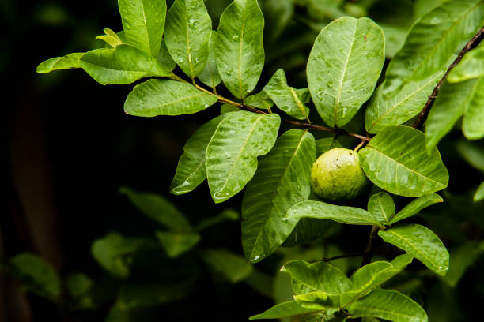
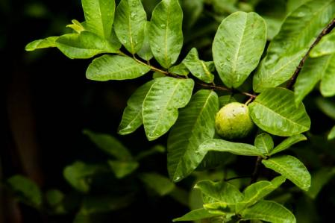
Guava Leaf Extract (Psidium guajava)
- Synonyms: Guava, Amrood (Hindi), Jambu (Sanskrit)
- Biological Source: Leaves of Psidium guajava
- Taxonomical Classification:
Kingdom | Plantae
Division | Angiosperms
Class | Magnoliopsida
Order | Myrtales
Family | Myrtaceae
Genus | Psidium
Species | guajava

- Active Constituents: Flavonoids (quercetin), tannins, saponins, triterpenoids
- Pharmacological Actions:
- Antibacterial: Inhibits Streptococcus mutans and other oral pathogens.
- Anti-inflammatory: Reduces swollen gums and decreases gum irritation.
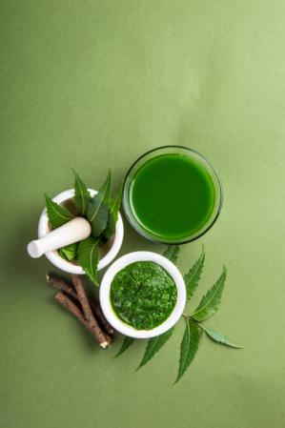
- Antioxidant: Protects oral tissues from oxidative stress.

Neem Extract (Azadirachta indica)
Figure 2-B Neem Leaves
- Synonyms: Indian Lilac, Margosa Tree
- Biological Source: Leaves of Azadirachta indica

- Taxonomical Classification:
Kingdom | Plantae
Division | Angiosperms
Class | Magnoliopsida
Order | Sapindales
Family | Meliaceae
Genus | Azadirachta
Species | indica
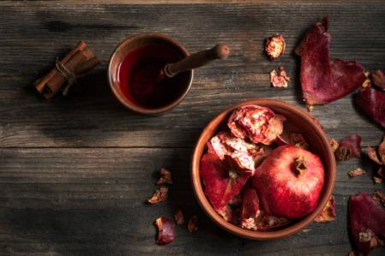

Figure 2-D Pomegranate Peels
- Active Constituents: Azadirachtin, nimbin, nimbidin, flavonoids
- Pharmacological Actions:
- Antibacterial: Inhibits plaque-forming bacteria.
- Anti-inflammatory: Reduces gum inflammation.
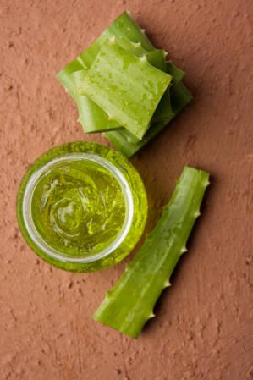
- Antifungal: Effective against Candida albicans.

Aloe Vera Gel (Aloe barbadensis)

Figure 2-C Aloe Leaves

- Synonyms: Ghrita-kumari (Sanskrit), Kumari (Ayurveda)
- Biological Source: Gel from leaves of Aloe barbadensis
- Taxonomical Classification:
Kingdom | Plantae
Division | Angiosperms
Class | Liliopsida
Order | Asparagales
Family | Asphodelaceae
Genus | Aloe
Species | barbadensis

- Active Constituents: Aloin, acemannan, polysaccharides
- Pharmacological Actions:
- Soothing: Provides relief from oral ulcers and irritation.
- Anti-inflammatory: Helps in healing gum diseases.
- Antimicrobial: Inhibits oral pathogens.

Pomegranate Peel Extract (Punica granatum)
- Synonyms: Anar (Hindi), Dadima (Sanskrit)
- Biological Source: Dried peel of Punica granatum
- Taxonomical Classification:
Kingdom | Plantae
Division | Angiosperms
Class | Liliopsida
Order | Asparagales
Family | Asphodelaceae
Genus | Aloe
Species | barbadensis

- Active Constituents: Punicalagins, ellagic acid, tannins, flavonoids
- Pharmacological Actions:
- Antibacterial: Inhibits Streptococcus mutans, reducing dental plaque.
- Antioxidant: Protects against oxidative stress in oral tissues.
- Anti-inflammatory: Reduces gingival swelling and irritation.

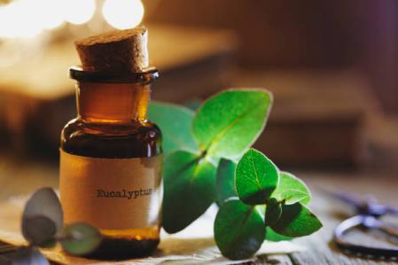
Eucalyptus Oil (Eucalyptus globulus)
Figure 2-E Eucalyptus Leaves
- Synonyms: Blue Gum Tree, Tasmanian Blue Gum
- Biological Source: Essential oil from leaves of Eucalyptus globulus
- Taxonomical Classification:
Kingdom | Plantae
Division | Angiosperms
Class | Magnoliopsida
Order | Myrtales
Family | Myrtaceae
Genus | Eucalyptus
Species | globulus

- Active Constituents: Eucalyptol (1,8-cineole), flavonoids, tannins
- Pharmacological Actions:
- Antimicrobial: Kills bacteria and fungi, causing oral infections.
- Analgesic: Provides mild pain relief for sensitive gums.
- Anti-inflammatory: Helps reduce swelling in gums.

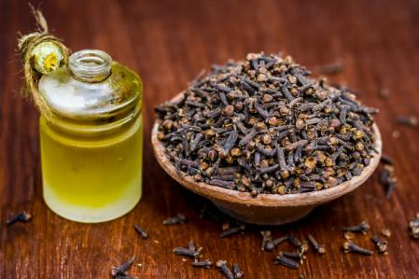
Clove Oil (Syzygium aromaticum)
Figure 2-F Clove Buds
- Synonyms: Laung (Hindi), Lavanga (Sanskrit)
- Biological Source: Essential oil from flower buds of Syzygium aromaticum
- Taxonomical Classification:
Kingdom | Plantae
Division | Angiosperms
Class | Magnoliopsida
Order | Myrtales
Family | Myrtaceae
Genus | Syzygium
Species | aromaticum

- Active Constituents: Eugenol, flavonoids, tannins
- Pharmacological Actions:
- Analgesic: Provides natural pain relief for toothaches.
- Antibacterial: Inhibits Streptococcus mutans and other oral pathogens.
- Anti-inflammatory: Reduces gum irritation and swelling.

Excipient Profile

Carbopol 940
- IUPAC Name: Poly(acrylic acid)
- Chemical Formula: (C3H4O2)n
- Function: Gelling and Thickening Agent
- Solubility: Dispersible in water; soluble in ethanol, glycerin, and propylene glycol; insoluble in oils
- Description: Carbopol 940 represents a synthetic polymer that functions to increase viscosity in gel formulation preparations. Water solutions of Carbopol 940 transform into a clear gel substance after neutralization occurs using a TEA (Triethanolamine) pH balancing agent. This substance improves both formulation texture and stability.

Polyethylene Glycol (PEG-400)
- IUPAC Name: Poly(oxyethylene)
- Chemical Formula: (C2H4O)nH2O
- Function: Humectant and Solubilizer
- Solubility: Completely soluble in water, ethanol, and acetone; insoluble in oils
- Description: PEG-400 functions as a water-soluble polymer that enhances the water-dissolving capabilities of compounds that have difficulty expressing solubility in water. The substance absorbs and retains moisture to stop the gel from becoming dehydrated during its shelf life.

Sorbitol
- IUPAC Name: (2S,3R,4R,5R)-Hexane-1,2,3,4,5,6-hexol
- Chemical Formula: C6H14O6
- Function: Sweetener and Humectant
- Solubility: Highly soluble in water; slightly soluble in ethanol; insoluble in oils and ether
- Description: Sorbitol functions as a sugar alcohol compound which serves to retain moisture in order to keep gels smooth while maintaining high hydration. Sorbitol both improves taste and texture properties in oral products during formulation.

Triethanolamine (TEA)
- IUPAC Name: 2,2',2''-Nitrilotri(ethan-1-ol)
- Chemical Formula: C6H15NO3
- Function: pH Regulator
- Solubility: Freely soluble in water, ethanol, and methanol; insoluble in benzene and ether
- Description: The pharmaceutical industry relies on TEA to control pH levels during gel preparation. The addition of TEA to Carbopol 940 acidic components results in the formation of stable transparent gels that retain their smooth consistency. The emulsion remains stable through TEA because it maintains the proper combination of water and oil phases.

Sodium Benzoate
- IUPAC Name: Sodium benzene carboxylate
- Chemical Formula: C7H5NaO2
- Function: Preservative and Antimicrobial Agent
- Solubility: Highly soluble in water; slightly soluble in alcohol; insoluble in oils
- Description: Sodium benzoate functions as a preservative to stop microorganisms which boosts the shelf life of the gel. Sodium benzoate makes its best contribution as a preservative when used in water-based formulations under slightly acidic pH conditions.

Chlorophyll Extract
- IUPAC Name: Magnesium [methyl (132R)-3,7,12,17-tetramethyl-8-vinyl-13-(2-carboxyethyl)-2,3-dihydroporphyrin-18-propionate]
- Chemical Formula: C55H72MgN4O5
- Function: Natural Colorant and Antioxidant
- Solubility: Soluble in ethanol, acetone, and chloroform; slightly soluble in water
- Description: The natural green color of the gel along with antioxidant properties come from chlorophyll extract. The formulation benefits from its gentle ability to stay fresh because chlorophyll extract provides mild deodorizing properties.

Distilled Water
- IUPAC Name: Oxidane
- Chemical Formula: H2O
- Function: Universal Solvent
- Solubility: Miscible with most polar substances; immiscible with non-polar solvents
- Description: Distilled water functions as the main solvent of the gel to create consistent and uniform integration of its components. Distillation removes pollutants from water so it becomes acceptable for pharmaceutical applications and cosmetic development.

Extraction Process of Active Ingredients

Guava Leaf Extract (Psidium guajava)
- Guava leaves (150 g) underwent a powdering process followed by placement within a filter paper-made Soxhlet thimble.
- A Soxhlet apparatus containing 500mL solvent solution of 70% ethanol underwent heating at 60°C.
- The process lasted six hours until the extracted solvent became transparent.
- A thick extract that contained bioactive compounds from guava leaves was produced when the ethanol was evaporated using a rotary evaporator.

Neem Extract (Azadirachta indica)
- A powered substance was created by grinding 125g of dried neem leaves into a delicate consistency.
- 80% ethanol solution (600mL) was combined with the mixture, which underwent 24 hours of maceration with periodic stirring.
- The filtered solution underwent vacuum evaporation at 45°C to produce a concentrated extract.

Aloe Vera Gel (Aloe barbadensis miller)
- The inner gel from fresh aloe vera leaves (150g) was extracted after washing the leaves and removing their skins.
- A filtration process using muslin fabric was applied to the gel in order to eliminate insoluble fibers.
- The preservative substance of 0.5% citric acid protected the solution from oxidation.

Pomegranate Peel Extract (Punica granatum)
- A device grounds 100 grams of dried pomegranate peels into a well-finished powder form.
- The mixture received 80% ethanol (500mL) after which it underwent maceration for 24 hours.
- Vacuum evaporative drying at 40 degrees Celsius produced the extract from the filtered solvent solution.

Eucalyptus Oil (Eucalyptus globulus)
- Steam distillation required 50g of fresh eucalyptus leaves kept in operation for 4 hours.
- The essential oil fraction was obtained by collecting condensed vapors followed by the separation of oil droplets from the aqueous layer.
- The extracted oil was then stored in an amber-colored bottle at room temperature to maintain its quality and prevent degradation.

Clove Oil (Syzygium aromaticum)
- A 4-hour steam distillation process was performed on 40g of dried clove buds.
- An isolation procedure separated the essential oil from the water phase.
- The extracted oil was then stored in an amber-colored bottle at room temperature to maintain its quality and prevent degradation.

Method of Preparation

Step 1: Preparation of the Aqueous Phase
- Initially, 50% of the necessary distilled water was filled into a sanitized mixing vessel.
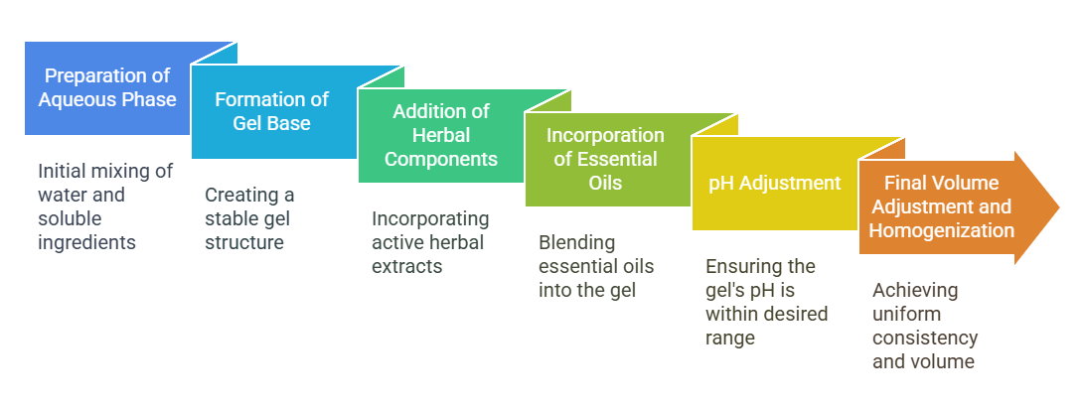
- The continuous stirring enables the dissolution of Sodium Benzoate into the water.
Figure 4-A Method of Preparation
- Sorbitol together with PEG-400 were added to the solution before mixing until complete dissolution.
- The solution received Chlorophyll Extract followed by thorough mixing.

Step 2: Formation of Gel Base
- The process involved adding Carbopol 940 slowly to the stirring aqueous solution to avoid formulation clumps.
- The stirring procedure continued until the solution transformed into a uniform gel-like state.

Step 3: Addition of Active Herbal Components
- The process involved gradually adding Guava Leaf Extract with Neem Extract along with Pomegranate Peel Extract, then Aloe Vera Gel into the gel base under continuous stirring.
- The stirring process continued until every herbal component dispersed uniformly throughout the mixture.

Step 4: Incorporation of Essential Oils
- A small amount of PEG-400 was added to mixtures of Eucalyptus Oil and Clove Oil to boost their solubility levels.
- The process involved slow addition of the mixture into the gel base while maintaining constant stirring to achieve complete mixture distribution.

Step 5: pH Adjustment
- A pH meter served to measure direct pH values in the solution. The correct pH level exists between 6.5 and 7.5.
- The addition of TEA was performed drop-wise under stirring conditions until the targeted pH level was achieved.
- A uniform mixing technique ensures equal distribution of the gel components to avoid localized gel thickening.

Step 6: Final Volume Adjustment and Homogenization
- The formulation reached its final weight of 100g by adding the remaining distilled water.
- A homogenizer operating at a controlled speed blended the solution to achieve complete uniformity.
- The gel underwent a rest period of\24 hours to eliminate air bubbles while allowing full hydration of the solution.

Evaluation of Herbal Dental Gel
The evaluation process of the herbal dental gel must cover all aspects to verify quality and stability as well as effectiveness.

Equipment for Evaluation
Equipment |  | Purpose
Weighing Balance |  | Accurate measurement of ingredients
Magnetic Stirrer |  | Mixing and dissolving ingredients
Soxhlet Apparatus |  | Extraction of active herbal ingredients
Homogenizer |  | Uniform dispersion of ingredients
Filtration Unit |  | Purification of extracts
Hot Plate |  | Heating for extraction and solubilization
Mortar and Pestle |  | Grinding and mixing solid ingredients
Table 5-A Equipment for Evaluation

Physicochemical Assessment

Physical Appearance & Consistency
- Objective: The purpose of the evaluation was to examine the gel's texture state alongside clarity and uniformity.
- Method: The visual examination of the gel under normal daylight revealed a smooth texture without lumps or phase separation. The consistency was tested by spreading a small portion on a glass plate to check for uniformity.
- Acceptance Criteria: The gel should maintain a uniform smooth texture without any phase separation or granule formation.

Color & Odor
- Objective: The goal was to check the color intensity and smell of the gel.
- Method: A visual examination of the gel revealed its light green color that resulted from chlorophyll extract. The formulation's smell was evaluated for its herbal essence.
- Acceptance Criteria: The light green color of the gel must stay consistent throughout its duration. The gel should smell pleasant with natural scents yet avoid any bitter or artificial chemical smells.

Transparency Test
- Objective: The examination aims to evaluate the translucency level of the tested gel.
- Method: The examination took place under white light using a transparent glass container with a minimal amount of gel inside. The classification of transparency relies on three categories: clear visibility through the gel, slightly translucent observation through the gel, or complete gel opacity.
- Acceptance Criteria: The acceptance requirement for the gel demands a transparent material which displays neither turbidity nor cloudiness.

pH Measurement
- Objective: The objective assesses whether the gel’s pH meets oral usage standards (6.5 – 7.5) and avoids tissue irritation.
- Method: 1g of the gel requires 10mL of distilled water for dissolving purposes. The pH measurements took place at room temperature of 25°C through a calibrated pH meter. The experiment was conducted three times to obtain average results.
- Acceptance Criteria: The acceptable pH range should fall between 6.5 and 7.5 to maintain oral tissue compatibility.

Spreadability Test
- Objective: The objective of this test is to measure the ease with which the gel covers teeth and gum surfaces.
- Method: A single quantity (1g) of gel received placement between two glass slides. A 100g weight was applied onto the top glass slide for one minute. The measurement device recorded the expanded dimension of the gel spread.
- Formula:
$$Spreadability(S)= (M× L)/T$$
Where:
- M = weight applied (g)
- L = distance spread (cm)
- T = time taken (seconds)
- Acceptance Criteria: The acceptance criterion states that the gel should be distributed evenly throughout its surface without destroying its structure.

Extrudability Test
- Objective: The study investigates the tube-based dispensing method for herbal dental gel to determine user-friendly operational characteristics under applied pressure conditions.
- Method: The process involved filling a collapsible tube with 10 grams of gel formulation while properly sealing it. An adjustable tube was mounted on a rectangular surface and its nozzle was installed at the bottom position. A 500g or 1kg weight was applied at the sealed end during a 30-second period to produce the gel from the tube. Weights of expelled gel were measured after the experiment.
- Formula:
$Extrudability\left(\%\right)=\left(\frac{Weight of extruded gel}{Total weight of gel in tube}\right)×100$
- Evaluation Criteria:
- Above 90% → Highly extrudable
- 80-90% → Good extrudability
- 70-80% → Moderate extrudability
- Below 70% → Poor extrudability

Viscosity Analysis
- Objective: This section aims to determine the thickness along with flow characteristics of the gel.
- Method: The Brookfield Viscometer operated with Spindle No. 64 and 25°C temperature at 50 rpm. The viscosity measurements took place after the gel was placed inside a sample holder.
- Acceptance Criteria: The required viscosity range lies between 10,000 to 50,000 centipoise (cP) to maintain an effective tooth and gum bond.

Homogeneity
- Objective: The purpose of this approach is to assess uniform distribution throughout the mixture as well as its enduring stability status.
- Method: One drop of gel was applied to glass slides to examine both phase separation and textural composition.
- Acceptance Criteria: The test requires the gel to stay uniformly mixed while maintaining its stability without forming separate phases.

Microbiological Evaluation

Total Microbial Load
- Objective: This procedure aims to detect bacterial and fungal presence in the gel specimen.
- Method: A mixture containing one gram of gel product with nine milliliters of sterile saline solution formed the experimental solution. A spread plate technique was performed on Nutrient Agar plates for bacteria while using Sabouraud Dextrose Agar plates for fungi. The incubation period lasted 48 hours at 37°C for bacteria as well as 25°C for fungi. The number of colony-forming units (CFU) was measured.
- Acceptance Criteria: The standards demand the microbe count not to exceed 1000 CFU/g bacteria nor 100 CFU/g fungi in the gel.

Antimicrobial Effectiveness
- Objective: The aim of this test is to verify the gel's antifungal and antibacterial qualities.
- Method: Agar Well Diffusion Test: Streptococcus mutans and Candida albicans were pre-inoculated in agar plates, and the gel was added to wells (6 mm in diameter). For a whole day, the plates were incubated at 37°C. The zone of inhibition was measured in millimeters.
- Acceptance Criteria: Antimicrobial activity is confirmed by a distinct zone of inhibition surrounding the gel sample.

Phytochemical Analysis

Alkaloids Test (Mayer’s Test)
- Principle: The reaction of alkaloids with Mayer’s reagent leads to cream or white precipitate formation, which indicates the compound’s presence.
- Method: Take 2 mL of the plant extract in a test tube. Place a small amount of Mayer’s reagent into the test tube. Observe for precipitate formation.
- Interpretation: White or cream ppt → Alkaloids present. No precipitate → Alkaloids absent

Flavonoids Test (Shinoda Test)
- Principle: The reduction reaction of Flavonoids with magnesium ribbon under hydrochloric acid (HCl) exposure creates either pink or red-colored substances.
- Method: Take 2 mL of plant extract in a test tube. Put a tiny piece of magnesium ribbon into the solution. Add concentrated HCl dropwise. Observe for color changes.
- Interpretation: Pink or red color → Flavonoids present. No color change → Flavonoids absent

Tannins Test (Ferric Chloride Test)
- Principle: The combination of tannins in contact with ferric chloride solution (FeCl₃) creates a blue-black or greenish-black reaction color.
- Method: Take 2 mL of plant extract in a test tube. Place 5% FeCl₃ solution drops into the test tube. Observe for color changes.
- Interpretation: Blue-black color → Tannins present. No color change → Tannins absent

Saponins Test (Foam Test)
- Principle: This method detects saponins through their surfactant characteristics, which cause stable foam creation by mixing them with water and agitation.
- Method: Take 2 mL of plant extract in a test tube. Shake the mixture of 10 mL distilled water and extract solution vigorously. Observe for foam formation.
- Interpretation: Froth formation → Saponins present. No foam formation → Saponins absent

Terpenoids Test (Salkowski Test)
- Principle: Sulfuric acid at high concentration turns terpenoids into reddish-brown compounds which form at the solution’s border.
- Method: Take 2 mL of plant extract in a test tube. Mix 2 mL of chloroform together with the solutions. Pour 3 milliliters of concentrated H₂SO₄ into the test tube while moving it along its sides. Detect the reddish-brown color that forms at the interface between the solution layers.
- Interpretation: Reddish-brown color → Terpenoids present. No color change → Terpenoids absent

Phenols Test (Ferric Chloride Test)
- Principle: The ferric chloride (FeCl₃) reaction with plant phenolic compounds produces deep blue through black color development.
- Method: Take 2 mL of plant extract in a test tube. A few drops of 5% FeCl₃ solution should be added. Observe for color changes.
- Interpretation: Deep blue or black color → Phenols present. No color change → Phenols absent

Glycosides Test (Keller-Killiani Test)
- Principle: The reaction between glycosides and glacial acetic acid together with ferric chloride solution followed by sulfuric acid solution creates a brown ring at the test tube interface which indicates their occurrence.
- Method: Take 2 mL of plant extract in a test tube. Place 2 mL of glacial acetic acid together with a single drop of FeCl₃ solution into the mixture. Drop 1 mL of concentrated H₂SO₄ solution down the inside of the test tube. Observe for brown ring formation.
- Interpretation: Brown ring at the interface → Glycosides present. No ring formation → Glycosides absent.

Pharmacological Aspects

Mechanism of Action
The herbal dental gel achieves its oral health promotion by executing several mechanisms of action which involve:
- Antimicrobial activity: The presence of Neem and Guava Leaf extract alongside Clove oil and Eucalyptus oil in the gel operates by damaging bacterial membranes while preventing dental plaque buildup.
- Pain relief: The pain-killing properties of Clove Oil rely on eugenol to deliver natural pain relief for teeth and gums.
- Anti-inflammatory action: Aloe Vera and Pomegranate Peel Extract minimize inflammation because they block chemical mediators which cause gum swelling and irritation.
- Anti-caries activity: Eucalyptus Oil together with Neem Extract helps prevent plaque buildup while supporting breath freshness through bacterial reduction.
- Healing and Tissue Regeneration: Through tissue regeneration and collagen synthesis mechanisms, Aloe Vera assists with the healing process and regrowth of gum tissues and oral ulcers.
- Antioxidant effect: Polyphenols and flavonoids in the mixture act as antioxidants to defend oral tissues from damaging oxidative stress.

Pharmacokinetics
The Pharmacokinetics of Herbal Dental Gel has unique characteristics when used for applications within the mouth because it functions topically.
- Absorption: The active components of the herbal extracts penetrate the oral mucosa where they operate directly in their application area. The low systemic absorption yields fewer adverse effects on the body.
Figure 8-A Dental Cavity
- Distribution: The herbal compounds stay focused within the oral cavity on teeth and gums to deliver precise therapeutic effects. The deeper oral tissues may absorb oil-based elements including, Clove Oil and Eucalyptus Oil.
- Metabolism: The gel shows very minimal metabolism because it mainly operates within a specific area. Small compound quantities that reach the bloodstream eventually undergo liver detoxification.
- Excretion: Most of the gel products leave the body through saliva droplets as well as swallowing or rinsing behavior. Compounds that get absorbed from the skin surface are eliminated through urine and bile.

Mucoadhesive Drug Delivery System in Herbal Dental Gel:
The mucoadhesive drug delivery method both prolongs how long the formulation stays on mucosal surfaces and maintains a strong bond to this tissue surface which ensures effective treatment duration. Through this system, the herbal dental gel maintains contact with the teeth and gums, so active herbal substances have longer exposure time until they start working.
Figure 8-B Oral Ulcer

Mechanism of Mucoadhesion in Herbal Dental Gel:
The mucoadhesive characteristic of the gel base arises from its Carbopol 940 polymer, which binds to saliva mucins through hydrogen bonds and electrostatic forces. The adhesive quality of this substance prevents quick removal of the gel, so active substances remain at the application site for longer durations.
The dental gel gradually releases active compounds from Guava Leaf along with Neem and Aloe Vera extracts along with Pomegranate Peel and Clove essential oil and Eucalyptus essential oil through sustained mechanisms. The controlled release mechanism enables persistent antimicrobial, anti-inflammatory and wound-healing effects to occur within the oral cavity.
Due to its strong adherence qualities, the gel stays in place with the oral tissues, creating an extended period during which therapeutic components can operate. The formulation containing antimicrobial agents and healing properties experiences enhanced effectiveness because of the adhesive action.

Diseases and Conditions Treated by Herbal Dental Gel

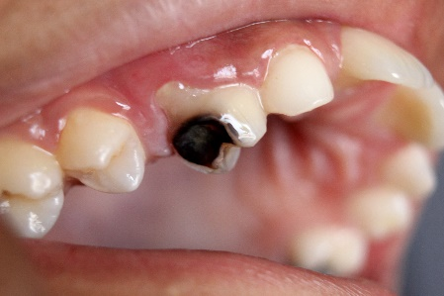
Dental Infections and Plaque Control
Herbal dental gel demonstrates two functions, which include the treatment of dental infections together with prevention of plaque accumulation. Buildup of plaque material creates the risk of tooth cavity formation while setting conditions for gum disease and poor breath. The antibacterial strength of Guava Leaf Extract and Neem in the human body successfully targets Streptococcus mutans, which produces tooth decay. The astringent properties of Pomegranate Peel Extract cause gum tissue tightening and decrease plaque binding to create more dental caries protection.

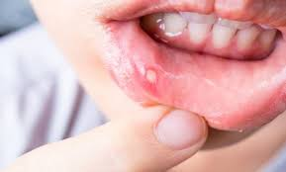
Oral Ulcers and Wound Healing
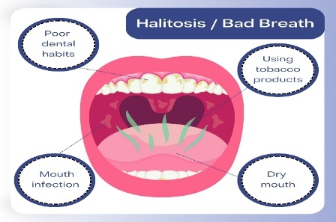
Oral ulcers, which people also refer to as mouth ulcers or canker sores, appear as painful lesions throughout the soft mouth tissues of the inner cheeks together with the tongue area and lips along with the throat and gums. Such conditions create discomfort during eating, drinking and speaking activities. People who have oral ulcers or wounds can benefit from using the gel because it creates healing effects while providing comfort to their condition. Pomegranate Peel Extract and Aloe Vera speed up tissue repair through the stimulation of fibroblast cells while establishing an ulcer-protective layer that stops infections from happening.
Figure 8-E Halitosis

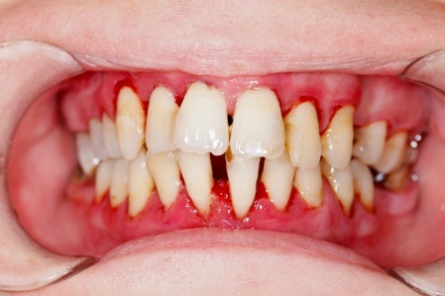
Gingivitis and Periodontitis Gum Infections
Figure 8-C Gingivitis
The bacterial infection which affects gum tissues produces gingivitis symptoms including inflammation together with redness and bleeding. Through their antimicrobial and anti-inflammatory qualities, Neem, Aloe Vera and Clove Oil accomplish dual functions which secure gum tissues and stop bacterial infections while minimizing swelling. The pain-killing properties of eugenol-rich Clove Oil act as both antiseptic and natural pain reliever to calm inflamed gums while stopping additional bacterial development.

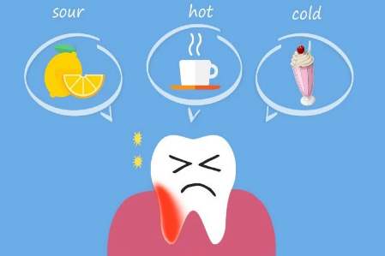
Toothache and Sensitivity
Figure 8-D Toothache
Herbal dental gel helps alleviate dental pain together with sensitivity that stems from enamel erosion and cavities and gum recession. Clove Oil in this formulation delivers two major benefits – it neutralizes nerve sensitivity and controls swelling through its anti-inflammatory properties. Sensitivity to hot and cold foods is minimized through the protective layer formed by Eucalyptus Oil and Aloe Vera application on teeth.

Bad Breath (Halitosis)
Table 9-A Observation of Physicochemical Evaluation
The bacterial buildup responsible for bad breath has an effective remedy in the form of herbal dental gel. Together, Neem and Eucalyptus Oil and Clove Oil fight bacteria that cause odor while releasing a scent mixture and stimulating saliva for mouth cleaning. The antimicrobial and antiseptic characteristics of the gel stop bacterial overgrowth, which stands as a widespread reason behind persistent bad breath.

Results and Discussion

Extraction Process
The extraction of herbal materials implemented proper techniques that maintained high retention levels of bioactive elements. Soxhlet extraction served to concentrate both active compounds in Guava Leaf Extract and Neem Extract. The preservation of natural therapeutic attributes in Aloe Vera Gel occurred through cold processing. Steam distillation extracted essential volatile compounds from both Eucalyptus Oil and Clove Oil and maceration enabled Pomegranate Peel Extract to reach maximum yield. The extraction analysis proved that both purity levels and phytochemical profiles were acceptable for use in preparation.

Evaluation

Physicochemical Evaluation
The dental gel prepared from medicinal herbs exhibited a gentle feel and standard appearance along with a delicate herbal aroma which made the product suitable for oral use. The tested solution had an optimal oral-friendly pH range of 6.5–7.5 that stopped the development of tissue inflammation. The examination of spreadability along with viscosity demonstrated that the gel product had acceptable application properties and sufficient adhesive quality.
Parameter | F1(2%Guava) | F2(3%Guava) | F3(5%Guava) | F4(6%Guava)
Appearance | Smooth, uniform | Smooth, uniform | Smooth, uniform | Smooth, uniform
Color | Light  Green | Light  Green | Green | Dark  Green
Odor | Herbal | Herbal | Strong  Herbal  Aroma | Strong  Herbal  Aroma
Transparency | Slightly  translucent | Translucent | Less  translucent | Opaque
pH | 6.8 | 6.9 | 7.0 | 7.1
Spreadability | 5.8 ± 0.2 | 5.6 ± 0.2 | 5.4 ± 0.2 | 5.3 ± 0.2
Extrudability | 90% | 88% | 85% | 82%
Viscosity | 4500 ± 100 | 4600 ± 120 | 4700 ± 130 | 4800 ± 150
Homogeneity | Uniform | Uniform | Uniform | Uniform
Observation:

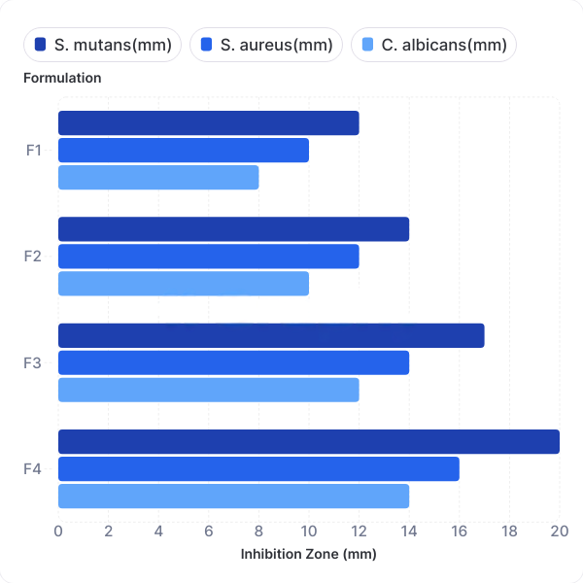
Antimicrobial Activity Evaluation
Figure 9-B Graph of Antimicrobial Efficacy Test
The antimicrobial component of the gel proved powerful enough to eliminate Streptococcus mutans, Staphylococcus aureus, and Candida albicans through its antibiotic properties from Neem Extract, antimicrobial properties of Clove Oil, and antifungal properties within Pomegranate Peel Extract. The herbal gel showed promising action against these microbes and was able to control their growth, thus preventing the teeth and oral mucosa from various bacterial and fungal infections. Total bacterial count and total fungal count were found to be within limits, which is an indication of the antimicrobial efficacy of the herbal dental gel.
Observation:
Formulation | Total Bacterial Count (CFU/g) | Total Fungal Count (CFU/g) | Acceptable Limits
F1 | 150 | 20 | Within Limits
F2 | 120 | 15 | Within Limits
F3 | 80 | 10 | Highly Acceptable
F4 | 70 | 5 | Best Microbial Quality
Table 9-B Observation of Total Microbial Load Test
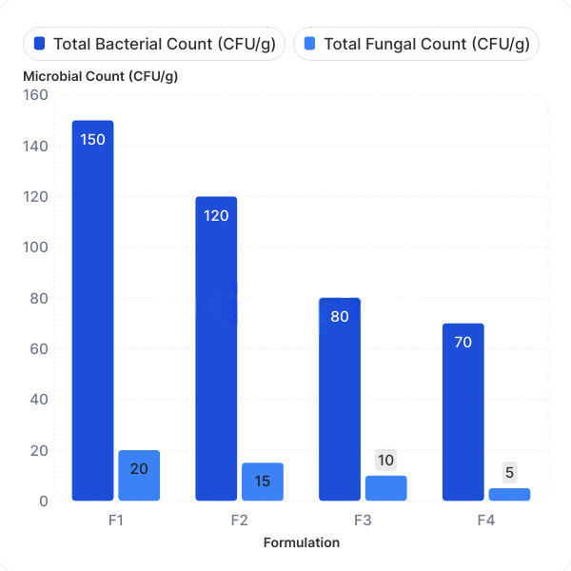
Figure 9-A Graph of Total Microbial Load Test
Formulation | S. mutans(mm) | S. aureus(mm) | C. albicans(mm) | Effectiveness
F1 | 12 | 10 | 8 | Moderate
F2 | 14 | 12 | 10 | Good
F3 | 17 | 14 | 12 | Very Good
F4 | 20 | 16 | 14 | Excellent
Table 9-C Observation of Antimicrobial Efficacy Test

Selection of the Best Formulation
Formulation 3 proved to be the most suitable among the four developed formulations when tested for effectiveness. It exhibits desirable viscosity properties as well as strong mucoadhesive behavior and superior antiseptic properties and stability pattern. The testing results proved that the gel maintained both its consistency and its effective properties, resulting in selection as the preferred formulation for additional studies and commercial potential.

Phytochemical Screening
The analysis of herbal extracts within the formulation showed that important biological compounds were present. The study detected multiple compounds, including alkaloids, flavonoids, tannins, saponins, phenolic compounds and terpenoids, which serve to provide antimicrobial protection against infection and anti-inflammatory benefits and wound-healing properties for the gel. The compounds perform an essential function when it comes to blocking microbial infection as well as improving total oral wellness.
Observation:
Phyto-chemical Test | Guava Leaf Extract | Neem Extract | Pome-granate Peel Extract | Aloe Vera Gel | Clove Oil | Euca-lyptus Oil
Alkaloids | + | + | - | - | - | -
Flavonoids | + | + | + | - | + | +
Tannins | + | + | + | - | + | -
Saponins | - | + | + | + | - | -
Terpenoids | + | + | - | - | + | +
Phenols | + | + | + | + | + | +
Glycosides | + | + | - | - | - | -
Table 9-D Observation of Phytochemical Tests

Mucoadhesion and Retention
The presence of Carbopol 940 as the gelling ingredient conferred mucoadhesive properties that enabled effective mucous membrane attachment during usage. A consistent release of active ingredients through an extended interaction with oral membranes produces extended therapeutic advantages. The gel maintained good adhesive qualities without feeling sticky, which delivered effective comfort while protecting. The gel maintained good adhesive qualities without feeling sticky, which delivered effective comfort while protecting oral sites from pathogens over extended periods.

Oral Health Benefits and Therapeutic Efficacy
The developed gel offered aid against multiple oral health problems including dental caries alongside gingivitis and periodontal infections, as well as oral ulcer treatment. The analgesic and tissue-healing benefits of Pomegranate Peel Extract together with Aloe Vera helped reduce the healing time of oral ulcerations while also decreasing gum-related inflammation. The plaque-controlling features, together with breath-freshening effects of the gel, provide a beneficial natural option for managing oral health needs.

Discussion
According to research results, the polyherbal dental gel serves as an effective natural product which provides better safety than standard oral care products. The simultaneous use of various herbal components in the formulation strengthens antimicrobial properties and minimizes inflammation and maximizes gum health benefits. Extensive contact time between the mucoadhesive gel and oral tissues persists due to its adhesive property which maintains therapeutic benefits throughout its duration. The formulated product displayed adequate stability together with easy application mechanics and positive user feedback, which established it as an appropriate choice for everyday oral hygiene practices.


Future Prospects
Figure 10-A Future Prospects
Natural dental gels from herbal sources present people with an effective and natural choice for oral care beyond standard products. Additional research should concentrate on enhancing both the formulation and application of the herbal dental gels as follows:
- Improved Mucoadhesion: Enhancing the retention time of the gel in the oral cavity for prolonged therapeutic action.
- Clinical Validation: The evaluation of long-term safety together with effectiveness and patient adherence requires extensive clinical trials.
- Advanced Drug Delivery: Nanotechnology-based methods need exploration to boost active herbal component bioavailability while improving their penetration rates.
- Extended Antimicrobial Spectrum: Investigating the effectiveness of the formulation against a broader range of oral pathogens.
- Product Optimization: The optimization process focuses on improving stability and texture and enhancing user acceptability of the product formulation.
- Sustainable Manufacturing: It includes creating sustainable packaging and improving manufacturing scale operations to increase affordability for customers.

Conclusion
The creation of a polyherbal dental gel offers nature-based oral healthcare products which replace commonly used conventional dental care items. The combination of Guava Leaf Extract with Neem Extract and Aloe Vera, together with Pomegranate Peel Extract, Clove Oil and Eucalyptus Oil, creates a formulation that delivers antimicrobial and anti-inflammatory and wound-healing effects suitable for oral hygiene maintenance and dental disease prevention. Extended therapeutic benefits result from the mucoadhesive quality found in this gel as it stays locked within the oral cavity.
Testing of the formulation through physicochemical methods and phytochemical analysis showed that the product maintained its stability and spreadability with its bioactive compounds while antimicrobial tests verified potent pathogen inhibition. The gel effectively treated dental caries together with gingivitis along with periodontal infections as well as mouth ulcers.
The research shows that herbal dental gel presents itself as an effective daily oral care treatment which is safe and well-tolerated by users. More investments in herbal dental research should occur but future clinical trials need to confirm how the medication performs over time while assessing patient preference as well.

References
- Abdollahzadeh S, Mashouf RY, Mortazavi H, Moghaddam MH, Roozbahani N, Vahedi M. Antibacterial and antifungal activities of Punica granatum peel extracts against oral pathogens. J Dent (Tehran). 2011;8(1):1-6.
- Agrawal H, Sharma R, Patel N. Evaluation of viscosity and rheological behavior of herbal oral formulations. J Pharm Sci Res. 2013;5(12):268-273.
- Andrews GP, Laverty TP, Jones DS. Mucoadhesive polymeric platforms for controlled drug delivery. Eur J Pharm Biopharm. 2009;71(3):505-518.
- Balouiri M, Sadiki M, Ibnsouda SK. Methods for in vitro evaluating antimicrobial activity: A review. J Pharm Anal. 2016;6(2):71-79.
- Bansal M, Jain A, Bansal R, Kumar A. Antibacterial efficacy of neem (Azadirachta indica) extract against Streptococcus mutans: An in vitro study. J Indian Soc Pedod Prev Dent. 2015;33(3):213-217.
- Bhadbhade SJ, Acharya AB, Rodrigues SV, Thakur SL. The anticandidal effect of neem extract in a herbal toothpaste: A randomized controlled trial. Indian J Dent Res. 2011;22(3):417-421.
- Bhattacharjee R, Rani PJ, Paul S, et al. Antibacterial efficacy of herbal dentifrice against oral microflora. J Adv Pharm Technol Res. 2011;2(1):21-25.
- Bhowmik D, Gopinath H, Kumar BP, Duraivel S, Kumar KS. Recent advances in mucoadhesive drug delivery system: A review. Int J PharmTech Res. 2014;6(2):411-418.
- Chaieb K, Hajlaoui H, Zmantar T, et al. The chemical composition and biological activity of clove essential oil, Eugenia caryophyllata (Syzigium aromaticum L. Myrtaceae): A short review. Phytother Res. 2007;21(6):501-506.
- Chaieb K, Hajlaoui H, Zmantar T, Kahla-Nakbi AB, Rouabhia M, Mahdouani K, Bakhrouf A. Antibacterial activity of Eugenol alone and in combination with other antimicrobial agents against multidrug-resistant bacteria. Phytomedicine. 2007;14(7-8):601-607.
- Chandel P, Rajesh KS, Thomas S, Biju K. Formulation and physicochemical evaluation of herbal dental gel for treatment of oral diseases. Ind J Pharm Sci. 2012;74(1):62-66.
- Deters A, Schröder KR, Hensel A. Aloe vera gel and its effects on the wound healing process. J Ethnopharmacol. 2001;75(1):121-127.
- Florence AT, Attwood D. Physicochemical Principles of Pharmacy. 5th ed. London: Pharmaceutical Press; 2011.
- Gupta A, Agrawal M, Ahlawat A, Singh RP. Evaluation of anti-inflammatory and wound healing activity of Aloe vera gel in experimental models. Int J Pharm Sci Res. 2021;12(4):2234-2241.
- Gupta P, Vermani K, Garg S. Hydrogels: From controlled release to pH-responsive drug delivery. Drug Discov Today. 2002;7(10):569-579.
- Gutiérrez RM, Mitchell S, Solis RV. Psidium guajava: A review of its traditional uses, phytochemistry, and pharmacology. J Ethnopharmacol. 2008;117(1):1-27.
- Hamman JH. Composition and applications of Aloe vera leaf gel. Molecules. 2008;13(8):1599-1616.
- Harborne JB. Phytochemical Methods: A Guide to Modern Techniques of Plant Analysis. 3rd ed. London: Chapman and Hall; 1998.
- Hashemi SA, Madani SA, Abediankenari S. The review on properties of Aloe vera in healing of cutaneous wounds. BioMed Res Int. 2015;2015:714216.
- Hegde MN, Hegde P, Malhotra A, Narkhede M. Evaluation of antimicrobial activity of Azadirachta indica (Neem) against Streptococcus mutans: A randomized controlled trial. J Indian Soc Periodontol. 2013;17(4):480-485.
- Howell AB, D'Souza DH. The pomegranate: Effects on bacteria and viruses that influence human health. Evid Based Complement Alternat Med. 2013;2013:606212.
- Jain NK, Roy R, Pathan HK, Sharma A, Ghosh S, Kumar S. Formulation and evaluation of polyherbal aqueous gel from Psidium guajava, Piper betel, and Glycyrrhiza glabra extract for mouth ulcer treatment. Res J Pharmacogn Phytochem. 2020;12(3):145-148.
- Javadzadeh Y, Jafari N, Nokhodchi A, Barzegar-Jalali M, Shahba MA. Design, formulation, and evaluation of a mucoadhesive gel from Quercus brantii L. and Coriandrum sativum L. as periodontal drug delivery. Adv Pharm Bull. 2013;3(1):115-121.
- Javed F, Al-Askar M, Samaranayake LP, et al. Herbal products in oral healthcare: Evidence-based perspectives. Clin Oral Investig. 2021;25(9):5431-5445.
- Jurenka JS. Therapeutic applications of pomegranate (Punica granatum L.): A review. Altern Med Rev. 2008;13(2):128-144.
- Kamatou GP, Vermaak I, Viljoen AM. Eugenol—a review of a versatile molecule. Molecules. 2012;17(6):6953-6981.
- Kaur L, Gupta R, Garg R. Formulation and characterization of herbal gel. Int J Pharm Sci Rev Res. 2013;20(1):122-126.
- Kaur R, Kaur R, Chalia DS, et al. Herbal oral gels: A review on formulation and evaluation parameters. Int J Pharm Res. 2020;12(2):1819-1826.
- Kibbe AH. Handbook of Pharmaceutical Excipients. 3rd ed. Washington, DC: American Pharmaceutical Association; 2000.
- Kokate CK, Purohit AP, Gokhale SB. Pharmacognosy. 47th ed. Pune, India: Nirali Prakashan; 2017.
- Malhotra R, Singh S, Sharma Y, Banerjee M. Efficacy of clove (Syzygium aromaticum) in the treatment of dental caries and as an analgesic. J Ethnopharmacol. 2016;194:117-121.
- Manipal S, Shah J, Madan K, et al. Herbal extracts and their role in the management of oral diseases: A review. J Clin Diagn Res. 2014;8(10):ZE01-ZE07.
- Metwally FM, Omar AA, Harraz FM, Lehmann RP. Antimicrobial activity of guava (Psidium guajava) extracts against foodborne pathogens. J Environ Agric Sci. 2014;2:1-8.
- Mothana R, Al-Rehaily A, Al-Jabri A, Fadhel N. In vitro antimicrobial activity of Punica granatum peel extracts against oral pathogens. Phytomedicine. 2013;20(6):487-492.
- Panichayupakaranant P, Tewtrakul S, Yuenyongsawad S. Antibacterial, anti-inflammatory, and anti-allergic activities of standardised pomegranate rind extract. Food Chem. 2010;123(2):400-403.
- Park K, Robinson JR. Bioadhesive polymers as platforms for oral-controlled drug delivery: Method to study bioadhesion. Int J Pharm. 1984;19(1):107-127.
- Patel M, Chudasama V, Suthar K, Rajpurohit B. Formulation and evaluation of polyherbal gel. Int J Pharm Sci. 2024;2(7):1217-1225.
- Patel S, Ishnava KB. Evaluation of the antimicrobial efficacy of Punica granatum peel extract against oral pathogens and its biocompatibility. Int J Pharm Sci Res. 2021;12(6):3154-3162.
- Patel VF, Liu F, Brown MB. Advances in oral transmucosal drug delivery. J Control Release. 2011;153(2):106-116.
- Pimentel TC, Cruz AG, Almeida ESP, Cadena RS, Faria JAF. Exploring the potential of herbal toothpaste for oral health: A comprehensive review. J Oral Biosci. 2020;62(2):155-162.
- Pooja D, Kulhari H, Reddy BB, et al. Polyethylene glycol (PEG)-Prodrug Conjugates for Improved Pharmacokinetics and Therapeutics. Drug Discov Today. 2019;24(3):731-743.
- Pradeep AR, Martande SS, Singh SP, et al. Antimicrobial efficacy of herbal dental gels against oral pathogens. Contemp Clin Dent. 2012;3(3):331-335.
- Pradeep AR, Martande SS, Singh SP, et al. Clinical evaluation of the anti-gingivitis effect of a herbal mouth rinse containing guava leaf extract. J Periodontol. 2016;87(6):658-664.
- Pradhan SP, Dey S, Nandy S, et al. A review on formulation and evaluation of herbal gel. J Pharm Innov. 2021;10(1):1-9.
- Prakash S, Shetty MS, Shroff R. Role of nanotechnology in herbal dental formulations: A review. Nanomedicine Res J. 2021;6(3):187-195.
- Rajeswari R, Umadevi M, Rahale CS, Pushpa R, Selvavenkadesh S, Kumar KS, Bhowmik D. Aloe vera: The miracle plant its medicinal and traditional uses in India. J Pharmacogn Phytochem. 2012;1(4):118-124.
- Rowe RC, Sheskey PJ, Quinn ME. Handbook of Pharmaceutical Excipients. 6th ed. London: Pharmaceutical Press; 2009.
- Sadlon AE, Lamson DW. Immune-modifying and antimicrobial effects of Eucalyptus oil and simple inhalation devices. Altern Med Rev. 2010;15(1):33-47.
- Sari DRA, Sari DCR, Fithri N, Sari M, Sari R. Formulation and evaluation of mucoadhesive oral care gel containing Kaempferia galanga extract. J Oral Biol Craniofac Res. 2022;12(1):85-90.
- Shaikh R, Raj Singh TR, Garland MJ, Woolfson AD, Donnelly RF. Mucoadhesive drug delivery systems. J Pharm Bioallied Sci. 2011;3(1):89-100.
- Sharma P, Agrawal G, Paliwal SR. Formulation and characterization of herbal toothpaste: A natural approach to oral hygiene. J Drug Deliv Ther. 2019;9(4):479-484.
- Sharmila G, Umadevi M, Rajeshwari M, Suganya S. Antimicrobial and antioxidant properties of selected medicinal plants against halitosis causing bacteria. J Med Plants Res. 2014;8(10):451-457.
- Shirsand SB, Para MS, Nagendrakumar D, Kanani K, Keerthy D. Formulation and evaluation of mucoadhesive bilayer buccal tablets of carvedilol. Int J Pharm Investig. 2012;2(2):55-60.
- Singh A, Vijayalakshmi S, Viswanathan S. pH of oral herbal gels: Role in oral health maintenance. J Appl Pharm Sci. 2018;8(3):145-150.
- Sinha DJ, Sinha AA. Natural medicaments in dentistry. Ayurpharm Int J Ayur Alli Sci. 2014;3(1):21-26.
- Smart JD. The basics and underlying mechanisms of mucoadhesion. Adv Drug Deliv Rev. 2005;57(11):1556-1568.
- Sontakke R, Singhal R, Jain NK, Sontakke S. Formulation and evaluation of polyherbal gel containing ethanolic extract used as local anaesthetics in oral cavity. Int J Drug Deliv Technol. 2022;12(1):85-88.
- Subapriya R, Nagini S. Medicinal properties of neem leaves: A review. Curr Med Chem Anticancer Agents. 2005;5(2):149-156.
- Subramaniam P, Gupta M. Nanotechnology in dentistry: Clinical applications, benefits, and hazards. Int J Pharm Investig. 2019;9(2):40-45.
- U.S. Pharmacopeial Convention. United States Pharmacopeia and National Formulary (USP-NF). Rockville, MD: USP; 2021.
- United States Food and Drug Administration (FDA). Guidance for Industry: Botanical Drug Development. Rockville, MD: FDA; 2016.
- Waghmare PF, Chaudhari SP, Karhadkar VM, Jamkhande AS. Aloe vera: A boon in dentistry. J Indian Soc Periodontol. 2013;17(5):538-541.
- WHO. Quality Control Methods for Medicinal Plant Materials. Geneva: World Health Organization; 1998.
- Williams AC, Barry BW. Penetration enhancers. Adv Drug Deliv Rev. 2012;64(Suppl):128-137.
- Yadav R, Kumar N, Chauhan NS. Advances in herbal oral care: Clinical perspectives and future directions. J Clin Dent Res. 2020;12(1):25-31.

