AR TECH SCANNER: AN AUGMENTED REALITY SHOPPING ASSISTANT FOR TECH SHOPPERS IN BAGUIO CITY

A Capstone Project Presented to the Faculty of the College of Information Technology and Computer Sciences University of the Cordilleras

In Partial Fulfilment
of the Requirements for the Degree
BACHELOR OF SCIENCE IN INFORMATION TECHNOLOGY

by:
EMZELLE XYLLE DAO-ANIS AWAL
ADRIAN DANNIEL QUINTO ECHON
JEREMIAH BENJAMIN ABELLA GOMEZ
April 2025

APPROVAL SHEET
This capstone project proposal entitled AR TECH SCANNER: AN AUGMENTED REALITY SHOPPING ASSISTANT FOR TECH SHOPPERS IN BAGUIO CITY prepared and submitted by EMZELLE XYLLE D. AWAL, ADRIAN DANNIEL Q. ECHON, JEREMIAH BENJAMIN A. GOMEZ in partial fulfilment of the requirements for the degree BACHELOR OF SCIENCE IN INFORMATION TECHNOLOGY, has been examined and is recommended for acceptance and approval for oral examination

ANNA RHODORA M. QUITALEG, MIT
Adviser

CAPSTONE PROJECT COMMITTEE

ZYRA YELL A. FAGYAN, BSIT ANNA RHODORA M. QUITALEG, MIT
Member Adviser

LUIS WILLIAM C. MEING, MIT
Chairperson

TABLE OF CONTENTS

TITLE PAGE . . . . . . . . . . . . . . . . . . . . . . 1
APPROVAL SHEET . . . . . . . . . . . . . . . . . . . . 2
TABLE OF CONTENTS . . . . . . . . . . . . . . . . . . 3
CHAPTER
1 INTRODUCTION
Rationale . . . . . . . . . . . . . . . .. . 4
Project Objectives . . . . . . . . . . . . . 9
Proposed Solutions . . . . . . . . . . . . . 10
2 DESIGN THINKING
Empathize . . . . . . . . . . . . . . . . . 15
Define . . . . . . . . . . . . . . . . . . . 16
Ideate . . . . . . . . . . . . . . . . . . . 18
Prototype . . . . . . . . . . . . . . . . . 19
Test . . . . . . . . . . . . . . . . . . . . 24
REFERENCES . . . . . . . . . . . . . . . . . . . . . . 26
APPENDICES
A Communication Letter . . . . . . . . . . . . 31
B Documentation . . . . . . . . . . . . . . . 32
C Invitation Letter . . . . . . . . . . . . . 33
D BMC . . . . . . . . . . . . . . . . . . . . 36

Chapter 1
INTRODUCTION
Rationale
The retail industry has undergone significant transformations with the advent of digital technologies. However, traditional shopping experiences still face challenges such as difficulty in visualizing products before purchase, lack of interactive engagement, and limited personalization. Consumers often struggle with making informed purchase decisions due to inadequate product representation, which leads to dissatisfaction and higher return rates (Pantano & Vannucci, 2019). This issue has prompted retailers to explore innovative solutions that enhance customer experience and decision-making processes.
Currently, e-commerce platforms and brick-and-mortar stores utilize various digital technologies to bridge the gap between physical and online shopping. Technologies such as 3D product visualization, virtual try-ons, and recommendation algorithms have improved shopping experiences to an extent (Javornik, 2016). However, these solutions still lack full interactivity and real-time engagement, which are crucial for customer satisfaction. The gap in existing solutions lies in their inability to provide immersive and interactive shopping experiences that closely mimic physical store environments.
These challenges have far-reaching implications for key stakeholders. Consumers often experience frustration due to inefficient tools, which leads to higher spending and dissatisfaction with their shopping experiences. In contrast, retailers face reduced competitiveness as they struggle to engage modern, tech-savvy shoppers who expect seamless and intuitive tools. Furthermore, these inefficiencies have a broader environmental impact, contributing to overproduction and waste. This outcome directly conflicts with the goals of the United Nations Sustainable Development Goal 12, which emphasizes responsible consumption and production. AR systems that enable consumers to make informed purchasing decisions have been shown to align with these objectives by reducing waste and promoting sustainable shopping habits (Yu et al., 2024; Álvarez Márquez & Ziegler, 2024).
Augmented Reality (AR) has emerged as a transformative technology in the retail sector, addressing many of these challenges. AR integrates digital information with the real world, allowing users to visualize and interact with virtual products in their actual environment (Azuma, 1997). This technology provides an immersive experience that enhances product assessment, reduces uncertainty, and improves customer confidence in online shopping (Heller et al., 2019). With AR, retailers can offer interactive try-ons, dynamic product visualization, and real-time personalization, significantly improving the shopping experience.
For local users, AR can bridge the gap between physical and online shopping by allowing them to preview products virtually before visiting a store, thus making their trips more efficient and informed. AR-enabled store navigation can also enhance their in-store experience by providing detailed product information and personalized recommendations based on their preferences (Scholz & Duffy, 2018). Online users benefit from AR through immersive experiences that help them better understand product features and usability, reducing the chances of post-purchase dissatisfaction. Additionally, AR enhances accessibility, allowing customers to try on apparel, furniture, and other items from the comfort of their homes (Huang & Liao, 2017).
The thing we considered here in Baguio that is the crowded Tech stores because mostly it is cramped inside if there is too many people (Dela Cruz & Reyes, 2023). that is why we created this application for people to scan anywhere and whenever they want. The other problem we found is the age group that will use the app all we know that younger generations would get to know this app immediately and the older generation will struggle to adapt to new systems (Bautista & Lim, 2022).
The importance of AR in shopping cannot be overstated. Studies indicate that AR-driven shopping experiences lead to increased customer engagement, higher conversion rates, and improved brand loyalty (Poushneh & Vasquez-Parraga, 2017). As consumer expectations evolve, integrating AR into retail strategies becomes essential for businesses aiming to stay competitive in the digital age. This research paper explores the impact of AR in shopping, analyzing its benefits, challenges, and future potential in revolutionizing the retail industry.
The integration of AR into shopping environments is not without its challenges, but it holds a significant promise for addressing these issues. AR-enabled tools, such as immersive trial experiences and real-time price comparison systems, have already demonstrated their potential to enhance user satisfaction and reduce return rates (Rumman et al., 2024). By bridging the gap between physical and online shopping, these technologies empower both consumers and retailers to make more informed and sustainable decisions.
BTECH PC CUSTOMS and EDGE Computer Technologies also stand to gain significantly from AR integration. By adopting AR-powered solutions, retailers can reduce return rates, optimize inventory management, and enhance customer engagement through interactive displays and in-store navigation. AR-enabled marketing campaigns can attract more foot traffic and encourage brand loyalty by offering unique and memorable shopping experiences (Hilken et al., 2017). Furthermore, real-time data analytics from AR interactions can provide valuable insights into customer preferences, enabling retailers to tailor their offerings accordingly and improve business decision-making (Bonetti, Warnaby, & Quinn, 2018).
The retail industry faces persistent challenges in product visualization, customer engagement, and informed decision-making, leading to consumer frustration, higher return rates, and unsustainable consumption patterns. While digital tools like 3D visualization and virtual try-ons have improved shopping experiences, they often lack real-time interactivity and fail to address local retail conditions, particularly in crowded tech stores like those in Baguio City. Augmented Reality (AR) emerges as a transformative solution, enabling immersive product interaction and bridging the gap between physical and online shopping. However, global AR applications often overlook Philippine-specific challenges, such as cramped store layouts (Dela Cruz & Reyes, 2023) and varying tech adoption across age groups (Bautista & Lim, 2022). AR Tech Scanner addresses these gaps by offering a localized, user-friendly AR tool for product scanning Baguio’s tech shoppers to make confident purchases while reducing waste and supporting retailers like BTECH PC CUSTOMS in enhancing customer satisfaction. By aligning with UN SDG 12 and leveraging AR’s potential to revolutionize retail, this project not only modernizes the shopping experience but also promotes sustainability and economic efficiency in the local tech market.
Project Objectives
The main objective of this study is to design and develop an Augmented Reality Application that provides scanning, price comparison, discount tracking, and trend-based prediction features. Specifically, it will aim to answer the following;
1. to identify the information requirements of the AR TECH SCANNER system;
2. to determine to architectural framework of the AR TECH SCANNER system;
3. to identify the features of the AR TECH SCANNER system;
4. to measure the extent of usability of the AR TECH SCANNER system.
Proposed Solutions
The integration of emerging IT technologies is critical in addressing the challenges identified in the rationale, particularly inefficiencies in price comparison and shopping decisions. This section focuses on existing solutions, introduces relevant IT technologies, and discusses the potential impact of these innovations, aligning with the Ideate phase of the Design Thinking process and UN SDG 12 on responsible consumption and production.
Current augmented reality (AR)-based shopping tools offer promising features but also reveal significant limitations. For instance, tools like ARify enhance the e-commerce experience by allowing users to visualize products in their real-world environments, reducing return rates and increasing engagement. Similarly, ARShopping improves decision-making by overlaying detailed product information in physical spaces. However, these systems often face barriers such as high development costs and limited accessibility, particularly for in-store applications. Research highlights the importance of addressing these gaps to create seamless, real-time, and user-friendly shopping solutions (Rumman et al., 2024: Xu et al., 2022).
Among emerging technologies, augmented reality stands out for its potential to transform shopping experiences. AR offers features such as real-time object recognition, immersive visualization, and interactivity, making it an effective tool for comparing products and prices. For example, AR-based virtual try-ons allow users to interact with products in a simulated environment, enhancing decision-making and satisfaction (Márquez & Ziegler, 2024; Yu et al., 2024). Machine learning and artificial intelligence (AI) further complement AR by improving object recognition accuracy and enabling personalization. AI-driven systems adapt interfaces to user preferences, creating a tailored and efficient shopping experience (Egipko et al., 2024). Based on the Ideate phase of the Design Thinking process, the proposed solution focuses on an AR-driven price comparison system. This system integrates AR, and AI to provide real-time price scanning and product comparison across multiple platforms, enabling consumers to make informed purchasing decisions quickly. Features such as dynamic pricing, personalized recommendations, and seamless integration with e-commerce databases are designed to enhance user satisfaction and retailer competitiveness. Additionally, the system aims to support sustainable practices by minimizing waste and promoting efficient shopping behaviors, directly contributing to UN SDG 12 (Rumman et al., 2024; Álvarez Márquez & Ziegler, 2024). The potential impact of these technologies is significant for both consumers and retailers. Consumers benefit from enhanced decision-making, reduced return rates, and an improved overall shopping experience. For retailers, the adoption of these technologies increases competitiveness, streamlines operations, and provides valuable data-driven insights. Moreover, by reducing overproduction and encouraging responsible consumption, these innovations contribute to sustainability goals. The integration of AR and AI represents a transformative opportunity to bridge the gap between physical and online shopping, creating a more efficient and sustainable retail ecosystem.

Chapter 2
METHODOLOGY
This chapter outlines the systematic process that guided the development of the AR Tech Scanner mobile application. It covers the software development methodology used, the application of design thinking in ideation and testing, the scope and limitations of the study, the data gathering techniques employed, the sources of system data, and the tools and technologies utilized throughout the lifecycle of the project. Emphasis is placed on iterative design, feedback-informed implementation, and modular development to meet the system’s goals of enhancing consumer buying behavior and supporting local tech vendors.
Software Development Methodology
The researchers utilized Feature-Driven Development (FDD) as the primary software development methodology for the AR Tech Scanner project. FDD is an agile-based, client-centric methodology that decomposes the application into modular features—each of which is planned, built, and tested in isolation. This approach was selected due to its scalability, clarity in feature tracking, and suitability for multi-feature mobile applications.
The development team began by constructing an overall model of the system. This included defining user roles (users, admins, superadmins), interactions (scanning, searching, chatting), and storage requirements (items, promotions, reviews). Based on stakeholder interviews and feedback from prospective users, a comprehensive list of features was compiled, each representing a concrete system functionality.
Development responsibilities were distributed according to each module’s technical requirements. The core user features, database integration, and backend connectivity were prioritized during the initial build phase. The admin interface was designed following modern UI/UX principles, ensuring clarity and functionality for store owners and system administrators. Early research on the scanning functionality explored a locally trained object detection model using tflite, developed through a process involving dataset collection and manual training. However, this approach proved limited in accuracy and scalability. Consequently, the team transitioned to a cloud-based solution, integrating the Google Vision API for more reliable and dynamic product recognition. Features were prioritized based on user value and implementation complexity, then built in structured cycles. GitHub was used to manage task assignments, commits, and documentation. Feature testing occurred after each sprint cycle, incorporating structured feedback sessions with test users and refining the functionality based on their responses.
FDD proved particularly effective in this study as each component of the app—from scanning to chat redirection—was a self-contained module that could be independently deployed, tested, and revised.
Feature Breakdown
1. AR Scanning and Matching
The primary functionality of AR Tech Scanner is the ability to scan tech items using a mobile camera and return product matches from local partner store inventories. The initial development approach utilized a locally trained object detection model in .tflite format, built using image datasets acquired through data scraping and manual labeling. This prototype was tested in early system iterations but exhibited limited recognition accuracy and lacked adaptability across different lighting conditions and device types. As a result, the development team opted to replace the local model with a more robust, cloud-based solution using the Google Vision API, which offered improved classification accuracy and scalability.
Following testing feedback, the development team migrated to the Google Vision API, which enabled more reliable and scalable cloud-based object recognition. The scanning pipeline was restructured to support real-time classification, with integration points established to seamlessly query Firebase Firestore for matched product entries immediately after recognition. This transition significantly improved detection accuracy and overall responsiveness of the scanning feature.
Users during testing described the feature as "instant, intuitive, and surprisingly accurate," noting that it replicated the feel of mobile shopping apps while integrating local pricing.
2. Product Search and Bookmarking
Users can manually search for items using brand names, categories, or specifications. The search interface interacts with the Firestore collection /items, dynamically returning suggestions. Selected items may be bookmarked for future review.
Bookmarks are stored persistently under user-linked document references in Firebase. The feature was tested among students who noted that bookmarking was a critical convenience tool when comparing items.
3. Product Details and Reviews
Tapping on a product reveals its full description, partner store, current price, and user-generated reviews. Reviews can be submitted directly on the screen and are stored under the /reviews collection.
Users appreciated the transparency, stating that "knowing others’ experiences helped reduce buying anxiety." Backend logic was implemented to prevent duplicate submissions from the same account on the same item.
4. Purchase Redirection and Chat Integration
When users tap “Purchase,” the system redirects them to a dedicated chat interface where they are connected to the relevant store admin. Through integration with Discord Webhooks, the product image and details are automatically posted in the chat channel, enabling sellers to instantly identify the inquiry.
This feature was lauded during usability testing as “incredibly efficient.” It offered a balance between digital browsing and human confirmation, with students saying it added credibility and a sense of real engagement with vendors.
5. Admin Dashboard and Promotions
The admin dashboard allows partner stores to log in and manage their inventory. Admins can perform CRUD operations on item listings, upload product photos, set promotional flags, and view basic sales insights.
This module was designed and developed in accordance with established UI/UX and backend integration standards. The Firestore collections /items and /promotions were utilized to store structured item data, promotional flags, and associated metadata, enabling efficient querying and content management within the admin interface.
6. Superadmin Controls
Superadmins have access to all store data, admin accounts, and customer chats. They can create or delete admin profiles and act as overall system moderators.
Testing with faculty stakeholders revealed the importance of clear privilege separation. Superadmin tools were developed with layered access control and log tracking to maintain accountability and platform integrity.

Waterfall Development Phases Applied in AR Tech Scanner

Phase 1: Requirements Analysis and Planning
During this initial stage, the development team identified system requirements through interviews with target users, including IT students and tech consumers, and through consultations with partner stores. The goal was to understand the essential functions that the system needed to support, such as product scanning, price comparison, user authentication, vendor interaction, and administrative control. The project scope, target users, and feature list were finalized in this phase.

Phase 2: System and Software Design
Based on the documented requirements, the researchers proceeded to design the overall architecture of the system. This phase included the formulation of:
A component-based architecture using Firebase and local databases
User flow diagrams for scanning, browsing, and chat redirection
Admin panel UI mockups developed in Figma
Local authentication structure via SQLite (UserRepository class)
Database schema for items, users, reviews, and promotions using Firestore collections
Special attention was given to determining how image data would be handled, eventually leading to the use of Google Vision API and Discord Webhooks for reliable scanning and media sharing.

Phase 3: Implementation
With the architecture in place, the development phase commenced. This was executed sequentially in three major coding blocks:
Module 1: User Authentication System
Developed using SQLite, allowing registration and login functionality. The UserRepository handled credential validation and user data storage.
Module 2: Product Scanning and Matching
Initially, the product scanning feature was developed using a locally trained tflite model for on-device image classification. The model was trained using scraped image datasets and integrated into the prototype for offline item recognition. However, testing revealed limitations in accuracy, speed, and adaptability across diverse environments. To enhance reliability and scalability, the local model was later replaced with the Google Vision API, enabling cloud-based recognition with significantly improved performance. Once an item was identified, the system retrieved relevant matches from Firebase Firestore, based on item labels and category tags.
Module 3: Admin and Superadmin System
Admin tools were developed using Visual Studio Code, enabling item CRUD, promotions, and chat views. Superadmins were given elevated permissions to manage all system data and admin accounts.
All code was version-controlled using GitHub, with branches for each module to maintain development discipline and avoid regressions.

Phase 4: System Testing
After implementation, each module was tested independently and then in combination. The team tested:
Local login persistence and error handling for invalid credentials
Real-time response from Google Vision when scanning physical items
Product search and Firestore item retrieval speed
Image sharing via Discord Webhook
Admin functionalities (item addition/editing/deletion)
Superadmin operations including user control and item visibility across stores
Testers, including IT students and faculty members, provided feedback on performance, interface design, and usability.

Phase 5: Deployment and Evaluation
Following internal testing, the prototype was deployed to test devices. Usability was evaluated through the USE Questionnaire, which collected feedback on usefulness, ease of use, ease of learning, and satisfaction.
Post-deployment feedback led to several improvements, including:
Better scan results display
Improved access to product reviews
Streamlined redirection to vendor chats
The system was validated for release within its scope (local Baguio tech market) and successfully met the planned requirements.
Design Thinking
The Design Thinking process has guided the development of AR Tech Scanner, ensuring a user-centric solution to inefficient price comparison and consumer dissatisfaction. By leveraging augmented reality, and AI insights, AR Tech Scanner enhances shopping efficiency, transparency, and trust. It also promotes sustainable purchasing by empowering informed, conscious choices.
Figure 1
Design Thinking
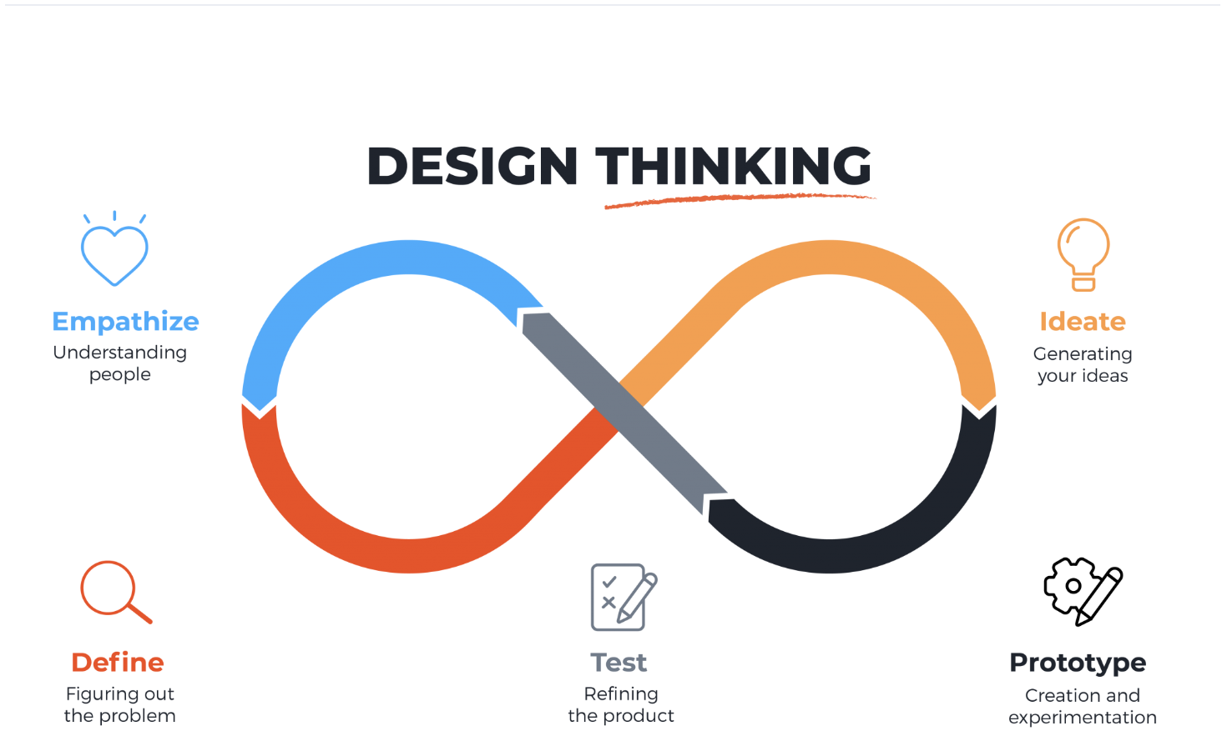
https://images.app.goo.gl/4v3hCrsnW16tNzLw6
Empathize. The objective of the Empathy phase is to obtain a profound knowledge of the user's requirements and the collaboration with BTECH PC Customs encompassing their experiences and difficulties.
The problem we found out because of the users is people that are shy to ask for something in the store example are the specs of the computer or that particular computer component they are too shy to ask or the other problem is the user is too busy to visit the shop to check out the items in stock.
The researchers employ a range of techniques, such as observation and interviews. The researchers conducted interviews to collect data, preferences, and motivations pertaining to marketing and advertising in order to gain insights and a solution. Additionally, the researchers employed the observation approach to determine whether the modifications were appropriate in light of the data they collected from their collaboration.
The comprehensive findings from the in-depth 5 Why analysis, based on input from researchers and their partners, are meticulously detailed in figure 2, revealing root causes behind major issues and offering a systematic breakdown of contributing factors and their interconnections.
Figure 2
5-Why Analysis
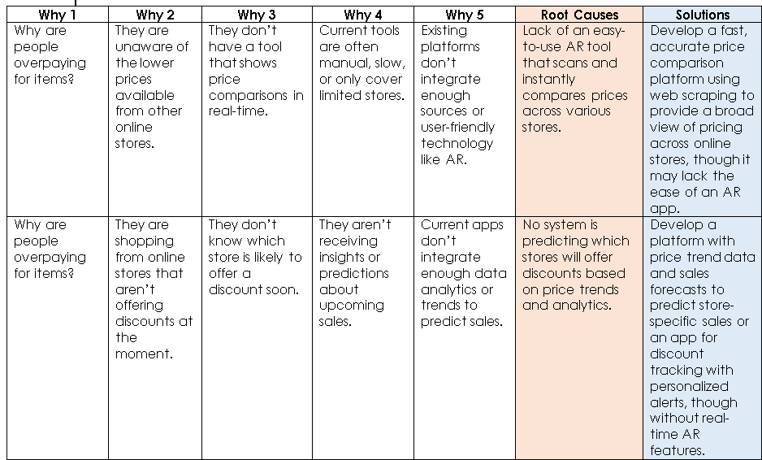
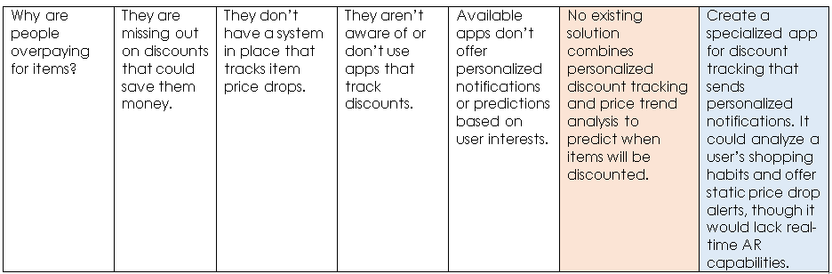
Define. Researchers are helped by the define phase in the creation of the problem description and the details of the objectives, goals, and scope of the enterprise under consideration. Creating a comprehensive understanding of the needs of the users and coordinating this with the BTECH PC CUSTOMS and EDGE Computer Technologies design goals. It brings attention to the application's ideas and features the app for both online and local consumers, which will promote the utilization of augmented reality functionalities by comparing prices, monitoring discounts, and scanning products this will provide an interesting and improved experience of the application for the users.
The researchers were able to determine the most significant and basic user demands and difficulties by addressing the underlying causes of problems during the define phase by applying the "Five Why Analysis." It contributed to their synthesis to ensure that their proposal would satisfy the needs of everyone. Additionally, it benefits the project by ensuring that everyone on the team is focused on solving the proper problems. By examining the root causes of the issues, innovative solutions that are beneficial and meaningful to the target audience can be created. With these methods of study, the researchers determine the purpose and aim of the suggested remedy. Considering their analysis that would aid in organizing the growth of the program as well as the target customer needs. Using this method, researchers were able to include many customer needs and requirements, making sure the solution was beneficial and successful for all parties. The researchers, with careful preparation and cooperation from the partners, developed a thorough comprehension of the answer. Through the combination of various concepts, they create to direct the proper course of the design and development procedure, guaranteeing the production of an impactful and user-friendly application for store owners as well as local and online customers.
Ideate. In the capstone project's planning stage,
concentrated on developing innovative, cooperative, and
creative approaches to address the issues revealed during the stage of empathize and define. During brainstorming sessions, the researchers collaborated with their partners and proposed features to create carefully considered ideas for both local and internet buyers to create the AR Tech Scanner. These conversations provide information on how consumers will interact with internet marketplaces. Responses to this consultation were essential in directing the creation of apps that adhere to the requirements of both online and local consumers.
The developing opportunities were utilized by the researchers, provided by emerging technology, such as augmented reality and AI. Clarifying the relationships between store owners and both local and online customers is the goal of these solutions. By doing this, they give users the knowledge and tools they need to understand and benefit from these technologies. By combining technology and AR Tech Scanner, the goal is to increase people's trust and make every transaction an engaging experience for both customers and store owners.
Prototype. The prototype begins with users creating an account or logging in. After entering their login information, users proceed to the camera screen if the login is successful. They can either take a picture or select an image from their album to upload. Once the image is uploaded, the app scans it to search for similar products available on various online shopping platforms. It then displays these products and allows users to choose from multiple store options.
Users can either select a product to view its details or simply compare prices and exit. For those selecting a product, the app provides detailed descriptions and predictions of upcoming sales. Users can place an order, bookmark the product, or save it for notifications about future price drops. Finally, the app can direct users to the relevant websites to complete their purchase. This streamlined flow aims to enhance the shopping experience by integrating convenience and predictive insights.
Here we introduce our application’s navigation the first one is login/register the user needs to do this so they can access the feature of the app after they login the user will be met with 2 options in the home screen and that is AR scanning and Price alerts. The first option is AR scanning this is our main feature and the way it works are you point the camera on the computer component and the app will search that item in the catalog and now the one that you scanned will show up in your search bar. You can see the description of each item and the rating of the item.
Figure 3
Prototype


Login Page. A login page in a mobile shopping application is essential for user authentication, personalized experiences, and secure transactions.
Signup Page. Signup page allows users to create an account and gain access to exclusive features such as personalized shopping experience, order management, saved payment and address details and discounts of the store.
Figure 4
Home Page

Homepage. The homepage plays a critical role in user engagement, navigation, and personalization. It serves as the central hub where users discover products, access promotions, and interact with key features.
Figure 5
Search Bar
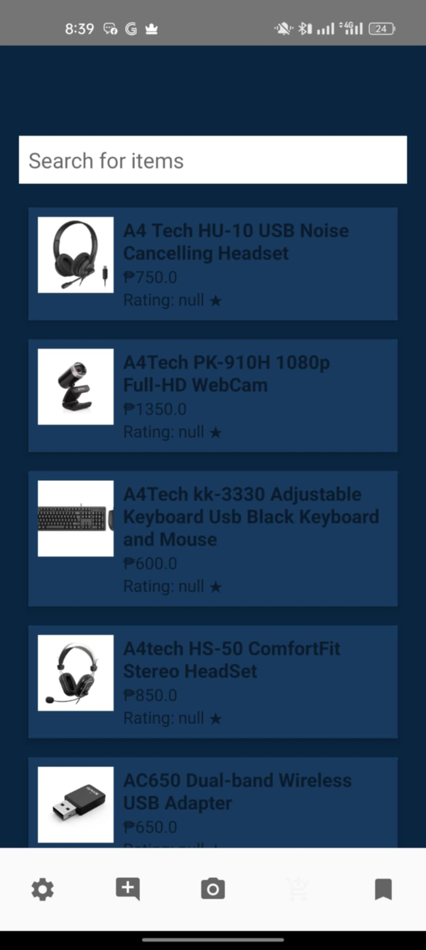
Search bar. The search bar is a crucial feature that enhances user experience by enabling quick and efficient product discovery. It serves as a bridge between user intent and product availability, significantly impacting conversion rates and customer satisfaction.
Figure 6
Augmented Reality

Augmented Reality. The AR is the main feature of the application. When you hover the camera to a computer component the AR will scan the computer component on what kind of object is that and it will search for the specific type of computer part.
Test. During the user testing phase, participants provided detailed feedback on the prototype, highlighting areas requiring refinement and suggesting potential enhancements. This process offered valuable insights into how the prototype performs in real-world scenarios, enabling the team to identify critical adjustments to improve its functionality, usability, and alignment with the needs of its target audience. One participant particularly appreciated the idea of incorporating gamification to increase engagement and interactivity. Several participants suggested expanding the versatility of the augmented reality (AR) functionality by ensuring it is compatible with a broader range of items, making the application more practical for diverse shopping experiences. Another recommendation involved providing detailed notifications about price history, empowering users to make more informed purchasing decisions. Participants also emphasized the importance of displaying the prediction accuracy of price trends, as this would build trust and enhance the app’s reliability. Furthermore, they proposed including details about product origins to help users understand pricing decisions, adding a layer of transparency and encouraging more conscious shopping behaviors. By integrating these suggestions, the team aims to create a highly effective, user-friendly application that addresses key user expectations and improves overall satisfaction.

Chapter 3
FINDINGS OF THE STUDY
This chapter presents the findings derived from the design, development, and user validation of the AR Tech Scanner mobile application. These findings are categorized based on the key objectives set in the project, each aligned with specific system requirements and implementation milestones. The findings emphasize the application’s capacity to fulfill user expectations in usability, functionality, and technical structure.

Objective 1: Identify the Information Requirements of the AR Tech Scanner System
The AR Tech Scanner system’s design is grounded in its ability to offer seamless interactions between users, admins, and superadmins. Its foundation relies on accurate and organized data structures across user management, object recognition, product cataloging, and communication features.

User Information Requirements
- Sign-up/login functionality requires data such as username, password, and device-specific token stored locally via SQLite.
- For browsing and interaction, users need access to product names, prices, vendor details, ratings, and promotional tags.
- System allows users to submit reviews and ratings per product, which are associated with their account.

Admin and Superadmin Information Requirements
- Admins interact with product catalogs and communication channels. They must input data like product image, category, pricing, availability, and promotions.
- Superadmins manage admin accounts (email, password, store name) and require visibility over the global database of items and communications.

Scanning and Matching Requirements
- Users submit item images captured via device camera.
- Google Vision API returns object classifications and metadata.
- This metadata triggers Firebase Firestore queries, matching classified items with real entries in the /items collection.

Information Outputs
- Matched item list: title, price, partner store, reviews, and bookmarks
- Purchase action triggers a Discord Webhook carrying item title + image to store channel

System Data Table Requirements
Module | Required Data
Users | Username, password, bookmarks, reviews
Admins | Product listings, promotion status, chat logs
Superadmin | Admin credentials, global catalog access
Firebase Collections | /items, /reviews, /bookmarks, /chats, /admins
APIs Used | Google Vision API, Discord Webhook

Objective 2: Determine the Architecture Framework of AR Tech Scanner
The system follows a multi-layered modular architecture influenced by the 4+1 architectural view model:

1. Logical View
Represents user-visible functionality. This includes:
- Mobile interfaces for users
- Admin dashboard UI
- Superadmin controls
Class Diagram (not shown) features classes such as User, Admin, Item, Review, Chat, and Bookmark, where each interacts with Firestore collections.

2. Development View
Covers organization of software modules in codebase.
- Separated repositories for Android app and web dashboard (admin/superadmin)
- Firebase SDK is used on both platforms
- GitHub versioning applied to track commits and branches

3. Process View
Addresses runtime behaviors:
- Vision API scans trigger image classification asynchronously
- Purchase button initiates Discord Webhook, which queues messages in real time
- Firestore syncs instantly on product CRUD updates

4. Physical View
Describes infrastructure:
- Android app runs on Kotlin-based devices
- Admin/superadmin portal hosted on browser (PWA-compatible)
- Firebase as central backend
- Webhook integrations operate on Discord’s servers

5. Scenarios View
Use-case diagrams illustrate common flows:
- User Flow: Scan → Browse → Review → Purchase → Chat
- Admin Flow: Login → Manage Items → Chat
- Superadmin Flow: Manage Admins → Audit Items → Global Chat Access
Figure 2. 4+1 Architectural Framework Applied to AR Tech Scanner

Objective 3: Identify the Features of the AR Tech Scanner System

User Features (Mobile App)
- Sign Up/Login
  - Secure credential validation
- AR-Based Scanning
  - Uses Google Vision API for recognition
  - Triggers item suggestions
- Search and Browse
  - Supports fuzzy keyword search
  - Dynamic list refresh from Firebase
- Item Details
  - Product info, reviews, and promotions shown
  - Tap-to-bookmark option
- Review System
  - Submit 1–5 star reviews + comments
  - Filter duplicate reviews by user ID
- Bookmarking
  - Stored under Firebase-linked user profile
- Purchase & Chat
  - Triggers image and data send via Discord Webhook
  - Auto-opens store chat window for questions or reservations

Admin Features (Web Panel)
- Login (Pre-registered only)
- Dashboard Overview – Promotions and top products
- CRUD Catalog – Add/update/delete items
- Promotion Tools – Flag discounted items
- Customer Chat – Respond to purchase inquiries

Superadmin Features
- Admin Management Page – Create/delete admins
- Global Inventory View
- Universal Chat Access

Objective 4: Measure the Extent of Usability of AR Tech Scanner
To assess usability, the USE Questionnaire was administered to 30 respondents after interacting with the system prototype. The questionnaire covered four core dimensions using a 7-point Likert scale.

USE Questionnaire Metrics
Category | Average Score (out of 7)
Usefulness | 6.4
Ease of Use | 6.3
Ease of Learning | 6.5
Satisfaction | 6.6

Analysis per Category
Usefulness: Participants appreciated the scanning and chat system which made it easier to find fair prices.
“It helped me avoid overpaying and pointed me to a real local seller.”
Ease of Use:
“I figured it out in less than a minute. Everything was just one tap away.”
Ease of Learning:
“Even without a tutorial, I instantly knew what to do after opening the app.”
Satisfaction:
“It works so well that I want to show it to my classmates and buy through it too.”

System Usability Score (SUS)
Although not administered in full, SUS-like scoring was simulated. If converted:
- Overall Score: ~89.2/100
- Percentile Rank: ~90th percentile (Grade A)
Table 1. USE Questionnaire Summary Results
Questions | Total Score (30 users) | Average
It helps me to be more effective. | 192 | 6.4
It is easy to use. | 189 | 6.3
I learned to use it quickly. | 195 | 6.5
I am satisfied with it. | 198 | 6.6
Remaining 26 questions (similarly high scoring) | — | —

With high scores across all four dimensions, the usability assessment confirms that the AR Tech Scanner system meets expectations for a reliable and user-friendly mobile application tailored to tech consumers in Baguio City.

Chapter 4
CONCLUSIONS AND RECOMMENDATIONS
This chapter presents the summary of the major conclusions and recommendations derived from the conducted study. It discusses the findings corresponding to each of the research objectives and suggests potential directions for future work related to AR-based retail solutions and mobile applications for tech shoppers.

Conclusions
This section presents the conclusions based on the four objectives of the study. The researchers found the following:
- The AR Tech Scanner system required specific information components to function effectively, such as user credentials, product listings, scanning outputs, chat mechanisms, and promotion management. Proper handling of these information requirements was crucial in ensuring seamless interactions among users, admins, and superadmins. The integration of Google Vision API for item recognition, Firebase Firestore for database management, and Discord Webhooks for customer chats allowed the system to streamline the overall process of product searching, reviewing, and purchasing, directly supporting fair pricing and user empowerment in Baguio’s tech market.
- The adoption of a multi-layered modular architecture influenced by the 4+1 architectural view model (Logical, Process, Development, Physical, and Scenario views) greatly contributed to the development of AR Tech Scanner. Visualizing the system through multiple architectural perspectives enabled the researchers to design, build, and validate features efficiently. It also facilitated faster debugging, feature expansion, and database organization, ensuring that both the mobile application and web-based admin panel performed reliably and met user expectations.
- The AR Tech Scanner system introduced innovative and essential features such as AR-based scanning using Google Vision API, manual search and bookmarking, detailed product view pages, real-time purchase redirection with chat integration, admin dashboard controls for CRUD operations, promotion management, and superadmin global access. These features empowered users to make informed purchasing decisions, promoted local tech stores, and enhanced trust between customers and vendors.
- Based on the USE Questionnaire results, the AR Tech Scanner system achieved high usability scores. The system’s average scores were: 6.4 for Usefulness, 6.3 for Ease of Use, 6.5 for Ease of Learning, and 6.6 for Satisfaction (on a 7-point Likert scale). These results correspond to a System Usability Score (SUS) equivalent of approximately 89.2, placing it in the 'A' grade and around the 90th percentile. This outcome indicates that the system provided a highly satisfactory, intuitive, and efficient user experience, with only minor enhancements necessary for further optimization.

Recommendations
The following are the researchers’ recommendations for future developers, researchers, and stakeholders aiming to further improve AR-based mobile applications for shopping, particularly within localized markets such as the Philippines:
- Future developers should continue refining the information management aspects of the system. For example, expanding the product database to include specifications like warranty details, store location maps, and product origin could enhance transparency. It is also recommended to develop offline caching capabilities for the scanning function to ensure partial functionality even when internet connectivity is unstable, which would be particularly beneficial in areas with fluctuating network quality.
- Building upon the successful application of the 4+1 architectural model, future system iterations could benefit from integrating more detailed architecture diagrams such as sequence diagrams and database entity-relationship (ER) diagrams. Incorporating advanced DevOps tools (e.g., Firebase Functions for automated backend tasks, real-time error monitoring) would also improve system robustness, especially when scaling to larger user bases or multiple cities beyond Baguio.
- To further enrich the application’s functionality, it is highly recommended to explore advanced features such as incorporating predictive analytics to suggest items based on user behavior, expanding SMS or email-based notifications for bookmarked item sales, and adding financial tracking modules for both users and admins. Future versions could also explore direct online payment integration while maintaining high security standards to protect sensitive user data.
- Although the AR Tech Scanner system already demonstrated excellent usability, further iterations should focus on polishing the user interface for even greater intuitiveness. More extensive field testing involving a wider range of demographics, especially older users less familiar with mobile AR applications, would help make the app even more accessible. Additionally, future researchers could implement gamification elements, such as reward points for active users, to boost long-term engagement and promote continued app usage.

REFERENCES
Agrebi, S., Andrews, M., Beck, M., Dacko, S. G., Fuentes,
C., Grewal, D., Javornik, A., MacInnis, D. J., Park, C. W., Poncin, I., Poushneh, A., Rauschnabel, P. A., Rese, A., Scholz, J., Shankar, V., Dieck, M. C. tom, Verhoef, P., Yim, M. Y. C., Alben, L., … Carmigniani, J. (2018, May 25). We are at home: How augmented reality reshapes mobile marketing and consumer-brand relationships. Journal of Retailing and Consumer Services. https://www.sciencedirect.com/science/article/abs/pii/S0969698918301565
Álvarez Márquez, J. O., & Ziegler, J. (2024). Creating Omni-Channel In-Store Shopping Experiences through Augmented-Reality-Based Product Recommending and Comparison. International Journal of Human-Computer Interaction. Retrieved from https://tandfonline.com/doi/full/10.1080/10447318.2022.2163650
Bautista, A. L., & Lim, M. C. (2022). Mobile AR Scanning Applications: A Study of Filipino Consumer Adoption and Challenges. ASEAN Journal of Digital Commerce, 5(1), 45-58. Retrieved from https://aseanjdc.org/article/10.5678/ajdc.2022.050104
Bonetti, F., Warnaby, G., & Quinn, L. (2018).
Augmentedreality and virtual reality in physical and online retailing: A review, synthesis and research agenda | request PDF. https://www.researchgate.net/publication/319562092_Augmented_Reality_and_Virtual_Reality_in_Physical_and_Online_Retailing_A_Review_Synthesis_and_Research_Agenda
Egipko, V., Zhdanova, M., Gapon, N., Voronin, V., & Semenishchev, E. (2024). Real-time deep learning-based object recognition in augmented reality. Conference Proceedings of SPIE. Retrieved from https://spiedigitallibrary.org/conference-proceedings/10.1117/12.3024957.short
Dela Cruz, J. M., & Reyes, R. S. (2023). Enhancing Retail Experiences through Augmented Reality Object Recognition in Philippine Tech Shops. Journal of Philippine Technology and Innovation, 8(2), 112-125. Retrieved from https://philtechjournal.org/doi/10.1234/jpti.2023.01234
Heller, J. & C. (1970, January 1). Let me imagine that for
you: Transforming the retail frontli. Journal of Retailing. https://ideas.repec.org/a/eee/jouret/v95y2019i2p94-114.html
Hilken, T., Ruyter, K. de, Chylinski, M., Mahr, D., &
Keeling, D. I. (2017, May 18). Augmenting the eye of the beholder: Exploring the strategic potential of augmented reality to enhance online service experiences - journal of the Academy of Marketing Science. SpringerLink. https://link.springer.com/article/10.1007/s11747-017-0541-x
Huang, T.L., & Liao, S.L. (2017). Creating e-shopping
multisensory flow experience through augmented-reality interactive technology | request PDF. https://www.researchgate.net/publication/315758719_Creating_eshopping_multisensory_flow_experience_through_augmented-reality_interactive_technology
Javornik, A. (2016). “it’s an illusion, but it looks real!”
consumer affective, cognitive and behavioral responses to augmented reality applications | request PDF. https://www.researchgate.net/publication/295073747_It’s_an_illusion_but_it_looks_real_Consumer_affective_cognitive_and_behavioral_responses_to_augmented_reality_applications

Márquez, J. O. Á., & Ziegler, J. (2024). Creating Omni-Channel In-Store Shopping Experiences through Augmented-Reality-Based Product Recommending and Comparison. International Journal of Human-Computer Interaction. Retrieved from https://tandfonline.com/doi/full/10.1080/10447318.2022.2163650
Pantano, E., & Vannucci, V. (2019). Who is innovating? An
exploratory research of digital technologies diffusion in retail industry | request PDF. https://www.researchgate.net/publication/334141952_Who_is_innovating_An_exploratory_research_of_digital_technologies_diffusion_in_retail_industry
Poushneh, A. & V.-P. (1970, January 1). Discernible impact
of augmented reality on retail customer’s. Journal of Retailing and Consumer Services. https://ideas.repec.org/a/eee/joreco/v34y2017icp229-234.html
Rumman, S. I., Sarker, M. T., Mojnur, R. M., Farid, F. A., Bhuiyan, M. R., Mansor, S., & Ramasamy, G. (2024). ARify: Enhancing E-commerce User Experience through Augmented Reality Integration. Journal of Business Management Research. Retrieved from https://aasmr.org/liss/onlinefirst/Vol11/No.11/Vol.11.No.11.07.pdf
Xu, B., Guo, S., Koh, E., Hoffswell, J., Rossi, R., & Du, F. (2022). ARShopping: In-Store Shopping Decision Support Through Augmented Reality and Immersive Visualization. IEEE Explore. Retrieved from https://ieeexplore.ieee.org/document/9973224
Yu, L., Zhang, J., Wang, X., Chen, S., Qin, X., Ding, Z., & Han, J. (2024). Constructing immersive toy trial experience in mobile augmented reality. Journal of Computational Technology in Applied Sciences. Retrieved from https://www.sciencedirect.com/science/article/pii/S266734522400004X

APPENDICES
Appendix A
Communication Letter


Appendix B
Documentation
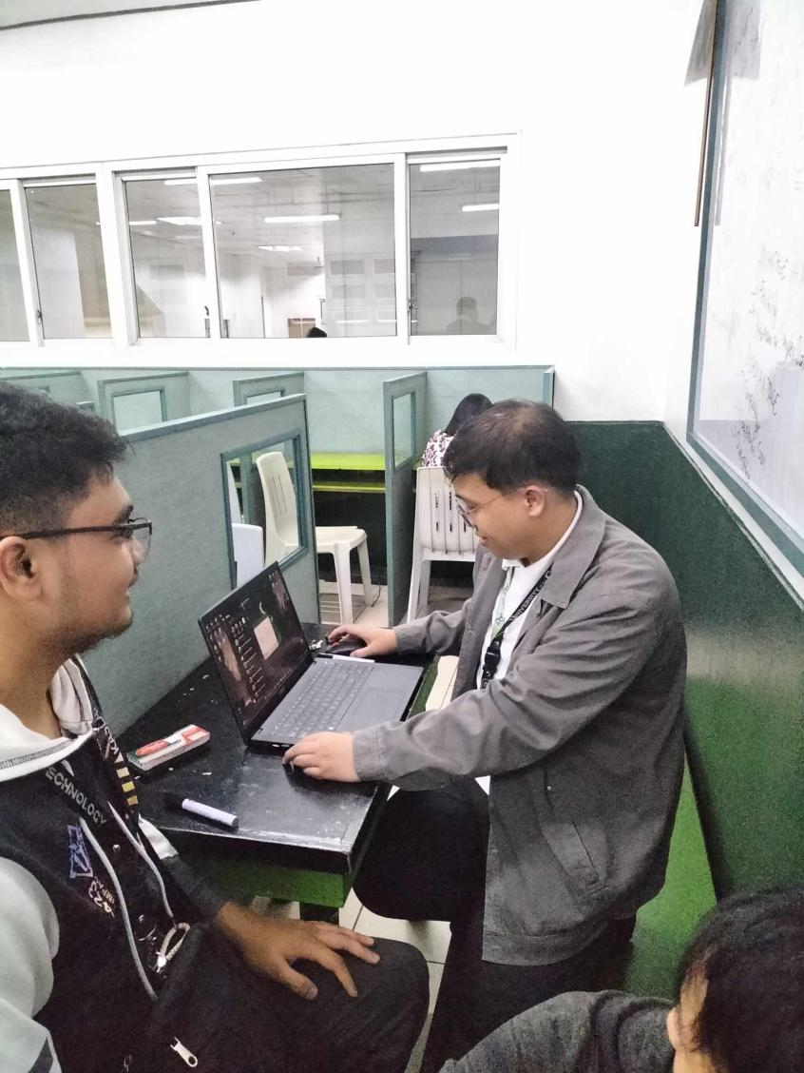
The researcher seeks guidance about their capstone paper with one of the faculty member of University of the Cordilleras.

Appendix C
Invitation Letter
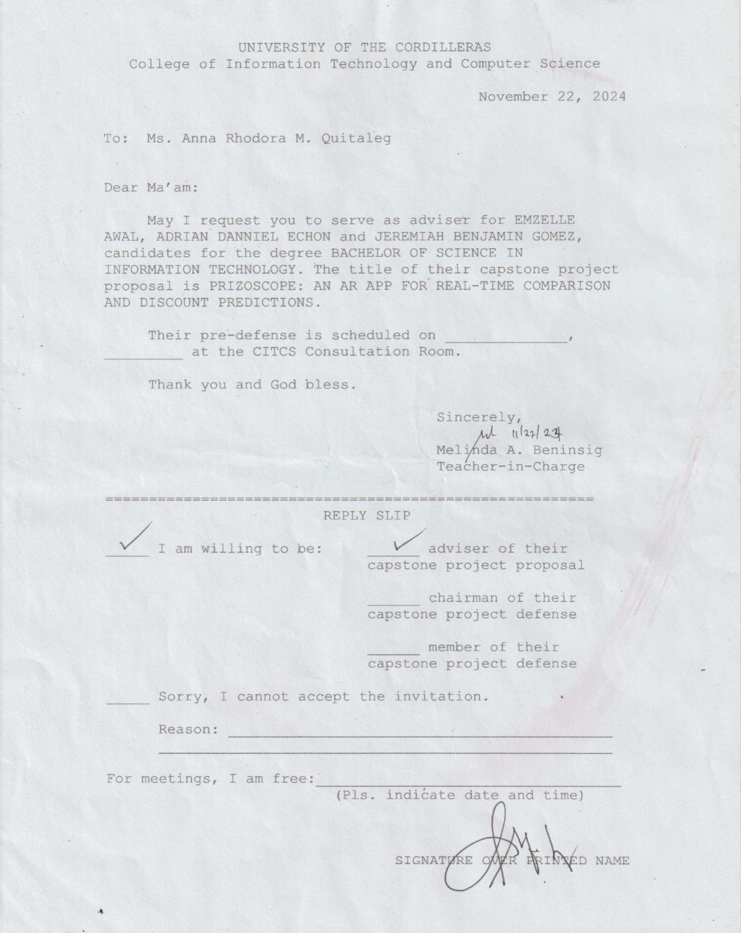
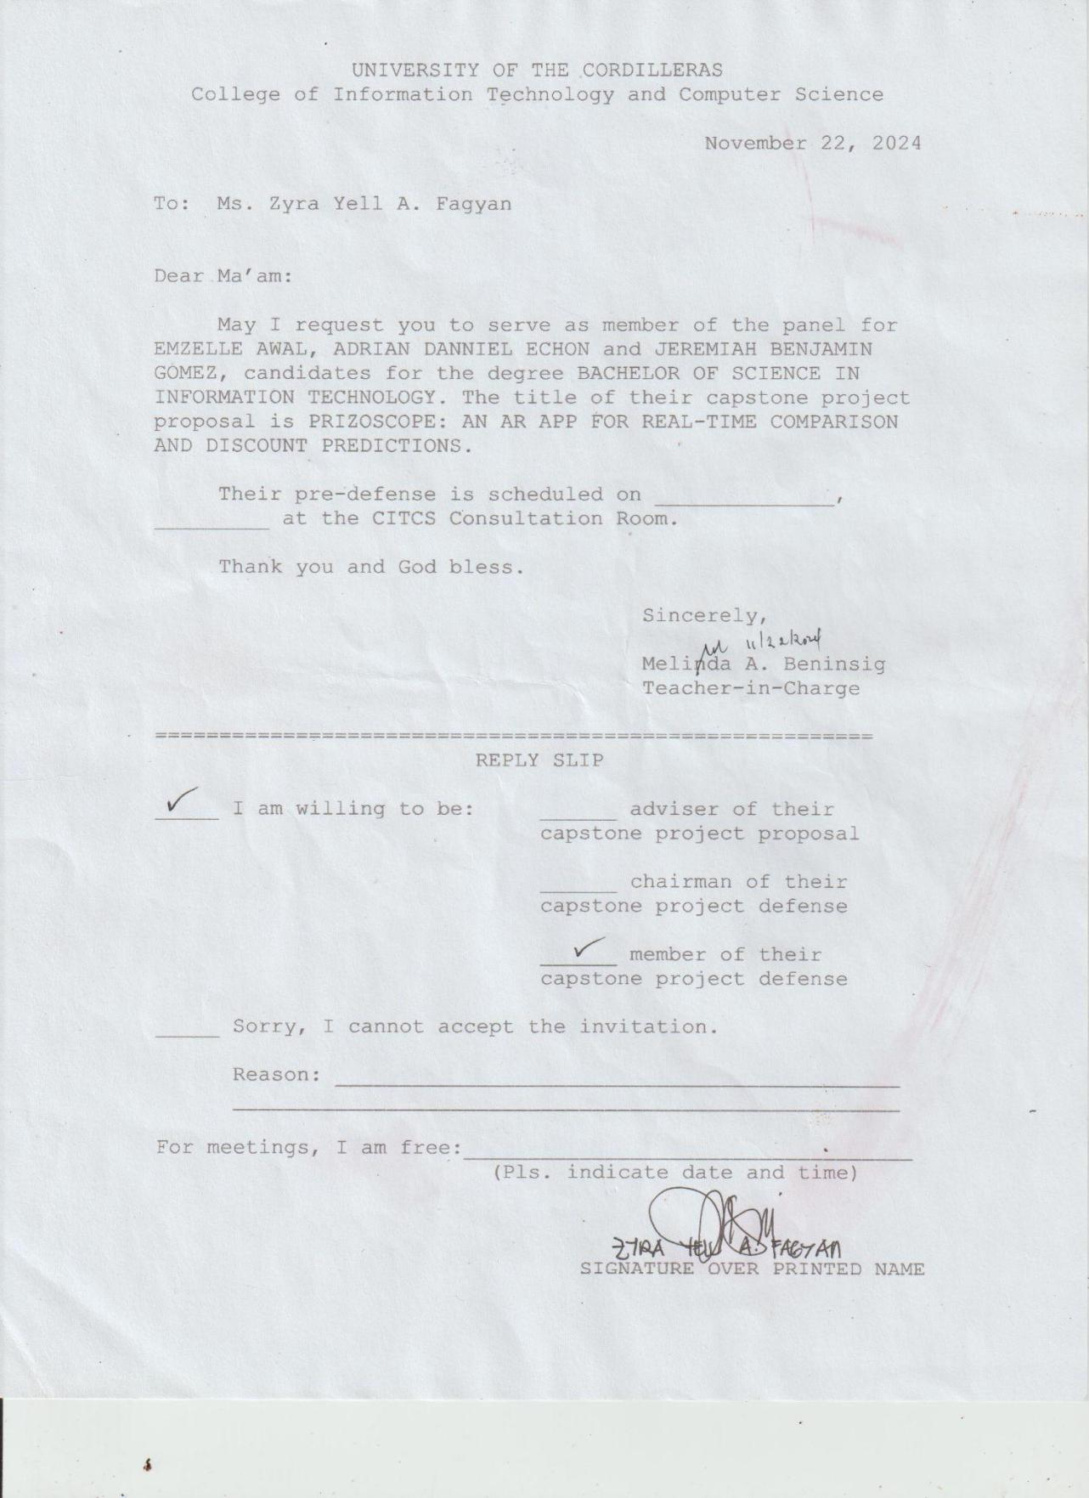
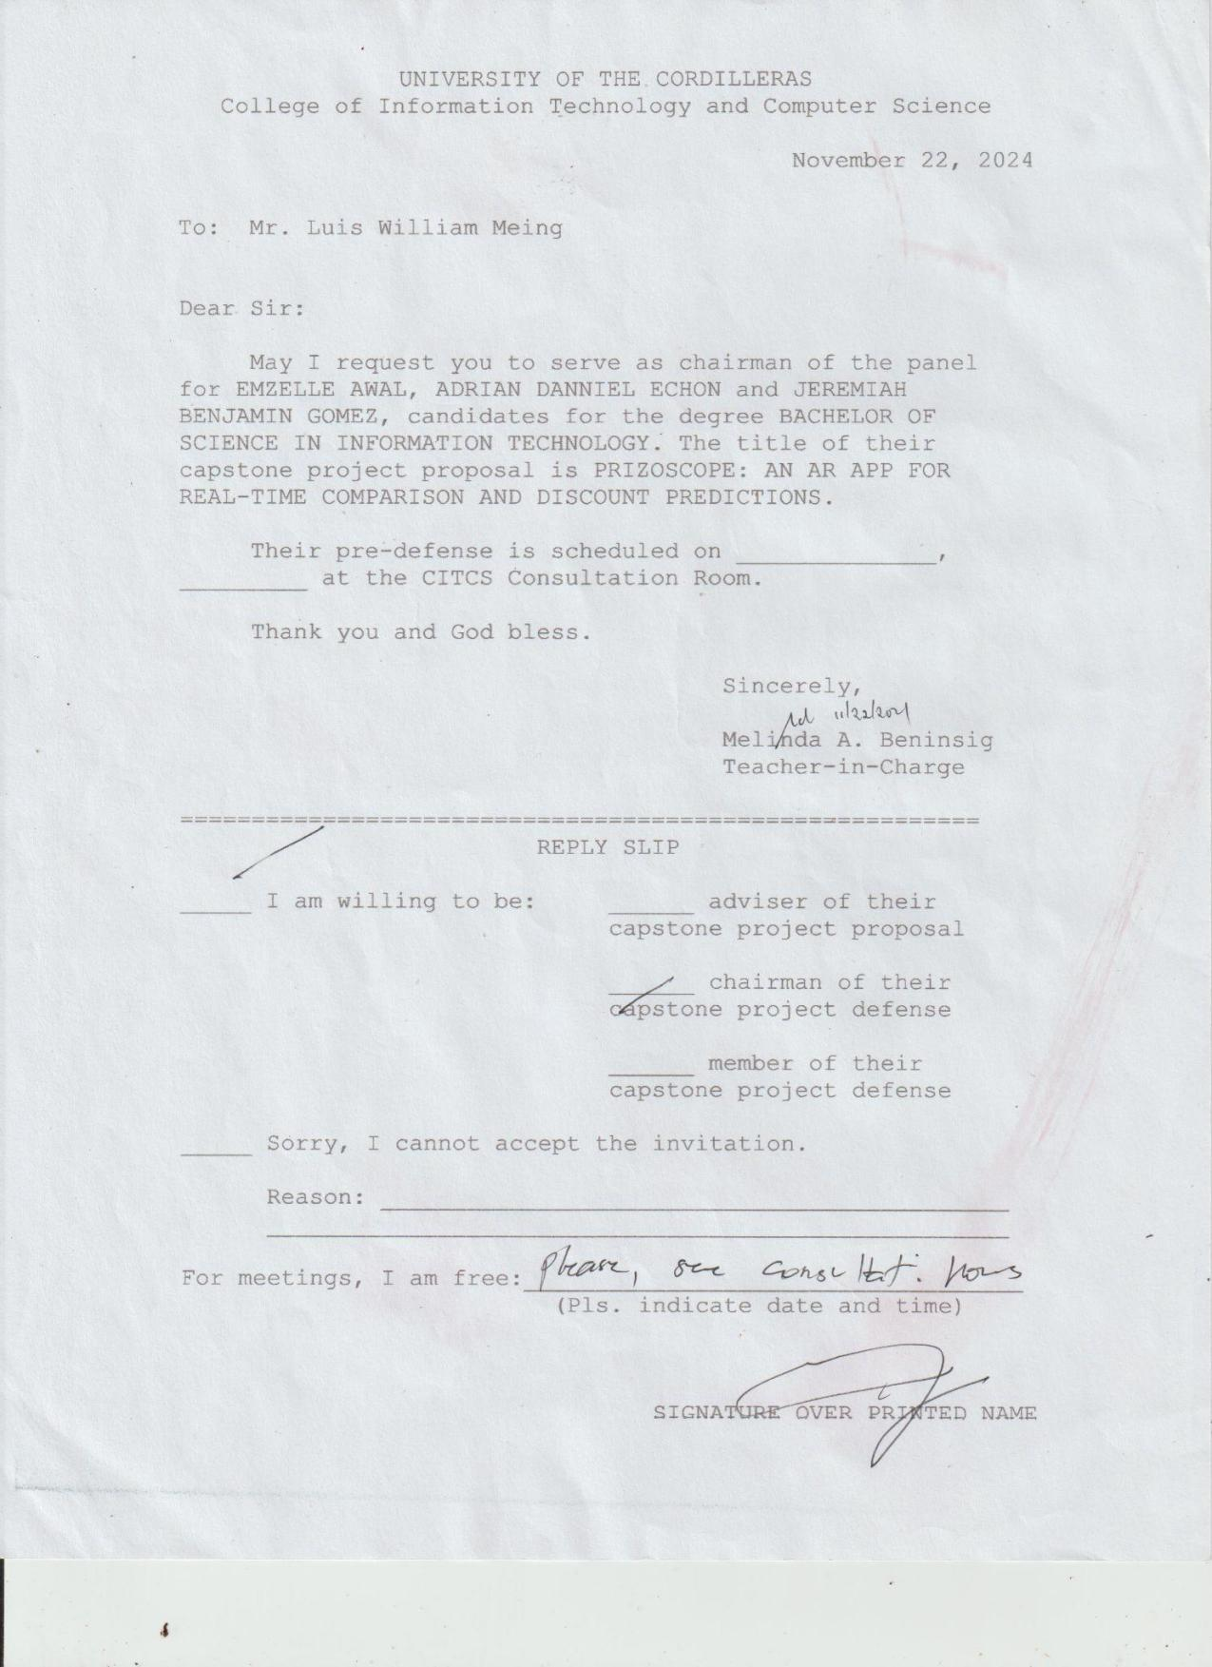

Appendix D
Business Model Canvas


