DISCUSSION

Laparoscopic cholecystectomy is presently regarded as the gold standard in the surgical management of gallbladder stones. Due to its low invasiveness and safety, less surgical problems, quicker recovery, and noticeably shorter hospital stay, LC is used more frequently than open cholecystectomy (OC) in many facilities worldwide. Conversion to open surgery may be necessary to prevent injury (e.g. bile duct injury), treat an intraoperative complication (e.g. bleeding, bowel injury, bile duct injury) or due to failure to progress. There are many risk factors which predict the conversion from LC to OC.
Warchalowski et. Al(2020) stated the time during the day when the surgery is performed,limited experience of the surgeon performing cholecystectomy, emergency surgery,age,sex,diabetes, hypertension, heart disease, neurological disorders, acute cholecystitis, choledocholithiasis, and, to a lesser degree, anatomical confusion are statistically significant factors.The conversion rate was 8.2%.¹
Osuch et. Al(2020) found that Inflammatory infiltration of hepatic hilar area was the most common indication for conversion.The other reasons being difficulties in identification of Calot’s triangle structures,Common bile duct rupture,Hemorrhage of hepatic artery branches,Abscess of the Calot’s triangle,Fistula between gallbladder and duodenum.They had a conversion rate of 6.9%.Age was found as a statistically significant risk factor which increased the likelihood of conversion and complications in Male patients undergoing cholecystectomy.[2]The most common indication for conversion in my study was Dense Adhesions and 80% were female with a conversion rate of 10% .²
Masri et. Al(2018) stated that the most common intraoperative reasons for conversion were perceived difficult anatomy or obscured view secondary to severe adhesions or significant inflammation with a conversion rate of 1.07%. Patients who were in the LC–OC arm had a longer length of hospital stay.The mean duration of postoperative stay in the conversion group was 10.2 days in our study which is longer than that in the LC group of 3.6 days.³
Ishizuka et. Al(2016) stated that γ-glutamyltransferase ,albumin and platelet count were associated with conversion.Preoperative hypoalbuminemia is the most important risk factor for conversion to OC in patients undergoing elective LC for cholecystolithiasis with conversion rate of 5.4%.The intra-operative time,bleeding volume and hospital stay were found to be significantly more in the conversion group.⁴
Chavez et. Al(2016) revealed that the factor that was most associated with conversion was emergency surgery ,as well as dilatation > 6 mm of the common bile duct in ultrasound ,hepatomegaly ,diagnosis of chronic cholecystitis associated to previous biliary colics and elevated alanine aminotransaminase with a conversion rate of 1%.⁵
Conversion increases overall morbidity ,the intra-hospital stay, general hospital costs and surgical times. There have been statistical models to predict the conversion from laparoscopic to open cholecystectomy.Beksac et. Al’(2016) proposed a statistical model,” Using four parameters—age, gender, history of abdominal surgery, and ALP—in their statistical model, they were able to predict the conversion from laparoscopic to open cholecystectomy with 70% sensitivity and 79% specificity. The risk of conversion significantly increases after 55 years of age and an ALP over 80 IU/L.”⁶ The conversion rate in their study was 7.7%.
The Conversion from Laparoscopic to Open Cholecystectomy (CLOC) score from the CholeS study was assessed for external validity by interrogating its accuracy and calibration in the CHOLENZ dataset(2024),” Of 1162 cholecystectomies started laparoscopically, 20(1.7%) were converted to open in the CHOLENZ dataset. The CLOC score predicted 2.9% (IQR 1.3%–8.1%) would be converted.One of the largest validated scores is the CholeS Conversion from Laparoscopic to Open Cholecystectomy (CLOC) score based on six factors– age, sex, indication for surgery, American Society of Anaesthesiologists score (ASA), thickness of the gallbladder
wall, and common bile duct diameter. “⁷Being able to identify patients at higher risk
of conversion preoperatively may enable better operative list planning,
patient counselling, and determine the degree of consultant
supervision needed. 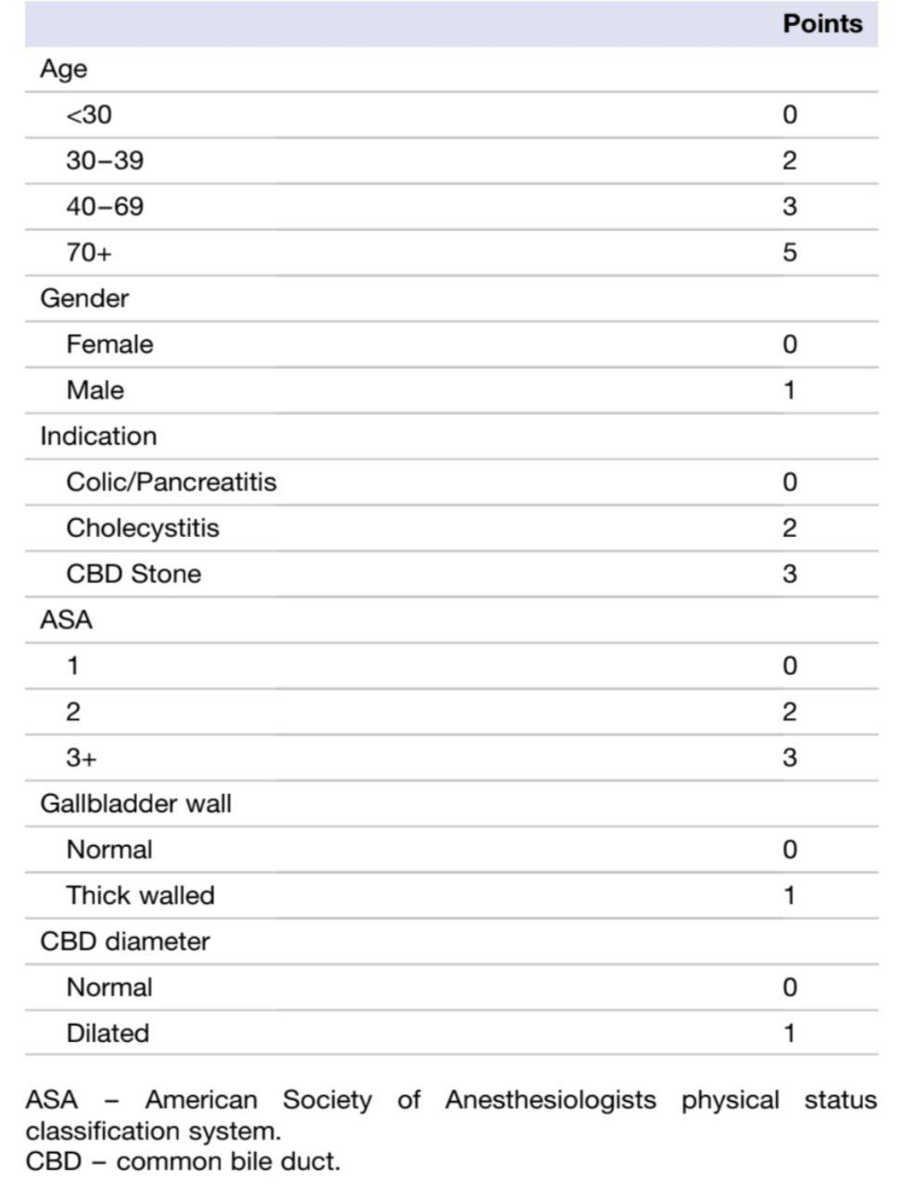

Conversion from laparoscopic to open cholecystectomy score(CLOC SCORE)

According to Assanee Tongyoo et. Al(2021),” the most common condition leading to the conversion was the difficult dissection of Calot’s triangle, then failure to
clearly inspect critical view of safety. A converted open cholecystectomy resulted in many consequences like, more intense post-operative pain, longer hospital stay, much more wound complication, and subsequently higher cost of treatment. The operative time of successful LC and converted OC were 76.17 ± 29.64 and 119.06 ± 28.30 min respectively. They had a conversion rate of 10.5%”⁸ The patients requiring conversion in our study also had more intense post operative pain and required analgesics for a longer mean duration of 7.4 days.66.6 % patients undergoing conversion had surgical site infection. The mean operative time in converted cases was significantly longer than those which were completed as LC.
According to Robert P. Sutcliffe et. Al, “Mean patient age requiring conversion was 51 ± 17 years with a conversion rate of 3.4%.”The mean age of patients requiring conversion in our study was
Patients with these risk factors should be counseled for the possibility of conversion to open surgery preoperatively. Further research is needed to determine whether these high risks patients should be operated on by surgeons with more extensive experience in minimal invasive surgery. Determining preoperative patient-related factors and anticipating the need to convert from LC to open surgery can help identify high risk patients and redefine surgical strategy in this group. Additionally, the conversion from laparoscopic to open surgery results in longer postoperative stays and higher morbidity and mortality rates in this group of patients.
The surgeon’s experience is an important factor in determining the rate of conversion. Increased laparoscopic experience is associated with reduction in conversion and complication rate. Surgeons with larger caseloads may have better outcomes than those who do the procedures less frequently.
The identification of parameters predicting conversion improves preoperative patient counselling, provides for better preoperative planning, optimizes operating room efficiency, and helps avoiding laparoscopic-associated complications by performing an open operation when considered appropriate.
Many centers around the world use the LC more frequently than classical cholecystectomy (CC) due to low invasiveness and safety of the surgeries performed, reduction of postoperative complications, faster recovery, and significantly shorter hospital stay . However, due to certain factors, there is occasionally a need to abandon the previously planned laparoscopic procedure and perform open cholecystectomy.Hence,Surgical training in O.C is still relevant. Rather than being considered a complication, the decision to convert should be regarded as a sign of good judgement in the presence of adverse conditions.
With regard to the gender of patients undergoing cholecystectomy, Sutcliffe et colleagues found a conversion rate of 6.4% in male and 2.3% in female cholecystectomy patients, respectively.⁹ Yol et al. found that men have more inflammatory cells and tissue collagen in the gallbladder wall, leading to more extensive fibrosis than women.¹⁰ The patients requiring conversion in our study were 80% female.
Numerous studies have provided evidence linking a patient's age to more challenging LC or a higher conversion rate. Yetkin et al reported conversion rate of 14.7% and 8% of patients aged more and less than 60 years, respectively.¹¹ This conclusion could be attributed to the presence of gallstones for a longer period of time and increased inflammation.The mean age of patients requiring conversion in our study was 35.5 years.

1)Warchałowski Ł, Łuszczki E, Bartosiewicz A, Dereń K, Warchałowska M, Oleksy Ł,
Stolarczyk A, Podlasek R. The Analysis of Risk Factors in the Conversion from Laparoscopic to Open Cholecystectomy. Int J Environ Res Public Health. 2020 Oct 18;17(20):7571. doi: 10.3390/ijerph17207571. PMID: 33080991; PMCID:
PMC7588875.
2)Osuch, Czesław, et al. "Gender as a predictive factor in cholecystectomy—is it true or false?." Folia Medica Cracoviensia 60.2 (2020): 97-107.
3)Al Masri, Samer, et al. "Predicting conversion from laparoscopic to open cholecystectomy: a single institution retrospective study." World journal of surgery 42.8 (2018): 2373-2382.
4)Ishizuka, Mitsuru, et al. "Preoperative hypoalbuminemia is an independent risk factor for conversion from laparoscopic to open cholecystectomy in patients with cholecystolithiasis." Asian Journal of Endoscopic Surgery 9.4 (2016): 275-280. 5)Chávez, K.V., Márquez-González, H., Aguirre, I. et al. Prognostic risk factors for conversion in laparoscopic cholecystectomy. Updates Surg 70, 67–72 (2018).
6) Beksac, Kemal, et al. "Risk factors for conversion of laparoscopic cholecystectomy to open surgery: a new predictive statistical model." Journal of Laparoendoscopic & Advanced Surgical Techniques 26.9 (2016): 693-696.
7) STRATA Collaborative and CholeS Collaborative, et al. "External validation of the CholeS conversion from laparoscopic to open cholecystectomy (CLOC) risk score in Aotearoa New Zealand: a validation study." ANZ journal of surgery 94.6 (2024): 1108-1113.
8) Tongyoo, Assanee, et al. "The pre-operative predictive model for difficult elective laparoscopic cholecystectomy: A modification." Asian Journal of Surgery 44.4 (2021): 656-661.
9) Sutcliffe RP, Hollyman M, Hodson J, Bonney G, Vohra RS, Griffiths EA. Preoperative risk factors for conversion from laparoscopic to open cholecystectomy:
a validated risk score derived from a prospective U.K. database of 8820 patients.
HPB. 2016;18:922e928
10) Yol, Serdar, et al. "Sex as a factor in conversion from laparoscopic cholecystectomy to open surgery." JSLS: Journal of the Society of Laparoendoscopic Surgeons 10.3 (2006): 359.
11) Yetkin G, Uludag M, Oba S, Citgez B, Paksoy I. Laparoscopic cholecystectomy in
elderly patients. JSLS. 2009;13:587e591.

