Results
The largest segment of participants was aged between 31 and 60 years (68%), predominantly female (58%), with an education level of 10th grade or lower (46%), married individuals (82%), residing in rural areas (55%), and a significant number identified as housewives (43%) [Table 1]. Most participants demonstrated an average level of knowledge regarding self-medication [Table 2]. Over the past three months, the majority had engaged in self-medication an average of two times. Pain relievers were the most frequently used self-medication drugs, with personal experience cited as the primary source of information for self-medication. The leading reason for self-medication was the mildness of the illness, followed by the ease of obtaining medications [Table 3]. Regarding attitudes towards self-medication, most participants held a positive view, agreeing that it can play a role in self-care, that it is important to have knowledge about medications and illnesses for safe self-medication and that self-medication can be effective in managing common ailments [Table 4].
The study's findings indicated a significant prevalence of self-medication, with 85% of participants reporting such practices within the three months preceding data collection [Figure-1].
The drugs most commonly used in this study were pain-relievers (58%), followed by cold medications (39%), antibiotics (8%), and other alternative medicines (4%), which aligns with findings from other investigations that report pain-killers, antibiotics, and cold/flu medications as frequently used self-medication options [Figure – 2].
Table 1: Socio-demographic characteristics of participants (n=102)

S.N. | Variables | Options | Frequency | Percentage
1. | Age | Less than 30 Years | 27 | 27
1. | Age | 31 to 60 Years | 69 | 68
1. | Age | More than 60 Years | 06 | 05
2. | Gender | Male | 43 | 42
2. | Gender | Female | 59 | 58
3. | Educational status | No Formal Education | 08 | 07
3. | Educational status | 10th & Below 10th Class | 45 | 46
3. | Educational status | 12th Class | 12 | 11
3. | Educational status | Graduate | 31 | 31
3. | Educational status | Post Graduate | 06 | 05
4. | Marital Status | Married | 84 | 82
4. | Marital Status | Unmarried | 18 | 18
5. | Belongs to area | Urban | 46 | 45
5. | Belongs to area | Rural | 56 | 55
6. | Occupation | Student | 18 | 17
6. | Occupation | Housewife | 43 | 43
6. | Occupation | Farmer | 11 | 10
6. | Occupation | Private job | 12 | 12
6. | Occupation | Govt. Job | 16 | 16
6. | Occupation | Self Employed | 02 | 02
7. | Health insurance | Yes | 32 | 31
7. | Health insurance | No | 70 | 69
8. | Birth Belongs to which area | Urban | 46 | 45
8. | Birth Belongs to which area | Rural | 56 | 55
9. | Nearby hospital distance from home | Less than 1 KM | 14 | 14
9. | Nearby hospital distance from home | 1-5 KM | 70 | 69
9. | Nearby hospital distance from home | More than 5 KM | 18 | 17
10. | Is there any of your Family member in health sector? | Yes | 28 | 27
10. | Is there any of your Family member in health sector? | No | 74 | 73
11. | Having any Chronic Disease, then please tell me the name? | No | 93 | 92
11. | Having any Chronic Disease, then please tell me the name? | HTN | 01 | 01
11. | Having any Chronic Disease, then please tell me the name? | DM | 03 | 02
11. | Having any Chronic Disease, then please tell me the name? | Joint Pain/ Arthritis | 02 | 02
11. | Having any Chronic Disease, then please tell me the name? | Hypothyroidism | 01 | 01
11. | Having any Chronic Disease, then please tell me the name? | Benign Tumor | 01 | 01
11. | Having any Chronic Disease, then please tell me the name? | fluid filled/ edema occur in pelvic region, cured after more than 1 year | 01 | 01

Table 2: Level of knowledge for self-medication

S.N. | Variables | Options | Frequency | Percentage
 | I believe that relying on self-medication is a secure approach. | Yes | 63 | 61
 |  | No | 39 | 39
 | Have you ever taken care of your own well-being by using medications for self-treatment? | Yes | 95 | 93
 |  | No | 07 | 07
 | Can you confirm whether the medications you've taken require a prescription? | Yes | 53 | 52
 |  | No | 49 | 48
- s | Self-medication may be employed to address various health issues. | Yes | 76 | 74
- s |  | No | 26 | 26
 | How do you determine the appropriate time to discontinue medications following self-medication? | Yes | 78 | 76
 |  | No | 24 | 24
 | I consistently review the guidelines provided on the packaging before administering any self-medication. | Yes | 54 | 53
 |  | No | 48 | 47
 | I consistently ensure to verify the expiration date prior to using any medication. | Yes | 77 | 76
 |  | No | 25 | 24
 | I consistently store medications according to the instructions provided on the drug packaging. | Yes | 41 | 41
 |  | No | 61 | 59
 | I always prioritize my health by avoiding the use of someone else's self-prescribed medications. | Yes | 55 | 54
 |  | No | 47 | 46
 | I rely on non-prescription medications for self-care purposes. | Yes | 51 | 50
 |  | No | 51 | 50
 | Have you shared your prescription with someone experiencing similar symptoms? | Yes | 55 | 54
 |  | No | 47 | 46
 | Is it possible to obtain the medication without a prescription easily from the pharmacy? | Yes | 57 | 56
 |  | No | 45 | 44
 | Have you ever experienced any side effects or adverse reactions when using medication for self-care? | Yes | 24 | 24
 |  | No | 78 | 76
Overall Level of knowledge for self-medication
 |  | f | %
 | Poor Knowledge (0-4) | 04 | 04
 | Average Knowledge (5-9) | 71 | 70
 | Good Knowledge (10-14) | 27 | 26

Table 3: Level of practice for self-medication

S.N. | Variables | Options | Frequency | Percentage
 | How frequently have you engaged in self-care practices without professional guidance in the last three months? | 1time | 29 | 28
 |  | 2 time | 68 | 67
 |  | 3 times or more | 05 | 05
 | Your choice of medication was influenced by: recommendations from pharmacists, input from family members and friends, doctor's prescription, exposure to advertisements, and personal experiences. | Personal experience | 23 | 23
 |  | Exposure to advertisements | 10 | 09
 |  | Doctor's prescription | 29 | 28
 |  | Input from family members and friends | 16 | 16
 |  | Recommendations from pharmacists | 24 | 24
 | Routinely used self-medication drugs?  Antibiotics, pain killers, cold tablets, contraceptives, other than allopathy drugs – Herbal/homeopathy/Ayurveda/siddha drugs | Antibiotics | 08 | 08
 |  | Pain Killers | 50 | 49
 |  | Cold tablets | 40 | 39
 |  | Other than allopathy drugs: Herbal/homeopathy/Ayurveda/siddha drugs | 04 | 04
 | How do you get source of information about drugs?  Health workers, old prescriptions, Pharmacists, others | Health workers | 27 | 26
 |  | Old prescriptions | 33 | 33
 |  | Pharmacists | 25 | 25
 |  | Others | 17 | 16
 | What is the reason for your self-medication practices?  To save money, to save time, emergency use, illness was mild, ease of access | To save money | 01 | 01
 |  | To save time | 04 | 03
 |  | Emergency use | 21 | 21
 |  | Illness was mild | 54 | 54
 |  | Ease of access | 22 | 21

Table 4: Attitude towards self-medication
S.N. | Question | Strongly  agree | Agree | Neutral | Disagree | Strongly disagree
 | Engaging in self-medication practices can be a component of self-care. | 26 (25) | 46 (45) | 28 (28) | 00 (00) | 02 (02)
 | Occasionally, relaying self-medication can result in selecting an inappropriate drug or treatment. | 19 (19) | 65 (64) | 18 (17) | 00 (00) | 00 (00)
 | Acquiring fundamental knowledge about medications and illnesses is essential for safe self-medication practices. | 22 (22) | 63 (62) | 17 (16) | 00 (00) | 00 (00)
 | Improper self-medication may result in unintended side effects and negative health outcomes. | 17 (17) | 65 (63) | 19 (17) | 00 (00) | 01 (01)
 | Once symptoms have improved Self-medication can be discontinued. | 14 (13) | 66 (65) | 22 (22) | 00 (00) | 00 (00)
 | The misuse of antibiotics through self-medication with over-the-counter drugs can lead to the development of antimicrobial resistance. | 08 (07) | 52 (51) | 41 (41) | 00 (00) | 01 (01)
 | You can effectively manage common illnesses with self-administered medication. | 04 (04) | 67 (65) | 31 (31) | 00 (00) | 00 (00)
 | I prioritize cost-effective healthcare by adhering to previously prescribed medications. | 08 (08) | 56 (55) | 38 (37) | 00 (00) | 00 (00)
Overall Attitude towards self-medication
 |  | f | %
 | Unfavorable attitude (8-18) | 00 | 00
 | Neutral attitude (19-29) | 28 | 28
 | Favorable attitude (30-40) | 74 | 72

Figure – 1: Self-Medication Practices in Santhal Community

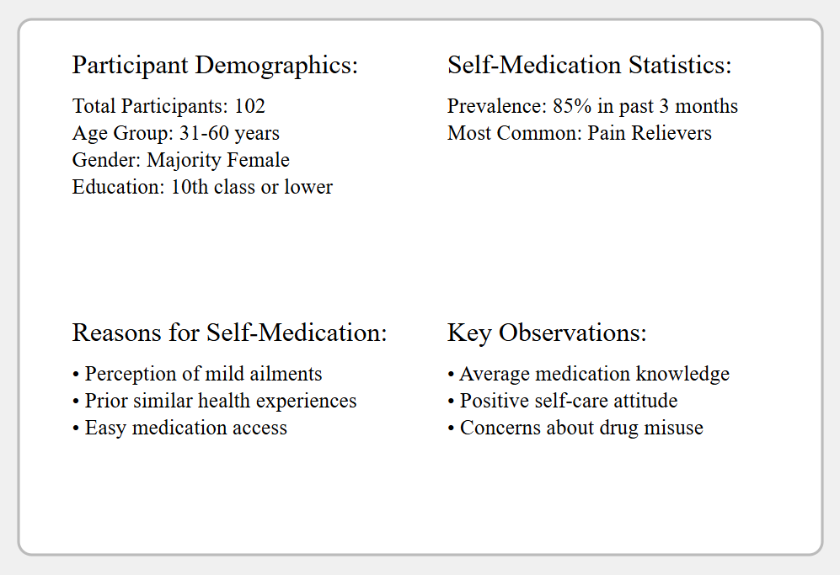

Figure – 2: Drugs most commonly used in this study



