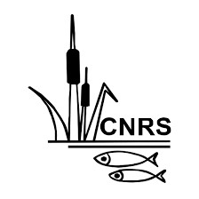
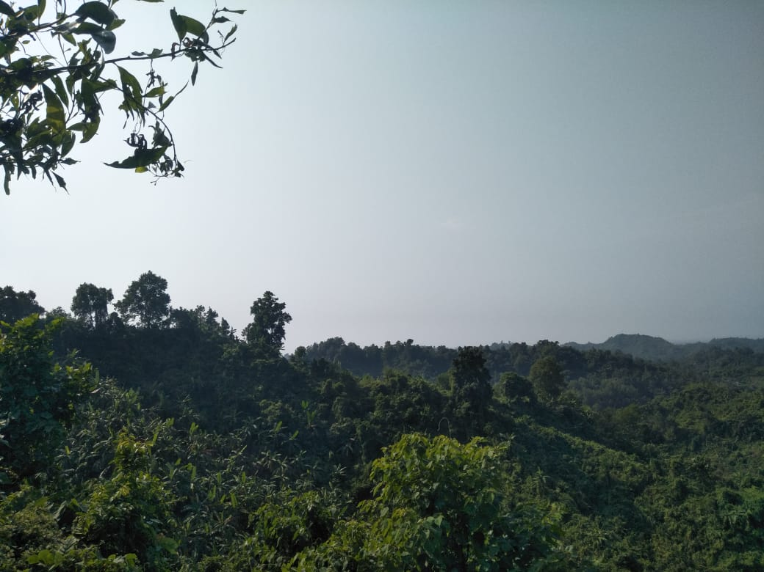
Field visit summary and strategy planning for outreach area's intervention

Sourav Chakma, Plantation Officer
Umonghla Marma, Swapan Mulla, Rafiul Hassan; Training & Field Officer
Bamboo for Climate Action Project
December 2024
Despite having few forest resources, Chittagong Hill Tracts (CHT) is still regarded as one of Bangladesh's most forested regions. The region's distinct geographic and social structures—which are defined by a steep terrain and are home to several indigenous communities—set it apart from other parts of Bangladesh. The forest and its resources are fundamental to the indigenous people's culture, way of life, and means of subsistence. The birth of community-managed VCF in the CHT is a direct result of resource constraints caused by deforestation and is a natural forest other than the government forest around the households of the ethnic communities and managed to fulfill their daily demands. VCF are commonly owned and managed by the community as a whole responsible for its upkeep and conservation which were later known as the mauza reserves or service forests (Ti-wari, 2003; Roy, 2000; Saha, 2010).
Due to unsustainable resource usage, many VCFs have lost significant biodiversity and witnessed environmental deterioration over the past decades [1]. Population pressure, unplanned development, unsustainable agricultural practices, lack of cultivable land, and alternative income-generating sources also have resulted in the overexploitation of VCF resources [2,3]. Besides. After the Rohingya influx in 2019, it might impact the livelihood of the nearer borderline residents, including the existing VCFs where the hill people rely on VCFs’ bamboo and timber resources for house construction, medicinal resources, and other sustainable biomass needs [4]. On the other hand, some researchers reveal that VCFs with NGO involvement have healthier ecosystems and greater biodiversity compared with those without, highlighting the necessity of NGO participation in managing and preserving these forests (Bari et al. 2024). Considering both issues, B4CA project intervention in the outreach area made a scope to role in supporting biodiversity, ecosystem services, and improving local livelihoods through improving environmental health. The field visit was conducted to gather information about VCFs, existing management practices, and observe the current status of VCFs. Transact work to one VCF in Ghumdhum union, and seven semi-structured group interviews, KIIs were conducted to collect the information and observe the current status as well as management pattern.
2) Objectives
- to ascertain the VCFs (outreach) that are currently in the vicinity of the project area
- to know VCFs management system and practice
- to comprehend the possible path for completing the outreach area project tasks

3) Legal framework
The CHT recognizes the special governance systems under the indigenous leadership such as CHT Regional Council, and 3 Hill District Councils, alongside the traditional administrative systems. Besides, the regular government administrative and local government systems also be functional like the District commissioner office, Upazila Administration, and Union Parishad. After all, the Ministry of CHT also coordinates all of the development activities.
As the CHT Accord created an enabling environment for peace and development, many international development agencies have come forward to support development interventions in the post-Accord period. The government also legislate through a different official circular on working procedure for foreign and foreign-assisted Bangladeshi non-governmental organizations (NGOs) in Bangladesh. A letter from Prime Minister's Office On 29 July 2021; letter no. 33.43.27.00.00.01.2000-107 stated the working procedure where clearly described how to operate the development activities in CHT. The following clause 2(g)(h) also be mentioned the working scope.
- According to the subsection 22 (g) of Chittagong Hill Tracts Regional Council Act/1998, the Chittagong Hill Tracts Regional Council shall oversee the overall coordination of the activities of the NGOs working in the CHT districts. The NGO Affairs Bureau, or the concerned division/department of the government and the Ministry of Chittagong Hill Tracts Affairs shall assess the activities of the NGOs in the region periodically or after the completion of the project. The Ministry of Chittagong Hill Tracts Affairs shall also perform mid-term assessment, and shall recommend on expanding their activities upon completion of the mid-term or final assessment.
- There should be a committee at the district level to supervise and assess the activities of the NGOs in the Chittagong Hill Tracts. The committee shall meet at least once in two months to review and coordinate the activities of the NGOs. The formation of the committee shall be as follows: (1) Chairman of the concerned CHT District Council – Convener (2) The Deputy Commissioner of concerned district – member secretary (3) A representative of the Chittagong Hill Tracts Regional Council – member (4) The Deputy Director of the Social Welfare Department of the concerned district– member (5) A district-level officer of the concerned government department– member (6) One representative from every NGO operating in the district – member (7) One representative from ADAB – member (8) The circle chief or his representative in the area – member
- In addition, a memo no. 03.070.022.03.00.013.2010-90(500), 14(d) from the Prime Minister's office states that all national non-governmental organizations, with the exception of three hill districts, give local NGOs priority when it comes to carrying out project operations in CHT.(attached)
Through interviews with some local organization personnel provided the below strategy…….
Approval Entities/institutions in CHT NGO’s activities intervention
- NGO Affairs Bureau (Applied in prescribed form like FD-6, FD-2, etc.)
- Ministry of Chittagong Hill Tracts Affairs (The Ministry also assess all of the NGO activities and also coordinates the activities)
- Chittagong Hill Tracts Regional Council (Regional council acts according to subsection 22 (g) of Chittagong Hill Tracts Regional Council Act/1998. They also monitor the field activities in CHT along with District and Upazila administration)
For new project intervention in CHT, the working process is as follows:
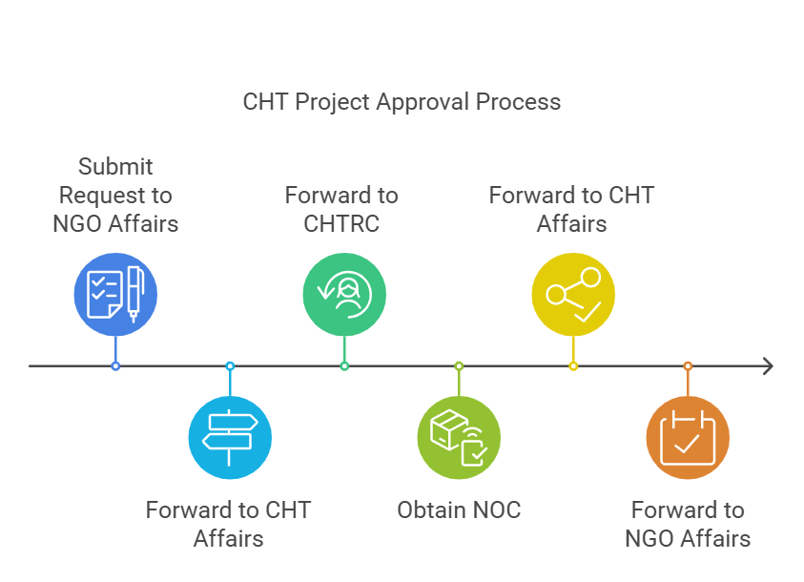

If already got Approval from NGO Affairs, then inform to respective authorities (CHTRC,HDC, DC, UzP)
4) NGO Bureau listed NGOs in Bandarban (attached the entire NGOs list in Bangladesh)
Sl. no | Name of NGOs | Address | Reg. No. | Reg. Date | Renewed on | Valid upto | District
1 | Balipara Nari Kallyan Samity (BNKS) | Ujanipara, Bandarban Sadar, Bandarban.  Phone: 0361-62944, 63179 | 1656 | 19-Aug-01 | 19-Aug-21 | 19-Aug-31 | Bandarban
2 | Chaindha Rakkhita Shishu Sadan | Sonaichari Marogapara, Naikhongchari, Bandarban Hill Tract District, Bandarban.  Phone: 01827-7262844 | 2118 | 06-Aug-06 | 06-Aug-21 | 05-Aug-31 | Bandarban
3 | Community Advancement Forum (CAF) | Ujanipara, PO Box: 05, Montu Babu Building (3rd floor), Bandarban- 4600, Bandarban,  Phone: 0361-63229 | 2022 | 29-Mar-05 | 29-Mar-15 | 29-Mar-25 | Bandarban
4 | ECO-Development | Vill: Uzanipara, Main Road, PO+PS: Bandarban Sadar, Dist: Bandarban.  Phone: 0361-63260 www.ecodevelopment.org | 2607 | 01-Nov-10 | 01-Nov-20 | 01-Nov-30 | Bandarban
5 | Grous (Gram Unnayan Sangathan) | Ujanipara, Bandarban Sadar, Dist.: Bandarban Parbatta District.  Phone: 0361-62104, Fax: 0361-62865 | 2144 | 09-Oct-06 | 09-Oct-21 | 08-Oct-31 | Bandarban
6 | Hanani Lantri | Uzanipara, Upazila: Bandarban, Dist: Bandarban. | 2597 | 26-Sep-10 | 26-Sep-15 | 26-Sep-25 | Bandarban
7 | HumanitarianFoundation | Shahbuddin Building (2nd Floor), College Road,Bandarban-4600  Phone: 0361-62797 www.hf_cht.org | 2116 | 30-Jul-06 | 30-Jul-21 | 30-Jul-31 | Bandarban
8 | Mro Chow Chen Chap Euong Ra Tia | Uzanipara, Bandarban  Phone: 0631-63580 | 0734 | 28-Jul-93 | 28-Jul-18 | 28-Jul-28 | Bandarban
9 | N.Z. Ekata Mohila Samiti | Chairmanpara, Lama, Bandarban.  Phone: 01727-628026 www.ekata-cht.org | 2083 | 19-Mar-06 | 19-Mar-21 | 18-Mar-31 | Bandarban
10 | Poverty Alleviation and Social DevelopmentOrganization (PAASDO) | Thana Road, Ali Kadam, Dist. Bandarban | 2050 | 21-Dec-05 | 21-Dec-10 | 21-Dec-15 | Bandarban
11 | Community DevelopmentConcern(CDC) | Ujani Para, PO & PS: Sadar,Bandarban  Phone: 01553209485 email:cdc@yahoo.com | 3292 | 16-May-22 |  | 15-May-32 | Bandarban
12 | Tahzingdong | Old Rajbari, VIP Road, 4 no Ward, Bandarban Municipality, Bandarban Hill District, Bandarban.  Phone: 01838487222 email: ed.tahzingdong@gmail.com | 3352 | 06-Apr-23 |  | 05-Apr-33 | Bandarban

5) Area coverage during the field visit
Information reviewed from secondary sources; the team visited nearby Upazila villages from the ongoing project area. Ghumdhum Union of Naikhyongchari and Fasiakhali Union of Lama Upazila where seven VCFs' current status were collected by conducting semi-structured group interviews with the villagers and KII.

6) Key observations and Findings
6.1 Geographical status and vegetation
SI | Name of the Indicators | 1 | 2 | 3 | 4 | 5 | 6 | 7
1 | Name of the VCF | Pattrajiri VCF | Garjanbonia VCF | Putte Mro para VCF | Mongjoy para VCF | Boroi Toli VCF | Gashbonia VCF | Bayesh Fari VCF
2 | Location | Gumdum, Nakyangchari, Bandarban | Gumdum, Nakyangchari, Bandarban | Fasiakhali, Lama, Bandarban | Gumdum, Nakyangchari, Bandarban | Gumdum, Nakyangchari, Bandarban | Gumdum, Nakyangchari, Bandarban | Gumdum, Nakyangchari, Bandarban
3 | Formation year of VCF | 2012 | 2003 | 2000 | 2000 | 2002 | 2000 | 2010
4 | Land area (Acre) | 50 Acre | 70 | 20 | 200 | 40 | 70 | 16
5 | Formation year of VCF management committee | 2012 | 2007 | - | 2017 | 2020 | 2017 | 2010
6 | VCF committee members (HH) | 52 | 30 | 25 | 90 | 100 | 50 | 65
7 | Distance from adjacent village (approximate Km) | 2 km to 2.5 km | 4 km to 4.5 km | 3 km to 3.5 km | 8 km to 9 km | 13 km to 14 km | 10 km to 11 km | 4 km to 5 km
8 | Direct & indirect benefits from VCF (HH) | 150 | 45 | 40 | 90 | 100 | 70 | 65
9 | VCF vegetation Type | Natural & Plantation | Natural | Plantation | Natural | Natural | Natural | Plantation and Natural
10 | Species name | Koroi, Jham, Garjan, Gamar, Champa, Bajja, Muli, Broom, Broom, Akashmoni, Banana, Mango etc. | Koroi, Jham, Garjan, Gamar, Champa, Ghun Goda, Badhi, Bajja, Muli, broom, Gutguttya, Dumur etc. | Akashmoni, Eukalyptus | sil koroi, sada Koroi, Jham, Garjan, Gamar, Champa, Ghun, Goda, Badhi, Bajja, Muli, Mitingya, dulu, sal, Gamar broom, Gutguttya, Dumur etc. | Koroi, Jham, Garjan, Gamar, Champa, Ghun, Goda, Badhi, Bajja, Muli, Mitingya, dulu, sal, Gamar broom, Gutguttya, Dumur etc. | Koroi, Jham, Garjan, Gamar, Champa, Ghun, Goda, Badhi, Bajja, Muli, Mitingya, dulu, sal, broom, Gutguttya, Dumur etc. | Koroi, Jham, Hargaza, Gamar, Champa, Ghun, Goda, Badhi, Bajja, Muli, Mitingya, farua, Dadhi, Dagaru, broom, Gutguttya, Dumur etc.
12 | Watershed Management | Yes | Yes | No | Yes | No | Yes | No
13 | Significant of VCF | Ground vegetation is moderate, availability of water in the dry season. | Virgin forest with higher number of ground vegetation, availability of water all over the year. | The land area is degraded by the community people, | Virgin forest with higher number of ground vegetation, availability of water all over the year, regular basis pettroling by community people. | Virgin forest with higher number of ground vegetation, a good source of water for local community, regular basis pettroling by community people. | Virgin forest with higher number of ground vegetation, availability of water all over the year, regular basis pettroling by community people. | Ground vegetation is moderate, availability of water in the dry season.

6.2 Generic management system of VCF
- VCFs are governed by a management committee, and the rules differ from para to para.
- Without prior permission of the management committee, access is restricted to the VCF.
- Every year, new plantation should be done in VCF by the consultation of members
- The committee decides on all aspects of VCF management (extraction, plantation, collection of forest resources, etc.).
7) Probable approach/pathway to implement project activities
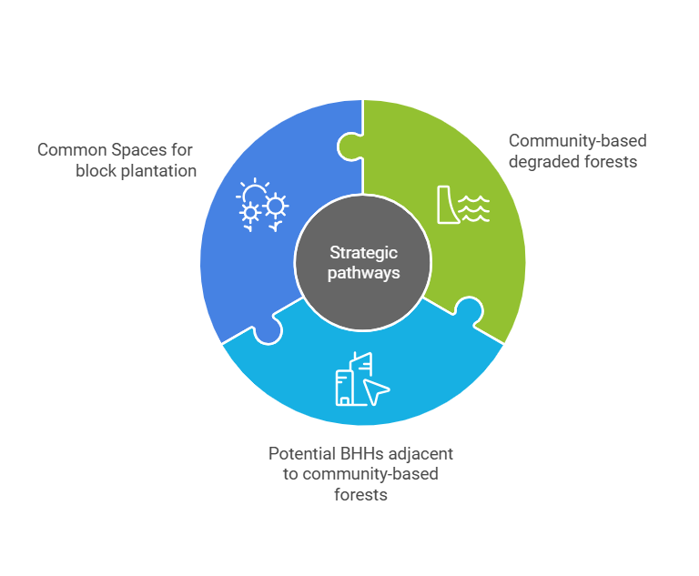
7.1 Working on community-based degraded forest: field experience and review of some articles also state that vegetation condition and tree diversity were better in NGO-supported VCFs compared with those without NGO intervention [5]. So, the B4CA project should consider those communities owning forests without NGO intervention to implement the project intervention that meets the project goals and outcome 1 indicator.
7.2 Potential BHHs adjacent to community-based forests: It was observed that the villages and inhabitants of the surrounding community-based forests have their own spaces where the project highlights the participants' interest in the intervention. In this approach, the project easily covered both BHHs and also degraded community-based forests in plantations.
7.3 Potential Common Spaces for block plantation (Jhiri, Khal, Graveyard, etc.)
8) Potential Site Selection process
Step-1: Union Consultation meeting to identify the potential common space for bamboo plantation following the B4CA matrix exercise
Step-2: Stakeholders/community consultation (from Indigenous community; Headmans, karbaris, Senior citizens, Indigenous Leaders, Youth youth representatives) following the matrix exercise
Step-3: Table exercise/shorting
Step-4: Transact work
Step 5: Finalize the potential sites
9) Probable intervention
- Bamboo Plantation
- Native tree species Plantation
- Training session on bamboo propagation and sustainability (day-long training)
- Livelihood enhancement (Distribution of seasonal vegetable seeds)
- Engage in entrepreneurship training or bamboo craft training
- Awareness program on climate change and adaptation (Youth-Para based) / Educational outreach
- Knowledge-sharing workshop
10) Budget (Budget prepared without operational cost; considering 7 VCFs)
Sl. no | Activity | Estimated Budget | Remarks
1 | Reconnaissance assessment | 40,000.00
2 | Watcher | 5,04,000.00 | 9 months
3 | Bamboo & Native tree species plantation (transportation, labor, and others cost) | 7,30,000.00 | 2000 nos. native and 20,000 bamboo seedlings
4 | Capacity Development | 5,25,000.00
5 | Knowledge sharing workshop | 1,50,000.00 | 2 Upazilas(30person/Upazila
6 | Livelihood Enhancement | 80,000.00
7 | Equipment Support | 30,000.00
8 | Visibility Board | 42,000.00 | 7 nos.
9 | Planning Excercise (PAPD+PLUS), | 2,00000.00 | 2 Upazilas
10 | Engage in entrepreneurship training or bamboo craft training | -- | Charged in activity 2.2.5 and from iDE part
Total |  | 23,01,000.00

11) Recommendation
- A nearby area from B4CA CS Nursery should be considered for the implementation of the programs and for overseeing the partners' intervention.
- Considering the limited time and resources, implement the outreach area activities in a union (ex. Ghumdum union is the most suitable area, and aligns with the project purpose, though the boundary line lies with Mayanmer and also with Ukhia subdistrict.
- Should avoid the monoculture plantation in degraded VCFs
- To maintain biodiversity and watershed management, need to provide other native species on a small scale
- Allocate a significant amount of funds for plantation operations (labor, transportation, and others cost) because of the presence of VCFs far from the para and also not available connecting road.
- Need to consult with existing VCF’s members regarding the intervention for common understanding and assessing the species needed
- Need a special concern at the south-east borderline areas for having an unstable incident of a neighboring country (particularly Ghumdhum & Duchori Union)

Annex
1) NGO List
2) Circular (Prime Minister's office; memo no: 03.070.022.03.00.013.2010-90(500); date: April 12, 2012)
3) Circular (Prime Minister’s Office; memo no: 33.43.27.00.00.01.2000-107; date:July 29, 2001)
3) Budget exercise Copy

References
1) Misbahuzzaman, K.; Smith-Hall, C. Role of forest income in rural household livelihoods: The case of village common forest communities in the Chittagong Hill Tracts, Bangladesh. Small-Scale For. 2015, 14, 315–330.
2) Thapa, G.B.; Rasul, G. Implications of changing national policies on land use in the Chittagong Hill Tracts of Bangladesh. J. Environ. Manag. 2006, 81, 441–453.
3) Salam, M.A.; Noguchi, T.; Koike, M. The causes of forest cover loss in the hill forests in Bangladesh. GeoJournal 1999, 47, 539–549
4) Chowdhury, M.A.; Zahra, F.T.; Rahman, M.F.; Islam, K. Village Common Forest Management in Komolchori, Chittagong Hill Tracts, Bangladesh: An example of community-based natural resources management. Small-Scale For. 2018, 17, 535–553.
5) Bari, M. S., Ali, M. M., Alam, M. J., Bashir, M. A., Sarkar, O. T., & Mukul, S. A. (2024). Forest Restoration through Village Common Forests in the Chittagong Hill Tracts of Bangladesh: The Role of NGO Interventions. Sustainability, 16(19), 8490.

