Telehealth Effect on Show Rate in Neonatology Follow Up Clinic
A dummy model

BY

PHORNPHAT RASAMIMARI
M.D., Phramongkutklao College of Medicine, Mahidol University, 1984
M.P.H., University of Illinois at Chicago, Chicago, 2021

THESIS

Submitted as partial fulfillment of the requirements
for the degree of Master of Sciences in Clinical Translational Sciences
in the Graduate College of the
University of Illinois at Chicago, 2025

Chicago, Illinois

Defense Committee:
Lisa Powell, Chair and Advisor
Martin Molly, Associate Head of Research, Department of Pediatrics
Kari Gali, Graduate Medical School
Susan Vonderheid, Director of nursing research at UI health

ACKNOWLEDGMENTS

I would like to thank my thesis committee, Dr. Lisa Powell, Dr. Martin Molly, Dr. Kari Gali and Dr. Susan Vonderheid, for their unwavering support and assistance. Their guidance in all areas helped me accomplish my research goals and enjoy the process. I would also like to acknowledge my former advisor, Dr. Thomas Leger, who oversaw the development of the proposal and made significant contributions to the initiation of this project. Additionally, I would like to thank my librarian, Rebecca Raszewski, for helping me search for article reviews.

TABLE OF CONTENTS
CHAPTER PAGE
I. INTRODUCTION………………………………………………………………
- Background and Statement Purposes………………………………………..
- Research Questions………………………………………………………….
- Objectives……………………………………………………………………
- Specific Aim…………………………………………………………………

II. METHODOLOGY………………………………………………………………
- The details of the methods…………………………………………………..
- A Valid Instrumental Variable………………………………………………
- Methodology Challenges……………………………………………………
- Ethical considerations……………………………………………………….
III. RESULTS……………………………………………………………………….
IV. DISCUSSION……………………………………………………………………
V. LIMITATION……………………………………………………………………
VI. CONCLUSION………………………………………………………………….

APPENDICES…………………………………………………………………..
Appendix A: Tables…………………………………………………….
Appendix B: Figures……………………………………………………
REFERENCES…………………………………………………………………
VITA……………………………………………………………………………

LIST OF TABLES

TABLE PAGE
- THE DIFFERENCES BETWEEN THE TRUE EXPERIMENTAL
AND THE QUASI-EXPERIMENTAL DESIGNS………………………………..

- THE VISIT WORKFLOW AT NEONATOLOGY FOLLOW-UP CLINIC……...

- DEMOGRAPHIC DATA
III-a. DEMOGRAPHIC SUMMARY OF CONTINUOUS VARIABLES…………
III-b. DEMOGRAPHIC SUMMARY OF CATEGORICAL VARIABLES……….

- THE RESULT OF THE TWO-STAGE LEAST REGRESSION
IV-a. THE ASSOCIATION BETWEEN PAMPHLET AND TELEHEALTH……..
IV-b. THE ASSOCIATION BETWEEN PAMPHLET AND NO-SHOW RATE….
IV-c. THE ASSOCIATION BETWEEN PREDICTED TELEHEALTH AND
NO-SHOW RATE……………………………………………………………………

- THE CORRELATION BETWEEN ALL PREDICTOR VARIABLES AND
NO-SHOW RATE ANALYZED USING BIVARIATE PROBIT REGRESSION…..

- THE MAGNITUDE IMPACT OF THREE SIGNIFICANTLY RISK
FACTORS ON NO-SHOW RATE……………………………………………………

LIST OF FIGURES

FIGURE PAGE
- Framework diagram of assumptions of a valid instrumental variable…….
- Pamphlet
2A. Pamphlet in English Version…………………………………………
2B. Pamphlet in Spanish Version………………………………………...

LIST OF ABBREVIATIONS

ASQ The Ages and Stages Questionnaire
CA Corrected Age: The age of a premature baby adjusted to accurately reflect their early delivery. This is calculated by taking the chronological age and subtracting the number of weeks of prematurity (gestational age at birth subtracted from 40 weeks).
CITI Collaborative Institutional Training Initiative
DCFS Department of Child and Family Service
GMA Gross Motor Assessment
NICU Neonatal Intensive Care Unit
PBQ Post Partum Bonding Questionnaire
PMA Post menstrual age: The age of a premature baby calculated by adding the gestational age at birth to the postnatal age until 40 weeks.
SCN Special Care Nursery
TIMP Test of Infant Motor Performance
UI health University of Illinois Hospital & Health Sciences System
UIC University of Illinois at Chicago

LIST OF LEGENDS OF ALL VARIABLES IN THIS STUDY

tvisit telehealth visit
novisit1 no-show
pamphlet pamphlet
ga gestational age at birth
bw birth weight
gender_f female gender
stays total days of hospital stays
nconfirmed1 the appointment not confirmed after sending or calling as a reminder prior to the first visit
tappt total scheduled appointments at the time of discharge
distance distance in miles from the house to the clinics
pworking whether both parents working 2 months prior to visit
mworking whether mother working 2 months prior to visit
smom single mom
daycare current daycare use
household how many people living in the same household
firstchild first child in the family

SUMMARY

This study examines the effects of telehealth on reducing no-show rates in a neonatology follow-up clinic using a randomized quasi-experimental design. The goal is to lower no-show rates from 25% to 15%, leveraging a telehealth pamphlet as an instrumental variable. Data were gathered from 650 subjects across three visits. Findings revealed a significant rise in telehealth participation and a corresponding decline in no-show rates, demonstrating the potential of telehealth to improve healthcare accessibility and outcomes for infants and their families.

I. INTRODUCTION
A. Background and Statement Purposes
Telehealth, also known as telemedicine, encompasses a variety of tools and platforms that enable clinicians to connect remotely with each other and with patients. It has gained popularity in public healthcare in recent years. The top reported uses of telehealth in pediatrics include critical care, neonatology, psychiatry, cardiology, physiotherapy, and neurology. Numerous reports on telehealth in neonatology services have shown that telehealth is either superior to or as effective as routine practice or in-person visit. As shown in recent reports, Hoffman (Hoffman et al., 2019) summarized the successful use of real-time telemedicine visits with a midlevel clinician after NICU discharge. Mobbs (Mobbs et al., 2022) found that remote post-discharge physiotherapy is beneficial for the ex-preterm infant and their family.
Most studies, including the most recent ones (DeMauro et al., 2021; Drerup et al., 2021; Siow et al., 2020) were conducted as natural events or as observational designs likely because telehealth option cannot easily be manipulable in the real life settings. Moreover, some authors, such as Cooper in 2009 (Cooper et al., 2009) have raised concerns about the lack of external validity in randomized controlled trials, which are generally considered the gold standard in scientific research. Despite of that, few clinical studies have been conducted using randomized controlled trials (Finn & Achilles, 1990; Gray, 2000; Krueger, 1999; Mobbs et al., 2022), but none have focused on the neonatology follow up clinic. As mentioned above, the studies on telehealth interventions have demonstrated either internal validity or external validity, but not both in the same study. Therefore, there is a chance that findings from such studies cannot be generalized to the community, which represents a real-world setting that cannot be well-controlled. Fostering internal change in individuals is more efficient and sustainable than imposing change upon them. Therefore, a quasi-experimental design is the most promising approach. Such a study would enhance the external validity of telehealth by grounding it in an understanding of the real-life conditions driving the effect of telehealth in the community. Moreover, none of the previous studies occurred in a neonatology follow up clinic. As such, we plan to conduct the first randomized quasi-experimental study on the effect of telehealth in the UI Health neonatology follow-up clinic. To enhance the internal validity of the study, we will introduce an instrumental variable.
Digging deeper into instrumental variable, using a pamphlet as an instrumental variable can help control selection bias, unmeasured confounding and measurement error, leading to more reliable and unbiased estimates of the causal effect of telehealth on no-show rates. This approach is supported by the principles of IV analysis, which aim to exploit natural or quasi-random variation to infer causality in uncontrollable exposure variable studies(Yeob Choi et al., 2020).
For this reason, we will use a pamphlet as both an instrumental variable and a persuasive tool to compare telehealth visits to in-person visits regarding no-show rates at 12 months’ corrected age. We predict that the outcome of this study will pinpoint the benefits and generalizability of telehealth visits within our community healthcare network. Simultaneously, it can serve as a quality improvement tool for our institute’s clinical services and help to identify additional benefits to patient outcomes.

B. Research question
Despite voluntary enrollment treatment by not controlling telehealth as our independent variable of interest, are there still the positive impact or benefit of telehealth on health care in our neonatology follow up clinic?
C. Objectives
To examine the extent to which telehealth visits can reduce no show rates. In turn, as part of a larger study we then will aim to investigate the impact of this on patient outcomes
D. Specific aim
To determine whether telehealth visits for neonatal follow-up care at UI health are associated with lower no-show rates at 12 month corrected age from 25% to 15%.
Telemedicine, as known as telehealth, is one of communication tools that connects one health provider to another provider or to the patients. For the patients, it increases care accessibility and reduces travel burden and time constraints leading to decrease in no-show rate. Despite those supports, telehealth which was first established in late 19th century was not well accepted until the Covid19 pandemic occurs causing the limits in physical contact and need for social distancing. Since then, it has automatically become a popular communication tool in health care.
In pediatric medicine, the current top 5 reported uses of telehealth are critical care, neonatology, psychiatry, cardiology, physiotherapy, and neurology (Hoffman et al., 2019; Mobbs et al., 2022). Gray (Gray, 2000) found that in NICU setting, of the 176 very low birth weight (VLBW) infants admitted during the study period, 30 control and 26 study patients were enrolled. Families of the intervention group infants were given access to the Baby CareLink telemedicine application. Families in the CareLink group reported significantly fewer problems with the overall quality of care received by their family (mean problem score: 3% vs 13%). In addition, CareLink families also reported greater satisfaction with the unit’s physical environment and visitation policies (mean problem score: 13% vs 50%). Among infants born weighing less than 1000 grams (n=31), there was a tendency toward shorter lengths of stay (77.4 vs 93.1 days). All infants in the CareLink group were discharged directly to home, whereas 6 out of 30 (20%) control infants were transferred to community hospitals before ultimately being discharged home. In the study conducted by Robinson(Charlotta Robinson et al., 2016), families were randomized to either a control group receiving standard home health care (n=42) or a telemedicine group receiving home health care with telemedicine support (n= 47) after discharge from the hospital. Both groups had follow-up hospital appointments with the neonatal nurse. In the telemedicine group, appointments were supplemented by the use of specially designed web pages and video calls. The author found that the use of the web page and video calls significantly decreased the number of emergency visits to the hospital (p=0.047). In addition, CareLink families also reported greater satisfaction with the unit’s physical environment and visitation policies (mean problem score: 13% vs 50%).
In an adult outpatient setting, Drerup(Drerup et al., 2021) conducted a prospective cohort study during the COVID-19 pandemic, between March and May 2020. The author found that the no-show rate of telehealth visits during this period was 7.5% (14/186), significantly lower than the no-show rate of 36.1% for in-person visits (56/155) (p<0.0001) and the pre-pandemic in-person no-show rate of 29.8% (129/433) (p<0.0001). The study concluded that telehealth offers significant benefits for both patients and providers, strongly supporting its widespread utilization during and after the pandemic. Based on the existing scientific evidence in both adult and pediatric populations, telehealth helps providers maintain continuity care, improve quality of care and patient care satisfaction.
A variety of research methodologies have been used to study the effects of telehealth on healthcare including case-control studies with historical data(Siow et al., 2020), prospective cohort studies (Drerup et al., 2021) and randomized controlled trials (Gray, 2000; Mobbs et al., 2022; C. Robinson et al., 2016) However, none of these studies employed a pragmatic design like a quasi-experimental approach. The question remains whether existing studies provide sufficient evidence to support telehealth as a practical and sustainable tool in healthcare. In one of the randomized trials conducted by Cooper (Cooper et al., 2009), the efficacy of an intervention designed to improve the mother-infant relationship and security of infant attachment was assessed in a South African peri-urban settlement with marked adverse socioeconomic circumstances. The study involved 449 pregnant women, with drop-off rate of 25%. The findings indicated that mothers in the intervention group were significantly more sensitive (6 months: mean difference=0.77 (SD 0.37), t=2.10, P<0.05, d=0.24; 12 months: mean difference=0.42 (0.18), t=-2.04 , P<0.05, d=0.26) and less intrusive (6 months: mean difference=0.68 (0.36), t=2.28, P<0.05, d=0.26; 12 months: mean difference=-1.76 (0.86), t=2.28 , P<0.05, d=0.24) in their interactions with their infants. Additionally, the intervention was also associated with a higher rate of secure infant attachments at 18 months (116/156 (74%) v 102/162 (63%); Wald=4.74, odds ratio=1.70, P<0.05). Despite the significant favorable results, the authors expressed concerns about the persistence and replicability of these effects. This demonstrates that while randomized controlled trials are considered the gold standard in scientific research, they can sometimes lack realism due to uncontrollable independent variables in real-world settings. The differences between the true experimental and the quasi-experimental design are well acknowledged as shown in Table I. A well-known naturistic design, the quasi-experimental study with a randomized instrumental variable, might offer the ideal solution, as detailed in framework diagram and analytic strategy as shown in Figure 1.
No show rates in outpatient clinics have been a major ongoing problem in public health, particularly in our neonatal follow-up clinic. Currently, the no-show rate of our clinic is approximately 25%, significantly higher than the international benchmark for outpatient clinics which is 5-10% (Gupta & Denton, 2008; Mohamed et al., 2016; Molfenter, 2013). Many experts from centers with higher rates have attempted various quality improvement initiatives (Gajwani, 2014; Johnson et al., 2007; Tang et al., 2018) but telehealth has rarely been used as a measure. As shown in recent reports, Shour(Shour et al., 2023) conducted a retrospective study on 1,260,083 appointment from 263,464 patients from the Marshfield Clinic Health System and developed a predictive model based on administrative data that didn’t include telehealth. His new model effectively distinguished between show and no-show appointments with high accuracy, recommending one overbook every six at-risk appointments. Additionally, it advised overbooking appointment slots on days with an elevated risk of no-show. Malloy(Malloy et al., 2023) conducted a retrospective chart review on 10,078 total encounters in pediatric orthopedic and found that significant predictors of no-show rate included race, insurance type and lag days between appointment scheduling completion. To improve appointment adherence, the author recommended individualizing patient care plans and appointments based on specific socioeconomic data, but didn’t include telehealth as an option.
During the COVID-19 pandemic, we introduced telehealth as an optional visit method, resulting in a promising decrease in our no-show rate from 35% pre-pandemic to 25% post-pandemic. At that time, we utilized Gross Motor Assessment (GMA), which has high sensitivity and specificity for early detection of cerebral palsy (Razak et al., 2024; Støen et al., 2019) and can be performed remotely. This result encouraged us to conduct a quasi-experimental study on the effect of telehealth on no-show rate, an area that has not yet been thoroughly explored. Our goal is to bridge the knowledge gap and demonstrate that telehealth can significantly reduce no-show rates in an uncontrolled setting.
To address potential weaknesses in this design and assess causal effects given imperfect compliance and voluntary enrollment, we will use a pamphlet as an instrumental variable, shown in Figure 1, and randomize its distribution to mimic a randomized clinical trial. The pamphlet will contain information about the benefits of telehealth, what to expect during a telehealth visit, and preparation tips. It will be written in English and in Spanish as shown in Figure 2A and 2B, respectively. We anticipate that the pamphlet will mitigate endogenous variables and help us determine the direct effect of telehealth on no-show rates, as illustrated in Figure 1.
We will examine the percentage of no-show rates and compare them between their telehealth and in person visits at each appointment until 12 to 13 months corrected the age using STATA program to analyze the data. We hope that telehealth visits can significantly reduce no-show rates and promote Health Equity by equalizing access to health care. We plan to use our data for future and analysis to explore the potential positive effects on parental compliance and long-term patient outcomes. Additionally, we will continue conducting studies, including quality improvement initiatives on telehealth, to ensure its sustainability and generalizability. Our goal is to maximize the benefits of telehealth for our institute and community we serve.
II. METHODOLOGY
A. The details of the methods
This study employed a randomized quasi-experimental design using an instrumental variable. The research was conducted at the Neonatology follow-up clinic at UI Health. Participants were recruited based on specific inclusion and exclusion criteria. The inclusion criteria encompassed infants admitted to the NICU/SCN with hospital stays of 14 days or longer, whose biological mothers could care for them after discharge. Exclusion criteria included mothers with psychiatric problems requiring medication, open DCFS cases, and lack of internet connectivity or digital literacy.
Participants were randomized into two groups using computer- generated block randomization using variable block sizes of 4. One group received a telehealth pamphlet before discharge, while the other did not. The group with the pamphlet could choose to follow up either in-person or via telehealth, while the other group could choose in-person or telephone follow-ups. The study included three follow-up visits at around 2-3 months, 6 months, and 12 months corrected age following our visit workflow at neonatology follow up clinic as shown in Table II. During these visits, medical evaluations and various assessments were performed, including the Gross Motor Assessment (GMA), Ages and Stages Questionnaire (ASQ), and Post Partum Bonding Questionnaire (PBQ). We also look at the following measures: gender, hospital stays, total appointment, mother or parent working status, being single mom, need for day care, number of persons in household and having first child. However, due to time and stuff constraints, and for thesis defense, we created dummy data for the first visit only.
The study aimed to measure outcomes such as growth, neurodevelopmental outcomes, and parental satisfaction. Of those, our primary outcome is no-show rate. Data collection and statistical analysis were conducted using the STATA program. The sample size, accounting for a 20% loss to follow-up, was calculated and rounded up to 650 subjects, with 325 in each group.
Safety measures were in place to ensure urgent medical attention if needed. The statistical analysis used for our study including t-test and chi-square test for demographic characteristics, both ordinary least squares regression and two-stage least squares regression as our key analysis of study, bivariate probit regression for the correlation analysis of general predictors of attending visit, and logistic regression for the analysis of the selected significant risk factors.
B. A valid instrumental variable
For the 2SLS method to yield valid results as shown in Figure I, we need to follow the assumptions of valid instrumental variable as below:
1. Relevance: The instrumental variable Z is correlated with the potentially endogenous variable X, which in our study is the telehealth (1).
2. Exogeneity: Z is unrelated to the error term in the second-stage equation, ensuring it doesn't directly affect Y, which in our study is the no-show rate (2).
The first stage condition is to show that an instrumental variable (Zi) is correlated with the actual treatment or variable of interest (Ti) but is not correlated to the outcome to interest (Yi). This predicted model has been cleaned off endogenous/confounding factors (1).
To show that an instrumental variable (Zi) is correlated with the actual treatment or variable of interest (Ti) as the following equation.
X̅ = β₀+ β₁Z_{i} + β_{n}X_{n} + ε_{i} (1)
To show that an instrumental variable (Ti) is not correlated to the outcome to interest (Yi) as the following equation.
Yi = β₀+ β₁Z_{i} + β_{n}X_{n} + ε_{i} (2)
In second stage in 2SLS, we are using predicted telehealth (X̅) as the following equation.
Y_{i} = β₀+ β₁ X̅_{i} + β_{n}X_{n} + ε_{i} (3)
(X=telehealth; X̅ = predicted telehealth; Z=pamphlet as an instrumental variable; Y= no show rate; Xn = covariances; ε =unobserved variables)
C. Methodology challenges
The study population primarily consisted of subjects from an urban community, with the majority identifying as African American and Hispanic American. This demographic focus introduces a potential selection bias, as the findings may not be fully generalizable to other populations, such as rural or suburban communities, or those with different ethnic compositions. These limitations should be considered when interpreting the results and drawing broader conclusions.
Additionally, a loss of follow up rate of approximately 20% is anticipated, which could affect the study's validity and reliability. The attrition of participants may introduce additional bias, particularly if those who discontinue participation differ systematically from those who remain in this study. Efforts to minimize this loss and account for its impact are crucial to ensuring the robustness of the study’s outcomes.
D. Ethical considerations
There is no IRB approval due to a dummy model.
III. RESULTS
In our study, we examined the demographic data of participants as shown in Table III-a and III-b, dividing them into two groups: telehealth users and in-person attendees. We found no significant difference in gestational age (GA) between the groups, with averages of 31.73 weeks (SD ± 4.29) for telehealth and 32.15 weeks (SD ± 3.95) for in-person (p = 0.18). However, birth weight (BW) was significantly lower in the telehealth group, averaging 2,358 grams (SD ± 747) compared to 2,473 grams (SD ± 685) in the in-person group (p = 0.04). Both groups had a median hospital stay of 102 days (p = 0.33), indicating hospitalization duration did not influence the choice of follow-up method.
Telehealth participants lived farther from the clinic, averaging 16.83 miles (SD ± 10.14) versus 7.08 miles (SD ± 4.35) for in-person attendees (p < 0.001), highlighting potential travel challenges for follow-up care. Gender distribution, parental employment status, single motherhood, daycare usage, and whether the infant was the first child showed no significant differences between the groups, suggesting these factors do not influence the choice between telehealth and in-person follow-up.
As shown in Table IV-a, the first stage of the Two-Stage Least Square Regression (2SLS) analysis highlights significant factors influencing the preference for telehealth over in-person visits. A key finding is the strong positive relationship between the pamphlet and telehealth, establishing it as a strong instrumental variable in the statistical model. Additionally, there is a strong positive relationship between the distance to healthcare facilities and telehealth utilization. For every additional mile from the clinic, the likelihood of choosing telehealth increases (coefficient: 0.0249, t-value: 14.45, p < 0.001), validating the hypothesis that greater travel distances act as barriers to in-person care while enhancing telehealth's appeal. This underscores the importance of telehealth in improving accessibility, particularly for families in rural or underserved areas. Moreover, we found that family structure and experience do not drive care mode preferences based on socio-economic factors like parental employment status (p = 0.087) and single motherhood (p = 0.273) were not significant predictors of telehealth adoption, household size (p = 0.99 ) and first-child (p = 0.794).
As shown in Table IV-b, the regression analysis reconfirmed the validity of the pamphlet as a good instrumental variable by proving it is not associated with the no-show rate. The results revealed that the coefficient for the pamphlet variable was -0.0123, which was not statistically significant (p = 0.714). As we expected, the telehealth visit was a critical factor to decrease no-show rate, with a coefficient of -0.2778 (p <0.001). Additionally, we found that first child status significantly decreases no-show rate, with a coefficient of -0.0694 (p = 0.023). Contrarily, being a single mother significant increases no-show rate, with a coefficient of 0.3502 (p < 0.001).
As shown in Table IV-c. The second stage of Two-Stage Least Square Regression (2SLS) analysis shows a significant negative correlation between telehealth visits and no-show rates, with a coefficient of -0.3119 (p < 0.001). This reinforces the hypothesis that telehealth interventions play a crucial role in reducing missed appointments in neonatology follow-up care. This finding highlights the necessity for healthcare facilities to explore and expand telehealth services as a viable alternative to traditional in-person visits, especially for families facing logistical challenges. Additionally, the results reaffirm the importance of understanding demographics and social determinants of health in telehealth utilization. The consistent significance of the single mother variable (smom) to increase no-show rate, with a coefficient of 0.3489 (p < 0.001); contrarily, first-child status remains a significant predictor to decrease no-show rate, with a coefficient of -0.0691 (p = 0.022). This suggests that targeted educational initiatives for new parents and social support for single mother could promote engagement and adherence to follow-up appointments.
To provide a clearer picture, we conduct another two analyses. The first one is the bivariate probit regression by using no-show rate and telehealth as dependent variables as shown in Table V. It reveals that Socioeconomic and demographic factors, such as maternal employment status and the presence of a stay-at-home mom, significantly impact patient attendance. The positive coefficient for single mother (1.14, p=<0.001) indicates that children with stay-at-home mothers are more likely to attend follow-up. Distance has significantly a dual effect by decreasing no-show rate (-0.02, p= 0.007), and increasing telehealth visit (0.11, p=<0.001). The pamphlet intervention also plays a dual role in patient; it reduces missed appointments engagement (-0.44, p= <0.001) and increases the likelihood of telehealth (1.27, p= <0.001). First-time parents, indicated by the significantly negative coefficient (-0.28, p= 0.02) are more likely to attend follow-up appointments. The correlation coefficient (rho) of -0.604 and 95% confidence interval between -0.72372 and -0.44963 indicates that unobservable factors influencing no-shows also affect attendance, emphasizing the need for integrated interventions.
The second analysis is the logistic regression by using only three significant risk factors identified in the study as shown in Table VI. The unadjusted analysis reveals that they significantly influence the odds of no-showing for follow-up appointments. Firstly, single mothers have nearly nine times the odds of missing appointments compared to their counterparts. Secondly, each telehealth visit is associated with an 85.3% reduction in the odds of missing future appointments. Lastly, having the first child significantly impacts appointment adherence. Families with their first child are about 38.3% less likely to miss follow-up appointments compared to families with subsequent children.
IV. DISCUSSION
Our study is the first quasi-experimental with instrumental variable to provide valuable insights into the factors influencing the no-show rate in healthcare appointments. We have found that the demographic data reveals significant differences in birth weight and distance to the healthcare facility between the telehealth and in-person groups. Specifically, the telehealth group has a lower mean birth weight and a greater mean distance to the healthcare facility compared to the in-person group. The rest of demographic data is not significant. This highlights potential travel and financial challenges for in person follow-up care. This information of our study echoes the findings of the retrospective cohort study conducted by Lakshmanan who identified that maternal education, race, and distance from the clinic were associated with follow-up visit attendance among very low birthweight infants, with greater distances correlating with lower attendance rates, underscoring the travel challenges faced by these families with RR, 0.92; 95% CI, 0.89-0.97. (Lakshmanan et al., 2022) Regarding birth weight, the prospective case control study conducted in Korea by Kim et al (Kim et al., 2018) found that birth weight has significantly affect to show rate with mean ± SD between showing group and no-showing group of 1093.76 ±270.31grams, 1158.56 ±245.29 grams, respectively with p<0.001. They explained that the smaller the patients were, the longer the parents had to stay and established the better attachment to the medical team leading increased follow up visit. However, the majority of our patients might come from socioeconomically disadvantaged backgrounds, probably leading the infants with lower birth weight and lack of support or availability for the in-person visit causing the difference from Kim’s study(Kim et al., 2018).
As shown in the first-stage regression analysis, it identifies two significant predictors of telehealth utilization: pamphlet interventions and distance to healthcare facilities. Pamphlet, which provides essential information on telehealth benefits and logistics, significantly increases patient engagement with telehealth services. This finding highlights the critical role of well-designed informational resources in shaping healthcare behaviors. This study aligns with the repeated-measures study conducted by Mc Cohon (McCahon et al., 2023). This author demonstrated that optimizing patient educational materials significantly improved parent understanding of retinopathy of prematurity (ROP) and increased follow-up attendance rates with a significantly improved rate from pre-study baseline among the new materials group (80.0% vs 68.2%, [P = 0.008). Like demographic data in this study, it has redemonstrated the positive correlation between greater distance to healthcare facilities and higher telehealth usage underscoring its potential to overcome access barriers like travel difficulties.
In the second-stage regression, this study has found that a negative relationship between telehealth visits and no-show rates redemonstrates telehealth’s effectiveness in reducing missed appointments in neonatology follow-up clinics at UI Health. By addressing logistical barriers, telehealth promotes better patient adherence, continuity of care, and improved outcomes for vulnerable neonatal populations. Additionally, the consistent significance of having first child in reducing no show rates indicates that the first-time parents are usually highly motivated to ensure their child's health and well-being. They are more likely to prioritize and attend appointments to ensure their baby is developing properly. This study doubles down the randomized control trial conducted in US by Miller et al. The authors found that first-time mothers had higher levels of program attendance in the Video Interaction Project (VIP), a primary preventive intervention delivered during pediatric well-child visits with VIP attendance was significantly higher among first time mothers (IRR = 1.06, p < 0.001). (Miller et al., 2020) This emphasizes that first-time mothers are particularly motivated to attend health-related appointments for their children. Additionally, this regression has shown that single mothers, who are more likely to face economic insecurity, time constraints, and a lack of support, significantly increases the no-show rate, highlighting the need for healthcare providers to consider their unique challenges. It echoes the prospective two-phase multi-site descriptive cohort study conducted in Canada by Ballantyne. This study utilized Andersen's Behavioral Model of Health Services Use and identified that single mothers, among other factors, were at higher risk of non-attendance (Ballantyne et al., 2014).
In the bivariate probit regression in this study indicates that unobservable factors influencing no-show rate, as shown by the correlation coefficient (rho) of -0.604 and significantly different from zero at the 95% confidence interval between -0.72372 and -0.44963, and by the discrepancy in the significant result of distance. It echoes the previous case study conducted in Italy by Ieva et al (Ieva et al., 2014). The authors highlighted the use of bivariate probit models in addressing unobservable factors. It emphasizes the need for 2 SLS, which can be used to correct endogeneity and improve the robustness of the findings, reinforcing the credibility of the conclusions regarding telehealth's impact on no-show rates. Telehealth engagements significantly increase the likelihood of visit attendance, highlighting its potential to enhance accessibility in healthcare delivery.
The odds ratios in this study provide deeper insights into factors influencing no-show rates. As shown in the analysis, single mother is eight times more likely to not showing at the follow up visit. Conversely, telehealth visits and having first child substantially lower the likelihood of no-show rate, confirming the value of virtual options for improving follow-up attendance. The results of this analysis emphasize the varying magnitude of these three variables to no-show rate. Targeted interventions, such as a comprehensive approach that includes providing financial support, flexible scheduling, and robust social services to help single mothers manage their responsibilities and access the care they need, educational resources and support networks, could help to reduce these barriers and improve follow up visits.
V. LIMITATION
This study has several limitations that should be acknowledged. Firstly, the study employs a dummy model, which may not fully capture the complexities of real-world scenarios. Secondly Additionally, the study was conducted in an urban area, and the majority of subjects at our center are Spanish-speaking, Black, and Medicaid-insured individuals. This demographic may not represent the entire population of the country, potentially affecting the external validity of the results. Therefore, caution should be exercised when extrapolating these findings to broader, more diverse populations.
VI. CONCLUSION
In summary, this novel quasi-experimental study’s outcome demonstrates that telehealth can be used effectively and efficiently to achieve higher rates of first-time and return outpatient visits, even in non-controllable environments such as community settings. It supports the integration of pamphlets to improve telehealth use as a core strategy in neonatology follow-up care. By bridging access gaps and accommodating patient realities, telehealth fosters inclusive healthcare delivery and strengthens engagement. By reducing logistical barriers and fostering patient-centric strategies, telehealth not only addresses no-show rates but also enhances overall healthcare delivery. Its integration into routine neonatal follow-up care is vital for improving accessibility, continuity, and quality of care for families such as single mothers facing traditional healthcare challenges. Perhaps, pamphlet-enhanced telehealth visits might be one of the keys to success in the mission of public health: ensuring good access and quality of healthcare for everyone.
Future research should examine the interplay between parental involvement, healthcare accessibility, and telehealth engagement in reducing no-show rates and improving patient satisfaction. Investigating how educational interventions influence patient behavior over time will be key to developing effective, family-centered strategies. Longitudinal studies could further explore the optimal timing and frequency of telehealth communications to refine these approaches. Lastly, transforming this study into a quality improvement initiative could enhance outpatient services and advance patient care outcomes.

APPENDIX A
TABLES

TABLE I
THE DIFFERENCES BETWEEN THE TRUE EXPERIMENTAL AND THE QUASI-EXPERIMENTAL DESIGNS
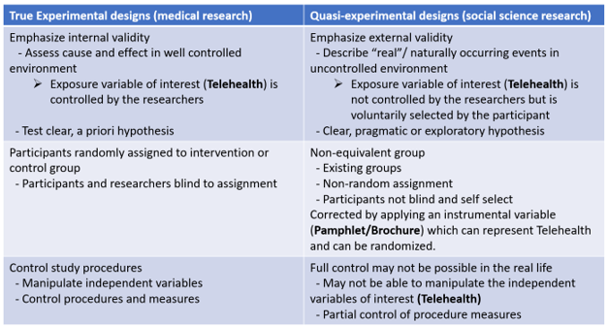

TABLE II
VISIT WORKFLOW AT NEONATOLOGY FOLLOW UP CLINIC
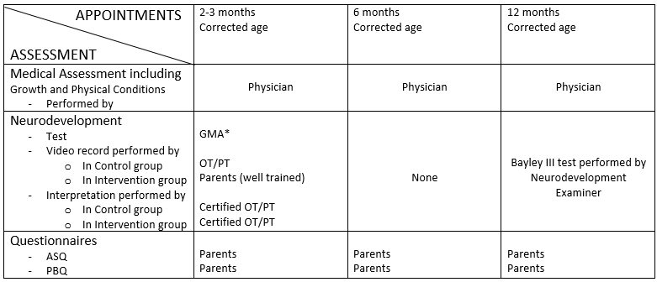
*Require 3-minute videorecording on infant’s spontaneous movement (Kwong et al., 2022; Paris et al., 2023)

TABLE III-a
DEMOGRAPHIC SUMMARY OF CONTINUOUS VARIABLES
Demographic | Telehealth | In person | p value
GAª | 31.73 (4.29) | 32.15 (3.95) | 0.18
BWª | 2358 (747) | 2473 (685) | 0.04
Stay^{b} | 102 (5-199) | 102 (8-196) | 0.33
TAPPT^{b} | 4 (2-6) | 4 (2-6) | 0.14
Distanceª | 16.83 (10.14) | 7.08 (4.35) | <0.001
Household^{b} | 4 (2-8) | 4 (2-8) | 0.99

TABLE III-b
DEMOGRAPHIC SUMMARY OF CATEGORICAL VARIABLES
Demographic | Telehealth | In person | p value
Gender |  |  | 0.935
-Female | 158/314 | 168/336
-Male | 156 /314 | 168/336
Not confirmed1 | 27/314 | 45/336 | 0.052
Parent working | 166/314 | 174/336 | 0.783
Mom working | 158/314 | 170/336 | 0.944
Single mom | 96/314 | 114/336 | 0.361
Daycare | 152/314 | 154/336 | 0.33
First child | 170/314 | 183/336 | 0.934

TABLE IV-a
THE ASSOCIATION BETWEEN PAMPHLET AND TELEHEALTH
Source | SS | df | MS | Number of obs | =650
 |  |  |  | F(14, 635) | =33.15
Model | 68.54313 | 14 | 4.89593801 | Prob > F | =0
Residual | 93.77071 | 635 | 0.147670416 | R-squared | =0.4223
 |  |  |  | Adj R-squared | =0.4096
Total | 162.3138 | 649 | 0.250098376 | Root MSE | =0.38428

tvisit1 | Coefficient | Std. err. | t | P>t | (95% confidence interval)
pamphlet | 0.3600721 | 0.031439 | 11.45 | 0 | 0.2983351, 0.4218092
ga | 0.0002569 | 0.0076866 | 0.03 | 0.973 | -0.0148372, 0.0153511
bw | -0.0000365 | 0.0000417 | -0.88 | 0.381 | -0.0001184, 0.0000454
gender_f | -0.0070556 | 0.0308404 | -0.23 | 0.819 | -0.0676171, 0.053506
stays | -0.0000642 | 0.0004706 | -0.14 | 0.892 | -0.0009884, 0.00086
nconfirmed1 | -0.0602488 | 0.0484292 | -1.24 | 0.214 | -0.1553495, 0.0348518
tappt | 0.0050944 | 0.0125672 | 0.41 | 0.685 | -0.0195839, 0.0297726
distance | 0.0248924 | 0.0017227 | 14.45 | 0 | 0.0215096, 0.0282753
pworking | 0.0523782 | 0.0305149 | 1.72 | 0.087 | -0.0075442, 0.1123006
mworking | -0.039064 | 0.0304869 | -1.28 | 0.201 | -0.0989313, 0.0208032
smom | -0.0367389 | 0.0334587 | -1.1 | 0.273 | -0.102442, 0.0289641
daycare | 0.0290084 | 0.0304354 | 0.95 | 0.341 | -0.0307579, 0.0887746
household | -0.0032428 | 0.0120393 | -0.27 | 0.788 | -0.0268845, 0.0203989
firstchild | 0.0081922 | 0.0314172 | 0.26 | 0.794 | -0.0535019, 0.0698864
_cons | 0.0790996 | 0.2380277 | 0.33 | 0.74 | -0.3883172, 0.5465163
The bold highlights show a strong association between pamphlet and telehealth.

TABLE IV-b
THE ASSOCIATION BETWEEN PAMPHLET AND NO-SHOW RATE
Source | SS | df | MS | Number of obs | =650
Model | 33.47924 | 15 | 2.231949 | Prob > F | =0
Residual | 88.14537 | 634 | 0.139031 | R-squared | =0.2753
 |  |  |  | Adj R-squared | =0.2581
Total | 121.6246 | 649 | 0.187403 | Root MSE | =0.37287

novisit1 | Coefficient | Std. err. | t | P>t | 95% confidence interval
pamphlet | -0.012288 | 0.0335084 | -0.37 | 0.714 | -0.0780889, 0.0535129
tvisit1 | -0.2777853 | 0.0385054 | -7.21 | 0 | -0.3533988, -0.2021717
ga | 0.0053873 | 0.0074583 | 0.72 | 0.47 | -0.0092587, 0.0200333
bw | -0.0000526 | 0.0000405 | -1.3 | 0.194 | -0.0001321, 0.0000269
gender_f | -0.0288711 | 0.0299259 | -0.96 | 0.335 | -0.0876368, 0.0298947
stays | -0.0004726 | 0.0004567 | -1.03 | 0.301 | -0.0013693, 0.0004242
nconfirmed1 | -0.0776329 | 0.0470483 | -1.65 | 0.099 | -0.1700223, 0.0147564
tappt | -0.0171636 | 0.0121956 | -1.41 | 0.16 | -0.0411122, 0.006785
distance | 0.0020575 | 0.0019269 | 1.07 | 0.286 | -0.0017263, 0.0058413
pworking | -0.0277032 | 0.0296774 | -0.93 | 0.351 | -0.0859812, 0.0305747
mworking | 0.0170413 | 0.0296198 | 0.58 | 0.565 | -0.0411234, 0.0752061
smom | 0.3501675 | 0.0324959 | 10.78 | 0 | 0.2863548, 0.4139802
daycare | -0.0100799 | 0.0295528 | -0.34 | 0.733 | -0.0681131, 0.0479532
household | -0.0028422 | 0.0116825 | -0.24 | 0.808 | -0.0257833, 0.0200988
firstchild | -0.0693936 | 0.0304859 | -2.28 | 0.023 | -0.1292592, -0.0095281
_cons | 0.4070263 | 0.2309796 | 1.76 | 0.079 | -0.0465514, 0.860604
The bold highlights show no association between pamphlet and no-show rate.

TABLE IV-c
THE ASSOCIATION BETWEEN PREDICTED TELEHEALTH AND NO-SHOW RATE
Instrumental | variables | 2SLS | regression | Number of obs | =650
 |  |  |  | Wald chi2(14) | =193.28
 |  |  |  | Prob > chi2 | =0
 |  |  |  | R-squared | =0.2744
 |  |  |  | Root MSE | =0.36848

novisit1 | Coefficient | Std. err. | z | P>z | (95% confidence interval)
tvisit1 | -0.3119118 | 0.083723 | -3.73 | 0 | -0.4760058, -0.1478177
ga | 0.0053961 | 0.0073711 | 0.73 | 0.464 | -0.009051, 0.0198432
bw | -0.0000539 | 0.0000404 | -1.33 | 0.182 | -0.000133, 0.0000253
gender_f | -0.0291118 | 0.0296123 | -0.98 | 0.326 | -0.0871509, 0.0289272
stays | -0.0004747 | 0.0004516 | -1.05 | 0.293 | -0.0013598, 0.0004103
nconfirmed1 | -0.079689 | 0.0470979 | -1.69 | 0.091 | -0.1719993, 0.0126212
tappt | -0.0169898 | 0.0120356 | -1.41 | 0.158 | -0.0405791, 0.0065995
distance | 0.002907 | 0.0029456 | 0.99 | 0.324 | -0.0028663, 0.0086803
pworking | -0.0259158 | 0.0294841 | -0.88 | 0.379 | -0.0837036, 0.0318721
mworking | 0.0157082 | 0.0293004 | 0.54 | 0.592 | -0.0417194, 0.0731358
smom | 0.3489137 | 0.0323636 | 10.78 | 0 | 0.2854821, 0.4123453
daycare | -0.00909 | 0.0293956 | -0.31 | 0.757 | -0.0667042, 0.0485243
household | -0.0029529 | 0.0115484 | -0.26 | 0.798 | -0.0255875, 0.0196816
firstchild | -0.069114 | 0.0301089 | -2.3 | 0.022 | -0.1281264, -0.0101016
_cons | 0.4097257 | 0.2289008 | 1.79 | 0.073 | -0.0389116, 0.8583631
The bold highlights show significantly inverse association between telehealth and no-show rate. Additionally, both single mom and having first child have significant associations to no-show rate.

TABLE V
THE CORRELATION BETWEEN ALL PREDICTORS AND NO-SHOW RATE BY BIVARIATE PROBIT REGRESSION
 | Coefficient | Std. err. | z | P>z | 95% conference interval
novisit1
pamphlet | -0.43936 | 0.123291 | -3.56 | 0 | -0.68101 | -0.19772
Gestation | 0.029271 | 0.030896 | 0.95 | 0.343 | -0.03128 | 0.089827
Birth weight | -0.00024 | 0.000167 | -1.41 | 0.158 | -0.00056 | 0.0000918
Gender_female | -0.09795 | 0.120282 | -0.81 | 0.415 | -0.33369 | 0.137801
Hospital stays | -0.00202 | 0.001849 | -1.09 | 0.276 | -0.00564 | 0.00161
No confirmation | -0.20429 | 0.193518 | -1.06 | 0.291 | -0.58358 | 0.175002
tappt | -0.0836 | 0.049162 | -1.7 | 0.089 | -0.17996 | 0.012757
distance | -0.01987 | 0.007364 | -2.7 | 0.007 | -0.0343 | -0.00544
pworking | -0.16409 | 0.118744 | -1.38 | 0.167 | -0.39682 | 0.068646
mworking | 0.084012 | 0.118593 | 0.71 | 0.479 | -0.14842 | 0.316449
smom | 1.144263 | 0.122581 | 9.33 | 0 | 0.904008 | 1.384518
daycare | -0.07085 | 0.118347 | -0.6 | 0.549 | -0.30281 | 0.161105
household | -0.01257 | 0.043862 | -0.29 | 0.775 | -0.09853 | 0.073402
firstchild | -0.28371 | 0.122167 | -2.32 | 0.02 | -0.52315 | -0.04426
_cons | -0.20099 | 0.93851 | -0.21 | 0.83 | -2.04044 | 1.638456
tvisit1
pamphlet | 1.266344 | 0.125616 | 10.08 | 0 | 1.020142 | 1.512546
ga | 0.005757 | 0.03128 | 0.18 | 0.854 | -0.05555 | 0.067064
bw | -0.00014 | 0.000173 | -0.8 | 0.425 | -0.00048 | 0.000201
gender_f | -0.08652 | 0.124563 | -0.69 | 0.487 | -0.33065 | 0.157624
stays | 0.000507 | 0.001884 | 0.27 | 0.788 | -0.00319 | 0.0042
nconfirmed1 | -0.26827 | 0.193748 | -1.38 | 0.166 | -0.64801 | 0.111466
tappt | 0.031465 | 0.051623 | 0.61 | 0.542 | -0.06971 | 0.132644
distance | 0.105609 | 0.009684 | 10.91 | 0 | 0.086628 | 0.124589
pworking | 0.22504 | 0.124537 | 1.81 | 0.071 | -0.01905 | 0.469128
mworking | -0.21979 | 0.12316 | -1.78 | 0.074 | -0.46118 | 0.021594
smom | -0.16876 | 0.134963 | -1.25 | 0.211 | -0.43329 | 0.095759
daycare | 0.136433 | 0.121968 | 1.12 | 0.263 | -0.10262 | 0.375486
household | -0.02391 | 0.047673 | -0.5 | 0.616 | -0.11735 | 0.069525
firstchild | 0.004637 | 0.126367 | 0.04 | 0.971 | -0.24304 | 0.252312
_cons | -1.72001 | 0.958665 | -1.79 | 0.073 | -3.59896 | 0.158938
/athrho | -0.69983 | 0.109999 | -6.36 | 0 | -0.91542 | -0.48423
rho | -0.60426 | 0.069836 |  |  | -0.72372 | -0.44963
The bold hightlights show that the coefficients for various variables yield crucial insights into the relationships between predictors and the likelihood of attending visits in the neonatology follow-up clinic at UI Health.
TABLE VI
THE MAGNITUDE IMPACT OF THREE SIGNIFICANT RISK FACTORS ON NO-SHOW RATE
Wald test, | begin with | empty model:
p = 0.0000 | < 0.0500, | adding smom
p = 0.0000 | < 0.0500, | adding tvisit1
p = 0.0248 | < 0.0500, | adding firstchild

Logistic regression | Number of obs | = | 650
 | LR chi2(3) | = | 183.46
 | Prob > chi2 | = | 0
Log likelihood = -273.2359 | Pseudo R2 | = | 0.2513

novisit1 | Odds ratio | Std. err. | z | P>z | 95% confidence interval
smom | 8.687115 | 1.943471 | 9.66 | 0 | 5.603324, 13.46807
tvisit1 | 0.1469851 | 0.0357265 | -7.89 | 0 | 0.0912807, 0.2366835
firstchild | 0.6171547 | 0.1326976 | -2.24 | 0.025 | 0.4049234, 0.9406223
_cons | 0.353592 | 0.067367 | -5.46 | 0 | 0.2434053, 0.5136589
We conducted a logistic regression on the unadjusted analysis of three significant risk factors to demonstrate the magnitude of their impact no show rate.

APPENDIX B.
FIGURES

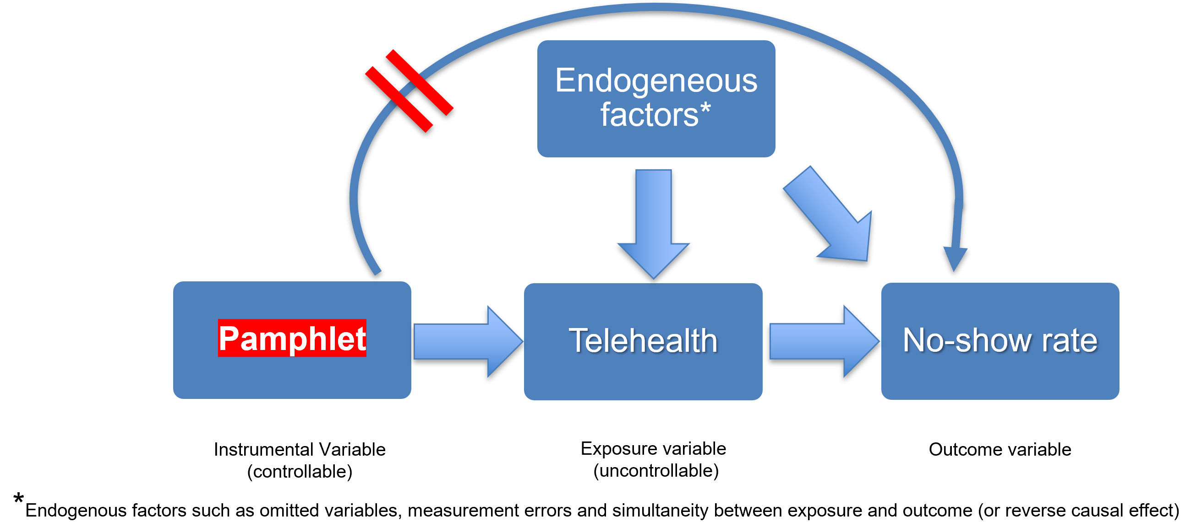
Figure 1. Framework diagram of assumption of a valid instrumental variable.



Figure 2A. Telehealth Pamphlet (English version).
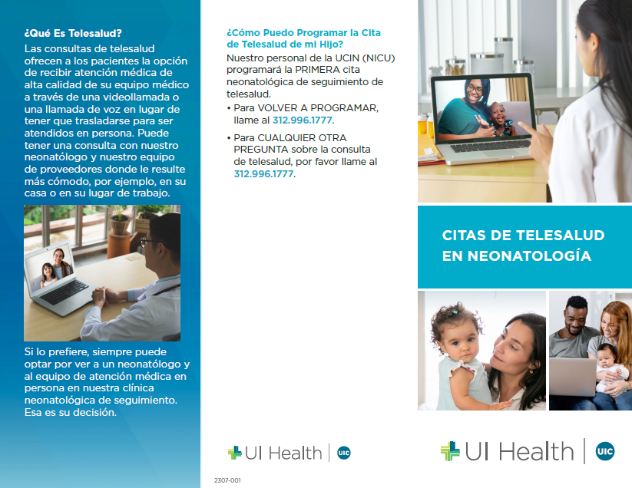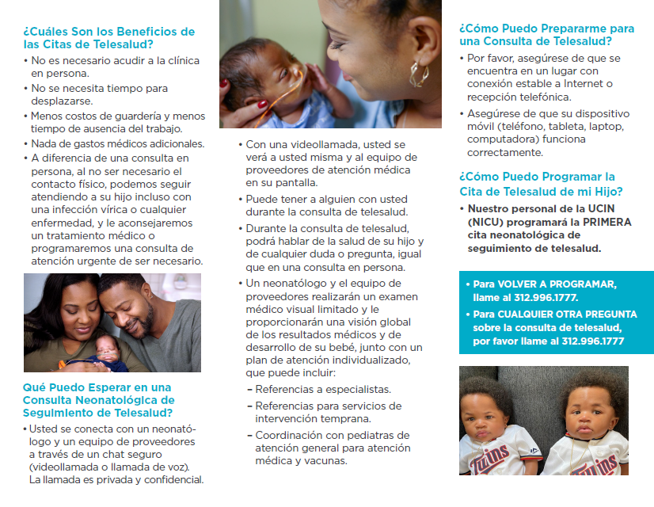
Figure 2B. Telehealth Pamphlet (Spanish version).
REFERENCES

Ballantyne, M., Stevens, B., Guttmann, A., Willan, A. R., & Rosenbaum, P. (2014). Maternal and infant predictors of attendance at Neonatal Follow-Up programmes. Child Care Health Dev, 40(2), 250-258. https://doi.org/10.1111/cch.12015
Cooper, P. J., Tomlinson, M., Swartz, L., Landman, M., Molteno, C., Stein, A., McPherson, K., & Murray, L. (2009). Improving quality of mother-infant relationship and infant attachment in socioeconomically deprived community in South Africa: randomised controlled trial. BMJ, 338, b974. https://doi.org/10.1136/bmj.b974
DeMauro, S. B., Duncan, A. F., & Hurt, H. (2021). Telemedicine use in neonatal follow-up programs - What can we do and what we can't - Lessons learned from COVID-19. Semin Perinatol, 45(5), 151430. https://doi.org/10.1016/j.semperi.2021.151430
Drerup, B., Espenschied, J., Wiedemer, J., & Hamilton, L. (2021). Reduced No-Show Rates and Sustained Patient Satisfaction of Telehealth During the COVID-19 Pandemic. Telemed J E Health, 27(12), 1409-1415. https://doi.org/10.1089/tmj.2021.0002
Finn, J., & Achilles, C. M. (1990). Answers and Questions About Class Size: A Statewide Experiment.
Gajwani, P. (2014). Can what we learned about reducing no-shows in our clinic work for you? Current Psychiatry, 13, 13-15, 22-14.
Gray, J. E. e. a. (2000). Baby Care Link: Using the Internet and Telemedicine to Improve Care For High-Risk Infants. Pediatrics, 106, 1318-1324.
Gupta, D., & Denton, B. T. (2008). Appointment scheduling in health care: Challenges and opportunities. IIE Transactions, 40, 800 - 819.
Hoffman, A. M., Lapcharoensap, W., Huynh, T., & Lund, K. (2019). Historical Perspectives: Telemedicine in Neonatology. NeoReviews, 20(3), e113-e123. https://doi.org/10.1542/neo.20-3-e113
Ieva, F., Marra, G., Paganoni, A. M., & Radice, R. (2014). A Semiparametric Bivariate Probit Model for Joint Modeling of Outcomes in STEMI Patients. Computational and Mathematical Methods in Medicine, 2014(1), 240435. https://doi.org/https://doi.org/10.1155/2014/240435
Johnson, B. J., Mold, J. W., & Pontious, J. M. (2007). Reduction and Management of No-Shows by Family Medicine Residency Practice Exemplars. The Annals of Family Medicine, 5(6), 534-539. https://doi.org/10.1370/afm.752
Kim, N. H., Youn, Y. A., Cho, S. J., Hwang, J. H., Kim, E. K., Kim, E. A., & Lee, S. M. (2018). The predictors for the non-compliance to follow-up among very low birth weight infants in the Korean neonatal network. PLoS One, 13(10), e0204421. https://doi.org/10.1371/journal.pone.0204421
Krueger, A. B. (1999). Experimental Estimates of Education Production Functions. The Quarterly Journal of Economics, 114(2), 497-532. http://www.jstor.org/stable/2587015
Kwong, A. K. L., Doyle, L. W., Olsen, J. E., Eeles, A. L., Zannino, D., Mainzer, R. M., Cheong, J. L. Y., & Spittle, A. J. (2022). Parent-recorded videos of infant spontaneous movement: Comparisons at 3-4 months and relationships with 2-year developmental outcomes in extremely preterm, extremely low birthweight and term-born infants. Paediatr Perinat Epidemiol, 36(5), 673-682. https://doi.org/10.1111/ppe.12867
Lakshmanan, A., Rogers, E. E., Lu, T., Gray, E., Vernon, L., Briscoe, H., Profit, J., Jocson, M. A. L., & Hintz, S. R. (2022). Disparities and Early Engagement Associated with the 18- to 36-Month High-Risk Infant Follow-Up Visit among Very Low Birthweight Infants in California. J Pediatr, 248, 30-38.e33. https://doi.org/10.1016/j.jpeds.2022.05.026
Malloy, M., Tarima, S., Canales, B., Nelson, D., & Hanley, J. (2023). Identifying Risk Factors for Appointment No-Shows in a Pediatric Orthopaedic Surgery Clinic: Original Research. Journal of the Pediatric Orthopaedic Society of North America, 5(3). https://doi.org/10.55275/JPOSNA-2023-695
McCahon, H., Chen, V., Paz, E. F., Steger, R., Alexander, J., Williams, K., Pharr, C., Tutnauer, J., Easter, L., & Levin, M. R. (2023). Improving follow-up rates by optimizing patient educational materials in retinopathy of prematurity. J AAPOS, 27(3), 134.e131-134.e135. https://doi.org/10.1016/j.jaapos.2023.04.002
Miller, E. B., Canfield, C. F., Morris, P. A., Shaw, D. S., Cates, C. B., & Mendelsohn, A. L. (2020). Sociodemographic and Psychosocial Predictors of VIP Attendance in Smart Beginnings Through 6 Months: Effectively Targeting At-Risk Mothers in Early Visits. Prev Sci, 21(1), 120-130. https://doi.org/10.1007/s11121-019-01044-y
Mobbs, C., Spittle, A., & Johnston, L. (2022). PreEMPT (Preterm infant Early intervention for Movement and Participation Trial): Feasibility outcomes of a randomised controlled trial. Early Hum Dev, 166, 105551. https://doi.org/10.1016/j.earlhumdev.2022.105551
Mohamed, K., Mustafa, A., Tahtamouni, S., Taha, E., & Hassan, R. (2016). A Quality Improvement Project to Reduce the 'No Show' rate in a Paediatric Neurology Clinic. BMJ Qual Improv Rep, 5(1). https://doi.org/10.1136/bmjquality.u209266.w3789
Molfenter, T. (2013). Reducing appointment no-shows: going from theory to practice. Subst Use Misuse, 48(9), 743-749. https://doi.org/10.3109/10826084.2013.787098
Paris, D., Allman, A., Manton, M., Maity, S., & James, A. (2023). 664 General movement assessment: motor optimality score correlation with later neurodevelopmental outcome. Archives of Disease in Childhood, 108(Suppl 2), A43-A44. https://doi.org/10.1136/archdischild-2023-rcpch.72
Razak, A., Johnston, E., Sackett, V., Clark, M., Charlton, M., Zhou, L., Pharande, P., McDonald, C. A., Hunt, R. W., Miller, S. L., & Malhotra, A. (2024). Early Neurodevelopmental Assessments for Predicting Long-Term Outcomes in Infants at High Risk of Cerebral Palsy. JAMA Netw Open, 7(5), e2413550. https://doi.org/10.1001/jamanetworkopen.2024.13550
Robinson, C., Gund, A., Sjoqvist, B. A., & Bry, K. (2016). Using telemedicine in the care of newborn infants after discharge from a neonatal intensive care unit reduced the need of hospital visits. Acta Paediatr, 105(8), 902-909. https://doi.org/10.1111/apa.13407
Robinson, C., Gund, A., Sjöqvist, B. A., & Bry, K. (2016). Using telemedicine in the care of newborn infants after discharge from a neonatal intensive care unit reduced the need of hospital visits. Acta Paediatrica, 105(8), 902-909. https://doi.org/10.1111/apa.13407
Shour, A. R., Jones, G. L., Anguzu, R., Doi, S. A., & Onitilo, A. A. (2023). Development of an evidence-based model for predicting patient, provider, and appointment factors that influence no-shows in a rural healthcare system. BMC Health Services Research, 23(1), 989. https://doi.org/10.1186/s12913-023-09969-5
Siow, M. Y., Walker, J. T., Britt, E., Kozy, J. P., Zanzucchi, A., Girard, P. J., Schwartz, A. K., & Kent, W. T. (2020). What Was the Change in Telehealth Usage and Proportion of No-show Visits for an Orthopaedic Trauma Clinic During the COVID-19 Pandemic? Clin Orthop Relat Res, 478(10), 2257-2263. https://doi.org/10.1097/CORR.0000000000001396
Støen, R., Boswell, L., de Regnier, R.-A., Fjørtoft, T., Gaebler-Spira, D., Ihlen, E., Labori, C., Loennecken, M., Msall, M., Möinichen, U. I., Peyton, C., Russow, A., Schreiber, M. D., Silberg, I. E., Songstad, N. T., Vågen, R., Øberg, G. K., & Adde, L. (2019). The Predictive Accuracy of the General Movement Assessment for Cerebral Palsy: A Prospective, Observational Study of High-Risk Infants in a Clinical Follow-Up Setting. Journal of Clinical Medicine, 8(11), 1790. https://www.mdpi.com/2077-0383/8/11/1790
Tang, B. G., Lee, H. C., Gray, E. E., Gould, J. B., & Hintz, S. R. (2018). Programmatic and Administrative Barriers to High-Risk Infant Follow-Up Care. Am J Perinatol, 35(10), 940-945. https://doi.org/10.1055/s-0038-1629899
Yeob Choi, B., Fine, J. P., & Alan Brookhart, M. (2020). Bias testing, bias correction, and confounder selection using an instrumental variable model. Stat Med, 39(29), 4386-4404. https://doi.org/10.1002/sim.8730

