Unit 7
Do You Want to Listen to My Story?
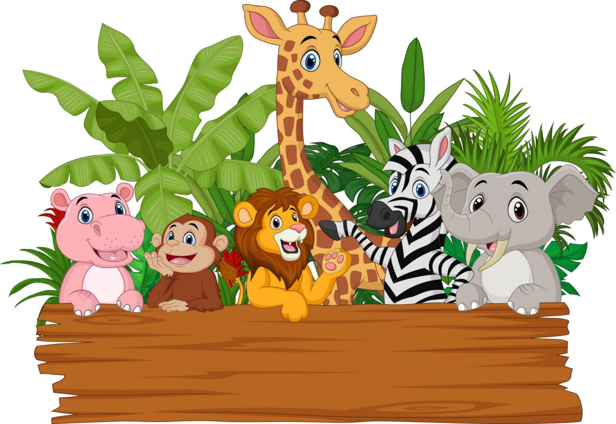
Learning Objectives:
- Read narrative texts: fable.
- Use grammar: Past tense.
- Understand theme, point of view, setting and character in a story.
- Practise story-telling confidently.
- Learn sounds: pl, sl.

CONCEPT MAPPING :

Use grammar: Past Simple tense.
Read narrative texts: fable.

Do You Want to Listen to My Story?

Practise story-telling
confidently.
Understand theme, point of view, setting, moral value and character in a story.
Learn sounds: pl, sl.

Key words:
Fable, Animal, Reading, Story
Socialising :
Great Indonesian children, do you like to sleep early every night?

Great Indonesian children, sleep early is good for us, it helps us to feel fit when we wake up in the morning.

PP-CP POIN POIN CAPAIAN PEMBELAJARAN :

A. Look, read and answer.
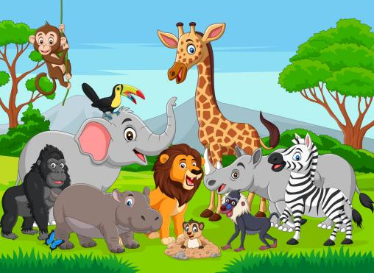
How can an animal speak?
It can speak only in a f__________ .
- Do you like to listen to an animal story?
- Why do you like it? And if you don’t Why you don’t like it?

B. Listen, look and give numbers.
Need a recording for listening.
Once upon a time,
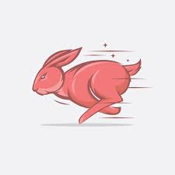
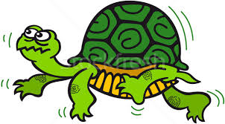
…
…

The tortoise walked slowly.
The rabbit ran quickly.

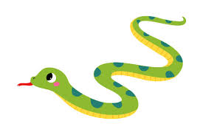
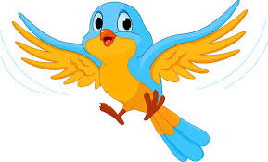
…
…

The snake slithered.
The bird flew so high.

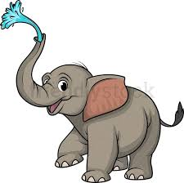
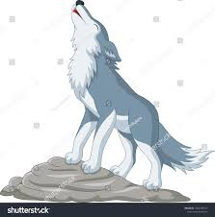
…
…

The elephant’s trunk sprayed water.
The wolf roared.

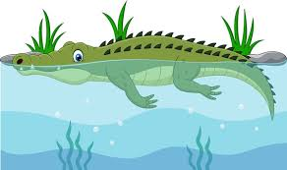
…
…
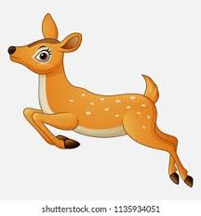

The crocodile swam.
The mouse deer jumped.

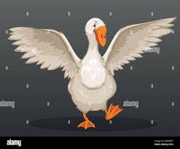
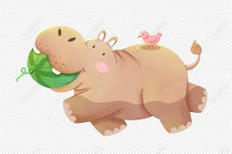
…
…

The hippo ate a big watermelon.
The goose spread its wings.

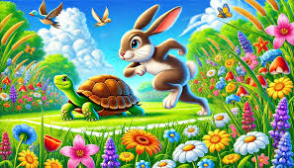
C. Read.
Need a recording for listening.

The Hare and the Tortoise
Orientation
Once upon a time, there was an arrogant hare. He was very proud of his ability to run fast. He was the best runner around. This made him very self-confident and brave to many animals in the jungle. However, there was a tortoise which was opposite to the hare. He was the slowest, but he was very hard-worker, kind and wise.
One day the hare found the tortoise walking very slowly. He laughed at the tortoise. The hare said, "Hello, the slowest animal in the world. Hahaha." Then the tortoise replied, "Hello hare, why did you say that to me? The hare continued, "Because of you. You need more time to get where you want to go". Surprisingly, the tortoise challenged the hare to a running race. "How do you know I need more time to reach my destination? Unless we have a running race." Hearing the tortoise's challenge, the hare laughed out loud. "Hahahahaha". Then the tortoise said again, "Are you afraid of losing?" The hare replied confidently, "Of course not. Let's have a race."
Problem

Many animals gather to watch the race. The hare and the tortoise got ready at the starting line. When the bell rang, they gave it their all to win the race. Because the hare was running very fast, he left the tortoise behind. He looked back, and there was no tortoise. Then he thought, "The tortoise will need more time to get closer to me, so I will rest here for a while in a big shady tree. Unfortunately, the hare slept so long and so deeply, and the tortoise never gave up to continue the race. The tortoise managed to get over the sleeping rabbit. When the hare woke up, he found that the tortoise had crossed him. He ran hard to reach the tortoise, but he couldn't. The turtle had already finished, and the hare was very disappointed.
Re-orientation
Resolution
Finally, the hare admitted that the tortoise was the winner of the race. The hare then apologised to the tortoise for being arrogant and underestimating him.

D. Based on the story above, give number in sequence.

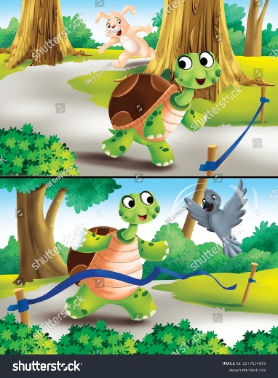
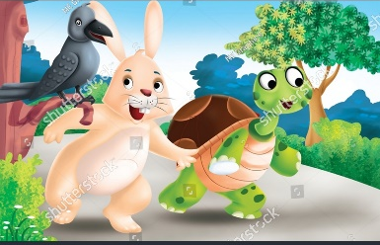

( … ) ( … )

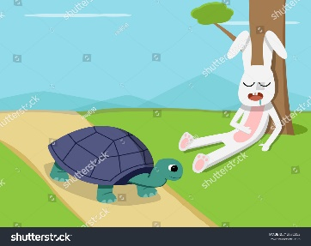

( … ) ( … )
E. Read and learn. Let’s recall.
- A fable is s short fictional story using animals as characters.
- The story is intended to entertain and teach moral values.
- The writer uses the past tense to tell the story in the past.
- The structure of a fable is orientation, problem, resolution and re-orientation.

- Theme is a main topic in a story. It can be about love, friendship or other things.
- Point of view is the position of a writer telling a story. It can be as first person (I, we, me/my, us, our), second person (you, your/yours) and third person (he, she, it, his, her, its)
- The time and place where a story takes place is called setting.
- People, animals, or things that act out a story are called characters.
- Moral value is a life lesson that we can learn from a story.

F. Circle T (True) or F (False) based on the text above.
- The hare was arrogant at the first. T F
- The hare was the winner of the race. T F
- The tortoise was sleeping under the tree. T F
- The race was followed by 2 animals. T F
- From the story, we have to be arrogant. T F

G. Reread the story above and complete.
Theme of the story:
__________________________
Settings:
__________________________
Characters:
__________________________
Point of view:
__________________________

The Hare and the Tortoise

H. Read and learn.
Past Tense is to talk about the past action, an imagination, and politeness.
Past simple | I played.
Past continuous | I was playing.
Past perfect | I had played.
Past perfect continuous | I had been playing.

I. Let’s learn.
An action that is started and ended in the past.

Past Simple Positive
I worked in Germany in 2021.
Past Simple
Past Simple Negative
I didn’t work in Germany in 2021.

Adverb of Time
Yesterday, last week, two days ago.
Past Simple Questions
Did you work in Germany in 2021?

- Regular verb : add –ed, such as played, asked, destroyed, etc.
- Irregular verb : mostly have different forms of verb, for example:
Base form | Past tense | Past participle
Be | was/were | Been
bend | Bent | Bent
buy | Bought | bought
choose | Chose | chosen
come | Came | Come
Cut | Cut | Cut
Do | Did | Done
draw | Drew | drawn
Dig | Dug | Dug
Eat | Ate | eaten
Feel | Felt | Find
forget | Forgot | forgotten
Find | Found | found
Get | Got | Got
Go | Went | gone
give | Gave | given
have | Had | Had
hear | Heard | heard

I. Let’s find out.
Keep | … | …
Know | … | …
Leave | … | …
Let | … | …
Lose | … | …
Make | … | …

J. Compete. Use base form, past tense or past participle.
1. Yesterday I _______ (play) basketball with my old friends.
2. She _____ (be) watching TV when the bell rang.
3. He had ______ (work) before I came.
4. The bird had _______ (eat) the food before the other birds came.
5. The rabbit and the mouse ________ (be) sleeping in a cave.

K. Read and learn. How to be a good story-teller.
1. Read, watch and listen to a story teller’s performance.
2. Practice a lot.
3. Observe other good story tellers.
4. Use any animal stuffs to present.
5. Be yourself.
Source https://www.linkedin.com/pulse/7-simple-techniques-become-good-storyteller-amit-nagpal-phd

L. Read aloud. Try to be a story teller.
The Mouse Deer and the Crocodiles
One day, in a jungle there were some crocodiles looking for prey. They moved around trying to find some prey, but they couldn't find it. On the other side, there was a little cleaver and a happy Mouse Deer who played and enjoyed the day.
After moving around, the Mouse Deer felt hungry and thirsty. He ate some grass, but he was still hungry. When he wanted to drink, he found a river with some hungry crocodiles. He also saw lots of cucumbers across the river. He knew he couldn't drink and cross the river because of the hungry crocodiles. He thought about how he could pass the river and drink.
After a few minutes of thinking, the Mouse Deer had an idea. So he said to the Crocodile, "Hi, Crocodile, are you hungry?" The Crocodile replied, "Hi, Mouse Deer, yes, would you like me to eat you?" The Mouse Deer replied, "Of course not. I have some good news for you, Crocodile. The Mouse Deer spoke calmly, and he wasn't afraid. The Crocodile was curious and asked, "What is it?" The Mouse Deer answered again, "I have a message from our king that you will have meat to eat, so I want to count how many crocodiles there are here. When I know how many crocodiles there are, I'll come back and bring meat for you all.” When the crocodile heard this news, he was very happy, "So how can you count all the crocodiles?" The Mouse Deer said, "You have to tell other crocodiles and make a line like a bridge, I'll jump over you and count how many there are. Immediately the crocodile told his friends and made a line. Then, the Mouse Deer jumped and counted until he had crossed the river. As he jumped over each crocodile, he paused for a moment to drink. When he got to the last crocodile, he jumped over the edge of the river, said "thank you" and ran away as fast as he could.
The crocodiles were puzzled for a while as to why the Mouse Deer said “thank you” and ran off so quickly. They only realised after the Mouse Deer had gone into the jungle. The crocodiles were very angry, hungry and upset because the Mouse Deer lied, and the Mouse Deer used them only to cross the river.

L. Present and give scores.
Steps:
1. Present the story above in front of the class.
2. Use animal stuffs if it’s possible.
3. Score your story-teller performance by your friend, in pair.
4. Take turn with your friend to present or to score.

Scoring Sheet
Name | Elements of Scoring |  |  | Total
Name | Fluency | Pronunciation | Expressiveness | Total

Scoring Rubric
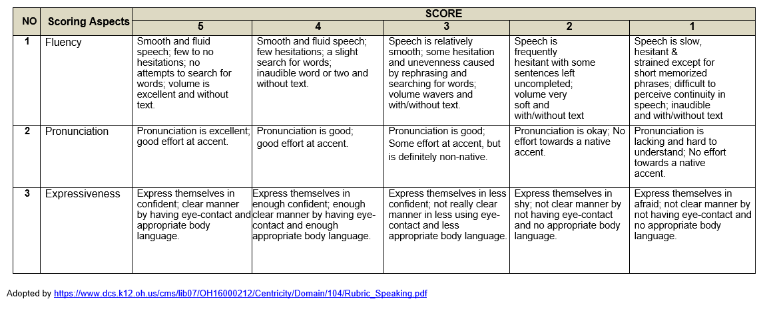

*rotate your book

M. Practice sound: pl and sl
Need a recording for listening.

Sound pl | Sound sl
place | Slow
plate | Slip
plum | sleep
apply | continuously
reply | simultaneously
people | grassland
plough | translate

Read and practice.
1. People plant some plants in a plaza simply.
2. A complete plan was applied to many employee in a plateau.
3. A principle accomplished a splendid task in a workplace.
4. Slavik was slightly sleepy in the grassland,
5. A sleeper oversleeps continuously in an island.
6. A translator translates a slang translation simultaneously.

N. Project: A Puppet Show (Pancasila Learner Profile: Kreatif)
A Puppet Show
Stuffs :
1. Scissors
2. Crayon/ coloring pencils
3. Straw
4. Sellotape

Steps :
- Find a fable story. You can use the story in this book.
- Draw 2 animals based on the story.
- Color your drawings.
- Cut your animals’ drawing.
- Stick your animals’ drawing with sellotape. Stick them behind the picture.
- Practice your story a lot.
- Present your puppet show in front the class.

The First Animal

The Second Animal

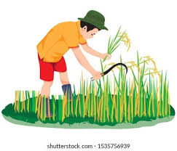
Review I
I. Read the instruction and answer.
1. Look at the picture.
Yesterday From the picture, what did the tortoise do?
A. It jumped.
B. It ran.
C. It walked.
D. It swam.

2. Look at the picture below.

Circle true or false based on the picture.
a. The story was about the hare and the tortoise. True False
b. The hare won the race. True False
c. The tortoise was faster than the hare. True False

3. Complete the conversation below.
Kaira : What did you do yesterday?
Dena : I ________ all day.
A. sleep
B. slept
C. am sleeping
D. have slept.

4. Look and give a check (√) to the correct sentence.
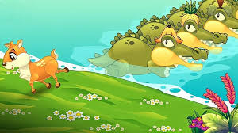

a. It’s a fable. ( … )
b. The setting of the story was in a city. ( … )
c. The point of view used the second person. ( … )
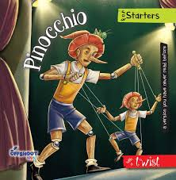
5. Match.
a. Fable
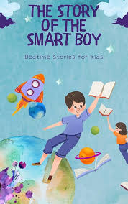
b. Non-fable.

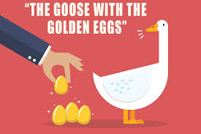

6. What time did you sleep last night?
A. It is 10 p.m.
B. It was 10 p.m.
C. it will 10 p.m.
D. It is being 10 p.m.
7. “She _________ (buy) some food yesterday.”
What is the correct word to complete the sentence?
A. buys C. bought
B. is buying D. was buying
8. Give a check (√ ) to correct statement about fable.
a. A fable is a story which talks about animals. (…)
b. In story such as fable, there are plot, character, theme, etc. (…)
c. There are 3 structures in a fable such as introduction, (…)
problem & solution.

9. Read and answer.
Student A : __________________________?
Student B : I was discussing during the lesson.
A. What were you doing during the lesson?
B. What do you do?
C. Where did you go?
D. Where are you going during the lesson?

10. Where does the orientation of the story usually appear?
A. At the beginning of paragraph
B. In the middle of paragraph
C. At the end of paragraph
D. at the beginning and the end.

II. Fill in the blanks.
No | Base Form | Past tense | Past participle
11. | eat | ... | …
12. | … | Drew | …
13. | … | … | studied

Look and make a sentence.
Yesterday
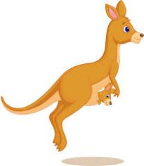

14. The kangaroo ____________________________ . (past simple positive)
15. The kangaroo ____________________________ . (past simple negative)

III. Essay.
- What is past simple?
______________________________________________________

- What is character in a story?
______________________________________________________

- How to be a good story-teller?
______________________________________________________

- Read and write a past simple question based on the answer given.
Q : ___________________________________?
A : Yes, she did. She slept in her mother’s room last night.

- There some elements in a story such as theme, character, etc. Write two more elements in story, and its definition.
1. ____________________________________________________
2. ____________________________________________________

SCORE

Review II
I. Read the instruction and answer.
Read and answer. Question for number 1-5.
The Ant and the Grasshopper
Once upon a time, there were two animals living in a jungle, an ant and a grasshopper. They had a different character. The Ant was a hard worker, but the Grasshopper was a lazy animal.
One day, the Ant was very busy. She collected some food such as grains of wheat in her place. She put the grain one by one to her place, but she never got tired. She tried to collect and store some food as much as she could. She also prepared her shelter to be strong and comfortable. On the other hand, the Grasshopper who was lazy didn’t do anything to gather food or prepare his shelter. He just sang and played his guitar all day long. When the Ant crossed in front of the Grasshopper, the Grasshopper was laughing and said to the Ant, “Why are you so busy the Ant? Let’s sing together with me.” The Ant didn’t want to focus on him, and she tried to ignore him when he laughed and asked something unimportant. Then, day by day, the season changed into another season until the winter came. The conditions were very different in the other seasons. The trees turned white, the weather was very cold, and he was very hungry and thirsty because everything was freezing. He also had no shelter to protect him from this condition.
The Grasshopper was very upset. Suddenly he remembered the Ant, “I think I’ll go to the Ant’s house, ask some food, and stay in her shelter.” He went to the Ant’s house and knocked on the door, “Knock Knock”, “Hi, Ant. Can I have some food and stay in your house for a while?” The Ant was very angry at that time because the Grasshopper laughed at her and often said bad things to her, and suddenly he came and asked for help. The Ant said angrily, “Hi Grasshopper, I was very angry with you when you sang all day and laughed at me a lot. And now you ask me about food and shelter. Do you think I’ll give you food and shelter? The answer is a big NO.” The Ant immediately closed her door. However, after the Grasshopper had left her shelter, the Ant felt very sad about the Grasshopper’s condition. Finally, the Ant chased the Grasshopper, gave him some food and stayed in her shelter with other ants.
The Grasshopper really thanked to the Ant and apologised for what he had done. The Ant told to him not to do it again and worked hard when summer coming. The Grasshopper learned from this lesson and promised to change his behavior.
- How many characters are there in the story above?
A. 1
B. 2
C. 3
D. 4

- Where was the setting of the story above?
A. The setting was in a beach.
B. The setting was in a city.
C. The setting was in a desert.
D. The setting was in a jungle.

- Why was the Ant angry with the Grasshopper?
A. Because the Grasshopper laughed at the Ant when she worked.
B. Because the Grasshopper sang a song.
C. Because the Grasshopper forgot the Ant’s birthday.
D. Because the Grasshopper was lazy.

- Give a check (√) to the correct statement about the story.
a. The Ant was a hard worker. ( … )
b. The Ant prepared for the winter’s condition well. ( … )
c. The Grasshopper didn’t get any help from the Ant. ( … )

- What is the moral value of the story above?
A. We have to follow the rules.
B. If we’re diligent, we’ll get more difficulties.
C. We have to prepare all the things well.
D. We have to take revenge for others’ evil.

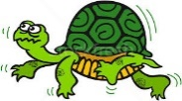
- Match.
a. I want to see a bird flying closely.
b. His rabbit ran when I came to his house.
c. Yesterday I saw a snake slithered.

- Read the sentence below.

“She usually read an animal story.”

Change the sentence above into past simple.
A. She will read an animal story tomorrow.
B. She has read an animal story since 5 years old.
C. She had read an animal story.
D. She read an animal story yesterday.

- Read.
Q : Where did you go yesterday?
A : ________________________
What is the correct answer to complete the conversation?
A. I went to a library yesterday.
B. I will go to a library tomorrow.
C. I should go to a library.
D. I had gone to a library.

- What does character mean?
A. The position of a writer telling a story.
B. The time and place where a story takes place.
C. A main topic in a story.
D. People, animals, or things that act out a story.

- How to be a good story teller?
A. Less practice
B. Waste your time
C. More confident
D. More money

II. Fill in the blanks.
Change the sentences into positive, negative or question!

No. | Positive | Negative | Questtion
11. | My brother ate some snacks. | ……………………………………………… | …………………………………………
12. | ………………………………………………………... | ……………………………………………… | Did you sleep in your grandma’s house yesterday?
13. | …………………………..  ………………………….. | Andi didn’t find a key on the table. | ………………………………………….
14. | She was my friend in junior high. | ……………………………………………… | …………………………………………

15. Look at the picture and give T (True) or F (False) to the statement.
Past Simple

a. It tells an activity in the past. ( … )
b. It’s used past participle for the verb. ( … )
c. It commonly uses did for question and negative. ( … )
III. Essay
16. What is the structure of a fable?
__________________________________________________________
17. Read
“My mom doesn’t cook yesterday.”
The sentence below is not correct. Fix the sentence into a correct
sentence.
_____________________________________________

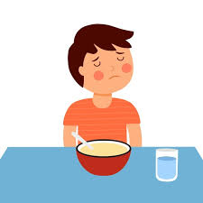
18. Look.

From the picture above, write a past negative sentence.
__________________________________________________________

19. Based on the questions number 18, change the sentence into a question!
_________________________________________________________
20. Read again the story of the Ant and the Grasshopper above. Then, fill in the blanks.
a. Theme of the story : ________________________________________
b. Point of view : ___________________________________________
c. Setting : _________________________________________________
d. Characters : ______________________________________________
SCORE

Review III
I. Read the instruction and answer.
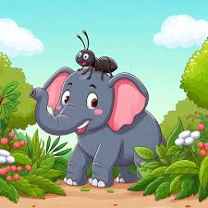
- Look and read.
From the picture, what is the title of the story?
A. The Ant and the Rooster
B. The Elephant and the Ant
C. The Flowers and the Ant
D. The Grass and the Flower

- From picture number 1, what kind of story is that?
A. Fable
B. Legend
C. Myth
D. Biography

- Read.
Once upon a time, there were many animals in a jungle. One of them was a frog. The Frog was different from the other frogs. He was bigger and stronger than the other frogs. Because of that, he became very arrogant.

From the paragraph above, what kind of structure is that?
A. Orientation
B. Problem
C. Resolution
D. Re-orientation

4. Which sentence that shows an activity in the past?
A. My mother is very beautiful.
B. My brother was very angry with me.
C. Her sister never comes late.
D. My uncle and my aunt will invite me to their house.
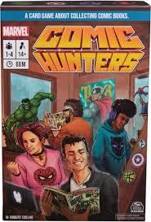
5. Look and match to correct uses.
a. Fable

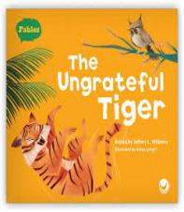

b. Non fable
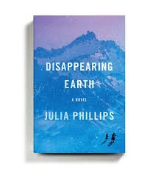

Listen to the conversation below and answer question for number 6-8.
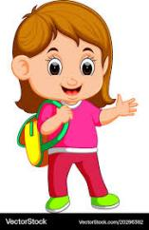


Betty
Anna
- Based on the conversation above, what fable did Anna read?
A. The Arrogant Squirrel
B. The Ugly Duckling
C. The Ant and the Grasshopper
D. The Hare and the Tortoise

- When did Mr Mike tell to read a fable?
A. Yesterday
B. Two days ago
C. Three days ago
D. Four days ago

- What lesson does Mr Mike teach?
A. Math
B. Music
C. Art
D. English

- Look and complete.
“Your friend _____ want to join us because he had to follow a course.”
A. doesn’t
B. isn’t
C. didn’t
D. Hasn’t

- What is the function of reading a fable?
A. To inform something.
B. To persuade buying a product.
C. To amuse readers.
D. To tell a procedure of something,
II. Fill in the blanks.
Listen and complete the story below with the words in the box.
complaint weak arrived attacked strong sad

Once upon a time, there were some elephants in a jungle. They were very big and (11) _______. One day, they went to a place where many ants lived. They wanted to look for some food.
When the elephants (12) __________, many nests of the ants were destroyed because the elephants stepped on the nests. The ant said, “Hi Elephants, go out from here! This is our house.” Hearing the ant’s (13)________, the elephants were just laughing and said, “Hahaha, I don’t care. I wanna look for some food.” The elephants thought that the ants were not dangerous for them because they were very small and (14) _________.
The ants were really mad because of the elephants. The next day, all the ants gathered and planned to drive out the elephants from their place. They planned to discuss with the elephants and ask them to go out from their place, but they still didn’t want to go out from there. These conditions made the ants angrier. As the result, all the ants (15) __________the elephants. They bit the elephants’ skin and entered the elephants’ ears and trunks.
Finally, the elephants gave up, and they ran away from the place. They realised that the ants were strong and could not be underestimated only because of their little body.

III. Essay
- From the story above, write the structure of the text.
Paragraph 1: _____________
Paragraph 2: _____________
Paragraph 3: _____________
Paragraph 4: _____________

- From the story above, write the elements of the text.
Theme : _________________________________
Setting : _________________________________
Point of view : _________________________________
Characters : _________________________________
Mora value : _________________________________

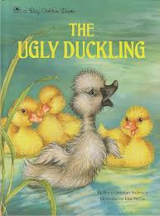
- Look and complete a simple orientation about the story.
Once (a)__________ a time, there was a family of (b)_____. There (c)_______ 5 ducklings. However, there was (d)_____ duckling had very different from the others, and he was very (e)_____.

- Write a sentence about this picture. Then, change it into negative and
question.

Two days ago Positive: __________________________
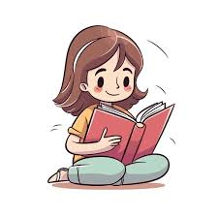
Negative: __________________________

Question: __________________________

- When you want to be a good story teller, you have to do some activities to
improve your skill. Write 3 activities that you do for being a good story
teller.
_______________________________________________________________________________________________________________________________________________________________________________________________________________________________________________________________

REFELECTION
Give a check (√) to your condition after finishing this material.
No. | Statement | Yes | No
1. | I can read narrative texts: fable.
2. | I can use grammar: Past simple tense.
3. | I can understand theme, point of view, setting. Moral value and character in a story.
4 | I can practise story-telling confidently.

