Step 1: Synthesis of Repaglinide Acid Chloride
Objective: Convert the carboxylic acid (–COOH) group of Repaglinide into a more reactive acyl chloride (–COCl) group using thionyl chloride (SOCl₂).
Procedure:
Dissolution of Repaglinide:
- 3.2 g (10 mmol) of Repaglinide is dissolved in 40 mL ethanol in a 250 mL round-bottom flask equipped with a stirrer.
- Ethanol acts as a solvent, though typically, non-nucleophilic solvents (e.g., dichloromethane) are preferred for acyl chloride formation to avoid esterification side reactions.
Addition of Thionyl Chloride (SOCl₂):
- 3.2 mL (27.6 mmol, 2.76 equiv.) of SOCl₂ is added dropwise over 30–40 min under ice-cooling (0–5°C) to control exothermicity.
- Why cooling? The reaction is highly exothermic, and cooling prevents decomposition of Repaglinide.
Reflux for 4 Hours:
- The mixture is refluxed (heated under boiling conditions) to complete the conversion.
- Observation: Evolution of HCl and SO₂ gases (bubbling) confirms the reaction progress.
- Mechanism: Thionyl chloride reacts with the carboxylic acid to form an acyl chlorosulfite intermediate, which decomposes to the acyl chloride.

- COOH + SOCl₂ → R-CO-O-SOCl → R-COCl + SO₂↑ + HCl↑
Workup:
- The reaction mixture is poured into ice-cold water to quench excess SOCl₂ and precipitate the product.
- The acid chloride is collected by filtration, washed, and air-dried.

Step 2: Synthesis of Curcumin-Repaglinide Ester Conjugate
Objective: React Repaglinide acid chloride with the phenolic (–OH) group of curcumin to form an ester linkage.

Procedure:
Preparation of Curcumin Solution:- In a 250 mL round-bottom flask, 3.2 g (9 mmol) of curcumin is dissolved in 40 mL ethanol with 2 mL pyridine (base catalyst).
Role of Pyridine:
- Neutralizes the released HCl during the reaction.
- Acts as a nucleophilic catalyst, forming a reactive acyl pyridinium intermediate.
Dropwise Addition of Acid Chloride:
- The solution of Repaglinide acid chloride (3.1 g, 9 mmol) in 20 mL ethanol is added slowly to the curcumin mixture.
- Why slow addition? Prevents side reactions (e.g., hydrolysis of acid chloride).
Stirring for 24 Hours at RT:
The reaction proceeds via nucleophilic acyl substitution:
- The phenolic –OH of curcumin attacks the carbonyl carbon of the acid chloride, displacing chloride (Cl⁻).
- Pyridine scavenges HCl, driving the reaction forward.

- COCl + Curcumin-OH → R-CO-O-Curcumin + HCl

Workup & Purification:
- The crude product is filtered, washed with water (to remove pyridine hydrochloride), and dried.
- Recrystallization from 95% ethanol yields the pure ester conjugate.

Key Chemical Reactions & Mechanisms
Formation of Acid Chloride:
Repaglinide (carboxylic acid) + SOCl₂ → Repaglinide acyl chloride (R-COCl) + SO₂ + HCl.
Esterification:
Curcumin (phenolic –OH) + R-COCl → Curcumin-Repaglinide ester (R-CO-O-Curcumin) + HCl.
Critical Notes & Considerations
- Solvent Choice: Ethanol may lead to ethyl ester byproducts; anhydrous DCM/THF could be better.

- Stoichiometry: Pyridine is used in excess to ensure complete reaction.
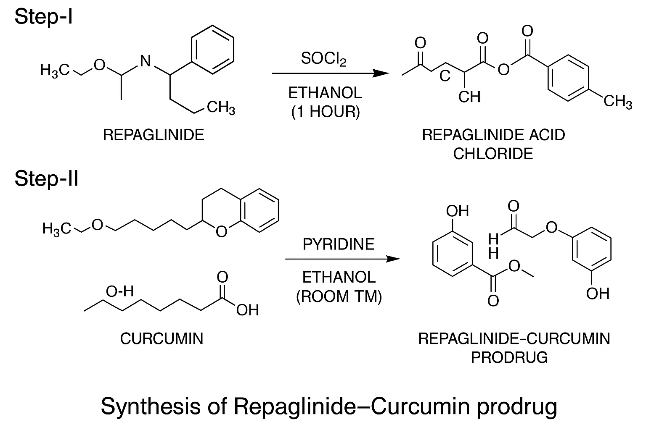
- Purification: Column chromatography may be needed if impurities persist after recrystallization.

Breakdown of the Image vs. Your Procedure
Step-I (Left Side of Image):
- Shows Repaglinide (structure with –COOH group) reacting with SOCl₂ (thionyl chloride) in ethanol to form Repaglinide acid chloride.
- Matches your Step 1 where Repaglinide is converted to its acyl chloride derivative.
Step-II (Right Side of Image):
- Shows Curcumin (structure with phenolic –OH) reacting with the Repaglinide acid chloride in the presence of pyridine/ethanol to form the ester conjugate (prodrug).
- Matches your Step 2 where the acid chloride couples with curcumin via esterification.

Labels & Conditions:

- "Ethanol (1 hour)": Likely refers to reflux time (your procedure used 4 hours; the image may simplify this).
- "Pyridine, Ethanol (room temp)": Confirms the esterification step at ambient temperature (as in your method).

Key Differences to Note
- Time Variation: The image mentions 1 hour reflux for acid chloride formation, while your procedure used 4 hours. This could be an abbreviation or optimization.
- Structures: The image omits full chemical structures but symbolically represents the reactants/products.

