Polymer nanocomposites. Part 1: The problem of the large discrepancy between expected and observed mechanical properties and the reason for that.
5

Stoyko Fakirov
Center for Advanced Composite Materials, Department of Mechanical Engineering, The University of Auckland, Auckland, New Zealand

Abstract
The extremely large discrepancy between the expected and observed mechanical properties of polymer nanocomposites is well documented. It is related mostly to the poor dispersion of the reinforcement in the matrix. Although for nanocomposites manufacturing genuine nanomaterials are used, due to their inherent property to agglomerate to larger particles in the final materials they are not nanosized, as proven by light scattering. It is concluded that polymer nanocomposites prepared via blending of matrix and nanomaterial are not of nano type but are microcomposites. Since currently there are missing techniques for proper dispersion of nanomaterials in polymer matrix it is suggested for preparation of true polymer nanocomposites to use methods excluding the blending step. In addition, it is demonstrated that the electrospun polymers cannot be used as reinforcing material for nanocomposites because of their inferior mechanical properties.

Introduction

In 2011 the European Commission suggested definition of “nanocomposites” whereas reinforcements are used materials with particle sizes in the nano-range, that is, “... 50% or more of the particles in the number size distribution, one or more external dimensions is in the size range 1-100 nm .. .” [1].
—

The reinforcing effect is much higher if these materials are fibrous. With the synthesis of carbon nanotubes (CNTs), credited to Iijima [2], a revolutionary opportunity for creation of new type of polymer composites with superior mechanical properties appeared because it was demonstrated that this new material is the strongest one ever created. Simple composite models predicted order-of-magnitude enhancement in modulus at loadings less than 1% because CNT is characterized by tensile moduli in the tera-Pascal range and lengths exceeding 10 μm.
The new composite materials with polymer matrix, the polymer nanocomposites, attracted the attention of academia and industry at that time for another reason too, in addition to the expected superior mechanical performance to that time. It was believed that they would solve the problem of the dramatic situation caused by plastic waste. The solution was supposed to come from the replacement of the common polymer composites comprising up to 30 wt.% glass fibers as reinforcement with the new nanocomposites comprising 1 - 2% nanomaterial as reinforcement.
—
Unfortunately, this expectation turned out to be elusive: “.. .Although claims of modulus enhancement by factors of 10 exist, these claims are offset by measurements that show little or no improvement... The lackluster performance of nanocomposites has been attributed to a number of factors including poor dispersion, poor interfacial load transfer, process-related deficiencies, and others’.. .” [3].
How do look at the experimental results regarding the improvement of mechanical properties of polymer nanocomposites? An improvement of 20% (for tensile strength) and 50% (for the modulus of elasticity) is quite typical for all polymer nanocomposites [4]. According to Bousmina [5], only in exceptional circumstances can one observe an improvement greater than 30% in the mechanical performance of nanocomposites. More specifically, Zhang et al. [6] studied thoroughly the case of polypropylene (PP)/SiO₂ nanocomposites in which the nanoparticles have been coated by various polymers to improve interfacial adhesion. They reported mechanical properties (Young’s modulus and tensile strength) only 20 - 25% higher than those of the neat PP [6].
—
The above conclusions were supported by the statements of Schaefer and Justice in their review “How Nano Are Nanocomposites?” [3]: “Composite materials loaded with nanometer-sized reinforcing fillers are widely believed to have the potential to push polymer mechanical properties to extreme values. Realization of anticipated properties, however, has proven elusive”.
Finally, let us mention in this respect the statement in a recent review on the practical applicability of polymer nanocomposites [7]: “Initial developments of nanocomposite thermosets focused on high aspect ratio nanoparticles such as nano clays, carbon nanotubes and more recently graphene. Generally, these systems showed 10 to 35% improvement in mechanical properties with 0.2 - 5 wt. % filler. However, the translation of these improvements to prepregs or laminates proved to be difficult due to processing issues, including extremely high viscosity, nanoparticle filtration, nanoparticles agglomeration, and void formation.”
—
—
It seems realistic to assume that polymer nanocomposites prepared via melt blending of the two basic components, the matrix, and the reinforcement, are characterized by a maximum improvement of their mechanical properties by 30% - 35% as compared with the respective neat isotropic matrix. Such a result is quite far from the expected 10-fold (at least!) improvement.
—
An interesting question regarding the reasons for this drastic discrepancy arises.

2. Reasons for the discrepancy between expected and observed mechanical results
According to Schafer and Justice [3] the concept of polymer nanocomposites failed for the following reasons:
- Poor dispersion,
- Poor interfacial load transfer,
- Process-related deficiencies,
- Poor alignment,
- Poor load transfer to the interior of filler bundles,
- The fractal nature of filler clusters.
It would be hardly correct to assume that all factors have the same contribution to the failure of the concept. According to the author’s opinion, the first one (the poor dispersion) plays a special role in this respect. This assumption is based on the common for all nano-sized materials, regardless of their chemical composition and method of manufacturing, inherent property - their extremely high ratio of surface area to volume. For example, 1 kg of particles of 1 mm³ has the same surface area as 1 mg of particles of 1 nm³. The natural tendency to reduce this free surface is the driving force for the agglomeration of nanoparticles in larger formations.
The preparation of true nanocomposites is not an easy task. The basic problem is the dispersion of the reinforcing component to single nanoparticles in the matrix material. Due to their extremely strong tendency to agglomerate, the dispersion in the matrix component becomes practically impossible. In this respect, it seems useful to cite here the opinion of Greiner and Wendorff [8] expressed in their excellent review on electrospinning as a method for the preparation of ultrathin fibers and their application as reinforcing material for nanocomposites: “Given the advantages of nanofibers for reinforcement, the number of investigations on this topic is rather small. The main problems, to which there is no convincing solution yet are the dispersion of the electrospun nanofiber webs and the control of the nanofiber orientation in the polymer matrix. The felt-mat structure of the nonwoven is, for the most part, maintained upon the incorporation of the nanofibers into the matrix. Attempts to disperse single nanofibers from the nonwoven mats using ultrasound, kneaders, or high-speed stirrers have only been marginally successful. Very similar problems occurred in matrix reinforcement with carbon nanotubes and nanofilaments [9]” [8].

Does blending lead to real nanocomposites?
Let’s remember that depending on the sizes of the reinforcing filler we distinguish between macrocomposites (the common ones), microcomposites when the sizes are in the micrometer range and nanocomposites if the single reinforcing particles are nano-sized particles, that is, with dimensions below 100 nm or around this size.
It seems important to be reminded how polymer nanocomposites are prepared [10]. The most widespread practice is to blend a polymer (the matrix) with nano-sized material (reinforcement) and to use as the title of the paper the modern word “nanocomposite.” In rare cases, attempts are undertaken to determine the degree of dispersion and if this is done, it is by using electron microscopy. Usually, 2 -3 micrographs are incorporated demonstrating a couple of nano-sized particles, which show how these particles look. At the same time, these photographs offer no information about their amount in the sample. The question regarding the degree of dispersion is not addressed. Proper information regarding the type of dispersion can be obtained by using scattering techniques such as X-ray, neutron scattering, etc. This important detail is also stressed in the review on the practical applicability of polymer nanocomposites [7] because the scattering techniques average the results.
—

Nanoscale dispersion is a critical requirement to take full advantage of nanoparticles in polymer nanocomposites [11 -14]. The question is if the aggregates dominate in the sample. The answer can be found if we return to the scattering techniques, for example, light scattering. Some polymers are completely transparent, that is, they let the light trough on 100% such as, for example, atactic poly(methyl methacrylate) (at-PMMA), atactic polystyrene (at-PS) and, to some extent, polycarbonates (PC) and polyarylates (PAr). They can be used as a matrix for the preparation of transparent nanocomposites via blending with nano-sized fillers.
—
Nanomaterials of inorganic origin have typical sizes below 100 nm and, in many cases around 2 -5 nm. If the dispersion during mixing with the matrix is good, that is, up to single nanoparticles, the transparency should not be different from that of the matrix, that is, the transmission of the light must be 100%. This situation is due to the known fact that light scattering can be observed only if particles have sizes in the range of the size of the wavelength of the used light, which for the common light is 500 -600 nm. The results of such studies are summarized in [15]. For example, nanocomposites have been manufactured from completely transparent at-PMMA (100% transmission of the light) and nanosized ZnO (particles of 75 nm in concentration 1 wt.%). The used light was with wavelength λ = 600 nm. The measured amount of transmitted light is only 2% but it increases up to 50% if the concentration of the filler drops to 0.01% [16, 17].
—
—
The neat at-PMMA and at-PS are completely transparent materials (the transmission of the light is 100%) and for this reason they are widely used for replacement of inorganic glasses. This situation changes drastically if to such polymers are added very small amounts (1- 2 wt.%) of non-transparent nano-sized material the light transmission ability is reduced. Such data are summarized in Table 1.

Table 1
Examples of light transmission of polymer nanocomposites where the matrix is inherently transparent material (light transmission of 100%) [18] .
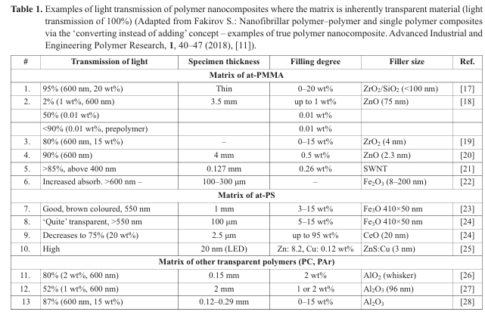
Source: Adapted from S. Fakirov, Nanofibrillar polymer-polymer and single polymer composites via the “converting instead of adding” concept - Examples of true polymer nanocomposite, Adv. Ind. Eng. Polym. Res. 1 (2018) 40-47.

(In the last column of Table 1 please change the existing digits by the following ones: 17 by [19], 18 by [16], 19 by [20], 20 by [21], 21 by [22], 22 by [23], 23 by [24], 24 by [25], 25 by [26], 26 by [27], 27 by [28], 28 by [29] and delete these 6 lines. Please also delete the repetition of the title of Table and reduce the space between the columns in order to increase the size of letters and digits).

From the data presented inTable1 one can conclude that: i) the polymers used as matrix are inherently completely transparent materials, (ii) the reinforcing nanomaterials used have dimensions below 100 nm (typically a couple of nm for most cases), and (iii) for the light transmission measurement a light with a wavelength between 500 and 600 nm has been used. If the composites studied are really polymer nanocomposites, i.e. materials in which the reinforcing component is dispersed to single nanoparticles, these composites should have the same transparency as the neat matrices since the single particles are too small to scatter. The reduction in transparency (Table 1) means that the particles in the matrix are much larger, approaching the size of the wavelength of the light used (500 - 600 nm), i.e. one deals practically with large aggregates of nanoparticles. It appears that currently we do not have reliable tools and/or
The situation described was also discussed in a recent review [17] on transparent polymer nanocomposites with emphasis on their synthesis and advanced properties. The review comprises the following text as a general statement: “The dispersion of particles and their affinity with the matrix are crucial parameters that closely control global properties of nanocomposites. For optimal transparency, nanocomposites require particles with very small dimensions compared to the wavelength λ (D/λ << 1). This condition can only be respected if primary particles are synthesized in such dimensions and if aggregation is avoided. A challenge for nanocomposite fabrication is to incorporate well-dispersed isolated particles into the polymer matrix and to improve interfacial interactions between matrix and fillers. However, due to their high specific surface area and surface interactions often involving polar groups located at the surface, nanoparticles have a strong tendency to aggregate” [17].
—

A peculiarity of this review is that contrasting the other studies summarized in [15], where the transparency for one wavelength only is studied, in [17] the cases cover quite a large interval of wavelengths and for this reason, the transparency is presented also as an interval usually between 5% - 40% and 70% - 95% as it can be concluded from the next Figs. 1 and 2.
— —
Fig. 1 demonstrates that, generally, the transmittance increases with the rise of the wavelength. It is the smallest for the shortest wavelengths below 350 nm).

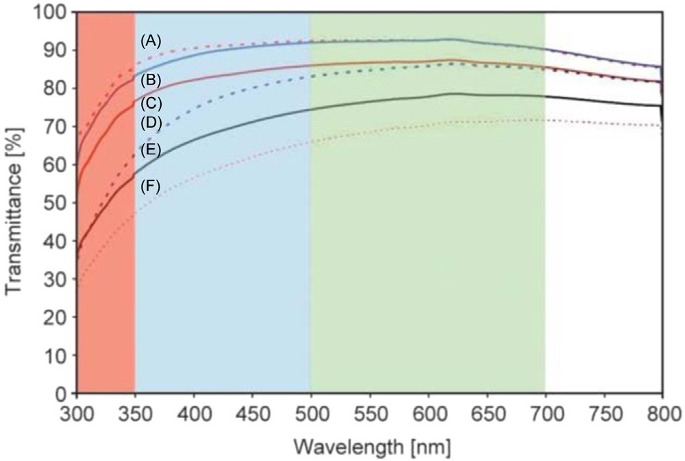
Fig. 1. UV-visible spectra of (A) extruded plain PC, (B) PC-Al₂O₃-RT-0.5%, (C) plain PC, (D) PC-Al₂O₃-RT-1%, (E) PC-Al₂O₃-RT-2%, and (F) PC-RAl₂O₃ 2% [27].
—
Source: Adapted from H.R. Hakimelahi, L. Hu, B.B. Rupp, M.R. Coleman, Synthesis and characterization of transparent alumina reinforced polycarbonate nanocomposite, Polymer 51 (2010) 2494-2502.
The PC-R-Al2O 3% - 2% nanocomposite film with PC matrix and 2 wt.% of nano-sized Al₂O₃ (Fig. 1, curve f) is less transparent over most of the wavelength range for visible light. The authors [27] explain this observation by the presence of large agglomerates of raw alumina nano whiskers in the composite film, resulting from poor compatibility with PC matrix. These large aggregates have comparable sizes to the wavelength of visible light (380 - 750 nm), which would result in scattering at the interface between alumina-rich and polymer-rich phases [27, 28].
—
The other important conclusion from Fig. 1 is that the transparency for the shorter wavelengths is much lower. This means that the nanocomposite materials dominate particle aggregates with dimensions between 100 and 300 nm, which do not scatter anymore if the wavelengths increase to 500 - 800 nm, and the transparency increases drastically too (above 70%) (Fig. 1). At the same time, the typical sizes of the inorganic nanomaterials are of a couple of nm [15] and the aggregates with sizes of 100 - 300 nm should comprise many tens of nanoparticles, which means, the composite material does not consist of individual nanoparticles. This situation is illustrated in Fig. 2 as well, where PC is melted with nano- sized Al₂O₃ with sizes of 96 or 30 nm, and the used light is of wavelength in the interval 300 and 700 nm.
—
—
Fig. 2 shows the light transmittance at various wavelengths of the used light. It is easy to see from this figure that at a wavelength shorter than 400 nm the transparency is extremely small (up to 25%, Fig. 2 curve b) or approaching zero (Fig. 2, curves c, d, and e). Even for λ = 500 -700 nm it approaches 35% - 40% transparency only (Fig. 2, curves c, d, and e). These observations indicate that the nanoparticles do not exist anymore in the PC matrix as individual particles but as aggregates with sizes of a couple of hundreds of nm. This is the reason why the transmittance does not depend on the size of individual nanoparticles. The transmittance is the same for particles of 30 or 96 nm and depends on their concentration only (Fig. 2, curves b -e).
— —
—

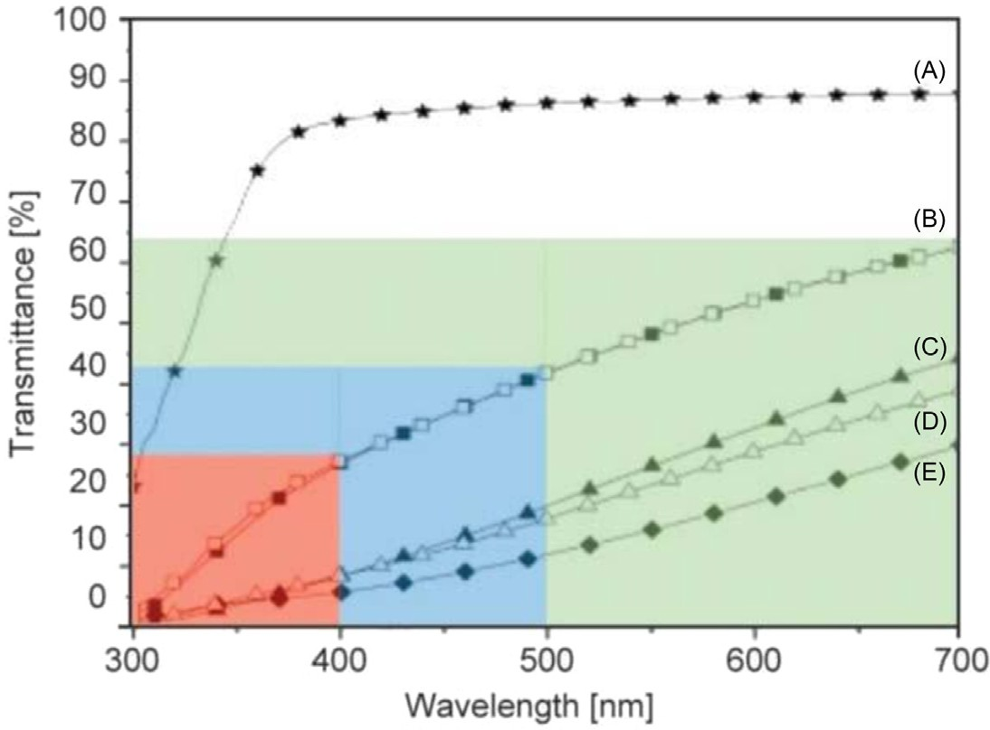
Fig. 2. Light transmittance at various wavelengths of the light used of melt compounded polycarbonate (PC)/Al₂O₃ nanocomposites: (A) PC neat resin, (B) PC with 1 wt.% nanoparticles of 96 nm subjected to centrifuge treatment, as well as PC with 1 wt.% nanoparticles of 30 nm subjected to centrifuge treatment, (C) PC with 2 wt.% nanoparticles of 96 nm subjected to centrifuge treatment, (D) PC with 2 wt.% nanoparticles of 30 nm subjected to centrifuge treatment, and (E) PC with 2 wt.% nanoparticles of 96 nm not subjected to centrifuge treatment [28].
Source: Adapted from A. Chandra, L.-S. Turng, K. Li, H.-X. Huang, Fracture behavior and optical properties of melt compounded semitransparent polycarbonate (PC)/alumina nanocomposites. Composites Part A: Appl. Sci. Manufact. 42 (2011) 1903—1909.
—
In addition to the dispersion problem, let us not forget some basic knowledge of composite science regarding the effect of reinforcing particle shape on the enhancement of mechanical properties of composite materials. Some of the properties, for example, elasticity modulus E, microhardness H [31] of polymers, and their composites obey the Rule of mixture. Contrasting E and H, the tensile strength σ does not obey the Rule of mixture. What is more, its enhancement can be observed only if the reinforcing particles are strongly anisometric, that is, their aspect ratio must not be smaller than 6, as demonstrated by modeling [32, 33] and experimental [34, 35] studies. Considering that practically all inorganic nanomaterials (rare exceptions are the nano whiskers) are isodiametric (with aspect ratios close to 1) [15], it follows that this fact only is a good reason for their modest mechanical performance experimentally observed.

- The electrospun polymers as reinforcement of nanocomposites

Electrospinning is a not expensive, not complex and at the same time a fascinating method for the preparation of ultrathin fiber-like materials (e.g. [8]). In fact, the diameters of the final products are in the nano-range and for this reason they attracted the attention of academia for using them as reinforcements in the preparation of polymer nanocomposites. Regardless of the severe problem with the dispersion of nanomaterials in polymer matrix [8] let us try to answer the question if these materials have the required properties, mostly mechanical, of the reinforcement of polymer nanocomposites.
—
—
The final textile fibers are characterized by extremely high molecular orientation leading to superior mechanical properties. Such an orientation is performed usually by means of drawing at temperatures above glass transition temperature (T_{g}) of the polymer but far below its melting temperature (T_{m}) (“cold drawing”). For majority of polymers (excluding the elastomers), this transition takes place via the necking phenomenon [36]. For this reason, the commercial manufacturing of synthetic polymer fibers comprises two basic steps: (i) extrusion trough spinnerets (melt-spinning), and (ii) cold drawing via necking. For example, PET single fibers prepared via the common melt-spinning have a modulus of elasticity (E) of 15000 MPa and a tensile strength (σ) of 1100 MPa [37]. The situation is quite similar with single fibers of Nylon 6 (PA 6) and Nylon 6,6 (PA 6,6) manufactured in the same way for which the E = 6000 MPa and σ = 1000 MPa [37]. At the same time, the mechanical performance of these three polymers in a bulk isotropic state are as follows: for PET - E = 2000 – 3000 MPa, σ = 50 – 150 MPa and for PA 6 and PA 6,6 - E = 2000 – 2500 MPa, σ = 50 – 80 MPa [38].
Based on the above considerations, we can define the polymer fibers as flexible anisotropic formations with cylindrical symmetry and molecular structure distinguished by high molecular orientation of extended parallel aligned molecules leading to superior mechanical performance.
What about the electrospun materials prepared from polymer solutions and melts? They are also flexible cylindrical formations belonging to the category of nanomaterials since they satisfy the definition suggested by European Commission of 2011 [1]. At the same time, they are distinguished by rather poor molecular orientation (if any!). Using various techniques, the local molecular orientation of the polymer chains within the fibers has been measured and found that the degree of orientation of the polymer chains with respect to the fiber axis increases with decreasing fiber diameters [39-43]. Although it has been shown by various researchers that electrospinning can induce some level of chain orientation in fibers based on flexible chain polymers, these levels are often rather low [39].
Of particular importance for the issue discussed are the results of small angle neutron scattering (SANS) studies on chain extension in electrospun polystyrene fibres [44]. These results are summarized in the excellent review of Ton Peijs et al. [39] on high strength and high modulus electrospun nanofibers in the following way: “…The SANS was used to quantify the size and shape of the chain conformation in electrospun fibers of deuterated atactic polystyrene prepared from solutions. Although the orientation parameter was found to increase with increasing collecting speed, the maximum value of about 0.15 was well below the orientation parameter expected for high performance polymer fibers with values typically approaching 1. When the tangential velocity of the rotating collector was greater than the flight velocity of the fibers some degree of orientation of the polymer coils was induced. However, even at the highest collector speeds the ratio of the radii of gyration increased only by 20% from bulk (17 nm) to fibers (20 nm), showing limited coil deformation. As the diameters of these fibers were much greater than the polystyrene radius of gyration these effects can be solely contributed to flow induced orientation, excluding size or confinement effects as a result of nanosized fiber diameters”.
The findings by using SANS [44] are of a paramount importance. They demonstrate that the prepared via electrospinning technique extremely fine cylindrical formations with diameters in the nano-range represent an isotropic material. Polymer fibers, as discussed above, comprise highly extended macromolecules aligned parallel to each other and thus demonstrate superior mechanical properties. The lack of molecular orientation in the electrospun materials is obviously the main reason for their inferior mechanical performance. As stated in a review on polymer nanofibers by electrospinning and their applications in nanocomposites [45], the mechanical properties of most electrospun polyamide and polyester fibers are not comparable with conventional microfibers manufactured by melt-spinning, which again can be ascribed to the low degree of chain orientation in these as-spun nanofibers and the absence of a post-drawing step in the electrospinning process. In fact, in many cases the properties of electrospun fibers are even inferior to that of the bulk polymer. For example, the E modulus of electrospun single nanofiber of PA 6 is reported to be 1320 ± 152 MPa and the tensile strength σ = 78.1 ± 6.0 MPa [46]. Quite similar are the results for electrospun single nanofibers of the same polymer (E = 902 MPa, σ = 304 MPa) of another report [47]. Almost the same values (E = 950 ± 390 MPa, = 150 ± 49 MPa) have been found for electrospun PA 6,6 single nanofibers [48].
Obviously, in addition to the general problem of the proper dispersion of nanomaterials into matrix [15], the electrospun polymer nanofibers cannot be used as reinforcement for manufacturing of polymer nanocomposites because their mechanical properties are close or even worse than those of the polymer matrix. It turned out that “nano-sized” does not mean necessarily “superior mechanical performance”. The sizes only are not enough, something more is needed!
In conclusion, the use of the term “polymer fibers” to electrospun polymers is misleading because this term assumes superior mechanical properties due to the perfect orientation of the parallel aligned macromolecules. Such an orientation in the case of electrospun polymers is missing and therefore their mechanical performance is poor – close to or below than that of the same materials in an isotropic state. For this reason, with respect of their molecular structure and mechanical behavior, the famous electrospun nanofibers represent sooner “nano-sized macaroni”
Possibly, it would be more correct if the electrospun polymeric materials will be called “fiber-like nanomaterials” instead of electrospun nanofibers, as already suggested [49]. Genuine polymer nanofibers can be manufactured by using the concept of “converting instead of adding” [50, 51] developed for overcoming the practically non-soluble problem of proper nanomaterial dispersion during preparation of polymer nanocomposites via blending the reinforcing and matrix components. Because these nanofibers are prepared via necking process during the cold drawing, they are characterized by perfect molecular orientation as well as by superior mechanical performance.
- Conclusions
There is currently a complete consensus among the researchers of polymer nanocomposites prepared via melt blending of the two basic components, the matrix and the reinforcement, that the maximum improvement of their mechanical properties is 30% - 35% as compared with the respective neat isotropic matrix [3 – 8]. The expected improvement was 10-fold (at least!) [e.g. 3].
This drastic difference between expectations and reality is mostly related to the unproper dispersion of reinforcement in the matrix as manyfold proven by light scattering measurements on fully transparent polymer nanocomposites where the sizes of the single particles are of a couple hundred nanometers [15 – 29].
Coming back to the terminological issue it should be noticed that it is hardly correct to classify the above-discussed composites as “nanocomposites” because they, in fact, belong to the category of microcomposites. In such a case the answer to the question regarding the drastic difference between expected and observed mechanical properties of polymer nanocomposites prepared via blending the matrix and reinforcement seems to be easier. These materials do not justify the expectations derived according to the nanocomposites concept because they are not nanocomposites - they are microcomposites. The situation is quite interesting because it could be considered from its reverse side - the lack of agreement between observed and predicted mechanical properties supports the conclusion that these composites are not of nano-type. Moreover, this can be proven if we succeed in preparing real polymer nanocomposites and measure their mechanical properties as will be demonstrated in the second part of this review [52].
It appears that currently we do not have reliable tools and/or techniques for a proper dispersion of nanomaterials in polymer melts to reach the dispersion degree of single nano particles what is the requirement for having true nanocomposites. Obviously, if the respective tools and techniques are missing, for the preparation of such composites one must use methods free of the dispersion step in the manufacturing process [52].

Acknowledgments
The author appreciates the Publishers Kingfa and Elsevier for using materials from their publications (mostly by the author of the current review).

References
- Nanomaterials, European Commission, ,https://ec.europa.eu/environment/chemicals/ nanotech/faq/definition_en.htm..
- S. Iijima, Helical microtubules of graphitic carbon, Nature 354 (1991) 56 58.
—
- D.W. Schaefer, R.S. Justice, How nano are nanocomposites? Macromolecules 40 (2007) 8501—8517.

- K. Friedrich, S. Fakirov, Z. Zhang (Eds.), Polymer Composites: From Nano- to Macro-Scale, Springer, New York, 2005.
- M. Bousmina, Fundamental insight into polymer nanocomposites, Abstracts of 21-st Annual Meeting Of Polymer Processing Society (PPS 21), Leipzig, Germany, 2005 p. 219.
- M.Q. Zhang, M.Z. Rong, K. Friedrich, Application of non-layered nanoparticles in polymer modification, in: K. Friedrich, S. Fakirov, Z. Zhang (Eds.), Polymer Composites, Springer Science and Business Media, New York, 2005, pp. 25-44.
—
- S.K. Kumar, B.C. Benicewicz, R.A. Vaia, K.I. Winey, 50th anniversary perspective: are polymer nanocomposites practical for applications? Macromolecules 50 (2017) 714 - 731.
—
- A. Greiner, J.H. Wendorff, Electrospinning: A fascinating method for the preparation of ultrathin fibers, Angew. Chem. Int. Ed. 46 (2007) 5670 - 5703.
—
- D.D.L. Chung, Comparison of submicron-diameter carbon filaments and conventional carbon fibers as fillers in composite materials, Carbon 39 (2001) 1119 -1125.
—
- S. Fakirov, Polymer nanocomposites: problems, preparation, mechanical properties, Adv. Mater. Lett. 9 (2018) 400 -405.
—
- Y. Zare, Study of nanoparticles aggregation/agglomeration in polymer particulate nano-composites by mechanical properties, Compos. Part. A: Appl. Sci. Manuf. 84 (2016) 158 - 164.
—
- M.S. Islam, R. Masoodi, H. Rostami, The effect of nanoparticles percentage on mechanical behavior of silica-epoxy nanocomposites, J. Nanosci. (2013). 275037/1275037/10.
—
- J. Liu, Y. Gao, D. Cao, L. Zhang, Z. Guo, Nanoparticle dispersion and aggregation in polymer nanocomposites: insights from molecular dynamics simulation, Langmuir 27 (2011) 7926 -7933.
—
- G. Hou, W. Tao, J. Liu, Y. Gao, L. Zhang, Y. Li, Tailoring the dispersion of nanoparti-cles and the mechanical behavior of polymer nanocomposites by designing the chain architecture, Phys. Chem. Chem. Phys. 19 (2017) 32024 -32037.
—
- S. Fakirov, Polymer nanocomposites: why their mechanical performance does not just-ify the expectation and a possible solution to the problem? Express Polym. Lett. 14 (2020) 436 -466.
- A. Anzlovar, Z.C. Orel, M. Zigon, Sub micrometer and nano ZnO as filler in PMMA materials, Materiali Tehnologije 45 (2011) 269- 274.
—
- J. Loste, J.-M. Lopez-Cuesta, L. Billon, H. Garay, M. Save, Transparent polymer nano-composites: an overview on their synthesis and advanced properties, Prog. Polym. Sci. 89 (2019) 133 --158.
—
[18] S. Fakirov, Nanofibrillar polymer-polymer and single polymer composites via the “converting instead of adding” concept - Examples of true polymer nanocomposite, Adv. Ind. Eng. Polym. Res. 1 (2018) 40-47.
[19] H. Wang, P. Xu, W. Zhong, L. Shen, Q. Du, Transparent poly (methylmethacrylate)/silica/zirconia nanocomposites with excellent thermal stabilities, Polym. Degrad. Stabil. 87 (2005) 319-327.
[20] Y. Hu, S. Zhou, L. Wu, Surface mechanical properties of transparent poly (methyl methacrylate)/zirconia nanocomposites prepared by in situ bulk polymerization, Polymer 50 (2009) 3609-3616.
[21] Y. Zhang, X. Wang, Y. Liu, S. Song, D. Liu, Highly transparent bulk PMMA/ZnO nanocomposites with bright visible luminescence and efficient UV-shielding capability, J. Mater. Chem. 22 (2012) 11971-11977.
[22] L.M. Clayton, A.K. Sikder, A. Kumar, M. Cinke, M. Meyyappan, T.G. Gerasimov, J.P. Harmon, Adv. Funct. Mater. 15 (2005) 259-266.
[23] Y.A. Barnakov, B.L. Scott, V. Golub, L. Kelly, V. Reddy, K.L. Stokes, Spectral dependence of Faraday rotation in magnetite-polymer nanocomposites, J. Phys. Chem. Solids 65 (2004) 1005-1010.
[24] V. Pagliarulo, G. Carotenuto, G.P. Pepe, D. Davino, C. Visone, A. Longo, F. Capezzuto, Synthesis and characterization of polymer embedded iron oxide nanocomposites, Microw. Optic. Technol. Lett. 51 (2009) 2774-2777.
[25] O. Parlak, M.M. Demir, Anomalous transmittance of polystyreneeceria nanocomposites at high particle loadings, J. Mater. Chem. C 1 (2013) 290-298.
[26] J. Huang, Y. Yang, S. Xue, B. Yang, S. Liu, J. Shen, Photoluminescence and electroluminescence of ZnS: Cu nanocrystals in polymeric networks, Appl. Phys. Lett. 70 (1997) 2335-2337.
[27] H.R. Hakimelahi, L. Hu, B.B. Rupp, M.R. Coleman, Synthesis and characteriza tion of transparent alumina reinforced polycarbonate nanocomposite, Polymer 51 (2010) 2494e2502.
[28] A. Chandra, L.S. Turng, K. Li, H.X. Huang, Fracture behavior and optical properties of melt compounded semi-transparent polycarbonate (PC)/alumina nanocomposites, Composites Part A Appl. Sci. Manuf. 42 (2011) 1903-1909.
[29] M.I. Sarwar, S. Zulfiqar, Z. Ahmad, Investigating the property profile of polyamide - alumina nanocomposite materials, Scrip. Mater. 60 (2009) 988-991.
[30] H. van de Hulst, Light Scattering by Small Particles, Wiley, New York, 1957.
[31] F. Balta Calleja, S. Fakirov, Microhardness of Polymers, Cambridge University Press, Cambridge, 2007.
[32] C.J.R. Verbeek, The influence of interfacial adhesion, particle size and size distribution on the predicted mechanical properties of particulate thermoplastic composites, Mater. Lett. 57 (2003) 1919—1924.
—
[33] C.J.R. Verbeek, W.W. Focke, Modelling the Young’s modulus of platelet reinforced thermoplastic sheet composites, Compos. Part. A: Appl. Sci. Manuf. 33 (2002) 1697 -1704.
—
—
[34] H.-H. Kausch, Polymer Fracture, Springer, Heidelberg, 1987.
—
—
—
—
[35] W. Yan, R.J.T. Lin, D. Bhattacharyya, Particulate reinforced rotationally moulded poly-ethylene composites mixing methods and mechanical properties, Compos. Sci. Technol. 66 (2006) 2080-2088.
—
—
—
—
[36] 1.S. Fakirov, S.; Fundamentals of Polymer Science for Engineers, WileyVCH, Weinheim, 2017, pp. 147-149.
[37] 2. A. Ajji, P. Coates, M. Dumoulin, I. Ward, Solid Phase Processing of Polymers, Carl Hanser Verlag, Munich, 2000, pp. 85–210.
[38] 3. J.G. Cook, Handbook of Textile Fibres: Man-made Fibres, Woodhead Publishing Limited, Cambridge, UK, 1984, pp. 192- 391.
[39] J. Yao, W. Cees, M. Bastiaansen, T. Peijs, High strength and high modulus electrospun nanofibers, Fibers, 2 (2014) 158-187.
[40] D.Y. Lin, D.C. Martin, Orientation Development in Electrospun Liquid-Crystalline Polymer Nanofibers, in: Polymeric Nanofibers, ACS Symposium Series, 2006, 918, 330-342.
[41] M. Richard-Lacroix, C. Pellerin, Molecular orientation in electrospun fibers: from mats to single fibers, Macromolecules 46 (2013) 9473-9493.
[42] S. Mihammadzadehmoghadam, Y. Dong, S. Barbhuiya, L. Guo, D. Liu, R. Umer, X. Qi, Y. Tang, Electrospinning: Current Status and Future Trends, In Nano-size Polymers: Preparation, Properties Applications, Fakirov, S.; (Ed.), Springer, Switzerland, 2016, pp. 89-154.
[43] D. Papkov, C. Pellerin, Y.A. Dzenis, Polarized Raman analysis of polymer chain orientation in ultrafine individual nanofibers with variable low crystallinity, Macromolecules, 51 (2018) 8746 - 8751.
[44] S.D. Mohan, G.R. Mitchell, F.J. Davis, Chain extension in electrospun polystyrene fibres: A SANS study, Soft Matter, 7 (2011) 4397–4404.
[45] Z.M. Huang, Y.Z. Zhang, M. Kotaki, S. Ramakrishna, A review on nanofiber polymers by electrospinning and their applications in nanocomposites, Compos. Sci. Technol., 63 (2003) 2223 -2253.
[46] F. Hang, D. Lu, R.J. Bailey, I. Jimenez-Palomar, U. Stachewicz, B. Cortes-Ballesteros, M. Davies, M. Zech, C. Bödefeld, A.H. Barber, In situ tensile testing of nanofibers by combining atomic force microscopy and scanning electron microscopy, Nanotechnology, 22 (2011) 365708, doi: 10.1088/0957-4484/22/36/365708.
[47] M.B. Bazbouz, G.K. Stylios, The tensile properties of electrospun nylon 6 single nanofibers, J. Polym. Sci. Part B Polym. Phys., 48 (2010) 1719- 1731.
[48] E. Zussman, M. Burman, A. Yarin, R. Khalfin, Y. Cohen, Tensile Deformation of Electrospun Nylon-6,6 Nanofibers, J. Polym. Sci. Part B Polym. Phys. 44 (2006) 1482 -1489.
[49] S. Fakirov, Are electrospun polymers polymeric fibers? Adv. Mater. Lett. 11 (2020) 20011456.
[50] S. Fakirov, Nano-/microfibrillar polymer-polymer and single polymer composites: the converting instead of adding concept, Compos. Sci. Technol. 89 (2013) 211-225.

[51] S. Fakirov, The Concept of Micro- or Nanofibrils Reinforced Polymer-Polymer Composites, In Synthetic Polymer-Polymer Composites, D. Bhattacharyya, S. Fakirov, (Eds.), Hanser, Munich, 2012, pp. 353-400.
[52]. S. Fakirov, Polymer nanocomposites. Part 2: Possible solution to the problem of the large discrepancy between expected and observed mechanical properties, Adv. Ind. Eng. Polym. Res. ? (2026) ? - ?.

