From Novel Proteins to New Drugs: MISTRAL’s Generative
Capabilities in De Novo Drug Design
Your Name Co-Author Name
February 27, 2025
Abstract
The discovery of new drugs is a complex process that requires the identification of molecules capable of interacting specifically and effectively with target proteins, often associated with diseases. However, a major challenge in this field is predicting drug-protein interactions when the target protein is entirely novel, i.e., it has never been encountered during the model’s training. This scenario is particularly relevant for emerging diseases or proteins with limited structural or functional information. In this study, we investigate the predictive capabilities of an advanced generative model, Mistral*, in scenarios where the target protein is entirely new, and the model must identify suitable drug candidates based solely on the protein target. Our results demonstrate the model’s ability to generalize to unseen proteins and explore uncharted regions of chemical space, offering new opportunities for drug discovery in data-scarce contexts.

1 Introduction
De novo drug discovery is a complex process that involves identifying molecules capable of interacting specifically and effectively with target proteins, typically associated with diseases. A key challenge is predicting drug-protein interactions when the target protein is novel, i.e., it has not been encountered during model training. This is particularly relevant for emerging diseases or proteins with limited structural or functional data. The ability to predict such interactions is crucial for designing specific or personalized drugs for individual patients, advancing the field of precision medicine. It is also essential for addressing new diseases or those that develop drug resistance over time due to genetic evolution.
In recent years, deep learning-based generative models have shown significant potential in generating pharmacologically active molecules. However, most approaches focus on scenarios where target proteins are wellcharacterized or part of the training set. Few studies have explored the ability of these models to generalize to entirely new proteins, a fundamental requirement for accelerating drug discovery in data-scarce or data-absent contexts.
Our work aims to bridge this gap by investigating the predictive capabilities of an advanced generative model, Mistral*, in scenarios where the objective is to generate novel, valid, and synthesizable drug-like molecules with high binding affinity to target proteins, including those never seen during training. This is achieved through conditional molecular generation, where the model is specifically trained on protein-drug pairs to learn the relationships between protein structures and drug molecules. The model’s key strengths include:
- Generalization to unseen proteins: The model can generate molecules for proteins not included in the training set, demonstrating its ability to generalize and learn meaningful representations of protein-drug interactions without overfitting.
- Exploration of chemical space: It produces valid, unique, and novel molecules with good binding affinity, indicating effective exploration of chemical space while maintaining biological relevance.
- Optimization for drug discovery: Mistral* is tailored for drug discovery applications, focusing on generating molecules that bind to specific protein targets, even in cases of emerging diseases or proteins with limited structural data.
- Synthesizability and reduced side effects: The model aims to generate molecules that are not only effective but also synthesizable and with minimal side effects, making them more suitable for real-world drug development.
- Handling complex data: Its ability to manage long sequences or structured data (e.g., protein and drug representations) is a significant advantage, enabling it to process complex biological and chemical information
effectively.
The primary goal of Mistral* is to accelerate drug discovery by generating novel, high-affinity, and synthesizable drug candidates for both known and novel protein targets, with a focus on precision, generalizability, and reduced side effects. This makes it a powerful tool for addressing challenges in precision medicine, emerging diseases, and drug resistance.

2 Related Work
The landscape of drug discovery is undergoing a profound transformation, driven by the need to explore the vast chemical space with unprecedented efficacy and creativity. Historically, this has included high-performance computing and structure-activity relationship (SAR) studies, which, although fundamental, often lacked scalability. Recent developments in generative approaches have initiated a paradigm shift, enabling researchers not only to optimize potential therapies but also to innovate in therapeutic development.
Generative models, leveraging machine learning and artificial intelligence, are among the most notable contributions. These models integrate biological and chemical data, demonstrating the ability to navigate complex chemical spaces and create compounds that are difficult to access through traditional methods. For example, [1] proposed a deep generative model focused specifically on protein targets, a crucial step in aligning molecular and biological objectives with greater precision.
Furthermore, advances in three-dimensional (3D) generative modeling have introduced innovative architectures that are not only novel but also optimized for desired biological activity. These models emphasize their promise in designing complex ligands that can interact in new ways, facilitating a more rational drug design process and overcoming methodologies that often lacked direction [7].
The COVID-19 pandemic highlighted the need for rapid drug discovery, and generative models have proven effective in addressing urgent public health challenges. [4] illustrated how these frameworks can accelerate the therapeutic development process, showcasing their adaptability and potential to address challenges beyond the reach of traditional approaches.
Generative models are not limited to molecular design; they also extend to the realm of efficacy. [2] reflect on these methodologies, advocating that deep generative structures and their associated biological activities allow for better predictions and optimization of lead compounds. This capability enhances bioavailability and refines compounds that were often discarded in earlier drug discovery phases [3].
The integration of artificial intelligence and machine learning technologies into the drug discovery process has led to a more comprehensive understanding of how these models can design therapeutic compounds. This bridges the gap between computational methodologies and experimental research, enabling researchers to exploit multimodal data, including genomic, proteomic, and interaction data, to understand how compounds interact with biological systems [9].
The versatility of generative models is further illustrated by their potential to revolutionize not only smallmolecule therapeutics but also bioactive compounds. [8] describes the extensive implications of integrating generative deep learning, contextualizing the emergence of new therapies and exploring drug-like properties.
Another significant advancement is the use of generative recurrent networks, which have been effectively trained on existing chemical libraries to push the boundaries of traditional drug candidates. [6] demonstrated the efficiency of these models in the drug discovery process, highlighting their key role in navigating the complex landscape of chemical space.
The implications of generative modeling extend beyond efficiency and innovation. Interdisciplinary collaboration between computational chemists, biologists, and researchers is crucial to understanding how new chemical entities progress through development phases, ensuring that these models are not only innovative but also practical [11].
In summary, generative models represent a radical shift in drug discovery methodologies. Their contributions range from improved molecular design to addressing the complexities of modern therapeutic development. By synthesizing various applications and methodologies, these models pave the way for future advances in the field. As the complexity of diseases grows, generative models will undoubtedly play a fundamental role in enriching our therapeutic arsenal.

3 Methods and Materials

3.1 Dataset
The datasets utilized in this study were obtained from ChEMBL 26 (Human) and consist exclusively of data derived from scientific literature, with a particular emphasis on clinical or pharmacological interaction outcomes. The data include both binding assays and functional assays, ensuring that the drugs incorporated have confirmed interactions with the target protein. This feature is essential for investigating drug-protein interactions, as it ensures the relevance and reliability of the data for model training and evaluation. From this dataset, we downloaded 437,410 drug-protein pairs.
The dataset was divided into training and test sets, with the test set comprising proteins that were not encountered during the training phase. The SMILES representations of the drugs were preprocessed by applying sequential filters to eliminate stereochemistry. SMILES containing isomer-related information, such as @, @@ (chirality), and ( /) (cis-trans), were excluded. Following this screening process, the training set comprised 304,139 drug-protein pairs.

3.2 Experimental setup

3.2.1 First Experiment: Unknown Protein target generation
The model was trained on drug-protein pairs to learn the chemical space between proteins and their corresponding drugs. During the training phase, the model was exposed to paired data, enabling it to capture the underlying relationships between the chemical structures of the drugs and their target proteins. For the testing phase, instead of providing the model with drug-protein pairs, only the protein structures were supplied. The model was then tasked with generating potential drug candidates, represented as SMILES strings, that could bind to these proteins.
Following the generation of drug candidates, a rigorous evaluation process was conducted to assess the quality and validity of the generated SMILES strings. This involved verifying the chemical feasibility of the generated molecules and their potential binding affinity to the target proteins. The evaluation process ensured that the model’s outputs were not only chemically valid but also biologically relevant, aligning with the goal of discovering novel drug candidates.

3.2.2 Second Experiment: Specific Protein Targets
In the second experiment, the model was subjected to a specific test in which only two well-known proteins were provided, identified by the PDB IDs: 6cm4 and 7kk4. These proteins correspond to the dopamine D2 receptor (DRD2, Uniprot ID: P14416) [5] and poly [ADP-ribose] polymerase 1 (PARP1, Uniprot ID: P09874) [10], respectively. The objective of this experiment was to evaluate the model’s ability to generate pharmacologically relevant drug candidates, represented as SMILES strings, that could specifically bind to these two target proteins.
During the test, the model generated a series of molecules represented in SMILES format, which were subsequently subjected to a rigorous evaluation process. This process included verifying the chemical validity of the generated molecules and analyzing their potential binding affinity to the target proteins. The goal was to ensure that the generated molecules were not only chemically feasible but also biologically relevant, in line with the objective of discovering novel drug candidates capable of specifically interacting with DRD2 and PARP1.
This experiment further assessed the model’s ability to generalize and generate molecules with therapeutic potential, even in well-defined and specific contexts, such as the selected target proteins. The results demonstrated the model’s capability to produce chemically valid and biologically relevant drug candidates, highlighting its potential for drug discovery applications.

3.3 Evaluation Metrics
To rigorously evaluate the performance of our generative model, we utilized a comprehensive set of metrics designed to assess the validity, uniqueness, novelty, physicochemical properties, docking scores, structural similarity, and pharmacokinetic/ADMET profiles of the generated molecules. The key metrics and methodologies employed in this evaluation are outlined below.

3.3.1 Performance Metrics for Generative Models
The performance of the model was evaluated using the RDKit library in Python, with a focus on three principal
metrics:
- Validity (Valid): This metric quantifies the proportion of syntactically and semantically valid compounds generated by the model. A SMILES string is deemed valid if it conforms to the correct syntax and represents a chemically feasible molecule. The validity is computed as follows:
Valid 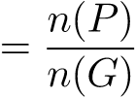
where:
  - n(P) denotes the number of valid compounds.
  - n(G) represents the total number of generated compounds.
In our experimental setup, out of 10,782 generated SMILES strings, 10,733 (99.55%) were valid. This high validity rate underscores the model’s proficiency in generating chemically feasible molecules.
- Uniqueness (Unique): This metric captures the fraction of unique compounds among the valid ones. A higher uniqueness value signifies a more diverse set of generated compounds, which is pivotal for exploring a broad chemical space. The uniqueness is calculated as:
Unique 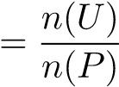
where:
  - n(U) denotes the number of unique compounds.
  - n(P) represents the number of valid compounds.
In our experiments, 6,140 (57.21%) of the valid SMILES strings were unique, while 4,593 (42.79%) were duplicates. This indicates that the model is capable of generating a diverse array of compounds, albeit with some redundancy that could be further minimized.
- Novelty (Novel): This metric measures the proportion of generated compounds that are absent from the test dataset. It is crucial for evaluating the model’s capacity to generate novel and previously unseen molecules.
The novelty is computed as:
Novel 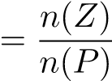
where:
  - n(Z) denotes the number of generated compounds that are not present in the test dataset.
  - n(P) represents the total number of valid and unique generated compounds.
The novelty calculation yielded the following results:
  - Total number of valid and unique generated SMILES: 6,140.
  - Number of generated SMILES not present in the test set (novel compounds): 5,389.
  - Novelty: 0.8777 (87.77%).
This high novelty score accentuates the model’s ability to generate compounds that are not only chemically valid and unique but also novel in comparison to the test dataset.

3.4 Statistical Analysis of Dataset Overlaps
To further evaluate the model’s performance, we conducted a detailed statistical analysis of the overlaps and uniqueness across the generated, training, and test datasets, focusing on valid and unique SMILES. Among the various analyses performed, one result stands out as particularly noteworthy:
• Overlap between generated and test datasets:
- Number of unique SMILES present in both the test and generated files but not in the training file: 4.
- Percentage of unique SMILES in both test and generated files but not in the training file: 0.53%.
This result is significant because, despite the model not having access to the SMILES in the test dataset during training, it successfully generated 4 approved drugs that are present in the test dataset but absent from the training dataset. Although the quantity is small, this demonstrates the model’s ability to generate real, approved drugs, which is a remarkable achievement. It highlights the model’s potential to produce chemically valid and biologically relevant molecules, even in the absence of explicit knowledge of the test dataset. This capability is particularly valuable in drug discovery, where generating novel yet biologically active compounds is a key
objective.

3.4.1 Summary of Metrics
The evaluation metrics collectively demonstrate the model’s efficacy in generating a high proportion of valid, unique, and novel compounds. Specifically:
- Validity: 99.55% of the generated SMILES were valid, indicating robust chemical feasibility.
- Uniqueness: 57.21% of the valid SMILES were unique, reflecting a diverse chemical space.
- Novelty: 87.77% of the unique and valid SMILES were novel, highlighting the model’s ability to generate previously unseen compounds.
The statistical analysis further reveals that:
- The model successfully generated 4 approved drugs that are present in the test dataset but absent from the training dataset, achieving a 0.53% overlap. This demonstrates the model’s ability to generate real, biologically relevant molecules, even without prior exposure to the test dataset.
These results underscore the effectiveness of our generative model in producing chemically valid, diverse, and novel molecules, as validated by the RDKit toolkit and comprehensive statistical analyses.

3.5 Physicochemical Property Filters
To ensure that the generated molecules exhibit drug-like properties and are chemically feasible, a comprehensive set of physicochemical property filters was implemented using the RDKit toolkit in Python. These filters are grounded in well-established criteria for drug-likeness, encompassing molecular weight, hydrogen bond donors and acceptors, lipophilicity (LogP), synthetic accessibility (SA), quantitative estimate of drug-likeness (QED), topological polar surface area (TPSA), and other relevant properties. The following sections provide a detailed description of the filtering process.

3.5.1 Filtering Criteria
The generated molecules were subjected to the following filtering criteria:
- Molecular Weight (MW): 200 ≤ MW ≤ 500 Da.
- Hydrogen Bond Acceptors (HBA): HBA ≤ 10.
- Hydrogen Bond Donors (HBD): HBD ≤ 5.
- LogP: −1 ≤ LogP ≤ 6.
- Quantitative Estimate of Drug-likeness (QED): 0 ≤ QED ≤ 1.
- Synthetic Accessibility (SA): 1 ≤ SA ≤ 5.
- Topological Polar Surface Area (TPSA): 20 ≤ TPSA ≤ 130 A˚ ².
- Aromatic Rings: ≥ 1.
- Number of Rotatable Bonds and Heavy Atom Count: Additional parameters were considered to assess
molecular flexibility and complexity.
This customized filter integrates and extends the classical Ghose, Veber, and Lipinski rules, retaining fundamental criteria for drug-likeness (such as HBA, HBD, MW, and LogP) while incorporating additional parameters (QED, SA, aromaticity, rotatable bonds, and heavy atom count) to provide a more comprehensive evaluation of pharmacokinetic properties and synthetic feasibility. This approach ensures the selection of molecules not only with favorable absorption and permeation characteristics but also with a robust profile in terms of synthetic tractability and structural stability.

3.5.2 Removal of Undesirable or Toxic Functional Groups
To eliminate molecules containing undesirable or toxic functional groups, the following rule-based filters were applied:
- PAINS Filter: Identifies molecules prone to nonspecific binding or assay interference.
- BRENK Filter: Removes molecules containing problematic functional groups (e.g., nitro groups, thiols).
- NIH Filter: Detects reactive or undesirable groups (e.g., aldehydes, alkyl halides).
Following the application of these filters, a total of 3,383 unique SMILES (55.09% of the initial valid set) remained. This refined dataset represents molecules with enhanced drug-like properties and reduced risk of toxicity or synthetic challenges.

3.6 Molecular Optimization and Conformational Energy Analysis
After applying the physicochemical property filters, the remaining SMILES strings were converted into molecular structures and subjected to geometry optimization. Initial optimization was performed using the Universal Force Field (UFF) through the UFFOptimizeMolecule function. For molecules where UFF optimization was not feasible, the Merck Molecular Force Field (MMFF) was applied via the MMFFOptimizeMolecule function. This two-tiered approach ensured robust conformational energy minimization across the dataset.
Following optimization, Morgan fingerprints were generated from the optimized molecular structures. These fingerprints provide a quantitative and high-dimensional representation of molecular features, encoding the presence and spatial distribution of substructures and functional groups. A radius of 2 and a 2048-bit vector were selected for fingerprint generation. This configuration strikes a balance between computational efficiency and the minimization of hash collisions, where distinct structural features might otherwise map to the same bit in the fingerprint vector.
This process resulted in a refined set of 2,043 molecules, representing 33% of the initial pool of valid and unique SMILES strings. The optimized molecular structures and their corresponding fingerprints form a robust and chemically diverse dataset, suitable for subsequent analyses. This ensures both the chemical validity of the molecules and the structural diversity necessary for meaningful exploration in downstream applications.

3.7 Conformational Energy Calculations
To assess the stability of the optimized molecules, the conformational energy of each molecule was calculated. Conformational energy refers to the energy associated with the three-dimensional arrangement of atoms in a molecule, which directly influences its stability and reactivity. This calculation is a fundamental step in computational chemistry and pharmaceutical research, as it provides critical insights into the molecular stability and potential drug-likeness of compounds.
The importance of conformational energy calculations extends to several applications in the chemical and pharmaceutical industries, including:
- Optimization of Novel Compound Synthesis: By identifying the most stable conformations, researchers can streamline the synthesis of new compounds.
- Cost Reduction in Drug Development: Early identification of promising drug candidates with favorable stability profiles reduces development costs.
- Study of Material Stability: These calculations are also valuable for investigating the stability of polymeric materials and nanostructured systems.

3.8 Energy Units and Hartree Conversion
The conformational energies were computed and expressed in Hartree (Ha), a unit of energy commonly used in quantum chemistry. One Hartree is approximately equivalent to 27.2114 electron volts (eV). The Hartree unit is preferred in quantum chemical calculations due to its natural alignment with the theoretical framework of quantum mechanics, providing a consistent and interpretable metric for energy comparisons.
By converting the conformational energies into Hartree units, the results are standardized, facilitating direct comparisons across different molecules and enabling a more robust evaluation of their relative stabilities. This approach ensures that the most stable and promising candidates are identified for further investigation in drug discovery and material science applications.

4 Evaluation of the Targeted Generative Model via Molecular Docking
Molecular docking was employed to evaluate the binding interactions between the generated compounds and target protein structures, with docking scores serving as a key metric for assessing binding affinity. The Vina docking package [12] was utilized to compute these scores, which are based on electrostatic and van der Waals interactions. From an initial set of 19 proteins, 17 were selected for detailed docking analysis using AutoDock Vina, focusing on binding interactions and the identification of high-affinity compounds.

4.1 Docking Procedure and Binding Affinity
The binding affinity of the generated molecules was evaluated using docking scores computed with the Glide module and AutoDock Vina. A docking score threshold of ≤−8.18 kcal/mol was established to indicate moderate bioactivity. The proportion of generated molecules exhibiting higher binding affinity than the reference ligands was calculated and summarized in Table 2 and Table ??.
To further assess the quality of the generated molecules, the Wasserstein distance metric was employed to compare key physicochemical properties—molecular weight (MW), LogP, and topological polar surface area (TPSA)—between the generated molecules and the test set. This metric is particularly effective for comparing continuous or multidimensional distributions, providing a quantitative measure of divergence between the two datasets. Table 3 presents the Wasserstein distances for the protein 3D59, revealing strong similarities in most properties, with notable deviations observed in MW and TPSA.
To visualize these differences, Kernel Density Estimate (KDE) histograms were generated for each physicochemical property. These plots enable a direct comparison between the property distributions of the generated molecules and those of the test dataset, facilitating the identification of divergences or convergences. An example of the molecular property distributions for the protein 3D59 is provided in the Appendix (Figure 3, Figure 4).
Table 1: Comparison of molecules performance against threshold
Protein | Num Test  Better  Than  Threshold | % Test  Better  Than  Threshold | Num Gen  Better  Than  Threshold | % Gen  Better  Than  Threshold
3D59 | 47 | 63.51 | 53 | 58.24
6Y3C | 85 | 12.01 | 129 | 47.78
4XAO | 24 | 9.13 | 20 | 18.52
3KMR | 9 | 32.14 | 6 | 22.22
2FLU | 1 | 50.0 | 9 | 100.0
7E32 | 85 | 41.06 | 91 | 49.46
8YHF | 310 | 93.37 | 163 | 80.69
7DUA | 166 | 97.65 | 83 | 96.51
8X8L | 9 | 100.0 | 27 | 72.97
2D92 | 0 | 0.0 | 1 | 5.56
3ZCW | 115 | 45.1 | 76 | 60.32
1HY7 | 12 | 80.0 | 40 | 72.73
5WQC | 65 | 90.28 | 55 | 74.32
7WC8 | 555 | 66.87 | 366 | 80.09
4EAR | 3 | 4.76 | 10 | 23.81
8V3O | 11 | 6.75 | 5 | 10.87
4A69 | 0 | 0.0 | 57 | 29.69
Table 2: Performance against test set minimum affinity values
Protein | Test Best (min value) | Num Generated Better Than Test Best | % Generated Better Than Test Best
3D59 | -9.48 | 6 | 6.59
6Y3C | -9.67 | 25 | 9.26
4XAQ | -9.56 | 1 | 0.93
3KMR | -13.78 | 0 | 0.0
2FLU | -11.98 | 0 | 0.0
7E32 | -11.46 | 0 | 0.0
8YHF | -12.08 | 0 | 0.0
7DUA | -13.21 | 0 | 0.0
8X8L | -9.97 | 4 | 10.81
2D92 | -7.63 | 2 | 11.11
3ZCW | -10.16 | 5 | 3.97
1HY7 | -10.24 | 8 | 14.55
5WQC | -11.46 | 0 | 0.0
7WC8 | -12.55 | 1 | 0.22
4EAR | -9.41 | 0 | 0.0
8V3O | -9.04 | 0 | 0.0
4A69 | -8.05 | 67 | 34.9
Table 3: Wasserstein Distance for Chemical Properties: 3D59 Protein
Property | Wasserstein Distance
MW | 7.942
HBA | 0.426
HBD | 0.720
LogP | 0.488
QED | 0.053
SA | 0.038
TPSA | 5.538
Aromatic Rings | 0.460
Rotatable Bonds | 0.787
Heavy Atom Count | 0.525

4.2 Success Rate Evaluation
The success rate was defined as the percentage of generated molecules that met predefined criteria for druglikeness, synthesizability, and binding affinity. A molecule was deemed qualified if it satisfied the following thresholds:
- Quantitative Estimate of Drug-likeness (QED) ≥ 0.25,
- Synthetic Accessibility Score (SAscore) ≥ 0.59,
- Docking score (Vina score) ≤−8.18 kcal/mol.

4.3 Cumulative Analysis of Binding Affinities
The plot in Figure 1 shows the distribution of affinity between the generated drugs and the test drugs for the protein 6Y3C. A kernel density estimation (KDE) plot was used to compare the binding affinity distributions of the generated molecules and the test set. While some generated molecules exhibited high affinity (≤−8.18 kcal/mol), the majority displayed less negative scores compared to the test set, indicating potential areas for improvement in the generative model.
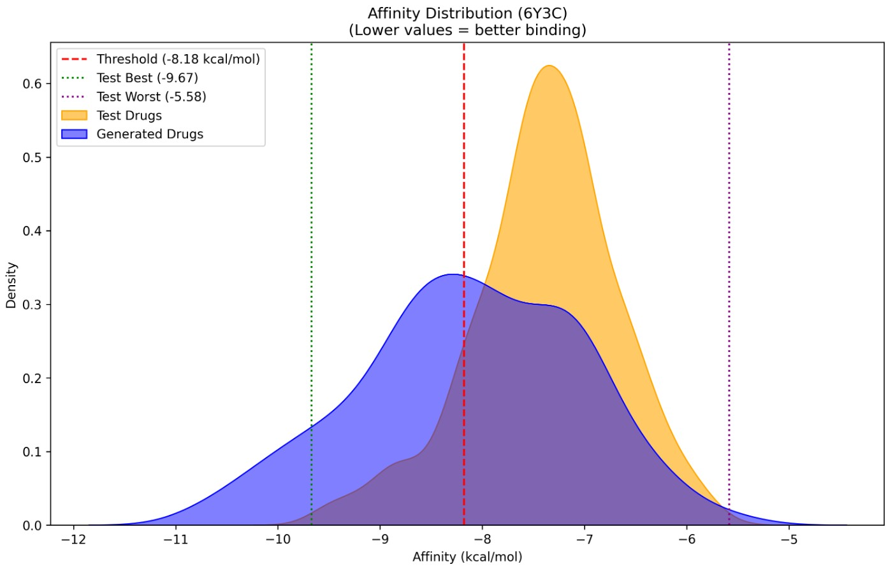
Figure 1: Distribution of affinities for protein 6Y3C. The plot compares the binding affinity distributions of generated molecules and test set molecules using a kernel density estimation (KDE). The threshold for high affinity is set at ≤−8.18 kcal/mol.

4.4 Structural Similarity and Deviation Analysis

4.4.1 Tanimoto Similarity
In addition to the Wasserstein distance, Tanimoto similarity was calculated to compare the generated molecules with those in the test dataset. Tanimoto similarity is particularly useful for binary feature-based comparisons, such as the presence or absence of specific functional groups. This metric provides a quantitative measure of structural overlap, ensuring that the generated molecules maintain a balance between novelty and chemical relevance, thereby minimizing the risk of overfitting to the training data.
Furthermore, Tanimoto similarity was employed to evaluate the three-dimensional (3D) structural similarity between the generated molecules and those in the test set. A similarity threshold of ≥ 0.8 was applied to identify molecules with significant structural overlap, ensuring that the generated structures retain chemically plausible features while maintaining a meaningful level of novelty.
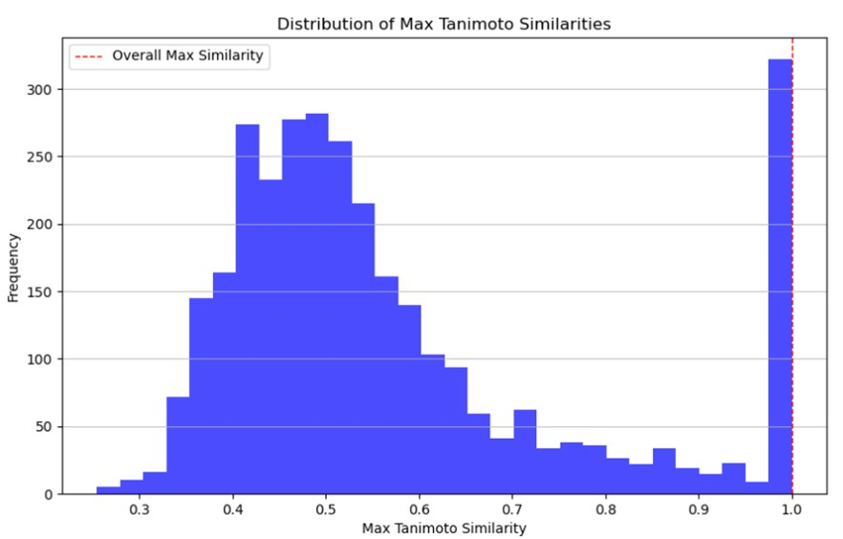
Figure 2: Distribution of Max Tanimoto Similarities. The plot shows the frequency of maximum Tanimoto similarity values between generated molecules and the test set. A threshold of ≥ 0.8 was used to identify molecules with significant structural overlap.

4.4.2 Root Mean Square Deviation (RMSD)
To further assess the structural alignment between the generated molecules and the reference molecules, the Root Mean Square Deviation (RMSD) was calculated using the AlignMol, AllChem, and GetBestRMSD functions from the RDKit library. RMSD is a widely used metric to quantify the average deviation in atomic positions between two molecular structures. The average RMSD value computed for the generated molecules was:
RMSD = 2.1877×10⁻⁸
This extremely low value, equivalent to 0.00000002187, indicates that the generated molecules are nearly identical to the reference molecules, with an average deviation in atomic positions very close to zero. Such precision suggests that the generation method is highly accurate and capable of producing molecules that align almost perfectly with the test set structures. This level of structural fidelity underscores the robustness of the generation approach in maintaining both chemical relevance and structural integrity.

4.5 Additional Insights

4.5.1 Analysis of PDB Proteins
Among the 17 Protein Data Bank (PDB) proteins investigated—characterized using experimental techniques such as X-ray crystallography, NMR, or cryo-EM—six structures (2D9Z, 3D59, 4A69, 6Y3C, 8X8L, and 8YHF) were found to lack associated ligands, small molecules, or binding affinity data. These ligand-free structures provided a unique opportunity to evaluate the performance of our generative model in predicting novel binding molecules.

4.5.2 Post-Processing and Binding Affinity Results
Post-processing of the generated molecules was performed, and binding affinities were calculated using AutoDock Vina. A molecule was considered qualified if it met the following thresholds: a Quantitative Estimate of Druglikeness (QED) ≥ 0.25, a Synthetic Accessibility Score (SAscore) ≥ 0.59, and a docking score (Vina score) ≤ −8.18 kcal/mol. The results, summarized in Table 4, revealed the following:
- For protein 1HY7, 7 generated molecule exhibited higher binding affinity than the ChEMBL reference
ligands.
- For protein 2D9Z, 1 generated molecules exhibited higher binding affinity than the ChEMBL reference
ligands.
- For protein 3ZCW, 3 generated molecule exhibited higher binding affinity than the ChEMBL reference
ligands.
- For protein 3D59, 5 generated molecules demonstrated superior binding affinity compared to the ChEMBL reference ligands.
- For protein 4A69, 49 generated molecules showed higher binding affinity relative to the ChEMBL reference
ligands.
- For protein 4XAQ, 1 generated molecules showed higher binding affinity relative to the ChEMBL reference
ligands.
- For protein 6Y3C, 22 generated molecules had higher binding affinity than the ChEMBL reference ligands.
- For protein 8X8L, 4 generated molecules displayed higher binding affinity compared to the ChEMBL reference ligands.
Table 4: Generated Molecules with Improved Binding Affinity Compared to Test Set
Protein Target | Test Affinity (kcal/mol) | Gen Affinity (kcal/mol) | N° Improved Generated Drugs
1HY7 | -10.24 | -11.45 | 7
2D9Z | -7.63 | -8.28 | 1
3ZCW | -10.16 | -10.79 | 3
3D59 | -9.48 | -10.43 | 5
4A69 | -8.05 | -9.97 | 49
4XAQ | -9.56 | -9.76 | 1
6Y3C | -9.67 | -10.80 | 22
8X8L | -9.97 | -10.41 | 4
These results were further validated using ADMET (Absorption, Distribution, Metabolism, Excretion, and
Toxicity) testing to ensure the drug-like properties of the generated molecules

4.6 Comparison between the generated drug and the reference drug
Table 5: Comparison of Reference Drugs vs. Generated Compounds Across Different Protein Targets

Target  (PDB) | Compound | Interactions | ∆G (kcal_{mol} ) | Binding Mechanism
HDAC3  (4A69) | Celecoxib (Ref.) | 1 H-bond (TYR51), -  CF₃/-SO₂NH₂ | −8.05 | Competitive inhibition
 | 304 (Gen.) | 5 H-bonds (TYR298), extensive HIS172/PHE200 | -9.36 | Innovative HDAC3 scaf-  fold
KIF11  (3ZCW) | CHEMBL557885  (Ref.) | Multiple contacts (-CF₃/-  OCH₃), 65 | −10.16 | Broad but less selective binding
 | 2509 (Gen.) | Optimized interactions,  46 contacts | -10.66 | Compact and efficient structure
MMP3  (1HY7) | CHEMBL584147  (Ref.) | 11 H-bonds (ALA665,  HIS711), 68 | −10.24 | Competitive inhibition
 | 654 (Gen.) | 0 H-bonds, 69 hydrophobic (TYR723, PHE732) | -11.46 | Steric inhibition
PAF-AH  (3D59) | CHEMBL1946061  (Ref.) | 1 H-bond (PRO62 O-F),  65 | −9.48 | Classic hydrophobic site inhibition
 | 923 (Gen.) | 5 H-bonds (SER273,  GLN352), 55 | -10.43 | Interaction with catalytic residue (SER273)

Table 6: Comparison of generated (Gen.) vs. reference (Ref.) ligands for 4 protein targets
Property | HDAC3 | KIF11 | MMP3 | PAF-AH
Ligands | 304 / Celecoxib | 2509 / 557885 | 654 / 2789 | 923 / 2888
Mol. Wt (Da) | 438.9 / 381.4 | 293.4 / 440.4 | 356.4 / 396.5 | 368.4 / 316.3
HBA/HBD | 7/3 / 4/1 | 2/2 / 5/2 | 2/3 / 4/1 | 5/1 / 4/3
LogP | 3.21 / 3.51 | 4.20 / 4.95 | 4.79 / 4.38 | 3.05 / 3.18
QED | 0.43 / 0.75 | 0.76 / 0.44 | 0.49 / 0.67 | 0.53 / 0.68
SA | 0.65 / 0.85 | 0.81 / 0.75 | 0.80 / 0.69 | 0.65 / 0.74
TPSA (A˚ ²) | 113.9 / 78.0 | 57.8 / 82.2 | – | 72.2 / 82.5
Arom. Rings | 4 / 3 | 3 / 4 | – | 5 / 3
Rot. Bonds | 6 / 3 | 3 / 6 | – | 3 / 2

HDAC3 Inhibitor: Compound 304
HDAC3 is a histone deacetylase that regulates gene expression by modulating chromatin structure. Dysregulation of HDAC3 has been implicated in cancer, neurodegenerative disorders, and metabolic diseases. The AI-generated Compound 304 exhibits a 16% stronger binding affinity for HDAC3 compared to the reference drug celecoxib. While its more complex and polar structure may enhance solubility, it could also reduce synthetic feasibility and drug-likeness. Despite celecoxib’s clinical use, its association with cardiovascular side effects limits its therapeutic utility. Compound 304 represents a promising epigenetic modulator for oncology, neuroprotection, and metabolic disorders, though further optimization of its pharmacokinetic properties is warranted.

KIF11 Inhibitor: Compound 2509
KIF11 is a microtubule-associated motor protein essential for mitotic spindle formation, with dysregulation linked to cancer, neurodevelopmental disorders, and ocular diseases. The AI-designed Compound 2509 demonstrates superior binding affinity and enhanced drug-likeness (QED = 0.76) compared to the reference inhibitor CHEMBL557885, alongside a more synthetically tractable structure. These features position Compound 2509 as a promising therapeutic candidate for KIF11-driven pathologies, highlighting the potential of AI-driven drug discovery in developing targeted inhibitors.

MMP3 Inhibitor: Compound 654
MMP3, a zinc-dependent endopeptidase, plays a critical role in extracellular matrix degradation and inflammatory processes, contributing to arthritis, cancer progression, and cardiovascular disease. Compound 654, a computationally designed inhibitor, exhibits stronger binding affinity than the reference drug, along with reduced molecular weight, increased lipophilicity, and improved synthetic accessibility. While promising for MMP3-associated diseases, further refinement is needed to enhance selectivity and drug-like properties.

PAF-AH Inhibitor: Compound 923
PAF-AH (platelet-activating factor acetylhydrolase) is a key mediator of inflammatory responses, with implications in cardiovascular disease, allergies, and immune dysregulation. Compound 923 demonstrates enhanced binding affinity relative to the reference inhibitor, attributed to optimized hydrogen bonding and π-stacking interactions. Although it holds therapeutic potential for inflammatory and cardiovascular conditions, improvements in solubility and drug-likeness are necessary for clinical translation.

4.6 Druggable Property Screening

4.6.1 ADMET Evaluation
The assessment of ADMET properties is critical in drug design and discovery, as these properties encompass essential pharmacokinetic attributes that determine the viability of a drug candidate. A promising drug must not only exhibit high potency against its target but also possess favorable ADMET characteristics. Advanced machine learning predictors were employed to screen and repurpose thousands of compounds from DrugBank, evaluating their ADMET properties. Additionally, sophisticated AI models were developed to address challenges such as drug addiction. In this study, ADMET properties and synthesizability were analyzed to identify potential lead compounds, as illustrated in Table ??.

4.6.2 ADMET and Synthetic Accessibility Metrics
The ADMET evaluation was conducted using seven key indices: FDAMDD, T1/2, F20%, Caco-2, NPscore, and BBB Penetration .
- FDAMDD (FDA Maximum Recommended Daily Dose) (Oral bioavailability) aims to prevent toxicity by ensuring doses remain within safe limits.
- T1/2 (Half-Life) indicates the time required for the drug concentration in the body to reduce by half. A half-life of less than 3 hours is considered short.
- F20% (Oral bioavailability) represents the probability of less than 20% of the administered dose reaching systemic circulation, which is critical for assessing bioavailability, therapeutic efficacy, and potential side effects.
- Caco-2 permeability (Intestinal permeability) provides insights into the in vivo absorption of oral drugs, including interactions with efflux transporters and metabolic pathways.
- NPscore (Natural Product-likeness Score) assesses how much a molecule resembles a natural product
(good pharmacodynamics).
- BBB Penetration (Blood-Brain Barrier Penetration predicts whether a drug can cross the blood-brain
barrier .
These metrics collectively ensure that the generated molecules not only exhibit strong binding affinity but also possess favorable pharmacokinetic and safety profiles.
Table 7: Optimal ranges of selected ADMET properties.
Property | Optimal Range
FDAMDD | Excellent: 0–0.3; Medium: 0.3–0.7; Poor: 0.7–1.0
T1/2 | Excellent: 0–0.3; Medium: 0.3–0.7; Poor: 0.7–1.0
F20% | Excellent: 0–0.3; Medium: 0.3–0.7; Poor: 0.7–1.0
Caco-2 | Acceptable: > −5.15 (log cm/s)
NPscore | Preferably > 0 (higher values suggest natural product-likeness)
BBB Penetration | High: BBB+ (able to cross); Low: BBB– (unable to cross)

4.6.3 Implications for Drug Development
The results underscore the importance of considering ADMET properties and potential side effects prior to synthesizing new compounds. This holistic approach ensures that drug candidates are not only effective but also safe and feasible for further development.
5 Appendix

6 Additional Details
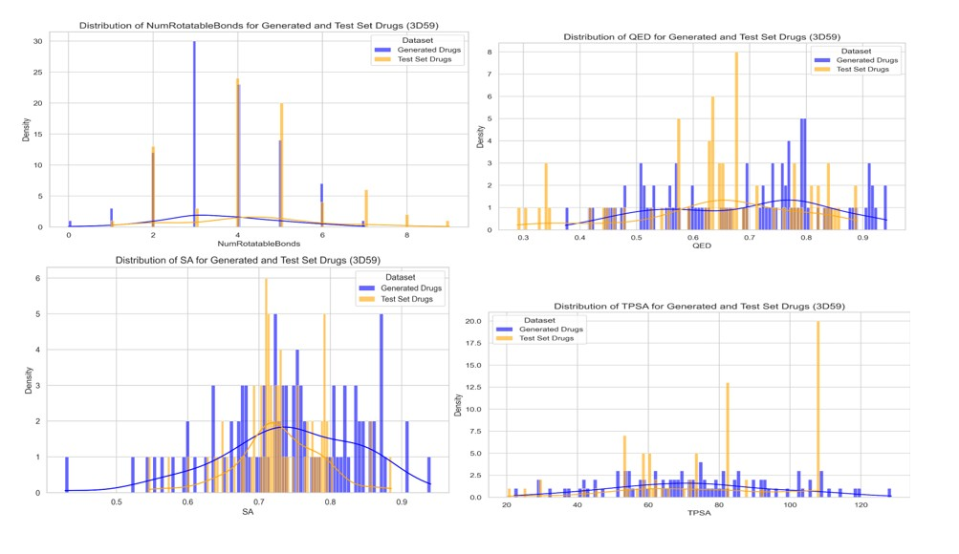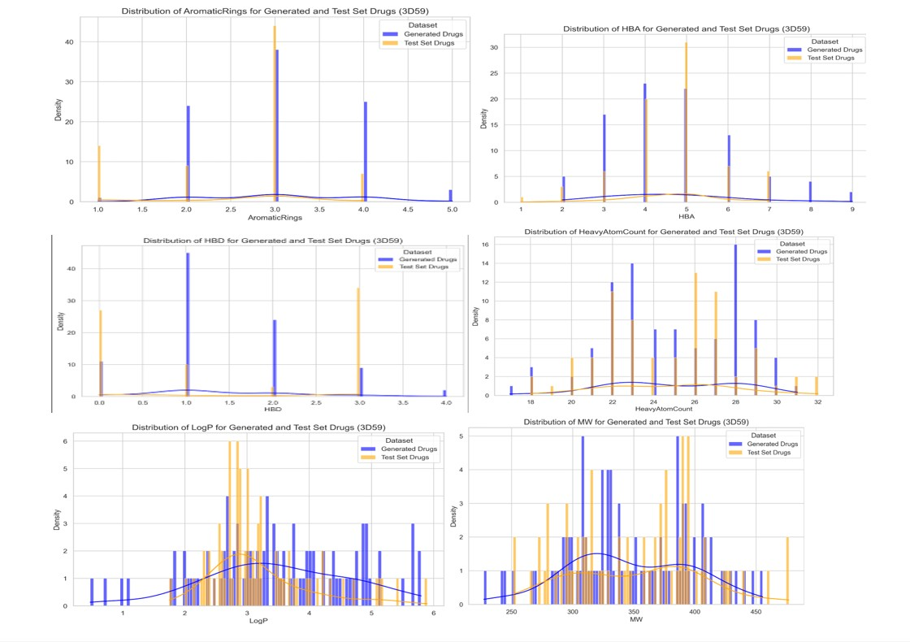

Figure 3: The molecular property distributions for the protein 3D59
Authors’ Contributions
Your Name: Conceptualization, Methodology, Writing. Co-Author Name: Data Curation, Validation.
Funding
This research was supported by [Funding Agency] under Grant [Number].
Data Availability
The dataset and code used in this study are available at [Repository Link].
Declarations
The authors declare no conflicts of interest.
Competing Interests
The authors declare that they have no competing interests.

References
- Benoit Baillif, Jason Cole, Patrick McCabe, and Andreas Bender. Deep generative models for 3d molecular structure. Current Opinion in Structural Biology, 80:102566, 2023.
- Jannis Born and Matteo Manica. Trends in deep learning for property-driven drug design. Current Medicinal
Chemistry, 28(38):7862–7886, 2021.
- Carmen Cerchia and Antonio Lavecchia. New avenues in artificial intelligence-assisted drug discovery. Drug
Discovery Today, 28(4):103516, 2023.
- Vijil Chenthamarakshan, Payel Das, Samuel C. Hoffman, Hendrik Strobelt, Inkit Padhi, Kar Wai Lim, Benjamin Hoover, Matteo Manica, Jannis Born, Teodoro Laino, and Aleksandra Mojsilovic. Cogmol: Targetspecific and selective drug design for covid-19 using deep generative models. arXiv: Learning, 2020.
- DE Comings, L Ferry, S Bradshaw-Robinson, R Burchette, C Chiu, and D Muhleman. The dopamine d2 receptor (drd2) gene: a genetic risk factor in smoking. Pharmacogenetics, 6(1):73–79, 1996.
- Anvita Gupta, Alex T. Muller, Berend J.H. Huisman, Julian A. Fuchs, Petra Schneider, and Gisbert Schnei-¨ der. Generative recurrent networks for de novo drug design. Molecular Informatics, 37(1-2):1700111, 2018. Erratum in: Molecular Informatics, 2018, 37(1-2), doi:10.1002/minf.201880141.
- Roc´ıo Mercado, Tamas Rastemo, Erik Lindelof, G¨ unter Klambauer, Ola Engkvist, and Hongming Chen.¨ Graphinvent: A graph-based deep learning framework for molecular generation. Journal of Chemical Information and Modeling, 60(12):5916–5927, 2020.
- Pascal Notin. Deep generative models for biology: represent, predict, design. PhD thesis, University of
Oxford, 2023.
- Bharath Ramsundar, Peter Eastman, Patrick Walters, and Vijay Pande. Deepchem: A deep learning library for drug discovery. Journal of Chemical Information and Modeling, 60(6):2695–2697, 2020.
- Marc Rouleau, Anand Patel, Michael J Hendzel, Scott H Kaufmann, and Guy G Poirier. Parp inhibition: Parp1 and beyond. Nature Reviews Cancer, 10(4):293–301, 2010.
- Miha Skalic, Jose Jim´ enez, Davide Sabbadin, and Gianni De Fabritiis. Shape-based generative modeling for´ de novo drug design. Journal of Chemical Information and Modeling, 59(3):1205–1214, 2019.
- O. Trott and A. J. Olson. Autodock vina: improving the speed and accuracy of docking with a new scoring function, efficient optimization, and multithreading. J. Comput. Chem., 31(2):455–461, 2010.

