Subscribe to DeepL Pro to edit this document.
Visit www.DeepL.com/pro for more information.
Introduction to Mathematical Logic

History of Mathematical Logic, Boolean Logic, Quantifiers, Syllogisms, Modus Ponens & Tollens, Quantum Logic, Fuzzy Logic

By: Bedy Purnama
Contributor: Iwan Sofana
Edition: February 2024

Foreword

The author has long wanted to write a book about Mathematical Logic but from a slightly different perspective. A book about Mathematical Logic that is "light" to be read and learned by various groups. This good intention can only be realized in 2022. For almost a year, the author searched for ways to put complex and philosophical material into simple language. How to express concepts that are very numerous and complicated so that everyone can understand them easily. To keep this book grounded and relevant enough to the present, without compromising its essence.

Almost everyone assumes that the science of Mathematical Logic is only for math teachers, students, researchers, and professors to learn. Especially when the word "Logic" is juxtaposed with the word "Mathematics". So the science of Logic seems exclusive and only for a limited circle. In fact, Mathematical Logic has been widely applied in everyday life even though some people still don't realize it. Mathematical Logic has been applied to electronic devices such as computers, smartphones, and others. Of course, Mathematical Logic is not only useful in the computer world. There are still many applications of Mathematical Logic in the real world.

The authors are two Physics graduates who did not study Mathematics specifically. So the authors realize that what is presented in this book is far from perfect. Even so, the authors hope that this book can be useful for everyone.

Greetings,

Bedy Purnama
(bedypurnama070@gmail.com)

Bandung, February 2024

Table of Contents

Foreword 2
Table of Contents 3
CHAPTER-1 Introduction to Logic 5
1.1 Logic and Mathematics 5
1.2 History of Logic 8
1.3 Quiz 9
CHAPTER-2 Getting to Know Mathematical Logic 10
2.1 Category 10
2.2 Implementation 11
2.3 Quiz 12
CHAPTER-3 Statement 14
3.1 Closed and Open Statements 14
3.2 Circularity or Negation 15
3.3 Compound Statements 15
3.2.1 Conjunctions 16
3.2.2 Disjunction 16
3.2.3 Implications 17
3.2.4 Biimplications or Biconditionals 17
3.3 Negation of compound statements 18
3.3.1 Negation of Conjunction 18
3.3.2 Negation of Disjunction 18
3.3.3 Negation of Implication 19
3.3.4 Negation of Biimplication 19
3.3 Tautology and Contradiction 20
3.4 Equivalent 21
3.5 Quantified Statements 21
3.5.1 Universal Quantifiers 22
3.5.2 Existential Quantifiers 22
3.5.3 Ingkaran Kuantor 23
3.6 Quiz 24
CHAPTER-4 Application of Compound Statements 26
4.1 Logic Gates 26
4.2 Computer Programming 29
4.3 Neural Network 30
CHAPTER-5 The Logical Paradox 37
5.1 Introduction 37
5.2 Logical Paradox 39
5.2.1 The Epimenides Paradox 39
5.2.2 Russel's Paradox 39
5.2.3 The Achilles and the Tortoise Paradox 40
5.2.4 Another Paradox 40
5.2.5 Conclusion and Benefits 40
CHAPTER-6 Introduction to Fuzzy Logic 42
6.1 Origin 42
6.2 Basic Concept 43
6.3 Operators and Truth Tables 47
6.4 Conclusion 50
CHAPTER-7 Conclusion 51
7.1 Introduction 51
7.2 Syllogism 51
7.3 Modus Ponens 52
7.4 Tollens mode 53
CHAPTER-8 Quantum Logic 55
8.1 Basic Qubit Concepts 55
8.2 Logic Gates 57
8.3 Truth Table 59
CHAPTER-9 Mathematical Logic Theory 62
9.1 Development of Mathematical Logic 62
9.2 Introduction to Mathematical Logic Theory 63
9.3 Cover 64
Bibliography 65
Biodata 67

CHAPTER-1 Introduction to Logic

1.1 Logic and Mathematics
In this section, the author deliberately does not write the word "Logic" as "Mathematical Logic". Although in everyday life we are more familiar with the term "Mathematical Logic". Why is that?

To answer this, try to understand some of the following terms. Some terms about Logic that are well known, especially in Indonesia are:

- Math Logic
- Classical Logic
- Computational Logic
- Fuzzy Logic
- Quantum Logic
- Political Logic
- Legal Logic
- Mistika Logic
- The Logic of Love
- Perhaps there is another logic?

Now, which of the above terms do you think is directly related to Math and which is not? The author will not force or intimidate you to decide. Because it would be quite difficult to make an accurate definition of these terms.

For example, the meaning of Classical Logic for those who study physics is identical to the various theories of classical physics (not quantum physics). Meanwhile, the meaning of Classical Logic for those who pursue mathematics may have another meaning, which is related to Boolean Logic which is different from Fuzzy Logic. So a term can have different meanings.

Boolean logic was invented by English mathematician George Boole in the 19th century. Boolean logic is a mathematical tool that describes the relationship between different states or conditions using basic operations such as AND, OR, and NOT. This concept plays an important role in the development of digital circuits, computer algorithms, and the design of electronics-based systems.

Apart from these differences in meaning and differences of opinion, according to the author, the logical terms listed from numbers 1 to 5 are directly related to science and technology. While the logic terms from 6 to 9 are rather difficult to relate to science and technology. Therefore, they will not be discussed in this book.

What exactly is Logic? Is Logic always synonymous with Math? Then what is the definition of Logic and Mathematics? These questions are quite intriguing to the author. There are quite a few references that explain in detail what is called Mathematics and Logic, some of which are:

Mathematics (from Ancient Greek μάθημα (máthēma), meaning "knowledge, thought, study, learning"), is a field of science, which includes the study of topics such as numbers (arithmetic and number theory), formulas and related structures (algebra), shapes and the spaces in which they exist (geometry), and quantities and their changes (calculus and analysis). There is no general agreement on its exact scope or epistemological status .

The last sentence is quite interesting, because there is no firm limit on the exact scope of mathematics. This means that mathematics can expand indefinitely and can cover all aspects of human life. Another more general (and simpler) view of mathematics is as follows.

Mathematics is the science of structure, order, and relationships that developed from the basic practices of counting, measuring, and describing the shapes of things. It is concerned with logical reasoning and quantitative calculations. Mathematics has become an indispensable complement to the physical sciences and technology. Nowadays, mathematics also makes valuable contributions in aspects of life sciences, psychology, religion, and so on .

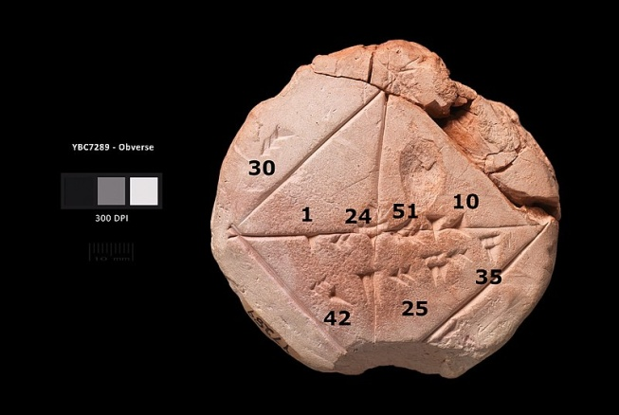

Figure 1.1 Babylonian clay tablets 7289 BC with annotations

I think the second opinion is much easier to understand and more down-to-earth. Perhaps some of you have a different opinion. That's fine, we live in the wild!

Furthermore, what is called Logic? Here is the definition of Logic that the author gets from several sources.

Logic is the study of correct reasoning, especially involving inference .

Pretty short, right? But the real meaning of Logic is more philosophical and profound. Here's another definition of Logic.

Logic is a branch of science that studies the principles of correct reasoning and valid inferences that are deductive or inductive.

The second definition of Logic still seems quite complicated, but we will ignore this complexity and keep it grounded, because our focus is not on the definition but on the application of Logic itself.

The following presents some experts' opinions on logic .

- According to William Alston, logic is the study of thinking, especially the attempt to find ways to distinguish valid thoughts from invalid ones.
- According to John Dewey, logic is the science of methodology in which there are five issues related to the logical process, namely awareness of the problem, clarification of the subject matter, survey of various possibilities, deducing the consequences of hypotheses, and verification through experience.
- According to Soekadijo, logic is a method or technique created to examine the accuracy of reasoning.
- According to Jan Hendrik Rapar, logic is seeing reason and thought guided by words and expressed by language.
- According to Irving M. Copi and Carl Cohen, logic is defined as the study of methods and laws used to distinguish correct reasoning from incorrect reasoning.
- According to Jujun S. Suriasumantri, logic means the correct way of drawing conclusions. More broadly, logic can be defined as the study of valid thinking.
- According to Fransiska Novita Eleanora, logic is rational thought expressed in words or language. As a science, logic is called episteme of logic or in Latin known as logica scientia which means the science of logic, but now we know it only as logic.
- According to Louis Ma'luf Al-Yassu'I, logic or mantiq is the law that preserves the conscience from errors in thinking.
- According to Hebert L. Searles, logic implies a thinking process that requires certain steps, such as collecting facts or collecting hypotheses and testing them.

From the explanations above, we can conclude that math and logic are not directly related. It is true that there is a "need" for anyone who wants to pursue mathematics to be able to think "logically". This is where the two scientific fields intersect. Now, do you agree with the author? If you don't agree, try to study further in the next section. Hopefully you can understand why the author concludes that Logic and Mathematics are not directly related.

1.2 History of Logic
According to research, Logic already existed in Ancient Greece pioneered by Aristotle. At that time Aristotle had not yet named it the term logic. Aristotle used the terms analithics and dialectics. Analytica is used to refer to a way of reasoning based on true statements. While dialectic is used to refer to a way of reasoning based on presumptive standards.

Until the middle of the 19th century, the most influential logic was the traditional logic created by Aristotle which was developed in the following period, especially from the 16th century to the 19th century. Today, logic is designated as an exact science, i.e. the science of formal inference or the science of reasoning processes.

The science of logic is growing rapidly and there are even groups of adherents of logic or schools of logic. Some of these groups that the author knows are:

- Traditional Logic
The group that interprets logic as a collection of practical rules that guide thinking. This group was pioneered by Aristotle (384 BC-322 BC).

- LogicMetaphysics
The group that thinks that the arrangement of thoughts is actually the same as reality, so logic is considered the same as metaphysics. This group was pioneered by Frederich Hegel (1770-1831).

- Epistemological Logic
The group that argues that in order to achieve adequate knowledge, the logical mind and feelings must be combined. This group was pioneered by Francis Herbert Bradley (1845-1924) and Bednard Bosanquet (1848-1923).

- LogicInstrumentalist
Also called logic-pragmatic. Logic is interpreted as a tool (instrument) and steps to solve a problem. This group was pioneered by John Dewey (1859-1952).

- LogicSymbolic
This group strongly emphasizes the importance of symbolic language to study in detail how reason should work. Logic is very technical and scientific, the method used is the mathematical method, so it is called Mathematical Logic. The pioneers were Gottfried Wilhem Leibniz (1646 - 1716), George Boole (1815-1864), and Augustus De Morgan (1806-1871).

If any of the readers know of other groups, please contact the author via email (listed in the Foreword). Because the author also wants to learn from the reader. By including these groups, the meaning of Logic will increase, complementing the previous terms.

Logic is often said to be a theory of thought. Logic leads to how thinking should go. In fact, logic can appear in various disciplines, various aspects of human life, and can even be adjusted to the "interests" of each person. That is why the author does not associate the word "Logic" with "Mathematics". Do you believe this statement?

1.3 Quiz
Can you find some other "Logic" terms that are not related to Math? If there are any:

- Write down what logics you know!
- Look up the real meaning of the term.

CHAPTER-2 Introduction to Mathematical Logic

2.1 Category
After getting to know some groups or understandings of logic, we can know that discussions about logic have been around for a long time, even before humans recognized the term logic itself. Efforts have been made to create an accurate and powerful method of reasoning (logic). One of them is symbolic logic or mathematical logic. In terms of understanding, this method is no different from the concept introduced by Aristotle thousands of years ago.

Mathematical logic formulates laws that can be used as a tool to assess whether the results of a thought are true or false. When still studying in high school, the author was taught that Mathematical Logic is divided into two, namely statements and conclusions.

- Statement
A statement is a sentence that can be proven true. Statements can be true or false, but not both.

- Conclusion
Inference is the process of determining the truth of a statement based on other statements that are known to be true. Inference can be done using agreed logical rules. The types of inference that are often used in mathematical logic are:
- Syllogisms
- Modus ponens
- Modus tollens.

Statements are also divided into two, namely single statements and compound statements.

- Single statement
A single statement is a statement that consists of only one sentence. A single statement is a statement that stands alone. For example:
  - Bandung is the capital of West Java Province.
  - The President of Indonesia in 2023 is Jokowi.

- Compound statement
A compound statement is a statement that consists of several statements. Compound statements are divided into:
- Conjunctions
- Disjunction
- Implications
- Biimplications

That's more or less the knowledge that the author had when he was in school. After the author studied other literature, it turns out that Mathematical Logic can still be grouped into:

- Propositional logic
A branch of symbolic logic that deals with single statements and compound statements, called compound statements. The science of this logic is often referred to as statement calculus.

- Logic of Mentions
A branch of symbolic logic that examines variables in a quantifier and the rules and procedures for inference and determining the validity of an argument. The science that discusses this logic is often referred to as the calculus of designations.

- Relationship Logic
This logic talks about the relationship of statements, such as symmetrical relationships, reflexive relationships, transitive relationships and so on.

- Set Logic
This logic is closely related to mathematics, namely Set Theory. This logic talks about the elements of a set, operations on the set and the laws or rules that apply.

Another source that the author gets from the book The Handbook of Mathematical Logic (1977), it is stated that mathematical logic is a branch of science in the field of mathematics that deepens logic problems, or rather clarifies logic with mathematical rules. Mathematical Logic is divided into four areas (the author lists them as they are without translation):

- Set theory
- Model theory
- Recursion theory
- Proof theory and constructive mathematics

2.2 Implementation
The role of calculus (math) is equally important for sciences, for example: physics, electronics, chemistry, and so on. Therefore, logic plays an important role in various scientific fields, even in everyday human life. Logic and mathematics are closely related because logic is the basis of mathematics.

Mathematics uses logic as a tool to prove theorems and develop new theories. Learning math helps one understand and use the underlying concepts of logic. Logic is also called "the calculus of computer science" because logic plays a very important role in the field of computer science.

Mathematical logic itself also continues to develop, starting from proportional logic, predicate logic, logic programming, and so on. The latest development of logic is fuzzy logic, or called vague logic. The implementation of fuzzy logic can be found in air conditioning, washing machines, refrigerators, and others.

Logic in computer science is used as the basis for learning programming languages, data structures, artificial intelligence, digital techniques/systems, databases, computational theory, software engineering, expert systems, artificial neural networks, and others that use logic intensively. One example is digital systems, which is a field of science based on logic to create logic gates and computer architecture as the core of microprocessors, computer brains or central processing units.

Logic, computational systems, and discrete mathematics have an important role in computer science because they all play a role in programming. Logic is the mathematical underpinnings of software, used to formalize programming language systems and program specifications, and test the accuracy of a program. This shows how important mathematical logic is because many sciences, especially in the field of computer science, require logic to develop.

2.3 Quiz
After reading Chapter 1 and Chapter 2, try to understand and answer the following questions.

- Let's say you are currently living during the first and second world wars. One day you meet Mr. Albert Einstein. Then Mr. Albert tells you the following:

  - Time is relative, if you are traveling close to the speed of light then time will slow down.
  - Speed is only limited to the speed of light, so no matter how much technology a vehicle uses, it will not be able to exceed the speed of light.
  - Gravity is the effect of the warping of space and time.

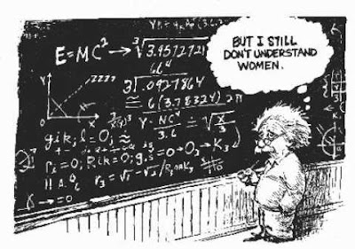
Figure 1.2 Illustration of Albert Einstein

Do you think Mr. Einstein's statement is logical? How would you define logical and illogical or true and false?

- Take a look at the following diagram image that the author got from one of the books . The diagram below tells about data grouping. Do you think the data grouping as shown in the diagram is logical? What is the rationale for declaring the diagram logical or illogical?

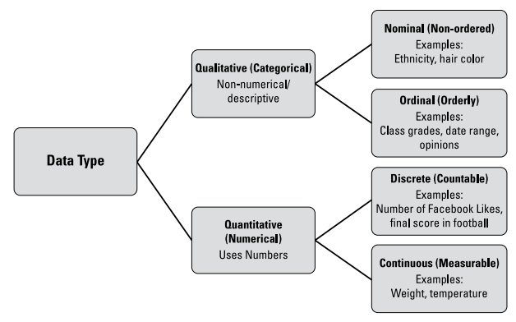

CHAPTER-3 Statement

3.1 Closed and Open Statements
We have already touched on statements, we also know that statements can be divided into several categories. In this chapter, the author would like to invite the reader to get to know more about what is called a statement.

Statement is the English translation of the word "statement". In mathematical logic, statements can be true or false, but not both. A statement that already has both true and false values is called a closed statement.

Statements are often called propositions. A proposition is a declarative sentence that is either true or false, but cannot be both. The truth or falsehood of a sentence is called its truth value.

Example:

- Three is the smallest odd number.

The sentence above is false because there are still odd numbers smaller than 3 (three).

Do you still remember the lesson on the set of integers? Here is an example of the set of odd numbers named A. We can see that 3 is not the smallest odd number.

A = {..., -9, -7, -5, -3, -1, 1, 3, 5, 7, 9, ...}

- The moon circulates around the earth.

The sentence above is true because the moon is a satellite of the earth so the moon goes around the earth.

A statement whose truth value is unknown is called an open statement. Open statements can be known because of a variable. Here are some examples of open statements:

- f(x): 2x + 1 > 6, x ∈ 

An open sentence in the form of an inequality where the domain x is the set of real numbers. The statement will be true only when $x> 2\frac{1}{2}$

- City C is the capital of West Java province

C is a variable that can change the nature of the sentence. The sentence above will be true if C is Bandung.

Not all sentences containing variables are always classified as open sentences. If the variable contains a quantor (such as the words "there is", "some", "there is", "every", "all" and others), the sentence is a closed sentence. Consider the following example.

- There is a member of the set of integers y that satisfies the equation 2y + 4 = 7.
- a b b + = + a, for any a and b real numbers.
- 2p is a positive even number, for every natural number p.

Can you give reasons why the three examples of sentences with variables above are classified as closed sentences?

Not all sentences can be classified as statements. For example, the following sentences are not statements:
- What is your name?
- No parking there.
- What is the total population of Indonesia?
- Do not swim in the lake.
- Anton is a good boy.

3.2 Circularity or Negation
In mathematical logic, negation is the opposite fact of the original statement. Negation is the rejection of an existing statement. If a statement is false (S) then its negation is true (B) and if a statement is true (B) then its negation is false (S).

The negation of a statement can be obtained by adding the word "is" or "is not" or inserting the word "is not" to the original statement.

Negation is given the symbol~ . Examples of negation in math are as follows:

- p: Ice melts when heated (true statement).
- ~p: Ice does not melt when heated (false value statement).

Another example:

- p: All fowl are birds.
- ~p: There are birds that are not birds.

3.3 Compound Statements
A compound statement is a statement that consists of several statements. A compound statement consists of two or more single statements connected by a conjunction. Connectives used in mathematical logic include: "and, or, if... then..., if and only if..."

Here's an example of a compound statement:

- Numbers that are divisible by 3 and 5 are odd numbers.
- 5 or 7 are prime numbers.
- If Budi is an Indonesian citizen then he must be in Indonesia.

Can you test the truth of each of the above statements? Which of these statements is true?

To know the truth of a compound statement, we must know the rules used. Therefore, the author will briefly discuss one by one what rules we should know. In general, compound statements can be divided into:
- Conjunctions
- Disjunction
- Implications
- Biimplications

3.2.1 Conjunctions
Conjunctions are compound statements with the conjunction "and". The conjunction "and" is symbolized by∧ . For example:

X ∧ Y is read as X and Y.

The truth value of a conjunction can be seen in a table (called a truth table).

X | Y | X Y∧
B | B | B
B | S | S
S | B | S
S | S | S

Notes:

B: True, sometimes abbreviated to T (True).
S: False, sometimes shortened to F (False).

Based on the table above, it can be concluded that the conjunction is only true if both statements are true.

3.2.2 Disjunction
A disjunction is a compound statement with the conjunction "or". The conjunction "or" is symbolized by∨ . For example:

X∨ Y is read as X or Y.

The truth value of a disjunction can be seen in the table.

X | Y | X∨ Y
B | B | B
B | S | B
S | B | B
S | S | S

A disjunction is only true if one of the statements is true.

3.2.3 Implications
An implication is a compound statement with the conjunction "if ... then ...". The symbol for implication is→ . For example:

X→ Y is read as if X then Y.

The truth value of an implication can be seen in the table.

X | Y | X→ Y
B | B | B
B | S | S
S | B | B
S | S | B

An implication is false if the first statement is true and the second statement is false. The "if" or X part is often referred to as the antecedent. The "then" or Y part is called the consequent.

X: antecedent
Y: consequent

3.2.4 Biimplications or Biconditionals
Biimplication is a compound statement with the conjunction "... if and only if...". ...". The symbol for a biimplication is↔ . For example:

X↔ Y is read as if X then Y.

The truth value of a biimplication can be seen in the table.

X | Y | X↔ Y
B | B | B
B | S | S
S | B | S
S | S | B

A biimplication is true if both statements have the same value, i.e. they are either true or false.

3.3 Negation of compound statements
Compound statements (disjunctions, conjunctions, implications, and bi-implications) can have negations. This means that we can still make a negation of the compound statement. In general, the negation truth table (for any statement) is as follows:

X | ~X
B | S
S | B

3.3.1 Negation of Conjunction
Negation conjunctions are characterized by the conjunctions: "and, if, but, as, although, that, so that". A negation of conjunction can be said to be true if the entire single proposition is true, otherwise it is false. The truth table is as follows.

X | Y | X ∧ Y | ~X | ~Y | ~X ∨~ Y
B | B | B | S | S | S
B | S | S | S | B | B
S | B | S | B | S | B
S | S | S | B | B | B

So conjunction negation is equivalent to: X ~∨~ Y

3.3.2 Negation of Disjunction
The truth value of a disjunction is only false (S) if the entire single proposition is false, otherwise it is true (B). So the negation of a disjunction is its opposite. Consider the truth table as follows.

X | Y | X∨ Y | ~X | ~Y | ~X Y∧ ~
B | B | B | S | S | S
B | S | B | S | B | S
S | B | B | B | S | S
S | S | S | B | B | B

So the negation of disjunction is equivalent to: ~X ∧~ Y

3.3.3 Negation of Implication
The truth value of an implication is only false (S) if the antecedent is true and the consequent is false, so otherwise it is true (B). The truth table of the negation of an implication is as follows.

X | Y | X→ Y | ~Y | X Y∧ ~
B | B | B | S | S
B | S | S | B | B
S | B | B | S | S
S | S | B | B | S

So the negation of the implication is equivalent to: X ∧~ Y.

Note that the negation of an implication is not the same as the contraposition of an implication. A contraposition is the antecedent and consequent negated and interchanged. Thus, the antecedent and consequent must be negated and the order must be swapped.

Statement: X→ Y
Contraposition: ~X→ ~ Y

For example:

If the COVID-19 virus is dangerous, then everyone is afraid of the disease.

Contraposition of the statement:

If everyone is not afraid of COVID-19, then COVID-19 is not dangerous.

Logically, this statement is true, even though we know that COVID-19 is very dangerous.

3.3.4 Negation of Biimplication
The negation of biimplication is a little more complicated than the others. The truth table is as follows.

X | Y | X↔ Y | ~X | ~Y | X Y∧ ~ | Y X ∧ ~ | (X∧ ~ Y)∨ (Y ∧ ~ X)
B | B | B | S | S | S | S | S
B | S | S | S | B | B | S | B
S | B | S | B | S | S | B | B
S | S | B | B | B | S | S | S

So the negation of biimplication is equivalent to: (X∧ ~ Y )∨ (Y∧ ~ X )

3.3 Tautology and Contradiction
A tautology is a compound statement that is always true for all possible truth values of its component statements. Whereas, a contradiction is a compound statement that is always false for all possible truth values of its component statements.

In other words, a tautology is a compound statement that is always true regardless of the value of the propositions that make it up. Whereas a proposition that is always false is called a contradiction. So tautology is opposite to contradiction.

Example of tautology:

X∨ ~X

The table of truth:

X | ~X | X ∨~ X
B | S | B
S | B | B

Notice how the above statement is always true.

Example of contradiction:

X∧ ~X

The table of truth:

X | ~X | X ∧~ X
B | S | S
S | B | S

Notice how the above statement is always false.

For another example, prove that the following statement is a tautology.

(~ p→ q ) p∨ ~

Using the following truth table, the above statement can be proven.

p | q | ~ p | ~ p q→ | (~ p→ q ) p∨ ~
B | B | S | B | B
B | S | S | B | B
S | B | B | B | B
S | S | B | S | B

Proof of compound statements does not always have to use truth tables. There are other ways but they are not discussed in this book.

Besides tautology and contradiction, there is something called contingency. Contingency is a statement that has true and false values in its truth table, regardless of the truth value of the propositions in it.

So contingency is a compound proposition that is neither a tautology nor a contradiction. Examples of contingency are:
- Disjunction
- Conjunctions
- Implications
- Biimplications
- NAND, NOR, XOR

We have discussed this contiguity before.

3.4 Equivalent
Two compound statements are said to be equivalent if for all possible truth values of their components, they have the same truth value.

Notation used for equivalents

<=> or ≡

The negation of a compound statement is equivalent to the disjunction of each of its conjunctions, and vice versa. This form of equivalence is known as the De-Morgan postulate.

~ ( X∧ Y ) X≡ ~ ∨ ~ Y
~ ( X∨ Y ) X≡ ~ ∧ ~ Y

Using this De-Morgan postulate, other equivalences can be derived. Some of them are:

~ ( X→ Y )≡ X Y∧ ~
~ (X↔ Y)≡ (X∧ ~ Y)∨ (Y∧ ~ X)
X Y→ ≡ ~ Y→ ~ X

3.5 Quantified Statements
In grammar, a predicate refers to the part of the sentence that gives information about the subject. Whereas in the science of mathematical logic, sentences that require a subject are called Predicates. To make a sentence complete (and meaningful), a predicate can be added.

Predicates are usually symbolized by letters, for example:

p : fly to the planet Mars
q : taller than a tree

both p and q are predicates.

Another way of completing a statement (sentence) is by adding quantifiers to the sentence. Quantifiers are words like "some", "all" and other words that indicate how many elements are needed for the predicate to be true.

So, a quantitative statement is a statement that contains a measure of identity or number. A quantitative statement consists of:
- Universal Quantifier
- Existential Quantor

3.5.1 Universal Quantifiers
Universal quantifiers are also called general quantifiers. Universal quantifiers show that every object in the universe has the properties of the sentence that states it. We can put the words "all", "every", "each" in front of an open sentence containing variable x to produce a sentence that has a truth value. The value of x is determined by its universe of speech.

The notation used for universal quantifiers is "∀ ", which reads "for all" or "for every".

Example:

- Everyone finds calculus difficult.
- All SMP 3 students wear blue shirts

Another example of a quantor statement using variables:

- p(x) is true for all values of x.
- For all x, p(x).
- For every x, p(x).
- For every x, p(x).

All of the above statements can be written as:

∀xp(x)

Which can be read into:

"for all x, p(x)."

3.5.2 Existential Quantifiers
Existential quantifiers are also called special quantifiers. Existential Quantifier shows that among the objects in its universe, there is at least one object (or more) that has the property of the sentence that states it.

The notation used for existential quantifiers is "∃ " which reads "there is", "there are", "some".

Example:

- There are passengers who survived the train accident
- Some SMK 1 students were absent from school today

Another example with variables:

- There exists x such that p(x).
- For some x, p(x).
- There is some x such that p(x).
- For some x, p(x).
- There is some x such that p(x).

The above statement can be written as:

∃xp(x)

Which can be read into:

"there exists x, which is p(x)."

The statement∃ x) q(x) is true if and only if there is at least one x for which q(x) is true and is false if for all x in its universe, q(x) is false.

3.5.3 Ingkaran Kuantor
A quantified statement can also have a negation. The two kinds of quantifiers are opposite or contradictory. Universal quantifiers become negations/refutations for existential quantifiers, and vice versa.

Quantified statement loops:

- Universal quantifier:

~(∀ x p(x)) ≡∃ x (~p(x))

- Existential quantifiers:
~(∃ x p(x)) ≡∀ x (~p(x))

Example:

- All passengers in the colliding trains survived.
The sentence above is false if a passenger dies.

- There are passengers who survived the train accident"

The sentence above is false if all the passengers died in the train accident.

3.6 Quiz
Try to recreate the truth table (as exemplified in this chapter) to prove other forms of negation of conjunction, negation of disjunction, implication, and negation of biimplication:

- Conjunction Negation

~ ( X∧ Y )≡ ~ X∨ ~Y

X | Y | X ∧ Y | ~X | ~Y | ~(X ∧ Y) | ~X ∨~ Y

- Conjunction Negation

~ ( X∨ Y )≡ ~ Y∧ ~ X

X | Y | X∨ Y | ~X | ~Y | ~ ( X∨ Y ) | ~X Y∧ ~

- Negation of Implication

~(X → Y)≡ X∧ ~ Y

X | Y | X→ Y | ~Y | ~ ( X→ Y ) | X Y∧ ~
B | B | B | S |  | S
B | S | S | B |  | B
S | B | B | S |  | S
S | S | B | B |  | S

- Negation of Biimplication

~ ( X↔ Y )≡ ~ ( X → Y )∨ ~ ( X→ Y )
~ ( X↔ Y )≡ ( X∧ ~ Y )∨ ( Y∧ ~ X )

X | Y | X↔ Y | ~X | ~Y | ~ ( X → Y )∨ ~ ( X→ Y )

Suppose defined

A : ~ ( X∧ Y )∨ Z
C : ~ A

Create a truth table for C.

- Prove the following statement is a tautology

~ (p∨ q )∨ (r→ ~ q )

- Determine the truth value of the following statements:
  - (∀ real number x) x²≥ 0.
  - (∀ real number x) x²≠ -1.
  - (∃ integer k) k²= k.
  - (∀ integer x) x²- 2≥ 0.
  - (∃ integer x) x²- 10x + 21 = 0.

- Determine the converse of the following statements

  - There are no even prime numbers.
  - All integers are real numbers.
  - Some natural numbers are rational numbers.
  - ∃x (cos x + sin x = 1).
  - ∀x [ (x + 1⁾⁽²⁾ = x²+ 2x + 1].

CHAPTER-4 Application of Compound Statements

4.1 Logic Gates
The author does not include examples of various types of compound statements. Instead, the author will include the application of compound statements in logic gates that are widely applied in computers and smartphones.

A logic gate compares two incoming electric currents and sends a new electric current out. A logic gate is like a guard of a building that allows people to enter the building only if they pass a certain test or condition.

Believe it or not, at the most basic level, sophisticated computer brains are actually built on the principles of logic. Such computers are called digital computers. Digital computers process signals encoded with bit 1s and bit 0s that are equivalent to True or False.

There are several types of logic gates, the most popular being AND and OR which are synonymous with conjunction and disjunction. Take a look at the table below to see the different symbols used by logic gates .

AND | 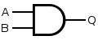
  Input |  | Output
  A | B | Q
  0 | 0 | 0
  0 | 1 | 0
  1 | 0 | 0
  1 | 1 | 1
OR | 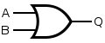
  Input |  | Output
  A | B | Q
  0 | 0 | 0
  0 | 1 | 1
  1 | 0 | 1
  1 | 1 | 1

In logic gates there is also something called NOT which is synonymous with negation or denial. The symbol and truth table forNOT are presented as follows.

NOT  (inverter) | 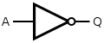
  Input | Output
  A | Q
  0 | 1
  1 | 0

NOT gates are often called Inverters. By using the combination of NOT, AND and OR, several other logic gates can be developed. Consider the following examples of how the gates NAND (NOT AND), NOR (NOT OR), XOR (Exclusive OR), XNOR (Exclusie NOR) are formed .

type | NAND construction | NOR construction
NOT | 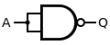 | 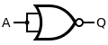
AND | 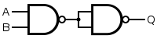 | 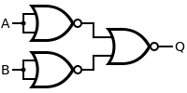
NAND | 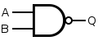 | 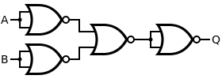
OR | 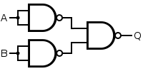 | 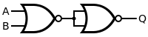
NOR | 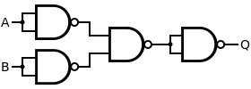 | 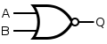
XOR | 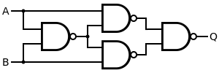 | 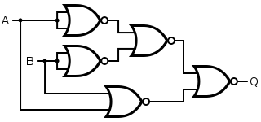
XNOR | 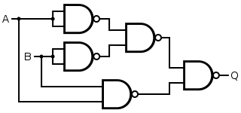 | 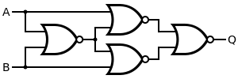

4.2 Computer Programming
Computer programming is an applied example of mathematical logic. Although not everything is always related to compound statements (in the context of logic), most computer programming activities require mathematical logic.

Currently, there is a choice of programming languages that have different characteristics. However, the principle is still the same. For example, in programming languages the term conditional is known, which consists of:
- Conditional statements
- Conditional expressions
- Conditional constructs

Conditionals are programming language commands to handle decisions. The syntax that is widely used in various programming languages is IF ELSE which can be described in the form of the following diagram .

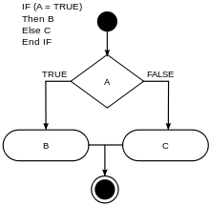

Another way to express IF ELSE in pseudo code that is close to programming languages is as follows:

If (boolean condition) Then
(consequent)
Else
(alternative)
End If

For example:

if discount < 11% then
print (you have to pay $30)
elseif discount<21% then
print (you have to pay $20)
elseif discount<31% then
print (you have to pay $10)
end if;

Regardless of what programming language is used, can you see the implication statement from the pseudocode example above?

Conjunctions, disjunctions, etc. are also available in programming languages with similar ways of writing. Here is an example of combining implication and conjunction made using the PHP language.

<? php
$a = 2;
$b = 5;

if ( ( $a == 2 ) && ( $b == 5 ) ) {
echo "a is 2 and b is 5.";
}
?>

Implication statements appear in syntax that uses the save word "if". Meanwhile, conjunction statements appear in syntax that uses the conjunction word "&&".

We will not discuss more about programming languages. But it can be proven that mathematical logic is used in programming languages.

4.3 Neural Network
Neural network or also known as Artificial Neural Network (ANN) is a set of machine learning algorithms designed to recognize data patterns by mimicking the way nerve cells (neurons) work.

Neural networks are inspired by the human brain and mimic the way nerve cells (neurons) send messages to each other. In humans, neurons receive signals or stimuli from outside then send them to the brain for processing. Afterward, the body will act according to the orders sent by the brain through the neurons.

Figure 4.1 Neuron Illustration

A neuron consists of several parts, namely:
- Dendrites or Dendrites that function to transmit the impulses received to the nerve cell body.
- Axons function to transmit impulses from the cell body to other tissues.
- Synapses serve as functional units between two nerve cells.

Based on the three things above, three main parts/components of ANN are determined, namely:
- Input
- Output
- Activation function

In diagram form the three components are depicted as follows.

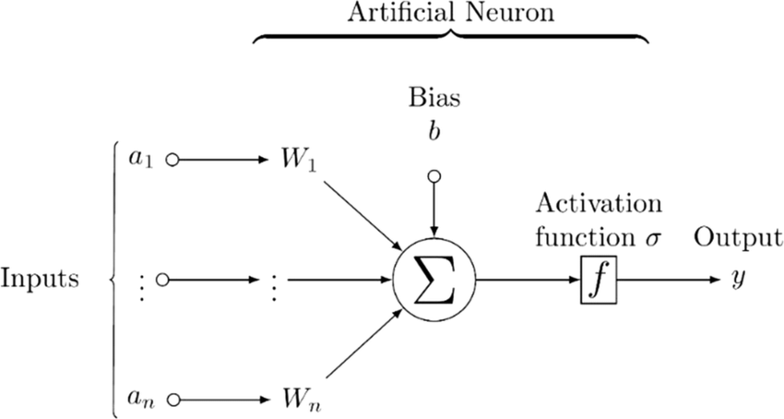

Figure 4.2 Illustration of Artificial Neuron

This activation function can be analogized to the "brain" of the neuron. A single neuron is clearly not reliable enough to solve various complex problems. However, if the ANNs are combined into thousands or even millions, we will get a "super" artificial brain.

Of course, ANNs do not just become "smart" without a learning process. The process of learning repeatedly using a set of rules is what makes ANNs able to mimic the way humans think. It can even outperform the intelligence of the human brain. This is because ANNs are implemented on computers that never forget and get tired. Unlike humans who are easily tired or forget.

Some of the learning rules commonly used by ANNs are as follows:

- Hebbian learning rule
Identify, how to change the weights of network nodes.
- Perceptron learning rules
It starts its learning by assigning random values to each weight.
- Delta learning rules
Modifying the sympatric weight of a node is equal to the multiplication of error and input.
- Correlation learning rule
Supervised learning.
- Outstar learning rules
Assumes that the nodes or neurons in the network are arranged in a layer.

The author cannot explain in depth how this ANN learns using the learning rules above. But in principle, the learning process for this ANN utilizes a set of rules that we already know in the discussion of Boolean logic.

Logic gates such as OR, AND, NOT, NOR, NAND, can be "easily" solved using ANN. To make it easier to understand, Figure 4.2 can be slightly modified to look like this.

Then change the above form once again into the following form:

To the right of the sumation notation can be seen the summation value which is the result (output) of the inputs W1, W0, and W2.

The prediction of the output is$y ̂$ can be explained as follows:

Prediction (y`) = 1 if Z > 0.5 and 0 if Z< 0.5

The following illustrates how the logic gate is applied to ANN.

For logic gate XOR can be formed with the following OR and AND combination.

To explain how a common logic gate can be replaced with an AAN would require a considerable amount of time. Because this study requires a basic understanding of the perceptron algorithm or perceptron algortima which is beyond the scope of this book.

ANN has many applied applications such as the following:
- Medical diagnosis by performing medical image classification
- Identification of chemical compounds
- Computer vision to extract information and insights from images and videos. With neural networks, computers can distinguish and recognize human-like images. Computer vision has several applications, such as the following:
- Visual recognition of self-driving cars so that they can recognize traffic signs and other road users
- Face recognition to identify faces and recognize attributes such as open eyes, glasses, and facial hair
- Image labeling to identify brand logos, clothing, safety equipment, and other image details
- Speech recognition can analyze human speech even if the speech pattern, pitch, language, and accent are different.
- And there are many more.

Chapter 5 Paradox Logic

5.1 Introduction
The author deliberately raises the issue of paradox in this chapter not merely to create controversy, but to show that paradox has contributed to mathematical logic.

The term paradox or paradox is often heard in everyday life and most people have a good understanding of its meaning. So the author no longer needs to explain it in depth.

A paradox can be defined as a situation that seems absurd or contrary to common assumptions, but in reality contains a truth. Is it difficult to understand? Take a look at this popular example image to get a better sense of what a paradox is.
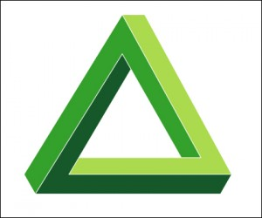
Figure 5.1 Paradox in picture form

Can you "see" the paradox in the image above? Do you think it looks logical? Some people would argue that the image above appears illogical.

What if the author says that the picture is logical and makes sense. Would you agree with the author?

According to the author, a paradox is a truth that has not been believed by many people, and can become a general truth if the majority of people believe it. Now, in relation to this statement, try to understand the author's way of thinking about this picture.

According to the author, the picture above is a picture of several triangles drawn on a piece of paper (two-dimensional). Each triangle is given a color in such a way that makes our minds confused. Indeed, it is quite difficult to understand how a geometric shape (3 dimensions) can be made in such a way. However, the author assumes that the picture above has nothing to do with objects or (three-dimensional) buildings. This is just a creative drawing. So the picture above according to the author's understanding is quite logical.

So what do you think? I'm sure you have other opinions and also different points of view on the picture above. You can define what is logical and illogical according to your own beliefs.

Another equally popular paradox is the Chicken and Egg paradox. The fundamental question is: "Which comes first, the chicken or the egg?"

If we say that the egg came first, then who produced the egg? Was it the chicken?" On the other hand, if we think that the chicken came first then we would ask, "How can there be a chicken without an egg hatching it?" This question already creates an endless loop that is difficult to solve.

Another tricky paradox is the paradox of the rock and God. Can God create a rock that is so heavy that God himself cannot lift it. If God can create such a rock, it means that there is something that God cannot lift. If God cannot lift it, then there is a limitation in God's power. This paradox has tested our understanding of the concept of divinity for centuries.

This question is known as the omnipotence paradox. A paradox of the belief that God is omnipotent. The omnipotence paradox dates back to the 12th century AD. This question was raised by Averroes aka Ibn Rushd, a Muslim scholar. Thomas Aquinas, a Christian theologian, also asked a similar question. Going back even further, Pseudo-Dionysius the Areopagite asked a similar question - similar to the two later scholars .

What do you think? According to the author, we can revisit the so-called paradox. A paradox can be defined as a statement that involves a logical contradiction or opposition that defies conventional understandings of truth.

Thus, logical and illogical are very relative, as they relate to conventional understandings of the truth. With regard to the paradox of stone and God, here is the author's explanation:

God or Allah is different. To understand Him we cannot rely solely on logic. Therefore, God cannot be referred to as something logical and illogical. So it cannot be studied using only mathematical logic or paradoxes.

The Prophet forbade thinking about the form and shape of Allah. He said, Think of the creations of Allah, but do not think of the Essence of Allah. (HR Ath Thabrani)

The author wants to emphasize that logic and paradox are not the ultimate science that can answer all our questions. So logic cannot always be used as a guideline. The same applies to paradox. Paradoxes cannot always be used as a basis for drawing conclusions.

5.2 Logical Paradox
Paradox is believed to come from the Greek, "paradoxon" which means "contrary to expectation, existing belief, or perceived opinion". From this term paradox, the term Logical Paradox emerged. What distinguishes a paradox from a logical paradox?
Logical Paradoxes are easier to understand once we understand their categorization. Although it is not absolute, it can be used as a frame of reference for thinking.

5.2.1 The Paradox of Epimenides
Epimenides was a Greek Cretan who lived around 600 years BC. Epimenides issued a statement that:
All Cretans are liars
Since Epimenides himself was Cretan, he himself was a liar. But if he was a liar, what he said was not true, so the Cretans were honest.
But Epimenides was a Cretan, so what he said was true, that the Cretans were liars. So Epimenides himself was a liar, and what he said was not true.
Now this question seems right but if you dig into it properly, it will lead to two things that contradict each other, namely:
If Epimenides is telling the truth then he is not telling the truth.
Thus, Epimenides and the Cretans are both righteous and unrighteous . What do you think? In this context, it seems as if the truth has become vague, doesn't it.

5.2.2 Russel's Paradox
Russell's Paradox is an important paradox in set theory and mathematical logic, first discovered by British philosopher and mathematician Bertrand Russell in the early 1900s. Russell's paradox is almost similar to Epimenides' Paradox. Betrand Russell introduced the "barber paradox". Russell states:

barber as 'one who shaves all those, and those only, who do not shave themselves'
Or
barber as 'one who shaves everyone, and only those, who do not shave themselves'

This is more or less an example of Russell's paradox regarding barbers:
In a town there was a barber who shaved all the men and only the men in the town did not shave themselves. The question is, does the barber shave himself?

If the barber shaves himself then he belongs to the group of people who shave themselves, but the barber never shaves anyone from that group, so the barber does not shave himself, but if the barber does not shave himself then he belongs to the group of men who do not shave themselves and the barber shaves every man in the group so the barber shaves himself.

Finally, the sentence "the barber shaved himself" or "the barber did not shave himself" has two values, true and false . The solution to the question is neither yes nor no.

5.2.3 The Achilles and the Tortoise Paradox
The Achilles Paradox is often attributed to the 5th century BC Greek philosopher Zeno and one of his four paradoxes described by Aristotle. The paradox concerns a race between the fleets of Achilles and the tortoise. Achilles was going to capture the tortoise and the rule was that the tortoise could move first.

The result is that whenever Achilles reaches the turtle's place, there is no turtle there because it is already in front of him.The turtle can move before Achilles. This paradox will result in an endless loop, so that the tortoise can never be caught by Archilles.

5.2.4 Another Paradox
Some other paradoxes that are not discussed are:
- The Thesus Boat Paradox
- The Paradox of the Day of Execution
- etc.

5.2.5 Conclusion and Benefits
A paradox can be defined as a statement that involves a logical contradiction or opposition that defies conventional understandings of truth.

For example, Russell's paradox reveals contradictions in set theory, which is the basic foundation for much of modern mathematics. Russell's paradox destabilizes the foundations of set theory developed by mathematicians such as Georg Cantor and Richard Dedekind. Russell offered two solutions to avoid this paradox, namely by using type theory or axiomatic set theory.

Mathematicians have developed more rigorous foundations of set theory, such as the now widely used Zermelo-Fraenkel (ZF) axioms. With the advent of more rigorous set theory, Russell's paradox is no longer a problem. But Russell's paradox remains a valuable lesson in the history of mathematics.

The biggest benefit of studying paradoxes is trying to think "outside the box" in order to discover new concepts and theories, especially in the world of mathematics.

Well, do you agree with this expression?

CHAPTER-6 Introduction to Fuzzy Logic

6.1 Origin of
In English, fuzzy means blurred or unclear. So, fuzzy logic is logic that is fuzzy, or contains elements of uncertainty.

Quite a few people think that the world of logic is black and white, right or wrong, one or zero. However, Fuzzy Logic is here to demolish that notion. Fuzzy logic or vague logic or Fuzzy Logic was first introduced by Lofti A. Zadeh in 1965 through fuzzy set theory. Zadeh is an Iranian scientist from the University of California at Barkeley, United States. Fuzzy logic is a way to model uncertainty similar to human uncertainty.

Earl Cox, an expert in artificial intelligence and Fuzzy Logic, defines Fuzzy Logic as a technique for describing and processing ambiguous and uncertain data. In fuzzy logic there is no black and white, right or wrong, one or zero. Everything can be between these two extreme values.

Fuzzy logic is more often applied by Japanese practitioners in the field of artificial intelligence. Westerners prefer black-and-white or yes-no issues, while easterners can accept a gray or "fuzzy" world.

In everyday life, there are many examples that show that we are often dealing with uncertain and fuzzy situations.

- How to determine the speed of a car that can be considered "fast". Is 90 km/h fast enough? Or maybe it should be 120 km/h or more? Here Fuzzy Logic can answer through membership degrees, which are values between 0 and 1 that reflect the extent to which an element meets a criterion.
- We can say that today it is 36.7 C hot and 33.5 C warm. While on another day we can say that 27.0 C is hot and 22.5 C is warm. So the degree of heat and warmth is relative and not absolute.

Unlike traditional binary (boolean) logic that only recognizes two values (true and false), Fuzzy Logic recognizes many values between these two extremes. With Fuzzy Logic, we can better model fuzzy knowledge and uncertainty, resulting in systems that are more robust and resistant to disturbances.
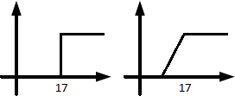

Figure 6.1 Binary Logic vs Fuzzy Logic

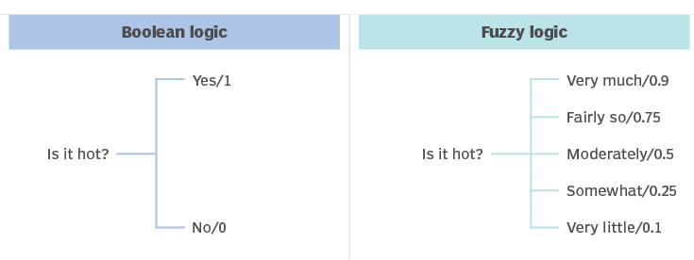

Figure 6.2 Fuzzy comparison

With Fuzzy Logic, a way can be found to process data and make decisions in environments that are full of uncertainty and ambiguity. By using this approach, we can create systems that are more similar to the way humans think and respond to real situations.

6.2 Basic Concept
Fuzzy logic generally has four parts or components, namely:
- Rule Base
- Fuzzification
- Inference engine
- Defuzzification

These four components can be depicted in diagram form. Some people call it a Fuzzy Logic Controller (FLC). We can imagine the four components as a box-shaped system that receives input (from the left) and then outputs (on the right).
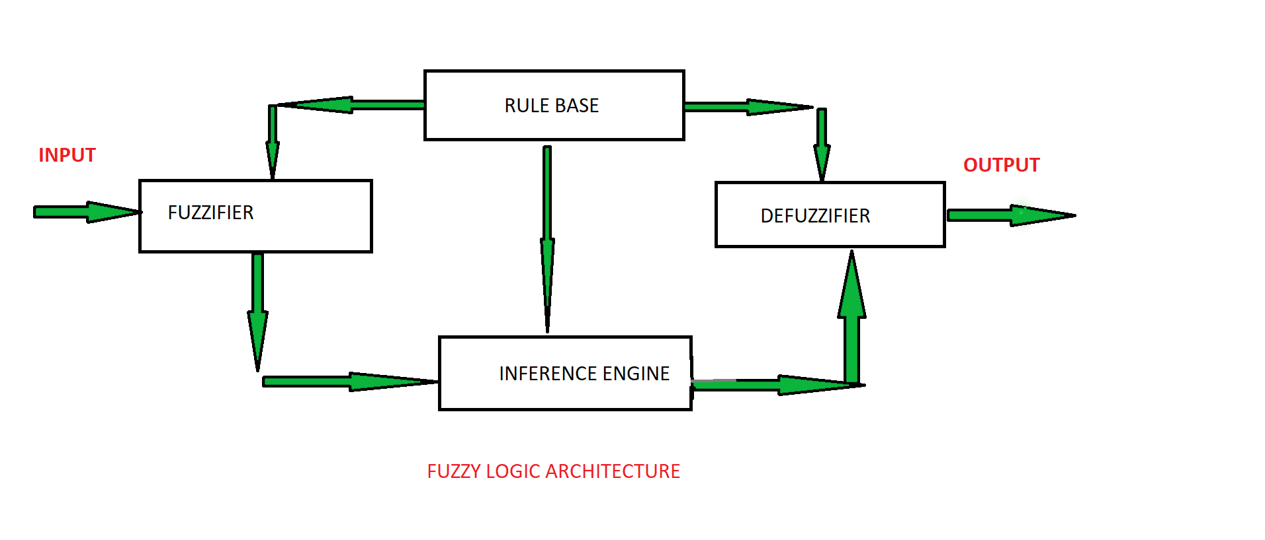
Figure 6.3 Structure of Fuzzy Logic Controller

Another way of describing Fuzzy logic systems is as follows:

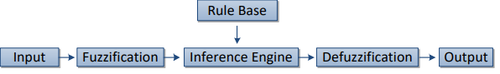

Figure 6.3 Structure of Fuzzy Logic Controller

Fuzzy Logic Controller (FLC) is a nonlinear and adaptive controller that uses a rule-based system. The following is a brief explanation of each part.

Fuzzy logic is developed from fuzzy set theory. The classic set that has been studied so far is called a crisp set. In a strict set, the membership of an element in the set is stated explicitly, whether the object is a member of the set or not.

In fuzzy set theory, the membership of an element in the set is expressed by membership values that lie within the interval [0, 1].

Fuzzy sets have two attributes:

1. Linguistic: naming groups that represent states using natural language

Example: OLD, YOUNG, SLOW, FAST, HOT, COLD, etc.

2. Numeric Numeric: a value that indicates the size of a fuzzy variable variable

Example: 32, 55, 7835, -12, etc.

Components of a fuzzy system:

1. Fuzzy variable

Examples: age, speed, temperature, etc.

2. Fuzzy set
Groups that represent certain conditions in a fuzzy variable

Example:

The water temperature variable is divided into 3

fuzzy sets: HOT, COLD, COOL, etc.

3. Universe of speech
The overall value allowed to operate with fuzzy variables

Example:

the universe of speech of the variable age is [0, ]∞

4. Domain
The totality of values that are allowed to be operated on in a fuzzy set

Example:

COLD = [0, 15]
YOUNG = [0, 35]

Rule base

FLC (Fuzzy Logic Controller) is a rule-based control system, so basic rules are created to operate this system with input processing.

This section contains a set of IF-THEN rules and conditions given by experts to control the decision-making system. This decision-making system works based on linguistic information.

Here's an example of a simple rule form.

If 〈 input variable is A 〉 then 〈 output variable is B 〉
,
IF X is A THEN Y is B

X is A: called the antecedent or premise.

Y is B: called the consequent.

A and B: called descriptors or terms or linguistic values

X and Y are fuzzy variables.

For example:

If 〈 temperature is high 〉 then 〈 electricity demand is also high 〉

Another more complex example:

IF 〈 temperature IS very cold 〉 THEN 〈 fan_speed is stopped 〉
IF 〈 temperature IS cold 〉 THEN 〈 fan_speed is slow 〉
IF 〈 temperature IS warm 〉 THEN 〈 fan_speed is moderate 〉
IF 〈 temperature IS hot 〉 THEN 〈 fan_speed is high 〉

There are three fuzzy variables for error and error derivative, namely:
- negative (A)
- zero (B)
- positive (C).

So the number of rules (IF-THEN) is 9.

There are five modifications of fuzzy variables for errors and faults, namely:
- Large negative (AH)
- Small negative (AL)
- Zero (B)
- Small positive (CL)
- Large positive (CH)

then the number of rules (IF-THEN) is 25.

Fuzzification

It is used to convert the input which is a crisp number (extreme number) into a fuzzy set. Crisp inputs are values measured by sensors and passed on to the control system for processing, such as temperature, pressure, rpm, and so on. There are 5 modules converting system inputs viz.

- Large Positive
- Medium Positive
- Small
- Medium Negative
- Large Positive

Engine Interference

Inference engine is the third component that functions to determine the level of compatibility between fuzzy inputs and fuzzy rules. This match will determine which rules need to be applied according to the given input. Furthermore, the activated rules are combined to form control actions.

Defuzzification

Defuzzification is the opposite of fuzzification. Fuzzy values are converted into extreme values through mapping. The methods used for defuzzification are the average and center of area methods which serve to make a fixed decision. Defuzzification methods are available and the most suitable method is used with a particular expert system to reduce errors.

Some examples of fuzzy logic applications include:

1. Temperature Control

Fuzzy Logic in temperature control systems to interpret ambiguous inputs such as "warm" or "cold".

2. Traffic Light Control
Fuzzy Logic to control traffic lights based on changing traffic conditions.

3. Recommendation System
Fuzzy Logic for recommendation systems to handle uncertain and changing user preferences.

4. Stock Price Prediction
Fuzzy Logic to make more accurate stock price predictions based on historical data and market trends.

5. Medical Diagnostics
Fuzzy Logic for medical diagnostics to help doctors make a diagnosis based on ambiguous and uncertain symptoms.

6. Artificial Intelligence
Fuzzy Logic for artificial intelligence to create systems that can handle uncertainty and ambiguity.

7. Home Automation
Fuzzy Logic for home automation to control household devices based on changing user preferences.

8. Crime Detection System
Fuzzy Logic for crime detection systems to handle ambiguous and uncertain data.

9. Navigation System
Fuzzy Logic for navigation systems to handle uncertain and changing data.

10. Image Processing
Fuzzy Logic for image processing to process uncertain and changing image data.

11. Medical
- Diagnosis of prostate cancer and diabetes
- Controls arterial pressure when administering anesthesia
- Used in diagnostic radiology and diagnostic support systems

And there are many more.

6.3 Operators and Truth Tables
The author will not discuss too deeply how a Fuzzy logic system is made, because the author's goal is not that, but to provide insight that Boolean logic is not the only logic used in science and technology. However, Boolean logic can be used as a foundation for the development of Fuzzy logic.

Now if Boolean logic is known as operators and truth tables, are there operators and truth tables in fuzzy logic?

The answer is there, it's just that the formation of the truth table for fuzzy logic is not as simple as Boolean logic. So the author will only include the basic formulation.

Operators are used to combine and modify fuzzy sets. We have already briefly touched on fuzzy sets. There are three basic operators used namely.
- AND (Intersection) operator, operator symbol ∩
- OR (Union) operator, operator symbol ∪
- NOT (Complement) operator, operator symbol¬ or ∼

a. AND Operator
The AND (intersection) operator deals with the intersection operation on sets. Intersection of two sets is the minimum of each pair of elements in both sets.

Example:

(A∩ B)(x) = min[A(x), B(x)]

b. OR Operator
The OR (union) operation corresponds to the join operation on sets. The union of two sets is the maximum of each pair of elements in both sets.

Example:

(AUB)(x) = max[A(x), B(x)].

c. NOT operator
The NOT operation corresponds to the complement operation on sets.

The complement of fuzzy set A is marked Ac (NOT A) or¬ , and is defined as :

Ac(x) = 1 - A(x).

The membership degree is

µAc(x) = 1 - µA(x).

Here is an example of a fuzzy set operation:

x AND y = x*y
NOT x = 1 - x

x OR y = NOT( AND( NOT(x), NOT(y) ) )
x OR y = NOT( AND(1-x, 1-y) )
x OR y = NOT((1-x)*(1-y) )
x OR y = 1-(1-x)*(1-y)
x OR y = x+y-xy

Recall the following truth table of Boolean logic disjunction.

X | Y | X∨ Y
B | B | B
B | S | B
S | B | B
S | S | S

Well, in Fuzzy logic the truth table is more varied and long.

Here's an example of a truth table for the OR operator. The OR operator is identical to the disjunction operator.

X | Y | X∪ Y
0 | 0 | 0
0 | 0.5 | 0.5
0 | 1 | 1
0.5 | 0 | 0.5
0.5 | 0.5 | 0.5
0.5 | 1 | 1
1 | 0 | 1
1 | 0.5 | 1
1 | 1 | 1

Here is an example of a truth table for the NOT operator. The NOT operator is synonymous with negation.

X | ¬X
0 | 1
0.5 | 0.5
1 | 0

What about implication, is there an analog for fuzzy logic?
Recall the following truth table of Boolean logic implications.

X | Y | X→ Y
B | B | B
B | S | S
S | B | B
S | S | B

Recall the equivalent for the following implication.

X → Y ≡ ~ Y→ ~ X
X → Y ≡ ~ X∨ Y

In fuzzy logic, implication is synonymous with

max((1-A),B)

Here's an example of a truth table:

X | Y | max((1-A),B)
0 | 0 | 1
0 | 0.5 | 1
0 | 1 | 1
0.5 | 0 | 0.5
0.5 | 0.5 | 0.5
0.5 | 1 | 1
1 | 0 | 0
1 | 0.5 | 0.5
1 | 1 | 1
Well, although it is brief, we should be able to understand the basic principles of fuzzy logic.

Now can you answer the following questions:

- How to create a truth table for the AND operator?

- Can we create truth tables that are identical to biimplications?

- Is the truth table always absolutely the same for every problem?

After discussing fuzzy logic (although not in depth), you should agree with the following points. Some of the advantages of fuzzy logic are:

- It can lead to more "humanized" decisions, so it can be used for most real-world problems.

- It can work with various types of inputs that are imprecise, distorted, or contain noise information.

- Allows for objective observation of subjective values. It has flexible and modifiable algorithms. Fuzzy logic can express concepts that are difficult to formulate through Boolean logic.

While some of the shortcomings of fuzzy logic are:

- Difficult to determine the right inference model, the accuracy of the system is easily compromised.
- Not having a single systematic approach to solving problems, many solutions emerge and cause confusion.
- Should always change the number of linguistic values used according to the problem and should always determine the boundaries of linguistic values.

6.4 Conclusion
Some of the conclusions of fuzzy logic are as follows, namely:
- Fuzzy logic is not a vague logic, on the contrary, fuzzy logic is used to describe vagueness.
- Fuzzy logic is based on fuzzy set theory that calibrates fuzziness.
- Fuzzy logic is an improvement on Boolean logic regarding the concept of partial truth. Fuzzy logic replaces Boolean truth with a truth level that has a value between black and white, namely gray.

CHAPTER-7 Conclusion

7.1 Introduction
Until this chapter we have seen the basics of mathematical logic and some applications of mathematical logic in everyday life. Mathematical logic is not only used to assess the truth of a statement. Mathematical logic can also be used to draw conclusions or inferences. Inference through mathematical logic is done through:
- Syllogisms
- Modus ponens
- Modus tollens

Modus ponens and modus tollens are two types of inference through the method of asserting and the method of denying. We will discuss each of them briefly.

7.2 Syllogisms
The word syllogism comes from the Greek, which means "to deduce, calculate, reckon". Syllogisms are believed to have originated from a Greek philosopher named Aristotle. According to him, there are two main forms of logical inference, namely:
- Through syllogism
- Through induction

In other words, syllogism is a way of drawing conclusions deductively, that is, from general (major) and specific (minor) premises.

A premise is a statement of what is considered true as the basis for a conclusion, rationale, reasoning. A premise is a proposition that one offers to support a conclusion.

There are two types of premises:

- Major Premise
Information or results of thought in the form of general or outline statements. Major premises contain predicates (P) and class members (M or intermediate terms) or abbreviated as M-P. The result of the statement of the major premise is often used as a grand theory.

- Minor Premise
A particular description or statement of a thought. The minor premise contains a subject (S) and a class member (M or intermediate term) or abbreviated as S-M. The result of the minor premise is usually called the middle range theory.

Syllogisms are also referred to as indirect inference because the conclusion is drawn from two issues that are connected in some way.

Syllogisms can be divided into two types, namely:
- Pure hypothetical syllogism
- Impure hypothetical syllogism

In pure hypothetical syllogisms, the premises used are usually conditional propositions.

A conditional proposition is a form of assumption sentence that follows a cause-and-effect form, such as "if ... then ...", "if ... then ...", or "if ... then ...".

Another source mentions that syllogisms are divided into:
- Categorical syllogisms are syllogisms where the premises and conclusion are categorical decisions.
  - A single categorical syllogism, consisting of two premises.
  - A categorical syllogism is composed of more than two premises.
- Hypothetical syllogism, is a syllogism that consists of one or more premises in the form of a hypothetical decision.
  - Conditional hypothetical syllogism, characterized by the expression: 'if... (then)...'
  - A disjunctive hypothetical syllogism, characterized by the expression:...., or ....
  - Conjunctive hypothetical syllogism, characterized by the expression: not at the same time ... and ...

The single categorical syllogism is the most important and most common form of syllogism. It consists of three terms, namely the subject (S), predicate (P), and intermediate term (M).

Here are some examples:

- Major premise: All students (M) are human beings (P).
Minor premise: Anton (S) is a student (M).
Conclusion (conclusions): Anton (S) is human (P).

- Major premise: Studying (P) is the duty of all students (M).
Minor premise: Budi (S) is a student (M).
Conclusions: Budi (S) has an obligation to study (P).

- Major premise: All plants (M) need water (P).
Minor premise: Acacia (S) is a plant (M).
Conclusions: Acacia (S) needs water (P).

- Major premise: Every human being (M) is bound to die (P)
Minor premise: Agus (S) is a human being (M).
Conclusions: Agus (S) will definitely die (P).

7.3 Modus Ponens
Modus ponens is one of the ways to get the right conclusion based on the modus ponens formula. Modus ponens is characterized by the presence of two premises.

Premise 1: p→ q (if p then q)
Premise 2: p (happens p)
Conclusion: ∴ q (hence, the conclusion is q)

To write the premise and the conclusion, you can use this method:

According to modus ponens, the conclusion is q. Modus ponens can be written with the formula:

[(p→ q)∧ p]→ q

Example:

Premise 1: If it's a red date, then school is out.
Premise 2: Today is a red day.
Conclusion: School is out today.

To analyze whether the statement above is in accordance with the modus ponen formula, we can use the truth table as discussed above. Can you make a truth table for the example above?

The author will only include the header of the table. You are welcome to continue.

7.4 Tollens mode
Modus tollens is the procedure of inferring from two premises, as in modus ponens. What distinguishes modus tollens from modus ponens is the type of premises used. One premise is still a conditional proposition that conveys a cause and effect relationship, the other premise is the negation of the consequence in premise 1.

So modus tollens uses two premises, one of which negates the other. Thus, the conclusion is also in the form of negation, usually using the words "not" and not".

Premise 1: p→ q (if p then q)
Premise 2:∼ q (not/not q)
Conclusions: ∴∼ p (hence, the conclusion is not/not p)

To write the premise and the conclusion, you can use this method:

So according to modus ponens the conclusion is∼ p. Modus tolens can be written with the formula:

[(p→ q)∧ ∼ q] →∼ p

Premise 1: If Bonang is from Bandung, then he is Indonesian.
Premise 2: He is not Indonesian.
Conclusion: He's not from Bandung.

Now, to analyze whether the statement above is in accordance with the modus tollens formula, you can use a truth table. The author will only include the header of the table. Then you are welcome to continue.

CHAPTER-8 Quantum Logic

8.1 Basic Qubit Concepts
Quantum Logic is the basis of quantum computer technology which is said to be millions of times faster than the fastest supercomputer today. The face of a quantum computer is very different from ordinary computers, even compared to super computers. Not only is the "face" different but the concept of logic used is also different.

Figure 8.1 A quantum computer in a data center

Although the author is not an expert in the field of quantum mechanics, which is the basis of quantum computers, we will get acquainted with the very, very simplified concepts of quantum mechanics.

In classical (non-quantum) computer computing, the smallest units are expressed in terms of 1s and 0s. Traditional computers use electrical signals that represent binary 1s and 0s, or bits. Logic gates are the basic operations that allow these bits to change between 0 and 1. Examples of logic gates include 'AND', 'OR', and 'NOT' .

You may remember Boolean logic as the basis for the development of logic gates. It may seem simple, but the amazing thing is that all possible processes, from simple calculations on a calculator app, to watching Youtube shows, can be done thanks to the above set of logic gates, called the universal gate set. This universal gate set is what allows our computers to perform a wide variety of different tasks.

Quantum computers operate using qubits (quantum bits) instead of bits (binary digits). Unlike traditional bits that can only be 0 or 1, qubits can be in a 'superposition' of 0 and 1. The ability to be in multiple states at once gives quantum computers incredible power.

A qubit is a two-state (or two-level) quantum mechanical system, one of the simplest quantum systems that displays the peculiarities of quantum mechanics. Examples include electron spin whose two levels can be thought of as spin-up (upward) and spin-down (downward) or the polarization of a single photon with two spin states (left and right circular polarization) can also be measured as horizontal and vertical linear polarization.

Qubits correspond to the spin of atoms or electrons. These atoms can be in two spin states: spin-up and spin-down. We can map the spin-up state to 1, and call it 'on', while spin-down to 0, or 'off.' For two qubits, we get states 00, 01, 10 and 11, and so on.

The way to write states 00, 01, 10 and 11 in the form of a four-dimensional linear vector space is as follows:

When someone mentions the word "spin" to atoms and electrons, we might think of electrons and atoms spinning like the earth spins. Unfortunately, this analogy is not entirely correct. Why is that? Because the world of atoms and electrons is not entirely the same as the world we live in everyday. This is the biggest difficulty in understanding quantum mechanics.

In classical systems, a bit must be in one state or another. However, quantum mechanics allows qubits to be in a coherent superposition of several states simultaneously, a property that is fundamental to quantum mechanics and quantum computing.

The basis of quantum computing is not Boolean logic, but quantum logic. To the best of the author's knowledge, until this book is published, there is still no quantum logic calculus that corresponds to the classical calculus based on Boolean algebra. Please be corrected if the author is wrong.

There are at least two fundamental differences between quantum logic and Boolean logic. One is that every quantum gate must be reversible, i.e. the input and output must always correspond uniquely to each other. Which is not possible with Boolean logic.

The following illustrates the comparison of bits and qubits. This is just a very simplified diagram. The real thing is of course much more complex.

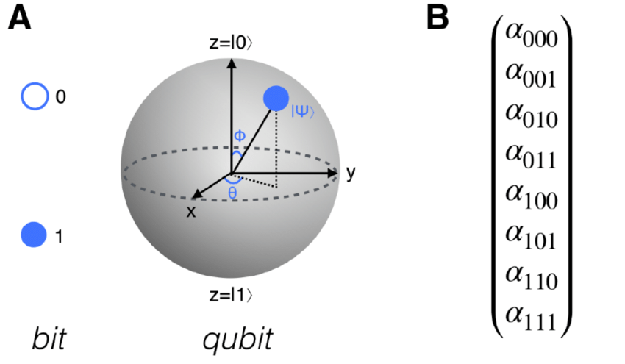

Figure 8.2 Comparison of Bits and Qubits

It can be seen in the diagram that a qubit can produce many possibilities between the values 0 and 1.

8.2 Logic Gates
In quantum computing, a qubit is the basic unit of quantum information, a quantum version of the classical binary bit physically realized with a two-state device. In particular, the number of input and output qubits must be equal. This is in contrast to the Boolean case, where most gates have two input bits and only one output bit.

All the basic binary operations of Boolean logic ( ,∧∨ , ¬, XOR, NAND, NOR, ...) are 2-1, which implies that they are not reversible: in fact, since 1∧ 0 = 0∧ 1 = 0∧ 0 = 0, we cannot deduce from the result "0" which one the input bit belongs to.

Another difference between quantum logic and Boolean logic is that quantum gates can change a qubit basis, say {|0>, |1>}, to another qubit basis, for example {|0> + |1>, |0> - |1>}, just as a vector basis can be changed through reflection or rotation.

This property is not possible in Boolean logic, where every operation changes to one of the two values 0 or 1. In other words, the base never changes in Boolean logic.

But qubits are useless unless we can use them to perform quantum calculations. And these quantum calculations are achieved by performing a series of fundamental operations, known as quantum logic gates.

There are many types of quantum gates. There are single-qubit gates, which can flip a qubit from 0 to 1 and allow for superposition states. There are also two-qubit gates. These allow qubits to interact with each other and can be used to create quantum entanglement, which is a state of two or more qubits correlating in a way that classical physics cannot explain.

An example of a gate is the controlled-NOT (CNOT) gate. It is a two qubit operation where the first qubit is labeled the control qubit and the second is the target qubit. If the control qubit is |1> then the state of the target qubit will be changed from |0> to |1> or vice versa.

In fact, if CNOT is expressed in another form called the Pauli basis, it will look even more "scary", so it becomes as follows.

Notes: | and > are used in the notation only to remind us that we are talking about vectors representing qubit states labeled 0 and 1.

Here are some logic gates commonly used in quantum computers .
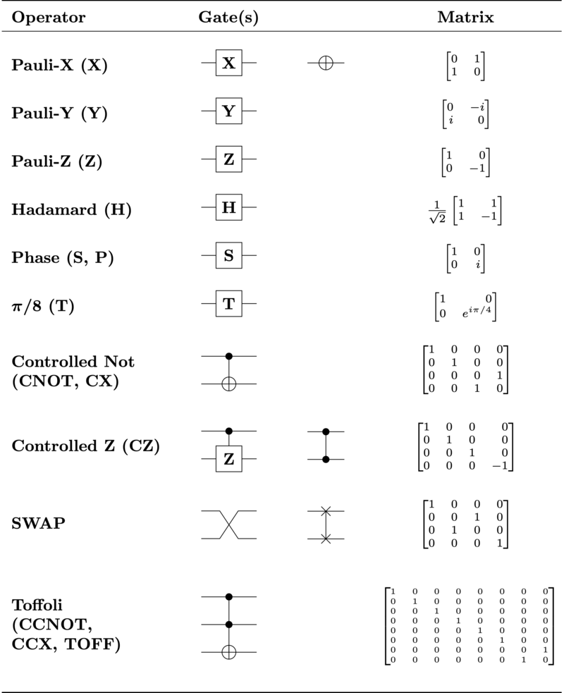

Similar to traditional computers, a quantum algorithm with many qubits can be broken down into a single quantum gate circuit and two qubits, forming a universal quantum gate circuit.

If we can make these quantum gates work in a reliable way and scale to many qubits, we can use them to run all possible algorithms in quantum computers.

8.3 Truth Tables
So far we have used truth tables to understand Boolean logic. Now can this quantum logic have a truth table that says similar or close to what we have learned before?

Since quantum logic gates are represented by unitary linear operators, quantum "truth tables" are not much different from classical truth tables, but must be interpreted differently for superposition states and when using different bases.

In other words, the truth table in quantum logic exists but the interpretation is different and the number of inputs/outputs will be different. It was mentioned earlier that Boolean logic is different from quantum logic.

- The number of input and output qubits must be equal. Unlike Boolean, where most gates have two input bits and only one output bit.
- Quantum gates can change a qubit basis, say {|0>, |1>}, to another qubit basis, for example {|0> + |1>, |0> - |1>}, just as a vector basis can be changed through reflection or spin. Which is not the case with Boolean.

These two conditions make the truth table of quantum logic "look strange". For example, a qubit expressed in terms of 0 and 1, let's call it X, will appear as follows:

Which is synonymous with:

Calculating X in each state results in:

So the truth table becomes like this:

This is just one qubit, imagine if more qubits are involved and more complex operations are involved. What would the truth table look like!

CHAPTER-9 Mathematical Logic Theory

9.1 The Development of Mathematical Logic
Dear readers, the science of mathematical logic that has been explained in this book is only a skin or introduction. Although it is a little and still general, but the author hopes that quite a lot of benefits can be obtained.

So what distinguishes mathematical logic from general mathematics? How deep is the science of mathematical logic?

Readers, according to the author, what distinguishes mathematical logic from mathematics is the statement about mathematical objects. In mathematical logic we formalize (formulate in a precise mathematical way) notions used informally by mathematicians such as:
- Property
- Statement
- Structure
- Truth (what does it mean for a particular statement to be true in a particular structure)
- Proof (of a certain set of axioms)
- Algorithm

In mathematical logic, some people who are said to be pioneers who emerged in the 19th century include: Bolzano, Boole, Cantor, Dedekind, Frege, Peano, CS Peirce, and E. Schr¨oder.

This pioneering work led to boolean algebra, set theory, propositional logic, predicate logic, as explaining the foundations of the natural number and real number systems, and as introducing a suggestive symbolic notation for logical operations. In addition, their activities led to the view that logic + set theory can serve as the basis of all branches of mathematics.

This era did not produce theorems in mathematical logic, but it was able to bring important advances of a conceptual nature, and the recognition that the logic used in mathematics obeys mathematical rules that can be made fully explicit.

In the period 1900-1950, important new ideas emerged, coming from Russell, Zermelo, Hausdorff, Hilbert, L¨owenheim, Ramsey, Skolem, Lusin, Post, Herbrand, G¨odel, Tarski, Church, Kleene, Turing, and Gentzen.

They discovered theorems in mathematical logic, with G¨odel's theorem having a dramatic impact. Hilbert (in G¨ottingen), Lusin (in Moscow), Tarski (in Warsaw and Berkeley), and Church (in Princeton) had many students and collaborators, most of whom became the next generation in the development of mathematical logic.

Various complicated but beautiful theories began to be formulated and confirmed as the basis of "true" mathematical logic. In the second half of the last century, the logic such as embraced by mathematicians gradually branched out into four main areas, namely:
- Model theory
- Computation theory (or recursion theory)
- Set theory
- Theory of proof

These kinds of in-depth theories are generally only discussed at university, and may only be taught to students majoring in mathematics.

9.2 Introduction to Mathematical Logic Theory
In mathematics, model theory is the study of the relationship between a formal theory (a collection of sentences in a formal language expressing statements about mathematical structures), and its models, taken as interpretations that satisfy the sentences of the theory.

Model theory developed rapidly during the 1990s, and a more modern definition was found by Wilfrid Hodges (1997), namely:

Model theory = Algebraic geometry - Plane

Computability theory is a branch of computer science and mathematics that addresses whether and how a problem can be solved on a computational model, using algorithms. The field mainly deals with computability and complexity, in relation to computational formalisms. The field of computability theory is divided into three major branches: automata theory and formal languages, computability theory and computational complexity theory.

Computing theory can be used to create a model of the entire field of computer science. Thus, math and logic are used. In the last century, computational theory became an academic discipline separate from mathematics.

Set theory is the theory of collections of abstract objects. The modern study of set theory was initiated by Georg Cantor and Richard Dedekind in 1870. After the discovery of paradoxes in naive set theory, such as Russell's paradox, many axiom systems were proposed in the early 20th century, of which the Zermelo-Fraenkel axioms, with or without the axiom of choice, are the most famous. Set theory is commonly used as a foundational system for mathematics, particularly in the form of Zermelo-Fraenkel set theory with the axiom of choice

Albert Einstein once questioned how mathematical theories could be proven. This is because this theory only comes from the human mind, unlike physics which can be proven through experiments. Now the theory of proof can be used to prove formulas, theorems, with the help of logic and mathematics.

In mathematics, a proof is a set of logical arguments that explain the truth of a statement. These arguments can come from the premises of the statement itself, other theorems, definitions, and finally can come from the postulates from which the mathematical system is derived. Mathematical proof can be done by: direct proof, contraposition, contradiction, mathematical induction, and other methods.

9.3 Cover
Even though it is a little bit, but what is reviewed in this chapter hopefully can provide insight to the reader that mathematical logic is not only limited to what we know so far. There is still quite a lot of mathematical logic that we can learn and dive into. The author can only provide suggestions and has not been able to explain it easily and clearly.

Hopefully, what is explained in this book can benefit us all. Aamiin.

Bibliography

  - Sharma S. N, Widiastuti N, Himawan C, et al (2017) Exploring High School Mathematics Class XI Compulsory Program. Jakarta: Yudisthira
  - Fadli, A. M. D., Wahyudin, M., & Arfah, J. (2022). Philosophy of Science and Logic. Deepublish.
  - Diana (2016). Fostering Academic Character in Logic-Based Lectures.Hazrat Uddin (2018). Analysis Metacognition High School Students in Ability
  - Mathematical Problem Solving in Problem-Based Learning (PBL) Learning Model".
  - Misel (2016).Informal Evidence in Mathematics Learning.
  - Rahman, A., Ropianto, M., & Kom, M. Designing a Web-based Toy Car Rental Application.
  - Ropianto, M. (2016). Understanding the Use of Unified Modeling Language. IbnuSina Engineering Journal (JT-IBSI), 1(01).
  - Ropianto, M., Rukun, K., Hardianto, M., Hayadi, B. H., Mesterjon, M., Utami, F. H., &Candra, M. O. (2017, September). Optimization of Strategic Planning Organization in the Framework of Achievement Objectives of Education. In 2nd International Conference on Education, Science, and Technology (ICEST2017).Atlantis Press.
  - Rukun, K., Permatasari, R. D. P., & Hayadi, B. H. (2019, November). Development of Digital Information Management Learning Media Based on Adobe Flash in Grade X of Digital Simulation Subject. In Journal of Physics: Conference Series (Vol. 1363, No. 1, p.012066).IOPPublishing.
  - Billstein, Rick. Libeskind, Shlomo and Lott, Johnny W. 1990. A Problem Solving Approach to Mathematics for Elementary School Teachers. Fourth Edition. Redwood City California: The Benjamin/Cummings Publishing Company, Inc.
  - Musser, Gary L. Burger, William F. and Peterson, Blake E. 2008. Mathematics For Elementary Teachers A Contemporary Approach. Eight Edition. New York: John Wiley & Sons.
  - Rosen, Kenneth H. 1993. Elementary Number Theory and Its Applications Third Edition. New York: Addision-Wesley Publishing Company, 1993.
  - Sukirman. 2006. Logic and Sets. Yogyakarta: Hanggar Kreator Yogyakarta.
  - Sukirman, et al. 2009. Math. Jakarta: Open University Publisher.
  - Lorens, Bagus, Dictionary of Philosophy, Publisher Gramedia Pustaka Utama, Jakarta 1996
  - Ofm, Alex Lanur, Logic at a Glance, Kanisius Publisher, Jogjakarta 2008
  - Rapar, Jan Hendrik, Introduction to Logic, Principles of Systematic Reasoning, Kanisius Publishers, Indonesia 1996
  - Rinaldi Munir, "Discrete Mathematics", Informatics Publisher, 2005.
  - Shoenfield, J. R., Mathematical Logic, Reading, Addison-Wesley, 1967.
  - Chang, C. C. and Keisler, H. J., Model Theory, New York, NorthHolland, 1990.
  - Poizat, B., A Course in Model Theory, Springer, 2000.
  - Rogers, H., Theory of Recursive Functions and Effective Computability, McGraw-Hill, 1967.
  - Jozef Gruska: Quantum Computing, McGraw-Hill, London 1999.
  - Samuel J. Lomonaco, Jr. (Ed.): Quantum Computation: A Grand Mathematical Challenge for the 21st Century and the Millennium. American Mathematical Society Short Course January 17-18, 2000, Washington, DC. American Mathematical Society, Providence, Rhode Island, 2002.
  - Michael A. Nielsen and Isaac L. Chuang: Quantum Computation and Quantum Information, Cambridge University Press, Cambridge, 2000.
  - Karl Svozil: Quantum Logic, Springer-Verlag, Singapore, 1998.
  - Bernd Thaller: Visual Quantum Mechanics, Springer-Verlag, New York Heidelberg, 2000. http://www.kfunigraz.ac.at/imawww/vqm/

Biodata

Bedy Purnama is the author of several Machine Learning books and several other books, the author was born in the city of

Iwan Sofana
Synopsis

This book explores Mathematical Logic but from a slightly different perspective. A book about Mathematical Logic that is "light" to read and learn by everyone who wants to know the science of Mathematical Logic. This book also presents the implementation of Mathematical Logic in computer science, quantum computers, algorithms, and others.

https://id.wikipedia.org/wiki/Matematika
https://www.tntech.edu/cas/math/what-is-mathematics.php
https://en.wikipedia.org/wiki/Babylonian_mathematics
https://www.britannica.com/topic/logic
https://www.kompas.com/skola/read/2023/10/16/050000269/10-pengertian-logika-menurut-para-ahli
https://id.wikipedia.org/wiki/Matematika
https://anengineersaspect.blogspot.com/2009/09/favorite-albert-einstein-cartoons-and.html
Data Governance for Dummies
https://en.wikipedia.org/wiki/Logic_gate#Symbols
https://en.wikipedia.org/wiki/Logic_gate#Symbols
https://en.wikipedia.org/wiki/Conditional_(computer_programming)
https://socs.binus.ac.id/2012/07/26/konsep-neural-network/
https://www.researchgate.net/figure/Schematic-of-a-single-neuron-in-a-neural-network_fig3_334519607
https://iep.utm.edu/par-log/
https://mojok.co/terminal/omnipotence-paradox-bisakah-tuhan-menciptakan-batu-yang-tak-bisa-tuhan-angkat/
https://id.wikipedia.org/wiki/Paradoks_Epimenides
https://informatika.stei.itb.ac.id/~rinaldi.munir/Matdis/2014-2015/Makalah2014/Makalah-IF2120-2014-070.pdf
https://www.trivusi.web.id/2022/05/pengertian-fuzzy-logic.html
https://www.geeksforgeeks.org/fuzzy-logic-introduction/
Comparison of Different Rule Base Matrix in Fuzzy Logic Controller, : Verdy Afrian and Slamet Riyadi 2020 J. Phys..: Conf. Ser. 1444 012018
https://www.silverliningsinfo.com/data-center/quantum-data-centers-whole-new-beast
https://medium.com/@universalquantum/quantum-gates-explained-without-the-maths-1c40e7d79611
https://www.researchgate.net/figure/A-Conceptual-illustration-of-bit-vs-qubit-The-state-of-a-qubit-can-be-represented-by-a_fig1_337336568
https://en.wikipedia.org/wiki/Quantum_logic_gate

