Title:
A cost-effective approach for estimating the Pavement Condition Index using Ensemble learning techniques.
Magdy M. Shaheen, Rowan A. Elsayed, Hassan G. Elgazoly, and Wael A. Bekheet
Transportation Engineering Department, Faculty of Engineering, Alexandria University

Abstract:
Pavement management systems (PMSs) rely on accurate evaluation of pavement conditions to make informed maintenance and rehabilitation decisions. The Pavement Condition Index (PCI) and International Roughness Index (IRI) are widely used indicators for assessing pavement performance. However, conducting pavement condition surveys for PCI determination is time-consuming and resource-intensive compared to measuring IRI. This study proposes a novel approach for estimating PCI using optimized ensemble learning techniques and easily accessible features, such as IRI, pavement age, environmental factors, structural attributes, and material properties. Data from 105 Long-Term Pavement Performance (LTPP) sections, including 1493 observations, were utilized to develop predictive models using Random Forest (RF) and Extreme Gradient Boosting (XGBoost) algorithms. Hyperparameter optimization was performed using a randomized search to enhance model performance. XGBoost and Random Forest achieved high accuracy, with an R² of 0.923 and 0.912 in the test set, respectively. Feature importance analysis revealed that IRI and pavement age were the most influential predictors, while environmental and structural factors also played significant roles. The XGBoost model exhibited superior generalization and reduced prediction errors compared to the RF model. This study demonstrates the effectiveness of optimized ensemble learning techniques in providing a cost-effective approach to pavement condition assessment, offering valuable insights for maintenance and rehabilitation decision-making in PMSs.
Keywords: Pavement Condition Index (PCI), International Roughness Index (IRI), Ensemble learning, and Pavement condition assessment.

Introduction:

A country's road network is vital to its development. Effective maintenance and rehabilitation of highways enhances traffic safety, improves ride comfort, reduces vehicle operating costs, and lowers future pavement repair expenses.(1). Evaluating the effectiveness of road networks is essential. Road authorities are responsible for maintaining these networks to ensure they meet the required performance criteria. The decisions made in this regard are informed by pavement management analysis, which is of utmost importance for highway agencies globally. To tackle this challenge, numerous highway authorities have implemented protocols to guarantee timely and suitable maintenance choices(2).
A crucial component of an effective pavement management system (PMS) is the precise evaluation of the current state of the pavement network. The ASTM stipulates that this evaluation is conducted through yearly visual inspections of pavement conditions. For example, the assessment of pavement surface cracking involves a Surface Rating and Major Defects for each section of the pavement network(3). Contemporary technologies now enable the measurement of additional significant pavement distresses. These include capturing images of the pavement surface through photography. Wang (4) employed non-contact sensors to obtain pavement profile measurements.
In pavement engineering, the integrity and surface degradation of roadways are vital considerations for design and longevity. Pavement degradation is broadly categorized into structural and functional failures. These can be further delineated into four distinct conditions: structural issues, surface distress, skid resistance problems, and roughness. Structural conditions are directly linked to structural failure, while the remaining three are indicative of functional failure(1). To evaluate pavement performance, several metrics are employed globally. Among these, the Pavement Condition Index (PCI), Present Serviceability Rating (PSR), Pavement Quality Index (PQI), and International Roughness Index (IRI) are frequently utilized as key performance indicators for pavement. (1,2,4,5).
A widely employed method is the PCI indicator, developed by the United States Army Corps of Engineers during the early 1970s. This indicator relies on a sophisticated index that considers the structural and operational requirements of flexible pavements. The calculation of the PCI involves the integration of nineteen distinct pavement distress severities and intensities.(3). Recognized as a Standard ASTM Test method, specifically ASTM D6433-18, the PCI utilizes a numerical scale ranging from 0, indicating a failed pavement, to 100, representing optimal condition.
Data required for the determination of PCI are gathered through either visual assessment or image-based analysis methods. The visual assessment takes a long time, causes traffic stoppage, and is unfeasible for long and large road networks in addition may be insecure for workers doing the inspection. Alternatively, the image-based survey method uses a vehicle to collect film, video, or digital images of the pavement system is considered faster, more reliable, and safer but requires advanced equipment and may be costly(2).
Similarly, the IRI is a worldwide indicator to measure ride quality or smoothness. The IRI was developed by the World Bank in the mid-eighties. It is calculated by dividing the cumulative vibrations or vertical movements by the profile length as obtained from a mathematical model of a simulated quarter-car crossing a measured profile at 80 km/ hr. (1-2,5). Many highway agencies around the world consider the initial IRI (IRI₀) value as a quality reliability measure while the terminal IRI (IRI_{t}) as an indicator of pavement maintenance actions or reconstruction needs as mentioned in the Mechanistic-Empirical Pavement Design (MEPDG). The MEPDG considers the terminal IRI as one of the main pavement structural design criteria. (5).
Several tools are used for gathering IRI data: inertial profiler, Rough meter NAASRA, MERLIN, profile graph, Dipstick, rod and level, and so forth (6). Furthermore, at least two sources provide standardized guidelines for computing the IRI: ASTM E1926-08 (7) and AASHTO standard R 43 M/R 43-07 (8).

Literature review:

In PMS, there are two vital modeling levels: Project and network-level modeling. At the project level, decisions are made about specific projects related to a particular portion of the network. At the network level, models aim to predict the average deterioration of a comprehensive, interconnected road network rather than focusing on individual sections. The Pavement Management Guide classifies models into deterministic, probabilistic, and subjective (or expert-based) models. Moreover, it indicates that models can be categorized according to the variables included, classifying them as mechanistic, mechanistic-empirical, or empirical.

Model Types:

When road agencies have historical pavement condition information or enough survey data, deterministic models are used to identify statistically significant pavement deterioration trends. These models use regression analyses to define relationships between variables. Since the connection between the dependent variable and independent variable(s) is not precise, the best statistical fit must be determined, commonly with the least square regression technique. Deterministic models establish linear or non-linear relations between affecting factors and the predicted variable. This method is simple, easy to understand and apply, and proven efficient with large datasets. However, they cannot be generalized beyond experimental data limits and produce a single value of the dependent variable. Calibration is generally recommended when transferring a deterministic model from one site to another(9).
Probabilistic models evaluate the probabilistic distribution of the expected value, integrating uncertainty in pavement performance. Bayesian and Markov probabilistic models are of greatest interest, with discrete-time Markov chains being the most used in pavement deterioration modeling (9,10). These models consider the dynamic nature of pavements including deterioration, environmental, and loading conditions, and are extensively employed in predicting comprehensive indices like IRI (11).
Bayesian models combine prior knowledge of event probabilities with observed data to produce an adjusted expression of the event's probabilistic distribution. They can integrate uncertainty and expert opinions to supplement historical data when unavailable. However, Bayesian inference involves evaluating different posteriors, which can be comprehensive (9,10).
Subjective or expert-based models can provide useful insights when historical data is unavailable, new practices or materials are being used, or confidence in available data is low. While they may introduce subjective opinions less formally, they can be effective in certain situations.
One such approach that has gained attention in recent years is the use of Artificial Intelligence (AI) techniques for predicting pavement conditions. The application of various Machine Learning (ML) algorithms, such as decision trees, artificial neural networks, gene expression programming, AdaBoost, bagging, boosting, support vector machines, and random forests, has proven effective in forecasting pavement conditions. ML models are relatively pioneering. The quantitative relations between model input variables and output variables are constructed by sophisticated model structures and learning algorithms that can improve automatically through the data for model construction (9,11).

Previous research work:
From the early of nineties, researchers proposed several models based on pavement distress to predict IRI. Some of these models were derived based on the Long-Term Pavement Performance database (LTPP), while others were developed based on research teams' measurements or the local agency database. Mactutis et al (12) investigated the relationship between IRI, rutting, and cracking based on 317 observations from roads located near Reno, Nevada which resulted in a coefficient of determination (R²) of 0.71. In his relationship, IRI (m/km) depended on IRI_{o}, alligator cracks, longitudinal cracks, and rutting depth (mm). Sandra and Sarkar (13) established a linear regression model to estimate IRI based on the severity and area of five major failures in Indian roads. Data was collected over 39.5 km length of major roads. The R² value of the model was 0.986. The five pavement failures were rutting, potholes, cracking, raveling, and patching. Prasad et al (14) considered the same distress to present a regression model to calculate IRI, the results yielded R² =0.66.
Other studies used ML, Yousef Zadeh et al (15) discussed the capability of using ANN for road profile estimation. Lin et al (16) analyzed the relationships between IRI and pavement distress using a backpropagation artificial neural network (ANN) methodology. The ANN was constructed using 14 nodes at the input layer,6 nodes at the hidden layer, and one output (16). An ANN was developed by Vidya et al. (17) to estimate IRI based on data obtained from construction work zones. Their model was designed with three input variables, a single hidden layer containing four neurons, and one output. The predicted IRI values from the model were compared with the actual measured IRI values to evaluate roughness using low-cost instrumentation. The developed ANN model resulted in an R² of 0.86, which indicates satisfactory predictions. Abd ElAziz et al (18) presented regression and ANN models predicting (IRI) as a function of distresses based on a comprehensive LTPP database of 506 sections. The models were proposed for IRI prediction as a function of age, IRI_{o}, transverse crack length, alligator fatigue cracks, and standard deviation of the rut depth. The regression analysis produced fair accuracy with R² of 0.57 while the ANNs model yielded better accuracy with R² of 0.75. Bashar and Torres-Machi (19) presented three meta-heuristic algorithms: ANN, Random Forest (RF), and Support vector machine(SVM), which are commonly used to predict IRI and compare their performance to traditional techniques. They showed that ML algorithms improve the variability by 15.6% compared to traditional techniques. RF was the most accurate technique with an overall performance value of 0.995. The presented studies showed that IRI and PCI are both functions of pavement distress. Thus, there should be a relationship between IRI and PCI.

Table 1: Related previous studies concerning the correlation between PCI and IRI:
Author(s) | Year | Equation/Model | Data collected | R²
Dewan and Smith(20) | 2002 | PCI=153-$\frac{IRI}{0.0171}$ (1) | California | 0.53
Park et al.(21) | 2007 | $\log\left(PCI\right)=2-0.436log⁡(IRI)$ (2) | 9 states in Northern America | 0.59
Shah et al.(22) | 2015 | $PCI=1.28{(IRI)}^{2}-17.73\left(IRI\right)+100$ (3) | - | -
Arhin et al.(23) | 2015 | $PCI = -0.224 (IRI)+120.02$ (4) | Dense urban areas in the District of Columbia | 0.82
El Hadidy et al.(2) | 2019 | $PCI = 1 0.048 × ln({79.933}/{IRI} - 14.061)$ (5) | LTPP | 0.99
Muataz Safaa(24) | 2019 | 𝑃𝐶𝐼 = − 6.647 𝐼𝑅𝐼 + 80.878 (6) | Al-Diwaniya, Iraq | 0715
Muataz Safaa(24) | 2019 | 𝑃𝐶𝐼 = − 9.031 𝐼𝑅𝐼 + 0.283 𝐼𝑅𝐼² + 85.119 (7) | Al-Diwaniya, Iraq | 0.722
S. Madeh Piryonesi and Tamer El-Diraby(5) | 2021 | $IRI=-0.012PCI+2.064$ (8) | 61 states over 28 years | 0.31, up to 0.7
Sasan Adeli et al(1) | 2021 | PCI=4.915−0.1126IRI (2.5 < IRI < 3.5); (9) | 6000 sections in Iran | 0.75
Sasan Adeli et al(1) | 2021 | PCI=6.038-0.438IRI (3.5<IRI<5) (10) | 6000 sections in Iran | 0.76
Sasan Adeli et al(1) | 2021 | PCI=5.54-0.332IRI (5<IRI< 8) (11) | 6000 sections in Iran | 0.59
A. Ali et al(25) | 2021 | PCI=85.657−11.386(IRI) (12) | Harsh climate regions | 0.895
Ali et al.(4) | 2022 | Conventional models: Linear, Quadratic, and Cubic regression; Machine Learning: RF and SVM | LTPP | RF: 0.997SVM: 0.968
Traditionally, many researchers have tried to model the relation between PCI and IRI as a function of the pavement distresses using the classical regression modeling techniques as mentioned in the literature review section (1,2,5,20–22,25). On the other hand, other studies promise the role of ML algorithms such as ANN, RF, and SVM in improving the accuracy of predictive models in predicting a single index e.g. IRI (16,17,19,26). These models outperformed conventional models.
Several other researchers developed prediction models for the PCI as a function of influential parameters. Hamid Behbahani (27) proposed a model that predicts the PCI as a function of age and maintenance. Gaber et al proposed an equation to predict PCI from age, Annual daily traffic (ADT), and structural number (SN) as follows:
PCI = 98.87 − 2.18(AGE) + 0.02(ADT) + 0.28(SN) ……...…(13)
where PCI represents the Pavement Condition Index, AGE denotes the number of years since construction, ADT refers to the average daily traffic measured in 1000 vehicles per day, and SN indicates the existing structural number of the pavement. 20 pavement sections, local data were used, and R² is 0.973. Maher Mahamoud (28) conducted an equation to predict PCI
𝑃𝐶𝐼 = 𝑎1 + 𝑎2 𝑋1 + 𝑎3 𝑋2 + 𝑎4 𝑋3 + 𝑎5 𝑋4 + 𝑎6 𝑋5.. ……….(14)
Where X1 = Cumulative Equivalent Single Axle Load (ESAL); X2 = Pavement age; X3 = Maintenance effect (inlay and overlay thickness); X4 = Longitudinal and transverse cracking length; X5 = Cracking area (alligator, edge and block); 𝑎1, 𝑎2, 𝑎3, 𝑎4, 𝑎5, 𝑎6 = Coefficients using 820 observations from LTPP. The R² results vary from 0.52 to 0.93 according to zone. Parsons and Pullen(29) obtained a relation between PCI, age, and deterioration rate(dr) as follows:
dr = (100−PCI)/age…………………………………………….(15)
They used 10,000 observations from The United States Air Force. Another study by M. A. Younos et al (30) used 89 LTPP sections, encompassing 617 observations. Relationships between PCI and influencing factors were identified. Two modeling approaches, multiple linear regression (MLR) and Artificial Neural Networks (ANNs), were employed to predict PCI, considering climatic factors and traffic loading. The models were validated with a subset of the data, achieving a coefficient of determination (R²) of 0.771.

Problem statement:
Regardless of the great effort that has been exerted, the literature models correlating PCI with IRI were based only on limited data that did not cover a wide range of IRI and PCI values representing the board spectrum of pavement conditions. In addition, the regression models need calibration to be used on a wider scale. The following points summarize the observed gaps in previous studies.
- Limited Predictive Accuracy: Previous studies have demonstrated correlations between IRI and PCI, but many rely on simplistic models.
- Lack of Integration: Many existing studies rely on limited datasets or case-specific data sources, leading to challenges in generalizability and scalability.
- Inefficient use of Advanced Techniques: While ML techniques show promise for PCI prediction, there is a gap in their application to pavement management due to the limited exploration of advanced ensemble learning algorithms and optimization methods.
- Optimization of Hyperparameters: Existing studies (4) often overlook the optimization of model hyperparameters, leading to inadequate predictive performance. The literature lacks a systematic optimization of model parameters, which enhances model generalizability and predictive accuracy.

Ensemble learning techniques:
Ensemble learning techniques have recently shown high predictivity and accuracy compared to ANN and SVM and are widely used in pavement engineering applications. Decision tree (DT), RF, Gradient Boosting Machines (GBM), Extreme Gradient Boosting (XGBoost), and LightGBM (LGBM) are considered some of the most predictive ensemble learning techniques.
Ritha Nyirandayisabye et al(31)evaluated road distress quality using a dataset from the Michigan Department of Transportation using GBM and LGBM, comparing results with SVM. GBM performed better with the most accurate asphalt pavement damage model of R² = 99%. Guo et al(32)used DT to predict IRI and rut depth RD using the LTPP database. Hyperparameters were determined through Grid Search (GS). The ensemble model outperformed ANN, reaching R² equal to 0.9. Barua et al(33)employed GBM to predict PCI of runways and taxiways of Chicago O'Hare International Airport, using GS to optimize hyperparameters. GBM models outperformed other methods. Damirchilo et al(34)predicted IRI using the LTPP database with XGBoost, comparing results with SVM and RF models. XGBoost provided a better model fit in terms of mean absolute error (MAE) and coefficient of determination. Gupta et al(35)developed a framework using XGBoost to compute pavement condition parameters in India, using the Optuna framework for hyperparameter optimization. The boosting model yielded higher accuracy for all pavement condition parameters. Ali Taheri and John Sobanjo(36)investigated RF, extremely randomized trees (ETR), and XGBoost using the LTPP database. Three optimization methods were used: GS, Random Search (RS), and Bayesian method. XGBoost, optimized using Bayesian methods, emerged as the most effective, demonstrating good predictive accuracy with an R² of 0.79.

Objectives:
Establishing a pavement condition survey required for PCI determination requires more time and resources as compared to calculating IRI. Moreover, since IRI is influenced by various pavement distresses as informed in the literature (12–14,16,17,19). The core of this research suggests a significant correlation between PCI and IRI. Due to the high accuracy and predictive results obtained from ensemble learning techniques (XGBoost and RF), the optimization method randomized search (RS) is used to optimize hyperparameters.
Accordingly, the main objectives of the research are:
- Develop a novel predictive model for estimating PCI using optimized ensemble learning techniques.
- Investigate the impact of key variables, such as IRI, pavement age, climate conditions, traffic volume, and structure attributes on PCI prediction accuracy.
- Evaluate the performance and accuracy of the proposed models.

Research Methodology:
To achieve objectives, 105 LTPP sections including 1493 observations are used. These sections were selected from both General Pavement Studies (GPS) and Specific Pavement Studies (SPS) experiments. Subsequently, data processing is accomplished in three steps. The initial step involved calculating the PCI based on measured distresses from LTPP, followed by determining the relationship between PCI and other factors. Finally, predicting the PCI was accomplished through two proposed models using RF and XGBoost. To evaluate the accuracy of the proposed models, statistical analysis was conducted. The analysis concentrated on asphalt concrete (AC) pavements.

Figure 1: The overall framework of the predictive system.

Data collection and processing:
In this study, the LTPP Standard Data Release (SDR) number 38, released in August 2024, is utilized(37). The PCI prediction models were developed using 105 LTPP sections, including 1493 observations. Figure 2 illustrates the geographic distribution of the test sections considered in the analysis, and Table 2 shows the LTPP tables used for data collection.

Figure 2: Locations of the LTPP sections used in this study
Table 2. Predictor variables used to predict PCI
Class | Data | LTPP table | Symbol
Time | Age | PROJECT_HIST_AGE_EXP
Climate | The mean annual average temperature | CLM_VWS_TEMP_ANNUAL | MAAT
Climate | Total annual precipitation | CLM_VWS_PRECIP_ANNUAL | TAP
Climate | Freeze Index | CLM_VWS_TEMP_ANNUAL | FI
Structure | Pavement thickness | SECTION_LAYER_STRUCTURE | TTh
Structure | Asphalt thickness | SECTION_LAYER_STRUCTURE | ATh
Material | Plastic Index | TST_UG04_SS03 | PI
Material | Pass sieve 200 subgrade | TST_SS01_UG01_UG02
Material | Pass sieve 200 base_subbase | TST_SS01_UG01_UG02
Traffic | Annual Average Daily Truck Traffic | TRF_TREND | AADTT
Performance | Mean International Roughness Index | MON_HSS_PROFILE_SECTION | MIRI
Performance | Pavement distress | MON_DIS_AC_REV

Pavement Condition Index calculation:
Having collected the pavement distress data along with their severities from the LTPP database, the PCI values were calculated adopting the ASTM D6433 procedure (3), as a function of the corrected deduct values (CDV) as expressed by equation 16:
PCI = 100−max CDV ………………………………….…. (16)
For each distress, the deduct value (DV) was determined based on its density and severity. Following this, the DV was adjusted according to the ASTM procedure, which is performed manually. This method is tedious, trivial, and time-consuming, particularly when handling large datasets. To circumvent this manual process, one might consider using commercial software like Micro Paver. However, this is not a viable solution because data for each section must still be entered manually, making it equally trivial and time-consuming. To address this issue, a spreadsheet was developed (38). This spreadsheet automates the entire process, eliminating the need for the previously mentioned trivial solutions.
Table 3: Descriptive statistics of distress data used for model development
Distress | Minimum |  |  | Maximum
Distress | Low severity | Medium severity | High severity | Low severity | Medium severity | High severity
Alligator cracking (m²) | 0 | 0 | 0 | 426 | 369 | 406
Block cracking (m²) | 0 | 0 | 0 | 371 | 304 | 24
Longitudinal cracking and Transverse Cracking (m) | 0 | 0 | 0 | 394 | 390 | 792
Patching (m²) | 0 | 0 | 0 | 318 | 99 | 415
Potholes (number / 150 m section length) | 0 |  |  | 3
Raveling (m²) | 0 |  |  | 610
Rutting (mm) | 0 |  |  | 26

The collected data incorporate various parameters, each of which was examined and analyzed to evaluate its potential impact on the PCI over time. This is one of the most important steps in modeling pavement deterioration to develop accurate and rational models. In this study, the parameters used for the proposed models are described in Table 4. The table provides descriptive statistics of the variables, including the number of variables, mean, standard deviation, minimum, percentiles, and maximum. Some variables have many missing values. Ensembled models can handle missing values without requiring substituting any value. Handling missing values is not a black box in XGBoost. It is based on the sparsity-aware split-finding approach(39). It proposed to add a default direction in each tree node. So, in each split, if a value is missing, then the instance is dedicated to the default direction. Optimal default directions are learned based on the data set(39). Based on the nature of gradient boosting in handling missing values and the novel sparsity-aware split-finding approach, it is not required to delete variables with missing values from the XGBoost model. Researchers who used ANN, such as Choi and Do (40), had to omit missing variables. But in XGBoost, missing values do not cause an issue.
Table 4: Descriptive statistics for observations
Variable | Count | Missing | Mean | Std | Min | 25% | 50% | 75% | Max
Age (years) | 1493 | 0 | 13.53 | 9.56 | 0.08 | 5.61 | 11.08 | 20.80 | 38.32
TTh (mm) | 1493 | 0 | 404.26 | 296.32 | 96.50 | 210.80 | 307.30 | 454.70 | 1351.30
ATh (mm) | 1493 | 0 | 150.02 | 54.02 | 25.40 | 111.80 | 137.20 | 182.90 | 337.80
TAP (mm) | 1493 | 0 | 334.76 | 190.32 | 32.60 | 228.90 | 309.20 | 406.60 | 2997.00
MAATºC | 1493 | 0 | 11.00 | 5.80 | 0.00 | 7.20 | 9.80 | 16.40 | 24.60
FIºC | 1493 | 0 | 388.80 | 505.08 | 0.00 | 3.00 | 192.00 | 532.00 | 3369.00
MIRI (m/km) | 1493 | 0 | 1.34 | 0.65 | 0.48 | 0.83 | 1.20 | 1.65 | 5.70
PI % | 171 | 1322 | 10.99 | 10.64 | 0.00 | 0.00 | 6.00 | 21.00 | 28.00
AADTT (year) | 181 | 1312 | 336.72 | 578.41 | 0.00 | 0.00 | 248.00 | 484.00 | 5336.00
pass Sieve 200 subgrade % | 143 | 1350 | 34.36 | 23.62 | 2.70 | 11.45 | 49.80 | 57.00 | 65.00
pass Sieve 200 base subbase% | 164 | 1329 | 12.70 | 4.71 | 5.30 | 9.00 | 12.00 | 16.95 | 22.00
PCI | 1493 | 0 | 60.13 | 30.90 | 0.39 | 30.91 | 67.20 | 90.55 | 100.00
Pavements are primarily engineered to withstand two main sources of degradation: traffic and environmental factors. The continuous stress imposed by vehicles passing over asphalt pavements leads to mechanical failure of the pavement materials. Additionally, environmental conditions significantly influence the durability of flexible pavements. External environmental elements, including precipitation, temperature fluctuations, and freeze, are crucial in determining the extent of environmental impact on pavement performance.
For this research, the freeze index has been selected to represent the impact of extremely cold conditions on the road surface. Moisture effects are characterized by precipitation, whilst temperature is typically employed to denote thermal influences on the pavement. These thermal effects can result in various forms of road surface deterioration, including cracking and rutting.
The extracted roadways include all types of asphalt pavements. In total, 1493 observations for PCI and predictors were analyzed. The average of the left and right wheel path IRI values (mean roughness index) was used as the IRI value.
The traffic, climate, and material properties predictors were considered in PCI prediction. Also, age and IRI are two variables used in PCI prediction. One traffic-related variable Average annual daily traffic truck (AADTT). Three climate-related variables (precipitation, freeze index, and mean annual average temperature) and material property variables (plastic index, pass sieve 200 for subgrade and base subbase). For structure: asphalt thickness ATh and pavement thickness TTh are considered.
The histograms in Figure 3 illustrate the distribution of variables within the model. Notably, these distributions exhibit significant variation amongst themselves, with the majority deviating from normality. This observation indicates that the relationship between the predictor variables and PCI is non-linear in nature.
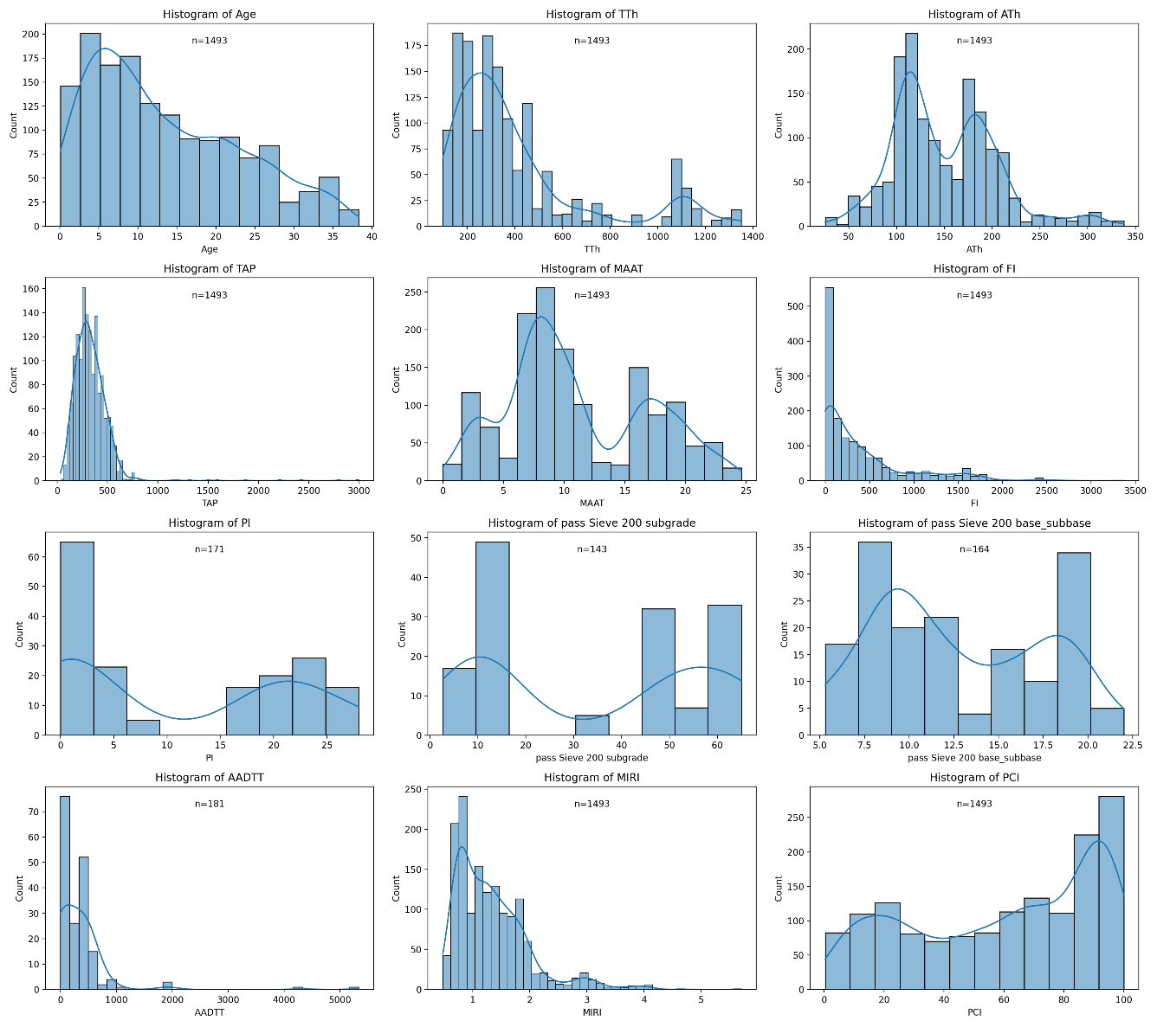
Figure 3. Histograms of variables
The correlation heatmap in Figure 4 depicts the interrelationships between various input parameters and the Pavement Condition Index (PCI). The correlation coefficients, ranging from -1 to +1, elucidate the linear associations among the variables.
A pronounced negative correlation exists between MIRI and PCI (-0.74), suggesting that increased roughness corresponds to diminished pavement condition ratings. Age also demonstrates a negative correlation with PCI (-0.56), corroborating the anticipated trend of pavement degradation over time. In contrast, AADTT shows a weak positive correlation with PCI (0.26), which is unexpected as higher lorry traffic is typically associated with accelerated pavement deterioration. This could indicate intricate interactions with other structural or environmental factors not captured by basic correlation analysis. Additionally, Total Annual Precipitation (TAP) and Mean Annual Air Temperature (MAAT) display modest correlations with PCI (0.22) and (-0.26) respectively, underscoring the impact of climatic conditions on pavement degradation.
The correlation matrix also unveils strong interdependencies among predictor variables, particularly between PI and passing sieve 200 subgrade (0.94), and between FI and MAAT (-0.91), indicating potential collinearity issues that may affect model performance. These observations emphasize the need for sophisticated feature selection techniques, such as SHAP analysis, to identify the most influential predictors and mitigate redundant information in predictive modeling.
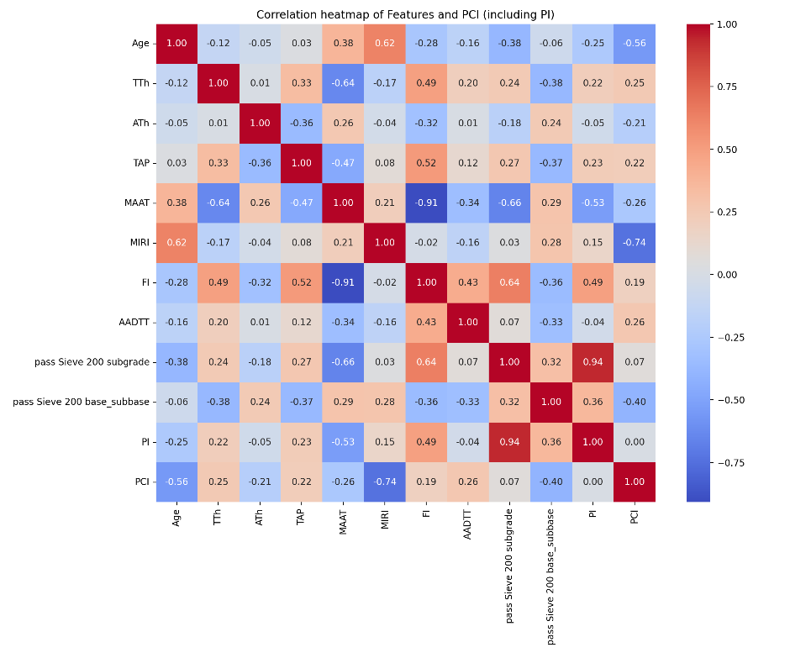
Figure 4: Correlation Heatmap matrix between variables

Model development:
Random Forest RF:
Random Forest (RF) is a parallel-ensemble technique that utilizes bagging, as introduced by Breiman (41). Rather than relying on a single model, ensemble methods integrate multiple models to enhance prediction accuracy. These methods can be categorized into two types: sequential (serial) and parallel ensemble techniques. Whilst RF exemplifies a parallel ensemble model, XGBoost represents a sequential ensemble approach. In the RF algorithm, trees are constructed independently using randomly sampled data. Furthermore, each tree's splitting process involves selecting a random subset of variables for consideration (34). For the RF algorithm, several crucial hyperparameters must be considered. These include the forest's tree count (n_estimators), the maximum number of features evaluated when splitting a node (max_features), the highest permissible level count in individual decision trees (max_depth), the lowest quantity of data points required before node division (min_samples_split), and the minimum number of data points allowed in a leaf node (min_samples_leaf)(19).

Random Forest Pseudocode
- Input: Training dataset X, y (features and target variable)
- Initialize: Number of trees N_{t}rees, max depth D, minimum samples per leaf min_samples
- For i=1to N_{t}rees:
- Sample X, y with replacement to create a bootstrap dataset.
- Grow a decision tree:
    - Start at the root node with all data in the bootstrap sample.
    - Recursively split the dataset on features to minimize error.
    - Stop when the tree depth reaches D or the number of samples in a node < min_samples.
- Store the trained tree.
- Predict:
  - For a new input x_{new}:
    - Pass x_{new}​ through all N_{t}rees to get predictions.
    - Average predictions from all trees.
Xtreme Gradient Boost XGBoost:
XGBoost, a tree-based algorithm, was introduced by Chenard Guestrin (39) as an enhancement of the gradient-boosting tree method proposed by Friedman (2001), this technique employs boosting, which combines weak learners to create a robust model. The process involves sequentially adding new trees to the ensemble, with each subsequent tree aiming to rectify errors made by its predecessors. During each iteration, a new learner is trained by considering the collective errors of all existing ensemble learners, resulting in progressively diminishing errors. XGBoost improves upon gradient boosting by implementing additional regularization techniques to mitigate overfitting, thereby enhancing model performance. Furthermore, XGBoost can automatically manage missing values, which is particularly beneficial when dealing with LTPP data. The algorithm is known for its accuracy, insensitivity to input scaling, and ease of control and interpretation (36).
In machine learning, the objective is to minimize both training loss and regularization. Optimizing training loss helps predictive models fit well in the training set. Optimizing regularization helps to reach simpler models that tend to have smaller variances in future predictions in the test set and bring more stability. In other words, the regularization term controls the complexity of the model, which prevents overfitting.

XGBoost Pseudocode
- Input: Training dataset X, y
- Initialize: Learning rate η, number of trees N_{t}rees, max depth D.
- Set: Initial prediction F₀(x) = mean(y).
- For i=1to N_{t}rees:
  - Compute residuals: r_{i} = y−F_{i−1}(x)
  - Fit a decision tree to the residuals using X, ri
  - Limit tree depth to D.
  - Update predictions: Fi(x)=Fi−1(x)+η⋅ Tree_{i}(x)
- Predict:
For a new input x_{new:} Compute F_{final} (x_{new})=F₀(x_{new}) + $\sum_{i=1}^{N_{trees}}{η⋅ Treei(x new)}$

Results and Discussion:
This study developed two machine learning models, XGBoost and Random Forest, to estimate the Pavement Condition Index based on MIRI and other accessible easy features.
The XGBoost model has shown promising results in various applications due to its ability to handle complex non-linear relationships and its efficient computation. The Random Forest model has also been widely used as a benchmark for comparison in pavement condition assessment studies.
To assess the proposed models’ accuracy, the mean absolute error (MAE) which represents the average absolute difference between observed and obtained values, mean square error (MSE) indicating the average squared difference between the predicted values and the actual values, and coefficient of determination (𝑅 ²) which is considered a measure of the variance proportion for the dependent variable. The following figure illustrates a calculation of three matrices.
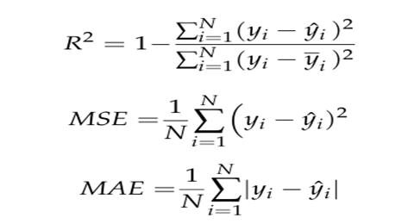
Where yi is the actual value, ŷi is the predicted value by the model output, ȳi is the mean of the actual values, and N is the total number of observations. R² ranges from 0 to 1. A higher coefficient indicates better goodness of fit.
Figure 5 represents the relation between actual versus predicted for both training and testing sets using XGBoost. For hyperparameter tuning, 5-fold cross-validation and randomized search were used. The maximum tree depth (3, 5, 7, 9), Learning rate (0.01, 0.1, 0.3), number of estimators (100, 200, 300), min_child_weight (1, 3, 5), gamma (0, 0.1, 0.2), subsample: (0.6, 0.8, 1.0), colsample_bytree (0.6, 0.8, 1.0), reg alpha (0, 0.1, 0.5) and reg lambda (0.1, 1.0, 5.0). The R² for the test set was 0.923.
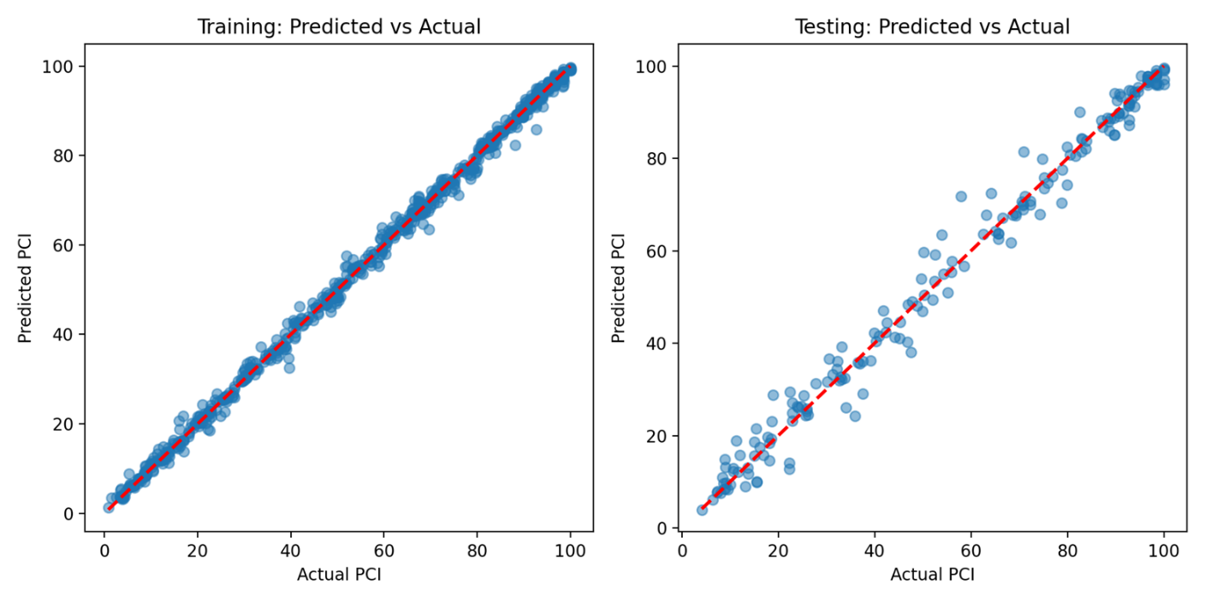
Figure 5: proposed XGBoost performance in training and testing sets
The XGBoost model feature importance scores, depicted in Figure 6, reveal the comparative influence of various input variables on predicting the pavement condition index (PCI). The analysis shows that (MIRI) and Age are the most significant factors, with (TAP) and Asphalt Thickness (ATh) following closely behind. Conversely, variables such as the Plasticity Index (PI), Freeze Index (FI), and (AADTT) demonstrate lower importance scores, implying they have a minimal impact on the model's forecasts.
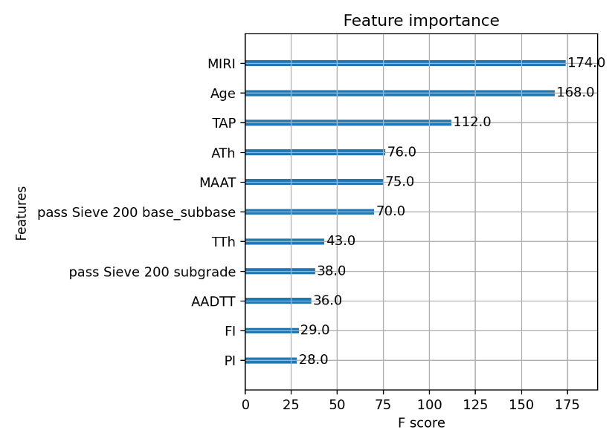
Figure 6: Feature importance score of XGBoost.
The SHAP summary plot in Figure 7 provides a more nuanced understanding of how specific feature values affect the model's output. In line with the feature importance findings, MIRI and Age demonstrate the most significant influence, with higher MIRI values generally resulting in lower PCI predictions, whilst increased pavement age typically leads to deterioration. Furthermore, TAP, ATh, and the proportion passing through the No. 200 sieve in base and subgrade layers also show considerable effects, their impact varying according to conditions. Interestingly, despite their lower feature importance rankings, PI and FI display some degree of influence in SHAP values, indicating potential interaction effects that may not be fully captured by conventional importance metrics.
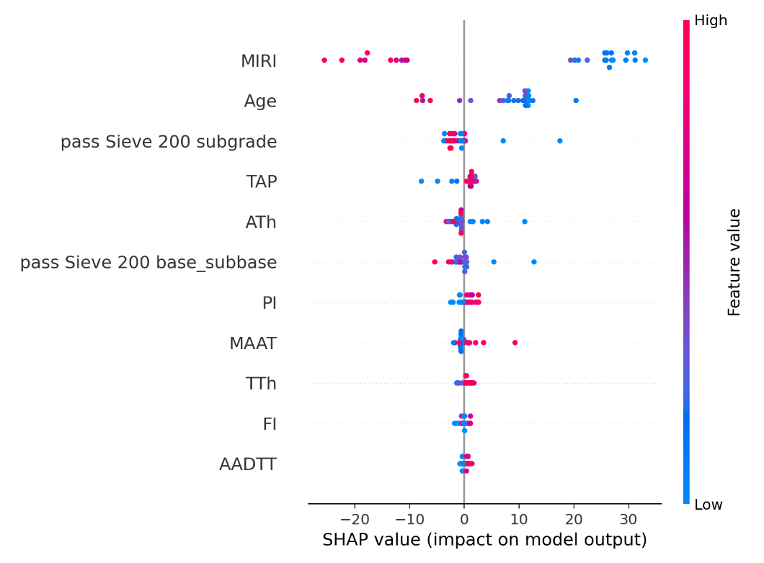
Figure 7: SHAP Summary Plot
These results highlight the importance of examining both feature importance rankings and SHAP analysis to gain a comprehensive understanding of each variable's impact. Although some features may seem less crucial in the feature importance hierarchy, their SHAP values indicate that they can still have a significant effect under the circumstances.
RF model has a coefficient of determination of 0.912 and an MAE of 5.48 for the test set. For hyperparameter tuning, 5-fold cross-validation and randomized search were used. The number of estimators (100, 200, 300, 500), maximum tree depth (None, 10, 20, 30,40,50), min_samples_split (2, 5, 10), and min_samples_leaf (1, 2, 4).
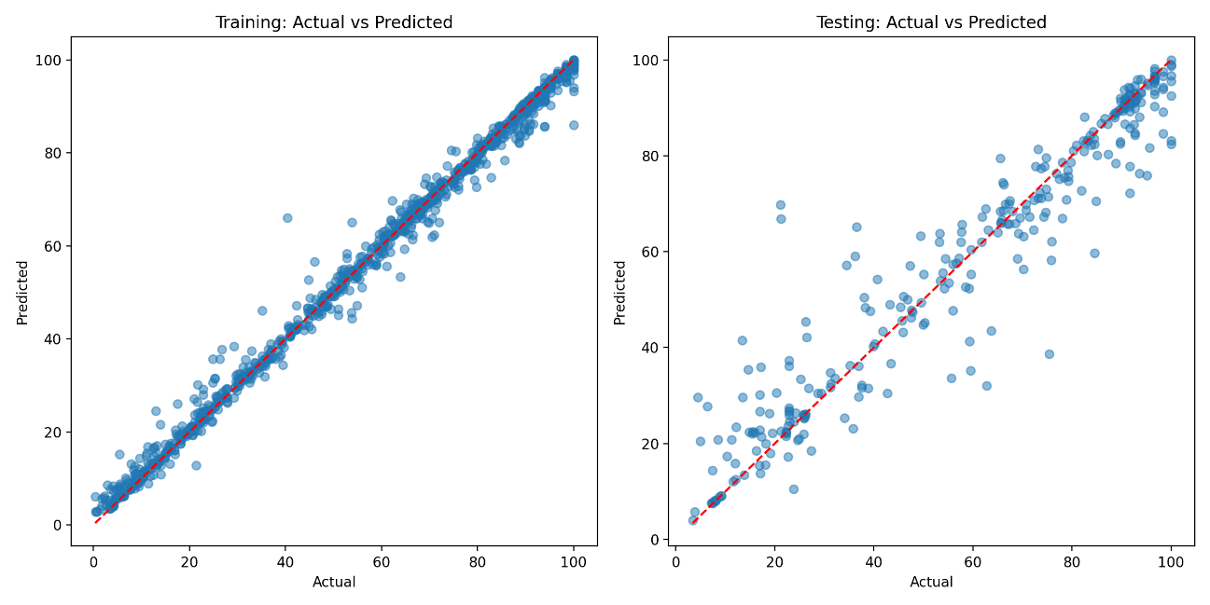
Figure 8: proposed RF performance in training and testing sets
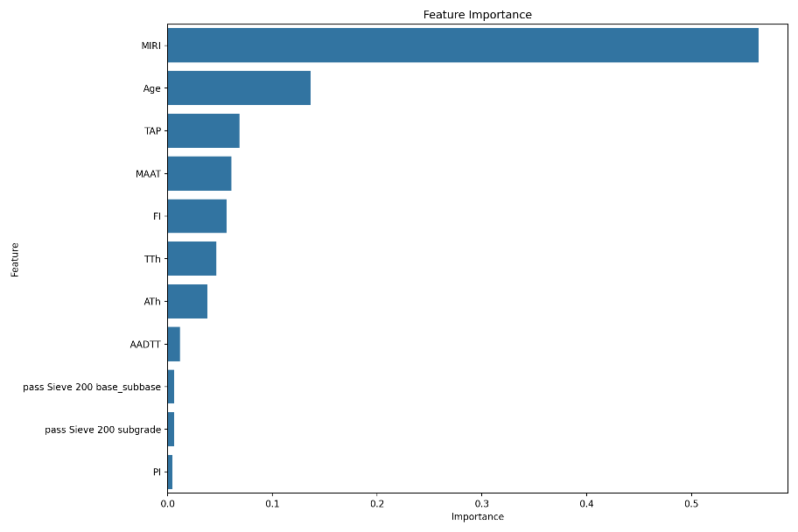
Figure 9: Feature importance of Random Forest
The feature importance plot in Figure 9 demonstrates the comparative impact of various input variables on the predictive model's outcome. The Mean International Roughness Index (MIRI) stands out as the most crucial factor, considerably surpassing all other variables in significance. Additional key contributors include the age of the pavement, total annual precipitation (TAP), and mean annual air temperature (MAAT), highlighting the considerable influence of both environmental and structural elements on pavement condition. Factors related to traffic load (AADTT) and material characteristics (sieve passing percentages and plasticity index, PI) exhibit lower relative importance, implying that their effects may be indirect.
Both models corroborate that pavement roughness and age are the primary determinants in predicting the Pavement Condition Index (PCI). However, discrepancies in the importance of secondary features suggest that XGBoost might be more adept at capturing intricate interactions between environmental and structural factors, whilst Random Forest tends to place greater emphasis on dominant predictors.
Figure 10 compares actual Pavement Condition Index (PCI) values with predictions from Random Forest and XGBoost models across 30 random samples. The predicted values were analyzed against measured PCI values to evaluate model performance and error distribution.
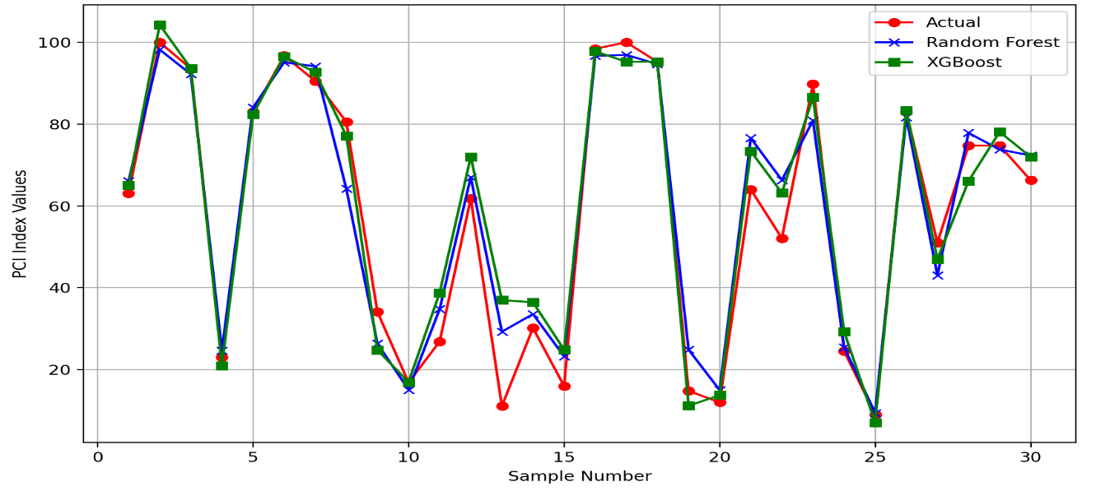
Figure 10: Comparison of predicted results and measured values of PCI.
The two models demonstrate a robust correlation with actual PCI figures, showcasing their capacity to reflect pavement condition patterns accurately. The findings suggest that XGBoost and Random Forest are both proficient in predicting PCI, with XGBoost showing marginally superior concordance with actual measurements. This slight advantage is likely attributable to XGBoost's enhanced capability in capturing non-linear relationships within the data.
Table 5: Results of three metrics used in training and testing.
 | XGBoost |  | Random Forest
 | Training | Testing | Training | Testing
R² | 0.993 | 0.923 | 0.994 | 0.912
MSE | 7.835 | 58.867 | 5.20 | 81.53
MAE | 1.484 | 4.106 | 1.277 | 9.03

The performance evaluation of XGBoost and Random Forest models highlights notable differences in predictive accuracy and generalization as shown in Table 5. While both models achieve high R² values in training, XGBoost demonstrates superior generalization during testing, reflecting its ability to maintain predictive reliability across unseen data. Additionally, the Mean Squared Error (MSE) and Mean Absolute Error (MAE) are significantly lower for XGBoost in the testing phase, indicating reduced prediction deviations and improved accuracy. These results suggest that XGBoost outperforms Random Forest in PCI prediction, making it a more robust choice for modeling pavement conditions. The best hyperparameters for XGBoost and random forest are summarized in Table 6.
Table 6: Best Hyperparameters used
Hyperparameter | XGBoost | RF
Subsample | 0.6
reg_lambda | 5.0
Reg_alpha | 0
Number of estimators | 100 | 300
min_child_weight | 5
Max depth | 7 | 50
Learning rate | 0.1
Gamma | 0.2
colsample_bytree | 1.0
Min_samples_split |  | 5
Min_samples_leaf |  | 1
As illustrated in Figure 11, the error distribution shapes reveal distinct differences in model performance. XGBoost errors exhibit a more Gaussian-like distribution, whilst Random Forest errors display irregular spikes, indicating inconsistent prediction accuracy across various samples. This suggests that XGBoost delivers more consistent predictions with reduced variance, whereas Random Forest may encounter difficulties with certain instances, resulting in more pronounced deviations. The comparative analysis implies that XGBoost surpasses Random Forest regarding error consistency and predictive stability, rendering it a more appropriate choice for PCI prediction in this scenario.
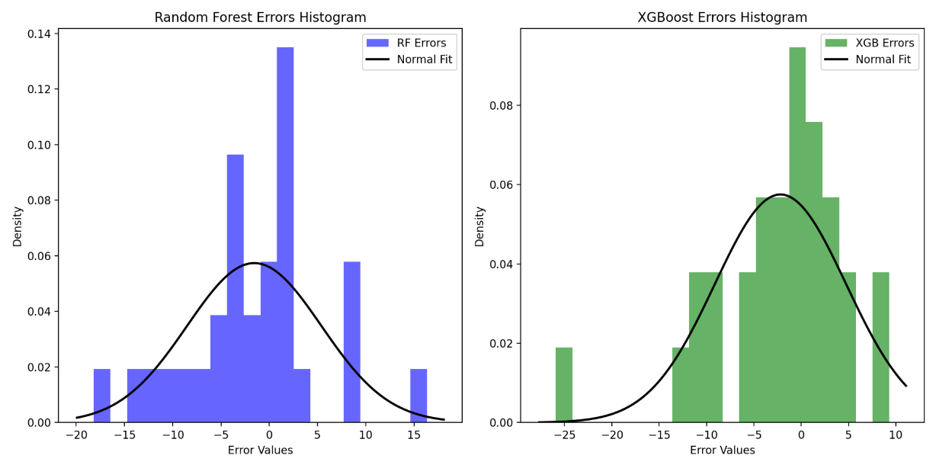
Figure 11: Models’ errors histogram and normal fitting

Conclusion And Recommendation for Future Work:
Assessing pavement performance is crucial for effective maintenance and rehabilitation planning. Among the commonly used indicators, the International Roughness Index (IRI) measures ride quality, while the Pavement Condition Index (PCI) comprehensively evaluates pavement health. However, determining PCI requires extensive surveys, making it a time-intensive and resource-demanding process. To address this challenge, this study focused on developing a predictive model that estimates PCI using IRI measurements alongside other easily accessible features, such as pavement age, environmental factors, structural characteristics, and material properties. By leveraging optimized ensemble learning techniques, the proposed model offers a cost-effective and efficient alternative for pavement condition assessment.
This paper investigated the development of a new PCI prediction model for flexible pavements using XGBoost and random forest based on the LTPP database. A total of 105 LTPP sections, including 1493 observations, were used for this purpose.
This study assessed the performance of XGBoost and Random Forest models in predicting the Pavement Condition Index (PCI). The results indicate that both models provide high accuracy, with XGBoost demonstrating slightly superior generalization performance in testing. While both models achieved comparable R² values in training, XGBoost exhibited lower mean squared error (MSE) and mean absolute error (MAE) in testing, suggesting better robustness in handling unseen data. Feature importance analysis revealed that the mean international roughness index (MIRI) and pavement age were the most influential factors in PCI prediction, followed by total annual precipitation (TAP). This aligns with expected pavement deterioration trends, where roughness and aging are key indicators of surface degradation. Although plasticity index (PI) and passing sieve 200 for base, subbase, and subgrade had missing values and showed low feature importance, they remain essential in pavement modeling due to their indirect influence on deterioration mechanisms. Notably, suggesting their impact may be embedded through interactions with other variables. This study highlights the potential of using optimized ensemble learning techniques to estimate PCI, providing a more efficient and cost-effective approach for pavement condition assessment.
While the models achieved promising results, this study represents the first phase of the research. A second phase will be conducted through a case study in Alexandria, Egypt, to validate the models using real-world pavement condition data. This validation step will further assess model reliability and applicability in different pavement environments, contributing to more effective AI-driven pavement management strategies.

References:

1. Adeli S, Najafi Moghaddam Gilani V, Kashani Novin M, Motesharei E, Salehfard R. Development of a Relationship between Pavement Condition Index and International Roughness Index in Rural Road Network. Adv Civ Eng. 2021;2021.
2. Elhadidy AA, El-Badawy SM, Elbeltagi EE. A simplified pavement condition index regression model for pavement evaluation. Int J Pavement Eng [Internet]. 2021;22(5):643–52. Available from: https://doi.org/10.1080/10298436.2019.1633579
3. American Society for Testing and Materials. Standard Practice for Roads and Parking Lots Pavement Condition Index Surveys. ASTM D6433-07. 2007.
4. Abdualmtalab Abdualaziz Ali, Mohamed Imbarek Esekbi, Muftah Mohamed Sreh. Predicting Pavement Condition Index Using Machine Learning Algorithms and Conventional Techniques. J Pure Appl Sci. 2022;21(4):304–9.
5. Piryonesi SM, El-Diraby TE. Examining the relationship between two road performance indicators: Pavement condition index and international roughness index. Transp Geotech [Internet]. 2021;26(September 2020):100441. Available from: https://doi.org/10.1016/j.trgeo.2020.100441
6. Psalmen Hasibuan R, Sejahtera Surbakti M. Study of Pavement Condition Index (PCI) relationship with International Roughness Index (IRI) on Flexible Pavement. In: MATEC Web of Conferences. 2019. p. 03019.
7. ASTM. ASTM E1926- 08 standard practice for computing international roughness index of roads from longitudinal profile measurements. [Internet]. West Conshohocken; 2015. Available from: doi: 10.1520/E1926-08.
8. AASHTO. Standard specifications for transportation materials and methods of sampling and testing. Washington DC; 2008.
9. Pérez-Acebo H, Linares-Unamunzaga A, Rojí E, Gonzalo-Orden H. IRI performance models for flexible pavements in two-lane roads until first maintenance and/or rehabilitation work. Coatings. 2020;10(2).
10. Thomas, O.; Sobanjo J. Comparison of Markov chain and Semi-Markov models for crack deterioration on Flexible pavements. J Infrastruct Syst. 2013;(19):186–95.
11. Deng Y, Shi X. Modeling the rutting performance of asphalt pavements: a review. J Infrastruct Preserv Resil [Internet]. 2023;4(1). Available from: https://doi.org/10.1186/s43065-023-00082-9
12. Mactutis JA, Alavi SH, Ott WC. Investigation of the relationship between roughness and pavement surface distress based on WesTrack project. Transp Res Rec. 2000;(1699):107–13.
13. Sandra AK, Sarkar AK. Development of a model for estimating International Roughness Index from pavement distresses. Int J Pavement Eng. 2013;14(8):715–24.
14. Prasad JR, Kanuganti S, Bhanegaonkar PN, Sarkar AK, Arkatkar S. Development of Relationship between Roughness (IRI) and Visible Surface Distresses: A Study on PMGSY Roads. Procedia - Soc Behav Sci [Internet]. 2013;104(December 2000):322–31. Available from: http://dx.doi.org/10.1016/j.sbspro.2013.11.125
15. Yousefzadeh M, Azadi S, Soltani A. Road profile estimation using neural network algorithm. J Mech Sci Technol. 2010;24(3):743–54.
16. Lin J, Yau J-T, Hsiao L-H. Correlation Analysis Between International Roughness Index ( IRI ) By. Transp Res Board 82th Annu Meet. 2003;(January):1–21.
17. Vidya R, Santhakumar SM, Mathew S. Estimation of IRI from PCI in Construction Work Zones. Int J Civ Environ Eng [Internet]. 2013 Aug;2(1):1–5. Available from: https://www.proquest.com/scholarly-journals/estimation-iri-pci-construction-work-zones/docview/1466279621/se-2?accountid=178282
18. Abdelaziz N, Abd El-Hakim RT, El-Badawy SM, Afify HA. International Roughness Index prediction model for flexible pavements. Int J Pavement Eng [Internet]. 2020;21(1):88–99. Available from: http://doi.org/10.1080/10298436.2018.1441414
19. Bashar MZ, Torres-Machi C. Performance of machine learning algorithms in predicting the pavement international roughness index. Transp Res Rec. 2021;2675(5):226–37.
20. Dewan SA, Smith RE. Estimating international roughness index from pavement distresses to calculate vehicle operating costs for the San Francisco Bay Area. Transp Res Rec. 2002;(1816):65–72.
21. Park K, Thomas NE, Lee KW. Applicability of the International Roughness Index as a Predictor of Asphalt Pavement Condition. 2007;(December):706–9.
22. Shah YU, Jain SS, Tiwari D, Jain MK. Development of Overall Pavement Condition Index for Urban Road Network. Procedia - Soc Behav Sci [Internet]. 2013;104:332–41. Available from: http://dx.doi.org/10.1016/j.sbspro.2013.11.126
23. Arhin SA, Williams LN, Ribbiso A, Anderson MF. Predicting Pavement Condition Index Using International Roughness Index in a Dense Urban Area. J Civ Eng Res. 2015;5(1):10–7.
24. Abed MS. Development of Regression Models for Predicting Pavement Condition Index from the International Roughness Index. J Eng. 2020;26(12):81–94.
25. Ali A, Dhasmana H, Hossain K, Hussein A. Modeling Pavement Performance Indices in Harsh Climate Regions. J Transp Eng Part B Pavements. 2021;147(4):1–10.
26. Liu J, Liu F, Zheng C, Zhou D, Wang L. Optimizing asphalt mix design through predicting the rut depth of asphalt pavement using machine learning. Constr Build Mater [Internet]. 2022;356(October):129211. Available from: https://doi.org/10.1016/j.conbuildmat.2022.129211
27. Behbahani H. Research Note Prediction of the Pavement Condition for Urban. 2004;17(October):219–26.
28. Mahmood M. Network-Level Maintenance Decisions For Flexible Pavement Using A Soft Computing-Based Framework Network-Level Maintenance Decisions For Flexible Pavement Using A Soft Computing-Based Framework. 2016.
29. Parsons TA, Pullen BA. Characterization of Pavement Condition Index Deterioration Curve Shape for USAF Airfield Pavements. In: Airfield and Highway Pavements 2017: Airfield Pavement Technology and Safety - Proceedings of the International Conference on Highway Pavements and Airfield Technology 2017. 2017. p. 230–40.
30. Younos MA, Abd El-Hakim RT, El-Badawy SM, Afify HA. Multi-input performance prediction models for flexible pavements using LTPP database. Innov Infrastruct Solut. 2020;5(1).
31. Nyirandayisabye R, Li H, Dong Q, Hakuzweyezu T, Nkinahamira F. Automatic pavement damage predictions using various machine learning algorithms: Evaluation and comparison. Results Eng [Internet]. 2022;16(May):100657. Available from: https://doi.org/10.1016/j.rineng.2022.100657
32. Guo R, Fu D, Sollazzo G. An ensemble learning model for asphalt pavement performance prediction based on gradient boosting decision tree. Int J Pavement Eng [Internet]. 2022;23(10):3633–46. Available from: https://doi.org/10.1080/10298436.2021.1910825
33. Barua L, Zou B, Noruzoliaee M, Derrible S. A gradient boosting approach to understanding airport runway and taxiway pavement deterioration. Int J Pavement Eng [Internet]. 2021;22(13):1673–87. Available from: https://doi.org/10.1080/10298436.2020.1714616
34. Damirchilo F, Hosseini A, Mellat Parast M, Fini EH. Machine Learning Approach to Predict International Roughness Index Using Long-Term Pavement Performance Data. J Transp Eng Part B Pavements. 2021;147(4).
35. Gupta A, Gowda S, Tiwari A, Gupta AK. XGBoost-SHAP framework for asphalt pavement condition evaluation. Constr Build Mater [Internet]. 2024;426(April):136182. Available from: https://doi.org/10.1016/j.conbuildmat.2024.136182
36. Taheri A, Sobanjo J. Ensemble Learning Approach for Developing Performance Models of Flexible Pavement. 2024;
37. FHWA (Federal Highway Administration). LTPP Standard and Data Release. FHWA, Washington, DC, USA. 2024.
38. Wu K. Development of PCI-based pavement performance model for management of road infrastructure system. Arizona State University, Tempe, AZ; 2015.
39. Chen T, Guestrin C. XGBoost: A scalable tree boosting system. Proc ACM SIGKDD Int Conf Knowl Discov Data Min. 2016;785–94.
40. Choi S, Do M. Development of the road pavement deterioration model based on the deep learning method. Electron. 2020;9(1).
41. LEO BREIMAN. Random Forests. Mach Learn. 2001;45:5–32.

