M y S t o r y
Between two Continents
An Autobiography
Revised Edition

Joachim Barkhausen

My Story Copyright © 2025 Joachim Barkhausen

Typesetting by Joachim Barkhausen

Published by Joachim Barkhausen

For my grandchildren
Dominique Gabrielle, Danielle Marie,
Diego Alexander and Katerina Veronika

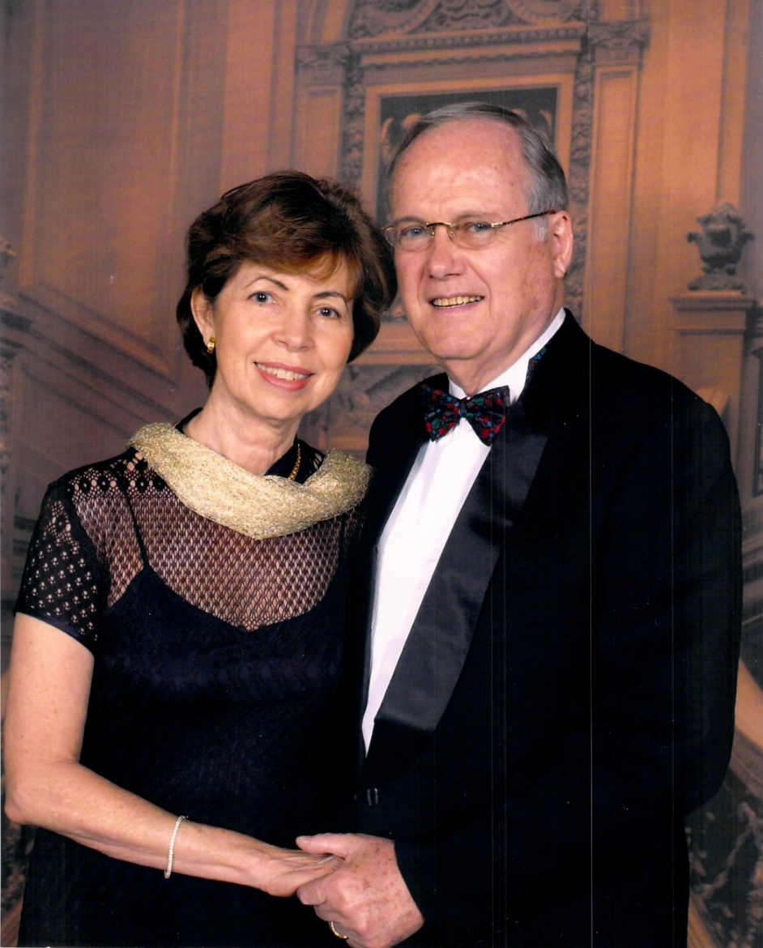

Me and my Better Half Zaida

Introduction

Why did I decide to write my story? Occasionally, one of my grandchildren asks me questions about my past and I came to realize that I wished I had asked my parents more about their lives, of which I know little. While everybody is alive you take all for granted and such questions never arise. Later in life, you start wishing you had asked more. I want my successors to know a little more about my life, if they so desire.
My good old friend, Peter Noble, encouraged me to write my story. He wrote his story and I enjoyed reading it. I found his story very impressive and inspiring.
This is the second Edition of “My Story”, which is more detailed. Many events and emotions have been added, as I remember them. Also, some corrections have been made.
So, I continue: -

Contents

My Mother and Father 14
Early Life 22
World War II 33
After War 49
Starting to Work 64
Arriving in New York 76
Arriving in San Juan, Puerto Rico 88
Returning to Santo Domingo 98
Revolution 111
After the Revolution 117
Hurricane David 138
Starting Our Own Business 141
Closing Shop 173
Going to Florida 184
DIARY: After 85th Birthday 192
Cruises We Took 289
The Name BARKHAUSEN 293
My Father’s Acknowledgements 296
Genealogy 298

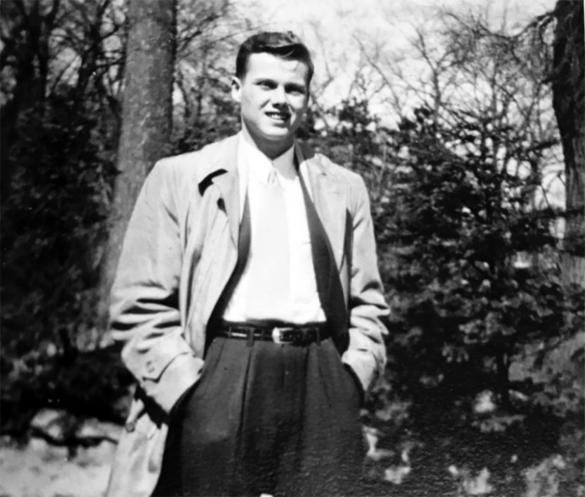
My name is Joachim Barkhausen, born in Hamburg, Germany, on April 15, 1937 at 5:30 AM. My mother was Nelly Frieda Marie Brunkhorst, and my father was Hermann, Heinrich Wilhelm Barkhausen. I was baptized on October 16, 1937 in the smallest Lutheran Church in Hamburg, with a capacity of only about one dozen people. The pastor’s name was Pastor Gerber. My godparents were my aunt Claire (my father’s sister), another not-blood-related gentleman and adopted uncle, as well as Tete Ariza de Michelena, whose husband was the Dominican Consul in Hamburg at that time. (She is the mother of Santiago jr., who became my friend later in life.)

My 15th Birthday

All major churches in Hamburg are Lutheran, including of course the Icon Church of the city, St. Michaels. She stands elevated on a hill and overlooks the harbor and river Elbe. She was renovated some years ago and is a beauty, with the largest gold-plated organ I have seen. I found it notable in later years that some of these Lutheran churches looked like Catholic churches with features and icons not really belonging. I was told that no one had bothered to change these after the reformation. I personally found little difference in both religions, besides procedure and ritual. I felt comfortable in all churches including Greek Orthodox. I am not a devout Christian, and I guess my time in church was more a moment of reflection. While I do believe in the Almighty, it is more a sense of “faith” that I value and which I believe helps enormously in difficult situations in life and keeps your aspirations and goals on track. Besides, I believe all religious houses contribute enormously to teaching respect, decency, and good behavior, attributes which have declined in past decades. In the south of Germany, most major churches are Catholic, which I also occasionally attended.
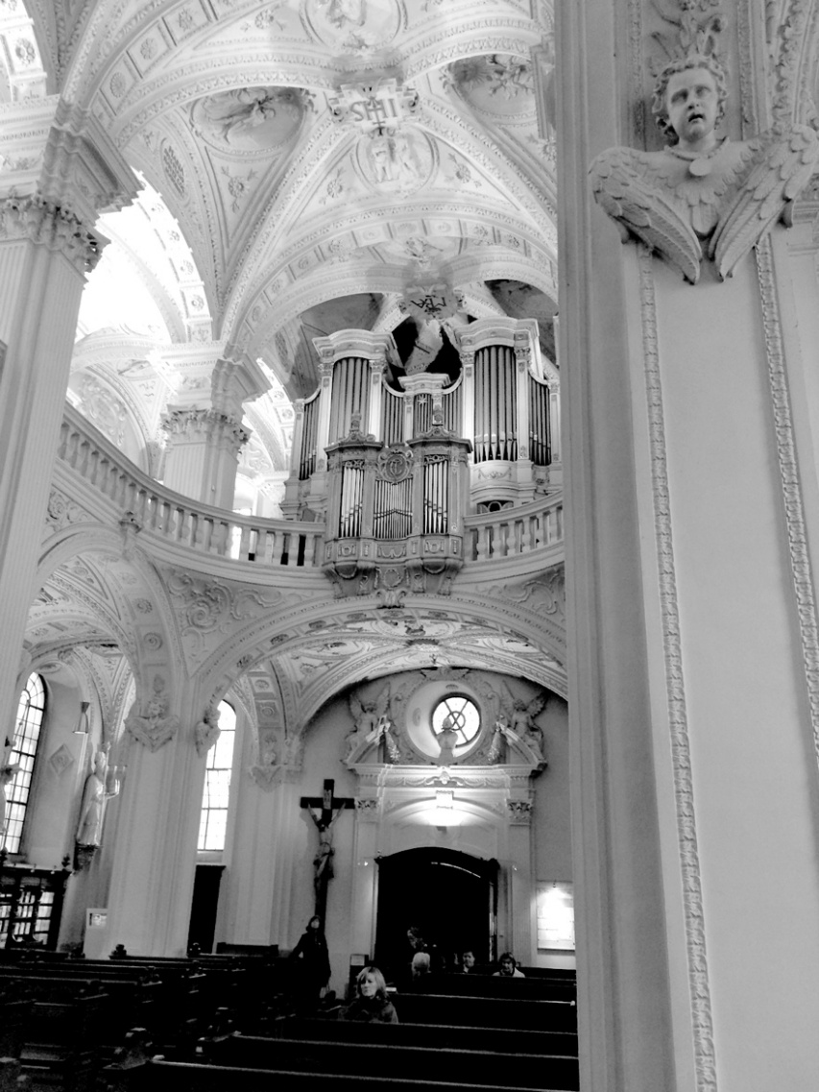

St. Michaels interiors with organ

My Mother and Father
My mother was born on December 24, 1899 in Hamburg. Her father, Heinrich Gehard Martin Kueck, was a barge company owner and operator, meaning he had multiple barges on the river Elbe to transport cargo from the sea-going ships to the storage houses. Her parents divorced and she stayed with her mother and later adopted her mother’s new husband’s name, Brunkhorst. My mother never spoke much of her past and I never heard her speak of her father and mother, who apparently died early. According to the pictures, she was a very attractive young lady but apparently also very fragile in health. She and her ancestors were all from Hamburg. As a matter of fact, she was born and raised only a block away from the St. Michaels church.

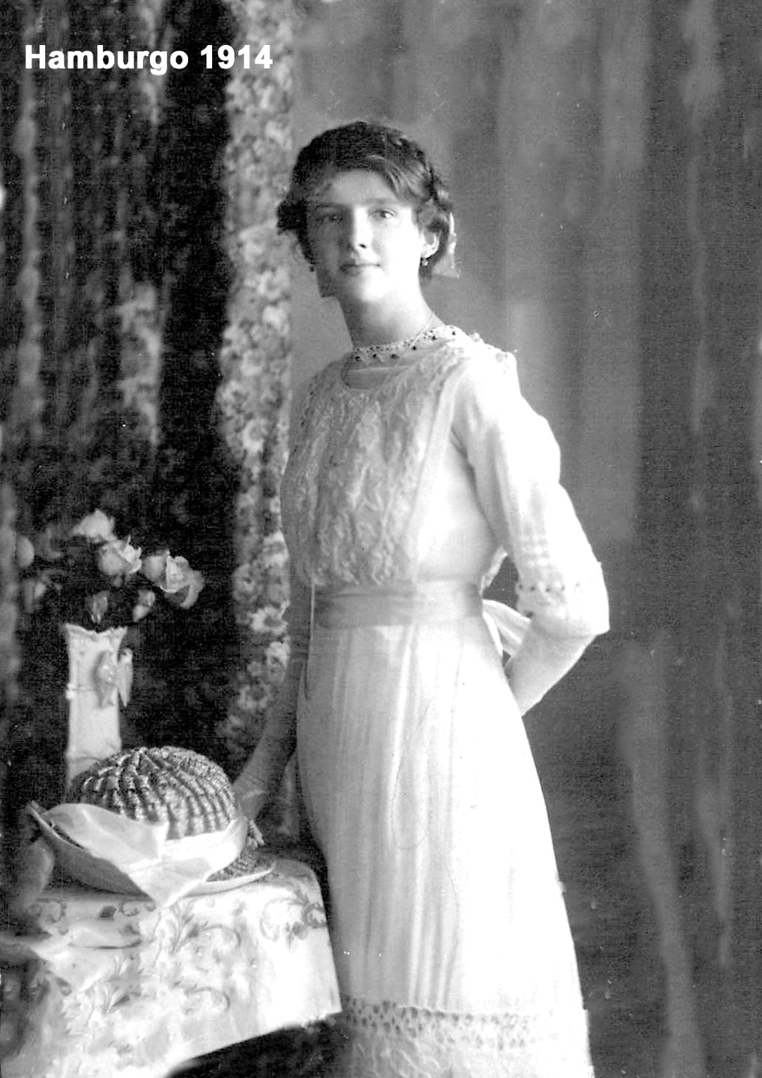

My mother on her 15th birthday

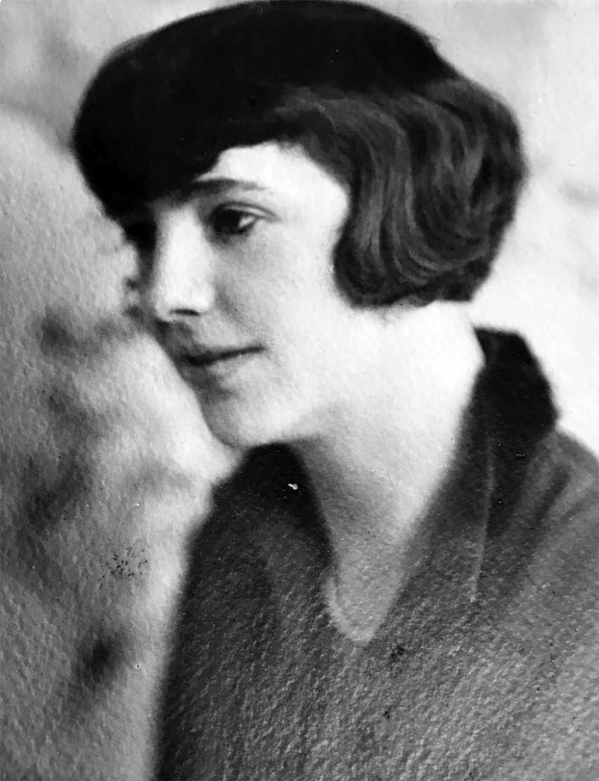

My mother later in life
My father was born on October 12, 1889, also in Hamburg. His father, Hermann August Friedrich Barkhausen, married Constante Agnes Hermine Dorothee Oehle. His only sibling was his sister Claire, married to Onkel Otto, who lost one arm during the First World War. I am not sure what my grandfather’s occupation was, but apparently, he was a merchant. In his younger years, he appears to have been living for some years in Turkey, possibly as an assistant to the German government during the Ottoman Empire. The family tree of the Barkhausen (and our “so-called” blue line) is documented for 15 generations to the 16th century. The original family name was “von Barckhausen” but the “von” was stripped from the name of the successors because the first was born out of wedlock. The “c” was also omitted many years later by error. They all seem to come from Porta Westphalia and surrounding areas, where one town still has the name Barkhausen.

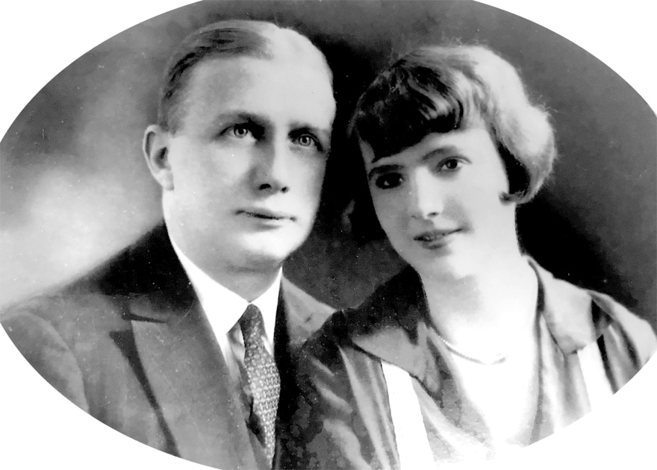
My Father & Mother

My father traveled extensively in South America prior to his marriage. He had lived and worked in Chile, Venezuela, Peru, and Bolivia for German trading companies which had offices in these countries. For several years he was the office manager of a well-known German company in La Paz, Bolivia. He traveled the River Orinoco bartering Caucho with the Indians, where he had the opportunity to meet Pope Pius XII, who was a missionary at that time. My father was an avid tennis player and apparently a good equestrian, which he practiced mainly in Chile and Bolivia.
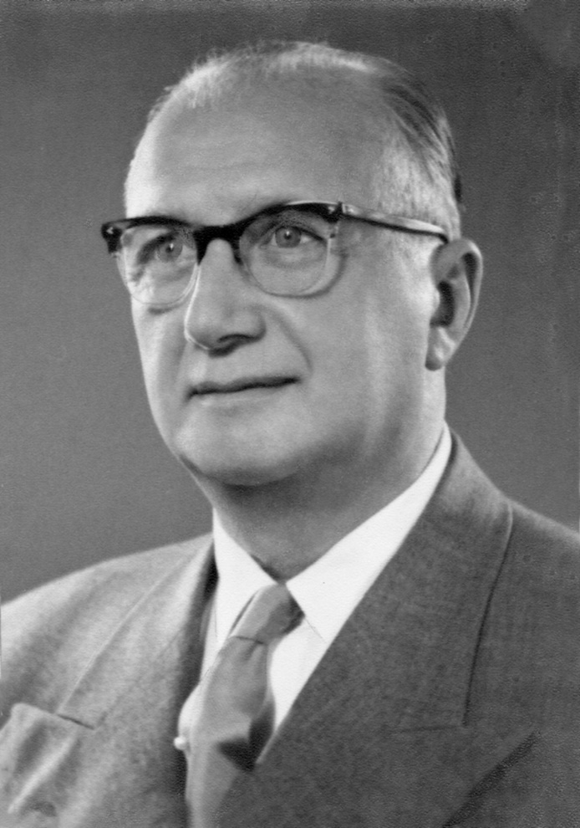

My parents were married on a September day in 1927 in Antwerp, Belgium. I don’t know many details about their marriage. It is possible that they just eloped, considering that my mother was not very close to her family, except for two or three of her sisters among her ten siblings. I never got to know most of her brothers or sisters, some of whom I believe had immigrated to the US and apparently were never again heard from. One of her brothers apparently became a pilot for the US Air Force. During the war, she often wondered whether her brother was one of the soldiers piloting the planes bombing Hamburg. My mother was the second youngest of all ten. It appears that Antwerp was the port city from which they both departed by vessel from Europe to South America.
During these times many freight vessels, on their journey to South America, docked also in Curacao and neighboring islands, mainly to take on fuel, discharge, or load cargo. At times they also docked in Santo Domingo, Dominican Republic. My father remembered Santo Domingo to be one of the most appealing little cities in the Caribbean Islands and they decided to move there.
In 1927 my father established a company in Santo Domingo and named it “Agencia Antillana, H. Barkhausen & Co.” He registered the trademark of “Palma Antillana” for some of the products traded. The purpose of this company was to represent German exporters and to mediate between these companies and the local importers and distributors. It seems that Agencia Antillana, which had several employees, was prosperous because I never heard my parents complain about financial difficulties. My father was also named German Consul as well as “Delegate to the German Reich” in the Dominican Republic. Our residence on Ave. Independencia also served as the German Consulate and my father was a member of the Diplomatic Chor. His superior was the German Ambassador who was stationed in Havana, Cuba.

Early Life
At that time there were only very few cars on the streets of Santo Domingo and my father owned one of them. A traffic jam was unheard of.
At that time most people in Santo Domingo knew each other or at least had an idea who was who.
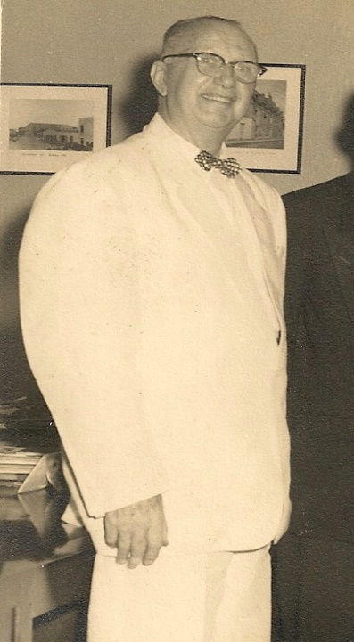

My father was well-known everywhere. He was probably also easily recognizable by the fact that he only dressed in starched white linen suits, which had to be washed and carefully ironed every day. Apparently, we had the personnel to manage this habit. He had at least a dozen of these suits.
Our residence at that time was located on Avenue Independencia, about where the restaurant “Vesuvio” was later constructed. The highway Autopista 30 de Mayo (“el Malecon”) did not exist at the time so our back garden extended all the way down to the Caribbean coast. Our swimming pool must have been where now the wide Malecon Ave. runs.
Back then my mother counted several dozen coconut trees on our premises. There were no fences in the back, in between each property, and we kids could play anywhere amongst the adjacent properties. My neighboring friend Georgi, son of General Federico Fiallo, had several ponies which we rode through all the properties.
I believe that all the neighboring properties belonged to the Ricard Ariza family. They lived four properties further east in a large wooden colonial house with a wide balcony all around the house. The balcony had rocking chairs on different sides of the house. They would gather their large family and sit together on the side of the balcony where the coolest breeze was coming through that day. They had three daughters, adopted apparently, from a sister of Clara Ariza who had died early.
They gave each daughter a lot to live on. One daughter, Clarita (if I remember correctly), married General Fiallo. Another was married to a wealthy Spanish merchant by the name of Eladio Fernandez (later Suarez Fernandez). The third was married to Tommy Stocker, an American businessman. Each daughter built an impressive residence on their lot. The old Clara Ariza was practically my aunt and my mother befriended the three sisters. The neighborhood was like a family. By the way, General Fiallo was a very powerful and influential personality, being very close to Generalissimo Trujillo.
In the early years, my father played frequently Tennis with his neighbor General Federico Fiallo. He also befriended his brother, Viriato Fiallo, who was opposed to the regime of Trujillo and was on the so-called blacklist by Trujillo. Viriato was underhouse arrest for many years and was not to receive visitors, but my father visited him regularly anyway. Sometimes I accompanied him. Federico asked my father on some occasions not to visit his
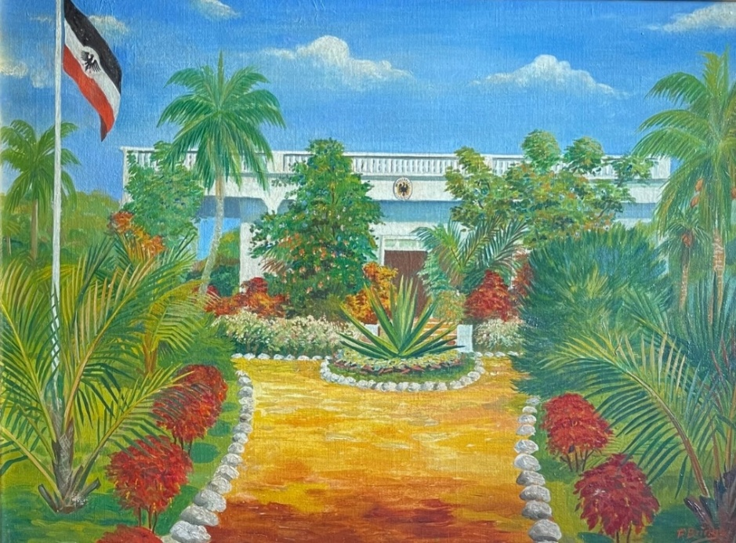

brother, but my father insisted that he was also his friend. I guess my father could only afford to disobey Federico’s advice because of his diplomatic status. Federico killed himself after the assassination of Trujillo, as he was being hunted by the assassins for supposedly having committed many crimes for the Trujillo regime. Afterward, Viriato became a political leader and a candidate for the presidency but did not win the elections.
Our residence and the Consulate was a very spacious, and very colonial-style home with a large balcony in the back. My father tried to breed dogs and imported them from Belgium. His experiment with German Shepherds failed because of the local climate. They were born either too big or too small, or their fur was too long or too short. He also tried breeding Fox Terriers and at one time we had half a dozen Terriers occupying many chairs in the house.
Living near the Caribbean coast meant we had very large crabs as well as large bullfrogs circulating around our house each night. The very aggressive little terriers hunted the crabs with the result that some got serious claw wounds on their paws which were difficult to cure. At one time we also had some black ravens in a big cage in the garden. They made so much noise that my mother protested, and we got rid of them.
My parents were not the youngest when they got married and I was born 10 years later. My mother would travel to Hamburg for me to be a typical “Hamburger.” That was a journey that took about fourteen days on the Atlantic Ocean.
The bigger problem was that I was born with both feet twisted inside, meaning that I would never walk normally if that could not be fixed. My parents consulted different doctors but none in Germany would operate on such a small child and even in the US they declined.
There was a German doctor, by the name of Dr. George in San Pedro de Macoris, who was the head of a hospital given to him by Trujillo to administrate. The hospital itself was run by Catholic nuns. Dr. George was a very particular and curious figure, but he was known to be very effective with his medicine. As a matter of fact, many dying patients were sent to Dr. Georg’s care by their own doctors, who preferred to avoid the bad reputation of having a patient die under their care.
Dr. George came as a sailor to Santo Domingo. In fact, he abandoned the freight ship that had hired him and settled in San Pedro de Macoris, at that time about a two-hour drive from Santo Domingo. San Pedro de Macoris was at that time an important Port city, to the east of Santo Domingo and on the Caribbean coast. Dr. Georg married the daughter of a wealthy black “COCOLO” (so-called because they originated from San Thomas and were mainly sugar cane plantation owners). Dr. Georg worked on the plantation and started to treat the cane cutters who would hurt themselves by accident. He then returned to Germany with his black wife who, as I remember, had very pleasant-looking facial features. Both spent some years studying in Germany where he obtained a medical doctorate degree and she, I believe, a doctorate in Philosophy. She also spoke four or five languages fluently.
Dr. George had a peculiar personality. He would run around the halls of his hospital with a white jacket, a pistol on his belt, and a human femur bone in his hand, with which he tapped his patients on the shoulder as a greeting. He was known to subscribe to hundreds of medical journals from all over the world and was very familiar with the latest available drugs and procedures. He was also a devoted Nazi but treated his Jewish patients with the same care. However, at their convalescence he would place a little booklet on their bedside, explaining why he did not like Jews.
When my parents brought me, their only child, to his hospital to obtain Dr. George’s opinion on my situation, he immediately reacted and said, “Now or never,” before the bones of the child became denser and less flexible. In the presence of both of my parents, he started twisting a foot to the outside by some force, while I screamed at full volume. While he held the foot in position, the whole leg was put in a cast up to the knees. He repeated this same act with my other foot and this entire procedure was repeated two or three more times over a period of one year until both feet were in the right position.
A male babysitter had to be hired because no one else could carry me with these heavyweights on my feet. His name was Manuel, he was very black with lots of very white teeth and I remember he was always smiling. (He visited me some forty years later and was still smiling). I developed a belly hernia on each side of my leg because of the weights. These were later operated on and fixed. My mother, who just about passed out during that first painful procedure, never forgave Dr. George for being such a brute.
My father befriended Dr. George and we visited him and his wife occasionally in San Pedro de Macoris. Dr. Georg always kept a staff of one or two young German doctors, which he apparently contracted for three-year terms. One of them became a famous doctor in Germany, a Professor Doctor and head of the largest hospital in Hamburg. However, while in San Pedro de Macoris, Doctor George did not treat these doctors very well as they were housed in very small rooms in the Hospital and were given very little time off.
So, my father frequently tried to intervene and convince Dr. George to be a little less demanding and to permit those young doctors some days off occasionally to see and explore the Island. Of course, these doctors were grateful to my father for this little intervention and on some occasions, my father drove them to Santo Domingo for their days off. In later years Dr. George moved into the hospital while his wife kept their beautiful house on the Caribbean coast, nearby. I attended the funeral of Dr. George accompanied by Klaus Heuer from E.T. Heinsen. We had never seen such a long caravan of cars driving in a funeral procession toward the cemetery. It seemed that all of San Pedro de Macoris was mourning and on the move.

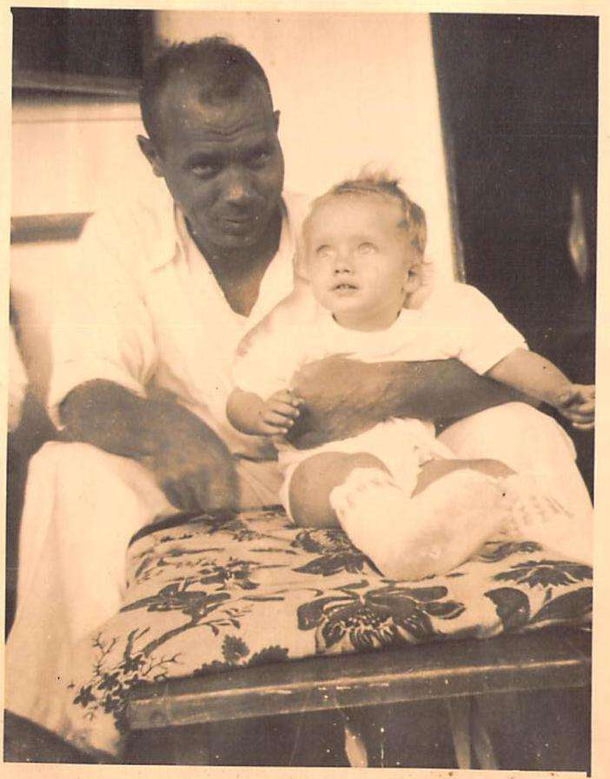

Manuel, my babysitter with me and my legs in gypsum

Another remarkable story about Dr. George was, that as told by his German doctors, he once insisted on operating himself without any help. The operating room was modified to include more mirrors and the Dr. removed his Appendix and stitched his belly closed by himself.
During these years we crossed the Atlantic on several occasions and always with the small freighters from the Horn Line and later Hapag Lloyd. These had regular service to Santo Domingo and accommodated about 8-12 passengers. The crossing to Hamburg or Bremen took about two weeks or a little less. All the Dominican Students who studied in Germany during those years used the Horn Line for transportation. Generally, the weather was good and the sea was relatively calm, which meant that the ship was still rolling and pitching, but with soft knees, walking with a glass of water was still possible. At night, many flying fish had landed and died on the deck. Sometimes the Atlantic turned ugly and the waves were high. The ship tried to steer against the waves and consequently, the pitch made the ship dip its bow deep into the waves. Rolling, meaning going from one side to another, would have been worse and more dangerous. On one crossing I made, I remember that we had such bad weather that water came into the chimney of the ship and knocked out the electric generator, leaving us without light. One loading boom also got loose and did a lot of damage. Also, some cars in the hold came loose and knocked on each other, which was a very dangerous situation as they could also destroy the outer walls of the ship.

World War II
In 1941 Naziism was getting popular. Certainly, in Germany, but notably also in the Dominican Republic and mainly in San Pedro de Macoris. Some of the Armenteros families, who at that time were established in San Pedro, were fanatic Nazis and even paraded in Nazi uniforms on the street. Even Trujillo seemed sympathetic to the cause, by declaring “Yo, Hitler, and Mussolini.”
At that time the FBI was already watching what was going on in the D.R. At some point they discovered that Dr. George was operating a radio station from the hospital. He was apparently communicating and coordinating with German U-boats, obviously with approval by Trujillo, who was believed to supply the U-boats with fuel. This was apparently done in Samana Bay, where full fuel barrels were floated on the water and picked up by the U-boats at night. There is no other good explanation for how some U-Boats could navigate into the Hudson River without having been refueled.
My father was also being harassed by FBI Agents. Customers and friends were told not to visit Agencia Antillana, his credit at the Esso Gas station was closed, etc. It came to a point where the Americans were pressuring Trujillo to expel all German citizens. Trujillo gathered a group of Germans and gave them the choice to stay under his protection or leave. Some, including Dr. George, decided to stay and were later interned in a comfortable facility of the Dominican Forces until the end of the war. My father decided to leave and closed his office which remained under the custody of his long-time Spanish, nationalized Dominican, secretary, Enriqueta.
All three of us, in early 1942 traveled by boat to the US, where all German diplomatic personnel were to be united for transfer to Germany. We were sent to the state of West Virginia where we stayed for several weeks at a very large and beautiful Hotel called the Greenbrier Resort. To me, being about five years of age, it seemed like a big city with many beautiful stores in the long hallways. I suppose that no one knew at that time, that this Resort also contained a large survival bunker that had been built for President Roosevelt and/or the American Congress. Nowadays the bunker can be shown by appointment. I remember that my parents purchased me the nicest tricycle I had ever seen, which we took with us to Germany.
After some weeks at this hotel, we were transferred to the port of New York and boarded the Swedish passenger ship “Drottningholm” with a destination to Lisbon, Portugal on May 2nd, 1942. Two Swedish ships had been picked to transfer the German diplomats from the US to Germany and the American Diplomats from Germany to the US. The ships were to meet in the middle of the Atlantic and both were totally illuminated day and night so that they would be recognized as nonhostile to the German U-boats. Supposedly all submarines were informed about this exchange, but I guess some missed this message. We later learned that one U-boat, commandeered by Hanno von Krieg, had not received the message from

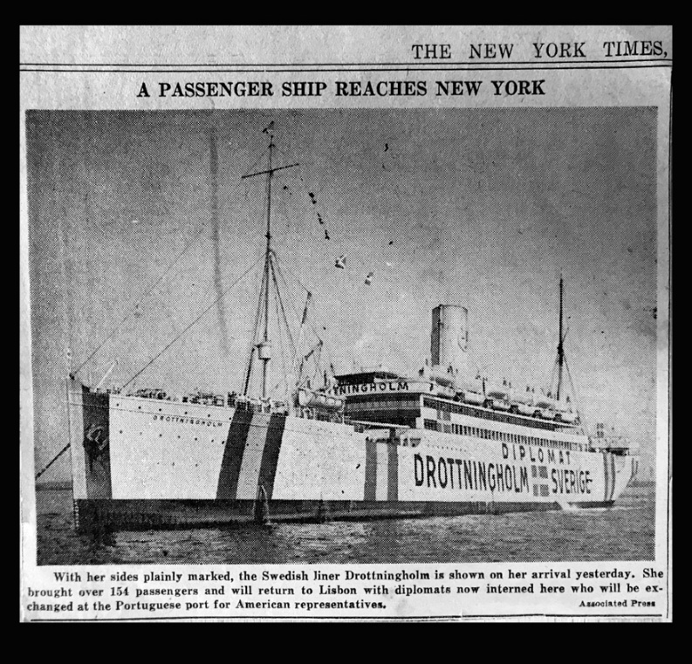

May 2nd, 1942 from N.Y. to Lisabon
with the M.S. Drottningholm

their headquarters and had our ship in his sight. Only the excessive illumination of the ship stopped him from proceeding. Upon our arrival in Lisbon, we were greeted by the German Military Police. We were obliged to turn in all gold and jewels and send by train to Germany. My father always owned a couple of dozen gold coins, which he lost. However, he did not know that my mother, who was more street-smart, had taken some out and hidden them separately. She was not about to give them up, which was a big risk to take. We practically lived during the war from those few coins she had separated.
My father was to be conscripted to the army and was assigned to some regiment going to Russia, which never came back. He had never been sympathetic to the Nazi movement and was on a blacklist, apparently for not lifting his arm up high enough or with more enthusiasm when saluting on official occasions in Santo Domingo. A few days before he was to report for duty, he found a friend who helped him to obtain a better position as a civilian for the German government in Oslo, Norway. Germany was controlling the Norwegian fishery. During the war, until about 1945, my father was deployed in Oslo and Stavanger as a civilian working for the German Government.
In the meantime, I stayed with my mother in Hamburg, where we occupied a rather large apartment in a nice sector of Hamburg, namely Rothenbaumchaussee No. 91. I went to elementary school in Hamburg and my teacher was Mr. Sommer.
I always remember Mr. Sommer not because he was a very good and effective teacher, but because he was also very respected by the students. Mr. Sommer would walk into the classroom and start the math class by verbally starting a chain mathematical problem, like: - “23 multiplied by 4, menus 12, divided by 3, plus 7 ….. “ on and on for some 3-5 minutes. Not a sound, except his voice, was heard when he stepped into the classroom. He also believed in physical punishment and used a very thin cane to hit an offender on their open hand once or twice. It did hurt.
During this time in Hamburg, I made several friends, one of whom was Gerd Sohns to whom I will revert later. Whenever there was no alarm to alert us against aerial attacks, we played on the side street where there was little traffic. One popular game was with marbles. Each participant threw three marbles against a wall and the owner of the marble which stayed closest to the wall won and collected all the marbles.
Bombardments in the city were continuous, mainly at night. Some sectors were totally destroyed. Hamburg was fifty percent destroyed and there was a ruin about every third or fourth building in many sectors. Many nights we sat in the cellar of the building and when something got hit nearby, it seemed that also our building was moving down and then back up by the pressure waves. On top of the apartment building, there were men stationed who picked up the incendiary bombs with a long stick and threw them down to the street. These could burn through the concrete. I learned they threw down dozens of incendiary bombs during that time, each of which could have started a major fire. On several occasions I was able to look at the spectacular sights at night when hundreds of planes were in the air from both sides, searchlights beaming up, German guns firing up and parachutes and planes coming down. A lot of action and sound. For a young boy it was very exciting, but my mother stopped me from looking on and we had to hide in the cellar.
This was a difficult time for my mother and we struggled but I do not recall that we ever went hungry. My mother was a fighter and knew how to handle the situation. At one point her weight dropped to less than 100 pounds. On several occasions, she took me to the famous park-like Hamburg cemetery named “Ohlsdorf” to show me where it was she had hidden the gold coins. She would have me watch as she retrieved a gold coin, which she had buried behind some big headstone. She wanted me to know where the coins were, and at the same time, she wanted me to be her lookout to make sure that no one was watching.
We lived through the war from the forbidden gold coins she had hidden. Twenty-dollar gold coins were a large denomination that could not be used for smaller purchases. Therefore, she made contracts with different suppliers, for instance, carbon (coke briquettes) for the whole winter for our small oven. We received and stored about 50-75 sacks of briquettes on our veranda and sealed the windows so no one could see them. This was forbidden.
We converted the smallest room in the house, namely the servant’s room beside the kitchen, to our living room by installing a very small furnace. It was the only heated room in the Apartment. The furniture of this room consisted only of a small table and some chairs. At Bedtime we heated up some hot water bottles and placed them under the cover of the beds of our dormitory. We also had a small radio, capable of listening to the BBC, which was prohibited.
We listened every evening at a very low volume so our neighbors would not hear. Of course, we wanted to know how the war was really going and whether an end was in sight.
My mother also negotiated with farmers at the “Alte Land,” on the other side of the River Elbe, for food against one twenty-dollar gold coin. This was of course also prohibited, including owning gold, using it to barter, and finally, the farmer was not allowed to supply individuals with fruits, vegetables, and other items like bread and butter. We could only carry a certain amount of goods away each time we visited and so these contracts were extended for several months.
Carrying the food away was another problem because returning to the other side of the river there were inspectors checking your bags. We were always lucky, but I asked my mother what to say if we were caught. She told me to say that this was “food for our rabbits” and explained, that if the rabbits won’t eat that, we would not know what they eat. I thought that was funny.
Once she collapsed and fainted in the subway on our way home, probably also because we had been carrying a lot of food and vegetables. Luckily, she woke up fast. My mother had lost a lot of weight, while obviously, she kept me well-fed. In retrospect “admirable.” I remember, to get me to a dentist’s check-up she promised me one egg and that convinced me to see the Doctor.
Our life during these years was humble as everything was in short supply. One of the items you could readily purchase in some stores was “Sauerkraut,” which was served right out of a big barrel as well as “Blutwurst,” meaning blood sausage. My friends on the street often went to buy portions of both when hungry.
On the opposite side of the avenue where we lived was a big field owned by the University for all kinds of athletic purposes. There was also a complete soccer field not being used in those times. That is where we played soccer for hours and days on end. First with stones, then tennis balls, and much later finally, someone brought a real soccer ball. I remember I was pretty good at playing. I always thought playing with a tennis ball first helped to improve the soccer game.
Spent and live ammunition as well as abandoned military equipment was everywhere to be found. Care was necessary, but we kids got used to the situation. On one occasion one of the younger players sat on one of the many empty gasoline tanks, as used on each side of the military jeeps. It was of course empty but it occurred to him to drop a lit match into the tank while looking inside. For an instant, you could just see a blue flame coming out and at the next moment, you could see him running into the street at high speed, looking to lift and open some water drainage to dip his head in. He lost one eye.
Some of the older boys were also very inventive and collected live ammunition to take out the powder and make more potent devices suitable for demolition. Since there were so many buildings in ruins, with large sections still standing high, they watched when everything came down. Of course, the parents did not know about this and the authorities were not around at those times
During the worst days of the bombardments, we stayed for days with my Aunt Ella, who lived in a very rural area outside of Hamburg in a rather modest home. No bombs had been dropped there, nor were there any targets, besides wide-open fields, planted mainly with sugar beets. During those days my only occupation was walking into the fields with my pocketknife, sitting down occasionally to cut up and eat a beet or carve some decoration into my self-made cane.
At one point I heard a plane and saw the plane coming in very low. It was a smaller, one-seater, fighter plane and I could see the pilot and the round British identification under the wings. I did not sense any danger, but all of a sudden I heard the machine gun blasting away and saw bullets landing on the field about twenty feet away. This all in an instant, but I thought that this idiot could return and I ran into some bushes some distance away. He did not return and must have been bored. I wondered how this rather small plane came from England and had to make it all the way back home.
Frequently we received so-called “care packages” from my father in Norway. They contained mainly “military rations” in cans and wrapping and often cranberries, which are available in abundance in Norway.
Obviously, food was also scarce and rationed in Norway. Once, however, he send me a new bicycle and I learned fast how to use it. I do not recall what happened to this bicycle and would not be surprised if it was stolen, because in those times anything could easily vanish, just like my beautiful tricycle which we brought from the US. It was stolen only a few weeks after we arrived in Germany in “Planten und Blomen”.
This is a beautiful large park in the middle of Hamburg, with many attractions. We deposited the tricycle at the entrance against a receipt. When leaving the park and claiming the tricycle it was nowhere to be found.
My mother only had contact with three of her sisters. One was Tante Ella, where we stayed some days during the bombings. She lived very modestly and very rural and was married to a handyman who was an alcoholic. The other was Tante Wilma, whom I only meet on one or two occasions and do not remember well. She also seemed to live very modestly and struggled with health issues.
The third, Tante Thea, was very well situated in every sense. She was married to Onkel Oscar, who was a Danish subject and owned a prosperous seafood wholesale business in St. Pauli, which was where the fishing fleet landed on the river Elbe. Onkel Oscar was a heavy and rough guy, obviously made good money, but went to bed every day at eight PM as he had to be at the fish market by 4 AM every day, including Sundays. They owned a beautiful two-story villa on the outskirts of Hamburg, near the well-known Hagenbeck Zoo, where there was little destruction. We visited them frequently.
Then in the first days of 1945 came the day when the Allied occupation forces moved in. Hamburg was in the British Zone. We were to have our curtains drawn and not to look out while the British rolled in with thousands of different vehicles and equipment. I peeked out and found it fascinating. I was about eight or nine years old.
First came a large batch of tanks with their machine gun turrets turning in all directions and searching for resistance. Then hundreds of manned Jeeps also with mounted machine guns and of course a huge amount of more equipment. Most of these stopped right in front of our house and maneuvered into the big field where we played soccer. That field was about the size of three soccer fields. Big tents were set up there and that force remained for several months.
On the evening of that day, some British military officers knocked on our apartment door, asked to see our apartment, and determined that two or three rooms were not used and consequently they would send some officers to occupy them. My mother was very worried but luckily, they never came. Maybe her knowledge of the English language helped.
My mother spoke also fluent “Hamburger Platt”, a dialect used by blue-collar workers, mainly in the harbor and vicinity. Of course, my mother was brought up in this milieu and her natural father worked in the harbor. Platt is a dialect taken from German, English, and maybe some Dutch and Danish. Even if someone spoke the German language perfectly, you would not understand people talking in Platt.
Onkel Oscar spoke better Platt than good German and probably Danish, for obvious reasons. Often when my mother spoke Platt with Oscar, my father was somewhat embarrassed, which my mother found very funny. Whenever my mother had the seldom opportunity to speak Platt and my father was present, she teased my father with this and he did feel uncomfortable. The reason was that Platt was the language of the harbor workers and did not fit his status as Consul. I hear that nowadays many young people in Hamburg are trying to learn Platt. It seems to get more popular and fashionable nowadays.
During and even after the war, titles were very popular in Germany. Wives were addressed with the same title as their husbands. For example, Herr Doctor would have his wife referred to as “Frau Dr.”. Hundreds of titles were used, depending on the occupation of the individual, and then evaluated according to importance. My father, during his visits to Germany and when in Duesseldorf, always stayed in the Hotel Savoy. I was impressed as well as intrigued that he was always greeted by the reception staff with the title of “Herr Consul Barkhausen”.

After The War
In 1945 the war came to an end and my father was sent home to Hamburg several months later. He contacted a friend in New York, who apparently was the president of the American Red Cross. This gentleman helped my father to obtain permission to leave Germany early and travel to Santo Domingo, to find his office as he left it on Calle Jose Reyes 43. Enriqueta had taken care of it. Immediately he went to work again and some months later we followed, also via freighter.
Arriving again in Santo Domingo I had forgotten the Spanish language and a lady teacher was employed to teach me. Later I was placed in the catholic school of “De La Salle” where each student received a weekly ranking and I always would be more or less in the middle of the class.
My parents rented a villa in Gasque, on “Calle Benigno Filomena Rojas, Esquina Cayetano Rodriguez” with a rather large back garden. During those years I kept different animals in the garden. I had beautiful chicken of different breeds, ducks, over a dozen rabbits, a Bucaro which is a night bird and eats only meat, a parrot, turtles, and of course our dogs Kiki and Boby. On one birthday my father bought me a dozen chicken and one rooster of a very big species, white and black, imported from the US. These hens lay one egg every day, so we did not buy eggs for a long time. The parrot lived in a very large and high tree in the garden and my mother had complete control of her. When she called, the parrot climbed down and in the evening she was brought to a roofed shower place to sleep on the pipe of the shower head.
My close friend was Jimmy Castanada, two years older and the son of Ana Maria, the best-known photographer in Santo Domingo at that time. We roamed the streets of Santo Domingo with our bicycles. There was little traffic.
Life in Santo Domingo at that time was pretty much routine. Early on the most popular restaurant was called Cremita, located on the Malecon. We dined at Cremita frequently mainly during the weekends. The popular restaurant Vesuvio originated many years later. Saturday evening was usually Movie-Night. We had a choice of about five movie theaters. All moviegoers were nicely dressed and of course, most knew each other or at least knew where they came from. My parents liked to play Canaster (a card game) with friends on the balcony of the famous Jaragua Hotel. Sometimes they let me join.
During these years my father drove a big two-door green Buick with a huge eight-cylinder motor, which he purchased from President Trujillo. Trujillo imported all sorts of special expensive automobiles, which he resold after very little use. I believe my father purchased several of these vehicles over the years. I also drove a variety of different vehicles over my lifetime, but my first car was a VW, meaning the original Beatle. After that an Opel Record, a Chevy Nova, a Chevrolet Impala, a Mitsubishi Jeep, a Ford Explorer, a Mercedes 280S, a BMW 7 as well as two different Jeep Cherokees. There might have been some vehicles in between, but I do not recall. Anyway, I usually kept my vehicles for over five years, and some of them even for some ten years. Usually, they looked like new when I finally sold them.
Very frequently on Sunday mornings my father and I drove to the beach in Haina. The beach at Haina at that time was still very pristine. Only a few “Campesinos” who lived there appeared and served us coconut water. There were a lot of iguanas which did not bother us. The sand was white and the beach was only about 12 feet wide, separated from the Coconut Trees in the background and by bushes of “Uvas de Playa” (Beach Grapes). The water was crystal clear and many small fish of different colors could be observed. Unfortunately, however, in Haina, the water had some strong currents for which reason we always brought along a long thick rope that we tied to a rock. While bathing it was a matter of also hanging on to the rope as otherwise, we would wind up a couple of hundred feet further down from where we started.
At one point my father agreed with the German Volkswagen manufacturer to help them introduce these vehicles in the Dominican market. Some VWs of different colors as well as two Porsche cars were imported, exhibited, and paraded around the city. The public response, which was used to the huge American-made cars, was very negative. They gave the VW all sorts of funny names and it was clear that at that time the Volkswagen could not be sold in the D.R. Ramfis, the eldest son of President Trujillo purchased the two Porsches, had an accident with one two days later and who knows what happened to the other. Regular imports of these vehicles started many years later.
In 1953, for some reason or other, my parents decided to send me to a college in Canada. I was then sixteen or seventeen years old. During this period several known families in the D.R. send their children to schools and universities in Canada and purchased second homes, mainly in Montreal. For instance, the Vitienes and Schnabel Families had beautiful homes on the mountain slopes of Montreal. We visited the Schnabel Family on several occasions.
My mother suffered a great deal from the climate in Santo Domingo, with average temperatures between 85 to 90 degrees Fahrenheit. Of course, air conditioning was not available at that time. She had been living in the Dominican Republic for a total of 28 years and once told me that every day of it was too much, because of the climate. So, we traveled to Montreal, but this time on a super constellation airplane by Pan American Airways. I remember that the engines of that plane glowed red hot at night.
In Montreal, my mother rented a small apartment and sent me first to a summer camp run by the YMCA called Camp Kanavana. It was a good distance north of Montreal in the middle of nowhere. I remember I had a great and memorable summer camp vacation in Kamp Kanavana, which apparently still exists. There were about one hundred boys aged between 7 to 18. We were housed in large tents of 8 each, including the so-called counselor who could also be an older boy. The bunks in the tent were double-decker’s, with one kid sleeping below and another above. Our camp was right on the edge of a large lake and the camp owned a variety of watersport equipment and many lightweight canoes and sailing boats. We could participate and graduate in many activities, such as speed swimming or long-distance swimming, canoe racing single or double, diving, survival in the Canadian wilderness, how to deal with wildlife, and many more. There was one big dining hall and that was also where all the performances and indoor activities took place. On several occasions, every tent unit of the older boys ventured out for a couple of days for a canoeing trip into the wilderness. They were accompanied by a knowledgeable guide. There were hundreds of lakes in the area, some connected to each other and others one or two miles apart. We moved from one lake to another, carrying our canoes, which were thin-skinned and lightweight, from one lake to the next. We always camped on the edge of a Lake and at night could often hear elks wading through the shallow waters, which sounded like a paddle steamer. My mother visited once or twice on a Sunday and it was difficult for me to take time off for her, being so busy with different activities. In all, I had a terrific time in Camp Kamp Kanavana and have great memories.
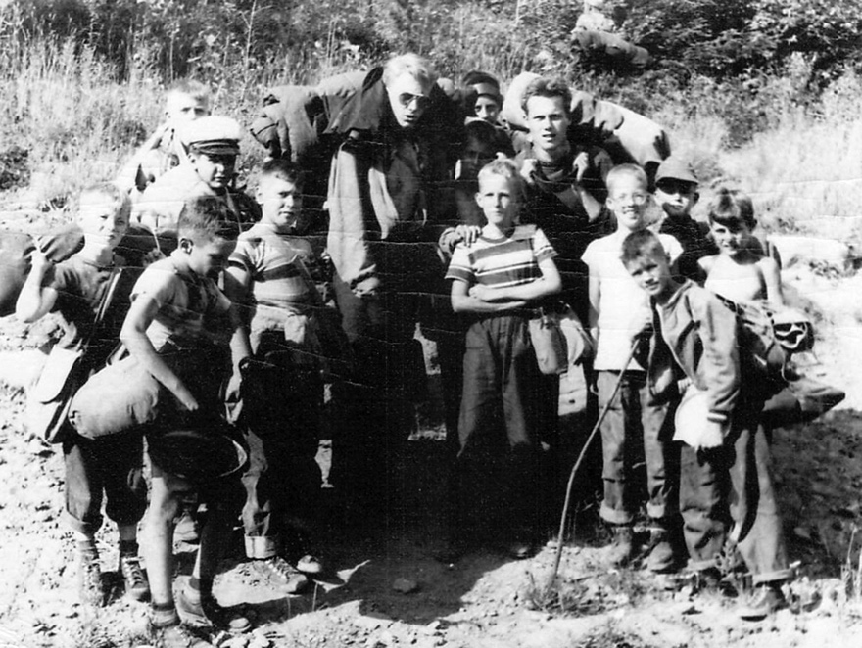
Hiking trip at Camp Kanawana
Me and another young man was hired as Counselor

Upon arrival at Camp Kanawana, I immediately decided to change my name and introduced myself as “Joe”. Who would pronounce Joachim correctly and remember my real name? I wanted to blend in rapidly and did not need more obstacles to do so than my accent. Joe remains my name in all English-speaking countries.
After the end of summer, I was to attend high school at Stanstead College in Stanstead, Quebec. Stanstead was about a three-hour train ride south of Montreal, right on the border of the US. As a matter of fact, the train left me in Rock Island, Vermont and I just walked some half mile back to Stanstead on the Canadian side.
Since I did not have a US visa, it was always some hassle with immigration on the US side and I needed to prove that I was a student at Stanstead. The college was a boarding school for boys and girls and I estimated that the total attendees were about 200, half boys and half girls. Even at that time, the school was well equipped (nowadays even better) and we had a lot of different athletic activities depending on the season. The main events for the boys were football in the summer, ice hockey in the winter, and basketball in between, while the girl’s played soccer in the summer. I arrived one afternoon while still speaking only broken English which I had learned in Kamp Kanavana. I knew no one and had problems communicating. I went to the pool room where some students were shooting pool and looked on, but very lonely. Then came a student, more or less of my age, who I quickly recognized as being Austrian because he came in with his father and they spoke German. It was Helmut Kuhnert, who also became one of my roommates and with whom I am still in contact today. That was some help. Helmut also had an older brother in the school, who was already in 12th grade and seemed to be a genius or at least an outstanding student who won many honors.
My roommates in Stanstead were Helmut Kuhnert and Tommy Houghton. Tommy was a very blond good-looking and very nice Canadian-born guy. He was also a great athlete. We got along very well. I learned later that he went to Australia, and became a sports coach, during which time he suffered a terrible accident, which left him disabled for lifetime. While on a track & field event, coaching, he was hit by a disk, thrown by a disk thrower during an event. I tried to correspond with him some years later, but his writings were incoherent, and apparently, he had some minor job at a hospital in Australia.
On Sundays, we were obliged to attend church. Any church according to our choice. In the little town of Stanstead, there were at least four churches of different denominations. Although there was an Anglican church, which is probably closest to the Lutheran church, I choose the United Church, because of Pastor Rose. This Pastor was a very likable and friendly person. Sunday mornings he would stand outside of his church with his wife and some 6-7 of his children, to personally greet all his filigrees with a handshake. He would allow all to bring their musical instruments, including trumpets, to participate in the background music for the choir. Of interest to many students was also the fact, that his Sunday service was always a little shorter than the service of the other churches, which meant we were always the first to arrive for our next activities at the school, which often gave us an advantage. Of course, the students were quick to figure this one out and I suspect pastor Rose did this intentionally. On my last day in Stanstead, Pastor Rose visited me at the school and brought me a new bible as a present.
I am not certain in what grade I was scheduled, but it included a class in Latin and of course the mandatory French class. I struggled with the English language and was finally excused from Latin and French. Instead, I was given a class in typewriting, which I never forgot, and which served me extraordinarily well all my life. The classroom had about 40 old Underwood manual typewriters and the teacher was an elderly lady, who insisted that every finger of the hand managed only certain letters of the typewriter. We had to write with ten fingers and preferably blind. I have always been very grateful for this experience and expertise, which served me well. Much better than French, not to mention Latin.
The boy’s dean who commanded the boy’s floor and dormitories was a tough Scottish man who policed us with an iron hand. Physical punishment was not excluded. This was probably necessary because some of the French boys from Quebec were tough cookies and also because the girl’s floor was right below ours. Mr. McPherson, the dean, demanded strict discipline, which today I support and appreciate. Every evening, we had study time during which all students were to be seated at their desks, without talking to their roommates, and keeping the doors open while he patrolled the long hallway. It was dead silence and beware if it was not. Similarly, at “lights out” time, there must be strict quiet. An offender would be taken to a lab-room one story higher, had to bend over one of the lab chairs and McPherson would hit him with a thin cane on the bare rear-end according to the graveness of his offense. I saw some guys who came back with a bleeding bottom. I guess that would be classified as barbaric nowadays, but in hindsight, I believe it made us more respectful and considerate. I was only caught two times for a smaller offense and hence hit only with two or three strokes, which hurt and burned a lot for some minutes but caused no rupture. After my time in Canada came to an end, during which I certainly learned the English language well, I returned with my mother to Germany.
I speak and write three languages fluently: German, English and Spanish. I never made it to a university to obtain some degree, but I did receive a practical education at a vocational School and received a recognized Diploma as a Merchant. This line of education was very popular in Germany, as there were vocational schools for every occupation, and people were required to attend one when self-employed in an occupation. In other words, you could not just establish a business as a baker, cook, electrician, plumber, etc., without the corresponding Diploma.
Arriving in Germany I was in doubt about what to do with myself. I was not going to go back to school, nor could I have been able to pass Abitur with my previous education. I was fully aware of that situation and did not even try. The Abitur Examen in Germany is obligatory to enter any state-sponsored University, which by the way were free of charge. On the other hand, at that time, only a few young men went to university; the so-called Academics. Many other different options were offered, like vocational schools and even universities. For instance, an engineering degree obtained in a known University generated the title of a so-called “Diplom Engineer”. However, the alternative, which did not require the Abitur, was a vocational University called “Technicum” which would produce the simple and official title of “Engineer.” At that time, these Engineers were more in demand and often paid higher than the Diploma Engineers, because these were the people running the factories and machinery, whereas the Diploma engineers were mostly white-collar desk people, working in offices of corporations, managing and designing.
While considering my options, my father asked me to look into two of his new projects in Santo Domingo. At that time my father was obviously successful in selling larger power plants for a company in Hamburg by the name of Ad. Struever. At the same time, the authorities in Santo Domingo had a project to install parking meters in the city, which my father offered from a clock manufacturer by the name of Kienzle, located in the south of Germany. I agreed that I would work with both companies for a couple of months to learn about their products. First, it was Struever and I remember that I started to attend in the very cold winter and had to arrive by seven AM when it was still pitch dark. However, these three or four months were very interesting and I learned a lot. Struever produced generators of all sizes. Some were as big as a two-story building and also hundreds of small generators on wheels for Nato to start the jet fighter planes. The very large generators were mainly for hospitals in Africa and often there were two to work in tandem, meaning every six hours they would automatically switch from one to the other. They were started by air pressure tanks which would automatically refill once the machine was started. Usually, these machines were tested for one week continuously. The larger engines were usually from MAN and the generators from
Siemens. Struever put them together and constructed the control panels. I found it fascinating to observe the huge machines changing from one to another, which was usually a process of some five minutes because before the second machine can supply electricity to the circuit, they must adapt to the same electrical wave frequency. The process was also very loud, considering these were huge diesel engines.
Kienzle was in the black forest of Germany. My mission was to get a good idea of how the parking clocks worked and if the deal of selling them would conclude, how to show someone in Santo Domingo to maintain and repair them. The project did not materialize and only many years later some parking meters were sold and installed in the city by other people but quickly destroyed by the public. By the way, Kienzle also produced (Fahrtenschreiber) Tachographs, which I found interesting and I thought that this could be something for the future. I stayed about 6-8 weeks.

Starting to Work
I considered registering at the Tecnicum but on the other hand, I was also considering joining my father’s business, and for that purpose, I needed to learn other business-related skills. So, I applied, with my father’s help, for an apprentice internship at Thyssen Stahlunion GmbH., in Duesseldorf, Germany. Thyssen Stahlunion was the main export institution for all major steel-producing mills in Germany and of course mainly for those belonging to the Thyssen group of enterprises, like Phoenix Rheinrohr, etc. Stahlunion was located on the Breite Strasse in Dusseldorf, only one block away from the famous Koenigs Alle. This company had about 500 employees and some 20 different departments. My father represented Thyssen Stahlunion in the Dominican Republic. These apprenticeships were very popular in Germany and generally lasted three to three and one-half years. I began my apprenticeship with Thyssen on Oct. 1, 1955, at the age of 18. During this time the company was obliged to rotate their apprentices to all departments of the company and to give them one day off each week for schooling in certain vocational
schools. Thyssen had their own school located at Phoenix Rheinrohr and I was transferred every two to three months to another department over the three and one-half years. I was also sent to the largest distributor of Steel products in Germany, namely Heinrich August Schulte, for a period of some three month. I ended up with a Diploma as a “merchant” (Kaufmann), necessary in Germany to register a company.
My typewriting skills, obtained at Stanstead College, served me more than well during these years. Apprentices were not paired with secretaries and either loaned a secretary from an employee when available or were limited to odd jobs like filing and helping others. With my typing skills, I was able to work independently, but of course under the supervision of a regular employee and thereafter the manager of the corresponding department, who had to sign all outgoing documents and was finally responsible.
During these three years in Duesseldorf, I had a very good time. Duesseldorf is a beautiful city, with a gorgeous old town, right alongside the river Rhine and with a lot of nightlife. Duesseldorf is also the city of fashion in Germany and huge fashion shows take place about twice a year, overflowing all hotels and restaurants. There are a variety of large Brewery Restaurants, mainly in the old part of the city. Duesseldorf has its own brew of beer, called “Duessel”. It is a little darker in color than Pils, tastes distinctly different, and is generally served in narrow glasses of 0.5 liters. Every brewery is different, but all serve mainly “Duessel”, straight from a big barrel. The consumption is very high and depending on attendance every so many minutes a new barrel is opened. The beer then runs freely into the glasses without stopping, only the glasses are pushed forward. Empty glasses will automatically be replaced by the server and a line is drawn on the cardboard coaster below. Every fifth line is a cross line, meaning that five glasses have been consumed. Heavy drinkers could have two or three coasters on top of one another, meaning they had already consumed several dozens of glasses. These brewery restaurants were always very well visited, mainly in the early to late evenings.
Contrary to southern Germany, northern Germany, meaning also Hamburg, does not celebrate Carnival. However, Duesseldorf and Cologne celebrate their carnival once a year for one week, culminating in a huge parade always on a Monday, which is called “Rosenmontag”. During that week there are numerous large events and of course, the breweries are more than occupied. It is a very popular celebration. During this special Monday, called “Rosenmontag” most offices are closed, but at Thyssen we had a so-called emergency service in the morning, attended by only a few employees. The first year I was asked to attend and when I arrived that morning without having eaten anything, some men had a bottle of Cognac on their desks, and I was invited to participate in drinking. I remember that I woke up at around 4 PM sitting on the floor of the office with only some cleaning lady present, cleaning the place up. I do not remember how I got home and of course, missed the parade. Marlu, my girlfriend was looking for me and finally realized that I was home sleeping. That was the first and last time I was ever drunk. I could not even smell Cognac for a long period of time. I still do not like it.
After renting a room in a hurry, I found a much better one a month later and moved. I rented a big room in a very nice neighborhood near the Rhine River from an elderly couple. Both were very old and fragile and rented me their living room, which was the best and most spacious room with a nice view of the river. It was furnished with antiques, and I had all I needed, including a big sofa as well as a regular bed. There was only one bathroom in the apartment, which was an old but well-kept two-story row housing structure with only one apartment on each floor. The agreement was that the bathroom was to be kept as clean as it was found. I had no problem with this and probably learned to be meticulous.
I was able to buy a Vespa after some time, which I used not only for daily transportation but also for excursions to other cities, even to Amsterdam in Holland. I once even traveled from Duesseldorf to Hamburg with my Vespa, which was, of course, not advisable. The distance between these two cities is approximately 211 miles on the autobahn, where cars go by at 150 miles per hour, which creates such a pressure wave that a little Vespa is just about blown off the road. Let us say that it was not recommendable to do with such a small two-wheel vehicle.
During my last year in Duesseldorf and after two accidents with the Vespa, my father agreed to help me
buy a used Volkswagen. I never drove my Volkswagen to the office and preferred to use public transportation. The reason was that several of my bosses at Thyssen drove a Volkswagen and at least at that time, it would not have looked appropriate that a young apprentice drove a car of the same category as their superiors.
However, I drove my Volkswagen from Hamburg to Italy and invited my old friend from Stanstead College, Helmut Kuhnert, to join me on this vacation. I picked Helmut up in Frankfurt and we traveled south. After Innsbruck and the Italian border, we ventured into a secondary road to cross the Dolomites. We were going uphill for hours; it was getting dark and we were running short on fuel. The road was narrow and carved into the mountain, no cars came by and no houses were in sight. After complete darkness and on the last drops of fuel, we saw a small light in the distance. We decided to walk toward the light and came to a small house with dogs barking. A man appeared, I believe with a shotgun in his hands, and we explained that we got lost. He offered to take us in and showed us to a very clean and well-kept guest room. The next day, when we got up and opened the shutters of the window, we could not believe our eyes as we looked at the most impressive and beautiful mountainous landscape we had ever seen. I believe we were served some breakfast and were told that we needed very little fuel because from that point it was straight downhill to Venice. We stayed in Venice, on the beach of Remini, and ventured up to St. Marino, where we sampled the famous sweet wine Muscatel.
At graduation from the Thyssen school, at the end of 1958, my father gifted me with a Globus Tour to Spain. It astonished me that life in Spain was so different compared to Germany and even to the Dominican Republic. People in Spain insist on a nap at midday and dinner as well as nightlife starts at 10 PM. When ordering a meal, all components had to be ordered separately. Otherwise, you would be served a piece of meat or let’s say a fish, with nothing more on the plate. For the first few days, I wondered whether in Spain that was considered to be a full meal, until I started to compare it with other plates on neighboring tables.
In Majorca, I rented a Vespa to explore the volcanic island. Unfortunately, I had a little accident with the Vespa and collided with a man who ran into my path. We both had only a couple of minor scratches, but it did cost me and I ran out of money. I barely made it back to Barcelona.
I always carried a twenty-dollar gold coin with me, which my father taught me to always keep on me in case of any emergency. That emergency had come, but when I tried to offer the coin to a jewelry store in Barcelona, I was told that selling and buying gold was prohibited in Spain by law at that time.
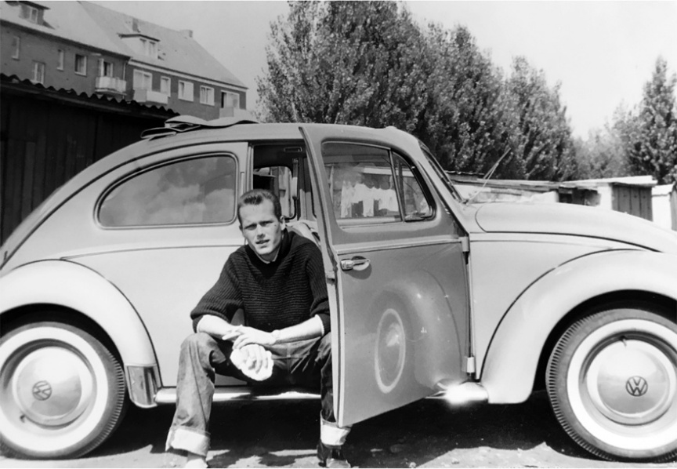

My Volkswagen

My Volkswagen
I always carried a twenty-dollar gold coin with me, which my father taught me to always keep on me in case of any emergency. That emergency had come, but when I tried to offer the coin to a jewelry store in Barcelona, I was told that selling and buying gold was prohibited in Spain by law at that time. I then went to the best hotel in Barcelona (I believe its name was Hotel Aricasa) and sat in the lobby for a couple of hours until I saw a lady walking in with a couple of gold coins on her bracelet. She was an American tourist and I followed her into the elevator, where I told her my story, asked her to help me if she could, and offered her my coin at a discount. At that time these gold coins were often used as jewelry on bracelets and most people knew the approximate value. She agreed, asked me to wait in the lobby, and paid for my coin. I was ready to continue my trip.
As I passed around from department to department at Thyssen, I developed a friendship with one of my superiors, who was only about eight years older than me. His name was Wilfrid Michels. He introduced me to his friends who called themselves “The Dixie Club.” Nice people with different occupations and all a little older than me. They united at a bowling alley once a week and occasionally also made trips to wineries along the river Rhine. We were a total of about eight plus their girlfriends or wives. It was always entertaining and often fun. They still meet, but several of them have already passed away. The father of one of them, namely Juergen Wein, was the owner of the most prestigious tailor shop in Duesseldorf by name of Anton Wein, with a studio on Koenigsallee, the most fashionable Avenue in Duesseldorf. Suits for men made by Anton Wein did cost a fortune but we all had one or two. Juergen was a tailor also and he used his father’s labels to label the suits he made for us.
While working, every morning I left the building for a moment to buy myself a warm ham sandwich for breakfast from a very nearby store. Usually, I went out and returned via a back entrance of the building, but it was a very hot summer morning and I returned to enter the main entrance, which was a shortcut. I had no jacket on, the sleeves of my shirt were folded up, and my tie was half-pulled down. I had to walk a long hallway past many offices of the very high company echelon. We were to wear jackets when not in our office. A short and regular-looking guy came along and passed me by. Some fifteen minutes later, while I was sitting in my office, the phone rang and I was to report to the director of personnel. The director told me that I was just seen by Director Riester, a man who was on the board of about one dozen of the largest Steel companies in Germany. He complained that he saw someone walking without a jacket close to his office. I had never seen this guy before, but he was certainly a big-deal executive. Fortunately, nothing happened and I was told not to do this again.
After completing my time at Thyssen and passing my exam, I traveled back to Hamburg, where I stayed with my mother. I had a girlfriend in Duesseldorf by the name of Marlu (Marie Luise). She was a very nice girl, but I could not afford commitment. We parted and I believe she went to London, met a Spaniard, and lives somewhere in Spain.
In Hamburg, I started to work for a well-known company called Coutinho, Caro & Co. selling steel products. While in Hamburg I also spend time sailing on Lake Alster in Hamburg with my long-time friend Gerd Sohns. Gerd owned a sailing boat of the category “Sharpy” and we spend our free time on the Alster, also frequently participating in regattas. The boat had two sails and also used a spinnaker sail with a trapezoid.
Hamburg is a beautiful city, with the big lake Alster in the middle and lined by beautiful parks around the lake. However, Hamburg, with a population of close to two million, is also a somewhat quiet and sleepy city, with little nightlife (except of course the famous Reeperbahn). It always seemed to me that everyone was home by eight o’clock, which was very different from Duesseldorf. The weather in Hamburg is often overcast and rainy. It is not the usual downfall of rain, but rather small droplets and mists which often continue for days. My mother loved to walk outside with a raincoat during these rather wet days.
After some time, I moved on to Saarbruecken, way in the south of Germany, to work with Ferromar A.G. doing more or less the same job. Just as in Hamburg, I was not on a full salary but my father, who represented these companies in the Dominican Republic, wanted me to get familiar with their business and staff. The boss at Ferromar was an Armenian, Mr. Mandula, whose insistence and perseverance in achieving his goals amazed me. He could spend hours on the phone to convince people to accept his proposals. I returned to Hamburg after some six months and planned to finalize my business experience in New York, with the Kurt OrbanCompany, owned by another Armenian, Mr. Orbanovski.
Arriving in New York
After learning and working for some five years in Germany, I arrived in New York at the beginning of 1960. My father, in bad health, told me that if I was interested in continuing his business, I should join him in Santo Domingo as soon as possible. He had already taken a business partner, who was running the business as my father spent most of his time in Germany. It was agreed that I would come to Santo Domingo, but not before obtaining some more work experience in New York and thereafter in my father’s second office in San Juan, Puerto Rico, also run by an administrator. Air travel was already available at that time, but I chose to travel via the Hapag Lloyd freighter “MS Remscheid” from Antwerp directly to New York because I wanted to take my new car, an Opel Record, with me. The MS Remscheid was a relatively new ship, somewhat larger than the freighters from the Horn line we used to travel with from Europe to Santo Domingo, and these freighters usually accommodated 6 to 12 passengers. The Cabins were small and relatively simple and these smaller vessels had no stabilizer and of course no thrusters, but instead only
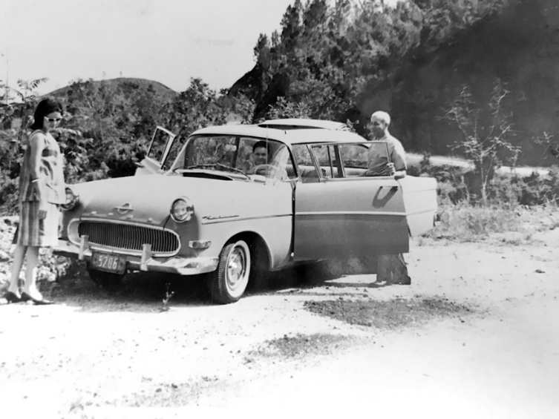
one propeller in the stern. During bad weather, these ships were often rolling and pitching heavily. GPS had not been invented and the navigators relied on Sextants and were often unable to avoid extreme weather conditions. The crossing of the Atlantic took generally between 12-14 days. The common area for the few passengers was generally a sitting area, maybe with a small library corner and the adjoining dining room for the 3-4 officers of the ship and the passengers. That’s it! Some of the furniture in this area was permanently screwed to the floor and the rest could be screwed down in bad weather. The rather narrow sleeping bunks had side bars to avoid falling out.

My Opel, is in Santo Domingo
I boarded the ship in Antwerp, where I arrived from
Hamburg in my brand new light green Opel Record.
I do not remember much about all the other passengers, but I do remember that there was a gentleman from some Zoo, who was traveling with some exotic African animals to be delivered to a Zoo in the US. Occasionally he took me down to a hold, where I could see the animals in their respective cages. Vividly I remember that among the passengers was also a girl about my age. This is mainly because the captain of the vessel, Captain Uebel (his name translates into “evil” or “terrible”), made us two his favored guests. Captain Uebel was an old Submarine Captain and daily entertained us with U-Boot stories. He had a big and comfortable Cabin near the Bridge, invited us frequently, and showed us pictures of his submarine experience. He had a lot of interesting stories to tell. I had the feeling he was not too well-liked by his staff. He was a loner and possibly not too happy that the war was over. Anyway, he was nice to us and kept us entertained. We were often invited to the bridge and I was also given the opportunity to steer the ship with the big hand wheel. Every time I thought I had done a good job, I was made to look back
to the wake of the ship and then saw a long spiral snake going zig-zag. It needs a lot of experience to steer a ship in a straight line, because of the waves and the longer reaction time the ship takes before correcting.
When we arrived in New York there was some kind of general strike going on and there were no pilots or tug boats available to steer us into a rather difficult harbor berth on the Jersey side of the Hudson. Capitan Uebel decided to go in without help and we stood on the bridge observing this very delicate millimetric operation with only one propeller in the back. Nowadays most ships have side thrusters, allowing them to turn on the spot. We finally arrived and Captain Uebel offered me a surprise. My car was the first to come out of the hold and to be on land. It had a duty-free German License plate and being an Opel, looked very German compared to the huge American cars which dominated the American streets at that time.
On the dock was a young man standing and waiting for me. He was an employee of Kurt Orban Company, where I was to be working for the next year. He asked me to follow his car with my car and there we went through the Holland Tunnel into Manhattan. I was overwhelmed by the skyscrapers when we came out of the Tunnel and looked up at the narrow bands of blue sky where the buildings seemed to collide. He finally stopped in front of a huge building in Downtown Manhattan and told me to drive into the underground garage of the same building to find parking. It turned out to be the very luxurious New York Downtown Athletic Club, which obviously was also a hotel for members, which Mr. Orban obviously was. The next morning, I found the New York Times Newspaper in front of my door and searched for a small apartment in Mid or Lower Manhattan. I could not use my Opel without a valid driver’s license and the club provided a limousine with a chauffeur.
After a two-day search, I found a brand new one-room apartment with a bath and kitchenette, on 25th Street, between 1st and 2nd Avenues. The brand-new six-story building (long demolished now) was owned by Joe Gagliano and the small attractive apartments were nicely furnished and had air conditioning. The next day I was driven to Macy’s and purchased all the items needed; like bed sheets, towels, pots, and pans, rugs, cleaning items, silverware, a clock and I am not sure whether it was a TV or a radio. All was delivered the following day by Macy’s and by the afternoon of the fourth day I moved via Limousine from the luxurious downtown Athletic Club to my new small apartment. My new friend Joe Gagliano (Landlord) did not tell me that I was going to be the only male tenant in the building. Most woman tenants were nurses from the nearby Bellevue Hospital. Some were obviously Lesbian. My next-door neighbor worked in a nearby bar as a bartender and after a couple of months was murdered in that same bar. Although I was occasionally asked to lend a pot or pan, I preferred not to entertain a closer relationship with any of them. My car was parked on 23rd Street between 2nd and 3rd Avenues in an open lot with metal racks, stacked two to three cars high. Since I used the car seldom during the week, it was usually the highest up and I had to call thirty minutes in advance for it to be available. Complications came when I tried to obtain an N.Y. driver’s license. I drove to the corresponding authorities and when it was time for the practical driving test, the inspector was not willing to get into my car with the German license plate. I had to rent a passing taxi, that was willing to cooperate. I do not remember whether I was allowed to drive with my German license plate or whether a New York plate was issued.
My new little apartment was small but practical. I had all I needed and was able to do some small cooking when tired of TV dinners, which at that time were very popular. I hired a cleaning lady to come in once or twice a week. She had a key and came while I was at work and I only saw her once or twice personally. Between my small salary and small subvention from my father, I was in fairly good shape, but of course, I had to be careful and practical with my spending. I had two, or three German friends, who worked with Thyssen at the Empire State Building and whom I knew from my time working for Thyssen in Duesseldorf, Germany. We used to join frequently at one of the German Beer Houses in German Town or sometimes at the German Club Bowling Alley. We also frequently visited the Scandinavian Club and even the YWCA to meet some girls. (There we were only allowed to sit in the lobby). During weekends we drove out to Jones Beach, Fire Island, and others. On longer weekends we drove on two or three occasions up to Cape Cod.

Once I was asked by Mr. Orban to drive him to the airport. I remember this situation well because he had one of the biggest Chrysler Station wagons I had seen and the lanes driving through the Tunnel seemed to me rather narrow for that vehicle. I was not used to the power steering the American cars had, which offered no resistance at all when steering. European cars do have some resistance on the steering, which offers more control. I obviously made it safely through the tunnel and back.
My work with Kurt Orban Company was interesting and I learned a lot. This is also because I was permitted to work independently and use my own judgments and decisions. Their offices were in Hoboken, New Jersey, right above the subway station coming from Manhattan. I believe I boarded the subway in the morning on 23rd Street and then traveled through the Holland Tunnel to the first station on the other side of the Hudson, Hoboken. I just had to climb some stairs and was in the office. The huge building used to be a factory building and our office was a large rectangular hall without subdivisions and some forty to fifty desks distributed in different configurations. At the end of the hall was the desk of Mr. Orban, (who had changed his name from Orbanovski) an Armenian emigrant, and his second-in-command Mr. Rothschild.
I would develop a very amicable relationship with Mr. Orban, but not so much with Mr. Rothschild, who as a Jew was obviously not so fond of Germans. In those years I learned to be very careful how to communicate with the New York Jewish community because there were still a lot of understandable resentments. It also seemed that at least half of Manhattan’s population was of Jewish descent. Mr. Orban was a friendly guy with a lot of drive and conviction. I did have an Armenian boss before when I worked for Ferromar in Saarbrucken and these people impressed me. My father thought they were the smartest people in the world and he might have been right. Maybe, because of the oppression, they went through during the Ottoman Empire, where most of them were murdered by the Turks or driven all over the Middle East.
I was happy to be assigned to the “Drawn Wire Department,” not only because I was very familiar with this commodity, but also because it was the smallest department in the Company and consisted only of two persons. I was to be the third. My immediate boss was Hasso von Bredo, a nationalized German immigrant. Hasso was a nice gentleman and now we were a small department of three, counting our secretary, a middle-aged lady. Our job was to sell drawn wires all over the US and to buy them wherever possible. Orban employed salespeople in different states, who sent us their inquiries and demands. We then offered, purchased, and sold the material, at that time, mainly from Germany. As a matter of fact, mainly from the company where I had previously worked for over three years as an apprentice, Thyssen in Duesseldorf. Orban used to be the representative of Thyssen in the US before Thyssen installed their own offices in the Empire State Building.
Now, it so happened that I communicated frequently with some of my old friends in the Empire State Building regarding steel transactions. When I called, I was first greeted by their receptionist Maureen. We became friends on the phone and I asked her out. I had seen her before when visiting Thyssen and I knew she was pretty and very Catholic. She usually spend her lunchtime breaks in the Cathedral on 5th Avenue. She, later, invited me on several weekends to her parent’s house on Long Island and I was impressed with their beautiful big home. Her mother was of Polish origin and her father, who was an executive of a well-known company in New York, was Irish. Her little brother was trying to get into the West Point Academy and I suppose that eventually he got accepted. Of course, that needed a congressional recommendation, which they apparently had. I visited several times but was aware that I would soon be moving along. I was not ready for any commitment, nor was I particularly excited about her devotion to the church. Finally, she was not a woman to live in the tropics as I remembered my mother, who suffered 28 years of heat without an air conditioner. At that time air conditioners were just coming up and were very big and expensive. She was a typical New Yorker with a very different lifestyle and of course, did not speak Spanish. I learned later that apparently she got married to the son of the governor of the World’s Fair in New York. Probably a much better deal for her than me.
Several months after my arrival my immediate boss and friend Hasso got fired. He was called to the desk of Mr. Orban and when he came back, he told me that he was fired and would not come back the next day. I never learned the reason and was somewhat sad because Hasso was a nice guy and had a big family. He later visited me in Santo Domingo. The next day it was me with my secretary doing as well as we could. We muddled along expecting every day that we would get some help, but it did not come. After another month Mr. Orban came by our desks to tell us that we were doing great and expected us to keep it up. When my time came to quit, he asked me to stay and offered me a fully paid job. I declined, explaining that my father, whom Orban knew, was waiting for me.
I flew to San Juan, Puerto Rico, and shipped my Opel to Santo Domingo, Dominican Rep. I was to work for a couple of months in my father’s company in San Juan to get acquainted and familiarize myself with our work. I was now twenty-five years old. I remember the new airport in San Juan was recently inaugurated and Munoz Marin was the Governor of Puerto Rico.
Arriving in San Juan, Puerto Rico
I arrived in San Juan one afternoon late in 1961 and was greeted by our office Manager Egon Schulz. Over a period of approximately another year, I got to know Egon as an excellent friend and a nice person to be with. He was six or seven years older than me and treated me as his younger brother. We had no secretary and most of our correspondence was via Telex Machine, of which we had one from RCA and another one from ALL America. The Antillana Agency office was located at the centric Ponce de Leon Avenue, in Santurce. It was a large building of some six floors. There was a larger shoe store, Almacenes Gonzalez, on the ground floor. In the back was a small private parking lot. Egon had an old, green, convertible, two-door Bel Air with a huge motor. I also purchased, second-hand, an old four-door, green Bel Air. Both cars looked similar, had huge engines, and probably weighed five tons each. I remember that the transmission of my car, which still looked very decent, was so worn out that most of the time I did not need to use the clutch to change gears.

Air conditioning was still not available and we drove with open windows. We had two covered fixed parking places, which came with the Apartment (our office). The owner of the building was an elderly Spanish Gentleman who owned the shoe store (Mr. Gonzalez). We could see him in the morning directing the traffic in the parking lot. At night there was an elderly guardian at the lot, singing and playing his Puerto Rican guitar. I suppose that he was there to guard the back door of the shoe store.
Our office (apartment) consisted of three bedrooms, two of which Egon and myself occupied, and the third we converted into a living room with a Sofa and normal living room furniture. Our office (apartment) consisted of three bedrooms, two of which Egon and myself occupied, and the third we converted into a living room with a Sofa and normal living room furniture. At the entrance was a large area, which conventionally would have been a living room and dining room together and which we converted into
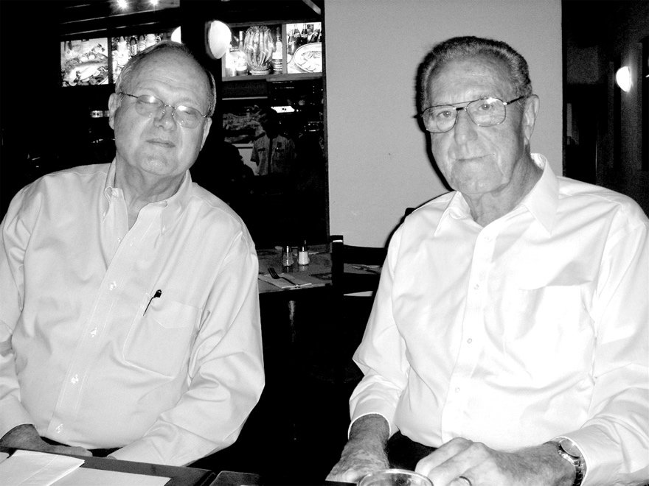
Egon Schulz & me
our office with three large desks, office equipment, and furniture. We must have had a kitchen, which I do not remember and which had little use to us. We worked all day in and out of the office and at around six PM we went regularly out to dine somewhere. There was a time we had dinner just about every night at the Café Pierre, which was a dependency of the Swiss Chalet. Café Pierre had the same food but was cheaper than the main restaurant and we, as constant guests, had preferential treatment. Here I befriended Magda, who was the daughter of one of the principal owners of the Swiss Chalet. She was very young and obviously had a terrible crush on me. I became scared of her insistence and stayed away from the place. After dinner Egon and I would often go to different hotels or meetings, to sort of “single and mingle” as we called it. We always had a good time. Once, at the bar of the Caribe Hilton, some young man sat on the adjourning stool beside Egon. Suddenly, I saw that Egon was knocking the guy from the seat (Egon was a tall and strong guy). After the brawl was over, I learned from Egon that the guy he had knocked out was gay and came on to him. Later I learned that Egon had been molested as a young boy and was allergic to these people. Thereafter, when going out together, I often tried to shield Egon against suspicious guys by sitting in between. Once, also at the Bar of the Hilton, I met a young guy, good-looking, about my age, and very sympathetic. He told me he had just arrived from New York and knew no one in Puerto Rico. He told me that he was a stockbroker and quit his job to take on a new job as a broker in San Juan. We had some drinks and talked a lot and I thought that since I did not know many people in Puerto Rico either, this could be my first friend. Obviously, he was financially struggling to get over the first transitional period till salaries kicked in, but we kept in touch. His name is Peter Noble, and we remain friends and talk to each other often. He now lives in Greenacres, a county in Palm Beach, approximately 70 miles north of Miami, Florida. Pete is married to a Puerto Rican lady Ana (we call her Jaja) and he is retired, but still an active council member of the Greenacre local government at 87 years of age.
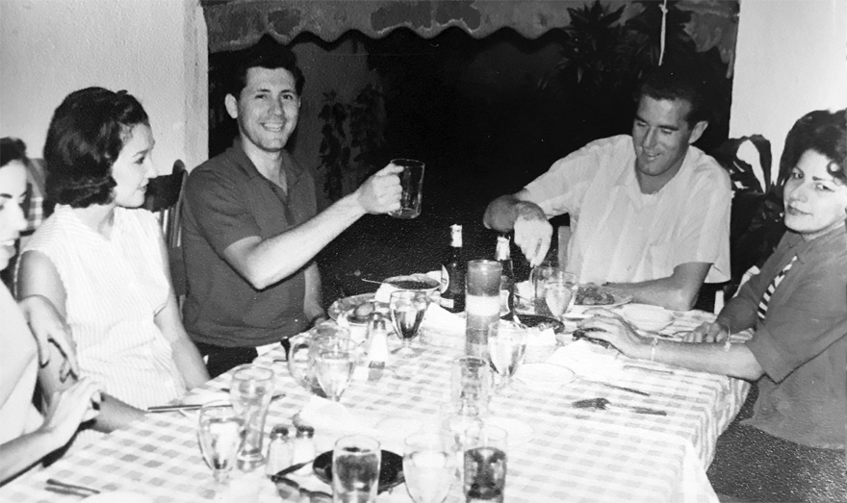

Left to right Peter Noble with his wife
and Egon Schulz with his wife.

After some months, Pete called me one day to tell me that he had been invited by some girls to a party at an address that seemed to be in a very nice neighborhood. He was reluctant to go because he knew no one and asked me to join him. I guess I agreed reluctantly, and we finally arrived at the scene. The big residence looked very nice and all the attending people also. I was told that the home belonged to a well-known doctor and it was his daughter who was the host. She had invited several girlfriends and was apparently short of some men to round up the party. Pete was formally invited and I was not, nor did I know any of the people present. For some reason, I lost Pete out of sight in the crowd, probably occupied by whoever invited him, and realized that most had already paired up. So, I sat in one corner and watched the people when I realized that there was a very attractive girl all by herself sitting just like me in another corner. I already thought that I looked like a fool sitting there by myself and so I hoisted myself up and sat beside that girl and introduced myself. Her name was Zaida and she turned out to be my wife-to-be.
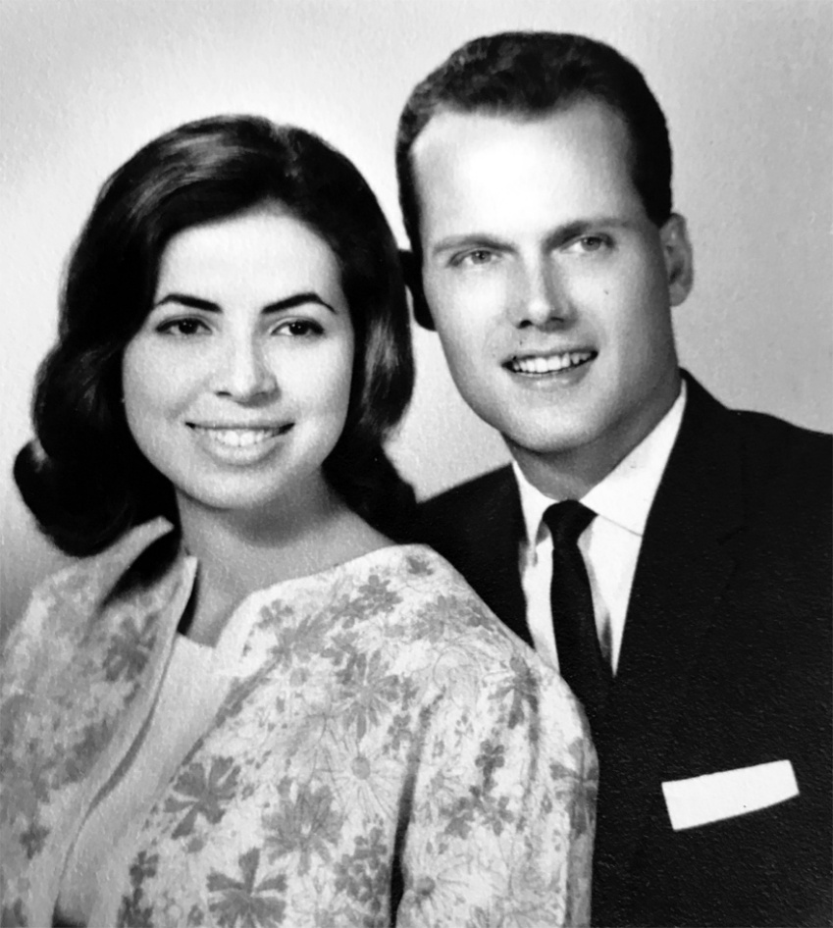
I guess we liked each other immediately, and after some talking, she agreed with me that the party was boring and we excused ourselves and drove to Old San Juan to a place called “The Sand and Seas,” where we danced to good music until later that night. We saw each other frequently thereafter until it was time for me to join my father in Santo Domingo.

That’s us !
At that time the German Consul in San Juan was a very well-known and very sympathetic Puerto Rican Gentleman by the name of Luis Aponte, who was also the Administrator of the Waterman Lines. He knew everyone in Puerto Rico and everyone knew him. Anyway, this very nice and influential gentleman helped us a lot with advice and he also introduced us to some corporate executives of interest to us and our business. He also tried to introduce me to young girls, daughters of his many friends, all of whom were obviously very well-to-do. However, these girls were all much too young for me, meaning around 16 or 17 years of age, and were obliged to be home by 9 p.m. When two German frigates visited San Juan, he organized a big party for the young German trainee sailors and I was surprised how many pretty girls this gentleman drummed up to attend the party, which however ended at around 9:30 PM. I was glad that all Marines behaved well. This gentleman also attended my father’s burial in Puerto Rico and was very helpful with all pertinent arrangements and documentation, for which I was very grateful. Some years later, after the demise of this gentleman, Egon Schulz became the German Consul in Puerto Rico. Also much later, Agencia Antillana gave up its interest in its Office in San Juan and Egon Schulz, who had married, continued under his name and from his new home. If I remember correctly, Puerto Rico, after Governor Munos Marin was not reelected, went into a recession and business was very slow.
Our work in Puerto Rico consisted in selling mainly steel products to the local steel retailers. There were quite a few in Puerto Rico at that time, such as Garcia Commercial, Caribe Lumber, International Agency, Rio Piedras Lumber, etc.
I was on the street most of the time and so was Egon. During the first month, we went together for him to introduce me and thereafter we visited individually. About every second week I traveled the whole island, starting in Ponce, then Mayaguez, and returning on the northern side of Puerto Rico to complete the whole circumference of the island. Often, I stayed in Ponce overnight, but only if it had gotten too late to continue. Mayaguez was a half day’s work and then I loved to stay in a very little fishermen’s beach town at Rincon, where I rented a Bungalow for the night directly on the beautiful coconut-covered beach with very white sand. There I jumped in the water and early in the morning again, had some good breakfast, and was on the road again. I enjoyed it. The customers, mostly Spaniards, were all friendly and it was sort of easygoing while doing business.
Often delegates of European suppliers visited us and I remember that one, in particular, stood out. He was from the old German company Dobbertin & Co. in Hamburg and in this case, it was Mr. Dobbertin himself. It so happened that the elder Dobbertin had recently died and his adopted son, also named Dobbertin, was now in charge and apparently on a mission to explore the world. When he saw that the prices he received from his office were not competitive in Puerto Rico, he instructed us to take firm buying offers at prices below the competition. He hoped to later recompensate with lower freight rates and possibly lower costs by obtaining a big volume. Trade was always done by Telex at that time and we had the reply the next morning, considering the time difference between Europe and the Caribbean. We took bids for one complete shipload of twenty thousand tons of Steel and then for a second. Mr. Dobbertin send his telex from our office to his office and told them to accept the bids. Of course, he was the boss. The next morning came the answer from his directors that they could not understand his reasoning and would not know where to buy the material at these prices. Mr. Dobbertin ordered us to inform our customers that their bid was accepted and to send in the order forms. Egon and I were so happy that we took Mr. Dobbertin to Luquillo Beach on a weekend, where we regularly met with a larger group of boys and girls. Mr. Dobbertin promised to send all the girls a Bikini from Rimini. We received the two boatloads of Steel at the agreed price as well as our corresponding commission of ½ percent (small commission but large total value) and I do not know whether the Bikinis were ever delivered. About one or two years later Dobbertin & Co went bankrupt and I never heard from this gentleman again.

