Love,Karma

& Liberation
Healing Past Relationship Patterns
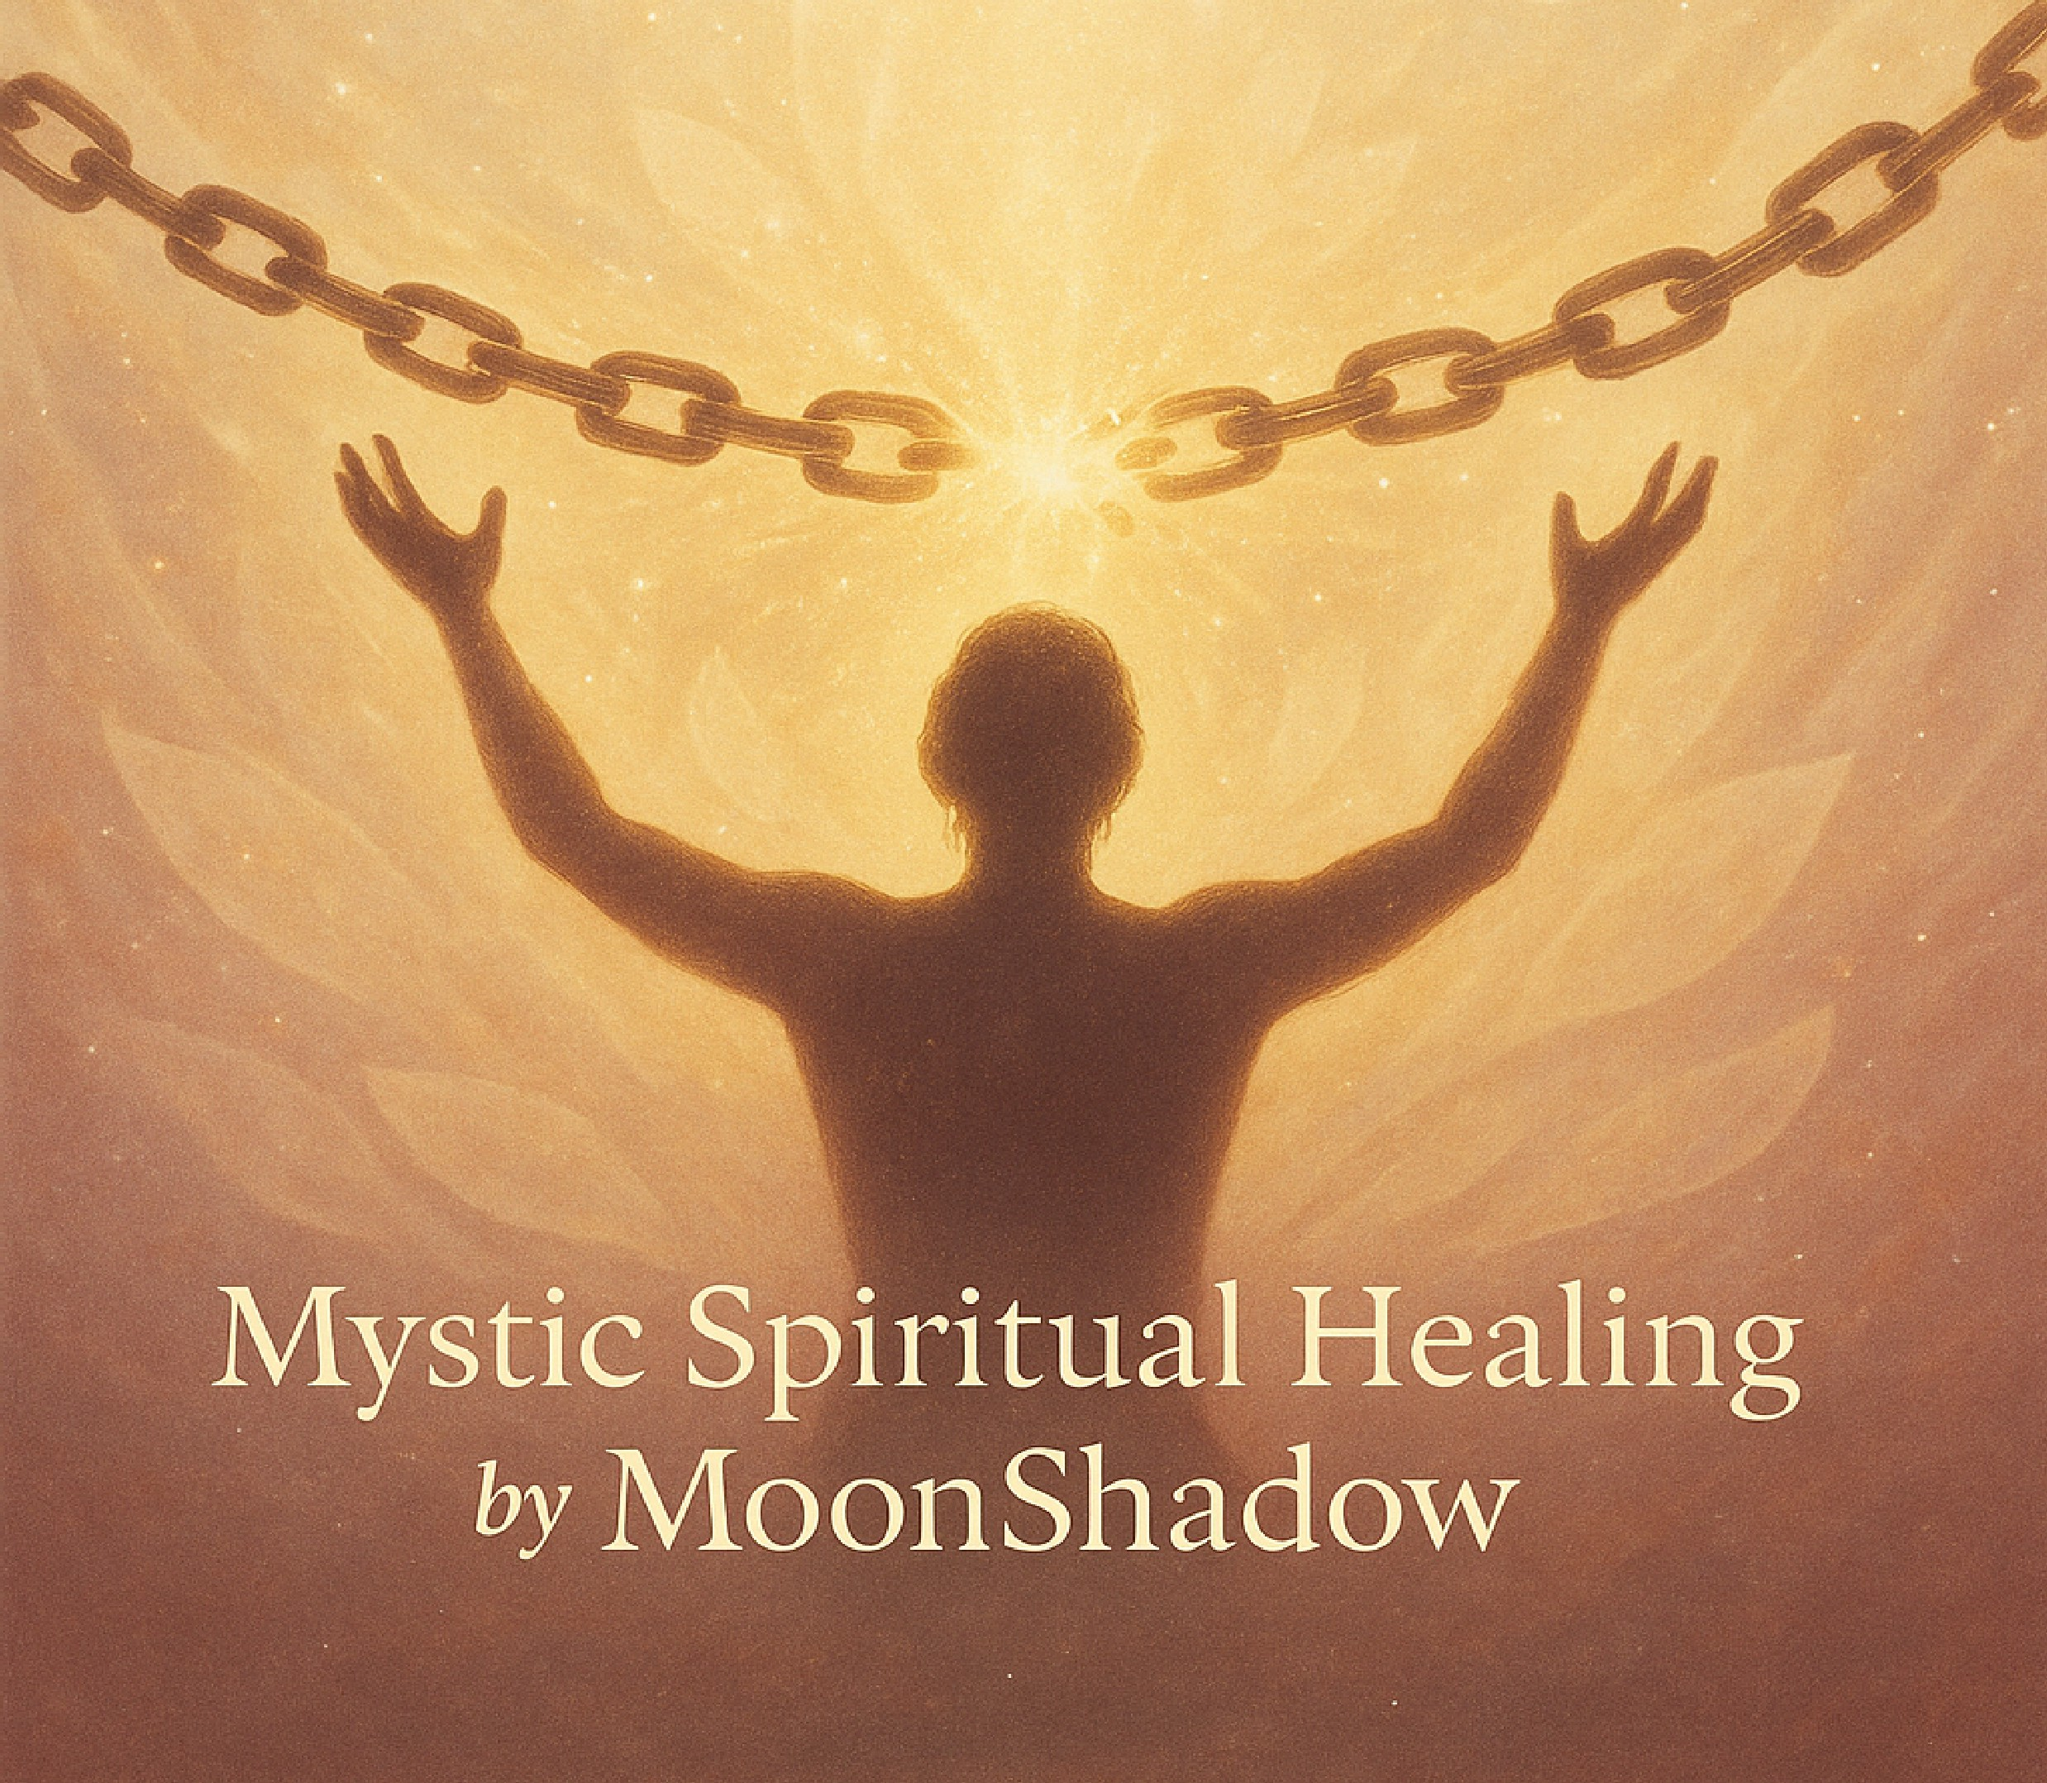
& Embracing Your Soul's Freedo,m

Love, Karma & Liberation
Healing Past Relationship Patterns
by Mystic Spiritual Healing by MoonShadow

LOVE, KARMA & LIBERATION

by Mystic Spiritual Healing by MoonShadow

---

**Chapter 1: Understanding Karmic Relationships**

_Explore what karmic relationships are, why they show up, and how they shape our soul journey._

Karmic relationships are not just coincidences or unfortunate love storiesthey are soul contracts. These connections often come into our lives to teach us deep spiritual lessons through intense, sometimes painful, emotional experiences...

[Continues with detailed Chapter 1 content...]

---

**Chapter 2: Identifying Your Relationship Patterns**

_Uncover your attachment styles, emotional triggers, and repeating dynamics in love._

Every relationship leaves a mark. Over time, patterns emergeways you love, fight, attach, and let go. Some of these patterns come from childhood, others from previous lives. The key to transformation is seeing the pattern clearly enough to break it...

[Continues with detailed Chapter 2 content...]

---

**Chapter 3: The Purpose and Lessons of Karmic Relationships**

_Learn what each karmic connection comes to teach you and how to recognize when a soul contract is complete._

Karmic partners often arrive as mirrors. They show us what were avoiding. They crack us open so we can grow. But not all karmic relationships are meant to last. Some are designed to endbeautifully, painfully, necessarily...

[Continues with detailed Chapter 3 content...]

---

**Chapter 4: Healing Emotional Wounds**

_Deepen your self-awareness, process emotional pain, and work with the inner child for lasting healing._

Emotional wounds from karmic bonds dont just fade with timethey demand conscious healing. You must sit with your pain, name it, and tend to it like a sacred garden...

[Continues with full Chapter 4...]

---

**Chapter 5: Forgiveness as a Pathway to Freedom**

_Unlock the transformative power of forgivenessof others and yourselfto finally release the past._

Forgiveness is not condoning the harm. It is freeing yourself from the grip of what happened. Forgiveness says: I refuse to be bound by this pain any longer. It is sacred closure...

[Full Chapter 5 content follows...]

---

**Chapter 6: Reclaiming Your Power**

_Reclaim your worth, your voice, and your energetic sovereignty after trauma and emotional betrayal._

Once you stop chasing validation, your true self returns. Reclaiming your power isnt a single momentits a practice. Every boundary you set, every truth you speak, every time you choose peace over chaosits a homecoming...

[Full Chapter 6 content follows...]

---

**Chapter 7: Breaking the Cycle**

_Shift from karmic repetition into conscious response. Learn how to walk away, set boundaries, and break generational patterns._

To break the cycle is to become conscious. You must be honest about what youve accepted that was never love. This chapter invites you to rewrite the story...

[Chapter 7 fully included here...]

---

**Chapter 8: Attracting Healthy Relationships**

_Embody your new vibration. Call in love that meets you with presence, respect, and truth._

Youve done the healing. Now its time to receive. Healthy love feels like exhale. It doesnt demand you shrinkit celebrates your expansion...

[Full final Chapter 8 content here...]

---

**Conclusion: Your Liberation is Now**

_Celebrate the rebirth. Youre no longer in survivalyou are in sovereignty._

This is not the endits a new beginning. Youve returned to yourself. And from here, everything sacred begins...

[Final affirmations, letter prompts, and closure]

