RESOLVINGAN ABO DISCREPANCY: IDENTIFICATION OF THE RARE A SUBGROUPIN A PATIENT WITH ACUTE MYELOID LEUKEMIA
X

AUTHOR- DR.SAGAR GOMASE

CO-AUTHORS- DR.JOSEPH PHILLIP, DR.RAJEEV MALLHI, DR.RITIKA BASNOTRA, DR.DILNAEDISON

BHARATI VIDYAPEETH MEDICAL COLLEGE, PUNE

INTRODUCTION
oThe ABO blood group system is the most clinically significant in transfusion medicine. Subgroups ofA, such as A , A , and rare variants like A can cause ABO discrepancies, requiring further serological and molecular evaluation.
1 2 x,

oThe Ax subgroup is a rare variant ofA, characterized by:

Weak or absent agglutination with anti-Abut detectable agglutination with anti-A,B. Presence ofAantigen in small amounts, often undetectable by routine serological methods. Anti-A1 antibodies in the plasma, leading to discrepancies in forward and reverse grouping.

oThis case highlights the identification of an A individual, detected during routine blood grouping due to an ABO discrepancy. Further workup confirmed the A phenotype, emphasizing the importance of detailed serological testing in transfusion practice.
x
x

MATERIALAND METHODS

oSample Collection: Blood samples (plain & EDTA) were received from a 20-year-old male diagnosed with Acute Myeloid Leukemia (AML) requiring platelet transfusion.

oInitial Blood Grouping:performed using Biorad gel card technology, revealing an ABO discrepancy between forward and reverse grouping. To resolve this, grouping was repeated at 4°C, and reverse grouping was further analyzed usingA1 andA2 cells separately.

oFurther Immunohematological Workup:
oTesting with anti-A1 lectin to differentiate betweenA1 and non-A1 subgroups. oIndirect Coombs Test (ICT) to detect unexpected antibodies.
oDirect Coombs Test (DCT) to check for in vivo sensitization.
oAuto-control to differentiate between alloantibodies and autoantibodies.

oConfirmatory Testing:
Repeated blood grouping using the conventional test tube method. Microscopic examination of agglutination to assess weak antigen expression.
This systematic approach confirmed the presence of the A subgroup, highlighting the importance of extended serological testing in resolving ABO discrepancies.
x


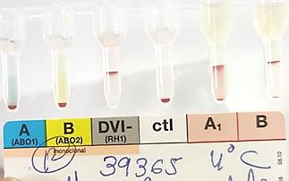
RESULTS

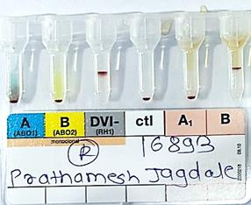
wR 0 4+ 0 0 4+ DP 0 wR 0 4+ 0 DP 4+

Fig 1:- Showing Blood Group at
Room Temperature(CAT)
Fig 2:-Showing Reverse Group with A1 and A2 cells At Room Temperature(CAT)

Fig 3:-Showing Blood Group at 4°C (CAT)



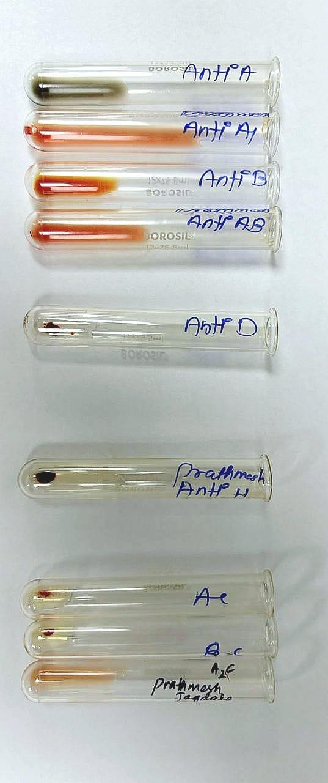
ICT DCT AUTO 0 0 0
A1C
A2C

2+ 0 0 1+ 4+ 4+ 1+ 4+ 0

Fig 4: - Showing ICT, DCT, AutoControl

Fig 5:- Showing Forward and Reverse Blood Group in CTT

CAT- Column Agglutination Technique CTT- Conventional Tube Technique DP- Double Population

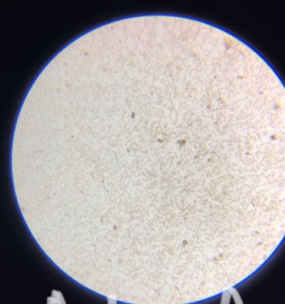
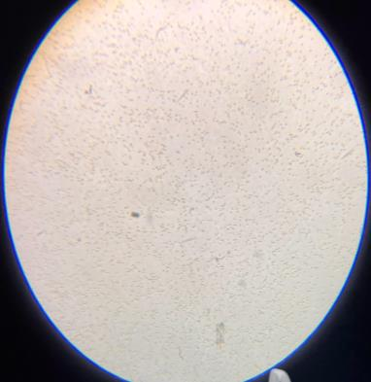
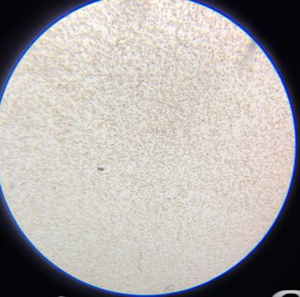
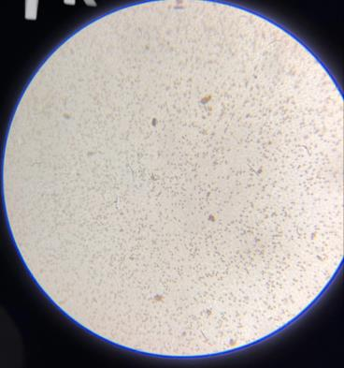
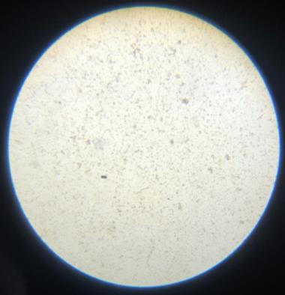
MICROSCOPIC PICTURE

ANTI- A

AGGLUTINATION PRESENT

ANTI- AB

AGGLUTINATION PRESENT

ANTI-A1 LECTIN

AGGLUTINATION ABSENT

A1 CELLS

AGGLUTINATION PRESENT

ANTI- B

AGGLUTINATION ABSENT

A2 CELLS

AGGLUTINATION ABSENT

CELL GROUPING  Anti- A | REACTION GRADE AT ROOM TEMPERATUR E (CAT) | REACTION GRADE AT 40C (CAT) | REACTION GRADE BY CONVENTIONAL TUBE TECHNIQUE
CELL GROUPING  Anti- A | Weak reactive | Weak reactive | Weak reactive (confirmed microscopically)
Anti- A1 | - | - | 0
Anti- B | 0 | 0 | 0
Anti- AB | - | - | Weak reactive( confirmed microscopically)
Anti- D | 4+ | 4+ | 4+
REVERSE GROUPING
A cells | Weak reactive | DP | Weak reactive( confirmed microscopically)
A1 cells | DP | - | 1+
A2 cells | 0 | - | 0
B cells | 4+ | 4+ | 4+

INTERPRETATION-Ax Rh D positive with AntiA1 Antibody

DISCUSSION

• ABO discrepancies can arise due to weak antigen expression, unexpected antibodies, or technical errors.

• In this case, a 20-year-old AMLpatient showed an ABO discrepancy, prompting further testing. The A subgroup was identified, characterized by weak/absent reaction with anti-A, positivity with anti-A,B, and the presence of anti-A antibodies in plasma.
x
1

• Further workup with anti-A lectin, IAT, DAT, and auto-control ruled out other causes.
1

• Test tube method with microscopy confirmed weak Aantigen expression. Clinically, A individuals may develop anti-A, requiring careful transfusion planning to prevent reactions. This case underscores the importance of detailed serological evaluation in resolving ABO discrepancies.
x

CONCLUSION

• The identification of the A subgroup in a patient with an ABO discrepancy highlights the importance of detailed serological testing.
x

• Weak A antigen expression and the presence of anti-A antibodies can lead to misinterpretation in routine blood grouping.
1

• Accurate subgroup identification is crucial for safe transfusion, as A individuals may develop anti-A, necessitating careful donor selection. This case reinforces the need for advanced Immunohematological workup to resolve discrepancies and ensure transfusion safety.
x

REFERENCES

• Modern Blood Banking & Transfusion Practices 7th Edition • Transfusion Medicine Technical Manual Third Edition 2023

