EDM Festival Manual
This book explores the EDM lifestyle through
descriptions, anecdotes, and commentary on
iconic festivals like
Tomorrowland and Ultra Music Festival, as
well as underground raves!!!


CAMPING FESTIVAL LISTS
-
TABLES & LANTERNS:
SET THESE SOMEWHERE CENTRALLY ACCESSIBLE. YOU DON'T WANT TO BE
STUMBLING THROUGH THE CAMPSITE BLIND AT NIGHT!
-
BRINGING ALONG TAPESTRIES ARE A GREAT WAY TO NOT ONLY DECORATE
YOUR CAMPSITE, BUT THEY ALSO PROVIDE YOU WITH SOME PRIVACY AS WELL
AS SHADE THROUGHOUT THE SUNNY DAYS! HANG THEM UP ON THE OUTSIDE
OF YOUR TENT/SHADE TENT.
-
-
PLAN OUT YOUR ROUTE BEFOREHAND.
MAGAZINES, PUZZLES, ALREADY MADE PLAYLISTS
-
CHECK YOUR CAR MILEAGE AND MAKE SURE YOU'RE NOT GOING TO GO OVER
ANY MAINTENANCE MILESTONES-IF YOU WILL, BE PROACTIVE ABOUT IT.
-
-
JUMPER CABLES
SPARE TIRE
-
JACK
-
-
ROADSIDE ASSISTANCE NUMBERS
UPDATED INSURANCE CARD & REGISTRATION CARD.
-
-
-
-
-
-
-
-
-
-
-
-
-
-
CURRENT TAGS & STICKERS
VALID DRIVER'S LICENSE
Camping tent
Tent locker
Camping lights
Portable chair
Sleeping bag
Blanket & pillow
Hammock
Camping stove
Coffee maker
Kitchen supplies
Portable solar generator
Tarp

-

CAMPING TIP
MARKING THE SPOT:
Once you’ve pitched your tent, you'll be wanting a 5-minute break to get your sanity
back — well, if you're like me you will anyway. But your work is not done yet, so take a
few deep breaths (or swigs of beer) and get back up on your feet. Before others start
congregating nearby, make sure you signal to them that the space around your tent is
yours too. Like the cat does to your front-door area but without the urinating part, mark
your territory. Do this by putting down blankets and setting up pop-up chairs, or
whatever you can get your hands on, in the area around your tent(s). That way, when
you go off to explore you won't have to come back to see that your entrance now backs
onto someone else’s.

CONFISCATED AT THE ENTRANCE
At every festival | know of, there are certain items that aren't allowed
on-site. So don't be that person that doesn't check the list of prohibited
items. At that point you’ll have two options, go back to the hotel,
campsite just to drop it off or say goodbye to your confiscated item.

DATING A RAVER!!
-
-
-
-
it's not easy
We are Free Spirit
We Live & love in the Moment
We work so we can Rave.
-
try to keep up / we love hugs.
Don't talk over the music
-
-
-
-
-
-
Don't Make us choose.
Forget flowers we want tickets
We are unlike any other human.
Not all EDM Genre is "US"
Our outfits are not a Joke ,we spend weeks, months
working on it.

TRANCE
-
-
-
-
Armin Van Buuren
W&W
A&B
—-------------------> VOCAL/ PROGRESSIVE/ TRANCE
Gareth Emery
DUBSTEP/ BASS
Mala
Skrillex
Borgore
DJ Diesel
Excision
-
-
-
-
-
---------------> BORN IN THE HARDCORE OF LONDON (1990’S)
HOUSE
-
-
-
-
David Guetta
Avicci
—--------> ELECTRO HOUSE, BORN IN CHICAGO 3 DECADES AGO.
Zedd
Hardwell
TECHNO
Original Fucking genre, originated in Detroit and at that time it wasn't as popular but still pushes
Artists/DJ's to use it and create all this Great New Genre.


DJ’S
EPIC/FEMALE Bass DJ'S
-
-
-
Blue tight > Wind Wartu
Daddy - Level Up
Blood Moon- Vampa
EPIC SONGS to get into Dubstep
-
-
-
-
-
Frontlines -Zeds Dead
Superhuman- Slander
Crave You - Adventure club.
Promises- Nevo
Clone- Kayzo
Awesome Female DJ'S
-
-
-
-
-
Vampa- Dubstep.
Lucii- Spychedelic
Blossom- Bass HOuse
Level Up- Bass
Whipped Cream / Dark Bass
BAD ASS DJS
•
-
-
-
Wax Motif
G.Jones
Diesel (Shaq)
Skream


Dress Codes
Cyberpunk futuristic / Gothic usually. black clothes but with one item that is neon or super
bright, Reflective Accessories, Chokers *
Military Camouflage prints, earth tones, Congo pants, Aviation Glasses, French Braids.
Psychonaut trippy, Mandalas, meditation symbols, For people that lille to space out and
explore.
Bohemian Gypsy, hippy, feminine Vibes, Colorful patterns, kimonos.
Carnival Sexy, bedazzled Bras, Bright Colors, wigs,Glitter. Eg: ( EDC las Vegas)
Tie Dye Clothes Symbol of peace and love, Boomed in the 1960's, hippie, Vibes, Fun.
Kandikids, tons of perlers cuffs, hugging, Superchill and Lovely.
The Rave Baby Diverse planned DIY, Glitter, Cheeky, Booty Shonts
WHAT NOT TO WEAR...
Playsuits and jumpsuits seem like the perfect outfits to take to a festival. They are stylish, light to
wear and don't take up much room in your luggage. But don't be lured by their seemingly good
functionality because you'll soon be cursing once you break the seal. It's bad enough being in a
Portaloo, let alone being naked in one. As well as concentrating on where to aim and what not
to touch, you will also have to secure the outfit with one hand to spare it from falling to its stinky
fate on the ground.
If you don't take heed of this tip, make sure you pay attention to this: take a suit that hasn't got
strings, ties or belts that are long enough to inadvertently dunk into the toilet's swampy waters -
you really don't want to be tying up loo- soaked strings.

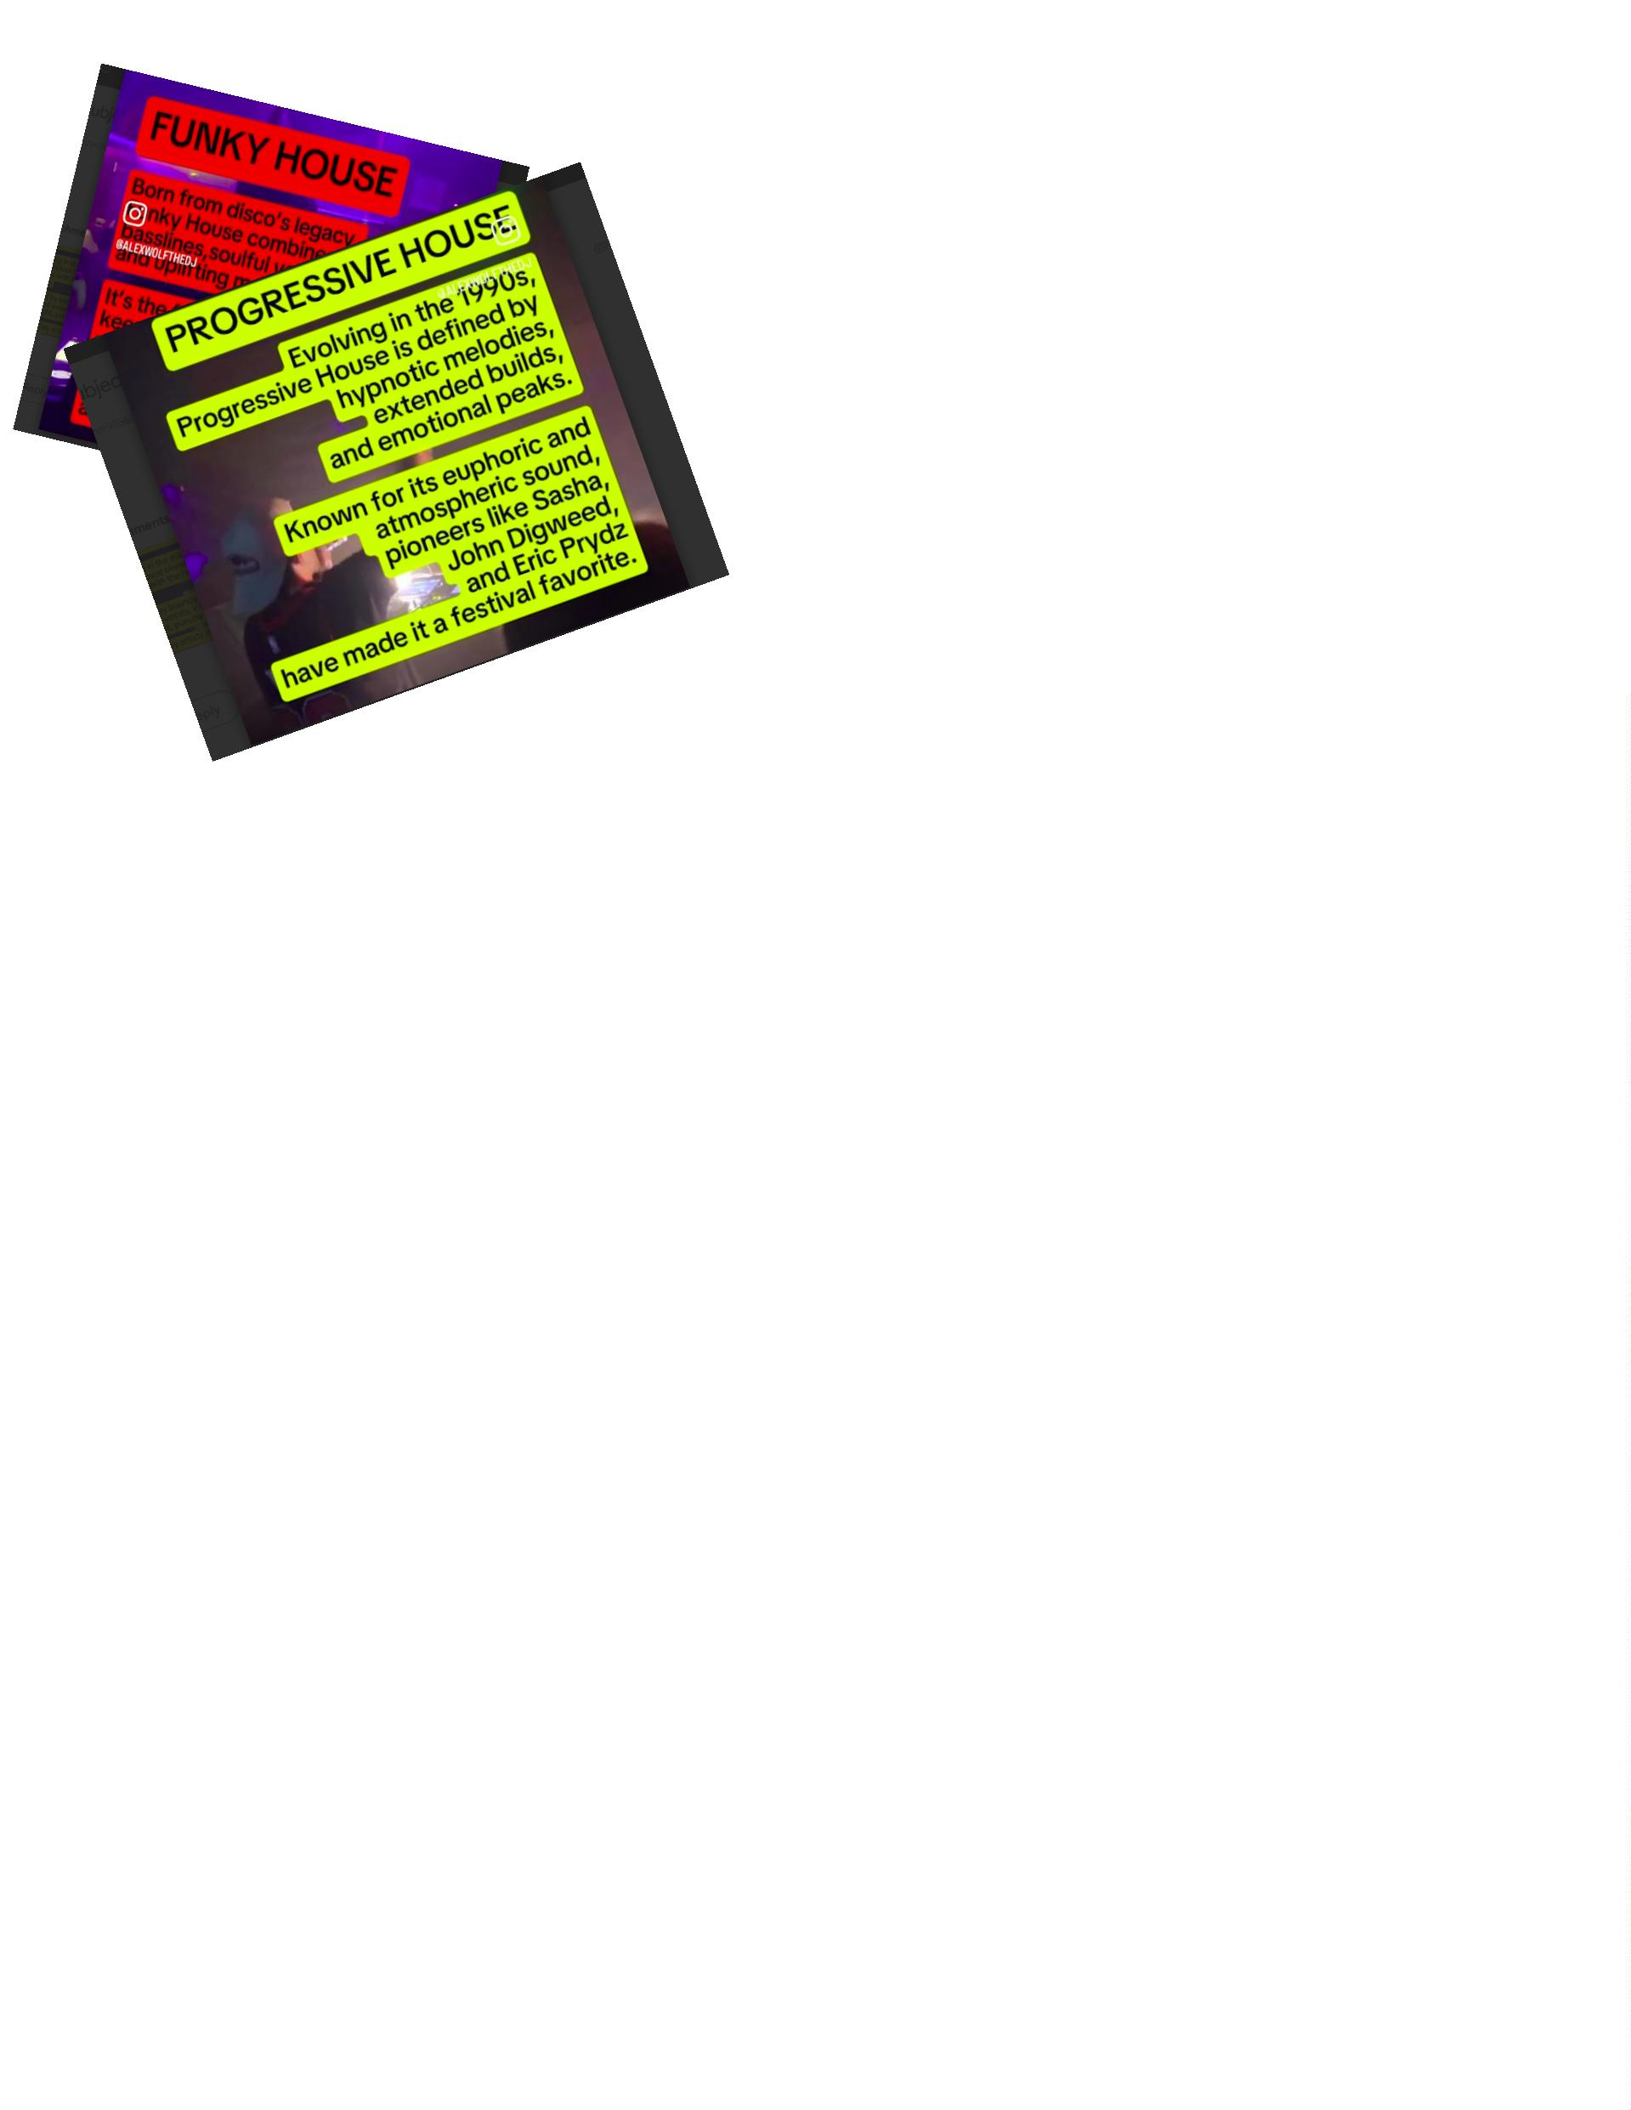

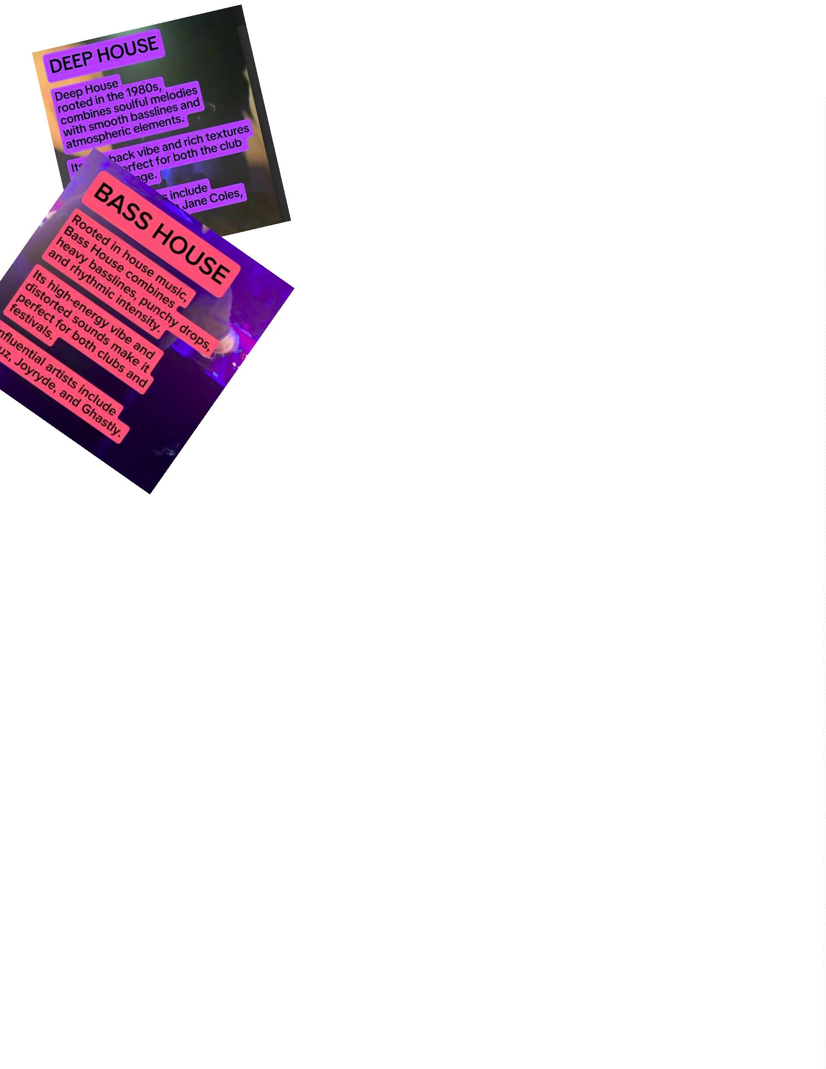

EDM JOBS
-
-
-
-
THE AFTER MOVIE PRODUCER
PHOTOGRAPHER
BLOGGER
PROMOTER
-
BRAND AMBASSADOR
-

EDM MUSIC GENRES/ SUB-GENRES:
Hardstyle and hard trance are not for the weak of heart, as its profound thumping kick drum
bassline reverberates out of (usually) main stage. Originating in the Netherlands, hardstyle is
very much still revered over the pond, with evidence in Defqon.1, an all hardstyle festival in the
Netherlands. I encourage you to listen to many different hardstyle songs until you find one you
like, for it can be an acquired taste. Hardstyle is for those looking for hardcore electronic dance
music.
Hard dance fans: Probably foreign. Nah, they're definitely foreign.
Trap
Hucci & Stooki Sound Ball So Hard
R.L. Grime-Scylla
Sub-genres:
Glitch Hop: G. Jones & Bleep Bloop- Mind
Trap music is recognized by hip-hop sounds and 808 bass. Many people who originally
favor rap and hip hop find their way into the EDM scene through trap music. Many EDM artists
collaborate with rap artists who create vocals for their songs.
Glitch hop is of the "weirder" variety when it comes to trap music. Using classic hip hop
sounds and integrating glitchy noises over the 110 BPM bassline, glitch hop artists have created
a whole new animal in the realm of EDM.
Trap fans: Say "your mom" jokes on multiple occasions, have questionably big muscles,
probably sweating profusely and wearing a graphic t

EDM MUSIC GENRES/ SUB- GENRES 2
Dubstep, the electronic version of heavy metal has overtaken the scene with its two-step
bassline sounding like "bom-chhh, bom-chhh, bom-chhh, bom-chhh and heavy, dark sounding
noises with the occasional high pitch. While at first dubstep can seem like something out of a
horror movie, its classical undertones appeal to a very large crowd. While dubstep has evolved
massively in the past two years (into something unrecognizably terrible in my opinion), I thrived
during 2013 when real dubstep was kept alive by heavy hitters like Doctor P. Skrillex, and Knife
Party.
Brostep was mastered by the likes of Skrillex and Zomboy around 2012, and is recognized
as a more aggressive, "in your face" version of dubstep. This sub-genre displays many noises
that remind me of an electric guitar. The term "brostep" started as a joke to describe
Americanized, "macho" dubstep, but this sub-genre grew into something that is definitely not a
joke. Listen closely and the intricacy will blow your mind. Many people refer to the "wobble" like
bassline of dubstep, which is created using low frequency distortion resulting in that "wub"
noise. Be careful not to hurt your neck as you throw it backwards and forward as soon as you
hear this unprecedented bassline.
Melodic DUBSTEP is for fans who enjoy the two-step bassline with a more relaxing,
chill, and pretty feel. Melodic dubstep is usually characterized using vocals, a sub-genre that
Adventure Club took a hold of and revolutionized.
Riddim made its way back into the scene recently, and is understood to be a minimal
sub-genre of dubstep, with focus on its constant tone and repetitive nature.

EDM MUSIC GENRES/ SUB-GENRES 3
Drum & Bass has a bassline that sounds similar to the two- step of dubstep, but much
faster. This sub-bass focused sub- genre will get away from you if you're not on your toes, as
the kick drum is very quick, but pair it with vocals and high pitched noises and it makes for a
very pleasurable musical experience. This UK popular sub-genre originated in the early 1990s,
and has been making its way to the US, even taking over its own stages here.
It's hard not to love the dubstep/house collaboration called bass house. This sub-genre takes
house music to a place it hasn't been before with its grimy, warehouse sampled sounds like
those of dubstep. Bass house has become very popular, and can be heard at many festivals, as
it seems to draw crowds of fans of both house music and dubstep.
Weird, "space", or experimental bass has come to fruition and revived the bass music genre
for the better. Its unpredictable basslines and noises have rejuvenated the bass scene and
added some funk. Weird bass boasts a heavy hitting tempo with excessively trippy and "other
worldly" noises to compliment. Bassnectar has ingeniously held this genre on his shoulders for a
long time, and has a massive fan base to prove it.
Trance
Sub-genres:
Progressive: Alpha 9- You and I
Psytrance: Freedom Fighters & Outsiders- Dust
Vocal: Above & Beyond- Thing Called Love
Trance is an extremely popular genre of electronic dance music, and artists like Armin Van
Buurin and Tiësto have blown it out of the water with their ingeniously curated sounds. Above &
Beyond takes the cake when it comes to vocal trance, which combines the continuous lengthy
build up and release of the beat with soft and effervescent vocals to truly encapsulate listeners
in a "trance".
Progressive Trance is a bit more subtle than trance, as are the breakdowns after the
long build up. DJ Arty's other alias Alpha 9 has really taken over this sub-genre and made it
something quite special.

Electronic Music industry Principles
1
- Kill your EGO, we are not better than Any
Other Genres. Yes, we make it big, loud Colorful & everyone knows us
but we also work hard so we can afford going to those events.
(hotels, Flights, tickets)
2
-Treat everyone equally. People will always remember how you
make them feel so respect and accept others most of all treat others
with the same amount of respect you would like to be treated.
3
) Know why you doing this, Festivals are crazy, passionated
We all have attached ourselves to different Genres of EDM for a
reason.
4
) Be good DO good, bad people exist in all Industries
And EDM is not immune to it, so let's help others without any
Expectations.
"
For the hand we give is not helping at all”

Festivals remind us what's already possible.
The way you treat people, the way you let
yourself experience things
the connection, the excitement, none of that
is tied to a location.
You can choose to see the world that way
every day.

HEY BABY RAVERS AND FIRST TIME RAVERS
FOUNDATION
Yes, the scene is vastly different than it was, but at the end of the day, the reason the events are
still called raves years later is because the core stayed the same. The music still kicks, the lights
are still low, and you still have the freedom to be yourself. What more could you ask for?
Be Responsible
As we age, responsibilities increase, making raving harder. To keep raving you have to find a
way to make it happen, and that's what the OGs have done. Whether it's pinching enough
pennies to hit one festival a year or integrating dance music into their source of income, raving
is more than a hobby for them, it's a priority.
MIND:
Of course the scene is different than it was when you first became a part of it. EDM is ever
evolving. If you want to stay raving that's something you will have to accept and better yet,
embrace.
YOU:
Being authentic is probably the most important part of enjoying yourself at a festival. Don't be
afraid to stand in the back and chill by yourself if that's your thing. as long as you're true to
yourself, that's something that doesn't fade with age. This goes for your daily life too!

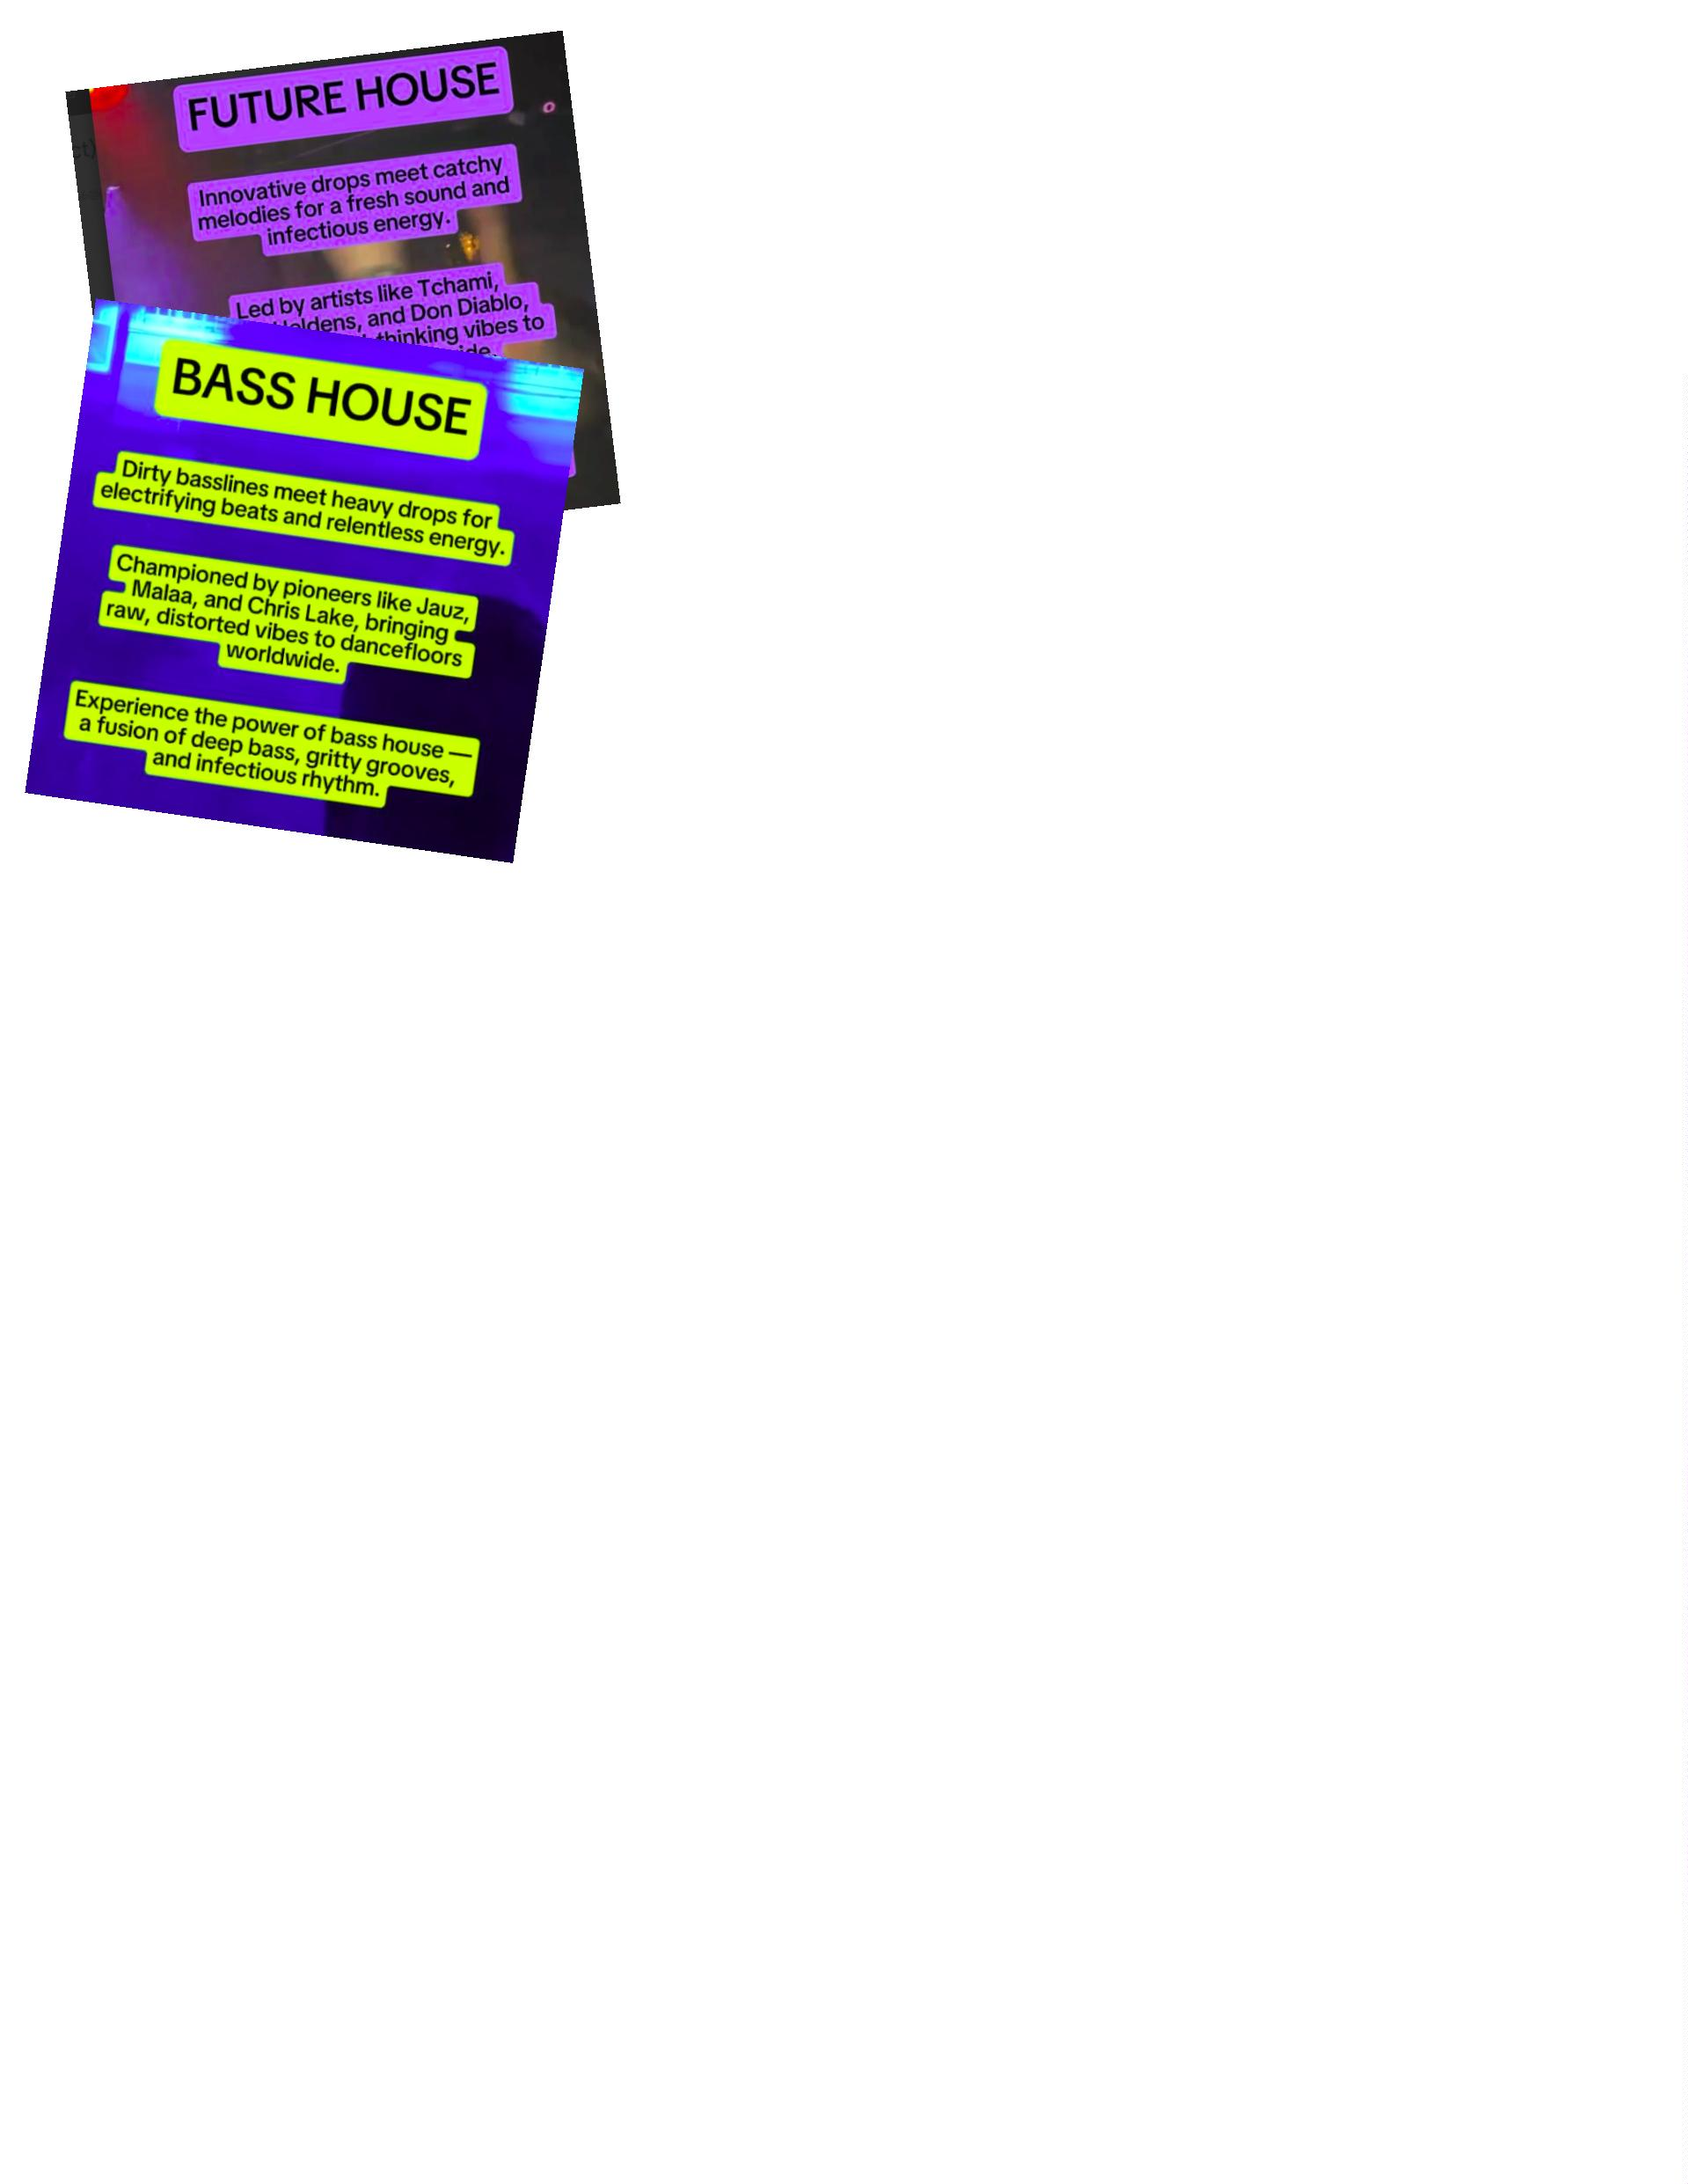

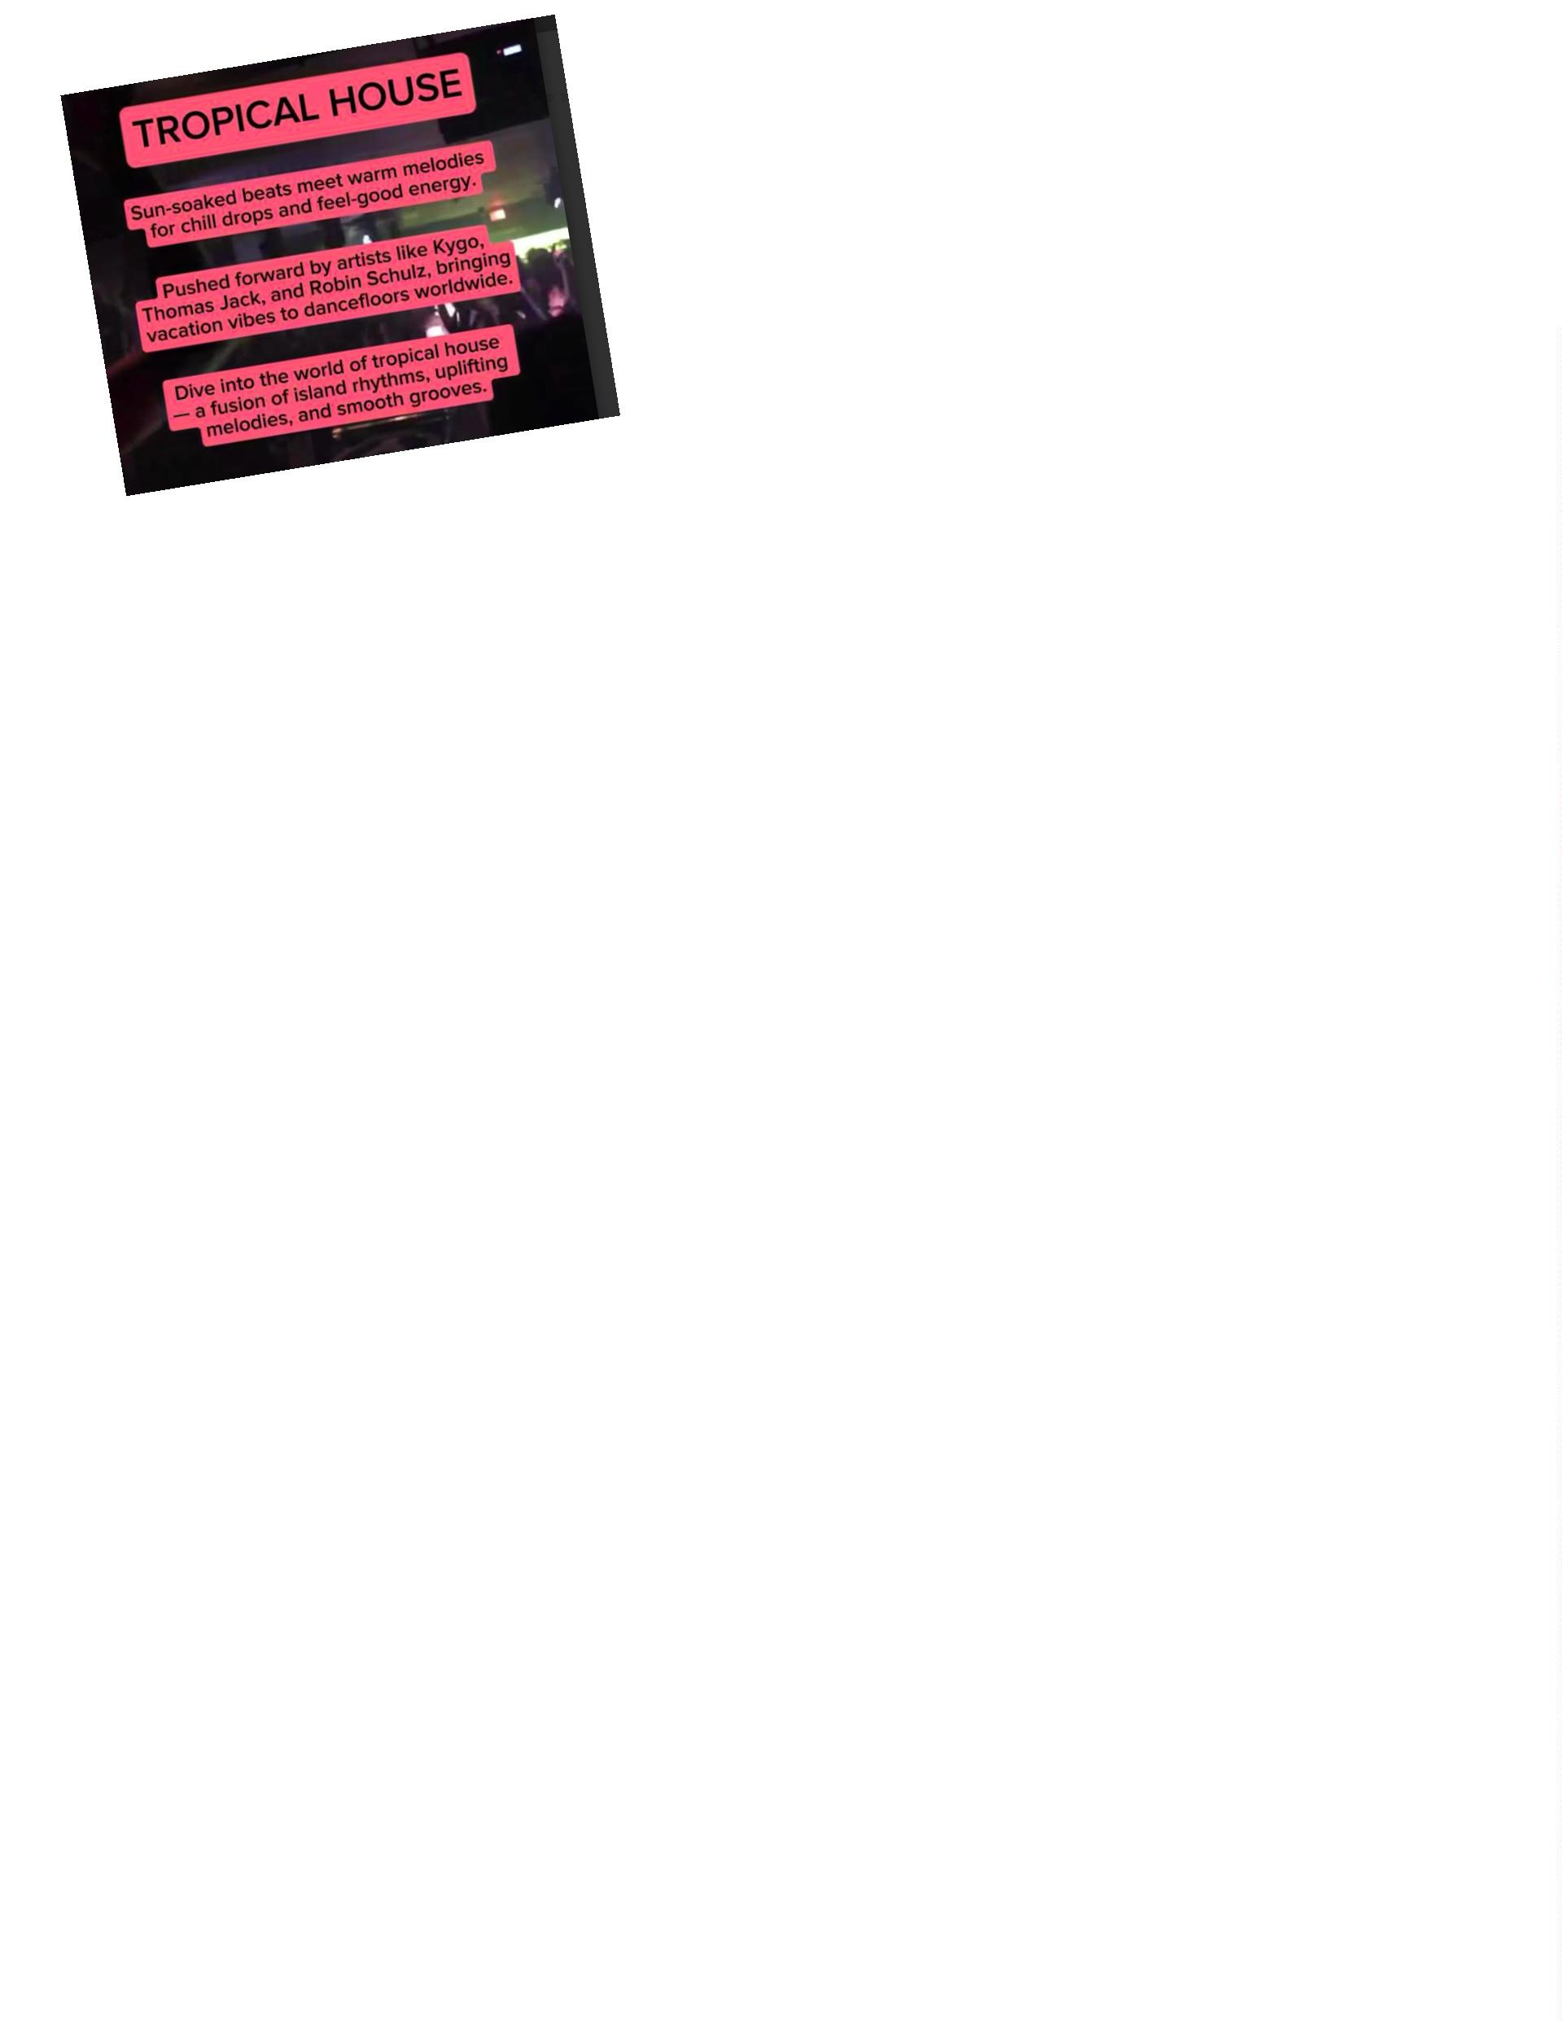

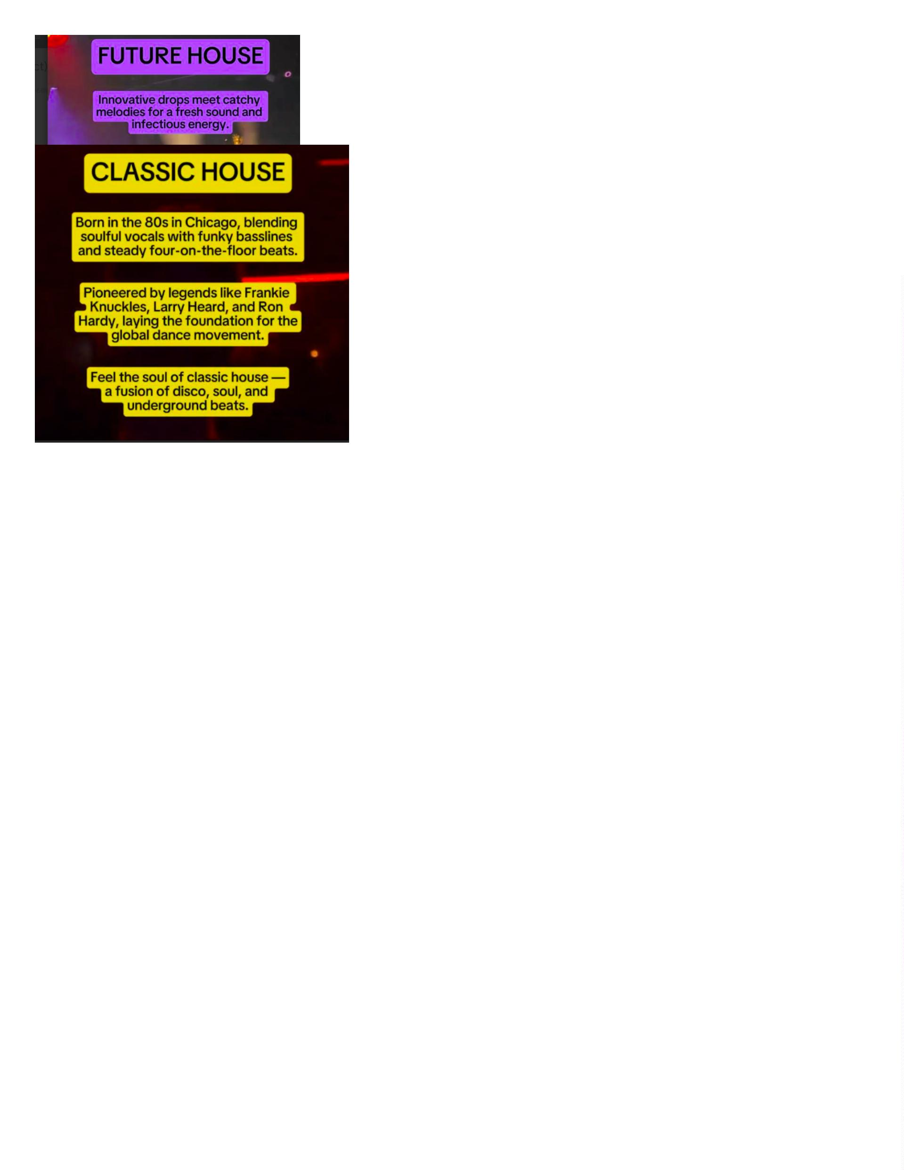

EDM Genre Guide For Deciphering That Festival Lineup
At the beginning of your EDM journey, when the cajoling
beats and addictive noises first take hold, you find yourself on
a musical rollercoaster that you never wanna get off.
This time
This time in your life is undeniably exciting, unforgettable, and lastly,
overwhelming. Once you've accepted the fact that this music
is a huge part of your life now, and that you'll do whatever it
takes to be in front of a stage that's bumpin' these beats, the
The next step is to figure out what genres you like. This is
important, so you can hone in on them and prioritize them.
Whenever you see that vast festival lineup and are unsure
make it to, you can rely on this guide to take you exactly where you
Belong and have the most enjoyable experience possible.

GOING TO FESTIVALS IN 2025
VIDEO KILLED THE FESTIVAL FUN
Don't take videos of your favourite acts. As well as getting stern looks from the people around
you as you block their view with your arm stuck in the air, you'll miss out on seeing them live.
And let's face it, no matter how many megapixels your phone has, it will never beat the cameras
used to broadcast on TV If you want to relive your memories then get someone you know who
isn't going to record it at home, or, if the festival you're attending isn't being broadcast, go on
YouTube and watch some other sucker's video.
Put your phone in your pocket, keep it there and experience the spectacle with your own eyes.
ELECTRIC NIGHTS
As technology is ever-expanding, so is the quantity of gadgets you carry with you on a daily
basis. No matter how naked you feel without certain items, strip yourself of the unnecessary and
when you pack for the festival and try going back to basics-you'll be having such a good time
that you'll forget about them anyway, However, if you can't go without for one weekend, try only
taking the items below:
Phone
Portable phone charger
USD light keyring for when you're trying to find your way back to the font at night)

Headliners Handbook
Our values represent the cornerstone of our own culture.
–
-
Always be a headliner and keep up with the goodness.
Say hello, give high fives, good vibes, dance.
-
Care for one another, look out for your friends, welcome
strangers, be courteous to locals and Also the staff.

HOW TO GET THE PERFECT RAVE BOOTY
1
2
3
4
5
-Get in your underwear.
- Look at yourself in the mirror.
- Tell yourself “ I'm sexy, I love my body, I look good.
- Put on your Rave clothes.
- go out and have Fun.

