FIRST THINGS FIRST

If a monkey hoarded more bananas than it could eat, while most of the other monkeys starved, scientists would study that monkey to figure out what the heck was wrong with it. When humans do it, we put them on the cover of Forbes.
– Nathalie Robin

This is an educational and tactical guidebook for how to negatively impact the mega-wealthy in your everyday life. While this is targeted for Australians many of the ideas and concepts are also applicable to other similar countries.
This book is intended to serve as a resource of ideas and a source of information.
I hope that it may trigger some lifestyle changes or even just support your understanding of the capitalist environment we are all navigating day to day.
This is not a guide on growing wealth. Rather, this is a guide for looking after yourself without adding to the gold swimming pool of the mega rich. It investigates how the system got like this, untangles the lies we’ve been fed, and gives practical advice on living your best life while not contributing to the already stuffed pockets of the 1%.

Warning: Some of the dishes contained in this book are not legal in Australia. Feel free to skip these and we do not endorse or encourage anyone to partake in these dishes. They are merely provided to help contextualise the greater socio-economic environment and to provide some food for thought.

What is Mega-Rich?

I want to be really clear at the outset of what we mean by Mega-rich. This menu is not about punching down, sideways, or slightly up. The Mega-rich have set up the system to make us hate and fight each other to keep us from seeing the real enemy.
We’re talking about the villionaires. The mega super rich dragons of the modern age who hoard wealth and destroy everything to keep and take more without giving anything of value back.
Think of The Hobbit dragon Smaug in the mountain with acres of gold and jewels. Now consider the dwarf party arguing over who has the nicer cup in their backpack. That’s the equivalent between us and them. And you’ll see on the next page that Smaugs’ entire mountain of gold is barely a blip on the real dragons running the world at the moment.
You’ve heard of the 1%, but these guys are barely a fraction of that. They are the 0.00000033% of the 8 billion people on earth (2023) and they control well over half of the world’s assets and wealth.
Ironically, even in our greatest fictional imaginings of wealth we don’t come close to the actual reality of the current mega-wealth around the world.
Fig.1 Fictional vs real rich list 2025
Source: Lottoland Ireland, Forbes Rich List 2025
The Richest site keeps a list of the top 15 wealthiest fictional characters with Jay Gatsby ($1.3 Billion) as the metaphorical and hypothetical poorest, and including the Simpsons Mr Burns ($1.9 Billion), Batman/Bruce Wayne ($11.8 Billion), The Hobbits’ dragon Smaug with his literal mountain of gold ($79.6 Billion) and culminating with Scrooge McDuck – the infamous money-pool diving duck himself with a fictional worth of $82.8 Billion. Compare that to Forbes 2025 list of the wealthiest 500 individuals where Michael Herz sits with a meagre $6.9 Billion and another 499 individuals have more than that. The ridiculously wealthy cartoon Mr Burns wouldn’t even make the list. Marvel’s billionaire hero Tony Stark with his fictional $16 Billion doesn’t make it into the top 150 spots and our fictitious penny-pinching duck king would sit just outside the top 20.
Twenty-one individuals globally now each have more value than the wealthiest fictional character to ever exist. The current richest man, Elon Musk, is reported as having a net worth of 410.8 Billion in June of 2025 (an increase of nearly 17% from the 2025 rich list reporting of 342 Billion in just 6 months) and is predicted to be the world’s first ever Trillionaire. For context, that’s more than the annual GDP of 153 out of 193 countries.
It says something that in all those lists of the richest fictional characters ever, none of them have half as much money as the richest man in the real world.
Like, even our boundless imaginations that have circumscribed infinity think 'nah. nobody could be THAT rich lol.
- @prosinplanet
For many people a million and a billion seem like similarly massive numbers, just a one followed by a lot of zeros.
One of the best explanations I've heard for understanding the massive leap from one million to one billion is to compare it to time.
One million seconds is 11.6 days. One billion seconds is 31.7 years.
The first time I heard this statistic it blew my mind. I had to sit and let it sink in for a minute and I suggest you do the same. A week and a half compared to over 30 years. It’s not even close.
Want to visualise it in cute little piggy banks?
Fig.2 1 BILLION VS 1 MILLION
1 billion | 1 million
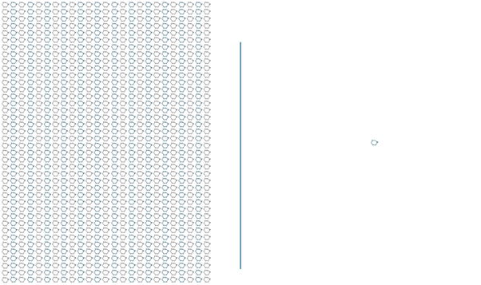
That’s crazy, right?!
Not yet.
The mega-rich are multi billionaires. With HUNDREDS of billions of dollars as their net worth. That’s who the real enemy is. Want to see what that looks like?

Neal.fun have created an interactive ‘game’ called Spend Bill Gates’ Money where you can pretend to buy everything from a $2 Big Mac to a $2,120,000 NBA team and watch how it affects Bill Gates worth.
His worth is a little outdated in the game, set at a nice round $100 billion USD. At the start of 2025 his net worth is reported at $108 billion.

Source: https://neal.fun/spend/
Spoiler; I predict you will get tired of the game before impacting his net worth to any significant amount.

Who are the Mega-rich? People and Corporations

I want to clarify here that I believe no one should be a billionaire. It’s unethical, it's unnecessary and no one achieves that level of wealth without stealing it from others. Many, many others. Modern day slavery is rampant, and these billionaires are the slave owners in our time. The dishes in this menu are designed according to this belief.
But who are these people? Forbes maintains The World’s Real-Time Billionaire list of current global billionaires that you can see online: www.forbes.com/real-time-billionaires
Forbes has been scanning the globe for billionaires since 1987. We found 140 of them that first year. It took two decades for their numbers to swell beyond 1,000. Then there were 2,000 in 2017. Now, eight years later, another milestone: 3,028 entrepreneurs, investors and heirs make up this year’s ranking, 247 more than a year ago. Not only are there more of them, but they’re richer than ever, worth $16.1 trillion in total—up nearly $2 trillion over 2024. The U.S. has a record 902 billionaires, followed by China (516, including Hong Kong) and India (205)
- Forbes.com
That’s a heck of a lot of billionaires. And they’re growing both in number and wealth every year, demonstrating the increasing gap between the haves and the have nots.
Demonstrating this gap, 3,028 people represent only 0.00000031% of the total global population.
That means in a group of a million people (1,000,000), one would have a Billion dollars or more. In that same group statistic, 85,000 would be in what’s considered Extreme Poverty (surviving on less than $2.15 per day) and 440,000 – nearly half – would be on less than $6.85 per day in the Global Poverty bracket. If I was in this group of people I would have some distinct ideas about changes to the distribution of assets!


You’d be familiar with some of the people identified as they double as media personalities (among other less endearing terms) but there’d be others you’ve never heard of. Many of these billionaires are there because they are part of families that have been mega-rich for generations. You may have heard of the Rockefellers, who are worth $10.3 Billion, or the Koch family, with a net worth of 148.5 Billion, or even the Saudi Royal family, with a net worth of $1.4 Trillion? Familial groups of dragons hungry for money and power, accumulating more over decades than any person could reasonably dream of.
And it’s not just families. Much of the wealth disparity and global impact is caused by organisations and boards of shareholders who facilitate each other. The capitalistic ideas of ‘competition’ and a ‘free market’ purportedly protecting the interests of the people have been usurped by the Mega-rich supporting and owning each other. Nearly every market is a monopoly, taking advantage of poorer countries to extract wealth while paying as little as possible.
…the share of national income going to the top 1 percent of earners in G20 countries has increased by 45 percent over the last four decades. During the same period, the top tax rates on their incomes has fallen by roughly a third (from around 60 percent in 1980 to 40 percent in 2022)
- Oxfam, 2024
(Here I’d recommend Naomi Klein’s groundbreaking book ‘No Logo’ for an in-depth take on how these companies do just this.)
For example, Unilever is a mega corporation that owns thousands of brands purporting to be in competition with each other:

Fig.4 Unilever Owned Brands
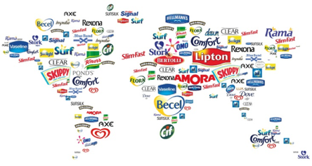
Source: ResearchGate, Some products of Unilever
If you’ve ever found yourself trying to decide between Ben and Jerries or Streets ice cream or arguing over whether Rexona or AXE are the more ethical companies – it doesn’t matter. Your consumer dollars are going to the same mega corp. The illusion of choice provided to us every day helps to grow consumer loyalty and makes us feel like we oversee our choices but from an economic standpoint it’s all just window dressing.
In a similar example of rampant monopoly, just 10 companies own most of the food brands in the world.
Fig.5 10 Corporations That Control Almost Everything You Buy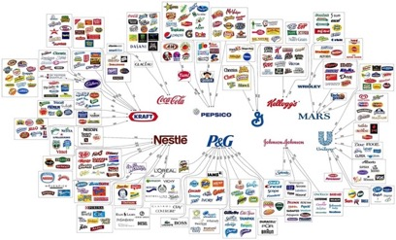
Source: r/infographics, brods_brods; Brands: The illusion of choice
With revenues to match below – tens or even hundreds of billions of dollars received each year.
Fig.6 Top publicly traded food companies by revenue
Rank | Name | Revenue 2023
1 | JBS | $281,879,729,981
2 | Nestle | $111,031,817,679
3 | Ahold Delhaize | $96,120,636,268
4 | Archer Daniels Midland (ADM) | $91,710,000,000
5 | PepsiCo | $91,471,000,000
6 | Sysco | $78,016,112,000
7 | Unilever | $58,202,215,428
8 | Performance Food Group | $57,957,200,000
9 | Bunge | $57,629,000,000
10 | Tyson Foods | $52,879,000,000
11 | Coca-Cola | $45,800,000,000
12 | George Weston | $45,248,451,813
13 | Wilmar International | $42,640,519,000
14 | Compass Group | $37,844,839,573
15 | Mondelez | $36,140,000,000
Source: Top publicly traded food companies by revenue, 2024
But what about beyond the food industries? What about the rest of the economy?
It’s even worse there. Industries such as oil, technology and, of course, banking make the billions of dollars in revenue listed above look like child’s play. They operate at a level of profit that small countries dream of.
According to the latest data on the world’s wealthiest companies by earnings, the majority of the companies making up the Top10 list generate hundreds of billions of dollars in annual profit. Note – PROFIT not revenue. This is what they keep for shareholders after they’ve paid all their expenses.

Fig.7 World Companies Ranked By Earnings
Rank | Company Name | Annual Profit
1 | Saudi Aramco | $230,483,000,000
2 | Apple | $120,004,000,000
3 | Microsoft | $105,264,000,000
4 | Alphabet (Google) | $101,821,000,000
5 | Berkshire Hathaway | $96,221,000,000
6 | JPMorgan Chase | $62,938,000,000
7 | ICBC | $58,252,500,000
8 | Meta Platforms (Facebook) | $54,821,000,000
9 | China Construction Bank | $53,917,300,000
10 | Amazon | $49,424,000,000
Source: Companies Ranked By Earnings, 2024
If you’re interested, this list continues down to another 1,261 companies around the world that make more than a billion dollars profit every year.
Perhaps you’re thinking, so what? There are giant companies that make lots of different products – it’s probably more efficient, it means things are available more often, they employ millions of people around the world, I love having all the choices available to me…
The key word here is MONOPOLY. We all heard monopolies are bad and are illegal to maintain in Australia, but…why exactly?
Firstly, they inhibit competition – smaller businesses don’t stand a chance against the buying power of larger companies. Giants like Woolworths and Coles can afford to lose money on key products by continually lowering the price until a smaller competitor is forced out of business. Then, once there is no competition, they can charge what they like as people don’t have a choice of where to buy it.
This prevention of competition also stifles innovation – there’s no desire to risk time and effort on creating new and better products and services when you own the market. More providers in any space means they need to be more efficient, more creative and come up with better products to continually improve over their competition. It’s a capitalistic form of natural selection – those that don’t adapt and innovate, die.
But when there’s no competition, companies don’t need to improve meaning that we end up with the same old offerings and processes year on year.
In Australia, we have a number of duopolies: Woolworths and Coles. Qantas and Virgin. Carlton United Breweries and Lion Nathan. While technically these markets are not controlled by a monopoly, the existence of two giants doesn’t create the high competition environment required to create a fair market and maintain prices to a reasonable level.
Rob Nicholls, an associate professor of Regulation and Governance at the UNSW Business School explains, “The joy of competition is that in order to compete, businesses have to either reduce prices to offer a better deal than their competitor, or improve their product or services in some way, to do better than their competitor. From an economic perspective, you expect healthy competition to drive costs down to the marginal cost of production, including a normal rate of return. That is, the businesses will make a normal profit but not a supernormal profit, because their prices or services are constrained by other players in the market.”
The reason we’ve seen a slowdown in productivity in Australia is because we’re seeing a lack of competition in the Australian economy,” Grudnoff said, arguing that Australia has come to be dominated by oligopolies.
“If you’re a big oligopoly, all you’re really interested in doing is managing, and making sure to keep your shareholders happy as your profit slowly grows.
– Matt Grudnoff

Monopolies also affect supply chains negatively, as we saw with the milk pricing war of 2011. Coles, followed by Woolworths and then Aldi, offered $1 milk to try and entice customers away from the other supermarkets. They put pressure on their suppliers to provide the bottled milk as cheaply as possible to minimise their losses, and suppliers had little choice but to accept to keep their valuable contracts. This in turn flowed down to the farmers, who then received less income for the same amount of product.
The price of milk was kept artificially low (artificial pricing means a price that has been manipulated or distorted until it no longer aligns with the true cost to produce that product or the usual impact of supply and demand) for nearly a decade until mid 2019. During this time the number of Australian dairy farms in operation fell from 6,883 to 5,213, a decrease of nearly 25% in just 8 years.

Fig.8 Number of Registered Dairy Farms Australia
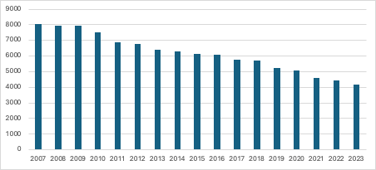
Source: Dairy Australia, 2023
Being able to offer a product at below cost, then pushing that loss onto smaller providers and farmers without seeing any impact or loss of profits is another bullying technique that makes mono and duopolies so detrimental to society.
In an ideal economic state, the laws of supply and demand ensure that prices and quality are kept to a ‘fair market price’ by increasing and decreasing with the number of consumers and competitors. Once a monopoly is formed, this no longer applies as consumers have no choice and the providers have no incentive to maintain quality or innovate and can use their larger buying power to bully smaller suppliers.
Finally, fewer providers create supply chain issues and single point dependencies. If Qantas is the only one flying to a certain destination and they suddenly decide not to, or something happens that means they can’t, then there’s no alternative provider to cover the gap. Everything hinges on the one supplier, making for a risky market environment.
The larger a corporation becomes, the more ways it negatively impacts the world around it.
Too many corporations… engage in elaborate practices of tax avoidance and even illegal tax evasion. They bend and break laws, or pressurize politicians to change the rules for their commercial advantage. They pursue monopolistic control of the markets they operate in and engage in vicious price gouging. They pay workers as little as possible, lobbying against fair wages and moving operations around the world to get the cheapest labour possible.
– Carl Rhodes, Woke Capitalism, 2022

But let’s return to the mega corporations making billions of dollars profit every year. That list of 1,281 companies around the world that make more than a billion dollars profit every year can be added to the 2,540 individuals with more than a billion in net worth. But we know those lists crossover. And that’s where it gets even messier as these individual companies aren’t really individual. All of them are publicly listed and are managed by a group of shareholders with an overarching board. Which leads us to…

Investment Funds

Investment funds are pools of money from groups of people to buy investments, sharing the risk and the reward. These have immense buying power and control most of the world’s assets as the collective wealth of many people or companies is much greater than any individual alone.

The largest 30 shareholders (out of more than 2,100 share controllers) owned or controlled some 51.4% of the assets of the 299 companies. This is a significant concentration of resources and power – 1.5% of shareholders controlling 51% of shares.
- Edward Munoz/Reuters

To further compound this funnelling of assets, the majority of these companies’ shares are owned by just a few investment funds. Blackrock, Vanguard, and State Street (called The Big Three in the industry), own shares in all the companies listed previously. Together they constitute the largest shareholder concentration in 88 - 90% of S&P 500 firms.
Even more troubling, the biggest investors in these funds are other large funds. Which means most of the dots in the below graphic are more like babushka dolls, all nesting within each other.

Fig.9 Network of ownership and control by the Big Three in listed U.S. firms
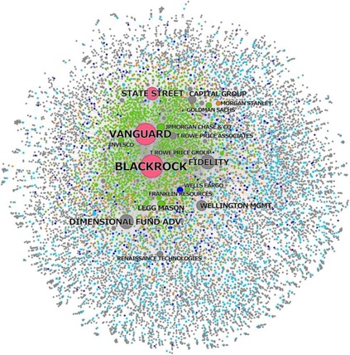
Source: Fichtner J, 2017
Consider the investor ownership stats from 2023 of inter-fund overlap as shown in Fig.10 below:
Fig.10 Investor Ownership Between Key Funds
 | Blackrock | State Street | Vanguard
Blackrock |  | 4.21% | 8.62%
State Street | 8.23% |  | 10.29%
Vanguard | 14.24% | 3.9%

These numbers may seem small, but they represent the largest shareholders of the most powerful groups in the world. That’s not competition. That’s a monopoly. The group of people, companies and investment funds managing the decisions around the world gets smaller and smaller the higher you go and it’s far worse than they want it to appear.
As of the first quarter of 2024, the New York City-based asset management company BlackRock had total assets under management (AUM) of around 10.5 trillion U.S. dollars. This compares to 8.59 trillion U.S. dollars of AUM as of 2022.
- Statista

I don’t share all of this to make you despair at your own tiny insignificance. Rather, I want you to be freed by this. You are free from the ethical responsibilities of the usual rules because the mega rich are not playing by them, and you cannot do more damage to these dragons than they are doing to the world and our communities.

Be brave. Take action. Be free.

We live in capitalism, its power seems inescapable — but then, so did the divine right of kings. Any human power can be resisted and changed by human beings. Resistance and change often begin in art. Very often in our art, the art of words.
- Ursula K. Le Guin

Why are we eating the Mega Rich?
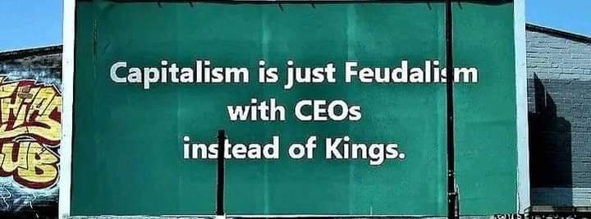
So why do we care if some people have so much wealth? If we’re never going to affect them or become mega rich, why should I do anything?
Because they are evil.
Yes, they are. Every. Single. One.
Each and every day they have the option to end homelessness, hunger, to improve the environment, reduce the cost of living, build better infrastructure or help foster kids or a million other major societal improvements that are widely known to be wanting and effective.
And every day they choose not to.

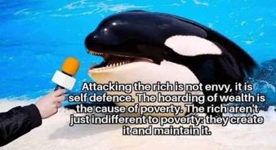
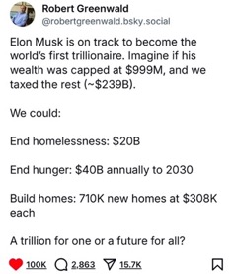
These problems that are often presented as individual social failings and impossible to actually solve are actually neither.
Homelessness is an issue in every country of the world and can be caused by any number of reasons including loss of employment, domestic violence, landlord or family issues. Regardless of the reason, housing should be available for every person as a right, not a luxury. And Finland has shown that solving the problem is possible. Over 30 years between 1989 to 2020, they decreased homelessness by 75%, the greatest improvement of any country. How? Simply by making homes available. No conditions, no catches. Solving homelessness requires homes.
While this sounds impossibly expensive, for a billionaire it’s barely pocket change. Solving homelessness in Finland cost €250 million ($413 million AUD). That’s just 0.15% of Elon Musks’ net worth.
The Australian Government department of Social Services estimated that total homelessness services cost about $6.3 billion in 2022-2023 and this figure is growing by approx. 1.7% each year. Research and Australian think tank B Corp, SGS Economics and Planning, released a report called Give Me Shelter in 2022 that delivered a cost-benefit report for housing all Australians.
Across 30 years, the Commonwealth’s estimated budget savings (from improved health outcomes, reduced crime and domestic violence) would surpass its outlays in meeting projected social and affordable housing needs. This saving is estimated at $3.5 billion in present value.
- Give Me Shelter, 2022
So not only is providing homes for everyone good ethically, it’s also good fiscally and for the community. Yet billionaires will have you believe that it’s impossible to fix and not their responsibility.
Fig.11 Estimated Fiscal Impacts - Commonwealth Government
Cost Category | Net Present Value (NPV)
Total government outlays | $27,471,206,341
Total savings to government budgets | $30,989,492,638
Difference (NPV) | $3,518,286,297
Source: SGS Economics and Planning (2021)
About 9 million people die from hunger and hunger-related diseases each year, which is equivalent to about 25,000 people per day. This is more than the number of people who die from AIDS, malaria, and tuberculosis combined. At the same time nearly one third of food produced globally- 1.3 billion tons - is wasted rather than eaten.
We produce enough food to feed 1.5x the global population. That's enough to feed 10 billion yet we are at just over 7 billion currently. There is enough for everyone.
The problem is our food systems – the way we produce, harvest, transport, process, market and consume food.
- Gabriel Ferrero, Spain’s Ambassador at Large for Global Food Security
Some of the biggest causes of starvation and extreme hunger are conflict, climate change and economic shocks - all of which are money makers for the world's wealthiest individuals and companies. The death toll of these catalysts are irrelevant to them in their pursuit of more and more money.
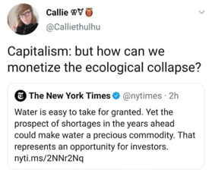
Oxfam reported in 2022 that around $37 billion is needed each year for the next eight years to tackle both extreme and chronic hunger. While that sounds huge, and it is, Amazon owner Jeff Bezos’ net worth grew by $70 billion between 2023 and 2024. That’s one man, in one year, able to fund two years of eradicating hunger with his growth alone without even touching his existing $100 billion gold pile.
If we wanted to share the responsibility, the 2,781 billionaires on the Forbes 2024 Rich List would collectively have to donate just 0.002% of their wealth to completely eradicate global hunger. That’s the equivalent of an average Australian paying $14.60 to end world hunger, forever. And they don’t do it.
The interesting thing about capitalism is that it’s entirely incompatible with the future, so we’ve just decided to get rid of the future and keep capitalism for a while.
- @ecomarxi
Climate Change and Global Warming is literally killing the planet, destroying the only place humans have to live for future generations. Choosing profit over the survival of our species is both diabolically evil and clinically insane. UK-based thinktank InfluenceMap conducted a study in 2018 and found that: of the fifty most influential businesses worldwide, 35 “are actively lobbying against climate policy” while the other “15 of the 50 most influential are pushing for an ambitious climate policy agenda, favouring renewable power and electric vehicles” (InfluenceMap, 2017). These companies are shown on the graphic below.

Fig.12 How strongly companies support or oppose climate policies and how intensely they lobby on them
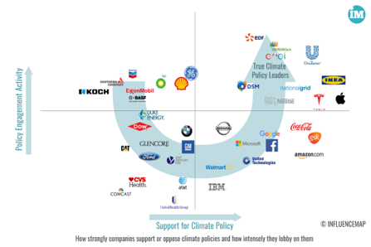
Source: influencemap
Reminder that 100 corporations are responsible for 71% of global greenhouse gas emissions and presenting the crisis as a moral failing on the part of the individual without noting this fact is journalistic malpractice.
- @adamjohnsonNYC
Fig.13 Global Emissions by sector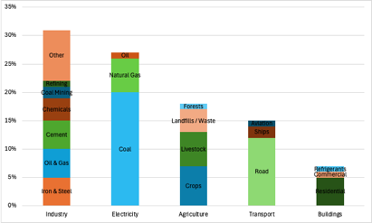
Source: Rhodium Group
West Coast Environmental Law has been pushing for a polluter pays principle since 2018; “The polluter pays principle – the idea that those who profit from pollution should pay for the harm it causes – is at its core both common sense and good economic theory. In complicated situations like climate change, the solution may involve many different actors being held accountable, but it’s certainly not acceptable for those who profit most to not pay anything.”
And that’s just current behaviour. To become billionaires, they had to take the fair wages and remuneration of thousands if not millions of people, for years upon years. To be a billionaire is to be selfish beyond the pathological.
Because unlike Smaug, these wealth-hoarding dragons don’t just sit quietly in their caves.
They own the media, controlling the narrative and focus of news, TV shows, radio programs, newspapers and magazines. The mining rights and the renewable energy patents.
The flight paths and transport systems.
Pharmaceutical companies and the beauty industry.
They profit off war and disease and suffering, encouraging conflict and disasters.
Shareholders of the world’s top five oil and gas companies saw record profits of €192 billion ($209 billion) from the war in Ukraine.
They manipulate governments and political parties, squashing policies and writing laws to suit themselves.
In the most recent US election Twitter owner Elon Musk donated nearly $120 million dollars to supporting Trump, an investment that paid off as shares for Tesla rose by more than $13 billion the day Trump was elected. The rich look after their own, for their own benefit.
They dictate and control not only the entire messaging systems of our species, but, by extension, the opportunities of the human race. What we see, do, and have, where we go, who we think we are, and what the future looks like.
Even if you can’t impact them directly, removing yourself from their monopolised, force-fed narrative is likely to be beneficial for your quality of life, your mental health, your sense of worth, and quite possibly even the future of our planet.
A major airline company is producing planes with less and less regard for safety and it’s starting to get noticeable. Man takes them to court which would reduce profit at the cost of public safety. He fucking dies the night that Boeing’s legal team asks him to stay an extra day. If nothing happens about this, I hope it gets through to people that corporations will literally murder you to save a few extra cents.
- @youcantsayitstrue
Do it for you, because you deserve it. Eat the rich.

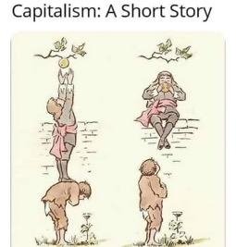

Impacts of the Mega Rich

Studies have shown that the more wealth an individual accumulates, the less empathetic and self-aware they become. A 2012 UC Berkeley study found that drivers of luxury cars were four times less likely to stop and allow pedestrians the right of way than those in less expensive vehicles. They were also more likely to cut off other drivers.
Another study suggested that merely thinking about money could lead to unethical behaviour. Researchers from Harvard and the University of Utah found in 2013 that study participants were more likely to lie or behave immorally after simply being exposed to money-related words.
Berkeley psychologists Paul Piff and Dacher Keltner ran several studies on how social class predicts increased unethical behaviour in 2012.
In one, participants were asked to watch two videos while having their heart rate monitored. One video showed somebody explaining how to build a patio. The other showed children who were suffering from cancer.
After watching the videos, participants indicated how much compassion they felt while watching either video. Social class was measured by asking participants questions about their family’s level of income and education.
The results of the study showed that participants on the lower end of the spectrum, with less income and education, were more likely to report feeling compassion while watching the video of the cancer patients. In addition, their heart rates slowed down while watching the cancer video—a response that is associated with paying greater attention to the feelings and motivations of others.
In a 2012 article titled Why the Rich Are Less Ethical: They See Greed as Good, Maia Szalavitz writes:
“In one study, participants reported their own socio-economic status and then read descriptions of people stealing or benefiting from things to which they were not entitled. When asked how likely they would be to engage in similar behaviour, the richest of 105 undergraduates were more likely admit that they would do so, compared with those from middle-class or lower-class backgrounds.
Of course, this finding could simply reflect the fact that the rich are more likely to get away with such things – and therefore may feel more comfortable admitting it – so the researchers also studied actual behaviour.
In the next experiment, researchers asked 129 students to compare themselves with those who were either far richer or far poorer than they were. Previous studies have found that this manipulation influences people’s perceptions of class and their own behaviour, with those primed to feel wealthy behaving less generously and becoming less sensitive to the emotions of others, regardless of their actual socio-economic class.
The participants were then offered candy from a jar that they were told would otherwise be given to children in another lab. Those primed to feel rich took more candy than those who were made to feel disadvantaged.”
Experiments like this showcase what can be easily seen around us – the wealthier someone is, the less they care about others and the more likely they are to see every situation as being a competition – if you win they lose and vice-versa as opposed to finding mutually beneficial outcomes.
The free-market mythology argues that the most ruthless, selfish, opportunistic, greedy, calculating plunderers applying the most heartless measures in cold blooded pursuit of corporate interests… will produce the best results for all of us.
- Micheal Parenti

This is also demonstrated by the 1968 article by Garrett Hardin titled the Tragedy of the Commons which argues that any group of people with equal access to a finite resource such as water, pasture lands or hunting grounds will inevitably compete with each other until nothing is left. His premise is that people are selfish and will always try to take as much as possible, acting in their own interests over the interests of the community.
Hardin's Tragedy of the Commons paper has been widely discounted by anthropologists and historians including Simon Fairlie who in 2009 referred to the article as “a travesty of historical interpretation, carried out by a theorist with a pet idea, who knew little about the subject he was writing about.”
Also disproving this theory that common property cannot be equitably shared by a population is the thousands of years and thousands of examples of indigenous populations carefully curating and living on lands without depleting resources. These communities develop over long time periods and have complex rules and systems.
Hardin himself retracted his original thesis in the early 1990’s in the face of a barrage of evidence of both historical and existing commons but by then the damage was done.
This idea that no area could be fairly managed by a community was music to the ears of capitalists who pounced on the article and used it to gradually eradicate the free access and use of shared communal assets until we arrive at the heavily profitable use of every resource, ironically with no consideration of sustainability.
This rise in capitalism and eradication of free access to resources has been steadily growing worldwide since the industrial revolution in the 1760’s. Greater production efficiencies allowed for the few to profit from the many in a way not previously possible, and the wealth gap began to grow.

Oxfam put together an amazing article outlining the impact of the mega rich during Covid that included
- The world’s small elite of 2,755 billionaires fortunes grew more during Covid-19 than in the previous fourteen years combined
- The wealth of the 10 richest men doubled, while the income of 99% of humanity decreased
- Every day inequality contributes to the deaths of at least 21,3000 people, approx. one person every 4 seconds
- Twenty of the richest billionaires are estimated to be emitting as much as 8,000 times more carbon than the billion poorest people
- Hunger kills over 2.1 million people each year
- By 2030, the climate crisis is predicted to kill 231,000 people per year in poor countries
Source: https://www.oxfam.org/en/5-shocking-facts-about-extreme-global-inequality-and-how-even-it

Where is the money?
Money, pardon the expression, is like manure. It’s not worth a thing unless it’s spread around, encouraging young things to grow.
- Dolly Levi, Hello Dolly
First, let’s try and understand how much wealth there actually is in the world.
Fig.19 World Economy Visualised
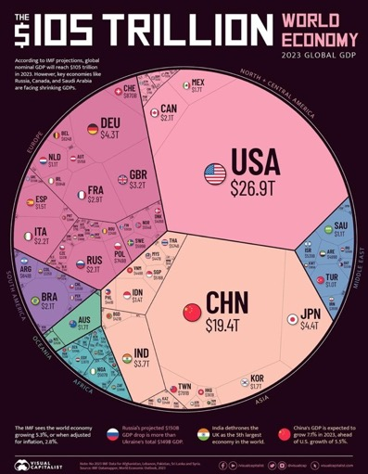
Source: https://www.visualcapitalist.com/visualizing-the-105-trillion-world-economy-in-one-chart/
The International Monetary Fund (IMF) is a global organization that works to achieve sustainable growth and prosperity for all of its 190 member countries. It projected the global economy to reach nearly US$105 trillion in value by the end of 2023.
Gross Domestic Product (GDP) measures the total value of economic output – goods and services – produced within a given time frame by both the private and public sectors.
Now that we have a visualisation of the total economic value, let’s break it down to understand what that looks like in more detail.
Fig.20 Comparing the world's money markets (billions)
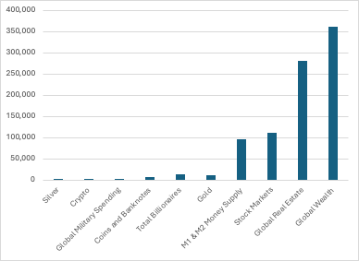
Source: Visual Capitalist, 2020
But that doesn’t include the amount of goods and services and investments operating on borrowed money.
In June 2022 the total amount that governments, households and corporations around the world owed was THREE HUNDRED TRILLION DOLLARS!
Let’s see that in numbers:
$300,000,000,000,000.
That’s a lot more than the global money supply, currently sitting at around $95 trillion.
As you can see below, the US is far and above the biggest offender in this global debt game, but the rest of the world aren’t playing small fry either:
Country/Region | External Debt (US Dollars)
United States | 31 trillion
United Kingdom | 8.73 trillion
France | 7.04 trillion
Germany | 6.46 trillion
Japan | 4.36 trillion
China | 2.64 trillion
Italy | 2.51 trillion
Spain | 2.26 trillion
Canada | 3.2 trillion
Australia | 1.83 trillion

Source: https://en.wikipedia.org/wiki/List_of_countries_by_external_debt
Aggregate global wealth totalled USD $463.6 trillion at the end of the year, a rise of USD 41.5 trillion or 9.8%.
- Global Wealth Report 2022

Any debt means interest repayments. Someone is borrowing and paying interest on the loan to someone else, similar to a mortgage or a credit card but on a much larger scale

The National Debt is owed to the financial markets who lend credit, which they create themselves. In addition, they use the "gilt-edged" status of the Government bonds as security to create up to 9 times more credit which they lend to others such as the public and businesses.
- Guardian.co.uk, 2011

According to the International Monetary Fund’s 2014 article; The Trillion Dollar Question: Who Owns Emerging Market Government Debt “…half a trillion dollars in foreign investment poured into emerging market government bonds from 2010 until 2012 alone, most of it from foreign financial institutions that aren’t banks (large institutional investors, hedge funds, sovereign wealth funds). These investors held about $800 billion of the debt – 80 percent of the total – at end-2012.”

Fig.21 Visualizing Who Holds U.S. Debt Internationally
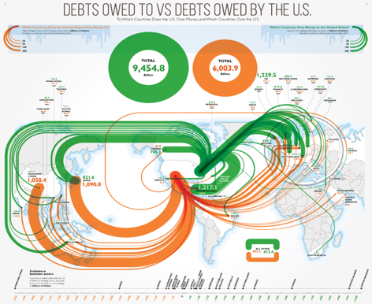
Source: Visual Capitalist, 2017
What this translates to is that while it appears that countries are loaning to each other, mostly hedge funds are being used to facilitate these loans and manage the mind-boggling values being borrowed and the accompanying interest. Hedge funds such as Blackrock, Vanguard and State Street in particular.
The amount of debt being created and loaned is increasing rapidly. Mckinsey Global Institute’s 2021 report, ‘The rise and rise of the global balance sheet: How productively are we using our wealth?’ emphasised that
For each $1 of new investment, almost $2 in debt, or about $4 in total liabilities including debt, were created between 2000 and 2020.
- McKinsey Global Institute, 2021

The report went on to point out that this raises questions about capital allocation, the purposeful creation of debt and the sustainability of this practice. Borrowing far and above the existing value of assets is a common practice for the wealthy to accumulate property, shares or businesses and then turn around and claim no responsibility for the ensuing debt.

Where do they keep their money?

Two-thirds of global net worth is stored in real estate and only about 20 percent in other fixed assets, raising questions about whether societies store their wealth productively.
–Money Matters, Kamran Hafeez, 2022

Ideas of the mega-wealthy utilising offshore Cayman Island bank accounts and Ocean Eleven style vaults loaded with pallets of cash aren’t the stock holds of wealth that we poors imagine. Rather the wealth is allocated, or loaned, to a complex combination of hedge funds, equity and bond platforms as well as commodities or real estate. While the mega wealthy do have access to many things that we don’t, and with their financial privilege comes a raft of other trade secrets and behind closed door deals, most of them keep their money in the same investment funds and private equity funds that are available to anyone above a certain income bracket, not just billionaires.
Fig.22 Investments of the Ultra Wealthy (avg. proportion of total wealth)
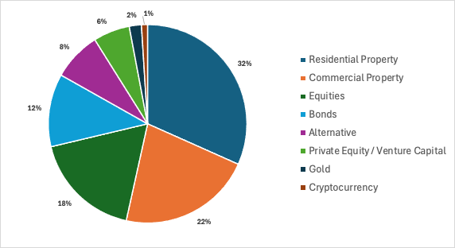
Source: Visual Capitalist, Visualizing the Investments of the Ultra-Wealthy, 2023
Studies indicate that many of them keep cash reserves as security against market downturns or fluctuations, or in investments that are considered as safe as cash such as money market mutual funds, certificates of deposit or Treasury bills.
Real estate is also a popular vehicle for asset allocation. While you or I may look at real estate for secure housing and long term stability, the mega wealthy accumulate enormous portfolios of residential and commercial real estate, managed by property managers, including office buildings, hotels, stadiums etc. This is seen as a great passive income and a long term investment strategy and real estate agents will often contact wealthy buyers with pre-market offers and special deals, allowing them even more of an advantage to you or I.
Aside from these, the mega wealthy are on the whole frugal and risk averse and prefer to keep their money in traditional stocks or stock funds, private equity or hedge funds, or commodities like gold, silver, mineral rights or cattle. While many of these funds and investment vehicles are open to the public, the scale at which the mega wealthy invest in them means that they are actually directing and influencing the market that they are buying into. It’s less playing the game and more driving the flow of money.
If the total value of a given industry or market is $1 billion dollars, then average investors moving around hundreds or even thousands of dollars as they buy and sell doesn’t move the graph enough to influence other investors.
But the mega wealthy can put millions or billions into that same industry, completely transforming the trends and natural balance of the market. This is like a football game where one player can physically move the goalposts or psychically control the ball. It’s not a fair game when one player has so much more control than everyone else trying to play.

Wealth inequality; an analogy

Drive through the winding hinterland backroads behind the Sunshine Coast or northern NSW and you’ll often see farm gate stalls offering fresh, seasonal avocados, mangoes, potatoes, and a plethora of other produce. They’ll have scraps of cardboard with hand drawn chunky texta-font prices, cheaper than any established stores, alongside a chained down can, or a welded pipe with a gap, for money.
The farm gate concept works because (most) people are, on the whole, good. They are honest, well meaning, respectful, and inherently try to do the right thing.
However, a few people would see farm gate stalls as opportunities to profit without having to work. They would tell you that they’ve discovered an opportunity that everyone else missed. That they’re smarter, and everyone else is obviously a dumb sucker. These individuals take the produce and set up their own farm gate stall. In reality, this would mean the farm gate stopped being stocked in short order but stay with me for the analogy.
For hundreds of years a privileged number of individuals stole all the produce and sold it for their own profit, forcing the farmers to continue to pointlessly lay out their own produce only for it to be taken.
After outright profiteering from others’ labour (slavery) was physically overturned, capitalists had to actually engage the farmers on fairer terms. In theory.
However, the situation had changed. The farmers couldn’t simply continue to put their produce out on the farm gate stalls for passing traffic; the ‘savvy’ capitalists had diverted the roads, spread misinformation about farm gate stalls, and trained the passing traffic to expect a convenient range of goods in a single location.
This meant the providers (farmers and manufacturers) had to negotiate with their former tormentors on an uneven playing field.
So, the deal offered to the farmers by those who had been stealing their produce amounts to, ‘We’ll build an amazing stall and give you a cut of the sales, however we’re used to this being free so we’re going to offer as little as possible.
Remember, these are the same people that stole the produce, and congratulated themselves for being smart, when everyone else respected the honour system. They can’t conceive of a situation with mutual benefit, just winners and losers. In their minds it’s them versus you and there can only be one winner. It’s a negative sum game that hurts everyone.
So now we have a situation where an oppressed group, with generations of trauma but all the skills for production, must negotiate with a group that holds the power (financially, resource wise, and socially), and believe that they hold the power because they are smarter, work harder and have ‘earnt it’ despite having no skills other than bullying and generational privilege

Australian Income Inequality

In Australia, someone in the highest 20% of the income scale lives in a household with almost 12 times as much income as someone in the lowest 20% of the income scale. People in the highest 20% of the wealth scale hold nearly two-thirds of all wealth (62%), while those in the lowest 60% hold less than 1% of all wealth (0.9%).
Fig.23 Australian Income and Wealth Distribution
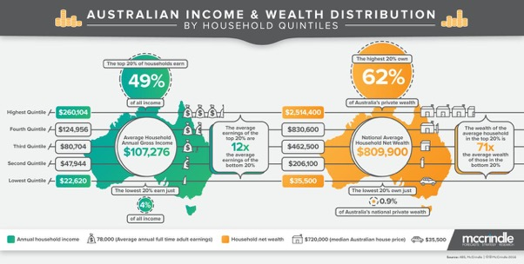Source: https://www.linkedin.com/pulse/australias-household-income-wealth-distribution-mark-mccrindle/
Beginning in the 1970s, income disparities began to widen, with income growing much faster at the top of the ladder than in the middle or bottom. Household (as opposed to family) income data, which are available only since 1967, show a similar pattern of widening inequality and scant growth in median income and income at the 20th percentile following the 1999 and 2007 business cycle peaks.
The benefits of economic growth in Australia have been going more towards the top 10% since the 1950’s as you can see below:

Fig.24 Per adult real economic growth: Share of growth (%) going to the top 10% and bottom 90%
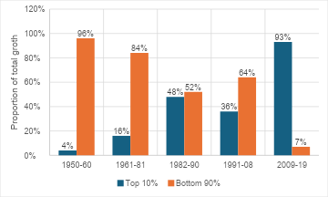
Source: Australian Institute, Inequality on Steroids: Distribution of economic growth in Australia, 2023
Data from over 70,000 companies in 134 countries over four decades shows that the global average markup – the ratio of price to cost – rose from 7% above costs in 1980 to 59% above costs in 2020.
- Oxfam, Inequality Inc publication, 2024

That phrase in the previous quote – ‘above costs’ – doesn’t just mean that corporations are charging more for goods, they are also squeezing suppliers and paying staff less.
Markup growth from just 7% to 59% doesn’t happen through savvy business practices, it’s a determined effort to charge as much as possible, remove competitors and quality control measures while simultaneously outsourcing manufacturing to the lowest bidder and lobbying against minimum wages, standard working conditions and local impacts. It negatively impacts our health, our safety, our communities, our environment and our quality of life. The only one who benefits from this is billionaires.
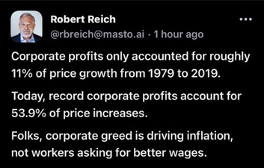
The Organisation for Economic Co-operation and Development (OECD) reports on wealth and income inequality for each of 34 included countries as an indicator of community wellbeing. Between 2012 and 2018 Australia was showing gradual improvement towards more equality however once Covid started in 2020, we dropped sharply in the rankings with 2024 predicted to decrease even further.
Fig.25 Relative Position for OECD Gini Coefficient rankings on wealth and income inequality:
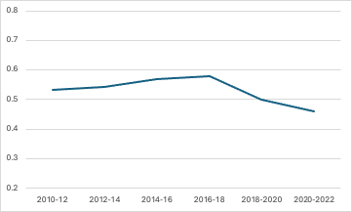
Source: The Organisation for Economic Co-operation and Development (OECD)
This trend shows that the top earners and those with the greatest wealth accumulations in Australia are accumulating more and receiving more in remuneration than those in lower income brackets, and that this disparity is increasing rather than balancing out.
The graphic below shows the distribution of wealth compared to the adult population of the world:
Fig.26 Distribution of Global Wealth
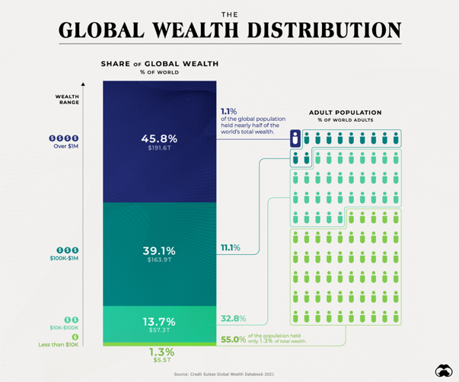
Source: visualcapitalist.com, 2021
I want you to focus on the bottom stat for a moment; 55% of the world's population (4.51 Billion people) hold just 1.3% of the global wealth - $5,500,000,000,000
And, perversely, on the other end of the scale just 1.1% of humanity (9 Million people) have 45.8% of all world wealth - $191,600,000,000,000.
That’s such a wildly uneven playing field that in any other scenario it would be insane. Imagine a soccer match where one team has 45 people and the other has one. Or a house where one family gets 45 rooms and the other family gets just one. It’s absurd. And the inequality just keeps growing.
Fortunately, in Australia we tend to fall in the category of wealthier countries and the spread between the richest and poorest demographics does not have the enormous spread of other countries. That said, the gap between our top and bottom wealthiest households is still significant.
The wealth of the highest quintile households, on average, is 92 times that of the lowest quintile households.
- Mccrindle, Australia’s household income and wealth distribution

Cost of Living Generally
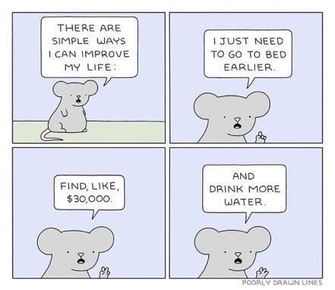
Source: @poorlydrawnlines
Open any newspaper (lol) at the moment and you’ll see the phrase ‘cost of living crisis’. A quick google search for News in mid-February 2024 delivered up 5 pages of results including this cartoon on the Independent Australia site:
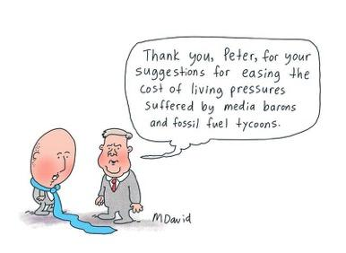
But where is this coming from? Why does everything feel so much more expensive? Are we just whinging or is it really getting harder?
I’m here to tell you now: things are getting more expensive faster than they have before, and we are being paid less. Things are getting harder.
Housing, food prices, fuel, utilities, clothing, entertainment… everything has risen sharply in price over the last few years except income.
Looking at this graph developed by The Guardian using ABS data of the inflation rate growth of various commodities over the last 10 years and you can see the steadily rising increase in costs.
Fig.27 Change in price for various goods and services
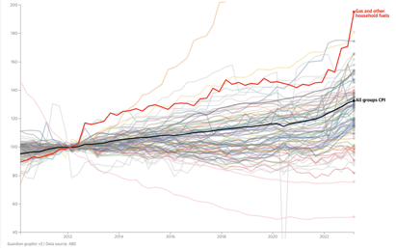
Source: Cost of living 2023: see how inflation has changed prices in Australia in the March quarter – interactive

What is CPI? The Cost Price Index is the rate at which goods and services are influenced by inflation, i.e. the rate at which they get more expensive. In Australia a ‘normal’ or aimed for CPI increase rate is 2 to 3% per year. However, according to the Parliament of Australia’s June 2022 cost of living report:
In the 12 months to March 2022, the Consumer Price
Index (CPI) increased by 5.1%, the highest annual
rise reported since the introduction of the GST in 2000.

- Peter McDonald, Statistics and Mapping

And since the above statement it’s gotten even worse, with CPI peaking in September 2022 at 7.8% growth. That’s a massive jump in the cost of everyday things.
Fig.28 CPI quarterly percentage change
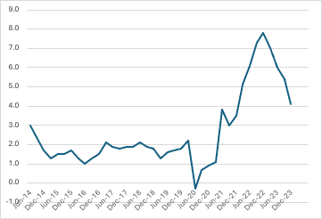
Source: ABS, Consumer Price Index, Australia; 2024
If you’re curious about exactly how much more expensive things have gotten, this is a handy little online tool to waste some time and make you angry:
Cost of living calculator: https://costofliving.studyaustralia.gov.au/
Unfortunately, the only thing to not have gone up in correlation with CPI is wages. Let’s go back in history a bit and look at the first established national minimum wage system in Australia; the Harvester Decision;
In 1907, the Harvester Decision set a ‘living’ or ‘family’ wage. It was supposed to allow an unskilled labourer to support a wife and three children, to feed, house, and clothe them.
Think Homer from the Simpsons as a classic example of this. For many people, particularly young people, this is a dream world in 2024.
But the workforce looks different now right? Less kids, more women, more double income households…not every working person is a man supporting a wife and three kids.
Should that matter?
The value of each person's hours hasn’t changed. Whether the person doing the work is supporting others, whatever age (within reasonable child protection laws and safety), whatever gender, race, religion etc. – an hour’s work produces an hour’s labour. Putting the emphasis on what their costs are and how little they need works for the employers, but it drives down the value of the hours for everyone.
In August 2023,
- 25% of all employees earned less than $820 per week in their main job (25th percentile).
- 50% of all employees earned less than $1,300 (50th percentile/median).
- 75% of all employees earned less than $1,975 (75th percentile).
- 90% of all employees earned less than $2,820 (90th percentile).
Source: Employee earnings, Australian Bureau of Statistics
ABS data in February 2022 had 2.6 million of the working population of 13.4 million on minimum wage - that’s nearly 20% of the entire workforce.
How is someone supporting a wife and kids, or who has greater medical expenses, or wants to contribute financially to good causes supposed to be able to compete with someone who has no dependents, frugal and medically able to work more if they are bidding for the same job?
Limiting or lowering the minimum wage creates a supply and demand driven race-for-the-bottom society where employers can pocket more of the profit and we as a society are driven to be self-serving, lonely and discriminatory.
There are also fears that higher wages will increase inflation and push prices up, worsening the wealth gap and making basic goods increasingly unaffordable. But this is just corporate propaganda to protect their own interests. As the Australian Institute reported in February of 2023:
New empirical research reveals the main driver for inflation in Australia is excess corporate profits, not wages, and that inflation would have stayed within the RBA target band if corporates had not squeezed consumers through the pandemic via excess price hikes.
- Australian Institute, 2023
A Profit-Price spiral is the main driver of inflation in Australia, rather than a supposed “Wage-Price” spiral, which does not exist.
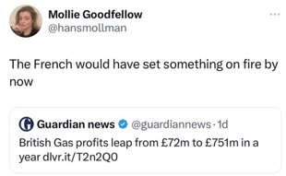
Dr. Jim Stanford, director of the Centre for Future Work reported the below major findings in February 2023;
- As of the September quarter of 2022 (most recent data available), Australian businesses increased prices by a total of $160 billion per year over and above their higher expenses for labour, taxes, and other inputs, and over and above profits generated by growth in real economic output.
- Without the inclusion of those excess profits in final prices for Australian-made goods and services, inflation since the pandemic would have been much slower: an annual average of 2.7% per year, barely half of the 5.2% annual average actually recorded since end-2019.
- That pace of inflation would have fallen within the RBA’s target inflation band (equal to its 2.5% target, plus-or-minus 0.5%).
- Excess corporate profits account for 69% of additional inflation beyond the RBA’s target. Rising unit labour costs account for just 18% of that inflation
- The RBAs 9 back-to-back interest rate rises would have been unlikely without excess profits and prices based on the RBA’s own policy framework.
Source: https://futurework.org.au/wp-content/uploads/sites/2/2023/02/Profit-Price-Spiral-Research-Report-WEB.pdf

Real Wages: the effect of inflation on income.
It’s important to understand why it feels like everything is getting more expensive and harder to buy when reports show that income has gone up as well. This is because Real Wages have failed to keep up with CPI.
Let me share an example.
Say that as a society we’ve agreed that every year, everything costs 3% more than it did the previous year.
(Don’t ask why – it’s corporate profits and interest rates and something called usury.)
And in this mythical world a loaf of delicious sourdough bread costs $1.
Coincidently, your job pays $1 per hour.
Therefore, one hour of your labour is able to buy a loaf of bread.
The next year, bread goes up 3% to $1.03. But your salary remains the same. So now, one hour of your labour is not enough to buy a loaf of bread.
The effective value of your labour has decreased.

Because we live in a world where everything is affected by inflation, not just bread, rent, fuel, electricity, food, clothes…. everything has gone up in price each year. That means if your income hasn’t risen to at least match the rate of inflation, every year you are being paid effectively less, as the value of what your $1 can buy decreases. This is what we call real wages – the calculation of how workers’ wages are tracking compared to the rising cost of purchasing everything.

Despite low unemployment rates, wages growth has not kept pace with inflation, so real wages have declined – in some cases noticeably.
- Reserve Bank Australia, 2022 Statement on Monetary Policy

In the 12 months prior to March 2022, the ABS showed that CPI increased by 5.1% however the Wage Price Index (WPI) only grew by 2.7%, meaning a real wage loss of 2.4%. What this means is anyone that didn’t get a pay rise of at least 5.1% got an effective pay cut.

Fig.29 Quarterly CPI & Nominal Wage Rate vs Real Wage Percentage Changes
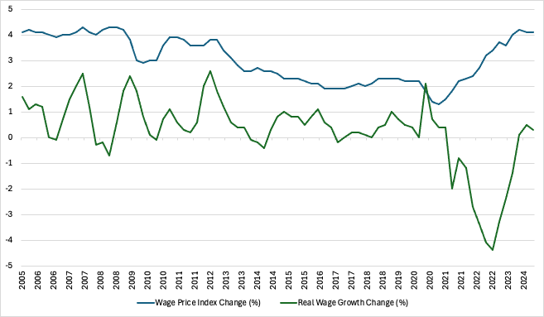
Source: Australian Bureau of Statistics Wage Price Index and Consumer Price Index
Remember, CPI works for employers as well – their costs are higher but they can charge more for their goods and services and this should be passed along to staff in the form of wages that match CPI.
Australians have experienced their largest real wage decline on record, with nominal wages growing by 3.3 per cent in 2022, well below inflation of 7.8 per cent.
- Gareth Hutchins, ABC News

Compounding this, the percentage of the Gross Domestic Product (GDP) that makes up worker compensation, or wages, and the percentage that is profits have been getting closer since 2016, most dramatically since Covid-19 lockdowns in 2020.
And corporate profits are larger than ever, particularly compared with wage increases.
Fig.30 Wages vs Profit Index (March 2001 = 100)
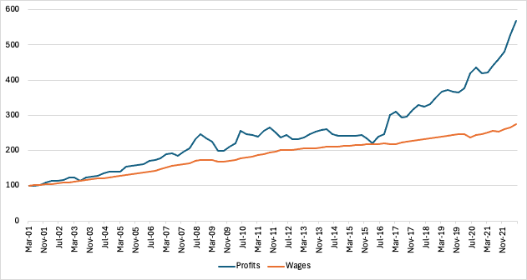
Source: The Australian Institute, Greg Jericho, 2022
This is the cause of the current cost of living crisis – corporations charging more, making more profit and not paying more in wages. They’re taking from the economy more than they’re contributing and that’s unsustainable – eventually we run out of funds to keep buying their goods.
Compare the costs of living in Australia now (2024) to 30 years ago:
- University was free, now it’s upwards of $30,000.
- Rent was about 20% of income, now it’s double that.
- A house in Sydney was around $64,337, now it’s $1,595,310 (+1,747%).
- Buying a house used to cost 6.4 times the national average income and now costs 21.5.
- A loaf of bread was 0.54c, now it’s $3.06 or more (+466%).
- Fuel in the 1980’s was around 0.50c/L, today it’s $1.80/L or more (+260%).
To quote a trite mantra, the rich are getting richer, and the poor are getting poor. That’s because it’s not a pool that lifts everyone, it’s a series of buckets that they take from and don’t give back to. The only thing that trickles down is piss.
Inflation rose 14% between July 202 and July 2022. But corporate profits rose by 75% over those two years – five times as fast as inflation. Don’t tell me corporations have no choice but to raise prices.
– Robert Reich
Which actually makes everyone suffer.
Comparing data from the Gallup World Poll and the World Top Incomes Databases found that the higher the concentration of wealth and income in the hands of a few, the more likely people are to report lower levels of life satisfaction and increased daily emotional experiences.
In a Harvard Business Review article, Jan-Emmanuel De Neve and Nattavudh (Nick) Powdthavee reported: “The higher the share of national income that is held by the top 1%, the lower the overall well-being of the general population. Specifically, we found that a 1% increase in the share of taxable income held by the top 1% hurts life satisfaction as much as a 1.4% increase in the country-level unemployment rate.”
Fig.31 Overall Well-Being Drops as National Income Inequality Rises
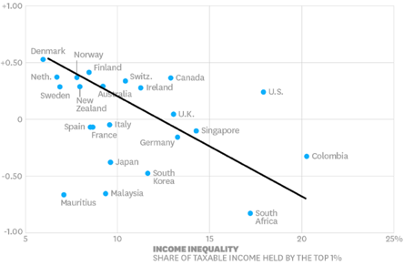
Source: Income Inequality Makes Whole Countries Less Happy

