Three types of bodies
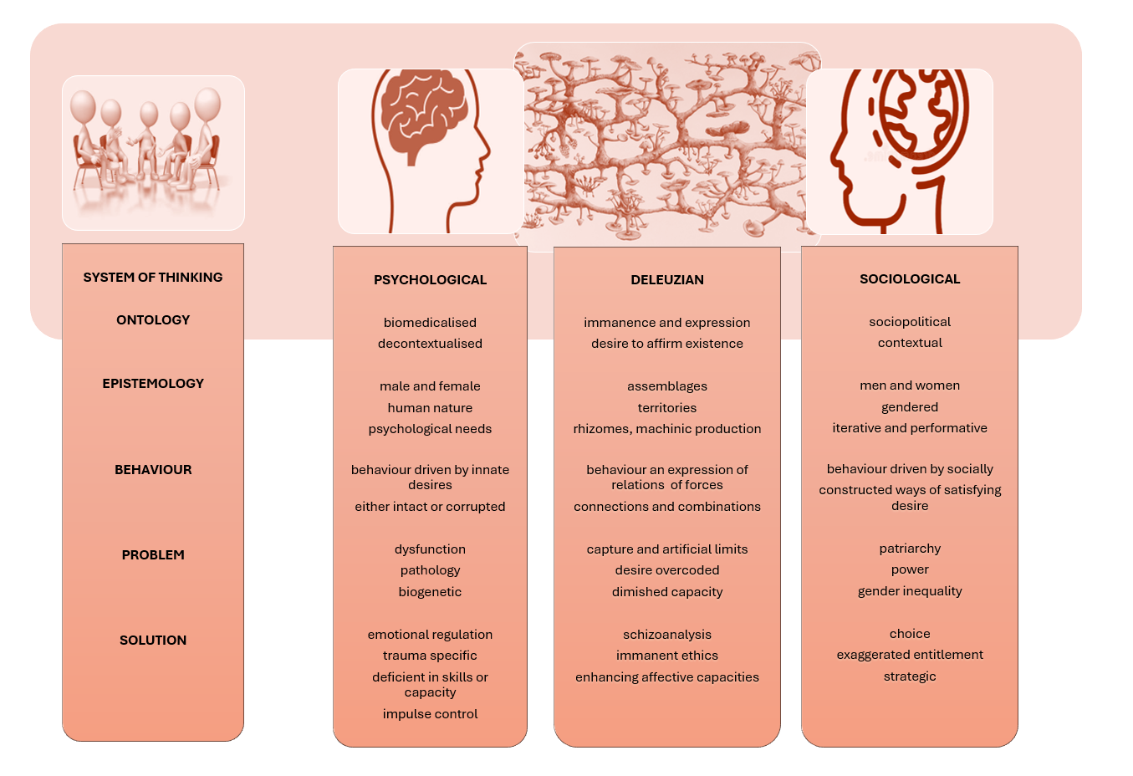
For Deleuze and Guattari difference between bodies should not be thought of in terms of quantities of attributes or qualities of interiors, but in terms of the qualities as an effect of encounters. Deleuze and Guattari ( ) argue…
The distinction between two kinds of quality is of the greatest importance…there is a deep affinity, a complicity, but never a confusion between action and reaction, between affirmation and negation…affirmation is not action but the power of becoming active, becoming active personified. Negation is not simple reaction but a becoming reactive. It is as if affirmation and negation were both immanent and transcendent in relation to action and reaction…
This continues the critique of bodies being understood through predicates, such as identities, as an event of both production and capture not discovery and true reality. Such conceptualisations are seductive for times when we hope to be able to offer a degree of certainty but for Deleuze and Guattari the problem is when ‘...we always think we have done enough when we understand an organism in terms of reactive forces....’ (Deleuze 2006, p. 38). Understanding in terms of purely reactive forces is akin to thinking that we have found the sufficient and necessary cause of violent behaviour, or the full and correct constellation of risk factors that tell us why a particular man or group of men use violence. It may also manifest when we invest in one form of VAW intervention as being the sufficient and necessary force to intervene in violent behaviour. Questions of why often infer recognition and tend to reproduce the assemblages of enunciation is if they were abstracted realities that we can and should refer to and rely upon. We may call them up as reliable and valid measures to the extent of calling them best practice or evidence based. Neither claim sis necessarily wholly false as we should be aspiring towards both, but at such times we have reconnected with systems of classification and who becomes the question of which one, what type. Deleuze argues (2006, p. 71)
‘…according to Nietzsche the question which one(qui) means this: what are the forces which take hold of a given thing, what is the will that possesses it? Which one is expressed, manifested and even hidden in it?
When we are thinking with forces taking hold, we are thinking of social forces taking hold of bodies where what is thought possible for the body is a product of the forces action upon the body, the forces capturing and limiting affective capacities. This can introduce problems of discourse determinism and reduces agency to provocation and response stimuli type understandings of violent behaviour. Alternatively, a Deleuzian framing suggests a set of particular emergent capacities are produced as an effect of the encounters between forces. Methodologically this means that we may reject the idea bodies have a quantity of power or a quality of power outside of their relation/s to other bodies. Therefore, a VAW intervention model does not carry power in terms of definitional authority because of any particular arrangement of concepts that make it up unless it is granted so by a context. There is no convergence on higher dimensions of understanding and thus giving over to the definitional authority of the model and applying it faithfully will produce effective interventions. A model, system of thinking has power, definitional authority because of the ways it has been enabled to make other bodies reactive to it. Because of the intensity of investments in particular concepts. A prevailing order insists that these concepts are what can be logically thought about the problem. In a Deleuzian framing corporeal bodies are thought similarly.
Human bodies have physical properties that infer physical attributes such as strength, but the authority of bodies over other bodies is an investment in the body to affectuate particular relations with other bodies – to make other bodies reactive to it, to dominate. Physically overpowering other bodies directly and indirectly are an obvious investment in setting up particular relations between bodies. Deleuze argues that a reactive force, one which makes other forces react to it, even when connected to many other reactive forces does not have more power then any active force per se. Forces in this framing are not physical forces, such as strength but are the assemblage of ideas that encourages, and may be argued for as the prompt to try to overpower others. What it does contain is a will to get active forces to react to it…’ where reactive forces...separate active force from what it can do...they make active forces join them.’ (Deleuze 2006, p. 53). Patriarchal capitalism is an example of a reactive force. The very intention of this series of ideas embedded in patriarchal institutions is to impose artificial limits on what bodies can do – both men and women. The continuation of a regime is how this relation of forces has set bodies into regular patterns of relating – how it has stratified the space with regard to the expression of bodies. This should not be taken to infer that patriarchy is not real. Or that the effects of subjugation can be easily overcome by just refusing the reactive force. However, for Deleuze to become is to become reactive. Yet, reactive forces also ‘...separate us from our power, but at the same time they give us another power...’ (Deleuze 2006, p.61). Here we may consider this as a way of understanding how patriarchy separates men from who they can be maybe in terms of richer emotionally, but also provides the ideology of male privilege. As such, Deleuze argues that when an active body is made reactive, or is separated from what it can do, it becomes partially negated in terms of it’s capacity to enact itself…
.’...imposes limitations and patrial restrictions on it and is already controlled by the spirit of the negative...difference has become negation, affirmation has become contradiction...’ (Deleuze 2006, p. 52).
What Deleuze is referring to as negation and affirmation as contradiction in this context is similar to noting that patriarchy argues for male entitlement which becomes who the VAW perpetrator believes he needs to be, who men and women intrinsically are and should be. This is a negation as it continuously interrupts the potential to be otherwise, to be other then what the reactive force of patriarchy proscribes and prescribes. The negation is of the affective capacities of the other body, women’s bodies, but also of his own as he is trying to repeat already enabled positions and limiting how the other body, his partner’s body, can affect him. Affirmation appears as contradiction because the man may believe he is asserting who he really is, but this is a contradiction as he is affirming the limits set by the reactive force. Furthermore, affirmation of enhanced affective capacity requires contradicting the limits set by stabilised orders and identities. Every line of flight begins with identifying a problematic situation, that is what encounters between bodies are – excitations and perplexing’s. To affirm the affective capacities of bodies is to contradict, but not against that order, not to negate the order, but to release immanent capacity from the constrains of stability.
Male, men, masculinity/ies, toxic or healthy are new stabilising orders that make maled bodies reactive to artificial limits. To affirm new affective capacities is to continually escape such discursive boundaries. If we approach VAWPI with concepts we have elevated with specific predetermined orders and territorial boundaries, such as masculine or feminine, we artificially restrict transformation to within those limits. The line of flight, the becoming active and enhancing affective capacities is the natural tendency of all bodies to affirm their existence. This is the movement of the rhizome. Bodies becoming different to themselves at each event of subjectivation. The role of the interventionist is to encourage the creation of the new. New ways of being that are safer. Here the Deleuzian question is not what human bodies are, but what can they do. This for Deleuze and Guattari is the most profound affirmation of life. These expressions of life are not cut free from an ethics. As previously noted ontology and epistemology is for the creation of ethics, practices of life. These expressions of life when freed from the constructs of human nature, or the human condition as a thing are considered the most humane from for possibilities as what a body can do is preferred over who it should be. This form of humaneness relies on an ethic of striving to make my own becomings as humane for others as I seek them to be for myself. The immanent ethics of Deleuze and Guattari argue for attention to this as a responsibility to mutuality. It is this this ethic of mutuality that the next chapter considers by attaching the guiding principles rhizomorphously with VAWPI.

Chapter 7: Concepts, Guiding Principles and a Deleuzian model

