Labor Migration Impact on Labor Shortages in Nepal's Construction Industry

ABSTRACT
This study investigates the significant impact of labor migration on Nepal's construction industry, with a focus on labor shortages, project delays, rising costs, and declining quality. Nepal's construction sector, a vital contributor to the nation's GDP, faces enormous challenges due to the outflow of skilled and semi-skilled labor, primarily to Gulf countries and Malaysia. Over 4 million Nepali work permits have been issued since 2008, with nearly half of Nepali households having a migrant worker in the past decade. This massive labor migration has led to a depletion of the national workforce, causing delays in construction projects, increased labor costs, and compromised quality. The study identifies several critical issues, including the lack of skilled labor, limited adoption of modern technologies like Building Information Modeling (BIM), and insufficient training and education in the sector. These challenges, exacerbated by the COVID-19 pandemic, have further hindered progress and safety in construction activities.
The research employs a mixed-methods approach, combining qualitative data from in-depth interviews with industry experts, policymakers, and migrant workers, and quantitative data from surveys of Nepalese construction companies and workers. The findings indicate that the labor shortage has significantly impacted on the efficiency and quality of construction work, with many firms struggling to employ and retain skilled workers. Moreover, the study highlights the rising wage rates, which further strain construction budgets and project viability. The lack of comprehensive labor policies, coupled with inadequate enforcement mechanisms, has left migrant workers vulnerable to exploitation and unfair labor practices.
In addition to labor shortages, the study explores the cultural and economic dimensions of labor migration, noting how remittances from migrant workers influence local communities and contribute to grassroots development. However, over-reliance on remittances has stifled local entrepreneurship and contributed to a "migrant syndrome," where foreign labor is perceived as the key to economic success. The research calls for a multi-pronged approach to address these issues, including improving local workforce capacity through training, implementing fair labor policies, and promoting sustainable construction practices. The study recommends fostering community involvement in sustainability efforts and enhancing international cooperation to protect migrant workers' rights. By integrating sustainability into the construction sector and reducing dependence on foreign labor, Nepal can achieve long-term economic resilience and sustainable development in the construction industry.
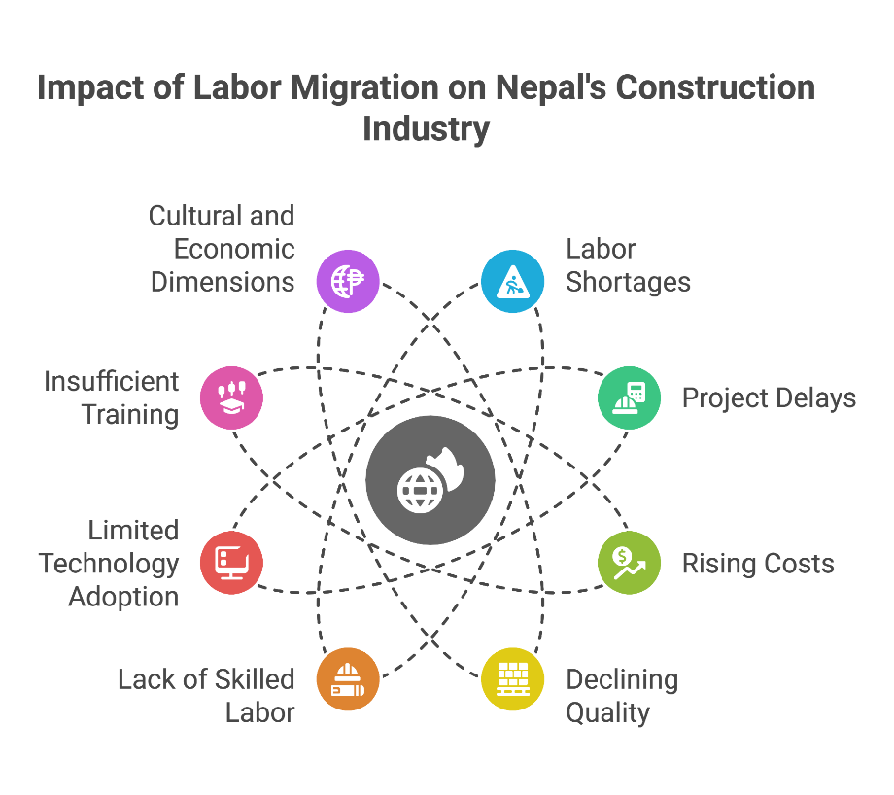

Introduction
Nepal's construction sector, key propeller of the nation's GDP, faces humongous difficulties in ensuring inclusive and sustainable development, spearheaded by labor migration [1]. The industry faces pressure from high poverty and unemployment rates that require people's involvement, policy actions, and adoption of green technology for porous jobs and economic development creation [2]. Export of Nepali labor in quest of better jobs abroad created a void in the national labor market, predominantly the construction sector, leading to delayed projects, rising costs, and poor quality [3]. This is facilitated by a preference for proven construction conventional techniques as opposed to new digital technology innovation, especially in government construction work wherein cost becomes a major determinant as opposed to innovation's long-term benefit [4]. Nepal has issued over 4 million work permits since 2008, predominantly for Gulf state and Malaysian jobs, with nearly half of Nepali homes having a migrant worker in the last decade [5]. This massive outflow, while garnering massive remittance incomes, has inadvertently depleted the nation's labor force, making it realize its own reliance on foreign employment as its main economic plan [6].
Construction Industry
In spite of economic benefits arriving in the form of foreign remittances, over-reliance on a single source of revenue is a worry for its contribution towards economic resilience in the long term and poverty reduction as the migrant workers do not work or send money back to homes regularly [7]. Socio-economic status, education, marriage, landownership, and family size are contributory variables to laborer migration and economic issues are at the helm of these variables [8]. Existing mechanisms and policies for protecting and advancing the rights and well-being of migrant workers are still lacking to meet their size and magnitude [9]. It is not just the Nepalese workers going out to labor; huge numbers of Nepalese students have been emigrating as well in search of better times, particularly to destinations like the UK [9]. Delay in the construction industry has implications to delayed adoption of technologies like Building Information Modeling, delayed due to insufficient training and knowledge gap between the experts and resulting in compromise on efficiency and project safety [10]. A multi-pronged approach is needed for addressing these challenges and fostering sustainable practices, construction worker welfare enhancement, and economic development in Nepal [11].
Effect of Labour Migration on Labour Shortages
Massive emigration of Nepalis as overseas migrant workers, mainly to Malaysia and Gulf countries, has therefore led to a huge local labor loss and thus labor shortages on a large scale in Nepal's construction industry.
Temporary labor emigration has grown increasingly important since 1971 [12]. Nepali workers are driven by a need for improved economic opportunities to seek work outside their homelands, creating a vast shortage in the national labor pool. This outflow has triggered project delays, increased construction expenditure, and reduced quality, thereby stifling the sector's contribution to Nepal's economic advancement [13]. Financial remittances, in the position to provide lifelines to lives and stimulate economic development by investing in human and productive assets, may not always reach migrant homes, leading to stagnant or lower living standards due to losing supply of labor and indigenous sources of income [14]. Nepal's construction sector is further plagued by concerns such as a shortage of skilled labor, lack of investment, laws and regulations creating barriers, environmental impact, and limitations in accessing sustainable materials [15]. Nepal's reconstruction activity has been significantly impacted by COVID-19 due to the fact that the pandemic has slowed and compounded a myriad of construction activities [16]. Inadequate availability of a skilled workforce, enhanced by outside emigration, has led to the hiring of fewer-qualified employees, further lowering the quality and safety of construction work. This is supplemented by poor performance on the part of construction industry players to leverage modern technologies such as Building Information Modeling that is thwarted by limited widespread training and education among industry players, thereby affecting project efficiency and construction site safety [17]. Furthermore, inadequate attention towards the physical and mental health of construction industry players highlights shortages in labor, due to a physically stressful and high-risk construction occupation that requires a healthy and stable workforce [18].
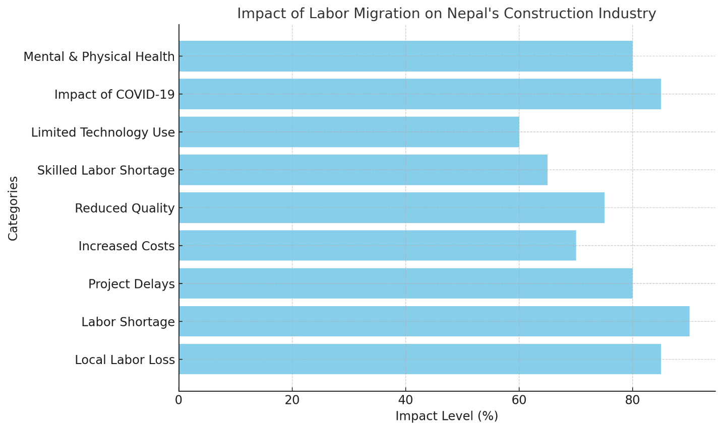
Here is the graph that visualizes the impact of labor migration on Nepal's construction industry, showing the percentage impact on various factors such as labor shortages, rising costs, and reduced quality.

Building Works
The labor shortage problem in Nepal's construction industry is compounded by compliance and enforcement loopholes and lack of rules, thus engendering poor observance of sustainability standards in construction practices [19]. Perceptions by policymakers and project leaders may differ, and this creates a contradiction. This raises ambiguity regarding labor and sustainable development's challenge and promise [20]. These include climate change and environmental pollution and natural disasters [21]. These work to jointly compromise efforts in sustainable construction practices. Nepal's construction industry is also characterized by limited availability of sustainable materials, thus making eco-construction practices a difficult prospect to achieve [22]. Ineffective comprehensive training frameworks reinforce these factors, thus making the workforce unschooled in sustainable construction norms and implementation of new technology [23]. Remittance dependence can control other socio-cultural drivers like migrant's sending community's political involvement [24]. Economic dependence may discourage local entrepreneurship activity, thus creating a 'migrant syndrome' wherein foreign labor is perceived as a sure determinant of success, thus suffocating local industries [25].
Cultural Factors
The economic activity's cultural dimension, like construction of homes using remittance funds, makes homes exist as monuments that enforce kinship relations in society [26]. Remittances are not only sent to the land of destination, but new concepts that become notions that influence local practices [27]. Remittances have a desire for novelty in the world and expose households to new practices and cultures [28]. Migrant remittances are a leading financier of grassroots development, with influence, however, very significantly skewed toward economic influence [29]. In Nepal, new practices are at times valued less than old ones because of societal cultural values [30]. In-depth studies and education on sustainable practices on all levels of the construction industry are necessary, and this is key in ensuring experts have the capability to execute practices toward sustainability [31]. These hazards can only be managed by having a holistic approach that involves integrating cultural values and modern sustainable practices toward ensuring a sustainable construction industry future and toward sustainable development in Nepal [25], [32].
There exists an imperative to address Nepali migrant worker needs in host countries that is urgent, prompting the government to commence greater labor diplomacy and host responsibility [33]. Moreover, Nepali construction industry shortages undermine not only sustainable uptake but also construction quality and safety overall. In striving towards sustainable construction management in Nepal, carefully documented policy needs to be prepared and clear enforcement systems need to be established. and strong training regimes must be transposed into local settings [34]. This requires redressing gender inequalities in access to resources and decision-making processes that too frequently compound challenges in remittance-dependent female-headed households.

Literature Review
Sustainable construction management is among the key topics of global discussion on sustainable development, especially among nations with high urbanization rates and high environmental aspirations [35]. These aspirations constitute economic limits, high urbanization rates, and other factors that can make sustainable practices viable on a large scale hard [36]. Integrated sustainable construction practices can reduce environmental impacts, enhance resource productivity, and enhance resilience of constructed environments. Despite surging awareness of its significance, Nepal's construction sector still faces complex problems on a large scale that suppress sustainable construction management practices [22], [37]. Construction sectors have significant effects on physical infrastructure development [38].
Learning and education are some of the key areas in getting construction management practitioners embrace sustainable practices effectively [39]. It requires an integrated approach integrating environmental custodianship and risk management, and corporate governance's contribution to enabling sustainable exploitation of resources by construction organizations [40]. This would enable the integration of contemporary notions of sustainability with regionally feasible indigenous knowledge and rendering locally viable solutions environmentally sustainable and socially acceptable [41].
For Nepal, construction industry dynamics are greatly influenced by labor migration with potential to create opportunity as well as obstacle towards the achievement of sustainability goals. Construction practices that are sustainable encounter Nepal on a big scale owing to work force emigration and dependency on remittances. Direct positive impact by the construction industry itself is promoted in conserving the environment by connecting environmental and enterprise risk management and promoting corporate governance on the lines of ethical consumption of resources [42].
Economic pressure that may arise from labor shortages and rising labor costs could discourage adoption of sustainable materials and technologies, which are generally more expensive in the initial stages. Improvement of labor conditions and achievement of decent remuneration of labor in the construction industry is needed in order to retain and attract local staff. Promotion of cooperation among industry players, government, and academy is important to support innovation as well as adoption of sustainable practices[43]. Integration of principles of sustainability in construction activities is needed to counteract the otherwise devastating environmental effects of construction works, such as emission of air pollutants and energy consumption [44]. Green building technologies, such as energy efficiency and use of sustainable materials, can reduce buildings' and infrastructure environmental footprint by a colossal margin [45].
The research recommends policy actions toward making stakeholders accountable and boosting community involvement in sustainability practices. Policy actions toward this end have to work toward decreasing migrant workers' vulnerabilities, minimizing labor exploitation, and encouraging fair labor practices among destination countries and Nepal. Long-term benefits of integrating sustainability principles and practices into Nepal's construction industry are immense.
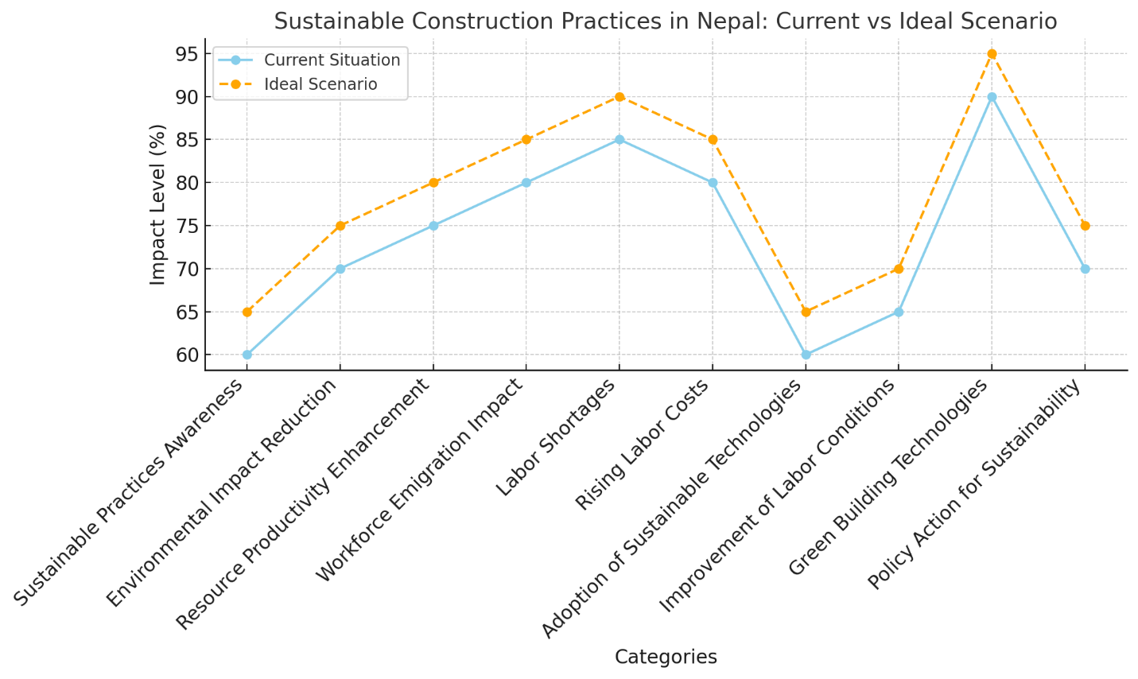

Here is the line graph showing the comparison between the current situation and the ideal scenario for sustainable construction practices in Nepal. It visualizes the impact levels across various factors like sustainable practices awareness, labor shortages, and adoption of green building technologies.

Methodology
Given the inherently multilateral and multi-dimensional nature of labor migration and their implications on Nepal's construction industry, a mixed-methods study design was chosen in this case that allowed for a multilayered and holistic understanding of these underlying dynamics. In its early stages, the study involved an extensive literature review of available studies, policy studies, and industry studies in constructing a theoretical framework and determining key research gaps [46]. This literature review exercise was conducted to narrow research questions and enable conceptual mapping that diverged into data collection and analysis stages that followed.
Qualitative data was collected via in-depth interviews of construction practitioners, policymakers, labor migrants, and other stakeholders of concerned organizations. In-depth interviews were planned to gather in-depth data on experience, perceptions, and concerns on labor migration and its consequences on the construction industry. Interviewees were thoroughly chosen in a way a broad spectrum of experience and opinion was gathered enriching and adding crediblity to qualitative data.
Quantitative data were gathered by conducting surveys between Nepalese construction companies and workers. The questionnaire contained questions on labor force mix, wages, project delays, and application of sustainable construction methods. Quantitative data were processed using statistical packages to derive trends, relationships, and significant correlations among variables.
Application of Systems Theory, Economic Theory, and Theory of Planned Behavior is a good foundation to examine complexities of sustainable construction practice [47]. The theories present supportive findings on determinants of construction decision-making behavior and sustainability processes. Integrating qualitative and quantitative findings, this study presents a general evaluation of labor migration's influence on labor shortages in Nepal's construction industry.
Qualitative data supplemented quantitative analysis by offering a description of context data and other explorations into identified trends of statistics [48]. This approach offers a holistic exploration into labor migration's influence on labor shortages within Nepal's construction industry as well as having several sources of varied perceptions and empirical data to inform policy orientations of future research agendas. A qualitative research design was used for research study under the constructivist epistemological orientation [49]. Interpretative phenomenological analysis dimensions were used in research design based on research purpose [50]. Analysis of data involved identification of repeated trends, narrations, and tendencies that articulated labor migration's inherent dynamics and their effects on the construction industry. [13], [51], [52].

Result
The studies discovered a link between labor mobility and Nepalese construction work force shortages.
The research indicates that Nepali labor outflow, especially skilled and semi-skilled manpower, resulted in a shortage of skilled manpower, construction work delays, rising labor costs, and inferior construction quality. It was reflected in the construction firms' survey report that a significant percentage of construction work was delayed because of a lack of manpower, and most firms had experienced difficulties in employing and retaining skilled workforce.
These shortages have caused increased wage rates as well, generating extra costs on construction companies and possibly on projects' viability.
The findings were complemented with interview data, and industry experts in the construction sector were concerned about the effects of labor migration on industry competitiveness and productivity. Creating and forming good economic opportunities, such as improving the agriculture sector, is necessary in addressing overseas labor migration growth from Nepalese farming families [53].
The outcome showed a pacey uptake of digital technologies like Building Information Modeling, whose use was hindered by a lack of proper training [54].
Additionally, a lack of comprehensive labor policies and rules has made the negative effects of labor migration more acute. Additionally, a lack of a functional enforcement and monitoring system made migrant laborers susceptible to exploitation and unfair labor practices [55]. Additionally, a lack of a functional enforcement and monitoring system made migrant laborers susceptible to exploitation and unfair labor practices and thus aided construction sectors' woes [56]. In spite of their socio-economic circumstances on construction sites in principal cities, women have poorer results than could have been anticipated and experienced thus far [57]. These factors, as a group, form a distressing portrait of construction industries in Nepal today.

Discussion
The discussion on research results takes into account labor migration's cause and influence on labor shortages in Nepal's construction industry.
The research delves into structural circumstances compelling Nepali labor into foreign employment markets owing to poor spheres of labor around homes, declining incomes, and socio-economic disparities.
The paper further discusses institutional mechanisms and policies that have been put into place to control labor migration and curb its negative effect on construction activity.
Further, while analyzing, research takes into account wider impacts of labor deficiencies on economic growth plans as well as infrastructure development of Nepal. St Gotthard Foundation studies attempt to evaluate employment challenge of agrifood sectors of developing countries and employment policy orientation structuring related research [58]. Results of this work are that issues of agrifood sectors of developing countries currently, like lack of infrastructure, finance, training, and market access, are main factors hindering employment growth.
These are exacerbated by high levels of unemployment and poverty as well as a shortage of sustainable and inclusive development strategies [59].
The economic crisis leads to emigration as well as working and social protections that they possess as urban working people [60].
The research found new dynamics of seasonal migration like labor brokers' role, mobility between generations, social networks, grassroots politics, brokers' interaction with the migrants and market intervention, intervention by civil society [61].
Raising these drivers involves a multi-pronged strategy that involves encouraging more equitable economic growth, decent work opportunities, and enhanced social protection policies.
The research also uncovered the ways in which migrant agency influences urban shape and urban development as part of translocal migrant economies like foreign remittances' urban investments [62].

Conclusion
In brief, labor migration has been most impactful on labor shortages in Nepal's construction industry [61]. This has resulted in project delays, rising labor costs, and decreasing quality of construction [63].
To address these issues, this paper recommends policies promoting community involvement in sustainability [64].
The research advocates for universal labor standards and best practices in legislation for safeguarding migrant labor and promoting fair labor practices [65].
In addition, the administration must invest in education and training exercises to develop the capacity and capability of local human resources and reduce dependence on foreign workers. It's essential to encourage decent and safe migration for work by educating potential migrants, safeguarding their rights at the destination, and using remittances and skills as national development [66]. In addition, greater information transfer between the sending and receiving nations is necessary in guaranteeing workers' rights protection and calculating new policy impacts [67]. It requires further research with more variables and other sectors as well for a thorough accounting of its actual relationship [68]. It also highlighted innovation's contribution toward triumphing over difficulties and venturing into new territories.

