Clinical Characteristics and One-Year Mortality in ANCA-Associated Diffuse Alveolar Hemorrhage: A Comparative Analysis of MPO-Positive versus PR3-Positive Patients

Villarroel M. Florencia, Camargo Parra Daniela, Rizzo Guillermina, Dubinsky Diana, Quadrelli Silvia
Sanatorio Güemes University Hospital, Buenos Aires, Argentina.

Abstract
Objective: To compare clinical characteristics and one-year mortality between myeloperoxidase (MPO)-ANCA and proteinase-3 (PR3)-ANCA positive patients with diffuse alveolar haemorrhage (DAH) secondary to ANCA-associated vasculitis.
Methods: We conducted a retrospective cohort study at a tertiary university hospital in Buenos Aires, Argentina, from January 2015 to May 2023. Patients aged ≥18 years with ANCA-associated vasculitis and DAH were included. Patients were stratified by ANCA specificity and clinical characteristics, treatment responses, and outcomes were compared.
Results: Forty patients were analysed: 26 (65%) PR3-ANCA positive and 14 (35%) MPO-ANCA positive. Mean age was 50±14.2 years with 55% female predominance. MPO-ANCA patients were significantly older (55.9±14.3 versus 46.5±13.5 years, p=0.045) and experienced substantially higher rates of acute renal failure (92.9% versus 50.0%, p=0.013; OR 13.0, 95% CI: 1.4-119.6). No significant differences were observed in clinical presentation, treatment requirements, or mechanical ventilation needs between groups. Overall in-hospital mortality was 22.5% (MPO-ANCA 28.6% versus PR3-ANCA 19.2%, p=0.241). One-year mortality was 7.5% overall, with paradoxically lower mortality in the MPO-ANCA group (0% versus 11.5%, p=0.263).
Conclusions: In ANCA-associated DAH, MPO-ANCA positivity is associated with significantly older age at presentation and markedly increased risk of acute renal failure compared to PR3-ANCA positivity. Despite more severe renal involvement, MPO-ANCA patients demonstrated comparable short-term survival, suggesting distinct disease phenotypes requiring tailored management approaches.
Keywords: ANCA-associated vasculitis; diffuse alveolar haemorrhage; myeloperoxidase; proteinase-3; acute renal failure

INTRODUCTION
Anti-neutrophil cytoplasmic antibody (ANCA)-associated vasculitides constitute a category of systemic necrotising vasculitides that predominantly target small to medium-sized vessels, including granulomatosis with polyangiitis (GPA), microscopic polyangiitis (MPA), and eosinophilic granulomatosis with polyangiitis (EGPA). ¹ These diseases are defined by the presence of circulating ANCA that target specific antigens within neutrophil cytoplasmic granules, chiefly myeloperoxidase (MPO) and proteinase-3 (PR3). ²
The clinical importance of ANCA specificity transcends diagnostic value, as increasing data indicates that MPO-ANCA and PR3-ANCA positive individuals display unique clinical phenotypes, patterns of organ involvement, and long-term prognoses. ³⁻⁵ PR3-ANCA positivity is mostly associated with granulomatosis with polyangiitis, typically manifesting with upper respiratory tract involvement, while MPO-ANCA positivity is more frequently connected to microscopic polyangiitis, favouring renal involvement. Diffuse alveolar haemorrhage (DAH) constitutes one of the most severe and life-threatening symptoms of ANCA-related vasculitis, affecting 10-30% of patients and associated with fatality rates of 20-50%. ⁹⁻¹²
Although numerous research have examined the clinical distinctions between MPO-ANCA and PR3-ANCA positive patients within the broader vasculitis community, there is a paucity of data explicitly addressing these differences in the context of DAH. ¹³⁻¹⁵ Determining the impact of ANCA specificity on clinical presentation, disease severity, treatment response, and long-term outcomes in DAH is essential for risk stratification and individualised therapy strategies.
Recent investigations indicate that MPO-ANCA positive patients may exhibit distinct patterns of organ involvement and potentially poorer renal outcomes compared to PR3-ANCA positive patients. ¹⁶ The prognostic influence of ANCA specificity on long-term mortality in DAH is little defined. Moreover, the ideal treatment options may vary among these subgroups, rendering this divergence clinically significant for therapeutic decision-making.
The main aim of this study was to compare clinical features and one-year death rates between MPO-ANCA positive and PR3-ANCA positive individuals with diffuse alveolar haemorrhage resulting from ANCA-associated vasculitis. The secondary objectives were the comparison of treatment responses, the necessity for organ support (haemodialysis and mechanical breathing), in-hospital mortality, and the identification of ANCA-specific prognostic variables.

MATERIAL AND METHODS
We conducted a retrospective comparative cohort study at a tertiary-level University Hospital in Buenos Aires, Argentina, from January 2015 to May 2023. Medical records were systematically reviewed using the search terms: "ANCA vasculitis," "Wegener's granulomatosis," "granulomatosis with polyangiitis," "Churg-Strauss," "eosinophilic granulomatosis with polyangiitis," and "microscopic polyangiitis."

Eligible patients were aged 18 years or older with a diagnosis of ANCA-associated vasculitis according to the 2022 American College of Rheumatology/European Alliance of Associations for Rheumatology classification criteria and positive MPO-ANCA or PR3-ANCA serology. DAH was defined by the simultaneous presence of new pulmonary infiltrates on chest imaging, acute decrease in hemoglobin/hematocrit without an identifiable bleeding source (anemia defined as hemoglobin <12 g/dL in men and <11 g/dL in women), and either hemoptysis or evidence of >20% hemosiderin-laden macrophages on bronchoalveolar lavage. All patients required hospital admission and had complete one-year follow-up data available.

We excluded patients younger than 18 years, those with double-positive ANCA serology (both MPO and PR3 positive), ANCA-negative vasculitis, non-immune DAH, and immune-mediated DAH not associated with ANCA vasculitis. Additional exclusions included patients with incomplete medical records or missing ANCA specificity data, and those lost to follow-up before the one-year assessment.

Patients were stratified into two groups based on ANCA specificity. The MPO-ANCA group comprised patients with positive MPO-ANCA and negative PR3-ANCA serology, while the PR3-ANCA group included patients with positive PR3-ANCA and negative MPO-ANCA serology.

We systematically collected baseline demographic characteristics (age, sex, smoking history), clinical manifestations at presentation (hemoptysis, dyspnea, cough, arthralgia, chest pain, fever), laboratory findings (hemoglobin levels, leukocyte count, acute-phase reactants, renal function, urinalysis), imaging studies, instituted treatments (corticosteroids, immunosuppressive agents, plasma exchange), organ support requirements (mechanical ventilation, hemodialysis), and outcomes (in-hospital mortality, one-year mortality). Active urinary sediment was defined by the presence of proteinuria (>300 mg/24h or >30 mg/mmol creatinine), red blood cell casts, or dysmorphic red blood cells (>80% of total red blood cells). Acute kidney injury was defined according to KDIGO criteria.

Statistical Analysis
Continuous variables are presented as means with standard deviations or medians with interquartile ranges, depending on distribution normality assessed by the Shapiro-Wilk test. Categorical variables are presented as frequencies and percentages.
For comparative analysis between MPO-ANCA and PR3-ANCA groups, continuous variables were compared using Student's t-test or Mann-Whitney U test as appropriate, while categorical variables were compared using Chi-square test or Fisher's exact test. Survival analysis was performed using Kaplan-Meier curves with log-rank test for one-year mortality comparison. Multivariable Cox proportional hazards regression was used to identify independent predictors of one-year mortality, adjusting for relevant confounders.

Odds ratios (OR) and hazard ratios (HR) with 95% confidence intervals (CI) were calculated for significant associations. A p-value <0.05 was considered statistically significant. Statistical analysis was performed using SPSS version 28.0 (IBM Corp., Armonk, NY, USA).

This study was conducted in accordance with the Declaration of Helsinki and local institutional guidelines. Given the retrospective nature of the study using de-identified medical records, individual informed consent was waived by the institutional review board. The study protocol was approved by the hospital's ethics committee.

RESULTS

General Characteristics and Study Population
The study period involved the initial evaluation of 103 medical records. 33 cases were excluded from the study as a result of non-immune DAH, with the most prevalent causes being heart failure, thrombocytopenia, and pulmonary infections. Additionally, 8 medical records were incomplete, 10 patients did not pursue follow-up at the institution following hospital discharge, and 12 cases were associated with immune-mediated DAH that was not associated with ANCA vasculitis. Systemic lupus erythematosus was the most prevalent aetiology in this group. The final analysis included 40 patients with ANCA-associated DAH, following the application of inclusion and exclusion criteria.
The mean age of the study population was 50 years (SD ±14.19), with 55% of the patients being female. Only one patient (2.5%) had a history of diffuse alveolar haemorrhage. The presenting manifestation of ANCA vasculitis was DAH in 75% of cases. In 75% of patients, the classical triad of anaemia, haemoptysis, and pulmonary infiltrates was observed. In terms of ANCA specificity, 26 patients (65%) were ANCA-C/PR3 positive, while 14 patients (35%) were ANCA-P/MPO positive.
Laboratory Results and Clinical Presentation
In 87.5% of patients, dyspnoea was the most prevalent clinical manifestation at presentation, followed by haemoptysis in 85% and wheezing in 70%. Fever was detected in 37.5% of cases. The mean haemoglobin level was 8.4 g/dL (SD ±2.5) and the mean haematocrit was 28% (SD ±6.5), with anaemia being documented in 85% of patients. Elevated acute-phase reactants were prevalent, with a mean erythrocyte sedimentation rate of 80 mm/h (SD ±37) in 75% of patients and a mean C-reactive protein of 112 mg/L (SD ±79) in 70% of patients. (Tablexxx) Dejar solamente la Tabla, en inglés. Las figuras son repetitivas con lo que ya dice el texto.
Active urinary sediment was detected in 88% of patients, and acute renal failure was diagnosed in 65% of patients. Haemodialysis was necessary in 48% of patients. The mean serum creatinine level was 3.8 mg/dL (SD ±3.7). In 65% of patients, bronchoscopy with bronchoalveolar lavage was conducted, and it was confirmatory for DAH in all cases where it was performed by the presence of siderophages.

In-hospital mortality occurred in 9 patients (22.5%), while one-year mortality was 3 patients (7.5%), demonstrating a marked improvement in survival following successful management of the acute episode. Bivariate analysis revealed that organ support requirements were powerful predictors of fatal outcomes, with mechanical ventilation showing the strongest association with in-hospital mortality (OR 30.0, 95% CI: 29.21-217.87, p < 0.001). The need for hemodialysis was also strongly associated with increased mortality risk (OR 14.5, 95% CI: 1.60-131.0, p < 0.001). Additional risk factors for mortality included age greater than 60 years (RR 2.4), presentation with DAH as the initial manifestation of vasculitis (RR 2.26), and bilateral pulmonary infiltrates on chest imaging (RR 1.63). Gender showed minimal impact on mortality risk (RR 1.1 for male versus female), as did the presence of hemoptysis (RR 1.1). No significant differences in hospital mortality or duration of mechanical ventilation were observed between patients receiving rituximab versus cyclophosphamide as induction therapy.

Comparative Analysis: Demographic and Clinical Characteristics of MPO-ANCA and PR3-ANCA Groups
The MPO-ANCA group consisted of 14 patients (35%), while the PR3-ANCA group consisted of 26 patients (65%) when stratified by ANCA specificity. In both groups, female predominance was observed; however, the PR3-ANCA group exhibited a more pronounced predominance (61.5% vs 42.9%, p > 0.05). Mean age was significantly higher in the MPO-ANCA group compared to the PR3-ANCA group (55.9 ± 14.3 vs 46.5 ± 13.5 years, difference 9.3 years, 95% CI: 0.2-18.5, p = 0.045). The smoking history, and overall clinical presentation of the groups were comparable at the time of diagnosis.
In terms of clinical manifestations, the rates of haemoptysis (MPO 85.7% vs PR3 84.6%), dyspnoea (MPO 100% vs PR3 84.6%), and fever (MPO 46.2% vs PR3 36.0%) were comparable between the two groups, with no statistically significant differences (all p > 0.05). The proportion of patients who presented with DAH as the initial manifestation of vasculitis was also comparable between the two groups (MPO 85.7% vs PR3 69.2%, p > 0.05). (Table xxx)
Laboratory Findings
The analysis of laboratory variables did not reveal any significant differences between the groups. The MPO-ANCA group and the PR3-ANCA group had mean haematocrit levels of 26.5 ± 4.8% and 29.2 ± 6.8%, respectively (difference -2.7%, 95% CI: -6.9 to 1.4, p = 0.19) and the erythrocyte sedimentation rate values were comparable between the two groups (MPO 74.9 ± 36.8 mm/h vs PR3 84.6 ± 35.5 mm/h, difference -9.7 mm/h, 95% CI: -33.8 to 14.4, p > 0.40).
Renal Involvement
The pattern of renal involvement between the groups exhibited a substantial difference. MPO-ANCA positive patients experienced acute renal failure at a rate of 92.9%, while PR3-ANCA positive patients experienced ARF ( 50.0% , p = 0.013, OR 13.0). This resulted in a 42.9% absolute increase in the risk of acute renal failure in the MPO-ANCA group. Active urinary sediment was universally present in MPO-ANCA patients (100%) compared to 80.8% in PR3-ANCA patients although did not reach statistical significant difference (p = 0.20). as the trend to higher requirement haemodialysis in MPO-ANCA group (57.1% vs 42.3%, p = 0.20).
The analysis of therapeutic interventions did not reveal any statistically significant differences between the groups.(Table xxx) Regardless of the specificity of the ANCA, corticosteroid pulse therapy was administered to all patients (100%). Cyclophosphamide was the most frequently used induction agent, administered to 71.4% of MPO-ANCA patients and 76.9% of PR3-ANCA patients (p = 0.40). MPO-ANCA patients utilised plasmapheresis at a rate of 50.0%, while PR3-ANCA patients did so at a rate of 42.3% (p = 0.40). A significant trend was observed in the use of rituximab, with 28.6% of MPO-ANCA patients receiving this agent compared to 11.5% of PR3-ANCA patients (p = 0.40). This did not reach statically significance and may be indicative of clinical decisions that were made in response to the increased renal involvement observed in the MPO-ANCA group.
Clinical Results
The groups had comparable intensive care support requirements. The proportion of MPO-ANCA patients who required mechanical ventilation was 35.7%, while the proportion of PR3-ANCA patients who required mechanical ventilation was 38.5% (p > 0.05). The incidence of prolonged mechanical ventilation for more than 10 days was infrequent and was comparable in both groups (MPO 7.1% vs PR3 7.7%, p > 0.05).
The MPO-ANCA group had an in-hospital mortality rate of 28.6%, while the PR3-ANCA group had an in-hospital mortality rate of 19.2% (difference 9.3%, p = 0.241), but no statistically significant difference was observed between the groups (OR 1.68, 95% CI: 0.37-7.65) according to the Fisher exact test. The one-year mortality rate was 0% mortality in the MPO-ANCA group and 11.5% in the PR3-ANCA group (difference -11.5%, p = 0.263) in spite of the higher degree of renal involvement.

DISCUSSION
This study is the first comprehensive investigation of ANCA-associated diffuse alveolar haemorrhage in a South American population, offering some insights into the clinical characteristics and outcomes of this severe manifestation of systemic vasculitis.

Characteristics of the Total Population and Comparison with International Literature
The clinical presentation of DAH in our cohort is consistent with international experience. Our mean age of 51.2 years aligns with contemporary series, though slightly younger than Fussner et al's (2024) PEXIVAS substudy (61.1 years) and Quartuccio et al's (2020) Italian cohort (55 years median), possibly reflecting different disease epidemiology in South America.

The frequency of haemoptysis (51.9%) matches international observations: Quartuccio et al (2020) reported 51.9% and Yadavalli et al (2023) found 61.9%. This consistency across populations confirms haemoptysis as an important but not universal DAH feature, supporting previous emphasis by Haworth et al (1985) and Gallagher et al (2002) that its absence should not diminish clinical suspicion.

Notably, 75% of our patients presented with DAH as the initial vasculitis manifestation, significantly higher than Quartuccio et al's 45.8% or Yadavalli et al's median 8-week delay after AAV diagnosis. This suggests more aggressive disease presentation, delayed systemic disease recognition, or referral bias to our tertiary center.

Organ Involvement and Disease Severity
Renal involvement occurred in 72.6% of patients, consistent with literature ranges: Fussner et al (2024) found 64% and Quartuccio et al (2020) reported 72.6%. This reflects the shared pathophysiology of pauci-immune necrotizing inflammation affecting pulmonary and renal capillaries (Jennette et al, 1989).

The requirement for mechanical ventilation in 70.6% of respiratory failure patients reflects disease severity at our institution and highlights regional differences. Quartuccio et al (2020) found 46.1% requiring respiratory support, while Yadavalli et al (2023) reported only 23.8% needing mechanical ventilation. These differences likely reflect tertiary referral bias, healthcare access variations, and different disease recognition patterns. The requirement for mechanical ventilation in 70.6% of patients with respiratory failure in our cohort reflects the severity of DAH cases managed at our institution and highlights important differences in disease presentation and healthcare system factors across different regions. Yadavalli et al (2023) reported mechanical ventilation requirement in only 23.8% of their overall DAH cohort of 42 patients, while Quartuccio et al (2020) found respiratory failure requiring support in 46.1% of patients in their Italian multicentre study. These substantial differences warrant detailed analysis of their potential underlying causes.

The markedly higher proportion of patients requiring mechanical ventilation in our series may reflect several interconnected factors. First, as a tertiary referral center, our institution likely receives the most severe and complex cases from across the region, creating an inherent selection bias toward patients with life-threatening presentations. This referral pattern may concentrate the most critically ill patients at our center, while less severe cases are managed at primary or secondary care facilities.

The timing of DAH presentation relative to AAV diagnosis provides additional context for these differences. While Yadavalli et al (2023) reported that patients presented with DAH at a median of 8 weeks after AAV diagnosis, 75% of our patients presented with DAH as the initial manifestation of vasculitis. This suggests that our cohort may represent cases where the disease was unrecognized until respiratory symptoms became life-threatening, potentially resulting in more advanced disease at the time of presentation.

Differences in healthcare access and system organization may contribute significantly to these variations in disease severity at presentation. The Italian experience reported by Quartuccio et al (2020) provides an important intermediate comparison point. Their multicentre study across 29 Italian centers found that 29.5% of patients required intensive care unit admission and 10.4% needed extracorporeal membrane oxygenation (ECMO), figures that fall between our experience and that of Yadavalli et al (2023). This suggests that regional and healthcare system factors may create a spectrum of disease severity at presentation.

Chest CT abnormalities appeared in 99% of cases, with bilateral ground glass opacities and consolidation most common (53.5%), confirming high diagnostic sensitivity reported previously (Cordier et al, 1990; Lauque et al, 2000). Bronchoscopy achieved 98.4% sensitivity when performed (58.5% of patients), with 56.4% showing progressively bloody BAL fluid, supporting its diagnostic value (Klemmer et al, 2003).
All patients received corticosteroids (90.1% intravenous methylprednisolone initially). Cyclophosphamide was used in 77.7%, alone or with rituximab, following international guidelines (Chung et al, 2021; Yates et al, 2016). Rituximab use in 39% reflects contemporary practice following efficacy trials (Stone et al, 2010). Plasma exchange in 44.7% showed no significant outcome benefit, consistent with PEXIVAS trial findings (Fussner et al, 2024).

Mortality and Infectious Complications
Our 22.5% in-hospital mortality falls within the higher contemporary range: Quartuccio et al (2020) reported 17.9%, Fussner et al (2024) found 12%, and Yadavalli et al (2023) 16.6%. The temporal mortality pattern, with most deaths in the first 30 days, matches international experience and emphasizes critical early management importance.
Infectious complications affected 39.2% of patients, with pneumonia (40%) and urinary tract infections (20%) most common. The median 3-month timing aligns with Quartuccio et al's (2020) observation that infections become the primary mortality cause after three months, highlighting the ongoing immunosuppression-infection balance challenge.

MPO-ANCA vs PR3-ANCA: Comprehensive Comparative Analysis
Our cohort showed PR3-ANCA predominance (65% vs 35% MPO-ANCA), contrasting with Asian populations (Qi et al, 2023: 79% MPO-ANCA) but aligning with some European/North American series. The age difference between subtypes (MPO-ANCA 55.9±14.3 vs PR3-ANCA 46.5±13.5 years, p=0.045) matches international patterns, suggesting fundamental biological differences in disease pathogenesis.

The most striking finding was significantly higher acute renal failure rates in MPO-ANCA patients (92.9% vs 50.0%, p=0.013). Mohammad and Segelmark's (2014) population-based study strongly supports this, showing MPO-ANCA patients had higher end-stage renal disease risk (38% vs 15%, adjusted HR 2.64), providing the first population-based evidence for superior PR3-ANCA renal prognosis.

This pattern is similar to Hilhorst et al's (2015) reviews demonstrating MPO-ANCA patients have more severe renal involvement with greater chronicity and fibrosis. Genetic studies by Lyons et al (2012) identified distinct associations for MPO-ANCA and PR3-ANCA vasculitis, supporting classification based on ANCA specificity rather than clinical phenotype.

It has been previously shown that patients with PR3-ANCA exhibit markedly elevated relapse rates compared to those with MPO-ANCA (Qi). Nonetheless, the advancement to end-stage renal disease and overall survival may be comparable in both cohorts, although several studies indicate a poorer renal prognosis in MPO-ANCA (Aljuhani)
MPO-ANCA correlates with a poorer renal prognosis owing to increased glomerular damage and fibrosis. Nonetheless, overall survival may not exhibit substantial differences across the subtypes, while several studies indicate elevated mortality in PR3-ANCA (Vogt). Advanced age and the extent of renal impairment at diagnosis are more significant predictors of adverse outcome than the ANCA subtype.

Despite higher renal failure rates, MPO-ANCA patients showed paradoxically lower one-year mortality (0% vs 11.5%, p=0.263). Wallace et al (2020) found MPO-ANCA patients had five-fold higher cardiovascular mortality risk despite similar overall mortality, suggesting different mortality patterns by cause-specific analysis.

The consistent differences in renal involvement between ANCA subtypes likely reflect distinct pathophysiological mechanisms. Recent genetic studies have provided biological support for classification based on ANCA specificity rather than clinical phenotype. Lyons et al (2012) identified distinct genetic associations for MPO-ANCA and PR3-ANCA vasculitis, demonstrating that these represent genetically distinct disease entities. This genetic distinctiveness may explain the consistent clinical differences observed across multiple populations and healthcare systems.
The differential organ involvement patterns may also relate to the distinct properties of the target antigens. Proteinase 3 is primarily stored in azurophil granules of neutrophils and is highly expressed in upper respiratory tract tissues, potentially explaining the higher frequency of ENT involvement in PR3-ANCA patients (Jennette et al, 1989). Conversely, myeloperoxidase is more widely distributed and may have different interactions with endothelial cells in various vascular beds, potentially explaining the predilection for severe renal involvement in MPO-ANCA patients.
Despite the higher rate of acute renal failure in MPO-ANCA patients, we observed paradoxically lower one-year mortality in this group (0% vs 11.5% in PR3-ANCA patients, p = 0.263). This finding, while not statistically significant, contrasts with some international studies and warrants careful interpretation.

Clinical Implications and Future Directions
The consistent evidence across populations that ANCA subtype influences organ involvement, disease course, and outcomes supports personalized medicine approaches based on serological classification. Key implications include: MPO-ANCA patients requiring vigilant renal monitoring, risk stratification tools incorporating ANCA specificity, and treatment selection benefiting from ANCA-guided approaches.
Future research should focus on larger international collaborative studies validating ANCA-specific differences, investigating underlying biological mechanisms, and developing ANCA specificity-guided treatment protocols. The emerging genetic, clinical, and prognostic distinctions between subtypes support this paradigm shift in AAV classification and management.

In conclusion, our study adds evidence that MPO-ANCA and PR3-ANCA associated DAH represent distinct clinical entities with different organ involvement patterns, treatment responses, and outcomes. These findings support evolution toward ANCA specificity-based management while highlighting the need for continued international collaboration to optimize care for these complex patients.

Table xxx
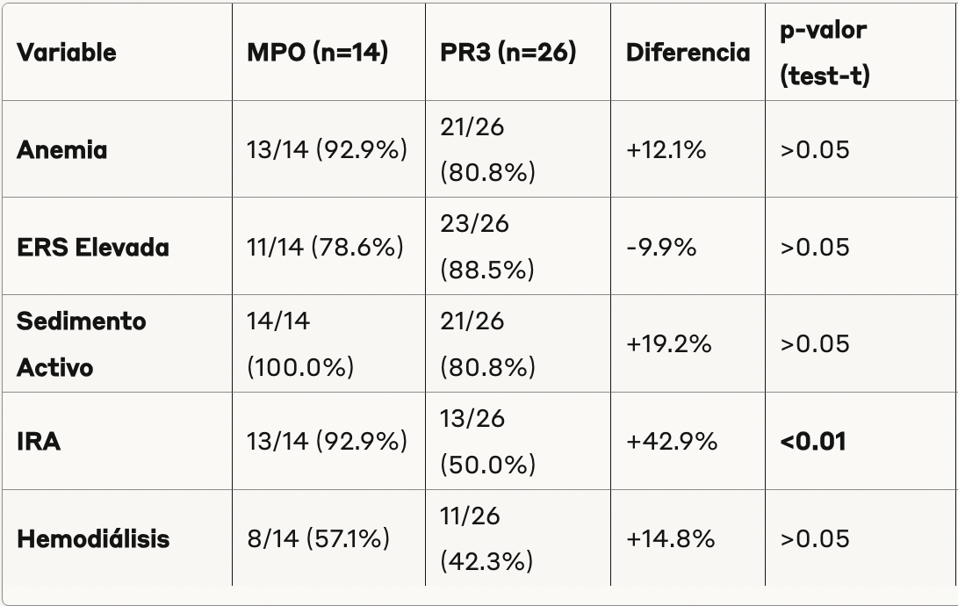

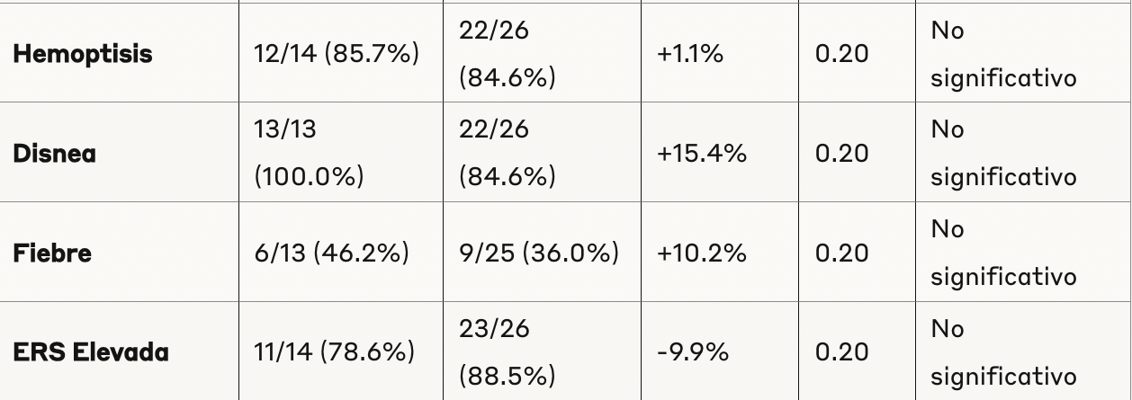

Hacer una sola table de estas dos. En inglés. Chequeen la expresión correcta en inglés mirando cómo la ponen en otros papers. En la columna de la p pongan simplemente NS. Lo único que fue diferente fue la falla renal p = 0.013

Table xxx

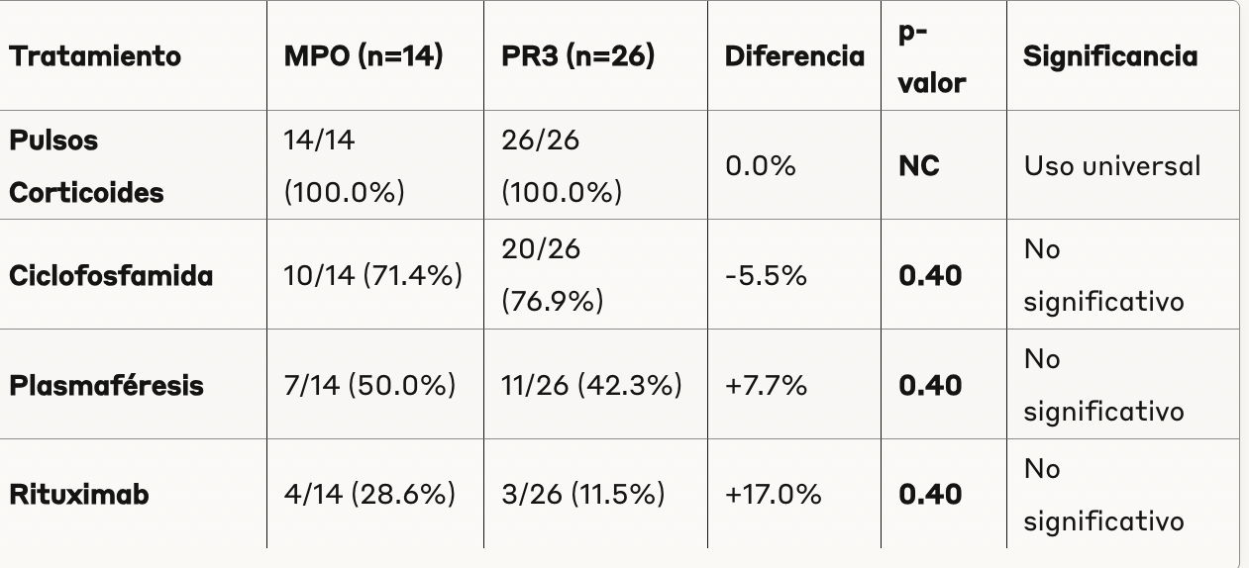

Idem

Table xxxxx

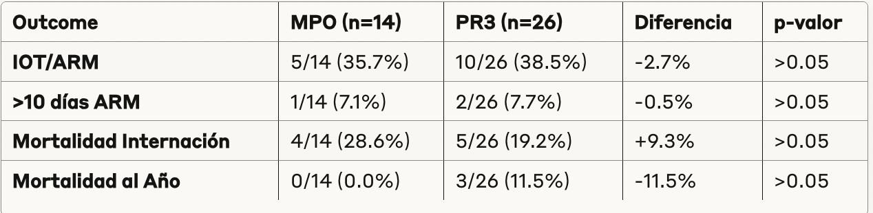

References:
- Escandon, A., Valderrama, M., Londoño, L., Varela, A., & Rueda, J. (2015). Hemorragia alveolar difusa asociada a vasculitis ANCA positiva, manejo con plasmaféresis. Reporte de un caso. Revista Argentina de Reumatología, 26(4), 42-44.
- Quadrelli, S., Dubinsky, D., Solis, M., Yucra, D., Hernández, M., Karlen, H., & Brigante, A. (2017). Immune diffuse alveolar hemorrhage: Clinical presentation and outcome. Respiratory Medicine, 129, 59-62. doi: 10.1016/j.rmed.2017.06.003.
- Collard, H., & Marvin, I. (2004). Diffuse alveolar hemorrhage. Clinics in Chest Medicine, 25, 583-592.
- Gallagher, H., Kwan, J. T., & Jayne, D. R. (2002). Pulmonary renal syndrome: a 4-year, single-center experience. American Journal of Kidney Diseases, 39, 42e7.
- Lara, A. R., & Schwarz, M. I. (2010). Diffuse Alveolar Hemorrhage. Chest, 137, 1164-1171.
- Leatherman, J. W., Davies, S. F., & Hoidal, J. R. (1984). Alveolar hemorrhage syndromes: diffuse microvascular lung hemorrhage in immune and idiopathic disorders. Medicine (Baltimore), 63, 343e61.
- De Lassence, A., Fleury-Feith, J., Escudier, E., Beaune, J., Bernaudin, J-F., & Cordonnier, C. (1995). Alveolar hemorrhage. Diagnostic criteria and results in 194 immunocompromised hosts. American Journal of Respiratory and Critical Care Medicine, 151(01), 157–163.
- Rolla, G., Heffler, E., Guida, G., Bergia, R., & Bucca, C. (2005). Exhalo NO en hemorragia alveolar difusa. Thorax, 60(07), 614-615.
- Cordier, J. F. (1996). A lung biopsy is unnecessary in the management of ANCA-positive patients with chest-roentgenographic abnormalities. Sarcoidosis, Vasculitis, and Diffuse Lung Diseases, 13(03), 235–237.
- De Prost, N., Parrot, A., Cuquemelle, E., et al. (2012). Diffuse alveolar hemorrhage in immunocompetent patients: etiologies and prognosis revisited. Respiratory Medicine, 106, 1021e1032.
- Travis, W. D., Colby, T. V., Lombard, C., & Carpenter, H. A. (1990). A clinicopathologic study of 34 cases of diffuse pulmonary hemorrhage with lung biopsy confirmation. American Journal of Surgical Pathology, 14, 1112-1121.
- Klemmer, P. J., Chalermskulrat, W., Reif, M. S., Hogan, S. L., Henke, D. C., & Falk, R. J. (2003). Plasmapheresis therapy for diffuse alveolar hemorrhage in patients with small-vessel vasculitis. American Journal of Kidney Diseases, 42, 1149–53.
- Walsh, M., Merkel, P. A., Peh, C. A., et al. (2020). Intercambio de plasma y glucocorticoides en vasculitis grave asociada a ANCA. New England Journal of Medicine, 382, 622-31.
- Cartin-Ceba, R., Diaz-Caballero, L., Al-Qadi, M. O., Tryfon, S., Fervenza, F. C., Ytterberg, S. R., & Specks, U. (2016). Diffuse Alveolar Hemorrhage Secondary to Antineutrophil Cytoplasmic Antibody-Associated Vasculitis: Predictors of Respiratory Failure and Clinical Outcomes. Arthritis & Rheumatology, 68(6), 1467-1476. doi: 10.1002/art.39562.
- Kahl, G. N., Orazi, M. L., De Vito, E. L., Dubra, C. L., Svetliza, G. N., & Precerutti, J. A. (2016). Hemorragia alveolar difusa: Diez años de experiencia. Diario Americano de Medicina Respiratoria, 16(1), 84-89.
- Hruskova, Z., Casian, A. L., Konopasek, P., Svobodova, B., Frausova, D., Lanska, V., et al. (2013). Long-term outcome of severe alveolar haemorrhage in ANCA-associated vasculitis: a retrospective cohort study. Scandinavian Journal of Rheumatology, 42, 211–4.
- Quartuccio, L., Bond, M., Isola, M., Monti, S., Felicetti, M., Furini, F., et al. (2020). Alveolar haemorrhage in ANCA-associated vasculitis: Long-term outcome and mortality predictors. Journal of Autoimmunity, 108, 102397. doi: 10.1016/j.jaut.2019.102397.
- Kostianovsky, A. M., Hauser, T., Pagnoux, C., Cohen, P., Daugas, E., Mouthon, L., & Jean-Francois, C. (2010). Alveolar hemorrhage (AH) in ANCA-associated vasculitis: characteristics and prognostic factors in 65 patients. Arthritis & Rheumatism, 30, S77–S82.

- Badsha H, Cheng LT, Kok OK, et al. Pulmonary hemorrhage in systemic lupus erythematosus. Semin Arthritis Rheum. 2004;33:21-37.
- Chung SA, Langford CA, Maz M, et al. 2021 American College of Rheumatology/Vasculitis Foundation guideline for the management of antineutrophil cytoplasmic antibody-associated vasculitis. Arthritis Rheumatol. 2021;73:1366-1383.
- Cordier JF, Valeyre D, Guillevin L, et al. Pulmonary Wegener's granulomatosis. A clinical and imaging study of 77 cases. Chest. 1990;97:906-912.
- Franssen CF, Gans RO, Arends B, et al. Differences between anti-myeloperoxidase- and anti-proteinase 3-associated renal disease. Kidney Int. 1995;47:193-9.
- Fussner LA, Flores-Suárez LF, Cartin-Ceba R, et al. Alveolar Hemorrhage in Antineutrophil Cytoplasmic Antibody–Associated Vasculitis: Results of an International Randomized Controlled Trial (PEXIVAS). Am J Respir Crit Care Med. 2024;209(9):1141-1151.
- Gallagher H, Kwan JT, Jayne DR. Pulmonary renal syndrome: a 4-year, single-center experience. Am J Kidney Dis. 2002;39:42-47.
- Hauer HA, Bajema IM, van Houwelingen HC, et al. Renal histology in ANCA-associated vasculitis: differences between diagnostic and serologic subgroups. Kidney Int. 2002;61:80-9.
- Haworth SJ, Savage CO, Carr D, et al. Pulmonary haemorrhage complicating Wegener's granulomatosis and microscopic polyarteritis. Br Med J. 1985;290:1775-1778.
- Hilhorst M, van Paassen P, Tervaert JWC. Proteinase 3-ANCA vasculitis versus myeloperoxidase-ANCA vasculitis. J Am Soc Nephrol. 2015;26(10):2314-27.
- Jennette JC, Wilkman AS, Falk RJ. Anti-neutrophil cytoplasmic autoantibody-associated glomerulonephritis and vasculitis. Am J Pathol. 1989;135:921-30.
- Klemmer PJ, Chalermskulrat W, Reif MS, et al. Plasmapheresis therapy for diffuse alveolar hemorrhage in patients with small-vessel vasculitis. Am J Kidney Dis. 2003;42:1149-1153.
- Lauque D, Cadranel J, Lazor R, et al. Microscopic polyangiitis with alveolar hemorrhage: a study of 29 cases and review of the literature. Medicine (Baltimore). 2000;79:222-233.
- Lionaki S, Blyth ER, Hogan SL, et al. Classification of antineutrophil cytoplasmic autoantibody vasculitides: the role of antineutrophil cytoplasmic autoantibody specificity for myeloperoxidase or proteinase 3 in disease recognition and prognosis. Arthritis Rheum. 2012;64:3452-62.
- Lyons PA, Rayner TF, Trivedi S, et al. Genetically distinct subsets within ANCA-associated vasculitis. N Engl J Med. 2012;367:214-23.
- Mohammad AJ, Segelmark M. A Population-based Study Showing Better Renal Prognosis for Proteinase 3 Antineutrophil Cytoplasmic Antibody (ANCA)–associated Nephritis Versus Myeloperoxidase ANCA–associated Nephritis. J Rheumatol. 2014;41(7):1366-73.
- Qi F, Hao J, Wei W. Impact of different ANCA serotypes on the long-term outcome of ANCA-associated vasculitis patients. Ann Med. 2023;55(2):2289614.
- Quartuccio L, Bond M, Isola M, et al. Alveolar haemorrhage in ANCA-associated vasculitis: Long-term outcome and mortality predictors. J Autoimmun. 2020;102397.
- Stone JH, Merkel PA, Spiera R, et al. Rituximab versus cyclophosphamide for ANCA-associated vasculitis. N Engl J Med. 2010;363:221-232.
- Unizony S, Villarreal M, Miloslavsky EM, et al. Clinical outcomes of treatment of anti-neutrophil cytoplasmic antibody (ANCA)-associated vasculitis based on ANCA type. Ann Rheum Dis. 2016;75:1166-9.
- Wallace ZS, Fu X, Harkness T, et al. All-cause and cause-specific mortality in ANCA-associated vasculitis: overall and according to ANCA type. Rheumatology. 2020;59(9):2308-2315.
- Yadavalli JNR, Telang K, Khatri P, et al. Long term outcomes of diffuse alveolar haemorrhage in antineutrophil cytoplasmic antibody-associated vasculitis: a single centre study. Ann Rheum Dis. 2023;82(Suppl 1):1366.
- Yates M, Watts RA, Bajema IM, et al. EULAR/ERA-EDTA recommendations for the management of ANCA-associated vasculitis. Ann Rheum Dis. 2016;75:1583-1594.
- Aljuhani, M., Makati, D., Hoff, A., Thompson, J., Pellegrino, B., Shawwa, K., Schmidt, R., & Kannabhiran, D. (2021). Antibody subtypes and titers predict clinical outcomes in ANCA-associated vasculitis. Rheumatology International, 41, 965 - 972. https://doi.org/10.1007/s00296-021-04802-w.
- Vogt, K., Fink, C., Schreibing, T., Krämer, S., Reinartz, S., & Rauen, T. (2024). Distinct pulmonary patterns in ANCA-associated vasculitides: insights from a retrospective single center cohort study.. Rheumatology international. https://doi.org/10.1007/s00296-024-05664-8.

