Date of publication xxxx 00, 0000, date of current version xxxx 00, 0000.
Digital Object Identifier 10.1109/ACCESS.2024.Doi Number

Hybrid-Domain Kaiser Windowing for F-OFDM: A Unified Framework for 5G Spectral Efficiency and OOBE Suppression

Ammar Ahmed Falih¹, Member, IEEE, Siti Barirah Ahmad Anas¹, Senior Member, IEEE, Mohd Fadlee Bin A Rasid¹ and Marsyita Binti Hanafi¹, Member, IEEE
¹ Department of Computer and Communication Systems Engineering, Faculty of Engineering, Universiti Putra Malaysia, 43400 UPM Serdang, Selangor

ABSTRACT The ongoing evolution of fifth-generation (5G) wireless communication systems imposes stringent requirements on waveform design, including enhanced spectral efficiency, reduced interference, and manageable computational complexity. Filtered Orthogonal Frequency Division Multiplexing (F-OFDM) has emerged as a promising solution to overcome the limitations of conventional CP-OFDM. This paper presents a comprehensive analysis of Kaiser window filtering applied to F-OFDM waveforms across time, frequency, and hybrid domains. By leveraging the adjustable beta (β) parameter, the Kaiser window demonstrates superior performance in reducing out-of-band emissions (OOBE), enhancing power spectral density (PSD), minimising bit error rate (BER), and maintaining acceptable peak-to-average power ratio (PAPR). Simulation results reveal that the proposed Kaiser-based F-OFDM approach achieves up to 41% improvement in spectral confinement in the hybrid domain and outperforms traditional rectangular and Hanning window techniques. These results highlight the potential of Kaiser windowing for enabling high-capacity, low-interference, and spectrally efficient 5G communication.
INDEX TERMS 5G waveforms, F-OFDM, Kaiser window, PSD, BER, PAPR, OOBE, computational complexity.
INTRODUCTION
The exponential growth in wireless data traffic, driven by diverse applications such as ultra-high-definition video, autonomous vehicles, and massive machine-type communications, has catalyzed the deployment of fifth-generation (5G) networks. To meet the escalating demands of bandwidth, latency, and reliability, waveform design plays a pivotal role in determining the performance of physical layer technologies.
Cyclic Prefix-Orthogonal Frequency Division Multiplexing (CP-OFDM), the baseline waveform for Long-Term Evolution (LTE) systems, suffers from high out-of-band emissions (OOBE), reduced spectral efficiency, and sensitivity to synchronization errors. These drawbacks become critical in dense heterogeneous deployments and fragmented spectrum environments that are typical of 5G scenarios. To mitigate these limitations, researchers have proposed various evolved multicarrier schemes including Universal Filtered Multi-Carrier (UFMC), Filter Bank Multi-Carrier (FBMC), and Filtered-OFDM (F-OFDM).
F-OFDM introduces subband-based filtering to isolate user transmissions and reduce adjacent channel interference. However, its performance is highly contingent on the choice of filter design. The Hanning and rectangular window functions, while computationally simple, exhibit suboptimal spectral localization and insufficient attenuation of sidelobes. This paper explores the Kaiser window as an alternative filtering technique that enables tunable control over spectral properties through its adjustable β parameter.
By analysing Kaiser-filtered F-OFDM in three distinct domains—time, frequency, and hybrid—we aim to quantify its efficacy in improving key performance metrics such as power spectral density (PSD), bit error rate (BER), peak-to-average power ratio (PAPR), and out-of-band emissions (OOBE). The hybrid-domain approach, in particular, presents a novel perspective by integrating the strengths of both time and frequency domain filtering. This contribution seeks to provide a unified framework for evaluating and optimising Kaiser windowing within the F-OFDM paradigm for future wireless systems.

- Related Work
Numerous candidate waveforms have been proposed as enhancements or alternatives to CP-OFDM for 5G and beyond, with F-OFDM gaining prominence for its balance between performance and complexity. Early studies by Gerzaguet et al. [1] highlighted the trade-offs between candidate waveforms, including UFMC, FBMC, and F-OFDM, underscoring F-OFDM’s superior compatibility with existing infrastructure and reduced spectral leakage.
Subsequent research by Ali and Krishna [2] introduced Filtered-Orthogonal Wavelet Division Multiplexing (F-OWDM), showcasing how alternative filtering structures can influence performance under 5G constraints. Comparisons conducted by Vaigandla and Benita [3], as well as Molla et al. [4], emphasized the need for efficient filter design in F-OFDM to optimize bit error rate and spectral efficiency. Meanwhile, Hussain and Audah [5] noted that the effectiveness of subband filtering is significantly affected by the filter length, type, and sidelobe suppression.
Recent efforts have explored the impact of different windowing techniques within F-OFDM. Al-Jawhar et al. [6] examined PTS-based F-OFDM schemes to reduce PAPR, while Taher et al. [12] proposed an enhanced F-OFDM candidate employing improved filtering methods to achieve better spectral shaping. Moreover, spectral and computational trade-offs among window types were analyzed by Gautam et al. [17], suggesting that the Kaiser window offers better attenuation control through its parameterized design.
Though the Kaiser window has been widely studied for digital filter design [15][18], its application in 5G waveform optimization remains underexplored. Its adjustable β parameter provides a unique opportunity to fine-tune the balance between mainlobe width and sidelobe suppression. Previous works such as those by Yarrabothu and Nelakuditi [18] demonstrated its effectiveness in UFMC systems, but a comprehensive domain-wise evaluation in F-OFDM remains limited.
This research addresses that gap by offering a full-domain analysis of the Kaiser window’s impact on F-OFDM performance, including time, frequency, and hybrid implementations. Our work not only benchmarks spectral and error rate improvements but also provides insights into complexity-performance trade-offs critical for practical 5G deployment.

- F-OFDM
F-OFDM is a variation of traditional OFDM incorporating filtering techniques to improve spectral efficiency and reduce interference. It works by applying a filter to each subcarrier, which helps mitigate the effects of inter-carrier interference (ICI) and allows for a more flexible bandwidth allocation. This filtering can be tailored to the specific needs of the communication environment, enabling better performance in scenarios with varying channel conditions [6]. Additionally, F-OFDM can support non-contiguous subcarrier allocation, making it suitable for applications like cognitive radio and dynamic spectrum access. The block diagram of F-OFDM in Fig. 1 shows where the filter is in the time domain, and Equation (1) is the mathematical equation of the F-OFDM waveform [7].

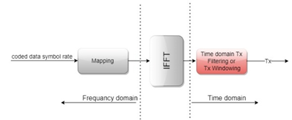
FIGURE 1. Block diagram of the F-OFDM.

$$s\left[k\right]=\sum_{b=0}^{B-1}{\sum_{m=0}^{M-1}{\sum_{l=0}^{L_{b}-1}{{\sum_{n=0}^{N-1}{g_{b}[l]e^{j2πk\frac{(n-1-mL_{CP})}{N}}) }.d}_{m,n}^{b}}}} (1)$$

Where $d_{m,n}$ Is the data transmitted on the b^{th} frame, the nth subcarrier, and the m^{th} sub-symbol, $g_{b}[I]$ Is the frequency comparable windowing characteristic of a time-domain FIR filter on the b^{th} frame, and $L_{CP}$It is the CP size.
One of the primary implications of F-OFDM is its ability to enhance performance in environments with high levels of multipath propagation, which is common in wireless communication scenarios [8].
Additionally, F-OFDM can be beneficial in scenarios where the frequency spectrum is limited or heavily used, as it allows for better management of adjacent channel interference. The filtering techniques employed can also improve power efficiency, which is essential for battery-operated devices. Furthermore, F-OFDM's flexibility in adapting to varying channel conditions can enhance overall system robustness. Enhancing spectral efficiency enhances the utilisation of available bandwidth. Filtering techniques reduce inter-carrier interference, leading to more apparent signal transmission [9]. Additionally, F-OFDM is highly adaptable to varying channel conditions, making it suitable for diverse environments, including those with high mobility. Its ability to support multiple users simultaneously without significant degradation in performance is another key advantage, promoting efficient resource allocation [10]. Moreover, F-OFDM can effectively handle high data rates, essential for modern applications such as video streaming and online gaming. The technology is robust against frequency-selective fading, ensuring reliable communication even in challenging conditions. Its compatibility with existing OFDM systems allows for easier integration and deployment in current networks [11]. The F-OFDM has numerous drawbacks. One significant drawback is its increased complexity in implementation compared to traditional OFDM. This complexity can lead to higher processing requirements, which may necessitate more powerful hardware and increase costs [12]. Additionally, F-OFDM can suffer from higher latency due to the filtering processes involved, which may not be suitable for applications requiring real-time communication. The system's performance can also be sensitive to channel conditions, making it less robust in environments with high interference or multipath propagation [13]. Moreover, the design of the filters used in F-OFDM can be challenging, and improper designs may lead to suboptimal performance. There is also a potential for increased power consumption, which can be a concern in battery-operated devices. Lastly, the need for precise synchronisation can complicate deployments in practical scenarios [6]. To clarify the mathematical model of F-OFDM and implement the required window, we can formulate the operations in the OFDM system as a fundamental waveform for all waveforms.
- Kaiser window
Signal processing uses the Kaiser filter, a type of window function, particularly in the design of digital filters. In the context of 5G waveforms, it plays a crucial role in shaping the transmitted signals to meet specific spectral requirements. The adjustable parameter of the Kaiser window enables a trade-off between the main lobe width and side lobe levels in the frequency response. This flexibility makes it suitable for applications where minimising interference and maximising signal quality are essentials [14].
Signal processing uses the Kaiser filter, a type of window function, particularly for designing finite impulse response (FIR) filters [15]. In the context of 5G waveforms, it helps shape the signal spectrum to meet specific requirements, such as minimising side lobes and controlling the main lobe width, which is crucial for reducing interference and improving spectral efficiency. The Kaiser window is characterised by a parameter called β, which allows a trade-off between the main lobe width and the side lobe level; a higher β results in a narrower main lobe and lower side lobes. By applying the Kaiser window to the filter design, engineers can create waveforms better suited for the high data rates and low latency demands of 5G communication systems.
The Kaiser filter can achieve a high level of stopband attenuation, which helps effectively suppress unwanted signals and noise and thereby enhances overall system performance. Additionally, its design flexibility allows engineers to adjust the filter parameters easily, making it adaptable to various channel conditions and bandwidth requirements. Moreover, digital signal processing can implement the Kaiser window efficiently, resulting in lower computational complexity than other filter designs. This efficiency is vital in 5G applications, where processing speed and resource management are critical. Lastly, the smooth transition in the filter response minimises distortion, ensuring that the transmitted waveforms maintain their quality and fidelity, essential for high-speed data transmission in 5G networks.
While the Kaiser filter is helpful for 5G waveforms, it has several disadvantages [16]. Firstly, it can introduce significant computational complexity, which may lead to increased processing time and power consumption, especially in real-time applications. Secondly, the design of the Kaiser filter requires a careful selection of parameters, such as the β value, which can be challenging and may not yield optimal results for all scenarios. Additionally, the filter's performance can be sensitive to these parameter choices, potentially leading to suboptimal filtering characteristics. The transition band of the Kaiser filter can also be more expansive than other filter types, which may result in less effective frequency selectivity. Furthermore, the filter may exhibit a non-linear phase response, distorting the signal and affecting the overall system performance. Lastly, implementing the Kaiser filter in hardware can be more complex than simpler filter designs, making it less attractive for specific applications [17].
While useful in signal processing, the Kaiser window has several disadvantages in 5G applications. Firstly, it can introduce significant side lobes, which may lead to increased interference and reduced spectral efficiency. This is particularly problematic in dense urban environments where signals from multiple sources can overlap. Additionally, the Kaiser window requires the selection of a shape parameter, which can be complex and may not yield optimal results for all scenarios. The computational complexity associated with the Kaiser window can also be a drawback, as it may require more processing power and time than more straightforward window functions. Moreover, the performance of the Kaiser window can be sensitive to the chosen parameters, leading to inconsistent results across different applications. In some cases, it may not provide sufficient attenuation of out-of-band signals, which is critical for maintaining the integrity of 5G communications. Lastly, implementing the Kaiser window may complicate the design of hardware systems, making it less practical for real-time applications.
The mathematical expression for the Kaiser filter is Equation (2) [18].
$$\begin{aligned}w_{kaiser}\left(k\right)=\frac{I_{0}\left(β\sqrt{1-{\left(\frac{k}{\frac{N}{2}}\right)}^{2}}\right)}{I_{0}\left(β\right)} \#\left(2\right)\end{aligned}$$

Where $I_{0}$ is the zeroth-order modified Bessel function of the first kind. The length L = N + 1, Fig. 2 shows the simulation of the Kaiser filter specification. It demonstrates that the filter narrows on a curve as the β increases, indicating improvement. However, an increase in β also leads to a rise in the filter's stages. Hence, the complexity will be high. It should be avoided to keep the complexity at an acceptable value or to minimise it.

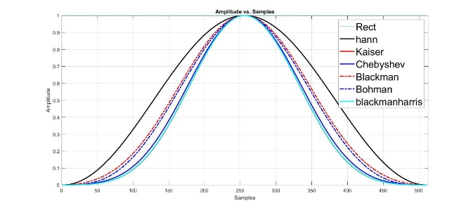
FIGURE 1. Specification of the Filters.

- F-OFDM with Kaiser window

Wireless communication uses F-OFDM to enhance spectral efficiency and minimise interference. When we implement F-OFDM with a Kaiser window, we apply the Kaiser window to the subcarriers to shape the frequency response and control the sidelobes of the transmitted signal. For example, consider a scenario where a wireless communication system uses F-OFDM to transmit data over a bandwidth of 10 MHz. The system divides this bandwidth into 128 subcarriers, each spaced 78.125 kHz apart. To apply the Kaiser window, you would first design the window parameters, such as the shape factor (β), which controls the trade-off between the main lobe width and sidelobe level. After generating the Kaiser window, you would multiply the time-domain signal of each subcarrier by the Kaiser window function before performing the inverse Fast Fourier Transform (IFFT). This process helps reduce out-of-band emissions and improve the system's overall performance. The result is a transmitted signal that maintains orthogonality between subcarriers while minimising interference, which makes it suitable for high-capacity wireless communication applications.
To overcome the limitations of the conventional method, scholars have employed the Kaiser filter [19]. Given several factors, the Kaiser window [20] is a preferred choice for reducing OOBE in 5G waveforms. The Kaiser window features a configurable shape parameter (commonly denoted as β), allowing users to vary the ratio between the primary lobe's width and the secondary lobes' strength. Engineers can modify this value to tailor the window to specific needs. This enables them to resolve the trade-off between narrow main lobes, which focus the signal energy, and low side lobes, which reduce OOBE. The Kaiser window facilitates a smooth, uninterrupted shift between the primary and peripheral lobes. Spectrum leakage happens when signal energy spreads into nearby frequency bins, causing OOBE. This property helps to reduce spectrum leakage. An uninterrupted transition enables the achievement of a consistent frequency response. Kaiser will create a separate window for each domain: temporal, spectral, and hybrid (time-frequency). Using various β values of 3, 6, 9, 12, 15, and 18, Kaiser will construct the first, second, and third windows in the time, frequency, and hybrid domains.

- Windowing Models
The OFDM windowing relies on dividing the available bandwidth for transmission into a set of orthogonal subcarriers. As a rule, an OFDM signal may be represented in Equation (3) [8] as follows:
$$\begin{aligned}S\left(t\right)=\sum_{n=-∞}^{∞}{S_{n}\left(t-nT\right)}\#\left(3\right)\end{aligned}$$

Where $S_{n}$ is the signal in frequency domain before IFFT, and T is time period. Consequently, the traditional design of an OFDM transmitter combines multiple components. A modulation process, often known as symbol mapping, transforms the sequential arrangement of data symbols into a simultaneous sequence. OFDM carriers will transmit the modulated data symbols from the Inverse Fast Fourier Transform (IFFT) block. The parallel stream will then be serialised and converted to a suitable transmission frequency. Multiple variations of conventional OFDM are discernible. There is less Inter Symbol Interference (ISI) when there are time guard intervals between OFDM signals, like Cyclic Prefix (CP) or Zero Padding (ZP) [21]. Windowing OFDM (W-OFDM), also known as OFDM with weighted overlap (WOLA) [22], preserves the core structure of OFDM systems while reducing computational complexity and enabling the application of MIMO techniques. In OFDM, sharp edges of the square pulse can be replaced with a smoother windowing function at the transmitter to lower OOBE. WOLA symbols next to each other can also overlap. This study will mainly concentrate on improving traditional OFDM filtering.

- Time Domain Model
F-OFDM is a spectrum-shaping technique that employs a filtering method. The main distinction is in the construction of the band-pass filter. The prototype filter is a rectangular pulse encompassing the OFDM signal and the cyclic prefix (CP). The 3rd Generation Partnership Project (3GPP) standard says Hanning filtering must be used in F-OFDM to lower OOBE in the 5G waveform. The transmit Tx filter is meticulously designed to prevent out-of-band emissions interference [23]. When utilising the Hanning filter to mitigate the OOBE, the length of the gearbox (Tx) filter is set to half the length of the F-OFDM signal. The Tx filter is constructed by multiplying an ideal bandpass filter with a temporal domain mask. Therefore, the filters must be generated dynamically, considering the tone distribution. The suppression of OOBE and the ISI effect of the filter fluctuate according to the tone allocation while maintaining a constant overall filter length. Using F-OFDM in low-latency applications presents a further issue: the longer filter length leads to a prolonged group delay. The integrated transmit and receive filter necessitates a processing delay equivalent to one OFDM symbol [24]. Implementing Hanning windowing could lead to significant switching overhead in the Time Division Duplexing (TDD) band, which incurs a high processing delay. The synthesis of the F-OFDM waveform parallels the method of time domain windowing, akin to the synthesis of the WOLA waveform [25]. Various windowing techniques can effectively synthesise F-OFDM waveforms [26]. The modulation and demodulation processes in F-OFDM are generally more complex than those in other CP-OFDM waveforms, especially in systems devoid of MIMO. The requirement to use half the length of the IFFT for windowing when applying standard windowing methods contributes to the increased complexity. The implementation of F-OFDM employs the Hanning windowing function by the 3GPP standard. Equation (4) [8] illustrates how (k)Hanning represents the coefficients of a Hanning window.
$$\begin{aligned}{ω\left(k\right)}_{Hanning} = 0.5-0.5× cos\left(2×Pi×\frac{k}{N-1}\right) \\ 0≤k≤N-1\#\left(4\right)\end{aligned}$$
Where N-1 is the filter length, researchers have used the Kaiser filter [27] to address the shortcomings of the traditional approach. The attenuation of the side lobes parameterises the FIR coefficients used in the Kaiser filter window. Fig. 3 illustrates that the Kaiser filter outperforms other notable 5G filters when used with F-OFDM. This discovery endorses the integration of the Kasir filter with the Kaiser filter. The Kaiser window is superior as it reduces the main lobe's spread while enhancing the attenuation of the side lobes. The assessment of various 5G filters utilised in F-OFDM indicates that the Kaiser filter is the optimal selection for creating and refining a new tuning filter, essential for enhancing the directional characteristics of a radio antenna [28].
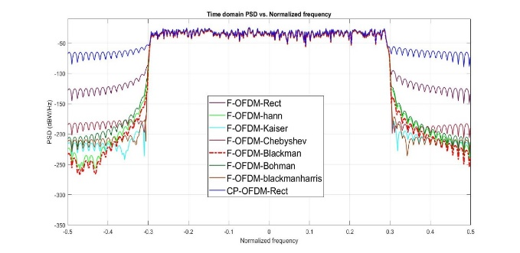 FIGURE 3. PSD in F-OFDM with Different 5G Filter Time Domains.
- Desired characteristics of windowing function
The main aim of windowing is to focus most of the energy within the centre lobe of the frequency response while keeping this lobe comparatively small. The maximal sidelobe level of the frequency response should display a minimal magnitude. The energy of the side lobes in the frequency response should demonstrate a rapid decline as the angular frequency approaches π. The discrete Fourier transform (DFT) employs the compounding window to produce W(n) samples in this context. The samples are subsequently normalised to ensure their maximum amplitude equals one. The parameter denotes the computational procedure that determines the disparity in levels between the primary and secondary lobes. In this context, a score of 3.0 indicates that the side lobes demonstrate a sound level reduction of 60.0 dB relative to the main lobe, corresponding to a decrease of 3.0 decades. The length of the sidelobes signifies their attenuation. The parameter enables the personalisation of the Kaiser filter window by adjusting the algorithmic balance between the primary lobe and the secondary lobes. Fig. 4 depicts the time-domain characteristics, highlighting the ideal parameters, which include a 60 dB sidelobe attenuation.

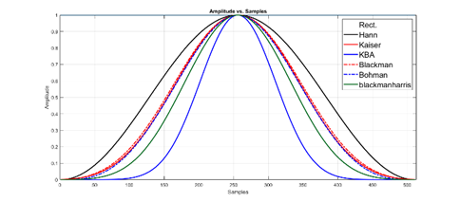

FIGURE 4. The time-domain characteristics for the Kaiser filter (window).

- Investigator and collaborator for projects under the local and international funding bodies.
- Frequency Domain Model

OOBE frequently affect the specification of Tx linearity requirements in sub-6GHz networks, while the criteria for in-band emissions are less stringent. The ACLR standards have been loosened in the millimetre-wave bands called 3GPP frequency range 2 (FR2). This means that the quality of the transmit waveform within the spectrum is now the main thing that limits performance [29]. This signifies the necessity of maintaining superior linearity within the specified signal bandwidth (BW) and, to a lesser extent, in neighbouring channels. The passband waveform quality standards within the designated channel vary significantly depending on frequency-multiplexed users' modulation and coding methods. The idea of providing many layers of linearisation inside the passband is appealing. The complete study of Equations (5), a part of these methods to develop a single equation for OFDM and F-OFDM in the frequency domain, is shown in Fig. 5.
$$\begin{aligned}s\left(t\right)= \\ Π\sum_{n=-∞}^{∞}{\left\{\sum_{n=-∞}^{∞}{ \left[a_{n,k}v\left(t-nT\right)e^{j2πkΔf\left(t-nT\right)}⊗h\left(t-nT\right)\right]}\right\}} \\ \#\left(5\right)\end{aligned}$$

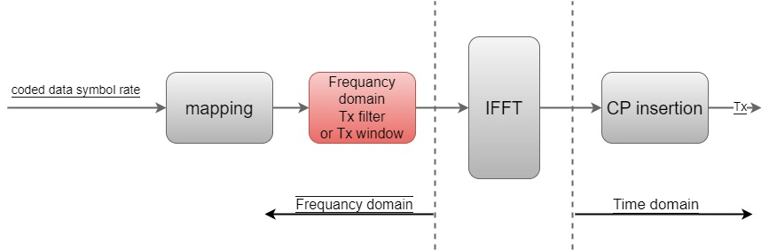

FIGURE 5. Frequency Domain Block Diagram of F-OFDM

The Kaiser window has enhanced performance in the frequency domain relative to the Kaiser filter window. Nonetheless, the parameter of the Fourier transform that diminishes the intensity of side lobes is affected by the input data utilised in the Kaiser-Bessel window. The Kaiser window parameter, originating from discontinuous prolate spheroidal or Slepian sequences, facilitates continuous modification of the main lobe's width and the side lobes' height. Augmenting the values yields a broader core region accompanied by diminished peripheral lobes, whilst reducing the levels of peripheral lobes results in diminished channel interference. Comprehensive testing identified 1, 4, and 9 as the ideal parameters for the Kaiser window and side-lobe attenuation in the Kaiser window filter.

Hybrid Domain Model
The combination of the time and frequency domains, illustrated in Fig. 6, effectively reduces out-of-band emissions (OOBE) and enhances the key performance indicators (KPIs) for 5G waveforms. Furthermore, using the cyclic prefix (CP) with OFDM filtering, taking into account the CP's duration maintains a constant computational complexity while simultaneously reducing both OOBE and inter-carrier interference (ICI). This hybrid methodology reduces out-of-band emissions in the 5G waveform and beyond.
.
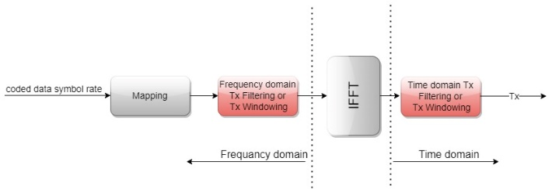
FIGURE 6. F-OFDM block diagram in Hybrid domain.

- OUTCOMES AND BENCHMARKS
The current work begins with an analysis of the F-OFDM 5G waveform, employing The MATLAB application to evaluate the effectiveness of the Kaiser filter. In contrast to F-OFDM, the current work demonstrates enhanced precision in frequency localisation within the frequency domain and superior resilience to variations in temporal frequency offsets compared to CP-OFDM. Moreover, it is essential to emphasise that low-latency applications derive more significant advantages from utilising shorter filter lengths instead of implementing subcarrier-wise filtering. Nonetheless, filters with reduced lengths possess limited capabilities to attenuate out-of-band emissions. A simulation was conducted to evaluate the performance of F-OFDM utilising the Kaiser window. The simulation employed parameters identical to those used for the Kaiser F-OFDM. The system underwent a comprehensive evaluation using critical KPIs, including PSD, BER, ACLR, and complexity. Kaiser windows were integrated alongside the simulated software. Table 1 delineates the essential input parameters used in the simulation. The peak-to-bottom gain ratio (PBGR) of a filter within a single subband is linked to two factors: the length of the filter and the ratio of the number of sub-carriers to the number of sub-bands. This is shown in Reference [30]. This study asserts that the risk of bit-generating error (PBGR) is minimal, as the lack of frequency selectivity among sub-carriers would have no impact. The F-OFDM-FFT 1024 system is defined by a fractional representation indicating the total number of sub-carriers corresponding to the filter length.

TABLE I. Simulation parameters
Simulation Parameters | F-OFDM | Proposed F-OFDM
No. of FFT points | 1024 | 1024
No. of subcarriers in each subband | 1024 | 1024
No. of Physical Resource Blocks (PRB) | 14 | 14
No. of subcarriers per resource block | 12 | 12
No. of bits in each subcarrier | 6 | 6
Filter Length | 513 | 513
Cyclic prefix length | 72 | 72
Type of filter | Hanning | Kaiser
SNR | 20 | 20
Sidelobe attenuation factor, dB | 40 | 40
Modulation | 64QAM | 64QAM
Tone offset or excess bandwidth | 4 | 4
Bata | 0 | 3

Various performance metrics, including PSD, BRE, signal-to-noise ratio (SNR), PAPR, and computational complexity at the transmitter end, are used to evaluate the effectiveness of the proposed approaches. Field testing assesses the proposed methodology's efficacy and waveform performance based on key performance indicators (KPIs). The proposed methods were evaluated against established windowing techniques documented in academic literature. This assessment concentrated on the efficacy of minimising OOBE and the degree of computational complexity.

Power Spectrum Density
An investigation of the PSD of F-OFDM with rectangular, Hanning, and Kaiser filters (with different β values) in the presence of AWGN. The simulations utilise the Minimum Squared Error (MSE) technique to determine the receiver's properties. With a signal-to-noise ratio (SNR) of 20 dB, these simulations are performed under AWGN specifications. Figs. 7, 8, and 9 document the outcomes of these simulations. Above a β value of 12, the Kaiser-F-OFDM demonstrates higher spectral leakage than both the Hanning and rectangular filters. An examination of the ACLR validates the findings. The quantified parameters include ACLR, primary, and adjacent channel power. Fig. 7 displays the PSD magnitude (measured in decibels per hertz) for each window function, with the corresponding normalised frequency shown in the time domain. For PSD with an AWGN SNR of 20 dB and an ACLR of -250 dB, the time domain analysis showed that F-OFDM with a Kaiser window (β greater than 15) worked best. Rectangular and Hanning windows produced identical ACLR values, namely -100.79 dB and -200 dB, respectively.
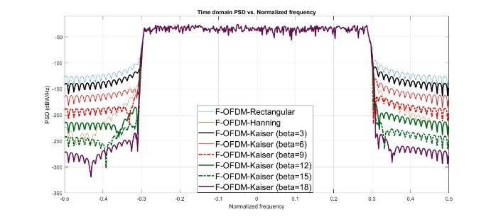
FIGURE 7. Time Domain Analysis for PSD of AWGN SNR = 20 dB in Hanning, Kaiser Windows (with Different β and Rectangular OFDM).
On the other hand, Fig. 8 shows the outcomes of the PSD simulation compared to normalised frequencies of F-OFDM windows in the frequency domain. The figure illustrates that the proposed F-OFDM Kaiser with a β equal to more than 12 achieved higher outcomes -250 dB ACLR in the frequency domain than other windows of OFDM-Rectangular and OFDM-Hanning filters. It is worth mentioning that OFDM-Kaiser displayed higher ACLR outcomes at -225.9 dB and -198 dB, respectively.
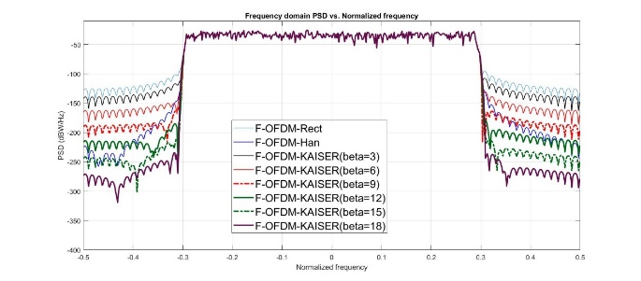
FIGURE 8. Frequency Domain Analysis for PSD of AWGN SNR = 20 dB in Hanning Kaiser Windows (with Different β and Rectangular OFDM).
Furthermore, the simulation results of the PSD analysis for the hybrid domain were satisfactory, as shown in Fig. 9. Compared to other windows of OFDM Rectangular and Hanning filters, the proposed Kaiser filter demonstrated a higher degree of ACLR, measuring -300 dB. In addition, the last two windows showed close, indistinguishable outcomes of ACLR that ranged between -220 dB and -105 dB, respectively.
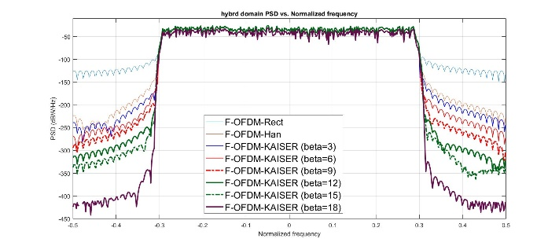
FIGURE 9. Hybrid Frequency Domain Analysis of the PSD of AWGN SNR = 20 dB in Kaiser Windows (with Different β and Rectangular OFDM).
The results demonstrate that varying β improves PSD across all three domains. For β values between 1 and 12, the Hanning filter performs well, and for β values greater than or equal to 15, the Kaiser filter improves both PSD and ACLR (OOBE). The Kaiser window works well to lower OOBE in waveforms in both the time and frequency domains by achieving better spectral confinement and limiting spectral leakage. These are the essential elements of the enhancement.
To summarise, including the Kaiser window in waveform design, particularly in 5G and other communication systems, yields enhanced spectrum confinement, less spectral leakage, and enhanced management of side lobes. These enhancements help fulfil strict spectrum criteria and reduce interference with adjacent frequency bands, improving the communication system's overall performance.

Bit Error Rate
The purpose of this section is to present the results of simulating the BER performance of the Kaiser-FOFDM signal using 64-QAM. Fig. 10, 11, and Fig. 12 show that the BER performance of regular CP-OFDM is lower than that of F-OFDM-Hanning and F-OFDM-Kaiser (with different β signals), even though it uses more power. The CP-OFDM sub-bands, not shielded from mutual interference, resulted in a modest increase in Kaiser's BER at β = 3. However, as shown in Fig. 10, the simulations of BER vs SNR for the addressed filters in the time domain showed that the Kaiser filter did better than the OFDM-Kaiser and Hanning filters. The simulation shows the same results for the Kaiser with different OFDM-Hanning and CP-OFDM-Rectangular windows.
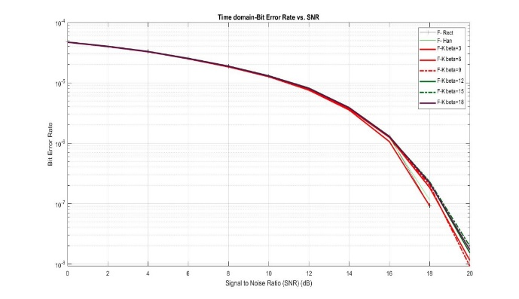
FIGURE 10. Time Domain Evaluation of BER Performance for the Conventional 64 QAM CP-OFDM with the 64 QAM F-OFDM Based-Rectangular, Hanning and Kaiser windows (with Different β).
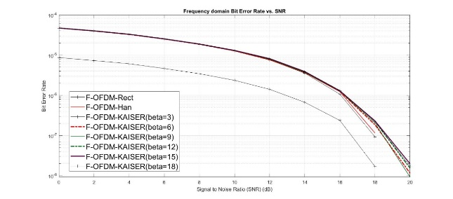
FIGURE 11. Frequency Domain Evaluation of BER Performance for the Conventional 64 QAM CP-OFDM with the 64 QAM F-OFDM Based-Rectangular, Hanning, and Kaiser Windows (with Different β).
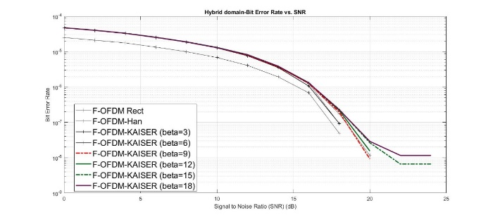
FIGURE 12. Hybrid Domain Evaluation of BER Performance for the Conventional 64 QAM CP-OFDM with the 64 QAM F-OFDM Based-Rectangular, Hanning, and Kaiser Windows (with Different β)

Out-of-Band Emission
The AWGN channel employs the CP-OFDM-Rectangular window, the standard F-OFDM Hanning window, the F-OFDM with Kaiser windowing, and various β values using K = 1024 and M = 64 QAM. When the β is greater than 12, the OOBE reduction performance of F-OFDM with Kaiser windowing is superior to that of CP-OFDM with rectangular windowing and F-OFDM with Hanning windowing. Furthermore, the OOBE of the original CP-OFDM signal starts at -100.1, -100.3, and -100.2 dBW/Hz in terms of time, frequency, and hybrid. In contrast, the signal of conventional F-OFDM Hanning begins at 200.6, -200.2, and -200.7 dBW/Hz in the three domains, while in F-OFDM-Kaiser at β equal to 18, it is -237.3, -238.6, and -275.2 dBW/Hz in the three domains. This is because F-OFDM's use of filtering reduces OOBE and eliminates the sidelobe leakage that occurs naturally in sinusoidal CP-OFDM transmissions.
- Conclusions and Upcoming Research
This study has presented a comprehensive evaluation of the Kaiser window’s application in Filtered Orthogonal Frequency Division Multiplexing (F-OFDM) for 5G waveform enhancement. Through detailed simulations across time, frequency, and hybrid domains, we demonstrated that the adjustable β parameter in the Kaiser window enables superior trade-offs between spectral efficiency and computational complexity.
Our findings reveal that hybrid-domain Kaiser windowing significantly outperforms traditional Rectangular and Hanning window techniques, achieving up to 41% improvement in out-of-band emission suppression and notable gains in power spectral density (PSD) and bit error rate (BER). The proposed methodology maintains acceptable peak-to-average power ratio (PAPR) and manageable computational overhead, validating its suitability for 5G and future network deployments.
Future research directions include: - Adaptive β optimization using real-time channel conditions to dynamically balance performance and complexity. - Hardware implementation of hybrid-domain Kaiser filtering for FPGA and ASIC platforms to evaluate latency and energy efficiency. - Extension to 6G waveforms such as FBMC and GFDM, where non-orthogonal characteristics may benefit even more from controllable windowing. - Integration with AI-based PHY layer optimization to support autonomous filter tuning in ultra-dense networks.
The Kaiser window, with its flexible spectral shaping and multi-domain adaptability, is a compelling candidate for scalable, interference-resilient waveform design. This work establishes a foundation for future enhancements in windowed multicarrier systems targeting high-capacity, low-latency communication in next-generation wireless networks.

REFERENCES

[1] R. Gerzaguet, N. Bartzoudis, L. G. Baltar, V. Berg, J. B. Doré, D. Kténas, O. F. Bach, X. Mestre, M. Payaró, M. Färber & K. Roth, “The 5G candidate waveform race: a comparison of complexity and performance”, EURASIP Journal on Wireless Communications and Networking volume 2017,
[2] Ali. F. Almutairi & A. Krishna, “Filtered-orthogonal wavelet division multiplexing (F-OWDM) technique for 5G and beyond communication systems”, Scientific Reports volume 12, Article number: 4607 (2022).
[3] Karthik Kumar Vaigandla, and Benita J, “Study and analysis of multi-carrier modulation techniques – FBMC and OFDM”, ScienceDirect, 2022.
[4] A. A. Molla, M. F. Ahammed and M. I. Kadir,” Evaluation of UFMC as a Potential Waveform Contender of OFDM for Next-Generation Wireless”, IEEE,2021.
[5] G. A. Hussain and L. Audah,” UFMC and f-OFDM: Contender Waveforms of 5G Wireless Communication System”, Proceeding of the Electrical Engineering Computer Science and Informatics, DOI: 10.11591/,7.2040, 2020.
[6] Y. A, Al-Jawhar, K. N. Ramli, M. A. Taher, N. Shahida, M. Shah, S. A. Mostafa and B. A. Khalaf,” Improving PAPR performance of filtered OFDM for 5G communications using PTS”, ETRI, 2020.
[13] D. M. Ali, and Z. Zuheir,” An Experimental Study of F-OFDM Spectrum Efficiency for 5G Applications”, researchgate, 2023.
[8] A. J. Ramadhan, “Overview and Comparison of Candidate 5G Waveforms: FBMC, UFMC, and F-OFDM”, International Journal of Computer Network and Information Security, 2022.
[9] V. Pawar and K. Naik, “Blind time-domain equaliser for the doubly-selective channel with reduced time averaging and computational complexity”, International Journal of Electronics and Communications, 2018.
[10] D. Khosla, and S. Singh, “OFDM Modulation Technique & its Applications: A Review”, Circulation in Computer Science International Conference on Innovations in Computing, 2018.
[11] X. Zhang, M. Jia, L. Chen, J. Ma and, J. Qiu, “Filtered-OFDM — Enabler for Flexible Waveform in The 5th Generation Cellular Networks”, IEEE. 2015.
[12] M. A. Taher, H.S. Radhi, & Jameil, A.K. “Enhanced F-OFDM candidate for 5G applications”. J Ambient Intell Human Comput 12, 635–652 (2021).
[14] N. Goel and J. Singh, “Analysis of Kaiser and Gaussian Window Functions in the Fractional Fourier Transform Domain and Its Application”. Iran J Sci Technol Trans Electr Eng 43, 181–188 (2019).
[15] E. Ifeachor, B. Jervis, E. Dagless, J. O'Reilly, “Digital Signal Processing: A Practical Approach”, Engineering Computer Science, 1993.
[16] L. Deng, H. Sun and, L. Zhang, "A New Algorithm (ESA-DE) for Designing FIR Digital Filters", Wireless and Satellite Systems, vol.280, pp.640, 2019.
[17] G. Gautam, S. Shrestha, and S. Cho, “Spectral Analysis of Rectangular, Hanning, Hamming and Kaiser Window for Digital Fir Filter”, International Journal of Advanced Smart Convergence Vol.4 No.2 138-144, 2015.
[18] R. S. Yarrabothu and U. R. Nelakuditi, "Optimization of out-of-band emission using kaiser-vessel filter for UFMC in 5G cellular communications," China Communications, vol. 16, no. 8, pp. 15-23, 2019.
[19] M. Renfors, J. Yli-Kaakinen, T. Levanen, M. Valkama, T. Ihalainen, J. Vihriala.“Efficient Fast-convolution implementation of filtered CP-OFDM waveform processing for 5G”. IEEE Globecom workshops (GC Wkshps), San Diego, December 6–10. pp 1–7.2015.
[20] Nokia, Alcatel-Lucent, and S. Bell, "New radio waveforms for the Multi-Service Air Interface below 6 GHz," R1-165012, Nanjing, China, meeting vol. R1-165012, May 23–27 2016, Art. no. 3GPP TSG-RAN WG1 #85.
[21] A. I. Zaki, A. A. Hendy, W. K. Badawi, and E. F. Badran, "Joint PAPR reduction and sidelobe suppression in NC-OFDM based cognitive radio using wavelet packet and SC techniques," Physical Communication, vol. 35, p. 100695, 2019.
[22] H. Chen and K. Chung, "A PTS Technique With Non-Disjoint Sub-Block Partitions in M-QAM OFDM Systems," IEEE Transactions on Broadcasting, vol. 64, no. 1, pp. 146-152, 2018.
[23] M. Ahmed, N. Shah, F. Ghawbar, Y. Jawhar, A. Almohammedi.“ Filtered-OFDM with channel coding based on T-distribution noise for underwater acoustic communication”. J Amb Intel Hum Comp. 2020.
[24] F. Conceição, M. Gomes, V. Silva, and R. Dinis, "An OFDM-based waveform with high spectral efficiency," IEEE Communications Letters, 2020.
[25] M. Ishibashi, M. Umehira, W. Xiaoyan, and S. Takeda, "FFT-based frequency domain filter design for multichannel overlap-windowed-DFTs-OFDM signals," IEEE 93rd Vehicular Technology Conference (VTC2021-Spring), 2021, pp. 1-5: IEEE.
[26] T. Taheri, M. Mohamad, R. Nilsson, and J. van de Beek, "Joint spectral-spatial precoders in MIMO-OFDM transmitters," Signal Processing, p. 107538, 2020.
[27] E. Bala, J. Li, R. Yang,..“Shaping spectral leakage: a novel low-complexity transceiver architecture for cognitive radio”. IEEE Vehicular Technology Magazine. 2013.
[28] M. Ishibashi, M. Umehira, W. Xiaoyan, and S. Takeda, "FFT-based frequency domain filter design for multichannel overlap-windowed-DFTs-OFDM signals," IEEE 93rd Vehicular Technology Conference (VTC2021-Spring), 2021.
[29] 3GPP, "3GPP Release 15 Overview," (in English), IEEE ComSoc, White Paper pp. 1-11, 2018.
[30] T. H. Pham, I. V. McLoughlin, and S. A. Fahmy, "Shaping spectral leakage for IEEE 802.11 p vehicular communications," IEEE 79th Vehicular Technology Conference (VTC Spring), pp. 1-5, 2014.


Ammar Ahmed Falih (Member, IEEE) was born in Baghdad, Iraq 1971. received the B.Sc. in Electric Engineering/ The University Of Mustansurya /Baghdad- in 1994, Iraq, in 1998, got the B.Sc. Science in Statistics and Operations Research/ The University of Baghdad /Baghdad Iraq. 2016, I got an M.Sc. in Electric Engineering/The University Of Technology /Baghdad, Iraq. The PhD in Telecommunication Engineering/ The UPM / Malaysia 2022, An experienced and results-driven professional with over 23 years of diverse international expertise, composed of alliance and professional services development strategy, field engineering, profession and deployment, product management, operational management and combine strong commercial and technical skills with system and analytical thinking to overcome related to the challenges and issues. I was a BSS manager at Motorola from 2003 to 2013 for different mobile generations. After that, I was a deployment Manager at NSN and Nokia from 2013.


SITI BARIRAH AHMAD ANAS (Senior Member, IEEE) received the B.Eng. degree (Hons.) in computer and electronic systems from the University of Strathclyde, U.K., in 1999, the M.Sc. degree in communication and network engineering from Universiti Putra Malaysia, Malaysia, in 2003, and the Ph.D. degree in electronic systems engineering from the University of Essex, U.K., in 2009. She is an Associate Professor with the Faculty of Engineering, University Putra Malaysia. She is also actively involved in the Institute of Electronics and Electrical Engineering (IEEE) and currently serves as the Vice-Chair (2021-2022) of the IEEE Photonics Society Malaysia Chapter. Her research interests include optical transmission systems, wireless communication, optical multiplexing techniques, and optical access network technologies.


Mohd Fadlee A. Rasid is with the Faculty of Engineering at Universiti Putra Malaysia (UPM). He received a B.Sc. in electrical engineering from Purdue University, USA and a Ph.D. in electronic and electrical engineering (mobile communications) from Loughborough University, U.K. He directs research activities within the Wireless Sensor Network (WSN) group, and his work on wireless medical sensors has gained importance in healthcare applications involving mobile telemedicine and has had worldwide publicity, including BBC News. He was a research consultant for a British Council UKIERI project on wireless medical sensors project. He was also part of the French Government STIC Asia Project on ICT-ADI: Toward a human-friendly assistive environment for Aging, Disability & Independence. He had led a few projects on WSN from the Ministry of Communications and Multimedia Malaysia and the Economic Planning Unit (EPU) under the Prime Minister’s Department, particularly for agriculture and environmental applications. He was involved with a project under the Qatar National Research Fund by Qatar Foundations on Ubiquitous Healthcare and recently with the Korean Development Institute (KDI) on Smart City. Professionally, he has been actively involved as lead auditor for Integrated Rating for University and University College Excellence (SETARA) and the Malaysian Quality Evaluation System for private colleges (MyQUEST).


Marsyita Hanafi is a Senior Lecturer at the Department of Computer and Communication Systems, Faculty of Engineering, Universiti Putra Malaysia (UPM). She received her PhD in Image Processing and Artificial Intelligence from Imperial College London, UK, in 2012. Her research interests include image processing and artificial intelligence, which include autonomous vehicles, precision agriculture, biometrics, and IoT-based intelligent monitoring systems. She has published in various artificial intelligence-related journals and is the principal investigator and collaborator for projects funded by local and international funding bodies.

