Title: VIRTUAL ASSESSMENT OF FUNCTIONAL PERFORMANCE IN ELDERLY USING SHORT PHYSICAL PERFORMANCE BATTERY
Authors (to appear on the article; please list only Name, Department, Institution, City, Country, Email):
1. Ajay Kumar S, Department of Physiotherapy, Sri Devaraj Urs Academy Of Higher Education And Research Tamaka, Kolar, Karnataka. Kumarsajay999@gmail.com
2. Dr. Sarulatha H, Professor, Department of Physiotherapy, Sri Devaraj Urs Academy Of Higher Education And Research Tamaka, Kolar, Karnataka. charuparthe@gmail.com
3. Dr. Naveen Kumar I, Assistant Professor, Sri Devaraj Urs Academy Of Higher Education And Research Tamaka, Kolar, Karnataka. naveenk.inba@gmail.com
Full correspondence details (for review) for contact purposes only:
Name | Dr. Sarulatha H, Professor
Department | Department of Physiotherapy
Institution | Sri Devaraj Urs Academy Of Higher Education And Research
Country | India
Tel
Mob | 9686235790
Fax
Email | charuparthe@gmail.com

Full correspondence (for publication) for contact purposes only:
Name | Ajay Kumar S
Department | Department of Physiotherapy
Institution | Sri Devaraj Urs Academy Of Higher Education And Research
Country | India
Email | Kumarsajay999@gmail.com

Abbreviated title: Virtual Assessment of Functional Performance in Elderly Using SPPB

Key words: Feasibility study; short physical performance battery; virtual assessment; telehealth; geriatric care; physiotherapy; geriatric population.
Word Count: Abstract – 250 Words
Introduction, Method, Results, Discussion - 4121
References: 32
Tables: 9
Figures: 10
Graphs: 4
Ethics approval: This study was Ethical Approved by Sri Devraj Urs Academy Of Higher Education And Research(SDUAHER/IEC/mj/180/23-24).
Competing interests: Nil
Source(s) of support: This study was supported by a grant from the Sri Devraj Urs Academy Of Higher Education And Research(SDUAHER/IEC/mj/180/23-24).
Acknowledgements: We are grateful to Dr Sarulatha H and Naveen Kumar I for their help with sample collection and Analysis.

Correspondence: Dr. Sarulatha H, Professor, Department of Physiotherapy, Sri Devaraj Urs Academy Of Higher Education And Research Tamaka, Kolar, Karnataka. charuparthe@gmail.com

Abstract
Introduction: The rising number of elderly individuals in rural areas poses challenges in accessing healthcare, necessitating innovative solutions. The Short Physical Performance Battery (SPPB) is a validated tool for assessing physical performance in older adults. This study aimed to assess the feasibility of conducting SPPB tests virtually and compare these results to in-person assessments.
Methodology: Sixty-nine individuals aged 65 and older participated, meeting set inclusion and exclusion criteria. Each participant completed the SPPB test both virtually and in person in a randomized sequence with a washout period. The SPPB assesses balance, gait speed, and lower limb strength through standing balance, timed walking, and chair stand tests. Virtual assessments were conducted under the supervision of a physiotherapist via an audio- and video-enabled mobile application. Data from both online and offline assessments were analyzed using independent t-tests and Levene’s test for equality of variances. The primary focus was comparing SPPB scores across the two modes to determine if virtual assessments could replicate in-person results.
Results: There was no statistically significant difference in the average SPPB scores between the in-person (mean ± 7.34) and virtual (mean ± 7.19) modes across balance, gait speed, and chair stand components (p > 0.05). High consistency demonstrated that virtual SPPB assessments are as reliable as in-person assessments.
Conclusion: Virtual SPPB assessments are feasible and effective, particularly benefiting older adults in rural or underserved areas with limited healthcare access. Future studies with larger, diverse populations are recommended to further validate these findings and explore broader applications within telehealth.

Keywords: feasibility study; short physical performance battery; virtual assessment; telehealth; geriatric care; physiotherapy; geriatric population.

Introduction
Falls are the number two cause of accidental injury deaths worldwide, claiming over 684,000 lives annually, with the majority occurring in low and middle-income countries. The elderly, aged 60 and above, bear the brunt of fatal falls, with 37.3 million severe incidents necessitating medical attention each year (WHO). The prevalence of falls among older adults in India is estimated to be 31%. The fear of falling among older adults in Karnataka is estimated to be 30-55%. A vital marker for health, particularly for older persons is physical function. Lower quality of life and unfavourable health outcomes, such as cognitive decline, institutionalization, and mortality, are linked to reduced physical function. This widespread problem in older adults substantially negatively influences quality of life; it can lead to accidents, low self-esteem, and greater worry when engaging in daily tasks. Early detection and management are crucial in alleviating impaired physical function in community-dwelling adults, given the significant burden associated with age-related functional decline. This will help to prevent functional decline and dependency.
The cause of falls is muscle weakness, lack of strengthening of the muscle, lack of proprioception, and neuropathic changes which are very common in the elderly with associated Diabetes mellitus and hypertension. So role of the screening these causes like changes in gait, balance impairment & lower limb weakness.
Various assessment tools exist to address fall risk in older adults, yet none stand as a definitive gold standard. Widely used tools like the Berg Balance Scale and the time-consuming Tinetti Performance-Oriented Mobility Assessment (POMA) scale provide effective insights. However, in this context, the Short Physical Performance Battery (SPPB) is sensitive in the elderly & and emerges as a promising option, assessing 4-meter walking speed, and balance, and predicting mobility disability. Studies have indicated a correlation between poor performance on the Short Physical Performance Battery and unfavourable health outcomes, including placement in a nursing home, a greater need for caregiver assistance, a reduction in functional abilities, and death. Its simplicity, efficiency, and cost-effectiveness position it as an ideal instrument for evaluating geriatric clinical conditions.
In addition in addition to covering digital technology options using electronic information and telecommunication technologies to support long-distance clinical healthcare, patient professional health-related education, health administration, and public health, digital health also encompasses categories like mobile health, health information technology, virtual screening, and Telehealth. It covers digital consumers such as anyone using a computer or smartphone to seek medical attention. The virtual screening enables the elderly to undergo fall risk evaluation at home, in the facility, and in the community. Ogawa and colleagues found that virtual functional fitness assessments have high reliability and support the utility of these tests to identify clinically significant improvements in managing conditions such as diabetes and depression. It is expected that feasibility of virtual assessment, many elderly from their own facility can be screened for fall risk and those with minimal to high risk category can be intervened with a tailored health care program virtually or physically. Since the elderly don’t visit the hospital often or don’t pay attention or importance to the screening. So there is a need to screen them in the feasible method.
Traditional assessments, while essential, are not always practicable or accessible to older people, particularly those who live in rural or distant locations. The virtual adaption of the SPPB addresses these issues by providing remote evaluation and monitoring of functional performance. Therefore, the purpose of this study was to assess the feasibility of conducting virtual screening of physical function in older adults using SPPB.
Traditional assessments, while essential, are not always practicable or accessible to older people, particularly those who live in rural or distant locations. The virtual adaption of the SPPB addresses these issues by providing remote evaluation and monitoring of functional performance.
Our Aim and Objective of the study is to assess the feasibility of virtual SPPB assessments for the screening of physical function in older adults and provide a practical solution for elderly individuals who may not have easy access to traditional healthcare facilities
To assess the feasibility of implementing the Short Physical Performance Battery (SPPB) through telehealth for evaluating functional performance in the geriatric population.
To explore the preliminary effectiveness of virtual-based SPPB assessments in identifying early signs of functional decline among older adults.
To Compare the mean scores of SPPB through virtual and in person mode.

Method
Study Setting: Subjects were selected on the basis of inclusion and exclusion criteria. The study was conducted in the Physiotherapy Outpatient Department (OPD) and Medicine OPD of RLJH&RC Kolar Karnataka, India 563101.
Sample size calculation:
n= Z2 x p x (1-p)
E2
Therefore, a sample size of approximately 62 is needed to achieve an 80% confidence level with a margin of error of ±5% when considering a population proportion of 10.49% in a population of 149 million. The recommended sample size would be 6
Inclusion criteria
- Participants will be individuals aged 65 and above
- Able to walk for at least 10 meters. (with/without assistive devices)
- Both genders (men and women)
Exclusion criteria
- Participants with cognitive impairments that may hinder their ability to understand and perform the virtual SPPB tasks will be excluded from the study
- Individuals currently affected by acute diseases/ impairments.

Study Tool
SHORT PHYSICAL PERFORMANCE BATTERY
The physiotherapist identified physical activity levels through SPPB software (mobile application)
Balance Test

1. Preparation:
- Ensure the testing area is quiet with no visual distractions.
- The participant should be able to look straight ahead at a fixed object.
- The participant must stand unassisted, without using a cane, walker, or assistance from another person.
- The participant should wear supportive footwear with a heel less than 3 cm (~1 inch).
2. Procedure:
- The test administrator should stabilize the participant while they get into the proper position at the start of each test.

Gait Speed Test

1. Equipment:
- Two pieces of coloured tape approximately 25 cm or 10 inches in length.
- Tape measure (>12 feet or 4 meters).
2. Course Layout:
- Standard 4-meter course: Place the tape pieces parallel to each other 4 meters apart (starting line and finish line).
- Ensure 3 feet or 1 meter of space beyond each piece of tape.
3. Alternative Course Layout:
- 3-meter course: Two pieces of tape 3 meters apart.
- 4-meter moving start course: Four pieces of tape 1 meter, 4 meters, and 1 meter apart.
4. Preparation:
- Have a chair nearby for the participant to sit if needed.
- Ensure the participant wears supportive footwear with a heel less than 3 cm (~1 inch). No flip-flops, slippers, or high heels.
5. Gait Speed Measurement:
- Assess the participant’s usual walking speed, which is the pace they walk from one place to another without urgency.
- Perform the test without a gait aid if possible.
- The test administrator should demonstrate the usual walking speed before the participant attempts the first test.
- The administrator should walk behind and to the side of the participant and should not talk to the participant during the test.
- If the participant looks rushed, repeat the instructions to walk at a “usual” or “normal” pace and demonstrate the course again if needed.
- For the 3-meter or 4-meter courses, start timing when the participant’s foot starts to move across the starting line and stop timing when one of the participant’s feet is completely across the finish line.

Chair Stand Test
1. Equipment:
- A stable, standard-height chair with or without arms, preferably without, with a firm seat and NOT on wheels.
2. Preparation:
- The participant should sit comfortably in the chair with both feet flat on the floor.
- Give the instruction “Ready, stand” and start the stopwatch when you say “Stand.”
3. Procedure:
- Ensure the participant stands up fully each time (such that knees straighten) and count out loud when the participant reaches the standing position, up to five times in total.
- Stop the stopwatch when the participant has stood up completely (standing up straight) for the fifth time.
- Stop if the participant becomes excessively tired, short of breath, or if continuing is judged to be unsafe for the participant.
- If the participant stops and appears fatigued before completing the five stands, confirm by asking “Can you continue?” If the participant says “Yes,” continue timing. If the participant says “No,” stop the test.
4. Additional Stop Criteria:
- If the participant uses their arms.
- After 1 minute, if the participant has not completed five stands.
- At your discretion, if you are concerned about the participant’s safety.

Procedure
A physiotherapist conducted a virtual assessment lasting 10 to 15 minutes. Prior to the assessment, demographic information, history of falls, and relevant medical history were collected in-person from the patient. After obtaining informed consent and providing a patient information sheet, the study began with the virtual Short Physical Performance Battery.
The first session focused on educating the patient about safety and ensuring the environment was suitable for the assessment. The physiotherapist ensured that the patient understood all the instructions provided. Following this session, actual assessment will begin.
During the assessment, left one therapist with the patient to monitor them which took place in a well-lit and ventilated room, the patient used an audio- and video-enabled platform that was comfortable for them. Then began with Assessing balance, gait, and lower limb strength. Patients were shown images of standing positions for the balance test, instructed to walk a 4-meter distance for the gait test, and performed a sit-to-stand test with a stool. Patients could stop the test at any time if needed. The PT rated their performance accordingly.(Figure 01).
After more than one day of washout period. We have taken the same assessment of SPPB in offline mode with the same patients (Figure 02).

Figure 01: Online Assessment
BALANCE
Semi Tandem

Feet Together

Full Tandem

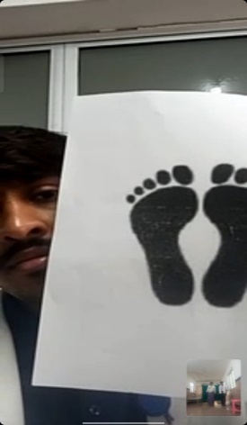
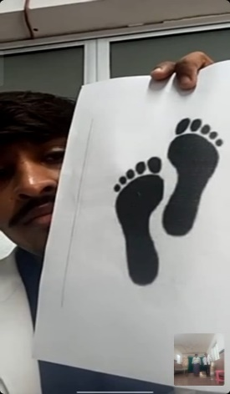
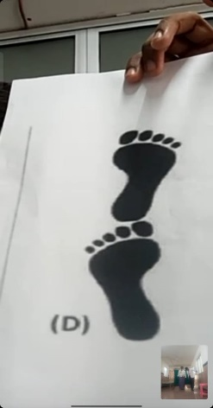

GAIT


CHAIR STAND


Figure 02: Offline Assessment
BALANCE
Semi Tandem

Feet Together

Full Tandem

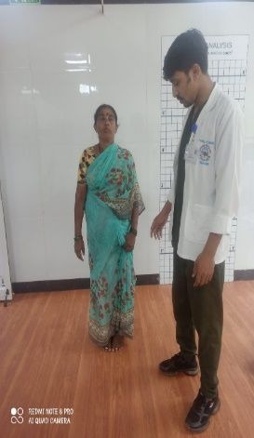
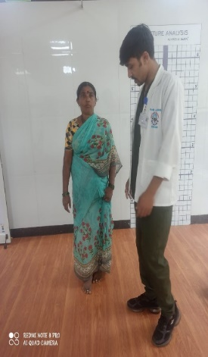
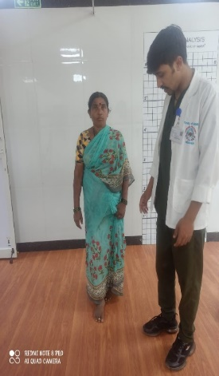

GAIT
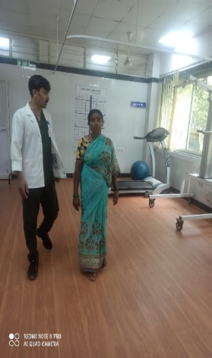

CHAIR STAND
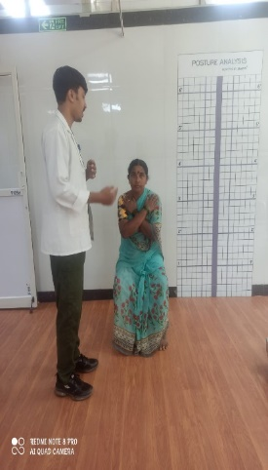

Result

Table 01: - Demography Data of the Subjects
Mode |  |  | GENDER |  | Total
 |  |  | Male | Female | Total
Online | Age group | 65-75 | 32 | 26 | 58
Online | Age group | 76-85 | 7 | 2 | 9
Online | Age group | >85 | 2 | 0 | 2
Online | Total |  | 41 | 28 | 69
Offline | Age group | 65-75 | 18 | 9 | 27
Offline | Age group | 76-85 | 3 | 1 | 4
Offline | Age group | >85 | 1 | 0 | 1
Offline | Total |  | 22 | 10 | 32
Total | Age group | 65-75 | 50 | 35 | 85
Total | Age group | 76-85 | 10 | 3 | 13
Total | Age group | >85 | 3 | 0 | 3
Total | Total |  | 63 | 38 | 101

65-75 age group is the most common group of participants in all event modes (offline and online) and most of these people are using the online form while a small group are using the offline mode. The male to female ratio is consistently greater than 1, especially at 65-75 age, which is very prominent among all ages of the sample. The number of participants in older age groups (76-85 and over 85) decreases significantly, with very few over 85 years of age.

Table 02: - Online Verses Offline Assessment Data of SPPB
Group Statistics
 | Mode | N | Mean | Std. Deviation | Std. Error Mean
Total | Online | 69 | 7.19 | 1.427 | .172
Total | Offline | 32 | 7.34 | 1.753 | .310

The Group Statistics table compares two modes based on the total scores of participants:
Online: With 69 participants, the average score is 7.19, with a standard deviation of 1.427, indicating consistent performance. The standard error of 0.172 suggests a precise estimate of the mean due to the larger sample size.
Offline: With 32 participants, the average score is slightly higher at 7.34, but the standard deviation is 1.753, indicating more variability in scores. The standard error of 0.310 reflects less precision in the mean estimate due to the smaller sample size.
Overall, while Mode 2 has a slightly higher average score, Mode 1 shows more consistent performance and a more accurate mean estimate.

Table 3a: Online Versus Offline SPPB Assessment comparison using independent sample test for both Online And Offline Mode
Independent Samples Test
 |  | Levene's Test for Equality of Variances |  | t-test for Equality of Means
 |  | F | Sig. | t | df
Total | Equal variances assumed | 1.999 | .161 | -.473 | 99
Total | Equal variances not assumed |  |  | -.438 | 50.815

The Independent Samples Test examines whether there are significant differences
Between the means of two groups. The test evaluates, first of all, whether or not groups
Have equal variances through Levene's Test for Equality of Variances. The F-value is 1.999, with a 0.161 significance level; therefore, the variances are not significantly different, so it is OK to proceed, assuming equal variances.
The t-test for Equality of Means compares the group means assuming equal variances and not assuming equal variances. The values obtained in both cases are negative, with t-values of -0.473 and -0.438, associated with significance values of 0.637 and 0.663, respectively, both well above the typical threshold of 0.05; therefore, the differences observed in the means are not statistically significant.

Table 3b: Online Versus Offline SPPB Assessment comparison using independent t test for both Online And Offline Mode

Independent Samples Test
 |  | t-test for Equality of Means
 |  | Sig. (2-tailed) | Mean Difference | Std. Error Difference | 95% Confidence Interval of the Difference
 |  |  |  |  | Lower
Total | Equal variances assumed | .637 | -.155 | .329 | -.807
Total | Equal variances not assumed | .663 | -.155 | .354 | -.867

The results for independent samples T-test compare the two group means. In both cases, significance values are 0.637 and 0.663, indicating that the difference is not statistically significant between these groups regarding their means. The mean difference is very minor at -0.155, and the 95% confidence intervals range from -0.807 to 0.497 when assuming equal variances, and from -0.867 to 0.556 when such variances were not assumed; in both instances, this includes zero. It would then say that the differences in means are likely due to random variation, and thus groups may be considered statistically similar.

Independent Samples Test
 |  | t-test for Equality of Means
 |  | 95% Confidence Interval of the Difference
 |  | Upper
Total | Equal variances assumed | .497
Total | Equal variances not assumed | .556

This is a two-sample test for difference of means. Confirmed in this analysis is that the confidence interval for difference of means ranges from the lower bound already stated to an upper bound of 0.497, assuming equal variances, and to 0.556, not assuming equal variances. Since these intervals include zero, there is no statistically significant difference in the means of the two groups.

Table 4: - Online Verses Offline Assessment Data of SPPB

Group Statistics
 | Mode | N | Mean | Std. Deviation | Std. Error Mean
BALANCE SCORE | Online | 69 | 3.78 | .591 | .071
BALANCE SCORE | Offline | 32 | 3.72 | .729 | .129
GAIT SCORE | Online | 69 | 1.97 | .804 | .097
GAIT SCORE | Offline | 32 | 1.97 | .740 | .131
CHAIR STAND SCORE | Online | 69 | 1.43 | .977 | .118
CHAIR STAND SCORE | Offline | 32 | 1.66 | 1.066 | .188

It compares the balance, gait, and chair stand scores for online and offline participants. For the balance score, this is shown with an online participant mean of 3.78 and a standard deviation of 0.591, while offline had a slightly lower mean of 3.72 with a higher standard deviation of 0.729. Hence, it returns that the online participants' performance in terms of balance was a little better and more consistent.
The gait score indicates the means for both groups, online and offline, are precisely 1.97. However, again, performance in the online group is much more variable: the standard deviation is 0.804 as compared with that of the offline group of 0.740. This indicates that participants' walking speed is very similar between the two modes, with small variations in performance.
The chair stand score differs in that the online group has a mean of 1.43, while the offline group has a higher mean of 1.66. The latter also shows more variability for this score, as evident in their higher standard deviation of 1.066 compared to the online group's 0.977. This could mean that generally, participants who are offline perform better in chair stand, although there is more variation within the offline group.

Table 5a: - Online Versus Offline SPPB Assessment comparison using independent test for both Online And Offline Mode

Independent Samples Test
 |  | Levene's Test for Equality of Variances |  | t-test for Equality of Means
 |  | F | Sig. | t
BALANCE SCORE | Equal variances assumed | .976 | .326 | .469
BALANCE SCORE | Equal variances not assumed |  |  | .434
GAIT SCORE | Equal variances assumed | .169 | .682 | .013
GAIT SCORE | Equal variances not assumed |  |  | .014
CHAIR STAND SCORE | Equal variances assumed | 2.257 | .136 | -1.029
CHAIR STAND SCORE | Equal variances not assumed |  |  | -.997

Then, independent samples t-tests were conducted for balance, walking, and chair stand scores between the online and offline groups.
Balance Score: Based on the performed Levene's Test, there was equal variance between the two groups with a p-value of 0.326. The obtained results from the t-test yielded a t-value of 0.469 when assuming equal variances and 0.434 if variances were not equal, with a p-value of 0.637. There is no significant difference in balance performance of online and offline participants.
Gait Score: Levene's Test confirms equal variances (p = 0.682). The t-test comes in at a value of 0.013 with equal variances assumed, and 0.014 with equal variances not assumed. This equated to a p-value of 0.989. There were no significant differences in the gait scores between the two modes of walking.
Chair Stand Score: Based on Levene's Test, the variances are equal (p = 0.136). The t-test, under equal variances assumed, gives a t-value of -1.029, and under equal variances not assumed, it gives -0.997, with a p-value of 0.306. While the offline
group has a higher mean score, the difference is not statistically significant.
There were no differences found between the online versus the offline participants on balance, gait, or chair stand scores, thus performance was the same in both modes.

Table 5b: Online Versus Offline SPPB Assessment comparison using independent sample t test for both Online And Offline Mode

Independent Samples Test
 |  | t-test for Equality of Means
 |  | df | Sig. (2-tailed) | Mean Difference
BALANCE SCORE | Equal variances assumed | 99 | .640 | .064
BALANCE SCORE | Equal variances not assumed | 50.631 | .666 | .064
GAIT SCORE | Equal variances assumed | 99 | .989 | .002
GAIT SCORE | Equal variances not assumed | 65.312 | .989 | .002
CHAIR STAND SCORE | Equal variances assumed | 99 | .306 | -.221
CHAIR STAND SCORE | Equal variances not assumed | 56.008 | .323 | -.221

Independent Samples Test
 |  | t-test for Equality of Means
 |  | Std. Error Difference | 95% Confidence Interval of the Difference
 |  | Std. Error Difference | Lower | Upper
BALANCE SCORE | Equal variances assumed | .136 | -.207 | .334
BALANCE SCORE | Equal variances not assumed | .147 | -.232 | .359
GAIT SCORE | Equal variances assumed | .168 | -.331 | .335
GAIT SCORE | Equal variances not assumed | .163 | -.323 | .327
CHAIR STAND SCORE | Equal variances assumed | .215 | -.648 | .205
CHAIR STAND SCORE | Equal variances not assumed | .222 | -.666 | .224

The Independent Samples Test evaluates differences in balance, gait, and chair stand scores between online and offline modes of participation.
Balance Score: The mean difference between online (3.78) and offline (3.72) participants is 0.064, with p-values of 0.640 (equal variances assumed) and 0.666 (equal variances not assumed). This indicates no significant difference in balance scores between the two groups. The 95% confidence intervals range from -0.207 to 0.334 (equal variances assumed) and -0.232 to 0.359 (unequal variances), both including zero.
Gait Score: The mean difference is 0.002, with p-values of 0.989 for both equal and unequal variances. This shows no significant difference in gait scores between online and offline participants. Confidence intervals for this measure range from -0.331 to 0.335 (equal variances assumed) and -0.323 to 0.327 (unequal variances), both including zero.
Chair Stand Score: The mean difference is -0.221, with p-values of 0.306 (equal variances assumed) and 0.323 (unequal variances), indicating no significant difference. The confidence intervals are -0.648 to 0.205 (equal variances assumed) and -0.666 to 0.224 (unequal variances), including zero.
Mode of participation (online vs. offline) does not significantly affect scores in balance, gait, or chair stand tests.

Discussion
Physical function is a key indicator of health in older adults and may be closely linked to the quality of life, as well as to health events such as cognitive decline, institutionalization, and mortality. Poor physical function carries an increased risk for accidents, poor self-esteem, and anxiety in performing daily activities, thereby impacting substantially on the quality of life. For this reason, early detection and management of functional decline among community-dwelling adults are essential to preventing dependency. Muscle weakness, impaired proprioception, and neuropathic changes are common culprits leading to falls, especially among the elderly, diabetics, and those suffering from hypertension. Regarding these risks, it's important to screen for gait changes, balance impairment, and lower limb weakness. The Short Physical Performance Battery, on the other hand, serves to measure the 4-meter walking speed, balance of the elderly patient, and predicts mobility disability. Poor performance in SPPB is also linked to adverse health outcomes that include nursing home admission, increased need for assistance on the part of a caregiver, loss of functional abilities, and death. Its simplicity, efficiency, and cost-effectiveness make it ideal for assessing conditions in geriatric cases.

Virtual screening can therefore be a real alternative for elderly subjects to receive fall risk assessment at home or within the community, with the rise of digital health, including mobile health, health IT, and telehealth. It has also been proven that virtual assessment of functional fitness is highly reliable. Therefore, this study aims to determine the feasibility of virtual SPPB screenings to assess physical function in older adults and offering a practical solution for elderly individuals who do not have easy access to traditional healthcare. Virtual assessments have become very relevant, particularly during the COVID-19 pandemic, which really accelerated the uptake of telemedicine in geriatric care. Studies used virtual Short Physical Performance Battery among older adults and measured its feasibility against standard in-person testing. The vSPPB utilized self-reported, recorded video-based assessments of balance, gait, and chair stand activities. While further research is required to fully assert the feasibility and effectiveness of virtual versus in-person assessment, this study demonstrated a practical approach by which virtual assessment could yield valid fitness measures in older adults. This finding on virtual assessment has many potential advantages in terms of less travel time and less anxiety associated with going into healthcare facilities, especially for this age group, who often have mobility limitations or concerns about public health challenges.

Our study results concluded that mean scores of physical performance variables were roughly similar between online and offline groups, though the latter had a slight advantage over their online counterparts, with a mean score of 7.34 versus 7.19. Smaller standard error margins in the online group suggest that virtual assessments will have limited variability and hence should give consistent and reliable results with fewer changes in these differences. The Balance Score in particular showed the online group slightly outperformed the offline with a balance score of 3.78 versus 3.72, while both groups demonstrated identical Gait Scores with a mean of 1.97, but the offline group did slightly better on the Chair Stand test, 1.66 to 1.43. These small differences reinforce the idea that virtual assessments may have to be refined in certain areas, especially those kinds of exercises that require more exertion or specific positioning. The findings are further supported by the mean differences analysis and 95% confidence intervals for Balance, Gait, and Chair Stand Scores. The point estimates of mean differences were small, and their confidence intervals crossed zero, signaling that there was no statistically significant difference between online and offline assessments. Virtually, assessments also provide excellent opportunities for health providers to observe the home environment of subjects that may present hidden dangers or aspects that need improvement. This is not as easily doable in standard in-person assessment processes where the clinician doesn't have any idea about a participant's living conditions.

However, virtual assessments are not without problems. Guaranteeing uniform and accurate procedures is challenging. Thoroughly written instructions, visual aids, and incremental set-up instructions are necessary to ensure the reliability of the assessment. Moreover, the assessor must be well-trained to handle the assessment process and be ever cautious in one's overview of the participant under evaluation to ensure integrity in the results obtained. Despite these challenges, this study has proven that virtual testing is quite feasible and efficient if well-planned. Small differences in the mean scores between online and offline groups, like the chair stand score being a little higher for the offline group, have not been significant.

Further, the quality and accuracy of the review in this study were maintained by the use of video-based assessments, irrespective of the mode. These results suggest that virtual assessments might form a good substitute for traditional face-to-face assessments in the measurement of physical performance among older adults.
Conclusion
The findings suggest that virtual SPPB assessments are feasible and effective for older adults in line in-person testing. It is of significant interest particularly in rural or underserved areas with possibly very limited access to health services. Potential future studies, on larger, more diverse populations, are indicated to operationalize further the generalizability of these findings and explore applications with telehealth.
Graphs
Graph 01: Gender Distribution by Age Group, Gender and Mode of Assessment

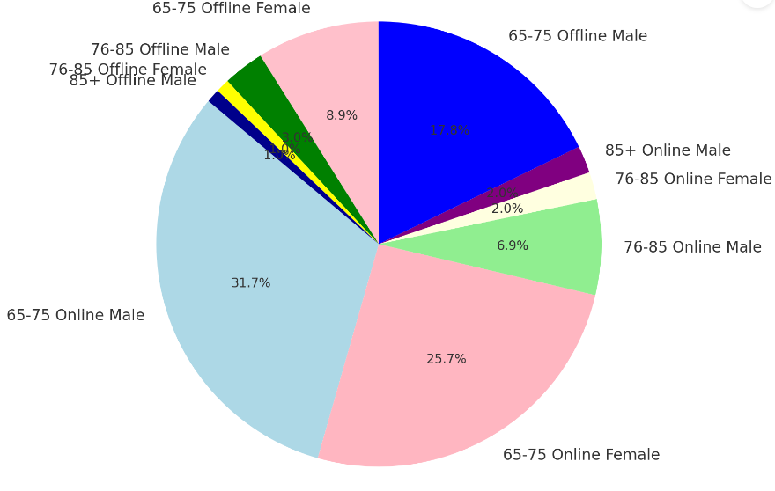

The pie chart gives the distribution of all participants in terms of age and gender, as well as assessment mode, online or offline. The largest age category was that of 65-75 years, with a total of 85 participants. Of these, 58 were assessed online, while the remaining were assessed offline. The gender distribution is to some degree well-balanced online, at 32 males and 26 females. Off-line, however, there is a male majority in assessment: 18 males to 9 females. The age bracket 76-85 years comprises 13 participants, having a stronger male presence, especially online. Males number 7, whereas females are only 2. A similar pattern of male dominance is found to exist in the offline venue, in which males total 3 and females total 1. The oldest, and thus smallest, group is that over 85; it has 3 participants, all males, with 2 assessed online and 1 offline.
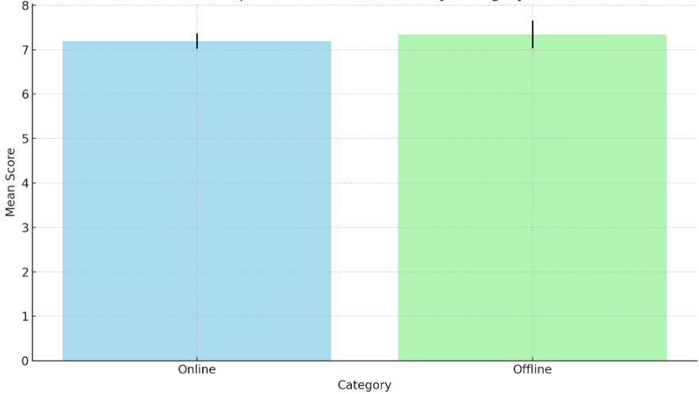
Graph 02: Comparison of Mean Scores by Category

The bar chart displays comparisons of the mean scores for Online and Offline categories. The latter stands at a bit higher, with almost equal mean scores: mean 7.19 and mean 7.34 correspondingly. The standard error is represented by error bars, which demonstrate less variability in the online category (.172) in comparison with.310 in the Offline category. Overall, differences between the two categories are minute, with moderate error margins, especially for the Offline group.

Graph 03: Comparison of Mean Score Between Online And Offline Mode
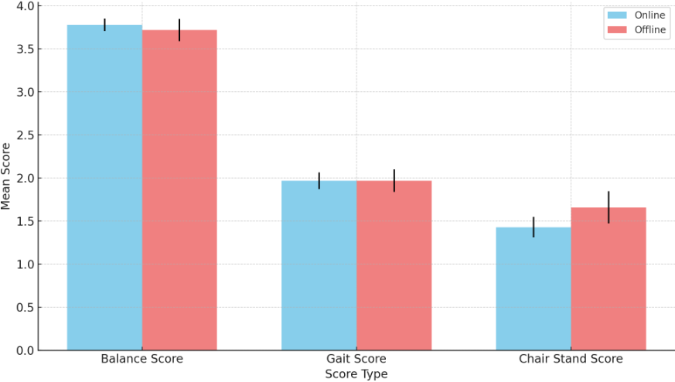
The bar graph depicts the comparison in mean scores for tests on "Balance," "Gait," and "Chair Stand" between subjects assessed online and offline. In the Balance Score, the online group has a minor advantage with 3.78 compared to 3.72 in the offline group. Gait Score for both groups is an identical mean score of 1.97, indicating no difference between online and offline assessments. In chair stand scores, the offline group does better than the online group with mean scores of 1.66 compared to a score of 1.43, respectively, for the online group.

Graph 04: Mean Difference And 95% Confidence Interval For Balance, Gait And Chair Stand Score

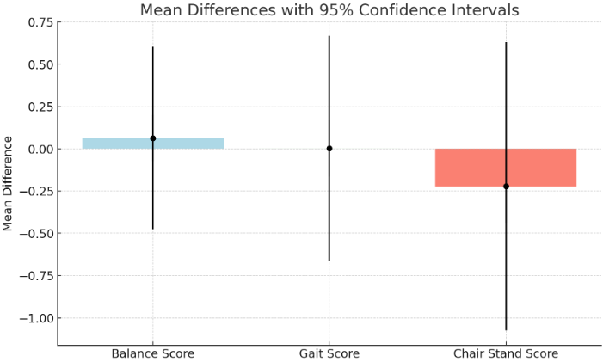

This bar chart with error bars provides a fast visual summary of mean differences and variability between two groups for Balance, Gait, and Chair Stand Scores.
Balance Score: Mean difference: 0.064
The 95% confidence interval extends from about –0.207 to 0.334, so the true mean difference could be slightly negative or positive.
It follows from the error bars that there is no significant difference between groups.
Gait Score: Mean difference: is 0.002, which is very close to zero.
This gives a very wide confidence interval of approximately -0.331 to 0.335, crossing zero, so it does not show any significant difference between the groups.
Chair Stand Score: Mean difference: -0.221.
The confidence interval is from approximately -0.648 to 0.205. This still shows a bit of variability, though it does cross zero, so is not statistically significant.

Abbreviations
SPPB – Short Physical Performance Battery
Acknowledgment
The authors would like to express their gratitude to Dr. Sarulatha H for her valuable insights during the initial conception of this study and to Mr. Naveen Kumar I for his assistance with data collection and analysis. Special appreciation goes to the Sri Devraj Urs Academy Of Higher Education And Research Institute for providing the resources necessary for this research.

References
- “Mane AB, Sanjana T, Patil PR, Sriniwas T. Prevalence and Correlates of Fear of Falling among Elderly Population in Urban Area of Karnataka, India. J Midlife Health. 2014 Jul;5(3):150-5.”
- “Joseph A, Kumar D, Bagavandas M. A Review of Epidemiology of Fall among Elderly in India. Indian J Community Med. 2019;44(2):166–8.”
- “Zaninotto P, Batty GD, Allerhand M, Deary IJ. Cognitive Function Trajectories and Their Determinants in Older People: 8 Years of Follow-up in the English Longitudinal Study of Ageing. J Epidemiol Community Health. 2018;72(8): 685–94. Https://Doi.Org/10.1136/Jech-2017-210116.”
- “Ye P, Er Y, Wang H, Fang L, Li B, Ivers R, et al. Burden of Falls among People Aged 60 Years and Older in Mainland China, 1990–2019: Findings from the Global Burden of Disease Study 2019. Lancet Public Health. 2021 Nov 25;6(12):E907–18.”
- “Reeves ND, Orlando G, Brown SJ. Sensory-Motor Mechanisms Increasing Falls Risk in Diabetic Peripheral Neuropathy. Medicina (Kaunas). 2021 May 8;57(5):457. Doi: 10.3390/Medicina57050457. PMID: 34066681; PMCID: PMC8150714.”
- “Schülein S. [Comparison of the Performance-Oriented Mobility Assessment and the Berg Balance Scale. Assessment Tools in Geriatrics and Geriatric Rehabilitation]. Z Gerontol Geriatr. 2014 Feb;47(2):153–64.”
- “Strini V, Schiavolin R, Prendin A. Fall Risk Assessment Scales: A Systematic Literature Review. Nurs Rep. 2021 Jun 2;11(2):430–43.”
- “Welch SA, Ward RE, Beauchamp MK, Leveille SG, Travison T, Bean JF. The Short Physical Performance Battery (SPPB): A Quick and Useful Tool for Fall Risk Stratification Among Older Primary Care Patients. J Am Med Dir Assoc. 2021 Aug;22(8):1646-1651.”
- “Guralnik JM, Ferrucci L, Simonsick EM, Salive ME, Wallace RB. Lower-Extremity Function in Persons over the Age of 70 Years as a Predictor of Subsequent Disability. N Engl J Med. 1995 Mar 2;332(9):556-61. Doi: 10.1056/NEJM199503023320902. PMID: 7838189; PMCID: PMC9828188.”
- “Fisher S, Ottenbacher KJ, Goodwin JS, Graham JE, Ostir GV. Short Physical Performance Battery in Hospitalized Older Adults. Aging Clin Exp Res. 2009 Dec;21(6):445-52. Doi: 10.1007/BF03327444. PMID: 20154514; PMCID: PMC2822997.”
- “Bernhardsson S, Larsson A, Bergenheim A, Ho-Henriksson CM, Ekhammar A, Lange E, Larsson MEH, Nordeman L, Samsson KS, Bornhöft L. Digital Physiotherapy Assessment vs Conventional Face-to-Face Physiotherapy Assessment of Patients with Musculoskeletal Disorders: A Systematic Review. PLoS One. 2023 Mar 21;18(3):E0283013. Doi: 10.1371/Journal.Pone.0283013. PMID: 36943857; PMCID: PMC10030027.”
- “Ogawa, E.F.; Harris, R.; Dufour, A.B.; Morey, M.C.; Bean, J. Reliability of Virtual Physical Performance Assessments in Veterans During the COVID-19 Pandemic. Arch. Rehabil. Res. Clin. Transl. 2021, 3, 100146.”
- “Lauretani F, Ticinesi A, Gionti L, Prati B, Nouvenne A, Tana C, Meschi T, Maggio M. Short-Physical Performance Battery (SPPB) Score Is Associated with Falls in Older Outpatients. Aging Clin Exp Res. 2019 Oct;31(10):1435-1442. Doi: 10.1007/S40520-018-1082-y. Epub 2018 Dec 4. PMID: 30515724.”
- “De Fátima Ribeiro Silva C, Ohara DG, Matos AP, Pinto ACPN, Pegorari MS. Short Physical Performance Battery as a Measure of Physical Performance and Mortality Predictor in Older Adults: A Comprehensive Literature Review. Int J Environ Res Public Health. 2021 Oct 10;18(20):10612. Doi: 10.3390/Ijerph182010612. PMID: 34682359; PMCID: PMC8535355.”
- “Silva CFR, Gonçalves Ohara D, Pena Matos A, Nunes Pinto ACP, Sousa Pegorari M. Short Physical Performance Battery as a Predictor of Mortality in Community-Dwelling Older Adults: A Longitudinal Study in the Brazilian Amazon Region. PeerJ. 2022 Jul 12;10:E13630. Doi: 10.7717/Peerj.13630. PMID: 35846876; PMCID: PMC9285644.”
- “Welch SA, Ward RE, Beauchamp MK, Leveille SG, Travison T, Bean JF. The Short Physical Performance Battery (SPPB): A Quick and Useful Tool for Fall Risk Stratification Among Older Primary Care Patients. J Am Med Dir Assoc. 2021 Aug;22(8):1646-1651.”
- “Thompson C, Porter Starr KN, Kemp EC, Chan J, Jackson E, Phun J. Feasibility of Virtually Delivering Functional Fitness Assessments and a Fitness Training Program in Community-Dwelling Older Adults. Int J Environ Res Public Health. 2023 May 30;20(11):5996. Doi: 10.3390/Ijerph20115996. PMID: 37297600; PMCID: PMC10252352.”
- “Fisher S, Ottenbacher KJ, Goodwin JS, Graham JE, Ostir GV. Short Physical Performance Battery in Hospitalized Older Adults. Aging Clin Exp Res. 2009 Dec;21(6):445-52. Doi: 10.1007/BF03327444. PMID: 20154514; PMCID: PMC2822997.”
- “Hong J, Kim J, Kim SW, Kong HJ. Effects of Home-Based Tele-Exercise on Sarcopenia among Community-Dwelling Elderly Adults: Body Composition and Functional Fitness. Exp Gerontol. 2017 Jan;87(Pt A):33-39. Doi: 10.1016/j.Exger.2016.11.002. Epub 2016 Nov 9. PMID: 27838369.”
- “Sanapala C, Jensen-Battaglia M, Watson EE, Konatham S, LoCastro M, Wang Y, Culakova E, Sohn M, Flannery M, Magnuson A, Wildes TM, Loh KP. In-Person and Virtual Assessment of Short Physical Performance Battery Test in Older Adults with Myeloid Malignancies. Blood Adv. 2023 Aug 22;7(16):4414-4417. Doi: 10.1182/Bloodadvances.2022009396. PMID: 36790922; PMCID: PMC10440456.”
- “Duncan L, Zhu S, Pergolotti M, Giri S, Salsabili H, Faezipour M, et al. Automated Camera-Based Assessment of Short Physical Performance Battery (SPPB) for Older Adults with Cancer [Internet]. Biomedical Engineering. IntechOpen; 2024. Available from: Http://Dx.Doi.Org/10.5772/Intechopen.112899.”
- “Marsh AP, Wrights AP, Haakonssen EH, Dobrosielski MA, Chmelo EA, Barnard RT, Pecorella A, Ip EH, Rejeski WJ. The Virtual Short Physical Performance Battery. J Gerontol A Biol Sci Med Sci. 2015 Oct;70(10):1233-41. Doi: 10.1093/Gerona/Glv029. Epub 2015 Mar 31. PMID: 25829520; PMCID: PMC4692971.”
- “Falk Erhag H, Guðnadóttir G, Alfredsson J, Cederholm T, Ekerstad N, Religa D, Nellgård B, Wilhelmson K. The Association Between the Clinical Frailty Scale and Adverse Health Outcomes in Older Adults in Acute Clinical Settings - A Systematic Review of the Literature. Clin Interv Aging. 2023 Feb 18;18:249-261. Doi: 10.2147/CIA.S388160. PMID: 36843633; PMCID: PMC9946013.”
- “De Fátima Ribeiro Silva C, Ohara DG, Matos AP, Pinto ACPN, Pegorari MS. Short Physical Performance Battery as a Measure of Physical Performance and Mortality Predictor in Older Adults: A Comprehensive Literature Review. Int J Environ Res Public Health. 2021 Oct 10;18(20):10612. Doi: 10.3390/Ijerph182010612. PMID: 34682359; PMCID: PMC8535355.”
- “Devin M Mann, Ji Chen, Rumi Chunara, Paul A Testa, Oded Nov, COVID-19 Transforms Health Care through Telemedicine: Evidence from the Field, Journal of the American Medical Informatics Association, Volume 27, Issue 7, July 2020, Pages 1132–1135, Https://Doi.Org/10.1093/Jamia/Ocaa072.”
- “Marsh AP, Wrights AP, Haakonssen EH, Dobrosielski MA, Chmelo EA, Barnard RT, Pecorella A, Ip EH, Rejeski WJ. The Virtual Short Physical Performance Battery. J Gerontol A Biol Sci Med Sci. 2015 Oct;70(10):1233-41. Doi: 10.1093/Gerona/Glv029. Epub 2015 Mar 31. PMID: 25829520; PMCID: PMC4692971.”
- “Duncan L, Zhu S, Pergolotti M, Giri S, Salsabili H, Faezipour M, et al. Automated Camera-Based Assessment of Short Physical Performance Battery (SPPB) for Older Adults with Cancer [Internet]. Biomedical Engineering. IntechOpen; 2024. Available from: Http://Dx.Doi.Org/10.5772/Intechopen.112899.”
- “Hao Q, Zhou L, Dong B, Yang M, Dong B, Weil Y. The Role of Frailty in Predicting Mortality and Readmission in Older Adults in Acute Care Wards: A Prospective Study. Sci Rep. 2019 Feb 4;9(1):1207. Doi: 10.1038/S41598-018-38072-7. PMID: 30718784; PMCID: PMC6362215.”
- “Sanapala C, Jensen-Battaglia M, Watson EE, Konatham S, LoCastro M, Wang Y, Culakova E, Sohn M, Flannery M, Magnuson A, Wildes TM, Loh KP. In-Person and Virtual Assessment of Short Physical Performance Battery Test in Older Adults with Myeloid Malignancies. Blood Adv. 2023 Aug 22;7(16):4414-4417. Doi: 10.1182/Bloodadvances.2022009396. PMID: 36790922; PMCID: PMC10440456.”
- “Beaudart C, Zaaria M, Pasleau F, Reginster JY, Bruyère O. Health Outcomes of Sarcopenia: A Systematic Review and Meta-Analysis. PLoS One. 2017 Jan 17;12(1):E0169548. Doi: 10.1371/Journal.Pone.0169548. PMID: 28095426; PMCID: PMC5240970.”
- “Hong J, Kim J, Kim SW, Kong HJ. Effects of Home-Based Tele-Exercise on Sarcopenia among Community-Dwelling Elderly Adults: Body Composition and Functional Fitness. Exp Gerontol. 2017 Jan;87(Pt A):33-39. Doi: 10.1016/j.Exger.2016.11.002. Epub 2016 Nov 9. PMID: 27838369.”
- “Rubenstein LZ. Falls in Older People: Epidemiology, Risk Factors and Strategies for Prevention. Age Ageing. 2006 Sep;35 Suppl 2:Ii37-Ii41. Doi: 10.1093/Ageing/Afl084. PMID: 16926202.”

