Exploring the Diversity and Bioactive Potential of Actinomycetes in Alkalic and Saline Soils of the Runn of Kachchh, Gujarat, India

Paras Dayma^{1†}, Virendra Kumar Yadav^{2†}, Nisha Choudhary², Hesham S. Almoallim³, Mohammad Javed Ansari⁴, Tisha Darji², Sumita Chaudhary², Rajesh Patel^{1*}, and Ashish Patel^{3*}

¹ Department of Biosciences, Veer Narmad South Gujarat University, Surat 395007, Gujarat, India; paras_dayma@yahoo.com (P.D.)
² Department of Life Sciences, Hemchandracharya North Gujarat University, Patan, Gujarat, India; yadava94@gmail.com (V.K.Y.); nishanaseer03@gmail.com (N.C.); tishadarji852@gmail.com (T.D.); sumichaudhary2229@gmail.com (S.C.)
³ Department of Oral and Maxillofacial Surgery, College of Dentistry, King Saud University, PO Box-60169, Riyadh -11545, Saudi Arabia; hkhalil@ksu.edu.sa (H.S.A.)
⁴ Department of Botany, Hindu College Moradabad (Mahatma Jyotiba Phule Rohilkhand University, Bareilly), India-244001; mjavedansari@gmail.com (M.J.A.)

† These authors contributed equally to this work
Corresponding: rkpatel@vnsgu.ac.in (R.P.); uni.ashish@gmail.com (A.P.)
ABSTRACT
Actinomycetes are facultatively anaerobic, Gram-positive, filamentous, high guanine and cytosine-containing bacteria. Here, firstly, actinomycetes were isolated from alkalic and saline soils from Runn of Kutch (RoK), Gujarat, India which was further analyzed for their colony characteristics, morphological features, staining, and molecular and enzyme activity. The isolated strains were analyzed for melanin production, nitrate reductase, and antibiotic production. Moreover, the effect of pH, temperature, and nutrient media was observed on the isolated actinomycetes. About 6 different sites from Little Rann of Kutch and 4 sites from Great Rann of Kutch were selected for soil sampling and out of these a total of 26 actinomycetes were isolated, 13 isolates from Little Rann and 13 from Great Rann of Kutch. Out of 26, 16 isolates gave positive lipid hydrolysis test on tributyrin agar medium, while 10 isolates were not able to degrade tributyrin. Fifty percent of isolates showed the production of brown and dark brown melanin pigments. Out of 26 isolates, 18 isolates showed optimum growth at 30°C and the rest at 40°C. The range of pH for all the isolates was found similar from 7-9 with optimum pH of 8 (13 isolates) and 9 (13 isolates). Physiological characterization in the presence of a range of NaCl concentrations and pH showed the halophilic, alkaliphilic, and halotolerant nature of isolates. In the primary screening method, 26 isolates were screened against test organisms, of which 23 isolates exhibited antagonistic activity against at least one tested culture. All the isolates except LR-KAR-2, LR-KSA-1, and LR-KVD-1 exhibited antimicrobial activity against B. subtilis in the range of 6 to 40 mm inhibition zone. Positive anti-fungal activity against A. niger was noticed in nine actinomycetes isolates. Out of 26 isolates employed for the anti-MRSA potential, four isolates inhibited the growth of MRSA strains. Such investigations could prove to be a foundation for further research toward obtaining broad-spectrum antibiotics for antibiotic therapy.
KEYWORDS
actinomycetes, halotolerant, saline environment, guanine-cytosine, antibiotic
Introduction
Actinomycetes are a heterogeneous group of filamentous Gram-positive bacteria with high guanine and cytosine content (Takahashi and Nakashima 2018; AboElmaaty et al. 2022). In Greek “aktis” means (a ray) and “mykes” means (fungus) as these actinomycetes have some morphological resemblance to fungi (AboElmaaty et al. 2022; Nayaka et al. 2020; Subathra Devi et al. 2022). Actinomycetes can produce many useful secondary metabolites of commercial value. It is mainly prevalent in terrestrial and aquatic ecosystems where they play essential biological and ecological roles, especially in the degradation and recycling of substances, and generation of bioactive molecules (Subathra Devi et al. 2022). Actinomycetes are prolific producers of bioactive substances like antibiotics which are widely used in antimicrobial therapy. Among all the naturally derived compounds which are used as drugs nearly 70% alone are obtained as actinobacterial secondary metabolites (Manivasagan et al. 2014). To date, numerous antimicrobial compounds (Mondal, Thomas, and Amaresan 2023) have been isolated from actinomycetes like taromycin A (anti-MDR activity), (Breitling et al. 2021), retimycin A (cytotoxicity) (Sapkota et al. 2020), and tetrocarcins (Motallebirad et al. 2023) have been isolated from actinobacteria. Antibiotic therapy proved to cure almost all infections with a reduction in death and disability occurrence (Uddin et al. 2021). In the last few decades, microbial infections have increased tremendously which has led to resistance to most of the available antibiotics due to misuse and overuse of the antibiotics (Mancuso et al. 2021). The evolution of drug-resistant microorganisms has led to the need for the development of novel compounds for better public health achievements. Besides this, multidrug resistance has led to the urgent need for new compounds having anti-biological activity from unexplored habitats (Muteeb et al. 2023).
Deserts are considered as an extreme environment due to scarce water, nutrient availability, temperature variation, UV rays, alkalinity, and salinity (Alsharif, Saad, and Hirt 2020). The desert ecological niche is highly saline and alkaline, which makes this habitat unique from a biodiversity point of view and the microorganisms residing in the highly saline environment have unique survival mechanisms that result in the development of very different microbial compositions and structures (S. Li et al. 2023). Microorganisms from this unique habitat exhibit distinctive physiological processes to adapt to this environment with the generation of secondary metabolites that have industrial and medicinal significance (Wani et al. 2022). The physiological demonstration of these defense abilities of desert microorganisms is in the form of bioactive metabolites, which could be a solution to fight against multi-drug resistant pathogenic bacteria (Sarma et al. 2023; Xie and Pathom-aree 2021).
One such unique and untapped hypersaline ecosystem is the Rann of Kutch (RoK), a saline desert present in Gujarat, India (Juyal 2014). In these ecosystems, there is enhanced evapotranspiration, and salt accumulation which becomes an important stress factor and high salinity reduces the water potential which may lead to a quick decline in growth rate affecting the native microbial community dynamics (M 2008). Hence, it becomes imperative to explore the actinomycetes diversity and their adaptations in extreme stress environments such as high salinity (P. Singh et al. 2021). The water of the Gulf of Kutch flows towards the flat surface of the RoK in monsoon when there are storm tides and wind forces, while it remains dry for the rest of the period (H. M. Patel et al. 2019). Therefore, this desert exhibits an intermediate level of disturbance so it is expected to harbor higher microbial diversity (Bhatt, Gohel, and Singh 2018b). The bacteria from this area were phylogenetically associated with those reported from the aquatic, hypersaline, and desert habitats, suggesting a diverse distribution pattern (Bhatt, Gohel, and Singh 2018a). The dynamic ecosystem and season in the Great RoK are due to the substantial geomorphic phenomenon caused by sea-level changes, variations in climate, and movements of tectonic plates over decades (Biswas, S. K., & Deshpande 1970).
Among all the genera, Streptomyces is the best-recognized genus to produce a wide range of secondary metabolites as bioactive molecules, including antimicrobial, anticancer, antiviral, anti-malarial, amino acids, enzymes, organic acids, pigments, insecticides, herbicides, and other metabolites. Streptomyces species contribute about 75% of the medically useful drugs (Miyadoh 1993). Among actinomycetes, Streptomyces sps are the frontrunner in the production of antibiotics. Still, many genera of actinomycetes are unexplored which could be a valuable source of bioactive metabolites.
The cultivation-based approach was used to study the diversity in heterotrophic bacteria (Subrahmanyam et al. 2014) in which Firmicutes and Actinomycetes groups were dominant. In addition to this, the investigator also studied enzymatic profiling of the soil. In the study carried out by Patel et al., (R. Patel et al. 2015), they analyzed functional metagenomics and community metagenomics, including stress-responsive genes and the presence of commercial enzymes. A similar study of screening on functional capabilities of genes involved in the transport and metabolism of carbohydrates and protein, energy production, and conversion was reported by (P. Singh, Patel, and Madamwar 2017). A metagenomics-based approach to study the effect of alkalinity, nutrient availability, temperature, and the relationship between these extreme conditions affecting microbial diversity still needs to be explored. Bhatt et al., 2018 gave the 1st report on the diversity of haloalkaliphilic bacteria and their phylogenetic relationship in Little Rann of Kutch. The data showed that there are very few reports available on cultivable biodiversity, and many more taxonomic groups to be recovered to study the relationship between them, their strategy to adapt, and their role in biogeochemical cycles (Bhatt, Gohel, and Singh 2018a). The first report on the characterization and purification of the antimicrobial compound from halotolerant and alkaliphilic actinobacteria was given by Thumar et al., (Thumar, Dhulia, and Singh 2010). Endophytic PGPR has been reported from Little Rann of Kutch (M. V Patel and Patel 2014; Goswami et al. 2014). Moreover, the isolation of lipase from halophiles obtained from Little Rann of Kutch has been demonstrated by Mrugesh et al., (Mrugesh Khunt and Neepa Pandhi 2015). Patel et al., isolated cyanobacteria and further studied their diversity in mat samples from the hypersaline Runn of Kutch desert (H. M. Patel et al. 2019). Recently Padia et al., studied the fossils of the hypersaline desert and their implication in the identification of tidal inundation boundary from the RoK (Padia, Pandya, and Desai 2024).
To date, very little investigation has been carried out and information revealed about the microbial and actinomycetes diversity and geomicrobiological and biogeochemical capability of the flat salt basin of RoK. All the above studies have covered only a portion of the Runn of Kutch and hardly any attempt was made where sampling of Great and Little Runn of Kutch was done. Moreover, few studies reported on the antibiotic profiling of the isolated actinomycetes from this desert area. So, a study is required that may cover both Great and Little Runn of Kutch along with the microbial diversity among the antibiotic-producing halotolerant actinomycetes (Shu and Huang 2022; Prudence et al. 2020).
The main aim of this investigation was to isolate the actinomycetes from the saline conditions of Rann of Kutch. Another objective was to perform screening, biochemical characterization, and molecular identification of actinomycetes from the desert environment. One more objective was antibiotic production and antimicrobial activity profiling of isolates. Such investigation will provide deeper insights into the alkali and saline environment with the actinomycetes species. This will also help in revealing new actinomycetes from the extreme environment with distinctive survival strategies, physiological mechanisms, or secondary metabolites.
Material and methods
Materials
Actinomycetes Isolation Agar (Raja and John 2017), ISP medium No 2 (Manikprabhu et al. 2016), casein-glycerol agar (Soltani Nejad, Khatami, and Shahidi Bonjar 2016), and ISP medium no 7 (Chauhan, Kumar, and Abraham 2013), cycloheximide, EzTaxon kit (Himedia, Mumbai, India); HiMedia antibiotic zone scale

Study area and sample collection
The soil samples were collected from the Rann of Kutch (Gujarat, India), which lies between 22°55’N latitude and 69°05’E to 71°50’E longitudes. The Great RoK, along with the Little RoK is situated in the district of Kutch and comprises nearly 30,000 square kilometers (10,000 sq. mi) between the Gulf of Kutch and the mouth of the Indus River in southern Pakistan. Ten samples, differing in salinity levels were collected from the Rann of Kutch. About 6 different sites from Little Rann of Kutch: Amarapur, Dada nu Rann, Soil nearby Farasi Plant, Kung bet, Salt Pan, and Vadilal Dam while from Great RoK, 4 stations: Charanka Solar Park, Santalpur Adesar Bridge, Samkhiyali, and Adesar were selected for the study purpose. Samples were collected by scraping off approximately three cm of surface material with a spatula and taking a nearly 200 g sample at a depth of two inches. Solid salt crusts were removed before sampling and these samples were placed in sterile plastic bags, transferred to the laboratory, and stored in a refrigerator at 4°C. (Figure 1) shows the sampling site for the study.
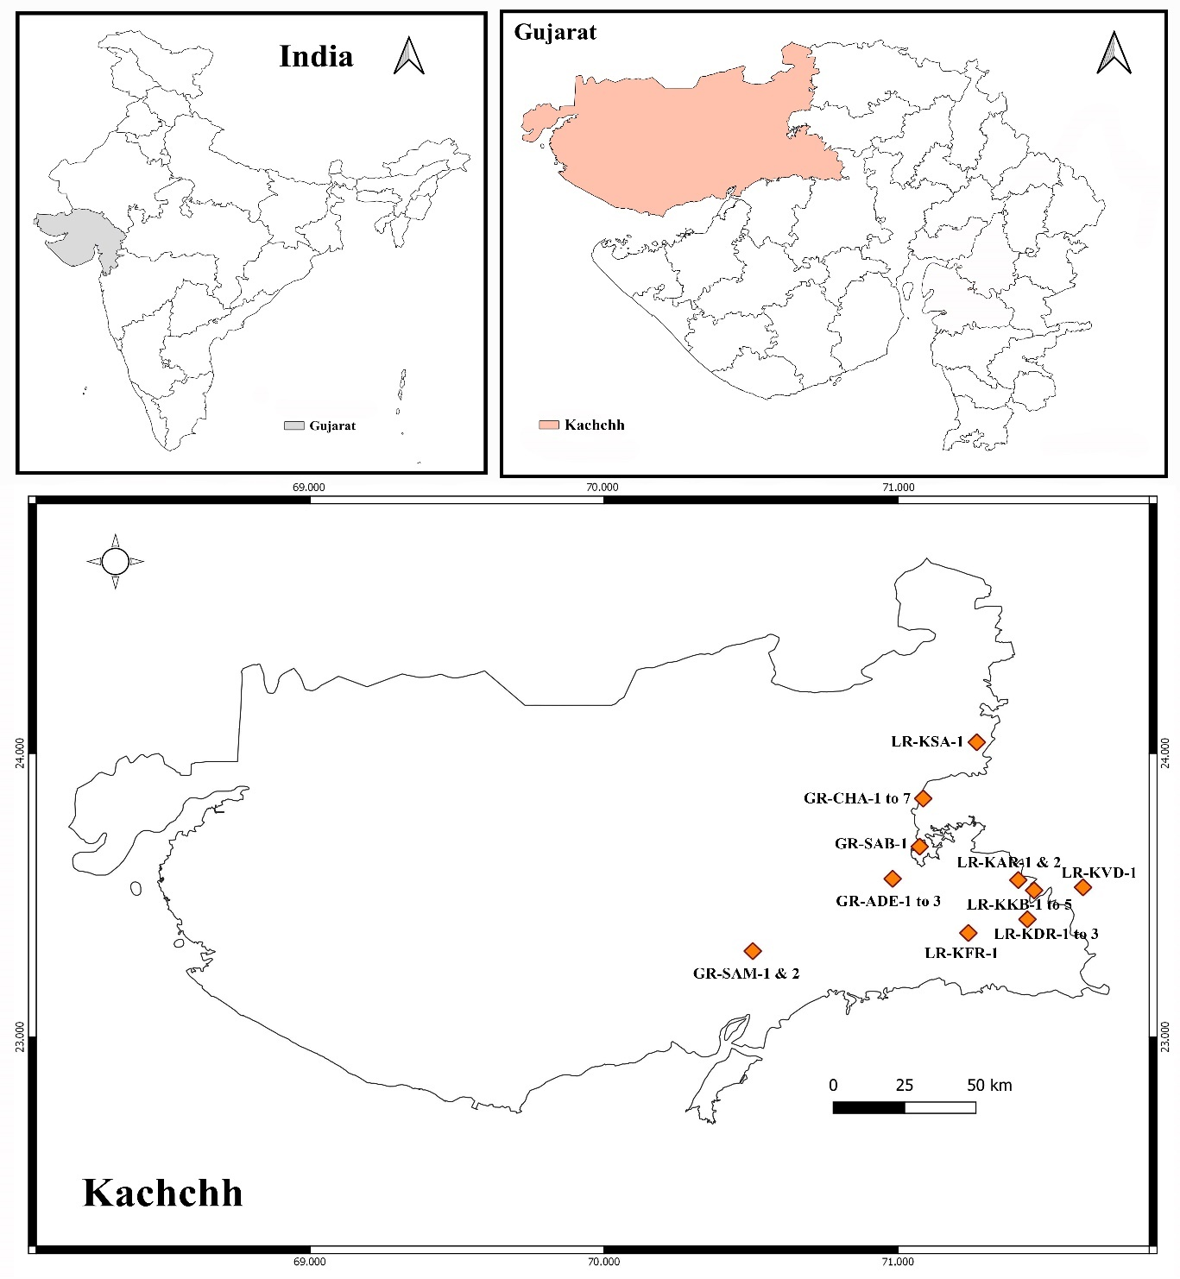
Figure 1. Area showing sampling site: Kutch map.

Physico-chemical characterization of soil samples
Soil samples were crushed, thoroughly mixed, and sieved to get rid of large debris. One portion of each sample was used for physicochemical analysis and the second part was used for isolation purposes. The samples were dried at 45°C until they reached a constant weight before physicochemical analysis. Soil samples were characterized using pH and electrical conductivity.

Enrichment and isolation of actinomycetes
The enrichment and isolation of the actinomycetes were done by the following procedure as shown in (Figure 2) (El-nakeeb and Lechevalier 1962)(Raja and John 2017)(Soltani Nejad, Khatami, and Shahidi Bonjar 2016).
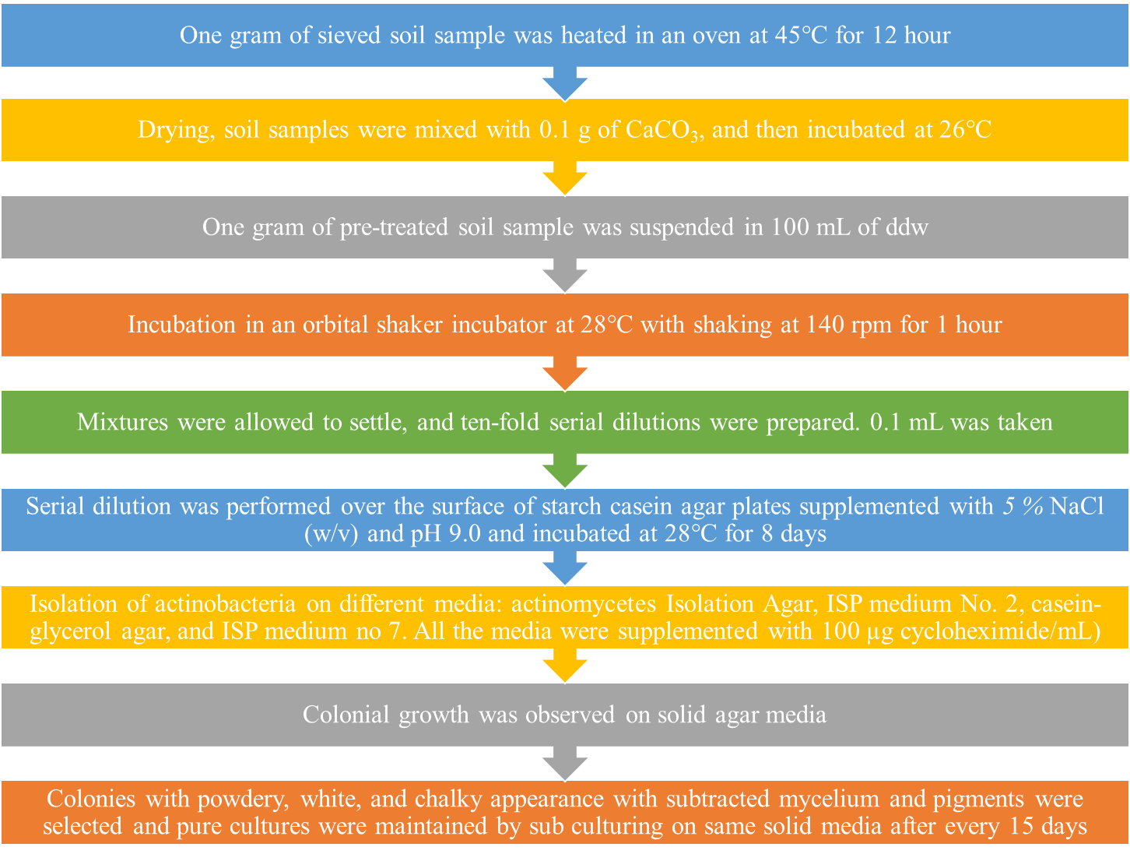

Figure 2. Steps involved in the enrichment and isolation of actinomycetes.

Maintenance of isolates and preparation of glycerol stock

Pure cultures of isolates were preserved at 4°C on Starch Casein Agar (SCA) supplemented with 5 % NaCl (w/v) and pH 9.0 with the periodic transfer at regular intervals. Isolates were grown in starch casein broth for 4-5 days. After incubation, glycerol cultures were prepared by suspending the spores of isolates in 20 % glycerol (v/v) at -80°C for further study (Sapkota et al. 2020).

Morphological and Cultural Characterization
Morphological characterization was studied on Glycerol Asparagine Agar (ISP medium no) and tyrosine agar medium as recommended by the International Streptomyces Project (Gottlieb 1966). Isolates were grown on for 5-7 days until mature spore mass produced and used to study the morphological cultural characteristics.

Gram Staining and Colony Characteristics
Gram staining was performed to study cell morphology and spore. (Mondal and Thomas 2022) Following the incubation period, the well-isolated mature colony was selected to study the colony characters concerning their shape, size, margin, elevation, and texture.

Aerial mass color & substrate mycelium color (reverse side pigments)
The color of the mature sporulating aerial mycelium was recorded as White, grey, red, green, blue, and violet color. The ability to produce characteristic pigments on the reverse side of the colony was recorded as pale yellow, olive, or yellowish brown and brown (Malviya et al. 2013; Naligama, Weerasinghe, and Halmillawewa 2022; Abdelrahman et al. 2022).

Melanin production
Presence of melanin pigments was studied on Tyrosine Agar Medium (ISP medium No-7). Isolates were grown on tyrosine agar medium for 7 days at 30 °C. After 5 days of incubation, browning of organic medium containing tyrosine was detected. Based on the different colors observed in the above-mentioned medium, the grouping of all 26 isolates was done (i.e., Greenish-brown, brownish-black, or distinct brown, pigment modified by other colors) on the medium (Rudrappa et al. 2022).

Physiological characterization

Effect of Temperature on the growth of isolates
Isolates were grown at three different temperatures of 20 °C, 30°C, and 40°C in starch casein agar medium, and growth was observed after 7 days.

Effect of salt concentration on the growth of isolates
The effect of salt concentration on growth was studied by supplying the isolates with a range of NaCl concentrations of 0.0, 2.5, 5.0, and 10.0 (% w/v) on starch casein agar plates. After 7 days of incubation, the tolerance limits of actinomycetes to NaCl were determined and analyzed comparatively. Incubation was done as per the optimum temperature observed in the earlier study (Bukhari, Thomas, and Wong 2013).

Effect of pH on the growth of isolates
The influence of pH on growth was demonstrated by using starch casein agar plate having different pH from 5.0 to 9.0. The Acidic pH was adjusted with 5 % sterile CH₃COOH solution, and the alkaline pH was adjusted with 20 % sterile Na₂CO₃ solution after separate autoclaving. After 7 days of incubation, the tolerance limits of isolates to pH were determined and analyzed comparatively (El Karkouri, Assou, and El Hassouni 2019a; Chukwuneme et al. 2020).

Effect of growth conditions: normal, alkaline, saline, and saline + alkaline conditions on the growth of isolates
Growth response was also investigated with the stress-supplemented condition i.e., alkaline, saline, and saline + alkaline. Four different combinations (depicted in Table 1) of pH and salt were used to study the haloalkaliphilic nature of the isolates. Control was kept without any stress.
Table 1. Combination of stress conditions.
Condition | pH | NaCl (%, w/v)
Normal | 7.0 | 0.0
Alkaline | 9.0 | 0.0
Saline | 7.0 | 5.0
Saline + alkaline | 9.0 | 5.0

Extracellular enzyme profiling

Gelatinase
Screening for the extracellular production of the proteolytic enzyme, gelatinase was detected using gelatin as a substrate. The test cultures were inoculated in nutrient gelatin tubes and incubated at 28°C temperature for 5-7 days. After incubation, tubes were refrigerated and observed for the hardening of the gelatin (A. J. Salle 1943; Masi, Gemechu, and Tafesse 2021).

Amylase
The isolates were streaked on starch agar plates and incubated at 28 ºC temperature for 5-7 days. After incubation, the plate was flooded with iodine solution. The area of the hydrolyzed zone around the colony was measured. The starch hydrolyzed zone surrounding the colony was observed (A. J. Salle 1943; Fatoki et al. 2023).

Lipase
Screening of extracellular lipase enzyme was determined by streaking the isolates on a tributyrin agar base supplemented with tributyrin as a substrate for the enzyme. The plates were incubated at 28°C for 5-7 days followed by observation of a clear zone surrounding the growth (A. J. Salle 1943; Nimkande, Sivanesan, and Bafana 2023).

Screening for antagonistic substances

Primary screening
The primary screening of antibiotics was performed using the top agar method. Isolates were grown on starch casein agar (5.0 %, w/v, NaCl, pH 9.0) for seven days. After incubation, the top agar was mixed with the test culture overlaid on the base agar and incubated for 24 h. The zone of inhibition surrounding the actinobacterial colony was observed, and results were recorded in mm (Song et al. 2020; Murtaza et al. 2024; Trenozhnikova and Azizan 2018; El-Sayed, Alshammari, and Sharaf 2023). All the isolates were screened for their antimicrobial activity against MTCC strains obtained from the Microbial Type Culture Collection Center (MTCC), Chandigarh, India (Table 2).
Table 2. Test cultures used in antimicrobial studies.
No | Test organism | MTCC code
I | Gram-positive bacteria
1 | Bacillus subtilis | 441
2 | Staphylococcus aureus | 737
II | Gram-negative bacteria
3 | Escherichia coli | 1687
4 | Pseudomonas aeruginosa | 1688
III | Fungi
5 | Candida albicans | 183
6 | Aspergillus niger | 1344
IV | MRSA strain
7 | MRSA 2 | Lab isolates
8 | MRSA 7 | Lab isolates

Secondary screening
Isolates with positive antimicrobial activity against one or more test organisms in the top agar method were further checked for their antimicrobial potential using a well-diffusion technique (Perez, C., Pauli, M., & Bazerque 1990; Mir et al. 2021). Isolates were grown in starch casein broth supplemented with optimized NaCl and pH conditions. After five days of incubation at 28°C and 120 rpm on a shaker, the cell-free supernatant was used to check the antimicrobial activity. Test culture maintained at 0.5 McFarland standard (Sutton 2011) was spread with the aid of sterile cotton swabs on Mueller Hinton agar (MHA). A 6 mm diameter well was punched carefully with the help of a sterile cork borer and loaded with 100 μL of the cell-free supernatant. The plates were kept in the refrigerator for about 2 hours to allow the diffusion of antibiotics. The plates were incubated at 37°C for 24 h. The zone of inhibition (ZOI) was measured using the HiMedia Antibiotic Zone scale (V. Singh et al. 2016).

Molecular identification
Based on the results of Nitrate reductase activity and antimicrobial activity of the strains, potent isolates were identified using 16S rRNA gene sequencing. A pure culture of strain grown on starch casein agar slant was sent to Chromous Biotech Pvt. Ltd., Bangalore, India for identification.

Analysis of Sequence Data
The 16s rRNA sequence alignment was done manually with the available nucleotide sequence retrieved from EzTaxon (Kim et al. 2007).
Results and Discussion

Study area
The RoK, a saline desert, is one of the unique and untapped hypersaline ecosystems located in Gujarat, India. It is one of the largest salt deserts in the world having a total area of 7,505 square kilometers which lies between 22°55’N latitude and 69°05’E to 71°50’E longitudes. It is divided into two different parts: Great Rann of Kutch (GRK) and Little Rann of Kutch (LRK) which also covers part of the most beautiful grassland of Asia called “Banni” (Pardeshi, Gajera, and Joshi 2010). The Great RoK is one of the largest saline marshlands in India (Juyal 2014). The Little Rann of Kutch has an ecosystem of the saline desert climate which inhabits unique flora and fauna (Bhatt, Gohel, and Singh 2018b). It is a large, dry surface of dark silt that converts into a coastal wetland after the rains (H. M. Patel et al. 2019). The RoK is a large ecotone encrusted with salt with average temperatures of nearly 44°C to 50°C during summer (M 2008). The Kutch is thought to have originated from marine transgression (Biswas, S. K., & Deshpande 1970) which is a mixture of saline, marshy, and coastal deserts having extremely saline soil and water. This distinctive environment makes the RoK a harbor for a unique and robust diversity of microorganisms. Cultivable as well as non-cultivable biodiversity (R. Patel et al. 2015; A. S. Pandit et al. 2014) has been reported from the saline desert of Kutch. The desert of Kutch is a rich source of novel microbial species having immense biotechnological potential. Production of IAA from endophytic bacteria isolated from Little Rann of Kutch (M. V Patel and Patel 2014). PGPR promotes the growth of Arachis hypogea isolated from the saline desert of Kutch (Goswami et al. 2014). Actinomycetes with a wide variety of secondary metabolites, such as enzymes (Mrugesh Khunt and Neepa Pandhi 2015), antibiotics (Thumar et al., 2010), and immune suppressors are isolated from the saline desert of Kutch. The pH and electrical conductivity (EC) were checked in all 10 collected soil samples which is provided in Table 3.
Table 3. Physical and chemical assessment of soil.
No | Area of Kutch | Location | Site Code | pH | EC mS/cm
1 | Great RoK | Charanka Solar Park | GR-CHA | 7.93 | 80.40
2 | Great RoK | Santalpur-Adesar Bridge | GR-SAB | 7.27 | 67.14
3 | Great RoK | Samakhiyali | GR-SAM | 7.92 | 89.20
4 | Great RoK | Adesar | GR-ADE | 7.82 | 72.22
5 | Little Rann of Kutch | Kung bet | LR-KKB | 7.81 | 78.30
6 | Little Rann of Kutch | Dada nu ran | LR-KDR | 7.89 | 65.30
7 | Little Rann of Kutch | Farsi plant | LR-KFR | 7.71 | 69.41
8 | Little Rann of Kutch | Vadilal dam | LR-KVD | 7.65 | 76.23
9 | Little Rann of Kutch | Salt pan | LR-KSA | 7.82 | 82.33
10 | Little Rann of Kutch | Amarapur | LR-KAR | 7.81 | 70.20

Soil pH is the measurement of the acidity or alkalinity in the soil that may affect soil nutrient chemistry and microbiological flora. The pH of the soil ranged from 7.27 to 7.93 with the highest in Charanka Solar Park and Samkhiyali locations while others were having moderately alkaline conditions. Analysis of pH revealed the alkaline nature of the soil having different levels of alkalinity. The alkaline nature of the saline desert of the Kutch has been reported by (Aanal S. Pandit et al. 2015). The highly alkaline pH of the saline lake in the Gobi Desert region was detected by (Bayanmunkh et al. 2017). On the contrary, (S. Patel, Jinal, and Amaresan 2017) reported the neutral nature of the rhizospheric soil from a desert zone of Kutch.
Salinity level influences the microbial composition in the soil (A. S. Pandit et al. 2014; Narayan et al. 2018). The salinity of the soil samples was estimated using EC because electrical conductivity and salinity are positively correlated. The EC of the samples ranged from 65.30 mS/cm in Dada nu Rann to 89.20 mS/cm in Samkhiyali. (Aanal S. Pandit et al. 2015) has reported the EC of the saline desert of Kutch in different locations from 68.5 mS/cm to 513.3 mS/cm. Results of EC revealed the saline nature of the selected habitat. The ions responsible for the salinization are Na⁺, K⁺, Ca²⁺, Mg²⁺, and Cl⁻. The high rate of evaporation and low annual rainfall lead to the accumulation of these salts resulting in salinization which is the characteristic of the tropical desert area. Salinity level also affects the microbial physiological processes thereby showing the presence of unique secondary metabolites (Bhatt, Gohel, and Singh 2018a). On the contrary, Saker et al., (2015) have stated that the degree of salinity in the selected habitat does not always correlate with the salt resistance pattern of the isolates.
From the soil analysis report, soil samples can be categorized under saline and alkaline conditions. As the study aimed to explore the haloalkaliphilic/halotolerant actinomycetes, soil samples selected for the study were appropriate for isolation purposes. Soil samples with the extremity of salt and pH are a good source of the actinomycetes having unique bioactive potential. The antagonistic property of halophilic actinomycetes from saline soil has been reported by Meklat et al., (Meklat et al. 2011). The antitumor compound from Streptomyces griseoincarnatus CTF15 has been recovered by Sajid et al., (Sajid, Shaaban, and Hasnain 2011).

Isolation of actinobacteria from the soil sample
Isolation of actinomycetes from ten different locations of Little and Great RoK was carried out using the enrichment culture technique (Sapkota et al. 2020). Four locations from Great Rann and six locations from Little Rann of Kutch were selected for isolation which was carried out in starch casein agar medium. Isolation resulted in the growth of ninety-two isolates from Little and Great RoK. The isolates that appeared identical concerning the color of aerial mycelium, substrate mycelium, and texture were eliminated. A total of twenty-six morphologically distinct isolates (Table 4) were obtained from both areas with an equal number of isolates from each area. Several researchers have reported the utilization of SCA for the isolation of actinomycetes from different habitats (Kumar et al. 2014; Shaik et al. 2017; El Karkouri, Assou, and El Hassouni 2019b).
Table 4. Isolation of actinomycetes from diverse ecological niches of Little and Great RoK.
Area of Kutch | Location | Latitude | Longitude | Site Code | Isolate
Great RoK | Charanka Solar Park | 23.8952° N | 71.2261° E | GR-CHA | GR-CHA-1
 |  |  |  |  | GR-CHA-2
 |  |  |  |  | GR-CHA-3
 |  |  |  |  | GR-CHA-4
 |  |  |  |  | GR-CHA-5
 |  |  |  |  | GR-CHA-6
 |  |  |  |  | GR-CHA-7
Great RoK | Santalpur Adesar  Bridge | 23.6713° N | 71.0733° E | GR-SAB | GR-SAB-1
Great RoK | Samakhiyali | 23.3032° N | 70.5057° E | GR-SAM | GR-SAM-1
 |  |  |  |  | GR-SAM-2
Great RoK | Adesar | 23.5581° N | 70.9814° E | GR-ADE | GR-ADE-1
 |  |  |  |  | GR-ADE-2
 |  |  |  |  | GR-ADE-3
Little Rann of Kutch | Kung bet |  |  | LR-KKB | LR-KKB-1
 |  |  |  |  | LR-KKB-2
 |  |  |  |  | LR-KKB-3
 |  |  |  |  | LR-KKB-4
 |  |  |  |  | LR-KKB-5
Little Rann of Kutch | Dada nu ran |  |  | LR-KDR | LR-KDR-1
 |  |  |  |  | LR-KDR-2
 |  |  |  |  | LR-KDR-3
Little Rann of Kutch | Farsi plant |  |  | LR-KFR | LR-KFR-1
Little Rann of Kutch | Vadilal dam |  |  | LR-KVD | LR-KVD-1
Little Rann of Kutch | Salt pan |  |  | LR-KSA | LR-KSA-1
Little Rann of Kutch | Amarapur |  |  | LR-KAR | LR-KAR-1
 |  |  |  |  | LR-KAR-2

The highest isolates were obtained from the location selected from Great Rann-GR-CHA (Charanka Solar Park) followed by 5 isolates from LR-KKB and 4 isolates from GR-ADE and LR-KDR, 2 isolates from LR-KAR and GR-SAM and 1 isolate from GR-SAB, LR-KFR, LR-KVD, and LR-KSA. Actinomycetes have been extensively reported from different ecosystems such as marine (Sarkar and Suthindhiran 2022), soil (Ahmad et al. 2017; Khirennas et al. 2023), freshwater (Zothanpuia et al. 2018; Salehghamari et al. 2023), mangroves (Biswas et al. 2017; Sangkanu et al. 2017; Meena et al. 2023; Palla et al. 2018b) and as endophytes (Tanvir et al. 2016; Gnanasekaran et al. 2023) from plants. However, actinomycetes from saline and unexplored habitats attracted the interest of researchers because of their applications in the medical and biotechnological fields (Jagannathan et al. 2021; Sharma, Kikani, and Singh 2021). Kutch desert represents one of such niches studied for microbial diversity from various saline regions.

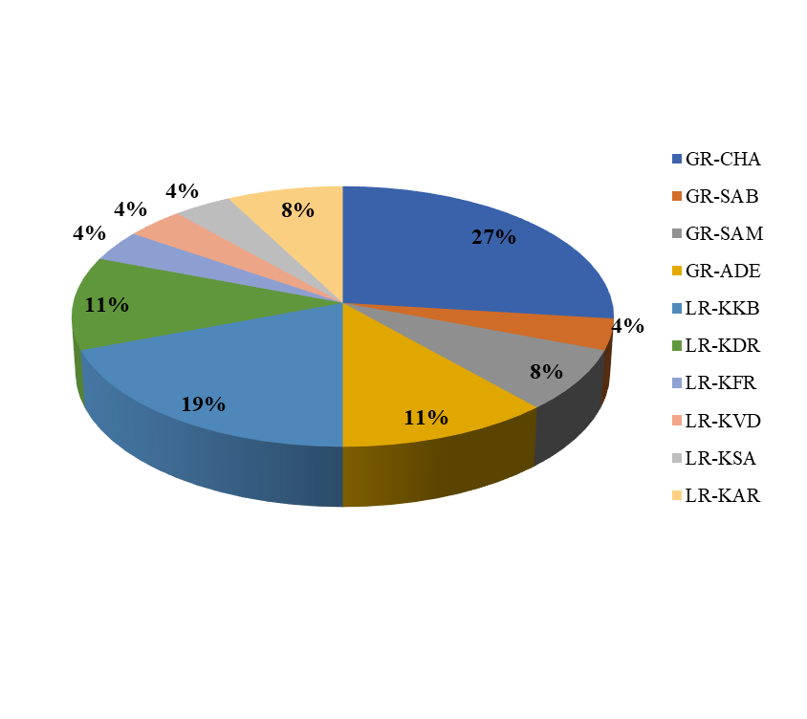
Figure 3. Distribution of isolates in different locations
Different locations of Little and Great RoK are explored for the biodiversity among microbes (Subrahmanyam et al. 2014; Aanal S. Pandit et al. 2015; Bhatt, Gohel, and Singh 2018a; P. Singh et al. 2021; H. M. Patel et al. 2019; Padia, Pandya, and Desai 2024). However, there are scanty reports available on the isolation of actinomycetes, and previously, the isolation of haloalkaliphilic Streptomyces aburaviensis has been reported by Thumar et al., (Thumar, Dhulia, and Singh 2010). Moreover, the isolation of antimicrobial compounds from halophilic fungi has been studied in this region (Prasad 2016). However, exploitation in context with the biotechnological potential of isolates requires much attention.

Cultural and morphological characterization of isolates
Morphology has an important role in distinguishing actinomycetes from the total actinomycetes group. Cultural and morphological characteristics were studied using colony characters, Gram reaction, the presence of melanin pigments, and the appearance of the substrate and aerial mycelium according to International Streptomyces Project (ISP) procedures (Gottlieb 1966). Colony morphology and the presence of pigments showed the diversity among the isolates (Table 5). Gram staining was performed from seven days old sporulated growth on glycerol asparagine agar, ISP medium no-5. All the isolates obtained were found to be Gram-positive. Further confirmation was done by using the KOH string test.
Primary diversification of microorganisms can be studied using colony morphology. Colony characters were studied on Glycerol asparagine agar. Most of the isolates grew within 3-5 days followed by sporulation in 5-7 days. 20% of isolates were slow growers and distinct colonies appeared after three days of incubation. The majority of isolates shared common features of round and irregular-shaped colonies having flat and convex types of elevations. The size was categorized as big and small. Appearances of the colony were entire, erose, filiform, curled, and undulate. The texture of the colonies varied from powdery, and cottony to velvety. Similarly, (Bhatt, Gohel, and Singh 2018a) have reported the colony morphology as a tool for the primary diversification of halophilic actinomycetes isolates.
Aerial mycelial color is an important taxonomic criterion for the grouping of actinomycetes (van Bergeijk et al. 2020). Among the twenty-six isolates, fourteen produced white/off-white color and twelve exhibited grey-colored aerial mass. Substrate mycelia of different colors from pale yellow to brown and dark brown were observed.
Melanin production is also a key feature in the cultural characterization of actinomycetes (Gupta, Imchen, and Kumavath 2022). Browning of the organic media containing tyrosine (tyrosine agar medium) showed melanin production in isolates. Fifty percent of isolates (13) showed the production of brown and dark brown melanin pigments.

Table 5. Cultural and morphological characterization of isolates.
No | Code | Shape | Size | Elevation | Margin | Texture | Melanin Pigment | Aerial  mass color | Substrate mycelium color | Gram Reaction | KOH string test
1 | GR-ADE-1 | Round | Big | Flat | Entire |  | - | Grey | Yellow | Gram +Ve | Negative
2 | GR-ADE-2 | Irregular | Big | Flat | Entire |  | - | White | Brown | Gram +Ve | Negative
3 | GR-ADE-3 | Oval | Big | Convex | Undulate |  | Brown | Grey | Pale Yellow | Gram +Ve | Negative
4 | GR-CHA-1 | Irregular | Big | Convex | Curled |  | Dark brown | White | Brown | Gram +Ve | Negative
5 | GR-CHA-2 | Round | Small | Convex | Filiform |  | - | Grey | Yellow | Gram +Ve | Negative
6 | GR-CHA-3 | Irregular | Small | Flat | Filiform |  | Brown | Pinkish grey | Dark Brown | Gram +Ve | Negative
7 | GR-CHA-4 | Irregular | Big | Convex | Entire |  | Dark brown | White | Pale Yellow | Gram +Ve | Negative
8 | GR-CHA-5 | Irregular | Big | Flat | Curled |  | - | White | Pale Yellow | Gram +Ve | Negative
9 | GR-CHA-6 | Round | Big | Convex | Entire |  | Brown | Grey | Pale Yellow | Gram +Ve | Negative
10 | GR-CHA-7 | Irregular | Big | Convex | Entire |  | - | Grey | Brown | Gram +Ve | Negative
11 | GR-SAB-1 | Irregular | Big | Flat | Curled |  | Brown | White | Brown | Gram +Ve | Negative
12 | GR-SAM-1 | Irregular | Big | Convex | Entire |  | Dark brown | White | Pale Yellow | Gram +Ve | Negative
13 | GR-SAM-2 | Irregular | Big | Convex | Filiform |  | - | White | Pale Yellow | Gram +Ve | Negative
14 | LR-KAR-1 | Round | Small | Flat | Entire |  | Dark brown | White | Light brown | Gram +Ve | Negative
15 | LR-KAR-2 | Round | Small | Flat | Filiform |  | Brown | Grey | Brown | Gram +Ve | Negative
16 | LR-KDR-1 | Irregular | Big | Flat | Erose |  | Dark brown | Grey | Brown | Gram +Ve | Negative
17 | LR-KDR-2 | Round | Small | Flat | Filiform |  | Brown | Grey | Brown | Gram +Ve | Negative
18 | LR-KDR-3 | Round | small | Convex | Entire |  | - | White | Yellow | Gram +Ve | Negative
19 | LR-KFR-1 | Irregular | Small | Flat | Entire |  | - | White | Pale Yellow | Gram +Ve | Negative
20 | LR-KKB-1 | Round | Big | Flat | Entire |  | - | Grey | Light brown | Gram +Ve | Negative
21 | LR-KKB-2 | Irregular | Big | Flat | Entire |  | Dark brown | Grey | Brown to black | Gram +Ve | Negative
22 | LR-KKB-3 | Round | Small | Convex | Entire |  | Dark brown | White | Dark Brown | Gram +Ve | Negative
23 | LR-KKB-4 | Round | Small | Convex | Erose |  | - | Grey | Brown | Gram +Ve | Negative
24 | LR-KKB-5 | Round | Small | Convex | Entire |  | Dark brown | White | Dark Brown | Gram +Ve | Negative
25 | LR-KSA-1 | Round | Big | Convex | Entire |  | - | Grey | Yellow | Gram +Ve | Negative
26 | LR-KVD-1 | Irregular | small | Flat | Erose |  | - | White | Yellow | Gram +Ve | Negative

Cultural and morphological characteristics indicate that all the isolate belongs to the taxonomic group actinomycetes. Moreover, primary identification at the genus level using spore chain morphology and chemical composition like cell wall sugars (Mary P. Lechevalier and Hubert Lechevalier 1988) and the presence of diaminopimelic acid (Mary P. Lechevalier and Hubert Lechevalier 1970) are conventional approaches used by the researchers.

Physiological characterization of isolates
Assessment of the physiological adaptability of the desert isolates in terms of pH, temperature, and salt concentration exhibited a noticeable variation in the tolerance level. The ability to withstand extreme conditions suggests the possibility of getting novel and robust bioactive and industrially important compounds from the actinomycetes. Physiological characterization was done using three parameters pH (5.0, 6.0, 7.0, 8.0, 9.0), Temperature (20°C, 30°C, 40°C), and NaCl (0.0, 2.5, 5.0, 7.5, 10.0 % w/v) concentration (Table 4-4).

Influence of temperature on the growth of bacteria
The growth of the isolates was evaluated at three different temperatures. It was noticed that all the isolates were able to grow between 20 to 40°C. Out of 26, 18 isolates showed optimum growth at 30°C while 8 isolates showed optimum growth temperature of 40°C. According to the growth profile at a different temperature, isolates can be categorized as mesophilic in nature.

Influence of pH on the growth of bacteria
The range of pH for all the isolates was found similar from 7-9 with optimum pH of 8 (13 isolates) and 9 (13 isolates). The results show the alkalotolerant nature of the isolates as growth was observed from neutral to alkaline pH of the medium (V. Singh et al. 2016). Similarly, an actinobacterium from desert soil in Egypt, Citricoccus alkalitolerans, was recognized as alkalotolerant and its optimum growth occurs at pH 8.0–9.0 (W. J. Li et al. 2005). Relatively, high tolerance to pH was observed in the novel alkaliphilic bacterium Nesterenkonia rhizosphaerae isolated from a saline alkaline desert by (Wang et al. 2014).

Table 6. Physiological characterization of Isolates.
No | Code | Range of Temp (°C) | Temp. Optima (°C) | Range  of pH | pH Optima | Range of NaCl conc. (% w/v) | Salt Optima  (% w/v) | Normal | Alkaline | Saline | Saline+  Alkaline
1 | GR-ADE-1 | 20 to 40 | 40 | 7 to 9 | 9 | 0 to 2.5 | 0 | ++ | ++++ | - | -
2 | GR-ADE-2 | 20 to 40 | 30 | 7 to 9 | 9 | 0 to 2.5 | 0 | ++ | ++++ | - | -
3 | GR-ADE-3 | 20 to 40 | 30 | 7 to 9 | 9 | 0 to 2.5 | 0 | ++ | ++++ | - | -
4 | GR-CHA-1 | 20 to 40 | 30 | 7 to 9 | 8 | 0 to 7.5 | 5 | + | ++ | ++ | ++++
5 | GR-CHA-2 | 20 to 40 | 40 | 7 to 9 | 8 | 0 to 10 | 5 | ++ | ++ | ++++ | ++++
6 | GR-CHA-3 | 20 to 40 | 40 | 7 to 9 | 8 | 0 to 10 | 5 | ++ | ++ | ++++ | ++++
7 | GR-CHA-4 | 20 to 40 | 30 | 7 to 9 | 8 | 0 to 7.5 | 5 | + | ++ | ++ | ++++
8 | GR-CHA-5 | 20 to 40 | 40 | 7 to 9 | 8 | 0 to 10 | 5 | ++ | ++ | ++++ | ++++
9 | GR-CHA-6 | 20 to 40 | 40 | 7 to 9 | 8 | 0 to 7.5 | 5 | + | ++ | ++ | ++++
10 | GR-CHA-7 | 20 to 40 | 30 | 7 to 9 | 8 | 0 to 7.5 | 5 | + | ++ | ++ | ++++
11 | GR-SAB-1 | 20 to 40 | 40 | 7 to 9 | 9 | 0 to 7.5 | 2.5 | ++ | ++++ | ++ | ++
12 | GR-SAM-1 | 20 to 40 | 30 | 7 to 9 | 8 | 0 to 2.5 | 2.5 | ++ | ++++ | ++ | ++
13 | GR-SAM-2 | 20 to 40 | 30 | 7 to 9 | 9 | 0 to 2.5 | 0 | ++ | ++++ | - | -
14 | LR-KAR-1 | 20 to 40 | 30 | 7 to 9 | 8 | 0 to 10 | 5 | ++ | ++ | ++++ | ++++
15 | LR-KAR-2 | 20 to 40 | 30 | 7 to 9 | 9 | 0 to 7.5 | 5 | ++++ | ++++ | +++ | +++
16 | LR-KDR-1 | 20 to 40 | 30 | 7 to 9 | 9 | 0 to 7.5 | 2.5 | ++ | ++++ | ++ | ++
17 | LR-KDR-2 | 20 to 40 | 30 | 7 to 9 | 9 | 0 to 7.5 | 2.5 | ++ | ++++ | ++ | ++
18 | LR-KDR-3 | 20 to 40 | 30 | 7 to 9 | 9 | 0 to 7.5 | 5 | ++++ | ++++ | +++ | +++
19 | LR-KFR-1 | 20 to 40 | 30 | 7 to 9 | 8 | 0 to 10 | 5 | ++ | ++ | ++++ | ++++
20 | LR-KKB-1 | 20 to 40 | 40 | 7 to 9 | 8 | 0 to 10 | 5 | ++ | ++ | ++++ | ++++
21 | LR-KKB-2 | 20 to 40 | 30 | 7 to 9 | 8 | 0 to 10 | 5 | ++ | ++ | ++++ | ++++
22 | LR-KKB-3 | 20 to 40 | 40 | 7 to 9 | 8 | 0 to 10 | 5 | ++ | ++ | ++++ | ++++
23 | LR-KKB-4 | 20 to 50 | 30 | 7 to 9 | 9 | 0 to 7.5 | 2.5 | ++ | ++++ | ++ | ++
24 | LR-KKB-5 | 20 to 40 | 30 | 7 to 9 | 9 | 0 to 7.5 | 2.5 | ++ | ++++ | ++ | ++
25 | LR-KSA-1 | 20 to 40 | 30 | 7 to 9 | 9 | 0 to 7.5 | 2.5 | ++ | +++ | +++ | ++++
26 | LR-KVD-1 | 20 to 40 | 30 | 7 to 9 | 9 | 0 to 7.5 | 5 | + | ++++ | ++++ | +++
Poor: +; Moderate: ++; Good: +++; Excellent: ++++ No growth: -

Influence of NaCl concentration on the growth of bacteria
According to the degree of their salt requirement: slight halophiles grow optimally at 0.2–0.85M (1–5%) sodium chloride (NaCl); moderate halophiles grow optimally at 0.85–3.4M (5–20%) NaCl; and extreme halophiles grow optimally at 3.4–5.1M (20–30%) NaCl. In contrast, halophiles grow optimally in less than 0.2M NaCl conditions. Halotolerant organisms can grow either in high salinity or in its absence. Many non-halophiles and halotolerant microorganisms can grow over a wide range of salt concentrations, with the requirement or tolerance for salts occasionally dependent on environmental and/or nutritional factors (DasSarma and DasSarma 2017; Dutta and Bandopadhyay 2022).
Depending on the salt tolerance profile isolates were classified under halotolerant and slight halophiles. Though they are less exciting at first glance than the extreme halophiles the moderately halophilic bacteria, and halotolerant microorganisms in general, pose quite sufficiently interesting questions, especially those implied by their ability to grow over wide ranges of solute concentrations (Kushner 1978; Rathakrishnan and Gopalan 2022a).
Isolates from Adesar (GR-ADE-1, GR-ADE-2, GR-ADE-3) and isolate GR-SAM-2 showed halotolerant nature with 0% w/v optimum salt concentration and growth up to 2.5% w/v salt concentration. Similarly, a novel halotolerant Streptomyces xinjiangensis sp. was isolated from the Lop Nur region (Cheng et al. 2016) in China and required optimum salt concentration from 0 to 2.5 % NaCl (w/v).
All the remaining isolates were classified under slight halophiles as they grew optimally between 5-10 % w/v NaCl concentration. The results are in agreement with the haloalkaliphilic actinobacterium isolated from the saline desert of Kutch which requires 5-10% NaCl concentration for its growth (Thumar, Dhulia, and Singh 2010). Various types of soil samples (terrestrial, saline, and hypersaline) have yielded several novel isolates and the most distinct feature of these isolates was their NaCl requirement (Hamedi, Mohammadipanah, and Ventosa 2013; Negacz et al. 2022; Rathakrishnan and Gopalan 2022b).
Several new taxa (species and genera) of halophilic actinobacteria have been reported (Meklat et al. 2015; Cheng et al. 2016; R. Zhang et al. 2017). Halophilic actinomycetes have unique biological and chemical resistance systems such as pH tolerance and salt tolerance present one of the main resources for the detection of novel metabolites, biosurfactants, and commercially important enzymes with diverse applications (Arasu, Esmail, and Al-Dhabi 2016; Rathinam et al. 2023). The exploration of extreme ecosystems especially arid and saline habitats led to the detection of many bioactive compounds (R. Zhang et al. 2017; Souagui et al. 2017).

Enzymatic characterization of isolates
Isolates were detected for the presence of extracellular enzymes namely amylase, gelatinase, and lipase (Table 7).
Table 7. Enzymatic Characterization of Isolates.
No | Code | Lipase | Protease | Amylase
1 | GR-ADE-1 | - | + | +
2 | GR-ADE-2 | + | + | +
3 | GR-ADE-3 | + | + | +
4 | GR-CHA-1 | + | + | +
5 | GR-CHA-2 | - | + | +
6 | GR-CHA-3 | + | + | +
7 | GR-CHA-4 | + | + | -
8 | GR-CHA-5 | + | + | +
9 | GR-CHA-6 | - | + | +
10 | GR-CHA-7 | - | + | +
11 | GR-SAB-1 | + | + | +
12 | GR-SAM-1 | + | + | +
13 | GR-SAM-2 | + | + | -
14 | LR-KAR-1 | - | + | +
15 | LR-KAR-2 | - | + | +
16 | LR-KDR-1 | + | + | +
17 | LR-KDR-2 | - | + | +
18 | LR-KDR-3 | + | + | +
19 | LR-KFR-1 | + | + | +
20 | LR-KKB-1 | + | + | +
21 | LR-KKB-2 | - | + | +
22 | LR-KKB-3 | + | + | +
23 | LR-KKB-4 | + | + | +
24 | LR-KKB-5 | + | + | +
25 | LR-KSA-1 | - | - | +
26 | LR-KVD-1 | - | + | +

All the isolates were able to utilize starch except GR-CHA-4 and GR-SAM-2 which indicated the ability of the isolates to produce amylase enzyme. Except for LR-KSA-1, all other isolates gave gelatin test positive. Out of 26, 16 isolates gave positive lipid hydrolysis test on tributyrin agar medium, while 10 isolates were not able to degrade tributyrin.
Previously Agamy et al., also reported the isolation of four marine actinomycetes namely Streptomyces griseorubens, S. rochei, S. parvus, and Streptomyces sp., on SCA, where the highest hydrolytic halo zone was 24 mm for the S. rochei. Further α-amylase was isolated and purified and was active at pH 6 and 65°C. Besides this, it was reported to have a thermal stability of 70°C for 40 minutes (Al-Agamy et al. 2021).
Dezfully et al., isolated Streptomyces flavogriseus, strain ACTK2 from the soil samples of the Karnataka region, India, and found that the particular strain could liquefy the gelatine (Khandan D and G.R. 2015).

Screening for the presence of antagonistic substances
Actinomycetes have contributed a lot to the pharmaceutical industries with a range of bioactive metabolites. They are excellent elaborators of pharmaceutical products and are well known for finding novel biologically active secondary metabolites (Goodfellow and Fiedler 2010).

Preliminary screening for antimicrobial activity
In the primary screening method, 26 isolates were screened against test organisms, of which 23 isolates showed antagonistic activity against at least one tested culture.

Secondary screening for the antibacterial activity
All the isolates except LR-KAR-2, LR-KSA-1, and LR-KVD-1 exhibited antimicrobial activity against B. subtilis in the range of 6 to 40 mm inhibition zone (Figure 4a). Maximum activity was observed in GR-ADE-1 followed by LR-KDR-2 (28 mm). Isolate GR-SAM-2 showed minimum activity (6 mm). Out of twenty-six isolates positive activity against S. aureus was found in twenty-two isolates and no inhibition was observed in four isolates (Figure 4b). Maximum activity of 26 mm was observed in GR-ADE-1 and LR-KDR-2 followed by LR-KDR-1 and GR-CHA-5 (25 mm). Minimum activity (6 mm) was observed in the LR-KAR-1 isolate. Out of 26, thirteen isolates inhibited the growth of P. aeruginosa while remaining isolates failed to show activity against P. aeruginosa. The highest activity was recorded in GR-ADE-1 (18 mm) (Figure 4c). For E. coli, out of twenty-six, sixteen isolates were able to show inhibitory action in the range of 2-40 mm diameters (Figure 4d). The highest inhibitory action was displayed by GR-ADE-1 (30 mm) followed by LR-KDR-2 and GR-SAB-1 (16 mm). Maximum antibacterial activity against all the bacteria was observed in GR-ADE-1 [B. subtilis and E. coli (40 mm) followed by S. aureus (26 mm) and P. aeruginosa (18 mm).
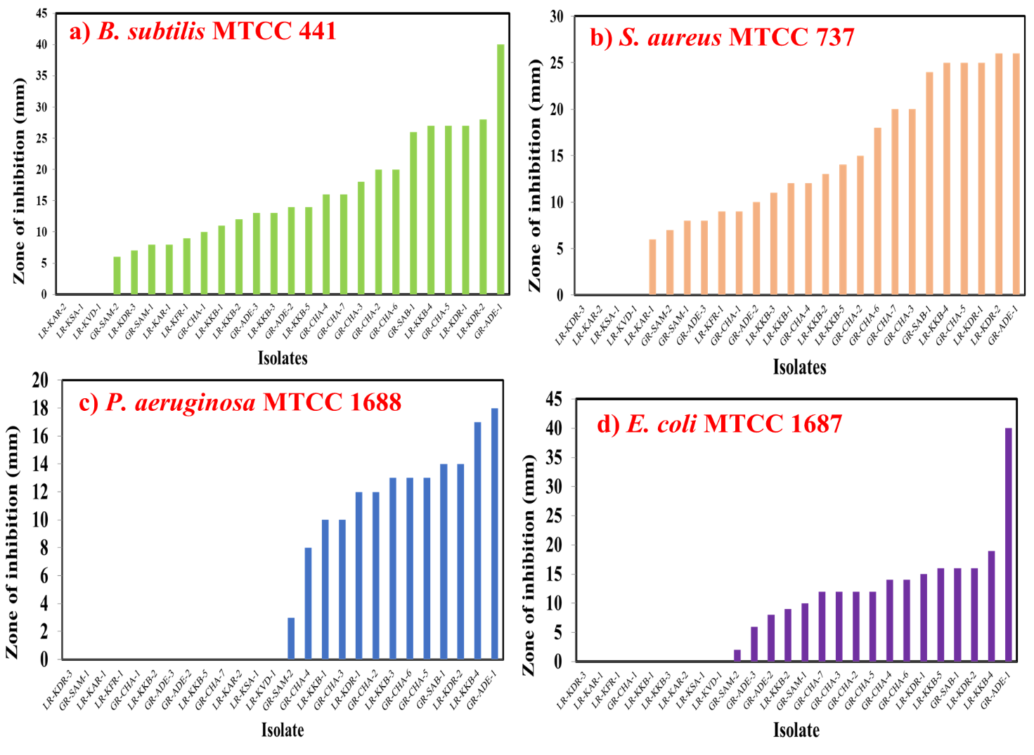
Figure 4. Screening for antibacterial activity against a) B. subtilis MTCC 441, b) S. aureus MTCC 737, c) P. aeruginosa MTCC 1688, and d) E. coli MTCC 1687.
Screening of actinomycetes compounds for the anti-fungal activity
Positive anti-fungal activity against A. niger was noticed in nine actinomycetes isolates (Figure 5a). Maximum activity was displayed by GR-CHA-4 (16 mm) while minimum activity was observed in LR-KFR-1 (6 mm). GR-CHA-4 showed the highest inhibitory action (18 mm) against C. albicans followed by LR-KKB-4 and GR-CHA-5 (13 mm) (Figure 5b).
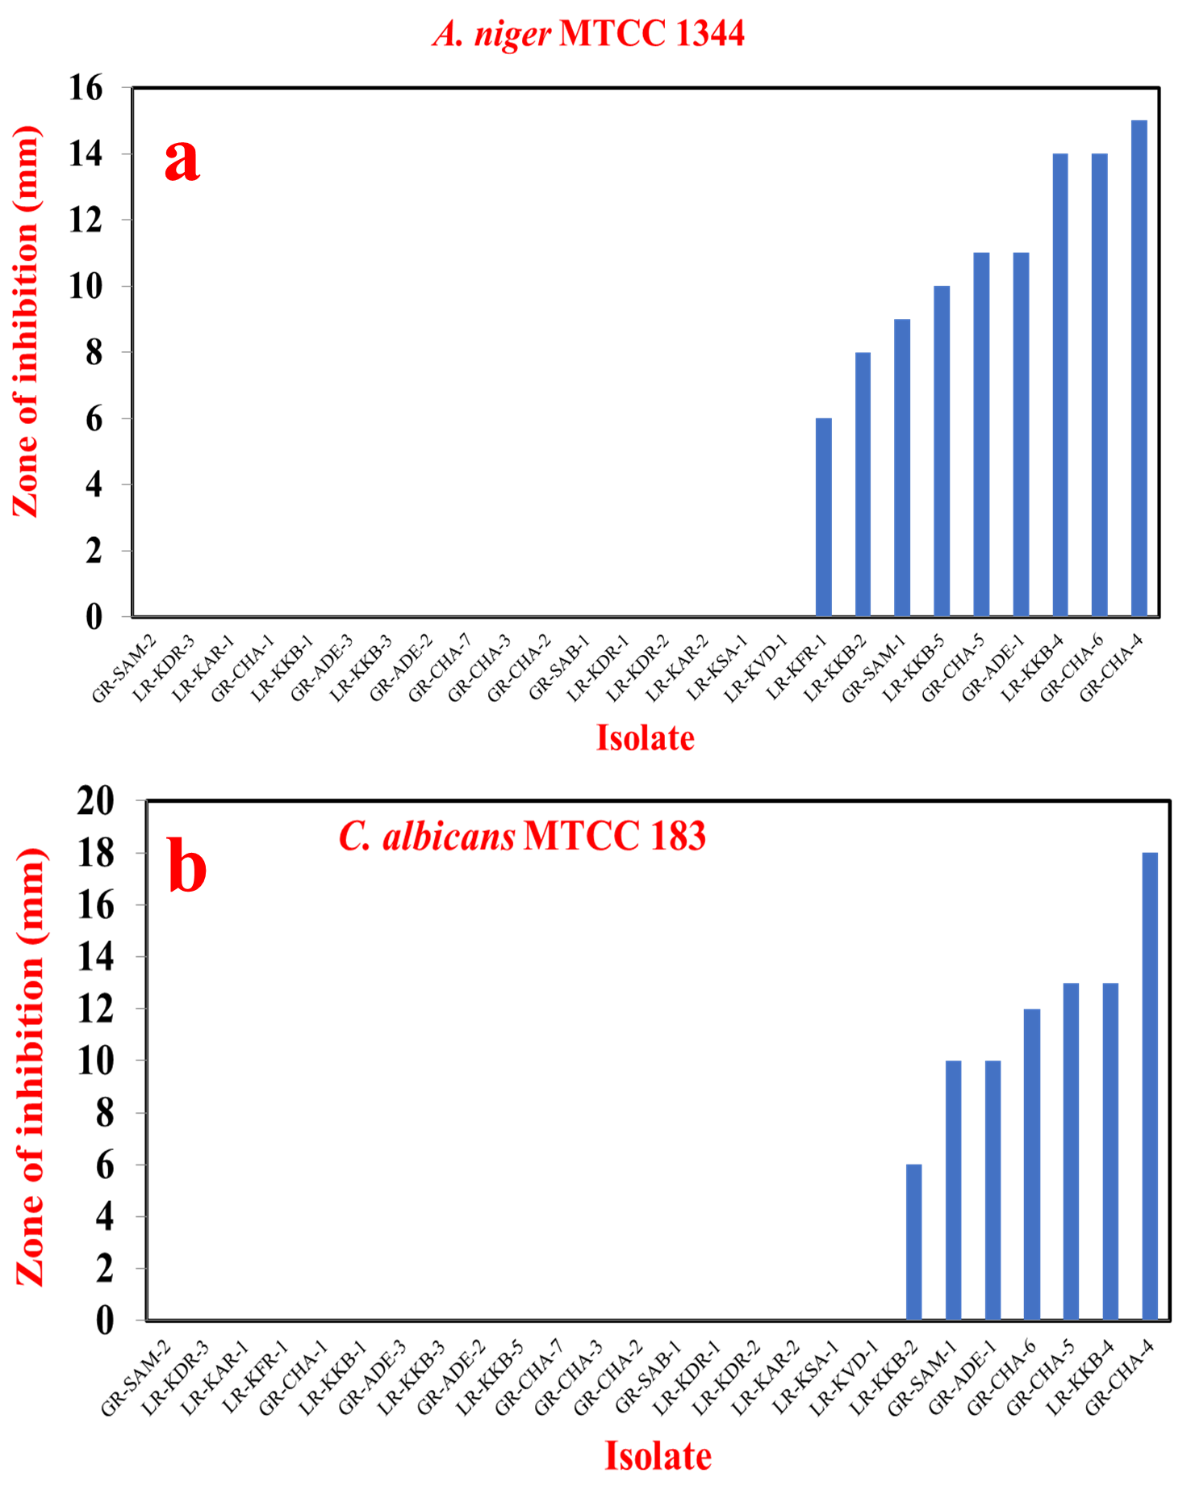
Figure 5. Screening for antimicrobial activity against a) A. niger MTCC 1344, and
C. albicans MTCC 183.
Earlier several actinomycetes peptides have been used as antifungal agents against A. niger and C. albicans. Chitinase was isolated from the marine Streptomyces DA11 which showed potential antifungal activity against A. niger, C. albicans (Han et al. 2009). Further marine actinomycetes M045 (Cladothrix actinomycetes) were used for the extraction of Chandrananimycin A which was further applied for the antifungal activity against Mucor miehei (Maskey et al. 2003). A peptide called polyoxin D was extracted from the Streptomyces cacaoi and exhibited antifungal activity against C. albicans, and Cryptococcus neoformans (Becker et al. 1983). Hector et al., extracted Nikkomycin Z (MW: 495.4) from the Streptomyces tendae and used them against Glomus and Aspergillus fumigatus (Hector, Zimmer, and Pappagianis 1990).

Screening for the anti-MRSA activity
MRSA strains isolated from the clinical samples were used over here. Out of 26 isolates employed for the anti-MRSA potential, four isolates inhibited the growth of MRSA strains (Figure 6). Isolate GR-ADE-1 inhibited the growth of both the MRSA strains with a ZOI of 30 mm and 11 mm against MRSA-2 and MRSA-7 respectively. Isolate LR-KKB-4 inhibited the growth of MRSA-2 and MRSA-7 with zone inhibition of 10 mm and 8 mm respectively. GR-CHA-4 and GR-CHA-6 showed activity against MRSA 7. Isolate GR-ADE-1, LR-KKB-4, GR-CHA-4, and GR-CHA-6 were found to have broad-spectrum activity against tested organisms. However, GR-ADE-1 with maximum inhibition of all the tested organisms was the most potent among all.
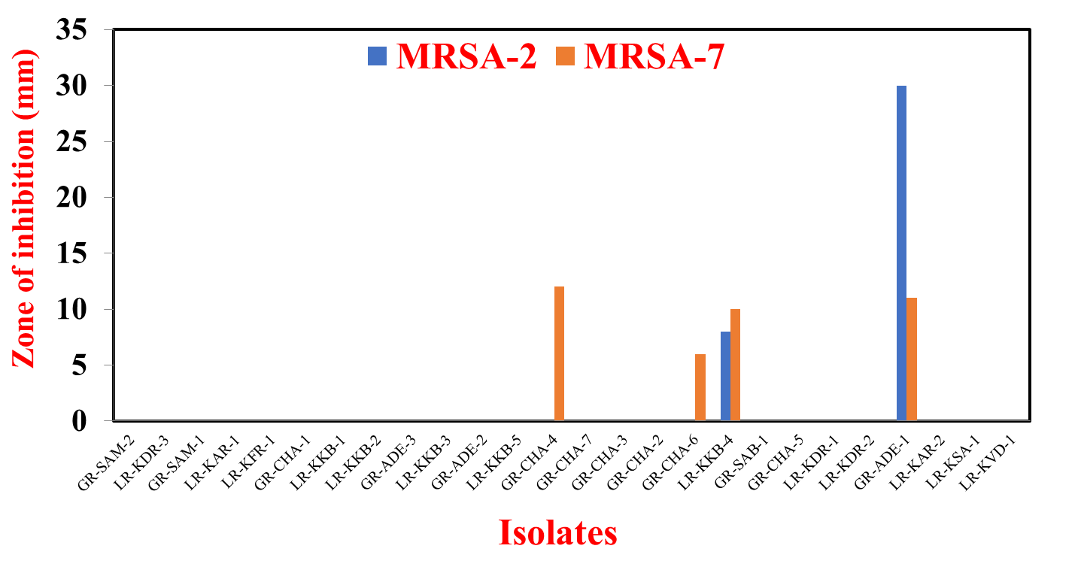
Figure 6. Screening for antimicrobial activity against MRSA.
In recent years, the discovery of novel compounds against drug-resistant pathogens has become a difficult task; therefore, it is important to target unexplored/less-explored environments such as marine or desert soil. Literature review shows the exploitation of desert areas for the isolation of novel isolates having potent antimicrobial activity (Saker et al. 2015; R. Zhang et al. 2017). Anti-MRSA metabolites have been reported from saline desert isolates by (Selvameenal, Radhakrishnan, and Balagurunathan 2009; Tiwari et al. 2015). Recently, inhibition of the staphyloxanthin-based anti-MRSA activity from Streptomyces has been demonstrated (Charousová et al. 2018). Many species of actinomycetes particularly those belonging to the genus Streptomyces (Abdel Azeiz et al., 2016; Al-Askar et al., 2015; Atta, Dabour, & Desoukey, 2009; Palla et al., 2018; Souagui et al., 2017; Yandigeri et al., 2015)., 2017; Yandigeri et al., 2015).
Streptomyces smyrnaeus UKAQ_23 was isolated from Saudi Arabia (mangrove sediment), and showed strong antimicrobial potential against MRSA and other Gram-positive bacteria (GPB). It was found that the isolated species produced the highest amount (561.3 ± 0.3 mg/kg fermented agar) of actinomycin X2 and actinomycin D in modified ISP-4 agar under specific conditions. The former antimicrobial compound exhibited a higher antimicrobial activity in comparison to the latter and the actinomycins mixture when tested against MRSA and non-MRSA GPB. The measurement of the antimicrobial activity was done at a concentration of 5 µg/disc. The minimum inhibitory concentration (MIC) of actinomycin X2 for non-MRSA bacteria, ranged from 1.56 to 12.5 µg/mL, while for MRSA it ranged from ranged from 3.125 to 12.5 µg/mL. The MIC activity indicated that the MRSA needed slightly higher concentrations to inhibit the growth (Qureshi et al. 2021).

Screening for nitrate reductase activity
All the isolates were screened for the presence of nitrate reductase enzyme which aids in the synthesis of Nanoparticles via biological route. Of the 26 isolates, 14 isolates gave positive nitrate reductase tests from Little and Great RoK (Table 8). These results are in agreement with the authors who used the above screening protocol for the biosynthesis of metal nanoparticles (Narasimha 2013; Kundu et al. 2014). The exact mechanism for the biosynthesis has not been established but nitrate reductase is known to be involved in the bioreduction of metal ions to metal nanoparticles.
Table 8. Screening for nitrate reductase activity.
No | New code | Nitrate reductase
1 | GR-ADE-1 | Positive
2 | GR-ADE-2 | Positive
3 | GR-ADE-3 | Positive
4 | GR-CHA-1 | Negative
5 | GR-CHA-2 | Positive
6 | GR-CHA-3 | Negative
7 | GR-CHA-4 | Positive
8 | GR-CHA-5 | Positive
9 | GR-CHA-6 | Negative
10 | GR-CHA-7 | Positive
11 | GR-SAB-1 | Positive
12 | GR-SAM-1 | Negative
13 | GR-SAM-2 | Negative
14 | LR-KAR-1 | Negative
15 | LR-KAR-2 | Negative
16 | LR-KDR-1 | Negative
17 | LR-KDR-2 | Negative
18 | LR-KDR-3 | Positive
19 | LR-KFR-1 | Positive
20 | LR-KKB-1 | Negative
21 | LR-KKB-2 | Positive
22 | LR-KKB-3 | Positive
23 | LR-KKB-4 | Positive
24 | LR-KKB-5 | Negative
25 | LR-KSA-1 | Negative
26 | LR-KVD-1 | Positive

Many investigators have used the nitrate reductase-based screening procedure for the successful production of metal NPs from different prokaryotic organisms (Narasimha 2013; Kundu et al. 2014; Saminathan 2015).

Molecular identification
Based on the nitrate reductase and antimicrobial screening, three isolates i.e., GR-ADE-1, GR-CHA-4, and LR-KKB-4 were selected for molecular identification (Figure 9).

Table 9. Identification of isolates using EzTaxon database.
Isolate code | Top three suggested in EzTaxon database | Selected identification | Hit strain name | Similarity (%)
LR-KKB-4 | Streptomyces rochei | Streptomyces rochei | NRRL B-2410(T) | 98.62
LR-KKB-4 | Streptomyces vinaceusdrappus |  | NRRL 2363(T) | 98.62
LR-KKB-4 | Streptomyces enissocaesilis |  | NRRL B-16365(T) | 98.62
GR-ADE-1 | Nocardiopsis alba | N. alba | DSM 43377(T) | 99.60
GR-ADE-1 | N. lucentensis |  | DSM 44048(T) | 99.60
GR-ADE-1 | N. dassonvillei |  | DSM 43111(T) | 99.33
GR-CHA-4 | Streptomyces tendae | S. tendae | ATCC 19812(T) | 98.46
GR-CHA-4 | Streptomyces violaceorubidus |  | LMG 20319(T) | 98.46
GR-CHA-4 | Streptomyces gougerotii |  | NBRC 3198(T) | 98.46

The isolates Streptomyces rochei, Nocardiopsis alba, and Streptomyces alba are well-documented for their anti-bacterial, anti-fungal, anti-MRSA, anti-cancer, and NPs-producing abilities. Streptomyces rochei isolated from marine habitat was found to produce silver nanoparticles with anti-bacterial and anti-cancer activity (P.Selvakumar et al. 2012; Abd-Elnaby et al. 2016). Bioactive compounds such as Terpenoid and Lankacidin were reported by S. Rochei (Pazhanimurugan et al. 2016; Arakawa et al. 2005). Further, the anti-fungal and anti-bacterial activity was reported from the S. rochei (N.G. Reddy 2011). Nocardiopsis alba isolated from marine environments has also been reported for the production of novel bioactive metabolites such as Isomethoxyneihumicin and diketopiperazine (cytotoxic activity) (Fukuda et al. 2017; Q. Zhang et al. 2013). Moreover, the haloalkaliphilic strain of Nocardiopsis alba was found to produce alkaline protease (Thakrar and Singh 2019). Tylosin and nikkomycin-like compounds have been reported from Streptomyces tendae (Veelken and Pape 1982).
Conclusion
The exploration of actinomycetes diversity in the saline and alkalic soils of the Runn of Kutch was successfully observed which revealed a fascinating insight into their unique characteristics and potential applications. Through rigorous sampling and isolation efforts from 10 different soil samples, 26 distinct actinomycete strains 13 each from Little and Great RoK, each exhibiting diverse characteristics reflective of their halophilic, alkaliphilic, and halotolerant nature. Out of 26 actinomycetes isolates, for nitrate reductase 14 were positive, for lipid hydrolysis test 16 isolates were positive on tributyrin agar medium, 13 isolates produced brown and dark brown melanin pigments. The optimum temperature was 30°C, for 18 isolates and 40°C for 8 isolates whereas the pH for all the isolates was in the range of 7-9 with optimum pH of 8 (13 isolates) and 9 (13 isolates). Out of 26 isolates, 23 isolates showed antagonistic activity against at least one tested culture. Isolate GR-ADE-1, LR-KKB-4, GR-CHA-4, and GR-CHA-6 were found to have broad-spectrum activity against all the tested microorganisms. However, GR-ADE-1 with maximum inhibition against all the tested microorganisms was the most potent among all isolates. Out of 26 isolates employed for the anti-MRSA potential, four isolates inhibited the growth of MRSA strains. Positive anti-fungal activity against A. niger was noticed in nine actinomycetes isolates. Based on the EzTaxon database GR-ADE-1 was identified as Nocardiopsis alba, GR-CHA-4 as Streptomyces tendae, and LR-KKB-4 as Streptomyces rochei. Such investigation underlines the significance of exploring unique ecological niches, such as the Runn of Kutch, in the search for novel antimicrobial agents. It also helps in understanding the interaction between the environment and the microorganism and accordingly adaptation to them. The continued investigation of the antibiotics produced by the actinomycetes holds immense promise for the discovery of next-generation antibiotics with broader efficacy and reduced side effects.
Acknowledgement
This project was supported by Researchers Supporting Project number (RSP2024R283), King Saud University, Riyadh, Saudi Arabia. The authors are also thankful to the Department of Life Sciences at Hemchandracharya North Gujarat University, Patan, Gujarat, India, for providing the laboratory facilities.
Disclosure statement
No potential conflict of interest was reported by the author(s).
References
A. J. Salle. 1943. Laboratory Manual on Fundamental Principles of Bacteriology. McGraw-Hill Book Company,Inc.
Abdel Azeiz, Ahmed Z., Donia K. Hanafi, and Sameh E. Hasanein. 2016. “Identification of a New Antifungal Oligoacetal Derivative Produced by Streptomyces Toxytricini against Candida Albicans.” Natural Product Research 30 (16): 1816–1823. doi:10.1080/14786419.2015.1081199.
Abd-Elnaby, Hanan M., Gehan M. Abo-Elala, Usama M. Abdel-Raouf, and Moaz M. Hamed. 2016. “Antibacterial and Anticancer Activity of Extracellular Synthesized Silver Nanoparticles from Marine Streptomyces Rochei MHM13.” The Egyptian Journal of Aquatic Research 42 (3). Elsevier: 301–312. doi:10.1016/J.EJAR.2016.05.004.
Abdelrahman, Ola, Sakina Yagi, Marmar El Siddig, Adil El Hussein, Fanny Germanier, Mout De Vrieze, Floriane L’Haridon, and Laure Weisskopf. 2022. “Evaluating the Antagonistic Potential of Actinomycete Strains Isolated From Sudan’s Soils Against Phytophthora Infestans.” Frontiers in Microbiology 13 (June). doi:10.3389/fmicb.2022.827824.
AboElmaaty, Sabah A., Ali A. Shati, Mohammad Y. Alfaifi, Serag Eldin I. Elbehairi, Norhan S. Sheraba, Mervat G. Hassan, Mona Shaban E. M. Badawy, Ahmed Ghareeb, Ahmed A. Hamed, and Ebtsam Z. Gabr. 2022. “Biofilm Inhibitory Activity of Actinomycete-Synthesized AgNPs with Low Cytotoxic Effect: Experimental and In Silico Study.” Microorganisms 11 (1): 102. doi:10.3390/microorganisms11010102.
Ahmad, Maged S., Ahmed O. El-Gendy, Rasha R. Ahmed, Hossam M. Hassan, Hussein M. El-Kabbany, and Ahmed G. Merdash. 2017. “Exploring the Antimicrobial and Antitumor Potentials of Streptomyces Sp. AGM12-1 Isolated from Egyptian Soil.” Frontiers in Microbiology 8 (MAR): 1–11. doi:10.3389/fmicb.2017.00438.
Al-Agamy, Mohamed H., Mohammad R. Alhuzani, Mahmoud S. Kelany, and Moaz M. Hamed. 2021. “Production and Partial Characterization of α-Amylase Enzyme from Marine Actinomycetes.” BioMed Research International 2021 (December): 1–15. doi:10.1155/2021/5289848.
Al-Askar, Abdulaziz A., Zakaria A. Baka, Younes M. Rashad, Khalid M. Ghoneem, Waleed M. Abdulkhair, Elsayed E. Hafez, and Yasser M. Shabana. 2015. “Evaluation of Streptomyces Griseorubens E44G for the Biocontrol of Fusarium Oxysporum f. Sp. Lycopersici: Ultrastructural and Cytochemical Investigations.” Annals of Microbiology 65 (4): 1815–1824. doi:10.1007/s13213-014-1019-4.
Alsharif, Wiam, Maged M. Saad, and Heribert Hirt. 2020. “Desert Microbes for Boosting Sustainable Agriculture in Extreme Environments.” Frontiers in Microbiology 11 (July). doi:10.3389/fmicb.2020.01666.
Arakawa, Kenji, Fuminori Sugino, Kazuya Kodama, Tatsuya Ishii, and Haruyasu Kinashi. 2005. “Cyclization Mechanism for the Synthesis of Macrocyclic Antibiotic Lankacidin in Streptomyces Rochei.” Chemistry & Biology 12 (2). Cell Press: 249–256. doi:10.1016/J.CHEMBIOL.2005.01.009.
Arasu, Mariadhas Valan, Galal Ali Esmail, and Naif Abdullah Al-Dhabi. 2016. “Hypersaline Actinomycetes and Their Biological Applications.” Actinobacteria-Basics and Biotechnological Applications, 229–245. doi:10.5772/52807.
Atta, H M, S M Dabour, and S G Desoukey. 2009. “Sparsomycin Antibiotic Production by Streptomyces Sp . AZ-NIOFD1 : Taxonomy , Fermentation , Purification and Biological Activities.” American-Eurasian J. Agric. & Environ. Sci. 5 (3): 368–377.
Bayanmunkh, B, T Sen-Lin, D Narangarvuu, B Ochirkhuyag, and O Bolormaa. 2017. “Physico-Chemical Composition of Saline Lakes of the Gobi Desert Region, Western Mongolia.” Journal of Earth Science &amp; Climatic Change 8 (2): 388. doi:10.4172/2157-7617.1000388.
Becker, J M, N L Covert, P Shenbagamurthi, A S Steinfeld, and F Naider. 1983. “Polyoxin D Inhibits Growth of Zoopathogenic Fungi.” Antimicrobial Agents and Chemotherapy 23 (6): 926–929. doi:10.1128/AAC.23.6.926.
Bhatt, Hitarth B., Sangeeta D. Gohel, and Satya P. Singh. 2018a. “Phylogeny, Novel Bacterial Lineage and Enzymatic Potential of Haloalkaliphilic Bacteria from the Saline Coastal Desert of Little Rann of Kutch, Gujarat, India.” 3 Biotech 8 (1). Springer Berlin Heidelberg: 1–12. doi:10.1007/s13205-017-1075-0.
Bhatt, Hitarth B., Sangeeta D. Gohel, and Satya P. Singh. 2018b. “Phylogeny, Novel Bacterial Lineage and Enzymatic Potential of Haloalkaliphilic Bacteria from the Saline Coastal Desert of Little Rann of Kutch, Gujarat, India.” 3 Biotech 8 (1): 53. doi:10.1007/s13205-017-1075-0.
Biswas, Kaushik, Jayanta D. Choudhury, Riddhi Mahansaria, Malay Saha, and Joydeep Mukherjee. 2017. “Streptomyces Euryhalinus Sp. Nov., a New Actinomycete Isolated from a Mangrove Forest.” Journal of Antibiotics 70 (6). Nature Publishing Group: 747–753. doi:10.1038/ja.2017.3.
Biswas, S. K., & Deshpande, S. V. 1970. “Geological and Tectonic Maps of Kutch.” Bull. Oil Nat. Gas Comm 7 (2): 115–120.
Breitling, Rainer, Martina Avbelj, Oksana Bilyk, Francesco Del Carratore, Alessandro Filisetti, Erik K R Hanko, Marianna Iorio, et al. 2021. “Synthetic Biology Approaches to Actinomycete Strain Improvement.” FEMS Microbiology Letters 368 (10). doi:10.1093/femsle/fnab060.
Bukhari, M. A. A., A. N. Thomas, and N. K. Wong. 2013. “Culture Conditions for Optimal Growth of Actinomycetes from Marine Sponges.” In Developments in Sustainable Chemical and Bioprocess Technology, 203–210. Boston, MA: Springer US. doi:10.1007/978-1-4614-6208-8_26.
Charousová, Ivana, Juraj Medo, Lukáš Hleba, and Soňa Javoreková. 2018. “Streptomyces Globosus DK15 and Streptomyces Ederensis ST13 as New Producers of Factumycin and Tetrangomycin Antibiotics.” Brazilian Journal of Microbiology, 1–7. doi:10.1016/j.bjm.2017.12.007.
Chauhan, Ritika, Abhishek Kumar, and Jayanthi Abraham. 2013. “A Biological Approach to the Synthesis of Silver Nanoparticles with Streptomyces Sp JAR1 and Its Antimicrobial Activity.” Scientia Pharmaceutica 81 (2): 607–621. doi:10.3797/scipharm.1302-02.
Cheng, Cong, Yu Qian Li, Mipeshwaree Devi Asem, Chun Yan Lu, Xiao Han Shi, Xiao Chu, Wan Qin Zhang, Deng Di An, and Wen Jun Li. 2016. “Streptomyces Xinjiangensis Sp. Nov., an Actinomycete Isolated from Lop Nur Region.” Archives of Microbiology 198 (8). Springer Berlin Heidelberg: 785–791. doi:10.1007/s00203-016-1234-4.
Chukwuneme, Chinenyenwa Fortune, Olubukola Oluranti Babalola, Funso Raphael Kutu, and Omena Bernard Ojuederie. 2020. “Characterization of Actinomycetes Isolates for Plant Growth Promoting Traits and Their Effects on Drought Tolerance in Maize.” Journal of Plant Interactions 15 (1): 93–105. doi:10.1080/17429145.2020.1752833.
DasSarma, Shiladitya, and Priya DasSarma. 2017. “Halophiles.” ELS, 1–13. doi:10.1002/9780470015902.a0000394.pub4.
Dutta, Bhramar, and Rajib Bandopadhyay. 2022. “Biotechnological Potentials of Halophilic Microorganisms and Their Impact on Mankind.” Beni-Suef University Journal of Basic and Applied Sciences 11 (1): 75. doi:10.1186/s43088-022-00252-w.
El Karkouri, Abdenbi, Soumia Ait Assou, and Mohammed El Hassouni. 2019a. “Isolation and Screening of Actinomycetes Producing Antimicrobial Substances from an Extreme Moroccan Biotope.” Pan African Medical Journal 33. doi:10.11604/pamj.2019.33.329.19018.
El Karkouri, Abdenbi, Soumia Ait Assou, and Mohammed El Hassouni. 2019b. “Isolation and Screening of Actinomycetes Producing Antimicrobial Substances from an Extreme Moroccan Biotope.” Pan African Medical Journal 33. doi:10.11604/pamj.2019.33.329.19018.
El-nakeeb, Moustafa A, and Hubert A Lechevalier. 1962. “Selective Isolation of Aerobic Actinomycetes.” Applied Microbiology 11 (2): 75–77.
El-Sayed, Mohamed H., Fahdah A. Alshammari, and Mohammed H. Sharaf. 2023. “Antagonistic Potentiality of Actinomycete-Derived Extract with Anti-Biofilm, Antioxidant, and Cytotoxic Capabilities as a Natural Combating Strategy for Multidrug-Resistant ESKAPE Pathogens.” Journal of Microbiology and Biotechnology 33 (1): 61–74. doi:10.4014/jmb.2211.11026.
Fatoki, O. A., A. A. Onilude, Y. A. Ekanola, and C. T. Akanbi. 2023. “Optimisation of Alpha-Amylase Inhibitor Production in Solid State Fermentation.” Frontiers in Pharmacology 14 (March). doi:10.3389/fphar.2023.1073754.
Fukuda, Takashi, Misaki Takahashi, Kenichiro Nagai, Enjuro Harunari, Chiaki Imada, and Hiroshi Tomoda. 2017. “Isomethoxyneihumicin, a New Cytotoxic Agent Produced by Marine Nocardiopsis Alba KM6-1.” The Journal of Antibiotics 70 (5). Nature Publishing Group: 590–594. doi:10.1038/ja.2016.152.
Gnanasekaran, Chackaravarthi, Ramachandran Govindan, Mohan Kumar N., Chenthis Kanisha Chelliah, Rajivgandhi Govindan, Priya Ranganathan, Maruthupandy Muthuchamy, et al. 2023. “Isolation and Molecular Detection of Endophytic Actinomycetes Nocardiopsis Dassonvillei DMS 1 (MH900216) from Marine Sea Grasses with Bacterial Inactivation.” Biocatalysis and Agricultural Biotechnology 54 (November): 102938. doi:10.1016/j.bcab.2023.102938.
Goodfellow, Michael, and Hans Peter Fiedler. 2010. “A Guide to Successful Bioprospecting: Informed by Actinobacterial Systematics.” Antonie van Leeuwenhoek, International Journal of General and Molecular Microbiology 98 (2): 119–142. doi:10.1007/s10482-010-9460-2.
Goswami, Dweipayan, Pinakin Dhandhukia, Pranav Patel, and Janki N. Thakker. 2014. “Screening of PGPR from Saline Desert of Kutch: Growth Promotion in Arachis Hypogea by Bacillus Licheniformis A2.” Microbiological Research 169 (1). Elsevier GmbH.: 66–75. doi:10.1016/j.micres.2013.07.004.
Gottlieb, E.B. Shirling and D. 1966. “Methods for Characterization of Streptomyces Species.” International Journal of Systematic Bacteriology 16 (3): 313–340.
Gupta, Puja, Madangchanok Imchen, and Ranjith Kumavath. 2022. “Exploration and Characterization of Melanin Pigment Produced by Actinomycetes.” In , 671–681. doi:10.1007/978-1-0716-1728-1_99.
Hamedi, Javad, Fatemeh Mohammadipanah, and Antonio Ventosa. 2013. “Systematic and Biotechnological Aspects of Halophilic and Halotolerant Actinomycetes.” Extremophiles 17 (1): 1–13. doi:10.1007/s00792-012-0493-5.
Han, Yue, Bingjie Yang, Fengli Zhang, Xiaoling Miao, and Zhiyong Li. 2009. “Characterization of Antifungal Chitinase from Marine Streptomyces Sp. DA11 Associated with South China Sea Sponge Craniella Australiensis.” Marine Biotechnology 11 (1): 132–140. doi:10.1007/s10126-008-9126-5.
Hector, R F, B L Zimmer, and D Pappagianis. 1990. “Evaluation of Nikkomycins X and Z in Murine Models of Coccidioidomycosis, Histoplasmosis, and Blastomycosis.” Antimicrobial Agents and Chemotherapy 34 (4): 587–593. doi:10.1128/AAC.34.4.587.
Jagannathan, Sveta V., Erika M. Manemann, Sarah E. Rowe, Maiya C. Callender, and William Soto. 2021. “Marine Actinomycetes, New Sources of Biotechnological Products.” Marine Drugs 19 (7): 365. doi:10.3390/md19070365.
Juyal, Navin. 2014. “The Great Rann of Kachchh: The Largest Saline Marshland in India.” In , 231–237. doi:10.1007/978-94-017-8029-2_25.
Khandan D, Nooshin, and Janardhana G.R. 2015. “Isolation, Identification and Assessment of the Antimicrobial Activity of Streptomyces Flavogriseus, Strain ACTK2, From a Soil Sample From Kodagu, Karnataka State in India.” Jundishapur Journal of Microbiology 8 (2). doi:10.5812/jjm.15107.
Khirennas, Omar, Slimane Mokrani, Belkacem Behira, Noureddine Bouras, El Hadj Driche, and Ouahiba Moumen. 2023. “Isolation, Identification and Screening of Saharan Actinomycete Strain Streptomyces Fimbriatus AC31 Endowed with Antimicrobial Activity.” International Journal of Molecular and Cellular Medicine 12 (1). Babol University of Medical Sciences: 51–69. doi:10.22088/IJMCM.BUMS.12.1.51.
Kim, Byung Kwon, Young-Woon Lim, Myungjin Kim, Seil Kim, Jongsik Chun, Jae-Hak Lee, and Yoonyoung Jung. 2007. “EzTaxon: A Web-Based Tool for the Identification of Prokaryotes Based on 16S Ribosomal RNA Gene Sequences.” International Journal of Systematic and Evolutionary Microbiology 57 (10). Microbiology Society: 2259–2261. doi:10.1099/ijs.0.64915-0.
Kumar, Pachaiyappan Saravana, Naif Abdullah Al-Dhabi, Veeramuthu Duraipandiyan, Chandrasekar Balachandran, Panthagani Praveen Kumar, and Savarimuthu Ignacimuthu. 2014. “In Vitro Antimicrobial, Antioxidant and Cytotoxic Properties of Streptomyces Lavendulae Strain SCA5.” BMC Microbiology 14 (1): 1–12. doi:10.1186/s12866-014-0291-6.
Kundu, Debasree, Chinmay Hazra, Aniruddha Chatterjee, Ambalal Chaudhari, and Satyendra Mishra. 2014. “Extracellular Biosynthesis of Zinc Oxide Nanoparticles Using Rhodococcus Pyridinivorans NT2: Multifunctional Textile Finishing, Biosafety Evaluation and in Vitro Drug Delivery in Colon Carcinoma.” Journal of Photochemistry and Photobiology B: Biology 140 (November): 194–204. doi:10.1016/j.jphotobiol.2014.08.001.
Kushner, D. J. 1978. “Life in High Salt and Solute Concentrations: Halophilic Bacteria.” Microbial Life in Extreme Environments.
Li, Shuai, Wen-Hui Lian, Jia-Rui Han, Mukhtiar Ali, Zhi-Liang Lin, Yong-Hong Liu, Li Li, et al. 2023. “Capturing the Microbial Dark Matter in Desert Soils Using Culturomics-Based Metagenomics and High-Resolution Analysis.” Npj Biofilms and Microbiomes 9 (1): 67. doi:10.1038/s41522-023-00439-8.
Li, Wen Jun, Hua Hong Chen, Yu Qin Zhang, Chang Jin Kim, Dong Jin Park, Jae Chan Lee, Li Hua Xu, and Cheng Lin Jiang. 2005. “Citricoccus Alkalitolerans Sp. Nov., a Novel Actinobacterium Isolated from a Desert Soil in Egypt.” International Journal of Systematic and Evolutionary Microbiology 55 (1): 87–90. doi:10.1099/ijs.0.63237-0.
M, McGinley. 2008. “Rann of Kutch Seasonal Salt Marsh.” In: Clevel CJ (Eds) Encyclopedia of Earth. Environmental Information Coali- Tion, National Council for Science and the Environment, Wash- Ington DC.
Malviya, Mukesh K., Anita Pandey, Avinash Sharma, and Suresh C. Tiwari. 2013. “Characterization and Identification of Actinomycetes Isolated from ‘Fired Plots’ under Shifting Cultivation in Northeast Himalaya, India.” Annals of Microbiology 63 (2): 561–569. doi:10.1007/s13213-012-0504-x.
Mancuso, Giuseppe, Angelina Midiri, Elisabetta Gerace, and Carmelo Biondo. 2021. “Bacterial Antibiotic Resistance: The Most Critical Pathogens.” Pathogens 10 (10): 1310. doi:10.3390/pathogens10101310.
Manikprabhu, Deene, Juan Cheng, Wei Chen, Anil Kumar Sunkara, Sunilkumar B. Mane, Ram Kumar, Mousumi Das, et al. 2016. “Sunlight Mediated Synthesis of Silver Nanoparticles by a Novel Actinobacterium (Sinomonas Mesophila MPKL 26) and Its Antimicrobial Activity against Multi Drug Resistant Staphylococcus Aureus.” Journal of Photochemistry and Photobiology B: Biology 158 (2016). Elsevier B.V.: 202–205. doi:10.1016/j.jphotobiol.2016.01.018.
Manivasagan, Panchanathan, Kyong-Hwa Kang, Kannan Sivakumar, Eunice C.Y. Li-Chan, Hyun-Myung Oh, and Se-Kwon Kim. 2014. “Marine Actinobacteria: An Important Source of Bioactive Natural Products.” Environmental Toxicology and Pharmacology 38 (1): 172–188. doi:10.1016/j.etap.2014.05.014.
Mary P. Lechevalier and Hubert Lechevalier. 1970. “Chemical Composition as a Criterion in the Classification of Aerobic Actinomycetes.” International Journal of Systematic Bacteriology 20 (4): 435–443.
Mary P. Lechevalier and Hubert Lechevalier. 1988. “A New Thin-Layer Chromatographic Method for Whole-Cell Sugar Analysis of Micromonas Species .” The Actinomycetes 20 (3): 182–192.
Masi, Chandran, Getachew Gemechu, and Mesfin Tafesse. 2021. “Isolation, Screening, Characterization, and Identification of Alkaline Protease-Producing Bacteria from Leather Industry Effluent.” Annals of Microbiology 71 (1): 24. doi:10.1186/s13213-021-01631-x.
Maskey, Rajendra P., Fuchao C. Li, Song Qin, Heinz H. Fiebig, and Hartmut Laatsch. 2003. “Chandrananimycins A-C: Production of Novel Anticancer Antibiotics from a Marine Actinomadura Sp. Isolate M048 by Variation of Medium Composition and Growth Conditions.” The Journal of Antibiotics 56 (7): 622–629. doi:10.7164/antibiotics.56.622.
Meena, Balakrishnan, Lawrance Anburajan, Munir Ahamed Johnthini, Nambali Valsalan Vinithkumar, and Gopal Dharani. 2023. “Exploration of Mangrove-Associated Actinobacteria from South Andaman Islands, India.” Systems Microbiology and Biomanufacturing 3 (4): 702–718. doi:10.1007/s43393-022-00134-3.
Meklat, Atika, Noureddine Bouras, Salim Mokrane, Abdelghani Zitouni, Peter Schumann, Cathrin Spröer, Hans Peter Klenk, and Nasserdine Sabaou. 2015. “Bounagaea Algeriensis Gen. Nov Sp. Nov an Extremely Halophilic Actinobacterium Isolated from a Saharan Soil of Algeria.” Antonie van Leeuwenhoek, International Journal of General and Molecular Microbiology 108 (2): 473–482. doi:10.1007/s10482-015-0500-9.
Meklat, Atika, Nasserdine Sabaou, Abdelghani Zitouni, Florence Mathieu, Ahmed Lebrihi, Atika Meklat, Nasserdine Sabaou, Abdelghani Zitouni, Florence Mathieu, and Ahmed Lebrihi. 2011. “Isolation , Taxonomy , and Antagonistic Properties of Halophilic Actinomycetes in Saharan Soils of Algeria Isolation , Taxonomy , and Antagonistic Properties of Halophilic Actinomycetes in Saharan Soils of Algeria ᰔ.” doi:10.1128/AEM.00326-11.
Mir, M. Amin, Muhammad Waqar Ashraf, Vibha Tripathi, and Bilal Ahmad Mir. 2021. “Isolation, Characterization and Prevention of Various Microbial Strains in NIC Unit and PIC Unit.” Scientific Reports 11 (1): 647. doi:10.1038/s41598-020-79364-1.
Miyadoh, S. 1993. “Research on Antibiotic Screening in Japan over the Last Decade: A Producing Microorganisms Approach.” Actinomycetologica 9: 100–106.
Mondal, Haimanti, and John Thomas. 2022. “Isolation and Characterization of a Novel Actinomycete Isolated from Marine Sediments and Its Antibacterial Activity against Fish Pathogens.” Antibiotics 11 (11): 1546. doi:10.3390/antibiotics11111546.
Mondal, Haimanti, John Thomas, and Natarajan Amaresan. 2023. “Antibacterial Activity and Extraction of Bioactive Compound from Actinomycetes.” In , 195–198. doi:10.1007/978-1-0716-3032-7_26.
Motallebirad, Tahereh, Omid Mardanshah, Mehdi Safarabadi, Kazem Ghaffari, Mohammad Ali Orouji, Behnam Abedi, and Davood Azadi. 2023. “Screening, Molecular Identification, Population Diversity, and Antibiotic Susceptibility Pattern of Actinomycetes Species Isolated from Meat and Meat Products of Slaughterhouses, Restaurants, and Meat Stores of a Developing Country, Iran.” Frontiers in Microbiology 14 (July). doi:10.3389/fmicb.2023.1134368.
Mrugesh Khunt and Neepa Pandhi. 2015. “Purification and Characterization of Lipase from Extreme Halophiles Isolated from Rann of Kutch ,.” International Journal of Life Science & Pharma REsearch 2 (1): 55–61.
Murtaza, Mohd, Vidushi Abrol, Ekta Nehra, Poonam Choudhary, Shashank K. Singh, and Sundeep Jaglan. 2024. “Biodiversity and Bioactive Potential of Actinomycetes from Unexplored High Altitude Regions of Kargil, India.” Indian Journal of Microbiology 64 (1): 110–124. doi:10.1007/s12088-023-01133-1.
Muteeb, Ghazala, Md Tabish Rehman, Moayad Shahwan, and Mohammad Aatif. 2023. “Origin of Antibiotics and Antibiotic Resistance, and Their Impacts on Drug Development: A Narrative Review.” Pharmaceuticals 16 (11): 1615. doi:10.3390/ph16111615.
Naligama, Kishani N., Kavindi E. Weerasinghe, and Anupama P. Halmillawewa. 2022. “Characterization of Bioactive Actinomycetes Isolated from Kadolkele Mangrove Sediments, Sri Lanka.” Polish Journal of Microbiology 71 (2): 191–204. doi:10.33073/pjm-2022-017.
Narasimha, G. 2013. “Extracellular Synthesis, Characterization and Antibacterial Activity of Silver Nanoparticles by Actinomycetes Isolative.” Internatonal Journal of Nanodimension 4 (1): 77–83.
Narayan, Avinash, Vrutika Patel, Prachi Singh, Avani Patel, Kunal Jain, K. Karthikeyan, Amita Shah, and Datta Madamwar. 2018. “Response of Microbial Community Structure to Seasonal Fluctuation on Soils of Rann of Kachchh, Gujarat, India: Representing Microbial Dynamics and Functional Potential.” Ecological Genetics and Genomics 6. Elsevier Inc.: 22–32. doi:10.1016/j.egg.2017.11.001.
Nayaka, Sreenivasa, Bidhayak Chakraborty, Meghashyama Prabhakara Bhat, Shashiraj Kareyallappa Nagaraja, Dattatraya Airodagi, Pallavi Sathyanarayana Swamy, Muthuraj Rudrappa, Halaswamy Hiremath, Dhanyakumara Shivapoojar Basavarajappa, and Bharati Kanakannanavar. 2020. “Biosynthesis, Characterization, and in Vitro Assessment on Cytotoxicity of Actinomycete-Synthesized Silver Nanoparticles on Allium Cepa Root Tip Cells.” Beni-Suef University Journal of Basic and Applied Sciences 9 (1): 51. doi:10.1186/s43088-020-00074-8.
Negacz, Katarzyna, Žiga Malek, Arjen de Vos, and Pier Vellinga. 2022. “Saline Soils Worldwide: Identifying the Most Promising Areas for Saline Agriculture.” Journal of Arid Environments 203 (August): 104775. doi:10.1016/j.jaridenv.2022.104775.
N.G. Reddy, D.P.N. Ramkrishna and S.V. Raja Gopal. 2011. “A Morphological, Physiological, Biochemical Studies of Marine Streptomyces Rochei (MTCC 10109) Showing Antagonistic Activity against Selective Human Pathogenic Microorganisms.” Asian Journal of Biological Sciences 4 (1): 1–14.
Nimkande, Vijay D., Saravanadevi Sivanesan, and Amit Bafana. 2023. “Screening, Identification, and Characterization of Lipase-Producing Halotolerant Bacillus Altitudinis Ant19 from Antarctic Soil.” Archives of Microbiology 205 (4): 113. doi:10.1007/s00203-023-03453-8.
Padia, Darshit, Pranav J. Pandya, and Bhawanisingh Desai. 2024. “Trace Fossils of Hypersaline Environment and Its Implication in Identifying Tidal Inundation Boundary in Great Rann of Kachchh, Western India.” Ichnos, February, 1–16. doi:10.1080/10420940.2024.2306973.
Palla, Mary Sulakshana, Girija Shankar Guntuku, Murali Krishna Kumar Muthyala, Sirisha Pingali, and Prafulla Kumar Sahu. 2018a. “Isolation and Molecular Characterization of Antifungal Metabolite Producing Actinomycete from Mangrove Soil.” Beni-Suef University Journal of Basic and Applied Sciences, no. January. Elsevier B.V.: 0–1. doi:10.1016/j.bjbas.2018.02.006.
Palla, Mary Sulakshana, Girija Shankar Guntuku, Murali Krishna Kumar Muthyala, Sirisha Pingali, and Prafulla Kumar Sahu. 2018b. “Isolation and Molecular Characterization of Antifungal Metabolite Producing Actinomycete from Mangrove Soil.” Beni-Suef University Journal of Basic and Applied Sciences 7 (2): 250–256. doi:10.1016/j.bjbas.2018.02.006.
Pandit, A. S., M. N. Joshi, P. Bhargava, G. N. Ayachit, I. M. Shaikh, Z. M. Saiyed, A. K. Saxena, and S. B. Bagatharia. 2014. “Metagenomes from the Saline Desert of Kutch.” Genome Announcements 2 (3): e00439-14-e00439-14. doi:10.1128/genomeA.00439-14.
Pandit, Aanal S., Madhvi N. Joshi, Poonam Bhargava, Inayatullah Shaikh, Garima N. Ayachit, Sandeep R. Raj, Akshay K. Saxena, and Snehal B. Bagatharia. 2015. “A Snapshot of Microbial Communities from the Kutch: One of the Largest Salt Deserts in the World.” Extremophiles 19 (5). Springer Japan: 973–987. doi:10.1007/s00792-015-0772-z.
Pardeshi, M, N Gajera, and PN Joshi. 2010. “Kachchh Biosphere Reserve: Rann and Biodiversity.” Research Journal of Forestry 4 (2): 72–76.
Patel, Hiral M., Rajesh P. Rastogi, Ujjval Trivedi, and Datta Madamwar. 2019. “Cyanobacterial Diversity in Mat Sample Obtained from Hypersaline Desert, Rann of Kachchh.” 3 Biotech 9 (8): 304. doi:10.1007/s13205-019-1837-y.
Patel, Rajesh, Vishal Mevada, Dhaval Prajapati, Pravin Dudhagara, Prakash Koringa, and C. G. Joshi. 2015. “Metagenomic Sequence of Saline Desert Microbiota from Wild Ass Sanctuary, Little Rann of Kutch, Gujarat, India.” Genomics Data 3. The Authors: 137–139. doi:10.1016/j.gdata.2015.01.003.
Patel, Sanjay, H. N. Jinal, and N. Amaresan. 2017. “Isolation and Characterization of Drought Resistance Bacteria for Plant Growth Promoting Properties and Their Effect on Chilli (Capsicum Annuum) Seedling under Salt Stress.” Biocatalysis and Agricultural Biotechnology 12 (March). Elsevier Ltd: 85–89. doi:10.1016/j.bcab.2017.09.002.
Patel, Monita V, and Rajesh K Patel. 2014. “Indole-3-Acetic Acid (Iaa) Production By Endophytic Bacteria Isolated From Saline Dessert, the Little Runn of Kutch.” CIBTech Journal of Microbiology ISSN 3 (2): 2319–3867.
Pazhanimurugan, Raasaiyah, Manikkam Radhakrishnan, Thangavel Shanmugasundaram, Venugopal Gopikrishnan, and Ramasamy Balagurunathan. 2016. “Terpenoid Bioactive Compound from Streptomyces Rochei (M32): Taxonomy, Fermentation and Biological Activities.” World Journal of Microbiology and Biotechnology 32 (10). Springer Netherlands: 161. doi:10.1007/s11274-016-2121-5.
Perez, C., Pauli, M., & Bazerque, P. 1990. “An Antibiotic Assay by the Agar Well Diffusion Method.” Acta Biologiae Et. Medicine Experimentalis 15 (1): 113–115.
Prasad, Ram. 2016. “Isolation and Characterization of Halophilic Soil Fungi from the Salt Desert of Little Rann of Kutch , India.” doi:10.7287/PEERJ.PREPRINTS.1914V1.
Prudence, Samuel M.M., Emily Addington, Laia Castaño-Espriu, David R. Mark, Linamaría Pintor-Escobar, Alicia H. Russell, and Thomas C. McLean. 2020. “Advances in Actinomycete Research: An ActinoBase Review of 2019.” Microbiology 166 (8): 683–694. doi:10.1099/mic.0.000944.
P.Selvakumar, S.Viveka, S.Prakash, and S.Jasminebeaula And R.Uloganathan. 2012. “Antimicrobial Activity Of Extracellularly Synthesized Silver Nanoparticles From Marine Derived Streptomyces Rocheiv.”
Qureshi, Kamal A., Avinash D. Bholay, Pankaj K. Rai, Hamdoon A. Mohammed, Riaz A. Khan, Faizul Azam, Mariusz Jaremko, et al. 2021. “Isolation, Characterization, Anti-MRSA Evaluation, and in-Silico Multi-Target Anti-Microbial Validations of Actinomycin X2 and Actinomycin D Produced by Novel Streptomyces Smyrnaeus UKAQ_23.” Scientific Reports 11 (1): 14539. doi:10.1038/s41598-021-93285-7.
Raja, M. M. Mahroop, and S. Ahmed John. 2017. “Biosynthesis of Silver Nanoparticles by Marine Micromonospora Species (KU 867645) with Antibacterial Activity against Multidrug-Resistant Hospital-Acquired Uropathogens.” Indian Journal of Pharmaceutical Sciences 79 (3). OMICS International: 369–376.
Rathakrishnan, Deepalaxmi, and Arun Kumar Gopalan. 2022a. “Isolation and Characterization of Halophilic Isolates from Indian Salterns and Their Screening for Production of Hydrolytic Enzymes.” Environmental Challenges 6 (January): 100426. doi:10.1016/j.envc.2021.100426.
Rathakrishnan, Deepalaxmi, and Arun Kumar Gopalan. 2022b. “Isolation and Characterization of Halophilic Isolates from Indian Salterns and Their Screening for Production of Hydrolytic Enzymes.” Environmental Challenges 6 (January): 100426. doi:10.1016/j.envc.2021.100426.
Rathinam, Arthur James, Henciya Santhaseelan, Hans-Uwe Dahms, Vengateshwaran Thasu Dinakaran, and Santhosh Gokul Murugaiah. 2023. “Bioprospecting of Unexplored Halophilic Actinobacteria against Human Infectious Pathogens.” 3 Biotech 13 (12): 398. doi:10.1007/s13205-023-03812-8.
Rudrappa, Muthuraj, Santosh Kumar M, Raju Suresh Kumar, Abdulrahman I. Almansour, Karthikeyan Perumal, and Sreenivasa Nayaka. 2022. “Bioproduction, Purification and Physicochemical Characterization of Melanin from Streptomyces Sp. Strain MR28.” Microbiological Research 263 (October): 127130. doi:10.1016/j.micres.2022.127130.
Sajid, Imran, Khaled A. Shaaban, and Shahida Hasnain. 2011. “Antitumour Compounds from a Saline Soil Isolate, Streptomyces Griseoincarnatus CTF15.” Natural Product Research 25 (5): 549–559. doi:10.1080/14786419.2010.534993.
Saker, Rafika, Atika Meklat, Noureddine Bouras, Abdelghani Zitouni, Florence Mathieu, Cathrin Spröer, Hans Peter Klenk, and Nasserdine Sabaou. 2015. “Diversity and Antagonistic Properties of Culturable Halophilic Actinobacteria in Soils of Two Arid Regions of Septentrional Sahara: M’zab and Zibans.” Annals of Microbiology 65 (4): 2241–2253. doi:10.1007/s13213-015-1065-6.
Salehghamari, E, M Moradi, M Sardabi, SA Etesami, GH Hassani, M Hosseini, F Taheri, et al. 2023. “Diversity of Actinomycete and Their Metabolites Isolated from Howz Soltan Lake, Iran.” Archives of Microbiology 205 (1): 24. doi:10.1007/s00203-022-03364-0.
Saminathan, K. 2015. “Biosynthesis of Silver Nanoparticles Using Soil Actinomycetes Streptomyces Sp.” Int.J.Curr.Microbiol.App.Sci 4 (3): 1073–1083.
Sangkanu, Suthinee, Vatcharin Rukachaisirikul, Chanwit Suriyachadkun, and Souwalak Phongpaichit. 2017. “Evaluation of Antibacterial Potential of Mangrove Sediment-Derived Actinomycetes.” Microbial Pathogenesis 112 (October). Elsevier Ltd: 303–312. doi:10.1016/j.micpath.2017.10.010.
Sapkota, Anupama, Aishwarya Thapa, Anupa Budhathoki, Muskan Sainju, Prativa Shrestha, and Sagar Aryal. 2020. “Isolation, Characterization, and Screening of Antimicrobial-Producing Actinomycetes from Soil Samples.” International Journal of Microbiology 2020 (March): 1–7. doi:10.1155/2020/2716584.
Sarkar, Gargi, and K. Suthindhiran. 2022. “Diversity and Biotechnological Potential of Marine Actinomycetes from India.” Indian Journal of Microbiology 62 (4): 475–493. doi:10.1007/s12088-022-01024-x.
Sarma, Jayshree, Aveepsa Sengupta, Mani Kankana Laskar, Shatabdi Sengupta, Shivendra Tenguria, and Ashutosh Kumar. 2023. “Microbial Adaptations in Extreme Environmental Conditions.” In Bacterial Survival in the Hostile Environment, 193–206. Elsevier. doi:10.1016/B978-0-323-91806-0.00007-2.
Selvameenal, L, M Radhakrishnan, and R Balagurunathan. 2009. “Antibiotic Pigment from Desert Soil Actinomycetes; Biological Activity, Purification and Chemical Screening.” Indian Journal of Pharmaceutical Sciences 71 (5): 499–504. doi:10.4103/0250-474X.58174.
Shaik, Mobeen, G. Girija Sankar, M. Iswarya, and P. Rajitha. 2017. “Isolation and Characterization of Bioactive Metabolites Producing Marine Streptomyces Parvulus Strain Sankarensis-A10.” Journal of Genetic Engineering and Biotechnology 15 (1). Academy of Scientific Research & Technology: 87–94. doi:10.1016/j.jgeb.2017.02.004.
Sharma, Amit K., Bhavtosh A. Kikani, and Satya P. Singh. 2021. “Diversity and Phylogeny of Actinomycetes of Arabian Sea Along the Gujarat Coast.” Geomicrobiology Journal 38 (4): 347–364. doi:10.1080/01490451.2020.1860165.
Shu, Wen-Sheng, and Li-Nan Huang. 2022. “Microbial Diversity in Extreme Environments.” Nature Reviews Microbiology 20 (4): 219–235. doi:10.1038/s41579-021-00648-y.
Singh, Prachi, Kunal R. Jain, Varun Shah, and Datta Madamwar. 2021. “White Rann of Kachchh Harbours Distinct Microbial Diversity Reflecting Its Unique Biogeography.” Science of The Total Environment 783 (August): 147094. doi:10.1016/j.scitotenv.2021.147094.
Singh, Prachi, Vrutika Patel, and Datta Madamwar. 2017. “Metagenomics An Insight into the Microbial Community Structure of White Rann of Kachchh : A Study towards Functional Aspects and Taxonomic Profiling.” Canadian Journal of Biotechnology 1: 24870.
Singh, Vineeta, Shafiul Haque, Harshita Singh, Jyoti Verma, Kumari Vibha, Rajbir Singh, Arshad Jawed, and C. K. M. Tripathi. 2016. “Isolation, Screening, and Identification of Novel Isolates of Actinomycetes from India for Antimicrobial Applications.” Frontiers in Microbiology 7 (December). doi:10.3389/fmicb.2016.01921.
Soltani Nejad, Meysam, Mehrdad Khatami, and Gholam Hosein Shahidi Bonjar. 2016. “Extracellular Synthesis Gold Nanotriangles Using Biomass of Streptomyces Microflavus.” IET Nanobiotechnology 10 (1): 33–38. doi:10.1049/iet-nbt.2015.0028.
Song, Lisha, Ni Jiang, Shugen Wei, Zuzai Lan, and Limei Pan. 2020. “Isolation, Screening, and Identification of Actinomycetes with Antifungal and Enzyme Activity Assays against Colletotrichum Dematium of Sarcandra Glabra.” Mycobiology 48 (1): 37–43. doi:10.1080/12298093.2020.1716604.
Souagui, Yasmina, Catherine Grosdemange-Billiard, Denis Tritsch, and Mouloud Kecha. 2017. “Antifungal Molecules Produced by a New Salt-Tolerant and Alkaliphilic Streptomyces Sp. BS30 Isolated from an Arid Soil.” Proceedings of the National Academy of Sciences India Section B - Biological Sciences 87 (2). Springer India: 527–535. doi:10.1007/s40011-015-0632-8.
Subathra Devi, C., S. Merlyn Keziah, S. Jemimah Naine, and V. Mohanasrinivasan. 2022. “Actinomycetes: Microbiology to Systems Biology.” In Actinobacteria, 1–35. Singapore: Springer Nature Singapore. doi:10.1007/978-981-16-5835-8_1.
Subrahmanyam, G., N. Khonde, D. M. Maurya, L. S. Chamyal, and G. Archana. 2014. “Microbial Activity and Culturable Bacterial Diversity in Sediments of the Great Rann of Kachchh, Western India.” Pedosphere 24 (1). Soil Science Society of China: 45–55. doi:10.1016/S1002-0160(13)60079-X.
Sutton, S. 2011. “Measurement of Microbial Cells by Optical Density.” J. Validation Techn 17 (1): 46–49.
Takahashi, Yōko, and Takuji Nakashima. 2018. “Actinomycetes, an Inexhaustible Source of Naturally Occurring Antibiotics.” Antibiotics 7 (2): 45. doi:10.3390/antibiotics7020045.
Tanvir, Rabia, Imran Sajid, Shahida Hasnain, Andreas Kulik, and Stephanie Grond. 2016. “Rare Actinomycetes Nocardia Caishijiensis and Pseudonocardia Carboxydivorans as Endophytes, Their Bioactivity and Metabolites Evaluation.” Microbiological Research 185 (2016): 22–35. doi:10.1016/j.micres.2016.01.003.
Thakrar, Foram J., and Satya P. Singh. 2019. “Catalytic, Thermodynamic and Structural Properties of an Immobilized and Highly Thermostable Alkaline Protease from a Haloalkaliphilic Actinobacteria, Nocardiopsis Alba TATA-5.” Bioresource Technology 278 (April). Elsevier: 150–158. doi:10.1016/J.BIORTECH.2019.01.058.
Thumar, Jignasha T., Kinjal Dhulia, and Satya P. Singh. 2010. “Isolation and Partial Purification of an Antimicrobial Agent from Halotolerant Alkaliphilic Streptomyces Aburaviensis Strain Kut-8.” World Journal of Microbiology and Biotechnology 26 (11): 2081–2087. doi:10.1007/s11274-010-0394-7.
Tiwari, Kavita, Dilip J. Upadhyay, Eva Mösker, Roderich Süssmuth, and Rajinder K. Gupta. 2015. “Culturable Bioactive Actinomycetes from the Great Indian Thar Desert.” Annals of Microbiology 65 (4): 1901–1914. doi:10.1007/s13213-014-1028-3.
Trenozhnikova, Lyudmila, and Azliyati Azizan. 2018. “Discovery of Actinomycetes from Extreme Environments with Potential to Produce Novel Antibiotics.” Central Asian Journal of Global Health 7 (1). doi:10.5195/cajgh.2018.337.
Uddin, Tanvir Mahtab, Arka Jyoti Chakraborty, Ameer Khusro, BM Redwan Matin Zidan, Saikat Mitra, Talha Bin Emran, Kuldeep Dhama, et al. 2021. “Antibiotic Resistance in Microbes: History, Mechanisms, Therapeutic Strategies and Future Prospects.” Journal of Infection and Public Health 14 (12): 1750–1766. doi:10.1016/j.jiph.2021.10.020.
van Bergeijk, Doris A., Barbara R. Terlouw, Marnix H. Medema, and Gilles P. van Wezel. 2020. “Ecology and Genomics of Actinobacteria: New Concepts for Natural Product Discovery.” Nature Reviews Microbiology 18 (10): 546–558. doi:10.1038/s41579-020-0379-y.
Veelken, Monika, and Hermann Pape. 1982. “Production of Tylosin and Nikkomycin by Immobilized Streptomyces Cells.” European Journal of Applied Microbiology and Biotechnology 15 (4). Springer-Verlag: 206–210. doi:10.1007/BF00499956.
Wang, Hong Fei, Yuan Ming Yong Guang Zhang, Ji Yue Chen, Wael N. Hozzein, Li Li, Mohammed A.M. Wadaan, Yuan Ming Yong Guang Zhang, and Wen Jun Li. 2014. “Nesterenkonia Rhizosphaerae Sp. Nov., an Alkaliphilic Actinobacterium Isolated from Rhizosphere Soil in a Saline-Alkaline Desert.” International Journal of Systematic and Evolutionary Microbiology 64 (May): 4021–4026. doi:10.1099/ijs.0.066894-0.
Wani, Atif Khurshid, Nahid Akhtar, Farooq Sher, Acacio Aparecido Navarrete, and Juliana Heloisa Pinê Américo-Pinheiro. 2022. “Microbial Adaptation to Different Environmental Conditions: Molecular Perspective of Evolved Genetic and Cellular Systems.” Archives of Microbiology 204 (2): 144. doi:10.1007/s00203-022-02757-5.
Xie, Feiyang, and Wasu Pathom-aree. 2021. “Actinobacteria From Desert: Diversity and Biotechnological Applications.” Frontiers in Microbiology 12 (December). doi:10.3389/fmicb.2021.765531.
Yandigeri, Mahesh S., Nityanand Malviya, Manoj Kumar Solanki, Pooja Shrivastava, and G. Sivakumar. 2015. “Chitinolytic Streptomyces Vinaceusdrappus S5MW2 Isolated from Chilika Lake, India Enhances Plant Growth and Biocontrol Efficacy through Chitin Supplementation against Rhizoctonia Solani.” World Journal of Microbiology and Biotechnology 31 (8). Springer Netherlands: 1217–1225. doi:10.1007/s11274-015-1870-x.
Zhang, Qingbo, Sumei Li, Yuchan Chen, Xinpeng Tian, Haibo Zhang, Guangtao Zhang, Yiguang Zhu, Si Zhang, Weimin Zhang, and Changsheng Zhang. 2013. “New Diketopiperazine Derivatives from a Deep-Sea-Derived Nocardiopsis Alba SCSIO 03039.” The Journal of Antibiotics 66 (1). Nature Publishing Group: 31–36. doi:10.1038/ja.2012.88.
Zhang, Renwen, Xiaoxue Han, Zhanfeng Xia, Xiaoxia Luo, Chuanxing Wan, and Lili Zhang. 2017. “Streptomyces Luozhongensis Sp. Nov., a Novel Actinomycete with Antifungal Activity and Antibacterial Activity.” Antonie van Leeuwenhoek, International Journal of General and Molecular Microbiology 110 (2). Springer International Publishing: 195–203. doi:10.1007/s10482-016-0790-6.
Zothanpuia, Ajit Kumar Passari, Vincent Vineeth Leo, Preeti Chandra, Brijesh Kumar, Chandra Nayak, Abeer Hashem, Elsayed Fathi Abd Allah, Abdulaziz A Alqarawi, and Bhim Pratap Singh. 2018. “Bioprospection of Actinobacteria Derived from Freshwater Sediments for Their Potential to Produce Antimicrobial Compounds.” Microbial Cell Factories 17 (1). BioMed Central: 68. doi:10.1186/s12934-018-0912-0.

