Topical Co-Delivery of Berberine Hydrochloride and Resveratrol using Liposomal Gel: A Novel Strategy for treatment of Acne Vulgaris
Dr. Monica RP Rao, Dr. Padmanabh B Deshpande, Isha P Bhaleghare

- INTRODUCTION
Acne vulgaris is most prevalent dermatological condition, affecting nearly 85% of adolescents and often persisting into adulthood. It predominantly appears on face but can also involve chest, back, and shoulders. This condition is driven by hormonal fluctuations, especially increased androgen levels during puberty which stimulate excessive sebum production, follicular hyperkeratinization, and clogged pores. These blocked follicles provide an ideal environment for Cutibacterium acnes (formerly Propionibacterium acnes), an anaerobic bacterium that triggers a local inflammatory response. This cascade leads to characteristic acne lesions such as blackheads, whiteheads, papules, pustules, nodules, and sometimes permanent scarring. With growing concerns over antibiotic resistance, there is a strong shift toward safer and more sustainable therapeutic options. Topical treatments have long been central to acne management, available in various forms such as creams, gels, lotions, and washes. Benzoyl peroxide is effective but can cause concentration-dependent irritation and dryness. Retinoids like tretinoin, adapalene, and tazarotene target early microcomedonal stage and are widely used, though they may lead to redness, dryness, flaking, and increased photosensitivity. Topical antibiotics such as clindamycin and erythromycin are commonly prescribed, but their prolonged use can result in skin irritation and development of bacterial resistance, making them unsuitable as monotherapy. Azelaic acid, naturally derived agent with antibacterial and anti-inflammatory properties, is generally better tolerated but may cause burning or itching. While these agents are effective, their use must be weighed against potential side effects and resistance issues. Therefore, there is a growing need to develop safer topical formulations with fewer side effects prompting interest in alternative approaches such as phytoconstituent based therapies.
Phytotherapy, the use of plant-derived bioactive compounds for therapeutic purposes, has gained considerable attention in management of acne due to its multifaceted benefits. Unlike herbal medicine, which typically employs crude or minimally processed plant materials, phytotherapy focuses on isolation and application of specific phytoconstituents such as alkaloids, flavonoids, terpenoids, glycosides, and tannins. These phytochemicals exhibit potent pharmacological activities, including antibacterial, anti-inflammatory, antioxidant, and sebum-regulating effects, key mechanisms involved in acne pathogenesis. Phytotherapy offers a natural, well-tolerated approach to acne by targeting its root causes with fewer side effects and resistance risks. Topical application of phytoconstituents is particularly advantageous, as it delivers active agents directly to the affected area, avoiding systemic exposure and improving patient compliance. Through strategic use of bioactive plant compounds, phytotherapy presents effective, natural alternative for acne management. Several studies have demonstrated that phytoconstituents possess significant antimicrobial activity against acne causing bacteria such as P. acnes. One of the key advantages of phytoconstituents is their reduced likelihood of inducing bacterial resistance, attributed to their structurally diverse and multifaceted chemical composition. In present study, phytoconstituents like Berberine Hydrochloride (BB-HCl) and Resveratrol (RES) were employed for treatment of acne vulgaris.
BB-HCl is quaternary isoquinoline alkaloid derived from plants like Berberis aristata and Hydrastis canadensis. It exhibits strong antimicrobial, anti-inflammatory, antioxidant and other therapeutic properties, making it effective against acne causing pathogens. However, its clinical utility is limited by poor bioavailability, as it is BCS Class III drug (high solubility, low permeability). To address this, advanced topical delivery systems such as liposomal gels and nanoformulations have been explored to enhance skin penetration, stability, and targeted delivery. These systems show promise not only for acne treatment but also for other skin conditions like psoriasis, eczema, and wounds. RES is natural polyphenolic compound with proven antimicrobial activity, including inhibition of P. acnes, making it a promising agent for acne treatment. It is found in various botanical sources such as Vitis vinifera (grapes), Polygonum cuspidatum (Japanese knotweed), Vaccinium species (blueberries, cranberries), and the skin of peanuts (Arachis hypogaea). In addition to its antimicrobial effect, RES possesses anti-inflammatory, antioxidant, antineoplastic, wound healing, antiviral, and antifungal properties. Although only few studies have explored its use in acne, both clinical and in vitro findings suggest its potential efficacy. Being a BCS Class II drug with poor water solubility, recent efforts have focused on developing novel delivery system particularly liposomal formulations to enhance its solubility, bioavailability and targeted skin delivery.
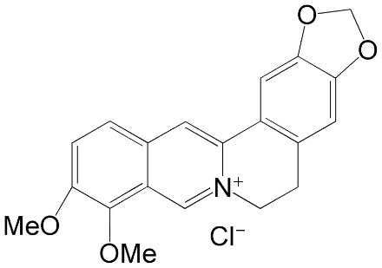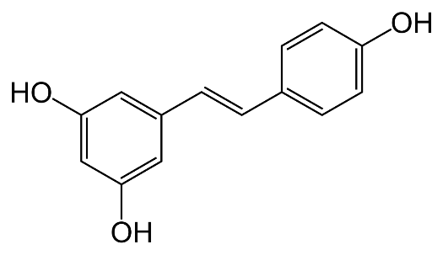
Figure 1: Structure of BB-HCl (A) and RES (B)
Vesicular systems like liposomes are advanced drug delivery platforms designed to enhance bioavailability and prolong therapeutic effects. These nano to microscale vesicles consists of one or more phospholipid bilayers encapsulating aqueous core, enabling the delivery of both water-soluble and lipid-soluble drugs. Due to their compositional similarity to skin lipids, liposomes facilitate enhanced dermal absorption, targeted localization, and minimized systemic exposure. Over past three decades, advancements in liposome technology have enabled development of diverse liposomal formulations with varying sizes, lipid compositions, and surface modifications tailored to specific therapeutic needs. In field of dermatology, topical liposomes have demonstrated significant therapeutic potential. Natural, non-toxic phospholipids and cholesterol are commonly used in their formulation, with membrane properties influenced by lipid type e.g., unsaturated phosphatidylcholine (from egg or soybean) offers higher permeability, while saturated lipids provide more rigid, stable bilayers. Topical liposomes offer multiple advantages such as enhanced drug retention in skin, biocompatibility, sustained release, moisturization, and ability to restore skin lipid layers. In cosmetics, liposomes have been successfully incorporated into various products such as anti-aging creams, moisturizers, and sunscreens.
Primary objective of this study is to develop and evaluate liposomal gel containing BB-HCl and RES for enhanced topical delivery for treatment of Acne vulgaris, aiming to improve their skin permeability and therapeutic efficacy, while minimizing systemic side effects. Box Behnken Design (BBD) was employed to optimize the formulation with respect to vesicle size, entrapment efficiency (EE), and zeta potential. Formulation was characterized by vesicle size, zeta potential, EE, in vitro permeation, ex vivo skin permeation, skin retention, viscosity, pH, texture analysis, in vivo anti-inflammatory activity, skin irritation testing, antimicrobial efficacy and transmission electron microscopy (TEM). Study aimed to explore synergistic therapeutic potential of combined phytoconstituents through comprehensive physicochemical and biological assessments.
- MATERIALS AND METHODS
  - MATERIALS
Berberine Hydrochloride and Resveratrol were procured from Yucca Enterprises, Mumbai, India. Cholesterol, soy lecithin, Polyethylene glycol 400 (PEG 400), tween 80, Carbopol 940, sodium alginate, Triethanolamine (TEA), propylene glycol and methyl paraben were obtained from Loba Chemie Pvt. Ltd., Mumbai, India. All other solvents were of analytical reagent grade.
2.2 PREFORMULATION STUDIES
    - Compatibility Studies by FTIR
Compatibility studies between drugs and excipients were conducted using Fourier Transform Infrared (FTIR) spectroscopy (Shimadzu IRSpirit). Physical binary mixtures were prepared by blending each drug with selected excipients in 1:1 ratio—soy lecithin (SL), cholesterol (CHL), and Carbopol 940 and stored in triple stability chamber (Thermolab PX0000310G) at 40 ± 2°C and 75 ± 5% RH for 30 days. FTIR analysis was then performed to detect any potential chemical interactions. Spectra of pure drugs, individual excipients, and their binary mixtures were compared.
  - METHODS
2.3.1 Preparation of blank liposomes
Preliminary studies involved preparation of liposomes using SL and CHL by thin film hydration method. Different weight ratios of SL and CHL were used i.e. 5:5, 6:4, 7:3, 8:2, 9:1 and dissolved in chloroform:methanol (2:1 v/v). These five liposomal dispersions were evaluated for vesicle size and zeta potential. Liposomes containing PEG 400 at concentrations of 5, 10 and 15 % v/v were also prepared to investigate its effect on vesicle size and zeta potential.
2.3.2 Preparation of drug loaded liposomes
Liposomes were prepared using thin film hydration method. Mixture of SL, CHL, and RES (10 mg/ml) was dissolved in chloroform:methanol (2:1 v/v) with 10 % v/v PEG 400 and transferred into pear-shaped flask attached to a rotary evaporator (HeidolphHei-VAP rotary evaporator). Dispersion was rotated at 140 rpm under vacuum at 65°C for 1 h, allowing for gradual evaporation of solvents and formation of thin lipid film. Then dried lipid layer was hydrated with distilled water (DW) containing tween 80 (1% v/v) and BB-HCl (3 mg/ml). Hydration was carried out under rotation for 1 h to ensure complete dispersion, followed by mechanical stirring (Remi RQ-121) at 1000 rpm to reduce vesicle size.
2.3.3 Experimental design
BBD was employed to evaluate effects of key formulation and process variables on liposome characteristics. Independent variables selected for study were quantity of SL (A), quantity of CHL (B) and rotation speed (C) each evaluated at three coded levels: low (–1), medium (0), and high (+1), (Table 1). Influence of these variables on four critical responses: particle size (Y₁), zeta potential (Y₂), EE of BB-HCl (Y₃) and EE of RES (Y₄) were studied. Design generated total of 13 experimental runs, including replicates at centre point to allow for estimation of experimental error. Experimental design matrix is shown in Table 1A.
Table 1: Coded levels and actual values of independent variables in Box–Behnken design
 | Coded levels
Factors | +1 | 0 | -1
Soy lecithin (mg) | 900 | 800 | 700
Cholesterol (mg) | 300 | 200 | 100
Rotational speed (rpm) | 180 | 140 | 100

Table 1A: Experimental runs and responses for optimization of drug loaded liposomes by Box-Behnken Design
Runs | Factors |  |  | Responses
 | A: SL  (mg) | B: CHL  (mg) | C: Rotational speed  (RPM) | Y₁: Vesicle size (nm) | Y₂: Zeta potential (mV) | Y₃: EE of BBH (%) | Y₄: EE of RES (%)
F-1 | 900 | 200 | 180 | 308.1±4.25 | -20.9±1.02 | 80.62±0.57 | 79.1±1.14
F-2 | 800 | 100 | 180 | 324.9±8.67 | -21.6±0.29 | 73.9±1.29 | 74.2±0.84
F-3 | 900 | 300 | 140 | 443.9±10.38 | -18.7±1.58 | 85.24±1.85 | 82.9±2.18
F-4 | 700 | 300 | 140 | 658.7±12.45 | -16.8±2.10 | 72.3±2.69 | 71.7±1.73
F-5 | 800 | 100 | 100 | 347.4±9.24 | -21.1±1.67 | 71±0.67 | 76.4±1.86
F-6 | 800 | 300 | 180 | 604.8±8.17 | -16.7±2.75 | 76.68±1.93 | 77.5±2.84
F-7 | 700 | 100 | 140 | 448.6±6.21 | -19.1±0.96 | 69.27±2.84 | 67.3±1.69
F-8 | 700 | 200 | 180 | 523.7±9.48 | -18.3±1.86 | 71.08±2.01 | 69.7±2.45
F-9 | 800 | 200 | 140 | 379.4±8.42 | -19.8±1.73 | 75.39±3.24 | 78.5±3.84
F-10 | 700 | 200 | 100 | 491.2±6.14 | -18.9±0.86 | 72.85±0.97 | 72.4±0.94
F-11 | 900 | 200 | 100 | 284.1±10.84 | -20.4±2.18 | 82.51±1.08 | 82.6±1.38
F-12 | 900 | 100 | 140 | 212.3±13.24 | -23.4±1.08 | 80.7±2.84 | 79.3±2.18
F-13 | 800 | 300 | 100 | 598.6±9.58 | -17.1±2.04 | 77.26±1.21 | 77.2±1.69

  - Evaluation of liposomes:
2.4.1 Vesicle size and zeta potential determination
Vesicle size and zeta potential were measured using Zetasizer (Malvern Zetasizer Nano-ZS90). For both analyses, liposomal dispersion was appropriately diluted with millipore-filtered water to obtain optimal scattering intensity and ensure accurate measurements. All assessments were conducted at 25 ± 1°C. Vesicle size was determined by transferring diluted dispersion into a disposable sizing cuvette, and measurements were recorded in triplicate. Zeta potential was measured using folded capillary cell to assess surface charge and predict stability of vesicles. Higher absolute value of zeta potential, whether positive or negative, was considered indicative of improved electrostatic stability of liposomal dispersion.
2.4.2 EE determination
EE of BB-HCl and RES in liposomal dispersion was determined using Q-absorbance ratio method by UV-Visible spectrophotometry (Shimadzu UV 1780). After ultracentrifuging (Remi R4C+R41) at 1500 rpm, supernatant was analysed. Absorbance of sample was measured at two wavelengths: 272 nm, isoabsorptive point of BB-HCl and RES, and 308 nm, λmax of RES. In this method, C_{RES} represents concentration of RES, and C_{BB-HCl} represents concentration of BB-HCl. Concentrations of drug was calculated using Eq. [1] and [2].
C_{RES} = $\frac{Q_{M }-{ Q}_{Y}}{Q_{X }- Q_{Y}}×\frac{A_{1}}{a_{1}X}$ [1]
C_{BB-HCl =} $\frac{Q_{M }- Q_{X}}{Q_{Y }- Q_{X}} ×\frac{A_{1}}{a_{1}Y}$ [2]
Where,
A₁ = absorbance of mixture at 272 nm
A₂ = absorbance of mixture at 308 nm
Q_{M} = A₂ / A₁ (absorbance ratio of mixture)
Q_{X} = ε₂X/ ε₁X (RES absorptivity ratio)
Q_{Y} = ε₂Y/ ε₁Y (BB-HCl absorptivity ratio)
a₁_{X} = absorptivity of RES at 272 nm
a₁_{Y} = absorptivity of BB-HCl at 272 nm
EE of each drug was calculated using Eq. [3]
% EE = Total drug loaded – Concentration of drug in supernatant / Total drug loaded × 100 [3]
2.5 Optimization of liposomal dispersion
Optimized liposomal dispersion was selected based on results generated through BBD, which evaluated influence of three independent variables— quantity of SL, quantity of CHL and rotation speed, on key responses such as vesicle size, zeta potential, and EE of both drugs. Second-order quadratic model was derived for each response, and statistical analysis (ANOVA) was conducted to determine significance of each factor and their interactions. Numerical optimization using desirability function approach was then applied, where goal was to minimize vesicle size, achieve maximum zeta potential (to ensure colloidal stability), and maximize drug entrapment. Combination of factor levels that yielded highest overall desirability score was selected as optimized batch.
  - Preparation of gel
2.6.1 Selection of gelling agent
Sodium alginate and Carbopol 940 were evaluated individually (1-3%) and in binary combinations to develop suitable topical gel base for incorporating liposomal dispersion. Binary gel formulations were prepared using sodium alginate at concentrations ranging from 1% to 3% w/v, each combined with 1% w/v Carbopol 940. Formulations were evaluated for viscosity, pH, and mechanical strength (hardness) by texture analyser (Brookfield CT3).
2.6.2 Preparation of drug loaded liposomal gel
Carbopol 940 (2 % w/v) was dispersed in DW with continuous mechanical stirring at 200 rpm to avoid air entrapment. It was then allowed to stand overnight to ensure complete swelling of polymer. Optimised liposomal dispersion (BRLD) was then incorporated into swollen gel with gentle stirring at 200 rpm. Propylene glycol was then added to formulation. The pH was adjusted to 5.5 (skin pH) using triethanolamine, and methyl paraben (0.01% w/v) was incorporated. Final dispersion was continuously agitated until smooth gel was formed.
2.7 Evaluation of liposomal gel
2.7.1 Viscosity and pH
Viscosity of liposomal gel containing BB-HCl and RES (BRL-Gel) was measured using viscometer (Brookfield DV II + PRO) equipped with spindle no. 04 at 10 rpm. Approximately 100 g gel was transferred to beaker. Reading was taken after allowing sample to equilibrate for 5 min at room temperature. Results were recorded as mean of triplicate readings. The pH of BRL-Gel was determined using digital pH meter (Toshcon Toshniwal Delux CL-54+). Electrode was immersed in gel and readings were recorded from pH meter.
2.7.2 Texture analysis
Hardness of BRL-Gel was assessed using texture analyser. Gel was placed in container and evaluated at ambient temperature (25 ± 2°C). Measurements were conducted in compression mode with trigger force of 10 g, penetration depth of 25 mm, and test speed of 1.0 mm/s. After reaching designated depth, probe was held in place for 30, 60, 90, and 120 s to examine time-dependent mechanical behaviour of gel. Key parameters measured included hardness and adhesiveness, with hardness defined as maximum force needed to deform gel structure.
    - In vitro drug release studies
In vitro release studies were conducted using Franz diffusion cell apparatus (Orchid Scientifics, FDC-03) equipped with dialysis membrane (HiMedia; molecular weight cutoff: 5000 Da; diffusion area: 3.14 cm²) positioned between donor and receptor compartments. Formulations evaluated included: BRLD, BRL-Gel, plain gel containing BB-HCl and RES (BRG) and aqueous solution of BB-HCl and RES in phosphate buffer pH 5.5 (BRS). Each formulation was loaded into donor compartment containing BB-HCl (6 mg) and RES (20 mg). Receptor compartment was filled with 7 ml of phosphate buffer (pH 5.5), maintained at 32 ± 0.5 °C, and continuously stirred at 200 rpm to simulate physiological conditions and maintain uniformity. At predetermined time intervals (0.5, 1, 2, 4, 6, and 8 h), 1 ml samples were withdrawn from receptor compartment and replaced immediately with equal volume of fresh buffer to maintain sink conditions. Samples were analysed using UV–Visible spectrophotometer at 272 nm for BB-HCl and 308 nm for RES.
2.7.4 Ex vivo permeation studies
Ex vivo permeation studies were carried out using Franz diffusion cells with diffusion area of 3.14 cm². Experimental conditions were same those of in vitro release experiments, with primary difference being use of porcine skin as barrier membrane. Test formulations—BRLD, BRL-Gel, BRG, and BRS were applied in amounts equivalent to 6 mg of BB-HCl and 20 mg of RES. At predetermined time intervals (0.5, 1, 2, 3, 4, and 5 h), samples were withdrawn from receptor compartment and analysed for BB-HCl and RES content using UV–Visible spectrophotometry at 272 nm and 308 nm, respectively. Steady-state flux (Jss) was determined by plotting cumulative amount of drug permeated (µg/cm²) versus time (h), with slope of linear portion of curve representing flux, expressed in µg/cm²/h [Eq. 1]. Permeability coefficient (Kp) was calculated by dividing flux by initial drug concentration in donor compartment (C₀), representing rate of drug permeation through skin in cm/h [Eq. 2].
$Jss=\frac{dQ}{dt}$ [1]
Where, dQ is cumulative amount of drug permeated per unit area (µg/cm²) and dt is time (h)
$Kp=\frac{Jss}{C₀}$ [2]
Where, C₀ is the concentration of drug in donor compartment at time zero.
2.7.5 Skin retention studies
After completion of the 5 h permeation experiment, skin was removed from diffusion cell. The surface was gently wiped with filter paper dampened with distilled water, followed by dry filter paper, to remove any residual formulation. To separate epidermis and dermis, skin area corresponding to the diffusion zone was cut and exposed to heat using hair dryer at 50 °C for 30 s. Epidermis was then gently peeled away from dermis using scalpel. Both epidermal and dermal sections were transferred into separate glass vials and subjected to methanol extraction overnight. Resulting extracts were diluted adequately and analysed using UV-Visible spectrophotometry at 272 nm for BB-HCl and 308 nm for RES to determine amount of drug retained within skin layers.
2.7.5 Drug content
Accurately weighed quantity of BRL-Gel, containing BB-HCl (6 mg) and RES (20 mg), was shaken with 10 ml of methanol to extract drugs. Resulting solution was filtered and analysed using a UV-Visible spectrophotometer at 272 nm for BB-HCl and 308 nm for RES to determine drug content.
2.7.6 Transmission Electron Microscopy (TEM)
Morphology and structural characteristics of BRLD was examined using TEM. Dispersion (30 µl) was diluted with 4 ml of DW. From this, 0.5 µl was drop-cast onto copper-carbon grid (200 mesh) and allowed to dry under infrared lamp for 10 min. Grid was then negatively stained with 1% phosphotungstic acid (PTA) for 20 s, and excess stain was gently blotted using filter paper. TEM imaging was performed using a TECNAI G2 Spirit Biotwin (FEI) operating at accelerating voltage of 100 kV. Images were captured to assess vesicle shape, size, and lamellarity of liposomal dispersion.
2.7.7 Antibacterial studies
Antibacterial potential of BRL-Gel was evaluated against P. acnes using agar well diffusion method. Pure cultures of P. acnes were uniformly swabbed onto Sabouraud Dextrose Agar plates. Wells were carefully bored using a sterile cork borer, and 100 µl of each test sample was introduced into wells. Plates were incubated at 37 °C for 18–24 h under anaerobic conditions optimal for P. acnes growth. Post-incubation, zone of inhibition (ZOI) was observed as clear area surrounding the wells and measured in millimeters. Clindamycin served as standard antibacterial agent.
2.7.8 Skin irritation studies
Total of twelve healthy Wistar albino rats of either sex, weighing between 120–150 g, were selected for skin irritation studies. Dorsal region of each rat was shaved to create an exposed area of approximately 4 cm². Animals were randomly divided into two groups: Group I (control) and Group II (BRL-Gel-treated). BRL-Gel (0.5 g) was applied topically once daily for three consecutive days. Treated areas were inspected daily for any signs of skin irritation. Occurrence and severity of erythema were assessed for 72 h using Draize scoring method.
2.7.9 In vivo anti-inflammatory studies
Anti-inflammatory studies were conducted in compliance with CPCSEA guidelines, and ethical approval was obtained from Institutional Animal Ethics Committee (IAEC) under approval number CCSEA/IAEC/PT-31/02-2K24. Anti-inflammatory potential of formulations was assessed using carrageenan-induced rat paw edema model. Wistar rats were divided into five groups (n = 6). Group 1 served as normal control (no treatment). Acute inflammation was induced in Groups 2 to 5 by subplantar injection of 0.1 ml of 1% w/v carrageenan solution in normal saline into right hind paw. Group 2 received carrageenan only (toxic control). Group 3 received carrageenan + BRG, Group 4 received carrageenan + marketed indomethacin gel (1%) and Group 5 received carrageenan + BRL-Gel. Paw volume was measured using plethysmometer (Panlab 3498723) before and at 0.5, 1, 2, 3, 4, 5, and 7 h after carrageenan administration. Percent inhibition of paw edema was calculated to assess anti-inflammatory effect of each treatment.
- RESULTS AND DISCUSSION
3.1 Compatibility studies by FTIR
Excipients used included SL, CHL and Carbopol 940. These mixtures were evaluated to assess potential drug–excipient interactions and their suitability for formulation development. For RES prominent peaks observed at 3300 cm⁻¹ (O–H stretching), 1640 cm⁻¹ (aromatic ring), and 1615 cm⁻¹ (C=C stretching) remained unchanged. SL exhibited characteristic peaks at 3021 cm⁻¹ (C–H stretching of alkenes), 2932 cm⁻¹ (C–H of methyl groups), 1712 cm⁻¹ (C=O), 1000 cm⁻¹ (C–O), and 1192 cm⁻¹ (P=O), all of which were retained in mixtures. CHL showed peaks at 3210 cm⁻¹ (O–H), 2831 cm⁻¹ (C–H stretching of CH₃), and 1623 cm⁻¹ (C=C). BB-HCl showed distinct peaks at 3594 cm⁻¹ (O–H), 2914 cm⁻¹ (C–H), 1587 cm⁻¹ (C=C), and 1167 cm⁻¹ (C–O), which remained unaltered in all physical mixtures. For Carbopol 940, characteristic peaks were observed at 1754 cm⁻¹ (C=O), 3295 cm⁻¹ (O–H), 2913 cm⁻¹ (C–H), and 1298 cm⁻¹ (C–O), with no shifts upon mixing. Results confirm that both BB-HCl and RES are chemically compatible and stable when combined with selected excipients. FTIR spectroscopy analysis further supported this finding, as no significant shifts, disappearance of characteristic peaks, or emergence of new peaks were observed in physical mixtures. This indicates absence of any chemical interactions between drugs and excipients, affirming their suitability for formulation development. FTIR spectra supporting these findings are presented in Figure 1.
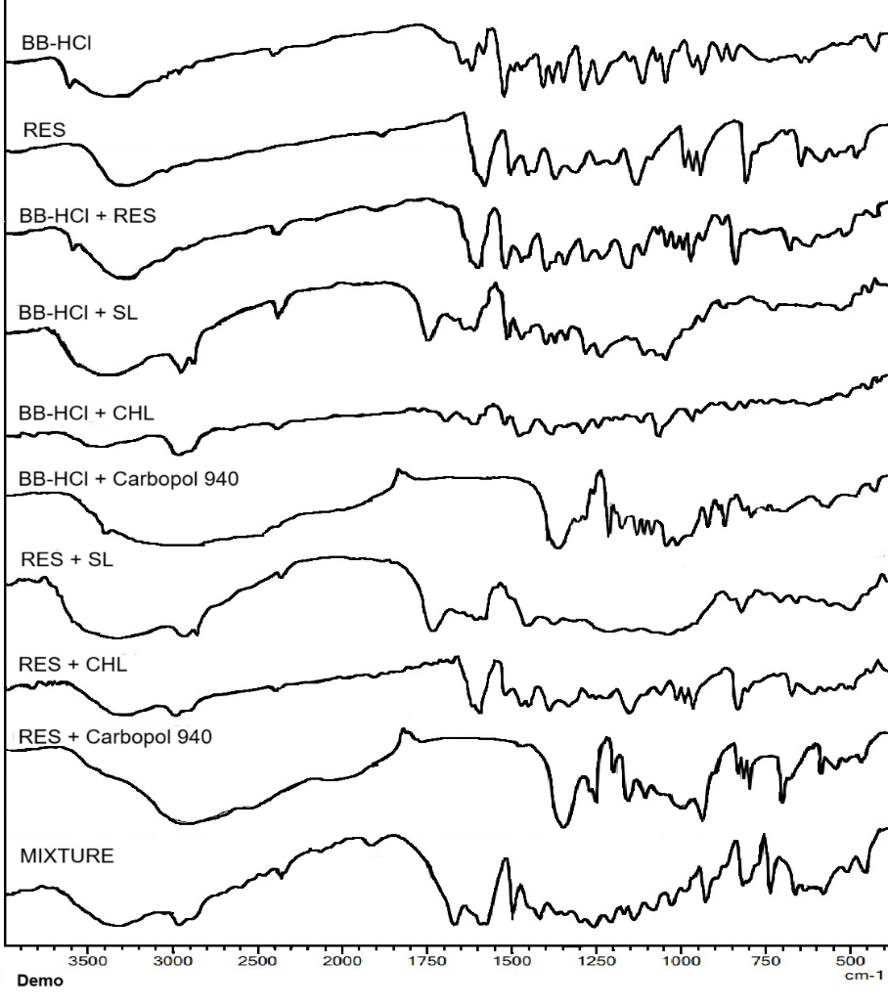
Figure 1: IR spectra of drugs, excipients and their binary mixtures
3.2 Experimental design
Design of Experiments (DoE) approach was employed using BBD to optimize liposomal dispersion. Total of 13 liposomal dispersion batches were prepared based on BBD matrix. Each batch was evaluated for vesicle size, zeta potential, and EE. These responses were used to analyse influence of independent variables and to identify optimal formulation conditions. The 3D response surface plots for vesicle size, zeta potential, and EE further illustrate interactive effects of formulation variables on outcomes (Figure 2).
Vesicle size data were effectively modelled using quadratic equation, yielding statistically significant results (p = 0.0052). Measured vesicle sizes of liposomal dispersion ranged from 212.3 nm to 658.7 nm, (Table 1A). SL (Factor A) exerted a significant negative effect on vesicle size (p = 0.0010), indicating that higher SL concentrations promoted the formation of smaller and more uniformly distributed vesicles. This reduction in size is due to improved bilayer organization and enhanced surface stabilization, which collectively reduced vesicle aggregation. Conversely, CHL had significant positive effect on vesicle size (p = 0.0008). Increase in vesicle diameter at higher CHL levels can be attributed to bilayer stiffening, which reduces membrane flexibility and leads to formation of larger, more rigid vesicles. Notably, CHL (Factor B) exhibited most pronounced influence on vesicle size, as reflected by its highest factor coefficient (+121.60), underscoring its dominant role in determining vesicle morphology Rotation speed (Factor C) displayed minimal and statistically insignificant effect on vesicle size (p = 0.5988), with only slight increase observed. Additionally, interactive effect of SL and CHL resulted in marginal increase in vesicle size (p = 0.6874), possibly due to opposing contributions—SL enhancing bilayer compactness while CHL increases membrane rigidity. However, this combined effect was less substantial compared to impact of individual components, as indicated by lower factor coefficient (+5.38). These findings highlight complex interplay of formulation variables in governing liposomal vesicle characteristics. Polynomial equation representing relationship between formulation variables and vesicle size is presented in Eq. 1.
Vesicle size = 379.40 – 109.23A + 121.60B + 5.03C + 5.38AB – 2.13AC + 7.17BC – 2.84A² + 64.31B² + 25.21C² [1]
Zeta potential data was found to be statistically significant (p = 0.0222). Zeta potential values of liposomal dispersions ranged from –23.4 mV to –16.7 mV, (Table 1A). Corresponding polynomial equation is presented in Eq. 2. Results indicated that increasing quantity of SL led to more negative zeta potential (p = 0.0081), possibly due to greater presence of negatively charged phospholipid headgroups. This increase in surface charge enhances colloidal stability by promoting electrostatic repulsion between vesicles, thereby reducing the likelihood of aggregation. In contrast, CHL exhibited significant negative impact on zeta potential (p = 0.0023). Higher levels of CHL are known to induce bilayer condensation, which can hinder binding of sodium ions (Na⁺) to polar headgroups of phospholipids, thereby reducing net surface charge of liposomes. Rotation speed did not exert significant effect on zeta potential within studied range (p = 1.0000), suggesting that mechanical agitation had no appreciable influence on surface charge characteristics.
Zeta potential = -19.80 – 1.29A + 1.99B + 0.0000C + 0.6000AB – 0.2750AC + 0.2250BC – 0.1000A² + 0.4000B² + 0.2750C² [2]
EE of BBH, analysed using BBD were well described by quadratic model (p = 0.0330). EE of BBH ranged from 69.27% to 85.24% (Table 1A). Polynomial equation is presented as Eq. 3. Results indicated that SL had significant positive effect on EE (p = 0.0026). Increase in SL level led to improved bilayer formation and expansion of aqueous core volume, which are favourable for encapsulation of hydrophilic drugs like BBH (log P -1.5). Similarly, CHL significantly enhanced EE of BBH (p = 0.0373). Increased CHL content contributes to improved stability and rigidity of liposomal bilayer, thereby aiding in retention of hydrophilic drugs within aqueous core. This effect is primarily attributed to CHL's ability to reduce membrane permeability, which helps minimize drug leakage during liposome formation. CHL restricts rotational motion of phospholipid hydrocarbon chains, thereby reducing leakage of hydrophilic compounds and enhancing bilayer stability. Rotation speed exhibited very minimal and negligible decreasing effect on EE of BBH; however, this influence was not statistically significant (p = 0.7916). This suggests that, although a slight decline in EE was observed with increasing speed, rotation speed did not play a meaningful role in affecting BBH entrapment within the experimental conditions.
EE of BBH = 75.39 + 5.45A + 2.08B – 0.1675C + 0.3775AB – 0.0300AC – 0.8700BC + 1.77A² – 0.2837B² – 0.3963C² [3]
EE of RES was found to be statistically significant with p = 0.0233. EE of RES varied from 67.3% to 82.9% (Table 1A). Polynomial equation for RES entrapment is given in Eq. 4. SL exhibited significant positive effect on RES entrapment (p = 0.0017). Increase in SL concentration enhanced incorporation of RES into lipid bilayer matrix, which is consistent with previous findings that support improved loading of lipophilic drugs in soy-lecithin-based systems. Amphiphilic nature of lecithin allows better solubilization and accommodation of lipophilic molecules like RES within the bilayer. CHL also demonstrated positive influence on RES entrapment (p = 0.0546). As a lipophilic molecule, RES preferentially partitions into lipid bilayer. Presence of CHL enhances bilayer rigidity and hydrophobicity, thereby creating more stable and suitable environment for RES retention within vesicle structure. Although rotation speed showed minimal, negligible decrease in EE of RES, the effect was not statistically significant (p = 0.1323), indicating that mechanical agitation had no meaningful impact within studied range.
EE of RES = 78.50 + 5.35A+ 1.51B – 1.01C – 0.2000AB – 0.2000AC + 0.6250BC – 1.79A² – 1.41B² – 0.7625C² [4]
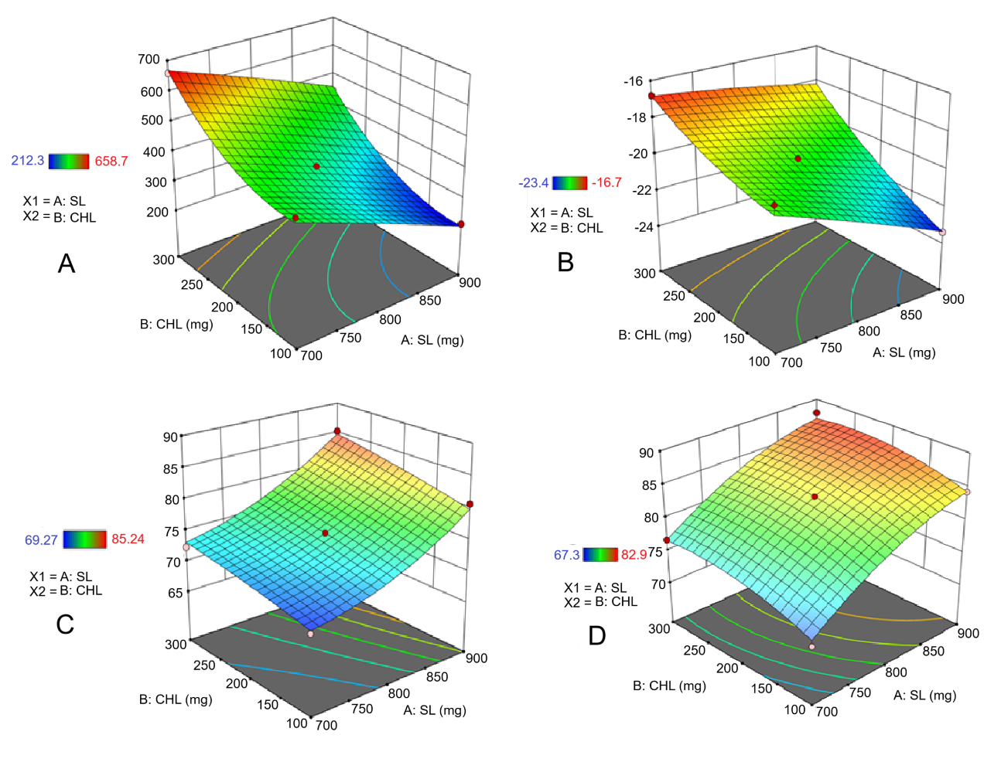
Figure 2: 3D Response surface plots showing the effect of SL (mg), CHL (mg), and Rotation Speed (rpm) on (A) Vesicle Size, (B) Zeta Potential, (C) EE of BBH, and (D) EE of RES
3.4.7 Drug content
Percent drug content of BB-HCl and RES in BRL-Gel was found to be 82.4% and 79.92%, respectively. These values indicate a high level of drug incorporation within gel matrix, reflecting uniformity and efficiency of formulation in retaining both hydrophilic and lipophilic drugs.
3.3 Optimization of liposomal dispersion
Optimized liposomal dispersion (BRLD) was predicted at quantity of SL 900 mg, quantity of CHL 267.7 mg, and rotation speed 110 rpm. Under these conditions, predicted responses were: vesicle size of 391.1 nm, zeta potential of –19 mV, EE of BBH at 84.5 %, and EE of RES at 82.4 %. To validate the model, dispersion was prepared using optimized parameters. Experimental results closely matched predicted values, with vesicle size of 298.3 ± 9.64 nm, zeta potential of –23.8 mV, EE of BBH at 86.26 ± 1.67 %, and EE of RES at 84.48 ± 2.10 %. Close agreement between predicted and experimental outcomes confirmed reliability and robustness of optimization model, indicating successful development of stable and efficient dispersion.
3.4 Evaluation of liposomal gel
3.4.1 Selection of gelling agent
Among all tested gelling agents, Carbopol 940 at concentration of 2% w/v exhibited most favourable characteristics, with viscosity of 32,240 cP and hardness of 13.8 g. These properties indicate optimal gel consistency, offering both structural integrity and ease of topical application. In contrast, sodium alginate-based gels alone demonstrated significantly lower viscosities, ranging from 7,500 to 8,200 cP, resulting in more fluid-like consistency that is less desirable for topical use. Combinations of sodium alginate with Carbopol 940 showed moderate increase in viscosity (13,300 to 16,700 cP), due to thickening effect of Carbopol 940. However, these values were still insufficient to achieve ideal consistency required for effective topical application. Furthermore, sodium alginate-based gels exhibited markedly lower hardness, indicating poor structural firmness. The pH of all gel formulations ranged from 5.9 ± 0.4 to 7.1 ± 0.9, falling within acceptable range for dermal compatibility and ensuring minimal risk of skin irritation. Compositions and properties of various gelling agent combinations used are summarized in Table 2.
Table 2: Gelling agents and their evaluation
Sr. no | Gelling agents | Viscosity (Cp) | pH | Hardness (g)
1. | 1% Sodium alginate | 7,658 ± 250 | 7.1 ± 0.9 | 5.16 ± 0.28
2. | 2% Sodium alginate | 7,840 ± 100 | 6.9 ± 0.5 | 5.60 ± 0.18
3. | 3% Sodium alginate | 8,100 ± 170 | 7.3 ± 0.8 | 5.91 ± 0.22
4. | 1% Carbopol 940 | 30,700 ± 210 | 6.3 ± 0.7 | 11.09 ± 0.31
5. | 2% Carbopol 940 | 32,240 ± 180 | 5.9 ± 0.4 | 13.8 ± 0.24
6. | 3% Carbopol 940 | 34,980 ± 150 | 6.2 ± 0.5 | 17.7 ± 0.14
7. | 1% Sodium alginate + 1% Carbopol 940 | 13,360 ± 230 | 6.5 ± 0.6 | 6.01 ± 0.13
8. | 2% Sodium alginate + 1% Carbopol 940 | 15,110 ± 200 | 6.9 ± 0.9 | 6.34 ± 0.26
9. | 3% Sodium alginate + 1% Carbopol 940 | 16,650 ± 100 | 6.8 ± 0.4 | 7.12 ± 0.29

3.4.2 Viscosity and pH
Optimized liposomal dispersion (BRLD) was incorporated in 2% w/v Carbopol 940 (BRL-Gel). BRL-Gel exhibited viscosity of 31,210 ± 150 cP which was marginally lowered than plain gel. This indicated good gel consistency, which is essential for prolonged retention on skin surface and effective drug delivery. Carbopol 940 reportedly displays pseudoplastic behaviour, which facilitates easy application while maintaining structural integrity at rest. The pH of BRL-Gel was found to be 5.2, which lies within normal physiological range of skin pH (4.5 to 5.5) This indicates excellent compatibility with skin and suggests that formulation is unlikely to cause irritation or disrupt natural acid mantle. Result confirms suitability of gel for safe and effective topical application.
3.4.3 Texture analysis
Texture analysis performed for BRL-Gel at holding intervals of 30, 60, 90, and 120 s provides insight into mechanical characteristics of gel during compression and retraction phases. Initial positive force peaks observed in profiles correspond to hardness, with measured values of 14.40 g (30 s), 14.30 g (60 s), 14.30 g (90 s), and 14.20 g (120 s). This negligible variation in hardness across time points highlights gel’s robust mechanical stability and uniform structure, even under extended compressive forces. Negative force region of curve represents adhesiveness, defined as energy required to separate probe from sample. Adhesiveness values were 0.62 mJ at 30 s, decreasing to 0.45 mJ at 60 s, 0.36 mJ at 90 s, and slightly increasing to 0.55 mJ at 120 s. Initial decline may reflect reduced tackiness due to polymer relaxation or mild moisture loss during prolonged probe contact. Subsequent increase observed at 120 s could indicate partial structural recovery or reformation of surface interactions. Overall, gel maintained consistent firmness and exhibited moderate, well-regulated adhesiveness—properties essential for effective skin adherence, ease of application, and minimal residue upon removal. These texture attributes confirm the gel’s suitability for dermal application, combining structural integrity with user-friendly characteristics.
3.4.4 In vitro drug release studies
In vitro release studies of BB-HCl and RES were investigated using dialysis membrane, with their distinct profiles attributed to differences in physicochemical properties. BB-HCl, a hydrophilic compound (log P ≈ –1.5), demonstrated 49.40 ± 0.8% release at 0.5 h and complete release from the buffer solution (BRS) within 4 h, indicating minimal diffusion resistance due to its high aqueous solubility. In contrast, RES, being lipophilic (log P ≈ 3.06) and poorly water-soluble, exhibited limited release of only 9.70 ± 1.3 % at 0.5 h and 23.52 ± 0.9 % at 8 h from BRS, with early plateau reflecting its low solubility and restricted diffusion through aqueous medium and membrane. From BRG, BB-HCl exhibited release of 16.28 ± 1.8 % at 0.5 h and 29.79 ± 1.1 % at 8 h, which can be ascribed to its high water solubility and rapid diffusion through hydrophilic gel matrix. RES, however, released 12.60 ± 0.5 % at 0.5 h and 26.26 ± 0.9 % at 8 h, indicating relatively slower diffusion due to weaker interactions with gel matrix. RES has three pKas viz., 8.8, 9.8 and 11.8 due to its polyphenolic nature. Applying the Henderson-Hasselbalch equation revealed that RES was largely present in its unionised (lipophilic) form at all 3 pKa values at skin pH (5.5). Higher release through aqueous gel matrix could be due to cosolvent effect of propylene glycol which was included in gel.
In BRLD, BB-HCl showed release of 19.10 ± 1.3 % at 0.5 h and reached 34.42 ± 2.1 % at 8 h, while RES released 27.40 ± 1.2 % at 0.5 h and 49.32 ± 1.8 % at 8 h. Enhanced RES release is attributed to liposomal encapsulation improving its apparent solubility and dispersibility. BRL-Gel demonstrated sustained release for both drugs. BB-HCl released only 10.38 ± 1.7 % at 0.5 h and 22.19 ± 0.6 % at 8 h, while RES showed slightly faster release of 14.88 ± 1.1 % at 0.5 h and 31.78 ± 1 % at 8 h. This extended release of RES from both liposomal formulations is attributed to effect of liposomal encapsulation. RES is lipophilic and presumably located in outer lipidic bilayers, diffused more readily than BB-HCl, which may be entrapped in aqueous core and faced higher diffusional path length. Sustained release behaviour of BRL-Gel suggests potential for reduced application frequency, making once-daily application feasible, which is advantageous for patient compliance and prolonged therapeutic action in topical delivery.
3.4.5 Ex vivo permeation studies
Ex vivo skin permeation studies were performed using porcine skin to assess permeation efficiency of BB-HCl and RES from different formulations. Cumulative percentage of drug permeated over 5 h, along with steady-state flux (Jss) and permeability coefficient (Kp) were calculated. In BRS, BB-HCl and RES exhibited cumulative permeation of 33.35 ± 0.8 % and 6.05 ± 1.1 % at 5 h, with corresponding flux of 0.90 µg/cm²/h and 0.55 µg/cm²/h, and Kp values of 0.00015 cm/h and 0.000027 cm/h, respectively. BRG showed further reduction in permeation, with BB-HCl and RES demonstrating cumulative permeation of 29.61 ± 2.2 % and 5.38 ± 2.3 % at 5 h, flux of 0.83 µg/cm²/h and 0.50 µg/cm²/h, and Kp values of 0.00013 cm/h and 0.000025 cm/h, respectively. Lower permeation in BRG compared to BRS can be attributed to presence of gel matrix, which increases viscosity and imposes an additional barrier to drug diffusion. Additionally, permeation of RES from BRG was markedly lower than that of BB-HCl, which can be ascribed to both its lipophilic nature and gel-based formulation. Hydrophilic BB-HCl is more compatible with aqueous microenvironment of gel, allowing for better diffusion, whereas lipophilic RES remains poorly solubilized and less mobile within gel matrix.
BRLD demonstrated highest permeation, attributable to advantages of liposomal drug delivery. BB-HCl and RES showed cumulative percent release of 47.70 ± 0.9 % and 57.80 ± 1.8 % at 5 h, respectively, with corresponding flux of 1.18 µg/cm²/h and 4.18 µg/cm²/h, and Kp values of 0.00019 cm/h and 0.0002 cm/h. Higher permeation of RES can be attributed to their differential localization within liposome. RES is predominantly incorporated into lipid bilayers of vesicles, allowing for more rapid diffusion from vesicle and more efficient partitioning into lipid-rich stratum corneum. In contrast, BB-HCl is mainly confined to aqueous core of liposome and must first traverse bilayer to be released, thus slowing its permeation. Additionally, phospholipids in liposomes enhance skin permeation, as these lipids closely mimic the structure of skin lipids. BRL-Gel showed slightly lower permeation compared to BRLD. BB-HCl exhibited cumulative permeation of 44.30 ± 1.7 % at 5 h, flux of 1.29 µg/cm²/h, and Kp of 0.0002 cm/h, while RES demonstrated 47.50 ± 2.1 % permeation at 5 h, flux of 3.91 µg/cm²/h, and Kp of 0.00019 cm/h. Reduced permeation in BRL-Gel is due to presence of gel matrix, which hinders mobility and diffusion of liposomal vesicles through skin. Overall, absence of vesicular carriers in both BRS and BRG contributed to their comparatively lower permeation performance.

Figure 3: In vitro and Ex vivo release studies of BB-HCl and RES in phosphate buffer pH 5.5
3.4.6 Skin retention studies
Retention of BB-HCl and RES in full-thickness skin was evaluated following 5 h application period. Figure 5 illustrates the percentage of each compound retained within epidermis and dermis. In BRG, RES exhibited minimal retention in epidermis (2.15%) and dermis (1.07%). This limited penetration can be attributed to mismatch between RES’s lipophilic nature and the hydrophilic gel base, which likely hindered its diffusion into deeper skin layers. In contrast, BBH showed higher epidermal retention (15.35%), consistent with its hydrophilic nature and compatibility with hydrophilic gel matrix. However, its dermal retention was relatively low (9.00%) due to diffusion resistance posed by gel. For BRS, RES retention in epidermis was slightly higher (2.23%) than in BRG, while dermal retention remained low (1.09%). This can be explained by RES’s poor solubility in aqueous buffer, limiting its penetration into skin. Slightly improved retention compared to BRG is likely due to absence of gel barrier. BBH, on other hand, exhibited epidermal and dermal retention of 15.45% and 9.05%, respectively, both marginally higher than in BRG, further supporting role of gel matrix in restricting deeper permeation.
In BRL-Gel, BBH exhibited higher retention in epidermis (19.90%) compared to RES (17.50%). This can be attributed to hydrophilic nature of BBH, which is primarily encapsulated in aqueous core of liposomes. Due to its lower permeability, BBH tends to accumulate in superficial layers before gradually diffusing into deeper tissues. Conversely, RES, being lipophilic and incorporated within lipid bilayer of liposomes, displayed higher dermal retention (26%), reflecting its greater affinity for and permeability through lipid-rich skin layers. In BRLD, RES retention in epidermis was reduced to 14.80%, likely due to absence of gel matrix that would otherwise act as a diffusion barrier. This allowed RES to penetrate more readily into dermis, where it showed significantly higher accumulation (34.75%). Enhanced dermal delivery of RES is consistent with its lipophilic nature and lipid composition of the liposomes, which closely resemble skin lipids, facilitating deeper penetration. For BBH, epidermal retention in BRLD was 16.80%, lower than in gel formulation but still greater than RES at same site. This is explained by BBH's hydrophilicity and its localization in liposomal core, which combined with permeability-enhancing effects of liposomes, promoted its deeper skin penetration in absence of gel barrier.

Figure 4: Skin retention studies of BB-HCl and RES in epidermis and dermis
3.4.8 Transmission electron microscopy (TEM)
TEM imaging was carried out to evaluate the morphological characteristics of BRLD. Micrographs revealed that liposomes were predominantly spherical in shape with smooth, well-defined boundaries. Observed vesicle size ranged from 200 nm to 500 nm, which is consistent with dynamic light scattering (DLS) data and confirms nanoscale vesicle formation. These structural features suggest successful formation of stable liposomes suitable for topical drug delivery. TEM photographs shown in Figure 5.
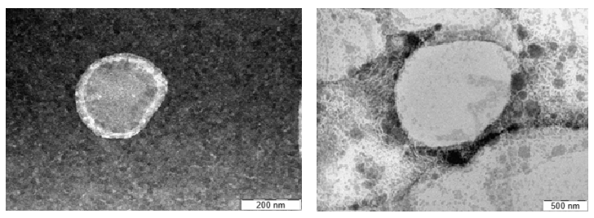
Figure 5: TEM analysis
3.4.9 Antibacterial studies
Efficacy of BRL-Gel was evaluated against P. acnes using agar well diffusion method. Control sample exhibited no inhibitory effect on bacterial growth, confirming the absence of intrinsic antibacterial activity from base components. Clindamycin concentration, used as standard, showed pronounced ZOI measuring 23.15 mm. BRL-Gel demonstrated ZOI of 18.89 mm, indicating moderate antibacterial activity. Although slightly less effective than standard, BRL-Gel displayed notable antibacterial potential against P. acnes, due to enhanced drug delivery via liposomal system. Measured ZOI values are presented in Table 3, and comparative antibacterial performance of test samples is visually depicted in Figure 7, which illustrates dispersion pattern against P. acnes.
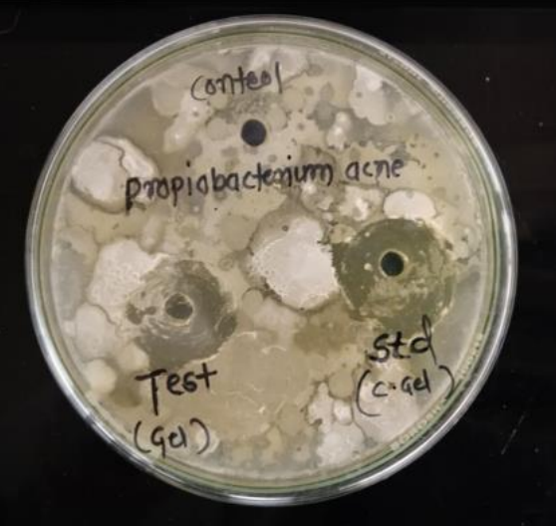
Figure 7: Test samples dispersion against P. acnes
3.4.10 Skin irritation studies:
Throughout 3-day observation period, no visible signs of skin irritation, such as erythema or edema were observed in any of the test animals. The Draize irritation scores remained consistently at 0.0, indicating the complete absence of dermal reactions following gel application. These results confirm that developed formulation is non-irritant and safe for topical use (Figure 7).
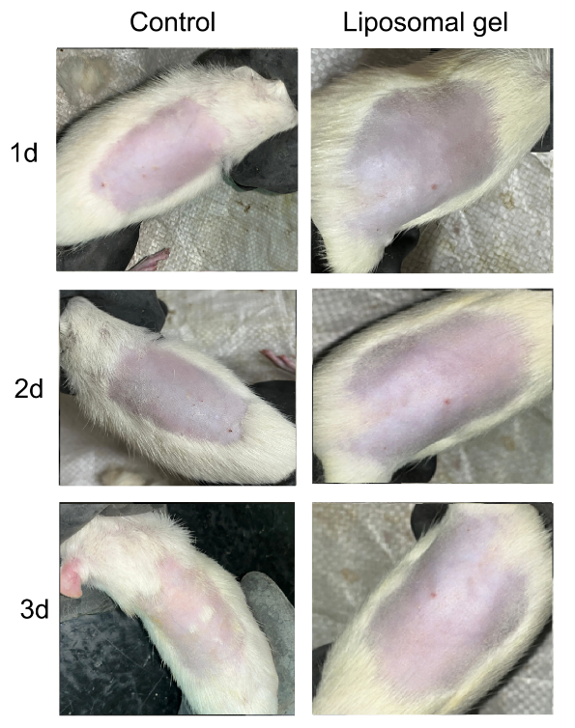
Figure 7: Skin irritation studies
3.4.11 In vivo anti-inflammatory studies
Studies compared the performance of BRG, BRL-Gel and standard Indomethacin gel (1%). (Figure 8). At 30 min, all formulations showed minimal inhibition of inflammation, with values of 0.87% for BRG, 0.88% for BRL-Gel, and 0.89% for standard, indicating initial phase of inflammation. However, as time progressed, notable differences emerged. By 1st h, BRL-Gel exhibited 7.31% inhibition, which was significantly higher than BRG (5.69%) and approached the standard (8.78%). At 2 h, anti-inflammatory effect increased further, with BRL-Gel showing 12.46% inhibition versus 8.72% in BRG, again highlighting the enhanced performance of liposomal system. This trend continued at 3 and 4 h, with BRL-Gel achieving 18.40% and 25.12% inhibition, respectively, as compared to 14.91% and 20.87% for BRG. Standard maintained the highest inhibition values across all time points, reaching 20.91% at 3 h and 26.16% at 4 h. At 5 H BRL-Gel displayed 30.20% inhibition, clearly outperforming BRG (28.85%), and at the 7 h mark, BRL-Gel showed maximum inhibition of 39.88%, compared to 36.41% for BRG. Standard Indomethacin gel, as expected, exhibited the most potent anti-inflammatory activity with 43.20% inhibition at 7 h. Overall, BRL-Gel demonstrated consistently higher anti-inflammatory
activity than BRG, due to improved skin permeation, enhanced drug retention at site of action, and sustained release characteristics offered by liposomal carrier. Although standard drug still exhibited superior inhibition, the performance of BRL-Gel closely approached it, indicating its potential as effective topical anti-inflammatory delivery system.
Table 3: Carrageenan-induced paw edema model
Groups | 0 min | 30 min | 1 h | 2 h | 3 h | 4 h | 5 h | 7 h
Control | 10.92 | 1.13 | 1.23 | 1.27 | 1.34 | 1.40 | 1.49 | 1.62
Plain Gel | 0.93 | 1.120 | 1.161 | 1.159 | 1.141 | 1.107 | 1.060 | 1.030
Standard Gel | 0.92 | 1.119 | 1.122 | 1.087 | 1.060 | 1.033 | 0.960 | 0.921
Liposomal Gel | 0.93 | 1.120 | 1.140 | 1.111 | 1.094 | 1.049 | 1.040 | 0.974

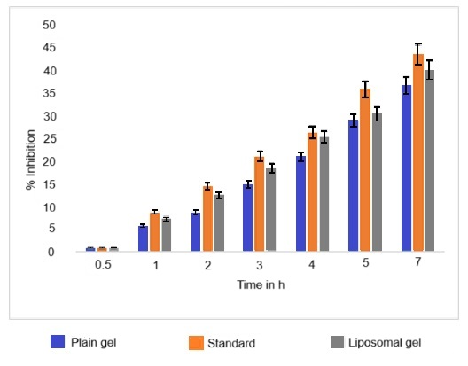
Figure 8: % Inhibition in h

