Author : Dr Malahat jarrahi
MD . Plastic Surgeon . General surgeon

I.M. Moscow state medical university of sechenov.

Editor and revision : Dr leyla khosravi MD. Radiologist
Mahan jarrahi

Content includes:

-Muscles of the neck
superficial , medial and deep groups………………………………………….

- Deep Muscles of the neck…………………………………………………………..
prevertebral muscles………………………………………………………………..
lateral muscles ……………………………………………………………………..

-Topography of the Neck: Regions and Key Structures………………………………………………….

- Triangles religion of the Neck. ……………………………………………………………………………..

-Muscles of Mastication…………………………………………………………………

-Mechanics of Jaw Movement……………………………………………………………………………

-Fascia of the Neck (Fascia Colli) …………………………………………………………………………..

-Muscles of Facial : Expression and Scalp …………………………………………………………..
Muscles surrounding eyes………………………………………………………
Muscles of the Mouth…………………………………………………………

-Muscles of the upper limb > shoulder girdle muscles…………………………………………….

> Muscles of upper Arm………………………………………………

> Muscles of the Forearm superficially …………………………

… Deep Muscles of the Forearm - Anterior Compartment………………………………….

Posterior group of forearm muscles (superficial layer)...............................................................

Muscles of the Hand (Thumb/Pollicis Region).......................................................................

Muscles of the neck including 3 groups as : superficial , medial and deep groups

1) Superficial Layer : A. Musculus Platysma
B. Musculus Sternocleidomastoid

A. Musculus Platysma
origins →of 2nd pharyngial arch , Facia deltoidia, Facia pectoralis, 2nd rib.
Insertion → near angulus oris .
Action →to Protect subcutaneous veins from compression.
Pulls angulus oris down ↓.
Take part in facial expression.

B. Musculus Sternocleidomastoid
origin→ manubrium sternalis.
Sternum
Clavicula
insertion → processus mastoidus , Linea nucha superiories.
Action → holding the neck in a straight position (fifth arch) .
Unilateral movement of neck to sides.
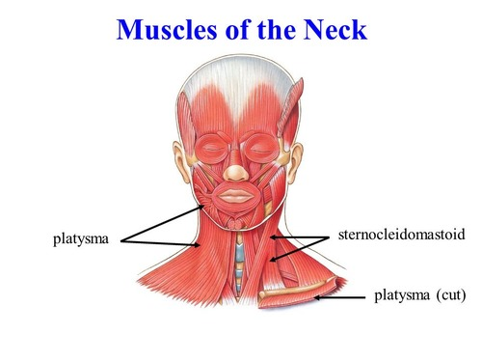

___________________________________________________________________

2) Medial Group: Muscles above the hyoid bone.
Muscles below the hyoid bone.

Muscles above the hyoid bone: ( pulls mandibula down ward to open mouth )
insertion of all four muscles → os hyoideus.

- M. Genohioidus origin → spina mentalis
- M. Mylohyoidous origin→ linea Mylohyoidous
- M. Stylohideus origin→ processus styloideus ( lateral movement of mandibula )
- M. Digastricus → anterior belly from fossa digasterica
→ posterior belly from incissura mastoidea.

Muscles below the hyoid bone: ventral part of myotome
-M.Sternohyoidous origin → posterior surface of sternum insert inferior surface of hyoid bone.
-M. Sternothyroidous origin → posterior surface of sternum insert lateral surface of thyroid
cartilage.Pulls larynx downward.
-M.Thyrohyoidous origin → thyroid cartilage insert to inferior surface of hyoid bone. Pulls larynx up ↑
-M.omohyoideus origin → superior margo of scapula insert to hyoid bone.

*Musculus omohyoideus protects subcutaneous veins together with musculus platysma
muscle of the neck.
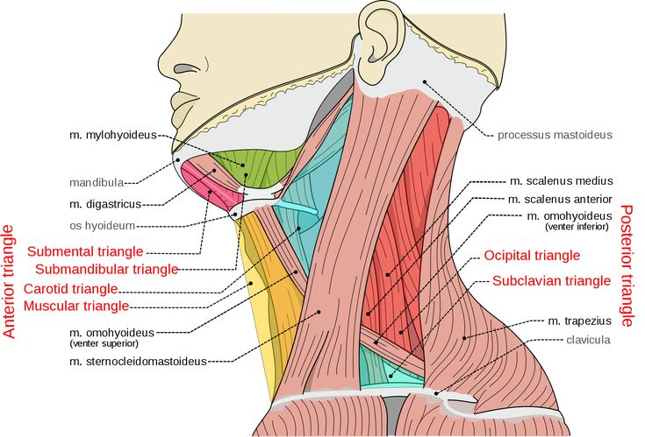

*Muscles below hyoid bone makes hyoid bone immovable as a Punctum fixum , so that muscles above hyoid bone can pull mandibula downward ↓ to open mouth.

* Lamina profunda fascia colli properiae forms sheath for muscles below the hyoid bone.
________________________________________________________________________

3) Deep Muscles of the neck.
Divided into { prevertebral muscles.
{ lateral muscles { M. Scalenus anterior
{ M. Scalenus medius
{ M. Scalenus posterior

prevertebral muscles: { M.Longus colli.
( deep group ) { M.Longus capitis.
{ M.Rectus capitis anterior.
{ M. Rectus capitis lateralis.

Their function > bilateral contraction of the neck.
Unilateral flexion.
Move neck forward flexion of spine.

Lateral muscles of the neck: ______________________________________________

- M. Scalenus anterior
origin > Anterior tubercles of transversus processus of C3-C6 cervical vertebrae .
insert >to first rib and tuberculum musculi scalenous anteriories of the first rib.

Action: Elevates the first rib (accessory respiration)
Bilateral : Neck flexion
Unilateral: Lateral flexion and slight rotation.

- M. Scalenus medius origin > tuberculum processus transversus of the 3rd -7th cervical
vertebrates.
insert> first rib , posterior to sulcus arteriae sub clavicula .
Action : bends cervical vertebra sideway.breathing muscle , helps inspiration .

- M. Scalenus posterior origin > tuberculum posterior of processus transversus of 3rd lower cervical vertebra insert > lower surface of 2nd rib.
Action : bends cervical vertebra sideway.breathing muscle , helps inspiration .

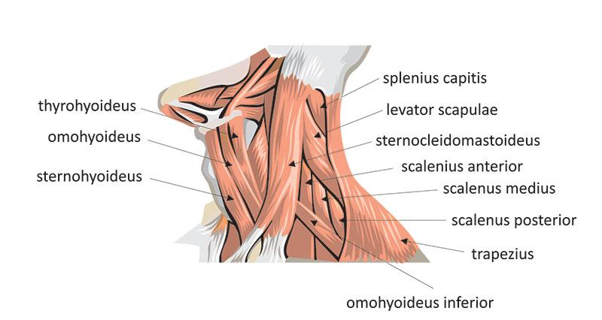

-Deep muscles of the neck (Longus colli, scalenes) contribute to neck flexion and stability.
*One of the main function of lateral group muscles of the neck is protection of plexus brachialis and subclavian arteries that are passing through scaleneous triangle made by musculus scaleneous anteriories and musculus scalenus medius to the lateral side of cervical vertebrae.
_______________________________________________________________________

**Clinical & Functional Notes:
- Scalene syndrome : Compression of the brachial plexus between scalene muscles.
- Neck stability : Prevertebral muscles maintain posture and support swallowing.
- Pocketedoral" likely refers to "hypaxial" muscles** (embryonic muscle group).

"Pseudo-tuberculum = Anterior tubercle.

Spatium Interscalenium Scalene Triangle (Interscalene Space)
-Location : Between M. Scalenus Anterior and M. Scalenus Medius and the first rib.
- Structures Passing Through : - plexus Brachialis (C5-T1) and Subclavian artery .
- Clinical Significance : Thoracic Outlet Syndrome (TOS) – Compression of neurovascular structures.

________________________________________________________________________

Topography of the Neck: Regions and Key Structures

Posterior Region of the Neck
- Location : Posteriorly, between the lateral borders of the M. Trapezius .
- Contents : - Extrinsic neck muscles (e.g., trapezius).
- Deep cervical muscles (e.g., splenius, semispinalis).
- Cervical vertebrae and associated ligaments.

2.Lateral Region of the Neck (Posterolateral Cervical Region)
- Location : Between the M. Trapezius and M. Sternocleidomastoideus .
- Key Structures :
- Accessory nerve (CN XI) – runs through this region.
- Cervical plexus branches (sensory nerves).
- Lymph nodes** (superficial and deep cervical chains).

3. Sternocleidomastoid Region
- Location : Corresponds to the M. Sternocleidomastoideus muscle.
- Function : - Bilateral contraction → Neck flexion (head forward).
- Unilateral contraction → Head rotation to the opposite side + ipsilateral tilt.
- Clinical Note :
- Torticollis (abnormal contraction) causes head tilt.

4. Anterior Region of the Neck
- Location: Between the two M. Sternocleidomastoideus muscles.
- Subdivisions: - Suprahyoid area (above hyoid bone).
- Infrahyoid area (below hyoid bone).
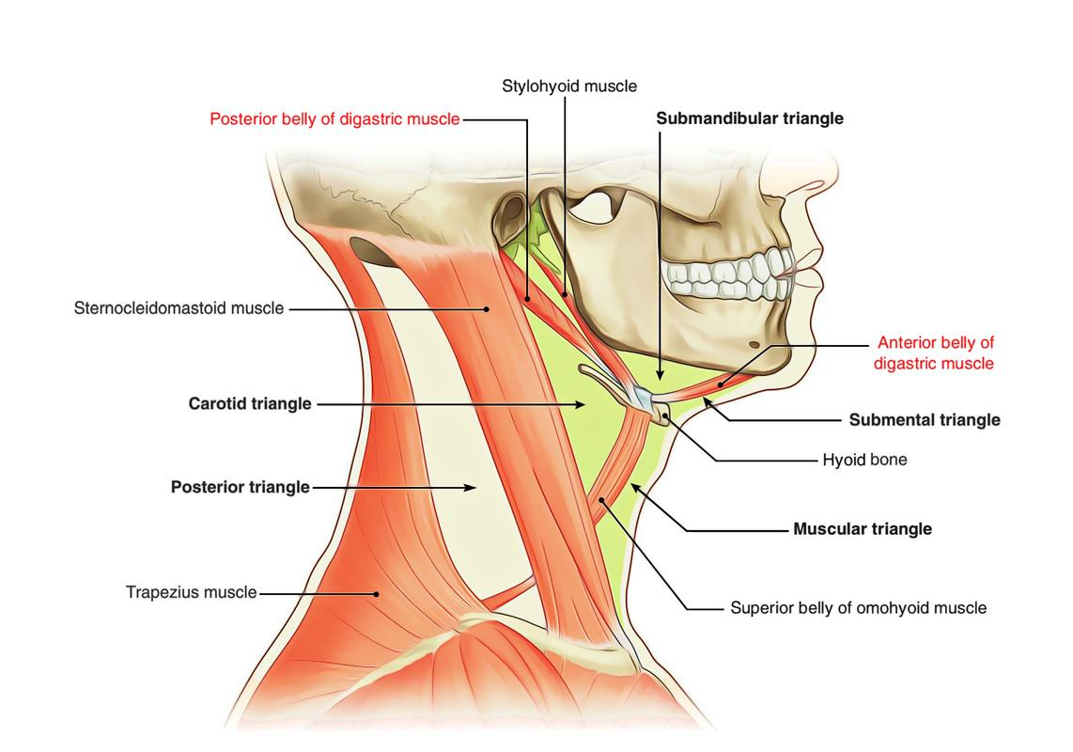
- Contents: -Thyroid gland, larynx, trachea.
- Infrahyoid muscles ( sternothyroid , sternohyoid, omohyoid, thyrohyoid).
-Carotid sheath (common carotid artery, internal jugular vein , vagus nerve).

_______________________________________________________________________

Triangles religion of the Neck.
1.trigonom omoclaviculae
-Encloses:
- M. Sternocleidomastoideus ( anteriorly )
- Clavicula (inferiorly)
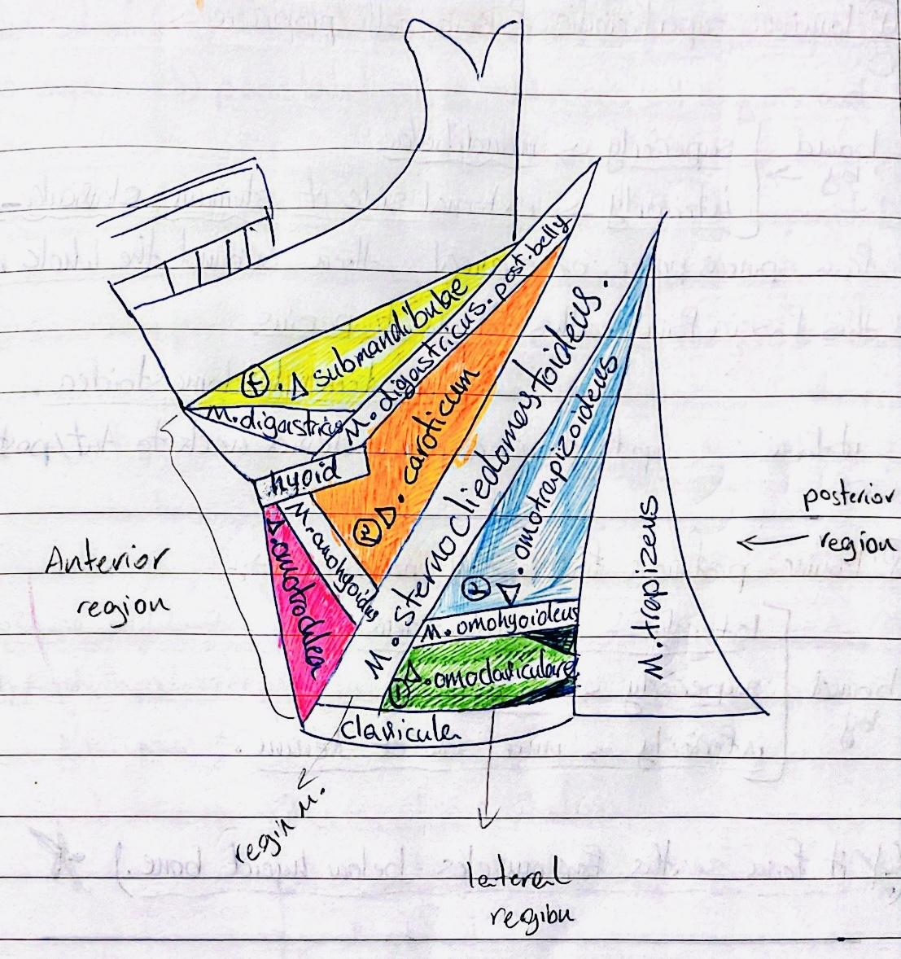
- M. Omohyoideus (superiorly )

2.trigonom Omotrapizoidium
- M. trapezius (posteriorly)
- M. omohyoideus (inferior belly)
- M. sternocleidomastoidus (anteriorly)

3.trigonom caroticum
- M. sternocleidomastoidus (posteriorly)
- M. digastricus* (posterior belly, intermediate tendon)
- M. omohyoideus* (superior belly)

4. Trigonom Submandibular
- Inferior border of the mandible (superiorly)
- *M. Digastricus (anterior and posterior bellies)

5.piragov s trigonom
- Superiorly → Nervus hypoglossus (CN XII)
- M. Mylohyoideus anteriorly)
- M. Digastricus (posteriorly)

6.trigonom Omotracheal
- white line of the neck (anteriorly)
- M. Omohyoideus (posteriorly)
- M. sternocleidomastoidus (laterally)

_____________________________________________________________________

Functional & Clinical Notes :
- The Carotid sheath is critical for vascular access and surgery.
- The pretracheal layer is relevant in tracheostomy procedures.
- The submandibular space is a common site for abscesses (Ludwig’s angina).
—------------------------------------------------------------------------------------------------------------------

Muscles of Mastication

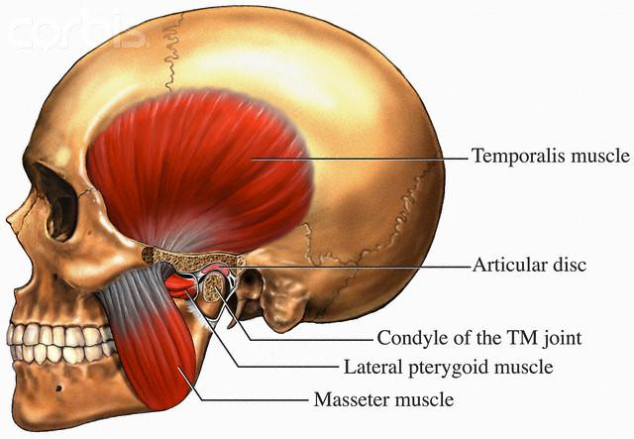
1 Musculus Temporalis
2.Musculus masseterica
3.Musculus Pterygoideus Medialis
4.Musclus Pterygoidius Lateralis

muscles of mastication develop from the first
pharyngeal arch and are primarily attached to
the mandible bone.

1 Musculus Temporalis
- Origin: Fossa Temporalis.
- Insertion: Coronoid process and anterior border of the mandibular ramus
- Action: close mouth, elevate mandible. Posterior fibers retract the mandible (pull it backward).

2.Musculus masseterica
- Origin: arcus Zygomaticus.
- Insertion: tuberositas Masseterica of the mandibular ramus.
- Action: the jaw (elevates mandible)

3. Musculus Pterygoidius Medialis
- Origin: Pterygoid fossa of the sphenoid bone
- Insertion: tuberositas Pterygoidea of angulus mandibulae medially.
- Action: Closes the jaw (elevates mandible)

4.Musclus Pterygoidius Lateralis
- Origin: Upper head: Greater wing of the sphenoid bone ( ala majoris os sphenoidalis )
- Lower head: Lateral pterygoid plate
- Insertion: ( column mandibula ) Neck of the mandibular condyle and articular disc.
- Action: Bilateral contraction : Pushes mandible (pushes it forward) .
- Unilateral contraction: Medial movement (side-to-side grinding)

_Multidirectional movement: The lateral pterygoid enables lateral excursions of the mandible (chewing motions).
_______________________________________________________________________
Peculiarities of Facial Muscles

1. No deep fascia – Unlike most skeletal muscles, facial muscles lack a deep fascial covering.
2. Cutaneous attachments – One end typically originates on bone, while the other inserts into the skin (enabling facial expressions).
3. Location – Concentrated around natural openings (eyes, mouth, nostrils) to control functions like blinking, smiling, and chewing.

_______________________________________________________________________

Mechanics of Jaw Movement

- Opening the mouth: - Primarily involves muscles above the hyoid bone (suprahyoid muscles:
digastric,mylohyoid, geniohyoid).
- The hyoid bone acts as a * punctum fixum (fixed point) for these muscles to depress the mandible.

- Closing the mouth:
- Controlled by *muscles of mastication* (*temporalis, masseter, medial/lateral pterygoids).

Embryological Origins
- Muscles of mastication : Derived from the first pharyngeal arch (innervated by the *mandibular branch of the trigeminal nerve, CN V3).
- Muscles of facial expression : Derived from the **second pharyngeal arch (innervated by the facial nerve, CN VII*).

-________________________________________________________________________

Fascia of the Neck (Fascia Colli)

1.Fascia Colli Superficiallis which encloses Platysma muscle .
- Location : Beneath the skin, enclosing subcutaneous tissue.

2. Lamina Superficialis Fascia Colli propriae,
-Superiorly : Mandible.
- Inferiorly : Clavicle and external side sternum.
- from the spinosus processus of cervical vertebrae , goes along the neck and surrounds it.
- Encloses musculus trapezius** and musculus sternocleidomastoid muscles.

3.Lamina Profunda Fascia Colli properia, forms sheath for Muscles Below the Hyoid Bone.
- Laterally > M. omohyoideus
- Superiorly > Hyoid bone (creates a triangular space).
- Inferiorly > Inner surface of the sternum and clavicle.

- Visceral compartment (thyroid, trachea, esophagus).

*Spatium intrauppernuraticum suprasternale >>Space between lamina superficialis
And Lamina profunda.

- Interfascial Space: Between the superficial and deep layers of the deep cervical fascia.
- Contains: - Infrahyoid muscles ( sternohyoid, sternothyroid , thyrohyoid, omohyoid ).
- Vascular and visceral structures.

4. Fascia EndoCervicalis > covers organs of the neck .which consist of two layers:
>Visceral layer : covers each organ separately.
>parietal layer : embarrasses all organs and vessels.

*Spatium previserale >> space between visceral and parietal layer.

5.fascia prevertebralis >> forms sheath for prevertebral muscles and deep muscles from one side
of the processus transversus to the other side.

*Spatium retropharyngeal >> space behind pharynx
Between fascia prevertebralis and fascia endocervicalis.

*Spatium interscalene >> between musculus scalenus Anterior
Musculus scalenous medius And first rib .
_________________________________________________________________

Muscles of Facial Expression and Scalp

Muscles of Facial Expression ,
Developed from the 2nd Pharyngeal Arch.

Scalp muscle → Musculus Epicranius
( occipitofrontalis ) → Galea aponeurotica

Anteriorly → venter frontalis → Raises eyebrows, creates horizontal forehead wrinkles.
Posteriorly → venter occipitalis → Retracts the scalp posteriorly.
Laterally → Temporoparietalis → Extends laterally around the ear.
-Auricularis anterior → Pulls ear forward.
- Auricularis posterior → Pulls ear backward.
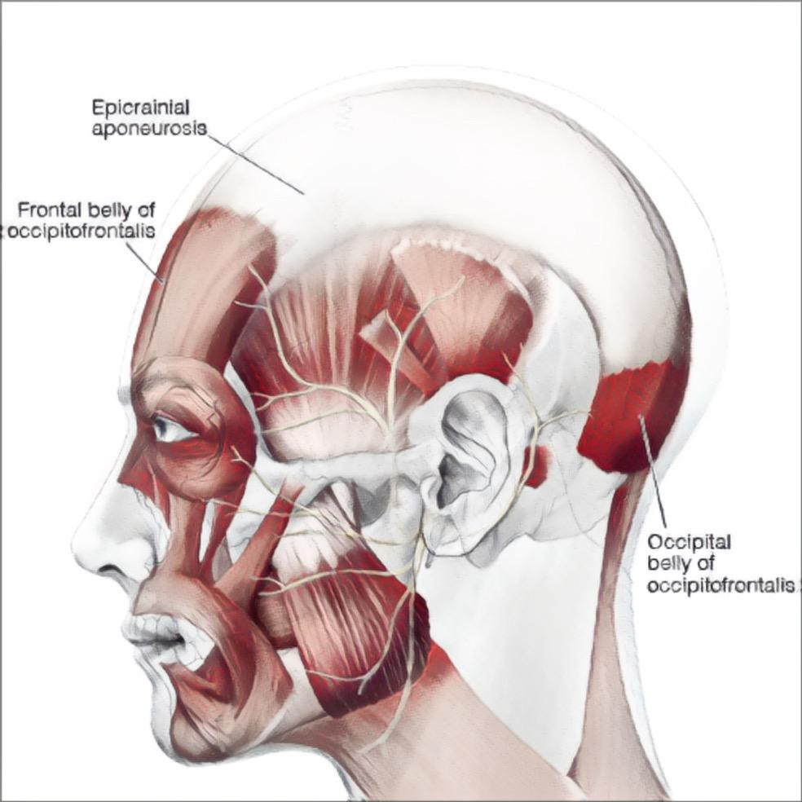
- Auricularis superior → Elevates the ear.

Muscles of Facial : Muscles surrounding eyes

1.Musculus procerus , Transfers tension to the skin above the bridge of the nose.
(e.g., frowning or squinting in bright light)

2.Musculus Orbicularis oculi
- Pars orbitalis ( attaches to the bony margin of the orbit ) → Forceful eyelid closure.
- Pars palpebralis ( on eyelids ) → Gentle eyelid closure ( blinking ).
- Pars lacrimalis (wall of lacrimal sac ) → Facilitates tear drainage.

Action: Closes eyelids, draws skin of the forehead medially, pulls eyebrows downward.

3. Musculus. Corrugator Supercili
- Action : Draws eyebrows medially (creates vertical "frown" wrinkles).
- Associated with expressions of worry or concentration.
______________________________________________________________________

Muscles of Facial: Muscles of the Mouth

1- M. levator labii superioris → raises upper lip.
2- M. levator anguli oris→ raises the angle of the mouth.
3- M. depressor labii inferioris → pulls lip down and laterally; expression of disgust.
4- M. risorius → involved in laughing and forming dimples.
5- M. zygomaticus major→ smiling and laughing.
6- M. zygomaticus minor → deepens nasolabial fold during contraction.
7- M. depressor anguli oris → pulls down the angle of the mouth.
8- M. mentalis→ raises the skin of the chin. - pushes the lower lip upward.
9- M. buccinator → expels air (e.g., when playing trumpet).
10- M. orbicularis oris → purses lips (forward) and closes the mouth.
11- M. nasalis→ Compresses nostrils and draws them down.
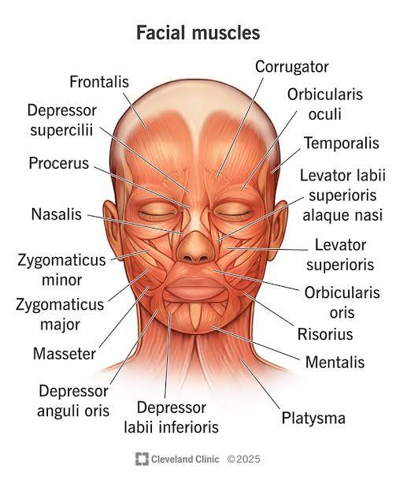

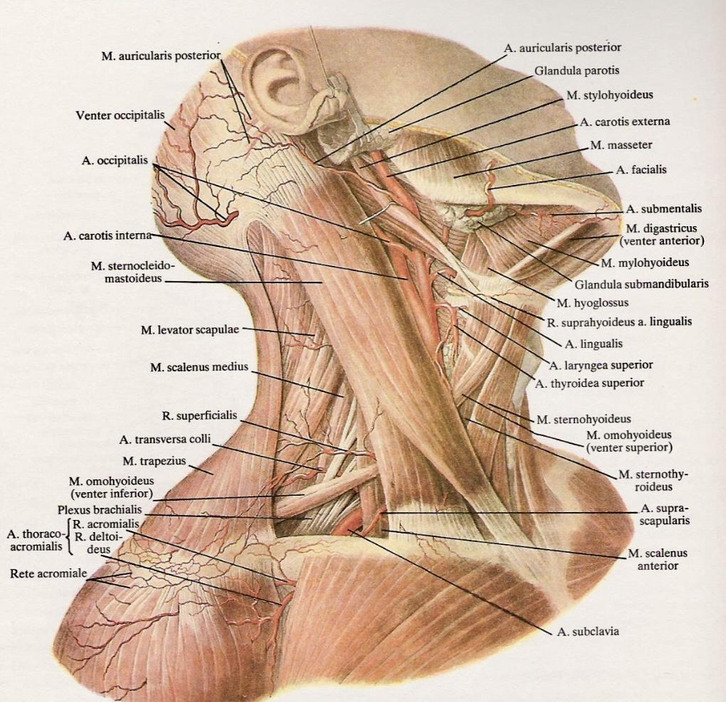

—----------------------------Muscle of the upper limb—------------------------------

Shoulder Girdle Muscles

Shoulder Girdle Muscles develop from the ventral part of myotome . Divided into anterior and posterior groups .
- Posterior muscles
1. M. deltoidus origin → spina scapula , acromion process of scapula , exterimitas acromialis os clavicula insert → tuberossitas deltoidea os humerus.
Action→ flexion shoulder joint abduction , extension of upper limb .
2 -M. Supraspinatus origin→ fossa Supraspinatus → tuberculum majus os humerus
Action : abduction of shoulder.
3-M. Infraspinatus origin → fossa Infraspinatus→ tuberculum majus os humerus
Action → supination shoulder
4.M. Teres minor origin→ margo lateralis os scapula insert → tuberculum majus os humerus
Action → supination shoulder
5. M.Teres major origin → Angulus inferioris os scapula insert → tuberculum minus os humerus
Action → pronation
6- M.Subscapularis origin → fossa subscapularis insert → tuberculum minos
Action → pronation

Anterior Group muscles
-M. Coracobrachialis origin → processus coracoideus → os humerus .
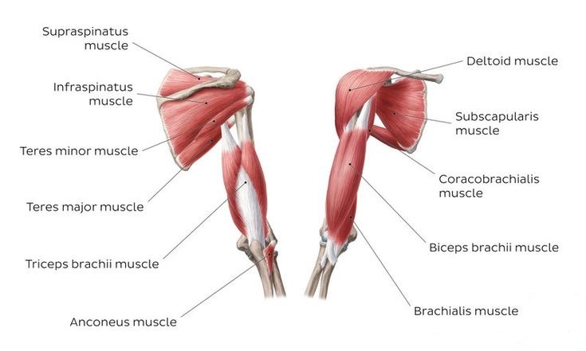
Functions: flexion-adduction of the humerus

—-----------------------------------------------------------------------------------------------------------------------
* Muscles of upper Arm Divided into anterior and posterior group .

________________________Anterior group

1- Musculus Biceps brachii anteriorly origin > caput longum, insert > tuberculum supraglenoidale os scapula insert > tuberositas radi
origin > caput bereve > processus crodoidius os scpuala insert > tuberositas radii

Action > flexion of arm and upper arm , flexion of elbow and shoulder girdle .

2- Musculus Brachialis posteriorly
origin > from os humorous insert > Tuberossitas ulnae, action > flexion of elbow .

______________________ Posterior group , upper arm .

M.Triceps brachi

Caput longum insert > Tuberculum infragelnoidale , insert >
Caput laterale insert > posterior side of humorous ,insert > ⍆ procesus Olecranon os ulna .
Caput mediale insert > posterior side of humorous , insert >
Action > extension of elbow and shoulder .

M . Anconeus epicondylus lateralis of humorous insert > ulna posterior surface,
Action > tension of anterior capsule of elbow joint.
______________________________________________________________________

Axillary region (armpit) anatomy, focusing on its boundaries and content.

Axillary Boundaries (4 Walls)

1. Anterior Wall 2. Medial Wall :
- M. pectoralis major -M.Serratus anterior
- M. pectoralis minor

3. Posterior Wall : 4. Lateral Wall :
M. Latissimus dorsi -M. Biceps brachii
- M. teres major -M. Coracobrachialis ( adduction )
- M. subscapularis
- humerus

- posteriorly Canalis humeromuscularis from by humerus 9 sulcus nervi radialis and M.triceps brachii.

- Foramen quadrilaterum : ⍆ M.triceps brachii ( caput longum)
⍆M.teres major
⍆M. subscapularis
⍆Humerus
Foramen trilaterum : ⍆M.teres major
⍆M. Subscapularis

Anteriorly on upper arm, there are two grooves:
-Sulcus bicepitalis medialis / lateralis , which is formed by m.bicpts brachi and M.barchialis . _______________________________________________________________

Muscles of the Forearm -
Anterior Compartment divided into: Superficial Layer
Deep layer

- Superficial Layer as below :

1. M.Pronator Teres
2. M.Flexor Carpi Radialis
3. M.Flexor Carpi Ulnaris
4. M.Palmaris Longus
5. M.Flexor Digitorum Superficialis

B) Deep Layer as below :

1.M.Flexor Pollicis Longus
2. M.Flexor Digitorum Profundus
3.M.Pronator Quadratus

Muscles of the Forearm - Anterior Compartment (Superficial Layer)
- All superficial flexors of the forearm share a *common origin* from the medial epicondyle (*common flexor origin ).

1. M.Pronator Teres
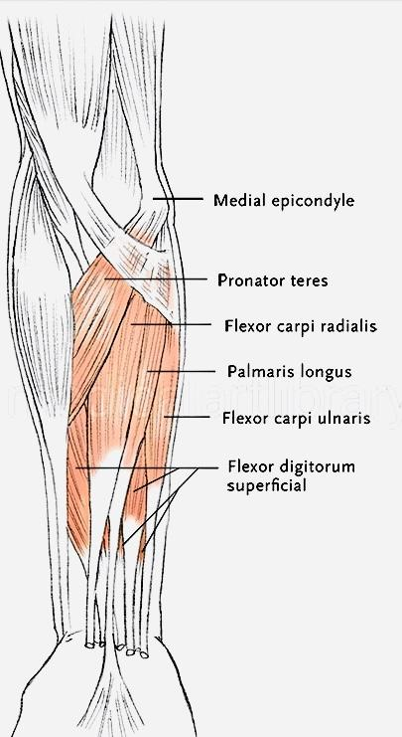
> Insertion : facies Lateralis of the radius
Action : Pronation of the forearm,
weak flexion of the elbow

2. M. Flexor Carpi Radialis
>Insertion : Base of the 2nd metacarpal bone
Action : Flexion of the wrist
And Radial abduction of the wrist when working
with posterior muscles

3. M.Palmaris Longus
- Insertion : Palmar aponeurosis
- Action : Tightens the palmar aponeurosis;
weak wrist flexion

4.M.Flexor Digitorum Superficialis
- Origin: epicondylus Medialis of the humerus head
- Coronoid process of the ulna (ulnar head)
- Insertion : 2nd–5th Middle phalanges of digits.
- Action : - Flexion of the wrist
- Flexion of the proximal and middle interphalangeal joints

5. M. Flexor Carpi Ulnaris
- Origin : Medial epicondyle of the humerus (humeral head)
- Olecranon and posterior border of the ulna (ulnar head)
- >Insertion : Pisiform bone, hook of hamate, and base of the 5th metacarpal
- Action : - Flexion of the wrist
- Ulnar deviation (adduction) of the wrist.

Deep Muscles of the Forearm - Anterior Compartment

1. M.Flexor Pollicis Longus
- Origin : Medial epicondyle of the humerus via common flexor tendon.
- Anterior surface of the radius distal to pronator teres .
- Interosseous membrane.
- Insertion : Base of the distal phalanx of the thumb
- Action : - Flexion of the thumb (interphalangeal joint)
- Weak flexion of the wrist.

2. M.Flexor Digitorum Profundus
- Origin : Proximal ulna (anterior and medial surfaces)
- Interosseous membrane .
- Insertion : Bases of the 2–5 distal phalanges of fingers .
- Action : - Flexion of the distal interphalangeal joints .
- Assists in flexion of the wrist

3. M.Pronator Quadratus
- Origin : Distal anterior surface of the ulna
- Insertion : Distal anterior surface of the radius
- Action : - Pronation of the forearm (primary muscle for this action)
- Stabilizes the radius and ulna during movement

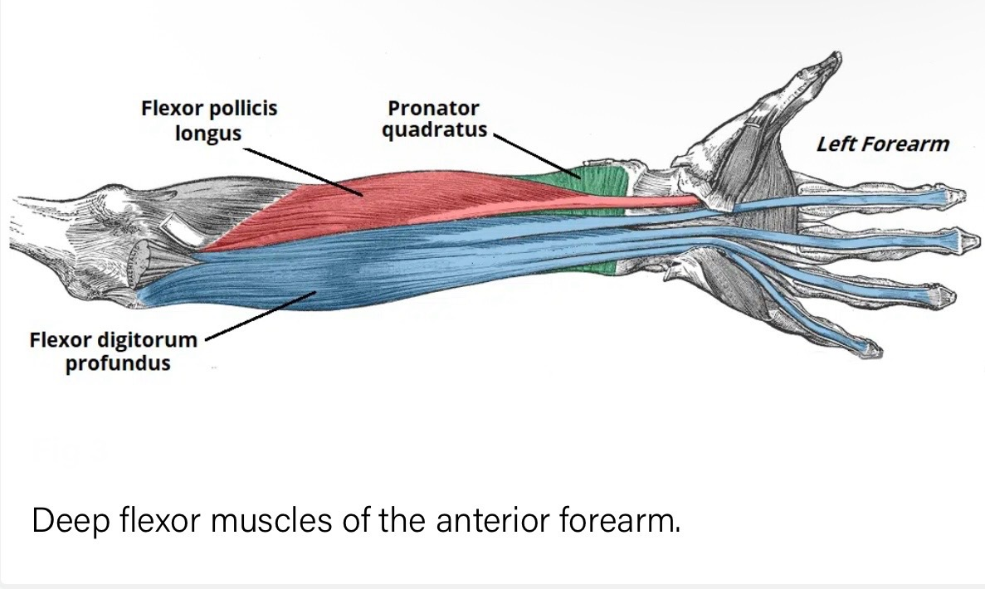

Posterior group of forearm muscles (superficial layer) .
Divided into radial and ulnar groups.

All originate from the lateral epicondyle of the humerus via the common extensor tendon.
Radial group : ( laterally )

1) M.Brachioradialis
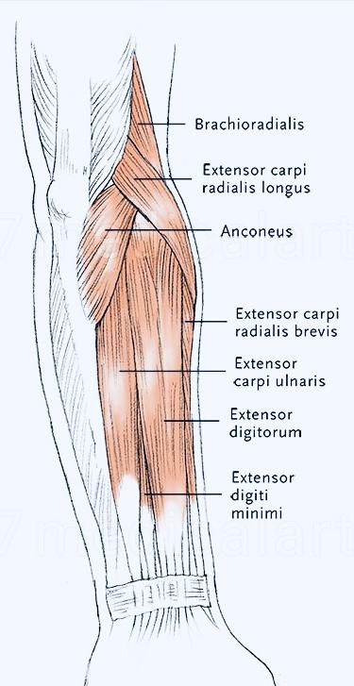
>> Brachioradialis is a flexor (not an extensor) despite being in the posterior compartment.
- Origin : Lateral supracondylar ridge of humerus
- Insertion : Distal radius (styloid process)
- Action : - Flexes the elbow (especially in mid-pronation)
- Stabilizes the forearm during rapid movements

2)M. Extensor Carpi Radialis Longus
- Origin : Lateral supracondylar ridge of humerus
- Insertion : Base of the 2nd metacarpal
- Action : - Extension of the wrist
- Radial deviation (abduction)
>> Works antagonistically with Flexor Carpi Radialis<<

3) M.Extensor Carpi Radialis Brevis
- Origin : Lateral epicondyle of humerus
- Insertion : Base of the 3rd metacarpal
- Action : - Extension of the wrist , Radial deviation.

_________________________________________________________________

Posterior Forearm muscles Group ( Deep Layer )

Ulnar group ( medially ) —————————————————————-

1. M.Extensor Digitorum Communis
- Origin. : Lateral epicondyle of humerus
- Insertion : Extensor expansions (dorsal surfaces) of fingers 2–5
- Action : - Extension of fingers 2–5 at metacarpophalangeal (MCP) and interphalangeal (IP) joints
- Weak wrist extension
- Passes under the extensor retinaculum
- Divides into 4 tendons distally

2. M.Extensor Digiti Minimi
- Origin : Lateral epicondyle of humerus (often a slip from extensor digitorum)
- Insertion : Extensor expansion of the little finger (5th digit)
- Action : - Independent extension of the little finger
- Assists extensor digitorum

3. Extensor Carpi Ulnaris
- Origin : Lateral epicondyle of humerus
- Insertion: Base of the 5th metacarpal
- Action: - Extension of the wrist - Ulnar deviation (adduction)
- Works synergistically with *Flexor Carpi Ulnaris* for wrist stability

Functional Notes
- The extensor retinaculum prevents bowstringing of tendons during wrist extension.
Clinical Correlation :
- Extensor Digitorum. is tested by asking a patient to extend their fingers against resistance.
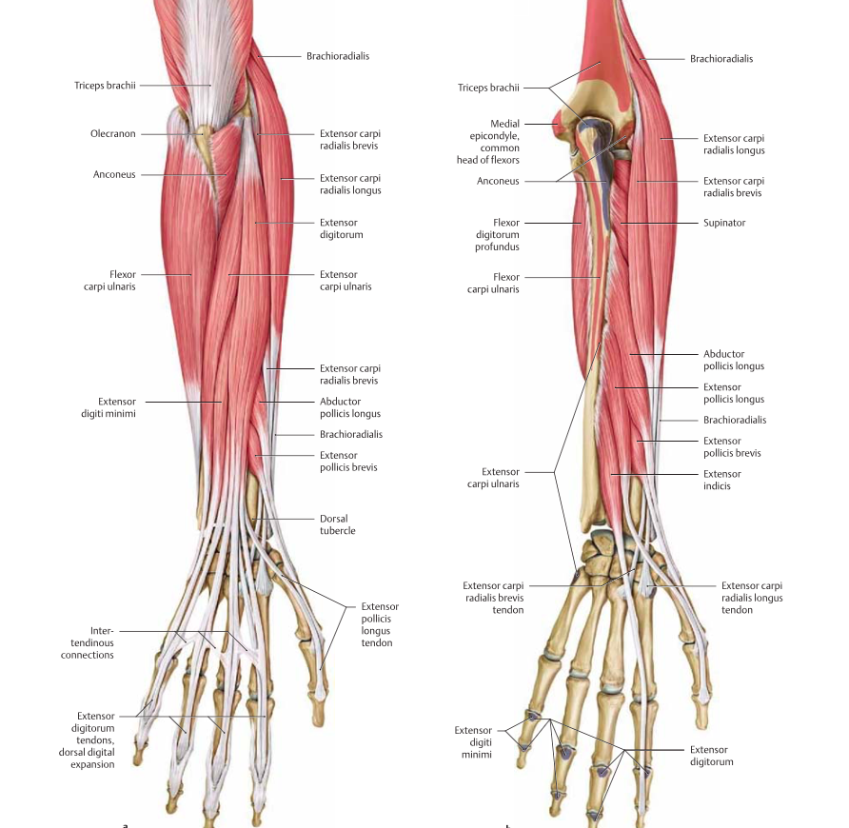
- Extensor Carpi Ulnaris weakness leads to radial deviation during wrist extension (seen in radial nerve palsy).

______________________________________________________________________
Deep posterior forearm muscles (Extensor/Abductor Group)
1.M. Supinator
- Origin : - Lateral epicondyle of humerus
- Proximal ulna (supinator crest)
- Insertion : Proximal 1/3 of radius
- Action: - Supination of the forearm (rotates radius laterally)

2. M. Abductor Pollicis Longus
- Origin : - Posterior ulna, radius, and interosseous membrane .
- Insertion : Base of 1st metacarpal.
-Action : Abduction of the thumb (at carpometacarpal joint)
- Assists in wrist extension

3. M.Extensor Pollicis Brevis
- Origin: Posterior radius and interosseous membrane
- Insertion : Base of proximal phalanx of thumb
- Action : - Extension of the thumb joint.

4. M.Extensor Pollicis Longus
- Origin : Posterior ulna and interosseous membrane
- Insertion : Base of distal phalanx of thumb
- Action : - Extension of the thumb (IP joint)
- Assists in wrist extension

5. Extensor Indicis
- Origin : Posterior ulna and interosseous membrane
- Insertion : Extensor expansion of index finger (2nd digit)
- Action : - Independent extension of the index finger
- Assists extensor digitorum

Functional Notes:
- These muscles form the "anatomical snuffbox" (Abductor Pollicis Longus, Extensor Pollicis Brevis, Extensor Pollicis Longus).
- All are innervated by the posterior interosseous nerve (PIN) .

Clinical Correlation:- De Quervain’s Tenosynovitis : Inflammation of Abductor Pollicis Longus and Extensor Pollicis Brevis tendons.
- PIN Palsy : Weakness in thumb/index finger extension handshake sign.

—--------------------------Muscles related to the thumb (pollicis)----------------------

Muscles of the Hand (Thumb/Pollicis Region):
1.M.Abductor Pollicis Brevis
- Action: Abducts the thumb (movement away from the palm, laterally).
- Note: "Pollicis" refers to the thumb; "brevis" means short.

2. M.Flexor Pollicis Brevis
- Action: Flexes the thumb (bends it toward the palm).

3. M.Opponens Pollicis
- Action: Opposes the thumb (brings it across the palm to touch other fingers).

4.M.Abductor Pollicis Longus
- Action: Abducts and extends the thumb (located deeper, not in the thenar eminence).

- "Opponent's policies" → Opponens Pollicis (a muscle enabling thumb opposition).

Additional Notes:
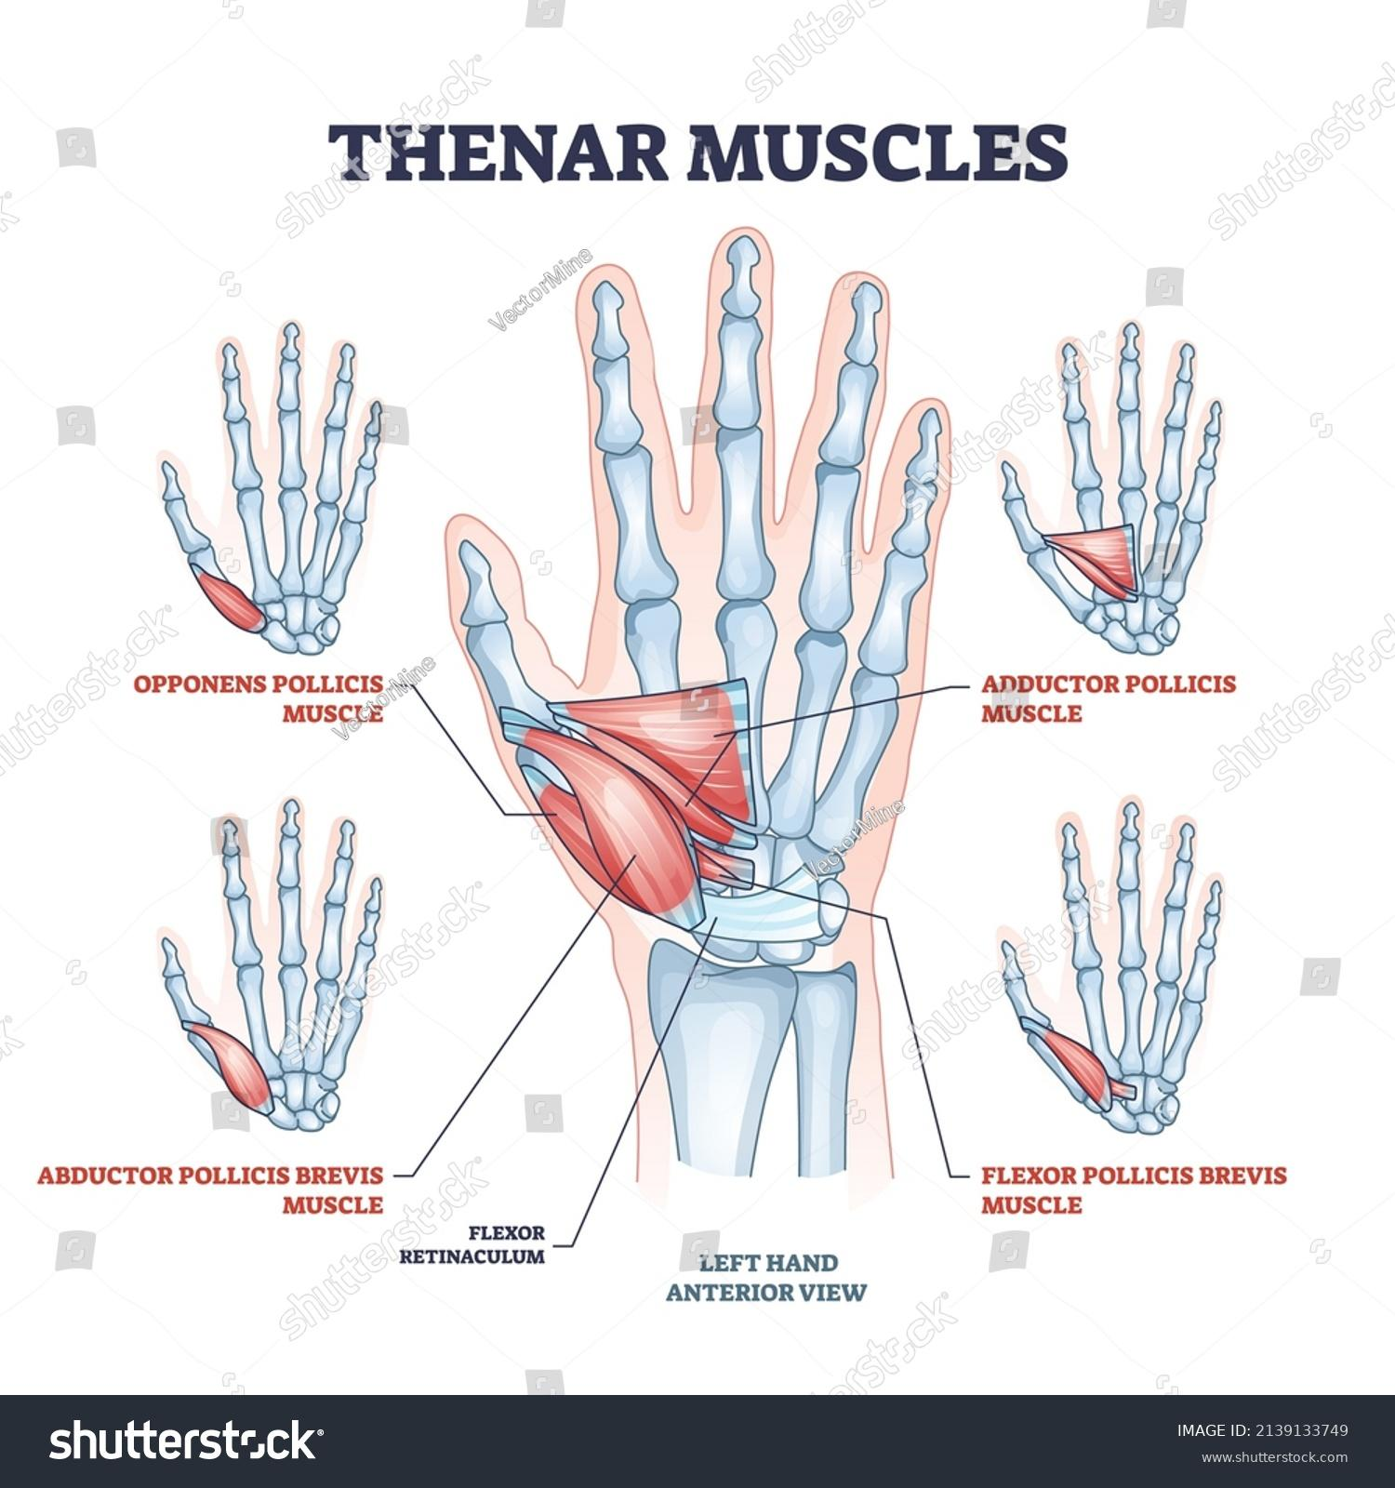
- These muscles are part of the **thenar eminence** (thumb base) except for **Abductor Pollicis Longus**, which is in the forearm.

