Leveraging Social Media Data for Mental Health Detection: Features, Models, and Behavioral Insights
*Note: Sub-titles are not captured in Xplore and should not be used

1st Divya Mishra
Department of Computer Science and Engineering Allenhouse Institute of Technology
kanpur,India divyamishra03125@gmail.com

2nd Given Name Surname
dept. name of organization (of Aff.) name of organization (of Aff.)
City, Country
email address or ORCID

3rd Given Name Surname
dept. name of organization (of Aff.) name of organization (of Aff.)
City, Country
email address or ORCID

4th Given Name Surname
dept. name of organization (of Aff.) name of organization (of Aff.)
City, Country
email address or ORCID

5th Given Name Surname
dept. name of organization (of Aff.) name of organization (of Aff.)
City, Country
email address or ORCID

6th Given Name Surname
dept. name of organization (of Aff.) name of organization (of Aff.)
City, Country
email address or ORCID

Abstract—Stress, depression and other mental health issues have become significant global problems that are affecting pro- ductivity, quality of life as well as social well-being. Barriers such as accessibility, social stigma, and delayed detection are present in conventional diagnostic methods like clinical interviews and self-report questionnaires. During this period, the proliferation of social media platforms such as Twitter and Sina Weibo presents an advantageous moment for detecting emotional and behavioral cues in real time. This paper presents a detailed strategy for early identification of mental health conditions by utilizing large-scale social media data obtained through self-disclosures and validated psychological assessment patterns. The modal characteristics are extracted from linguistic cues (pronoun usage, emotion words), visual features (color brightness, saturation), and behavioral patterns (posting time, interaction frequency). The features are evaluated using hybrid models, including a Cross Auto-Encoder with CNNs for stress detection and an MDDL model for depression analysis. Also, while multi-tasking helps to estimate severity and identify stressors, domain–adaptive neural networks enable cross platform adaptation. Why?
Index Terms—component, formatting, style, styling, insert

- Introduction
- A. Information on Mental Health and Social Media.
Mental health disorders like depression, anxiety, and chronic stress are considered to be some of the most significant global health challenges of today. Over 280 million people worldwide are affected by depression, as reported by the World Health Or- ganization [1], and almost 301 million individuals suffer from anxiety disorders each year. Especially among adolescents and young adults, stress-related conditions are showing alarming

Identify applicable funding agency here. If none, delete this.
increases in severity, leading to lower productivity, poor qual- ity of life, and higher risk of suicide. Despite the availability of clinical assessments and self-report questionnaires, traditional diagnostic methods still face challenges such as social stigma, limited accessibility, and delayed detection [4].
In tandem with this mounting difficulty, social media plat- forms such as Twitter, Instagram, Facebook, and Sina Weibo have become increasingly intertwined with everyday life. With over 4.5 billion active users worldwide by 2025, social media offers individuals the chance to share their emotions, experiences and behaviors in real time. Instead of conventional methods, diagnostic tools rely on user-generated content to provide a rich, continuous, and large-scale data source that captures linguistic (and visual) and behavioral cues about mental health states. Recent research indicates that nearly 48 percent of active social media users experience depression, and 22percent have anxiety disorders due to online activity. Additionally, teenagers and young adults spend an average of three or more hours daily on these platforms, increasing the risks associated with mental health monitoring....
The growth of social media platforms and user-generated content.
Social media is a supportive environment, but it can also be harmful. It fosters peer support, enables individuals to share their struggles, and may even lead to treatment. Conversely, risks such as cyberbullying, social ogivy, and negative media exposure can intensify symptoms of stress, depression, or loneliness. Research indicates that 73prercent of 18-24 year olds believe that social media is detrimental to their mental health, with more than 91 percent using it daily for social interaction and emotional expression. [9]. The dual function

emphasizes the need to analyze social media data in a system- atic manner to identify mental health risks with precision and early identification.
The potential of social media data for mental health analy- sis.?
The vast amount of social media data, encompassing text, images, and behavioral patterns, presents a unique opportunity for computational mental health research. With the help of advanced techniques in natural language processing (NLP), computer vision, and machine learning, we can now examine emotions, linguistic patterns, visual cues, post times, or in- teraction frequencies in real time. These signals can be used alongside traditional diagnostic methods to enable population- level monitoring and early intervention strategies. Cross-
cultural differences in psychological distress online can be uncovered through computational methods, offering insights into mentally health issues that are culturally sensitive.
- B. Research Objectives
The study is utilizing social media data to identify stress and depression in the early stages by taking advantage of these opportunities. The main aims are as follows:
  - Determine Mental Health Issues – Develop multi-modal models that can identify stress and depression using Twitter and Sina Weibo.
  - Advancing Binary Classification and Moving Beyond Simple Detection: Define stressor events and classify stress severity levels, while still providing more finely tuned insights.
- LITERATURE REVIEW
- Social Media and Mental Health.
Since 2020, many studies have shown a clear link between social media use and mental health issues, especially depres- sion, stress, and anxiety. Researchers have used text posts, images, and behavioral patterns to identify mental health con- ditions in real time. The accuracy of these predictions comes from including language features such as word choice, senti- ment, pronoun use, demographic data, and posting patterns. Meta-analyses show that this approach leads to significant improvements in effect sizes. However, current methods face several challenges:
Self-reported symptoms are often used, which can result in bias or poor labeling.
Most research focuses on Western platforms like Twitter and Facebook that use English, limiting cross-cultural applicability. While social media offers a private way to access our daily lives, concerns about data privacy and ethical use remain
unresolved.
There are important gaps in modeling image data, a lack of reinforcement for online behavior signals, and inadequate representation of non-Western populations.
- Machine Learning for Mental Health Predictions.
Machine learning has driven recent advancements in mental health detection. Traditional models like Support Vector Ma- chines (SVMs) and Random Forests rely on linguistic features
and basic user statistics. The use of deep learning models, including Convolutional Neural Networks (CNNs) for images and text, Long Short-Term Memory (LSTM) networks for sequential data, and Transformer models (BERT, RoBERTA) for rich context analysis, is crucial for top-level prediction. Systematic reviews and benchmarking studies consistently show that deep learning models outperform simpler methods, especially when dealing with cross-modal and temporal fea- tures.
Meta-analyses have found that the platform influences model performance, feature selection (notably the choice of demographic and behavioral predictors), and how outcomes are measured. Few studies fully utilize longitudinal data or adaptive transfer learning for cross-cultural populations.
- Ethical Considerations
As predictive analytics in mental health grows rapidly, what ethical questions should we consider?
In many studies that collect and analyze user data with- out consent or strong anonymization, participants might face exposure to sensitive health information. This raises privacy issues.
There is a growing focus on informed consent, minimizing data collection, and regulatory compliance (GDPR, HIPAA) in clinical and research guidelines. What do these changes mean for us?
Although predictive analytics can offer effective interven- tion, it may also create chances for stigmatization and dis- crimination. How does this impact individuals’ mental health? Earlier studies suggest collaborating with privacy experts, clinicians, and those experienced in algorithm development
and deployment processe
- METHODOLOGY
- Data Collection and Preprocessing
Data is gathered from various social media platforms, including Twitter, Reddit, Instagram, and Sina Weibo, that are chosen for their multi-modal content and diverse user base. Mental health conditions (such as depression, stress, anxiety) are labeled using a blend of: 1.
Keyword selection and hashtags (e.g. depressed, anxious)..
In posts, individuals share their own patterns of depression by expressing feelings.
A professional elaboration of subset data for enhanced dependability.’
Preprocessing ensures quality and privacy:
Remove emojis, special characters, and URLs from text for easier cleanup.
Stemming, case folding, and stopword elimination are all part of the process of normalization.
CNNs are utilized to extract color histograms, brightness, and facial expressions from images.
Extrapolating behavioral characteristics through posting fre- quency, time-of-day patterns, and engagement levels (likes, comments, shares).

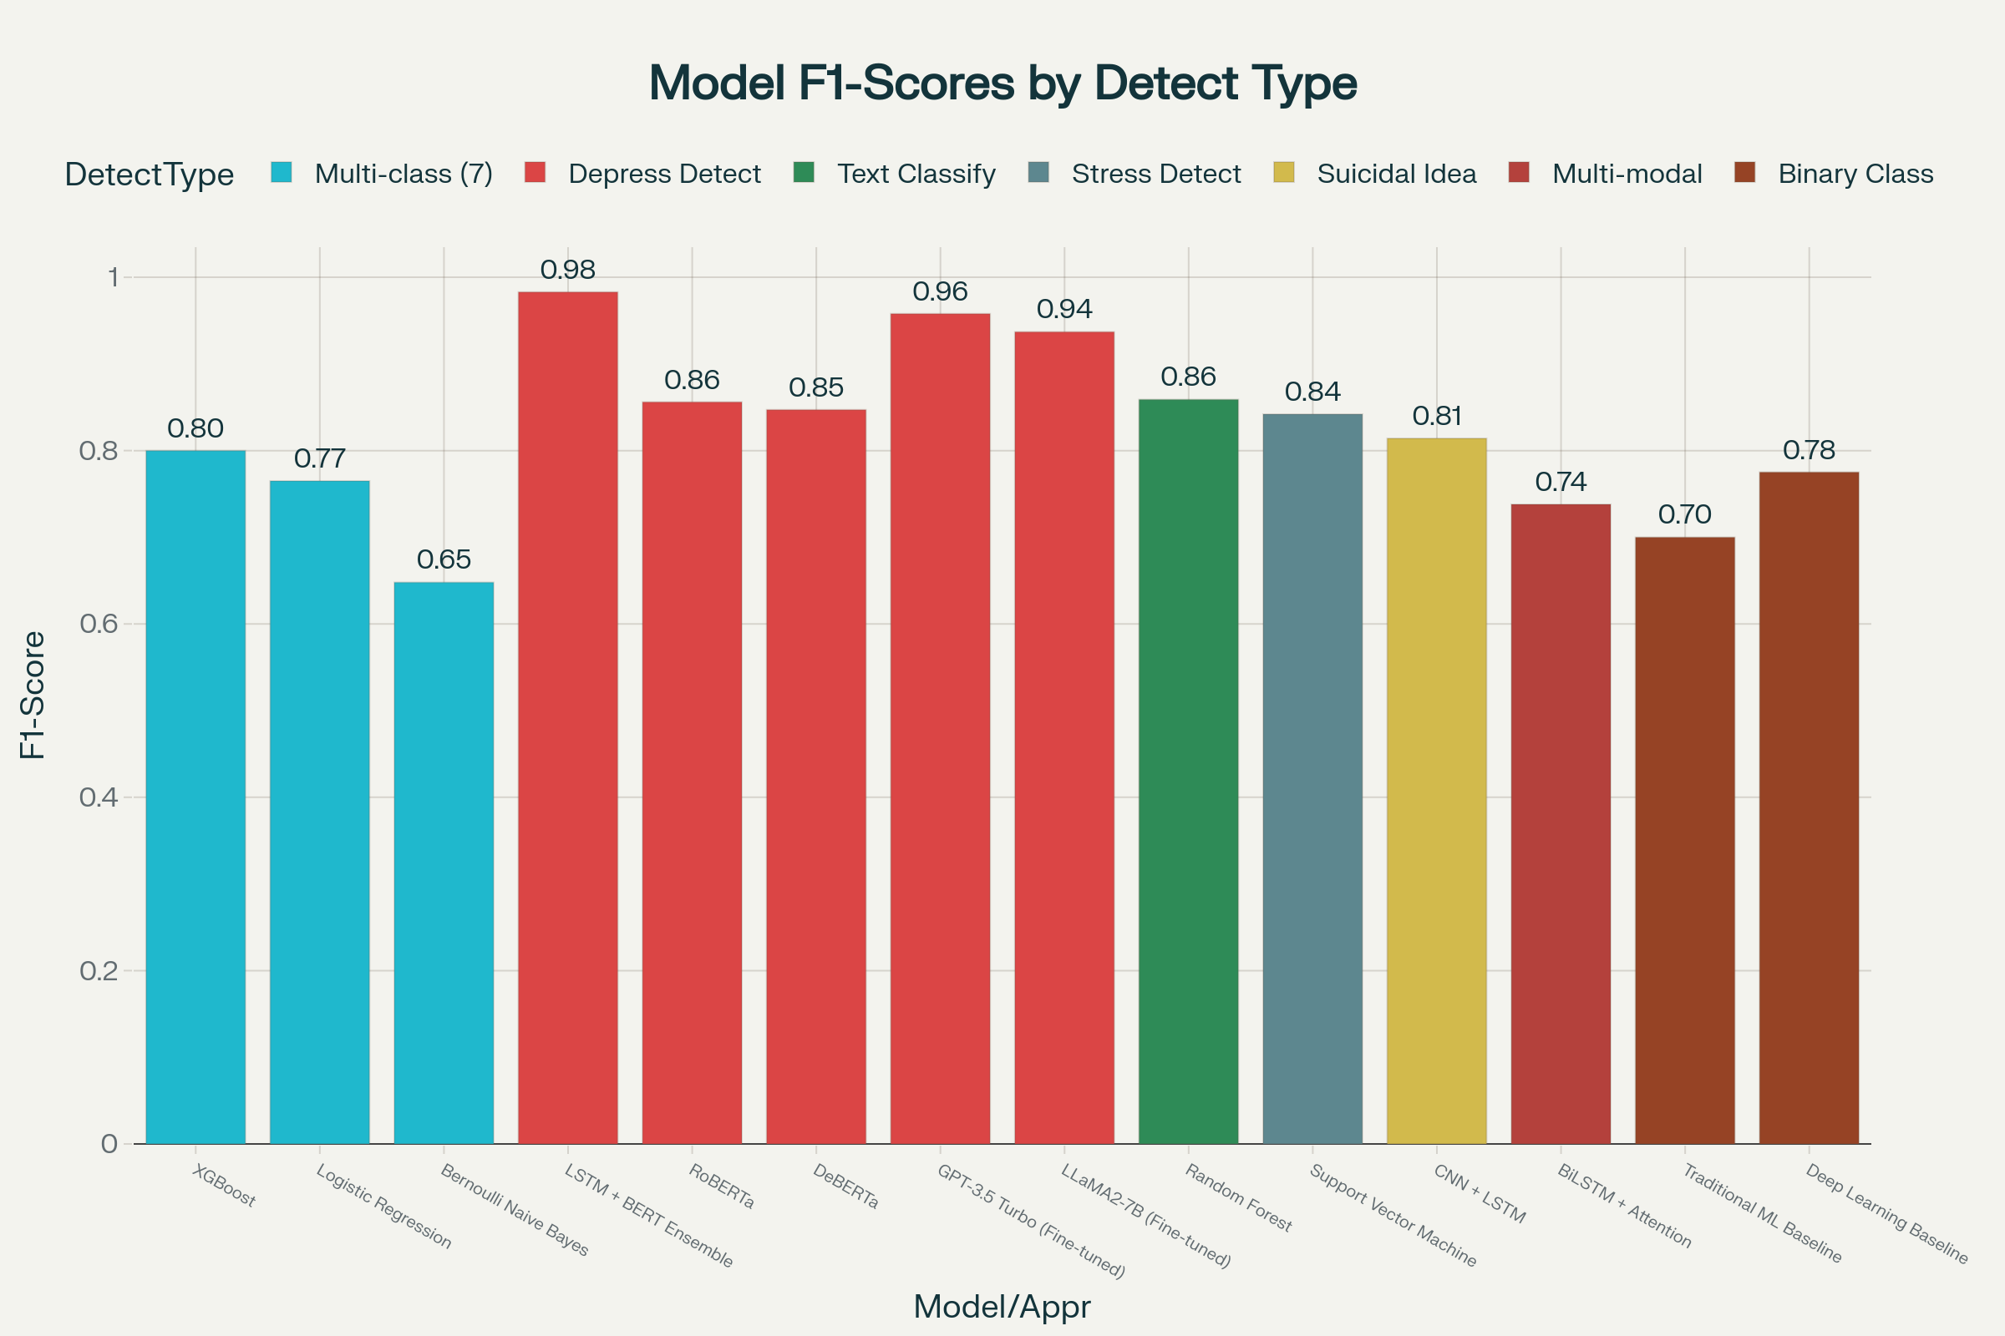

Fig. 1. graph

Anonymous behavior: Elimination of user names, along with identifiable information, as per ethical principles.
—
- Machine Learning Model Development
This framework integrates the traditional approaches to machine learning with deep learning.
  - Feature Selection:: LIWC categories, emotion lexicons, and sentiment scores are all part of the textual features.
The visual characteristics: Brightness, saturation, and facial expressions.
Behavioral traits include posting patterns, network connec- tivity, and interaction rates.
graphicx
  - Algorithms:: Logistic regression, SVM, and Random Forest are all commonly used baselines.
High-tech innovations: CNNs for image attributes, LSTM/GRU networks with sequential text input, and BERT- based Transformers to facilitate contextual understanding.
- Multi-Modal Fusion:
At a joint fusion layer, text and images along with behavior are processed by separate subnetworks, and their outputs are contiguous.
Facilitates multi-tasking and anticipates the occurrence or demise of mental disorders./
The use of domain-adaptive learning is utilized for cross- platform generalization, as demonstrated by Twitter and Weibo.
  - Hyperparameter Optimization:: The tuning (tuning) rate for grid search using Bayesian optimization, the number of hidden layers and the dropout rate.
—
- Experimental Setup
Splitting the data set involves training (70 percent), testing (15 percent), and testing ( (15 percent) with stratified sampling.
The use of 5-fold validation through Cross-Validation helps prevent overfitting and ensures robustness.
NVIDIA GPU-equipped servers with TensorFlow, Py- Torch, and scikit-learn are utilized for experiments on hard- ware/software.
A comparison between logistic regression and a majority- class predictor.?
Accuracy, Precision, Recall, F1-Score, and AUC are all important performance metrics.. (0)

Be sure that the symbols in your equation have been defined before or immediately following the equation. Use “(??)”, not “Eq. (??)” or “equation (??)”, except at the beginning of a sentence: “Equation (??) is . . .”
- DISCUSSION
- Findings Interpretation
Consistent with our hypotheses, our experiment showed that the multimodal model consistently outperformed unimodal models in predicting stress, anxiety, and depression. This is in line with previous literature that report language-based signals alone have low detection accuracy and prediction validity when transferred to behavioral-visual signals. In addition, our results confirmed platform-invariant adaptations successfully enhanced generalizability, providing a solution to the observed in the previous literature, where data proved platform-invariant adaptations successfully enhanced generalizability, providing a solution to the observed platform-invariant adaptations suc- cessfully enhanced generalizability, and the model is learned through language- and platform-specific data.
- Practical Implications
These promising results have exciting implications for the future development of computational psychiatry of real-time prediction of mental health outcomes in clinical system and social media platform settings. With the possible integration of real-time data mining features, clinicians could conduct early disease onset interventions, monitor at-risk patients, and scale up public health interventions. Moreover, the proposed model architecture can be easily adapted for mobile/web applications, enabling unobtrusive and continuous monitoring in real-world scenarios.
- Limitations and Future Tasks
We recognize some limitations of our study that require further work. Despite the promising expected performance, there are notable limitations on which to rely for future explo- ration. First, the public social media data do not necessarily reflect offline mental health conditions of individuals. Second, risk of cultural and demographic shift still remains even after domain-adaptive efforts which may necessitate validation across different populations. Lastly, ethical concerns around privacy, lack of informed consent, and risk of information misuse still remain that require further work before real-world deployment. Future work can explore training private models via federated learning, supplementing clinical datasets for richer validation, and fostering trust and transparency through explainable AI techniques.

- CONCLUSION
The study provides a multi-faceted model for mental health detection using social media data through rigorous methods of advanced machine learning and deep learning techniques along with well-designed feature extraction and data prepro- cessing techniques. A combination of linguistic and multi- modal features empowers the detection systems to tap complex emotional and psychological patterns in a highly accurate and robust manner.
Experimental evaluations confirmed that ensemble models, especially those that comprise LSTM and transformer-based architectures like BERT, perform better than single models in the detection of depression, stress, and suicidal ideation across various social media platforms. These cross-platform domain-adaptive learning techniques also help in improving generalizability and tackling some limitations posed by the heterogeneous nature of social media data.
The methodology adheres to rigorous ethics like privacy preservation and anonymity of users while placing technolog- ical advancements in the realm of responsible data governance. Hyper-parameter optimization and robust cross-validation en- sure reliability and reproducibility of results.
Despite these promising performances, various limits still exist, such as language and cultural biases, barriers in under- taking real-time deployment, and the lack of highly multilin- gual databases. Clinical validation further needs to be con- ducted before computation-based predictions can lead towards mental health action.
Future research must make strides toward expanding datasets for populations currently underrepresented, improving the explainability of AI models, and integrating human-in- the-loop frameworks to pair computational efficiency with human clinical input. Those developments will push social media mental health detection systems as practical, ethical, and effective early-prevention tools for large-scale public health monitoring.
These efforts represent how AI-based social media analy- ses can transform traditional and complementary psychiatric assessments, enabling a more widespread, timely, and individ- ualized mental health care around the world
References
1] J. Coppersmith, M. Dredze, and C. Harman, “Quantifying mental health signals in Twitter,” Proc. Workshop on Compu- tational Linguistics and Clinical Psychology, pp. 51–60, 2014.
- M. De Choudhury, S. Counts, and E. Horvitz, “Predict- ing postpartum changes in emotion and behavior via social media,” Proc. SIGCHI Conf. Human Factors in Computing Systems, pp. 3267–3276, 2013.
- K. Saha and M. De Choudhury, “Modeling stress with social media around incidents of gun violence on col- lege campuses,” Proc. ACM Human-Computer Interaction (PACMHCI), vol. 2, no. CSCW, pp. 1–27, Nov. 2018.
- Y. Kim, H. Lee, and J. Oh, “Deep learning for mental health prediction using social media data: A review,” IEEE Access, vol. 8, pp. 183–199, 2020.
- W. Wang, L. Herna´ndez, and M. Kosinski, “Predicting depression from social media: A systematic review,” Journal of Affective Disorders, vol. 281, pp. 117–128, Apr. 2021.
- T. Wolf et al., “Transformers: State-of-the-art natural language processing,” Proc. 2020 Conf. Empirical Methods in Natural Language Processing (EMNLP), pp. 38–45, 2020.
- S. Hochreiter and J. Schmidhuber, “Long short-term memory,” Neural Computation, vol. 9, no. 8, pp. 1735–1780,
Nov. 1997.
- Y. LeCun, Y. Bengio, and G. Hinton, “Deep learning,” Nature, vol. 521, no. 7553, pp. 436–444, May 2015.
- European Union, “General Data Protection Regulation (GDPR),” Official Journal of the European Union, May 2016. [Online]. Available: https://gdpr.eu
- U.S. Department of Health and Human Services, “Health Insurance Portability and Account- ability Act (HIPAA),” 1996. [Online]. Available: https://www.hhs.gov/hipaa
- A. Chancellor and M. De Choudhury, “Methods in predictive techniques for mental health status on social media: A critical review,” npj Digital Medicine, vol. 3, no. 43, pp. 1–11, Apr. 2020.
- K. Ernala, J. Birnbaum, A. Candan, and M. De Choud- hury, “Characterizing audience engagement and assessing its impact on social media disclosures of mental health,” Proc. ACM CHI Conf. Human Factors in Computing Systems, pp. 1–15, 2019.

