Transitions in ICT-Integrated Teaching and Learning in Transdisciplinary STEM Education
Abstract
The integration of digital technologies into teaching and learning practices accelerated significantly during the COVID-19 pandemic, driving enduring pedagogical shifts that persist beyond the pandemic. At the onset, educational institutions faced a choice: suspend curricular delivery or embrace alternative modalities to maintain instruction. Most opted for the latter, catalysing the widespread adoption of virtual technologies. Although virtual tools predated the COVID-19 pandemic, it dramatically increased their centrality in educational practice. This paper’s central argument is that the transition to ICT integration in transdisciplinary STEM education, as examined in peer-reviewed literature from 2010 to 2024, remains stuck predominantly at enhancement stages. Using the Substitution, Augmentation, Modification, and Redefinition (SAMR) model, this systematic study maps current pedagogical practices and interrogates the affordances and constraints of digital tools in teaching, learning, and assessment. Findings reveal incremental movement toward transformative use but emphasize that substitution and augmentation are still dominant. The study contends that deeper pedagogical transformation is necessary to fully harness ICT for innovative, transdisciplinary STEM learning environments.

Keywords: digital learning, STEM education, pedagogical transformation, bibliometric analysis

Introduction
Back in the mid-1980s, when I was a student teacher in Zimbabwe, my mathematics lecturer, Mr. Chisindi, would often quip, ‘A computer does not think. Ten years on, I suggested that our teachers’ college adopt computers to enrich teaching and learning. To my surprise, a colleague dismissed the idea with laughter — a reaction that now seems emblematic of how innovation is often met with scepticism before its value becomes undeniable. Decades later, with the rise of artificial intelligence, Mr Chisindi’s once-humorous remark now stands as a poignant reminder of how far we've come—and how mistaken we were about the cognitive potential of machines.
The onset of the COVID-19 pandemic precipitated an abrupt and unprecedented disruption to traditional face-to-face teaching and learning modalities. As physical teaching and learning became perilous, the pandemic became a powerful catalyst for the rapid adoption of online teaching and learning curriculum delivery—ushering in pedagogical innovations previously unimplemented and untested at scale (Pérez Echeverría, 2025). The much-discussed Fourth Industrial Revolution (Davis, 2016) was no longer a distant theoretical prospect; it had arrived as an unignorable imperative.
Educators, whether enthusiastic adopters or reluctant participants, were compelled to engage with digital platforms for teaching, learning, and assessment. This way of teaching and learning was no longer optional but became imperative for sustaining educational continuity (Scott, 2023; Ximba, 2022; Aina & Ogegbo, 2022). Consequently, the affordances and limitations of information and communication technologies (ICTs) in advancing educational agendas—particularly within STEM education—gained prominence as a focal point of scholarly inquiry. This shift is reflected in emerging research both locally (e.g., Makonye, 2022; Moosa, Ncube & Ramnarain, 2023) and internationally (e.g., Chan & Mohammad, 2019; Lukychova, Osypova & Yuzbasheva, 2022; Ah-Namand & Osman, 2018).
Across the educational spectrum—from early childhood to tertiary institutions—practitioners were faced with a stark choice: adapt to ICT-mediated instruction or risk institutional paralysis. The prohibition of face-to-face lectures, enforced through stringent government health regulations aimed at curbing viral transmission, made distance education the sole viable alternative. Unlike many years ago when distance tuition occurred via hardcopy correspondence through post-offices as in the case of University of South Africa for example, digital methods were now within easy reach. For many, ICTs had previously been perceived as peripheral or supplementary tools, often deferred or dismissed. As Pérez Echeverría (2025) argue, the pandemic, however, redefined their role as central to the survival and evolution of educational practice.
Interdisciplinary STEM education represents a pedagogical approach that integrates science, technology, engineering, and mathematics to address complex, real-world problems through the synthesis of knowledge and skills across disciplinary boundaries (Makonye, 2022). Rather than teaching these subjects in isolation, interdisciplinary STEM education fosters holistic learning environments in which students recognize the interconnections and interdependencies among STEM domains (Breiner et al., 2012; English, 2016). This approach cultivates collaboration, critical thinking, creativity, and problem-solving, as learners engage in projects that require them to draw upon diverse disciplinary methods and perspectives (Tytler et al., 2021). By embedding interdisciplinary strategies within STEM curricula, educators better prepare students for the demands of contemporary society, where multifaceted challenges necessitate integrated expertise and adaptive reasoning (NAE & NRC, 2014). Such pedagogical models promote a comprehensive understanding of how STEM fields interact, equipping learners with the cognitive flexibility and collaborative skills essential for innovation and lifelong learning.
This paper investigates the pedagogical transformations experienced by mathematics and science educators as they transitioned from traditional face-to-face instruction to blended and fully virtual modes of curriculum delivery. It critically examines the emergent skill sets and competencies required to navigate this shift, particularly in the context of transdisciplinary STEM education. The central research question guiding this inquiry is: Based on reviewed literature in transdisciplinary STEM education, what constraints and affordances associated with ICT use in mathematics and science teacher education can be identified to inform transformation in virtual learning spaces?
To address this question, the study explores teaching, learning, and assessment practices through the analytical lens of the SAMR model—Substitution, Augmentation, Modification, and Redefinition—as a framework for evaluating the depth and impact of ICT integration (Puentedura, 2014).
Theoretical Framework
Granted that education is an acculturation and enculturation process sustaining humanity (Vygotsky, 1978; Bishop, 1988), what theories may explain change in teaching and learning when ICT tools are used to replace or blend with the face-to-face traditional teaching approaches that are no longer sufficient in the 4th IR age? I propose that the use of technology in teaching and learning can be viewed with the lens of the sociocultural perspective, where learning is psychologically mediated by signs and tools (Vygotsky 1978), such as virtual artefacts.
Since integration of ICT in education, researchers have sought theoretical settings to map that pedagogical process. To the author, the theoretical framework that can further assist on the anchoring, on the harnessing of technology in pedagogy is the SAMR (Substitution, Augmentation, Modification, Redefinition) model (Puentadura, 2012) (see fig, 1).
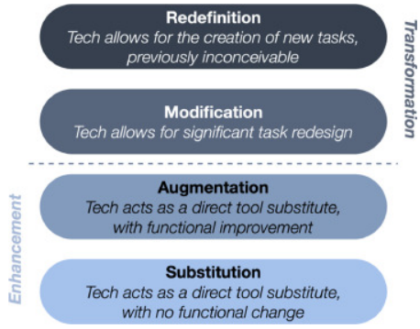
Figure 1: The SAMR Model
The substitution, augmentation, modification, and redefinition (SAMR) model seems appropriate for this study. It explains the various stages and evolution of technology use in teaching and learning. The first stage is where technology is used for students to access learning material; that is simply substituting traditional teaching roles such as giving texts, workbooks, and exercises – hard copy transformed to soft copy; such as a textbook in pdf form. Another example is writing a test in a word processor instead of using ballpoint and paper or learners do a long multiplication sum using a computer calculator app such as Symbolab in lieu of paper. The next stage is the augmentation level when technology is used for functional improvements, such as online direct learner feedback to STEM tasks, which improves participation. This is an improvement to the traditional situation where students would do the written work in exercise books then submit to the teacher and wait for the teachers to mark and assess the work and return it later. Another example of substitution is a teacher audio recording their mathematics lesson and sharing it on WhatsApp with students. The ICT augmentation stage is very personal and gives rapid feedback. The teacher’s main efforts are setting the work for learners to do as well as monitoring the feedback. An example in STEM education of augmentation is when students use a simulation to observe basic circuits with adjustable voltage inputs. As learners get rapid feedback when they vary inputs, they get to observe patterns more easily. The personal feedback on when they are right or wrong can motivate them to strengthen productive thinking and also reconsider their misconceptions. This can be referred to as Computer-Assisted Instruction (CAI) (Panjay, 2023). CAI refers to teaching or remediation done via a computer app; it is often interactive and produces immediate feedback. CAI supports personalised learning and enhances student participation and acquisition of expertise. The first two stages of the SAMR model, substitution and augmentation, can be viewed as an enhancement of traditional face-to-face teaching. At these stages, learners become more comfortable using digital tools but the old ways of teaching and learning only change in mode not in function.
The next two stages are functionally different.
In the modification stage, technology allows for significant task redesign. Here, common tasks are not only accomplished via technology, but there is more participation from students among themselves as they share knowledge and problem-solving approaches. Students can participate and interact across time and space, and multimedia can be used. In these situations, teachers and students from different schools can work together to solve STEM problems. The use of Zoom or Microsoft Teams Apps enhances that. Clearly, this was not possible for geographically spread students and teachers to collaborate in learning in real-time. This is a change of game. The highest stage is the redefinition stage, where previously inconceivable tasks, as well as teaching and learning, are now made available by technology. The emergence of artificial intelligence (AI) sits at the redefinition level. It will revolutionise and escalate pedagogical integration in ways unimagined ways. An example is learners sharing problems and solutions at a global stage. I do not doubt in my mind that AI will enable knowledge to be accessible to everyone in the world. That way, untapped talent from many undeveloped parts of the world will be shared globally, leading to exponential growth of STEM knowledge. Thus, the SAMR model shows the escalation of using technology in teaching and learning. It explains the transformation of use of technology in education from rituals and routine learning to learning to explorations (Sfard, 2016) which lie at the heart of educational transformation and learning. The last two stages represent transformative teaching and learning-a departure from the traditional teaching and learning methods that we have been using for many years.
Research questions
- How has ICT integration evolved in transdisciplinary STEM education between 2010 and 2024?
- In what ways can the SAMR model be applied to evaluate or guide technology-enhanced teaching and learning in transdisciplinary STEM education?
- What trends, challenges, and innovations characterize the transition from enhancement to transformation stages of using ICTs in transdisciplinary STEM education?
Significance of the Study
Research into ICT pedagogies within STEM education holds considerable significance. Firstly, ICT facilitates innovative teaching methodologies that enhance students’ conceptual understanding and engagement in STEM subjects. Technologies such as virtual reality, simulation labs, and computer-based experiments offer interactive and experiential learning opportunities, making abstract concepts more tangible and accessible (Stracke, Spatafora, Cotovanu, & Spatafora, 2019).
Secondly, ICT empowers collaborative learning among educators and students, both within and beyond the physical classroom. Digital platforms, including video conferencing tools like Zoom and Microsoft Teams, enable dynamic exchanges of ideas, fostering collective problem-solving and peer-supported inquiry.
Literature Review on STEM Education Research Using the SAMR Model
From around 2010, STEM education, focussing on science, technology, engineering, and mathematics pedagogy, has gained significant impetus due to its central role in preparing learners for the demands of a rapidly evolving world. The continuous advancement of digital technologies, now represented by the marvel of AI, calls for effective technology integration into educational processes.
Dzulkarnain, Aziz, and Khuluqo (2021) investigated student engagement in a university-level STEM course through the implementation of a digital video project. Using the SAMR model as a lens, their study assessed how varying levels of ICT integration influenced teaching and learning practices. The research involved two groups: a treatment group engaged in the digital video project and a control group taught via traditional lecture methods. Findings indicated that the treatment group demonstrated significantly higher levels of engagement and ICT integration, suggesting that technology-enhanced pedagogies can positively impact learner outcomes.
In a separate study, Dey (2017) examined the use of the SAMR model in flipped STEM classrooms, focusing on how technology integration influences student motivation, engagement, and learning in blended environments. The study contributed to a deeper understanding of how the SAMR framework can be applied to evaluate ICT-mediated learning experiences and pedagogical shifts.
Romrell, Kidder, and Wood (2014) explored the role of mobile devices in transforming classroom learning. As mobile technologies become increasingly embedded in students’ lives, their potential to support personalized, situated, and connected learning—referred to as mobile learning (mLearning)—has grown. The authors applied the SAMR model to categorize mLearning activities and assess their pedagogical impact. Their work highlighted both the opportunities and challenges of implementing mobile technologies in education, emphasizing the need for structured frameworks to guide effective integration.
Adulyasas (2021) conducted a study involving 60 students to examine the effects of ICT integration within a learning community and lesson study approach in mathematics education. The research employed both the SAMR and TPACK (Technological Pedagogical Content Knowledge) models to guide and evaluate the integration of technology, pedagogy, and content knowledge. The SAMR framework was instrumental in mapping the levels of technological integration across instructional practices, offering insights into how digital tools can enhance learner outcomes when strategically applied.
All the studies above, while having different foci and samples, demonstrate the effectiveness of the SAMR model in understanding how ICT-mediated educational processes can be better understood. Thus, the SAMR model shows potential in investigations of interdisciplinary STEM education research from 2010-2024. Thus, among the frameworks developed to guide ICT integration, the SAMR (Substitution, Augmentation, Modification, Redefinition) model (Puentedura, 2012) stands out for its clarity and applicability in evaluating the depth of ICT use in teaching and learning, such as in Transdisciplinary STEM Education.
Methodology
This systematic review explores STEM education research and uses the SAMR model as lens to the study. A qualitative research design (Yin, 2009) search was conducted on the Scopus academic databases to identify relevant research articles on ICT integration in STEM education.
In this systematic review examining transitions in ICT-integrated teaching and learning within transdisciplinary STEM education (2010–2024), the Preferred Reporting Items for Systematic Reviews and Meta-Analyses (PRISMA) guidelines (Moher, Liberati, Tetzlaff & Altman, 2009) were employed to ensure methodological transparency, consistency, and replicability. Prisma provides a structured approach for reporting systematic reviews and meta-analyses, including a 27-item checklist and a flow diagram that traces the identification, screening, eligibility, and inclusion of studies. By applying PRISMA, this review systematically documents the search strategy, inclusion/exclusion criteria, and synthesis process, particularly in relation to the SAMR model’s application across STEM contexts. This approach enhances the credibility of the findings and supports evidence-based insights into how digital technologies have transitioned from enhancement to transformation stages in educational practice.
Using the Scopus database, the search used the following strings;
("ICT integration" OR "technology-enhanced learning" OR "digital pedagogy" OR "educational technology");
("STEM education" OR "transdisciplinary learning" OR "interdisciplinary STEM" OR "cross-disciplinary education");
("SAMR model" OR "Substitution Augmentation Modification Redefinition" OR "technology integration framework").
The combined search string was;
TITLE-ABS-KEY("ICT integration" OR "educational technology") AND
TITLE-ABS-KEY("STEM education" OR "transdisciplinary learning") AND
TITLE-ABS-KEY("SAMR model") AND
PUBYEAR > 2010 AND PUBYEAR < 2024

In systematic research, using the PRISMA approach promotes transparency and replicability of the research. The research is replicable, which enhances its credibility.
In this study on ICT-integrated STEM education, PRISMA offered a rigorous scaffold that documents search strategy, inclusion criteria, and synthesis when evaluating transitions across SAMR stages.
Data Analysis
This study employed a structured literature analysis to examine ICT integration in transdisciplinary STEM education, focusing on teaching, learning, and assessment practices. Data were extracted from the Scopus database, which offers comprehensive coverage of peer-reviewed publications across global research domains. Selected articles were systematically reviewed and categorised according to pedagogical dimensions aligned with the SAMR framework.
Tables 1 to 3 present a synthesis of the reviewed literature, organized into three thematic categories: teacher actions, student actions, and assessment actions in transdisciplinary STEM education research. This classification enables an embedded understanding of how ICT tools are operationalized across instructional roles and learning processes. The analysis followed by a qualitative content mapping approach, identifying patterns of technology use and pedagogical transformation within each SAMR level, as recommended in bibliometric and thematic reviews of STEM education research (Chehlarova et al., 2023).
Analysis of teacher actions in transdisciplinary STEM education research
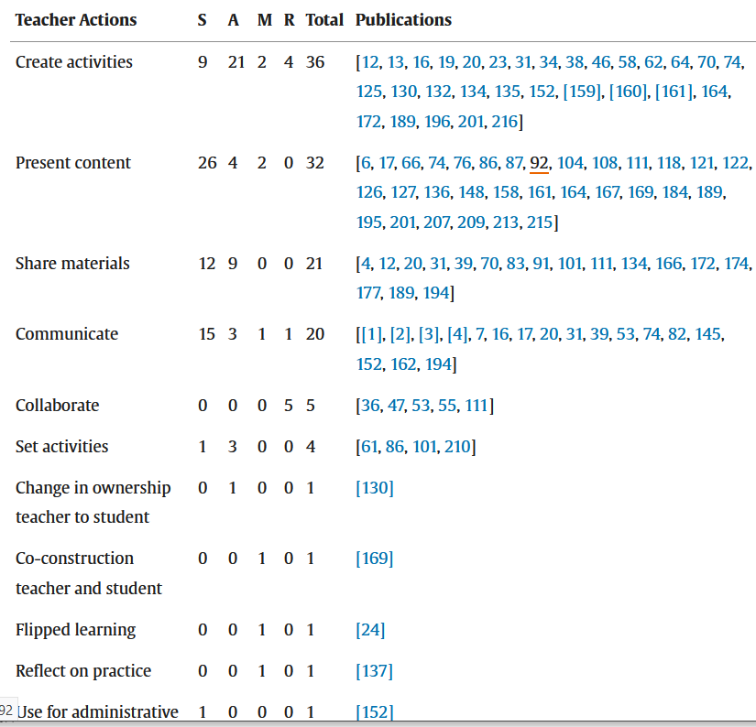
Table 1: Teacher actions in transdisciplinary STEM education

On selected teacher actions Table 1 is given below under Enhancement and Transformation
 | Enhancement | Transformation
Create Activities | 30 | 6
Present Content | 30 | 2
Share Materials and Communicate | 39 | 2
Collaborate | 0 | 5
Total | 99 | 15

Table 2: Selected teacher actions in ICT integration in transdisciplinary STEM education
The above data is visually represented in Figure 2.

Figure 2: Comparison between enhancing (S, A) and transformative (M, R) ICT teacher activities in STEM classes
The above data is visually represented in Table 2.

Table 2: Teacher Action: Create Activities with ICT- SAMR levels
The data show that teacher actions remain largely replicative, with a pronounced reliance on traditional instructional approaches. Most activities observed align predominantly with the Substitution level of the SAMR model, indicating minimal pedagogical transformation. While instances of Modification are present, they are relatively limited. Notably, there is a complete absence of practices corresponding to the Redefinition stage, suggesting that transformative use of ICT to create previously inconceivable learning experiences has yet to be realized in teacher-led initiatives.

Analysis of student actions in ICT use in transdisciplinary STEM education research

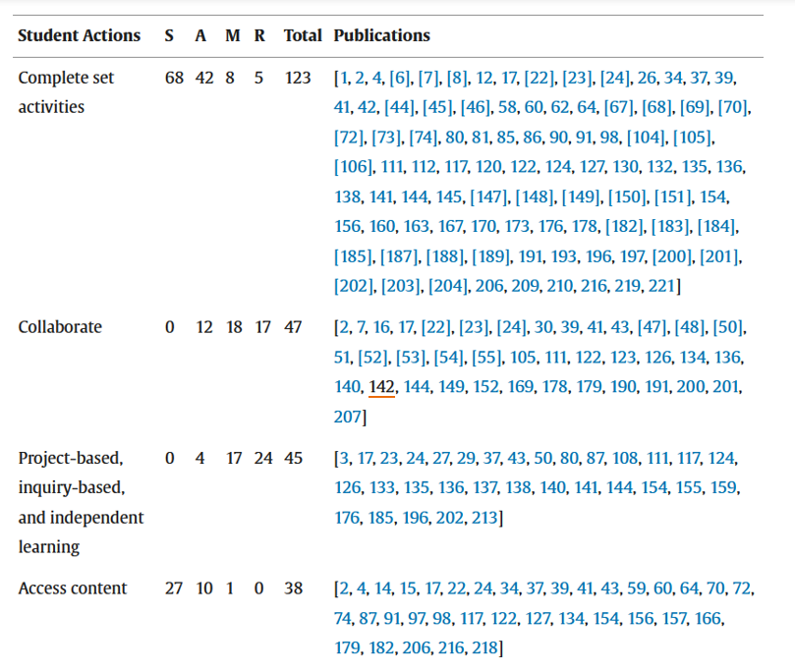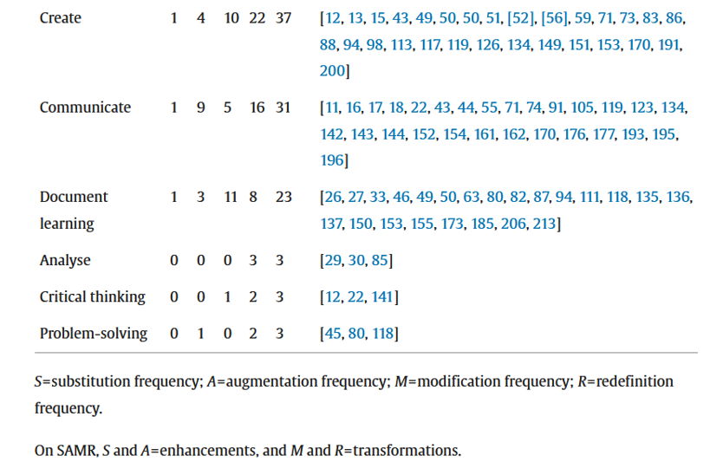
Table 3: Student actions in ICT integration in transdisciplinary STEM education

On selected student actions Table 4 is shown below under substitution and reformulation.

 | Substitution | Reformulation
Complete Set of Activities | 108 | 13
Access Content | 37 | 1
Collaborate | 0 | 5

Table 4: Frequency of Substitution (lowest level) and reformulation (highest level) on selected student actions.
The above data is visually represented in Figure 3.

Table 3: Student actions in ICT use in transdisciplinary STEM education

Figure 3: Comparison between enhancing (S, A) and transformative (M,R) ICT student activities in STEM classes

Analysis of assessment actions in ICT use in transdisciplinary STEM education research

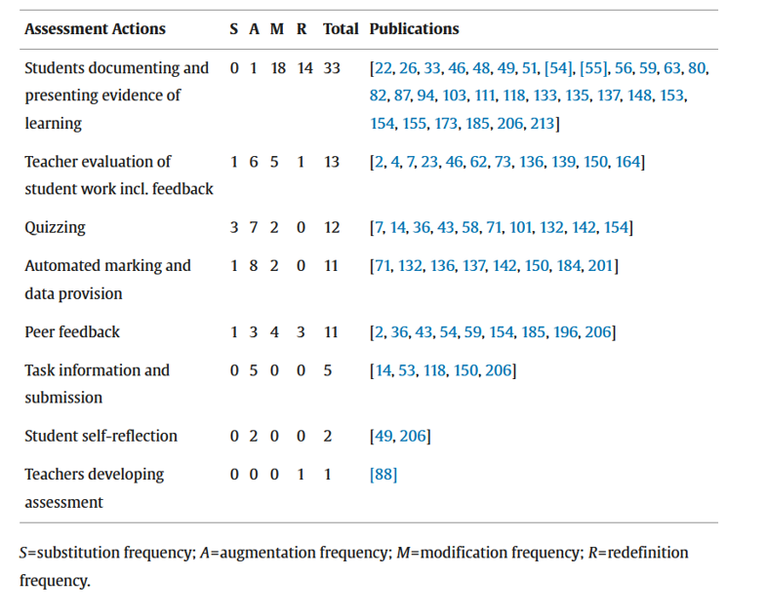

Table 6: Assessment actions in ICT use in transdisciplinary STEM education

The figure below shows the strong trend in transformation to more digital forms of assessment in transdisciplinary STEM education.

Table 5: Assessment; Project based-Inquiry based-Independent learning

The above Table 5 shows that in assessments, students moved away from the lower levels of SAMR to self-regulated learning when project work assessments were more frequent.

\

Figure 4: Comparison between enhancing (S,A) and transformative (M,R) ICT assessments, student documentation, and evidence of learning in STEM.
Discussion
As Vygotsky (1978) posited, learning is mediated by signs and tools in both inter-psychological and intra-psychological contexts. In the era of the Fourth Industrial Revolution, teaching and learning increasingly occur through digital artefacts represented by ubiquitous ICT tools now integral to everyday life, highlighted in social communication. Educational practitioners and researchers recognise that in terms of educational pedagogy, yesterday belongs to yesterday. The transformative potential of ICT technologies in shifting pedagogical practices across STEM disciplines (Romrell, Kidder, & Wood, 2014; Dzulkarnain, Aziz, & Khuluqo, 2021) is here and now. Rapid learning for teachers and other practitioners is crucial as technology itself is growing in leaps and bounds, and the education systems are trailing behind.
As folklore wisdom teaches, a child begins to crawl before they can walk and run. Similarly, the integration of ICTs into STEM education often begins at an assimilative stage, where educators replicate traditional teaching and methods using digital platforms without fundamentally altering pedagogical design. This phenomenon reflects a reliance on routine rather than exploration, as Sfard (2016) explains. The SAMR model (Puentedura, 2012) provides a framework on how start crawl, then walk and running. It delineates the four progressive levels of technology integration: Substitution, Augmentation, Modification, and Redefinition.
Findings from this study reveal varied patterns of ICT integration across teacher, student, and assessment actions in transdisciplinary STEM education. From the data, teacher practices predominantly align with the Substitution and Augmentation levels, indicating a continued dependence on conventional instructional approaches. This suggests that the transdisciplinary STEM education is still in the transitional phase, absorbing digital tools while remaining anchored to legacy pedagogies. This researcher argues that this is barely adequate and there is a need to employ ICT technologies in STEM education at a deeper level; it's like using a sledgehammer to kill a fly. The teachers are only scratching on the surface the educational potential of ICTs in transdisciplinary STEM education.
Data shows that student actions span all levels of the SAMR model, though they are more concentrated at the lower end, the enhancement stage. Activities such as completing digital worksheets or accessing online resources reflect Substitution and Augmentation, while collaborative projects and inquiry-based learning—though less frequent—demonstrate instances of Modification and Redefinition. This distribution suggests that learners are beginning to engage with ICTs in more transformative ways, albeit inconsistently.
Assessment actions, by contrast, show greater alignment with the higher levels of the SAMR model. Practices such as digital documentation of learning, peer feedback, and multimedia presentations reflect Modification and Redefinition, indicating that assessment is emerging as a domain where ICT integration is more advanced and more transformative. This may be attributed to students’ greater familiarity with digital tools, enabling them to respond to assessment tasks in innovative ways that transcend traditional formats.
The transformative use of ICTs in transdisciplinary STEM education has been shown to increase student engagement, particularly when technologies are employed at the Modification and Redefinition levels. These levels foster interaction not only with content but also among learners, promoting collaboration, creativity, and intrinsic motivation (Dey, 2017). Moreover, ICT integration supports the development of critical thinking and problem-solving skills by enabling learners to access diverse resources, engage in self-directed inquiry, and participate in continuous learning beyond the classroom.
Studies involving video-based projects further affirm the positive relationship between multimedia engagement and STEM learning outcomes. Dzulkarnain et al. (2021) demonstrated that students involved in digital video projects exhibited higher levels of engagement and achievement, reinforcing the pedagogical value of ICT-enhanced learning experiences.

Conclusion
I conclude by referring to the research questions of the study: How has ICT integration evolved in transdisciplinary STEM education between 2010 and 2024?, In what ways can the SAMR model be applied to evaluate or guide technology-enhanced teaching and learning in transdisciplinary STEM education? What trends, challenges, and innovations characterize the transition from enhancement to transformation stages of using ICTs in transdisciplinary STEM education?
This study examined the levels and depths of ICT integration in transdisciplinary STEM education by analysing selected research articles published between 2010 and 2023 via the proposed theoretical framework (Puentedura, 2012). The findings indicate that teacher actions are predominantly situated at the Substitution and Augmentation levels of the SAMR model, reflecting a replication of traditional pedagogies. Student actions span all SAMR levels, with limited but notable instances of Modification and Redefinition. Assessment practices, however, show stronger alignment with transformative stages, particularly in student-led documentation, project work, and peer evaluation. These trends show that teachers are struggling to shed old methodologies of teaching STEM subjects. They are still bound by yesterday's pedagogies. Old habits die hard; old success is a barrier to development. The SAMR model proves to be quite instructive in guiding actions to transform transdisciplinary STEM education. if teachers are staff-developed and trained to use it in their lesson development, they can improve their practice.
The SAMR model proved instrumental in theorizing and categorizing ICT integration, offering a structured lens through which pedagogical transformation can be assessed. While the study relied on secondary data sourced from Scopus, the analytical framework and conceptualization were original contributions. As Yin (2008) notes, qualitative research excels in generating theory from in-depth analysis of limited data, and this study aligns with that methodological strength.

Recommendations
- Curriculum Revision for Transformative ICT Pedagogies
STEM curricula should be revised to promote pedagogical practices that align with the higher levels of the SAMR model—Modification and Redefinition. Given the capabilities of digital tools such as Photomath, which can solve mathematical problems with step-by-step explanations, traditional assessment formats risk obsolescence. New learning and assessment tasks must be designed to challenge learners beyond what technology can automate, ensuring that education remains forward-looking and relevant.
- Professional Development for SAMR-Aligned Instruction
Teacher education programs should incorporate the SAMR model into their training frameworks. Educators must be equipped not only with technical skills but also with pedagogical strategies that enable transformative ICT integration. Institutions can organize workshops led by scholars experienced in SAMR-based instruction to build capacity and foster innovation in STEM teaching.
Acknowledgements
The author acknowledges the assistance of artificial intelligence in the development of this manuscript, specifically in articulating aspects of the research design—most notably the elaboration of the PRISMA approach—and in providing language editing and proofreading to enhance the overall flow and clarity of the text. All other contributions, including the conceptualisation of the study and the substantive writing, are entirely the author’s own.
References
Adulyasas, L. (2021). The use of learning community incorporating with lesson study in teaching and learning mathematics through TPACK and SAMR model: The effects on students’ mathematics achievement. [Unpublished manuscript].
Aina, A. Y., & Ogegbo, A. A. (2022). Investigating TVET college educators’ experiences while transitioning from the traditional classroom to the virtual classroom during the COVID-19 pandemic. Perspectives in Education, 40(1), 129–142. https://journals.ufs.ac.za/index.php/pie/article/download/5301/4361/14794
Bishop, A. J. (1988). Mathematical enculturation: A cultural perspective on mathematics education. Dordrecht: Kluwer Academic Publishers.
Blundell, C. N., Mukherjee, M., & Nykvist, S. (2022). A scoping review of the application of the SAMR model in research. Computers and Education Open, 3, 100093. https://doi.org/10.1016/j.caeo.2022.100093
Bray, A., & Tangney, B. (2017). Technology usage in mathematics education research: A systematic review of recent trends. Computers & Education, 114, 255–273. https://doi.org/10.1016/j.compedu.2017.07.004
Breiner, J. M., Harkness, S. S., Johnson, C. C., & Koehler, C. M. (2012). What is STEM? A discussion about conceptions of STEM education and partnerships. School Science and Mathematics, 112(1), 3–11. https://doi.org/10.1111/j.1949-8594.2011.00109.x
Chan, F. L., & Mohammad, F. S. (2019). ICT integration practices of STEM teachers in TVET. International Journal of Recent Technology and Engineering, 8(4), 11011–11015.
Chehlarova, N., Chehlarova, K., & Gecheva, N. (2025). Bibliometric analysis of Scopus publications related to STEM and STEAM research in the context of mathematics education. Futurity Education, 5(2), 67–89. https://doi.org/10.57125/FED.2025.06.25.04
Davis, N. (2016). What is the Fourth Industrial Revolution? World Economic Forum. https://alejandroarbelaez.com/wp-content/uploads/2020/10/What-is-the-fourth-industrial-revolution-WEF.pdf
Dey, T. (2017, June). Technology integration in STEM flipped classrooms using SAMR framework as a benchmarking tool. In EdMedia+ Innovate Learning (pp. 762–767). Association for the Advancement of Computing in Education (AACE).
Dzulkarnain, I., Aziz, N. A. A., & El Khuluqo, I. (2021, May). Student engagement in university STEM course through digital video project using SAMR model. In 1st Annual International Conference on Natural and Social Science Education (ICNSSE 2020) (pp. 49–57). Atlantis Press. https://doi.org/10.2991/assehr.k.210430.008
English, L. D. (2016). STEM education K–12: Perspectives on integration. International Journal of STEM Education, 3(3). https://doi.org/10.1186/s40594-016-0036-1
Lukychova, N. S., Osypova, N. V., & Yuzbasheva, G. S. (2022, March). ICT and current trends as a path to STEM education: Implementation and prospects. In CTE Workshop Proceedings (Vol. 9, pp. 39–55).
Makonye, J. P. (2022). Mathematics teacher educators’ use of virtual tools in lecture delivery. In J. P. Makonye & N. S. Ndlovu (Eds.), Innovations in online teaching and learning: Case studies of teacher educators from South Africa during the COVID-19 era (pp. 157–173). AOSIS Books. https://doi.org/10.4102/aosis.2022.BK376.09
Moher, D., Liberati, A., Tetzlaff, J., Altman, D. G., & The PRISMA Group. (2009). Preferred reporting items for systematic reviews and meta-analyses: The PRISMA statement. PLoS Medicine, 6(7), e1000097. https://doi.org/10.1371/journal.pmed.1000097
Moosa, S., Ncube, R., & Ramnarain, U. (2023). Translating policy to practice: The status of ICT in STEM education in South Africa. In Information and Communications Technology in STEM Education (pp. 1–13). Routledge.
NAE & NRC (National Academy of Engineering & National Research Council). (2014). STEM integration in K–12 education: Status, prospects, and an agenda for research. National Academies Press. https://doi.org/10.17226/18612
Nguyen, L. P., Hien, L. T. T., Linh, N. Q., Thao, T. T. P., & Giang, N. T. (2023). Implementation of STEM education: A bibliometric analysis from case study research in Scopus database. EURASIA Journal of Mathematics, Science and Technology Education, 19(6), em2278. https://doi.org/10.29333/ejmste/13216
Panja, M., & Kumar, U. (2023). Computer-aided or computer-assisted instruction. In Encyclopedia of Mathematical Geosciences (pp. 165–169). Springer.
Pérez Echeverría, M. del P., Cabellos, B., & Pozo, J.-I. (2025). The use of ICT in classrooms: The effect of the pandemic. Education and Information Technologies, 30, 14069–14093.
Puentedura, R. R. (2012). Technology in education: The first 200,000 years. The NMC Perspective Series: Ideas that Matter, NMC Summer Conference.
Puentedura, R. R. (2014). SAMR and TPCK: Intro to advanced practice. Retrieved from https://educationaltechnology.net/samr-model-substitution-augmentation-modification-and-redefinition
Romrell, D., Kidder, L., & Wood, E. (2014). The SAMR model as a framework for evaluating mLearning. Online Learning Journal, 18(2). https://olj.onlinelearningconsortium.org/index.php/olj/article/view/435
Scott, L. (2023). COVID-19, education and access to digital technologies: A case study of a secondary school in Gauteng. South African Journal of Education, 43(Suppl.2). https://scielo.org.za/scielo.php?script=sci_arttext&pid=S0256-01002023000600004
Sfard, A. (2016). Ritual for ritual, exploration for exploration: Or, what learners are offered is what you get from them in return. In A. Edwards (Ed.), Research for educational change (pp. 41–63). Routledge.
Stracke, C. M., Spatafora, M., Cotovanu, A. M., & Spatafora, A. (2019). A holistic pedagogical model for STEM education in schools: Its design and evaluation through mixed methods research with surveys and interviews. In C. M. Stracke (Ed.), Proceedings of Learning Innovations and Quality (LINQ) 2019 (pp. 40–48). Open Universiteit. https://research.ou.nl/ws/portalfiles/portal/12345479/Stracke_et_al_2019_A_Holistic_Pedagogical_Model_for_STEM_education_in_schools_LINQ.pdf
Tytler, R., Mulligan, J., Prain, V., White, P., Xu, L., Kirk, M., Nielsen, C., & Speldewinde, C. (2021). An interdisciplinary approach to primary school mathematics and science learning. International Journal of Science Education, 43(12), 1926–1949. https://doi.org/10.1080/09500693.2021.1946727
Vygotsky, L. S. (1978). Mind in society: The development of higher psychological processes. Harvard University Press.
Ximba, C. S. (2022). Educators’ perceptions of digital learning during the COVID-19 pandemic at a quintile-three primary school in Gauteng (Master’s thesis, University of Johannesburg). https://ujcontent.uj.ac.za/esploro/outputs/graduate/Educators-perceptions-of-digital-learning-during/9923410107691
Yin, R. K. (2009). Case study research: Design and methods (4th ed.). Sage.

