Federated and Explainable Deep Learning Framework for Social Media Abuse Detection.
By
Muhammad Israr ul haq
(CS320242006)

Supervisor-I Dr. Amjad Mehmood Institute of Computing, KUST, Kohat
Signature: _______________
Supervisor-II Dr. Muhammad Muneer Umar Institute of Computing, KUST, Kohat
Signature: _______________
Director Prof. Dr. Amjad Mehmood Institute of Computing, KUST, Kohat
Signature: ________________


Institute of Computing
Kohat University of Science and Technology, Kohat-26000
Khyber Pakhtunkhwa, Pakistan

Federated and Explainable Deep Learning Framework for Social Media Abuse Detection.

Introduction

Examples of social media platforms that have taken center stage as the primary means of communication, information sharing, and community engagement are Facebook and Twitter. However, these platforms can also be used for harmful purposes, such as hate speech and cyberbullying, which can seriously harm both individuals and society. Current thorough evaluations of algorithms for detecting hate speech and cyberbullying highlight persistent problems like changing language usage, covert abuse, and platform domain transitions [1]. These findings demonstrate the need for robust, adaptable, and privacy-compliant solutions that address the complexity of abusive content and the range of online communication.
Deep learning architectures that can replicate complex contextual relationships have replaced traditional machine learning pipelines for early detection. Comparative studies have shown that transformer-based transfer learning methods have performed better than machine learning in cyberbullying detection tasks [2]. Hybrid deep learning architectures like DEA-RNN have further improved detection capabilities on platform-specific datasets like Twitter [3], but generalization to other platforms is still limited.
Cross-platform detection frameworks are essential for managing the variety of social media settings. Platform-aware adversarial encoding research has shown that integrating platform-specific features into model training can significantly improve cross-platform performance [4]. The use of cross-lingual and cross-cultural natural language processing techniques to mimic linguistic and cultural diversity has given abusive language identification even more versatility [5]. Adding network-level and user-based features to detection pipelines, like graph-based representations of interaction patterns, has been shown to enhance the detection of active hate speech disseminators and coordinated abuse [6]. This transcends linguistic characteristics.

Privacy concerns are a major barrier to the deployment of scalable moderating systems. Centralized training necessitates the aggregation of sensitive user data, which undermines compliance and trust. Federated learning is a good alternative that enables distributed training without sharing raw data. Frameworks such as Fed Bully [7] and other federated techniques that integrate word embeddings with emotional attributes [8] have achieved competitive detection accuracy while preserving anonymity. Despite these advancements, most federated learning systems in this area have not adequately addressed decision-making transparency.
Deep learning moderation systems are not appropriate for use in high-stakes scenarios because they cannot be explained. Real-time detection pipelines, such as LSTM-based sentiment classification models for streaming tweets, often operate as opaque systems even though they provide operational responsiveness [9]. Explainable AI techniques could be integrated into cyberbullying detection frameworks to bridge this gap. Peer-reviewed research in this area is increasing, but little is known about the interplay between explainability, cross-platform resilience, and federated learning.
To bridge these gaps, this paper proposes a federated and explainable deep learning framework for multi-platform cyberbullying detection. The proposed system combines explainability modules, platform adaption mechanisms, and transformer-based architectures to provide accurate, privacy-compliant, and comprehensible moderation judgments. This integrated approach addresses a range of online abuses, including hate speech, harassment, and discriminatory language, while guaranteeing scalability and accountability in real-world deployment.
Problem Statement

Current studies on cyberbullying detection are limited in scope, often targeting a single form of abuse such as hate speech or harassment, which restricts their ability to address the diverse and evolving nature of online harm. Their effectiveness further declines when applied across platforms, where linguistic patterns, user behaviors, and interaction structures differ significantly. While cross-platform methods have emerged, they frequently overlook the interplay between user content and relational features that signal coordinated abuse. At the same time, centralized training architectures raise serious privacy risks by requiring sensitive user data to be aggregated, exposing systems to misuse and regulatory challenges. Although federated learning offers a privacy-preserving alternative, most implementations emphasize accuracy at the expense of transparency. This lack of explainability reduces accountability in automated moderation and undermines user trust. Therefore, there remains a need for a unified framework that can detect multiple forms of cyberbullying, generalize across platforms, safeguard user privacy, and provide interpretable outcomes.

Research Objectives
- To develop a unified framework for detecting all major forms of cyberbullying.
- To design a cross-platform model adaptable to Twitter and Facebook.
- To preserve user privacy through federated and secure learning methods.
- To integrate explainable AI for transparent and trustworthy detection.

Proposed Methodology
The proposed research develops a unified framework that integrates linguistic, relational, and platform-specific features to detect multiple forms of cyberbullying in a privacy-preserving and explainable manner. Input data from social platforms such as Twitter and Facebook are collected and preprocessed to remove noise, normalize text, and handle emojis, hashtags, and user mentions. From this processed input, two complementary feature sets are extracted. The first set consists of linguistic features, derived using contextual embeddings that capture abusive expressions, semantic nuances, and evolving vocabulary trends. The second set includes relational features, modeled through graph-based encodings of interactions such as replies, mentions, and user connectivity. Together, these features provide a more comprehensive representation of abusive behavior compared to text-only systems, which often miss coordinated or context-dependent attacks [1], [3], [4].
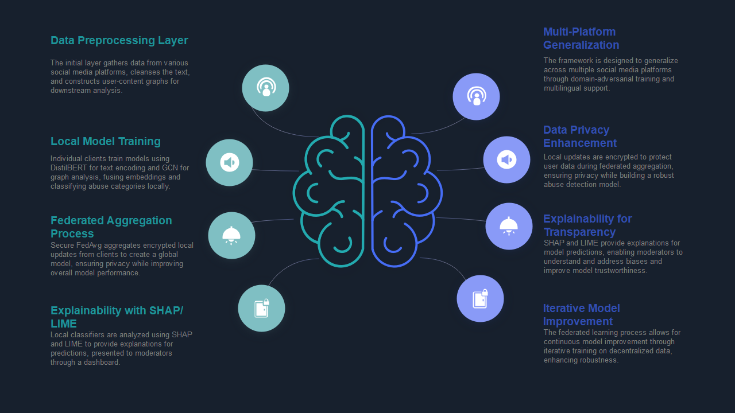

Figure X: Explainable AI and federated learning are combined to create a conceptual framework for identifying social media abuse. The pipeline demonstrates data preparation, secure aggregation, local model training, and cross-platform generalization while maintaining explainability and privacy.
Once features are extracted, they are fused through a hybrid deep learning layer that balances textual and relational signals. Training occurs locally at the client level under a federated learning setup, ensuring that raw user data remains on the originating device or platform. Instead of transmitting sensitive content, only encrypted model updates are shared with the central server, which aggregates them to maintain a global model. This design safeguards user privacy and mitigates regulatory concerns, while still enabling collaborative learning across diverse platforms [2], [5], [7].
A key contribution of the framework lies in its capacity for cross-platform generalization. Existing studies typically demonstrate strong performance on a single platform but degrade sharply when applied elsewhere due to shifts in language use, interaction patterns, and content structure [1], [6]. By adopting domain-adversarial training and aligning embeddings across platforms, the proposed model adapts to heterogeneous environments without requiring extensive platform-specific tuning. This ensures that cyberbullying detection remains robust across Twitter, Facebook, and potentially other platforms.
Equally important is the framework’s focus on explainability. While many high-performing models act as black boxes, explainable AI methods are integrated here to ensure transparent and interpretable results. Post-hoc interpretation tools such as SHAP and attention visualizations are applied to highlight key textual cues and relational features that influence classification decisions. This not only increases accountability in automated moderation but also strengthens user trust in the system, addressing a gap often overlooked in federated implementations [8], [9].
Finally, the framework is designed to address two major real-world challenges. The cold-start problem, where abusive behavior appears without historical context, is mitigated using transfer learning from large-scale pre-trained language models, supported by uncertainty calibration that flags low-confidence predictions for human review. In cases of restricted or locked profiles, where historical interaction data is inaccessible, the system leverages global knowledge captured in the federated model and falls back on content-only detection strategies. These provisions ensure resilience in varied deployment contexts [6], [10].

Time Frame
S. No | Research Components | Proposed Time
1 | Model Design | 02 months
2 | Implementation | 04 months
3 | Model Evaluation | 03 months
4 | Thesis Writing | 03 months

References
[1] A. Alshalan, A. Al-Khalifa, and H. Al-Muhtadi, “Twitter hate speech detection: A systematic review of methods, taxonomy analysis, challenges, and opportunities,” IEEE Access, vol. 11, pp. 12837–12861, 2023, doi: 10.1109/ACCESS.2023.3239375.
[2] A. Khurana, S. Sharma, and R. Saini, “Cyberbullying detection in social networks: A comparison between machine learning and transfer learning approaches,” IEEE Access, vol. 11, pp. 46944–46957, 2023, doi: 10.1109/ACCESS.2023.3275130.
[3] Z. Li, Y. Chen, and H. Wang, “Detecting disseminators of hate speech by optimizing textual and user-based features,” IEEE Trans. Comput. Social Syst., vol. 11, no. 1, pp. 120–131, Jan. 2024, doi: 10.1109/TCSS.2024.3452508.
[4] T. Ahmad, M. N. S. A. Rahman, and S. N. H. S. Abdullah, “DEA-RNN: A hybrid deep learning approach for cyberbullying detection in Twitter social media platform,” IEEE Access, vol. 10, pp. 22245–22257, 2022, doi: 10.1109/ACCESS.2022.3153675.
[5] P. Yi and A. Zubiaga, “Cyberbullying detection across social media platforms via platform-aware adversarial encoding,” in Proc. Int. AAAI Conf. Web Social Media, vol. 16, no. 1, pp. 1430–1434, 2022.
[6] S. Sharma, R. Singh, and P. Kumar, “A cross-cultural/lingual natural language processing analysis of disability awareness on social media,” IEEE Access, vol. 13, pp. 72845–72857, 2025, doi: 10.1109/ACCESS.2025.3580608.
[7] N. P. Shetty, B. Muniyal, A. Priyanshu, and V. R. Das, “FedBully: A cross-device federated approach for privacy-enabled cyberbullying detection using sentence encoders,” J. Cyber Security Mobility, vol. 12, no. 4, pp. 465–496, Jun. 2023.
[8] N. Abdel Samee, U. Khan, S. Khan, M. M. Jamjoom, M. Sharif, and D. H. Kim, “Safeguarding online spaces: A powerful fusion of federated learning, word embeddings, and emotional features for cyberbullying detection,” IEEE Access, vol. 11, pp. 124524–124539, 2023, doi: 10.1109/ACCESS.2023.3329347.
[9] M. Alshalan, H. Al-Khalifa, and A. Al-Muhtadi, “Hateful sentiment detection in real-time tweets: An LSTM-based comparative approach,” IEEE Trans. Comput. Social Syst., vol. 11, no. 2, pp. 345–356, Mar. 2024.
[10] V. Pawar, D. V. Jose, and A. Patil, “Explainable AI method for cyberbullying detection,” in Proc. IEEE Int. Conf. Mobile Networks and Wireless Communications, 2022, pp. 1–4.

