EED330 Lab 1 Velocio Ace vBuilder Software Installation

Objectives:
- To install PLC software for an Ace Velocio device
- To learn basic features of the PLC software
Part/ Equipment Needed:
- A Windows computer (A windows laptop preferred)
Intro: vBuilder is a programming language designed for Velocio’s Ace PLC products. It is a visual programming language that allows users to program Ace PLCs using either Ladder Logic or Flow Charts. Please install the software by following the instructions provided below. This is a group assignment, so please work collaboratively with your group members.

Module 1: Go to https://velocio.net/vBuilder/ and click to download vBuilder program, and install it on your computer.

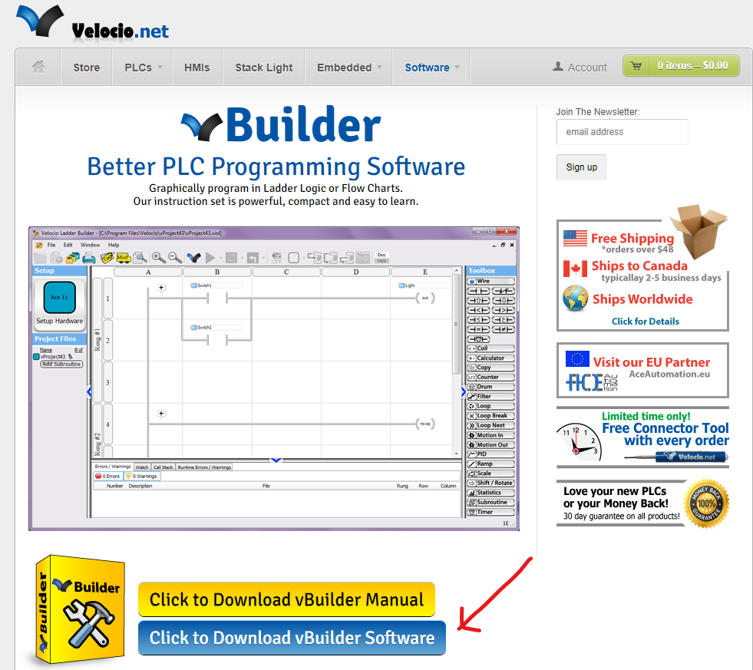

Module 2: Run vBuilder and check if it runs as shown below (the first page of the program
might be different as they upgraded meanwhile).

(Example)
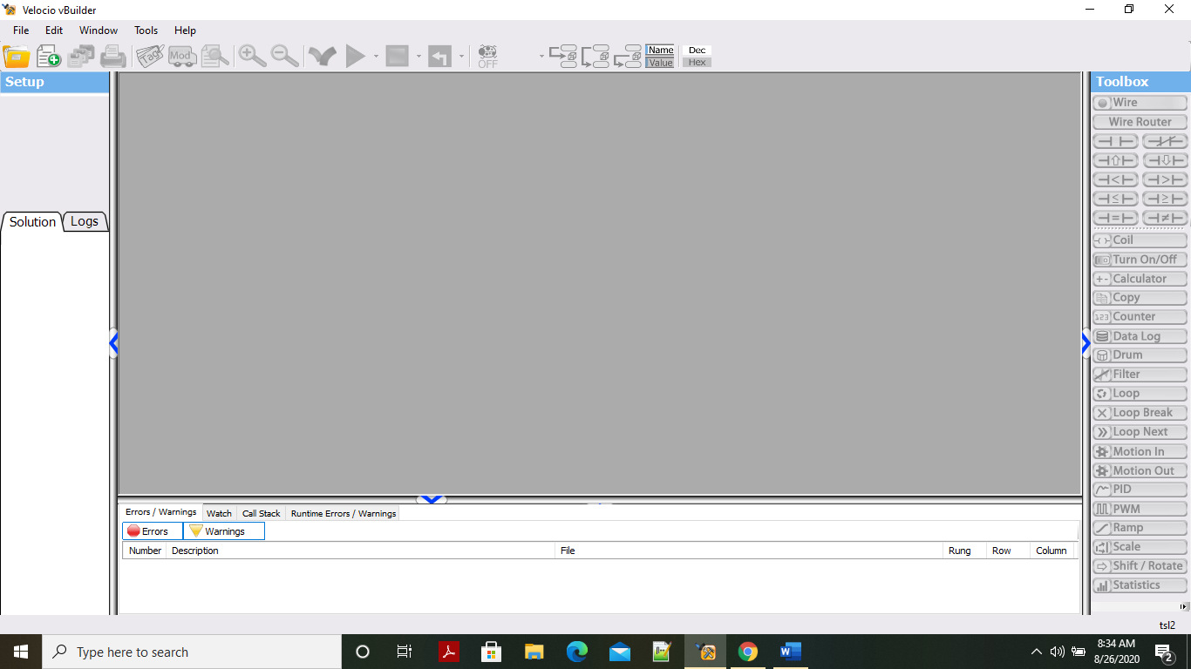

Module 3: Please take a screenshot of your vBuilder program, similar to the example provided in Module 2. Insert your screenshot directly below this text.

(Include your screenshot here)

Module 4: Explore the menus as described below. At the top of the screen, you’ll find menu items such as File, Edit, Window, Tools, and Help. These options allow you to start a new lab setup or make changes to your current lab configuration.

On the left side of the screen, you can set up your lab using the Start, Solution Log, and Logs options. These tools help you keep track of the components and changes in your lab.

On the right side of the screen, you’ll find the Toolbox. The Toolbox contains various tools, including Wire, Wire Router, Coil, Turn On/Off, Calculator, Copy, Counter, Data Log, Drum, Filter, Loop, Loop Break, Loop Next, Motion In, Motion Out, PID, PWM, Ramp, and Scale. These tools assist in configuring and analyzing your lab setup.

At the bottom of the screen, additional menu options are available, including Errors/Warnings, Watch, Call Stack, and Runtime Errors/Warnings. These options are useful for identifying and troubleshooting potential issues during your lab sessions.

Module 5: Please submit your lab report (this document) to the assignment folder on Web Campus. One submission per group is sufficient.

Module 6: Write any questions, suggestions, comments, or concerns that you/your group may have regarding this lab. (Optional)

