INTRODUCTION
INTRODUCTION
Falls are a significant and growing public health concern, particularly among older adults, where they are a leading cause of disability, morbidity, and mortality. The World Health Organization (WHO) defines a fall as an event that results in a person inadvertently coming to rest on the ground or a lower surface ^{1,2}. Age-related physiological decline, combined with chronic conditions and medication use, increases susceptibility to falls in this population. According to the U.S. Centre’s for Disease Control and Prevention (CDC), approximately 14 million adults aged ≥65 years nearly 28% of that population report falling annually, constituting to around 36 million falls^{1,3}. While not all falls result in injury, 37% lead to outcomes requiring immediate medical attention or restricting activity, translating to approximately 8 million fall-related injuries each year^{4,5}.Falls are also one of the predominant reasons of emergency visits and hospital admissions among geriatric population. Ageing is associated with multiple risk factors for falls, including sarcopenia, gait instability, reduced proprioception, and impaired reflexes. Additionally, age-related changes such as decreased muscle strength, reduced step length, and slower gait speed compound the risk. Superimposed acute triggers e.g., acute illness, postural hypotension, or environmental hazards can precipitate a fall in individuals with already compromised balance and mobility⁶. Globally, fall prevalence varies across countries: Among people aged ≥65, the percentage is 30% in the US, 13.7% in Japan, 26.4% in China, and up to 53% in India. Women are particularly vulnerable, with a higher fall incidence compared to men, potentially due to sex-specific differences in bone density, muscle mass, and postmenopausal changes^{6,7}.
Epidemiology of Falls Among the Elderly in India
India is going through a major demographic shift, with a growing percentage of older individuals and an ongoing rise in life expectancy. As the population ages, the country faces an increasing burden of age-related health challenges, with falls emerging as a critical public health concern among the elderly. Unlike high-income countries, India’s diverse socio-economic landscape, disparities in healthcare access, and environmental hazards compound the complexity of fall prevention efforts⁸. Epidemiological studies conducted across various regions of India reveal significant variation in the prevalence of falls among older adults, with reported rates ranging from 2.4% to 50% in community settings. This wide range reflects not only regional differences but also variations in study methodologies and socio-cultural factors. Falls contribute substantially to morbidity in this population, accounting for 20% to 30% of all injuries and approximately half of injury-related hospitalizations among the elderly⁹.
FALL RISK INCREASING DRUGS (FRIDs)
INTRODUCTION

FRIDs are medications associated with an elevated risk of falls, particularly in older adults¹⁰ FRIDs are known to elevate susceptibility to falls through various mechanisms, including drowsiness, cognitive impairment, low blood pressure, and delayed reflexes¹¹. FRIDs encompass a wide range of pharmacological agents, notably psychotropic drugs such as antidepressants, antipsychotics, benzodiazepines, and other sedative-hypnotics, which can negatively affect coordination and alertness¹. Other drug classes such as insulin, oral hypoglycemics agents, and corticosteroids have also been implicated in increasing fall risk due to their effects on blood sugar regulation, muscle strength, and bone health¹¹. Furthermore, a number of cardiovascular drugs, such as beta-blockers, calcium channel blockers, and diuretics, may affect cardiovascular stability, which would further disrupt the equilibrium. The effects of other pharmacological classes, including insulin, oral hypoglycemics, and corticosteroids, on blood sugar regulation, bone health, and muscle strength have also been associated to an increased risk of falls¹¹.Importantly, medication use plays a crucial role in modulating fall risk. Research indicates that individuals prescribed with more than four drugs falling under the category of fall, experience a 14% higher likelihood increase, regardless of the presence of other health conditions¹¹.
These drugs act through multiple mechanisms that predispose patients to falls, including orthostatic hypotension, dizziness, cognitive impairment, sedation, and gait disturbances. For instance, diuretics (e.g., furosemide, torsemide) may lead to volume depletion and hypotension; beta-blockers can cause bradycardia and fatigue; calcium channel blockers (e.g., amlodipine) often induce dizziness or peripheral edema and corticosteroids (e.g., methylprednisolone, budesonide) are linked with muscle weakness and bone demineralization¹². Polypharmacy and FRIDs exposure are both prevalent in the geriatric population, given the high burden of chronic illness. Therefore, understanding the association between FRIDs use and fall risk is essential for optimizing medication safety and reducing preventable injury in older adults¹³.
Multidimensional Risk Factors Contributing to Falls in the Elderly
Falls among the elderly are commonly the result of a combination of intrinsic and extrinsic risk factors that increase with advancing age. In addition, extrinsic factors, such as environmental hazards, unsafe footwear, poor lighting, and the use of certain medications, further elevate the risk of falls ¹⁴. The interaction of these internal and external factors contributes significantly to the high incidence of falls in older adults, highlighting the importance of a multifactorial approach to fall prevention. In addition to these changes, the presence of comorbidities further elevates the fall risk. Chronic conditions such as diabetes mellitus, cardiovascular diseases, arthritis, and neurodegenerative disorders like Parkinson’s disease and dementia contribute to impaired coordination, orthostatic hypotension, and cognitive deficits, all of which are often reported to contribute in the elevation of fall risk¹⁵. Polypharmacy, commonly observed in this age group, often exacerbates these risks through side effects such as dizziness, sedation, or altered sensorium.
INTRODUCTION

While falls in the elderly are undoubtedly multifactorial arising from a complex interplay of intrinsic factors along with extrinsic factors, FRIDs play a disproportionately significant role in precipitating falls¹⁴. Numerous studies have shown that the presence of FRIDs can independently elevate fall risk, even in the absence of other contributory factors. Their pharmacodynamic effects, including sedation, orthostatic hypotension, impaired cognition, and delayed reaction time, directly compromise balance and mobility. Therefore, despite the wide spectrum of fall contributors, FRIDs remain one of the most modifiable and clinically significant contributors to falls in older adults¹⁶.
Evaluation of PIMs and FRIDs Use in Older Adults
Despite growing clinical evidence linking FRIDs to falls, awareness among healthcare professionals remains suboptimal. This gap in knowledge contributes to the continued prescription of FRIDs in older patients. Consequently, there is a pressing need for targeted interventions, including clinical training, deprescribing protocols, and routine medication reviews, especially in populations at high risk¹⁷. A high proportion of elderly individuals use potentially inappropriate medications (PIMs), with prevalence ranging from 11.5% to 62.5%, and a pooled rate of 36.7% among geriatric outpatients over the past two decades. Factors such as advanced age, female sex, and polypharmacy contribute to this trend. These factors are significantly associated with the ongoing use of pharmacological agents that may be inappropriate due to age-related physiological decline, the presence of multiple comorbidities, and heightened susceptibility to adverse drug interactions⁸.
A substantial body of evidence indicates a critical knowledge deficit among healthcare professionals particularly pharmacists regarding FRIDs. In a cross-sectional survey evaluating awareness of FRIDs and orthostatic hypotension-inducing medications (ODs), approximately 90% of participating pharmacists demonstrated insufficient knowledge of drug classes associated with elevated fall risk. Moreover, only 40% of respondents were familiar with the concept of FRIDs and ODs, while formal training on these topics was reported by merely 9.3% of participants. Despite these gaps, the majority of respondents acknowledged the potential of patient counselling to mitigate fall risk and expressed support for structured educational initiatives. These findings underscore the need for targeted capacity-building programs including workshops, continuing education modules, and institutional protocols to enhance healthcare professionals’ competencies in identifying, managing, and deprescribing FRIDs in geriatric populations¹⁸.
INTRODUCTION

Pharmacokinetic and Pharmacodynamic Modifications in the Elderly: Implications for Fall Risk
With advancing age, intrinsic physiological changes significantly alter both the pharmacokinetics and pharmacodynamics of medications, thereby increasing the risk of ADRs, including falls. Age-related changes in liver physiology such as reduced hepatic mass, diminished blood flow, and decreased activity of cytochrome P450 (CYP) enzymes impair phase I metabolism¹⁹. As a result, the hepatic clearance of drugs undergoing oxidation, reduction, or hydrolysis may decline by 30–40%. The risk of toxicity is increased as a result of longer drug half-lives and higher systemic concentrations. In contrast, phase II metabolic pathways, including conjugation and glucuronidation, remain relatively intact, making medications primarily eliminated through these mechanisms preferable in older adults.
First-pass metabolism also declines with age, with a reported reduction of approximately 1% per year after age 40. This change results in increased bioavailability of orally administered drugs, further amplifying systemic exposure and pharmacological effects. Renal elimination is similarly affected by aging. A progressive decline in glomerular filtration rate (GFR) leads to reduced renal clearance of drugs excreted unchanged by the kidneys. Consequently, drug accumulation may occur, increasing the likelihood of dose-dependent adverse reactions, particularly in medications with narrow therapeutic indices²⁰.
Alterations in body composition further complicate drug distribution in the elderly. These changes necessitate careful consideration of drug dosing and pharmacologic monitoring²¹. Pharmacodynamically, older adults exhibit increased sensitivity to a range of medications, particularly central nervous system depressants, antihypertensives, and hypoglycemics agents. These drugs may cause sedation, dizziness, orthostatic hypotension, impaired coordination, and cognitive dysfunction, all of which are known contributors to fall risk¹⁹.

Lack of Clinical Knowledge in Geriatric Pharmacotherapy
INTRODUCTION

The specialty area of medicine known as "geriatric pharmacotherapy" is focused on the safe and efficient administration of drugs to the elderly, usually individuals 65 and older. Changes in body composition, altered drug metabolism, diminished renal and hepatic function, and other complex physiological changes that come with aging can all have a significant impact on medication absorption, distribution, metabolism, and elimination. These modifications are taken into account in this section. These age-related factors increase the risk of ADRs in older patients, particularly when they are using anticholinergic, cardiovascular, and central nervous system depressants. To help doctors detect PIMs and, when needed, facilitate deprescribing, clinical tools like, the Beers Criteria and the Screening Tool of Older Persons' Prescriptions and Screening Tool to Alert to Right Treatment (STOPP/START) criteria recommendations were developed. Geriatric pharmacotherapy seeks to optimize therapeutic results while reducing harm, enhancing functional status, and enhancing quality of life through tailored, evidence-based drug regimens tailored to the unique needs of older persons. ²²

An important challenge in geriatric pharmacotherapy is the limited awareness among healthcare professionals regarding age-related pharmacological risks. Insufficient knowledge of the potential harms associated with specific medications in older adults contributes to inappropriate prescribing practices, increasing the likelihood of adverse drug events, including falls and functional decline. This knowledge gap underscores the need for targeted education and evidence-based prescribing strategies in geriatric care. According to studies, a large number of pharmacists and doctors are barely familiar with tools like Beer’s criteria, which are used to detect PIMs for the elderly. Apart from this, deprescribing has been shown to enhance outcomes and lower polypharmacy-related risks, including falls, but its application is limited because of factors like clinical inertia, unclear guidelines, and a lack of interprofessional teamwork²³.
Importance of Fall Risk Assessment in Geriatric Care
A systematic and comprehensive assessment of fall risk is an essential component of fall prevention strategies in older adults. Given the multifactorial nature of falls, effective prevention requires consideration of a wide range of factors, including medical conditions, functional status, cognitive abilities, environmental hazards, and medication use. Several standardized tools have been developed to evaluate fall risk in clinical and community settings. Prominent among these are the Timed Up and Go Test (TUG), Berg Balance Scale (BBS), Tinetti Performance-Oriented Mobility Assessment (POMA), STRATIFY (St. Thomas's Risk Assessment Tool in Falling Elderly Inpatients), and the Morse Fall Scale (MFS)^{24,25}. Each tool varies in complexity, time requirement, and the parameters assessed. For instance, TUG evaluates basic mobility and balance; BBS assesses static and dynamic balance; and STRATIFY is tailored for inpatient elderly populations. these, the MFS is one of the most widely used, validated, and clinically practical tools, particularly in hospital settings. This validated tool consists of six key items that evaluate relevant risk domains, including a history of recent falls, presence of secondary medical diagnoses, use of assistive devices for ambulation, ongoing intravenous therapy, gait and transfer ability, and mental status. Due to its simplicity, rapid administration, and ability to provide standardized risk stratification, the MFS serves as a practical and effective tool for identifying individuals at increased risk of falls in both clinical practice and research settings^{25,26}.
INTRODUCTION

Each item is scored and summed to categorize patients into low, moderate, or high fall risk. The MFS is especially practical in acute care settings due to its simplicity, speed of administration, and ability to standardize risk assessment across healthcare providers. While functional assessment tools such as the MFS provide critical insights into an elderly patient’s physical vulnerability to falls, it is equally important to evaluate pharmacological contributors to fall risk. This necessitates the use of validated screening instruments like the STOPP/START criteria, which are designed to optimize prescribing in older adults. The STOPP criteria help identify PIMs that may increase the risk of adverse outcomes such as falls, delirium, or hospitalizations. Conversely, the START criteria aid in detecting omissions of beneficial medications, ensuring that older adults are not deprived of essential pharmacological therapy²⁷.
The STOPP/START criteria are evidence-based, system-specific tools widely endorsed in European and international geriatric guidelines. Their structured format enables a comprehensive review of drug regimens by evaluating drug-drug interactions, drug-disease interactions, therapeutic duplications, and the risk of specific adverse effects such as orthostatic hypotension or sedation both of which are significant contributors to falls²⁶. In the context of the current study, application of the STOPP/START criteria allowed for an objective and standardized identification of FRIDs among participants. This approach enhances the reliability of medication-related risk evaluation, complements the MFS-derived physical risk profile, and supports a multidimensional assessment strategy.
Integrating the STOPP/START criteria with physical fall risk tools like the MFS represents a comprehensive model of geriatric risk assessment, which not only identifies patients at risk of falling but also provides actionable insights to guide deprescribing and therapeutic optimization. Such combined assessments are essential in addressing the multifactorial etiology of falls in older adults and align with the goals of personalized, evidence-based geriatric pharmacotherapy.
INTRODUCTION

In the context of this study, the MFS served as a rigorously validated, quantitative instrument to establish fall risk thresholds and stratify hospitalized geriatric participants based on their propensity for falls. This stratification then enabled precise correlation analyses between exposure to FRIDs and actual fall events. Although the global linkage between FRIDs and fall incidence is well supported by the literature, substantial gaps persist in the Indian context²⁶. Existing epidemiological data are largely derived from Western cohorts and may not accurately reflect local prescribing behaviors, healthcare delivery systems, patient health literacy, or socio-cultural determinants.
To further enhance the internal validity of this case-control study and to mitigate residual confounding, the Edmonton Frail Scale (EFS) was utilized to quantify frailty, a recognized independent predictor of fall risk²⁸. The EFS comprises nine multidimensional domains- cognition, general health status, functional independence, social support, polypharmacy, nutrition, mood, continence, and performance-based assessment via the TUG Test. Participants received cumulative scores on a 0–17 scale, classifying them from non-frail to severely frail. Critically, case and control subjects were matched according to EFS-determined frailty status, thus minimizing systematic differences in baseline physiological vulnerability²⁹. The integrated application of MFS and EFS allowed for comprehensive risk modelling that encompassed both functional impairment and underlying frailty. This methodological design strengthens the inference of FRIDs-associated fall risk in an Indian geriatric population and contributes empirically grounded insights to optimize prescribing practices and fall-prevention strategies tailored to this demographic³⁰.
This study attempts to bridge these gaps by generating robust, localized evidence on the relationship between FRIDs exposure and fall risk in Indian geriatric patients. Utilizing a case-control design and standardized tools like the MFS, the study aims to contribute meaningful insights to guide clinical practice, improve prescribing behaviors, and support policy formulation tailored to India’s aging population.

- Click or tap here to enter text.
OBJECTIVES

OBJECTIVES
INTRODUCTION
OBJECTIVES

Aim:
To assess the fall risk among geriatrics prescribed with FRIDs.

Objectives:
- To estimate the association between FRIDs use and fall risk in geriatric patients using MFS.

- To identify specific FRIDs categories based on severity of fall risk.

REVIEW OF LITERATURE
REVIEW OF LITERATURE

Jonathan Hauff , Marietta Rottenkolber , Patrick Oehler , Sebastian Fischer , et al., conducted a study on “Single and combined use of fall-risk-increasing drugs and fracture risk: a population-based case-control study.” The study aims to investigate how the use of certain medications, known as FRIDs, affects the risk of fractures in older adults. The study involved a large cohort of 246,535 individuals aged 65 years and older, with 18,456 cases of incident fractures recorded between 2010 and 2020. Using case-control design, each fracture case was matched with up to 10 controls. They adjusted for confounders such as previous hospitalizations, drug use, and laboratory data, employing conditional logistic regression to quantify associations. Sensitivity analyses were performed to ensure robustness of findings. The study provides population-based evidence that both single and combined use of FRIDs significantly increase fracture risk in older adults, especially those aged 75 and above, supporting deprescribing strategies as a key preventive measure. The findings underscore the importance of careful medication review and management in older adults to mitigate adverse drug events related to falls and fractures³¹.
Osman, A., Speechley, M., Ali, S. et al., conducted a study on “Fall-Risk-Increasing Drugs and Gait Performance in Community-Dwelling Older Adults: Exploratory Results from the Gait and Brain Study.” This study aims to investigate the relationship between the use of FRIDs and gait performance in older adults living in the community. A cross-sectional analysis of 345 older adults aged 65 and above was performed to assess the use of various drug classes including antidepressants, benzodiazepines, alpha-blockers, beta-blockers, vasodilators, diuretics, statins, and aspirin. Medication use was verified through questionnaires and medical records. Gait performance was measured by gait speed and gait variability. The findings suggest that certain FRIDs, particularly diuretics and statins, negatively impact gait performance, potentially increasing fall risk. This article contributes to the understanding of how specific medications influence gait parameters in older adults, providing insight into the pathways through which FRIDs may increase fall risk³².

Mahin Delara , Krista M Reich , Wai-Yip Chan , Dallas P Seitz conducted a study on “Fall Risk-Increasing Drugs and Fall-Related Injuries among Older Adults in Ontario: A Population-Based Matched Case-Control Study.” The study examined the association between 12 major FRIDs classes, alone and in combination and fall-related injuries among older adults in home care (HC) and long-term care (LTC) settings. Cases were matched to controls by sex, age, history of falls, calendar year, and disease risk score. The results showed that exposure to any FRIDs increased the risk of fall-related injury when compared with non-users in both HC and LTC populations. The increased odds of fall-related injuries were evident among most FRIDs categories, with the highest odds found with dopaminergic agents and antidepressants in both HC and LTC populations. The use of multiple FRIDs was associated with a greater odd of fall-related injury. Exposure to ≥5 FRIDs was associated with an almost twofold higher odds of fall-related injury in HC and LTC residents compared with non-users. The findings were similar across multiple subgroups and sensitivity analyses, with higher odds among new users compared with chronic users. This study concluded that clinicians should minimize use of these medications wherever possible and fall prevention initiatives should incorporate strategies to prioritize deprescription of the highest risk FRIDs³³.
Natalie Cox , Isra Ilyas , Helen C Roberts , Kinda Ibrahim conducted a study on “Exploring the prevalence and types of fall-risk-increasing drugs among older people with upper limb fractures.” The study aimed to improve the fall risk by reducing the prescription of FRIDs. It explored patient characteristics associated with FRIDs use, prevalence and type of FRIDs and changes in their prescriptions among older people with arm fractures over 6 months. A prospective observational study was conducted in three fracture clinics in England. 100 patients aged ≥65 years with a single upper limb fragility fracture were recruited. The STOPP Fall tool identified the number and type of FRIDs prescribed at baseline, 3- and 6-months of follow-up was done. Changes in FRID prescription were categorised as discontinued, new, or exchanged. Patients with >1 FRID prescription had a significantly higher number of co-morbidities and medications. The most frequently prescribed FRIDs were antihypertensives, opioids and antidepressants. Between 0 and 3 months, 44 (60%) participants had changes to FRIDs prescription: 20 discontinued (opioids and antihistamines), 13 started (antidepressants) and 11 exchanged for another. Similar trends were observed at 6 months. This study concluded that older people presenting with upper limb fractures should be offered a structured medication review to identify FRIDs for targeted deprescribing³⁴.
Paar E, De Lai E, Držaić M, Kummer I, et al., conducted a study on “Fall risk-increasing drugs and associated health outcomes among community-dwelling older patients: A cross-sectional study in Croatian cohort of the EuroAgeism H2020 project.” The study aimed to assess the prevalence of FRIDs in a sample of community-residing older patients in Croatia and its association with negative health outcomes. An observational, cross-sectional study was conducted on older patients (65+) visiting community pharmacies in three regionally different study sites in Croatia. Data was collected using a questionnaire developed for that purpose and included components of comprehensive geriatric assessment. Prevalence of FRIDs was identified using the STOPP Fall. In the sample of 407 participants, 79.1 % used at least one FRIDs. The most common drug classes were diuretics, benzodiazepines, and opioids (in 51.1 %, 38.1 %, and 17.2 % participants, respectively). More FRIDs were prescribed to the oldest old patients (85+) and participants from poorer regions of Croatia (Slavonia) (p < 0.05). Exposure to FRIDs was identified as the significant risk factor associated with falls and higher health-care utilization. The study highlights the need for rationalization of FRIDs use. In order to reduce the unnecessary exposure to FRIDs in older adults, health-care professionals must consider high individualization of medication schemes regarding selection, dosing, and combinations of only necessary FRIDs³⁵.
De Winter S, Vanwynsberghe S, Foulon V, Dejaeger E, et al., conducted a study on “Exploring the relationship between fall risk-increasing drugs and fall-related fractures.” The study aims to evaluate the association between the number of FRIDs intake identified by a standardised medication reconciliation process and a fall-related fracture leading to a hospital admission in older adults. A prospective study with two individually matched cohorts was performed. Adult patients (≥75 years) admitted with an injury due to a fall were included in the first cohort (faller group). The second cohort consisted of patients who did not suffer from a fall within the last 6 months (non-faller group). A list of drugs considered to increase the risk of falling was created. It included cardiovascular drugs and drugs acting on the nervous system. A linear mixed model was used to compare the number of fall risk-increasing drugs between fallers and non-fallers. 61 patients were matched with 121 non-fallers. Patients received on average 3.1 ± 2.1 and 3.2 ± 1.8 fall risk-increasing drugs in the faller and in the non-faller group, respectively. The mean number of fall risk-increasing drugs was comparable in both groups (p = 0.844), even after adjusting for alcohol consumption, fear of falling, vision and foot problems (p = 0.721). The study concluded that in a sample of hospitalised patients admitted for a fall-related injury, no significant difference in the number of fall risk-increasing drugs versus that of an outpatient group of non-fallers was found³⁶ .
Xue L, Boudreau RM, Donohue JM, Zgibor JC, et al., conducted a study on “Persistent polypharmacy and fall injury risk: The Health, Aging and Body Composition Study.” The study examined the association between persistent polypharmacy and treated fall injury risk from inpatient and outpatient settings in community-dwelling older adults. Demographics, lifestyle factors, chronic diseases, and functional ability were considered while adjusting stepwise Cox models of fall injury risk with a time-varying variable for persistent polypharmacy (defined as ≥6 prescription drugs at the two most recent consecutive clinic visits). Sensitivity studies investigated whether the incidence of fall injuries was similarly correlated with persistent polypharmacy with and without the use of FRIDs. Persistent polypharmacy with FRIDs use was associated with a 48% increase in fall injury risk vs. those who had non-persistent polypharmacy without FRIDs use. Risks for persistent polypharmacy without FRIDs use and non-persistent polypharmacy with FRIDs use did not significantly increase compared to non-persistent polypharmacy without FRIDs use. The study concluded that persistent polypharmacy, particularly combined with FRIDs use, was associated with increased risk for treated fall injuries from inpatient and outpatient settings³⁷.
Johnell K, Jonasdottir Bergman G, Fastbom J, Danielsson B, et al., conducted a study on “Psychotropic drugs and the risk of fall injuries, hospitalisations and mortality among older adults.” The study aimed to investigate whether psychotropics are associated with an increased risk of fall injuries, hospitalizations, and mortality in a large general population of older adults. They performed a Case-control study on 1,288,875 persons aged ≥65 years. They used multivariate conditional logistic regression adjusted for education, number of inpatient days, Charlson co‐morbidity index, dementia and number of other drugs. The study concluded that Antidepressants were the psychotropic most strongly related to fall injuries and antipsychotics to hospitalizations and death. Number of psychotropics was associated with increase in the risk of fall injuries, hospitalization and death in a dose–response manner. Among persons with dementia (n = 58,984), a dose–response relationship was found between number of psychotropics and mortality risk³⁸.
de Godoi Rezende Costa Molino C, Forster CK, Wieczorek M, Orav EJ, et al., conducted a study on “Association of fall risk-increasing drugs with falls in generally healthy older adults: a 3-year prospective observational study of the DO-HEALTH trial.” The study population were community-dwelling healthy adults aged 70 and older, and it utilizes a robust prospective observational design over a significant three-year period. The authors systematically categorize the medications identified as fall risk-increasing, linking them to a measurable increase in fall occurrences. A total of 2157 participants were included. Baseline use of at least one FRIDs was significantly associated with increased incidence rates of total falls, injurious falls, and recurrent falls over 3 years. These associations were most pronounced among users of multiple FRIDs³⁹.
Zia A, Kamaruzzaman SB, Tan MP conducted a study on “The consumption of two or more fall risk-increasing drugs rather than polypharmacy is associated with falls.” The study aimed to determine the association between the risk of recurrent and injurious falls with polypharmacy, FRIDs and FRIDs count among community-dwelling older adults. The study participants (n = 202) were aged ≥65 years with two or more falls or one injurious fall in the past year, whereas controls (n = 156) included volunteers aged ≥65 years with no falls in the past year. Multiple logistic regression analyses were used to adjust for confounders. The results showed that the use of non-steroidal anti-inflammatory drugs was independently associated with an increased risk of falls. After adjustment for age, sex and comorbidities, blood pressure, and physical performance scores, polypharmacy was no longer associated with falls, whereas the consumption of two or more FRIDs remained a significant predictor for falls. Study findings will inform clinical practice in terms of medication reviews among older adults at higher risk of falls⁴⁰.
Jung YS, Suh D, Kim E, Park HD, et al., conducted a study on “Medications influencing the risk of fall-related injuries in older adults: case-control and case-crossover design studies.” The study aimed to assess the association between Fall-related Injuries (FRIs) and medications. It included older adults (≥ 65 years) who had their first FRI between 2007 and 2015 were matched with controls in 1:2 ratio. The researchers employed both case–control and case-crossover designs to assess the association between 32 medication subclasses and the risk of FRIs. The results indicated that certain medications, including anti-Parkinson agents, opioids, antiepileptics, antipsychotics, antidepressants, hypnotics and sedatives, anxiolytics, muscle relaxants, and NSAIDs/antirheumatic agents, were associated with an increased risk of FRIs in both study designs. Additionally, medications such as antithrombotic agents, calcium channel blockers, angiotensin II antagonists, lipid-modifying agents, and benign prostatic hypertrophy agents demonstrated a transient effect on FRIs, evident only in the case-crossover design. Corticosteroids were linked to a cumulative risk of FRIs, observed solely in the case–control design. In conclusion, the study underscores the importance of considering medication use in older adults as a modifiable risk factor for fall-related injuries, highlighting the need for cautious prescribing practices in this population⁴¹.
Vaesken C, Lelong-Boulouard V, Fedrizzi S, Muzard A, et al., has conducted a study on “Drug-related falls: proportion and impact of hospitalizations in geriatric departments on the prescription of FRIDs.” The study aimed to evaluate the impact of hospitalizations in geriatric departments on the prescription of FRIDs and their association with drug-related falls. The sample size consisted of 200 consecutive patients aged ≥65 years hospitalized for hip fractures. A cross-sectional design was employed, reviewing patient records to assess medication use and its potential contribution to fall episodes. Medications were evaluated using the STOPP criteria. The results revealed that 87.5% of patients used FRIDs, and medications were considered a likely contributor to the fall in 41% of cases. Psychotropic medications, alone or in combination with antihypertensives and/or diuretics, were most often implicated. The study concluded that a significant proportion of falls in older adults could be attributed to medication use, highlighting the importance of regular medication reviews to mitigate fall risks⁴².
Yu NW, Chen PJ, Tsai HJ, Huang CW, et al., conducted a study on “Association of benzodiazepine and Z-drug use with the risk of hospitalization for fall-related injuries among older people: a nationwide nested case-control study in Taiwan.” This nationwide nested case–control study utilized Taiwan's National Health Insurance Database. The study included elderly patients aged 65 years and above who were hospitalized for fall-related injuries between 2003 and 2012. A total of 2,238 case subjects were identified and individually matched (1:4) with 8,952 control subjects based on age, sex, and index year. The study found that current use of BZDs and Z-drugs was significantly associated with an increased risk of hospitalization for fall-related injuries. This study concluded that different dose levels and half-lives of BZDs, high doses of Z-drugs, and polypharmacy with BZDs and Z-drugs were associated with an increased risk of fall-related injuries requiring hospitalization in older adults. The authors emphasized the importance of balancing the risks and benefits when prescribing these medications to older individuals⁴³.
Akande-Sholabi W, Ogundipe FS, Adebusoye LA conducted a study on “Medications and the risk of falls among older people in a geriatric centre in Nigeria: a cross-sectional study.” This cross-sectional study was conducted between September and November 2019. The study aimed to assess the prevalence and predictors of falls among older adults, focusing on the association between FRIDs, orthostatic drugs (ODs), and the incidence of falls. The study included 400 ambulatory patients aged 60 years and above. Participants were interviewed using a semi-structured questionnaire to gather socio-demographic information, medication utilization, and history of falls. Bivariate and multivariate analyses were performed using SPSS version 23. A total of 578 FRIDs and ODs were used by the participants, accounting for 35.2% of the medications. Classes of medications such as anti-Parkinson's, sedatives, antipsychotics, and anticholinergics were significantly associated with falls. Logistic regression analysis identified female gender and use of antipsychotics as predictive factors for falls. The study underscores the importance of medication review and management in older adults to mitigate the risk of falls, highlighting the need for targeted interventions in geriatric care settings⁴⁴.
Naharci MI, Tasci I conducted a study on “Frailty status and increased risk for falls: The role of anticholinergic burden.” This cross-sectional study aimed to examine the association between anticholinergic burden (ACB) and the risk of falls among older adults, stratified by frailty status. The study was conducted at a geriatrics outpatient clinic in Ankara, Turkey. It included 520 older adults (mean age 77.7 years, 62.7% female). Participants were grouped based on their fall history in the past 12 months: fallers and non-fallers. Frailty status was assessed using Fried's phenotype method, and anticholinergic exposure was estimated using the ACB scale, categorizing participants into ACB 0 (none), ACB 1 (possible), and ACB 2+ (definite). The study found that the use of at least one drug with possible or definite anticholinergic properties was independently associated with falls in frail and pre-frail participants, but not in robust subjects. The findings emphasize the importance of medication management in fall prevention strategies for these populations⁴⁵.
Cox CA, van Jaarsveld HJ, Houterman S, van der Stegen JC, et al., conducted a study on “Psychotropic Drug Prescription and the Risk of Falls in Nursing Home Residents.” This retrospective observational study aimed to assess the association between the prescription of psychotropic drugs and the incidence of falls among nursing home residents in Eindhoven, the Netherlands. The study included 2,368 nursing home residents, resulting in a total of 538,575 person-days of observation. The study found that scheduled prescriptions of psychotropic drugs were linked to nearly a three-fold increase in fall incidence. Individual drug classes associated with increased fall risk included: Antipsychotics, Antidepressants and Benzodiazepines. The authors emphasized the need for careful consideration when prescribing these medications and recommended regular monitoring to mitigate fall risks⁴⁶.
Wedmann F, Himmel W, Nau R. conducted a study on “Medication and medical diagnosis as risk factors for falls in older hospitalized patients.” The matched case-control study aimed to examine the impact of medication and medical conditions on the risk of falls in older hospitalized patients. The study was conducted in a large regional hospital in a mid-sized German city. The study included 481 inpatients aged 65 years and above who experienced a fall during hospitalization (cases) and a control group of 481 patients matched for age, gender, and hospital department. Several drugs were significantly associated with falls in multivariate analyses: long-acting benzodiazepines, serotonin-noradrenalin reuptake inhibitors (SNRI), Z-drugs, low-potency neuroleptics, ACE inhibitors/sartans. Digoxin and aldosterone receptor antagonists were negatively associated with falls. No significant association in multivariate analyses was found for short- and intermediate-acting benzodiazepines, mirtazapine, and opioids. Hyponatremia and leucocytosis in blood examination on admission showed significant association with falls. As secondary diagnoses, Parkinson syndrome and delirium were strongly associated with falls. The use of more than one psychoactive drug was a separate risk factor for falls (p < 0.0001)⁴⁷.
Qian XX, Chau PH, Fong DYT, Ho M, et al., conducted a study on “Identifying factors associated with post-hospital falls in older patients: a territory-wide cohort study.” This retrospective cohort study aimed to identify factors associated with post-hospital falls in older patients. The study included patients aged 65 and above who were discharged from public hospitals in Hong Kong between 2007 and 2018. A total of 606,392 patients met the inclusion criteria. Falls were categorized into two groups: those requiring only emergency department (ED) visits and those requiring hospitalization. The study concluded that older patients with identified risk factors like discharge from non-surgical wards, length of hospital stay over two weeks, advancing age, being female, having more comorbidities, taking more fall-risk-increasing drugs, and previous admission for falls, are particularly vulnerable to post-hospital falls leading to rehospitalizations. The study recommended that fall risk assessment and tailored prevention strategies must be prioritized for this group⁴⁸.
REVIEW OF LITERATURE

Hamza SA, Adly NN, Abdelrahman EE, Fouad IM conducted a study on “The relation between falls and medication use among elderly in assisted living facilities.” This matched case-control study was conducted in Cairo, Egypt. The study participants were divided into two groups: 94 fallers and 94 non-fallers, matched for age and gender. All participants underwent the TUG test to assess mobility. Medication data were collected based on the list of fall-risk-increasing drugs and those that cause or worsen orthostasis. The study concluded that the use of certain medications, particularly vasodilators, alpha blockers, and antipsychotics, is associated with an increased risk of falls among elderly residents in ALFs. Additionally, these medications, along with opioids, sedative hypnotics, and recent dose changes in oral hypoglycemics, were significant predictors of higher TUG test scores, indicating impaired mobility⁴⁹.
Andersen CU, Lassen PO, Usman HQ, Albertsen N, et al., conducted a study on “Prevalence of medication-related falls in 200 consecutive elderly patients with hip fractures: a cross-sectional study.” A retrospective cross-sectional study was conducted at a Danish University Hospital during a 24-week period in 2017. The study included 200 consecutive patients aged 65 years or older who were admitted to the hospital with a hip fracture. Patients were identified using ICD-10 codes for femoral fractures. The results of this study showed that medications were considered a likely contributor to the fall in 82 patients (41%). These patients used more medications, FRIDs, and PIMs than those without suspected medication-related falls. In 74 (90%) of the 82 patients, at least one medication considered to be a contributor to the fall was also a PIM. Psychotropic medications, antihypertensives, and diuretics were most frequently implicated⁵⁰.

METHODOLOGY
METHODOLOGY
Study Site: The study was conducted in the In- patient and Out – patient department of General Medicine Department and Psychiatry Department of CDSIMER.

Study Design: Prospective observational study.

Sample size: 190 subjects

Study Period: The study was carried out for six months from November 2024 to April 2025.

Ethical Approval: Ethical approval for the research was obtained from the Institutional Scientific Committee and Human Ethics Committee, CDSIMER.
IEC No: CDSIMER/MR/0196/IEC/2024

Study Criteria:
1. Inclusion criteria
- Geriatrics ≥65 years of age who have consented to participate in the study.
- Study participants who have an active prescription of one or more FRIDs are Cases, while Control group must not be taking any FRIDs medication.
- Participants (both cases and controls) are selected based on similar range of age, gender and level of frailty score to ensure matching

2. Exclusion criteria
- Individuals who are using walking-aids.
- Individuals who are bed-bound and wheel-chair bound.

Sources of Data: All the required data were retrieved from the following:
- Patient’s case files
- Patient’s prescription form
- Patient interview using a well-designed Semi structured proforma and Questionnaires
Source of materials:
- Informed consent form
- Semi structured proforma
It is developed to collect information of patient’s name, age, gender, past medical and medication history, current diagnosis, FRIDs prescribed (if any), and assessment of other risk factors for fall, like vision, mobility, nutrition, continence, etc.

- Questionnaires
METHODOLOGY
1) Edmonton Frail Scale
It is a quick START tool with 9 domains assessed through 11 questions to evaluate frailty in older adults. It covers areas like cognition, general health status, functional independence, social support, medication use, nutrition, mood, continence and functional performance (typically measured with a TUG test). Scores range from 0 to 17, with higher score indicating greater frailty:
- 0-5: not frail
- 6-7: vulnerable
- 8-9: mild frailty
- 10-11: moderate frailty
- 12-17: severe frailty
This scale helps to efficiently assess frailty.

2) Morse Fall Scale
It assesses the patient’s risk of falling by considering the 6 factors like History of fall, Secondary diagnosis, Ambulatory aid, IV/Heparin lock, Gait/transferring and Mental status. Scoring and Risk levels is categorized as below:
- 0-24: Low risk
- 25-44: Moderate risk
- ≥45: High risk

Study Procedure:
- Patient enrollment: The subjects were enrolled based upon the inclusion and exclusion criteria from the In-patient and Out-patient Department of General Medicine and Psychiatry, CDSIMER.
FRIDs and Fall Risk: Examining the correlation in geriatrics through a
Case-Control approach

- Method of data collection
Geriatrics, 65 years and above, who came to General Medicine and Psychiatry department for their illness were informed about the project and asked if they were willing to participate in the study and provide additional information. Written informed consent was taken from those who agreed to participate in the study.
Following the acquisition of informed consent, Demographic and medical information about each subject was collected using a Semi structured proforma which was specifically designed for this study.
METHODOLOGY

Required data was obtained through case files, patient’s prescriptions and direct patient interview.
Subjects were divided into the Case and Control groups based on the Inclusion and Exclusion criteria.
Subjects were then evaluated for Frailty using EFS
Cases and controls were matched in a 1:1 ratio, based on age (within a 5-year range), sex, and frailty score (within a range of ±2).
Subjects were then evaluated for Fall Risk using MFS.

Following this, the treating physician was informed about subjects who had high fall risk so that further evaluation can be done and necessary changes in the treatment regimen as well as Fall prevention strategies can be implemented for those patients.
Statistical Analysis:
Statistical methods: Frequency and proportion were used to describe the categorical demographic factors, summary measures like mean and standard deviation were used to estimate the continuous variables like age, MFS score etc. Chi-square test was used to find the difference in the distribution of demographic factors among case and control group. Two-samples independent t-test was used to test mean difference between binary categorical variable Study group (Case/Control), Male and Female etc. One-way ANOVA test was used to test the MFS score between more than two subgroup factors. Binary Logistic regression were used to quantify and test the significance of risk factor among case and control. Microsoft Excel was used to compile the data. Statistical significance was treated at p-value<0.05 (that is at 5% significance level).

Statistical software: IBM SPSS version 27 was used to perform statistical data analysis.

RESULT
RESULT

FRIDs and Fall Risk: Examining the Correlation in Geriatrics Through a Case-Control Approach

Table No. 01: Distribution of Socio-demographic Characteristics of Study Participants (Cases and Controls)

SL No. | Socio- demographics |  |  | Case (n= 95)  100% | Control (n = 95)  100%
1. | Gender | Male |  | 48 | 48
1. | Gender | Female |  | 47 | 47
2. | Age | Mean SD |  | 73.312 ± 5.53 | 73.083 ± 5.88
2. | Age | Frequency (%) | Age Group | N = 41 | N=48
2. | Age | Frequency (%) | 60-70 Years | 31.7% (13) | 29.1% (14)
2. | Age | Frequency (%) | 70-80 Years | 43.9% (18) | 52% (25)
2. | Age | Frequency (%) | 80-90 Years | 24.4% (10) | 18.7% (9)
2. | Age | Median (IQR) |  | 72 | 70

A total of 190 participants were enrolled in the study, with an equal distribution between the case group (n = 95) and the control group (n = 95). The socio-demographic profile of the study participants is summarized in Table-1
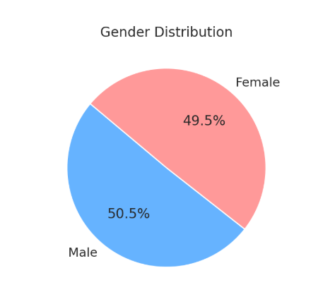
Figure 01: Distribution of the study samples according to Gender

Gender Distribution
The gender distribution was identical in both groups, with 48 (50.5%) males and 47 (49.5%) females in each. This equal representation of gender across cases and controls ensured gender was not a confounding factor in the analysis of fall risk.
Age Distribution
RESULT

The mean age of participants in the case group was 73.31 ± 5.53 years, while in the control group it was 73.08 ± 5.89 years, indicating a comparable age profile between the two groups. The median age (interquartile range) was 72 years for cases and 70 years for controls. Further age categorization showed that the majority of participants in both groups fell within the 70–80 years range. In the case group, 43.9% (n=18) of participants were aged 70–80 years, compared to 52% (n=25) in the control group. Participants aged 60–70 years made up 31.7% (n=13) in the case group and 29.1% (n=14) in the control group. The proportion of participants aged 80–90 years was higher in the case group (24.4%, n=10) compared to the control group (18.7%, n=9).This age distribution suggests that a significant portion of the study population was within the high-risk elderly age group (≥70 years), with a slightly higher representation of very elderly (80–90 years) individuals among the fall cases, which may have implications on the analysis of fall risk and associated factors.
Figure 02: Distribution of the subjects according to Age groups
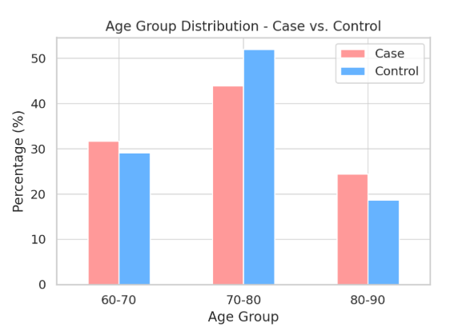

Table No. 02: Distribution of Comorbidities Among Study Participants
Commodities | Frequency | Percent
Hypertension | 61 | 31.28
Diabetes mellitus | 44 | 22.56
Pulmonary dysfunction/Tuberculosis | 19 | 9.74
COPD | 13 | 6.84
Nil | 11 | 5.78
Cardiac Abnormalities | 11 | 5.78
IHD | 5 | 2.63
Renal Abnormalities | 3 | 1.57
Stroke | 3 | 1.57
Pneumonia | 2 | 1.0
Thyroid dysfunction | 2 | 1.0
Angina | 2 | 1.0
Chronic alcoholic | 2 | 1.0
Others | 17 | 8.94
Nil | 11 | 5.78

Table 2 presents the distribution of comorbidities among the study participants. Multiple comorbid conditions were identified, reflecting the typical health profile of the geriatric population. The most commonly reported comorbidity was hypertension, present in 61 individuals (31.28%), followed by diabetes mellitus, reported in 44 individuals (22.56%). These findings are consistent with known epidemiological patterns in older adults, where cardiovascular and metabolic conditions are prevalent.
RESULT

Pulmonary dysfunction or tuberculosis was observed in 19 participants (9.74%), while chronic obstructive pulmonary disease (COPD) was noted in 13 individuals (6.84%). Cardiac abnormalities, including arrhythmias and other structural conditions, were present in 11 participants (5.78%).
A small proportion of participants reported conditions such as ischemic heart disease (IHD) (2.63%), renal abnormalities (1.57%), stroke (1.57%), and thyroid dysfunction, pneumonia, angina, and chronic alcoholism (each at 1.0%). In others there were 17 participants (8.94%) presented with a range of other comorbidities such as hypertensive retinopathy, obstructive airway disease, rheumatoid arthritis, benign prostatic hyperplasia, asthma, visual impairment, atrial fibrillation, right facial palsy, constipation, heart failure, musculoskeletal pain, insomnia, and a history of tumour excision. Notably, 11 individuals (5.78%) reported no existing comorbid conditions. The overall high prevalence of multiple comorbidities reflects the vulnerability of the elderly population and underscores the importance of individualized risk assessment, especially in relation to fall-risk-increasing drug use.

Table No. 03: Distribution of FRIDs Classes Among Study Participants
This distribution highlights the wide range of pharmacological agents that contribute to fall risk in the elderly, with a significant proportion involving cardiovascular and metabolic drug classes. The concurrent use of multiple FRIDs may further elevate the overall risk of falls, underscoring the need for regular medication review and risk-benefit assessment in geriatric patients.
Class of FRIDs | Frequency | Percent
Calcium Channel Blockers | 31 | 15.57
Corticosteroids | 31 | 15.57
Oral hypoglycaemic drug | 26 | 13.06
Beta Blocker | 19 | 9.54
Anti-platelet drug | 22 | 11.05
Diuretics (loop and thiazide) | 16 | 8.04
Insulin | 14 | 7.03
Anti-convulsant | 8 | 4.02
Loop Diuretics | 6 | 3.01
Antidepressants | 5 | 2.51
Alcohol | 4 | 2.01
Nitrates | 4 | 2.01
ACE Inhibitors | 3 | 1.50
Alpha receptor blockers | 3 | 1.50
Anticoagulants | 3 | 1.50
Antipsychotics | 3 | 1.50
Cholinesterase inhibitors | 1 | 0.5
RESULT

Figure 03: Distribution of FRIDs classes among the Study Participants
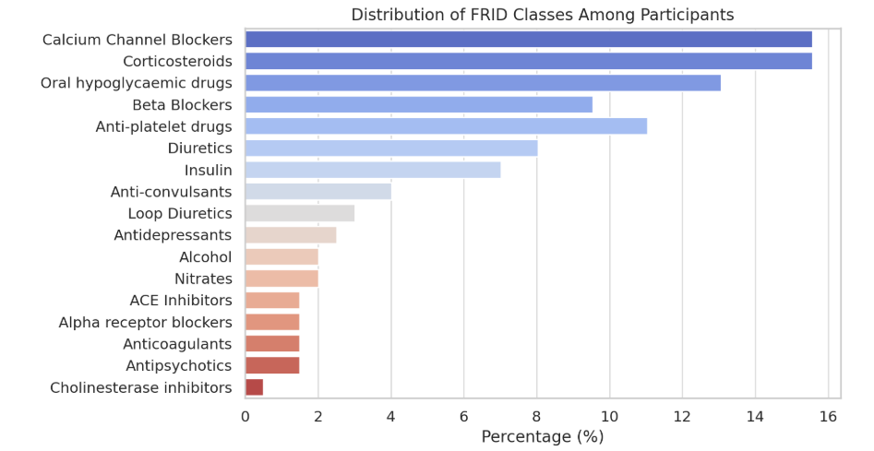

The distribution of FRIDs among the study participants revealed that the most frequently prescribed drug classes were calcium channel blockers and corticosteroids, each accounting for 15.57% of use, followed by oral hypoglycemic drugs (13.06%), antiplatelet drugs (11.05%), and beta blockers (9.54%). Other commonly reported FRIDs included diuretics (8.04%), insulin (7.03%), and anti-convulsant (4.02%). Less frequently used drug categories included loop diuretics, antidepressants, alcohol, nitrates, ACE inhibitors, alpha receptor blockers, anticoagulants, antipsychotics, and cholinesterase inhibitors, each comprising less than 5% of the total. This distribution underscores the diverse range of medications contributing to fall risk in geriatric patients, with cardiovascular and metabolic drugs being the most prevalent.

Table No. 04: Cumulative comparison of Age, Frail score and MFS score among the Case and Control groups
RESULT

Study Population | Group | N | Mean | Std. Deviation | Std. Error Mean | Two-Sided p | Mean Difference | Std. Error | 95% Confidence Interval
 |  |  |  |  |  |  |  |  | Lower | Upper
Age | Case | 95 | 72.69 | 5.533 | 0.568 | 0.612 | -0.421 | 0.829 | -2.057 | 1.215
Age | Control | 95 | 72.27 | 5.89 | 0.604
Frail score | Case | 95 | 4.79 | 2.259 | 0.232 | 0.0045* | -0.926 | 0.323 | -1.563 | -0.29
Frail score | Control | 95 | 3.86 | 2.186 | 0.224
MFS Score | Case | 95 | 29.47 | 22.39 | 2.297 | 0.000* | -18.042 | 2.689 | -23.347 | -12.737
MFS Score | Control | 95 | 11.43 | 13.629 | 1.398
Applied two-independent samples t-test, *statistically significant mean difference

Table No 04 - The results of two independent sample t-test present a statistical comparison between a control group and a case group (each with 95 participants) across three variables: Age, Total frail score (EFS), and MFS Score (MFS).
The results suggest there is no significant age difference among the case and control group. Whereas, a significant difference has been observed for mean total Frail score and MFS score among case and control group. It indicates that the mean age of the control group was 72.27 years, while the case group had a mean age of 72.69 years. The p-value for age was 0.612, which is not statistically significant (p > 0.05), suggesting that both groups are comparable in terms of age distribution, with no significant age-related bias. For the frailty score, the control group had a mean score of 3.86, whereas the case group had a higher mean score of 4.79. The mean difference was -0.926, and the p-value of 0.0045 indicates a statistically significant difference, with the case group showing higher frailty levels. This suggests greater frailty among individuals in the case group, potentially linked to an increased fall risk and exposure to FRIDs. Regarding the MFS Score, the control group had a mean score of 11.43, while the case group showed a substantially higher mean of 29.47. The mean difference was -18.042, with a p-value of 0.000 and a confidence interval of -23.347 to -12.737. This result is highly statistically significant (p < 0.001), indicating a much greater risk of falling in the case group compared to the control group.

Table No 05: The proportion of Item of MFS in the Study Population
RESULT

Item of Morse Fall Scale | Study Population |  | Total | P-value
Item of Morse Fall Scale | Control | Case | Total | P-value
History of falling (immediate or within 3 months) | 14 | 22 | 36 | 0.139
History of falling (immediate or within 3 months) | 38.9% | 61.1% | 100.0% | 0.139
Secondary diagnosis | 26 | 35 | 61 | 0.162
Secondary diagnosis | 42.6% | 57.4% | 100.0% | 0.162
IV / Heparin lock | 5 | 34 | 39 | 0.000
IV / Heparin lock | 12.8% | 87.2% | 100.0% | 0.000
Ambulatory aid | Control | Case
Bed rest/nurse assist | 90 | 80 | 170 | 0.070
Bed rest/nurse assist | 52.9% | 47.1% | 100.0% | 0.070
Crutches/cane/walker | 2 | 10 | 12 | 0.070
Crutches/cane/walker | 16.7% | 83.3% | 100.0% | 0.070
Furniture | 3 | 4 | 7 | 0.070
Furniture | 42.9% | 57.1% | 100.0% | 0.070
Gait/Transferring | Control | Case
Impaired | 4 | 7 | 11 | 0.032
Impaired | 36.4% | 63.6% | 100.0% | 0.032
Normal/bedrest/immobile | 33 | 48 | 81 | 0.032
Normal/bedrest/immobile | 40.7% | 59.3% | 100.0% | 0.032
Weak | 58 | 40 | 98 | 0.032
Weak | 59.2% | 40.8% | 100.0% | 0.032

Table No 05 presents the distribution of individual components of the Morse Fall Scale (MFS) between case and control groups. It includes items such as history of falling, presence of secondary diagnosis, IV/heparin lock usage, type of ambulatory aid, and gait/transferring status.
- A higher proportion of cases had IV/heparin lock (87.2%) compared to controls (12.8%), with a statistically significant p-value of 0.000, indicating a strong association between IV access and increased fall risk.
- The use of crutches/cane/walker was also notably higher in the case group (83.3%) than controls (16.7%), suggesting compromised mobility may contribute to fall risk.
- For gait/transferring, a higher proportion of impaired individuals were found in the case group (63.6%) than in the control group (36.4%), which was statistically significant (p = 0.032), implying gait disturbances are more prevalent among fall-risk individuals.
- Other variables such as history of falling, secondary diagnosis, and ambulatory aid using furniture showed a higher proportion in the case group but were not statistically significant.

Figure No 04: Distribution of Mean MFS Score among Case and Control groups
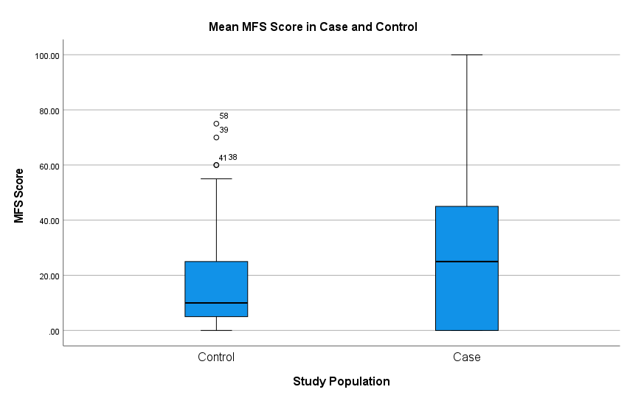
Table No 06: Comparison of Mean MFS score between the Female and Male group
Gender | N | Mean MFS Score | Std. Deviation | Std. Error Mean | Two-Sided p-value | Mean Difference | Std. Error | 95% Confidence Interval
 |  |  |  |  |  |  |  | Lower | Upper
Female | 95 | 21.96 | 21.775 | 2.234 | 0.315 | 3.011 | 2.986 | -2.880 | 8.901
Male | 95 | 18.95 | 19.308 | 1.981
Applied two-independent samples t-test

An independent samples t-test compared mean MFS scores between females (21.96) and males (18.95). The p-value of 0.315 indicates no statistically significant difference (p > 0.05). Thus, fall risk does not significantly differ by gender in this sample.
FRIDs and Fall Risk: Examining the Correlation in Geriatrics Through a Case-Control Approach

Evaluation and assessment of sleep quality, medication adherence, daytime somnolence in psychiatric patients: A prospective observational study
RESULT

Table No 07: Distribution of Gender across the MFS categories
RESULT

Gender | MFS Score |  |  | Total
Gender | No risk (0-24) | Low to Moderate risk (25-50) | High risk (equal or more than 51) | Total
Female | 53 | 36 | 6 | 95
Female | 55.8% | 37.9% | 6.3% | 100.0%
Male | 58 | 32 | 5 | 95
Male | 61.1% | 33.7% | 5.3% | 100.0%
Total | 111 | 68 | 11 | 190
Total | 58.4% | 35.8% | 5.8% | 100.0%
Chi-square statistic = 0.551, p-value = 0.759

The test suggests there is no significant proportion difference exists in the gender distribution across the MFS severity. Therefore, gender has no effect on the MFS severity.
Figure 04: Distribution of Gender across the MFS categories

Table No 08: Distribution of Age groups across the MFS categories
RESULT

Age Group | MFS Score |  |  | Total
Age Group | No risk (0-24) | Low to Moderate risk (25-50) | High risk (equal or more than 51) | Total
60-70 Years | 58 | 29 | 2 | 89
60-70 Years | 65.2% | 32.6% | 2.2% | 100.0%
70-80 Years | 48 | 28 | 5 | 81
70-80 Years | 59.3% | 34.6% | 6.2% | 100.0%
80-90 Years | 5 | 11 | 4 | 20
80-90 Years | 25.0% | 55.0% | 20.0% | 100.0%
Total | 111 | 68 | 11 | 190
Total | 58.4% | 35.8% | 5.8% | 100.0%
Chi-square statistic = 15.804, p-value = 0.003

Figure 05: Distribution of the three Age groups across the MFS categories

A chi-square test was performed to assess the association between age group and MFS risk categories. The results revealed a statistically significant association (χ² = 15.804, p = 0.003). Notably, the proportion of individuals in the high-risk category increased with age, from 2.2% in the 60–70 years group to 20% in the 80–90 years group. These findings suggest that fall risk, as measured by MFS, significantly increases with age in the geriatric population.
The results suggest statistically there is significant difference in age distribution across the MFS severity. This suggests that a major proportion of no risk are below age group of 70 years. Whereas, age more than 70 years, are under moderate to high-risk categories. Hence, it concludes that the age has significant effect on MFS severity.

Table No 09: Distribution of Cases and Controls across the MFS categories
RESULT

MFS Score | Study Population |  | Total
MFS Score | Control | Case | Total
No risk (0-24) | 73 | 38 | 111
No risk (0-24) | 65.8% | 34.2% | 100.0%
Low to Moderate risk (25-50) | 22 | 46 | 68
Low to Moderate risk (25-50) | 32.4% | 67.6% | 100.0%
High risk (equal or more than 51) | 0 | 11 | 11
High risk (equal or more than 51) | 0.0% | 100.0% | 100.0%
Total | 95 | 95 | 190
Total | 50.0% | 50.0% | 100.0%
Chi-square statistic = 30.507, p-value < 0.001

Figure 06: Distribution of the study population among the MFS categories

A chi-square test was conducted to examine the association between fall risk severity (based on MFS scores) and study group (case vs. control). The results revealed a statistically significant association (χ² = 30.507, p < 0.001). Notably, 100% of individuals in the high-risk category was from the case group, while only 34.2% of those at no risk belonged to the case group. These findings indicate that fall risk severity is significantly higher among the case group, supporting the association between case status—likely related to FRIDs exposure—and increased fall risk. This provides strong evidence toward fulfilling the study’s first objective.

Table No 10: Distribution of FRIDs in the Case group
RESULT

FRIDs | Frequency | Percent
Calcium Channel Blockers | 6 | 14.6
Corticosteroids | 20 | 48.8
Oral hypoglycemic drugs | 8 | 19.5
Diuretics (loop and thiazide) | 10 | 24.4
Antiplatelet Drugs | 16 | 39.0
Insulin | 10 | 24.4
Beta Blockers | 11 | 26.8
Loop Diuretics | 4 | 9.8
Applied Chi-square test of goodness of fit, p-value = 0.00233

A Chi-square goodness-of-fit test was conducted to assess the distribution of FRIDs among the participants. The most frequently reported FRIDs were corticosteroids (48.8%) and antiplatelet drugs (39.0%), followed by beta blockers (26.8%) and diuretics (24.4%). Less commonly reported were oral hypoglycemics drugs (19.5%), calcium channel blockers (14.6%), and loop diuretics alone (9.8%). The Chi-square test yielded a statistically significant result (p = 0.00233), indicating that the distribution of FRIDs usage among the sample is not uniform, with certain drug categories being significantly more prevalent than others.

The association between use of specific FRIDs and fall risk levels, as categorized by the MFS, was examined using the Chi-square test of independence. Across all drug types—including calcium channel blockers, corticosteroids, oral hypoglycemics, diuretics, antiplatelet drugs, insulin, beta blockers, and loop diuretics—there was no statistically significant association with MFS fall risk categories, as all p-values exceeded 0.05. This indicates that the use of these medications did not significantly differ between individuals classified as high risk versus low to moderate risk of falls based on MFS scores in this sample.

Table No 11: Distribution of major FRIDs classes across the MFS categories

FRIDs | MFS Category |  |  | Total | p-value
FRIDs | High risk (More than or equal to 51) | Low to moderate risk (25-50) | Low to moderate risk (25-50) | Total | p-value
Calcium Channel Blockers | 2 | 0 | 4 | 6 | 0.861
Calcium Channel Blockers | 33.3% | 0.0% | 66.7% | 100.0% | 0.861
Corticosteroids | 4 | 1 | 15 | 20 | 0.401
Corticosteroids | 20.0% | 5.0% | 75.0% | 100.0% | 0.401
Oral hypoglycemics drugs | 1 | 0 | 7 | 8 | 0.497
Oral hypoglycemics drugs | 12.5% | 0.0% | 87.5% | 100.0% | 0.497
Diuretics (loop and thiazide) | 3 | 0 | 7 | 10 | 0.830
Diuretics (loop and thiazide) | 30.0% | 0.0% | 70.0% | 100.0% | 0.830
Antiplatelet Drugs | 4 | 0 | 12 | 16 | 0.939
Antiplatelet Drugs | 25.0% | 0.0% | 75.0% | 100.0% | 0.939
Insulin | 4 | 0 | 6 | 10 | 0.498
Insulin | 40.0% | 0.0% | 60.0% | 100.0% | 0.498
Beta Blockers | 2 | 0 | 9 | 11 | 0.592
Beta Blockers | 18.2% | 0.0% | 81.8% | 100.0% | 0.592
Loop diuretics | 0 | 0 | 4 | 4 | 0.809
Loop diuretics | 0.0% | 0.0% | 100.0% | 100.0% | 0.809
Chi-square test of independent of attributes

A Chi-square goodness-of-fit test was conducted to evaluate the distribution of FRIDs among participants. The results were statistically significant (p = 0.00233), indicating that FRIDs use was not evenly distributed, with corticosteroids (48.8%), antiplatelet drugs (39.0%), and beta blockers (26.8%) being the most frequently reported. However, when examining the association between specific FRIDs use and fall risk levels categorized by the MFS, the Chi-square test of independence showed no statistically significant associations (all p-values > 0.05). This suggests that while certain FRIDs are more commonly used, their individual use did not significantly correlate with higher fall risk in this sample. Therefore, although FRIDs exposure is prevalent among geriatric patients, no single drug class was found to be independently associated with increased fall risk as measured by the MFS.

FRIDs and Fall Risk: Examining the Correlation in Geriatrics Through a Case-Control Approach

DISCUSSION
DISCUSSION
FRIDs and Fall Risk: Examining the Correlation in Geriatrics Through a Case-Control Approach

Falls remain a serious global health problem. This case-control study found a association between the use of FRIDs and increased risk of fall in older adults. Participants who used FRIDs showed higher frailty and fall risk scores compared to non-users. Age was significantly linked to fall risk severity, while gender showed no notable effect. Although several drug classes were commonly prescribed, no single FRIDs type was independently associated with fall severity, suggesting that the overall medication burden plays a more critical role. This highlights that regular medication review and individualized fall prevention strategies are essential in geriatric care.
AGE and MFS Score:
In our study, the majority of participants in the high fall-risk category (MFS ≥51) were in the older age groups. Specifically, 20% of participants aged 80–90 years were classified as high risk, compared to only 6.2% in the 70–80 age group and 2.2% in the 60–70 age group. These findings indicate a clear trend of increasing fall risk with advancing age, as shown in Table 7. A similar pattern was reported in the study by Noh Hye-Mi et al., where the MFS scores was more in older hospitalized individuals, especially subjects who are aged 80 years and above⁵¹. Both studies underscore that chronological age is an important independent predictor of fall risk severity, supporting the use of age-specific interventions to reduce fall incidence in elderly populations.
Comorbidities:
Through our study we found that, hypertension (31.28%) and diabetes mellitus (22.56%) were the most frequently reported comorbidities among participants, followed by pulmonary disorders (9.74%) and COPD (6.84%), as shown in Table 2. It reflects the typical burden of chronic illnesses in the elderly. Similarly, in the study conducted by Delara et al., common comorbidities among older adults with fall-related outcomes included cardiovascular disease, diabetes, and chronic respiratory conditions⁵². Both studies highlight that the presence of multiple comorbidities, especially cardiometabolic and respiratory disorders may contribute to impaired mobility, medication burden, and ultimately, a higher risk of falls in older populations.
FRIDs:
Our study reveals that, the most frequently prescribed FRIDs were corticosteroids (15.57%) and calcium channel blockers (15.57%), followed by oral hypoglycemic drugs (13.06%), antiplatelet agents (11.05%), and beta blockers (9.54%). This distribution, shown in Table 3, indicates a high prevalence of cardiovascular and metabolic drug classes among older adults. A comparable trend was observed in the study by Cox N et al., where antihypertensives (especially beta blockers and diuretics) and psychotropic medications were the most commonly identified FRIDs among elderly patients with upper limb fractures³⁴. Both studies emphasize that medications affecting blood pressure, glucose levels, and the central nervous system are dominant contributors to pharmacological fall risk in geriatric populations.
Age:
In this current study, the mean age of cases was 73.31 ± 5.53 years and controls were 73.08 ± 5.89 years. This result has been consistent with the study conducted by Noh H et al., where the mean age of the study participants, fallers was 73.7 ± 8.41 years and non-fallers was 73.6 ± 8.41 years ⁵¹. This data suggests that a significant portion of the study population was within the high-risk elderly age group (≥70 years).
Frailty:
In our study, the mean frailty score in the case group (FRIDs users) was 4.79, which was more than that of the control group (3.86), with a p-value of 0.0045, indicating that increased frailty was significantly associated with higher fall risk, as shown in Table 4. This aligns with findings from Kojima et al., who reported that frailty is a strong, independent predictor of falls in older adults and increases vulnerability to medication-related adverse effects⁵³. Additionally, we observed that 100% of participants in the high-risk MFS category (≥51) were FRIDs users, highlighting the direct association between medication exposure and fall severity. Similar results were found by Onder et al., who demonstrated that the number of FRIDs significantly predicted fall risk, particularly among patients with limited functional reserves⁵³.
Gender and fall-risk:
In our study, gender did not have a significant association with fall risk severity, statistically. Although females had a slightly higher mean MFS score (21.96) compared to males (18.95), and the distribution of MFS severity across gender groups was similar (p = 0.759), as seen in Table 6.
Similarly, Noh Hye-Mi et al. reported no significant gender-based difference in MFS scores among older hospitalized patients, emphasizing that fall risk is more strongly associated with clinical conditions and functional status rather than gender alone⁵¹. Both studies indicate that gender, while important demographically, may not be an independent predictor of fall risk severity when using MFS scoring.
In contrast, the study by Tosato et al. reported a higher prevalence of FRIDs use and fall-related fractures among female patients, suggesting a gender-based vulnerability, potentially influenced by longer life expectancy, higher rates of osteoporosis, and increased psychotropic drug prescriptions⁵¹. While our findings suggest that gender alone may not predict fall risk, the contrasting trend in Tosato et al., highlights the need for further exploration of gender-specific risk factors in different geriatric populations.
DISCUSSION
FRIDs class and Fall-risk:
An important finding in our study was that no single FRIDs class (e.g., corticosteroids, beta blockers, antiplatelets) was independently associated with fall severity (all p > 0.05), despite being commonly prescribed. This mirrors the conclusions of Hein et al., who reported that it is the cumulative burden of FRIDs, rather than individual drug types that best explains fall risk trends in older patients ⁵⁴.

CONCLUSION
CONCLUSION

FRIDs and Fall Risk: Examining the Correlation in Geriatrics Through a Case-Control Approach

Our study aimed to assess the connection between FRIDs and fall risk among the geriatric population, along with identifying specific FRIDs categories contributing to fall risk severity.

A total of 190 participants were enrolled, with 95 cases (individuals with a history of falls) and 95 controls (without falls). Both groups were comparable in terms of age and gender distribution, minimizing confounding factors.

The study revealed a statistically significant association between overall FRIDs use and increased fall risk, as evidenced by higher MFS scores and frailty scores among the case group compared to controls. Furthermore, age was found to be significantly linked to fall risk severity, with older individuals more likely to fall into higher risk categories. However, no significant association was observed between gender and fall risk severity.

Although corticosteroids, antiplatelet drugs, and beta blockers were among the most frequently reported FRIDs, no individual drug class showed a statistically significant independent association with increased fall risk severity. This suggests that the cumulative or synergistic effect of multiple FRIDs, rather than individual drug categories, contributes to heightened fall risk in the elderly.

The study emphasized the need for cautious prescribing, regular medication reviews, and comprehensive risk assessments in older adults to mitigate fall risk and its associated complications.

SUMMARY
SUMMARY
SUMMARY
FRIDs and Fall Risk: Examining the Correlation in Geriatrics Through a Case-Control Approach

This case-control study targeted to assess the connection between FRIDs and fall risk among the geriatric population, along with identifying specific FRIDs categories contributing to fall severity. A total of 190 elderly participants were enrolled for the research.
Study participants aged 65 years and above were equally divided into a case group (FRIDs users) and a control group (non-FRIDs users). Fall risk was assessed using the MFS, and frailty was evaluated using the EFS. Statistical analysis included independent samples t-tests and chi-square tests to examine associations between FRIDs use, fall risk, frailty, and demographic variables.
The results demonstrated that overall FRIDs exposure was significantly associated with increased fall risk, as evidenced by significantly higher MFS scores and frailty scores in the case group compared to controls (p < 0.001). Additionally, fall risk severity was significantly higher among older age groups, particularly those aged above 70 years.
While corticosteroids, antiplatelet drugs, and beta blockers were among the most commonly used FRIDs, no individual FRIDs category showed a statistically significant independent association with fall risk severity.
The research concluded that FRIDs use significantly contributes to fall risk in older adults, though no single FRIDs class alone was found to be an independent predictor of severe falls. The study findings highlight the significance of comprehensive medication reviews and individualized fall prevention strategies in geriatric care.

LIMITATIONS
LIMITATIONS

- The study was performed in only one center, limiting the generalizability of the findings to broader geriatric populations.

- Potential confounding factors such as nutritional status, cognitive function, and environmental hazards were not comprehensively assessed.

- Self-reported medication history may be subject to recall bias.

- The sample size, though adequate for the primary objectives, may not have been large enough to detect subtle associations between specific FRIDs categories and fall risk severity.

FUTURE DIRECTIONS
FRIDs and Fall Risk: Examining the Correlation in Geriatrics Through a Case-Control Approach

FUTURE DIRECTIONS
FRIDs and Fall Risk: Examining the Correlation in Geriatrics Through a Case-Control Approach

- Multi-center studies with larger, more diverse geriatric populations are recommended to improve generalizability.

- Future research should incorporate a longitudinal design to better establish causal relationships between FRIDs exposure and falls.

- Inclusion of additional risk factors such as cognitive impairment, functional status, and environmental hazards would provide a more holistic understanding of fall risk.

- Interventional studies evaluating the effectiveness of deprescribing or medication optimization programs in reducing fall risk among FRIDs users are warranted.

- Further investigation into specific FRIDs subclasses using larger sample sizes may help clarify their individual contributions to fall risk severity.

BIBLIOGRAPHY
BIBLIOGRAPHY

1. Hart LA, Phelan EA, Yi JY, Marcum ZA, Gray SL. Use of Fall Risk–Increasing Drugs Around a Fall‐Related Injury in Older Adults: A Systematic Review. J Am Geriatr Soc. 2020 Jun 17;68(6):1334–43.
2. Pavon JM, Davidson S, Sloane R, Pepin M, Bryan W, Bailey J, et al. Deprescribing electronic case reviews for older veterans at risk for falls: Effects on drug burden and falls. J Am Geriatr Soc. 2024 Feb 8;72(2):433–43.
3. Wabe N, Seaman KL, Nguyen AD, Siette J, Raban MZ, Hibbert P, et al. Epidemiology of falls in 25 Australian residential aged care facilities: a retrospective longitudinal cohort study using routinely collected data. International Journal for Quality in Health Care. 2022 Jul 9;34(3).
4. Demiris G, Harrison SL, Richmond TS, Skubic M, Hodgson NA. Using depth sensors for a fall risk prediction system for socially vulnerable older adults with cognitive impairment. Alzheimer’s & Dementia. 2023 Dec 25;19(S20).
5. Moreland B, Kakara R, Henry A. Trends in Nonfatal Falls and Fall-Related Injuries Among Adults Aged ≥65 Years — United States, 2012–2018. MMWR Morb Mortal Wkly Rep. 2020 Jul 10;69(27):875–81.
6. Colón-Emeric CS, McDermott CL, Lee DS, Berry SD. Risk Assessment and Prevention of Falls in Older Community-Dwelling Adults. JAMA. 2024 Apr 23;331(16):1397.
7. Lee S. Falls associated with indoor and outdoor environmental hazards among community-dwelling older adults between men and women. BMC Geriatr. 2021 Dec 12;21(1):547.
8. Yang YK, Kor CT, Sun YW, Wang HY, Yang YT, Liu SY. Associations between doses of fall-risk-increasing drugs (FRIDs) and falls of hospitalized patients. Sci Rep. 2023 Sep 1;13(1):14380.
9. Bindawas SM. The Changing Incidence and Prevalence of Falls and Its Disability Burden Among the Geriatric Population in Saudi Arabia from 1990 to 2019: A Longitudinal Analysis Using Global Burden of Disease Study Data. Cureus. 2023 Nov 20;
10. Lee J, Negm A, Peters R, Wong EKC, Holbrook A. Deprescribing fall-risk increasing drugs (FRIDs) for the prevention of falls and fall-related complications: a systematic review and meta-analysis. BMJ Open. 2021 Feb 10;11(2):e035978.
11. Yang YK, Kor CT, Sun YW, Wang HY, Yang YT, Liu SY. Associations between doses of fall-risk-increasing drugs (FRIDs) and falls of hospitalized patients. Sci Rep. 2023 Sep 1;13(1):14380.
BIBLIOGRAPHY
12. Juraschek SP, Simpson LM, Davis BR, Beach JL, Ishak A, Mukamal KJ. Effects of Antihypertensive Class on Falls, Syncope, and Orthostatic Hypotension in Older Adults. Hypertension. 2019 Oct;74(4):1033–40.
13. Seppala LJ, van der Velde N, Masud T, Blain H, Petrovic M, van der Cammen TJ, et al. EuGMS Task and Finish group on Fall-Risk-Increasing Drugs (FRIDs): Position on Knowledge Dissemination, Management, and Future Research. Drugs Aging. 2019 Apr 11;36(4):299–307.
14. Ang G, Low S, How C. Approach to falls among the elderly in the community. Singapore Med J. 2020 Mar;61(3):116–21.
15. Yang W, Luo H, Ma Y, Si S, Zhao H. Effects of Antihypertensive Drugs on Cognitive Function in Elderly Patients with Hypertension: A Review. Aging Dis. 2021;12(3):841.
16. Ie K, Chou E, Boyce RD, Albert SM. Fall Risk-Increasing Drugs, Polypharmacy, and Falls Among Low-Income Community-Dwelling Older Adults. Innov Aging. 2021 Jan 1;5(1).
17. Pavon JM, Davidson S, Sloane R, Pepin M, Bryan W, Bailey J, et al. Deprescribing electronic case reviews for older veterans at risk for falls: Effects on drug burden and falls. J Am Geriatr Soc. 2024 Feb 8;72(2):433–43.
18. Karani M V., Haddad Y, Lee R. The Role of Pharmacists in Preventing Falls among America’s Older Adults. Front Public Health. 2016 Nov 9;4.
19. Shi S, Klotz U. Age-Related Changes in Pharmacokinetics. Curr Drug Metab. 2011 Sep 1;12(7):601–10.
20. Kronfol MM, Jahr FM, Dozmorov MG, Phansalkar PS, Xie LY, Aberg KA, et al. DNA methylation and histone acetylation changes to cytochrome P450 2E1 regulation in normal aging and impact on rates of drug metabolism in the liver. Geroscience. 2020 Jun 27;42(3):819–32.
21. Fu EL, Carrero JJ, Sang Y, Evans M, Ishigami J, Inker LA, et al. Association of Low Glomerular Filtration Rate With Adverse Outcomes at Older Age in a Large Population With Routinely Measured Cystatin C. Ann Intern Med. 2024 Mar;177(3):269–79.
22. Lunghi C, Domenicali M, Vertullo S, Raschi E, De Ponti F, Onder G, et al. Adopting STOPP/START Criteria Version 3 in Clinical Practice: A Q&amp;A Guide for Healthcare Professionals. Drug Saf. 2024 Nov 11;47(11):1061–74.
BIBLIOGRAPHY
23. Baruth JM, Gentry MT, Rummans TA, Miller DM, Burton MC. Polypharmacy in older adults: the role of the multidisciplinary team. Hosp Pract. 2020 Mar 31;48(sup1):56–62.
24. McManus K, Greene BR, Ader LGM, Caulfield B. Development of Data-Driven Metrics for Balance Impairment and Fall Risk Assessment in Older Adults. IEEE Trans Biomed Eng. 2022 Jul;69(7):2324–32.
25. Park SH. Tools for assessing fall risk in the elderly: a systematic review and meta-analysis. Aging Clin Exp Res. 2018 Jan 3;30(1):1–16.
26. Jewell VD, Capistran K, Flecky K, Qi Y, Fellman S. Prediction of Falls in Acute Care Using The Morse Fall Risk Scale. Occup Ther Health Care. 2020 Oct 1;34(4):307–19.
27. Lunghi C, Domenicali M, Vertullo S, Raschi E, De Ponti F, Onder G, et al. Adopting STOPP/START Criteria Version 3 in Clinical Practice: A Q&amp;A Guide for Healthcare Professionals. Drug Saf. 2024 Nov 11;47(11):1061–74.
28. Vadanere NP, Debnath A, Verma A, Gupta P. Prevalence and Determinants of Frailty amongst the Elderly: A Study from a Tertiary Care Hospital in North India. Preventive Medicine: Research & Reviews. 2024 May 8;
29. He Y, Li LW, Hao Y, Sim EY, Ng KL, Lee R, et al. Assessment of predictive validity and feasibility of Edmonton Frail Scale in identifying postoperative complications among elderly patients: a prospective observational study. Sci Rep. 2020 Sep 7;10(1):14682.
30. Duzgun G, Ustundag S, Karadakovan A. Assessment of Frailty in the Elderly. Florence Nightingale J Nurs. 2021 Mar 10;29(1):2–8.
31. Hauff J, Rottenkolber M, Oehler P, Fischer S, Gensichen J, Drey M, et al. Single and combined use of fall-risk-increasing drugs and fracture risk: a population-based case–control study. Age Ageing. 2023 Jun 1;52(6).
32. Osman A, Speechley M, Ali S, Montero-Odasso M. Fall-Risk-Increasing Drugs and Gait Performance in Community-Dwelling Older Adults: Exploratory Results from the Gait and Brain Study. Drugs Aging. 2023 Aug 22;40(8):721–30.
33. Delara M, Reich KM, Chan WY, Seitz DP. Fall Risk–Increasing Drugs and Fall-Related Injuries among Older Adults in Ontario: A Population-Based Matched Case-Control Study. J Am Med Dir Assoc. 2025 Jun;26(6):105567.
BIBLIOGRAPHY
34. Cox N, Ilyas I, Roberts HC, Ibrahim K. Exploring the prevalence and types of fall-risk-increasing drugs among older people with upper limb fractures. International Journal of Pharmacy Practice. 2023 Mar 13;31(1):106–12.
35. Paar E, De Lai E, Držaić M, Kummer I, Bužančić I, Hadžiabdić MO, et al. Fall risk-increasing drugs and associated health outcomes among community-dwelling older patients: A cross-sectional study in Croatian cohort of the EuroAgeism H2020 project. Acta Pharmaceutica. 2024 Dec 1;74(4):635–53.
36. De Winter S, Vanwynsberghe S, Foulon V, Dejaeger E, Flamaing J, Sermon A, et al. Exploring the relationship between fall risk-increasing drugs and fall-related fractures. Int J Clin Pharm. 2016 Apr 9;38(2):243–51.
37. Xue L, Boudreau RM, Donohue JM, Zgibor JC, Marcum ZA, Costacou T, et al. Persistent polypharmacy and fall injury risk: the Health, Aging and Body Composition Study. BMC Geriatr. 2021 Dec 15;21(1):710.
38. Johnell K, Jonasdottir Bergman G, Fastbom J, Danielsson B, Borg N, Salmi P. Psychotropic drugs and the risk of fall injuries, hospitalisations and mortality among older adults. Int J Geriatr Psychiatry. 2017 Apr 25;32(4):414–20.
39. de Godoi Rezende Costa Molino C, Forster CK, Wieczorek M, Orav EJ, Kressig RW, Vellas B, et al. Association of fall risk-increasing drugs with falls in generally healthy older adults: a 3-year prospective observational study of the DO-HEALTH trial. BMC Geriatr. 2024 Nov 29;24(1):980.
40. Zia A, Kamaruzzaman SB, Tan MP. The consumption of two or more fall risk‐increasing drugs rather than polypharmacy is associated with falls. Geriatr Gerontol Int. 2017 Mar 28;17(3):463–70.
41. Jung YS, Suh D, Kim E, Park HD, Suh DC, Jung SY. Medications influencing the risk of fall-related injuries in older adults: case–control and case-crossover design studies. BMC Geriatr. 2023 Jul 22;23(1):452.
42. Vaesken C, Lelong-Boulouard V, Fedrizzi S, Muzard A, Descatoire P, Loggia G, et al. Drug-related falls: proportion and impact of hospitalizations in geriatric departments on the prescription of fall-risk increasing drugs (FRIDs). Eur J Clin Pharmacol. 2025 Jun 10;81(6):885–93.
43. Yu NW, Chen PJ, Tsai HJ, Huang CW, Chiu YW, Tsay WI, et al. Association of benzodiazepine and Z-drug use with the risk of hospitalisation for fall-related injuries among older people: a nationwide nested case–control study in Taiwan. BMC Geriatr. 2017 Dec 11;17(1):140.
BIBLIOGRAPHY
44. Akande-Sholabi W, Ogundipe FrancisS, Adebusoye LawrenceA. Medications and the risk of falls among older people in a geriatric centre in Nigeria: a cross-sectional study. Int J Clin Pharm. 2021 Feb 10;43(1):236–45.
45. Naharci MI, Tasci I. Frailty status and increased risk for falls: The role of anticholinergic burden. Arch Gerontol Geriatr. 2020 Sep;90:104136.
46. Cox CA, van Jaarsveld HJ, Houterman S, van der Stegen JCGH, Wasylewicz ATM, Grouls RJE, et al. Psychotropic Drug Prescription and the Risk of Falls in Nursing Home Residents. J Am Med Dir Assoc. 2016 Dec;17(12):1089–93.
47. Wedmann F, Himmel W, Nau R. Medication and medical diagnosis as risk factors for falls in older hospitalized patients. Eur J Clin Pharmacol. 2019 Aug 26;75(8):1117–24.
48. Qian XX, Chau PH, Fong DYT, Ho M, Woo J. Identifying factors associated with post-hospital falls in older patients: a territory-wide cohort study. Public Health. 2024 Oct;235:1–7.
49. Hamza SA, Adly NN, Abdelrahman EE, Fouad IM. The relation between falls and medication use among elderly in assisted living facilities. Pharmacoepidemiol Drug Saf. 2019 Jun 28;28(6):849–56.
50. Andersen CU, Lassen PO, Usman HQ, Albertsen N, Nielsen LP, Andersen S. Prevalence of medication-related falls in 200 consecutive elderly patients with hip fractures: a cross-sectional study. BMC Geriatr. 2020 Dec 30;20(1):121.
51. Noh HM, Song HJ, Park YS, Han J, Roh YK. Fall predictors beyond fall risk assessment tool items for acute hospitalized older adults: a matched case–control study. Sci Rep. 2021 Jan 15;11(1):1503.
52. Delara M, Reich KM, Chan WY, Seitz DP. Fall Risk–Increasing Drugs and Fall-Related Injuries among Older Adults in Ontario: A Population-Based Matched Case-Control Study. J Am Med Dir Assoc. 2025 Jun;26(6):105567.
53. Kojima G. Frailty as a Predictor of Future Falls Among Community-Dwelling Older People: A Systematic Review and Meta-Analysis. J Am Med Dir Assoc. 2015 Dec;16(12):102

Annexure-I
ANNEXURES
FRIDs and Fall Risk: Examining the Correlation in Geriatrics Through a Case-Control Approach


FRIDs and Fall Risk: Examining the Correlation in Geriatrics Through a Case-Control Approach

Annexure-II
ANNEXURES
Informed Consent of the Subject
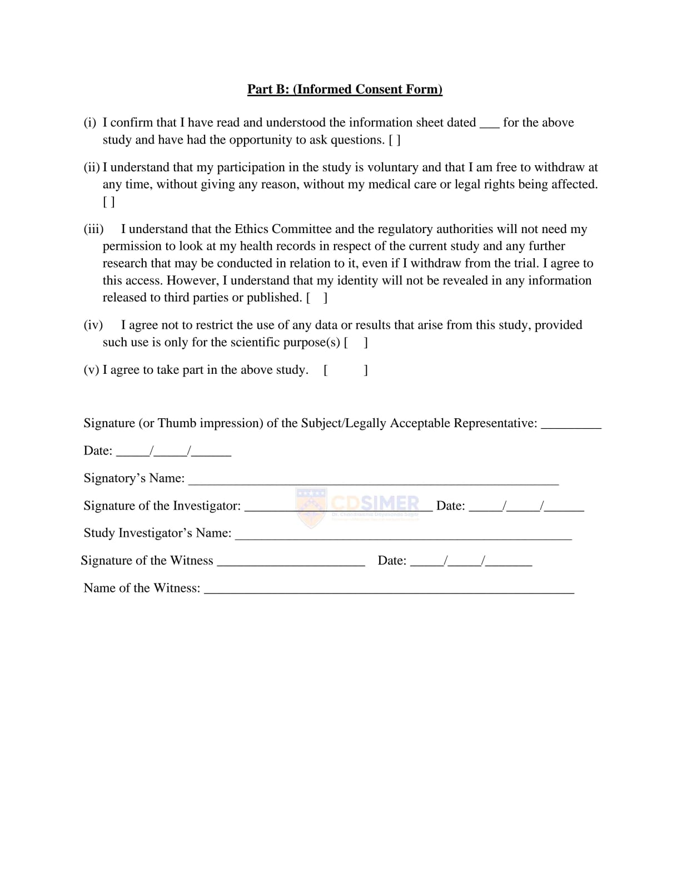

ANNEXURES

Annexure-III
ANNEXURES
FRIDs and Fall Risk: Examining the Correlation in Geriatrics Through a Case-Control Approach

ANNEXURES
Data Collection Form
DATA COLLECTION FORM
Case/control | Name | Age | Gender | IP/OP | DOA | DEPT
- Patient Demographics

- Subjective Evidence
Reason For Admission/ Diagnosis

- Past Medical History:

- Past Medication History:

Drug | Dose | Frequency | Duration
- Fall Risk Increasing Drugs in the Medication Chart:

ANNEXURES
SCALES | SCALE APPLIED
SCALES | Yes/No
The Edmonton Frail Scale
Morse Fall Scale
6. SCALES APPLIED:
ANNEXURES

Risk factors | Description | Y/N
Vision | Reports/ Observed difficulty seeing – Objects/ signs/ finding way around
Mobility | Mobility status unknown or appears unsafe/ impulsive / forgets gait aid
Nutrition | Underweight / low appetite
Continence | Reported or known urgency/ Nocturia/ Accidents
Others
7. ASSESSMENT OF OTHER RISK FACTORS:
Evaluation and assessment of sleep quality, medication adherence, daytime somnolence in psychiatric patients: A prospective observational study
Evaluation and assessment of sleep quality, medication adherence, daytime somnolence in psychiatric patients: A prospective observational study

Annexure-III.A
ANNEXURES
Questionnaire

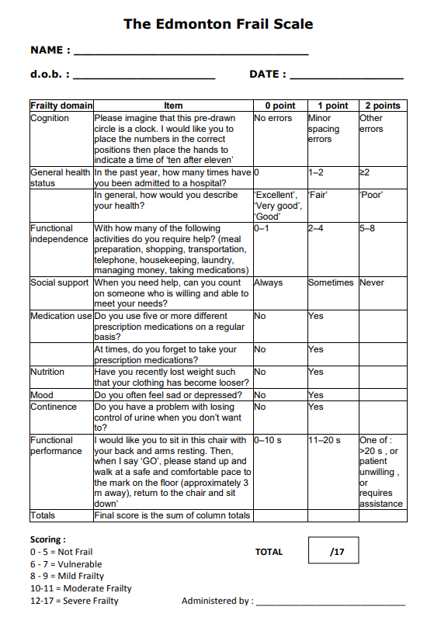
FRID and Fall Risk: Examining the correlation in geriatrics through a Case-Control Approach

ANNEXURES
FRIDs and Fall Risk: Examining the Correlation in Geriatrics Through a Case-Control Approach

FRIDs and Fall Risk: Examining the Correlation in Geria

Evaluation and assessment of sleep quality, medication adherence, daytime somnolence in psychiatric patients: A prospective observational study

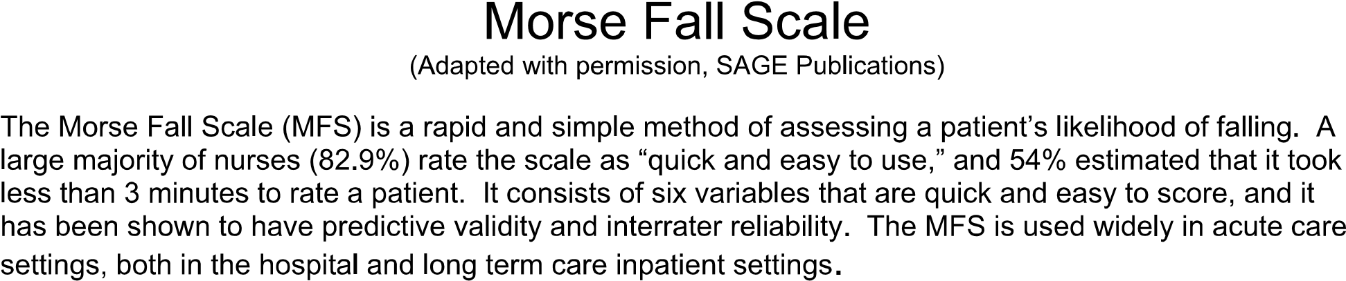

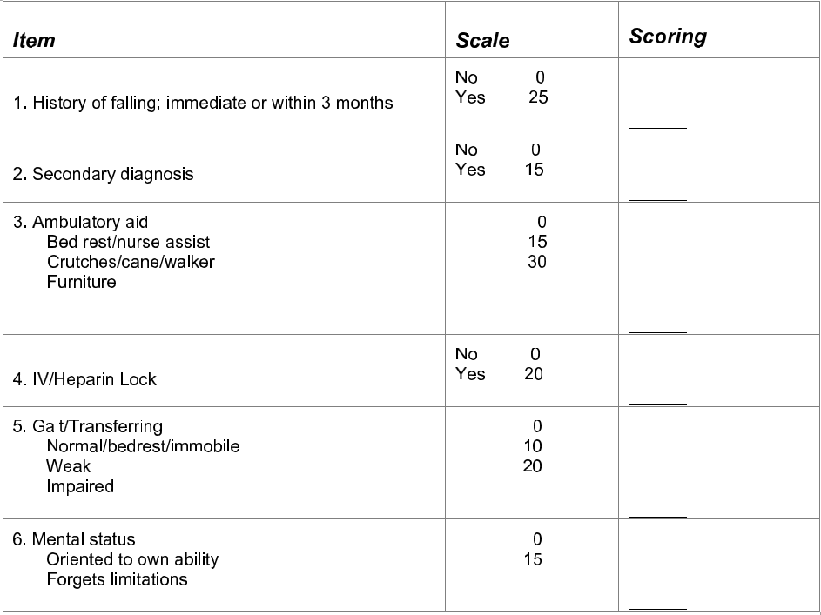

FRIDs and Fall Risk: Examining the Correlation in Geriatrics Through a Case-Control Approach

ANNEXURES

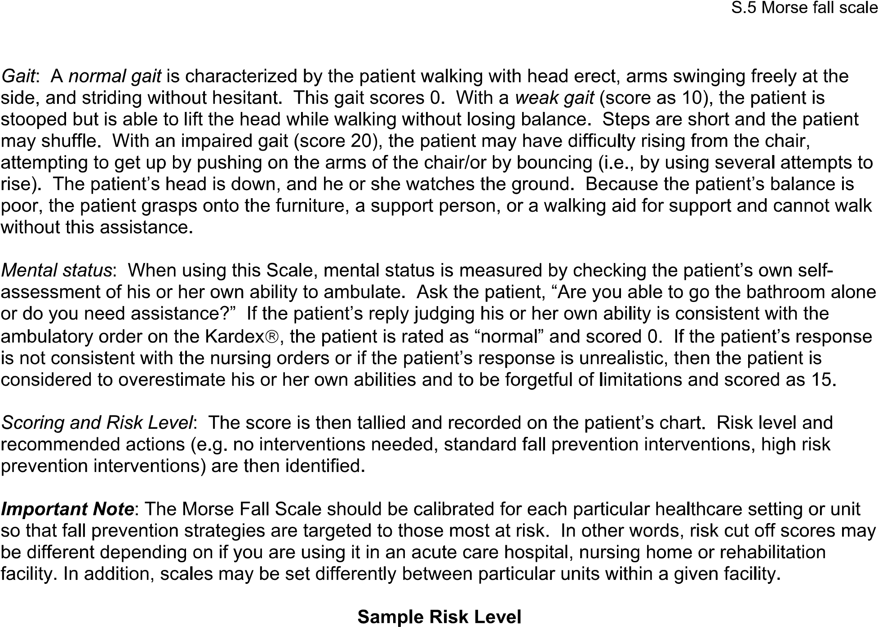

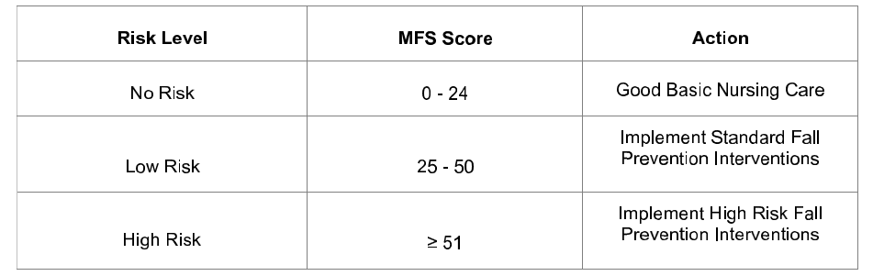
FRIDs and Fall Risk: Examining the Correlation in Geriatrics Through a Case-Control Approach

ANNEXURE - IV

