TEN DOLLAR CREDIT REPAIR ULTRA EDITION VOLUME 5
By Raoul Cannon

Copyright Page
First published by Raoul Cannon, 2025
Copyright © 2025 by Raoul Cannon
All rights reserved. No part of this publication may be reproduced, stored, or transmitted in any form or by any means—electronic, mechanical, photocopying, recording, scanning, or otherwise—without prior written permission from the publisher.
Designations used by companies to distinguish their products are often claimed as trademarks. All brand names and product names used in this book are trade names, service marks, trademarks, or registered trademarks of their respective owners. This publication and the author are not affiliated with or endorsed by any product, vendor, or company mentioned herein.

Table of Contents
- Your Personal Invitation to Credit Success!
- Disclaimer
- About the Author
- Testimonials
- Chapter 1: Understanding Credit – The Foundation of Your Financial Power
- Chapter 2: The “Credit Prepare” Power Play – Your Launchpad for Strategic Action
- Chapter 3: Selecting Your Dispute Method – Pacing Your Success
- Chapter 4: The Dispute Engine – Your Multi-Method Blueprint
- Chapter 5: Tailoring Your Main Disputes – A Deep Dive by Account Type

Your Personal Invitation to Credit Success!
Hello and a massive welcome, Credit Repair Warrior! ... (full motivational intro here)

Disclaimer
This ebook is intended for educational and informational purposes only ... (full disclaimer here)

About the Author
Raoul Cannon is a veteran of the credit repair industry with over 25 years of hands-on experience ... (full bio here)

Testimonials
“I’d been with Lexington Law for over a year with little to show ... – Liz C.”
“I can’t tell you how helpful this book has been ... – Shelia B.”
“When I started my company, I couldn’t even get a basic credit card ... – Robert G.”
“Honestly, I wasn’t expecting much ... – Roz E.”
“I removed a bankruptcy and two collections ... – Jayson F.”

Chapter 1: Understanding Credit – The Foundation of Your Financial Power
Credit is not just a number. It is the single most important financial tool you will ever control ...
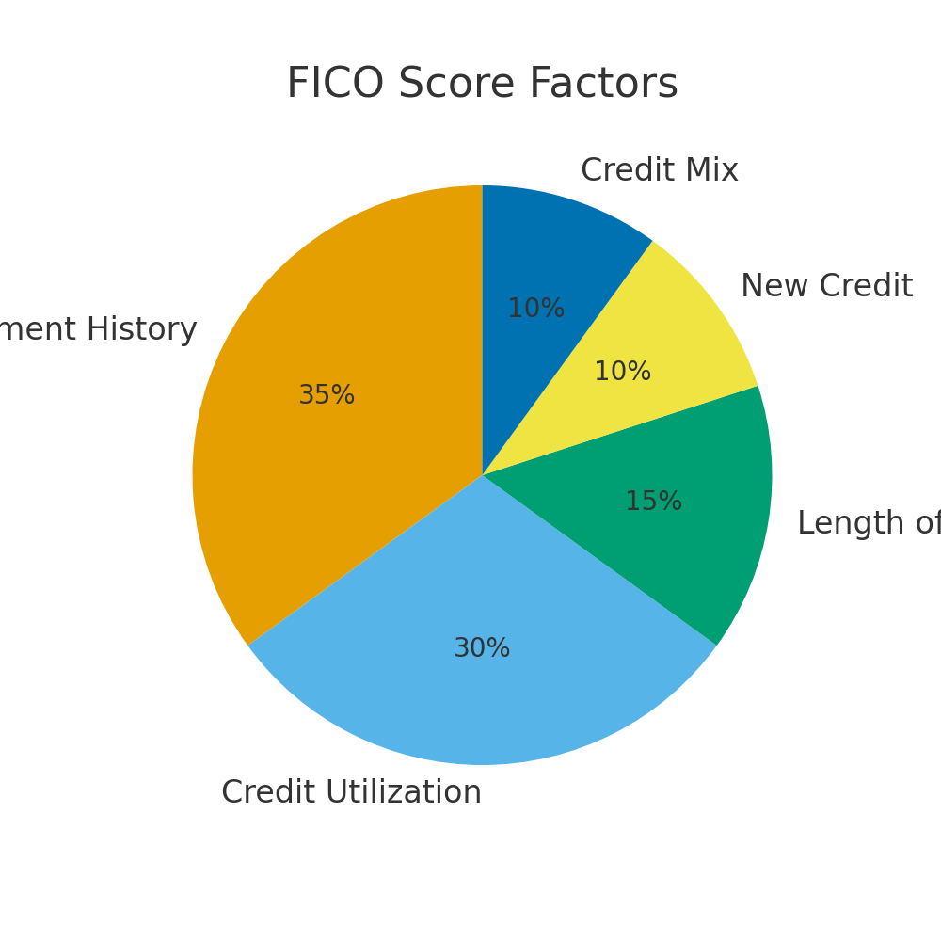
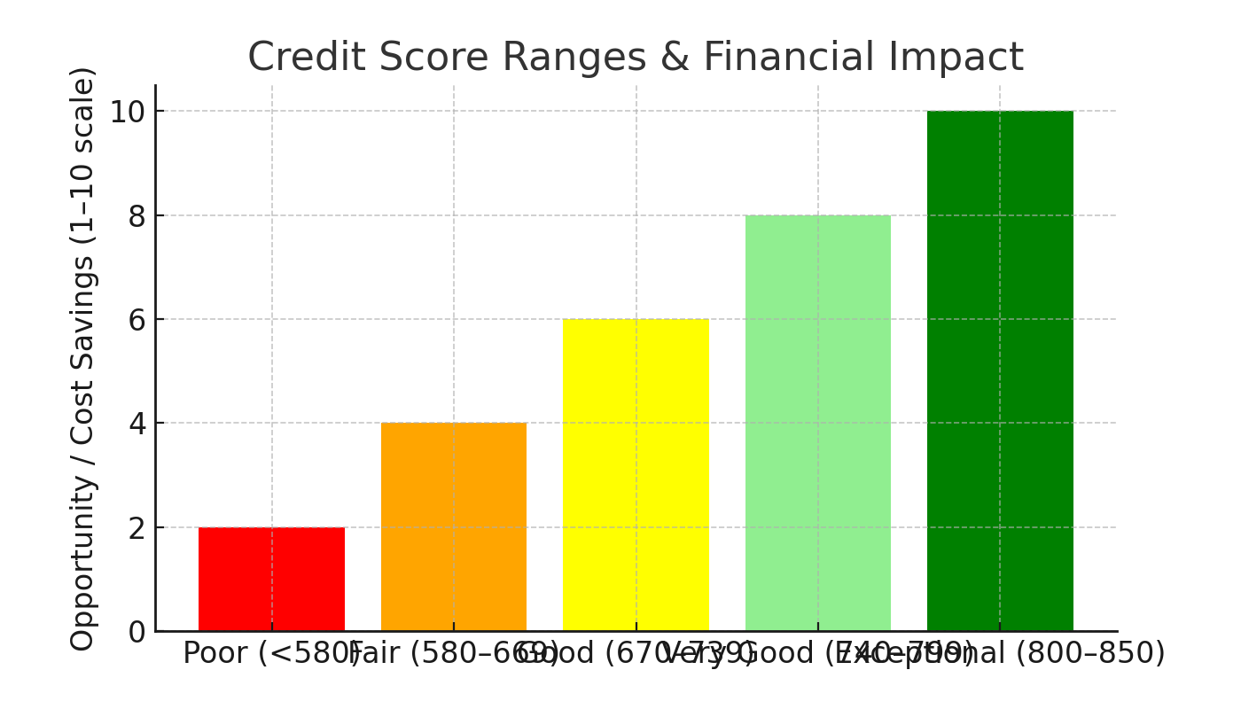
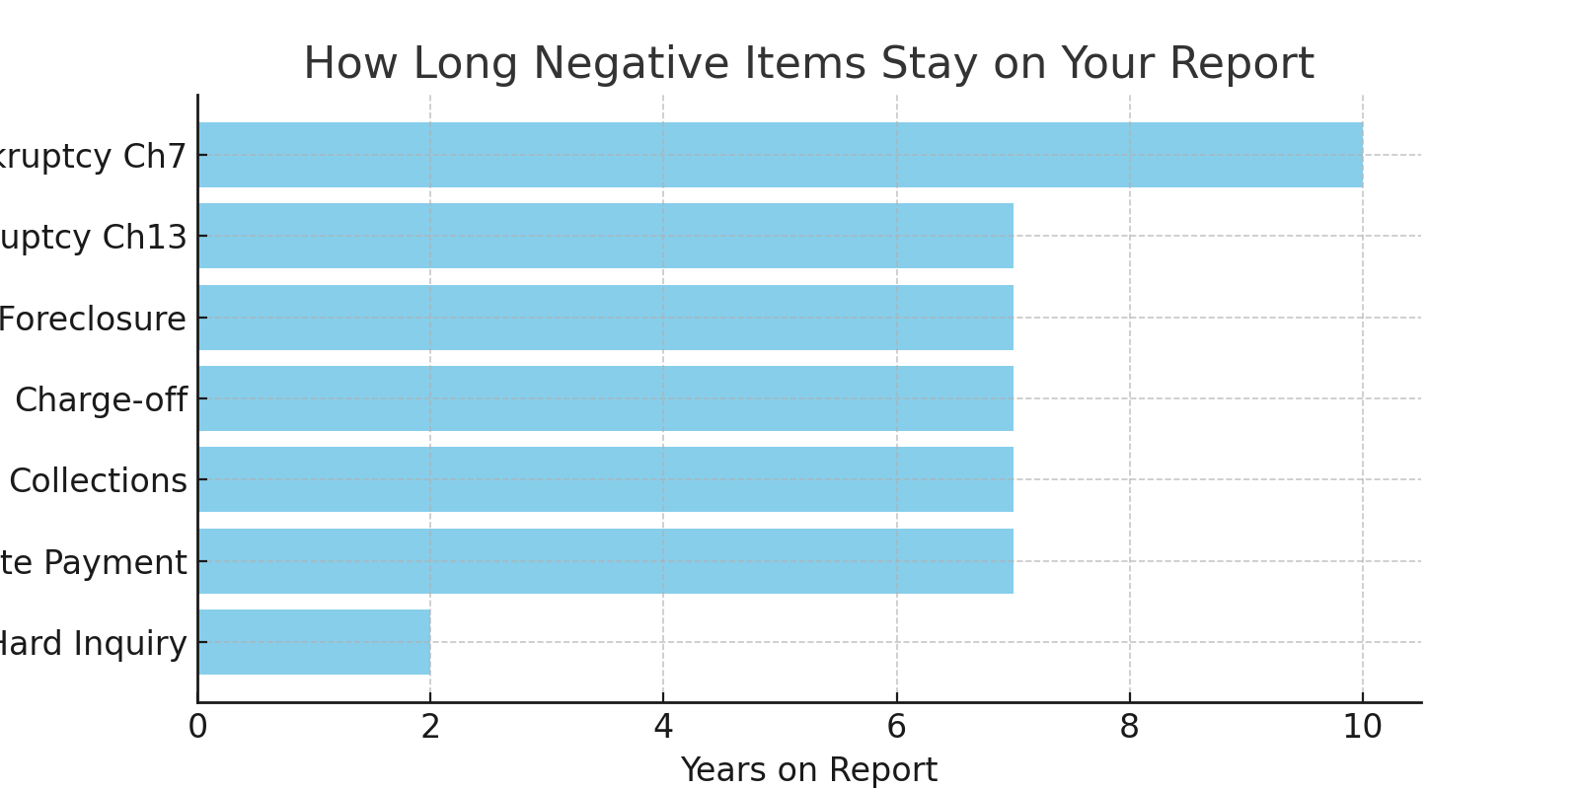
Case study + philosophy ... (full Chapter 1 content)

Chapter 2: The “Credit Prepare” Power Play – Your Launchpad for Strategic Action
Most people fail because they rush straight to disputing ... (expanded checklist)
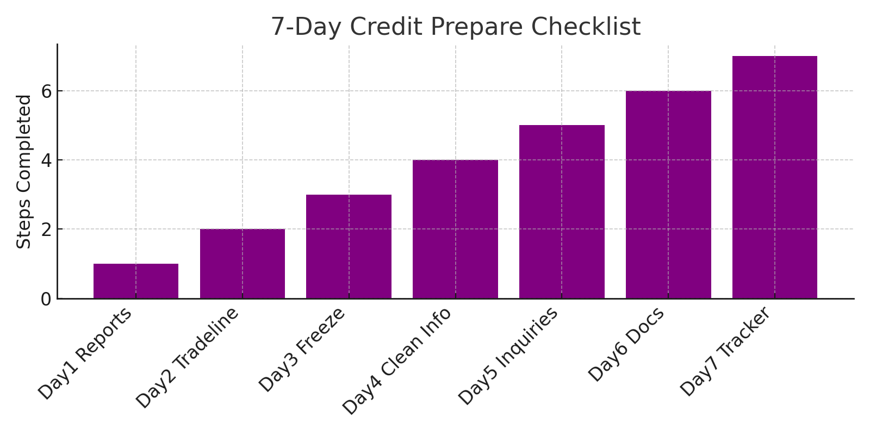
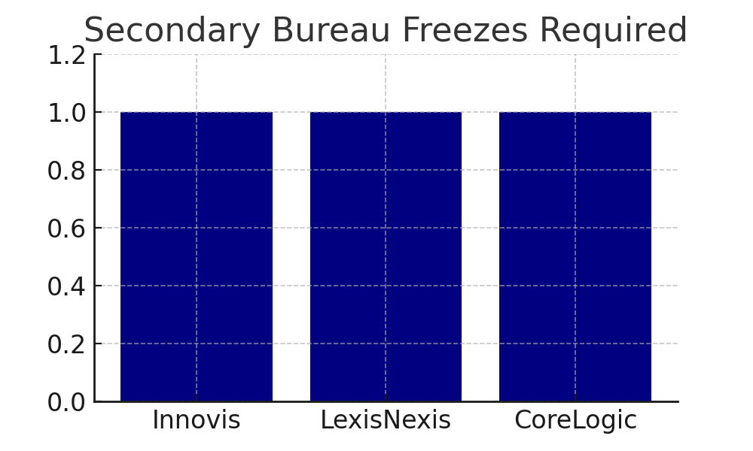
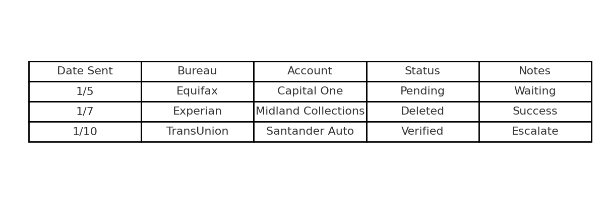
End of Chapter 2 ...

Chapter 3: Selecting Your Dispute Method – Pacing Your Success
Expanded content ...
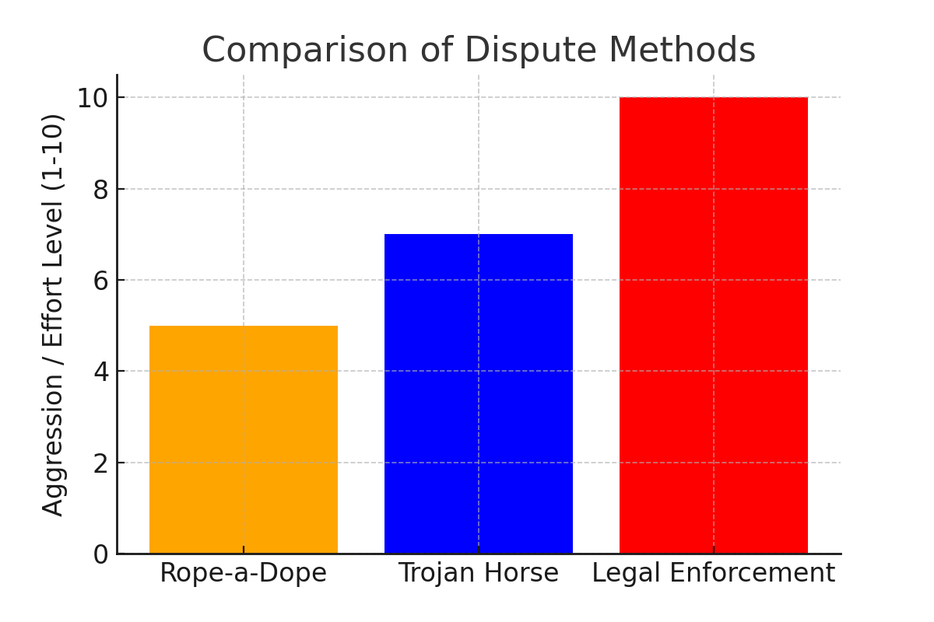

Chapter 4: The Dispute Engine – Your Multi-Method Blueprint
Expanded content ...
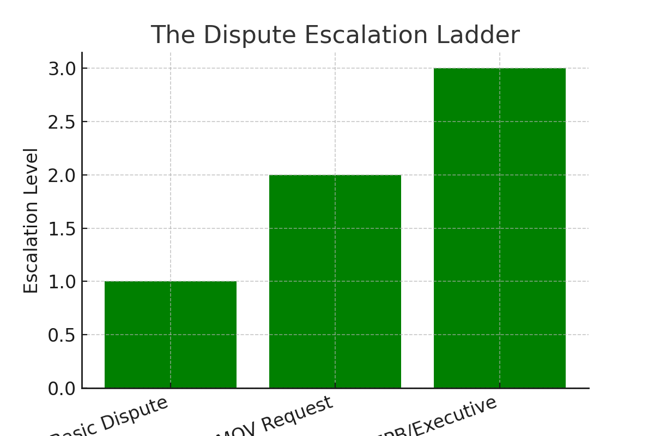

Chapter 5: Tailoring Your Main Disputes – A Deep Dive by Account Type
Expanded content ...
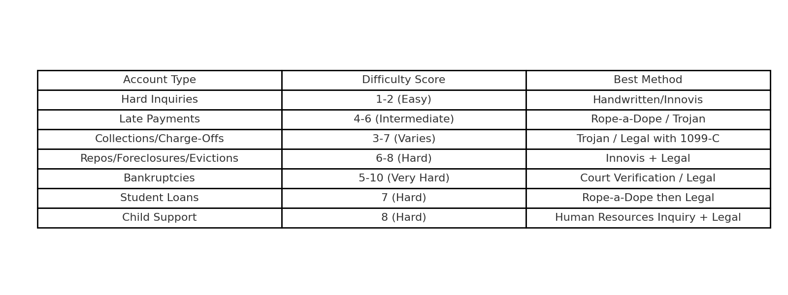
End of Chapter 5 ...

Chapter 6: The Strategic Blueprint – Trojan Horse & Rope-a-Dope in Action
In the world of credit disputes, two of the most effective tactical methods are the Rope-a-Dope and the Trojan Horse strategies. These are not gimmicks—they are proven dispute techniques that exploit weaknesses in how the bureaus process information.

Rope-a-Dope Method
This method applies light but consistent pressure. Think of Muhammad Ali’s famous strategy: take the hits, wait for your opponent to tire, and strike when the time is right. In credit repair, Rope-a-Dope means sending low-level disputes, usually handwritten, that test the bureau’s consistency. When they inevitably make errors, you escalate.

Trojan Horse Method
The Trojan Horse disguises strength as weakness. You appear to be sending a routine dispute, but inside your letter are carefully worded demands that require the bureaus to follow strict FCRA rules. If they fail, you gain leverage for escalation.
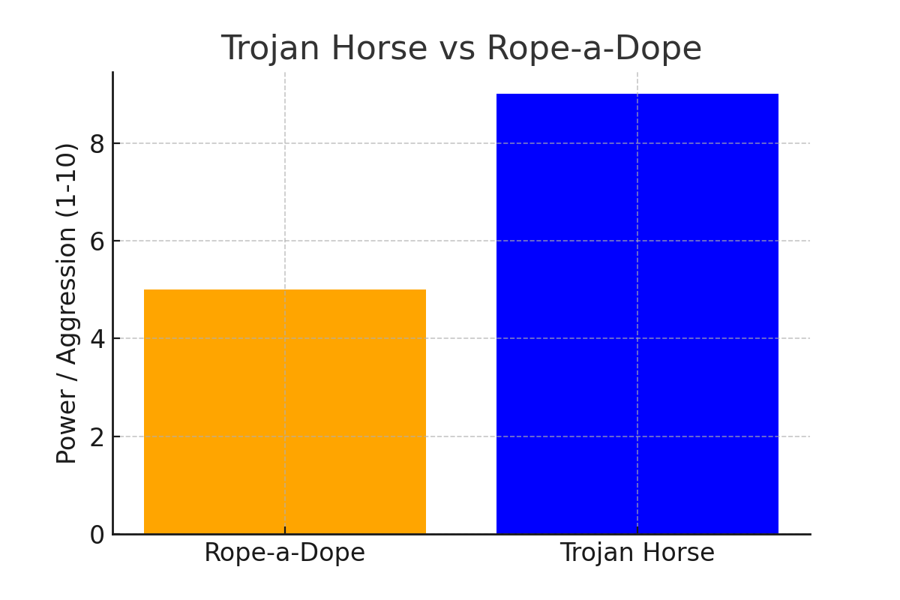

Flow of a Trojan Horse Dispute
1. Send a dispute letter disguised as a simple correction.
2. Include demands for Method of Verification or original documents.
3. Track the bureau’s failure to comply.
4. Escalate to executive offices or regulators.

Chapter 7: Legal Actions Against the Big Three
Sometimes, the bureaus will only respond when they see you are willing to escalate legally. Legal escalation is the final lever you pull when standard disputes have failed. It shows you are serious and ready to hold them accountable under the law.

When to Escalate
• After 2-3 failed rounds of disputes.
• When bureaus provide generic responses without real verification.
• When violations of the FCRA, FDCPA, or state laws are clear.
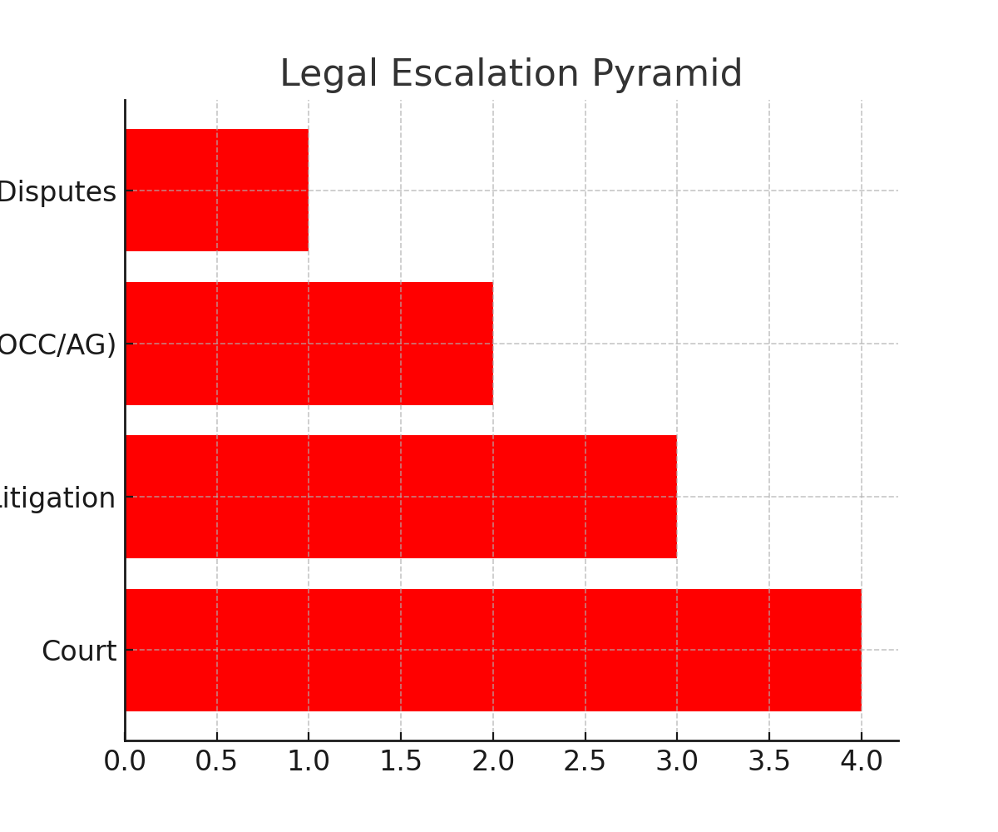

Pre-Litigation Letters
Before filing a lawsuit, send a pre-litigation letter. This letter outlines violations, gives the bureau one last chance to fix them, and shows you are documenting everything for court. Often, this alone is enough to trigger deletions.
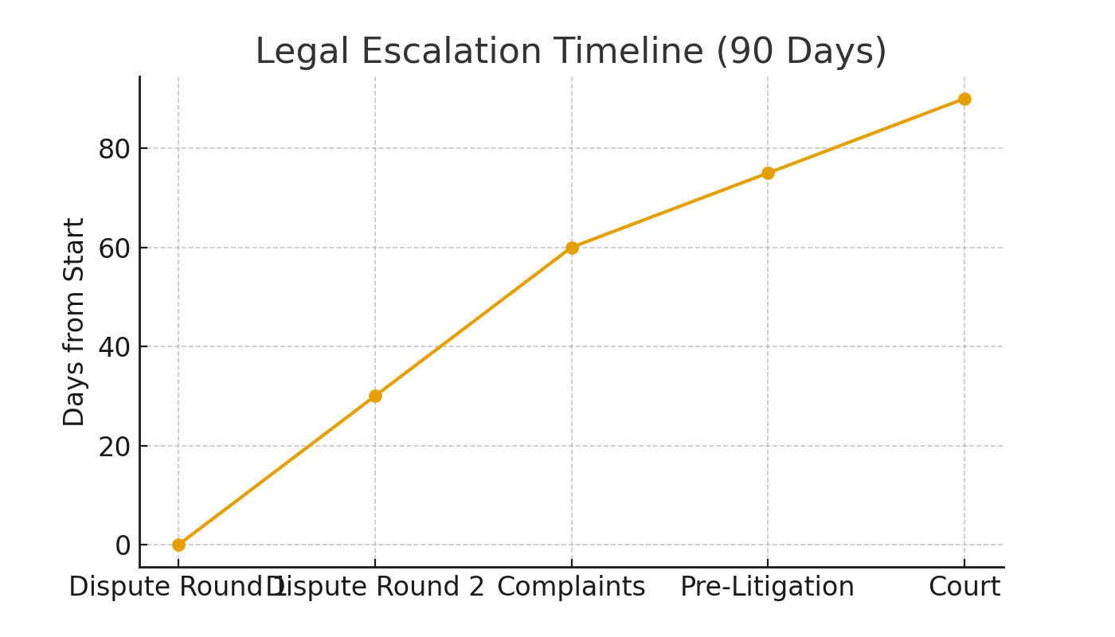

Chapter 8: The New Frontier of Credit – Buy Now, Pay Later (BNPL)
Buy Now, Pay Later services like Affirm, Klarna, and Afterpay have exploded in popularity. They allow consumers to split purchases into installments with little or no interest. But they come with hidden risks when it comes to credit reporting.

BNPL and Credit Reports
Some BNPL accounts are reported to the bureaus, while others are not. When they are reported, missed payments can damage your credit just like a credit card or loan. Managing BNPL accounts responsibly is critical.
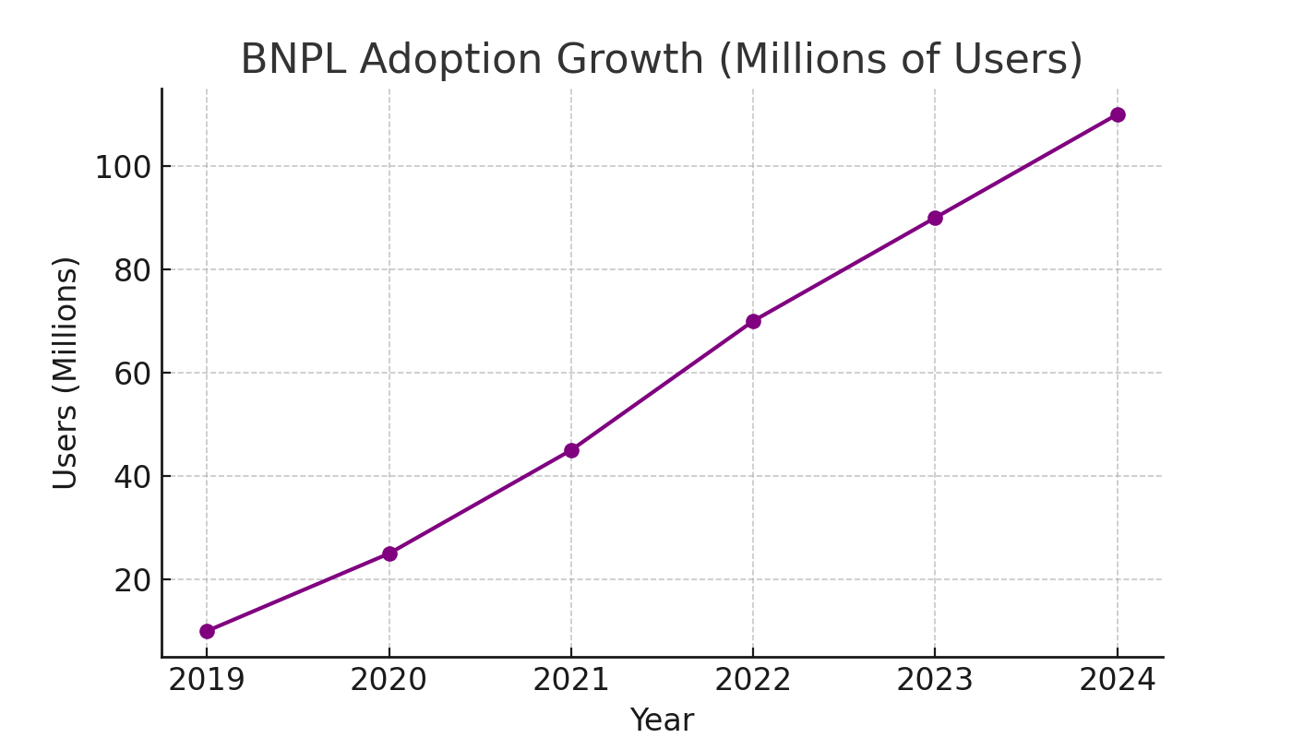

BNPL Risks vs Benefits
BNPL can be a tool for building credit if managed properly, but it can also become a trap if overused. The key is moderation and awareness of how each service reports.
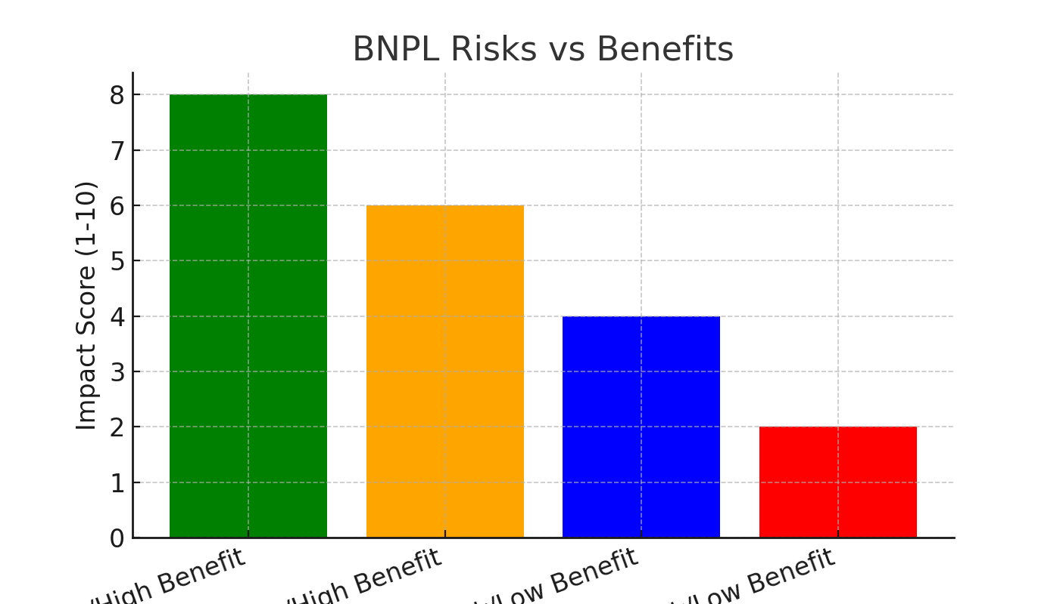
As a Credit Warrior, you must understand this new frontier. BNPL is here to stay, but how you manage it determines whether it becomes a stepping stone or a stumbling block.

Chapter 9: The Innovis Backdoor Method – Your Secret Weapon
Innovis is often called the 'fourth bureau,' yet few people know how to use it. Unlike Equifax, Experian, and TransUnion, Innovis handles consumer data differently and is less widely used by lenders. This creates opportunities for Credit Warriors.

Why Innovis Matters
Innovis often provides verification data to the Big Three. Freezing Innovis disrupts this pipeline and forces the other bureaus to verify information directly with creditors. This increases your chances of deletions.
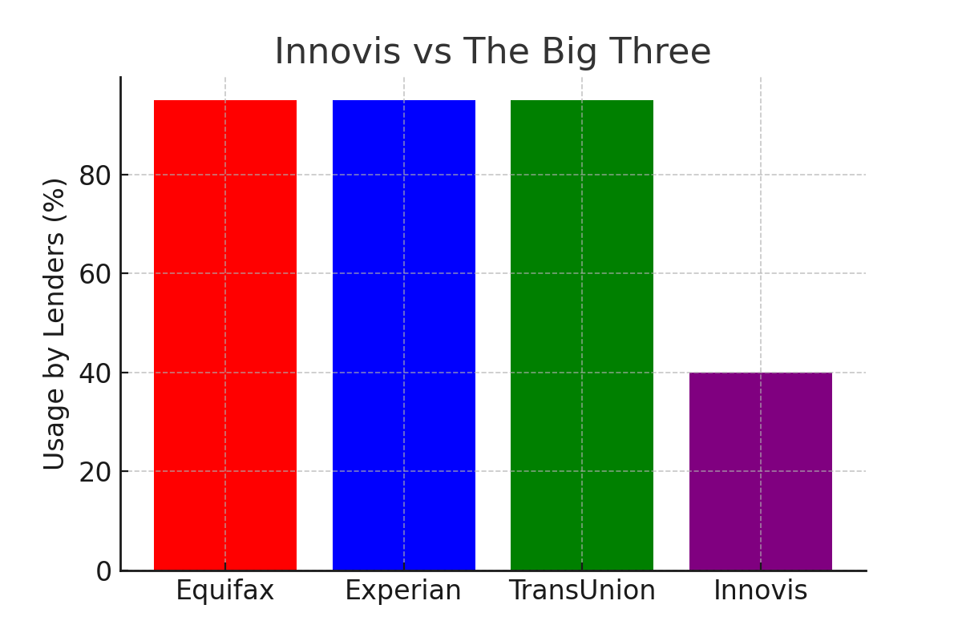

The Backdoor Method
1. Request your Innovis report by mail.
2. Freeze your Innovis file.
3. Dispute inaccurate accounts directly with Innovis.
4. Wait for inconsistencies between Innovis and the Big Three.
5. Use those discrepancies as leverage to force deletions.
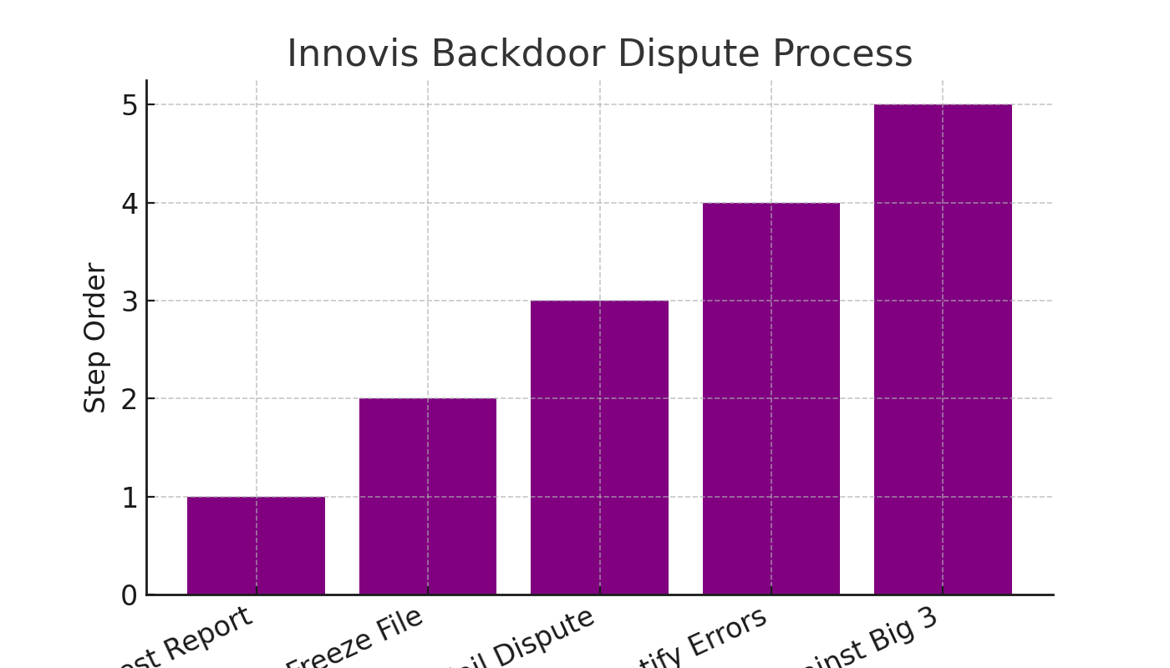

Chapter 10: Assessing Difficulty, Estimated Timelines & Targeted Strategies
Every negative item has a different level of difficulty for removal. Understanding difficulty scores and timelines allows you to plan your disputes more effectively.
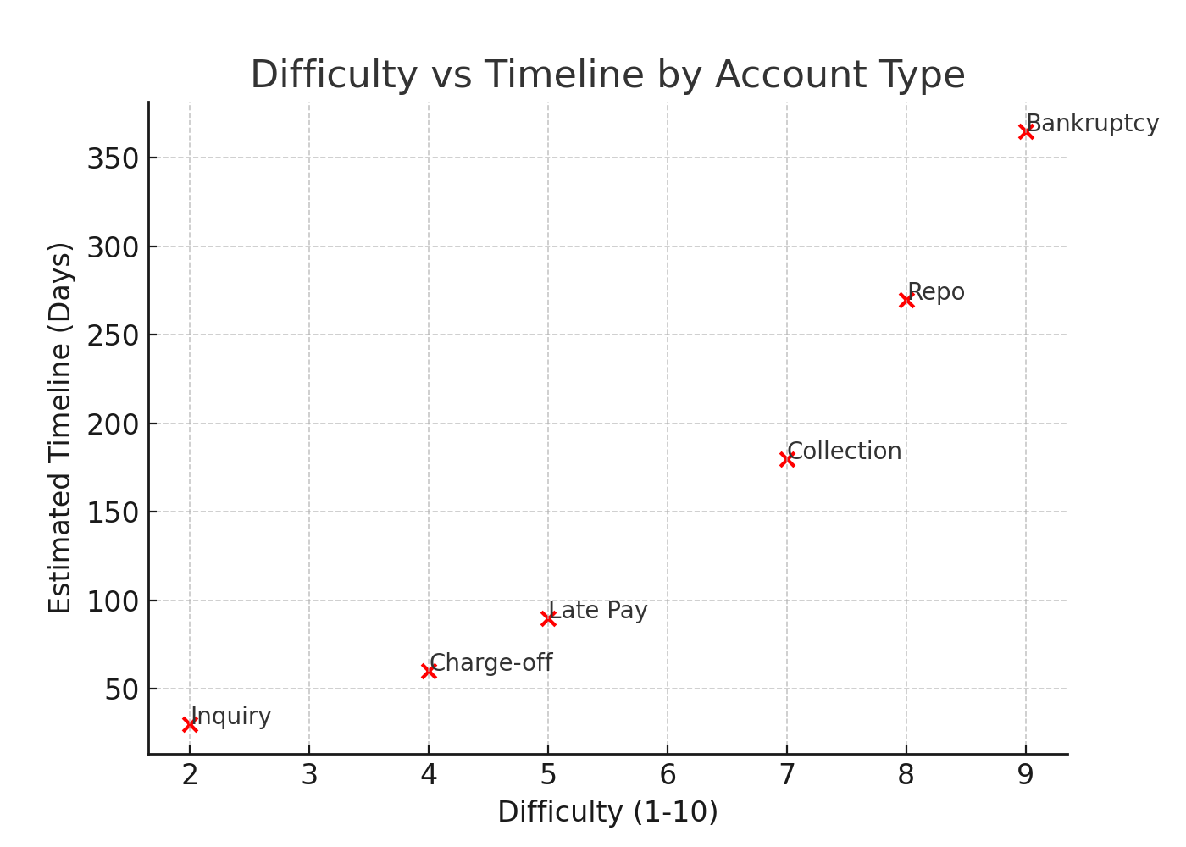
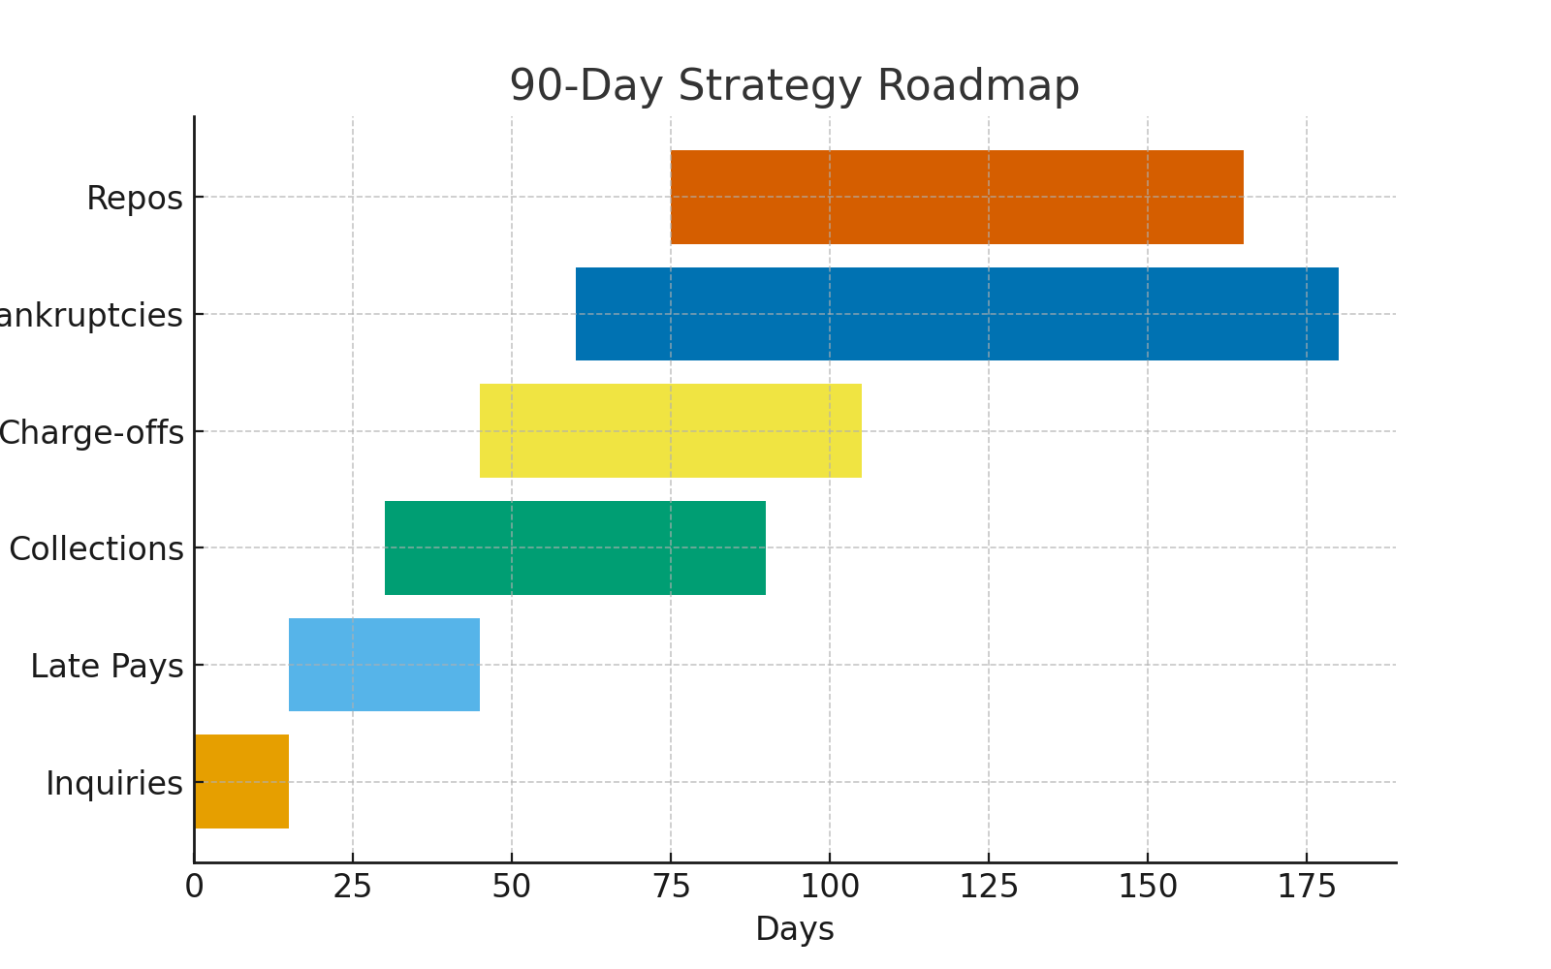
This roadmap helps you plan which items to attack first. Easier items like inquiries and late pays are targeted early, while more difficult items like bankruptcies are scheduled later.

Chapter 11: Secondary Credit Bureaus – Beyond the Big Three & Long-Term Credit Health
The Big Three aren’t the only players. Secondary bureaus like LexisNexis, CoreLogic, ChexSystems, and SageStream hold massive amounts of consumer data. These often feed information to the Big Three, making it critical to understand and freeze them.
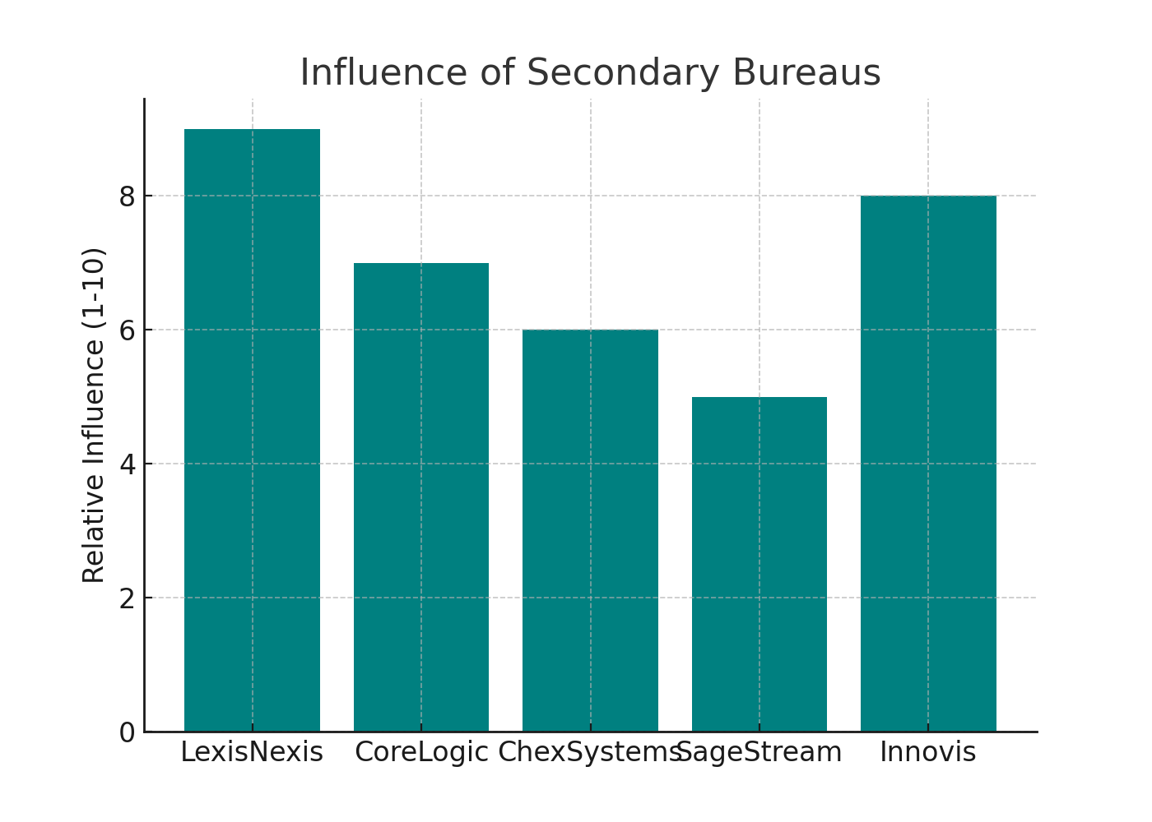
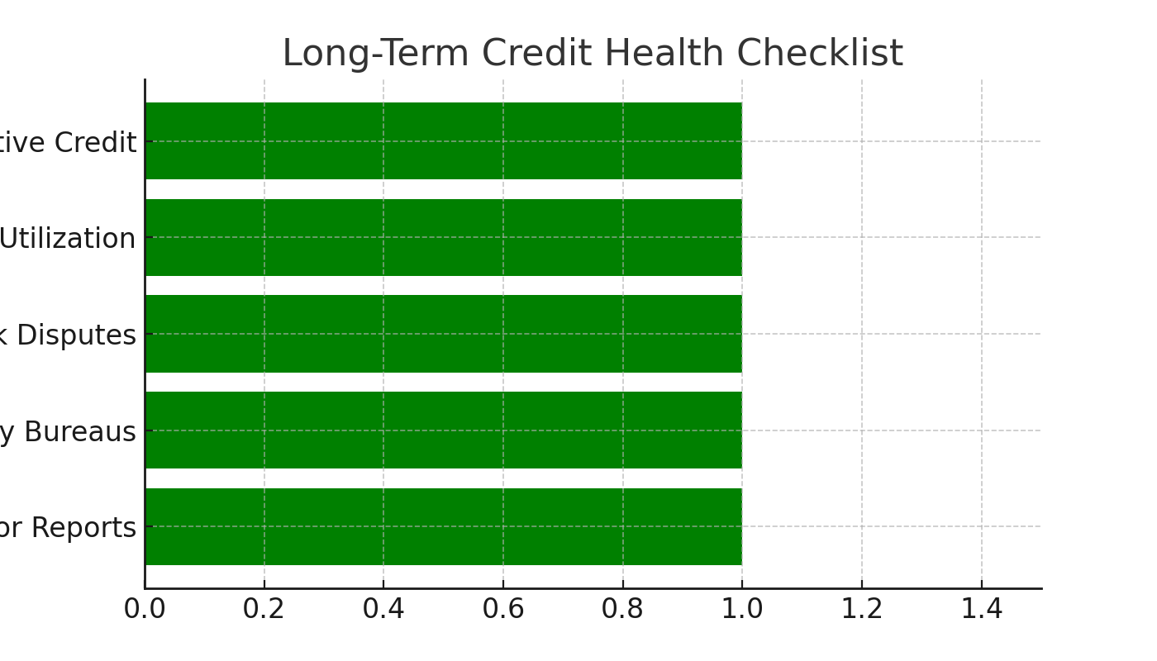
Long-term credit health means not just repairing damage but maintaining control. Freezing secondary bureaus, monitoring your reports, and adding positive tradelines ensure permanent success.

Chapter 12: Strategic Credit Building – Skyrocketing Your Score
Credit repair is only half the battle. To truly skyrocket your score, you must build positive credit alongside disputes. Lenders look for both history and responsibility. Strategic credit building ensures that as negatives fall away, positives fill the gap.
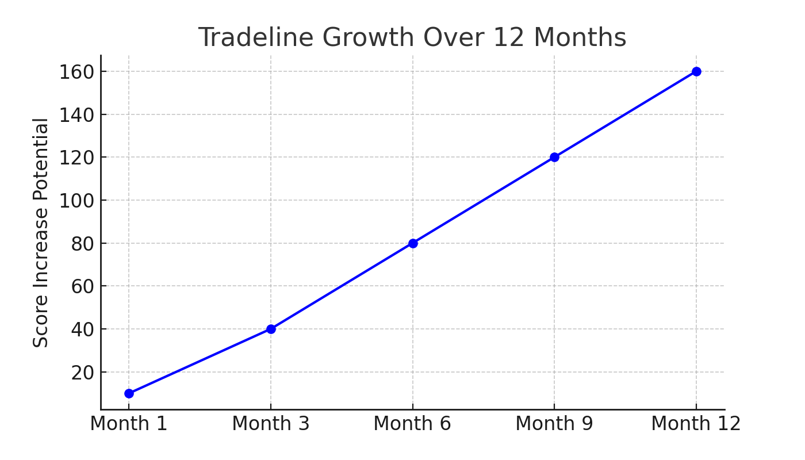
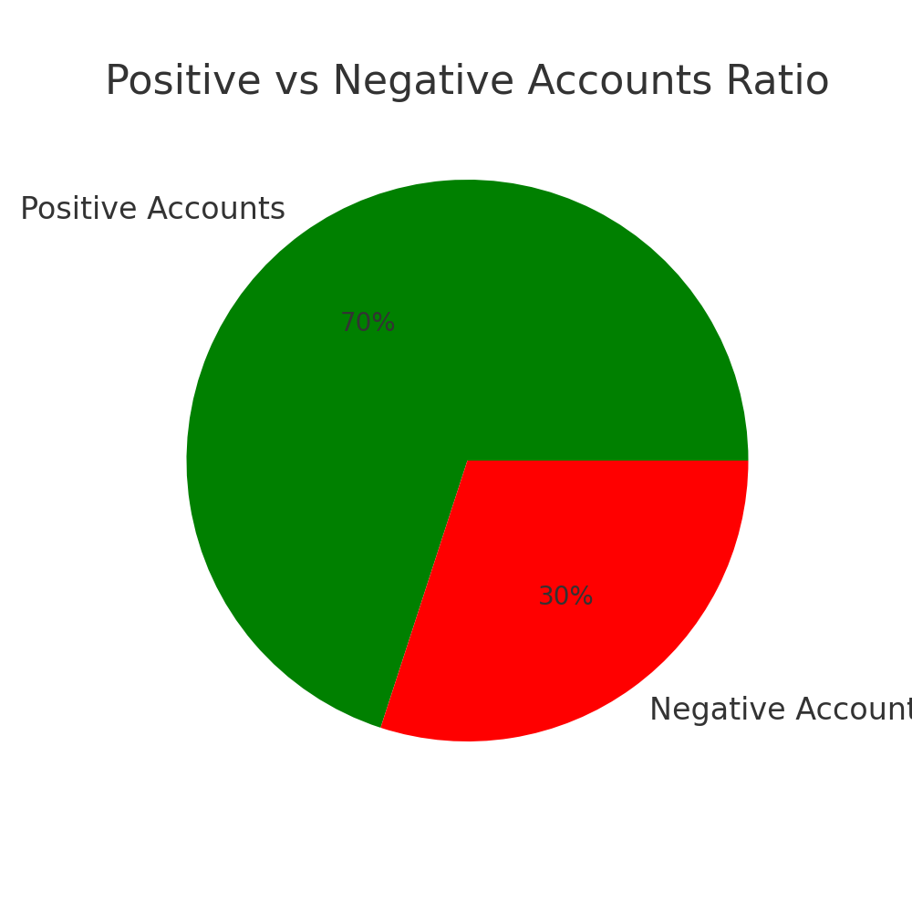
Your goal is to keep the majority of your accounts positive. A 70/30 ratio is excellent, but even 60/40 will dramatically improve your score over time.

Chapter 13: The Power of Secured Credit – Beyond Repair
Secured credit is the bedrock of rebuilding. By putting down a deposit, you eliminate the lender’s risk. In return, you gain a tradeline that reports positive history and boosts your score.
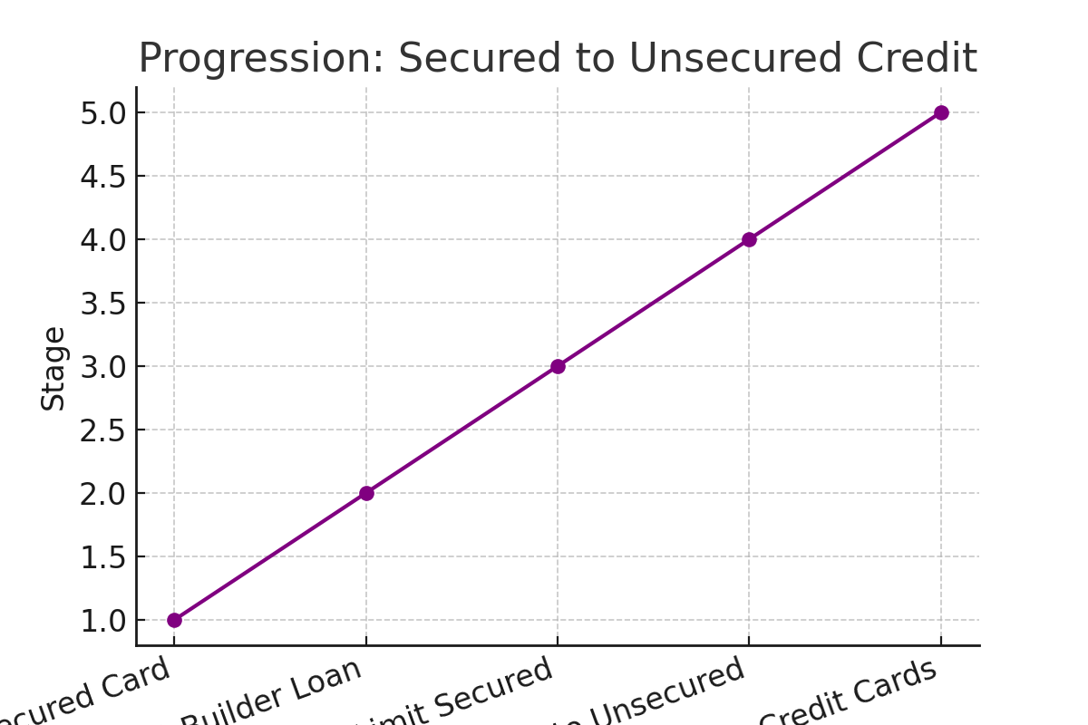
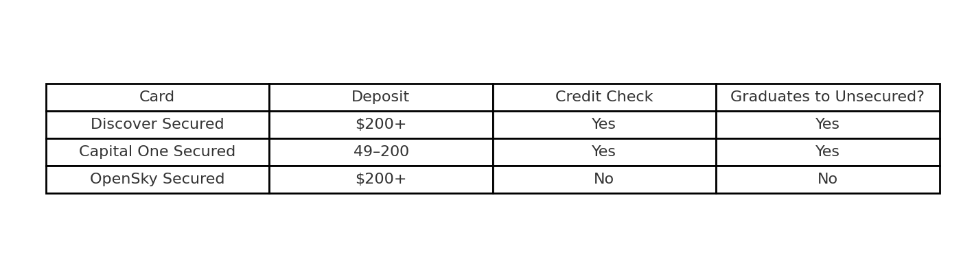
Secured cards and builder loans are your training ground. Choose cards that graduate to unsecured whenever possible for long-term growth.

Chapter 14: Unsecured Credit – Navigating the Landscape
Once your foundation is set, it’s time to pursue unsecured credit. These accounts carry no deposit requirement and often come with higher limits and rewards. But timing is everything—apply too early and denials will set you back.
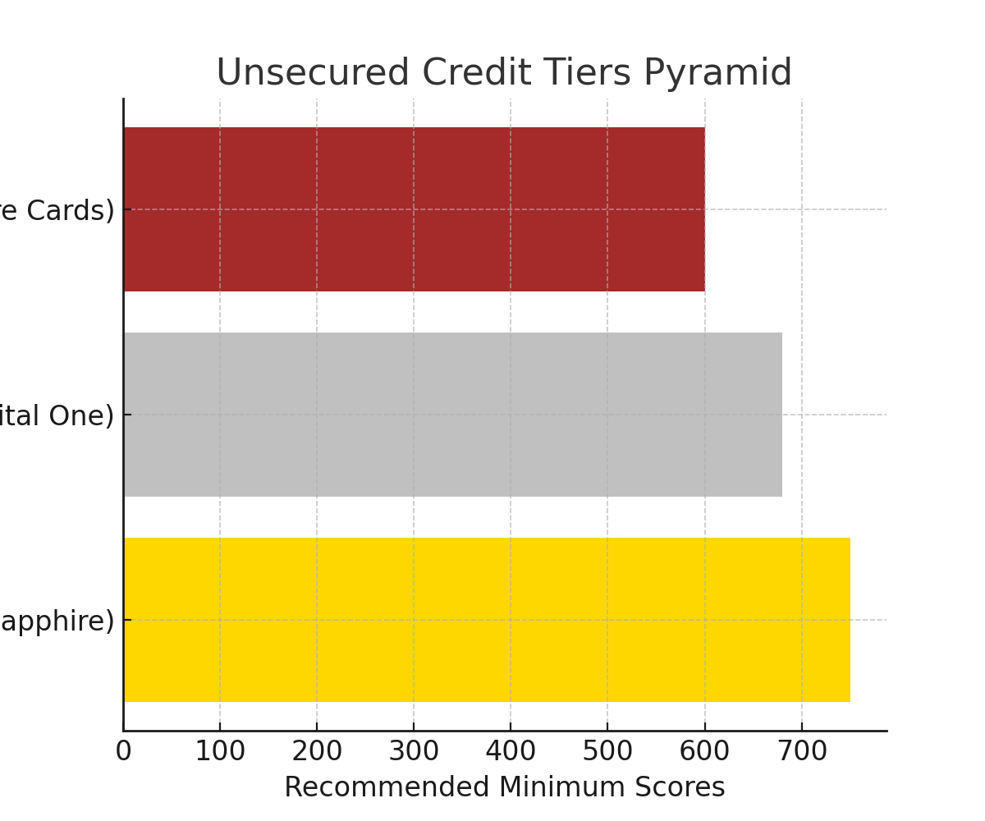
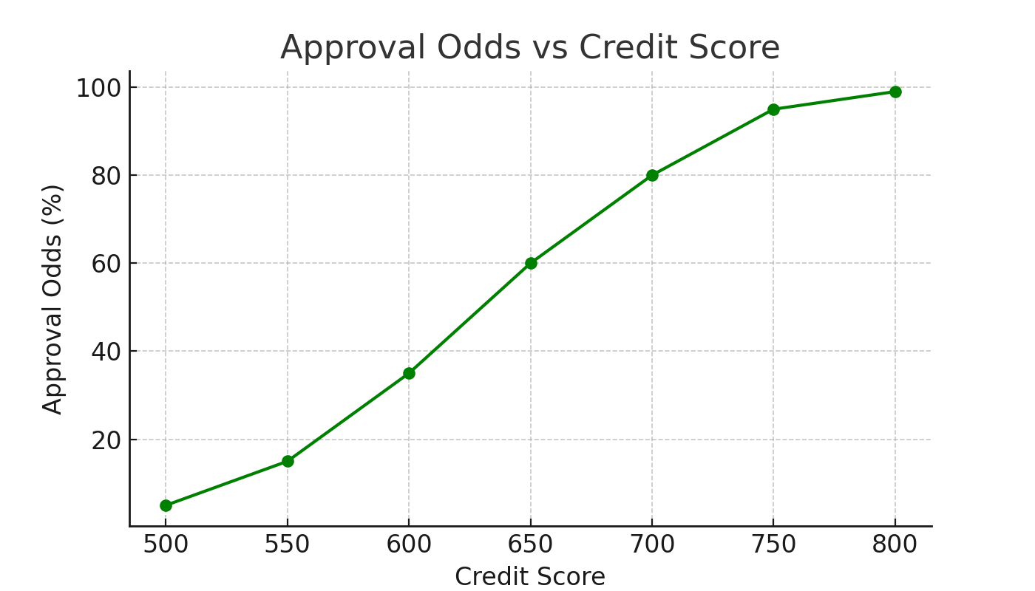
Target the right cards at the right time. Begin with starter unsecured accounts, move into prime lenders, and finally into elite cards once your score and history support it.

Chapter 15: The Profile of a Prime Applicant – What Lenders Look For
Lenders use more than just your credit score. They have a hidden checklist of criteria that determine whether you are a 'prime' applicant. Understanding these factors helps you shape your profile for maximum approvals and the best terms.
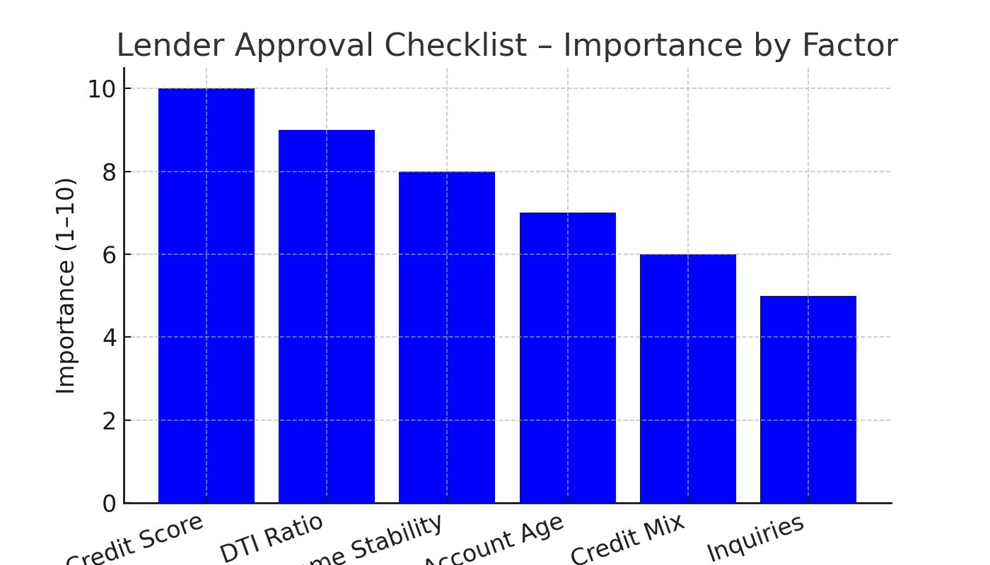
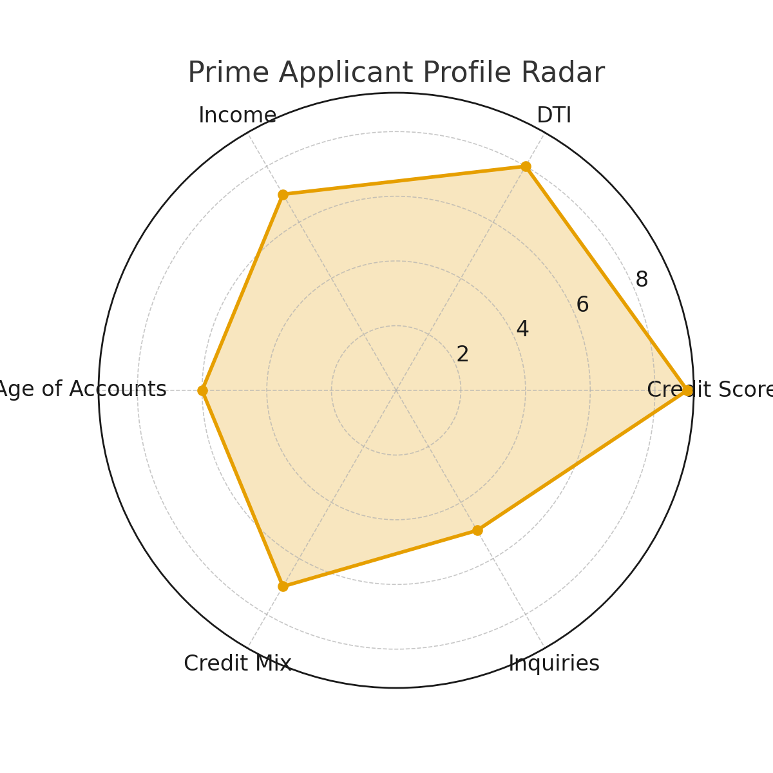

Chapter 16: The Power of the Zip Code
Lenders don’t just look at you—they look at where you live. Geographic risk modeling means that your zip code can influence approval rates and interest terms. High-risk zip codes can lead to higher rates even for strong applicants.
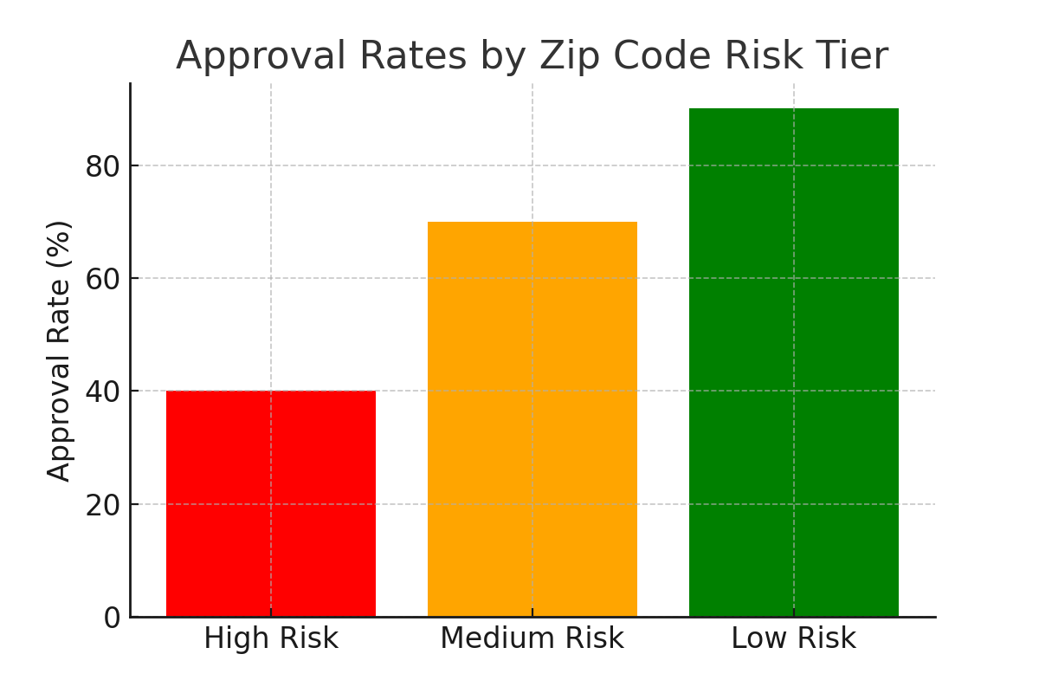
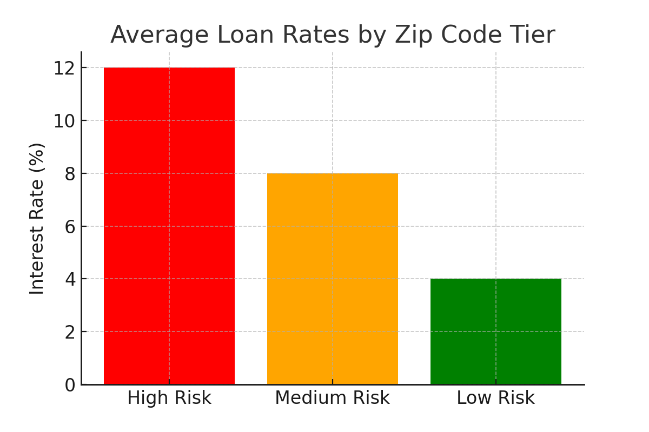

Chapter 17: Supreme Experian (Credit Boosting Tactics)
Experian is unique among the credit bureaus. With Experian Boost and their reporting quirks, you can strategically increase your score and correct errors faster than with other bureaus.
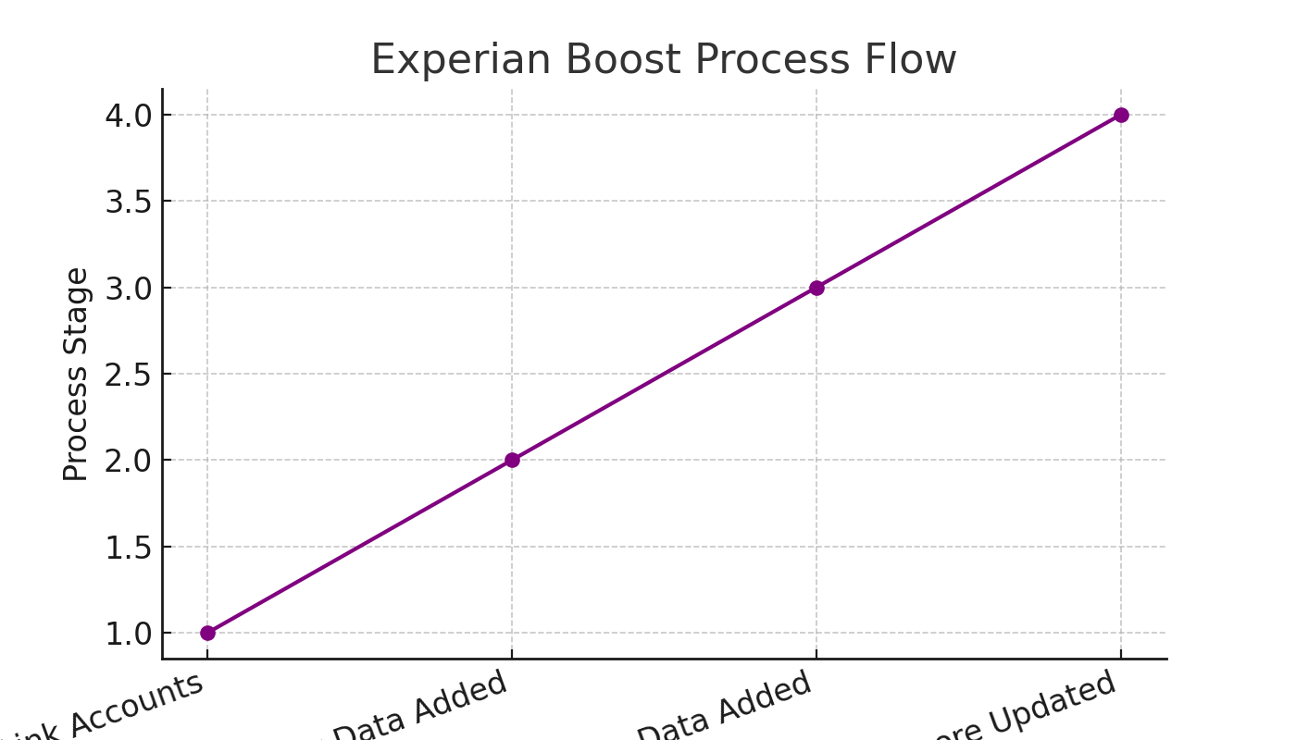
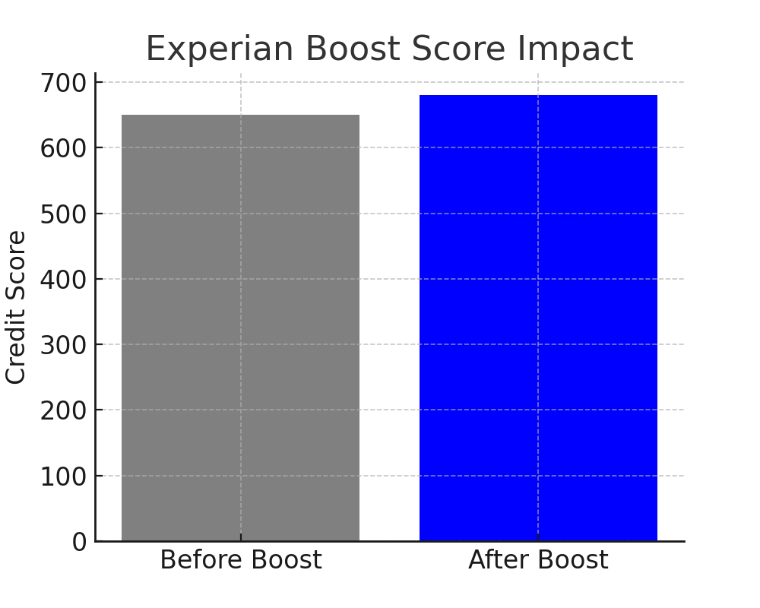
On average, Experian Boost can add 10–30 points to your score. This can be the difference between denial and approval, or between high interest and low interest.

Chapter 18: Strategic Credit Building Example – Integrating Both Methods
To put it all together, let’s walk through a 90-day case study. This example shows how combining dispute methods with strategic tradeline building leads to rapid credit improvement.
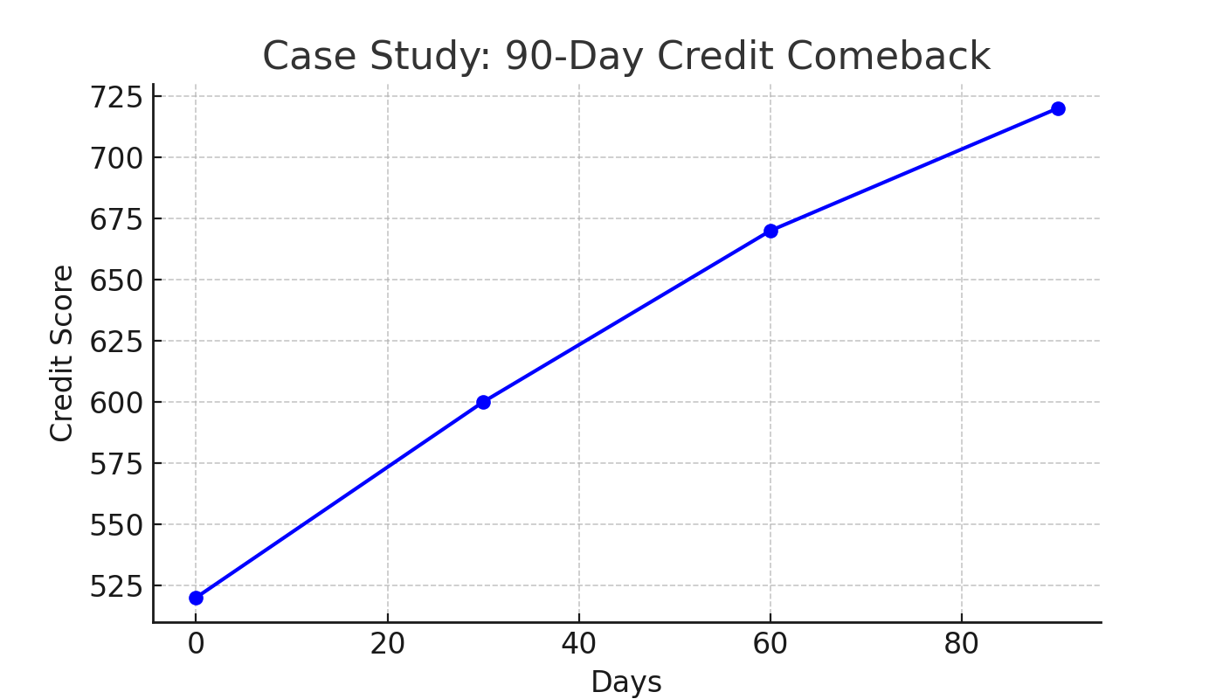
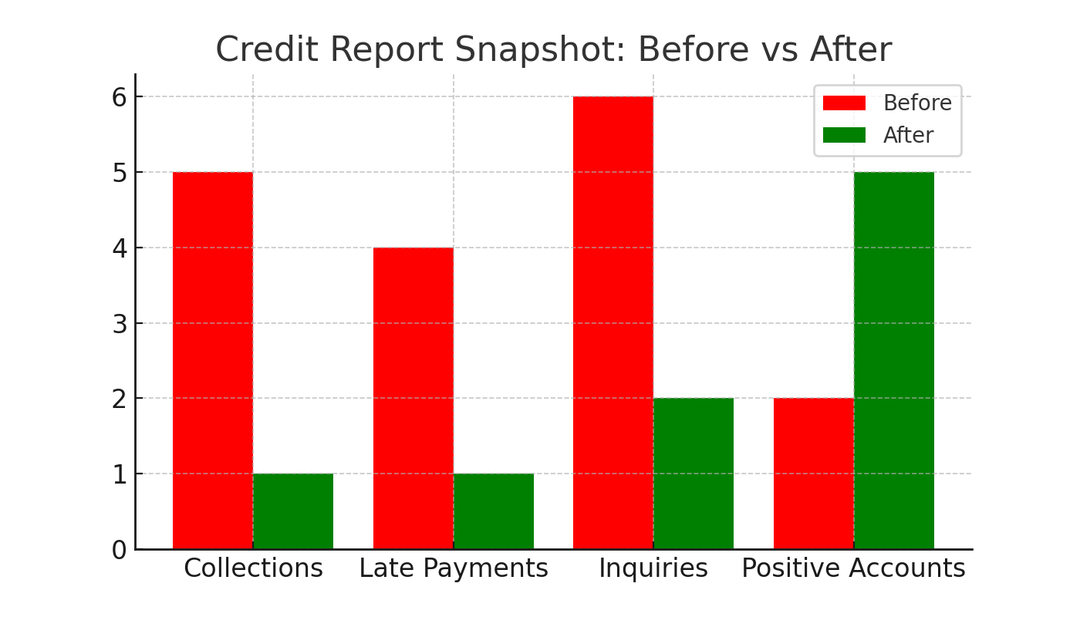

Appendix A: Your Strategic Letter Arsenal
Sample Initial Dispute Letter:
Dear Sir or Madam,
I am writing to dispute the following information on my credit report. The information is inaccurate and should be deleted immediately. ...
Sincerely,
[Your Name]
Sample Method of Verification Letter:
Dear Sir or Madam,
Under Section 611(a)(7) of the FCRA, I am requesting the method of verification used to verify the following account. ...
Sample Escalation Letter:
Dear Executive Office,
I have disputed the following account multiple times. Your failure to provide proper verification is a violation of the FCRA. I demand immediate deletion. ...
Sample CFPB Complaint Draft:
To Whom It May Concern,
This complaint is being filed against [Bureau/Company] for failing to comply with the Fair Credit Reporting Act. ...

Appendix B: Your Legal Edge – Key FCRA Codes
• Section 602 – Congressional findings and purpose.
• Section 604 – Permissible purposes of consumer reports.
• Section 605 – Requirements relating to information excluded from consumer reports.
• Section 607 – Compliance procedures.
• Section 609 – Disclosures to consumers.
• Section 611 – Procedure in case of disputed accuracy.
• Section 616 – Civil liability for willful noncompliance.
• Section 617 – Civil liability for negligent noncompliance.
• Section 623 – Responsibilities of furnishers of information.

Appendix C: Credit Repair Action Tracker Template
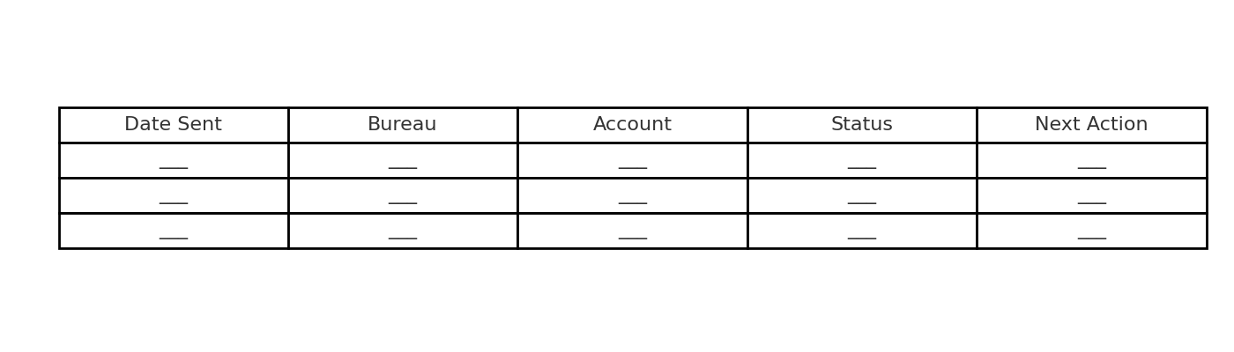

Appendix D: Comprehensive Contact Information & Key Resources
Credit Bureaus:
• Equifax: P.O. Box 740241, Atlanta, GA 30374 — (866) 349-5191
• Experian: P.O. Box 4500, Allen, TX 75013 — (888) 397-3742
• TransUnion: P.O. Box 2000, Chester, PA 19016 — (800) 916-8800
• Innovis: P.O. Box 26, Pittsburgh, PA 15230 — (800) 540-2505
Consumer Protection:
• CFPB: consumerfinance.gov — (855) 411-2372
• FTC: ftc.gov — (877) 382-4357
• State Attorneys General: [Visit your state’s AG website]

