A STUDY TO ASSESS THE PREFERENCE OF ACTIVITY TIME AND ITS INFLUENCE ON EDUCATIONAL ATTAINMENT AMONG UNDERGRADUATE STUDENTS OF NURSING IN A SELECTED COLLEGE, CHENNAI

This Project is submitted to
Sri Ramachandra Faculty of Nursing Sri Ramachandra
Institute of Higher Education and Research (Deemed to be University)
In partial fulfilment of the requirement for the award of degree of

M.Sc. (NURSING) – MEDICAL SURGICAL NURSING

By Reg No:

N1124002, N1124003, N1124004, N1124005, N1124006
Sri Ramachandra Faculty of Nursing, Sri Ramachandra
Institute of Higher Education and Research (Deemed to be University),
Porur, Chennai – 116.

Under the guidance of
Mrs.Geetha.P, M.Sc.(N),
Assistant Professor, Department of Nursing Foundation, Sri Ramachandra Faculty of Nursing,
Sri Ramachandra Institute of Higher Education and Research (DU), Porur, Chennai – 116.

JULY 2025



BONAFIDE CERTIFICATE
This is to certify that the project entitled “A study to Assess the Preference of Activity time and its Influence on Educational Attainment among Undergraduate Students of Nursing in a selected college, Chennai” is submitted to Sri Ramachandra Institute of Higher Education and Research (Deemed to be University) by Ms.Mariae Infanttina.D Reg No: N1124002, Mr.Badmanaban.V Reg No: N1124003, Ms.Sabari Sri.D Reg No: N1124004, Ms.Saranya.B Reg No: N1124005, Ms.Parkavi.R Reg No: N1124006 in partial fulfilment of the requirement for the award of degree of M.Sc(Nursing) – Medical Surgical Nursing. It is a bonafide work done by them in the academic year 2024-2025.

GUIDE

Mrs. Geetha. P, M.Sc.(N),
Assistant Professor,
Department of Nursing Foundation, Sri Ramachandra Faculty of Nursing, Sri Ramachandra
Institute of Higher Education and Research (DU), Porur, Chennai-600-116.0

Prof. Dr.S.J. NALINI, M.Sc.(N).,Ph.D
Principal,
Sri Ramachandra Faculty of Nursing, Sri Ramachandra
Institute of Higher Education and Research (DU). Porur,Chennai-600116.

CERTIFICATE
This is to certify that the dissertation entitled “A study to Assess the Preference of Activity time and its Influence on Educational Attainment among Undergraduate Students of Nursing in a selected college, Chennai” is submitted to Sri Ramachandra Institute of Higher Education and Research (Deemed to be University) by Ms.Mariae Infanttina.D Reg No: N1124002, Mr.Badmanaban.V Reg No: N1124003, Ms.Sabari Sri.D Reg No: N1124004, Ms.Saranya.B Reg No: N1124005, Ms.Parkavi.R Reg No: N1124006 in partial fulfilment of the requirement for the award of degree of M.Sc (Nursing) – Medical Surgical Nursing. It is a bonafide work done by them under my supervision and guidance and conclusions are their own. It is further certified that this Project or any part there of has not formed the basis for award of any degree, diploma or other similar titles.

GUIDE
Mrs. Geetha. P, M.Sc.(N), Assistant Professor,
Department of Nursing Foundation, Sri Ramachandra Faculty of Nursing, Sri Ramachandra
Institute of Higher Education and Research (DU), Porur, Chennai – 600116.

HEAD OF THE DEPARTMENT
Dr. A. Seethalakshmi, M.Sc. (N), M.A (Psy), Ph.D Professor and HOD,
Department of Nursing Foundation, Sri Ramachandra Faculty of Nursing, Sri Ramachandra
Institute of Higher Education and Research (DU), Porur, Chennai-600-116.0

DECLARATION BY THE CANDIDATE

- We Ms.Mariae Infanttina.D, Mr.Badmanaban.V, Ms.Sabari Sri.D, Ms.Saranya.B, Ms.Parkavi.R postgraduate student in the Department of Medical Surgical Nursing hereby declare that the project titled “ A study to Assess the Preference of Activity time and its Influence on Educational Attainment among Undergraduate Students of Nursing in a selected college, Chennai” is a bonafide and original work done by us under the guidance of Mrs.P.Geetha, M.Sc. (N), Assistant Professor, Dept of Nursing Foundation in Sri Ramachandra Faculty of Nursing at Sri Ramachandra Institute of Higher Education and Research (Deemed to be University), Porur, Chennai- 600 116 during the period from 2024 to 2025.

- We further declare that only after obtaining permission of the Publication and Oversight Committee of Sri Ramachandra Institute of Higher Education and Research (Deemed to be University), that publication of the said project work, either in part or in full, will be made by us and that such publication will include only the names of individuals who have actually contributed to the said project work.

- We agree to publish the said project work within a period of one year from the date of qualifying for the M.Sc. Nursing degree, failing which We hereby give our consent to transfer my rights to the guide and Head of the Department of Sri Ramachandra Faculty of Nursing, Sri Ramachandra Institute of Higher Education and Research (Deemed to be University).

- We hereby declare that Sri Ramachandra Institute of Higher Education and Research (Deemed to be University), shall have the rights to preserve, use and disseminate this project work to print or electronic format for academic research purposes.

- We also declare and undertake that this project work either in part or in full, will not be utilized by the subsequently for any purpose, without the written prior permission and consent of the Sri Ramachandra Institute of Higher Education and Research (Deemed to be University).

- We also understand and agree that this declaration made by us is final and irrevocable.

Signature of the candidate : Ms.Mariae Infanttina.D Mr.Badmanaban.V Ms.Sabari Sri.D Ms.Saranya.B Ms.Parkavi.R

Course : M.Sc.Nursing Place : Porur
Date : 29/07/2025

ACKNOWLEDGEMENT

We are grateful to Almighty God for showering abundant blessings for the successful completion of this study.

We thank the Managing Trustee of Sri Ramachandra Institute of Higher Education and Research (DU), Porur, Chennai – 600 116 for enabling the process of our higher education.

We are thankful to Dean of Students, Sri Ramachandra Institute of Higher Education and Research (DU) for permitting us to conduct this study.

Our heartfelt thanks to Prof. Dr. S.J. Nalini, M.Sc. (N), Ph.D., Principal, Sri Ramachandra Faculty of Nursing, Sri Ramachandra Institute of Higher Education and Research (DU) for permitting us to conduct this study.

We are thankful to Dr. Seethalakshmi. A, Professor and Head of the Department, Department of Nursing Foundation, Sri Ramachandra Faculty of Nursing, for her guidance and valuable suggestions to complete this study.

We are thankful to our Guide Mrs. P. Geetha, Assistant Professor, Dept. of Nursing Foundation, Sri Ramachandra Faculty of Nursing, for her guidance and valuable suggestions to complete this study.

We thank all the class teachers of B.Sc. Nursing programme for their support in the successful execution of this study.

We express our thanks and appreciation to all the B.Sc. Nursing Students at Sri Ramachandra Faculty of Nursing who willingly participated in this study for their cooperation and interest in supporting this study.

We are grateful to our family members for their constant support to complete this project.

 | TABLE OF CONTENTS
Chapter No | Titles | Page no
I | Introduction  Background of the study | 1
 | Need for the study | 3
 | Statement of the problem | 4
 | Aim and Objectives | 4
 | Operational Definition | 4
 | Hypothesis | 4
 | Assumptions | 5
 | Delimitation | 5
II | Review of Literature
 | Related Literature | 6
 | Conceptual Framework | 13
III | Methodology
 | Research Approach | 15
 | Research Design | 15
 | Setting | 15
 | Population  Sampling process  Sample | 15  15
 | Sample Size | 15
 | Criteria for Sample Selection | 15
 | Method of sample selection  Instruments  Description of the Instruments | 16  16
 | Scoring and Interpretation | 16
 | Data Collection Procedure | 17
 | Plan for Data Analysis | 19

Ethical Consideration 19
- Analysis and Interpretation 20
- Discussion 33
- Summary, Nursing Implication and Recommendations
Summary of the Study 37
Conclusion 39
Nursing Implications 39
Recommendations for Further Research 39
Reference 40

LIST OF TABLES

Table No | Title | Page no
1 | Distribution of demographic variables of all students | 20
2 | Distribution of demographic variables among male student | 24
3 | Distribution of demographic variables among female student | 25
Distribution of Morningness Eveningness Questionnaire among
4
all students 26
Distribution of Scoring of Morningness Eveningness
5
Questionnaire among all students 30
6 Frequency Distribution 30
Analysis of correlation of preferred activity time with
7
educational attainment 31
Association of Morning vs evening study time preference by
8
gender 31

LIST OF FIGURES

Figure No Title Page no

Conceptual framework on modified Ludwig von Bertalanffy
theory of General System theory 1950 14
1
  - Distribution of age of undergraduate nursing students 21
  - Distribution of gender of undergraduate nursing students 21
  - Distribution of year of study of undergraduate nursing students 22
  - Distribution of preference of activity time of undergraduate nursing students
22
  - Distribution of preference of study time of undergraduate nursing students
23
  - Distribution of hours of sleep per day of undergraduate nursing students
23

LIST OF APPENDICES

Appendix | Title | Page no
A | Ethical Clearance Certificate | xiii
B | Consent form | xiv
C | Permission letter to conduct study | xviii
D | Instruments (Morningness Eveningness Questionnaire) | xxii
E | Certificate of Content validity | xxvi

ABSTRACT

Purpose: Assess the preference of activity time and its influence on educational attainment.

Methods: The research design adopted for this study was descriptive. Using a consecutive Sampling technique, a total of 462 undergraduate students of Nursing from Sri Ramachandra faculty of Nursing, SRIHER(DU) are taken as a study participant who met the inclusion criteria were recruited. The data related to Demographic variables and to explore the relationship between students' activity time preferences and their educational attainment were identified using a Horne ostberg Morningness-Eveningness questionnaire. The data were analyzed using descriptive and inferential statistics.

Major findings: In this study, we found that the overall mean score for all students was 52.74, with a median of 53 and a standard deviation of approximately 7. This suggests a general tendency toward intermediate chronotype across the sample. When analyzed by gender, male students had a slightly higher average score of 53.75 with a median of 54 and a lower standard deviation of 6.02, indicating more consistency in their responses. In contrast, female students had a lower mean score of 51.69, a median of 52, and a higher variability, as reflected by a standard deviation of 7.76. The result of correlation p-value is 0.05, r-value is -0.07 which indicates negative correlation between preferred activity time and educational attainment. Hence our analysis revealed that there is no significant association between the preferred activity time and educational attainment.

Conclusion: The research findings reveals that the majority of students (71%) fall within the intermediate category, indicating neither a strong morning nor evening preference (score range: 42–58). However, no significant correlation was found between demographic factors and the Preference of activity time. Hence there is no significance between the preferred activity time and educational attainment. Furthermore, the study results revealed a negative relationship between preferred activity time and educational attainment.

Keywords: Preference of activity time, chronotype, educational attainment, Undergraduate Nursing students.

CHAPTER - I

INTRODUCTION

Background of the study

In the dynamic environment of higher education, students' academic performance is influenced by a multitude of psychological, physiological, and social factors. One such often overlooked but critical determinant is an individual's preference of activity time, commonly referred to as a chronotype. Chronotype refers to an individual’s natural inclination toward the timing of daily periods of activity and rest—essentially, whether one is a “morning person,” “evening person,” or somewhere in between. This biological predisposition can significantly affect learning behaviors, concentration, and, ultimately, academic performance.

Chronotype or Morningness – Eveningness refers to individual’s temperament, wired by nature for the preference of wakefulness and sleep for a good physical and mental health. It is an underlying body clock or a circadian rhythm , it exhibits your daily pattern of energy and alertness.

The concept of chronotype is rooted in circadian biology. The circadian rhythm is a 24-hour internal clock that regulates sleep-wake cycles, hormone release, body temperature, and other vital functions. While this rhythm is generally aligned with the natural light-dark cycle, it varies from person to person. These variations manifest as differences in alertness and performance across different times of the day. For example, a morning-type (lark) individual is most alert and productive early in the day, while an evening-type (owl) tends to reach peak performance in the late afternoon or evening.

In educational settings, particularly in universities, institutional schedules often do not account for these individual differences. Classes and exams are frequently scheduled during early morning hours, favouring morning-type students. Conversely, evening-type students may struggle with attending early classes or performing well in morning examinations due to misalignment with their internal clocks. This mismatch between preferred activity time and academic schedule may contribute to decreased academic engagement, poor performance, and even burnout.
Moreover, university students experience greater autonomy over their schedules than school students, leading many to adopt sleep and activity patterns that match their chronotype. However, this freedom can conflict with academic demands, leading to “social jetlag,” a condition where a student’s internal biological clock is misaligned with their social obligations. Research suggests that social jetlag is associated with sleep disturbances, decreased cognitive functioning, and lower academic performance.

CHRONOTYPE AND COGNITIVE PERFORMANCE

Chronotype is largely governed by the circadian system, which is synchronized with environmental cues such as light and social schedules. According to Adan et al. (2020), this

preference is stable and has a strong biological basis, though it may shift with age and lifestyle. Numerous studies have shown that morning chronotypes tend to perform better academically, as early academic schedules align better with their peak alertness times. Conversely, evening chronotypes may experience a “circadian misalignment,” which leads to poorer sleep quality and impaired academic functioning (Beattie et al., 2021).

This link between chronotype and academic achievement has been robustly demonstrated. In a longitudinal study by Roeser et al. (2021), evening chronotype students consistently reported lower academic engagement and poorer cumulative GPAs compared to morning-type peers. These effects were partly mediated by sleep deprivation and reduced executive functioning.

CHRONOTYPE, SLEEP, AND SOCIAL JETLAG

A major factor that mediates the link between activity time preference and academic success is “social jetlag” — the discrepancy between an individual's biological timing and their social obligations, such as class schedules and exams. Wittmann et al. (2020) define social jetlag as the difference between sleep timing on school days versus free days, and argue that it is a significant predictor of poor sleep quality and academic fatigue.

Evans et al. (2022) examined a sample of over 4,000 university students and found that social jetlag, particularly among evening-type students, was strongly associated with daytime sleepiness, increased procrastination, and lower academic productivity. This suggests that evening-types are not less capable but are simply operating in less favorable temporal conditions.

IMPACT ON EDUCATIONAL ATTAINMENT

Educational attainment, in this context, refers to measurable outcomes such as GPA, exam scores, assignment completion rates, and perceived academic satisfaction. Several recent studies have established a significant correlation between chronotype and these outcomes. A study by Kühnle et al. (2023) reported that even after controlling for sleep duration and lifestyle factors, evening chronotypes had significantly lower GPAs than morning types. This effect was particularly prominent in academic environments with early lecture schedules.

Moreover, research by Smarr and Schirmer (2021) highlights how academic institutions contribute to performance disparities by enforcing a “one-size-fits-all” timetable that advantages morning-oriented students. They advocate for more flexible class timings and asynchronous learning models to support chronotype diversity.

TECHNOLOGY USE AND LIFESTYLE CHANGES

In modern academic settings, digital device usage and irregular sleep schedules have further complicated chronotype regulation. Evening chronotypes are more likely to engage in late- night screen time, which suppresses melatonin production and leads to further delays in sleep

onset (Zerbini et al., 2020). As students increasingly rely on online learning, the blurring boundaries between study and rest time intensify chronotype misalignment.

Salmela et al. (2022) found that during the COVID-19 pandemic, the shift to remote education allowed evening-type students to align their learning with their natural rhythms, which resulted in significant improvements in academic performance and subjective well-being. This suggests that flexibility in academic schedules could be a viable intervention to reduce chronotype- related educational disparities.

NEED FOR THE STUDY

The transition from secondary to higher education introduces a multitude of changes in students’ routines, responsibilities, and academic expectations. Among these, one often overlooked but critical factor affecting academic performance is an individual’s chronotype— the natural preference for activity and alertness during specific times of the day. Despite growing international evidence suggesting that chronotype significantly impacts academic engagement and outcomes, this subject remains under-researched in many educational contexts, particularly in India.

Studies by Adan et al. (2020) and Roeser et al. (2021) have demonstrated that chronotype is not merely a matter of personal habit or preference, but a biological and psychological factor that directly influences alertness, concentration, and memory—key components of successful learning. These researchers found that students whose learning schedules are misaligned with their chronotypes, especially evening types forced to function in early-morning academic settings, suffer from reduced cognitive performance and academic achievement.

Social jetlag, defined as the mismatch between biological sleep patterns and social obligations such as early classes, is another factor contributing to poor academic outcomes. According to Evans et al. (2022), students experiencing greater social jetlag exhibit poorer sleep quality, increased fatigue, and diminished executive functioning, which in turn negatively impacts academic performance. These findings underscore the urgent need to consider chronotype in educational planning.

In the context of rapidly evolving digital lifestyles, the problem has become even more pronounced. Zerbini et al. (2020) report that increased use of electronic devices among students, especially in the evening, is linked to delayed sleep onset, sleep deprivation, and a drift toward eveningness in chronotype. These lifestyle changes contribute to irregular sleep- wake schedules, further affecting learning capacity and academic motivation. The use of screen-based learning, especially post-COVID-19, has exacerbated this misalignment for many students, as noted by Salmela et al. (2022), who observed that evening-type students reported improved academic engagement during remote learning periods that allowed flexible timing.

Moreover, there is a persistent systemic bias in academic institutions that favor early chronotypes. Most university schedules are structured around morning lectures and exams,

inadvertently privileging morning-type students and disadvantaging those with later chronotypes. Smarr and Schirmer (2021) argue that this structural rigidity contributes to an inequality of academic opportunity. They recommend a reevaluation of academic timetabling to accommodate the diverse chronotypes of students.

Despite the growing international literature, there remains a significant gap in regional studies exploring this topic among undergraduate populations in South Asian contexts. Indian students, in particular, face unique sociocultural and educational pressures that shape their academic and sleep patterns. Cultural expectations of early rising, rigid class schedules, intense competition, and limited awareness of sleep hygiene further aggravate the mismatch between biological rhythm and academic demands. There is, therefore, a pressing need to explore how these factors operate within the Indian undergraduate context.

Additionally, the scarcity of awareness about chronotype and its implications among educators, curriculum developers, and policymakers limits the development of supportive educational environments. The inclusion of chronotype-based learning strategies could not only improve academic outcomes but also enhance student well-being, reduce academic stress, and increase retention.

STATEMENT OF THE PROBLEM
A study to assess the preference of activity time and its influence on educational attainment among undergraduate students of nursing in selected college, Chennai
AIM AND OBJECTIVES
The aim of the study is to identify the relationship between preferred time for activity with educational attainment

THE OBJECTIVES OF THE STUDY IS TO
- Assess the preference of times for activity among undergraduate nursing students
- Correlate the preferred activity time with educational attainment of undergraduate nursing students
OPERATIONAL DEFINITION

PREFERENCE
An individual favoured option that can pertains to various choices adapted by the individual on their own.

ACTIVITY TIME
Time period when undergraduate nursing students wish to undertake most of their academic and non-academic activities include studying, completing their requirements, extracurricular activities whether morningness or eveningness determined using Horne Ostberg Morningness- Eveningness scale (1976).

INFLUENCE
Time chosen by the individual may impact the learning activities of undergraduate students to meet their educational achievements.

EDUCATIONAL ATTAINMENT
The academic performance of undergraduate students measured by their percentage of marks in the previous semester.

HYPOTHESIS
There is no significant relationship between preferred activity time and educational attainment among undergraduate nursing students
ASSUMPTION
The scoring given by the individual for the questionnaire was true based on their preferred time for their activities.

DELIMITATION
The study was delimited to the undergraduate students of nursing in Sri Ramachandra Institute of Higher Education and Research(DU).

CHAPTER – II

REVIEW OF LITERATURE
The review of literature facilitates comprehension of the work accomplished, identifying gaps and significant areas of importance within the chosen topic.
This chapter consists of two sections:
Section A: Review of Literature Section B: Conceptual Framework

Section A: Review of Literature
The review of literature has been organized and described under the following headings for easy understanding:
- Studies related to chronotype and academic activity among undergraduate nursing students
- Studies related to time preferences on other activities and its influence on education among undergraduate nursing students

Studies related to chronotype and academic activity
Non and Tempelaar (2016) conducted a study at Maastricht University to examine the relationship between time preferences, study effort, and academic performance among 794 first-year business and economics students. This observational study focused on students' actual study efforts in a compulsory quantitative methods course. The findings revealed a significant link between impatience and poorer academic outcomes. Impatient students tended to score lower on final exams and had a 34% higher failure rate, with an estimated 0.5 additional failed exams per academic year. The cumulative negative effect of impatience on performance could reach up to 55%, particularly among higher-ability students. Interestingly, while academic performance declined, no clear differences were found in study hours, exercise completion, or summer course participation.

Mirghani (2017) conducted a cross-sectional study at Omdurman Islamic University, Sudan, to examine the relationship between chronotype and academic performance among 140 medical students. The study compared students with excellent (A grade) and average (C grade) performance using a structured questionnaire to assess sleep patterns. Results showed that high- performing students had an earlier chronotype, consistent bedtimes, and less variation in sleep schedules. In contrast, average performers exhibited a strong evening preference, longer sleep latency, and irregular weekend sleep patterns. A significant association was found between

evening chronotype and lower academic performance, with no notable gender differences. The study concluded that chronotype significantly impacts academic outcomes, suggesting that academic schedules aligned with individual chronotypes may enhance student performance.

(Valladares et al., 2017) conducted a cross-sectional study to explore the association between chronotypes and academic performance among 703 Chilean university students. The Horne- Östberg Morningness–Eveningness Questionnaire was used to classify participants into morning, intermediate, or evening chronotypes. Results indicated that students with morning and intermediate chronotypes had significantly higher GPAs (p = 0.002) compared to those with evening chronotypes. The authors suggested that earlier chronotypes may align better with academic schedules, leading to improved performance. However, they emphasized the need for further investigation into the cognitive and behavioural mechanisms underlying this relationship. This study highlights the potential impact of biological rhythms on educational outcomes and suggests that aligning academic demands with individual chronotypes could enhance student success.

Alharbi et al. (2017) conducted a descriptive cross-sectional study at King Saud University, Saudi Arabia, to assess learning preferences among nursing students. Using a convenience sample of 56 students, of whom 43% completed the Felder-Silverman Learning Style Model (FSLSM) questionnaire, the study aimed to identify preferred learning styles to enhance learning outcomes. Findings revealed that 67.9% of students preferred visual learning, followed by active (50%) and sequential (37.5%) styles, while verbal learning was least preferred (3.6%). No significant association was found between gender and learning preferences (p > 0.05). The study concluded that visual, active, and sequential styles were the most common learning preferences.
(Kemptner & Tolan, n.d., 2018) examined the influence of time-inconsistent preferences on educational decisions using a structural dynamic choice model. The study utilized data from the German Socioeconomic Panel (SOEP) to analyse how hyperbolic discounting affects student behaviour and educational policy outcomes. Findings showed that students with time- inconsistent preferences respond differently to educational incentives, such as state grants and loans. Models accounting for hyperbolic discounting revealed significant differences in educational attainment compared to traditional exponential models, suggesting that conventional assumptions may underestimate the effects of short-term cost reductions or long-

term benefit increases. The study highlights the importance of incorporating behavioural economics into education policy design.
Akram et al. (2018) conducted a study among 345 undergraduate medical students to examine the effects of chronotype and learning approach on academic performance, measured by CGPA. Using the Morningness-Eveningness Questionnaire and Biggs Revised Two-Factor Study Process Questionnaire, the study found that morning types were more likely to adopt deep learning strategies, while evening types favored surface learning. Although no significant difference in CGPA was observed between chronotypes, deep learners performed better academically than surface learners. The interaction between chronotype and learning approach significantly influenced academic achievement, suggesting that chronotype affects performance indirectly through learning style.
(Adan, Natale & Smith, 2020) conducted a meta-analytical review to assess the relationship between chronotype and academic performance across various studies. The review included data from multiple studies that examined how morningness and eveningness preferences influenced students’ academic outcomes. The findings revealed that morning-type students typically achieve better academic results compared to their evening-type counterparts. This disparity in performance was attributed to various factors, including differences in attentiveness, motivation, and sleep quality between the two groups. The review highlights the importance of considering students' chronotypes in educational settings and provides recommendations for interventions that could support evening-type students in order to enhance their academic performance. Ultimately, the study emphasizes the need for further research on how educational practices can be adapted to accommodate diverse chronotypes among students.

(Roeser et al., 2021) conducted a longitudinal study examining the relationship between chronotype and academic achievement in university students. The research included multiple assessments over an academic year, tracking students' chronotype preferences and corresponding academic performance metrics. Findings revealed that students with a morning chronotype demonstrated significantly better academic achievement than evening-oriented peers. The study identified factors such as sleep patterns, time management, and class attendance as potential mediators of this relationship. Additionally, the authors emphasized the importance of aligning academic schedules with students' natural rhythms to enhance learning outcomes. Ultimately, this research contributes to a deeper understanding of how chronotype

can impact educational success and suggests practical implications for curriculum design in higher education.
(Smarr & Schirmer, 2021) explored the impacts of chronotype and time-of-day on student achievement, highlighting institutional implications for educational practices. The study analysed data from university students to assess how alignment between students' chronotypes and class schedules affected academic performance. Findings indicated that students who attended classes during their optimal performance times-aligned with their chronotype- achieved significantly higher grades. The authors discussed the detrimental effects of early morning classes on evening-type students, suggesting that institutions should consider flexible scheduling to accommodate diverse chronotypes. This research underscores the importance of aligning educational structures with biological rhythms to enhance student success and well- being, advocating for policies that support chronotype-sensitive scheduling in higher education settings.

(Salmela, Karhula, & Lankinen, 2022) examined the impact of remote learning on chronotype- aligned performance during the COVID-19 pandemic. The study assessed university students' academic outcomes in relation to their chronotype preferences as learning transitioned online. Findings revealed that students with a morning chronotype experienced improved academic performance in remote learning environments, likely due to alignment with traditional academic schedules. In contrast, evening-type students reported challenges, including decreased engagement and productivity. The authors discussed the implications of flexible learning schedules that could better accommodate diverse chronotypes, suggesting strategies to enhance academic success for all students during periods of remote learning. Overall, this research highlights the critical intersection of chronotype and educational strategies in the evolving landscape of higher education.

(Nicholson et al., 2022) Investigating the role of morningness/eveningness in physical activity engagement. A prospective design was conducted in 136 participants (16-64 years old). The study consisted of 99 women, 36 men and 1 individual who identified as non-binary. The aim of this study is to predict individuals’ engagement in physical activity depending on morningness/eveningness. The instrument used in this study were assessed using the Morningness-Eveningness Stability Scale (MESS), whereas physical activity engagement was evaluated with the short version of the International Physical Activity Questionnaire. Two hierarchical multiple regressions were performed to predict motivation for engaging in physical

activity and to directly forecast actual physical activity levels. Additionally, a mediation analysis was carried out to examine the influence of planning on physical activity engagement. Finally, the study findings indicated that younger participants and those with higher self- efficacy were more motivated to engage in physical activity, and that planning directly predicted actual engagement. However, morningness/eveningness did not significantly influence activity levels. Moreover, planning was found to mediate the relationship between motivation and engagement.

Hasan et al. (2022) conducted a study among 1,011 university students (aged 18–27) at the University of Rajshahi, Bangladesh, to examine the impact of chronotype shifts during the COVID-19 lockdown on mood and well-being. Using self-report questionnaires, data on chronotype, morningness-eveningness preference, mood, and well-being were collected via an online survey. Analysis included descriptive statistics, F-tests, Pearson correlations, and simple slope analysis. Results showed that participants adjusted their sleep-wake schedules in line with their chronotype, and those who shifted toward an earlier schedule experienced improved mood and well-being. Morning types benefited most, reporting higher vigor and greater well- being.

(Kühnle, Wolf, & Roenneberg, 2023) investigated the relationship between circadian rhythms and academic achievement, focusing specifically on GPA outcomes across different chronotypes. The study surveyed university students to assess how alignment between their biological clocks and academic schedules affected their grades. Results indicated that students whose chronotypes matched the timing of academic demands achieved higher GPAs, particularly those with morning chronotypes. The authors discussed the implications of their findings for educational policies, highlighting the potential benefits of scheduling lectures and exams in consideration of students’ natural circadian rhythms. This research emphasizes the need for institutions to adopt chronotype-sensitive strategies to enhance academic performance and student well-being, suggesting that greater awareness of circadian influences could lead to improved educational outcomes.

Imam et al. (2024) conducted a cross-sectional study at Jamia Hamdard, Delhi, to assess the effect of morningness-eveningness chronotype on academic performance among 100 undergraduate students aged 18–30. Using the Morningness-Eveningness Questionnaire (MEQ) and academic percentages from the past three years, data were analyzed with one-way ANOVA via SPSS v23. Results showed that morning types had the highest academic

performance (75.53 ± 7.28), followed by intermediate (73.72 ± 6.46) and evening types (66.42
± 10.08), with differences being statistically significant (p < 0.05). The study concluded that morning chronotype is associated with better academic outcomes

Studies related to time preferences on other activities and its influence on education

(Rahafar et al., 2016) conducted a study among 158 high school students to examine the relationships between chronotype, gender, conscientiousness, test anxiety, and academic achievement, measured by GPA. Using structural equation modeling (SEM), the study found that girls had higher GPAs and test anxiety than boys. Morningness and conscientiousness positively correlated with GPA (r = 0.29 and r = 0.17, respectively), while conscientiousness negatively correlated with test anxiety (r = -0.22). Gender emerged as the strongest predictor of academic performance. Test anxiety was linked to GPA only in girls, and chronotype moderated the relationship between gender and GPA. The study concluded that gender and chronotype significantly influence academic success.

(Wittmann et al.,2020) conducted a review on social jetlag—the misalignment between biological and social time—and its impact on sleep, health, and cognitive performance. The review highlighted that students are especially affected due to academic schedules conflicting with their natural sleep-wake cycles. Contributing factors include lifestyle, work, and social commitments, which can impair well-being and academic outcomes. The authors emphasized the importance of aligning social schedules with biological rhythms and called for increased awareness and strategies in educational settings to reduce social jetlag and improve student health and performance.

(Beattie, Kyle, & Espie, 2021) provided a comprehensive review of recent research exploring the intertwined roles of sleep and chronotype in academic performance. The review synthesized data from multiple studies suggesting that quality and quantity of sleep significantly influence cognitive functions and learning outcomes. Morning-type students generally outperformed their evening-type peers, particularly in traditional educational settings. Factors such as sleep disorders, academic workload, and lifestyle choices were identified as critical variables affecting sleep quality and consequently academic success. The authors advocated for educational interventions that take chronotype and sleep patterns into account, emphasizing the importance of promoting healthy sleep habits among students to optimize their academic

potential. This review highlights the need for further research into chronotype-specific educational practices aimed at enhancing student achievement.
(Evans, Kelley, & Kelley, 2022) examined the relationship between social jetlag and academic performance among university students. The study involved a survey of students to assess sleep patterns and academic outcomes over the course of the semester. Findings indicated that social jetlag, defined as the discrepancy between an individual's biological clock and their social schedule, negatively impacted academic performance. Students experiencing higher levels of social jetlag reported lower grades and increased absenteeism. The authors highlighted that managing sleep schedules in alignment with academic responsibilities could mitigate negative effects. The study emphasizes the need for educational institutions to consider chronobiological factors in student support services, aiming to enhance academic achievement through better sleep hygiene practices.

(Barley et al., 2023) investigated chronotype variation and its behavioural correlates among 858 undergraduate science students. Surveys assessed sleep quality, academic load, and habits like caffeine intake, social media use, and napping. Evening-types reported poorer sleep, more bedtime social media use (22% higher), longer daytime naps (27% higher), and more late caffeine use (46% higher) than morning-types. Chronotype was found to be malleable, with 6.3% of students switching chronotypes across the semester. Evening-to-morning switchers showed improved sleep and reduced caffeine intake. The study suggests that behavioural habits may influence chronotype and sleep outcomes in college students.

(Manjareeka et al., 2025) conducted a cross-sectional study among 148 first-year medical students in India to explore the relationship between chronotype, perceived stress, and academic achievement. Using the Munich Chronotype Questionnaire and Perceived Stress Scale, the study found that morning chronotypes had significantly better academic performance (49.1% in the “Excellent” group) compared to evening types (29%, p = 0.03). Evening types also reported higher stress levels (p = 0.028), longer sleep latency, and more irregular weekend sleep schedules (p < 0.001). No significant gender differences were observed. The study concluded that chronotype influences both academic success and stress, with morning types better aligned to academic demands.
(Jeppsson and Norrgren 2025) investigated the relationship between mothers’ time preferences and their children’s educational outcomes using the Stockholm Birth Cohort (SBC) data. The data included 3,317 adolescents born in 1953 and their mothers, with time preference data

collected in 1966 and 1968, respectively. The study found that children of patient mothers had higher grades, were more likely to be enrolled in academic elementary school tracks, and were more likely to attain post-secondary education. However, the mother’s time preferences were not significantly associated with the adolescent’s choice of upper secondary school program or completion. The analysis also explored potential mechanisms, finding evidence of intergenerational correlations of time preferences and a relationship between mothers’ time preferences and adolescents’ preferences for future education.

Section B: Conceptual Framework
Ludwig von Bertalanffy is the author of General System. He was an Austrian biologist and systems theorist. The book was first published in 1950 and has since become a foundational work in the field of systems thinking and interdisciplinary studies. Ludwig von Bertalanffy's General System Theory is an interdisciplinary framework that aims to understand complex systems across various fields such as biology, engineering, social sciences, and more. The core idea is that systems, regardless of their specific nature, share common principles and structures that can be studied and applied broadly.
Core Components: Input, Throughput, Output
The model views a system as an organized collection of parts with a flow of resources and information:
Input: These are the resources, energy, or information fed into the system from its environment. Inputs are necessary for the system to operate or produce outcomes.
Throughput: This refers to the processes or transformations that occur within the system. It involves the internal activities that convert inputs into outputs, such as processing, regulation, or feedback mechanisms.
Output: The final products, services, or results that the system releases back into its environment. Outputs can be physical materials, information, or signals.
Applying health general system theory. To identify the preference of activity time and its influence on educational attainment. Analysing the various components of the model to see how they might influence a student activity time on their education.




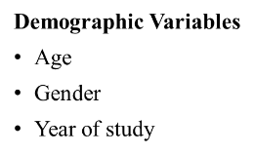
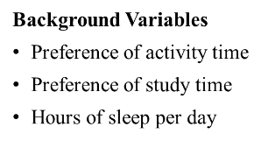
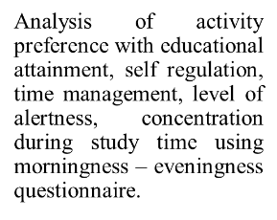


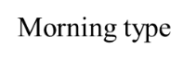
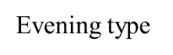
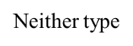
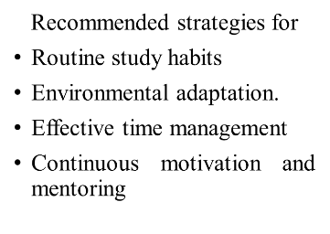

Figure 1: Conceptual framework on modified Ludwig von Bertalanffy theory of General System theory 1950.

CHAPTER – III

METHODOLOGY
This chapter describes the methodology that was followed to determine the preference of activity time and its influence on educational attainment among undergraduate students of nursing in selected college, Chennai
It includes the research approach, design, setting, population, sample size, sampling technique, sampling criteria, description of the tool, and data collection procedure

Research Approach
The quantitative approach was considered to be the most appropriate to achieve the set objectives.

Research Design
The research design adopted for this study was an Cross Sectional Research Design

Setting
The study was conducted in Sri Ramachandra Faculty of Nursing, SRIHER

Population Target Population
The target population was undergraduate students of Sri Ramachandra Faculty of Nursing, SRIHER, Porur, Chennai

Sampling Process Sample
Undergraduate Students of Sri Ramachandra Faculty of Nursing, SRIHER.

Sample Size
Justification of sample size
Since it is a consecutive sampling technique, all the undergraduate students of Nursing. Were included as study participant (I year -160 +II year -160+ III year
-100+ IV year -100. Total= 520).

Criteria for Sample Selection Inclusion criteria
The samples included were
- Undergraduate Nursing students aged from 18 to 21
- Those who are available at the time of data collection
- Willing to participate in the study

Exclusion criteria
The samples excluded from the study were those who were
- Not available at the time of data collection
- Not willing to participate

Method of sample collection
- Sampling Technique: consecutive Sampling
- Non-Randomization was done using the questionnaire method for the study and the control group.
Table 1: Methods of sample selection

NAME OF THE PROGRAMME | NUMBER OF STUDENTS PARTICIPATED
B.sc Nursing 1st year | 160
B.sc Nursing 2nd year | 160
B.sc Nursing 3RD year | 100
B.sc Nursing 4th year | 100

INSTRUMENTS:

Description of instruments
The data collection for this study was conducted using two parts of a structured tool: Part 1: Demographic variables
This section collected background information about the participants, including Age, Gender, Year of study, Percentage of marks obtained in the previous academic year, Preferred activity time, Preferred study time, Average sleep hours per day .These variables helped to describe the sample and analyze relationships between chronotype, academic behavior, and educational outcomes.
Part 2: Morningness–Eveningness Questionnaire (MEQ)
The Morningness–Eveningness Questionnaire (MEQ) developed by Horne and Ostberg (1976) is a validated tool used to determine a person’s chronotype, which reflects their preferred timing of daily activities — whether they are more active and alert in the morning, evening, or neither. The tool consists of 19 multiple-choice questions assessing, Preferred wake-up and sleep times, Alertness levels throughout the day, Self-perceived productivity at different times

Scoring and Interpretation:
70–86: Definitely morning type 59–69: Moderately morning type 42–58: Neither type
31–41: Moderately evening type 16–30: Definitely evening type

The total score categorizes individuals into chronotypes, which are then compared against academic performance to analyze their potential influence.

Data Collection Procedure
Ethical permission was obtained from the Institutional Ethics Committee (students) of Sri Ramachandra Institute of Higher Education and Research (DU). Permission to conduct the study was obtained from the Principal, Faculty of Nursing, Dean of students and Chairman, Institutional Ethics Committee, SRIHER (DU)IEC NO.187.The study was conducted from 2.06.2025 to 15.06.2025. Students are in Sri Ramachandra Faculty of Nursing. The investigator obtained formal approval after which the researcher selected participants who met the inclusion criteria. The researcher introduced themself to the study participants, explained the purpose and process of data collection. The informed consent was then obtained from the participants. Participants were approached during class hours and provided with the study’s purpose and informed consent form. Once consent was obtained, they completed the MEQ and a demographic through google form, which included their previous semester marks to measure educational attainment. The questions was posted to students through google forms to 520 students and only 462 response was received from the students .

Data Collection Procedure

Target population (undergraduate students)
Sri Ramachandra faculty of nursing
Undergraduate Nursing students (462)
Descriptive statistics and inferential statistics
Tools (section A- Demographic variable,
section B- morningness-eveningness questionnaire)
Consecutive sampling technique
Accessible population (undergraduate nursing students in Sri Ramachandra Faculty of Nursing)

Dissemination of research report

Plan for data analysis

Type of statistics | Methods | Purpose
Descriptive Statistics | Mean, Frequency and Standard Deviation | Determine the mean frequency and standard deviation of demographic variables and MEQ SCORING
Inferential Statistic | Chi – Square Test | Determine the preference time of students- morning and evening
 | Correlation | Correlation between preferred  activity time and educational attainment

Ethical Consideration:
The study was initiated as per the norms of Institutional Ethics Committee, SRIHER (Ref:).CSP/25/APR/160/213. The participants were explained about the study purpose and written informed consent was obtained prior to commencement of the study. Confidentiality was maintained throughout the study.

CHAPTER IV

ANALYSIS AND INTERPRETATION
This chapter deals with the analysis and interpretation of the data collected from 462 students. Data were organized, tabulated and analyzed to the objectives. The findings are presented in the following sections.

Organization of the data Section A
PART A: Distribution of demographic variables among all students (Table 1) PARTB: Distribution of demographic variables among male students (Table 2) PART C: Distribution of demographic variables among female students (Table 3) SECTION B
PART A: Distribution Of MEQ Among undergraduate nursing students(Table:4)
PART B: Distribution Of Scoring Of MEQ Among undergraduate nursing students(Table 5)

SECTION C
PART A: Frequency distribution table
PART B: Correlation of preferred activity time with educational attainment
PART C: Association of Morning vs Evening study-time preference by Gender

TABLE-1: DISTRIBUTION OF DEMOGRAPHIC VARIABLES OF ALL STUDENTS:
(N=462)

DEMOGRAPHIC VARIABLES | N | %
1. Age
18 | 121 | 26.2%
19 | 126 | 27.3%
20 | 98 | 21.2%
21 | 117 | 25.3%
2. Gender
Male | 235 | 50.9%
Female | 227 | 49.1%
3. Year of study
B.Sc.Nursing I year | 151 | 32.7%
B.Sc.Nursing II year | 152 | 32.9%
B.Sc.Nursing III year | 90 | 19.5%
B.Sc.Nursing IV year | 69 | 14.9%
4. Preference of activity time
Morning | 214 | 46.3%
Evening | 248 | 53.7%
5. Preference of study time
Morning | 135 | 29.2%
Evening | 327 | 70.8%
6. Hours of sleep per day
Less than 6hrs | 298 | 64.5%
More than 8hrs | 164 | 35.5%

The provided table details the demographic variables of a group,The largest age group is 19 years old (27.3%), followed closely by 18 years old (26.2%) and 21 years old (25.3%). The smallest group is 20 years old (21.2%). Gender Distribution:The group is almost evenly split between males (50.9%) and females (49.1%), indicating a near-equal representation of both genders.Year of Study :The majority of participants are in the first (32.7%) and second (32.9%) years of B.Sc Nursing, with significantly fewer in the third (19.5%) and fourth (14.9%) years. Preference of Activity Time:A slight majority (53.7%) prefer evening for activities compared to morning (46.3%).Preference of Study Time:A strong preference for evening study time is evident, with 70.8% preferring evenings compared to only 29.2% for mornings. Hours of Sleep

per Day:A substantial majority (64.5%) report sleeping less than 6 hours per day, while only 35.5% sleep more than 8 hours.

FIG.2:DISTRIBUTION OF DEMOGRAPHIC VARIABLES OF STUDENTS




AGE
25.3%
26.2%
21.2%
27.3%
18 19 20 21
Figure 2.1: Distribution of Age of Undergraduate Nursing Students
GENDER
50.9%
49.1%
Female Male
Figure 2.2: Distribution of Gender of Undergraduate Nursing Students

YEAR OF STUDY
B.Sc.Nursing I year B.Sc.Nursing II year B.Sc.Nursing III year B.Sc.Nursing IV year

14.9%
32.7%
19.5%

32.9%
Figure 2.3: Distribution of year of study of Undergraduate Nursing Students
PREFERENCE OF ACTIVITY TIME
56.0%

54.0%

52.0%

50.0%

48.0%

46.0%

44.0%

42.0%
PERCENTAGE

 | Percent
Evening | 53.7%
Morning | 46.3%
Figure 2.4: Distribution of preference of activity time of Undergraduate Nursing Students

PERCENTAGE

Figure 2.5: Distribution of preference of study time of Undergraduate Nursing Students
PREFERENCE OF STUDY TIME
80.0%
70.0%
60.0%
50.0%
40.0%
30.0%
20.0%
10.0%
0.0% Percent
Evening 70.8%
Morning 29.2%
HOURS OF SLEEP PER DAY
70.0%

60.0%

50.0%

40.0%

30.0%

20.0%

10.0%

0.0% Percent
Less than 6hrs 64.5%
More than 8hrs 35.5%
PERCENTAGE

Figure 2.6: Distribution of hours of sleep per day of Undergraduate Nursing Students

TABLE:2: DISTRIBUTION OF DEMOGRAPHIC VARIABLES AMONG MALE STUDENT: (N=462)

DEMOGRAPHIC VARIABLES | N | %
1. Age
18 | 62 | 26.4%
19 | 63 | 26.8%
20 | 52 | 22.1%
21 | 58 | 24.7%
2. Year of study
B.Sc.Nursing I year | 77 | 32.8%
B.Sc.Nursing II year | 76 | 32.3%
B.Sc.Nursing III year | 47 | 20%
B.Sc.Nursing IV year | 35 | 14.9%
3. Preference of activity time
Morning | 114 | 48.5%
Evening | 121 | 51.5%
4. Preference of study time
Morning | 71 | 30.2%
Evening | 164 | 69.8%
5. Hours of sleep per day
Less than 6hrs | 144 | 61.3%
More than 8hrs | 91 | 38.7%

The table presents demographic information specific to male nursing students. Age distribution shows that the majority were either 19 years (26.8%) or 18 years old (26.4%), with slightly fewer aged 21 (24.7%) and the least being 20 years (22.1%). In terms of academic year, most respondents were in their first (32.8%) or second (32.3%) year of the B.Sc. Nursing program, while fewer were in the third (20%) and fourth years (14.9%). Regarding activity preferences, a small majority (51.5%) favoured evening hours over morning (48.5%). Study time preferences leaned heavily toward the evening, as reported by 69.8% of students, compared to 30.2% who preferred mornings. When asked about sleep duration, 61.3% of male students indicated they sleep less than six hours per day, while 38.7% reported sleeping more than eight hours.

TABLE:3: DISTRIBUTION OF DEMOGRAPHIC VARIABLES AMONG FEMALE STUDENT: (N=462)

DEMOGRAPHIC VARIABLES | N | %
1. Age
18 | 59 | 26%
19 | 63 | 27.8%
20 | 46 | 20.3%
21 | 59 | 26.0%
2. Year of study
B.Sc.Nursing I year | 74 | 32.6%
B.Sc.Nursing II year | 76 | 33.5%
B.Sc.Nursing III year | 43 | 18.9%
B.Sc.Nursing IV year | 34 | 15.0%
3. Preference of activity time
Morning | 100 | 44.1%
Evening | 127 | 55.9%
4. Preference of study time
Morning | 64 | 28.2%
Evening | 163 | 71.8%
5. Hours of sleep per day
Less than 6hrs | 154 | 67.8%
More than 8hrs | 73 | 32.2%

This table outlines the demographic characteristics of female nursing students. The age group with the highest representation was 19 years (27.8%), followed by 18 and 21 years, each accounting for 26%, while the least represented were those aged 20 (20.3%). Concerning their academic year, most participants were in the first (32.6%) and second years (33.5%) of study, with fewer students in the third (18.9%) and fourth years (15%). A majority of students preferred evening hours (55.9%) for activities compared to morning (44.1%). When it comes to study time, 71.8% indicated a preference for studying in the evening, whereas only 28.2% chose morning hours. In terms of sleep patterns, 67.8% reported sleeping less than six hours a day, while 32.2% slept more than eight hours daily.

TABLE – 4: DISTRIBUTION OF MEQ AMONG STUDENTS: (N=462)

S.NO | ITEMS | SC  OR E | OVER ALL |  | MALE |  | FEMALE
S.NO | ITEMS | SC  OR E | N | % | N | % | N | %
1. | What time would you get up if you were entirely free to plan your day?
 | 5:00 - 6:30 AM | 5 | 121 | 26.2% | 72 | 30.6% | 49 | 21.6%
 | 6:31 - 7:45 AM | 4 | 151 | 32.7% | 91 | 38.7% | 60 | 26.4%
 | 7:46 - 9:45 AM | 3 | 103 | 22.3% | 38 | 16.2% | 65 | 28.6%
 | 9:46 - 11:00AM | 2 | 61 | 13.2% | 27 | 11.5% | 34 | 15.0%
 | 11:01 AM - 12 NOON | 1 | 26 | 5.6% | 7 | 3% | 19 | 8.4%
2. | What time would you go to bed if you were entirely free to plan  your evening?
 | 8:00 – 9:00 PM | 5 | 32 | 6.9% | 19 | 8.1% | 13 | 5.7%
 | 9:01 – 10:15 PM | 4 | 118 | 25.5% | 59 | 25.1% | 59 | 26.0%
 | 10:16 PM – 12:30 AM | 3 | 189 | 40.9% | 97 | 41.3% | 92 | 40.5%
 | 12:31 – 1:45 AM | 2 | 94 | 20.3% | 48 | 20.4% | 46 | 20.3%
 | 1:46 – 3:00 AM | 1 | 29 | 6.3% | 12 | 5.1% | 17 | 7.5%
3. | If there is a specific time at which you have to get up in the morning, to what extent do you depend on being woken up by an alarm clock?
 | Not at all dependent | 4 | 99 | 21.4% | 61 | 26.0% | 38 | 16.7%
 | Slightly dependent | 3 | 202 | 43.7% | 111 | 47.2% | 91 | 40.1%
 | Fairly dependent | 2 | 94 | 20.3% | 40 | 17.0% | 54 | 23.8%
 | Very dependent | 1 | 67 | 14.5% | 23 | 26.0% | 44 | 19.4%
4. | How easy do you find it to get up in the morning (when you are not woken up unexpectedly)?
 | Not at all easy | 1 | 100 | 21.6% | 49 | 20.9% | 51 | 22.5%
 | Not very easy | 2 | 165 | 35.7% | 90 | 38.3% | 75 | 33.0%
 | Fairly easy | 3 | 154 | 33.3% | 69 | 29.4% | 85 | 37.4%
 | Very easy | 4 | 43 | 9.3% | 27 | 11.5% | 16 | 7.1%
5. | How alert do you feel during the first half hour after you wake up in the  morning?
 | Not at all alert | 1 | 58 | 12.6% | 30 | 12.8% | 28 | 12.3%
 | Slightly alert | 2 | 222 | 48.1% | 122 | 51.9% | 100 | 44.1%
 | Fairly alert | 3 | 134 | 29.0% | 57 | 24.3% | 77 | 33.9%
 | Very alert | 4 | 48 | 10.4% | 26 | 11.1% | 22 | 9.7%
6. | How hungry do you feel during the first h hour after you wake  up in the morning?
 | Not at all hungry | 1 | 100 | 21.6% | 52 | 22.1% | 48 | 21.1%
 | Slightly hungry | 2 | 213 | 46.1% | 112 | 47.7% | 101 | 44.5%
 | Fairly hungry | 3 | 94 | 20.3% | 46 | 19.6% | 48 | 21.1%

 | Very hungry | 4 | 55 | 11.9% | 25 | 10.6% | 30 | 13.2%
7. | During the first half-hour  after you wake up in the morning, how tired do you feel?
 | Very tired | 1 | 86 | 18.6% | 39 | 16.6% | 47 | 20.7%
 | Fairly tired | 2 | 184 | 39.8% | 96 | 40.9% | 88 | 38.8%
 | Fairly refreshed | 3 | 154 | 33.3% | 78 | 33.2% | 76 | 33.5%
 | Very refreshed | 4 | 38 | 8.2% | 22 | 9.4% | 16 | 7.0%
8. | If you have no commitments the next day, what time would you go to bed co mpared to your usual bedtime?
 | Seldom or never later | 4 | 50 | 10.8% | 32 | 13.6% | 18 | 7.9%
 | Less than one hour later | 3 | 164 | 35.5% | 85 | 35.3% | 81 | 35.7%
 | 1-2 hours later | 2 | 168 | 36.4% | 83 | 36.2% | 830 | 36.6%
 | More than two hours later | 1 | 80 | 17.3% | 35 | 14.9% | 45 | 19.8%
9. | You have decided to engage in some physical exercise. A friend suggests that you do this for one hour twice a week and the best time for him is between 7:00 – 8:00 am. Bearing in mind nothing but your own internal “clock”, how do you think you would perform?
 | Would be in good form | 4 | 164 | 35.5% | 90 | 15.3% | 74 | 32.6%
 | Would be in reasonable form | 3 | 219 | 47.4% | 109 | 46.4% | 110 | 48.5%
 | Would find it difficult | 2 | 79 | 17.1% | 36 | 15.3% | 43 | 18.9%
 | Would find it very difficult | 1 | 0 | 0% | 0 | 0 | 0 | 0%
10. | At what time of day do you feel you become tired as a result of need for sleep?
 | 8:00 – 9:00 PM | 5 | 66 | 14.3% | 31 | 13.2% | 35 | 15.4%
 | 9:01 – 10:15 PM | 4 | 149 | 32.3% | 83 | 35.3% | 66 | 29.1%
 | 10:16 PM – 12:45 AM | 3 | 156 | 33.8% | 78 | 33.2% | 78 | 34.4%
 | 12:46 – 2:00 AM | 2 | 59 | 12.8% | 29 | 12.3% | 30 | 13.2%
 | 2:01 – 3:00 AM | 1 | 32 | 6.9% | 14 | 6.0% | 18 | 7.9%
11. | You want to be at your peak performance for a test that you know is going to be mentally exhausting and will last for two hours. You are entirely free to plan your day. Considering only your own internal "clock", which ONE of the four testing times would you  choose?
 | 8:00 AM – 10:00 AM | 4 | 165 | 35.7% | 86 | 36.6% | 79 | 34.8%
 | 11:01 AM – 1:00 PM | 3 | 162 | 35.1% | 92 | 39.1% | 70 | 30.8%
 | 3:01 PM – 5:00 PM | 2 | 73 | 15.8% | 35 | 14.9% | 38 | 16.7%
 | 7:01 PM – 9:00 PM | 1 | 62 | 13.4% | 22 | 9.4% | 40 | 17.6%
12. | If you got into bed at 11:00 PM, how tir ed would you be?
 | Not at all tired | 1 | 93 | 20.1% | 48 | 20.4% | 45 | 19.8%

 | A little tired | 2 | 197 | 42.6% | 110 | 46.8% | 87 | 38.3%
 | Fairly tired | 3 | 107 | 23.2% | 53 | 22.6% | 54 | 23.8%
 | Very tired | 4 | 65 | 14.1% | 24 | 10.2% | 41 | 18.1%
13. | For some reason you have gone to bed several hours later than usual, but there is no need to get up at any particular time the next morning. Which ONE of the following are you most likely to do?
 | Will wake up at usual time, but will NOT fall back asleep | 4 | 106 | 22.9% | 59 | 25.1% | 47 | 20.7%
 | Will wake up at usual time and will doze there after | 3 | 155 | 33.6% | 89 | 37.9% | 66 | 29.1%
 | Will wake up at usual time but will fall asleep again | 2 | 116 | 25.1% | 52 | 22.1% | 64 | 28.2%
 | Will NOT wake up until later than usual | 1 | 85 | 18.4% | 35 | 14.9% | 50 | 22.0%
14. | One night you have to remain awake between 4:00 – 6:00 AM in order to carry out a night watch. You have no commitments the next day. Which ONE of the alternatives will suite you best?
 | Would NOT go to bed until watch was over | 1 | 112 | 24.2% | 54 | 23.0% | 58 | 25.6%
 | Would take a nap before and sleep after | 2 | 192 | 41.6% | 106 | 45.1% | 86 | 37.9%
 | Would take a good sleep before and nap after | 3 | 104 | 22.5% | 49 | 20.9% | 55 | 24.2%
 | Would sleep only before watch | 4 | 54 | 11.7% | 26 | 11.1% | 28 | 12.3%
15. | You have to do two hours of hard physical work. You are entirely free to plan your day and considering only your own internal “clock” which ONE of the following time would you choose?
 | 8:00 AM – 10:00 AM | 4 | 147 | 31.8% | 71 | 30.2% | 76 | 33.5%
 | 11:01 AM – 1:00 PM | 3 | 147 | 31.8% | 73 | 31.1% | 74 | 32.6%
 | 3:01 PM – 5:00 PM | 2 | 98 | 21.2% | 59 | 25.1% | 39 | 17.2%
 | 7:01 PM – 9:00 PM | 1 | 70 | 15.2% | 32 | 13.6% | 38 | 16.7%
16. | You have decided to engage in hard physical exercise. A friend suggests that you do this for one hour twice a week and the best time for him is between 10:00 – 11:00 PM. Bearing in mind nothing else but your own internal “clock” how well do you think you  would perform?
 | Would be in good form | 1 | 128 | 27.7% | 70 | 29.8% | 58 | 25.6%
 | Would be in reasonable form | 2 | 206 | 44.6% | 101 | 43.0% | 105 | 46.3%
 | Would find it difficult | 3 | 99 | 21.4% | 51 | 21.7% | 48 | 21.1%
 | Would find it very difficult | 4 | 29 | 6.3% | 13 | 5.5% | 16 | 7.0%

17. | Suppose that you can choose your own work hours. Assume that you worked a FIVE hour day (including breaks) and that your job was interesting and paid by results). Which FIVE CONSECUTIVE HOURS would you select?
 | 5 hours starting between 4:00 AM and8:00 AM | 5 | 86 | 18.6% | 42 | 17.9% | 44 | 19.4%
 | 5 hours starting between 8:01 AM and9:00 AM | 4 | 168 | 36.4% | 93 | 39.6% | 75 | 33.0%
 | 5 hours starting between 9:01 AM and2:00 PM | 3 | 127 | 27.5% | 58 | 24.7% | 69 | 30.4%
 | 5 hours starting between 2:01 PM and5:00 PM | 2 | 58 | 12.6% | 30 | 12.8% | 28 | 12.3%
 | 5 hours starting between 5:01 PM and4:00 AM | 1 | 23 | 5% | 12 | 5.1% | 11 | 4.8%
18. | At what time of the day do you think that you reach your “feeling best” peak?
 | 5:00 – 8:00 AM | 5 | 90 | 19.5% | 45 | 19.1% | 45 | 19.8%
 | 8:01 – 10:00 AM | 4 | 123 | 26.6% | 61 | 26.0% | 62 | 27.3%
 | 10:01 AM – 5:00 PM | 3 | 153 | 33.1% | 83 | 35.3% | 70 | 30.8%
 | 5:01 – 10:00 PM | 2 | 96 | 20.8% | 46 | 19.6% | 50 | 22.0%
 | 10:01 PM – 5:00 AM | 1 | 0 | 0% | 0 | 0 | 0 | 0%
19. | One hears about “morning” and “evening” types of people. Which ONE of these types do you consider yourself  to be?
 | Definitely a “morning” type | 6 | 126 | 27.3% | 73 | 31.1% | 53 | 23.4%
 | Rather more a “morning” than an “evening” type | 4 | 144 | 31.2% | 82 | 34.9% | 62 | 27.3%
 | Rather more an “evening” than a “morning” type | 2 | 101 | 21.9% | 51 | 21.7% | 50 | 22.0%
 | Definitely an “evening” type | 0 | 91 | 19.7% | 29 | 12.3% | 62 | 27.3%
The data shows diverse sleep and activity preferences among students. Most prefer waking between 6:31–7:45 AM (overall 32.7%, males 38.7%, females 55%) and going to bed late (overall 40.9%, males 41.3%, females 40.5%). Many rely on alarms, with 43.7% overall, and find it challenging to wake early or feel alert afterward. Males report moderate alarm dependence (47.2%) and find mornings difficult (38.3%), while females rely more heavily on alarms (63.9%) and often wake tired (59.5%). Both groups prefer morning exercise, with 44.6% of males and 81.1% of females expecting to perform well at 7:00–8:00 AM. Peak mental performance is mostly from 8:00–10:00 AM, favored by 35.7% overall. Most students see themselves as more morning-oriented, with 66% of males and 50.7% of females identifying as morning types. Difference in sleep timing, alertness, and chronotype preferences highlight individual circadian variations among students.

SCORING OF MEQ
- 70–86 : Definitely morning type

- 59–69 : Moderately morning type
- 42–58 : neither type
- 31–41 : moderately evening type
- 16–30 : definitely evening type

TABLE-5: DISTRIBUTION OF SCORING OF MEQ AMONG ALL STUDENTS:

S.NO | INTERVAL | OVERALL |  | MALE |  | FEMALE
S.NO | INTERVAL | N | % | N | % | N | %
1 | 70-86 | 3 | 0.6% | 0 | 0% | 3 | 1.3%
2 | 59-69 | 98 | 21.2% | 54 | 23.0% | 44 | 19.4%
3 | 42-58 | 328 | 71.0% | 175 | 74.5% | 153 | 67.4%
4 | 31-41 | 33 | 7.1% | 6 | 2.6% | 27 | 11.9%
5 | 16-30 | 0 | 0% | 0 | 0% | 0 | 0%

This table presents the distribution of chronotype scores among the participants, based on the Morningness-Eveningness Questionnaire (MEQ), reveals that the majority of students (71%) fall within the intermediate category, indicating neither a strong morning nor evening preference (score range: 42–58). A substantial portion (21.2%) demonstrated a moderately morning-oriented chronotype (score range: 59–69). A smaller group (7.1%) were classified as moderately evening types (score range: 31–41), while only 0.6% were distinctly morning types (score range: 70–86). Notably, none of the students scored in the range indicating a definite evening preference (16–30).Table 8 present the analysis of MEQ scores among male students indicated that the vast majority (74.5%) were classified as intermediate chronotypes, reflecting no strong inclination toward either morning or evening tendencies. A notable proportion (23%) fell into the moderately morning type category, suggesting a slight preference for earlier activity. Only a small fraction (2.6%) showed characteristics of a moderately evening chronotype. Interestingly, there were no male participants identified as either definitely morning or definitely evening types, as none scored within the respective ranges of 70–86 or 16–30.Table 9 present the MEQ score distribution among female students reveals that the majority (67.4%) belong to the intermediate chronotype group, indicating a neutral preference toward morning or evening activities. Around 19.4% of participants were identified as moderately morning types, while 11.9% exhibited traits of a moderately evening type. A very small number (1.3%) scored in the range indicating a definite morning preference. Notably, none of the female students fell into the category of definite evening type, as no scores were recorded in the lowest interval (16–30).

TABLE 6: MEAN,MEDIAN AND STANDARD DEVIATION

 | MEAN | MEDIAN | STANDARD DEVIATION
ALL STUDENTS | 52.74 | 53 | 7.001138501
MALE | 53.75 | 54 | 6.018906987
FEMALE | 51.69 | 52 | 7.7649126

The MEQ scoring summary indicates that the overall mean score for all students was 52.74, with a median of 53 and a standard deviation of approximately 7. This suggests a general tendency toward intermediate chronotype across the sample. When analyzed by gender, male students had a slightly higher average score of 53.75 with a median of 54 and a lower standard deviation of 6.02, indicating more consistency in their responses. In contrast, female students

had a lower mean score of 51.69, a median of 52, and a higher variability, as reflected by a standard deviation of 7.76.

Table 7: CORRELATION OF PREFERRED ACTIVITY TIME WITH EDUCATIONAL ATAINMENT:
In this table at the preference column morning is given as 1 and evening is given as 2.

Variable | Study time preference (Morning=1, Evening=0) | Percentage years marks/ percentage
Study time preference (Morning=1, Evening=0) | 1.000 | -0.0736
Percentage years marks/ percentage | -0.0736 | 1.000

The result of correlation p value is (0.05) and the calculated r value is (-0.07) indicates negative correlation between the preferred time and the educational attainment. Hence there is no significance between educational attainment and the preferred activity time.

Table 8: CHI SQUARE TEST
Association of Morning vs Evening study-time preference by Gender:

 | EVENING | MORNING
FEMALE | 127 | 100
MALE | 121 | 114

Chi2: 0.7522234892956932 p-value: 0.38577317271311773
Male and female students are almost evenly split between Morning and Evening study preferences The formal Chi-square test (p ≈ 0.386) confirmed there is no statistically significant association between gender and preferred study time

CHAPTER V

DISCUSSION
The findings of the present study is to assess the preference of activity time and its influence on educational attainment among undergraduate students of nursing in selected college, Chennai is discussed in this chapter.

Description of the study participants
The sample consisted of 462 B.sc Nursing students from Sri Ramachandra Faculty of Nursing. The conceptual framework adopted for this study was Ludwig Von Bertlanffy’s theory which provides the theoretical foundation for understanding whether the preference of activity time helps in attaining the academic achievement of students. The present study sought to explore the relationship between students' activity time preferences and their educational attainment among undergraduate nursing students in a selected college in Chennai.
The provided table details in the demographic variables of a group,
The largest age group is 19 years old (27.3%), followed closely by 18 years old (26.2%) and 21 years old (25.3%). The smallest group is 20 years old (21.2%). Gender Distribution: The group is almost evenly split between males (50.9%) and females (49.1%), indicating a near- equal representation of both genders. Year of Study :The majority of participants are in the first (32.7%) and second (32.9%) years of B.Sc Nursing, with significantly fewer in the third (19.5%) and fourth (14.9%) years. Preference of Activity Time: A slight majority (53.7%) prefer evening for activities compared to morning (46.3%).Preference of Study Time: A strong preference for evening study time is evident, with 70.8% preferring evenings compared to only 29.2% for mornings. Hours of Sleep per Day: A substantial majority (64.5%) report sleeping less than 6 hours per day, while only 35.5% sleep more than 8 hours.

The first objective is to assess the preference of times for activity Among male students
Age distribution shows that the majority were either 19 years (26.8%) or 18 years old (26.4%), with slightly fewer aged 21 (24.7%) and the least being 20 years (22.1%).
In terms of academic year, most respondents were in their first (32.8%) or second (32.3%) year of the B.Sc. Nursing program, while fewer were in the third (20%) and fourth years (14.9%).
Regarding activity preferences, a small majority (51.5%) favoured evening hours over morning (48.5%). Study time preferences leaned heavily toward the evening, as reported by 69.8% of students, compared to 30.2% who preferred mornings.
With regards to sleep duration, 61.3% of male students indicated they sleep less than six hours per day, while 38.7% reported sleeping more than eight hours

Among female students
The age group with the highest representation was 19 years (27.8%), followed by 18 and 21 years, each accounting for 26%, while the least represented were those aged 20 (20.3%). Concerning their academic year, most participants were in the first (32.6%) and second years (33.5%) of study, with fewer students in the third (18.9%) and fourth years (15%).
A majority of students preferred evening hours (55.9%) for activities compared to morning (44.1%).
With regards to study time, 71.8% indicated a preference for studying in the evening, whereas only 28.2% chose morning hours.
In terms of sleep patterns, 67.8% reported sleeping less than six hours a day, while 32.2% slept more than eight hours daily.
(Valladares et al., 2017) conducted a cross-sectional study to explore the association between chronotypes and academic performance among 703 Chilean university students. The Horne- Östberg Morningness–Eveningness Questionnaire was used to classify participants into morning, intermediate, or evening chronotypes. Results indicated that students with morning and intermediate chronotypes had significantly higher GPAs (p = 0.002) compared to those with evening chronotypes. The authors suggested that earlier chronotypes may align better with academic schedules, leading to improved performance. However, they emphasized the need for further investigation into the cognitive and behavioural mechanisms underlying this relationship. This study highlights the potential impact of biological rhythms on educational outcomes and suggests that aligning academic demands with individual chronotypes could enhance student success.
Akram et al. (2018) conducted a study among 345 undergraduate medical students to examine the effects of chronotype and learning approach on academic performance, measured by CGPA. Using the Morningness-Eveningness Questionnaire and Biggs Revised Two-Factor Study Process Questionnaire, the study found that morning types were more likely to adopt deep learning strategies, while evening types favored surface learning. Although no significant difference in CGPA was observed between chronotypes, deep learners performed better academically than surface learners. The interaction between chronotype and learning approach significantly influenced academic achievement, suggesting that chronotype affects performance indirectly through learning style.

The second objective is to correlate the preferred activity time with educational attainment
MEQ questionnaire was used to assess the correlation of preferred activity time with educational attainment
Table 2 presents the distribution of students' responses to the Morningness-Eveningness Questionnaire (MEQ), reflecting their individual circadian preferences and routines.
Most students indicated they would prefer waking between 6:31–7:45 AM (32.7%) and going to bed between 10:16 PM–12:30 AM (40.9%) if left to their own schedule. While 43.7% were slightly dependent on alarm clocks, only 21.4% reported no dependency. Morning wakefulness appeared to be challenging, as 35.7% found it not very easy to rise, and nearly half (48.1%) felt only slightly alert upon waking. Similarly, 46.1% reported slight hunger after waking, and 39.8% felt fairly tired during that time. In terms of sleep timing flexibility, 36.4% would sleep 1–2 hours later on free days, and 47.4% believed they could exercise reasonably well at 7:00– 8:00 AM. Regarding fatigue onset, most students (33.8%) felt sleepy between 10:16 PM–12:45 AM. Peak mental performance was most preferred during 8:00–10:00 AM (35.7%), while 42.6% said they would be a little tired if going to bed at 11:00 PM. Following late nights, 33.6% would wake at their usual time and doze thereafter. In case of a 4:00–6:00 AM night watch, 41.6% would opt to nap before and sleep after. For intense physical activity, most students favoured 8:00–10:00 AM or 11:01 AM–1:00 PM equally (31.8%). With regards to exercising at 10:00–11:00 PM, 44.6% thought they’d manage reasonably well, while 27.7% would be in good form. Preferred work hours leaned toward early morning, with 36.4% choosing a 5-hour block beginning between 8:01–9:00 AM. Feeling their best typically occurred between 10:01 AM–5:00 PM (33.1%), while chronotype self-identification revealed that 27.3% should themselves as definite morning types, with a further 31.2% leaning more toward mornings than evenings.
Mean, median and standard deviation- the overall mean score for all students was 52.74, with a median of 53 and a standard deviation of approximately 7. This suggests a general tendency toward intermediate chronotype across the sample. When analyzed by gender, male students had a slightly higher average score of 53.75 with a median of 54 and a lower standard deviation of 6.02, indicating more consistency in their responses. In contrast, female students had a lower mean score of 51.69, a median of 52, and a higher variability, as reflected by a standard deviation of 7.76.
The result of correlation p-value is 0.05, r-value is -0.07 indicates negative correlation between preferred activity time and educational attainment. Hence there is no significance between the preferred activity time and educational attainment.

(Mirghani, 2017) assessed the relationship between chronotype and academic performance among medical students at Omdurman Islamic University, Sudan. The cross-sectional study included 140 students and compared those with excellent (A grade) and average (C grade) academic performance. Data on sleep patterns were collected through a structured questionnaire. The findings revealed that students with excellent grades had an earlier chronotype, earlier bedtimes, and less variation in sleep patterns between weekdays and weekends. In contrast, average-grade students showed a strong evening chronotype preference, longer sleep latency, and irregular sleep schedules, especially on weekends. A significant

association was found between chronotype and academic performance, with evening types showing poorer outcomes. No significant gender differences were observed in chronotype. The study concluded that chronotype affects academic performance, and aligning academic schedules with individual chronotypes may improve outcomes.
(Adan, Natale & Smith, 2020) conducted a meta-analytical review to assess the relationship between chronotype and academic performance across various studies. The review included data from multiple studies that examined how morningness and eveningness preferences influenced students’ academic outcomes. The findings revealed that morning-type students typically achieve better academic results compared to their evening-type counterparts. This disparity in performance was attributed to various factors, including differences in attentiveness, motivation, and sleep quality between the two groups. The review highlights the importance of considering students' chronotypes in educational settings and provides recommendations for interventions that could support evening-type students in order to enhance their academic performance.

(Imam et al., 2024)Effectiveness of morningness-eveningness chronotype on academic performance of undergraduate students. The study was conducted at Jamia Hamdard, Delhi. A cross-sectional study consists of 100 college students aged between 18 and 30. A convenience sampling technique was used. The study aimed to determine the morningness-eveningness chronotype and how it can impact on their academic performance. The instrument used in the study was Morningness-Eveningness Questionnaire (MEQ) which was developed by Horne and Ostberg (1976) consist of 19 questionnaires. The MEQ was used to assess their chronotype, while their academic performance was evaluated by averaging their academic percentages over the last three years. Data analysis was done using SPSS version 23.0. The demographic characteristics and MEQ score were compared between the groups using ANOVA. Participants in all the groups were tested using one-way ANOVA for all the variables. A p-value of < 0.05 was considered significant. The result shows that morning types had the highest academic performance (75.53 ± 7.28), followed by intermediate types (73.72 ± 6.46), and evening types (66.42 ± 10.08). Finally, the study concluded that the academic performance of morning preference students was better than the evening preference students.

Limitations

- The study was limited to undergraduate students of B.sc Nursing at a selected college, Chennai
- Data collection period of the study was only 2 weeks
- The study findings were limited to individual preference rather than performance

CHAPTER VI
SUMMARY, NURSING IMPLICATIONS AND RECOMMENDATIONS

This chapter comprises of four sections: Summary of the study, Conclusion, Nursing implications and Recommendations for further research

Summary of the study
The aim of the study is to assess the preference of activity time and its influence on educational attainment among undergraduate students of nursing in selected college. They were selected using consecutive sampling technique. The study included 462 undergraduate students from Sri Ramachandra faculty of nursing who fulfilled the inclusion criteria
The Objectives formulated for the study were
- Assess the preference of times for activity among undergraduate students
- Correlate the preferred activity time with educational attainment among undergraduate students
The quantitative research approach and descriptive cross-sectional study design was used. The data were obtained through a google forms consists of two sections. Section A consists of background variable, Section B consists of 19 questions from horne Ostberg morningness eveningness questionnaire. The data were analyzed using descriptive statistics frequency, percentage, mean, standard deviation and inferential statistics and for correlation of preferred activity time and educational attainment used r value
IEC permission was obtained to conduct the study REF: CSP/25/APR/160/213. The investigator explained the purpose of the study to the participants who were selected by consecutive sampling technique and based on the inclusion and exclusion criteria. The informed consent was obtained from the participants.

Summary of the study findings
Frequency and distribution percentage of demographic variables of a group, the largest age group is 19 years old (27.3%), followed closely by 18 years old (26.2%) and 21 years old (25.3%). The smallest group is 20 years old (21.2%). Gender Distribution: The group is almost evenly split between males (50.9%) and females (49.1%), indicating a near-equal representation of both Gender. Year of Study: The majority of participants are in the first (32.7%) and second (32.9%) years of B.Sc Nursing, with significantly fewer in the third (19.5%) and fourth (14.9%) years. Preference of Activity Time: A slight majority (53.7%) prefer evening for activities compared to morning (46.3%). Preference of Study Time: A strong preference for evening study time is evident, with 70.8% preferring evenings compared to only 29.2% for mornings. Hours of Sleep per Day: A substantial majority (64.5%) report sleeping less than 6 hours per day, while only 35.5% sleep more than 8 hours
The distribution of students' responses to the Morningness-Eveningness Questionnaire (MEQ), reflecting their individual circadian preferences and routines. Most students indicated they would prefer waking between 6:31–7:45 AM (32.7%) and going to bed between 10:16 PM– 12:30 AM (40.9%) if left to their own schedule.

While 43.7% were slightly dependent on alarm clocks, only 21.4% reported no dependency.
Morning wakefulness appeared to be challenging, as 35.7% found it not very easy to rise, and nearly half (48.1%) felt only slightly alert upon waking.
Similarly, 46.1% reported slight hunger after waking, and 39.8% felt fairly tired during that time. In terms of sleep timing flexibility, 36.4% would sleep 1–2 hours later on free days, and 47.4% believed they could exercise reasonably well at 7:00–8:00 AM.
Regarding fatigue onset, most students (33.8%) felt sleepy between 10:16 PM–12:45 AM. Peak mental performance was most preferred during 8:00–10:00 AM (35.7%), while 42.6% said they would be a little tired if going to bed at 11:00 PM. Following late nights, 33.6% would wake at their usual time and doze thereafter. In case of a 4:00–6:00 AM night watch, 41.6% would opt to nap before and sleep after. For intense physical activity, most students favoured 8:00–10:00 AM or 11:01 AM–1:00 PM equally (31.8%).
With regards to exercising at 10:00–11:00 PM, 44.6% thought they’d manage reasonably well, while 27.7% would be in good form.
Preferred work hours leaned toward early morning, with 36.4% choosing a 5-hour block beginning between 8:01–9:00 AM.
Feeling their best typically occurred between 10:01 AM–5:00 PM (33.1%), while chronotype self-identification revealed that 27.3% saw themselves as definite morning types, with a further 31.2% leaning more toward mornings than evenings.
The distribution of chronotype scores among the participants, based on the Morningness- Eveningness Questionnaire (MEQ), reveals that the majority of students (71%) fall within the intermediate category, indicating neither a strong morning nor evening preference (score range: 42–58). A substantial portion (21.2%) demonstrated a moderately morning-oriented chronotype (score range: 59–69). A smaller group (7.1%) were classified as moderately evening types (score range: 31–41), while only 0.6% were distinctly morning types (score range: 70–86). Notably, none of the students scored in the range indicating a definite evening preference (16–30).
Mean, median and standard deviation- the overall mean score for all students was 52.74, with a median of 53 and a standard deviation of approximately 7. This suggests a general tendency toward intermediate chronotype across the sample. When analyzed by gender, male students had a slightly higher average score of 53.75 with a median of 54 and a lower standard deviation of 6.02, indicating more consistency in their responses. In contrast, female students had a lower mean score of 51.69, a median of 52, and a higher variability, as reflected by a standard deviation of 7.76.
There is no statistically significant association between gender and preferred study time among male and female undergraduate nursing students
There is a negative correlation between the preferred activity time and educational attainment

Conclusion
The overall mean score for all students was 52.74, with a median of 53 and a standard deviation of approximately 7. This suggests a general tendency toward intermediate chronotype across the sample
Based on the Morningness-Eveningness Questionnaire (MEQ), reveals that the majority of students (71%) fall within the intermediate category, indicating neither a strong morning nor evening preference (score range: 42–58)
Hence there is no significant difference between the preferred activity time and educational attainment among undergraduate nursing students

Nursing implications
The findings of the study have implications in various areas of nursing.

Nursing Practice
By integrating circadian rhythm awareness into health education, nurses may assist patients and students in making the most of their daily schedules to enhance their general functioning and ability to learn.

Nursing Administration
To optimize learning and minimize stress, nursing administrators might arrange clinical rotations, duty schedules, and academic sessions according to students' most productive hours. The study's conclusions can help create schedules that are convenient for students and successfully strike a balance between clinical work and study time.

Nursing Education
Nurse educators can modify their lesson plans and instructional tactics, which may improve retention, attention, and comprehension. It can be easier to accommodate different learning styles by implementing flexible and blended learning (online/offline) alternatives according to time preferences. Counselling or mentorship programs that assist students in creating productive study habits that fit their individual schedules can be started based on the study.

Nursing Research
The results provide opportunities for more study on the effectiveness of time-based learning and how it affects academic achievement and clinical competency. Comparative research might be done comparing academic achievers, genders, or year groups. To enhance learning outcomes, it promotes the investigation of treatments such as individualized study plans or time-management seminars.

Recommendations of Further Research
- Interventional study can be performed for further research
- To determine the long-term effects of activity time preference on academic performance, conduct longitudinal research.
- The study can be done for other professionals.ss

REFERENCES:
Adan, A., Archer, S. N., Hidalgo, M. P., Di Milia, L., Natale, V., & Randler, C. (2012). Circadian typology: A comprehensive review. Chronobiology International, 29(9), 1153–1175. https://doi.org/10.3109/07420528.2012.719971

Díaz-Morales, J. F., & Escribano, C. (2013). Social jetlag, academic achievement and cognitive performance: Understanding gender/sex differences. Chronobiology International, 30(6), 682– 689. https://doi.org/10.3109/07420528.2012.701751

Hershner, S., & Chervin, R. (2014). Causes and consequences of sleepiness among college students. Nature and Science of Sleep, 6, 73–84. https://doi.org/10.2147/NSS.S62907

Klassen, R. M. (2010). Optimism and realism: A review of self-efficacy from a cross-cultural perspective. International Journal of Psychology, 45(3), 166–173. https://doi.org/10.1080/00207590903339902

May, C. P., & Hasher, L. (1998). Synchrony effects in inhibitory control over thought and action. Journal of Experimental Psychology: Human Perception and Performance, 24(2), 363–
379. https://doi.org/10.1037/0096-1523.24.2.363

Preckel, F., Lipnevich, A. A., Schneider, S., & Roberts, R. D. (2011). Chronotype, cognitive abilities, and academic achievement: A meta-analytic investigation. Learning and Individual Differences, 21(5), 483–492. https://doi.org/10.1016/j.lindif.2011.07.003

Reddy, A. V., Sharma, R., & Banerjee, S. (2021). Chronotype and academic performance among Indian undergraduates: A cross-sectional analysis. Journal of Sleep Research, 30(1), e13101. https://doi.org/10.1111/jsr.13101

Roenneberg, T., Allebrandt, K. V., Merrow, M., & Vetter, C. (2012). Social jetlag and obesity. Current Biology, 22(10), 939–943. https://doi.org/10.1016/j.cub.2012.03.038

Tonetti, L., Natale, V., & Randler, C. (2015). Association between circadian preference and academic achievement: A systematic review and meta-analysis. Chronobiology International, 32(6), 792–801. https://doi.org/10.3109/07420528.2015.1029741

Wittmann, M., Dinich, J., Merrow, M., & Roenneberg, T. (2006). Social jetlag: Misalignment of biological and social time. Chronobiology International, 23(1–2), 497–509. https://doi.org/10.1080/07420462500545979

Akram, N., Khan, N., Ameen, M., Mahmood, S., Shamim, K., Amin, M., & Rana, Q. U. A. (2018). Morningness-eveningness preferences, learning approach and academic achievement of undergraduate medical students. Chronobiology International, 35(9), 1262–1268. https://doi.org/10.1080/07420528.2018.1474473

Alharbi, H. A., Almutairi, A. F., Alhelih, E. M., & Alshehry, A. S. (2017). The Learning Preferences among Nursing Students in the King Saud University in Saudi Arabia: A Cross- Sectional Survey. Nursing Research and Practice, 2017, 3090387. https://doi.org/10.1155/2017/3090387

Arbabi, T., Vollmer, C., Dörfler, T., & Randler, C. (2015). The influence of chronotype and intelligence on academic achievement in primary school is mediated by conscientiousness, midpoint of sleep and motivation. Chronobiology International, 32(3), 349–357. https://doi.org/10.3109/07420528.2014.980508

Hasan, M. M., Jankowski, K. S., & Khan, M. H. A. (2022). Morningness-eveningness preference and shift in chronotype during COVID-19 as predictors of mood and well-being in university students. Personality and Individual Differences, 191, 111581. https://doi.org/10.1016/J.PAID.2022.111581

Imam, H., Singla, D., & Basista, R. (2024). Effect of morningness-eveningness chronotype on academic performance of undergraduate students. Bulletin of Faculty of Physical Therapy 2024 29:1, 29(1), 1–5. https://doi.org/10.1186/S43161-024-00199-2

Manjareeka, M., Dasgupta, S., Kanungo, P., & Das, R. C. (2025). Perceived stress and academic achievement among medical students with different chronotypes: a cross sectional study on first year medical students from India. BMC Medical Education, 25(1). https://doi.org/10.1186/S12909-025-07281-W,

Nicholson, L., Mullan, B., & Liddelow, C. (2022). Investigating the role of morningness/eveningness in physical activity engagement. Health Psychology and Behavioral Medicine, 10(1), 1003. https://doi.org/10.1080/21642850.2022.2136183

Preckel, F., Lipnevich, A. A., Boehme, K., Brandner, L., Georgi, K., Könen, T., Mursin, K., & Roberts, R. D. (2013). Morningness-eveningness and educational outcomes: the lark has an advantage over the owl at high school. British Journal of Educational Psychology, 83(1), 114–
134. https://doi.org/10.1111/J.2044-8279.2011.02059.X

Rahafar, A., Maghsudloo, M., Farhangnia, S., Vollmer, C., & Randler, C. (2016). The role of chronotype, gender, test anxiety, and conscientiousness in academic achievement of high school students. Chronobiology International, 33(1), 1–9. https://doi.org/10.3109/07420528.2015.1107084

APPENDIX – A

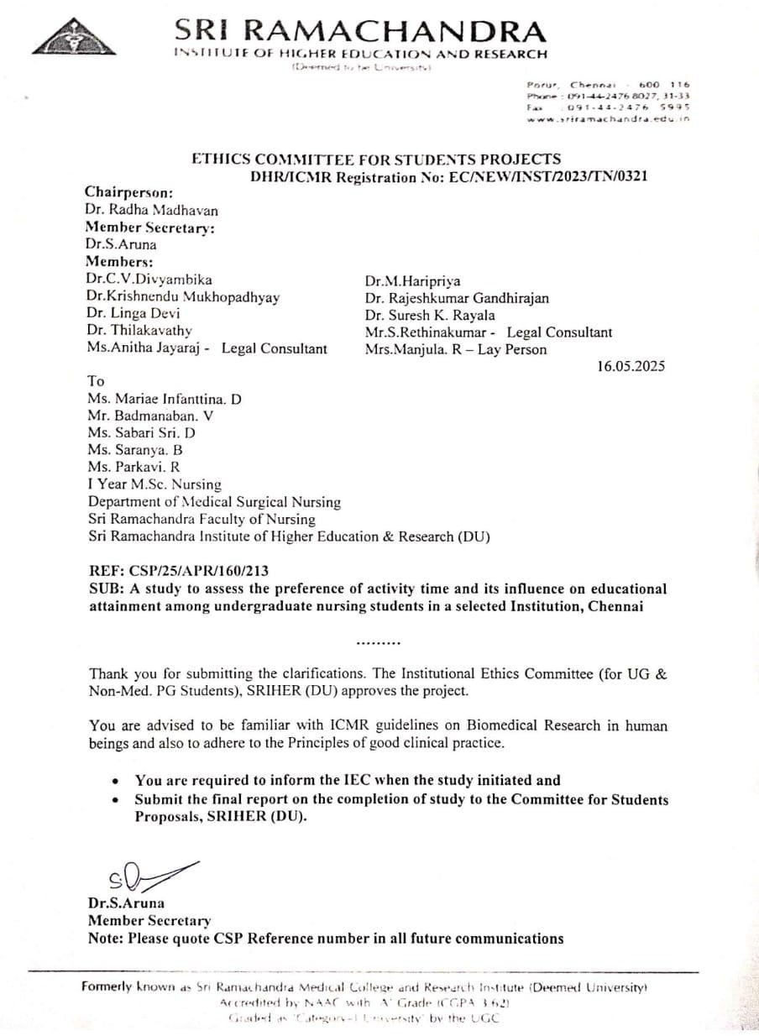

APPENDIX – B

Informed Consent

We Ms.Mariae Infanttina.D, Mr.Badmanaban.V, Ms.Sabari Sri.D, Ms.Saranya.B, Ms.Parkavi.R M.Sc. Nursing student at SRFON. We would like to conduct a study on
Title:
A study to assess the preference of activity time and its influence on educational attainment among undergraduate students of nursing in a selected college, Chennai.

Name of the Principal Investigator:
Ms.Mariae Infanttina.D, Mr.Badmanaban.V, Ms.Sabari Sri.D, Ms.Saranya.B, Ms.Parkavi.R M.Sc. Nursing 1 Year (2024-2025 Batch), Medical Surgical Nursing,
Sri Ramachandra Faculty of Nursing, Sri Ramachandra
Institute of Higher Education and Research (DU), Porur, Chennai- 600116

Description of the study:
  - Nature and proposal of the study stating it as research
As part of the study, I have planned to assess the preference of activity time and its influence on educational attainment among undergraduate students of nursing in selected college, Chennai.

Voluntary participation:
Informed consent will be obtained from the Participants who willingly agree to participate in a study voluntarily.
  - Duration of participation with the number of participations: Duration: 4 weeks
No. of participation: 462
  - Procedures to be followed:
As per the inclusion criteria, the samples will be selected. Demographic variables, Horne and Ostberg questionnaire (1976) have been used to assess the preference of activity time and its influence on educational attainment among undergraduate students of nursing

Investigations, if any, to be performed:
Not applicable

Any alternative procedures or courses of treatment that might be an Advantageous to the participant as the procedure or treatment to Which he/she in being subjected:
Not applicable

Storage period of biological sample and related data with choice Offered to participant regarding future use of sample, refusal for Storage and receipts of its result:
Not applicable

Possible risks to the participant:
Nil

Possible benefits to the participant
Helps to identify the preference of activity time

Cost and payments to the participants:
There is no cost for participation in this study. Participation is completely voluntary and no payment will be provided.

Confidentiality:
Information obtained in this study is strictly confidential. Your name will not be used in reporting of information in publications or conference presentations.

Participants’ right to with draw from the study:
You have the right to refuse to participate in this study, at any point of time.

Voluntary consent by the participate:
Participation in this study is completely voluntary and your consent is required before you can participate in this study.

Informed Consent
I have read this consent form (or it has been read to me) and I fully understand the contents of this document and voluntarily consent to participate in the study. All of my questions concerning this study have been answered. If I have any questions in the future about this study, they will be answered by the investigators listed below. I understand that this consent ends at the conclusion of this study.

Contact Address with phone number:

PI–from SRIHER (DU) | Collaborator (if any) outside SRIHER (DU)
Ms.Mariae Infanttina.D, Mr.Badmanaban.V, Ms.Sabari Sri.D, Ms.Saranya.B, Ms.Parkavi.R,  M.Sc. Nursing 1 Year (2024-2025 Batch),  Medical Surgical Nursing,  Sri Ramachandra Faculty of Nursing, Sri Ramachandra  Institute of Higher Education and Research (DU)  Porur, Chennai -600116 Ph no:8122738218 | NIL

A copy of the participant sheet should be given to the participant for her/his record. By signing this form, I agree to participate in this study. A copy of this form has been given to me.

Date:
Participant Name: Participant’s Signature: Witness name: Witness’s Signature:

CERTIFICATION OF INFORMED CONSENT

We certify that we have explained the nature and purpose of this study to the above-named individual, and we have discussed the potential benefits of this study participation. The questions the individual had about this study have been answered, and we will always be available to address future questions.

Date: Signature of the person obtaining consent:

Name:

Signature of Principal Investigator:

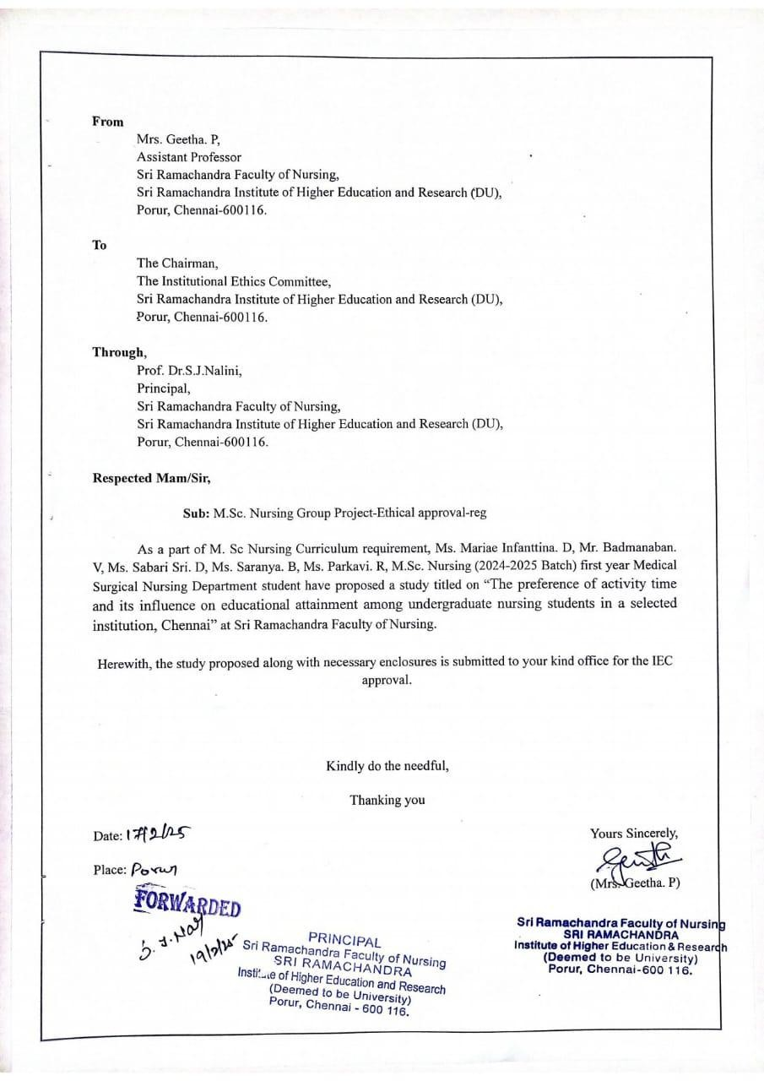

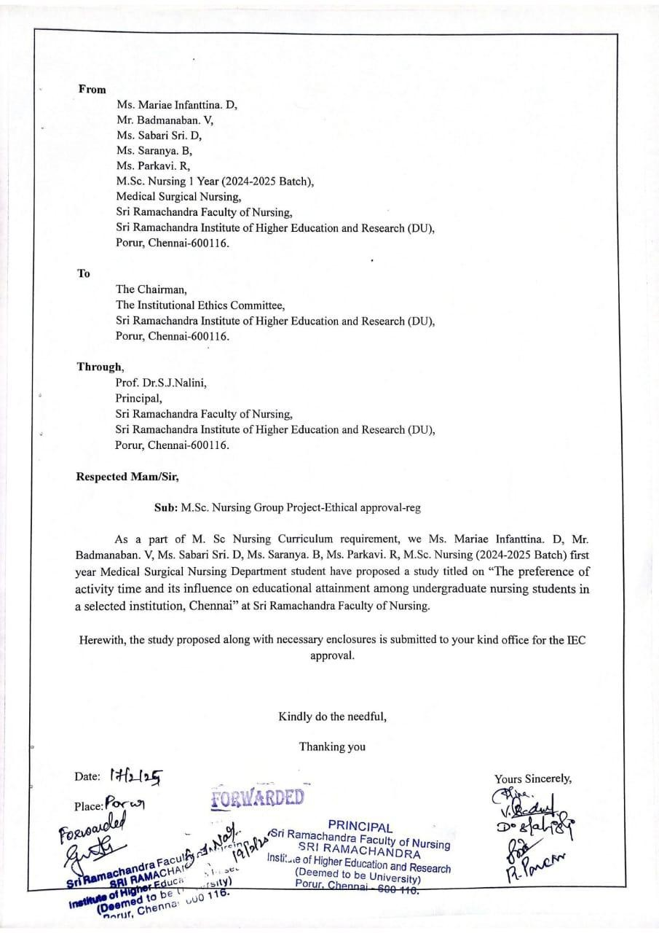

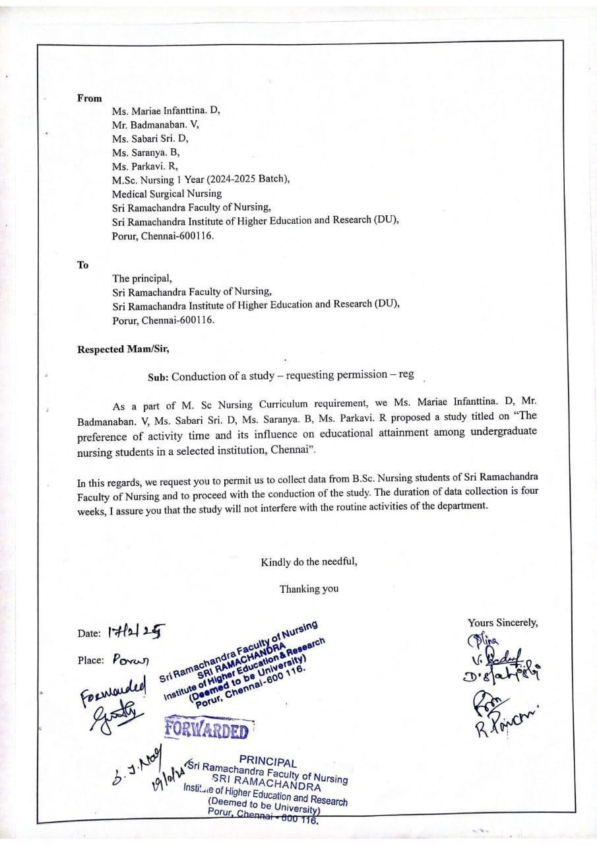

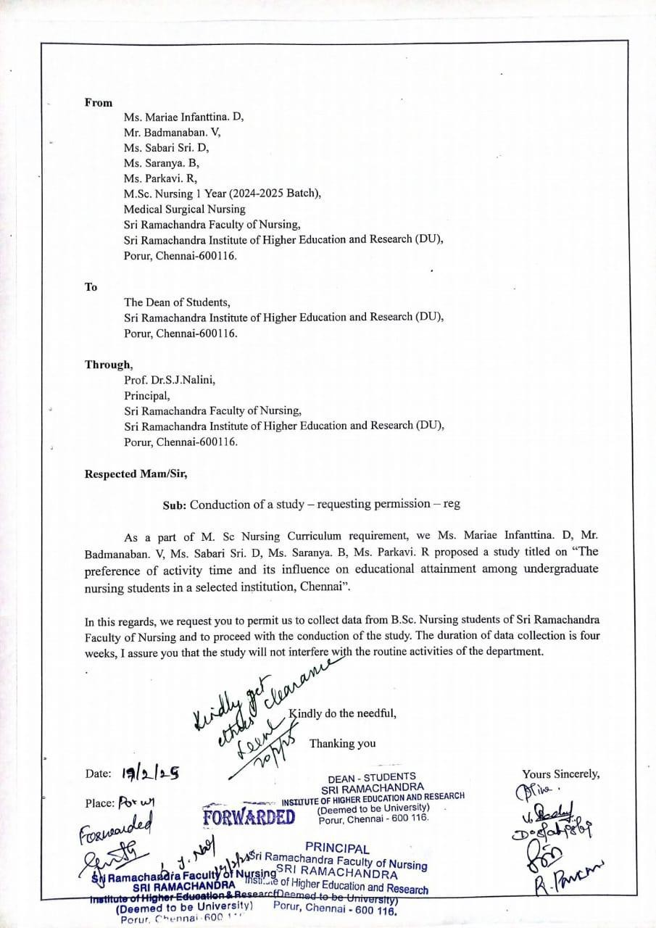

Instruments
Part:1

Demographic variables

- Age
  - 18-22
  - 23-25

- Gender
  - Male
  - Female

- Year of study
  - I B.sc Nursing
  - II B.sc Nursing
  - III B.sc Nursing
  - IV B.sc Nursing
- Email Id
- Previous year mark percentage

- Preference of activity time
  - Morning
  - Evening
- Preference of study time
  - Morning
  - Evening

- Hours of sleep per day
  - Less than 6
  - More than 8

Part: 2
- Morningness-eveningness scale:

S.NO | ITEMS | SCORE
1. | What time would you get up if you were entirely free to plan your day?
1. | 5:00 - 6:30 AM | 5
1. | 6:31 - 7:45 AM | 4
1. | 7:46 - 9:45 AM | 3
1. | 9:46 - 11:00AM | 2
1. | 11:01 AM - 12 NOON | 1
2. | What time would you go to bed if you were entirely free to plan your evening?
2. | 8:00 – 9:00 PM | 5
2. | 9:01 – 10:15 PM | 4
2. | 10:16 PM – 12:30 AM | 3
2. | 12:31 – 1:45 AM | 2
2. | 1:46 – 3:00 AM | 1
3. | If there is a specific time at which you have to get up in the morning, to what extent do you depend on being woken up by an alarm clock?
3. | Not at all dependent | 4
3. | Slightly dependent | 3
3. | Fairly dependent | 2
3. | Very dependent | 1
4. | How easy do you find it to get up in the morning (when you are not woken up unexpectedly)?
4. | Not at all easy | 1
4. | Not very easy | 2
4. | Fairly easy | 3
4. | Very easy | 4
5. | How alert do you feel during the first half hour after you wake up in the morning?
5. | Not at all alert | 1
5. | Slightly alert | 2
5. | Fairly alert | 3
5. | Very alert | 4
6. | How hungry do you feel during the first half-hour after you wake up in the morning?
6. | Not at all hungry | 1
6. | Slightly hungry | 2
6. | Fairly hungry | 3
6. | Very hungry | 4
7. | During the first half-hour after you wake up in the morning, how tired do you feel?
7. | Very tired | 1
7. | Fairly tired | 2
7. | Fairly refreshed | 3
7. | Very refreshed | 4

8. | If you have no commitments the next day, what time would you go to bed compared to your usual bedtime?
8. | Seldom or never later | 4
8. | Less than one hour later | 3
8. | 1-2 hours later | 2
8. | More than two hours later | 1
9. | You have decided to engage in some physical exercise. A friend suggests that you do this for one hour twice a week and the best time for him is between 7:00 – 8:00 am. Bearing in mind nothing but your own internal “clock”, how do you think you would perform?
9. | Would be in good form | 4
9. | Would be in reasonable form | 3
9. | Would find it difficult | 2
9. | Would find it very difficult | 1
10. | At what time of day do you feel you become tired as a result of need for sleep?
10. | 8:00 – 9:00 PM | 5
10. | 9:01 – 10:15 PM | 4
10. | 10:16 PM – 12:45 AM | 3
10. | 12:46 – 2:00 AM | 2
10. | 2:01 – 3:00 AM | 1
11. | You want to be at your peak performance for a test that you know is going to be mentally exhausting and will last for two hours. You are entirely free to plan your day. Considering only your own internal "clock", which ONE of the four testing times would you choose?
11. | 8:00 AM – 10:00 AM | 4
11. | 11:01 AM – 1:00 PM | 3
11. | 3:01 PM – 5:00 PM | 2
11. | 7:01 PM – 9:00 PM | 1
12. | If you got into bed at 11:00 PM, how tired would you be?
12. | Not at all tired | 1
12. | A little tired | 2
12. | Fairly tired | 3
12. | Very tired | 4
13. | For some reason you have gone to bed several hours later than usual, but there is no need to get up at any particular time the next morning. Which ONE of the following are you most likely to do?
13. | Will wake up at usual time, but will NOT fall back asleep | 4
13. | Will wake up at usual time and will doze there after | 3
13. | Will wake up at usual time but will fall asleep again | 2
13. | Will NOT wake up until later than usual | 1
14. | One night you have to remain awake between 4:00 – 6:00 AM in order to carry out a night watch. You have no commitments the next day. Which ONE of the alternatives will suite you best?
14. | Would NOT go to bed until watch was over | 1
14. | Would take a nap before and sleep after | 2
14. | Would take a good sleep before and nap after | 3
14. | Would sleep only before watch | 4

15. | You have to do two hours of hard physical work. You are entirely free to plan your day and considering only your own internal “clock” which ONE of the following time would you choose?
15. | 8:00 AM – 10:00 AM | 4
15. | 11:01 AM – 1:00 PM | 3
15. | 3:01 PM – 5:00 PM | 2
15. | 7:01 PM – 9:00 PM | 1
16. | You have decided to engage in hard physical exercise. A friend suggests that you do this for one hour twice a week and the best time for him is between 10:00 – 11:00 PM. Bearing in mind nothing else but your own internal “clock” how well do you think you would perform?
16. | Would be in good form | 1
16. | Would be in reasonable form | 2
16. | Would find it difficult | 3
16. | Would find it very difficult | 4
17. | Suppose that you can choose your own work hours. Assume that you worked a FIVE hour day (including breaks) and that your job was interesting and paid by results). Which FIVE CONSECUTIVE HOURS would you select?
17. | 5 hours starting between 4:00 AM and8:00 AM | 5
17. | 5 hours starting between 8:01 AM and9:00 AM | 4
17. | 5 hours starting between 9:01 AM and2:00 PM | 3
17. | 5 hours starting between 2:01 PM and5:00 PM | 2
17. | 5 hours starting between 5:01 PM and4:00 AM | 1
18. | At what time of the day do you think that you reach your “feeling best” peak?
18. | 5:00 – 8:00 AM | 5
18. | 8:01 – 10:00 AM | 4
18. | 10:01 AM – 5:00 PM | 3
18. | 5:01 – 10:00 PM | 2
18. | 10:01 PM – 5:00 AM | 1
19. | One hears about “morning” and “evening” types of people. Which ONE of these types do you consider yourself to be?
19. | Definitely a “morning” type | 6
19. | Rather more a “morning” than an “evening” type | 4
19. | Rather more an “evening” than a “morning” type | 2
19. | Definitely an “evening” type | 0

SCORING
  - 70–86 : Definitely morning type
  - 59–69 : Moderately morning type
  - 42–58 : neither type
  - 31–41 : moderately evening type
  - 16–30 : definitely evening type



