STEMI Reperfusion in Rural Emergency Departments: A Quality Improvement Initiative

Chelsea Neri, MSN, APRN, FNP-BC¹
College of Nursing, University of South Alabama¹

Please address all correspondence to:
Chelsea Neri
University of South Alabama
College of Nursing
5721 USA North Drive
Mobile, Alabama 36688
Phone: (570)-604-6949
Email: cln2023@jagmail.southalabama.edu

STEMI Reperfusion in Rural Emergency Departments: A Quality Improvement Initiative

Abstract
Purpose
Current best practice guidelines recommend a door-in-door-out (DIDO) time of ≤ 30 minutes, along with a door-to-balloon-time (DTBT) of ≤ 120 minutes. DIDO and DTBT of a zone 1, critical access hospital (CAH) emergency department (ED) have fallen outside of the ACC/AHA recommended treatment times for STEMI patients.
Methods
This quasi-experimental study included a retrospective clinical audit of ED STEMI cases presenting to the CAH in 2023, as well as annual DIDO/DTBT data over 10 years. A self-report instrument was designed to evaluate the perceptions of ED healthcare staff regarding delays in STEMI management.
Findings
Of the 2023 STEMI cases (n = 6), 83.3% exceeded 30 minutes for DIDO, with a mean transfer time of 55.8 minutes. Forty percent (n = 10) met the DTBT criterion of ≤120 minutes. The self-report tool found 75% (n=17) of ED nursing staff felt they understood the current best practice guideline for STEMI management, and 84% felt confident in interpreting EKGs consistent with STEMI. Fifty-three percent “agreed” that coordinated patient transfer causes delays in reperfusion.
Results/Conclusion
The mode of transportation and EMS preregistration raise concerns about potential bias in historical data and warrant further investigation. ED nursing staff reported confidence in recognizing STEMI via EKG and an understanding of current practices. Coordination of patient transfer, including EMS, was identified as the most significant perceived delay in STEMI reperfusion.
Keywords: STEMI, Reperfusion, Rural, Emergency Department, Quality Improvement

Introduction
Delays in percutaneous coronary intervention (PCI) have been found to increase the risk of major adverse cardiac events in STEMI patients, such as stroke, heart failure, and death. A significant portion of the U.S. population resides in rural areas with limited access to healthcare and long travel times to designated PCI centers.¹ The impact of clinical practice gaps and available resources on the recommended DIDO and DTBT in rural EDs is uncertain. However, it is known that individuals living in rural settings who had longer treatment times from first medical contact (FMC) to PCI intervention for STEMIs, with an associated higher 30-day and 90-day mortality (Hillerson et al., 2022).
Background
Current best practice guidelines recommend a DIDO to a PCI facility of 30 minutes or less, with a goal of DTBT for revascularization of 120 minutes for all patients presenting to a non-PCI center.² In 2007, the American Heart Association (AHA) introduced a national initiative called Mission: Lifeline to advance the quality of care provided for STEMI patients and reduce mortality and morbidity.³ This focus established a system of care to safely expedite patients with acute STEMI for primary PCI treatment. Since the program's initiation, more than 85% of the U.S. population is now within a STEMI system of care region. Modifiable barriers include regional resources, education, multidisciplinary knowledge sharing, and established plans and protocols.³
Rationale
Lack of developed STEMI protocols, education, resources, and under-triaging of patients presenting with symptoms consistent with an acute coronary syndrome (ACS) caused significant delays in care (EKG completion and provider evaluation) and, ultimately, a delay in reperfusion.^{4,5} The rationale of the quality improvement (QI) initiative is to integrate current best practice guidelines into the clinical management of ED STEMI patients. The Iowa Model of Evidence-Based Practice (IM-EBP) was selected to guide the development of the project plan.⁶ This seven-step process cycle model poses a clinical question, researches and appraises evidence, integrates evidence with clinical gestalt, executes change, evaluates outcomes, and disseminates findings. The IM-EBP model has generalizability, allowing for easy application in various clinical settings and utilization by multidisciplinary clinicians.⁷ To create change within the complex adaptive system, the change nursing theory, utilizing Kotter’s 8-Step Model for change, has guided the development and implementation of the QI project. These steps include creating a sense of urgency, building partnerships, developing a clear vision, communicating the vision effectively, empowering others to act, setting achievable goals, evaluating the impact of change, and implementing the necessary adjustments.⁸
Aim
This study aims to evaluate the effects of standardizing STEMI management to achieve a DIDO ≤ 30 minutes, with a DTBT ≤ 120 minutes for 75% of ED STEMI patients, as well as to comprehend further modifiable reperfusion delays, particularly encountered at referring PCI facilities.
Methods
To assess STEMI management of the referring ED, a retrospective clinical audit was performed from 2014 to 2023. More specific attention was paid to individual STEMI management in 2023. The 10-year review provided researchers with insight into the annual mean DIDO and DTBT of ED STEMIs, with a notable trend over the decade failing to meet ACC/AHA STEMI treatment times. Additionally, the individual review of STEMI cases in 2023 provided clarification on the documentation process, pharmacological management, and transfer procedures.
Eligibility criteria for the retrospective chart review included adult patients presenting to the CAH ED with a diagnosis of STEMI, as determined by medical coding, and who were emergently transferred to the designated PCI center. Patients presenting with symptoms of ACS diagnosed with non-ST elevation MI (NSTEMI), those who refused STEMI transfer for primary PCI, in-field cardiac arrests, and those who expired were excluded. In 2023, 6 STEMI cases met the inclusion criteria, 3 were excluded. Unfortunately, due to institutional changes that included the transition to new electronic medical charting platforms between the referring and receiving hospital facilities, individual clinical audits from 2014 to 2022 were unavailable to researchers, influencing the scope of the retrospective chart review. However, annual averages comprising DTBT and DIDO existed for review. From 2014 to 2023, the average (n = 10) DIDO and DTBT measures in minutes were found to be 39 (SD = 6) and 122 (SD = 11) minutes, respectively. STEMI performance was compared to ACC/AHA recommended DIDO and DTBT, with a notable annual decline in the ED to achieve the current best practice standards.
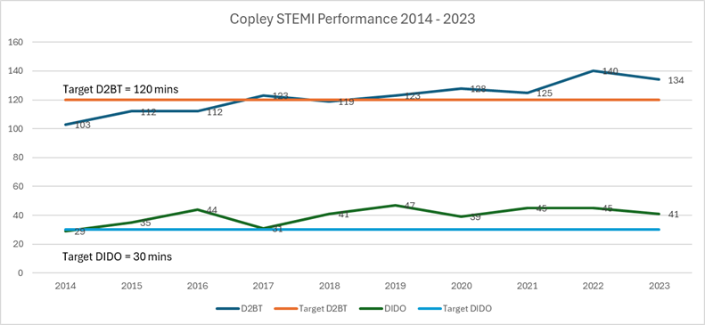 Figure 1. 2014-23 STEMI Performance
The 2023 clinical audit reviewed individual STEMI cases (n = 6), focusing on the time of ED registration, mode of transport to the ED, documented triage time, time of EKG completion, and time of STEMI transfer. Statistical and descriptive analyses of the data were performed using SPSS IBM software. Frequencies, descriptive statistics, and correlation analyses were completed, with p ≤ 0.05 considered statistically significant.
Phase 2 of this quasi-experimental study involved the use of a validated psychometric scale instrument to assess the perceptions of ED healthcare staff regarding competency and experienced delays in the management of STEMI. Based on previous literature, five vital domains of the STEMI management pathway were identified, including the current understanding of protocols, knowledge of STEMI evidence-based practices, available institutional resources, EKG competency, and perception of reperfusion delays in current practice.^{3,4,5} Descriptive statistical and thematic analyses were performed to explain the phenomenon of interest and assess the impact of the continued quality initiative.
Researchers included the CAH director of informatics, the director of quality and risk management, the ED nursing management, and the ED APRN. An assessment of the current STEMI protocol was performed in collaboration with the designated PCI stakeholders. The self-report instrument was designed to be modified and applied across various healthcare system settings. The reliability and validity confirmed in previous studies, using Cronbach's alpha, ranged from α = 0.75 to α = 0.91 for the five domains, respectively.⁹ Participation was voluntary, with a 10-day window for responses to be submitted, during which all responses were confidential and remained anonymous.
Measures and Analysis
Through the retrospective clinical audit, researchers sought to identify areas within the current STEMI process that may contribute to increased DIDO times exceeding 30 minutes. The 2023 clinical audit reviewed individual STEMI cases (n = 6). Process measures included the time of ED registration, mode of transport to the ED, documented triage time (including ED arrival time), and time of EKG completion. The outcome measure was the time of STEMI patient transfer, including the total DIDO time. Data extracted from the EMR included scanned STEMI nursing documentation, the EMTLA transfer form, the patient's face sheet, and electronic, time-stamped documentation to reduce margin for error and ensure the reliability of data collection. The time of EKG completion and outcome measures were benchmarked according to clinical practice guidelines to support validity.
Statistical and descriptive analyses of the data were performed using SPSS IBM software. Frequencies, descriptive statistics, and correlation analyses were completed, with p ≤ 0.05 considered statistically significant. The self-report instrument was designed to be modified and applied across various healthcare system settings, with reliability and validity confirmed in previous studies using Cronbach's alpha. The Cronbach alpha of the five domains ranged from α = 0.75 to α = 0.91, respectively.⁹ Participation was voluntary, with a 10-day window for responses to be submitted, during which all responses were confidential and remained anonymous to eliminate the risk of social biases.
Ethical considerations
Approval for the QI initiative was obtained from the University of South Alabama's Institutional Review Board (IRB), with support from the designated rural hospital facility. All retrospective chart reviews were conducted on the clinical site and accessed using login-secured devices, with patient health information encrypted and stripped of all personal identifiers. The aforementioned self-report instrument includes a voluntary participation information sheet.
Results
Of the 2023 STEMI cases (n = 6), 83.3% exceeded 30 minutes for DIDO, with a mean transfer time of 55.8 minutes (see figure 2). Thirty-three percent (n=2) of STEMI patients presented to the ED via EMS. The data revealed that DIDO times increased for patients based on their presentation to the ED (POV vs EMS). A statistically significant positive relationship was found between the mode of transportation and DIDO, with a Pearson's correlation coefficient (PCC) of 0.923 and p ≤ 0.01. At this CAH ED, patients arriving via EMS are “preregistered” into the EMR during EMS radio communication reports prior to physical arrival in the ED. To assess the relationship between preregistration and DIDO times, a statistical analysis was utilized. It noted a higher DIDO time for STEMI patients who were preregistered, with a PCC of 0.953, which was statistically significant (p ≤ 0.01).
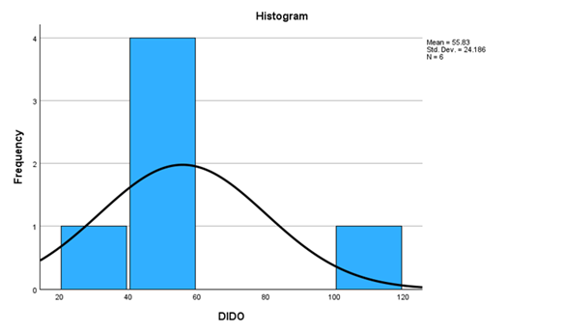
Figure 2. DIDO of 2023 Clinical Audit
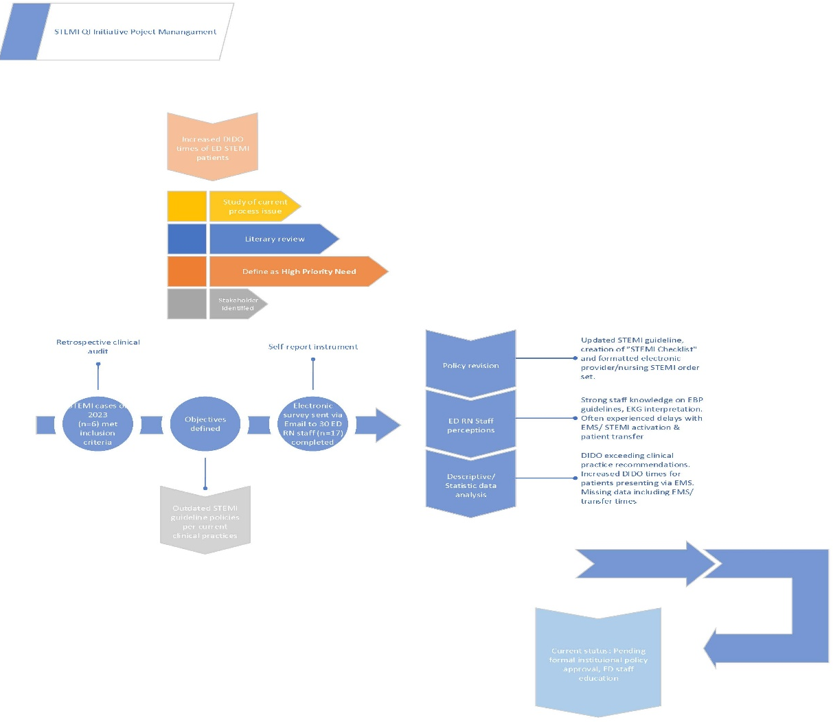
Figure 3. STEMI QI Flowchart
A 16-item Likert scale instrument was distributed to ED nursing staff via corporate e-mail. Items one through five were available responses, ranging from “strongly agree” to “disagree.” Item six assessed individual understanding of current best practice guidelines for STEMI management, ranging on a scale of one through 5, with one being the least and five being the most knowledgeable. Items seven through ten evaluated delays during STEMI patient management, with available responses ranging from “strongly agree” to “disagree.” Item eleven assesses individual confidence and competency in identifying EKG findings consistent with an acute STEMI, with responses scored on a scale from 1 to 5, where one is the least and five is the highest. Lastly, items twelve through sixteen evaluated the frequency of delays experienced, with responses ranging from “never” to “always.”
Of the thirty individuals invited to participate in the STEMI healthcare self-report instrument, 56% (n = 17) completed and submitted the survey with all items addressed. Analysis of the responses provided insight into the five focused domains. The first domain assessed the current STEMI protocol, medication administration, and documentation. In response to “ I understand current STEMI alert protocol 35% of total participants (n=17) “strongly agree,” while approximately 12% “disagree.” Forty-seven percent were “neutral” about item stating “current STEMI documentation is easy to complete,” while approximately 35% “agree” to “strongly agree” and 17.6 “disagree.” Over 70% of respondents reported “agree” to strongly agree” in regards to the statement “I am comfortable administering STEMI specific medications from STEMI.”
Domain two measured available resources for STEMI management. In response to “There are adequate resources available for ED timely STEMI patient management,” 41.2% of participants “agree”, 35.3% were “neutral”, and approximately 12% both” strongly agree” and “disagree.” Over 76% of participants “agree” to “strongly agree” that completion of EKG occurred within 5 minutes or less.
Domen 3 measured individual understanding of best practice guidelines for AMI care in the ED and STEMI EKG interpretation. On a 5-point scale, participants rated their overall knowledge of the current best practice guidelines/recommendations for STEMI/AMI management. The mean score of the total responses (n = 17) was 3.79 (75.8%). The same scale was used to rate “how confident are you at identifying STEMIs on EKG?” With a mean score of 4.19, 83.8% of participants.
Domain 4 measured the STEMI process and management delays. When asked, “Typically, STEMI activation is a single-call activation/transfer process,” 43.8% answered “agree” and 31.3% answered "disagree.” Sixty percent “agree” to “strongly agree” in response to the statement “Coordinating patient transfer delays DIDO of STEMIs.” Concerning “awaiting EMS arrival delays STEMI transfers,” 76.5% reported “agree” to “strongly agree.” Approximately 56% of participants reported they “disagree” that “documentation delays STEMI transfers.”
Lastly, the fifth domain asked, “In your experience, in the STEMI process, what frequently causes significant delays?” At 56.3%, documentation was reported to “rarely” cause delays. Providing patient care and administering medication “sometimes” caused delays, as reported by 56.3% of respondents. Communication with the receiving PCI center, including the transfer process, “sometimes” to “often” caused significant delays, both reported by 41.2% of participants. Coordination with local EMS services “sometimes” caused delays reported by 41.2%, “often” reported by 29.4% and “always” by 11.8% of total respondents. Medication calculation, including weight-based unfractionated heparin bolus and infusion, was noted to “sometimes” at 62.5%, 25% reported “often”, and 6.8% reported “always”, causing delays.
The methodology of this study yielded key insights for the researchers of the current STEMI management process. Discrepancies in EMR registration are skewed by STEMI patients presented by EMS who are preregistered before physical arrival into the ED. While this is not the only factor causing substantial delays in STEMI reperfusion patients, it warrants mitigation.
The self-reported instrument provided additional insights into individual confidence, competency, and experiences with delays in STEMI management among ED nursing staff. The understanding of STEMI best practice guidelines and EKG interpretation was found to be high among participants, at 76% and 84%, respectively. Process and individual delays experienced by ED nursing staff were most prominent in the STEMI patient transfer process and EMS coordination.
After completing the retrospective clinical audit, discrepancies were identified, including inaccurate registration times among patients presenting to the emergency department via EMS compared to those presenting as “walk-in” patients. STEMI patients presenting to the referring ED by EMS had increased DIDO in comparison to patients presenting by POV. The statistical significance found in the data was confirmed through a discussion between the PCI centers' quality and informatics departments, who benchmarked the DIDO and DTBT of STEMI patients from referring facilities using the patients' demographic face sheet. Because patients are preregistered before physical presentation in the ED, it is concerning that DIDO is inconsistent between the referring and receiving facilities.
Anticoagulation with the use of heparin was noted to vary among providers, with most opting for weight-based heparin administration for both bolus and infusion, as opposed to a standard bolus dose and infusion rate. Review of the standard heparin dosing from the existing STEMI protocol exceeded the current AHA/ACA pharmacotherapy-recommended maximum bolus dose by 1000 units.¹⁰ Twenty-five percent of participants of the self-report instrument reported “medication calculation” such as heparin bolus and infusion dosing, “often” delays STEMI management. The provider-dependent approach and the lack of standardized patient care add contextual relevance to the current fragmented state of STEMI management.
The time of EKG completion was noted to be outstanding, with 83% of EKG documentation (n = 5) completed within 5 minutes or less from the time of patient arrival. The level of confidence and knowledge of EKG interpretation reported by participants on the self-report instrument was impressive, with a mean rating of 4.19/5 (83.8%). These two elements provide contextual relevance in terms of the understood urgency of EKG completion and the staff's ability to alert the provider of findings consistent with STEMI on the EKG.
The time of initial EKG completion was noted to meet the best clinical practice guidelines. However, there is no regard for both process and outcome measures that account for EKG changes evolving into acute STEMI criteria during ED evaluation. This is an unexpected problem for data collection, as the DIDO time of STEMI patients includes those who initially had an EKG that did not meet STEMI criteria but developed into STEMI on subsequent EKGs.
After reviewing the process, outcome measures, and perceptions of ED nursing staff. Current STEMI guidelines and protocols lack crucial data to better understand the causes of reperfusion delays. This involved the time of STEMI single-call activation and transfer with the designated PCI center, the time of STEMI activation with EMS, and the time EMS arrived at the ED for STEMI transfer. With ED nursing staff participants reporting that both EMS and transfer coordination “often” cause delays at 29% and 41% respectively, the lack of available data is an unknown variable that warrants examination.
Summary
This quasi-experimental study provided insight into the current processes and clinical practices of rural emergency department care for STEMI patients. The review of existing STEMI guidelines, including the medical management utilized by a single rural ED, was found to be outdated when benchmarked against current clinical practice guidelines. The 2023 retrospective clinical audit of ED STEMI cases noted inconsistencies in patient arrival times for those presenting via EMS and who were preregistered before their actual arrival at the ED. Missed STEMI diagnoses through EKG interpretation and provider-dependent management were noted. Lack of standardized STEMI management poses a concern for delays in reperfusion and is a risk for major cardiac events in patients. The time of initial EKG completion met current clinical guidelines and was reiterated by the ED nursing staff's responses to the completed self-report instrument. Staff perceptions noted from the completed self-report instrument included frequently experienced delays while coordinating STEMI transfer/Cath lab activation, and EMS transportation for primary reperfusion. Currently, there is no data available on the time spent coordinating with both the PCI center and EMS to detect and mitigate delays related to this area in the STEMI management process.
The relevance of these findings was disseminated to both the institutional and regional stakeholders. In addition, to further understand delays in reperfusion, a “STEMI checklist” was created to evaluate times of specialty consultation, EMS activation, and arrival. Policy updates, including the transfer process and guidelines for STEMI treatment, as well as pharmacological and radiological testing, were implemented in accordance with current clinical practice guidelines. To ensure consistency in data for STEMI patients presenting via EMS, safeguards have been developed in collaboration with the facility’s patient access department to document the time of patient arrival accurately. The highlighted experience from ED nursing staff, along with the descriptive statistical analysis, strengthened the implementation of policy changes within the organization and ongoing evaluation to improve DIDO for STEMI patients.
Interpretation
The association between the current interventions and outcomes reinforces important areas of the STEMI management delays. The results identified in this study correlate with previously identified modifiable barriers, including regional resources, education, multidisciplinary knowledge sharing, and established plans/protocols.³ The impact of the QI initiative includes improved outcomes for STEMI patients. ED healthcare staff will require education before implementing clinical policy changes, thus necessitating revisions to practice. While ED healthcare staff are the primary focus of the QI initiative, timely STEMI management is a multifaceted process, and maintaining buy-in from stakeholders is necessary at both the institutional and regional system levels. Provider-dependent management and outdated policies were observed, which were not an anticipated outcome of this study. The guidelines currently in place were developed and disseminated by the designated PCI center when the STEMI regional system of care was established in Vermont 15 years ago, without any updates or revisions. Contextually, this raised a larger question about other referring facilities in this geographic area that may be unknowingly using outdated STEMI guidelines. Anticipated costs are low and are expected to remain a low concern, given modifiable barriers and potential changes in healthcare policy regarding ED STEMI management.
Limitations
Given the critical nature of acute STEMI, clinical data were collected retrospectively, with a notably small sample size. The self-report instrument was distributed to ED nursing staff, excluding ED providers, and poses a risk of bias. The study was conducted in a single CAH ED in a rural New England setting, which limits its generalizability to other regions. Skewed data from prehospital registration is a concerning factor limiting internal validity. Missing data, such as time of EMS activation, STEMI activation, and patient transfer coordination, hindered the completeness of the analyses. To minimize social bias, all submissions of the self-report survey were anonymous. Data collection from the clinical audit included cross-check confirmation throughout the electronic medical chart, along with scanned forms to reduce margin for error.
Conclusions
Primary PCI is the gold standard treatment for patients presenting with acute STEMI. While strides have been made with the development of STEMI systems of care, barriers persist. This study noted perceived delays surrounding EMS and STEMI activation coordination, along with disparities in DIDO for patients presenting by EMS versus private vehicle. Outdated guidelines and provider-dependent management are modifiable barriers to improving and standardizing the management of STEMI. Sustainability can be achieved through multidisciplinary knowledge sharing and revision of current clinical procedures.
Future Implications and Considerations
Regional STEMI systems of care have been found to improve the outcomes for STEMI patients presenting to non-PCI centers. Ongoing collaboration between both the referring and receiving facilities is crucial to guarantee that STEMI patients receive optimal care management. Implications for practice include maintaining competencies in ACS/STEMI management in accordance with clinical practice guidelines, reviewing clinical cases, engaging in ongoing education, and adapting strategies to mitigate delays in reperfusion. Further research is needed to assess the outcome improvements resulting from the interventions in this study on STEMI patient management before generalizing the findings to other referring institutions. Suggest next steps, involve formal policy approval of new STEMI guidelines and new “STEMI checklist” for pertinent data collection, electronic formatting of provider and nursing “ED STEMI Order set,” with clinical roll out of QI within the next 4 weeks.

References
- Orvad H, Savage L, Smith T, Hamiduzzaman M, Schmidt D. Not All STEMI Patients Receive Timely Reperfusion: Considerations for Rural Emergency Departments. Journal of Multidisciplinary Healthcare. 2021; Volume 14:3103-3108. doi:https://doi.org/10.2147/jmdh.s337197
- Lawton JS, Tamis-Holland JE, Bangalore S, et al. 2021 ACC/AHA/SCAI Guideline for Coronary Artery Revascularization: a Report of the American College of Cardiology/American Heart Association Joint Committee on Clinical Practice Guidelines. Circulation. 2022;145(3). doi: https://doi.org/10.1161/cir.0000000000001038
- Jacobs AK, Ali MJ, Best PJ, et al. Systems of Care for ST-Segment–Elevation Myocardial Infarction: A Policy Statement From the American Heart Association. Circulation. 2021;144(20). doi: https://doi.org/10.1161/cir.0000000000001025
- Anas Alsharawneh, Murad Sawalha, Nazih Abu Tabar, et al. Impact of triage nurses’ recognition of acute coronary syndrome on patients’ clinical outcomes: A retrospective study. Heart & Lung. 2024;68:60-67. doi: https://doi.org/10.1016/j.hrtlng.2024.06.010
- Martin LK, Lewis VJ, Clark D, et al. Frontline barriers to effective paramedic and emergency nursing STEMI management: clinician perspectives. Australasian Emergency Care. 2020;23(2):126-136. doi: https://doi.org/10.1016/j.auec.2019.12.001
- The Iowa Model Revised: Evidence-Based Practice to Promote Excellence in Health Care©. University of Iowa Health Care. Published 2017. http://uihc.org/iowa-model-revised-evidence-based-practice-promote-excellence-health-care
- Cullen L, Hanrahan K, Edmonds SW, Reisinger HS, Wagner M. Iowa implementation for sustainability framework. Implementation Science. 2022;17(1):1-20. doi: https://doi.org/10.1186/s13012-021-01157-5
- Kotter J. The 8 steps for leading change. Kotter. Published 2025. https://www.kotterinc.com/methodology/8-steps/
- Clinician Survey on Quality Improvement, Best Practice Guidelines and Information Technology. Accessed June 29, 2025. https://digital.ahrq.gov/sites/default/files/docs/survey/clinician-survey-quality-improvement.pdf
- Rao SV, O’Donoghue ML, Ruel M, et al. 2025 ACC/AHA/ACEP/NAEMSP/SCAI Guideline for the Management of Patients With Acute Coronary Syndromes: A Report of the American College of Cardiology/American Heart Association Joint Committee on Clinical Practice Guidelines. Circulation. 2025;151(13). https://doi.org/10.1161/cir.0000000000001309

Carpenter, R., McWhorter, R., Donaldson, S., Silberman, D., & Maffei, S. (2021). Working Against the Clock: A Model for Rural STEMI Triage. Health services insights, 14, 11786329211037521. https://doi/10.1177/11786329211037521

Figures and Graphs
Figure 1: Copley STEMI Performance 2014-2023
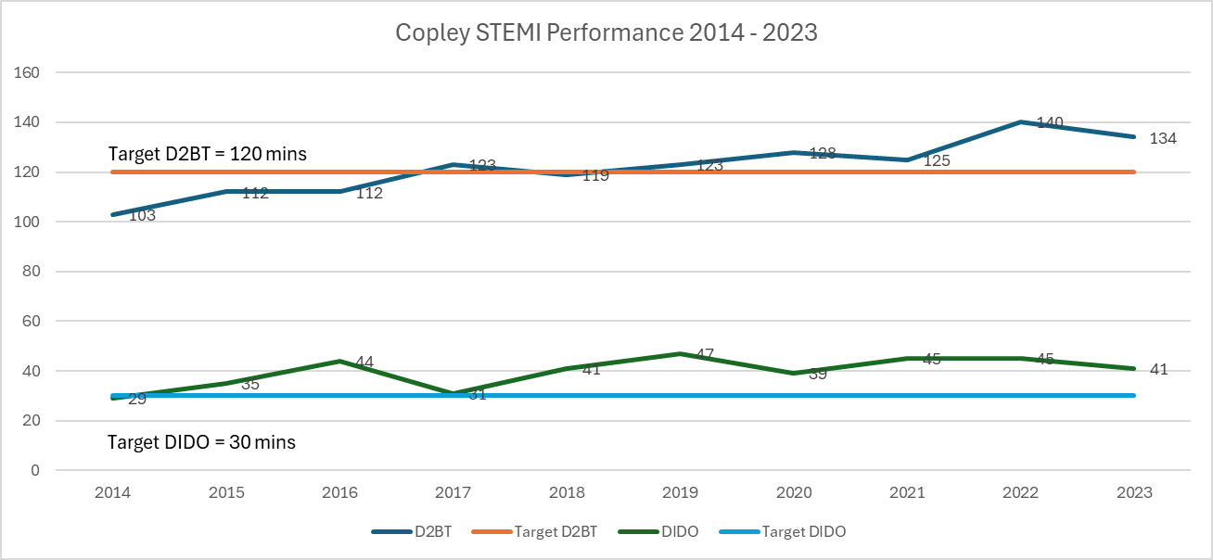

Figure 2: DIDO of 2023 Clinical Audit
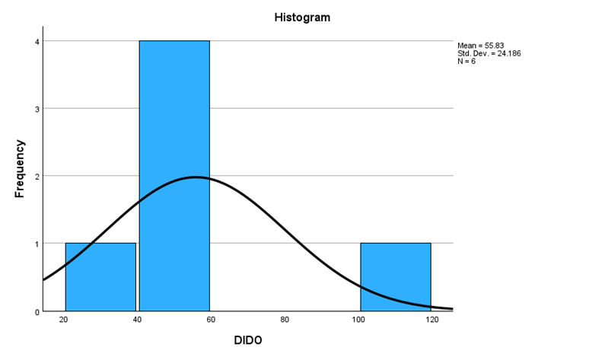

Figure 5. STEMI QI Flowchart


