Fundamentals of Building Construction
Contract Management and Administration


1. ENTRANCEWAY

GENERAL DEFINITIONS
Construction
Can be defined as the setting many of planned tasks together in to a Required Final production.

What does the “Construction Contract” mean
Construction Contract means a written agreement signed between the Owner and the Contractor, mentioning the required Quality Time and Cost as specified in the Contract Documents, which shall also be enforceable in the applicable Law.

Contract Management means
the proceeding and controlling the Total requirements stated in the Contract Documents.
Reception
Contract Administration means
the Over viewing of the total process to convince whether the Management of the Contract is run with no conflicts.
In Constructions Contract – Following Partnerships may act for,
Construction - The Contractor
Management - The Engineer
Administration - The Owner/Employer
How ever All three parties are bound to be act their Individual duties as per the Contractual Conditions.

1.1 Parties involved in the Construction Contracts

- Owner/ Client / Employer
- Contractor
- Consultant / Engineer

Definitions of Parties

- Owner/Client/Employer
He can be defined as a Person or an Institution that holds adequate Financial strength in hand when he wishes to compete an Engineering building project as required by him. Requiring another party, called the Contractor, to attend to the Construction of the Product.
- Contractor / Builder
The contractor can be defined as a Person or an Institution, or a Company that is experienced and registered, having the required resources for the relevant field of Construction that can be applied to the Owner’s expectations.
- Consultant/Engineer
This position can be defined as a Person or an Institution that is recruited by the owner to obtain the assistance of proceeding of the Construction and Contract Supervision in order to get the Final production completed accordance with the agreed Time < Quality and Cost.

All these parties are responsible to show and prove their Entitlement to enter in to a Contract in which they are separately signing.
- Main Construction Contract – Signed between Owner and the Contractor
- Contract for Supervision and Controlling all Requirements stated in the main Contract – signed between Owner and the Engineer
1.2 WHAT ARE CONTRACT DOCUMENTS AND PARTIES
(As accordance with the Priority order )

- Contract Data - (specified the Scope of the Contract )
- Particular Conditions of the contract - (Includes any Additions , Alterations or Deletions made to the General Conditions of the Contract , Particular to relevant Contract only )
- General Condition of the Contract ( Includes General Legal and Contractual Procedure of the Contract )
- Particular Specifications of the Contract – ( Includes any Additions , Alterations or Deletions made to the General Specifications of the Contract , Particular to relevant Contract only )
- General Specification of the Contract – ( Specified in details the General Quality and standards to be maintained for the Building Constructions , Quality Testing procedure , Construction Procedure , Payment Procedure )
- Drawings ( Showing Plan view , Line and Levels , Measurements , Structural Details, Details of Fixtures , Landscaping and Etc.’ )
- Bill of Quantities (UN priced/ Priced)
- Addendums

Priority order
Is the Priority of documents refers to the order of precedence or authority in which documents are interpreted or enforced when there is a conflict in between two or more of them.
In legal agreements or contracts, multiple documents might be involved, such as primary contracts, amendments, addendum s and schedules.

HOW PRIORITY ORDER OF CONTRACT DOCUMENTS ACTS
Ex- (1)
- May at the drawings shows as the Strip foundation footings - the grade of the Concrete to be used as 20 M Pa (Mega Pascal)
- General Specification specify it should be 25 M Pa
It is to be Concluding the Specification is Correct as it’s Priority order number is 5 while the Drawing sit on No 6.
Hence the Grade 25 M Pa Concrete should be used to such part of foundation.
Note-
Pascal is a Unit Pleasure (Pa) = N/m²
Mega Pascal (M Pa) = N/m² X 10⁶
= N/m²/ 10⁻⁶

= N/mm²

Ex - (2)
- Drawings and General Specifications Both agree together in stating the Minimum Yield Strength of the steel to be used for Structural reinforcements should be 400 M Pa;

- Particular Specifications specify it should be 500 M Pa

It is to be Concluding as the Required Minimum Yield Strength of Steel should be 500 M Pa as the Particular Specifications sits on order in higher Priority than the drawings and Specifications 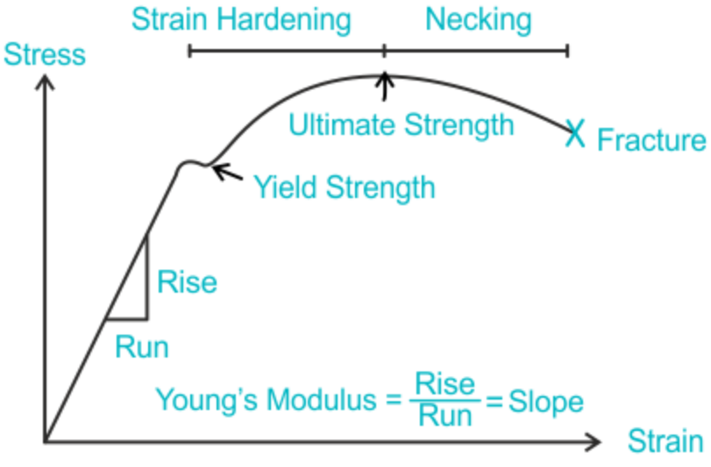

Ex -(3)

- General Conditions of contract specify the Engineer Confirmation requested by the Contractor should be responded by the Engineer either by Confirmation or by Rejection within 7 calendar days for oral instructions unless otherwise the Instructions given orally shall be considered as confirmed.

- Particular conditions of Contract amended it as Time to be Consumed as 2 calendar days.

It is to be Concluding as the Particular Conditions of Contract is to be accepted to proceed with.

Calendar days means – 365 days in standard year and 356 days in a long year

Three Equal requirements to be maintained by the above three parties
Time
Construction Project

Quality Cost

1.3 COST AND PRICE
The cost of any building Construction is the Amount to be expended for resources involved ( as the Direct Cost ) and the Amount of money spent Overhead consumed ( as the Indirect Cost ) for the owner’s production.
COSTRUCTION CONTRACT COST
The value of currency required to obtain a product or service, to expend labor and use equipment and tools, or to operate a business.
This total or subtotal is usually identified as such in an estimate report.
(Accepted by the owner)
Also known as Total Estimated Contract Cost (TECC).
Contractor’s Cost
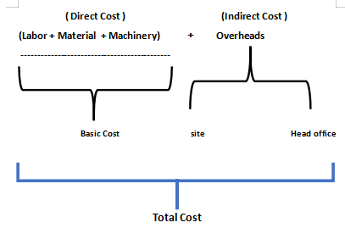

Direct Cost
- Value of all wages + Extra facilities + Health care for all laborers ( Unskilled +Semiskilled + Skilled + Labour Supervisors )
- Machinery – Residual % of Capital Cost + Depreciation Cost + Operational Cost + Maintenance Cost
- Material – All material costs that are directly involved in the construction
- Sub-Contractor’s or Supplier’s Cost ( If Any )
Indirect Cost
- Value of all wages for Employees in higher categories above the Laborer Supervisor ‘’’
(All employees – Above the category of labour supervisor- Technical Officer ---------- Up to Managers)
- Accommodation + Transports + Rents of Buildings + Office facilities+ Communications + Software + Security + Coordination of Regional and Central Government Sectors +Health care + Quality Tastings +Prepare Documentations + Legal and Medical assistance + Safety …… Etc

Contractor’s Price
Basic Cost + Overhead Cost + Contractor’s Profit = Contractor’s Price
Owner’s ( Client’s ) Cost
In this situation Owners Cost is also can be defined as the Total of His Direct Cost and Indirect Cost.
Contractor’s Price (Direct Cost) + Owner’s Overhead Cost (Indirect Cost) applied throughout of the all Stages of the Contract.

Cost Estimation and Pricing
At first it is a fact that Estimations are Not deems to be Constant fore ever and /But the Unit Pricing, submitted shall be constant in throughout of the Contract Period.
The process of applying appropriate costs to the line items after the takeoff.
Refers to this as, "Price the quantities."Per a Unit measurement. May also be called pricing.

Cost estimation is a process where project managers predict the amount of money they need to fund their projects.
The process entails direct and indirect costs of the project.
As managers estimate costs, they may also consider project elements, including:
Duration
Maximum period that can be consumed for Estimation and Pricing can be understood with the period speechified in the tender calling notice.
Scope and Amplitude
Then the Experienced manager planned and schedule what facilities to be provided and what and how intellectual human resources are to be deployed as per the Project Scope and amplitude, in order to reach the successful results in time.
Complexities
This is the most important to be considered by the manager in conjunctions with all conditions and requirements those compulsorily followed at this moment related with as per following factors..
- Risks those may be anticipated with or as determined as probable ,
- Geography and Weather pattern of the Project area
- Health and Administration Rules
- Scarcity of resources
- Effective variations
At standard theory of pricing in Constructions Industry too in expectation of flowing to be full filled at the activities of pricing implementations.
      - ROA -Return on asserts
      - ROI – Return on Investment
      - ROS- Return on sales
      - Break even analysis

in Short words –
ROA is the benefit to be taken in utilizing all resources productively ( Labour ( working / Intellectual ) , Machinery ( Light , Heavy Machinery, equipment and Plant.)
ROI is the benefit to be taken in overall Investing of Rs- xxx Million in a period of – y Years, this will not be being limited to the Profit merging of individual work item Unit rates.
This two returns (% factor of return against the should have to be considering the not only the prime Cost invested but when it returns after the specific time , the following conditions to be considered for most correct applications.
- Deprecation of Machinery
- Expected Inflation or deflation within the period
- Value of Currency fluctuation
ROS is the average profit that gains at Selling the Product , Simply in the Constructions comparison the Cost allocated in each work items against the Profit to take at the time of Payments received.
Break even analysis is a verification of minimum no of items to be produced to proceed with no loss.
In some instances, even in Constructions Contracts if the Contractor may sees that Quantity requested by the owner at any work item is fallen below the Break even level.
It is his understanding Either to add that loss + Expected profit factor to unit rates evenly within the this less quantity or add evenly among other work item Unit rates.
This study is comprehensively described in Constructions economic subject.

1.4 General formulas to be used

(F-1) Calculating the Machinery Depreciation

d= (C-s)/n
d= Annual depreciating Price
C= Capital Cost of the Machinery
S = Remained Scrap value after the Life time
n = Life time specified by the Manufacturer in years
this formula is being used commonly for evaluating machinery hiring rates with the Total Cost + Profit = Rs A/ hr or Day.
Total Cost of the Machinery/day is consisted of following.
(Capital Cost – Scrap value)/ Life Time in Years/365 +Fuel Cost + Maintenance Cost + Operating Cost + Overhead Cost

(F-2) Calculation of Residual value of Machinery
(SOID Formula)
D_{r =} (C-s)*[(2(N-r+1)//(N(N+1)]
D_{r =} depreciation charge of r^{th} Year
C = capital Cost Invested
S = Scrap value after the total life time
N = Remaining depreciable life in years
r = r^{th} year
with this SOID formula it can most accurately be used to verify whether the certain plant can be continuously utilized within the expected total period of Contract Period.
If it gets totally be reaching to the end-of-life time in between the Contract period,

(F-3) Price Variation Considering Inflation Factor

FV = PV ( 1+ r/100) ^{n}
PV= FV/ (1+r/100)^{n}
^{FV = Future Value}
^{PV = Present Value}
r = Annual average Inflation Factor
^{n = Time duration in years}
(F 4) Application of the allowable Price escalation to the Contractor’s payment

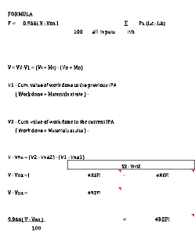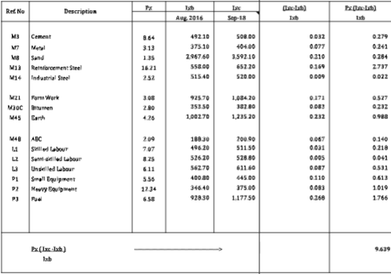

1.5 MEASUREMENTS OF WORKS
In order to get the Correct pricing of a unit, the Unit rates are to be calculated with assuming decade (most suitably 10th – 10, 50 or 100 or more) quantity of the work item by taking exact either as specified in drawings or as verifying a previously completed section of the works.
Mostly in except of an exclusive condition, all measurements are physical and having primary limitations for
      - Lengths for Length, Area, Volumes
      - Time in Hours, Days, months or years
      - Weight in gram , kilo Grams , Tons

To proceed with this requirements it is to be measured in Units in following contexts’
- Linear Measurements (mm or Cm or lm or Km Etc.)
- Length in Two dimensional or Three dimensional ( For area L’ X L’’ and For volumes L’X L’’X L’’’ as a result of any Quantity = a in a² or a³ )
In conditions of Natural, Bulk or Compacted.
- Time measurements ( Seconds , Hours , days or % of Specified Tome given such as a Period offered or allowed to complete a job)
- Weight - can be taken in weighing the Item in in any of above Units)
Under an conditions of
Wet of Dry or natural, Bulk or Compacted
Ex – Natural (Solid), Bulk and Compacted Volumes in earth
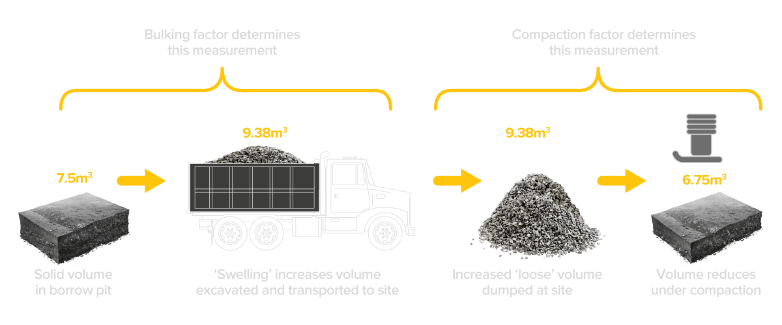

Measuring Time in days within the Contract period are basically taken in base of days are Calendar days, ie the 365 days in ordinary year and 356 days in a Long year.
Taking measurements on working days can be made only for works to be measured on day work basis as per the contract,

Definition of Measurements
It is an Act of verifying the Size or magnitude of an item before or after the work done, assuming the anticipated for an estimation to Quote and
Or a
Completed construction for a Valuation of the Price.
Therefore measurement, the process of associating numbers with physical quantities and phenomena. Measurement is fundamental to the sciences; to Engineering, construction, and other technical fields; and to almost all everyday activities. For that reason the elements, conditions, limitations, and theoretical foundations of measurement have been much studied.
Also measurement system can be applied for a comparison of different systems and the history of their development.
Further Measurements are interpreted as a Comparison between a Single Unit with the No of Units of the Physical Product.

Standard Methods and Rules of Measurements
· NRM
The New Rules of Measurement (NRM) are published by the Royal Institute of Chartered Surveyors (RICS)
· CESMM
Standard Method of Measurement of Civil Engineering CESMM3 was published in February 1991 And Latest one CESMM4 was published in April 2012. By the Institute of Engineers of UK.
· SLS 573
Sri Lanka did not have a standards method of measurement of building works prior to the 1968, though there was an attempt in 1950 which could be termed as a form of the method of measurement in Sri Lanka. However, in 1968 the first Sri Lankan standard method of measurement was developed. The institute of quantity surveyors Sri Lanka along with ICTAD felt the need, for a complete up-to-date standard method of measurement. Accordingly, ICTAD initiated action to provide this revision.
ICTAD (Institute for construction training and development) is being the authority for releasing the SLS 573. The SLS 573 first revision 1994, itself is a comprehensive complete document.
It contains twenty two work sections.

1.6 CONTRACT TIME AND QUALITY
What is Contract Time
Initially the Contract Time is the Time for Completion agreed by both party as stated in the Contract agreement.
It is the agreed time specified in the Contract agreement
What is Quality
A definition of quality is "your focus on the satisfying your customer's needs". Therefore, it can be said that the "quality of a product or service" is the extent to which it incorporates features and characteristics that allow the customer to use it.
At the same time you are satisfying their needs.

Quality can also be defined as being fit for the intended purpose, or "fit for purpose".
In addition a simple definition is "conformance to requirements".

What is Construction Quality
Quality in construction means that projects are finished within the guidelines established by the Scope of Work.
Finishing the project on time,
Meeting the requirements of the agreement
And
Staying within the budget are all essential aspects of quality management.
Note –
It is a common acceptance for all parties involved to a Construction Contract
As follows,
- Cost that initially agreed at the Agreement may vary at proceedings due to various reasons (controllable or Un controllable)
- Time that agreed at the agreement too may vary at proceedings due to various reasons (controllable or Un controllable)
- But in never at any instance No quality can be made varied by any of Party of the Contract (Unless by an variation either ordered by the owner/ Engineer or requested by the Contractor Under the Value Engineering *
Value Engineering shall be described in the next Advanced publishment of Contract management and Administration.

1.7 ACCOMPLISHMENT OF LEGALITY
OF CONSTRUCTION CONTRACTS

Contains the following six basic elements.
(i) Intention to accept legal relations. ...
(ii) Offer…(The price quoted by the Builder)
(iii) Acceptance. … (Price accepted by the Owner)
(iv) Consideration… (Benefit to be given to the other party)...
(v) Capacity... (the authority or ability to enter in to the contract)...
(vi) Certainty... (Accountability to be maintained among parties)
Briefing of above
- Legal Relation
Contract Formed as per above facts should be legally enforceable. Therefore a Party at any instant, is observed by the other party as victimized, the Party has authority to proceed with contractual proceeding to object and Inform his objection to other party.
If the party either may not respond the matter or not agreeable with the facts mentioned in the Objections raised ;
The party has right to call for a third party to involve to settle the matter at any extend
Settlement may be expected in fallowing processes
- Negotiation
- Mediation
- Adjudication
- Arbitration
- Litigation
Note- Above processes shall be described further more at the part 2 of this book

- Offer & Acceptance
Offer is the Sum quoted by the Builder/ Suppler to complete and produce the Owner's requirement within the Agreed Time, Quality and the Cost.
Acceptance is the Owner’s Acceptance of such offer.
Offer + Acceptance = Pre-Agreement
When the Offer is accepted by the Owner in written – called as the Letter of acceptance, the both parties may enter on to an ultimate legal agreement.
Until then the Letter of Acceptance issued by the owner and acknowledged by the Contractor is legally acting as a entitlement for both party to proceed with next activities with no creating unwanted delays.

- Consideration
Consideration can be different for both parties. In a contract involving the sale of a vehicle, while the delivery of the vehicle is a consideration for the buyer, the payment of money for the car is a consideration for the seller.
In Construction Contract the Consideration of the Owner is the Product or the Building Completed to his satisfaction.
Contractor’s Consideration is the Obtaining his Quoted Sum from the Owner after the completion and handing over to Owner the such Production
It is a Common Conception that of both party is a must to respect another party’s Consideration throughout the Contract period.

- Capacity and Certainty

It is the Cognition/ Ability/ commitment Owned by each party to be granted to other party for the fulfilling of other Parties Consideration with no or less Conflicts.
If there is an exclusive instance is discovered after constructions commenced as an any patty has entered in to the signed contract, with fugue documents or not with required pure and real capacity, other party may rake any legal action against such party even with no any error found in the construction activities what he has involved.
Consequently it is a most important for the Owner administrate his staff in selection of the most suitable Contractor with no conflicts at the time of tender evaluations which shall be described in a next chapter of this book.

1.8 STAGES OF CONSTRUCTION CONTRACTS

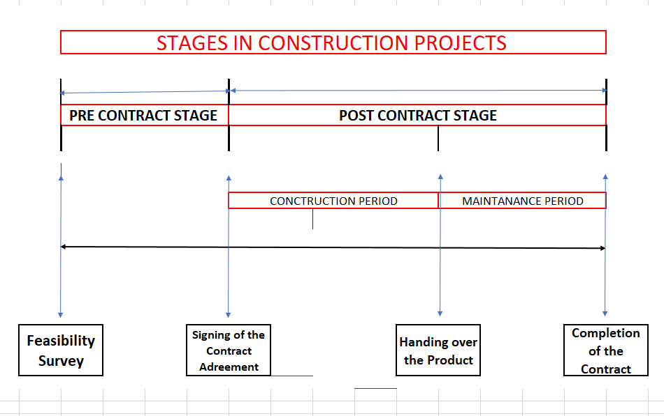

2. PRE CONTRACT STAGE

At first Owner should arrange a feasibility survey to study the what best practices are to be followed in order to Complete his production with no conflicts;
This survey is to foresee what types of Contrasts may be expected and how those can be overcome to get his expected benefit with no bother.

2.1 FEASIBILITY SURVEY
Definition of the Feasibility Survey
Then the Feasibility Survey for any project can be defined as the Preliminary Investigation that is to be made to verify and forecast what types of actions to be taken for smooth procedure of the expected project with avoiding or mitigating ( as far as possible) anticipated Risks , disturbances in Financially, Functionally and Operationally.
Therefore Feasibility survey can be separated in to three sectors.
- Financial Feasibility
- Functional Feasibility
- Operational Feasibility

Owner during the Pre - Contract Stage need assistance of following Staff members.

- Architect
- Geological Engineer
- Structural Engineer
- Design Team
- Quantity Surveyor
- Accountant
- Lawyer
- Draft persons
- Clerk of works
10.Office clerical Staff

- Financial Feasibility

  - Attending to the approximate Budget Estimation
  - Researching and Finding of the suitable Marketable option
  - Selection of the suitable design
  - Anticipated changes of Government Regulations
  - Anticipated Changes in Construction Cost and Government Tax systems

- Functional Feasibility
  - Legal and statutory Obligations
  - Environmental Regulations
  - Design Effected restrictions
  - Important Facts to be included to Contract Documents
  - Calling quotations from Contractors
  - Selection of the Most suitable Contractor
  - Selection of the Most suitable Engineer For work supervision
  - Process of Work Supervision and Quality Control or Assurance
  - Nominated sub-Contractors
  - Maintenance procedure

- Operational Feasibility

  - Business Opportunity
  - Third party involvements
  - Conditions applied to third parties
  - Post developments ( Building alteration and Marketing) Accountability of Expected Turn over
  - Facing for Anticipated changes of Rules and Regulations

------------------------------------------------------------------------------------------------
Sub topical Financial Feasibility
- Attending to the approximate Budget Estimation
This is the Consideration of the probability of the Owner’s Expectation and the consumable amount of Funds in hand ‘
Approximate estimation can be made with either comparing similar type Construction in the same area & same time or not ,
Or
With theoretical cost estimation.
Owner may with assistance of his staff have to decide , the amount and the scope of the expected production hereby .

- Suitable Marketing Option

This decision should at first to be taken before any of other steps taken.
Researching shall be with following facts
- Geography of the area
- Peoples demands
- Other Competitive businesses
- Accessibility

iii. Selection of the Suitable Design
Design of the building should be satisfied with following requirements
- Foundation bearing Strength suited with the Geological report
- Outlook obtaining people’s attraction
- Economical Structural design
- Allowance of Further developments
- Urban regulations

iv. Anticipation of changes Government Regulations
- Research next Government project plans
- Research next Government policy plans
- Acts and Ordinances assumed to be placed which may Obstruct the Objective

v. Anticipated Changes in Construction Cost and Government Tax systems
- Cost of living and variation in Wages material Costs ( Ex - Inflation )
- Imports Restrictions
- Changes in tax % s which may be assumed as occur in future ( Ex- Vat )
- Possibility for requesting Price escalation Allowance

Sub topical Functional Feasibility
- Legal and statutory Obligations
- Approval from the Administration Authorities
- Street limits
- Space Limits with neighbor buildings
- Noise Controls
- Environmental Regulations
- Disposals of debris
- Discharging of drainage out water
- Discharging of toxic smocks
- Interrupting to Natural water resources
- Protection of Flora and Fauna

- Design Effected Restrictions
- Engineering approval for Foundation process
- Obstructions for protected aesthetic views and archaeological places
- Security area regulations
- Building Height limits
- Approvals for Reinforcing steel
- Natural or Artificial Ventilation
- Sun rays reflective external wall surfaces

- Important facts to be included to Contract Documents
- Selection of favorable General Conditions and Specifications
- Studying amendments to be made in Particular Documents
- Instructions to bidders
- Survey data for sub soil conditions collected from relavant authorities
- Priority order of the Documents
- Bidder’s Qualifications and Relevant experience
- Construction Restrictions

V. Calling quotations from Contractors
- Deciding the duration of Calling Quotations
- Informing the date for Pre- Tender meeting
- Arranging Expert panel to monitor
- Keeping confidentiality

Vi. Selection of the Most suitable Contractor
Appointed Expert panel to attend for
- Consider the type of Registration
- Considering previous Experience
- Making Comparative report

Vii. Selection of the Most suitable Engineer For work supervision
Owner to take Expert advises to
- Verify his Previous Experience
- Consider his Engineering and Administration Qualifications
- Consider His appointing Assistant Staff members
- His quotations Figure

Viii. Process of Work Supervision and Quality Control or Assurance
- As the Owner Should be Knowledgeable
- Discuss with his expert panel to select and Decide
Most suitable Process of Work Supervision and the Quality Maintenance Process

iX. Nominated Sub Contractors
- Owner at the beginning should be able to decide Most suitable Sub Contractor’s are nominated and Includes their Names in to the Contract Documents for Some specialized work which are not specified in the Selected Main Contractor’s scope.
- Ex - Electro Mechanical works, Fire Controls, CCTV, Air Conditioning, Escalators, Lifts, Landscaping ….. Etc.
At the end of Feasibility Survey Lesson,
Note
It is not required to go deeper on Operational Feasibility Events related with the Clients Usage of the Building for marketing purposes, as this subject is to study Binding Contract Management only up to the Closer of the Contract trlated to the Construction of the building.
2.2 LIFE CYCLE OF THE BUILDING
The construction product life cycle includes all stages from Feasibility Survey up to the Establishing the Contract and Constructions, Contractual Maintenance, Closer of the Contract and then use, manufacturing, further repair, maintenance and Development , and up to the end of life Extraction, disposal of debris, Clearing the Land
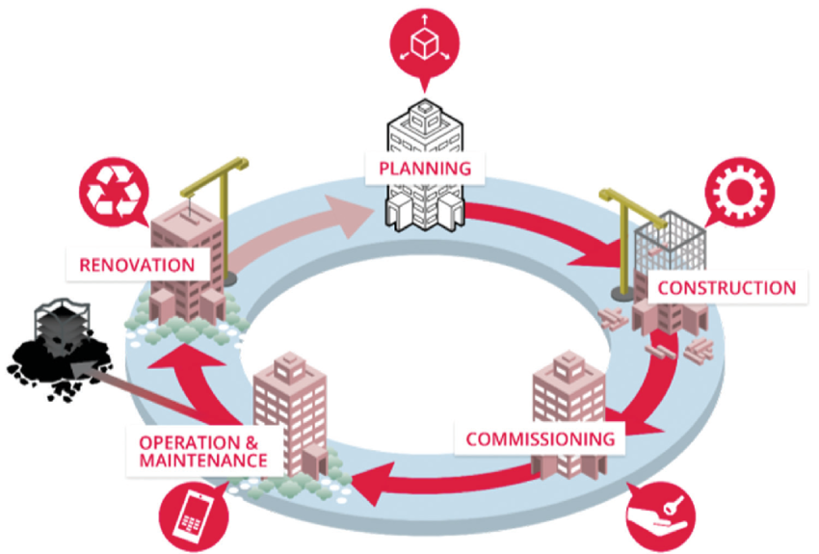
3
5
4
2
1

STAGES OF LYFE CYCLE OF THE BUILDING

Stage-01
- Initial Land Preparation
- Feasibility Survey
- Selection of the Suitable Contractor
- Signing of the Contract agreement
Stage-02
- Post Contract Legal Documentations
- Initial Construction Program
- Establishment of the Land Site
- Construction and Supervision
- Quality Control/Assurance
Stage-03
- Final Testing and Commissioning
- Taking Over of the building ( Handing over )
- Contractual Maintenance
- Performance and Liability Certification
- Closer of the Contract

2.3 SELECTION OF THE SUITABLE CONTRACTOR
Following Steps are to be Finalized by the Owner before the Quotations are called from Contractors

- Method of Tender
- Method of Payments

Popular Two Tender Procedures to be Applied
- Open Tender Method
It is called as by the Public Advertising for noticing any of Different Contractor’s to supply their Quotations to the construction of Clients building.
- Closed Tender Method
There is no public Noticing and in this method is not opened for any of Contractors, Client Select one or Two, Three Contractors , as he desire and called them for a negotiation requesting them their Quotations submission.
Open tenders allow any qualified contractor to submit a bid after the tender is publicly advertised, promoting transparency and equal opportunity.
Closed tenders, alternatively, are only available to a selected group of vendors or suppliers who have been invited to bid, thus limiting the pool of potential bidders.

Open vs Closed Tenders:

Pros & Cons

Open Tenders

Pros
- Open tenders don’t exclude any potential suppliers, which means your organization gets a great overall view of the supplier market and the deals on offer.
- By not excluding any suppliers, you take an unbiased approach to the supplier market – an important factor for government departments and agencies.
Cons
- Open tenders can be a more expensive process, simply because they are more time consuming; accepting all comers means there are more bids to analyse and decide upon.
- If the Client is unaware of anyone, it is potentially dealing with Contractors/suppliers you know nothing about. This can expose you to be patient more to find the better conclusion and to leaves bad deals.
- With open tenders, If there is sometimes too much focus on lowest price at the expense but of quality and other important considerations are sometime may be problematic.

Closed Tenders

Pros
- It can be a cheaper process. Inviting only a select few to submit bids means there is less time for the Client have to spend on analyzing them and deciding the best in less time equals less money.
- You have the opportunity to invite only those Contractors/suppliers you know to be reputable and professional. This avoids any bad eggs.
- With fewer bids, there is a chance to embark upon more substantial communication and a more collaborative approach.( Ex- Price negotiation with or without Discount) Not only can this lead to a better deal for both sides, it also lays the foundations for a positive, long-term business relationship.
Cons
- Obviously, a lot of potential suppliers are excluded. Dealing only with those you know CAN REDUCE THE CHANCE OF DEALING WITH BAD EGGS, BUT IT ALSO MEANS YOU MISS OUT ON THE good ones you don’t know about.
Somewhere out of them, the right Contractor/supplier for you may be waiting; a closed tender reduces your chance of meeting them.
- There’s a level of bias with closed tenders that can make them inappropriate for government departments and agencies.
- If you’re new to the Contractor/supplier Background, or have, it’s difficult to identify a shortlist of the best vendors out there.
Students are hereby requested to follow the Most popular Standard Method of Open tenders for this subject.
This is fallen to the Procedure called as Design, Bid, Build Method ( DBB).
PAYMENTS METHODS
Payments Routing can be decided and applied by the Client following different processes, and then include to the Contract agreement as accepted by both parties .
- Measure and Pay on unit Rates of the Contractor
- Lump Sum Payment
- Item Cost and different % s of Cost for the Contractor’s Overheads and Profit
- Cost + Fixed % as the Total Contractor’s Price
Note - We in this book describes Payment Routing No-01, comprehensively and other methods of payments are briefly described separately .
Construction payment terms vary by contract type, project size, and the agreement between the project owner and contractor. While there are no “typical” payment terms, common industry practices include progress payments, on terms vary by contract type, project size, and the agreement between the project owner and contractor.
While there are no “typical” payment terms, common industry practices include advance payments, progress payments with retains, final payments.

- Measure and Pay on unit Rates of the Contractor
Payments for the Contractor is to be calculated with the Selected Contractor’s Unit Rates agreed multiplying by the Quantity of works in Completed in Specified Units.
This payments are generally in once Monthly basis, after verifying the Quantity of different Items Completed and the agreed unit Rates

- Lump Sum Payments
Total Project is to be Completed by the Selected Contractor on agreed Total sum called as agreed Lump Sum , as the Contract Price.
Payments shall be made by computing the % of the works in the Building , by multiplying the same % by the Total Lump sum Contract price.

- Item Cost and different % s of Cost for the Contractor’s Overheads and Profit
Contractor’s Actual Cost calculated for different work items shall be calculated, and this amount shall be paid with added % s of agreed Overhead and Profit differently.

- Cost + Fixed % as the Total Contractor’s Price
Whatever the work Quantities are in different work items, if the Parties at the Contract signed agrees fixed % for Overhead and Profit, a certain % shall be added to the payment of Contractor’s payment and consider as the Owner’s actual Cost.
Note- This book of study dialogue with the Standard method Payment No-01.
Hence with the Contractual Tender documents all bidders ate receiving a UN-priced Bill of Quantities which are including all expected work items with estimated quantities.
Bidders are given instructions how to go through all descriptions in each documents and make their unit Prices as possible as accurate.

2.3 PUBLIC NOTIFICATION
Client has to make a public newspaper notice for the Information of his intended Building Project, under the Open Tender procedure.
The Notice includes followings,

- Scope of Work
- Required Qualifications for Bidders to prove
- List of Documents those they can collect from the Client Office
- Fixed date for the Pre -Tender Meeting
- Final Date specified for bids submission
- Any other - as required by the Client

Note- Students are requested to see week ends news papers and to observe similar mortification s with headings as follows.

- Calling Quotations a Construction of a Buildings
- Tender Notice for a Building Constructions
- Request Construction Contractors Quotations

2.4 RECEIVING TENDER DOCUMENTS FROM CLIENT

Bidders are collecting the set of following Tender Documents from the Client office after their Qualification, Experiences and Strength of Resources in hand are officially proved by submission of certifications .
- Contract Data
- Instructions to bidders
- Particular Condions of Contract
- General Conditions of Contract
- Particular Specifications of Contract
- General Specifications of Contract
- Set of Design Drawings
- UN priced Bill of Quantities
- Preamble to BOQ ( If provided)
- Any other Information

All bidders are carefully verifying each and every documents together Considering the order of priority and obtaining the full understand of all work items to be Completed as per the Conditions , Standards , Quantities under their Units ,Lines , Levels and Measurements prior to the attending for Unit Pricing s.
If they come cross with some miss matching data or any short of required information , they may record them all for making inquiry in latter at the Pre-tender meeting ( Pre-bid meeting) that is organized by the Client.
2.5 PRE TENDER MEETING
As informed by documents, all bidders are attending to the pre- tender meeting in order to get their uncleanness and queries to be settled by the Client with his expert panel.
Each Bidder may have different Matters to be cleared and then query at the meeting.
The Client should answer all of them with alternative solutions or clearings .
All Questions and Answers shall be recorded and within a possible short period distributed among all bidders.
This record is called as - “Query Sheet”.

2.6 QUERY SHEET

Distributed Query Sheet thereafter shall become a Part of Tender Documents and then the Client determine all Queries of Bidders have been Cleared.
Example - and Exercise
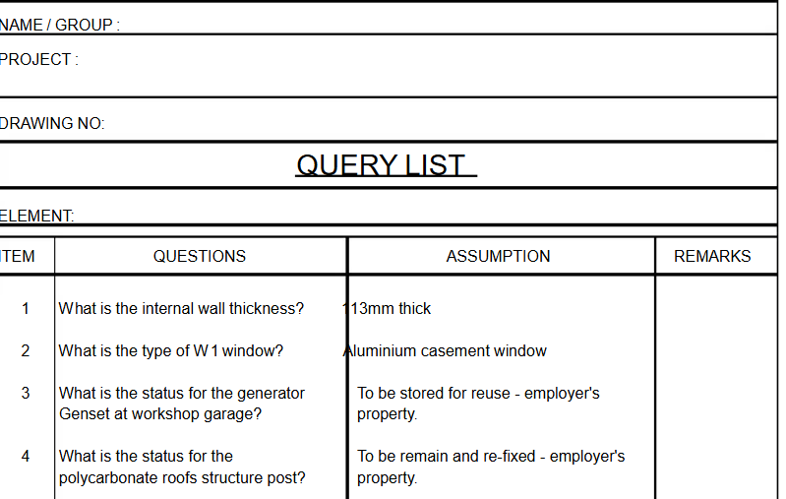

Some Other Queries Those may be arisen and added

- Drawings stated the Strip Foundation Concrete as 20 Mpa While the Specifications says it should be 25 M pa; which is Correct?
Assumed Answer - According to the Priority of Documents, Specifications should be followed in this case.
- In foundation Excavations are price rates to be based on the volume including working spaces?
Assumed Answer- No, It should be actual Designed Volume as specified in Drawings.
- Apart from list of Nominated Sub Contractors stated in Contract Documents have we to expect some more of them after the Constructions Commenced?
Assumed Answer- It might be.

- In the situation of above answer, will you considerate as a Additional work to attend with Extension of Time and Additional Cost for the Main Contractor ?
Assumed Answer- If you found it as per the Contract, you may proceed with.

2.7 ATTENDANCE TO UNIT PRICE CALCULATIONS

Bidders with Revering all tender Documents and the Query Sheet collected from the Owner of the Project.
Then they shall commence the preparation of most accurate unit rates to be included to the Un -Priced BOQ.
There system of calculation of Unit rates are based on Basic Cost estimated by the bidder and addition the Overhead and Profit in percentages of the Basic Cost as what they are being predicting to Consume and Gain.

2.8 GENERAL COST FORMULAS TO BE CONSIDERED FOR
EVQLUVATING CURRENT PRICES

(i) MACHINERY DEPRECIATION

d = ( C-s)/n

D - Annual depreciating value of the Machinery
C - Capital Cost Consumed at Purchasing
S - Scrap value of the machinery after the Life Time
n - No of years of specified Life time of the Machinery

ii)INFLATION FACTOR OF THE COUNTRY

FV = PV (1+ f/100)^{n}

FV = Future value of Present Value of Money
PV = Present Value of Money
r = Average Inflation Factor for the Duration in years
n = No of Years in the Time Duration

2.8 SUBMISSION OF TENDER QUOTATION PRICE

- Bidders should be knowledgeable enough to understand all conditions given by the Client in Tender documents to make their finalizing the reasonable contract Price with all details of calculations with not confusions to both party.
Following facts are to be considered by bidders to verify and finalize most accurate reliable unit Rates
- Geographical situation of the Project area
- Past annual Inflation factor of the Country
- Whether the Price escalation payment is allowed or not
- Competitiveness of finding Construction materials
- Availability of near Machinery Service centers
- Finding of Working Labour and Intellectual Labour
- Cost for security
- Cost for following Government Regulations
- Bidders are to be ready to submit their Price Quotation within the time limit given as per the Tender Notice public advertisement.
- They should also be prepared to face for any post bid negotiation, if Client request.
With calculated unit price rates for each work items against the Quantities stated in un-priced BOQ of Contract document, shall be written by pen to finalize the total budded price. This price calculation should be submitted by the Contractor with following attachments
- Proof of Qualifications, Registration, and Experiences previously earned with no conflicts.
- Signed Copy of the query Sheet issued by the owner.
- List of Resources asserts Owned or/and with easy possibility of from reputed out source
- Day work rates of all resources which have been used by the Contractor to pricing Tender Priced BOQ Unit Rate calculations.

2.10 TENDER EVALUATION

After the bid submission final day is passed, Client shall open all sealed bid papers and submit to the Tender Evaluation Board to select what most better get the final at best.
Assuming that the Client Budgeted Estimate is Rs 500.00 Million
They may separate following exampling quotations ( Either Lowest or significantly with best past experienced ) for final verification.
Following two situations may be finalized after the Comparisons

Table-01
Bidder | Quotation (ml) | Past Experience and  Performances | Remarks
Contractor-A | Rs. 320.00 | Qualified in relevant field but No more better Performances were Shown. | Quoted figure cannot be acceptable as justifiable . No enough Experience
Contractor-B | Rs. 490.00 | Qualified in relevant field more better Performances were Shown. | Quoted figure Can be Acceptable as Justifiable and better Past experiences
Contractor-C | Rs .740.00 | Qualified in relevant field more better Performances were Shown. | Very high figure’  Cannot be accepted.
Contractor-D | Rs. 550.00 | Qualified in relevant field and fair Performances were Shown. | Can be accepted as second Lowered ‘’ with no Finalizing

In this final tender evaluation as per the Table-01 ,
Contractor-B can be selected and the Owner may issue a Letter of Acceptance with no further negotiation ..

Table-02
Bidder | Quotation (ml) | Past Experience and  Performances | Remarks
Contractor-A | Rs. 320.00 | Qualified in relevant field but No more better Performances were Shown. | Quoted figure cannot be acceptable as justifiable. No enough Experience
Contractor-B | Rs. 490.00 | Qualified in relevant field more better Performances were Shown. | Quoted figure Can be Acceptable as Justifiable and better Past experiences
Contractor-C | Rs 520.00 | Qualified in relevant field more better Performances were Shown. | Considered as Contractor-C is most suitable Than Contractor-B  Can be accepted after a negotiation.
Contractor-D | Rs. 580.00 | Qualified in relevant field and fair Performances were Shown. | Cannot be accepted as quoted figure is higher ‘’

Contractor -B and C Shows fairly reasonable Prices. But the Owner may prefer Contractor -C even with Rs 30 .00 Million Figure higher than B, who has offered Rs 520.00 ml..
Tender Evaluation Board has recommended Contractor - C to be called for an Negotiation.
This final negotiation shall be made Contractor-C , and then Client Explain the situation of his preference to select him for the Contractor’ and with some requesting a Discount up to figure given by B ..
Contractor C some times may agree Full amount of 30.00 ml or lesser.
What ever it is if we assume that the Contractor -C agreed for giving a Discount of Rs 20.00 ml. The Discount given for the original quoted figure of Rs 520.00 ml shall be added to the priced BOQ as a percentage basis .
FINALIZING THE CONTRACTOR - C AS THE SELECTED CONTRACTOR WITH A DISCOUNT AGREED .

This discount shall be calculated as follows.
(20/520)x 100 = 3.85 %
Even though with the Discount of 3.85% agreed there shall not be any changes to be made to the original Unit rates or Item prices or Total Contract Price quotation originally offered by the Contractor C.
This matter is Specifically stated in the Client’ s Letter of Acceptance that shall be issued to the Selected Contractor C .

2.11 LETTER OF ACCEPTANCE (LOA)
Client after the successful negotiation shall issue the “Letter of Acceptance” to the selected Contractor - C saying that the Offer given by him ( Rs 520.00 ml ) is hereby accepted with the agreed % of Discount - 3.85 %.
Contractor shall write back to the “Letter of Acknowledgment” in response to the Client,s “Letter of Acceptance“ giving the information that his willing to Sign the Contract agreement up on the agreed offer for the Project .
A Letter of Acceptance (LOA) in construction projects is a formal document that signifies the employer's (or client's) acceptance of a contractor's bid or tender, thus forming a legally binding contract. It outlines the key terms and conditions of the agreement and initiates the contractual relationship between the parties.
Until the Formal Contract Agreement signed by both parties the Client’s LOA and Contractor’s LOA are bring considered as documents which are legally binding parties for the certain project.
This means Each party agree to fulfill other party’s Consideration.
Contractual Consideration s of the Other party
In contract law, contractual consideration is something of value that is exchanged between parties as part of an agreement. It's the "Price" or the “Value” that each party is willing to pay for the other party's promise or action, making the Contract agreement legally binding. Without consideration, a promise is generally not enforceable in any Contract.

2.12 SIGNING OF THE CONTRACT AGREEMENT
Building Contract Agreement is valid
Since the
- Project work Commencement
and
- Total Construction period
And at
- Handing Over the Production
- Contractual Maintenance
Then Up to the
- Closer of the Contract
Legal Construction Contract Agreements includes following Contract Documents in their Priority Order of legal and Contractual application.
- Contract Agreement
- Letter of Acceptance
- Contract data +Finalized Query Sheet
- Instructions to bidders
- Particular Conditions of the Contract
- General Conditions of the Contract
- Particular Specifications of the Contract
- General Specifications of the Contract
- Drawings
10.Priced Bill of Quantities
11. Addendum s ( Ex- Preamble to BOQ , agreed day works Rates ,Contractor”,s unit rates calculations , List of owned Resources , Etc)

(3) POST CONTRACT STAGE
3.1 BIGINING

Contract stage is to be considered as commenced after the date of legal contract agreement is signed by Both party.
Following Initial actions are to be taken by both party at the beginning of the Commencement of Works , Approved by the Client .

The Contractor

- Receiving the Possession of the Side land
- Submission of the Performance Bond
- Submission of the Advance payment Guaranty
- Submission of Resources Plan
- Submission of the Insurances
- Appointing Initial Staff members
- Submission of the Establishment Plan
- Submission of the Initial Construction Program with Cash Flow Prediction
- Establishment of Initial Facilities ( For The Client , Contractor and the Engineer )
- Submission of Environmental and Safety Plan

The Client
- Appointing of the Engineer
- Arrangement and Granting of the Possession of the land site

The Engineer
- Verifying Contractor’s all Submissions and Finalizing
- Submission of all Documents for Client approval and further actions ‘
- Supervising and advising to the Contractor for Establishments of Initial Facilities .
- Appointing Assistant Staff members of the Engineer .

3.2 POSSESSION OF THE SITE LAND
Site Land which is belongs to the Owner , is to be allowed for the use of the Contractor for the Initial preparation,
The contract may state the date for possession of the site by the contractor, or, if not, then the site must be handed over to the contractor within a reasonable time after signing of the contract.
ICTAD GOC SBD-02 says within 14 days from the Date of LOA , The owner shall grant the Contractor to the legal authority for the right of Access and permission of use all parts of the site land, Unless the specified period is separately stated in the Contract data.
This right of permission is exclusive to the Contractor since the Date of Owner’s grant, as specified in either the GCC or Particular Conditions or Contract data.
However it is Owner may withhold the action of granting the permission for the Contractor , until the Performance security ( Bond) is successfully received from the Contractor..

3.3 PERFORMANCE BOND
Bond means an instrument of Security furnished by the Contractor and/or Surety in accordance with Contract Documents. The term contract security refers to a payment bond
A performance bond, is a surety bond also a legal entering to the assurance to the Owner on mistake free performances of all activities in the Contract
It is a legal Document and should be issued by an Reputed Finance Authority or an insurance company or a bank to guarantee on satisfactory completion of a project by the contractor.
The term is also used to be enforced by collateral deposit of good faith money, intended to secure a futures contract, commonly known as a equivalent to the percentage Value of the Total Contract Sum as stated in the Contract Documents.
This should be submitted by the Contractor on his own Cost to the Employer within 14 days from the Date of LOA as Stated in GOC, unless any other period is specified in the Contract.
The Performance Bond shall be being applied to the Contract up to the Closer of the Contract

3.4 ADVANCE PAYMENT GUARANTY
It is a standard practice of the Owners of Construction Projects are granting an Advance Payment for the Contractor before he Commence the permanent works . This is an Interest free loan and shall be recovered by the Owner later time from Interim Payments entitlement of the Contractor in Installments basis .
Advance payment total sum is the Specified % of Total Contract sum , This percentage figure is mostly stated in Contract data with the description of the of the Recovery procedure.
Contractor should submit a Finance guaranty with the equal valuation to the Full payment sum to the Client to get assured for him to consider the Contractor’s application the granting of the Loan Payment.
Advance payment guaranty is ensuring that the contractor will fulfill their obligations or, if they fail, that the advance payment can be recovered by the guaranty. Essentially, it protects the client's interest in any of the events the contractor defaults on the contract, for receiving the loan payment back.
Advance payment, although it, is a Loan to be recovered, is considered as the first Payment to the Contractor to be made by the Owner.

3.5 SUBMISSIONS OF THE RESOURCES PLAN
As the Student already studied what are resources are to be Expected to utilize by the Contractor on his total Construction period for the Initial work Program .
- Human resources - Working Labour , Skilled Labour , and Intellectual Labour
- Material - Either by Own manufacturing or Purchasing from out source
- Machinery - Either by Own or Rentals from out source
- Registered Sub Contractors or suppliers
Note - There is a Initial Plan those mentioning All resources stating for Total project Time .
This may be at time to time as the variable Quantities of Utilization's those shall be stated in according to the Initial Work Program .
3.6 SUBMISSIONS OF INSURANCES
These Insurances are formally established with an reputed Financial & Insurance Agencies which are approved by the Owner.
Insurances are to be made and established by the Contractor with the Consent of the Owner for following active fields for the Post Contact Period ..
- Insurance of Labouré Compensation
- Insurance of Machinery
- Insurance of Works
- Insurance of Force of Nature ( Limited)
Those fields of Involvements are, in normal conditions, expected as Either may be occurred with no fault of the Owner or both parties.
Note -
However, the Owner has legal rights not to grant permission for commencing of works for the Contractor if no Insurances documents are fully completed.
Whatever it is, in Particular incidents in all fields, both party may have to be involved in an legal parameters , further details shall be discussed in next expected advanced issue of the Book .

3.8 APPOINTING OF INITIAL STAFF MEMBERS

The contractor initially require following Staff members for the Initial submissions of Documents and the Site establishments .
The Project Manager the Construction Manager who is being nominated by the Contractor and the application with his Qualifications for approval of the Client is to be submitted to the Client of If the Engineer has already been appointed , to him for commenting and/or granting certification for the Client.
Along with the Manager other Initial staff members are required immediately for the assistance for the Manager, and should their Details of Qualifications and Experiences to be submitted for the Client’s approval.

- Construction Manager
- Planning Engineer
- Quantity Surveyor
- Finance Assistance

3.9 SUBMISSIONS OF ESTABLISHMENT PLAN
Site Establishment facilities for the Contractor , The Engineer and the Client's representatives are to be Planned with Consultation and Consent of the Engineer /Client's Representatives.
This is to be Shown in a Planned Drawing with all particulars of following Temporary buildings and Lands areas with all conditions given in the Contract documents or if not Stated therein , may be finalized with all three parties requirements, Comments and Satisfactions .

- Contractor’s Office
- Engineer’s Office
- Client’s Office
- Material Testing laboratory h
- Stores Building
- Material Stock yard
- Vehicle parks
- Boundary wall with Entrance and Exit and Temporary Roads
- Security arrangement
- Temporary Service ( Water, Electricity , Communications Etc )

3.10 SUBMISSIONS OF INITIAL CONSTRUCTION PROGRAM
Initial Constriction Program is the Document to be submitted to the Client by the Contractor Through the Engineer, Showing Contractor’s work arrangement for the successful completion of the Project,
It should be prepared concordance with the Agreement considering for the Completion,
- Within the Agreed Time
- Withing Agreed Cost
- Including all Agreed works activities
- Following the Specified Standards and Quality
Contractor should indicate how he intend and Plan to complete Quantities of all work activities in each month of the Construction Period in a Bar Chart.
Accordance with Intended quantity of works Quantities multiplying by agreed BPQ rates the Value of work done in each month can be calculated and stated therein.
After Consultation with the Engineer Finalizing of the this graphical submission are made and submitted for the Client Approval.
Value of Intended Works to be done in Each month shall be Considered as the Project Cash flow prediction .
It is the Initial agreed Plan of Contractor’s Cash flow in and Client’s Cash flow out.

Simple Exercise for an Initial Construction Programmer
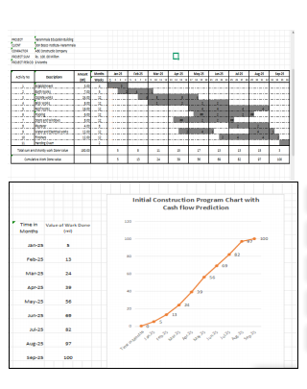
and Cash Flow Prediction in a Construction Project

- COMMENCEMENT OF WORKS
Works in a Constructions Project are divided in to Two Parts /
- TEMPORARY WORKS
- PERMANENT WORKS
Temporary Works
means the works of any things done for Establishments or any Other supporting services for Same,
And
Many other Structures or Services are to be fulfilled to complete the total project requirements as per the Contract agreement in the following activities.
- All supporting Structures Required for Permanent works
Ex-Form works, Lateral, and Many Force supports are allowed to complete the Product as per the Specified Quality
- Whatever constructions to be made to protect the Safety and Environmental
Ex- Coffer dams, Extra Temporary Accesses, Satiety Arrangements, Medical Treatment facilities, Anti-Collapsing Supports, Ect ,
- Whatever the physical involvements are applied at the Site to Protect Health and Safety and for mitigating losses for any unforeseen obstructions
(Physical or Force of Nature)

Permanent Works
Permanent works means the Whatever specified in the Contract Other than the Temporary works , and also can be stated as the all parts of productions which are to be remained at the handing over the Whole Production .
Commencement date of Works
The Contractor is Contractually Entitled to Request the Engineer for the approval to Commence the works after the Completion of his contractual obligations for the Commence the works.
ICTAD COC SBD-2 clause 8 says that the Engineer Should Grant his approval within 7 days of the Request made by the Contractor or within, if there is any other Period stated in Contract data.
Unless There is specified period at anywhere stated the Contract, Commencement of Works shall be after the 14 days from the issue of the letter of Acceptance.
It is the responsibility of the .Contractor to arrange all Quantities of works with no delay to be Completed in Time he promised as he stated in the Initial Construction Program which was approved by the Client.
It is the Client’s responsibility is the arranged all monthly payments after he receive the contractor’s Payment supplication as stated in the Contractor’s cash flow prediction with no delay. ( Within the Periods speechified I the Conditions of the Contract)

3.11 OEGANIZING CHART

Standard Staff Arrangement of a formal Constitution project
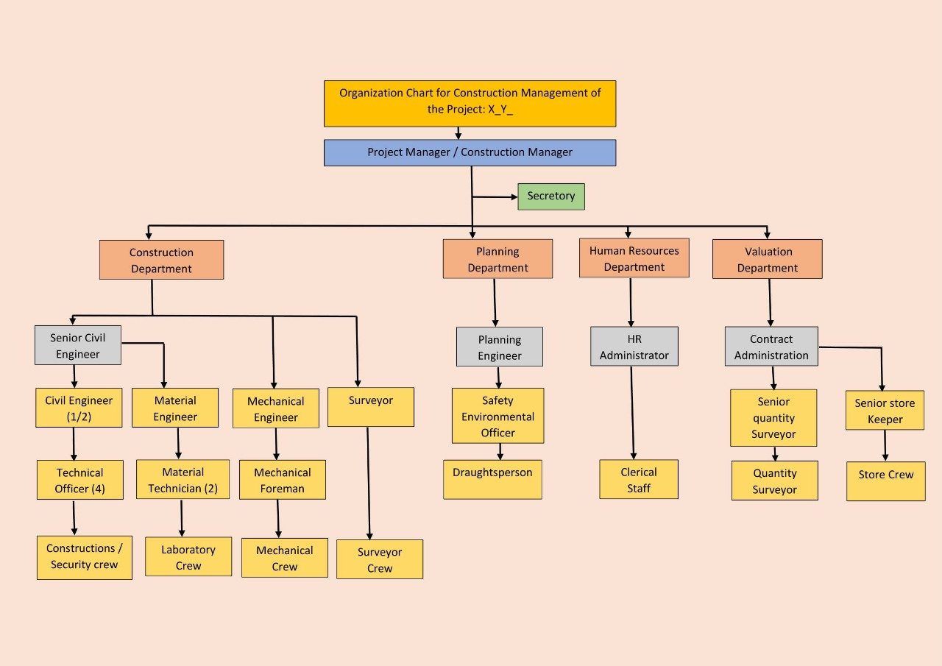

This is a nominal demonstration for the Staff arrangement at a |Construction Project. It can be varied or highly weighted depending on the width of the Project scope.
Also in a same project too according to the Initial constructions program submitted by the Contractor and approved by the Owner , Contractor may at time to time submit a Human Resources Histogram to the Owner with mentioning any changes ( Additions or Alterations ) those should be made according to the Requirements of changing work activities.
In construction projects, a resource histogram is a type of bar chart that visually displays resource allocation and workload over a specific project timeline.
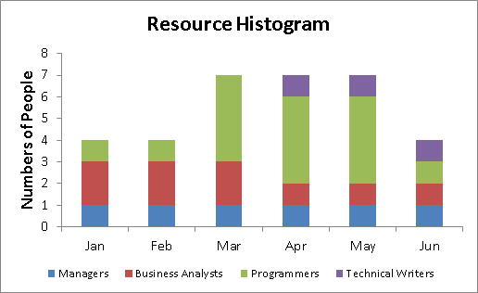

3.12 STANDARD PROJECT WORK ARRANGEMENT
  - The Contractor should submit the Engineer every day his work arrangement prior to 24 hours of the intended commencement of works . It is the Daily work Program.
Sometimes it may be the Weekly Work Program as agreed,
  - The Contractor is also the submit the Request for Inspection ( RFI) to the Engineer, expecting his inspection then to get his approval to commence all or part of the work items as specified in the BOQ and Drawings, 24 hours before his intended time of commencing the work
  - The Engineer shall inspect and check all arrangements at the site, with the line and levels, before the contractor’s commencement time of work. If he is satisfied with the Contractor's work arrangement, he may grant the written approval for the Contractor to commence the relevant work.
  - Engineer’s staff members shall inspect whether the following requirements are satisfactorily arranged by the Contractor..
- Availability of Sufficient Resources
- Interruption-free Work area
- Facilities available for the Checking Line and levels
- Accuracy of Line and Levels
- Health and Safety arrangements
- Quality testing arrangements
- Application of Correct methodology
3.13 CERTIFYING OF CONTRACTOR’S WORK DONE VALUATIONS
With the Coordination of the contractor’s Personnel assistance, the Engineer, after every work done, completed to his satisfaction, shall approve the following documents, certifying the Contractor’s entitlement for inclusion in to Monthly payment applications.
- RFI document approved by the Engineer to commence the Work
- Certified Measurement Sheet accepted by the Engineer/Contractor as correct,
- Laboratory Test Reports to Approve the Achievement of the Required Quality
The Contractor shall collect all of the Engineer Certified Documents for each work in the following order of attachments to the monthly Payment applications, prepared by him, the Total value of the work against the Quantities and relevant Unit Rates.

DOCUMENTS TO BE MAINTAINED

THE CONTRACTOR
The Contractor is required to carry out the works at Project as per the approved Initial Construction Program.
Conjunctive with the Approved program, the Quantities of the wonk are to be arranged with no changes .
He is to submit Daily or weekly following Documents to the Engineer.
- Daily or/and Weekly Work Program with details of Resources are to be intended to utilized ( Before 24 hour )
- Requests for Inspections for each works, in order to obtain the approval to commence the such work activity ( before 24 Hours)
- Daily or/and Weekly work Progress - (24 hours after the works Completed)
- Quality tested Results - ( just after the Joint Tests against the Completed works carried out )
- Daily or Weekly Environmental Protection Action Plan
- Daily or Weekly Health and Safety Action Plan
- Assistance for Certification for Line and Levels and Measurements of ongoing or Completed works
THE ENGINEER
The Engineer, with the Assistance of Contractor’s and His own Staff members is responsible to comply with Contractor’s submissions with no delay following response.
- Approve or Disapprove with the reason
- Comments for any alterations
- Mistakes to be Corrected
And
Attending for Measurements Taking and Approving with joining the Contractor

MONTHLY PAYMENT APPLICATIONS
Contractor’s Payment Applications are separated into the following categories ‘
1St payment - Advance payment

2nd Payment - First Month Work Done Valuation
Interim Payments
3rd Payment - Second Month Work Done Valuation
………………
………………
n^{th} Payment - n^{th} Month work Done Valuation

Statement at Completion - This is the Payment application to be made by the Contractor to the Engineer , After the Building is handed over to the Owner.

Interim Payments means all payments between 1st and Last during the period of Construction - Commencing up to Handing over at the Completion

PROCEDURE OF CONTRACTOR’S PAYMENTS
Different General Conditions of Contracts are specifying Different Periods for Engineer and Owner To consume for arranging payments of Contractor’s Applications
If we consider Ictad COC SDB-2 ,
It says ,
The Advance Payments
Employer shall grant his Advance payment when he receive the Advance Payment Guarantee from the Contractor.
The amount of Advance payments and the Recovery method with number of Installment are stated at the Contract data.
Interim Payments
The Engineer withing 21 days time of receiving the Contractor’s Interim Payment Application ( Statement with all supporting Documents ) shall issue his certification to the Owner.
This certificate shall state to the Owner,
- The amount which can be paid the Contractor
- IF the Amount certified by the Engineer is lower than the Amount Applied by the Contractor with his Statement , the reasons for Engineer’s Adjustments
The employer has to make payments to the Contractor withing 14 days Time after the Engineer’s certification received by him.
Whatever it is Employer has authority to delay any payments to the Contractor , If the Contractor has not fulfilled the Submission of Performance Security.
3.14 DELAY PAYMENTS
If the Contractor has not received the Interim payment within the Specified period ( 21 +14 days ) from the Employer ,While he has completed all necessary submissions correctly to the Employer,
It is Considered as the there is the Delay of the Contractor’s payment.
This is a Interruption to the Compactor's Cash Flow In Program.
SDB-02 Document says that , in such instant the Contractor is Entitled to claim the Delay payment . This delay payment is the Amount equals to the Interest payment to the Amount delayed against the Period Delayed.
Interest % shall be the 1% + Approved Lending rate of the Central bank of Sri Lanka applicable at the period of delay.
( This lending Rates may be varying at time to Time and published by Central Bank accordingly)

3.15 CONTRACTOR’S PROGRESS OF WORKS
Contractor should maintain his progress of works are accordance with the approved Initial Construction Program.
If he fails at any Instant to keep it Correct or it is noticed by the Engineer that the Progress of works are fallen behind the approved program, with No any acceptable reason , It is considered as a Contractor’s delay in Progress.
Engineer shall issue a notice request the Contractor to Correct the Situation reasonable time with providing a Revised Program to catch-up the Delay.
This Catch up Program should not vary with the Initial date for Completion.
Also the Any Extra involvements those may be required to catch up the Delay are necessary , the Extra cost incurring shall be a responsibility of the Contractor.
If the Contractor further fails to correct the Delay even with an Revised Program, Owner may suffer a delay of the Taking over the building in Time.
The period of Delay ( Actual Completion day - Date for Completion as per the Initial program ) shall be considered as the Delay Caused by the Contractor’s fault.
Delay caused by the above reasons as per the Chapter -18 , shall extend the Date of handing over the Building and it is Considered as an unapproved Extended Time of Contract with the Fault of the Contractor

3.16 LIQUIDATED DAMAGES
This is a penalty to be Imposed on the Contractor if there is a Delay of handing over the Building in Time , called as Liquidated Damages.
Amount of Delay Payment to be made by the Contractor is specified in the Contract Data as an Amount per the Day multiplied by the Total number of days delayed.
However it is there is a limit of Total Penalty and this limit is mentioned in the Contract data , then the Employer shall make arrangement's to recover total Penalty from the Contractor’s Payment Entitlement up to the Final payment .
Even with the Penalty is to be recovered from the Contractor, He shall become obliged to full fill all of his obligations as per the Contract up to the Closer of the Contract.
3.17 VARIATIONS AND VARIATIONS PROCEDURE
Variations means Amy changes which are applied on the Original Design of the Building in order to get a betterment of the Production or Cost saving.
At any time during the Contract,
Engineer has Authority to initiate a variation.
In some other instances He may Request a Proposal for any variations.If the contractor’s proposal is signified as Either a Financial or a Construction Benefit to the Employer It may be considered by the Engineer for application.
Variations may Include,
- Changes of Quantity ( Increase or Decrease )
- Changes of Line levels and Measurements
- Changes of Originally Specified Quality of work
- Deletion of any work item
- Addition of New Work item
- Changes of Time stages of any work items in Initial Construction Program
The Contractor at any time is bound to accept to proceed with any variations ordered by the Engineer. But he has authority to Request for any additional Cost or any Losses, if incurred due to applied variation on to his original cash flow program already approved by the Client, to be added to his Payments.
Variation is to be Considered for valuation in one of following procedure.
- For Original work items Payment with original BOQ rates
- For New work items Considering Contractor’s Cost analysis
- For any New works with Quantities which cannot be pre -measured-
By day work payments*.
- Counting the Contractor’s actual Cost + a % for his Overheads and Profit
- For deletions of Work items - Price deduction
Note* – day work Payments
Measuring for pricing on this procedure are to be made with counting all resources utilized by the Contractor in each working day in Hours actually worked or idled for the such variation.
Pricing for payment to Contractor can be made on Time based day works unit rates submitted by the Contractor in his submission of the tender price as an attachment, as required by the Contract conditions, shall be used. Ref – contractors Tender submission . (Page- )

3.18 SUPPLIERS /SUB CONTRACTORS
Sub-Contractors can be divided in to two categories.
- Contractors Direct Supplies/ Sub Contractors
- Nominated Suppliers / Sub Contractors
- Suppliers on the other hand provide physical products, goods or services that facilitate the services that we provide.
- Subcontractors are those that provide us with trades and services. This can include plumbers, roofers and scaffolds.
Contractor’s Direct suppliers and Sub Contractors are Selected by the Contractor own with the Approval of the Owner , for obtaining the Permission to Enter and work within the Owner’s territory. They can be engaged by the Contractor for any assistance for the Project Activities. The Contractor at any instance cannot avert his Contractual obligations in taking whole responsibility of Sub Contractor's Involvements.
NOMINATED SUBCONTRCTORS
The client may wish to select (nominate) a subcontractor themselves, rather than allowing the contractor to select them. This is referred to as a nominated subcontractor.
This process may be initiated by the Client,
- where the client has involved a subcontractor in the design process,
- where the client wishes to achieve a very specific outcome,
- where they have an existing relationship within performing specified Specialized works mostly fallen apart from the Main Contractor’s formal Scope of works.
( Ex- Elector Mechanical Installations, CCTV, Fire Fighting Systems, Air Conditioning ,Lifts & Escalators, Waste Water Treatments, Ect)

Nominated subcontractors may be selected before or after the contract is entered into with the main contractor.
Ultimately, the nominated subcontractor is deem to be appointed by the main contractor, when the time arrives for such works are required to be activated.
Payment for Nominated Sub contractors can be allowed for in the contract by their Prime cost sum, to which the contractor is permitted to add profit and attendance.

PRIME COST
Prime Cost sum is the Total sum provided by the Nominated Supplier/Sub Contractor as the His Complete quotation submitted for the Assigned work to him in the Contract.
We may called it as the PC Sum.
PROVISIONAL SUM
Provisional sum is defined as the Sum stated by the owner in the Accepted BOQ of the Contract as provisional expenses which would be required in future anticipated Costs for works to be done by the Nominated Suppliers/Sub Contractors and any unforeseen variations or any accidental Payments .
These Costs are considered as sums which could not have been determined at the Time of Initial bill preparation,
MAIN CONTRACTOR’S ATTENDANCE AND PROFIT
Any payments to be made to the Nominated sub Contractors are to be Included to the Main Contractor’s payment applications with his Costs of Attendances and the Profit .
3.19 EXTENTION OF TIME
As we studied in previous chapters, The Contractual Initial time for completion may get requited in some times delayed caused by parties or some other reasons in time to time as pointed below briefly,
- Granting the Possession of Site Land
- Advance Payment Guaranty and Advance Payment
- Finalizing the Performance Bond and Insurances
- Finalizing the Initial Construction Program
- Completion of the Essential Establishment Events
- Scarcity of Resources and Poor Management
- Issuing Drawings and Instructions in Time
- Unforeseeable Obstruction
- Extreme weather Conditions and Forces of Nature
- Variations
- Government Changes of Rules and Regulations
- Bankruptcy of a Party
Contractual actions to be taken on any of these causes, are described in Contract Documents. Whatever the it will lead to - Delay for Owner in Taking over the Production in time for Completion.
3.20 DELAY IN TAKING OVER
If there is a Un approved delay occurred for Employer’s Taking over the final production Engineer shall asses the cause of the delay on which party is fallen in the Responsibility.
Final evaluations of delays made by both party’s responsibilities are to be made in a comparatively, to take considering concurrently.
This assessment is called as Concurrent delay analysis.
Finally engineer has to issue the Statement of Delays caused by Both Parities Concurrently and put the penalties or payments to the Contractor over the Conclusion accepted by both party.
On these adjustments of payments are to be included by the Engineer in the Statement at Completion which shall be Submitted by the contractor following the Employer’s Taking over the final production.
If the Contractor make any of objections for the engineer’s evaluation in Adjustments to be made to the statement at Completion with no acceptance of the Contractor , the Contractor may make it noticed to the Owner for attending for settlement to be finalized at the Final Payment Certification ( at the End of the Maintenance Period )
3.21 EMPLOYER’S TAKING OVER
The Contractor should apply to the Engineer as on his opinion before 14 days of the date of that the Complete whole work or a part of works which can be handed over to the Employer tested and commissioned.
The Engineer within 28 days after receipt of the Contractors application,
Either,
Reject the Contractor’s application ( If he is not satisfied for Taking over) stating some balance works are to be attended by the Contractor, on some Snags and defects.
Or,
Shall issue the Taking over certificate to the Contractor for the whole work or part of work of which he inspect and ensure as completed.
Some minor outstanding works with his discretion, he may allow the Contractor to attend for within specified period while as he understood as the Owner’s use of the same is not affected by such for being continued .
With effect from the date of issue of Taking over certificate for such section or whole product , it is accepted as the Contractual maintenance period of the Section or Whole is commenced .
Contractor should attend for any Snags and Defects noticed by the Engineer in taken over part to be corrected within the time period given by the Engineer.

3.21 STAEMENT AT COMPLETION
Within 84 days after receiving of the Taking Over Certificate, the Contractor shall submit the Statement of Completion for the Application of all balance value of works done up to the date of Taking over, with all Supporting Documents for the Engineer’s certification.
He include following dues for him into the Statement.
- All value of Work done up to the date of Taking over Certificate.
- 50% of the retention money
- Further sum the Contractor deem to be due.
- The Estimate for whatever he consider as should become entitled to be due.
The Engineer shall consider this statement for certifying all of the Contractor,as due payment and , then any unsettled outstanding payment stated in the SAC as to be due shall be kept for the the finalizing before the Closing of the Contract at Final Statement.
3.22 MAINENANCE PERIOD
As students learns that the Contractual Maintenance period of any section of the product commenced from the Date of Issue the Taking over Certificate , following involvements should be expected by the Contractor with the Notices issuing by the Engineer for Defects Liability of the Contractor at any time within the Whole Maintenance period.
Therefore the Contractor should keep adequate resources at site, to comply for any defect liability notices issuing by the Engineer.
- Defects Notifications for the Contractor to attend
- Completion of all Outstanding works and Remedying Defects
- Removal of Defective works and Replacing s
- If necessary, Further Quality testing
- Unfulfilled Obligations , If any
- Removal of Unwanted Resources
- Clearance of the site
In this study Students are to consider the Contractor is fulfilling what ever things noticed by the Engineer requesting him to attend within the Maintenance Period.

3.23 DEFECTS LIABILITY
The Contractor shall inform the Engineer that he has full filled all obligations in his defects liability within the maintenance period with all defect notification issued by the Engineer. The Engineer verify all documents of defects Notifications and Contractor attendance for all remedies.
When he noticed that Contractor has satisfactorily ended the Defect liability period’ he will accept the Contractor’s information as correct.
This information can be treated as a certificate for that the Contractor’s satisfactory ending of Defect liability and Engineer’s issue of Defect Notifications are ended.

3.24 PERFOMANCE CERTIFICATE
Performance Certificate is the Engineer’s certification of the all obligation of the Contract has been performed satisfactorily by the Contractor.
Engineer then shall issue the Performance Certificate to the Contractor within 28 days of time of the ending of Defect Notification Period.
Performance certificate is deemed to be the only Certification that the Engineer ‘s acceptance of the Total Works in the Contract.
3.25 FINAL PAYMENT APPLICATION
Within 56 days of Time of receiving the Performance Certificate , the Contractor shall submit his final payment statement to the Engineer with all supporting Documents for the proofs of his attention for the whole obligation of the Contract.
This Payment application includes the following final entitlements of the Payments to the Contractor ,
- Value of all works done by the Contractor
- Any further sums which the Contractor consider to be due as stated below ,
  - Balance 50% of the Retention money
  - If their any other upstanding payments as he stated in the Statement at Completion
  - Any other additional payments he dues on doing Additional works as instructed by the Engineer in the Maintenance period
- Written discharge submission –
That is the Contractor’s Discharge of Confirming the total sum stated in the final Payment Statement is the sum with all moneys due to him under the Contract.

- ISSUE OF THE FINAL CERTIFICATE PAYMENT
Within 28 days of time of receiving Contractor’s Final payment Statement, Final Payment certificate shall be issued by the Engineer to the Employer.
Employer shall make his payments as per the Contract Conditions.
30 . RE-SETTLEMENT OF GUARANTIES AND BONDS
The Contractor may at last arrange with the Client to coordinate external Financing Authorities for the resettlement of the all bonds and Guaranties what he already entered as per the Contract.

4. CLOSER THE CONSTRUCTION CONTRACT
Closing a construction contract requires completing the scope of work, conducting a final inspection and punch list to address any outstanding items, and then providing all essential documents to the client, including lien waivers, warranties, Operation and Maintenance (O&M) manuals, and as-built drawings. Successful closeout also involves settling all payments, ensuring all permits and certificates are obtained, and archiving the project file for future reference.

4.1 Smooth Closeout,

Successful Project
Construction contract closeout is a pivotal phase in any project. By following best practices such as developing a detailed closeout plan, conducting thorough documentation reviews, managing punch list items effectively, ensuring financial transparency, and maintaining continuous communication, contractors can significantly reduce risks and enhance the success of the project. A well-managed closeout process not only ensures a smooth transition but also contributes to the long-term success and reputation of the project team.
Contract closeout is the final phase of a construction project. It verifies that every contractual obligation is met before the project is handed over to the owner. During closeout, all work is reviewed, necessary documents are gathered—like as-built drawings, warranties, and certificates—and final payments are processed. This stage ensures compliance, resolves any pending issues, and minimizes future contract disputes.

Key objectives of contract closeout include:
- Ensuring regulatory compliance by adhering to local, state, or national construction standards.
- Resolving financial obligations, including final payments and claims.
- Minimizing legal and reputational risks by documenting processes and outcomes comprehensively.
- As-Built/Redline Drawings: Final project drawings that reflect all modifications made during construction.
- Warranties: Includes both workmanship warranties and manufacturer warranties for installed materials and systems.
- Certificates: Covers the Certificate of Substantial Completion and Certificate of Occupancy to confirm project readiness and compliance.
- Lien Waivers: Includes conditional and unconditional waivers to verify all subcontractor and supplier payments are settled.
- Punch List: A final closeout documents checklist detailing incomplete work before project handover.
- Change Orders: Official records of all approved project modifications.
- Operation & Maintenance (O&M) Manuals: Guidelines for operating and maintaining installed systems.
- Test Reports & Inspection Certificates: Verifies that the project meets all required safety and regulatory standards.
A well-documented construction closeout documents package ensures quick approvals, helps you avoid non compliance, prevents disputes, and finalizes payments efficiently. Proper project close out documents streamline the construction project closeout process, making the transition from construction to occupancy seamless.

4.2 Step-by-Step Guide to Effective Contract Closeout
A methodical contract closeout prevents last-minute chaos and ensures a smooth transition. Below is an optimized, step-by-step guide for construction professionals to ensure nothing is overlooked.

Step 1: Verify Scope Completion
Before closing out a contract, confirm every deliverable meets the contract requirements. This step guarantees that the project’s objectives have been achieved and helps prevent disputes later.
• Cross-check drawings, specifications, and contract documents against completed work.
• Conduct a detailed walk-through with project managers and key team members.
• Document any deviations or modifications with detailed notes and photos.
• Secure written confirmation from the owner or architect that work is complete.

Step 2: Organize Final Documentation
Gather and arrange all essential documents to create a complete and accessible record. Organized documentation not only streamlines the handover process but also serves as proof of compliance. Organizing these on a contract register ensures smooth handover and project closure.

Step 3: Settle Financials
Ensure that all financial matters are resolved by clearing outstanding payments and finalizing any claims. This step is key for maintaining financial transparency and avoiding future delays.
• Reconcile invoiced amounts with actual payments and identify any discrepancies.
• Finalize all approved change orders and update the project’s financial records.
• Process the release of retainage and obtain all necessary unconditional lien waivers.
• Confirm that all subcontractor and supplier payments are fully settled, with supporting documentation.

Step 4: Conduct a Performance Review
Evaluate the performance of subcontractors and vendors to understand what worked well and what needs improvement. This review helps build trust with clients and informs best practices for future projects.
• Assess subcontractor and vendor work quality against agreed benchmarks.
• Collect feedback from on-site supervisors, inspectors, and the client.
• Review timelines and identify any delays or inefficiencies encountered during the project.
• Document best practices and areas for improvement to refine future project management processes.

Step 5: Formal Handover
Complete the process by officially transferring all project documents and responsibilities to the client. A formal handover signals project completion and secures client acceptance.
• Compile a comprehensive closeout binder or digital file containing all final documents.
• Provide a detailed handover checklist that covers all deliverables and approvals.
• Arrange a final walk-through with the client to review the documentation and finished work.
• Obtain written acceptance and sign-off from the client, confirming that all aspects meet contractual requirements.
:


