 Having fun
I am
years old
_
With English!
My teacher is
_____________



I want to be an
__________

I love
________

Student’s

Workbook

2025
Unit 1: Foundations
Lesson 1 : Basic Greetings
Lesson 2 : Body and Shapes
Review and Practice
Unit 2: Places
Lesson 1 : Everywhere around- Weather, Season, City and Country
Lesson 2 : My location
Lesson 3 : We are friends
Lesson 4 : I’m and you’re
Lesson 5 : Pronouns

Review and Practice
Unit 3: School

Lesson 1 : Classroom objects and toys 1.
Lesson 2 : Teachers and Manners
Lesson 3 : I like and don’t like
Lesson 4 : Open your book!
Lesson 5 : Text book time.
Lesson 6 : Feeling and Emotions 1
Lesson 7 : People at school
Lesson 8 : School building and Places
Lesson 9 : Stationary and Possessions 1
Lesson 10 : Life Skills- Learning to get ready
Review and Practice
Unit 4: Family
Lesson 1 : People in your family
Lesson 2 : Gender and Relations
Lesson 3 : I know my family ( Present Simple Tense )
Lesson 4 : Household chores
Lesson 5 : Family celebrations
Lesson 6 : Life skills – communication in the family.

UNIT 1 Foundations
-------------------------------------------------------------------------------------------------------------------------------------

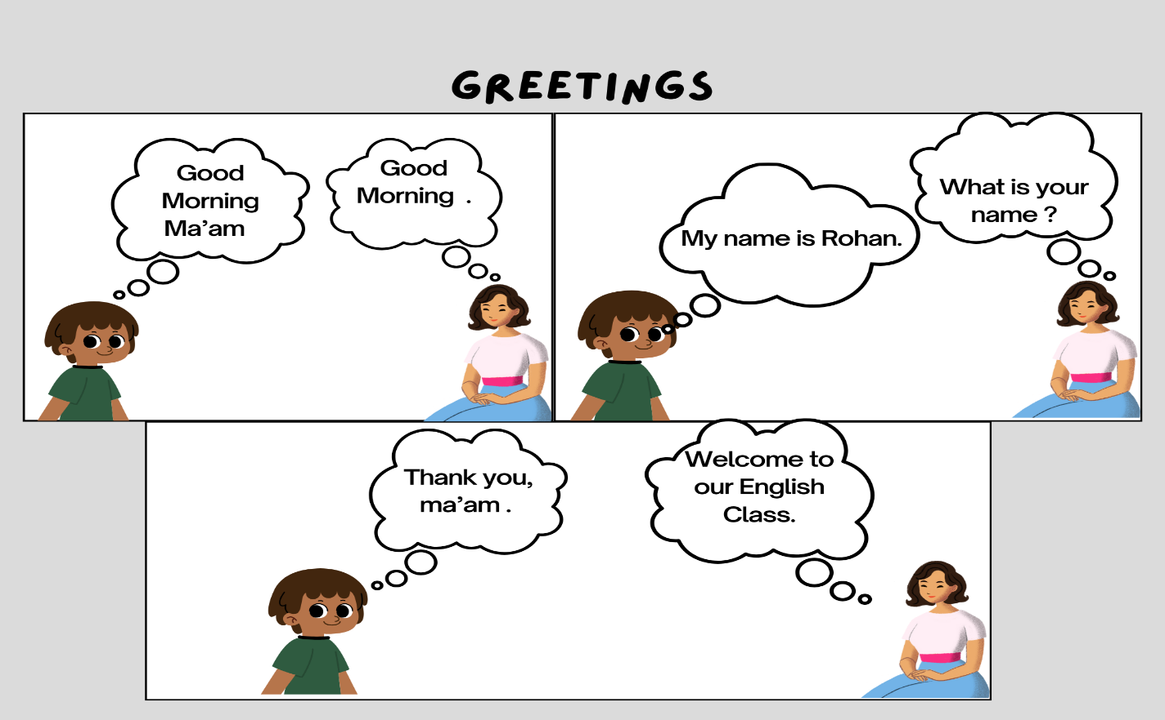

A. When to say good morning/good afternoon/good evening

- Good morning 6 am-12 pm
- Good afternoon 12 pm- 5 pm
- Good evening 5 pm-10 pm

B. Greeting and introductions
Introducing yourself
A: Hi. I am ___________. What is your name?
B: Hello. My name is ___________.
Introducing others

A: This is my friend, Sakshi.
B: Nice to meet you, Sakshi.

Asking about someone’s health

A: Hi, Sachin. How are you? Are you OK?
B: I am fine, thank you.

Sending greetings to others

A: Say hello to Jyoti for me.
B: Yes, I will.

Saying goodbye

A: See you later.
B: Yes, bye!
C. Practice the conversation using different scenarios from above. You can divide the classroom in pair of two.

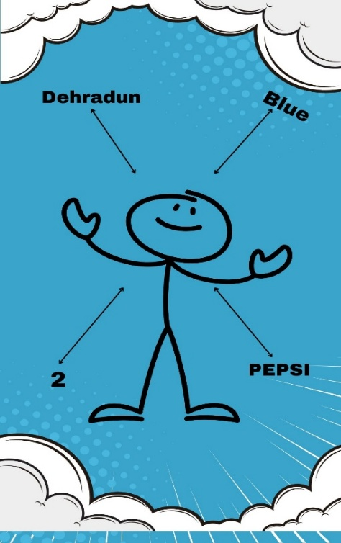
New Learning and Practice:

1. Do the "Ask Me" activity.
On the board draw a little stick man / woman and write your name under it.
Then write some answers to the following questions (just the answers) around the board:

Age: How old are you?
Hometown: Where are you from?
Pets: What pet do you have?
Food: What is your favourite food?
Drink: What is your favorite drink?
Color: What is your favorite color?
Brothers / Sisters: How many brothers and sisters do you have?

2. All about Me!

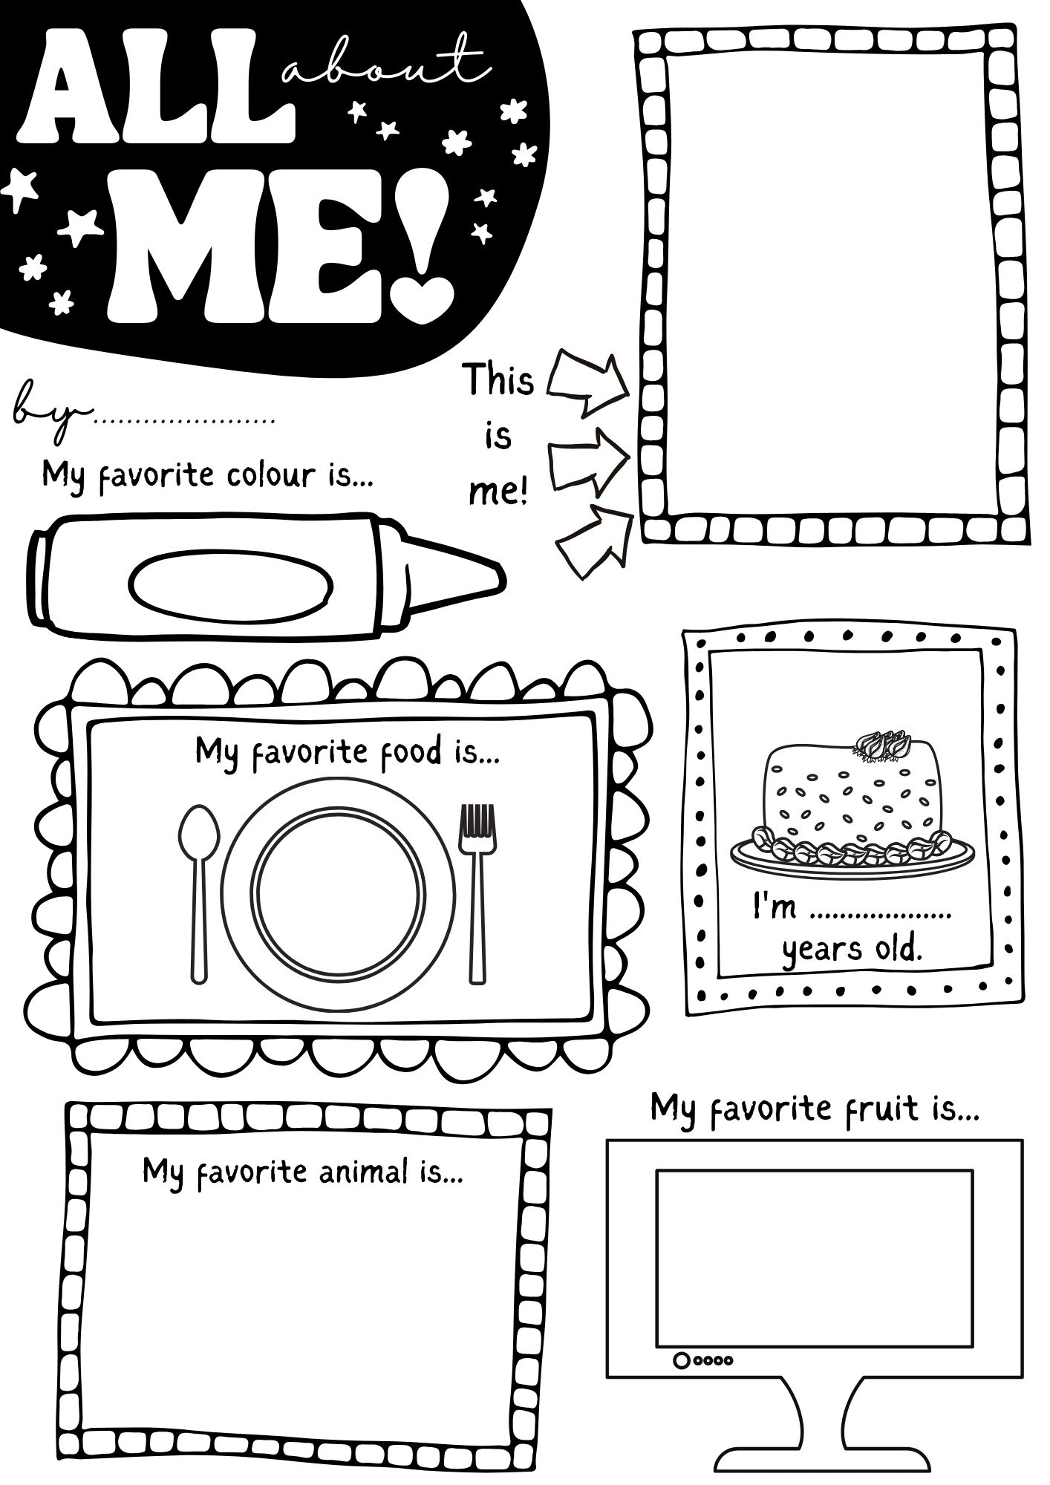

Body and Shapes

- Introduce them with the shapes: Square
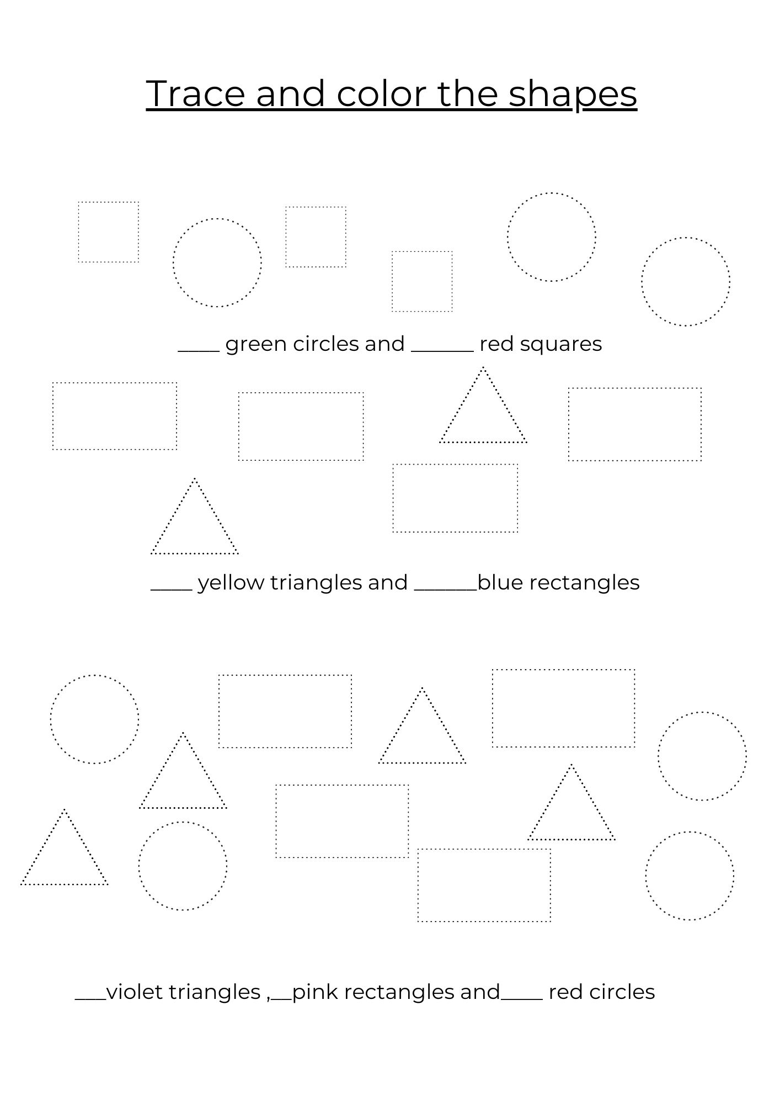

- Body part Simon Says:
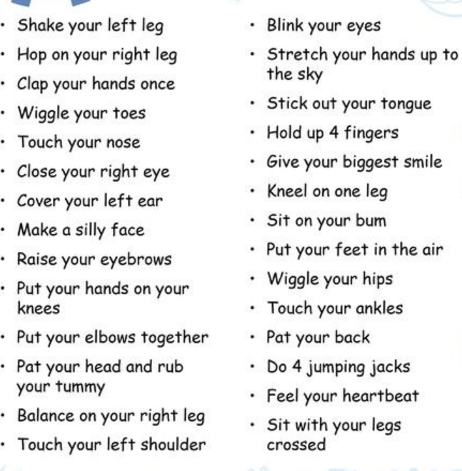

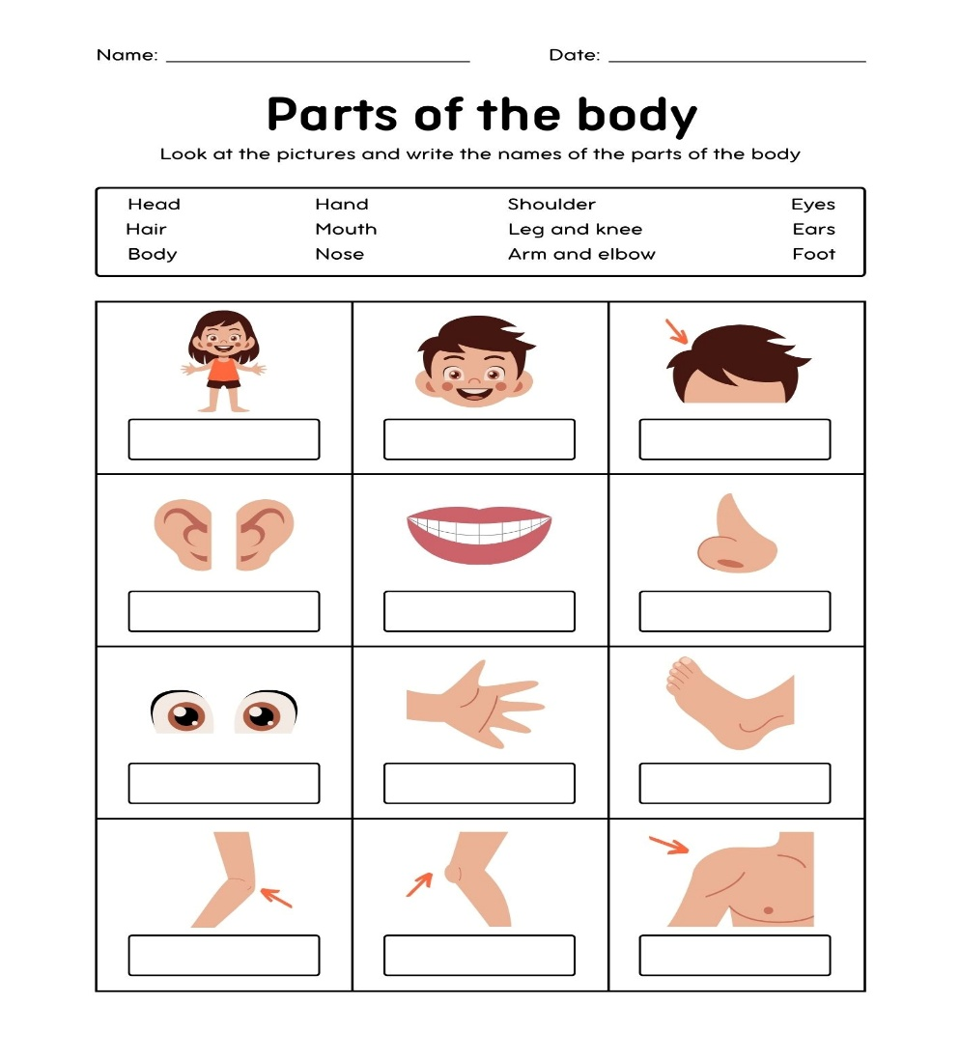

Unit 2: Places
Everywhere Around!
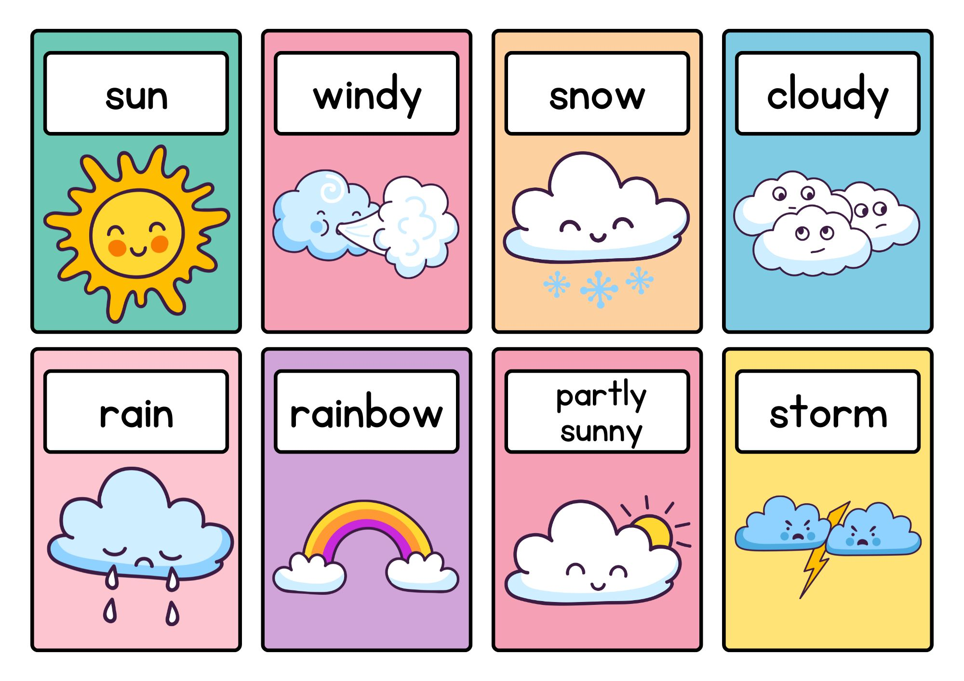
I. Weather- What’s the weather like today?

II. Say the weather words. What is your favorite weather?

III. Match the weather photos to the following words:


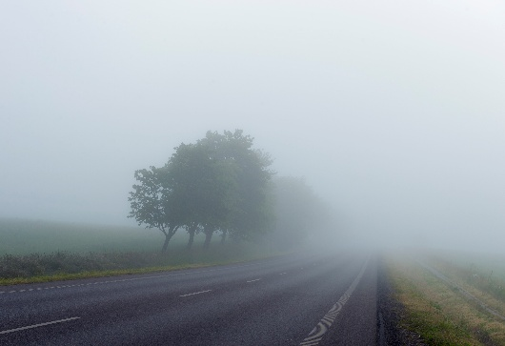







Cold Rain Snow
Windy Sunny Hot Misty
IV. Weather Project- Draw atleast three different weather in your notebook and write its name below.

Seasons:
Q. What season is it ?
Q. In which season is your birthday?
Q. Name the five season in India? What are the general seasons around the world?
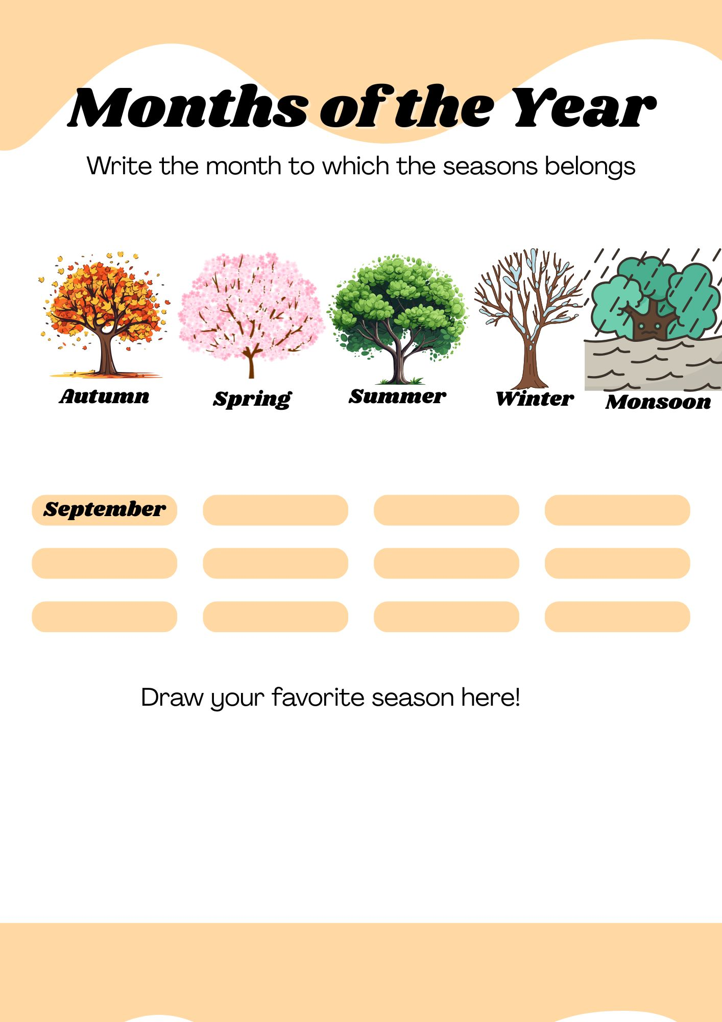
Q, Difference between weather and season? Match the weather with the season.
City and Country
Q. State your hometown:
Q. Talk about your hometown with someone using these questions:
Where is your hometown? My hometown is __________
Tell me about _______? Mention a special thing.

Q. Look at the Flag:
State the name of the country, colours and the capital city of this country.

Q. Write the name of the continents of the world.

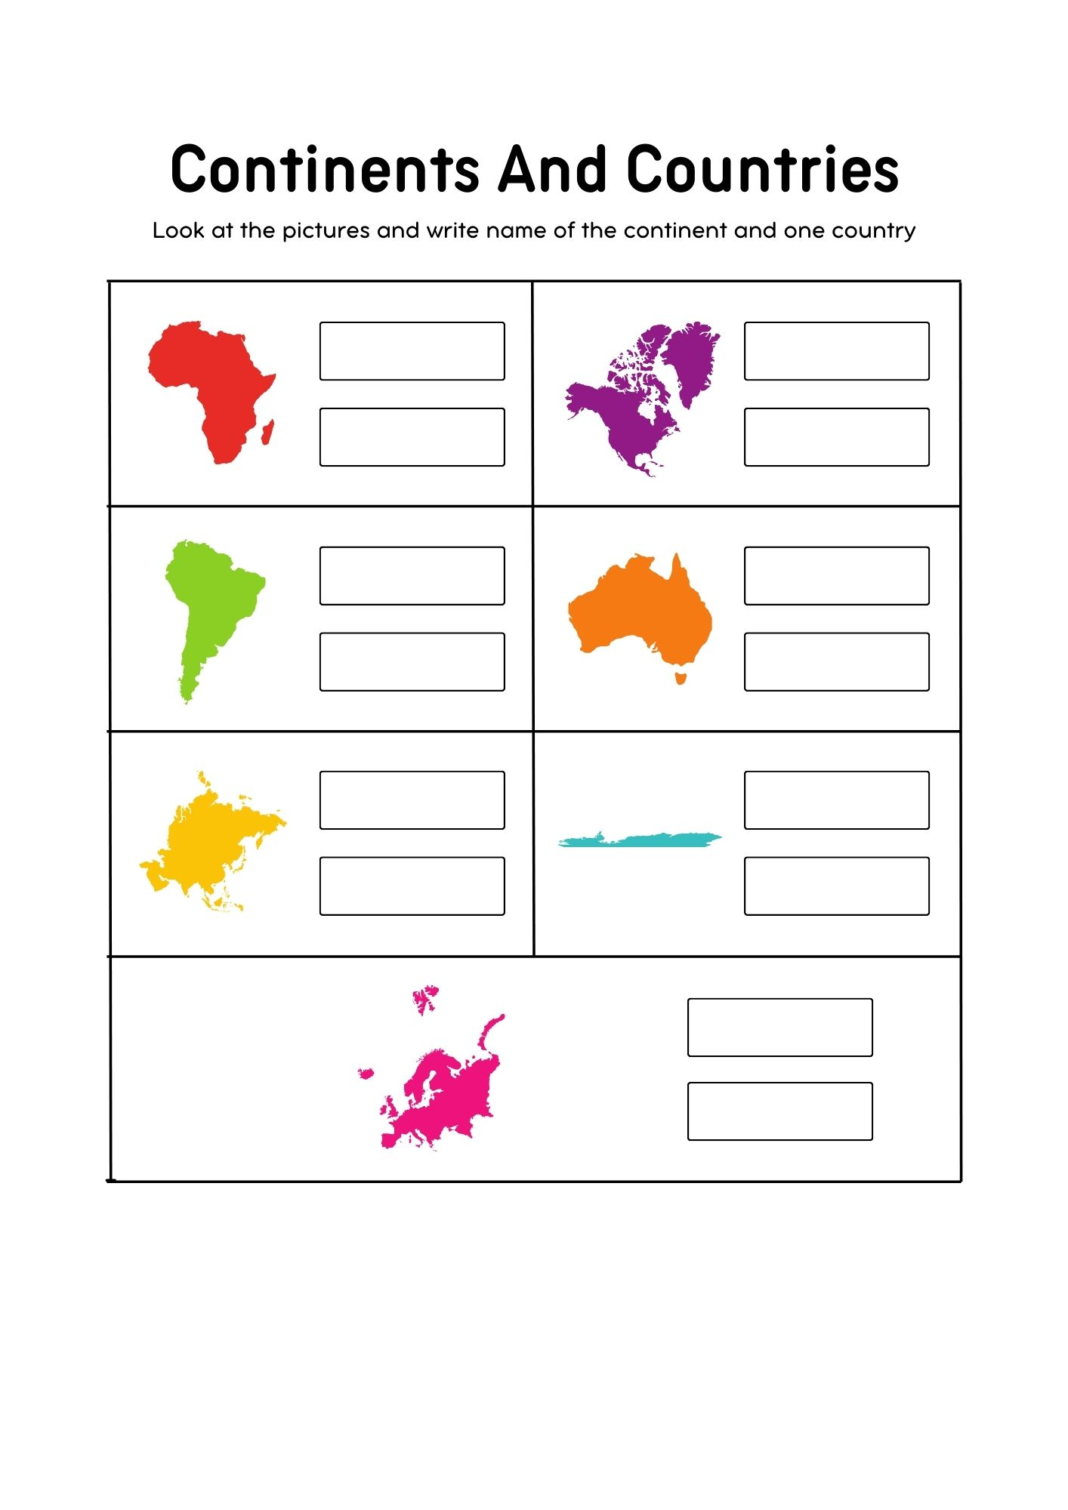
Q.

My Location

House and Home

- The difference:
House- It is just a building where you live.
Home- More than a building; its where you feel safe , loved and comfortable.
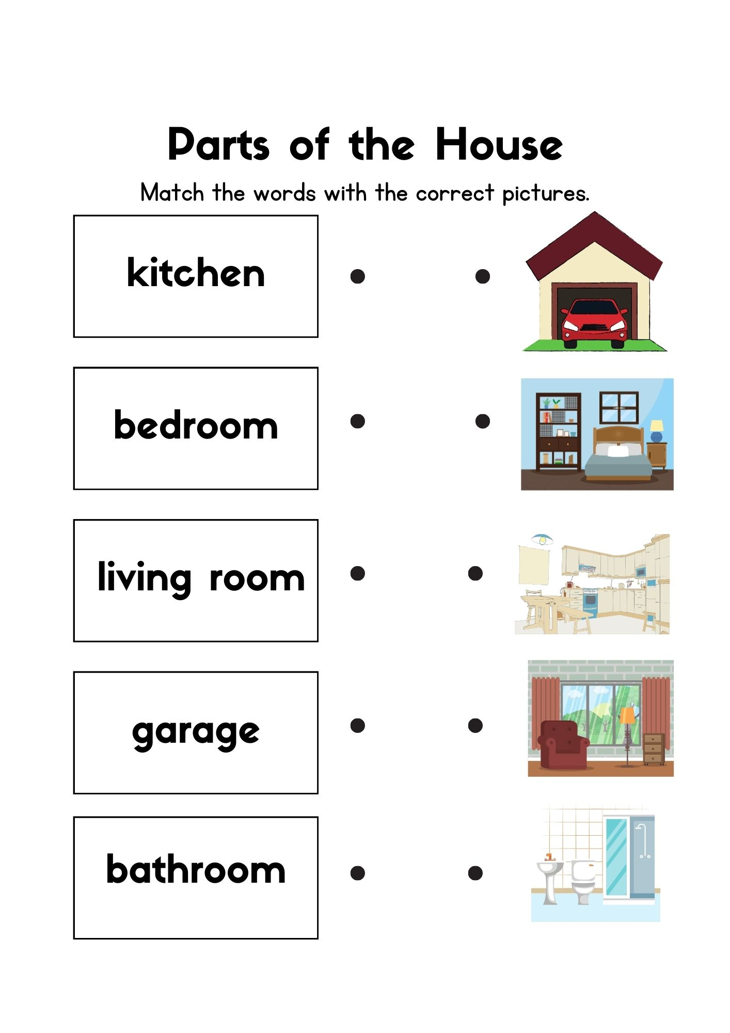
II .

Places in Your Town
I. Talk about some places in your town:
Park, School, Hospital, Shops, Zoo, Home, Market, Mountains, Police station.

II.
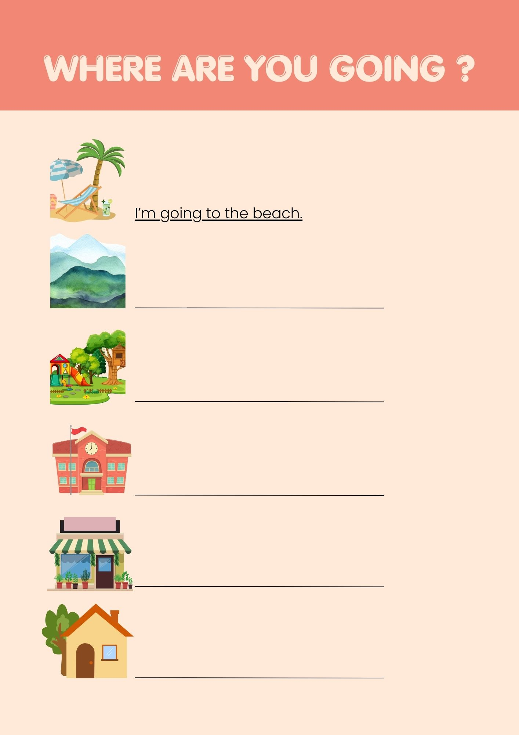

- Lyrics for the "Where are you Going?" song

Chorus:
Where are you going?
Where are you going?
Where are you going right now?

Verse 1:
I’m going to school,
I’m going to the park,
I’m going to the shops,
I’m going to the beach.

Chorus:
Where are you going?
Where are you going?
Where are you going right now?

Verse 2:
I’m going to my friend’s house,
I’m going to the station,
I’m going to the zoo,
I’m going home.

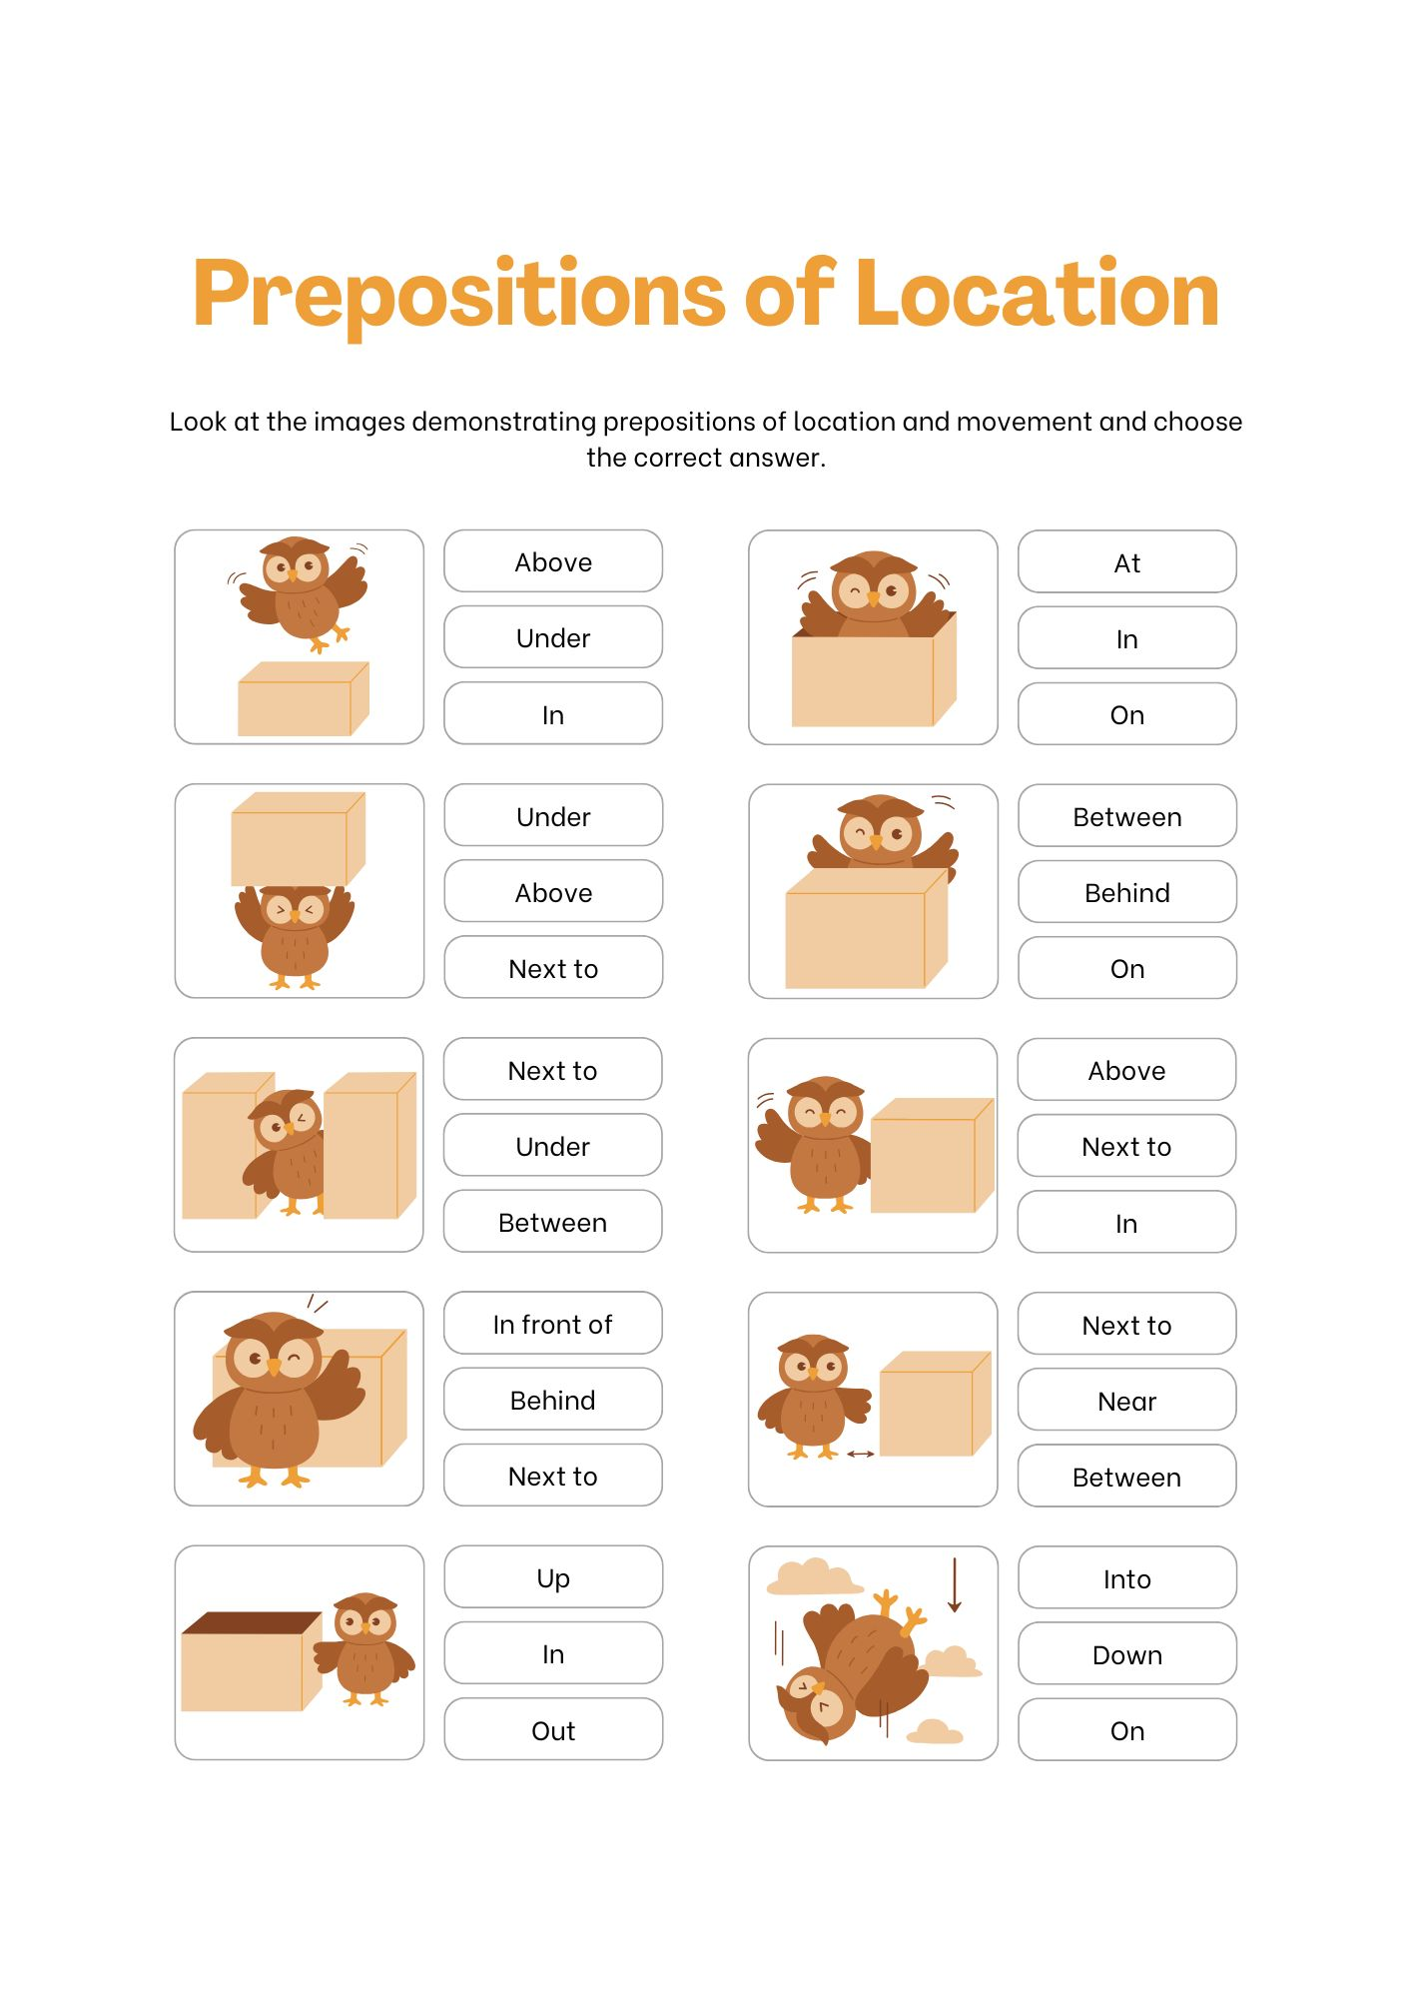

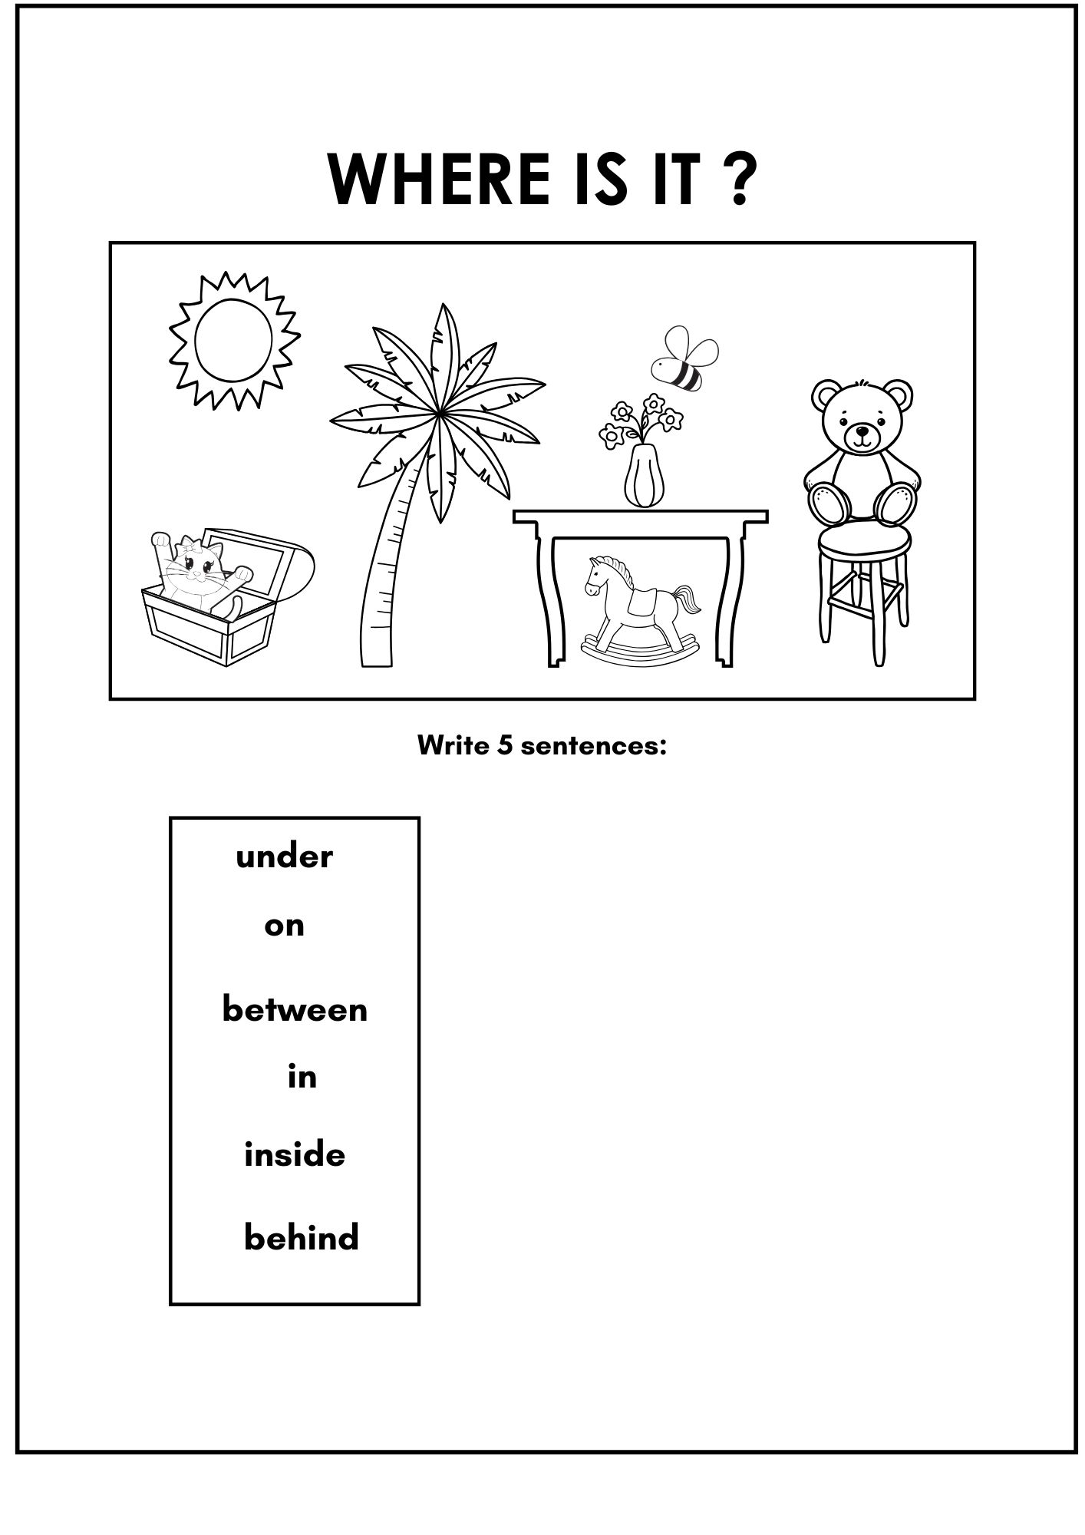
Lesson 3: We Are Friends

🗣️ Key Sentences
- Hello, I’m ___.
- Nice to meet you.
- How are you?
- I’m fine, thank you.
- This is my friend ___.
- We are friends.
- He/She is my friend.
- We like to play together.

👥 Example Dialogue
Anna: Hello, I’m Anna.
Ben: Hello, I’m Ben. Nice to meet you.
Anna: How are you?
Ben: I’m fine, thank you.
Anna: This is my friend, Ben.
Ben: This is my friend, Anna.
Together: We are friends!

✏️ Practice Activities
Activity 1 – Listen and Repeat
- Teacher reads each key sentence aloud slowly.
- Class repeats in chorus, then in small groups, then individually.
- Use hand actions (wave for “Hello”, shake hands for “Nice to meet you”).

Activity 2 – Pair Work: Introduce Your Friend
- Students work in pairs.
- Student A: “Hello, I’m __.”
- Student B: “Hello, I’m __. Nice to meet you.”
- Student A: “This is my friend __.”
- Together: “We are friends.”
- Rotate partners and repeat with new names.
Activity 3 – Find a Friend Who…
- Teacher gives a simple list (e.g. likes football, likes pizza, has a red bag).
- Students walk around asking: “Do you like football?”
- When they find someone, they introduce: “This is my friend. He likes football.”

Activity 4 – Friendship Circle (Speaking Game)
- Students stand in a circle.
- One student says: “This is my friend (points to someone).”
- That student continues: “This is my friend (points to another).”
- Continue until the whole class is connected as “friends.”

Activity 5 – Draw and Write
- Students draw themselves with a friend.
- They write 2–3 sentences below:
  - “This is my friend Ali.”
  - “He is my friend.”
  - “We like to play together.”

🎨 Creative Task – Friendship Poster
- In small groups, make a “We Are Friends” poster.
- Draw classmates, write their names, and add sentences like:
  - “This is my friend Sara.”
  - “We are friends.”

Lesson 4: I’m and You’re
🌟 Objectives
- Use contractions I’m and You’re in simple sentences.
- Introduce yourself and respond to introductions.
- Practice talking about “me” and “you.”
🗣️ Key Sentences
- I am a boy. → I’m a boy.
- I am a girl. → I’m a girl.
- I’m happy.
- I’m your friend.
- You’re my friend.
- You’re happy.
- You’re a boy/girl.
- We’re friends.
👥 Example Dialogue
Ali: Hello, I’m Ali. I’m a boy.
Sara: Hello, I’m Sara. I’m a girl.
Ali: You’re my friend.
Sara: And you’re my friend.
Together: We’re friends!
✏️ Practice Activities
- Listen and Repeat – practice I’m/You’re sentences with actions (point to self for I’m, to partner for You’re).
- Role Play with Cards – each student holds a boy/girl card, practices: “I’m a boy.” / “You’re a girl.”
- Pair Work Dialogue – exchange introductions with I’m… and You’re my friend.
- Guessing Game – teacher describes: “I’m happy.” Students guess who.
- Sentence Swap – students write one “I’m” sentence and swap to turn it into “You’re.”
- Circle Game – pass a ball around; student holding the ball says: “I’m __.” Next replies: “You’re __.”
🎨 Creative Task
Make a mini-book:
- Page 1: “I’m ___.” (draw self)
- Page 2: “You’re my friend.” (draw friend)
- Page 3: “We’re friends.” (draw both together)
📌 Teacher’s Tip
Use lots of pointing (self vs. partner) so students see the difference between I’m and You’re.

Lesson 5: Pronouns
🌟 Objectives
- Recognize and use subject pronouns (I, you, he, she, we, they).
- Match pronouns to people.
- Use pronouns in simple sentences.
🗣️ Key Sentences
- I am a student.
- You are my friend.
- He is my brother.
- She is my sister.
- We are friends.
- They are classmates.
- He is a boy.
- She is a girl.
👥 Example Dialogue
Teacher: Who is he?
Students: He is Ali.
Teacher: Who is she?
Students: She is Sara.
Ali: We are friends.
Sara: Yes, we are friends.
Class: They are classmates.
✏️ Practice Activities
- Listen and Repeat – practice all pronoun sentences aloud.
- Flashcard Game – show a picture of a boy/girl/group. Students shout: He/She/They.
- Pronoun Bingo – students mark pictures with pronouns when called.
- Pair Practice – student A asks: Who is he? Student B answers: He is Ali.
- Sentence Sorting – students sort sentences under “I / You / He / She / We / They.”
- Group Chant – teacher points at groups, class says: We are friends!
🎨 Creative Task
Make a Pronoun Poster with stick figures labeled:
- I → Me
- You → Friend
- He → Boy
- She → Girl
- We → Two friends
- They → Group
📘 Unit 3: School

Lesson 1: Classroom Objects and Toys 1
🌟 Objectives
- Identify and name classroom objects and toys.
- Use simple sentences to describe possessions.
🗣️ Key Sentences
- This is a book.
- This is a pencil.
- This is a bag.
- This is a toy.
- It is my book.
- It is your pencil.
- What is this?
- It is a ruler.
👥 Example Dialogue
Ali: What is this?
Sara: This is a bag.
Ali: Is it my bag?
Sara: No, it is my bag.
Both: It is a bag!
✏️ Practice Activities
- Listen and Repeat – repeat key sentences with classroom objects.
- Show and Tell – students hold up real objects and say: “This is a pencil.”
- Guessing Game – teacher hides an object in a bag; students ask: “What is this?”
- Matching Worksheet – match pictures of objects with the correct words.
- Pair Practice – students ask each other: “What is this?” – answer: “It is a …”
- Sorting Game – sort toy pictures vs. classroom objects.
🎨 Creative Task
Draw your school bag and label the objects inside with simple sentences.
📌 Teacher’s Tip
Always use real classroom objects when possible – it makes the lesson concrete and fun.

Lesson 2: Teachers and Manners
🌟 Objectives
- Recognize people at school (teacher, principal).
- Use polite expressions in class.
🗣️ Key Sentences
- This is my teacher.
- He is my teacher.
- She is my teacher.
- This is our principal.
- Good morning, teacher.
- Please, teacher.
- Thank you, teacher.
- Sorry, teacher.
👥 Example Dialogue
Student: Good morning, teacher.
Teacher: Good morning.
Student: Please, may I sit down?
Teacher: Yes, thank you.
Student: Thank you, teacher.
✏️ Practice Activities
- Listen and Repeat – polite phrases with actions.
- Role Play – act out polite conversations with the teacher.
- Flashcard Drill – show pictures of teacher/principal; students say: “This is my teacher.”
- Polite Phrases Game – teacher says an action, students respond with the right polite phrase.
- Pair Practice – one student plays teacher, one plays student.
- Song/Chant – short chant with please, thank you, sorry.
🎨 Creative Task
Make a Politeness Poster with drawings and phrases like: “Good morning, teacher!”
📌 Teacher’s Tip
Encourage students to use polite expressions daily – not only during English lessons.

Lesson 3: I Like and Don’t Like
🌟 Objectives
- Express likes and dislikes.
- Talk about favorite things.
🗣️ Key Sentences
- I like books.
- I like toys.
- I like games.
- I don’t like homework.
- I don’t like noise.
- Do you like football?
- Yes, I do.
- No, I don’t.
👥 Example Dialogue
Ali: Do you like football?
Sara: Yes, I do. I like football.
Ali: Do you like homework?
Sara: No, I don’t. I don’t like homework.
✏️ Practice Activities
- Listen and Repeat – positive and negative sentences.
- Like/Don’t Like Sorting – pictures of foods/toys; students sort into like/don’t like.
- Class Survey – students ask 3 classmates: “Do you like ___?” and record answers.
- Pair Practice – ask and answer about likes.
- Game: Stand Up If… – teacher calls: “I like pizza.” All who agree stand up.
- Flashcard Voting – students vote with thumbs up or down for each picture.
🎨 Creative Task
Draw 2 things you like and 2 things you don’t like. Write sentences under them.
📌 Teacher’s Tip
Keep examples relevant – use toys, games, and foods your students know.

Lesson 4: Open Your Book!
🌟 Objectives
- Follow and use classroom instructions.
- Respond quickly to commands.
🗣️ Key Sentences
- Open your book.
- Close your book.
- Stand up.
- Sit down.
- Listen to me.
- Look at the board.
- Take out your pencil.
- Put away your bag.
👥 Example Dialogue
Teacher: Open your book.
Students: (Open books)
Teacher: Close your book.
Students: (Close books)
✏️ Practice Activities
- Listen and Do – teacher gives commands, students act.
- Simon Says Game – use the sentences as commands.
- Pair Commands – students give each other instructions.
- Flashcard Drill – hold up a picture; students do the action.
- Action Race – 2 groups compete to follow instructions fastest.
- Chant – chant instructions with clapping.
🎨 Creative Task
Make a Classroom Rules Poster with pictures and sentences.
Lesson 5: Textbook Time
🌟 Objectives
- Use vocabulary for the textbook.
- Follow classroom routines using simple English.
🗣️ Key Sentences
- This is my book.
- That is your book.
- Where is my book?
- Here is my book.
- Open your book.
- Close your book.
- Let’s read together.
- Let’s write in our books.
👥 Example Dialogue
Ali: Where is my book?
Sara: Here is your book.
Ali: Thank you. This is my book.
Teacher: Open your book. Let’s read together!
✏️ Practice Activities
- Listen and Repeat – practice sentences with books in hand.
- Book Hunt – students look for their textbook and say: “Here is my book.”
- Pair Exchange – swap books and say: “That is your book. This is my book.”
- Teacher Commands – teacher says: “Open your book.” / “Close your book.”
- Small Group Reading – read short text together.
- Circle Practice – students pass one book around, saying: “Here is your book.”
🎨 Creative Task
Draw your school book and write: “This is my book.”
📌 Teacher’s Tip
Use real books in all activities – routines become language practice.

Lesson 6: Feelings and Emotions 1
🌟 Objectives
- Recognize and express basic emotions.
- Ask and answer about feelings.
🗣️ Key Sentences
- I’m happy.
- I’m sad.
- I’m angry.
- I’m tired.
- How are you?
- I’m fine, thank you.
- He is happy.
- She is sad.
👥 Example Dialogue
Ali: How are you?
Sara: I’m happy.
Ali: I’m tired today.
Sara: Oh, I’m sorry.
✏️ Practice Activities
- Listen and Repeat – act out emotions while repeating.
- Emotion Flashcards – students say: “I’m happy/sad…” when shown a card.
- Mirror Game – teacher shows an emotion, students copy and say it.
- Pair Practice – ask: “How are you?” → answer with an emotion.
- Guess the Feeling – one student acts out an emotion, others guess: “He is angry.”
- Emotion Circle – students pass ball, say: “I’m ___.”
🎨 Creative Task
Draw your face with 3 different emotions. Write under each: “I’m ___.”
📌 Teacher’s Tip
Encourage dramatization – children love acting out feelings.

Lesson 7: People at School
🌟 Objectives
- Identify people in the school community.
- Use simple sentences to describe them.
🗣️ Key Sentences
- This is my teacher.
- This is my friend.
- This is the principal.
- This is the nurse.
- He is the janitor.
- She is the librarian.
- We are students.
- They are my classmates.
👥 Example Dialogue
Ali: Who is he?
Sara: He is the janitor.
Ali: Who is she?
Sara: She is the nurse.
Ali: They are our classmates.
Sara: Yes, we are students.
✏️ Practice Activities
- Listen and Repeat – practice all roles.
- Picture Match – match people with their jobs.
- Role Play – act out being teacher, principal, nurse, etc.
- Guess Who – one student describes, others guess: “She is the librarian.”
- School Tour – point to real people/places if possible.
- Pair Practice – “Who is he?” → “He is the janitor.”
🎨 Creative Task
Draw 4 people from your school and label them: “This is the __.”
📌 Teacher’s Tip
If possible, invite real staff (nurse, librarian) for a short introduction.

Lesson 8: School Building and Places
🌟 Objectives
- Learn names of places in the school.
- Use “This is the ___” sentences.
🗣️ Key Sentences
- This is the classroom.
- This is the library.
- This is the playground.
- This is the office.
- This is the canteen.
- This is the hall.
- Where is the library?
- The library is here.
👥 Example Dialogue
Ali: Where is the playground?
Sara: The playground is here.
Ali: This is the library.
Sara: Yes, this is the library.
✏️ Practice Activities
- Listen and Repeat – repeat sentences with pictures.
- School Map Game – point to map: “This is the library.”
- Walk and Talk – tour real school areas if possible.
- Pair Practice – “Where is the ___?” / “The ___ is here.”
- Memory Game – cover picture, ask: “Where is the hall?”
- Flashcard Hunt – hide cards, students find and say sentence.
🎨 Creative Task
Draw a map of your school and label 4 places.
📌 Teacher’s Tip
Make this lesson interactive with a real walk – children remember better by moving.

Lesson 9: Stationery and Possessions 1
🌟 Objectives
- Identify stationery items.
- Use “This is my/your ___” to talk about possessions.
🗣️ Key Sentences
- This is my pen.
- This is your pencil.
- This is my ruler.
- This is your eraser.
- Is this my bag?
- Yes, it is.
- No, it isn’t.
- Whose book is this? It is mine.
👥 Example Dialogue
Ali: Is this my pen?
Sara: No, it isn’t. It is my pen.
Ali: Oh, this is your pen.
Sara: Yes, this is my pen.
✏️ Practice Activities
- Listen and Repeat – practice with real stationery.
- Show and Tell – students hold up their own stationery: “This is my pencil.”
- Guessing Game – teacher holds item: “Is this my bag?” Students answer.
- Pair Exchange – swap items and say: “This is your eraser.”
- Whose Is It? Game – lost-and-found role-play.
- Circle Practice – pass object: each student says: “This is my ___.”
🎨 Creative Task
Draw 3 of your favorite school things. Write under each: “This is my ___.”
📌 Teacher’s Tip
Use actual student belongings – they enjoy personal connections.

Lesson 10: Life Skills – Learning to Get Ready
🌟 Objectives
- Learn vocabulary for daily school preparation.
- Practice sentences about getting ready for school.
🗣️ Key Sentences
- I get up early.
- I wash my face.
- I brush my teeth.
- I put on my uniform.
- I eat my breakfast.
- I pack my bag.
- I go to school.
- I am ready for school.
👥 Example Dialogue
Ali: I get up early.
Sara: I wash my face.
Ali: I brush my teeth.
Sara: I put on my uniform.
Both: We are ready for school!
✏️ Practice Activities
- Listen and Repeat – daily routine sentences.
- Action Practice – students act out washing, brushing, packing.
- Picture Sequencing – put morning routine pictures in order.
- Pair Practice – ask: “What do you do in the morning?” → answer.
- Class Chain – each student adds a step: “I get up early.” Next: “I wash my face.”
- Memory Game – repeat routine steps in order as a group.
🎨 Creative Task
Make a Morning Routine Chart with drawings of your steps. Write simple sentences.
📌 Teacher’s Tip
Encourage students to use English phrases at home when doing their routine.

