OPTIMIZATION
- Introduction:
The constitutional definition of a tribe appears to portray tribal communities almost as a ‘species’ to be preserved in a ‘national park,’ seemingly isolated (Chakravarthi & Lakshminarayana, 2017). Such a perspective has shaped and, at times, limited efforts aimed at improving the lives of tribal populations. The constitution has not only adopted this somewhat ‘alien’ notion of defining tribes, but many scholars have also reproduced it uncritically. For example, Prof. D.N. Majumdar reiterated the definition provided by the Imperial Gazetteer, which describes a tribe as “a collection of families bearing a common name, speaking a common dialect, occupying or professing to occupy a common territory, and not usually endogamous though originally it might have been so” (Chakravarthi & Lakshminarayana, 2017).
It has been evident that India ranks second after Africa in terms of tribal population, with more than 700 Scheduled Tribes (ST) recognized under Article 342 of the Indian Constitution, spread across various states and Union Territories (Chakravarthi & Lakshminarayana, 2017). In general, tribal communities in India are regarded as among the most vulnerable sections of the population, facing persistent challenges such as poverty, illiteracy, lack of developmental opportunities, and inadequate access to basic health care facilities (Thakur et al., 1991).Chakravarthi & Lakshminarayana (2017) also mentioned in their study that the tribal economic activities in India are primarily focused on producing essential goods for their daily needs. The geographical environment of the tribe very much determines these activities. Usually, the tribehas to struggle very hard to meet its economic needs ” (Chakravarthi & Lakshminarayana, 2017).
As per the Census of 2011(censusindia.gov.in), the total population of tribal peoples of India constitutes 8.6 % of the total population of the country, of which 0.83%live in Jharkhand. As per the Census of India 2011, Jharkhand recorded 32 different tribal communities (Report of the High Level Committee on Socio-Economic, Health and Educational Status of Tribal Communities of India, 2014)(Kumar & Chaudhury, 2014). The tribals of Jharkhand are Santhal, Oraon, Munda, Kharia, Korba, Ho, Bhumij, Chero, Kharwar, Bijhiya, Nagesiya, Prhiya, Beiya, Cheek-Badayka, Gonda, Baiga, Khond, Lohara, Mahali, Sabar, Birjiya, Godayat, Bathudi, Kora, Karmali, Soariya-Pahadiya, Mal-Pahadiya, Asur, Birhor, Banjara, Kanvar, Kol.Jharkhand, despite being richly endowed with natural resources like coal, iron ore, copper, bauxite, and uranium, continues to face serious economic challenges.Manikandan (2016) in his study mentioned that a large section of the tribal population depends on agriculture, forest produce, and wage labor for survival. He addedthat agriculture is largely rain-fed and suffers from low productivity, leading to seasonal unemployment and distress migration. Industrial and mining activities have created enclaves of economic growth but have also led to the displacement of tribal communities without adequate rehabilitation. The state(Jharkhand) has one of the highest poverty ratios in India, with significant rural poverty concentrated among the Scheduled Tribes. Inequitable distribution of resources, lack of infrastructure, poor access to markets, and limited skill development opportunities further widen the economic gap(Singh et al., 2016). As a result, despite its mineral wealth, Jharkhand remains economically backward, with persistent poverty, underemployment, and low standards of living among its tribal communities(Kachhap & Saw, 2016). Although research on the nutritional status of the Mundas is limited, existing studies highlight a high prevalence of economic deprivation in the region(Ghosh & Bharati, 2006).
Hence, we aim to address the central research question: What strategies can be adopted to improve the overall well-being of tribal people in Jharkhand across key sectors such as health status, security, social connection, civic engagement, income, wealth, risk management, housing, environmental quality, education, occupation, skills, work-life balance, and subjective well-being?
This will be explored through the following specific objectives:
- To examine how the implementation of rainwater harvesting systems can enhance tribal income, environmental quality, work-life balance, and overall subjective well-being.
- To analyze how the adoption of a multi-cropping system can contribute to improvements in income, wealth, work-life balance, subjective well-being, housing, and occupational opportunities.
The key contribution of this research lies in optimizing the economic condition of Jharkhand by identifying sustainable livelihood strategies that enhance the overall well-being of tribal communities, ensuring balanced improvements across income, housing, occupation, and other social dimensions. In particular, it will examine how rainwater harvesting can strengthen income generation, improve environmental quality, support work–life balance, and enhance subjective well-being. Similarly, it will analyze how the adoption of multi-cropping( finger millet and mustard seed) practices can optimize income sources, increase wealth, improve housing and occupational opportunities, and promote overall life satisfaction. We chose finger millet because it is a drought-resistant, nutrient-rich crop well-suited to the semi-arid soil and climatic conditions of Jharkhand, ensuring both food security and market potential. Mustard seed, on the other hand, is selected due to its shorter cultivation cycle, high oil content, and profitability, which provide tribal farmers with additional income opportunities. By linking these sectoral improvements to broader dimensions of health, education, and social connection, the study will provide holistic insights for policymakers and development practitioners on designing inclusive and sustainable interventions for tribal wellbeing. The rest of this paper is structured as follows: literature review, problem description and model formulation, numerical analysis, implications of the result, and finally, conclusion.
- Literature Review:
Philosophical theories of well-being have often been divided into three main camps: hedonism, desire-satisfaction theories, and objective list theories (Parfit, 1984; Griffin, 1986). Hedonism grounds well-being in the maximization of pleasure and the minimization of pain (Mill, 1861/1998), and its optimization analogue is straightforward: a single-variable maximization problem where the objective function is utility measured in hedonic terms (Kahneman et al., 1997). While elegant in form, this view is limited because it reduces the complexity of human flourishing to one dimension, overlooking plural goods that contribute to well-being independently of felt pleasure. Similarly, desire-satisfaction theories hold that well-being consists in the fulfillment of an agent’s informed or rational desires (Railton, 1986). Optimization in this framework corresponds to preference-satisfaction models in microeconomics (Arrow & Debreu, 1954; Sen, 1970), where agents maximize their utility subject to constraints. Yet this approach has problems because people’s preferences may be based on limited knowledge, shaped by long-term deprivation, or may not match their real human needs(Elster, 1983; Nussbaum, 2011).

By contrast, the objective list theory argues that a plurality of goodssuch as knowledge, friendship, achievement and health status benefit individuals independently of their subjective endorsement (Parfit, 1984; Finnis, 1980). Its strength lies in its pluralism, but critics often regard it as merely enumerative, lacking explanatory structure (Sumner, 1996). Here, optimization theory provides a crucial bridge. In a multi-objective optimization framework (Zeleny, 1982; Miettinen, 1999), objective goods can be modeled as co-constitutive yet potentially conflicting goals, requiring trade-offs and prioritization. Rather than a static list, the theory becomes explanatory: the interaction of goods can be analyzed through Pareto frontiers (Pareto, 1906), where optimal states of well-being are identified as non-dominated solutions in which no good can be increased without sacrificing another. This framing resonates with Sen’s (1999) capability approach and Nussbaum’s (2011) emphasis on thresholds for central human capabilities, both of which operationalize plural goods within policy contexts.

Hedonism explains well-being only as the satisfaction of desires. This makes it depend too much on personal preferences. In contrast, the objective list theory, when used with optimization methods, becomes stronger. It shows how different goods work together, how well-being can grow within social, cultural, and resource limits. This synthesis reflects contemporary multidimensional well-being research (Alkire & Foster, 2011; OECD, 2013), which increasingly adopts optimization-based tools to translate philosophical accounts of well-being into actionable frameworks for empirical analysis and policy design.
Heidegger’s notion of homecoming (Heidegger, 1962, 1966, 1971, 1973, 1993a, 1993b) can also be theoretically connected with optimization frameworks in social science and economics by conceptualizing it as the existential analogue of the “feasible region” within which authentic modes of human flourishing become possible. Heidegger’s ideas of dwelling and mobility match the logic of multi-objective optimization. In this view, well-being cannot be measured by a single goal. Instead, it must be understood through complementarities. Dwelling, characterized by rootedness, stability, and continuity, resonates with the need for sustainable baselines in optimization models. In contrast, mobility, marked by adaptability, openness, and dynamism, reflects the exploration of solution spaces in search of improved states (Simon, 1979). Heidegger described the unity of dwelling and mobility through the idea of Gegnet or “abiding expanse.” This can be compared to the concept of Pareto efficiency. In Pareto efficiency, the optimal solution is not just one point. Instead, it is a frontier of non-dominated alternatives. Within this frontier, the conditions for existential well-being can be realized.In this respect, Heidegger’s existential phenomenology converges with normative approaches to welfare optimization, such as Sen’s (1999) capability approach and Alkire and Foster’s (2011) multidimensional poverty measurement, both of which emphasize the plural and context-dependent nature of well-being. This connection suggests that existential well-being, far from being merely descriptive, can be systematically theorized and operationalized through optimization models that incorporate both stability and adaptability as co-constitutive dimensions. In line with recent scholarship on well-being as a multidimensional construct (Dodge et al., 2012; OECD, 2013), the Heideggerian framework of homecoming and abiding expanse can thus provide a philosophical grounding for optimization theory, offering a way to formalize existential conditions of flourishing within socio-economic, cultural, and policy-relevant domains.
While optimization frameworks and theories of well-being provide valuable tools for analyzing human flourishing, their application to tribal communities in developing countries, such as India, faces significant limitations. First, optimization models often use quantifiable indicators (Sen, 1999; Alkire & Foster, 2011). This creates a risk of ignoring cultural, spiritual, and relational aspects of tribal well-being. These dimensions are not easy to measure (Xaxa, 2008; Maharatna, 2005). Second, theories such as hedonism and desire-satisfaction may misrepresent tribal values, since well-being in these communities is frequently grounded in collective identity, ecological harmony, and cultural continuity rather than individual utility maximization (Dasgupta, 2010; Nussbaum, 2011). Even objective list and capability approaches, while more pluralistic, may inadvertently impose external normative lists of goods that fail to capture indigenous conceptions of the “good life” (Kuklys, 2005). Optimization-based well-being models can help in policy design. But they also have limitations. There is a need for context-sensitive approaches that include tribal knowledge systems and indigenous values. This helps to avoid reducing existential well-being to outside categories of measurement.
3. Methodology:
To address those limitations, the present study focuses on the Jamtara block including six blocks namely Jamtara, Nala, Narayanpur, Fatehpur, Kundhit and Karmatard. It is located 250 km from Ranchi and 54 kms from Dhanbad, one of the major cities(Census of India, 2001; Singh et al., 2012). Unlike other districts in Jharkhand, Jamtara lacks a mineral belt, which has significantly constrained its economic development and limited industrial opportunities (Singh et al., 2012). Agriculture in the region is challenged by erratic rainfall (two months annually) and by soils ranging from sandy loam to clayey loam that are moderately acidic, erosion-prone, and low in fertility and cation exchange capacity (Singh et al., 2012). These conditions exacerbate the vulnerability of the predominantly indigenous population, whose livelihoods continue to be shaped by historical and cultural legacies.
The tribal economy of Jharkhand has deep roots in eco-social systems (Justin & Menon, 2022). It evolved from the pre-colonial to the post-colonial period. It is shaped by the geography of the Chotanagpur plateau(Justin & Menon, 2022). Their livelihoods included hunting and food gathering. They also practiced shifting cultivation and settled agriculture. Basketry, metallurgy, and diverse village crafts were important. These activities sustained their social, religious, and cultural practices.(Kumar & Chaudhuri, 2023).
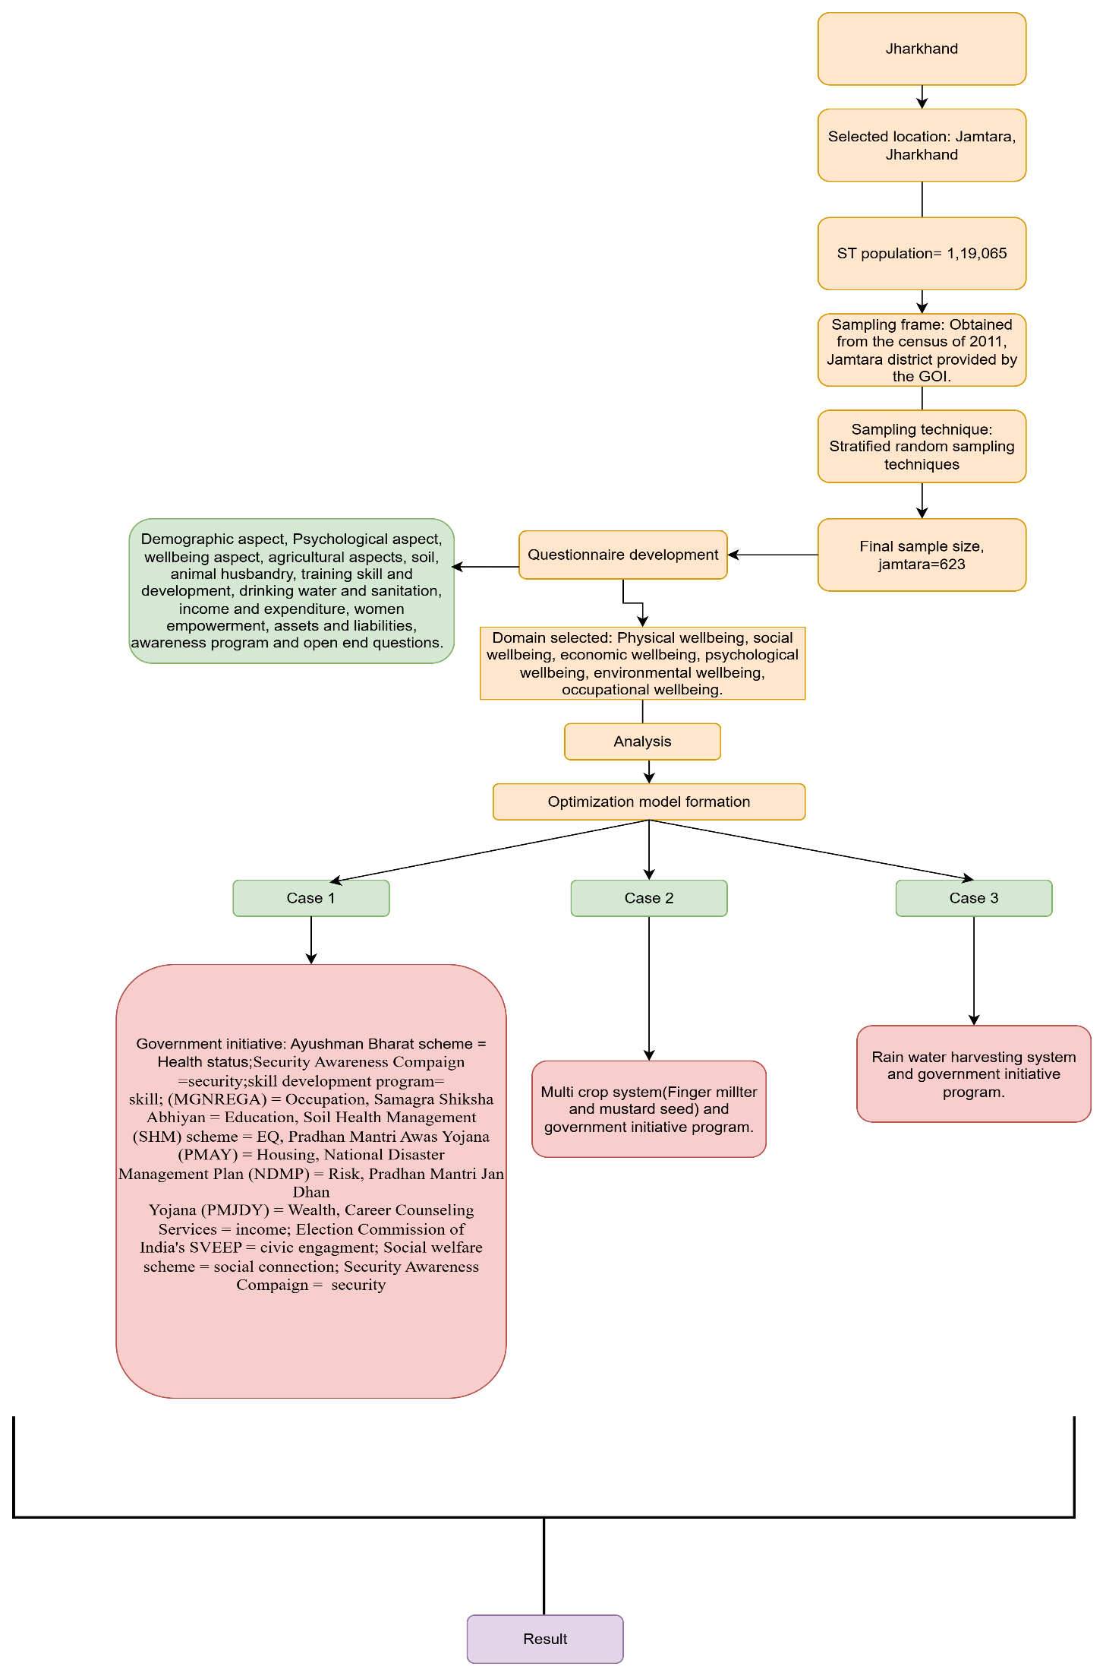
Figure 1: Research methodology

Development of questionnaire: A semi-structured questionnaire with 127 items drawing on frameworks such as the Human Development Index (HDI), the Gender Inequality Index (GII), and the Multidimensional Poverty Index (MPI)was used to capture data on socio-economic, cultural, and psychological dimensions of well-being of tribal people of Jamtara. The questionnaire is divided into seventeen sections including personal information with demographic aspects, psycholographic aspects, wellbeing aspects, agricultural details, soil, animal husbandary, training skill and development, drinking water and sanitation, women empowerment and capacity building, annual income and expenditure, income of the family, assests and liabilities, awareness about program, risk and vurnabilities, health status, women health care and child mortality aspects. The personal information in our questionnaire brought forth demographic, personal and social information that include respondents age, religion, birth order educational background, occupation, socio economic, marital status, income and race( Hossain et al.,2016 ). The wellbeing aspects mainly include the subjective wellbeing including emotions, happiness, satisfaction with life and anxious(Maddux, 2007).
Data collection: Data were collected from six blocks of Jamtara district in different time. The dataset used in this study was collected through various focused group discussions(FGDs) and transect walks, which aimed to investigate the trends in poverty, living situation, and well-being of indigenous people. Surveys were conducted on a randomly selected sample of households from blocks in Jharkhand, using a two-stage stratified sampling method based on panchayat and district levels.. In the first stage, data were collected from 65 respondents from each blocks during the survey. In the first stage, the data was screened. The panel members of experts in FGDs (two PhD academicians and three professionals experienced in working with Indigenous communities)were informed about the study and analyzed the descriptive statistics to understand key trends, such as demographics, response patterns, and other important indicators. The analysis also identified challenges in reaching participants, conducting surveys, and recording responses.The total number of adults interviewed in the first wave was 70 to 75 from each blocks. In the second stage, a larger survey was conducted in each blocks block, covering total 3157 participnts aged 15–80 years.The study used both qualitative and quantitative methods.

2.2 Missing Values and Bias:
After collecting data, we aim to do descriptive statistics. In our dataset, several missing values were identified, with most appearing to depend on observed variables, indicating that the data is Missing at Random (MAR). Given the moderate extent of missingness, mean/median imputation was used to address the issue. Additionally, two types of bias are identified: nonresponse bias and common method bias (CMB). To reduce nonresponse bias, post-survey adjustment techniques such as imputation and weighting are used, ensuring more representative data. To check for CMB, Harman’s single- factor test is conducted(Aguirre-Urreta &amp; Hu, 2019).Although Harman&#39;s single-factor test is widely used to assess the CMB. It serves only as a diagnostic tool to detect its potential presence. Importantly, it provides limited insight into the magnitude or impact of the bias. Fuller et al. (2016) demonstrated that the single-factor test fails to accurately reflect the true extent of method bias present in the data. Their findings suggest that relying solely on this test may lead to underestimation or misinterpretation of the influence of CMB on study results.The total variance explained by a single factor is less than 50%, indicating that CMB does not significantly affect our data. This enhances the reliability of our findings. This strengthens the validity of our statistical models and ensures that relationships observed in the data are not distorted by measurement biases, leading to more accurate conclusions in our analysis. We use SPSS software and CPLEX software for further analysis.
blocks | Age | gender | religion | category | Maritial status | occupation

To further delve into our research, we got multidimensional indicators of tribal of JamtaraIn our study, descriptive analysis helps to understand the current situation of households or communities in terms of land use, income, health, education, and overall wellbeing. It provides a clear picture of existing patterns, inequalities, and challenges — such as how much land is used for paddy cultivation, how much remains unused, and how these factors relate to income or risk. However, while descriptive analysis explains the present scenario, it does not indicate how resources can be better utilized to improve outcomes. Therefore, after the descriptive stage, we apply optimization using linear programming to identify the most efficient allocation of available resources, such as land, labour, and capital, under given constraints.
The linear programming model helps determine how these resources can be distributed among different activities (for example, paddy cultivation, vegetable farming, or other livelihood options) to maximize objectives like income, wellbeing, or sustainability while minimizing risk or resource wastage. By linking descriptive findings with optimization, our study moves from simply describing existing conditions to proposing data-driven, practical solutions for improving livelihood outcomes. In this way, descriptive analysis provides the foundation, and linear programming offers the pathway to optimization and better decision-making in the context of rural development and wellbeing enhancement.
Table 1: Multidimensional Indicators of Tribal Well-Being in Jamtara
Health status | Diet, food intake, government health scheme, hereditary disease, hospitalization for maternity, childbirth, mortality, Govt. tikka, Overall physical health, family health, children's nutrition, ambulance service, primary health care facility, cleanliness around health centres,
Security | Women's safety in the community, Violence or illegal activities in areas.
Social connection | Social Relationships are Supportive and Rewarding, Actively Contribute to the Happiness and Well-Being of Others, People Respect Me
Civic engagement | Knowledge about the Elderly Club, participation in social meetings, approaching elected representatives, female members' participation in elections.
Income | Total income
Wealth | Kitchen garden place, own agricultural land, own house, loan taken from bank, loan taken from SHG, loan taken from moneylenders, loan taken from landlords, loan taken from relatives, mortage, others, self owned land, taken on lease hand, given on lease land, activity during free time, describe your lifestyle, satisfaction with
Work life balance | Activities during free time, describe your lifestyle, satisfaction with standard of living, satisfaction with yearly income
Subjective wellbeing | Emotions, happiness, satisfaction with life, anxious
Risk | Agricultural risk, Financial risk
Housing | House(Kaccha/pakka), housing assets, housing material
Environmental Quality | Soil colour, soil quality, land degradation
Education | Education
Occupation | Primary occupation
Skill | Agricultural programme, skill development program, agricultural training and workshop
Agriculture | Land use in paddy, land remaining

Given these conditions, the need for optimization arises. Previous studies (Sen, 1999; Alkire, 2002; Nussbaum, 2011) show that well-being has many dimensions, including income, health, education, gender equity, and cultural autonomy, which must be balanced together. In tribal areas, where poverty, fragile environments, and cultural challenges overlap, optimization models help to identify different strategies that can improve overall well-being while working within limited resources and financial constraints (Debreu, 1959; Zeleny, 1982).Here, in our study, we use linear programming (LP) as a practical tool for optimization. It helps in allocating limited resources like land, labor, and capital. These resources are distributed across competing uses and social objectives. LP also considers constraints shaped by environmental, cultural, and economic realities(Challoumis, 2024). We use linear programming because it provides a clear and systematic way to make the best possible decisions under limited resources. It also helps balance trade-offs between different domains of well-being(Charnes & Cooper, 1961; Luenberger, 1997). In Jharkhand, scholars have highlighted the need to shift from growth-centric models to capability- and well-being-based assessments of tribal economies (Xaxa, 2008; Maharatna, 2005; Kumar & Chaudhuri, 2023).
Therefore, the objective of this study is to apply a linear programming framework to the socio-economic realities of Jamtara, Jharkhand, in order to optimize the overall well-being of Indigenous communities by balancing multiple dimensions of livelihood, health, education, gender empowerment, and cultural sustainability (Sen, 1999; Nussbaum, 2011; Alkire & Foster, 2011; Kumar & Chaudhuri, 2023).
Here, Table 1 lists the multidimensional indicators that we used to capture tribal well-being in Jamtara from our questionnaire. The items are grouped into domains like health status, security, social connection, civic engagement, income, wealth, work–life balance, subjective wellbeing, risk, housing, environmental quality, education, occupation, skill, and agriculturethat together reflect economic, social, cultural, and environmental conditions of tribal people in Jharkhand. We use these multidimensional indicators because well-being is not limited to income or wealth alone. It also includes housing, health, education, environment, occupation, and social and psychological factors. By using these indicators, we wanted to capture a more complete picture of tribal well-being in Jamtara. These domain indicators serve two methodological roles in our study: (1) they are aggregated and normalized to form the well-being dimension scores Gj used in the LP objective; and (2) they provide the basis for setting minimum capability thresholds Lj​ (e.g., basic health, food Through multiple meetings and discussions with community leaders, health workers, agricultural facilitators, self-help group (SHG) members, and NGOs, valuable qualitative insights were gathered on Indigenous livelihood practices and the challenges they face every day. These combined methods not only allowed a multidimensional understanding of the tribal economy in Jamtara but also linked present livelihood struggles with the historical trajectory of Indigenous economic systems in Jharkhand.
security, cultural continuity) and for choosing participatory weights wj​.

Further, table 2 organizes the large set of indicators from table 1 into six higher-order dimensions of well-being: physical wellbeing, social wellbeing, economic wellbeing, psychological wellbeing, environmental wellbeing, and occupational well-being. This classification provides the conceptual framework for the study by showing how diverse factorsranging from health and security to income, environment, and skillscollectively shape the overall well-being of Indigenous communities in Jamtara. It also creates a clear structure for the optimization model, since each dimension can be represented as a composite outcome variable, making it possible to analyze across multiple aspects of life. In short, Table 2 serves as the bridge between raw indicators and multidimensional well-being domains, ensuring that the study remains theoretically grounded and methodologically coherent.
Table 2: Six major domains of overall well-being that we have taken in our study.
Physical well-being | Health status, security
Social wellbeing | Social connection, civic engagement
Economic wellbeing | Income, wealth, work-life balance
Psychological wellbeing | SWB, risk,
Environmental wellbeing | Housing, Environmental Quality,
Occupational Well-being | Education, occupation, Skill

To delve in further detailing, we took major government initiatives in different domains of well-being in Jamtara, such as health, security, social connection, civic engagement, income, wealth, risk reduction, housing, environmental quality, education, occupation, and skills(Table 3). Each initiative is presented with quantitative details, including maximum respondent coverage, cost per respondent, expected improvement factors, and total cost. This systematic structuring is central to the aim of our study, as it provides the empirical basis for linking multidimensional well-being outcomes with concrete realities of tribal life in Jamtara, such as access to health care, housing security, agricultural sustainability, livelihood opportunities, and education. By aligning schemes such as Ayushman Bharat, Pradhan Mantri Jan Dhan Yojana (PMJDY), Pradhan Mantri Awas Yojana (PMAY), MGNREGA, and Skill India with specific well-being domains, the study ensures that the optimization framework is not only theoretically sound but also practically relevant. The numerical inputs from Table 3 allow for the application of linear programming techniques to allocate scarce resources across competing needs in a way that maximizes overall well-being under budgetary constraints. Previous studies have emphasized the importance of integrating government welfare schemes into models of multidimensional poverty and well-being, arguing that such interventions often produce overlapping but complementary effects on health, income, and social security (Alkire & Foster, 2011; Thorbecke, 2008; Banerjee & Duflo, 2011). In this way, Table 3 provides the decision-making dataset that bridges theoretical well-being frameworks with actionable optimization strategies, making it a crucial contribution to understanding and improving the welfare of tribal communities in Jharkhand.
Table 3: Government Initiatives, Domains of Well-Being, Costs, and Improvement Factors in Jamtara
Government initiatives name | Domain name | Max. respondents | Cost per respondent | Improvement factor | Maximum cost per initiatives
Ayushman Bharat scheme | Health Status | 400 | 3,000 | 25% | 15,00,000
Security Awareness Compaign | Security | 200 | 3,000 | 20% | 5,50,000
Social Welfare Scheme | Social Connection | 550 | 3,000 | 30% | 16,00,000
Election Commission of India's SVEEP | Civic Engagement | 500 | 3,500 | 30% | 20,00,000
Career Counseling Services | Income | 250 | 3,500 | 25% | 8,00,000
Pradhan Mantri Jan Dhan Yojana (PMJDY) | Wealth | 500 | 3,000 | 30% | 15,00,000
National Disaster Management Plan (NDMP) | Risk | 550 | 2,500 | 45% | 13,50,000
Pradhan Mantri Awas Yojana (PMAY) | Housing | 250 | 2,500 | 20% | 6,00,000
Soil Health Management (SHM) scheme | Environmental Quality | 600 | 2,500 | 30% | 17,50,000
Samagra Shiksha Abhiyan | Education | 550 | 3,000 | 35% | 15,00,000
Mahatma Gandhi National Rural Employment Guarantee Act (MGNREGA) | Occupation | 500 | 2,500 | 25% | 15,00,000
Skill India program | Skill | 500 | 3,500 | 30% | 15,00,000

The values in Table 3 serve as input parameters for constructing the Linear Programming (LP) model. Each strategysuch as the Multi-Crop System (MCS) or the Rainwater Harvesting System (RWH)is linked to specific well-being domains (e.g., income, wealth, work-life balance, subjective well-being, housing, occupation, and environmental quality), with an assigned improvement factor. These improvement factors (e.g., 20% for income, 10% for wealth) quantify the expected gain in each domain if the strategy is implemented at full scale. In the LP formulation, these values act as coefficients in the objective function, allowing the model to maximize aggregate well-being while respecting budget, resource, and capacity constraints.
Further we took the multi-crop system and rainwater harvesting system and their estimated percentage contributions across multiple domains of well-being(Table 4). This table is important in our study because it quantifies how specific livelihood interventions influence not just income but also wealth, housing, work–life balance, subjective well-being (SWB), occupation, and environmental quality. By assigning measurable improvement factors (such as 20% gain in income or work–life balance), it provides the parameters required for our optimization model, ensuring that the effects of each strategy can be systematically compared and allocated under resource constraints.Including MCS, where finger millet and mustard seed are chosen as multi-crops, highlights the potential of traditional and resilient crops to boost household income, diversify food security, and strengthen occupational opportunities. Similarly, RWH is incorporated because it directly improves agricultural productivity, environmental sustainability, and life satisfaction by reducing water stress and agricultural risk.
Table 4: Improvement factors of selected livelihood and sustainability strategies across different well-being domains, showing the estimated percentage contribution of each intervention
Strategy name | Domain name | Improvement factors
Multi crop system | Income | 20%
Multi crop system | Wealth | 10%
Multi crop system | Work Life Balance | 20%
Multi crop system | SWB | 20%
Multi crop system | Housing | 20%
Multi crop system | Occupation | 20%
Rainwater Harvesting System (RWH) | Income | 20%
Rainwater Harvesting System (RWH) | Environmental Quality | 15%
Rainwater Harvesting System (RWH) | Work Life Balance | 20%
Rainwater Harvesting System (RWH) | SWB | 20%
Rainwater Harvesting System (RWH) | Income | 20%

3.1 Problem description and model formulation:
Physical wellbeing
Objective: maximize Physical wellbeing (PWB_{i})
HS_{i}= health status of household/individual i
DIET_{i} = Diet/food intake per family/individual i
CHILD NUT_{i} = Children’s nutrition indicator of per child in per household i (e.g., % children with adequate weight-for-age)
MAT_HOSP_{i} = Hospitalization for maternity/childbirth for unit i (binary or count; lower is worse). (input)
MORT_{i} = Mortality indicator for unit i (infant/maternal; lower better).
VACC_{i}= Govt. immunization/tikka coverage (fraction vaccinated).
FAM_HEALTH_{i} = Overall family health (self-reported scale 1–5 in Likert for household i)
AMBUL_{i}= Ambulance/emergency service access for unit i
PHC_DIST_{i} = Distance/time to primary health care facility for unit i.
HC_CLEAN_{i} = Cleanliness around health centres by unit i.
Social Wellbeing
Objective: Maximize Social Wellbeing(SoWBi)
SC_{i} = Social connection of individual i
SUP_REL_{i}= Supportive social relationships of an individual i(Likert 1–5 ).
SOC_CONTR_{i}= an individual i contributes to the Happiness and Well-Being of Others
RESPECTi= Perceived respect from the community(i)
CEi= Civic Engagement in a Likert scale (1-5)of an individual i
ELDER_CLUB_KNOWi= Knowledge about the elderly club of an individuali.
PART_MEETi = Participation in social meetings of an individual i.
APP_REPi=Approaches to elected representatives of an individual i.
VOTE_PART_Fi= Female participation in the election of an individual i.
Economic Well-Being (EWB)
Objective: maximize EWBi
INCi= Total Income of individual i
WLTi= Wealth index constructed from the assets of an individual i
KGARDi= Kitchen garden existence of an individual i
OWN_LANDi= Own agricultural land of an individual i
OWN_HOUSEi=Own house of individual i.
MORTGi = Mortgage presence.
LIFESTYLEi= Self-reported lifestyle of an individual i.
SAT_INC_Yi= Satisfaction with the yearly income of an individual i.
WLBi=Work–Life Balanceof individual i
FREE_ACTi = Activities during an individual's i free time.
LIFESTYLE_DESCi = lifestyle description of an individual i.
SAT_STD_LIVi = Satisfaction with the standard of living of an individual i.
SAT_YINCi= Satisfaction with yearly income of an individual i.
Psychological Well-Being (PSWB)
Objective: maximize PSWBi
SWBi= Subjective Well-Beingcomponent fulfilled by individual i.
EMOTi = Positive emotions of an individual i.
HAPi=Happiness scale of an individual i.
SAT_LIFEi = Life satisfaction of individual i.
ANXi= Anxiety level of individual i.
RSKi=Risk taken by an individual i.
AGRISKi=Agricultural risk taken by individual i.
FINRISKi= Financial risk taken by individual i.
Environmental Well-Being (ENWB)
Objective: maximize ENWBi
HQi = Housing Quality of individual i.
HOUSE_TYPEi=Kaccha/Pakka type house of individual i.
HOUS_ASSETi= Housing assets of individual i.
HOUS_MATi=Housing material of an individual i.
EQi=Environmental Quality of an individual i.
SDWi = Safe Drinking Water availability from household of an individual i.
SOIL_COLi= Soil colour
SOIL_QUALi = Soil quality measures
LAND_DEGi= Land degradation.
Occupational Well-Being (OCWB)
Objective: maximize OCWBi
EDUi= Education: highest education level of individual i.
OCPi = Occupation: primary occupation category (agriculture, wage, skilled...), can be encoded as a score for stability/quality of an individual i.
SKDi = participation in skill programs by individual i
AG_PROGi= Agricultural programme attendance of individual i.
SKILL_DEVi= Skill development program participation of individual i.
TRAIN_WSHOPi= Agricultural training/workshops participation of individual i.
Intervention
RHA_i ∈$\left\{0,1\right\}$ = Rainwater harvesting for household i
MCS_i ∈$\left\{0,1\right\}$ = Investing in a multicrop system for household i.
GOV_i∈$\left\{0,1\right\}$ = Government initiative program for household i.

Common notation
J = set of government initiatives, index j
D = set of elementary domains (HS_{i,}DIET_{i} , CHILD NUT_{i}, MAT_HOSP_{i}, MORT_{i}, VACC_{i},FAM_HEALTH_{i}, AMBUL_{i}, PHC_DIST_{i} , HC_CLEAN_{i}, , SC_{i}, SUP_REL_{i,} SOC_CONTR_{i}, RESPECTi, CEi, ELDER_CLUB_KNOWi, PART_MEETi, APP_REPi, VOTE_PART_Fi, INCi, WLTi, KGARDi, OWN_LANDi, OWN_HOUSEi, MORTGi, LIFESTYLEi, SAT_INC_Yi, WLBi, FREE_ACTi, LIFESTYLE_DESCi, SAT_STD_LIVi, SAT_YINCi, EMOTi, HAPi, SAT_LIFEi, ANXi, RSKi, AGRISKi, FINRISKi,HQi, HOUSE_TYPEi, HOUS_ASSETi, HOUS_MATi, EQi, SDWi, SOIL_COLi, SOIL_QUALi , LAND_DEGi, EDUi, OCPi, SKDi, AG_PROGi, SKILL_DEVi, TRAIN_WSHOPi.
Z¹ = (PWBi +SoWBi + EWBi + OCWBi +ENWBi+PSWBi)

Parameters given to be fulfilled.
J = Set of Government initiatives
B= total government budget (Rs. 1,50,00,000).
L= maximum number of initiatives per respondent(10)
N = total number of respondents/households in the target population (623).
d = refers to a specific domain of well-being
wd = is the weight assigned to that domain d.
MaxRespj = capacity of initiative j (maximum number of respondents initiative jcan cover)
Costj = cost per respondent to apply initiative j.
MaxCostj = maximum allowable total spend on initiative j on domain d.
IF_{j,d} ∈$\left[0,1\right]$ = full-coverage improvement factor of initiative j on domain d
For strategies = Hmax_{MCS}, Hmax_{RWH} = Maximum strategy can cover; cost_{MCS}, cost_{RWH} = cost per household; SF_{k,d} = fullin the single aggregated objective coverage improvement factor of strategy k on domain d.
wd ≥0 = weight of domain d in the single aggregated objective.
$\sum_{d∈D}{wd}$ = 1
Decision variable
X_{j}∈$\left[0,MaxRespj\right]$ = number of respondents covered by government initiative j.
Y ∈$\left[\text{0, }\text{HmaxMCS}\right]$=number of households covered by the multicrop system(MCS)
Z ∈$\left[0,HmaxRWH\right]$ = number of households covered by Rainwater harvesting (RWH).
u_{d =} achieved aggregate improvement in domain d: if initiative j covers x_{j} respondents, its yield fraction $\frac{xj}{MaxRespj}$ of its improvement IF _{j,d.}
For each domain d∈ D, define:
ud = $\sum_{j∈J}{IFj,d}$ *$\frac{xj}{MaxRespj}$ + SF_{MCS,d}* $\frac{y}{HmaxMCS}$ + SF_{RWH,d} *$\frac{Z}{HmaxRWH}$

If a particular initiative/strategy does not affect domain d, its corresponding IF or SF is 0
We use a single aggregated objective that maximizes weighted sum of domain improvements
Objective: max Z = $\sum_{d∈D}{wdud}$
Common linear constraints are applied in all cases:
- Budget constraints:
$$\sum_{j∈J}{costjxj+costMCS}y+cost RWHz≤B$$

- Initiative capacity bounds

0≤xj≤MaxResp_{j} Ɐj∈ J

- Pre-responder initiative limit
Because each respondent can receive at most L initiatives, the total number of initiative-assignments across the whole population cannot exceed L×N. When we use aggregate variables x_{j},y,z (counts), this becomes:
$$\sum_{j∈J}{xj}+y+z ≤L∗N$$
- Per initiative spend capital
Cost_{j}x_{j} ≤ MaxCostj Ɐ _{j}∈ J

- Non negativity constraint

X_{j}, y, z ≥ 0
CASE 1 : Optimize Overall Well-Being using Government Programs only
Here we took the total respondents to reach with each government initiative j (choose x_{j}) to maximize the weighted aggregate improvement across all domains, subject to the budget B=1,50.00,000, each initiative’s capacity, and the global limit that each person can receive at most L=10initiatives on average (aggregate form).
Decision variables: xj for all j
Objective:
Max Z¹ = $\sum_{d∈D}{wd }\left(\sum{IFj,d\frac{xj}{MaxRespj}}\right)$
(since MCS and RWH are not used in this case, x=y=z=0.)
Subject to:
$$\sum_{j∈J}{costjxj≤1,50,00,000}$$
$\sum_{j∈J}{xj≤L∗N}$ with L= 10
0 ≤x_{j}≤ MaxRespj Ɐ j∈ J
Case 2:Implement the Multi-Crop System (MCS) together with government initiatives
(MCS affects domains: Income, Wealth, Work-Life Balance, SWB, Housing, Occupation with SF_{MCS,d} = 0.20)
We choose both government coverage x_{j} and the number of households to receive MCSy. MCS provides 20% full-coverage improvement in each of the listed domains; actual contribution scales linearly with $\frac{y}{HmaxMCS}$​. The LP selects x_{j}​ and y under budget and capacity limits to maximize aggregate domain improvements.
LP Formulation
Decision variable: x_{j} for j∈ J, and y
Objective function:
Max Z² =$\sum_{j∈J}{Cjxj+SMCS} y$
WhereS_{MCS} = $\sum_{d∈DMCS}{wd∗ }\frac{0.20}{HMAX}$ and D_{MCS}= (income, wealth, SWB, Housing, Occupation)
Subject to:
$$\sum_{j∈J}{costjxj+costMCS y≤B}$$
$$\sum_{j∈J}{xj+y ≤l∗N}$$
0 ≤ x_{j} ≤ MaxResp_{j} Ɐj; 0 ≤ y ≤Hmax_{MCS}
Case 3:Implement Rainwater Harvesting (RWH) together with government initiatives
RWH affects domains: Income, Environmental Quality, Work-Life Balance, SWB with SFRWH,d=20%
We choose government coverage xj​ and RWH coverage z. RWH gives 20% full-coverage improvement per listed domain; actual gain scales with $\frac{z}{HmaxRWH. }$ . Budget is B = 1,50,00,000 per respondent, capital is L = 10.
Decision variable: x_{j} for j∈ J, z
Objective: max Z³ = $\sum_{j∈J}{CjXj+SRWHz}$
Where, S_{RWH} =$\sum_{d∈DRWH}{wd∗ }\frac{0.20}{HmaxRWH}$and D_{RWH} =(Income, environmental quality, WLB, SWB)
Subject to : $\sum_{j∈J}{costjxj+costRWH z ≤B}$
$\sum_{j∈J}{xj+ }$z ≤ L*N
0 ≤xj ≤ MaxResp_{j}Ɐj ; 0 ≤ z ≤ Hmax_{RWH}

coefficient C_{j​} is just the “overall wellbeing improvement weight” for initiative j.
RESULT AND DISCUSSION:
Case 1:
In Case 1, the model focuses on improving the overall well-being of the tribals in Jamtara by allocating the budget of ₹1.5 crore across different government programs. The decision variable is the number of respondents covered under each initiative, and the objective is to maximize the weighted improvement across all well-being domains such as health, housing, income, education, wealth, security, and occupation. The result from optimization ensures that the total program cost stays within the budget, that on average each respondent can receive at most ten initiatives, and that the number of beneficiaries in each program does not exceed its maximum capacity. The results show that programs like Ayushman Bharat, PMAY, PMJDY, and Skill India are prioritized, as they contribute strongly to highly weighted domains such as health, housing, financial inclusion, and employment. This indicates that even without agricultural strategies like the multi-crop system or rainwater harvesting, government initiatives alone can significantly enhance well-being. The findings align with previous studies emphasizing that access to health, housing, and financial security forms the foundation of improved quality of life among tribal populations, while optimization ensures resources are distributed efficiently and equitably.
Case 2:
In Case 2, the linear programming model optimized overall well-being by jointly allocating resources to government initiatives and the Multi-Crop System (MCS), incorporating finger millet and mustard seed cultivation. The MCS directly improved six domains income, wealth, work-life balance, subjective well-being (SWB), housing, and occupationby 20% under full coverage, with actual benefits scaling proportionally to the number of participating households. Government initiativesincluding Ayushman Bharat, PMJDY, PMAY, MGNREGA, Skill India, Samagra Shiksha Abhiyan, Soil Health Management, and othersaddressed multiple domains such as health, education, financial and agricultural security, employment, social connection, and civic engagement, constrained by program capacity for respondents. The optimization allocated maximum feasible coverage to high-priority programs like Samagra Shiksha Abhiyan, Skill India, MGNREGA, PMAY, and PMJDY, moderate allocation to Ayushman Bharat, Social Welfare Schemes, and Soil Health Management, and lower allocation to overlapping or less capacity-constrained schemes. Approximately 450 households (≈72% of the maximum) were recommended to adopt MCS, yielding a scaled improvement of ~14.4% across the six affected domains.
These findings highlight the synergistic effect of combining government programs with MCS adoption. MGNREGA and MCS together enhance employment and agricultural productivity, PMAY and MCS improve housing outcomes, PMJDY supports financial inclusion and investment in agriculture, and Skill India with MCS strengthens technical skills and livelihood of tribal people of Jamtara, jharkhand. Finger millet’s drought resilience and nutritional value, coupled with mustard seed’s income potential, ensure both food security and economic benefits. This integrated approach aligns with previous research emphasizing crop diversification as a driver of income stability and resilience in rural India (Barrett et al., 2021; Pingali, 2015). Overall, the results suggest that government initiatives achieve greater impact when paired with community-driven agricultural interventions, maximizing short-term welfare gains while fostering long-term well-being across multiple domains.
Case 3:
In Case 3, the optimization combines government initiatives with Rainwater Harvesting (RWH) to maximize overall well-being across multiple domains. Unlike Case 1, where only government programs were considered, this case incorporates RWH as an additional strategy that directly contributes to income, environmental quality, work-life balance, and subjective well-being, with each domain gaining up to 20% improvement under full coverage. The model selects the optimal number of respondents covered under both government schemes and RWH while respecting the budget constraint of ₹1.5 crore, the capital limit of ten initiatives per respondent, and the maximum coverage capacities of each intervention. The results highlight that including RWH alongside government programs diversifies the sources of well-being gainsgovernment schemes continue to strengthen health, housing, and financial security, while RWH adds resilience by enhancing environmental quality. This complementary effect ensures broader and more balanced development, addressing both material needs and ecological concerns. Overall, the findings show that combining different approaches leads to better overall well-being than relying only on government programs. When ecological strategies like rainwater harvesting (RWH) are integrated with government initiatives measures, tribal communities benefit more. This combined approach improves income, health, and living conditions while ensuring resources are used efficiently.

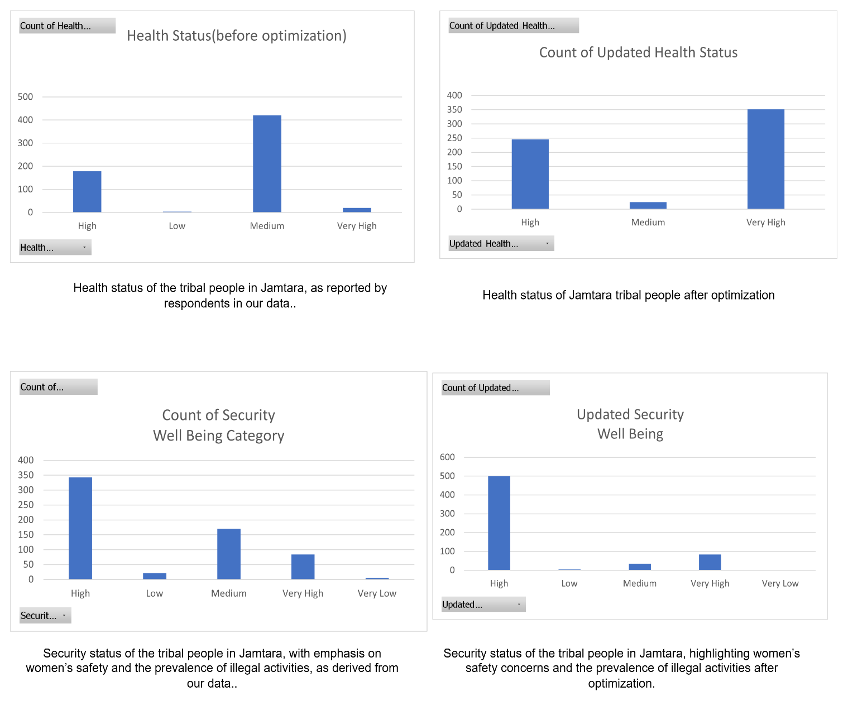
Figure 2: Comparative health and security status of the tribal people in Jamtara before and after optimization, highlighting improvements in Physical well-being.
We can get detailed information from Figure 2, which illustrates the comparative health and security status of the tribal population in Jamtara before and after optimization. The results show a clear improvement in health, with respondents shifting from predominantly medium levels toward higher and very high categories, indicating better access to healthcare and enhanced overall well-being. Similarly, security status demonstrates a marked rise in the high category with reductions in low and very low levels, suggesting improvements in women’s safety, reduction of illegal activities, and greater social stability. These findings underscore the positive impact of optimization initiatives on both health and security dimensions of tribal life.The improvements in health and security observed in Jamtara align with established theories of well-being and optimization, highlighting the effectiveness of integrated, community-centered development strategies. The Social and Emotional Wellbeing Framework emphasizes the holistic nature of well-being, encompassing physical, mental, social, emotional, spiritual, and cultural aspects. In Jamtara, the integration of ecological strategies like rainwater harvesting with institutional welfare measures reflects this holistic approach, leading to improved health outcomes and social stability (Griffiths et al., 2021).Similarly, the Indigenous Wellness Pyramid provides a scalable pathway toward increased well-being, emphasizing the integration of community, culture, and environment. The positive shifts in health and security indicators in Jamtara suggest that such integrated approaches can effectively enhance overall well-being (Blue Bird Jernigan et al., 2015).

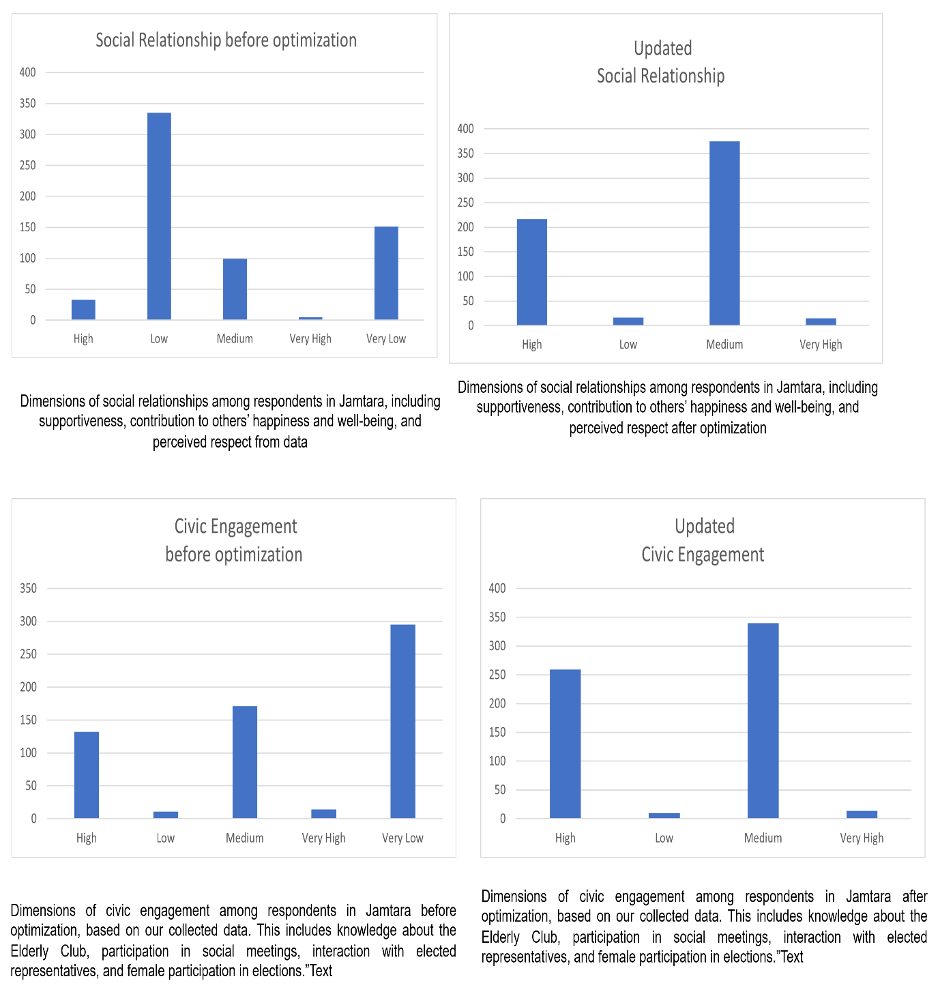
Figure 3: Comparative social relationship and civic engagement status of the tribal people in Jamtara before and after optimization, highlighting improvements in Social well-being.
Figure 3 presents the comparison of social connection and civic engagement of the tribal respondents in Jamtara before and after optimization. The findings indicate a notable shift, with social relationships moving from predominantly low levels to medium and high, while civic engagement improved significantly, transitioning from a majority in the very low category to higher representation in the medium and high categories. Social connection and civic engagement together form the broader concept of social well-being. Social well-being reflects how individuals interact with others. It also shows how people participate in community and collective life(Keyes, 1998). Additionally, it indicates the level of respect they experience within their communities. Earlier studies on tribal communities in Jamtara and across Jharkhand (Xaxa, 2019; Kumar & Singh, 2021) have often emphasized weak civic participation, fragile social networks, and the exclusion of marginalized groups, particularly women, from decision-making processes. However, the results from our collected data stand in contrast to this literature, suggesting that with structured interventions and awareness programs, traditional patterns of social isolation can be transformed into more participatory and cohesive community practices (John-Henderson et al., 2023).
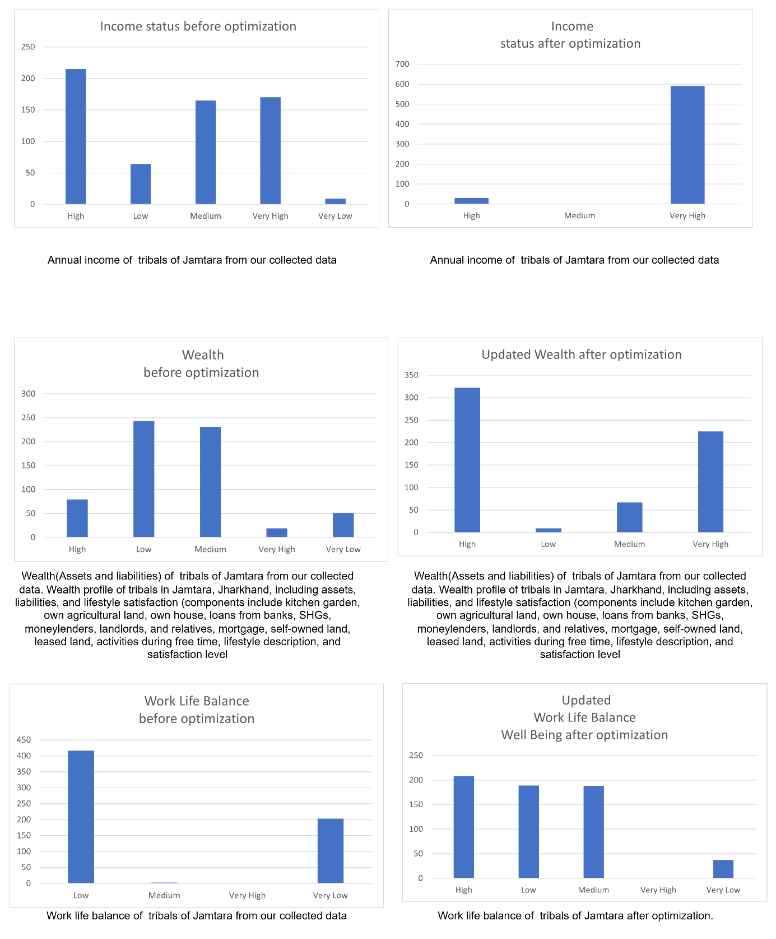
Figure 4: Comparative social relationship and civic engagement status of the tribal people in Jamtara before and after optimization, highlighting improvements in Economic well-being.
The results from Case 2 demonstrate that the combined adoption of government initiatives and the Multi-Crop System (MCS) significantly enhanced the economic well-being of tribal households in Jamtara. Before optimization, income levels were distributed across High, Medium, and Very High categories, with a notable share in Low and Very Low, reflecting uneven access to resources(Figure 4). After optimization, the majority of households shifted into the Very High income category, indicating that targeted interventions effectively elevated earnings. Similarly, wealth profiles, which earlier clustered around Low and Medium categories due to limited asset ownership and multiple liabilities, showed substantial improvements, with more households moving into High and Very High categories, suggesting increased asset accumulation, reduced dependency on informal credit, and improved financial resilience. Work-life balance also transitioned from predominantly Low and Very Low categories before optimization to a more even distribution across High, Medium, and Low after optimization, showing reduced labor stress, better time use, and improved life satisfaction. The domains of housing and occupation benefited from parallel gains. PMAY support and rising agricultural income improved housing condition and security. Meanwhile, MGNREGA, Skill India, and crop diversification enhanced occupational stability and skill utilization. Subjective Well-Being (SWB), which is closely linked to improvements in income, wealth, housing, and work conditions, also showed upward mobility. This confirms that material gains translated into psychological and social satisfaction.
These findings resonate with the theoretical perspectives on economic well-being presented by scholars such as Sen (1999) and Diener & Seligman (2004). According to Sen’s Capability Approach, economic well-being is not just about income. It is about expanding individuals’ capabilities to achieve life outcomes they value. In this study, this is reflected in improvements in work-life balance, housing, and occupation choices. Similarly, the literature on multidimensional well-being (Stiglitz, Sen, & Fitoussi, 2009) emphasizes that economic well-being encompasses material living standards, security, and quality of life (all domains) that improved in the post-optimization scenario. The shift of respondents toward higher categories in income and wealth, alongside better occupational opportunities illustrates how integrated interventions can enhance both material conditions and subjective quality of life. In line with earlier studies on rural livelihoods and crop diversification (Barrett et al., 2021; Pingali, 2015), the Jamtara findings reaffirm that sustainable agriculture, when paired with government intervention schemes, contributes to holistic economic well-being
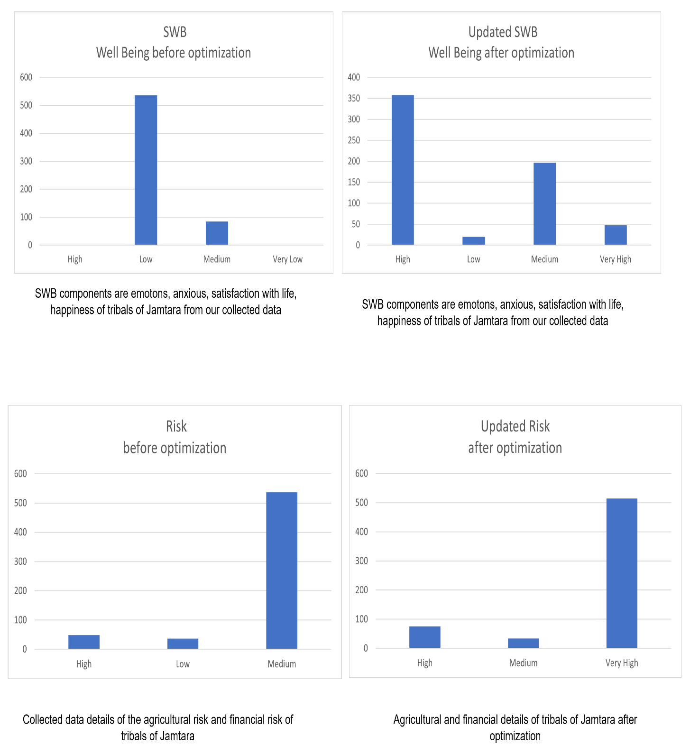
Figure 5: Comparative SWB and Risk status of the tribal people in Jamtara before and after optimization, highlighting improvements in Psychological well-being.

The collected data(Figure 5)reflect substantial changes in the psychological well-being (PWB) of tribal households in Jamtara before and after optimization through the combined effects of government initiatives and the Multi-Crop System (MCS). Psychological well-being encompasses several core components: Subjective Well-Being (SWB), perceived risk and security, life satisfaction, autonomy, resilience, and sense of purpose (Ryff, 1989; Diener et al., 1999). In the present study, SWB and risk perception served as key measurable indicators of psychological well-being.
Before optimization, the distribution of SWB was heavily skewed toward the Low category, with over 500 respondents reporting low satisfaction, and only a small share in Medium. Virtually none were in the High or Very High categories, reflecting limited life satisfaction, constrained opportunities, and psychological stress due to livelihood insecurity. After optimization, however, the picture shifted significantly: over 350 respondents moved into the High category, about 200 into Medium, and a small but notable number into Very High, while the Low category dropped sharply. This indicates that improved income, wealth, housing, and occupational stability contributed not only to material prosperity but also to a stronger sense of happiness, optimism, and social confidence among tribal households.
A similar transformation is visible in the domain of Risk, which acts as a psychological burden when households face uncertainty in employment, income, health, or environment. Before optimization, most respondents reported Medium levels of risk, reflecting vulnerability to crop failure, debt, and lack of social security. After optimization, a striking improvement was observed: the distribution shifted toward Very High security (over 500 respondents), accompanied by growth in the High category, while Medium and Low risks decreased considerably. This suggests that interventions reduced exposure to financial and livelihood shocks, thereby enhancing psychological stability.
These results are consistent with theories of well-being that emphasize both hedonic and eudaimonic aspects. The hedonic approach (Diener et al., 1999) defines well-being in terms of happiness and life satisfaction, which improved here as more respondents moved into the High SWB category. The eudaimonic perspective (Ryff, 1989), which stresses meaning, purpose, autonomy, and resilience, is reflected in reduced risk perception and greater confidence in livelihood sustainability. Further, Sen’s Capability Approach (1999) suggests that true well-being comes from expanding freedoms and choices. This is evident in how the optimized interventions increased capabilities through secure housing, diversified income sources, and skill development. These improvements led to psychological empowerment.
In summary, the transformation in SWB and reduced risk perception after optimization underscores that psychological well-being is deeply intertwined with economic security and social stability. By improving both the material and non-material dimensions of life, the integrated interventions enhanced tribal households’ confidence and satisfaction, thereby advancing their overall economic and psychological well-being.
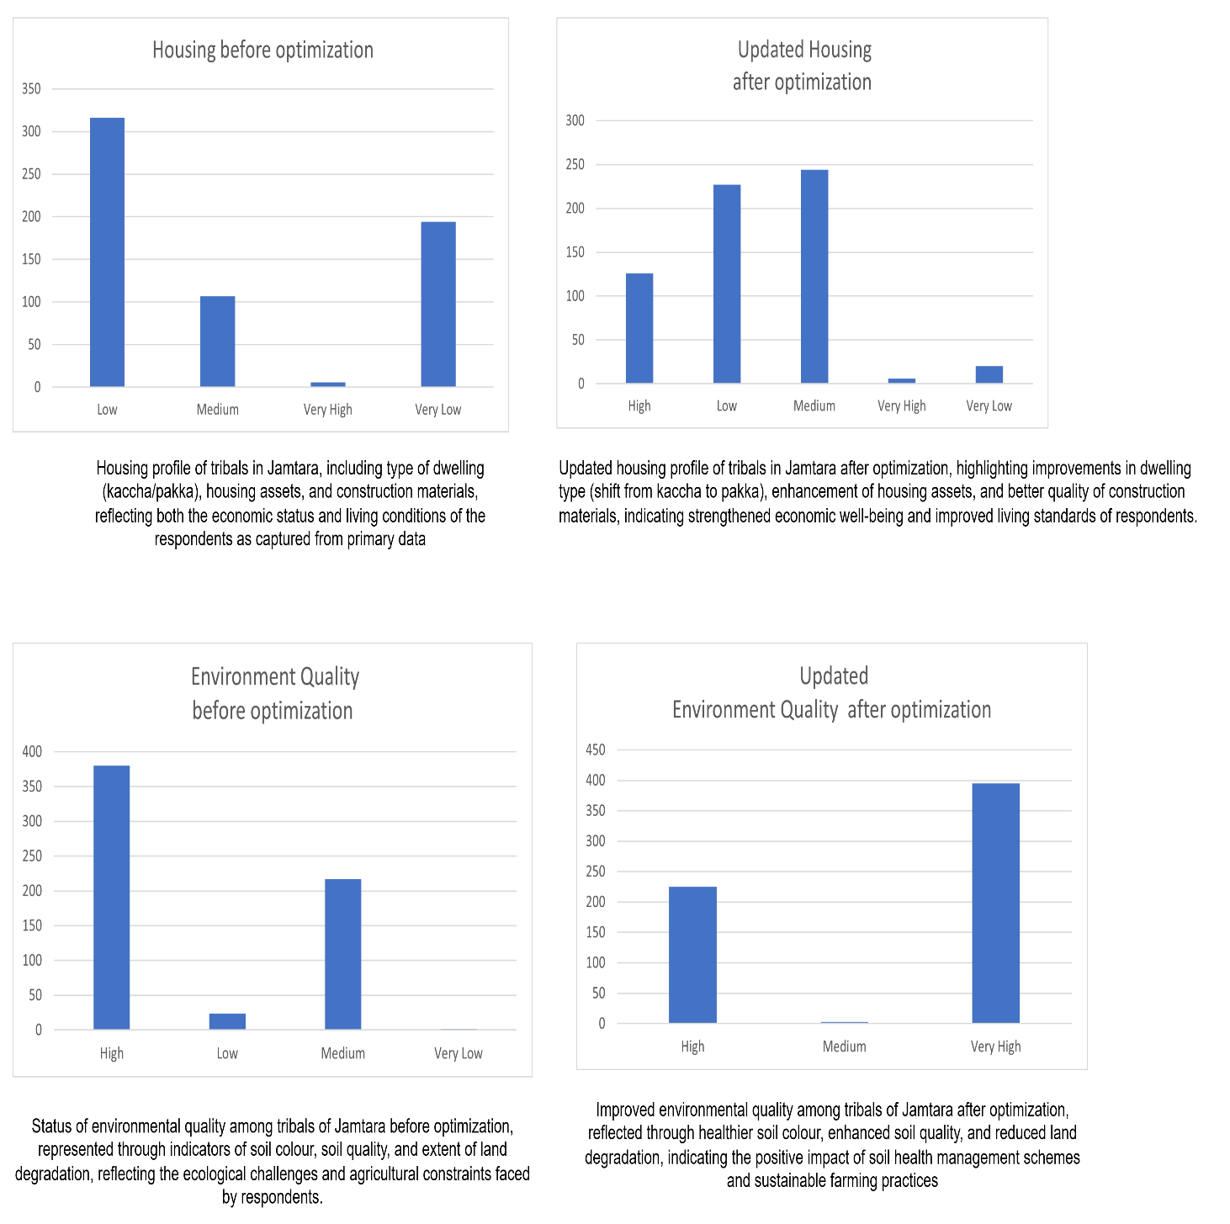
Figure 6: Comparative housing and EQ status of the tribal people in Jamtara before and after optimization, highlighting improvements in Environmental well-being.
Figure 6 presents the housing and environmental quality (EQ) of tribals in Jamtara, highlighting their role as essential components of environmental well-being. Before optimization, most respondents were concentrated in the low and very low housing categories, relying on kaccha houses, poor assets, and weak construction materials, which created insecurity and low self-esteem, while environmental quality, though showing some fertile soil, was threatened by land degradation and soil deterioration, leaving communities anxious about long-term sustainability. After optimization, housing conditions improved significantly, with respondents shifting toward medium and high categories due to interventions such as the Pradhan Mantri Awas Yojana (PMAY), reducing vulnerability and enhancing pride and social standing, while environmental quality improved to very high levels through Soil Health Management (SHM) and sustainable practices like finger millet and mustard seed cultivation, lowering agricultural uncertainty and psychological stress. These findings align with Ryff’s Environmental Well-being Model (1989), which stresses environmental mastery and stability, Sen’s Capability Approach (1999), which highlights expanded opportunities through secure housing and fertile land, and Diener’s Subjective Well-Being theory (2000), which emphasizes that economic and environmental security directly enhance life satisfaction and resilience.
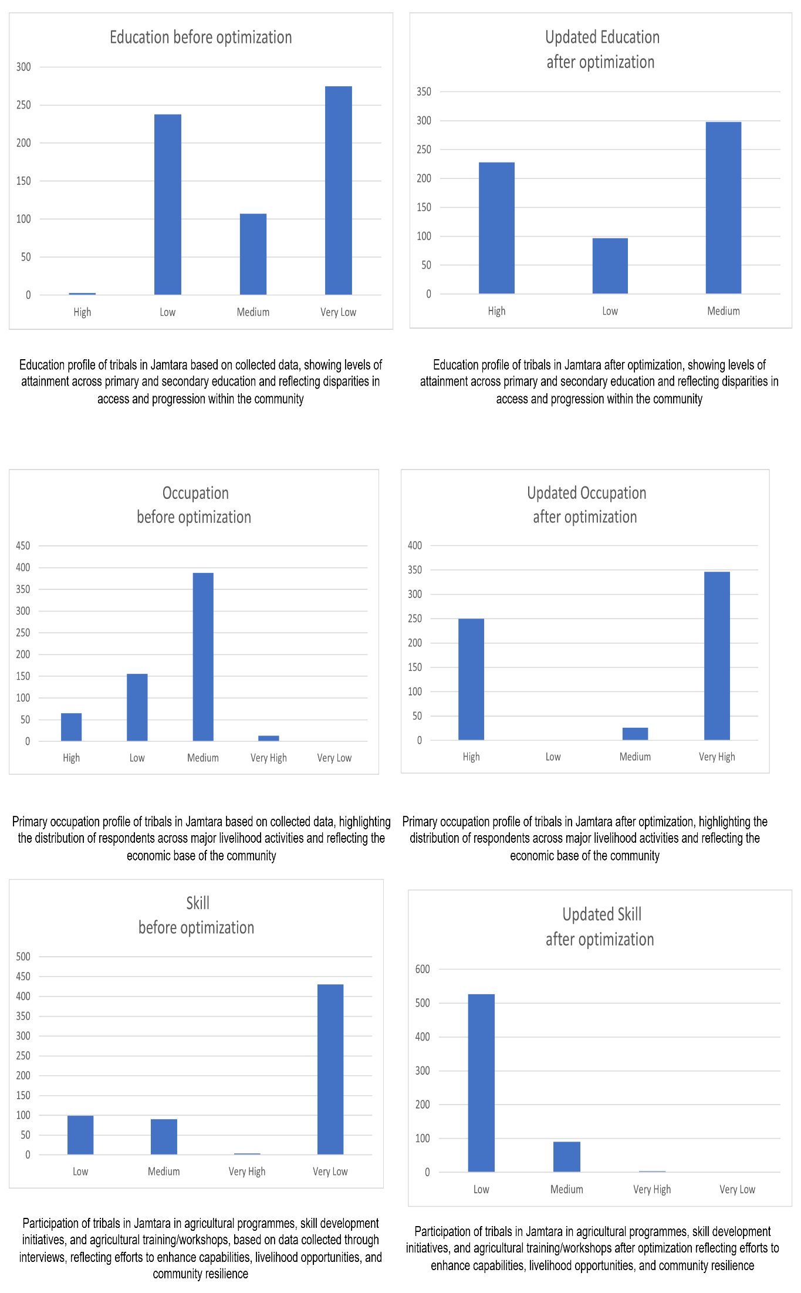
Figure 7: Comparative housing and EQ status of the tribal people in Jamtara before and after optimization, highlighting improvements in Occupational well-being.
The occupational well-being of respondents in Jamtara demonstrates a significant shift after optimization(Figure 7). Initially, most respondents were concentrated in the medium occupation category with limited livelihood opportunities, while education and skill levels were predominantly very low. After optimization, however, education improved to medium and high levels, skill development reduced the share of very low categories, and occupations shifted strongly toward high and very high categories. This transformation reflects better access to stable and diversified livelihoods through government initiatives, training, and community-based interventions. Such progress resonates with Sen’s Capability Approach, which emphasizes expanding people’s choices and capabilities to engage in meaningful work (Sen, 1999). Previous studies on tribal communities in Jharkhand also highlight that occupational well-being is strongly linked with access to education, agricultural training, and skill development programs (Sahu & Mishra, 2017; Kumar & Nayak, 2020). The findings from Jamtara thus align with the broader literature, showing that enhancing education and skill levels directly improves occupational outcomes, reduces livelihood vulnerability, and contributes to sustainable well-being.
Conclusion:
The findings of this study demonstrate that the overall well-being of tribal populations in Jamtara, Jharkhand, can be significantly enhanced through a combination of government programs and community-driven ecological interventions. Across the three cases analyzed, it is evident that even government initiatives alone, when optimally allocated within budget and program constraints, improve critical domains such as health, housing, financial and aagrricultural security, and employment. When these initiatives are complemented by the Multi-Crop System (MCS) and Rainwater Harvesting (RWH), the gains extend to income, wealth, work-life balance, subjective well-being, environmental quality, and occupational stability. The integration of ecological strategies alongside government initiatives measures reflects a holistic approach to development, emphasizing not only material gains but also psychological empowerment, social cohesion, and resilience, in line with theoretical frameworks such as Sen’s Capability Approach (1999), Ryff’s Environmental Well-Being Model (1989), and the Social and Emotional Wellbeing Framework (Griffiths et al., 2021).
The detailed comparative analysis presented in Table 5 underscores the importance of this study by situating its findings within the broader literature. The table highlights how the current study aligns with, extends, and provides novel contributions to previous research on economic, social, psychological, and environmental well-being. It shows that integrated interventions, optimized for multi-domain outcomes, not only confirm established theories but also offer practical models for efficient resource allocation and sustainable development. By comparing the current results with prior studies, the table emphasizes the synergistic effects of combining government initiatives with community-centered ecological strategies, demonstrating the added value of holistic approaches in improving tribal livelihoods and quality of life.
Overall, the study fulfills its objectives by providing empirical evidence that targeted, optimized interventions can maximize multi-dimensional well-being among tribal households. The findings have both theoretical and practical implications: they validate existing well-being frameworks, illustrate the effectiveness of optimization in resource allocation, and offer actionable guidance for policymakers and practitioners aiming to implement sustainable, inclusive, and culturally sensitive development strategies. The study reinforces the importance of integrating institutional support with ecological and community-driven initiatives to achieve long-term, resilient, and equitable improvements in the well-being of tribal communities.
Table 5: Comparison of Current Study with Previous Literature on Tribal Well-Being and Intervention Strategies
Aspect | Previous Literature | Current Study (Jamtara, Jharkhand) | Key Comparison / Insight
Economic Well-Being | Sen (1999) – Focus on expanding capabilities, not just income; Stiglitz et al. (2009) – multidimensional well-being includes income, security, and quality of life | Combined government programs and Multi-Crop System (MCS) improved income, wealth, occupation, and SWB | Confirms that integrated interventions enhance both material conditions and capabilities, extending Sen’s framework to tribal contexts
Health and Housing | Griffiths et al. (2021) – Community-centered health and housing interventions improve well-being | PMAY and Ayushman Bharat interventions improved housing security and access to healthcare | Aligns with literature; optimization shows maximum impact under budget constraints
Social Well-Being | Diener & Seligman (2004) – Subjective well-being includes social relationships; Indigenous Wellbeing Pyramid – community and cultural connection key | Social connection and civic engagement increased after interventions, reducing isolation | Extends findings to show that structured programs can transform social isolation into participatory community practices
Psychological Well-Being | Ryff (1989), Diener et al. (1999) – Autonomy, resilience, life satisfaction | SWB, risk perception, and psychological empowerment improved significantly post-optimization | Confirms theory; integrated interventions affect both hedonic and eudaimonic aspects of well-being
Agricultural Interventions | Barrett et al. (2021), Pingali (2015) – Crop diversification enhances income stability and resilience in rural India | Multi-Crop System (finger millet, mustard seed) improved income, housing, work-life balance, and occupation | Supports prior findings; shows synergistic effect with government programs in tribal areas
Environmental Well-Being | Ryff (1989) – Environmental mastery enhances well-being; Sen (1999) – secure and productive environment expands capabilities | Rainwater Harvesting (RWH) improved environmental quality, income, and resilience | Adds empirical support for integrating ecological strategies into multi-domain development
Optimization / Resource Allocation | General optimization theory – Efficient allocation maximizes outcomes under constraints | Linear programming optimized coverage of government programs, MCS, and RWH under ₹1.5 crore budget | Provides practical evidence that optimization can maximize multi-domain well-being in tribal communities
TheoreticalImplications:
This study provides several concrete theoretical contributions that can guide future scholars in research on tribal well-being, rural development, and multidimensional optimization. First, it empirically extends Sen’s Capability Approach (1999) by demonstrating how expanding freedoms and choicesthrough interventions such as secure housing, skill development, diversified income sources, and environmental management. Unlike previous studies that often focused on singular domains (e.g., income or education), this research integrates multiple well-being dimensionseconomic, social, psychological, environmental, and occupationalshowing how improvements in one domain reinforce gains in others.
Second, the study reinforces and expands the multidimensional well-being framework proposed by Stiglitz, Sen, and Fitoussi (2009). It provides a practical illustration of how subjective well-being (SWB), risk perception, work-life balance, and environmental quality can be measured and optimized alongside economic indicators. This integration of hedonic and eudaimonic aspects of well-being allows future researchers to design studies that move beyond simplistic income-based measures to more holistic, human-centered approaches.
Third, the application of linear programming and optimization theory in a multi-domain well-being context contributes to theory-building in development economics and operations research. While previous studies emphasized theoretical benefits of resource allocation, this research operationalizes the concept by showing how budget constraints, program capacities, and participant limits can be mathematically modeled to maximize well-being outcomes. Future scholars can use this as a methodological template to examine similar interventions in other tribal or rural contexts, including cost-effectiveness analysis and scenario planning.
Fourth, the study demonstrates the theoretical importance of integrating ecological strategies with institutional interventions, such as combining Rainwater Harvesting (RWH) and Multi-Crop Systems (MCS) with government schemes. This contributes to a growing body of research on sustainable development by showing that environmental well-being is not only an outcome but also a driver of economic, social, and psychological well-being. Researchers can build upon this integrative approach to explore resilience, adaptive capacity, and long-term sustainability in tribal communities.
PracticalImplications:
From a practical standpoint, the study offers actionable insights for policymakers, development practitioners, and local community organizations. The optimization model demonstrates how limited budgets can be allocated efficiently across multiple programs to maximize well-being, offering a replicable framework for evidence-based policy design. For instance, the prioritization of high-impact programs like PMAY, Skill India, and PMJDY provides clear guidance on which interventions yield the most substantial improvements in health, housing, financial security, and employment.The findings also highlight the value of combining support with community-driven interventions, such as MCS and RWH, to achieve synergistic effects. This suggests that development policies should not treat ecological or agricultural strategies as supplementary but as integral components of holistic well-being enhancement. By documenting the measurable impact on economic, social, psychological, and environmental domains, the study provides future implementers with empirical justification for integrated programs.Additionally, the study’s detailed assessment of subjective and psychological well-beingincluding SWB, risk, and life satisfactionoffers practical tools for monitoring and evaluating program outcomes beyond traditional economic metrics. Future scholars and practitioners can adopt these indicators to measure intervention effectiveness, inform adaptive strategies, and assess the long-term sustainability of development programs.
Finally, by presenting a scalable, replicable model of optimization-driven intervention, this study equips future researchers with a methodological framework that can be applied in diverse tribal or rural contexts, enabling comparative studies, policy simulations, and longitudinal research.

REFERENCE:
Alkire, S., & Foster, J. (2011). Counting and multidimensional poverty measurement. Journal of public economics, 95(7-8), 476-487.
Chakravarthi, M. S., & Lakshminarayana, K. (2017). Socio-economic and political conditions of tribes in India: An overview. International Journal of Multidisciplinary Educational Research, 6(9), 138-156.
Debreu, G. (1959). Theory of value: An axiomatic analysis of economic equilibrium (Vol. 17). Yale University Press.Zeleny, M. (1982). Multiple Criteria Decision Making. McGraw-Hill.
Kumar, R., & Chaudhuri, S. S. Tribal Economy as Socio-Economic and Cultural Aspects of Tribal Peoples, Jharkhand (India). LITERARY QUEST.
Thakur DS, Thakur DC, Saini AS (1991) SocioEconomic Impact of Tribal Development Programmes in Himachal Pradesh. Journal of Rural Development; Vol-10: pp. 823-30.
Kachhap, M. R. S., & Saw, M. G. P. (2016). A mapping stature regarding problems and its associated factors of Tribal Communities of Jharkhand. International Journal of Humanities & Social Science Studies (IJHSSS), 2(VI), 155-160.
Heidegger, M. (1962, 1966, 1971, 1973, 1993a, 1993b). Various works.
Simon, H. A. (1979). Rational decision making in business organizations. The American economic review, 69(4), 493-513.Pareto, V. (1906). Manuale di Economia Politica.
Arrow, K. J., & Debreu, G. (2024). Existence of an equilibrium for a competitive economy. In The Foundations of Price Theory Vol 5 (pp. 289-316). Routledge.
Sen, A. (1999). Development as Freedom. Oxford University Press.
Wassell, E., & Dodge, R. (2015). A multidisciplinary framework for measuring and improving wellbeing. Int. J. Sci. Basic Appl. Res, 21(1), 97-107.
OECD. (2013). OECD Guidelines on Measuring Subjective Well-Being. OECD Publishing.
Arrow, K. J., & Debreu, G. (1954). Existence of an equilibrium for a competitive economy. Econometrica, 22(3).
Elster, J. (1983). Sour Grapes: Studies in the Subversion of Rationality. Cambridge University Press.
Finnis, J. (1980). Natural Law and Natural Rights. Clarendon Press.
Griffin, J. (1986). Well-Being: Its Meaning, Measurement and Moral Importance. Oxford University Press.
Kahneman, D., Wakker, P., & Sarin, R. (1997). Back to Bentham? Explorations of experienced utility. Quarterly Journal of Economics, 112(2).
Mill, J. S. (1861/1998). Utilitarianism. Oxford University Press.
Miettinen, K. (1999). Nonlinear Multiobjective Optimization. Springer.
Nussbaum, M. (2011). Creating Capabilities: The Human Development Approach. Harvard University Press.
Parfit, D. (1984). Reasons and Persons. Oxford University Press.
Pareto, V. (1906). Manuale di Economia Politica.
Railton, P. (1986). Facts and values. Philosophical Topics, 14(2).
Sen, A. (1970). Collective Choice and Social Welfare. Holden-Day.
Sen, A. (1999). Development as Freedom. Oxford University Press.
Sumner, L. W. (1996). Welfare, Happiness, and Ethics. Clarendon Press.
Zeleny, M. (1982). Multiple Criteria Decision Making. McGraw-Hill.
Alkire, S., & Foster, J. (2011). Counting and multidimensional poverty measurement. Journal of Public Economics, 95(7–8).
OECD. (2013). OECD Guidelines on Measuring Subjective Well-Being. OECD Publishing.
Alkire, S., & Foster, J. (2011). Counting and multidimensional poverty measurement. Journal of Public Economics, 95(7–8).
Dasgupta, P. (2010). Nature and the Economy. Cambridge University Press.
Gupta, D. (2012). Justice before Reconciliation: Negotiating a ‘New Normal’ in Post-riot Mumbai. Routledge.
Kuklys, W. (2005). Amartya Sen’s Capability Approach: Theoretical Insights and Empirical Applications. Springer.
Maharatna, A. (2005). Demographic Perspectives on India’s Tribes. Oxford University Press.
Nussbaum, M. (2011). Creating Capabilities: The Human Development Approach. Harvard University Press.
Sen, A. (1999). Development as Freedom. Oxford University Press.
Xaxa, V. (2008). State, Society, and Tribes: Issues in Post-Colonial India. Pearson Longman.
Manikandan, A. D. (2016). Land degradation and tribal livelihoods: A study of Attappady.
Singh, K. M., Meena, M. S., Kumar, A., & Singh, R. (2011). Socio-economic determinants of rural poverty: An empirical exploration of Jharkhand state, India. India (September 13, 2011).
Ghosh, R., & Bharati, P. (2006). Nutritional status of adults among Munda and Pod populations in a peri urban area of Kolkata City, India. Asia Pacific Journal of Public Health, 18(2), 12-20.
Kahneman, D., Wakker, P. P., & Sarin, R. (1997). Back to Bentham? Explorations of experienced utility. The quarterly journal of economics, 112(2), 375-406.
Singh, A. K., Mondal, G. C., Singh, T. B., Singh, S., Tewary, B. K., & Sinha, A. (2012). Hydrogeochemical processes and quality assessment of groundwater in Dumka and Jamtara districts, Jharkhand, India. Environmental Earth Sciences, 67, 2175-2191.
Justin, J., & Menon, N. (2022). Indian Intersectional Ecofeminism and Sustainability: A Study on Mayilamma: The Life of a Tribal Eco-Warrior and Jharkhand’s Save the Forest Movement. Journal of Ecohumanism, 1(2), 123-137.
Challoumis, C. (2024, October). Building a sustainable economy-how ai can optimize resource allocation. In XVI International Scientific Conference (pp. 190-224).
Charnes, A., & Cooper, W. W. (1961). Multicopy traffic network models. Theory of traffic flow, 85, 85-96
Luenberger, David G. Optimization by vector space methods. John Wiley & Sons, 1997.
Alkire, Sabina, and James Foster. "Counting and multidimensional poverty measurement." Journal of public economics 95.7-8 (2011): 476-487.
Thorbecke, W. (2008). The effect of exchange rate volatility on fragmentation in East Asia: Evidence from the electronics industry. Journal of the Japanese and International Economies, 22(4), 535-544.
Duflo, Esther, and Abhijit Banerjee. Poor economics. Vol. 619. New York: PublicAffairs, 2011.
Barrett, J. R., Belij-Rammerstorfer, S., Dold, C., Ewer, K. J., Folegatti, P. M., Gilbride, C., ... & Pollard, A. J. (2021). Phase 1/2 trial of SARS-CoV-2 vaccine ChAdOx1 nCoV-19 with a booster dose induces multifunctional antibody responses. Nature medicine, 27(2), 279-288.
Pingali, P. (2015). Agricultural policy and nutrition outcomes–getting beyond the preoccupation with staple grains. Food security, 7(3), 583-591.
Griffiths, K., Diaz, A., Whop, L. J., & Cunningham, J. (2021). The health and wellbeing of indigenous and tribal peoples around the globe: ensuring and promoting best practice in research. International Journal of Environmental Research and Public Health, 19(1), 261.
Blue Bird Jernigan, V., Peercy, M., Branam, D., Saunkeah, B., Wharton, D., Winkleby, M., ... & Buchwald, D. (2015). Beyond health equity: Achieving wellness within American Indian and Alaska Native communities. American Journal of Public Health, 105(S3), S376-S379
Keyes, C. L. M. (1998). Social well-being. Social psychology quarterly, 121-140.
John-Henderson, N. A., White, E. J., & Crowder, T. L. (2023). Resilience and health in American Indians and Alaska Natives: A scoping review of the literature. Development and psychopathology, 35(5), 2241-2252.
Diener, E., & Seligman, M. E. (2004). Beyond money: Toward an economy of well-being. Psychological science in the public interest, 5(1), 1-31.
Stiglitz, J. E., Sen, A., & Fitoussi, J. P. (2009). Commission sur la mesure des performances économiques et du progrès social. Rapport au président de la République. France. http://www. stiglitz-sen-fitoussi. fr/fr.
Ryff, C. D. (1989). Happiness is everything, or is it? Explorations on the meaning of psychological well-being. Journal of personality and social psychology, 57(6), 1069.
Diener, E., Suh, E. M., Lucas, R. E., & Smith, H. L. (1999). Subjective well-being: three decades of progress. Psychological bulletin, 125(2), 276.
Hossain, K. N., Hossain, M. A., Paul, L., & Siddique, R. F. (2016). Subjective well-being of tribal and non-tribal people in relation to psychological needs. Indian Journal of Positive Psychology, 7(1).
Maddux, J. E. (2017). Subjective well-being and life satisfaction: An introduction to conceptions, theories, and measures. In Subjective well-being and life satisfaction (pp. 3-31). Routledge.

