The relationship between Social Media and Food Behaviours- Impulsivity, Craving and Choice.

Submitted in partial fulfilment
For the award of Degree in M.Sc. Dietetics and Applied Nutrition

By
NISTHA AGARWAL 241405001
PRIYADARSHINI NANDY 241405027
PRATISHTHA SHARMA 241405049

Under the guidance of

Mrs. Swathi K Acharya

and
Co-guidance of

Mrs. Pallavi Mahesh Shettigar



Manipal Academy of Higher Education Department of Dietetics and Applied Nutrition
Welcomgroup Graduate School of Hotel Administration 2024-2026



CERTIFICATE

It is hereby certified that this Master's thesis report entitled "The relationship between Social Media and Food Behaviours- Impulsivity, Craving and Choice." is a bona-fide record of the major research project done by Nistha Agarwal (Reg. No. 241405001), Priyadarshini Nandy (Reg. No.241405027), Pratishtha Sharma (Reg. No.241405049) in the second year of MSc. Dietetics and Applied Nutrition.

This Master's thesis report is submitted to Manipal Academy of Higher Education in September 2025 in partial fulfilment of the requirements for the degree of Master of Science in Dietetics and Applied Nutrition.

PROJECT GUIDE COURSE COORDINATOR

CO GUIDES

Place: Manipal
DATE:26 September 2025

DECLARATION
I hereby declare that the Master’s Thesis report entitled “ The relationship between Social Media and Food Behaviours- Impulsivity, Craving and Choice” submitted in Manipal academy of Higher Education in partial fulfilment for the award of degree of Masters of Science in Dietetics and Applied Nutrition is based on the result of original work carried out under the guidance of Ms. Swathi acharya K and co-guidance of Mrs. Pallavi Mahesh Shettigar and has not previously formed the basis for the award of any degree/ diploma/ associateship or any similar title.

Place: Manipal Date: 26-09-25

Nistha Agarwal Priyadarshini Nandy Pratishtha Sharma



ACKNOWLEDGEMENT

Our sincere gratitude is extended to the following people, without whose unwavering assistance, direction, and encouragement this study would not have been able to be completed. First and foremost, we would like to sincerely thank Ms. Swathi acharya, our guide, for her insightful advice, unwavering support, and essential mentorship during this project.

We also want to express our sincere gratitude to Ms. Pallavi Mahesh Shettigar, coordinator of the M.Sc. Dietetics and Applied Nutrition program, for her unwavering encouragement and support as well as for creating an atmosphere that promotes learning and academic success.
We would like to express our gratitude to the department's faculty for their collaboration, help, and encouragement throughout this project. Our work was made feasible by the resources, facilities, and academically stimulating environment that our college, the Welcomgroup Graduate School of Hotel Administration (WGSHA), Manipal, provided. For this, we are grateful. We appreciate the commitment, cooperation, and teamwork of every member of our project team.

We would also like to express our gratitude to all of the study participants who voluntarily participated in our investigation. We value their collaboration, confidence, and time, all of which were essential to the accomplishment of our study. In a personal capacity, we would like to express our sincere gratitude to our families for their unwavering support, motivation, and fortitude. We would like to express our gratitude to our friends, classmates, and well-wishers for your encouragement, support and support throughout this study.

Nistha Agarwal Priyadarshini Nandy Pratishtha Sharma.

INDEX

TABLE OF CONTENTS

Chapter no. | Title | Page no.
1. | Introduction | 1-3
2. | Review of literature | 4-10
3. | Methodology and Materials | 11-14
4. | Observations and Results | 15-31
5. | Discussion | 32-36
6. | References
7. | Annexures

LIST OF TABLES AND FIGURES

Table no. | Title | Page no.
4.1 | Age, Gender and Ethnicity | 15
4.2 | Education, Occupation, Income | 17
4.3 | Number of Hours in Social Media | 19
4.4.1 | Platform you use most for food related content | 20
4.4.2 | Food content encountered the most | 21
4.4.3 | Food purchased impulsively due to social media | 22
4.4.4 | Food Preferences Change | 24
4.5 | Social Media Classification | 24
4.6 | Food craving classification | 25
4.7 | Impulsivity Classification | 26
4.8 | Mean of Food Choice | 26
4.9.1 | Type of nutrition related content | 27
4.9.2 | Type of Social media content influencing food choice | 28
4.9.3 | Medium of social media used for nutrition information | 29
4.9.4 | Main social media source for nutrition related information | 30
5.1 | Linear regression model | 31

CHAPTER 1- INTRODUCTION

In today’s digital age, social media has become more than just a tool for communication it is a space where identities are shaped, behaviors are influenced, and choices are made. As of 2021, over 4.2 billion people globally use at least one social media platform, spending an average of 2 hours and 25 minutes daily on platforms such as Instagram, TikTok, WhatsApp, and Twitter (Meng et al., 2022; Cheng et al., 2021). This usage is increasing rapidly across all age groups, with young adults forming the most active and influenced demographic (Cheng et al., 2021).
While food content on social media may offer inspiration and entertainment, it has also been shown to influence impulsive behaviors and unhealthy eating patterns, particularly in young adults. The lack of planning, emotional vulnerability, and the constant exposure to visually appealing food makes individuals more prone to craving-based decisions. Despite growing awareness, limited research has explored how impulsivity and cravings mediate the effect of social media on actual food choices in the general adult population.
This research aims to contribute to the understanding of how digital environments influence eating behavior. By exploring how impulsivity and craving interact with social media exposure, the study can inform:
- Nutrition professionals in building awareness-based interventions,
- Mental health practitioners in behavior therapy,
- Health campaign designers creating digital health content.

Impulsivity in Social Media

Impulsivity has been defined as, “a predisposition toward rapid, unplanned reactions to internal or external stimuli with diminished regard to the negative consequences of these reactions to the impulsive individual or to others. (Brewer & Potenza, 2008).

The excessive use or maladaptive use of social media has been linked to an increased level of impulsivity in a myriad of forms. This includes attention-based impulsivity (focusing challenges), motor-based impulsivity (acting before thinking), and impulsivity without planning. (Lewin et al., 2023), (Guo et al., 2022).

There is impact of non-planned impulsiveness and social media utilization on the risk of developing eating disorders. Adults who have limited ability to plan were more susceptible to the damaging effects of social media content focused on body images and food, leading to negative body image perception (He & Yang et al.,2022).

Media, Social Platforms, Cravings, and Food-related Actions

A food craving is a strong need to consume a specific food. Hunger is defined as the lack of fullness, i.e., hunger sensations are caused by an empty belly. Food craving can be distinguished from hunger feelings by its specificity and intensity. In other words, while a craving for food can generally only be relieved by eating a specific food, hunger can be relieved through eating any kind of food. The experience of food craving is multidimensional. Physiologically, it is linked to a number of processes that condition the body for ingestion and drives food seeking and consumption like enhanced salivary secretion and stimulation of reward-related brain regions like the striatum. It also has cognitive (i.e., thinking about the food) and emotional (e.g., hunger to eat or mood changes) components. Lastly, it usually also has a behavioral component of seeking and ingesting the food (Weingarten & Elston, 1990).

The rumors and comments circulating in social media networks could result in impulsive eating among youth as social norming in relation to food consumption could incite powerful and automated mimicry responses. Observational learning extends beyond the immediate context and traditional settings where individuals learn from their peers. (Hermans et al., 2013).

Social media, Food choice and Disordered eating patterns

"Food choice is determined by a complex interaction of factors such as biological predispositions, personal preferences, psychological influences, social context, and cultural norms, as well as economic and environmental constraints."

Platforms such as TikTok and Instagram amplify concerns about body image due to promoting specific body shapes which encourage unhealthy dieting and eating habits.

Social media is greatly linked to disordered eating as noted by Arshad et al. (2025), where body image worries act as mediators of the link. This correlation is weakened in the presence of impulsivity, a measure of self-control. Put differently, high impulsivity leaves one with little cognitive resources to critically evaluate the toxic image and underlying cultural narratives that promote harmful body ideals and attain them through dieting, thus resulting in restriction or binge eating (Arshad et al., 2025).

The research by He & Yang (2022) validates these findings by establishing a link between social media dependency and the risk of eating disorders, particularly for students who are socially impulsive and media conscious (He & Yang et al.,2022).

The following are the objectives of the study:
- To analyse the impact of social media on food-related impulsivity among adults.
- To examine the role of social media in triggering food cravings.
- To explore the effect of social media on food choice patterns.
- To analyse the counteracting effects of demographic variation, social media usage, and food behaviours.

Operational Definitions

  - Social Media Usage: The frequency and intensity of engagement with food-related content on digital platforms.
  - Impulsivity: A tendency to act on immediate desires or emotions without adequate thought or planning.
  - Food Craving: A strong, often urgent desire to consume specific food, especially triggered by external stimuli like food posts.
  - Food Behaviour: Patterns and motivations behind food choices, including frequency of eating out, delivery, and meal planning

CHAPTER 2- REVIEW OF LITERATURE

SOCIAL MEDIA AND CONSUMER BEHAVIOUR

Prevalence and Impact of Social Media
Social media has a significant impact on consumer behavior and purchasing decisions, leading to increased spending and brand switching among buyers influenced by social media (Pushparaj & Kushwaha, 2024). It influences purchasing decisions, shopping habits, and trends, with businesses using elements of influencer marketing within social networking to build relationships with potential customers Igarová et al. (2022). Social media has transformed consumer lifestyles, keeping them informed and influencing their purchasing decisions, serving as a crucial marketplace for businesses to promote and sell their products and services (Surya & Celia, 2024).

Social Media as a Marketing and Advertising Platform
Social media marketing involves running advertisements, engaging followers, listening to followers, analyzing results, and publishing content on social media profiles Major platforms like Pinterest, Instagram, Snapchat, Twitter, Facebook, LinkedIn, and YouTube play a significant role in developing and increasing business (Zuhdi et al., 2019). Businesses are moving substantial amounts of their marketing budgets to these platforms for greater influence and outcome (Kumar & Nanda, 2023). Social media marketing is cost-efficient and offers substantial opportunities for customer engagement, insights into branding, and product development (Gowrishankar et al., 2024). It helps companies capture traffic, expose their business, and cut costs compared to other marketing tools.

Influencer Marketing and Its Effects
Influencer marketing has become one of the most important tools for companies to increase awareness, sales, or strengthen their image (Venciute et al., 2024). Influencers, who are independent opinion leaders on social media, significantly impact consumer behavior and decision-making. (Pan et al., 2024) (Johne, 2023). Influencer marketing leverages the trust and admiration consumers have for influencers, making it an effective marketing strategy (Nadanyiova et al., 2020)
Influencers' perceived credibility, trustworthiness, and identification positively affect consumers' purchase decisions (Özbölük & Akdoğan, 2022). The effectiveness of influencer marketing depends on various factors, including influencer characteristics, follower characteristics, and post characteristics. Influencers can impact consumers at multiple levels, including brand awareness, subject matter expertise, brand preference, and purchase intention. (Pan et al., 2024) (Chopra et al., 2020)

FOOD RELATED CONSUMER BEHAVIOUR

Food Impulsivity and Cravings- Definition and Theoretical Underpinnings
Impulsivity has been defined as, “a predisposition toward rapid, unplanned reactions to internal or external stimuli with diminished regard to the negative consequences of these reactions to the impulsive individual or to others. (Brewer & Potenza, 2008). A food craving is a strong need to consume a specific food. Hunger is defined as the lack of fullness, i.e., hunger sensations are caused by empty belly. Food craving can be distinguished from hunger feelings by its specificity and intensity. In other words, while a craving f o r food can generally only be relieved by eating a specific food, hunger can be relieved through eating any kind of food. The experience of food craving is multidimensional. The propensity to behave impulsively when distressed, was positively predictive of food addiction symptom count among undergraduate students. Food addiction can be described in terms of symptoms like loss of control over use, continued use despite adverse consequences, and inability to reduce despite a desire to do so. Impulsivity is also seen as one of the reasons why binge eating habits start and why they continue (Giel KE et al., 2017).

Factors Influencing Food Impulsivity and Cravings

Motor impulsivity is a major “bridge node” linking social media addiction and impulsivity. These findings highlight the fact that the reward and compulsive nature of many of these platforms (likes, shares, going viral, etc.) enhance impulsive behavior (Guo et al.,2022). PSMU has shown to correlate positively with traits and behaviors related to impulsive actions highly reminiscent of substance use disorder. (Lewin et al., 2023 Motor impulsivity is a major “bridge node” linking social media addiction and impulsivity. These findings highlight the fact that the reward and compulsive nature of many of these platforms (likes, shares, going viral, etc.) enhance impulsive behavior (Guo et al.,2022). There is impact of non-planned impulsiveness and social media utilization on the risk of developing eating disorders. Adults who have limited ability to plan were more susceptible to the damaging effects of social media content focused on body images and food, leading to negative body image perception (He & Yang et al.,2022). Social media posts showcasing appetizing foods, particularly their videos, can serve as strong external stimuli that increase the intensity of pre-existing cravings among the more reactive and impulsive individuals.

SOCIAL MEDIA AND FOOD RELATED BEHAVIOUR

Social Media Visual Cues and Their Impact on Cravings
Social media platforms (such as TikTok, Instagram, and YouTube) have turned food content into entertainment, education, and identity expression. This encompasses:
- Mukbangs that engage with exaggerated eating habits and social connection appeal. (Ataguba, Kalu, Chan, & Orji, 2025).

- Recipes and food hacks that empower viewers to cook, experiment, or replicate food trends (Wang, Sher, & Chung, 2024).

- Influencer content that draws on both emotional and rational appeals to advance food literacy and behaviors (Teunissen, 2024).

These structures take advantage of visual stimulation, narrative, and peer relationships to condition users' perception, planning, and activity towards food.

Social Influence and Normative Eating Behavior
The rumors and comments circulating in social media networks could result in impulsive eating among youth as social norming in relation to food consumption could incite powerful and automated mimicry responses. Observational learning extends beyond the immediate context and traditional settings where individuals learn from their peers. A teacher or parent could stop monitoring their wards during the meal towards watching a video and in no time their war could be masterful copy cats. Very few of the youngsters possess the appropriate mechanisms to be better at self-regulation and in moderation (Hermans et al., 2013).

Social Media and Food Impulsivity Targeted Marketing and Impulse Purchases
Food influencers promote highly engaging content that can override critical food judgment, especially among impulsive individuals. (Teunissen, 2024). Algorithmic exposure to clickbait or unhealthy food content can worsen impulsive eating habits. (Tan, Pereira, & Yusoff, 2024).

Social Media as a Trigger for Impulsive Eating

Likes, shares, and viral formats on social platforms activate reward pathways like those in s u b s t a n c e use, increasing impulsive tendencies. (Guo e t al., 2022) Social media content can drive reckless foraging behavior and excessive consumption of energy-dense foods. (Nederkoorn et al., 2009).

THEORETICAL FRAMEWORKS IN RELATION TO HEALTH, NUTRITION, AND SOCIAL MEDIA

Social Cognitive Theory (SCT)
Social Cognitive Theory (SCT) emphasizes the role of observational learning, self-efficacy, and outcome expectations in behavior change. In the context of health and nutrition on social media, SCT has been applied to understand how influencers can impact followers' behaviors. For instance, influencers sharing their positive experiences with therapy or healthy cooking can encourage followers to adopt similar behaviors, driven by perceived self-efficacy and the entertainment value of the content (Kamran et al., 2021). Additionally, SCT has been used to explore how social media health misinformation can affect users' anxiety and behavior during health crises like the COVID-19 pandemic.

Theory of Planned Behavior (TPB)
The Theory of Planned Behavior (TPB) posits that behavior is driven by intentions, which are influenced by attitudes, subjective norms, and perceived behavioral control. In health and nutrition contexts, TPB has been used to explain dietary behaviors and health information sharing on social media. (McDermott et al., 2015). For example, TPB has been applied to understand protein intake and dietary supplement use among bodybuilders, where subjective norms and perceived behavioral control were significant predictors 4. Additionally, TPB has been integrated with other theories to explore health information sharing behaviors on platforms like WeChat. (McDermott et al., 2015)

Dual-Process Theory of Impulsivity
The Dual-Process Theory of Impulsivity, which distinguishes between automatic (impulsive) and controlled (reflective) processes, is relevant in understanding how individuals make health- related decisions on social media. Although specific studies on this theory in the provided abstracts are limited, the theory can be inferred to explain behaviors such as impulsive health information sharing or dietary choices influenced by social media content. (Herman et al., 2018).

Elaboration Likelihood Model (ELM)
The Elaboration Likelihood Model (ELM) explains how individuals process persuasive messages through central (deep, thoughtful) or peripheral (superficial) routes. In health and nutrition contexts, ELM has been used to design internet-based programs promoting healthy eating and physical activity by enhancing central processing through interactive multimedia. Additionally, ELM can guide the creation of persuasive nutrition messages on social media, ensuring that the content is engaging and informative to promote behavior change.

MODERATING AND MEDIATING FACTORS

Demographic Variables
Social media influences modern food behavior, but its impact depends greatly upon demographic factors. Moderator/mediators Several key variables such as age, gender and culture have been found to moderate or mediate the associations between social media and food choices, impulsivity and cravings.

Age also has a strong impact on how people interact with information about food in social media, and how they make food-related decisions. Ogundijo et al. (2022) also found that younger adults (18–38 years old) in a college setting were affected by convenience and preparation instructions, fitting with an interest for fast and convenient food items that they often see through social media advertisements. On the other hand, elderly people (aged 55– 73) tended to use intrinsic food attributes, such as fat, salt and added sugar. This contrast demonstrates that there is an age moderation effect about how social media content influence food behavior, where older adults’ decisions tend to be based on health judgment than impulsive social cues.

Gender differences also influence the responses to food cues on social media. Ogundijo et al. (2022) found that women were more likely to read nutritional content labels and engage in health-related behaviors than were men. Moreover, Nadaf and Eljo (2024) emphasized that social network scores are generally stronger in men than women, and therefore the structure of an individual’s social network, potentially mediated through social network site use (e.g., Facebook and WhatsApp), might influence how emotional and behavioral respond to food content. These results suggest that gender might mediate the relationship between food choice, social media use, and social support networks.

Socioeconomic status and cultural background also affect how people react to digital food marketing. Al-Dmour et al. (2023) indicated that age, gender, education, and income acted as a moderator in the relationship between social media marketing strategies and customer satisfaction in the travel industry. While set in a tourism context, its application in food behavior is broader, particularly when incorporating culturally based food content or income- related food promotions.

Personality traits
Social media is becoming a dominant force in influencing the behaviours and lifestyles of young adults, particularly with respect to their eating habits. Of the numerous psychological traits that might mediate or moderate these influences, impulsivity and sensation seeking are two significant dimensions that stand out as important mediating variables.

Impulsivity, which is defined as a tendency to act without thought or inability to consider the consequences of present actions, has been found to exacerbate the association between exposure to social media and unhealthy food outcomes. High SMD in the context of low NPI was associated more with ED risk than high NPI, suggesting that low impulse control when using social media extensively elevates the risk for disordered eating possibly through social media facilitated comparisons and the internalization of appearance ideals.

Likewise, buying impulsiveness has been shown to predict adolescent and young adult unhealthy food-product purchases when social media marketing are present; examples include branded content or food influencers (Reale, Kearney and Hulsey 2017). Even price-based deterrents like sin taxes had minimal effects on purchase intentions when impulsivity was high (Dawson & Stradling, 2015).

Sensation seeking, the seeking of varied, novel, complex, and intense sensations and experiences, has been associated with problematic social media use and subsequent unhealthy behaviors such as food consumption. Meng et al. 2024 proposed a moderated mediation model that argues the fear of missing out (FoMO) mediates the relationship between sensation seeking and social network addiction. In this model, those high in sensation seeking experience greater FoMO, which leads to increased use of social media—a milieu replete with food cues, body image ideals, and impulsive food consumption.

As such, FoMO may be a psychological link between the sensation seeking trait and online activities that promote disordered eating or impulsive food consumption. The more that someone is drawn to excitement and the new, the more likely they are to use social media to vicariously fulfill those needs — usually with posts that focus on food and appearance. This can cause emotional overeating or binge eating for comfort or as a wayto make up to oneself.

Social and Environmental factors
Social media has a strong effect on food habits through defining social norms, modifying peer behaviour, and changing attitudes towards food. Research suggests that platforms like Instagram and Facebook shape our food preferences through aesthetics, peer influence and social transmission of information. This is certainly the case for young people, who are constantly influenced by what their peers and influencers post on social media. (Chung et al., 2021; Tamby Chik et al., 2019). Social media is additionally a source of homogenized dietary consumption behavior, which could drive unsustainable food practices. In the pursuit of more diverse food content however, stylistic clutter and food confusion can result from mixed messages and marketing jargon. (Simeone & Scarpato, 2020).
Food availability and affordability also play a role and can be seen on social media. Users from low-income or rural locations might also be presented with aspirational food content that they are unable to access, potentially reinforcing health inequalities. (Marcone et al., 2020).

Psychological factors
Social media came in as a powerful domain associated with young people’s body perceptions and eating behaviours. Seeing perfect images of thin or buffed bodies on social media platforms like Instagram, TikTok and Facebook is a major risk factor for body dissatisfaction and low self- esteem, particularly among adolescents and young adults (Zaharia & Gonța, 2024). This effect is motivated by self-objectification and social comparison as psychological mechanisms underlying the effect. People often internalize these beauty standards pushed by social media to extreme behaviours such as restrictive dieting, emotional eating or disordered eating habits (Rounsefell et al., 2020).
Although self-esteem in has not effect seen on the risk of eating disorders necessarily, but its interaction with body image and comparison behavior is important. Low body appreciation tends to result in emotional eating as a way of managing appearance-related upset (Zaharia & Gonța, 2024; Merino et al., 2024).

Influence of food craving on food choice
Prior studies have consistently indicated that food cravings significantly influence dietary behavior, frequently surpassing intentions to choose healthier options. Cravings are deeply connected to neural reward systems and are intensified by environmental signals, stress, and impulsiveness, leading individuals to prefer high-calorie, appealing foods even when considering long-term health objectives (Leng et al., 2017; Georgii et al., 2017). Cravings significantly forecast future eating and weight increase while also affecting personal food valuation, rendering unhealthy choices seem more appealing (Boswell et al., 2018). A rise in food cravings has been found to greatly affect food selection, often leading people to prefer high-calorie, tasty foods instead of healthier options (Leng et al., 2017; Boswell et al., 2018; Georgii et al., 2017). Simultaneously, research shows that cravings can be adjusted; for instance, cognitive approaches highlighting the advantages of nutritious foods or the drawbacks of unhealthy options can diminish desires for high-calorie foods and encourage healthier selections (Boswell et al., 2018). Overall, this emphasizes food cravings as both a risk element for unhealthy eating choices and a possible focus for behavioral strategies aimed at enhancing dietary habits.

Influence of social media usage on food choice
Exposure to social media has reliably been associated with poorer food choices. Platforms like Instagram and Facebook often showcase calorie-rich, branded food items, which can spark cravings and promote unhealthy eating habits, especially in teenagers and young adults (Hoogstins, 2017; Chung et al., 2021). Systematic reviews indicate that teenagers are more inclined to remember and favor unhealthy foods endorsed by influencers and celebrities, rendering them particularly susceptible to marketing tactics (Kucharczuk et al., 2022). Additionally, social media often standardizes consumption and encourages unsustainable eating habits, which further diminishes dietary quality (Simeone & Scarpato, 2020). While there are certain positive effects (e.g., health initiatives), the predominant pattern is that increased social media usage is linked to worse dietary decisions.

CHAPTER 3- METHODOLOGY

- Title of the Proposal and Project- The relationship between Social Media and Food Behaviours- Impulsivity, Craving and Choice.

- Type of study- Cross sectional quantitative survey

- Aim: To understand the relationship between social media and food behaviours- impulsivity, craving and choice.

Departments involved:
Department of Dietetics and Applied Nutrition, WGSHA, MAHE

- Study period: Duration- March 2025- August 2025.

Sample size: 366

The sample size was calculated using select statistical services calculator. The population for the convenience sampling was considered as 10,000. The confidence level was 95% with a 5% margin error and the likely sample proportion was 40%. The recommended sample size provided was 368.
Sample size formula:
𝑛0 = \𝑓𝑟𝑎𝑐{𝑍² ⋅ 𝑝 ⋅ (1 − 𝑝)}{𝐸²}

Z = 1.96 (for 95% confidence)
P = 0.40
E = 0.05
N = 10,000
𝑛0 =\𝑓𝑟𝑎𝑐{1.96² ⋅ 0.40 ⋅ 0.60}{0.05²} ≈ 369.6

Finite population correction:
𝑛 = \𝑓𝑟𝑎𝑐{𝑛0}{1 + \𝑓𝑟𝑎𝑐{𝑛0 − 1}{𝑁}}
𝑛 = \𝑓𝑟𝑎𝑐{369.6}{1 + \𝑓𝑟𝑎𝑐{369.1 − 1}{10000}} ≈ 368

- Materials and Methods
- Inclusion and exclusion criteria

Inclusion criteria:
Adults between the age of 18-75 years of age Subjects who will be consenting for the study Subjects using at least one social media platform daily
Subjects spending a minimum of 5–6 hours per week on social media.

Exclusion criteria:
Subjects below the age of 18 years or above the age of 75 years Subjects who do not use social media
Those who are unwilling to participate

- Statistical methods: SPSS version 25- correlation and regression.

Tools used:
Sampling Strategy-
A convenience sample of eligible participants was used to recruit the study participants. Participants were invited to participate in this study through google forms shared on social media platform. The study sample was invited using a survey link. All participants voluntarily participated in the study and had given consent for the study by clicking on the Participant Information Sheet. Study aims and objectives were clearly explained at the beginning of the invitation letter of the survey.
Questionnaire Tool:
This questionnaire combines validated tools from high-quality, Scopus-indexed journals to assess social media usage, food impulsivity, food cravings, and food choice. The specific tools
used are the Impulsive Behavior Scale for Adults (UPPS-P) - Impulsivity subscale (Cyders et al., 2014), Food Cravings Questionnaire-Trait (FCQ-T) (Cepeda-Benito et al., 2000), Scale of Effects of Social Media on Eating Behaviour (SESMEB), to examine the effect of social media on eating behaviour and relevant items adapted from other studies.

Short UPPS-P Impulsive Behavior Scale (SUPPS-P)-

The present study utilized the Short UPPS-P Impulsive Behavior Scale (SUPPS-P) to assess multidimensional aspects of impulsivity. The SUPPS-P evaluates five distinct traits: Negative Urgency (the tendency to act impulsively under negative emotions), Positive Urgency (impulsivity under positive emotions), Lack of Premeditation (acting without forethought), Lack of Perseverance (difficulty sustaining attention on tasks), and Sensation Seeking (the pursuit of novel and thrilling experiences). Each construct is measured using four items rated on a 4-point Likert scale, ranging from 1 (Strongly Agree) to 4 (Strongly Disagree). Specific items require reverse scoring to ensure accurate interpretation. Subscale scores are obtained by

averaging the relevant items after appropriate reverse coding. Higher subscale scores indicate greater impulsivity within the respective domain. The SUPPS-P is recognized for its robust psychometric properties and offers a comprehensive evaluation of impulsive tendencies across emotional and behavioral contexts.

Food Cravings Questionnaire—Trait

The Food Cravings Questionnaire—Trait—Reduced (FCQ-T-r) is a 15-item self-report scale designed to assess general trait-like experiences of food cravings. It is a shortened version of the original 39-item FCQ-T and focuses on core dimensions such as lack of control overeating, preoccupation with food, intentions to consume food, emotional triggers, and cue-elicited cravings. Items are rated on a 5-point Likert scale ranging from 1 (“Never”) to 5 (“Always”). Scoring involves summing the responses across all 15 items to generate a total score, with higher scores indicating greater trait-level food craving. No items require reverse scoring. The FCQ-T-r has demonstrated a one-factor structure with excellent internal consistency (Cronbach’s α ≈ 0.94). Interpretation of the results suggests that individuals with higher FCQ- T-r scores are more susceptible to intense and frequent food cravings, which are associated with higher body mass index (BMI), lower perceived dieting success, and greater eating disorder psychopathology. Thus, the FCQ-T-r serves as a reliable and efficient tool for evaluating habitual experiences of food cravings in both clinical and non-clinical populations.

Ethical considerations:
Voluntary participation, no individual is forced to participate or pressured into doing anything without consent. Informed consent form which includes a brief description of the study and research methods, inclusion criteria, contact information. Anonymity – participants are not identifiable in any way. The information gathered during study is kept confidential and are not disclosed to unauthorized individuals. A letter granting permission to conduct research in the study setting is obtained. Ethical issues concerning the study will be addressed through the institutional ethical committee.

Description of Study-
The present study, titled "The Relationship Between Social Media and Food Behaviours: Impulsivity, Craving, and Choice," is a cross-sectional, quantitative survey designed to examine the intricate associations between social media usage and food-related behaviours. The primary aim of the study is to understand the relationship between social media and food behaviours, specifically focusing on impulsivity, craving, and food choice. The specific objectives are to analyze the impact of social media on food-related impulsivity among adults, examine the role of social media in triggering food cravings, explore its effect on food choice patterns, and investigate how demographic variations and patterns of social media usage interact with food behaviours.

The study is conducted under the auspices of the Department of Dietetics and Applied Nutrition, Welcomgroup Graduate School of Hotel Administration (WGSHA), MAHE, over a six-month period from March 2025 to August 2025. A total sample size of 378 participants has been determined. Eligible participants include adults aged between 18 and 75 years who use at least one social media platform daily and spend a minimum of 5–6 hours per week on social media. Only participants who provide informed consent are included. Individuals under 18 or over 75 years of age, those who do not use social media, and those unwilling to participate are excluded from the study.

The questionnaire employed is a composite of validated tools sourced from peer-reviewed, Scopus-indexed journals. It includes the Impulsive Behavior Scale for Adults (UPPS-P) - Impulsivity subscale (Cyders et al., 2014), the Food Cravings Questionnaire-Trait (FCQ-T) (Cepeda-Benito et al., 2000), the Scale of Effects of Social Media on Eating Behaviour (SESMEB), along with additional items adapted from existing literature to comprehensively assess social media usage patterns, impulsivity, craving, and food choice behavior.

CHAPTER 4 – OBSERVATION AND RESULTS

Table 4.1 AGE, GENDER, ETHNICITY

Age | Frequency | Percent
≤ 25 | 153 | 41.8
26-35 | 67 | 18.3
36-45 | 60 | 16.39
46-55 | 64 | 17.48
>55 | 22 | 6.01
Gender | Frequency | Percent
Female | 238 | 64.2
Male | 128 | 34.5
Ethnicity | Frequency | Percent
Hindu | 327 | 88.1
Christian | 13 | 3.5
Muslim | 18 | 4.9
Sikh | 2 | 0.5
Jain | 4 | 1.1
Other | 2 | 0.5

Table 4.1:

Age Distribution of Participants

The age distribution of the participants revealed that the majority belonged to the younger age group. A total of 70 participants were under the age of 25, making this the most represented age category in the study. The 25–35 and 35–45 age groups were equally represented, with 27 participants each, indicating a balanced presence of individuals in early to mid-adulthood. The 45–55 age group included 18 participants, while the smallest group—participants over 55 years of age—comprised only 11 individuals. This distribution suggests that the study sample was largely composed of younger adults, with fewer participants from older age brackets.

Gender Distribution of Participants

Table 4.1 shows the gender distribution of the participants in the study. There are 366 valid responses for gender. The important observations were that the female participants formed the majority with 238 respondents, considered for 64.2% of the sample. As for the male participants numbered 128, making up 34.5% of the sample. The gender distribution, with a higher number of female participants suggests that the findings may more accurately reflect woman’s viewpoints especially on food behaviors, cravings, and social media activity. The study’s general findings may have been influenced by the existing research, which shows that women frequently report higher levels of food cravings and more interaction with food-related factrs online. The smaller percentage may restrict the scope of gender-specific study for men, even when male representation is adequate for comparison. Although the small percentage of missed response has little impact, it is still significant to note as a methodological aspect.

Ethnicity Distribution of Participants

Table 4.9 outlines the ethnic background of the participants based on self-declared religious identity or ethnicity. 366 valid responses were registered.
Observations: The majority of participants (88.1%) identified as Hindu, with minor percentages identifying as Christian (3.5%) and Muslim (4.9%). Minimal representations of Sikh (0.5%), Jain (1.1%), and other beliefs (0.5%) were found.
Implications for the Study: The sample's ethnic composition, which is largely Hindu, is consistent with the demographic profile of the geographical environment in which the research was conducted. This distribution offers a valuable historical framework to assess observed patterns in food-related behaviors and social media activity. Given that cultural and religious affirmations frequently influence dietary norms, fasting practices, and food limitations the inclusion of multiple religious groups—albeit in smaller proportions—provides an opportunity for examining potential cultural differences in impulsivity, food cravings, and food choice. However an inadequate representation of non-Hindu individuals may limit the validity of comparisons across religious or cultural categories, which must be discussed when drawing more broadly from the findings.

Table 4.2 EDUCATION, OCCUPATION, INCOME

Education
 | Frequency |  |  | Percent
Primary school certificate | 127 |  |  | 34.2
Middle school certificate | 206 |  |  | 55.5
High school certificate | 11 |  |  | 3.0
Intermediate or diploma | 19 |  |  | 5.1
Graduate | 1 |  |  | 0.3
Profession or honours | 2 |  |  | 0.5
Total | 366 |  |  | 98.7
Occupation
 |  |  | Frequency |  | Percent
Legislators, senior officials |  |  | 53 |  | 14.3
Professionals |  |  | 151 |  | 40.7
Technicians and associate professionals |  |  | 11 |  | 3.0
Clerks |  |  | 7 |  | 1.9
Skilled workers and shop/market sales workers |  |  | 10 |  | 2.7
Unemployed |  |  | 134 |  | 36.1
Total |  |  | 366 |  | 98.7
Monthly Family Income
 |  | Frequency | Percent
Less than equal to 10,702 |  | 34 | 9.2
10,703-31,977 |  | 43 | 11.6
31,978-53,360 |  | 45 | 12.1
53,361-80,109 |  | 45 | 12.1
80,110-1,06,849 |  | 34 | 9.2
1,06,850-2,13,813 |  | 72 | 19.4
More than equal to 2,13,814 |  | 93 | 25.1
Total |  | 366 | 98.7

Table 4.2

Education

The educational background of the study's participants ranges from lower to middle level. More than half of respondents (55.5%) claimed possessing a middle school certificate, wi- th 34.2% holding a basic school certificate. A lower fraction had finished higher levels of education such as high school (3.0%), intermediate or diploma (5.1%), graduate degree (0. 3%), and professional or honours qualification (0.5%). The distribution indicates that most participants have a basic to moderate level of formal education which may influence their digital literacy and their willingness to engage critically with online content, including so- cial media. Lower educational attainment has been linked to less exposure to formal nutrit
-ion instruction, perhaps increasing susceptibility to food trends, marketing, and visual ap- peal over evidence-based nutritional options.

Occupational Status

The occupational distribution of individuals displayed substantial variations. A significant majority of respondents (40.7%) identified as professionals, followed by unemployed indi- viduals (36.1%), who could be students, homemakers, or those in between employment. L- egisator senior officials, and managers made up 14.3% of the sample, while technicians an- d associate professionals constituted 3.0%. Smaller categories comprised skilled professio- nals shop/market salespeople (2.7%), and and clerks (1.9%). This occupational variety all- ows comparison analysis across professional categories, allowing the study to investigate work schedules, financial stability, and professional exposure to digital platforms influen- ce food-related behaviors. The unemployed group is particularly relevant, since their less organized daily routines may allow for more social media participation, thereby increasing vulnerability to impulsive or emotionally driven food intake patterns.

Monthly Family Income

Monthly family income data revealed significant socioeconomic diversity among the participants, The largest group (25.1%), which represents the upper income bracket, reported incomes of ₹2,13,814 or more. 19% of the ₹1,06,850–₹2,13,813 range and 12.1% of the
₹31,978–₹53,360 and ₹53,361–₹80,109 brackets came next. The percentages were lower for earnings between ₹80,110 and ₹1,06,849 (9.2%) and ₹10,703 and ₹31,977 (11.6%). 9.2%, a little but significant percentage, reported earning ₹10,702 or less. This variety represents a wide range of socioeconomic backgrounds, allowing the study to investigate the ways in which social media

exposure and financial capacity interact to shape food-related behaviors. While participants with lower incomes may experience social media-induced cravings with limited purchasing power, which might result in desirable or impulsive consumption choices, higher-income participants may have more access to a wider variety of dietary options and be more exposed to specific digital food marketing.

Table 4.3 NUMBER OF HOURS IN SOCIAL MEDIA

Social Media Hours
 |  | Frequency | Percent
 | <1 hour | 104 | 28.0
 | 1-3 hours | 160 | 43.1
 | 3-5 hours | 58 | 15.6
 | >5 hours | 44 | 11.9
 | Total | 366 | 98.7

Table 4.3 provides an overview of the amount of time each member spends on social media each day. The most prevalent usage category in the sample was social media, with most respondents (33.1%) reporting using it for one to three hours every day. Participants who reported using it for less than an hour a day (27.3%) came next, followed by those who reported using it for three to five hours a day (16.9%). Just 8.7% of respondents said they used social media sites for more than five hours every day. Furthermore, 33 participants (14.0%) did not specify the number of hours, representing missing data or non-responses for this variable.

The distribution shows that a significant percentage of participants use social media in a moderate amount of time (1–3 hours per day), with a notable segment using it for more than 3 hours per day. The study's inclusion requirements, which called for at least five to six hours of weekly social media exposure, are in accordance with this usage pattern. Assessing the different impacts of social media exposure on food-related impulsivity, cravings, and food choices is made possible by the inclusion of moderate users (less than an hour) and frequent users (more than five hours). Furthermore, subgroup studies (e.g., by demographic characteristics like age, gender, income, and education) provide for a better understanding of potential moderating effects on the association between eating behavior outcomes and social media involvement due to the variation in usage among participants.

Figure 4.4.1 PLATFORM YOU USED MOST FOR FOOD RELATED CONTENT

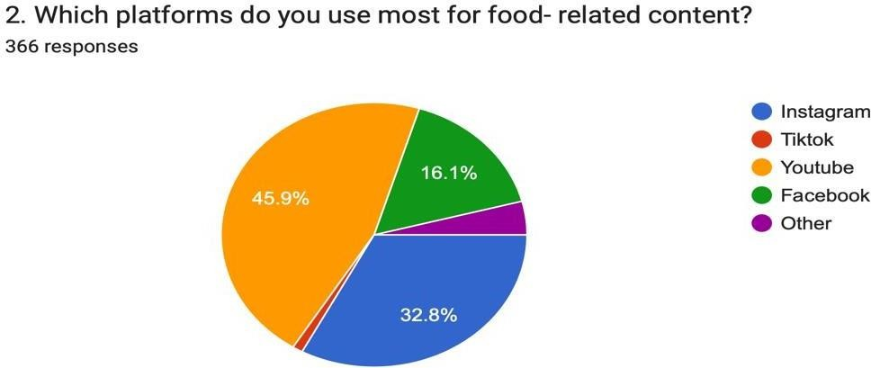

Figure 4.4.1 shows the number of participants' favorite social media platforms for food content access. The responses were obtained from a group of 366 participants, representing varied platform preferences based on age, exposure to content, and online behavior. YouTube appears as the most popular platform, accessed by 45.9% of respondents. This suggests that about half of the participants choose video-based, long-form, and visually appealing content for food- related information, recipes, and reviews. YouTube's rich audiovisual format and algorithm- driven recommendations are likely to make it a popular choice among both casual viewers and food connoisseurs.

Instagram is ranked second, with 32.8% of responses. This underscores Instagram's strong position as a visually appealing, trend-driven platform where short-form films (Reels) and well styled photographs have a significant impact on food discovery and consumption.

Facebook is the third most popular, with 16.1% of respondents declaring a preference. While its popularity has fallen when compared to Instagram and YouTube, it remains relevant, possibly due to recipe-sharing groups, community pages, and older demographic participation. Other platforms account for a small portion (around 3–4%), suggesting niche preferences such as Pinterest, blogs, or dedicated food forums.

The graph highlights the dominance of visual-content platforms (YouTube and Instagram) in driving users' exposure to food content. This is relevant in the context of the research, which aims to explore the effect of such content on food cravings, impulsivity, and choice behavior. The platforms that focus on engaging, visual content are more likely to activate emotional and psychological cues that drive cravings or impulse food consumption.

The findings indicate that video-centric and image-driven platforms dominate the consumption

of food-related content. YouTube's strong lead suggests that viewers value thorough, step-by- step culinary tutorials professional food reviews, and instructional content. Instagram's great performance contributes to the growing trend of rapid, visually appealing inspiration for food concepts, which is fueled by influencer culture. The comparatively low percentages for Facebook, TikTok, and other platforms imply that, while they contribute to the ecosystem, their functions are primarily supplemental. This distribution may be influenced by factors such as the target population's age, technological sophistication, and platform accessibility.

Figure 4.4.2 FOOD ENCOUNTERED THE MOST

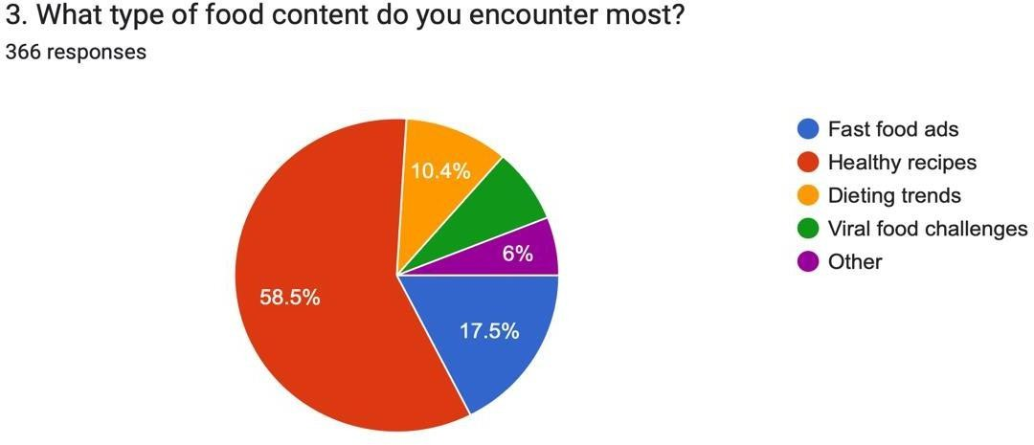

This pie chart shows the most common food-related content most seen by respondents on social media websites. The figures show the answers from 366 respondents, which give some information on the nature of food cues that dominate their online media usage. Healthy dishes took over the responses, contributing to 58.5%. This suggests that most respondents frequently encounter content about healthy cooking, meal preparation, and wellness-oriented eating behaviors. The high percentage reflects an increasing public emphasis on health awareness, diet quality, and preventative nutrition in online food media. Fast food advertising rank second at 17.5%, indicating that, despite the popularity of health-focused content, fast-food company marketing remains very visible in digital environments. This is consistent with the advertising strategy of big fast-food chains, who invest greatly in social media actions.

Healthy dishes took over the responses, accounting for 58.5%. This shows that most respondents are frequently exposed to content about healthy cooking, meal preparation, and wellness-oriented eating habits. The high percentage indicates the growing public emphasis on health awareness, diet quality, and preventative nutrition in online food media. Fast food advertising ranks second at 17.5%, demonstrating that, despite the popularity of health-related material, fast-food firm

marketing is still quite visible in digital settings. This is consistent with the advertising strategy of large fast-food businesses, who invest extensively in social media campaigns.

Other types of content also comprise 6%, indicating a niche variety of food-related topics that do not fit into the given categories, possibly including gourmet cooking, food history, cultural food traditions, or sustainable eating discussions. The findings show that the audience prioritizes health-focused food content, reflecting the growing global awareness of nutrition, fitness, and illness prevention. The popularity of healthy recipes over dieting trends suggests that people choose long-term, healthy eating over restrictive or fad-based approaches. Fast food commercials continue to occupy a significant share, demonstrating the persistent marketing dominance of convenience-driven food companies. The modest proportion of viral food challenges and other material demonstrates that, while novelty and joy exist in the food media landscape, they do not dominate user engagement.

Figure 4.4.3 FOOD PURCHASED IMPULSIVELY DUE TO SOCIAL MEDIA

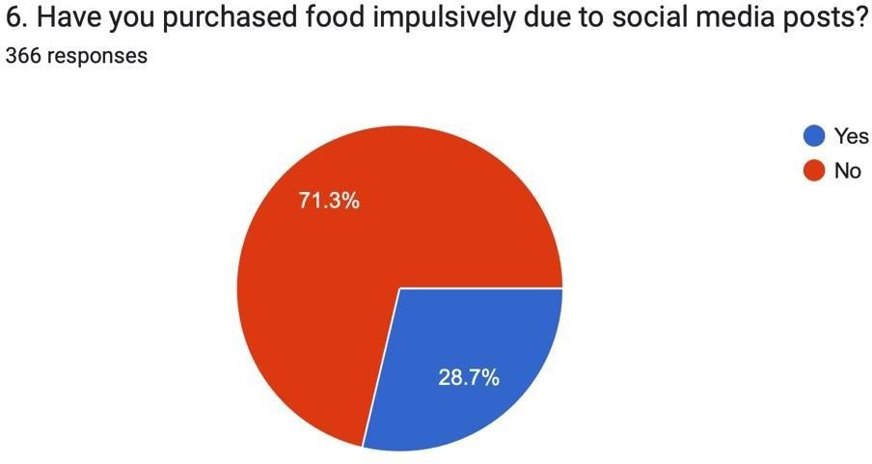

This graph looks at whether social media affects consumers to make spontaneous food buys, an important measure of behavioral reaction to online stimuli. The figures are based on 366 participants. ‘No’ replies dominated, with 71.3% of participants stating that they did not buy food impulsively as a result of social media influence. This majority implies that, while social media is an effective tool for food promotion, a significant portion of the audience makes deliberate decisions and rejects spontaneous purchasing behaviors prompted by online material. ‘Yes’, responses account for 28.7%, implying that more than one in every four respondents made unplanned food purchases as a direct result of social media exposure. This demonstrates the ability to persuade of appealing food pictures, influencer endorsements, and tailored marketing in shaping customer behavior. The findings indicate that, while impulsive buying behavior affected by

social media exists and is apparent it does not affect the vast majority of consumers in this sample. This is consistent with the idea that food shopping decisions are frequently impacted by a combination of factors such as personal budget, health awareness, and convenience, rather than just internet exposure. However, the 28.7% who acknowledged to making impulsive purchases represent an important market group that businesses may reach with engaging, trend- based, and emotion-driven campaign

Figure 4.4.4 FOOD PREFERENCE CHANGE

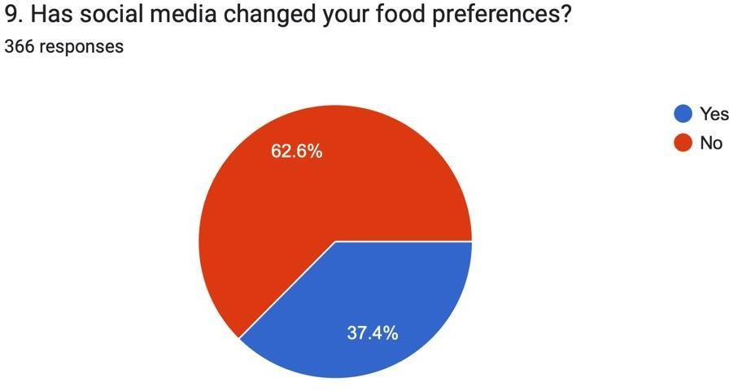

The majority of respondents (62.6%) said that social media had not changed their eating preferences. This shows that most people's food choices are still driven by cultural traditions, family customs, and personal preferences, rather than by online trends. In contrast, 37.4% of individuals individuals said social media influenced their dietary choices. For this population, exposure to digital content such as cooking videos, recipe demonstrations, influencer recommendations, and visually appealing food photography tends to alter eating habits. These influences may result in experimenting with new cuisines, accepting specific dietary trends (e.g., plant- based, keto), or picking foods for their visual presentation, as seen on sites like Instagram, TikTok and YouTube.

Table 4.5 SOCIAL MEDIA CLASSIFICATION

 | Frequency | Percent
Low PSI | 66 | 18.0
Medium Isolation | 244 | 66.7
High Isolation | 51 | 13.9
Total | 361 | 98.6

Interpretation
Low PSI (Perceived Social Influence): Participants in this group said social media food content had little effect on them (18.0%). After being exposed such content, they hardly ever notice

changes in their eating habits, emotional reactions, or cravings. They typically engage with postings about food more as observers than as responders. The majority of respondents (66.7%) fall into the category of medium isolation, which indicates a moderate degree of influence from food-related social media information. While they do not describe these effects as often or overwhelming, they may occasionally feel emotional reactions or cravings after exploring posts. High Isolation (13.9%): Individuals in this group react more strongly, either emotionally or behaviorally, to social media posts about food. They are more prone to compare, get prompted by engagement indicators like likes or comments, or have increased desires. This could suggest a greater vulnerability to emotionally motivated eating and social comparison. The majority of participants (about 80.6%) fit into the medium or high isolation categories overall, according to the results, indicating that a significant portion of the sample is psychologically influenced by food-related social media content to some extent.

Table 4.6 FOOD CRAVING CLASSIFICATION

 | Frequency | Percent
Low | 34 | 9.3
Medium | 224 | 61.2
High | 108 | 29.5
Total | 366 | 100.0

The findings indicate that the majority of participants (61.2%) have mild yet regular food cravings. A significant percentage (29.5%) reported severe food cravings, indicating a higher and more frequent desire to consume specific foods, which could be impacted by environmental factors such as social media exposure. Only a small minority (9.3%) expressed low desires, indicating a restricted vulnerability to such as social media exposure. Only a small minority (9.3%) expressed low desires, indicating a restricted vulnerability to such stimuli. Overall, these findings indicate that a significant 90.7% of respondents have medium to high food cravings, which may have implications for eating patterns, impulse control, and receptivity to external food signals. This trend underlines the potential impact of digital media, particularly food-related information, in maintaining or aggravating cravings, emphasizing the importance of addressing such influences in nutrition and behavioral treatments.

Table 4.7 IMPULSITY CLASSIFICATION

 | Mean | Std. Deviation
Premediation Score | 7.69 | 1.64867
Positive Urgency Score | 8.01 | 1.29791
Sensation seeking Score | 10.72 | 2.15700
Negative Urgency Score | 10.62 | 2.02178
Lack of Perseverance Score | 10.03 | 2.01882
Total Score | 47.07
The impulsivity scale was made up of 18 items evaluated on a 4-point Likert scale, resulting in a potential total score range from 18 to 72. The scale's theoretical midpoint is 45, indicating a level of impulsivity that is balanced. Scores higher than this midpoint suggest a stronger inclination towards impulsive behaviors, while scores lower indicate more measured and intentional behaviour tendencies.

In this sample, the average total impulsivity score was 47.09 SD = 4.15, which is just above the midpoint of the scale. This suggests that participants typically show a moderate degree of impulsivity, generally leaning toward more unrestrained actions, especially in emotionally intense or exciting situations. Nonetheless, the average score is near the threshold, indicating that although impulsive behaviors are apparent, they are not excessively pronounced.

The fairly low standard deviation also implies that there were individual variations in impulsivity, but they were not pronounced, indicating a fairly uniform sample concerning this characteristic. In general, these findings indicate a trend of moderately increased impulsivity marked by emotional reactivity and a desire for sensation, but not indicative of serious impulse control issues.

TABLE 4.8- MEAN OF FOOD CHOICE

 | Mean | Std.  Deviation
Food choice | 22.6913 | 16.23307

The total food choice score in this study was measured using a validated 18-item scale adapted from Alwafi et al. (2022), where participants indicated how frequently they experienced various food-related behaviors influenced by social media. The total possible score ranged

from 0 to 72, with a midpoint of 36. The mean score observed was 22.69, indicating a moderate but statistically significant level of influence. This was confirmed by the results of a one-sample t-test conducted on the sample.

SOCIAL MEDIA USUAGE AND ENGAGEMENT ON SOCIAL MEDIA CONTENT

Figure 4.9.1- Type of nutrition related content
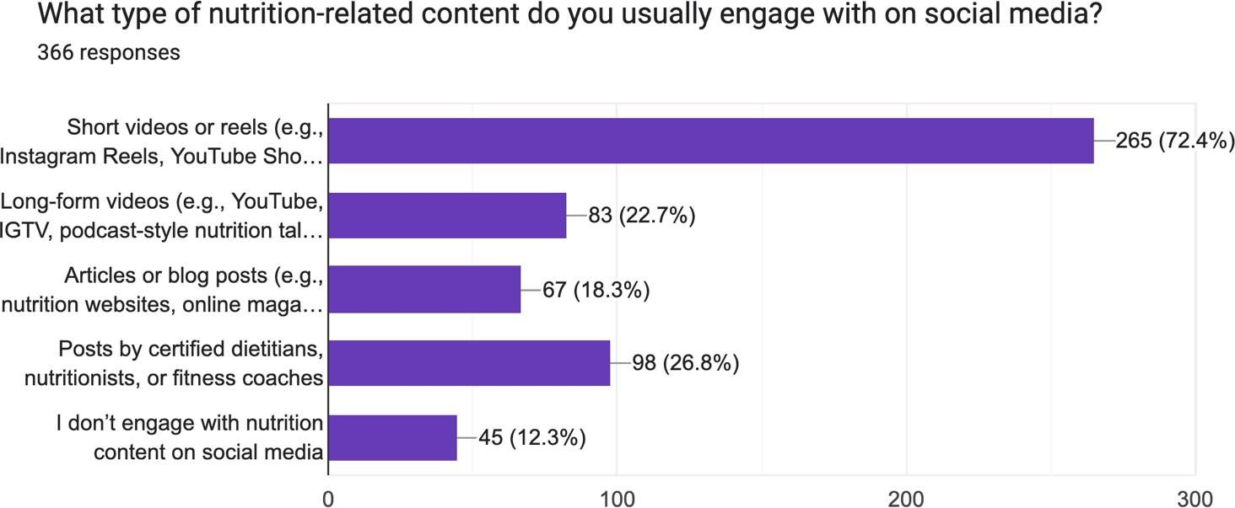

The majority of respondents (72.4%) reported engaging most frequently with short-form content such as Instagram Reels or YouTube Shorts. In contrast, fewer participants consumed long-form videos like YouTube or podcast-style nutrition talks (22.7%) or read nutrition-related articles and blogs 18.3%). A notable portion (26.8%) engaged with posts shared by certified dietitians, nutritionists, or fitness coaches, while 12.3% reported not engaging with nutrition content on social media at all. The preference for short form videos likely reflects their ability to deliver concise, visually appealing, and easily digestible information, making them more compatible with fast-paced scrolling behaviors. These formats are also strongly supported by social media algorithms, which prioritize quick, emotionally stimulating content—factors that may encourage impulsive engagement and influence unplanned dietary decisions (Coates et al. 2019).

Figure 4.9.2- TYPE OF SOCIAL MEDIA CONTENT INFLUENCES ON FOOD CHOICES

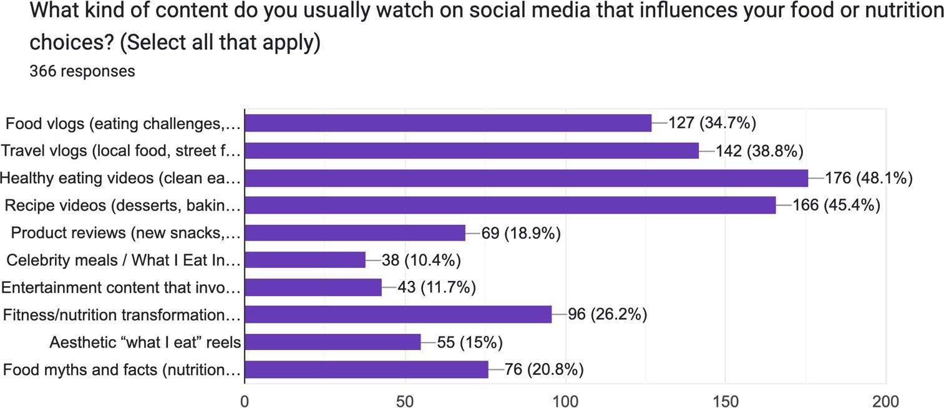

When asked what type of social media content most influenced their food or nutrition choices, the most common responses were healthy eating videos (48.1%) and recipe videos (45.4%), both of which highlight the strong pull of visually engaging, instructional formats. Travel vlogs featuring local food (38.8%) and food vlogs such as eating challenges (34.7%) also ranked high, suggesting that entertainment-driven and experiential content can shape dietary interests just as much as educational clips. Moderate influence was observed from fitness/nutrition transformation content (26.2%) and product reviews of new snacks or supplements (18.9%). In contrast, fewer participants reported influence from aesthetic “what I eat” reels (15%), food myths/facts (20.8%), celebrity meals (10.4%), or entertainment content involving food (11.7%).

This highlights that influential content is not limited to expert-driven or fact-based sources; visual appeal novelty, and emotional resonance play a crucial role. Food vlogs, travel meals, and recipe demonstrations trigger cravings and social modeling effects, often normalizing indulgent or trendy eating behaviors regardless of their nutritional value (Byrne et al., 2021).

Figure 4.9.3- MEDIUM OF SOCIAL MEDIA USED FOR NUTRITION RELATED CONTENT

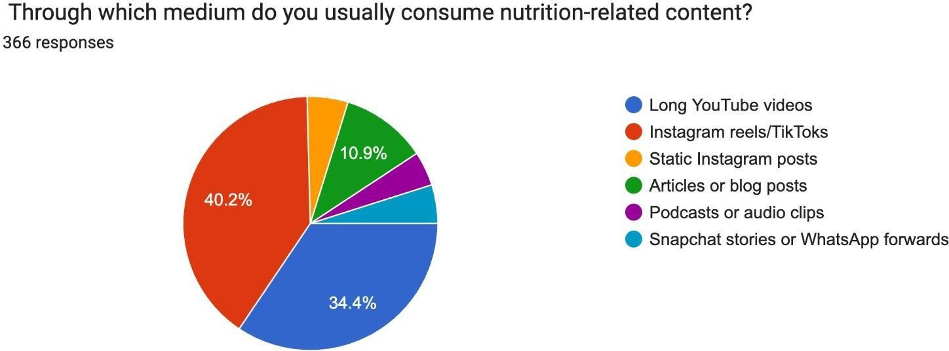

As shown in the pie chart, the largest proportion of participants (40.2%) consumed nutrition- related content through Instagram reels or TikToks, followed closely by long YouTube videos (34.4%). In contrast fewer respondents engaged with static Instagram posts (10.9%), articles or blogs (5.2%), podcasts/ audio clips (4.4%), or Snapchat/WhatsApp forwards (4.9%). This pattern highlights the dominance of short- form, visually dynamic platforms in shaping nutrition engagement. The preference for reels and TikToks reflects their ability to deliver fast, emotionally stimulating, and easily digestible content, which resonates strongly with impulsive browsing habits and short attention spans. While YouTube remains a secondary platform for more structured and detailed information, it is less aligned with spontaneous, craving-driven engagement compared to the instant gratification offered by quick-scroll media formats (Coates et al., 2019).

Figure 4.9.4- MAIN SOCIAL MEDIA SOURCE FOR NUTRITIONAL INFORMATION

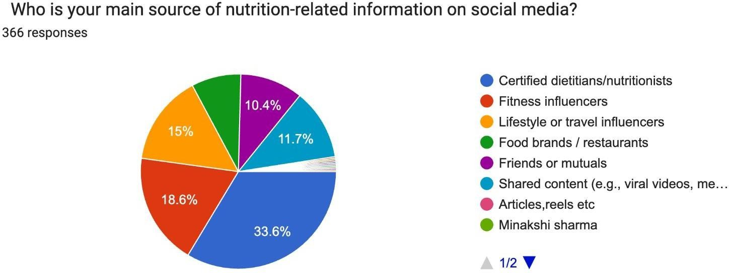

As shown in the pie chart, the majority of participants (33.6%) reported that their main source of nutrition-related information on social media was certified dietitians or nutritionists, reflecting the credibility and trust attributed to professional expertise. However, a substantial proportion rel- ied on fitness influencers 18.6%) and lifestyle or travel influencers (15%), thus indicating that non-expert sources also play a strong role in shaping nutrition perceptions. Smaller segments drew information from food brands/restaurants (10.4%), shared content such as viral videos (11.7%
), or friends/mutuals.

While professionals continue to serve as a trusted authority, the influence of non-expert figures hig- hlights the blurring of boundaries between evidence-based guidance and entertainment-driven content. Many participants may gravitate toward influencer-driven advice because of its relatability, emotional appeal, and aspirational lifestyle framing, despite the risk of misinformation or oversimpli- fied nutrition messages. This dual reliance underscores the tension between credibility and accessibil- ity in nutrition-related engagement on social media (Byrne et al., 2021).

LINEAR REGRESSION MODEL FOR FOOD CHOICE
The multiple linear regression model was developed to examine the influences of food craving score, food impulsivity score, and total social media usage on the food choice score. The regression coefficients, significance levels, and interpretations of the predictors are provided below:

Table 5.1- Linear regression model

Model |  | Unstandardized Coefficients |  | P value
Model |  | B | Std. Error | P value
(Constant) | 26.386 |  | 6.426 | .000
Total score-  Impulsivity | -.117 |  | .140 | .404
Total_socialmedia | -.839 |  | .380 | .028
Total Score- Food  craving scale | .243 |  | .069 | .000

The fitted regression model is of the form:

Food choice score =26.386+ {0.243× (Food craving score)} − {0.839× (Total social media usage)}

Interpretation of Coefficients:

B1= 0.243 indicates that for every 1 unit increase in the food craving score, the food choice score increases by 0.243 units on average, holding other variables constant. This suggests that stronger cravings are associated with a tendency towards certain food choices.

B2=−0.839 means that with every additional unit (e.g., hour) increase in total social media usage, the food choice score decreases by 0.839 units on average, after adjusting for other variables. This statistically significant negative relationship suggests that greater social media usage is linked to less favorable food choices.

The regression’s R-squared value is 0.039, meaning the included variables explain only about 4% of the variation in people’s food choice scores.

Chapter 5- DISCUSSION
The purpose of this study was to explore how social media engagement relates to food behaviors, specifically impulsivity, cravings, and food choice. Using a cross-sectional design with a large adult sample, the findings indicate that food cravings and social media usage play a stronger role in shaping eating behaviors than impulsivity.

Food Cravings and Food Choice
The regression analysis showed that cravings were consistently linked to food choice outcomes, suggesting that cravings are an immediate motivational factor influencing dietary decisions. This supports earlier work identifying cravings as a direct driver of consumption, particularly in response to appetitive cues (Meule, Lutz, Vögele, & Kübler, 2021). Social media platforms, with their constant stream of food-related images and short-form videos, may intensify this process by reinforcing emotional, cue-driven responses over deliberate decision-making (Filippone, Shankland, & Hallez, 2022).
The result that cravings heavily influence food choices matches previous studies. The finding that social media use is tied to poorer food options is also in line with recent research pointing to the disruptive influence of digital media on eating habits.

Impulsivity and Food Behavior
In contrast, impulsivity did not emerge as a significant predictor of food choice in the present study. This result differs from several experimental studies where impulsivity predicted overeating and poor food regulation (Georgii, Goldhofer, Meule, Richard, & Blechert, 2017; Meule & Kübler, 2014). A possible explanation is that impulsivity was assessed here as a stable personality trait, which may not fully capture moment-to-moment lapses in inhibitory control. Some studies have similarly found that the influence of impulsivity is attenuated when environmental nudges or structured choice settings are present, suggesting that context can overshadow dispositional tendencies (Marques, Ting, Cedillo-Martínez, & Pérez-Cueto, 2020).
The results of the current study align with prior research by Bano (2015), which also indicated that impulsivity was non-significant across various sociometric groups of secondary school girls. In Bano’s research, the insignificance was linked to the uniformity of the sample, since all subjects shared the same age, gender, and cultural background, which diminished variability in the expression of impulsivity. Moreover, the adolescent developmental phase, marked by overall increased yet evenly spread impulsive behaviors, probably played a role in the lack of group differences. In contrast, the current research focused on an adult group utilizing the multidimensional UPPS-P Impulsive Behavior Scale (Cyders et al., 2014), which evaluates different aspects of impulsivity including positive urgency, negative urgency, premeditation

deficits, perseverance deficits, and sensation seeking. Although this instrument has better psychometric properties than the Rai and Sharma 1988) scale utilized by Bano, impulsivity again did not appear as a significant predictor of behavioral outcomes, especially regarding food cravings and the impact of social media on eating habits. One possible explanation is that in adults, impulsivity functions less as a direct cause and more as a background vulnerability trait that interacts with situational and environmental factors. Cultural dietary habits, influence from persuasive media, and personal coping techniques might have a greater impact on eating behaviors than just baseline impulsivity scores. Additionally, the current results indicate that the intricacy of adult behavior outcomes cannot be solely attributed to trait-level impulsivity but should instead be viewed through a multifaceted perspective that encompasses psychosocial, environmental, and personality-driven factors. Both studies indicate that impulsivity, though theoretically significant, may not always act as a main factor in behavior; rather, its impact seems to be influenced by the developmental stage in adolescents and by wider psychosocial environments in adults. This gathering of evidence suggests that impulsivity might be more aptly understood as a moderator or mediator in behavioral models instead of a direct predictor, thus necessitating more refined research designs in the future.

The Role of Social Media in Eating Behaviors
Interestingly, greater social media usage was associated with poorer food choice scores. This finding aligns with research suggesting that extended exposure to digital platforms indirectly increases cravings through impulsivity and cue sensitivity (Filippone et al., 2022). Thus, while cravings appear to exert the most immediate influence on dietary decisions, the broader digital environment likely amplifies these tendencies and shapes the overall direction of eating behavior.
The study also highlights the double-edged role of social media. While many participants reported little behavioral change, others described adopting healthier practices or experimenting with trend-based routines. However, such changes were often inconsistent, reflecting how online platforms can simultaneously encourage dietary awareness and promote unsustainable behaviors.

Moreover, our study supports the notion that misinformation and conflicting health advice on social media confuse many users, which could be why some participants reported feeling motivated but unsure or unable to take action. As previous literature highlights, nutrition content shared online is often not regulated.

Strengths of the Study and Limitations
Strengths of this study include the relatively large and diverse sample, validated measurement tools, and ecological recruitment via social media itself. Nonetheless, limitations remain: the cross-sectional design prevents causal inferences, self-reports may have introduced bias, and the global measure of social media use did not distinguish between platform-specific or content-

specific effects. Further, impulsivity was only examined at a trait level, leaving situational inhibitory control unaddressed.

Future Directions

Future research should use longitudinal and experimental designs to clarify how specific social media content influences cravings and food choices over time. Examining moderators such as gender, age, and BMI may also be valuable, as earlier studies suggest differential vulnerability to digital cues (Meule et al., 2021). Finally, interventions focused on craving regulation and digital literacy may help individuals resist misleading content and make healthier, sustainable choices.
To enrich the quantitative findings, participants were asked a simple yet powerful open-ended question:
"Have you ever changed your food habits based on what you saw on social media? If yes, what did you adapt?"
Out of 366 participants, around 69% responded with “No” or “Not really”, showing resistance to online influence. However, some did report real lifestyle changes, including:

Health-driven adaptations: switching to millet, chia water, so up, infused hydration, and sugar substitutes like monk fruit, eating less grains, eating green vegetables, Intermittent Fasting, trying to avoid food/snacks that have palm oil in them, started cutting down on sugar and white salt.

Trend-based experiments: trying viral salad bowls, hummus, fermented drinks, or fasting techniques, started liking matcha, switched from sugary breakfast cereals to overnight oats with fruits and nuts, adding chia seeds, mint leaves, or sliced citrus fruits like lemon or orange to my water to make it more refreshing
Mindful shifts: increased awareness about portion size, skipping processed food, or consulting online dietitians, decreasing fried and adopting steamed food, healthy cooking styles, increased protein and fibre in diet, stopped eating packaged food and juices.
Motivated behavior: many admitted being inspired but couldn’t consistently implement the changes due to their lifestyle or routine.

CONCLUSION
This study demonstrated that food cravings and social media usage significantly shaped food choice, while impulsivity did not independently predict dietary outcomes. Stronger cravings were associated with greater alignment between desires and food choices, whereas heavier social media use was linked to less favorable eating patterns.
The qualitative findings highlighted the dual role of social media: for some, it fostered healthier practices and dietary awareness, but for others, it encouraged trend-driven or inconsistent behaviors. This reflects the complex and sometimes contradictory influence of digital platforms.
Overall, the findings underscore the importance of addressing both cravings and digital exposure in shaping modern eating habits. Reducing the negative influence of excessive social media use, while leveraging its ability to disseminate credible nutrition information, may help promote healthier, long-term eating behaviors.

36

REFERENCES
Cyders, M. A., Littlefield, A. K., Coffey, S., & Karyadi, K. A. (2014). Examination of a short English version of the UPPS-P Impulsive Behavior Scale. Addictive Behaviors, 39(9), 1372– 1376.

Primack, B. A., Shensa, A., Sidani, J. E., Whaite, E. O., Lin, L. Y., Rosen, D., ... & Miller, E. (2017). Social media use and perceived social isolation among young adults in the US. American journal of preventive medicine, 53(1), 1-8.

Vaterlaus, J. M., Patten, E. V., Roche, C., & Young, J. A. (2015). #Gettinghealthy: The perceived influence of social media on young adult health behaviors. Computers in Human Behavior, 45, 151-157.

Cyders, M. A., Littlefield, A. K., Coffey, S., & Karyadi, K. A. (2014). Examination of a short English version of the UPPS-P Impulsive Behavior Scale. Addictive behaviors, 39(9), 1372- 1376.

Liao, C., Tan, Y., Muniz, K., & Laudadio, T. (2016). Ethnic restaurant consumption experience: A cross-national virtual survey. Journal of Foodservice Business Research, 19(5), 554-572.

Mkono, M., Markwell, K., & Wilson, E. (2013). Interpreting the postcolonial: Challenges for developing country ethnic restaurant experiences. Tourism Analysis, 18(6), 687-701.

Zhu, D. H., Chang, Y. P., & Luo, J. J. (2018). Understanding the influence of cross-platform participants' social links: A perspective from social motivators. International Journal of Information Management, 39, 80-93.

Cepeda-Benito, A., Gleaves, D. H., Williams, T. L., & Erath, S. A. (2000). The development and validation of the state and trait food-cravings questionnaires. Behavior Therapy, 31(1), 151-173.

Hormes, J. M. (2016). Under the influence of Facebook? Excess use of social networking sites and drinking motives, consequences, and attitudes in college students. Journal of Behavioral Addictions, 5(1), 122–129.

Meule, A., & Kübler, A. (2012). Food cravings in food addiction: The distinct role of positive reinforcement. Eating Behaviors, 13(3), 252–255.

Turner, P. G., & Lefevre, C. E. (2017). Instagram use is linked to increased symptoms of orthorexia nervosa. Eating and Weight Disorders - Studies on Anorexia, Bulimia and Obesity, 22(2), 277–284.

Boelsen-Robinson, T., Backholer, K., & Peeters, A. (2016). Digital marketing of unhealthy foods to children: A critical review of the literature. Obesity Reviews, 17(8), 760–770.

Holmberg, C., Chaplin, J. E., Hillman, T., & Berg, C. (2016). Adolescents’ presentation of food in social media: An explorative study. Appetite, 99, 121–129.

Cheng, C., Lau, Y. C., & Chan, L. (2021). The global prevalence of social media addiction among university students: A systematic review and meta‐analysis. Journal of Behavioral Addictions, 10(3), 689–709.
Huang, Q., Wang, Y., Tang, S., & Yu, C. (2022). Prevalence of social media addiction across 32 nations: Meta-analysis with subgroup analysis of classification schemes and cultural values. Addictive Behaviors, 129, 107266.
Brewer, J. A., & Potenza, M. N. (2008). The neurobiology and genetics of impulse control disorders: Relationships to drug addictions. Biochemical Pharmacology, 75(1), 63–75.
Lewin, K. M., Kaur, A., & Meshi, D. (2023). Problematic social media use and impulsivity. Current Addiction Reports, 10, 553–562.
Guo, Z., Liang, S., Ren, L., Yang, T., Qiu, R., He, Y., & Zhu, X. (2022). Applying network analysis to understand the relationships between impulsivity and social media addiction and between impulsivity and problematic smartphone use. Frontiers in Psychiatry, 13, 993328. Impulsiveness as potential moderators of the relation between social media dependence and eating disorders risk. BMC Psychology, 10, 120.

Weingarten, H. P., & Elston, D. (1990). The psychology of food cravings: The role of food deprivation. Appetite, 15(2), 115–126.
Hermans, R. C. J., Larsen, J. K., Lochbuehler, K., Nederkoorn, C., Herman, C. P., & Engels,
R. C. M. E. (2013). The power of social influence over food intake: Examining the effects of attentional bias and impulsivity. British Journal of Nutrition, 109(3), 572–580.

Nederkoorn, C., Guerrieri, R., Havermans, R. C., Roefs, A., & Jansen, A. (2009). The interactive effect of hunger and impulsivity on food intake and purchase in a virtual supermarket. International Journal of Obesity, 33, 905–912.

Shepherd, R. (2005). Influence of personal values on food choice. Appetite, 44(3), 243–245. Arshad, F., Gillani, S. A., Qureshiee, M. A., Abbasi, P. N., & Maqbool, F. (2025).

Associations between social media usage and disordered eating: Mediated by body image concerns and moderated by impulsivity. Journal for Social Science Archives, 3(1), 347–362.
Tan, Y. L., Pereira, D. J., & Yusoff, H. (2024). Exploring Influence of Food-Related Social Media Content on Eating Habits of Undergraduate Students. Malaysian Journal of Medicine and Health Sciences, 20(2), 51–61.
Ataguba, G., Kalu, I., Chan, G., & Orji, R. (2025). Food mukbang on social media: Towards an AI-driven persuasive interventions for living healthy on social media, AI & Society.

Wang, C.-H. A., Sher, S. T.-H., & Chung, C.-F. (2024). From Viral Content to Real-Life Cuisine and Beyond: Examining Teenagers’ Interactions with TikTok Food Videos and the Influence on Their Food Practices. Proceedings of the ACM on Human-Computer Interaction, 8(CSCW2), Article 389.
Eunissen, L. (2024). From Food Media Entertainment to Food Literacy Education: An Investigation into Food Media Content, Food Media Exposure, and Food Literacy Among Emerging Adults.

Meng, S., Dong, Y., Dai, B., Zheng, Y., & Zhong, Y. (2022). Global prevalence of digital addiction in general population: A systematic review and meta-analysis. Clinical Psychology Review, 92, 102114.

Lafontaine, J., Hanson, I., & Wild, C. (2025). The impact of the social media industry as a commercial determinant of health on the digital food environment for children and adolescents: A scoping review.

Jeong, H., & Shin, K. (2022). How does adolescents’ usage of social media affect their dietary satisfaction? International Journal of Environmental Research and Public Health, 19(6), 3621.

Lafontaine, J., Hanson, I., & Wild, C. (2025). The impact of the social media industry as a commercial determinant of health on the digital food environment for children and adolescents: A scoping review. BMJ Global Health, 10(2), https://doi.org/10.1136/bmjgh- 2023-014667
Alwafi, H., Alwafi, R., Naser, A. Y., Samannodi, M., Aboraya, D., Salawati, E., Alqurashi, A., Ekram, R., Alzahrani, A. R., Aldhahir, A. M., Assaggaf, H., & Almatrafi, M. (2022). The

impact of social media influencers on food consumption in Saudi Arabia, a Cross-Sectional Web-Based survey. Journal of Multidisciplinary Healthcare, Volume 15, 2129–2139.

Brony, M., Alivi, M. A., Syed, M. a. M., Dharejo, N., & Jiaqing, X. (2024). A systematic review on social media utilization by health communicators in India: Insights from COVID- 19
Chopra, A., Avhad, V., & Jaju, A. S. (2020). Influencer Marketing: An exploratory study to identify antecedents of consumer behavior of millennial. Business Perspectives and Research, 9(1), 77–91.

Nadanyiova, M., Gajanova, L., Majerova, J., & Lizbetinova, L. (2020). Influencer marketing and its impact on consumer lifestyles. Forum Scientiae Oeconomia, 8(2), 109–120.

Pelchat, M. L. (2002). Food cravings in young and elderly adults. Appetite, 38(2), 103-113.

Macht, M. (2008). How emotions affect eating: A five-way model. Appetite, 50(1), 1-11.

Turner, P. G., & Lefevre, C. E. (2017). Instagram Use Is Linked to Increased Symptoms of Orthorexia Nervosa. Eating and Weight Disorders, 22(2), 277-284.

Chassiakos, Y. L. R., et al. (2016). Children and adolescents and digital media. Pediatrics, 138(5).

Boswell, R. G., Sun, W., Suzuki, S., & Kober, H. (2018). Training in cognitive strategies reduces eating and improves food choice. Proceedings of the National Academy of Sciences, 115(48), E11238–E11247.

Georgii, C., Goldhofer, P., Meule, A., Richard, A., & Blechert, J. (2017). Food craving, food choice and consumption: The role of impulsivity and sham-controlled tDCS stimulation of the right dlPFC. Physiology & Behavior, 177, 20–26.

Leng, G., Adan, R. A. H., Belot, M., Brunstrom, J. M., de Graaf, K., Dickson, S. L., Hare, T.,
Maier, S., Menzies, J., Preissl, H., Reisch, L. A., Rogers, P. J., & Smeets, P. A. M. (2017). The determinants of food choice. Proceedings of the Nutrition Society, 76(3), 316–327.

Chung, A., Vieira, D., Donley, T., Tan, N., Jean-Louis, G., Gouley, K. K., & Seixas, A. (2021). Adolescent peer influence on eating behaviors via social media: Scoping review. Journal of Medical Internet Research, 23(6), e19697.

Hoogstins, E. S. (2017). Modelling on social media: Influencing young adults’ food choices (Master’s thesis, Lund University).

Kucharczuk, A. J., Oliver, T. L., & Dowdell, E. B. (2022). Social media’s influence on adolescents’ food choices: A mixed studies systematic literature review. Appetite, 168, 105765.

Simeone, M., & Scarpato, D. (2020). Sustainable consumption: How does social media affect food choices? Journal of Cleaner Production, 277, 124036.

Meule, A., Lutz, A., Vögele, C., & Kübler, A. (2021). Food cravings discriminate differentially between successful and unsuccessful dieters and non-dieters. Appetite, 164, 105257.

Marques, I. C. F., Ting, M., Cedillo-Martínez, D., & Pérez-Cueto, F. J. A. (2020). Effect of impulsivity traits on food choice within a nudging intervention. Nutrients, 12(5), 1402.

Filippone, L., Shankland, R., & Hallez, Q. (2022). The relationships between social media exposure, food craving, cognitive impulsivity and cognitive restraint. Journal of Eating Disorders, 10, 184.

Bano, S. (2015). Impulsiveness of different sociometric groups among secondary school students. The International Journal of Indian Psychology, 2(4), 121–130.

Rai, S. N., & Sharma, A. (1988). Impulsiveness Scale. Agra: National Psychological Corporation.

Annexure

ANNEXURE I

PARTCIPANT INFORMATION SHEET
(For questionnaire only studies through online survey platforms)

Protocol title: The relationship between Social Media and Food Behaviours- Impulsivity, Craving and Choice.
Principal Investigator: Nistha Agarwal
Designation: Student
Contact number: 8337022993

Please read this information carefully. If you decide to volunteer to take part in this study you must click on the I agree button below.

This study assesses how social media usage influences food behaviour in adults. A validated questionnaire will be given to you to assess your food impulsivity, craving and choice.

People who are between the age of 18-75 years, using at least one social media platform daily and spending a minimum of 5–6 hours per week on social media are eligible to participate in this study.

The time required to answer these questions is approximately 7 minutes.

Entering a research study is voluntary. You may decline participation without giving any reason. Your participation in this research will not bestow upon you any competitive academic/ occupational/ social/ legal advantage over others who do not volunteer, and we will not impose any academic/ occupational/social/legal penalty on those who do not volunteer

If you have any questions about this form or any study related issue, you may contact the Principal Investigator as above.

-----------------------------------------Consent to Participate-----------------------------------------

Protocol title: The relationship between Social Media and Food Behaviours- Impulsivity, Craving and Choice.
I understand that my participation in this questionnaire-based study is voluntary, and I can decline

participation without giving any reason. I have been given sufficient time to review the information and have sought the required clarification. I understand that I am allowed to take a screenshot of the form for my reference
Name of the research participant:

By clicking on the “I Agree” button, I consent to be a part of the study.

→ Next to Questionnaire Page.
I Agree

ANNEXURE II

Questionnaire

Title- The relationship between Social Media and Food Behaviours- Impulsivity, Craving and Choice.
Demographic Information-

Name-
Age (in years)- Gender-
- Male
- Female
Ethnicity-
- Hindu
- Christian
- Muslim
- Sikh
- Jain
- Other
Education Level-
- Profession or honours
- Graduate
- Intermediate or diploma
- High school certificate
- Middle school certificate
- Primary school certificate

Occupation-
- Legislators, senior officials and managers
- Professionals
- Technicians and associate professionals
- Clerks
- Skilled workers and shop and market sales workers
- Unemployed
Monthly Family Income Level (Rs.)
- <=10,702
- 10,703-31,977
- 31,978- 53,360
- 53,361-80,109
- 80,110-1,06,849
- 1,06,850-2,13,813
- >=2,13,814
Social Media Usage
Answer the following questions with respect to use of social media in the past 4 weeks.
- How many hours per day do you spend social media platforms?
  - <1 hour
  - 1–3 hours
  - 3–5 hours
  - >5 hours

- Which platforms do you use most for food-related content?
  - Instagram
  - TikTok
  - YouTube
  - Facebook
  - others (specify)

- What type of food content do you encounter most?
  - Fast food ads
  - Healthy recipes
  - Dieting trends
  - Viral food challenges
  - Others (specify)

- Do "likes" on food posts increase your interest in trying the food?

  - Strongly agree
  - Agree
  - Neutral
  - Disagree
  - Strongly disagree

- After seeing food content, how often do you feel an immediate urge to eat?
  - Always
  - Often
  - Sometimes
  - Never

- Have you purchased food impulsively due to social media posts?
  - Yes
  - No

- Do food influencers affect your cravings?
  - Strongly agree
  - Agree
  - Neutral
  - Disagree
  - Strongly disagree

- Do you compare your eating habits to others’ food posts?
  - Frequently
  - Occasionally
  - Rarely
  - Never

- Has social media changed your food preferences?
  - Yes
  - No

Food Impulsity
Answer the following questions with respect to use of social media in the past 4 weeks. All items are to be rated on a five point liker agreement scale from 1 (strongly agree) to 4 (strongly disagree). 1- strongly agree, 2- agree, 3- disagree, 4- strongly disagree.

Food Impulsivity Scale:

- I sometime like doing things that are a bit frightening.
- When I am upset I often act without thinking.
- I generally like to see things through to the end.
- My thinking is usually careful and purposeful.
- In the heat of an argument, I will often say things that I later regret.
- I finish what I start.
- I quite enjoy taking risks.
- When overjoyed, I feel like I can't stop myself from going overboard.
- Once I start a project, I almost always finish it.
- I often make matters worse because I act without thinking when I am upset.
- I usually make up my mind through careful reasoning.
- I generally seek new and exciting experiences and activities.
- I tend to act without thinking when I am really excited.
- I am a productive person who always gets the job done.
- When I feel rejected, i will often say things that I later regret.
- I welcome new and exciting experiences and sensations, even if they are a little frightening and unconventional.
- Before making up my mind, I consider all the advantages and disadvantages.
- When I am very happy, I feel like it is OK to give into cravings or overindulge.

Food Cravings

Answer the following questions with respect to use of social media in the past 4 weeks. All items are to be rated on a Likert type 5 point scale from 1- (strongly agree) to 5 (strongly disagree). 1- strongly agree , 2- agree , 3- neutral, 4- disagree , 5- strongly disagree.

Food Cravings:

- When I crave something, I know I won’t be able to stop eating once I start.
- If I eat what I am craving, I often lose control and eat too much.
- Food cravings invariably make me think of ways to get what I want to eat.
- I feel like I have food on my mind all the time.
- I find myself preoccupied with food.
- Whenever I have cravings, I find myself making plans to eat.
- I crave foods when I feel bored, angry, or sad.
- I have no will power to resist my food crave.
- Once I start eating, I have trouble stopping.
- I can’t stop thinking about eating no matter how hard I try.
- If I give in to a food craving, all control is lost.
- Whenever I have a food craving, I keep on thinking about eating until I eat the food.

- If I am craving something, thoughts of eating it consume me.
- My emotions often make me want to eat.
- It is hard for me to resist the temptation to eat appetizing foods that are in my reach.

Impact of Social Media Towards Eating Choice

Answer the following questions with respect to use of social media in the past 4 weeks. All items are to be rated on a Likert type 5-point scale from 1(Never) to 5 (Always). 1- Never
, 2- Rarely, 3- Sometimes, 4- Often, 5- Always.

Food choice
- How likely are you to try a diet promoted by a social media influencer?
- How likely are you to recommend a diet that a social media influencer promotes to friends and/or acquaintances?
- Did you buy a food product that was promoted by a social media influencer/celebrity?
- When I use social media, I forget that I am hungry.
- I consume any food on social media even if it is not my eating habit.
- Even though I do not feel hungry, I eat food/plate of foods I watch on social media.
- When I see food/dish/nutrition content on social media, I read the entirety of the story.
- I think the foods shared on social media are more beneficial for health.
- When I see a dish on social media, I search for the recipe and its content.
- After I started using social media, my consumption of fast food increased.
- I follow nutrition-related content, blogs, and posts on social media.
- I eat/cook/buy the foods I watch on social media effortlessly.
- I organize my diet according to the photos/videos of foods I see on social media.
- I constantly snack when browsing social media and realize how much I ate later.
- I care about the foods/dishes that celebrities share on social media, and I consume them.
- I think the foods/dishes that get more likes/shares on social media are healthier.
- Foods/Dishes I see on social media make me want to eat more.
- On the days when I use social media for a long time, my desire to eat increases and I eat more.
- What type of nutrition-related content do you usually engage with on social media?
  - Short videos or reels (e.g., Instagram Reels, YouTube Shorts)

  - Long-form videos (e.g., YouTube, IGTV, podcast-style nutrition talks)
  - Articles or blog posts (e.g., nutrition websites, online magazines)
  - Posts by certified dietitians, nutritionists, or fitness coaches
  - I don’t engage with nutrition content on social media

- What kind of content do you usually watch on social media that influences your food or nutrition choices? (Select all that apply)
  - Food vlogs (eating challenges, mukbang, etc.)
  - Travel vlogs (local food, street food)
  - Healthy eating videos (clean eating, weight loss diets)
  - Recipe videos (desserts, baking, 2-minute snacks)
  - Product reviews (new snacks, supplements, diet products)
  - Celebrity meals / What I Eat in A Day videos
  - Entertainment content that involves food (funny skits, food dares)
  - Fitness/nutrition transformation journeys
  - Aesthetic “what I eat” reels
  - Food myths and facts (nutrition education posts)
- Through which medium do you usually consume nutrition-related content?
  - Long YouTube videos
  - Instagram reels/TikToks
  - Static Instagram posts
  - Articles or blog posts
  - Podcasts or audio clips
  - Snapchat stories or WhatsApp forwards
- Who is your main source of nutrition-related information on social media?
  - Certified dietitians/nutritionists
  - Fitness influencers
  - Lifestyle or travel influencers
  - Food brands / restaurants
  - Friends or mutuals
  - Shared content (e.g., viral videos, meme pages)
- Have you ever changed your food habits based on what you saw on social media? If yes, what you adapted?

ANNEXURE III

Kuppaswamy Socioeconomic Status (SES) Scale: Scoring:
S. No. | Education of the Head | Score
1 | Profession or honours | 7
2 | Graduate | 6
3 | Intermediate or diploma | 5
4 | High school certificate | 4
5 | Middle school certificate | 3
6 | Primary school certificate | 2
7 | Illiterate | 1

Occupation of the Head:

S. No. | Occupation of the Head | Score
1 | Legislators, senior officials  and managers | 10
2 | Professionals | 9
3 | Technicians and associate  professionals | 8
4 | Clerks | 7
5 | Skilled workers and shop and  market sales workers | 6
6 | Unemployed | 5
7 | Craft and related trade  workers | 4
8 | Plant and machine operators  and assemblers | 3
9 | Elementary occupation | 2
10 | Unemployed | 1

Family Monthly Income:

S. No. | Updated Monthly Family Income in Rupees (2012) | Updated Monthly Family Income in Rupees  (2016) | Updated Monthly Family Income in Rupees (2024) | Score

1 | 30,375 and above | 51,646 and  above | 2,13,814 and  above | 12
2 | 15,188 – 30,374 | 25,811 -  51,645 | 1,06,850 –  2,13,813 | 10
3 | 11,362 – 15,187 | 19,351 –  25,809 | 80,110 –  1,06,849 | 6
4 | 7,594 – 11,361 | 12,890 –  19,350 | 53,361 – 80,109 | 4
5 | 4,556 – 7,593 | 7,725 – 12,889 | 31,978 – 53,360 | 3
6 | 1,521 – 4,555 | 2,586 – 7,724 | 10,703 – 31,977 | 2
7 | ≤1,520 | ≤2,585 | <10,702 | 1

ANNEXURE IV

Perceived Interpersonal Solidarity (PIS)

1. Scoring Pattern (in SPSS terms):
For Perceived Social Isolation (PSI):

Each of the 4 PROMIS items was scored 1 to 5 (Never to Always). Sum the 4 item scores → Total PSI Score (Range: 4 to 20).
In SPSS, you would use:
- Compute Total_PSI = Q1 + Q2 + Q3 + Q4.
Because the raw PSI scores were non-normally distributed, they collapsed the total PSI scores into three categories (tertiles):
4–6 = Low PSI
7–10 = Medium PSI 11– 20 = High PSI
In SPSS, this would typically be done with:
- Recode Total_PSI into Low/Medium/High categories.
(Example using RECODE command or Transform ➔ Recode into Different Variables.) For Social Media Use (SMU):

Two variables:
Time spent per day on social media (in minutes).
Frequency of social media site visits per week (weighted average across platforms). They divided both Time and Frequency into quartiles:
Time Quartiles:

1st: 0–30 min
2nd: 31–60 min
3rd: 61–120 min
4th: 121 min and above Frequency Quartiles:
1st: <9 visits/week
2nd: 9–30 visits/week
3rd: 31–57 visits/week
4th: 58+ visits/week
Again, in SPSS, you would use: ➔ Visual Binning tool (Analyze ➔ Descriptive Statistics ➔
Visual Binning)
- or use Recode into Different Variables manually based on cut points.

ANNEXURE V

Short UPPS-P Impulsive Behavior Scale (SUPPS-P)

The present study utilized the Short UPPS-P Impulsive Behavior Scale (SUPPS-P) to assess multidimensional aspects of impulsivity. The SUPPS-P evaluates five distinct traits: Negative Urgency (the tendency to act impulsively under negative emotions), Positive Urgency (impulsivity under positive emotions), Lack of Premeditation (acting without forethought), Lack of Perseverance (difficulty sustaining attention on tasks), and Sensation Seeking (the pursuit of novel and thrilling experiences). Each construct is measured using four items rated on a 4-point Likert scale, ranging from 1 (Strongly Agree) to 4 (Strongly Disagree). Specific items require reverse scoring to ensure accurate interpretation. Subscale scores are obtained by averaging the relevant items after appropriate reverse coding. Higher subscale scores indicate greater impulsivity within the respective domain. The SUPPS-P is recognized for its robust psychometric properties and offers a comprehensive evaluation of impulsive tendencies across emotional and behavioral contexts.

ANNEXURE VI

Food Cravings Questionnaire—Trait

The Food Cravings Questionnaire—Trait—Reduced (FCQ-T-r) is a 15-item self-report scale designed to assess general trait-like experiences of food cravings. It is a shortened version of the original 39-item FCQ-T and focuses on core dimensions such as lack of control overeating, preoccupation with food, intentions to consume food, emotional triggers, and cue-elicited cravings. Items are rated on a 5-point Likert scale ranging from 1 (“Never”) to 5 (“Always”). Scoring involves summing the responses across all 15 items to generate a total score, with

higher scores indicating greater trait-level food craving. No items require reverse scoring. The FCQ-T-r has demonstrated a one-factor structure with excellent internal consistency (Cronbach’s α ≈ 0.94). Interpretation of the results suggests that individuals with higher FCQ- T-r scores are more susceptible to intense and frequent food cravings, which are associated with higher body mass index (BMI), lower perceived dieting success, and greater eating disorder psychopathology. Thus, the FCQ-T-r serves as a reliable and efficient tool for evaluating habitual experiences of food cravings in both clinical and non-clinical populations.

