Chapter 4. Characterizing the Role of mpeR in the Transcriptional Response of
N. gonorrhoeae to Iron Depletion

In Chapter 3, we used gene co-expression network (GCN) analysis to identify putative target genes of N. gonorrhoeae transcriptional regulators and to gain insight into their complex biological functions. This analysis highlights mpeR as a key regulator coordinating the bacterium’s response to iron depletion and oxidative stress. In Chapter 4, we build on these findings by directly examining mpeR’s role in adaptation to iron limitation, with the goal of establishing a comprehensive understanding of its contribution to N. gonorrhoeae survival under iron stress conditions.

4.1 Background
Iron is essential for bacterial growth and survival, serving as a cofactor for numerous metabolic enzymes and physiological processes (Puig et al., 2017). In the human host, however, iron is tightly sequestered by high-affinity binding proteins such as transferrin and lactoferrin, a defense strategy known as nutritional immunity (Cassat & Skaar, 2013; Flo et al., 2004; Hood & Skaar, 2012). This creates a severely iron-restricted environment that pathogens like N. gonorrhoeae must overcome to persist. To counter this challenge, N. gonorrhoeae has evolved specialized systems that directly extract iron from host proteins, enabling survival and proliferation in the host (Noinaj et al., 2012; Cornelissen, 2018; Anderson et al., 2020).
    - The Ferric Uptake Regulator (Fur)
Central to the regulation of these systems is the Ferric Uptake Regulator (Fur), a conserved transcriptional regulator that modulates bacterial responses to iron availability. Under iron-replete conditions, Fur bound to ferrous iron (Fe²⁺) represses the transcription of iron acquisition genes, whereas under iron-limited conditions, Fur remains inactive, thereby enabling the induction of high-affinity uptake pathways (Agarwal et al., 2008; Jackson et al., 2010; Yu et al., 2016). Beyond its role in iron acquisition, Fur governs the expression of additional transcriptional regulators, establishing a hierarchical network that integrates iron sensing with broader adaptive responses, including oxidative stress resistance and virulence regulation (Yu & Genco, 2012; Hollander et al., 2011; Sunkavalli et al., 2022). Through this multilayered control, Fur functions as a master regulator that balances iron homeostasis with the physiological demands of survival and pathogenicity in the iron-restricted host environment.
One critical downstream regulator in this network is mpeR, an AraC-family transcriptional regulator. Under iron-replete conditions, Fur directly represses mpeR expression by binding to the iroB–mpeR intergenic region (Yu & Genco, 2012; Hollander et al., 2011). During iron limitation, mpeR activates genes involved in antimicrobial resistance and nutrient acquisition, including mtrR and fetA (Moreau et al., 2017; Yu & Genco, 2012). mpeR expression also increases in response to oxidative stress and during host infection, including within monocytes and during natural human infection, suggesting that it integrates multiple environmental signals to coordinate adaptive responses.
    - Gap in knowledge and Study Objectives
Bacterial iron homeostasis is closely linked to growth phase. In early growth, bacteria prioritize iron uptake to fuel metabolism, while in the stationary phase, iron acquisition genes are downregulated, and stress response pathways are activated (Andrews, Robinson, & Rodríguez-Quiñones, 2003). In N. gonorrhoeae, the regulation of iron-responsive genes across growth phases, particularly under prolonged iron starvation, remains poorly characterized. Moreover, prior studies have defined the mpeR regulon only under iron-replete conditions, leaving its role in survival and growth under iron limitation unclear.
To address these gaps, we pursued four primary aims. First, we compared the growth and survival of wild-type and ΔmpeR strains under iron-replete and iron-depleted conditions to evaluate mpeR’s role in adaptation to iron stress. Second, we used transcriptomic analyses to define the mpeR regulon under both iron states, identifying genes regulated by mpeR. Third, we expanded this analysis to delineate operon architecture responsive to iron depletion and to MpeR regulation, thereby defining condition-specific transcriptional units within the MpeR regulon. Fourth, we assessed the impact of mpeR deletion on host interactions by measuring adhesion to and invasion of human cervical epithelial cells. Collectively, these studies establish a framework for understanding how mpeR contributes to the adaptive strategies that enable N. gonorrhoeae persistence and pathogenicity in the host.

4.1.3 Role of mpeR in the Growth Adaptation of N. gonorrhoeae to Iron-Depleted Conditions
To investigate the role of mpeR in the iron-limited response of N. gonorrhoeae, we generated an isogenic mpeR deletion mutant (ΔmpeR) by replacing the coding region in the FA1090 wild-type (WT) strain with a kanamycin resistance cassette via homologous recombination. WT and ΔmpeR strains were grown in chemically defined medium (CDM) under iron-replete (100 μM FeCl₃) or iron-deplete (100 μM deferoxamine) conditions, and growth was monitored over a 7 h period by OD₆₀₀. In parallel, viability was determined by plating serial dilutions for CFU enumeration at each time point. Five independent biological replicates (n = 5), each with three technical replicates, were performed.
Bacterial growth curves are a standard approach to assess adaptation to environmental stress. In response to fluctuating nutrient levels such as iron, changes in growth reflect the capacity to adjust metabolism. Nutrient limitations strongly influence gene expression and stress responses (López & Rodríguez-Medina, 2019; Kohanski et al., 2010). Coupling growth analysis with transcriptomic data enables tracking of adaptive strategies, providing insights into bacterial survival (Sharma & Venugopal, 2017; Ginn & O’Connor, 2011). For N. gonorrhoeae, the ability to maintain growth under iron restriction is closely linked to regulatory control, including mpeR (Kussell & Leibler, 2005).

4.2.1 mpeR Is Required for Optimal Growth under Iron-Replete and Iron-Depleted Conditions
WT and ΔmpeR strains both grew better in iron-replete medium than in iron-depleted medium (Fig. 4.1A–B). However, ΔmpeR consistently showed reduced biomass compared with WT. In iron-replete conditions, its final OD₆₀₀ was 1.8-fold lower than WT (p < 0.01; Fig. 4.1C). Under iron-depletion, the defect was stronger, with a 2.5-fold reduction relative to WT (p < 0.001; Fig. 4.1D). Thus, mpeR contributes to optimal growth across iron conditions.
Growth rates (μ) estimated from exponential-phase OD₆₀₀ trajectories showed significantly slower kinetics for ΔmpeR (Table 4.1). WT grew at 0.68 ± 0.02 h⁻¹ under iron-replete and 0.57 ± 0.02 h⁻¹ under iron-depleted conditions. ΔmpeR grew at 0.53 ± 0.02 h⁻¹ and 0.40 ± 0.03 h⁻¹, respectively, both significantly lower than WT (p < 0.01 and p < 0.001). These findings confirm that the deletion of mpeR reduces the growth rate, with the strongest effect in iron-depleted medium.
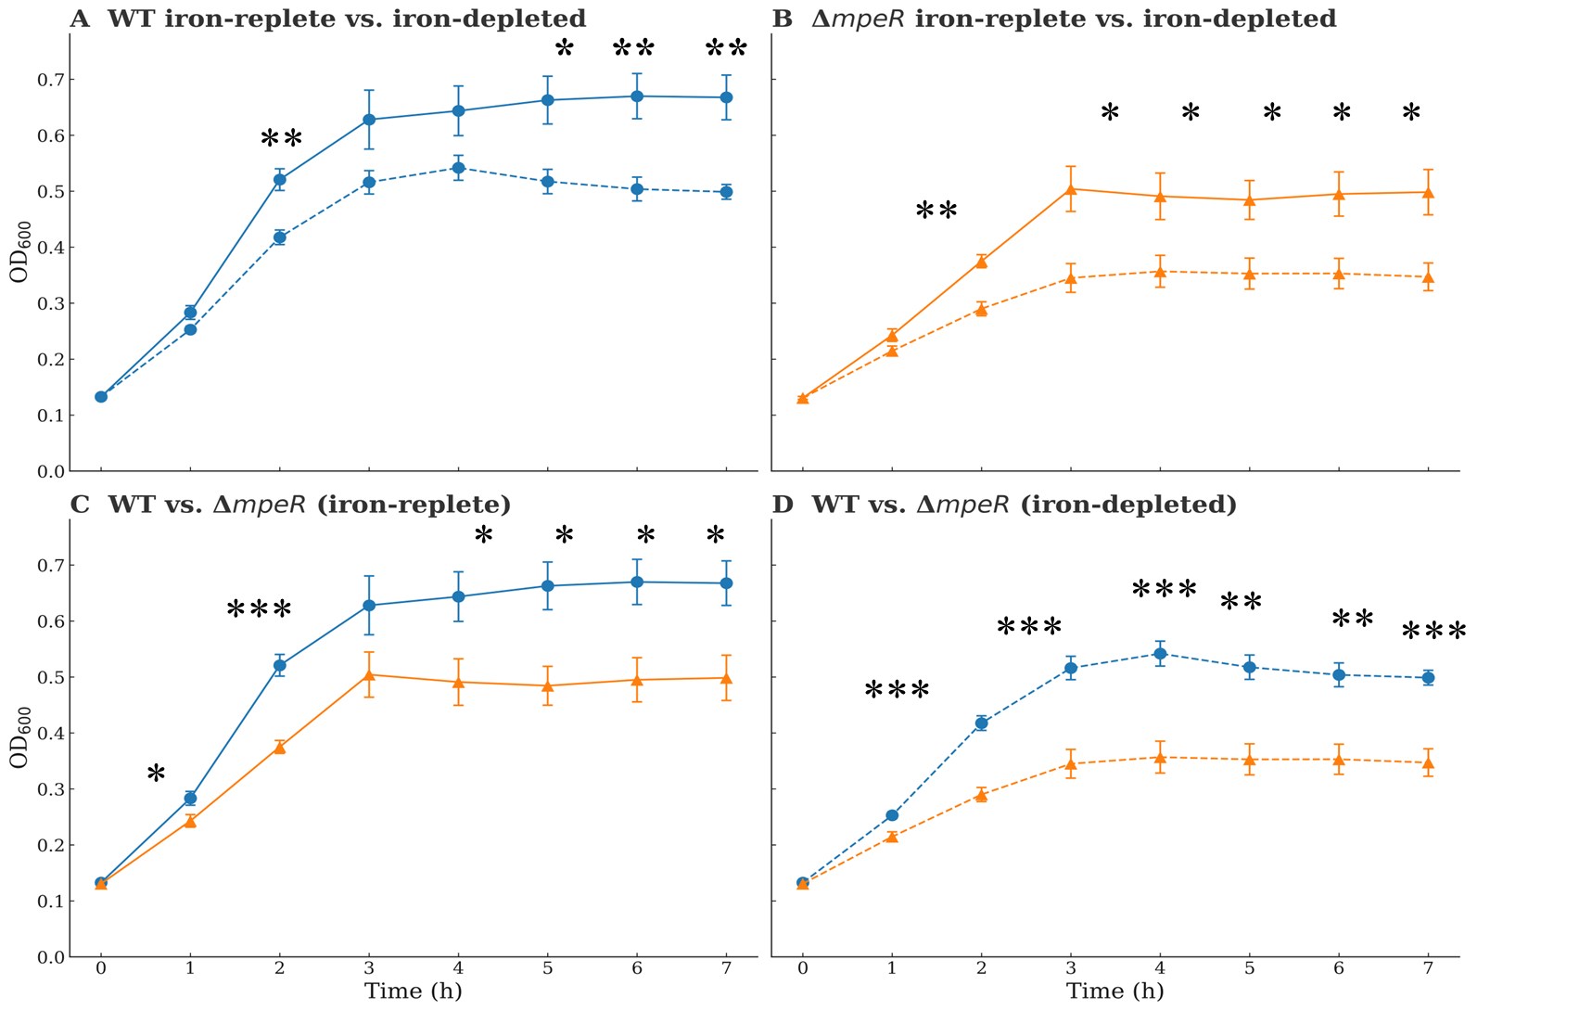
Figure 4.1. Growth analysis of N. gonorrhoeae WT and ΔmpeR strains under iron-replete and iron-depleted conditions.
WT and ΔmpeR strains were pre-grown in chemically defined medium (CDM) to mid-log phase (~90 min) and then divided into cultures supplemented with either 100 μM FeCl₃ (iron-replete) or 100 μM deferoxamine (iron-depleted). Growth was monitored over 7 h by measuring OD₆₀₀ at 1-h intervals. Blue lines represent WT, and orange lines represent ΔmpeR, with solid lines indicating iron-replete conditions and dashed lines indicating iron-depleted conditions. Data represent the mean ± SEM from five independent biological replicates (n = 5), each with three technical replicates. The same dataset is displayed across all four panels to facilitate direct comparisons. Statistical differences were assessed using two-sample t-tests at each time point, with asterisks denoting significance (p ≤ 0.05, p ≤ 0.01, p ≤ 0.001). (A) WT growth under iron-replete and iron-depleted conditions. (B) ΔmpeR growth under iron-replete and iron-depleted conditions. (C) WT versus ΔmpeR under iron-replete conditions. (D) WT versus ΔmpeR under iron-depleted conditions.

Genotype | Iron Condition | Growth Rate μ (h⁻¹) | Doubling  time (h) | p-value¹
WT | Iron-depleted | 0.57 ± 0.02 | 1.21 ± 0.04 | –
WT | Iron-replete | 0.68 ± 0.02 | 1.01 ± 0.03 | –
ΔmpeR | Iron-depleted | 0.40 ± 0.03 | 1.74 ± 0.06 | <0.001
ΔmpeR | Iron-replete | 0.53 ± 0.02 | 1.31 ± 0.05 | <0.01

Table 4.1. Growth rates and doubling times of N. gonorrhoeae strains under iron conditions. Specific growth rates (μ) and doubling times were estimated from OD₆₀₀ trajectories of wild type (WT) and ΔmpeR strains under iron-replete (100 μM FeCl₃) and iron-depleted (100 μM deferoxamine) conditions. Values are mean ± SEM from five independent biological replicates (n = 5), each with three technical replicates. ¹p-values were determined by two-sample t-tests versus WT under the same iron condition.

4.2.2 mpeR Deletion Improves Viability During Prolonged Iron Limitation
OD₆₀₀ reflects biomass but not viability, so CFU counts were measured to assess survival. In iron-depleted medium, WT maintained stable CFU until 4 h but then lost ~2 logs of viability between 4 and 6 h before partial recovery at 7 h (Fig. 4.2A). In contrast, ΔmpeR maintained relatively stable (without drastic changes in CFU over time) CFU throughout the 7 h course, with only a transient dip at 5 h that recovered by 6 h (Fig. 4.2B). Under iron-replete conditions, both strains increased CFU steadily, with no significant differences until 5 h, after which modest differences appeared (Fig. 4.2C). By contrast, under iron-depleted conditions, ΔmpeR maintained significantly higher CFU than WT at later timepoints (p < 0.001 at 6 h; Fig. 4.2D). These results indicate that although ΔmpeR accumulates less biomass, it maintains greater long-term viability under iron starvation.
Exponential-phase CFU trajectories confirmed the same trend as OD-based rates: WT grew fastest under iron-replete conditions (μ = 0.768 h⁻¹), while ΔmpeR was slowest in iron-depleted conditions (μ = 0.628 h⁻¹; Supplementary Table 4.1). Thus, while mpeR deletion reduces biomass accumulation, it preserves survival during prolonged iron limitation.

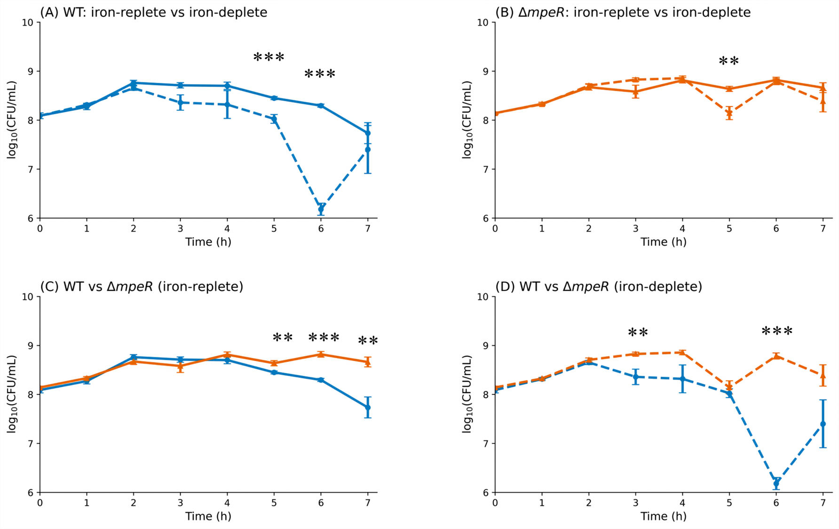
Figure 4.2. Viability of N. gonorrhoeae WT and ΔmpeR strains under iron-replete and iron-depleted conditions.
WT and ΔmpeR strains were pre-grown in chemically defined medium (CDM) to mid-log phase (~90 min) and then divided into cultures supplemented with either 100 μM FeCl₃ (iron-replete) or 100 μM deferoxamine (iron-depleted). Viability was monitored over 7 h by plating serial dilutions for CFU enumeration at 1-h intervals. Blue lines represent WT, and orange lines represent ΔmpeR, with solid lines indicating iron-replete conditions and dashed lines indicating iron-depleted conditions. Data represent the mean ± SEM from five independent biological replicates (n = 5), each with three technical replicates. The same dataset is displayed across all four panels to facilitate direct comparisons. Statistical differences were assessed using two-sample t-tests at each time point, with asterisks denoting significance (p ≤ 0.05, p ≤ 0.01, p ≤ 0.001). (A) WT viability under iron-replete and iron-depleted conditions. (B) ΔmpeR viability under iron-replete and iron-depleted conditions. (C) WT versus ΔmpeR under iron-replete conditions. (D) WT versus ΔmpeR under iron-depleted conditions.
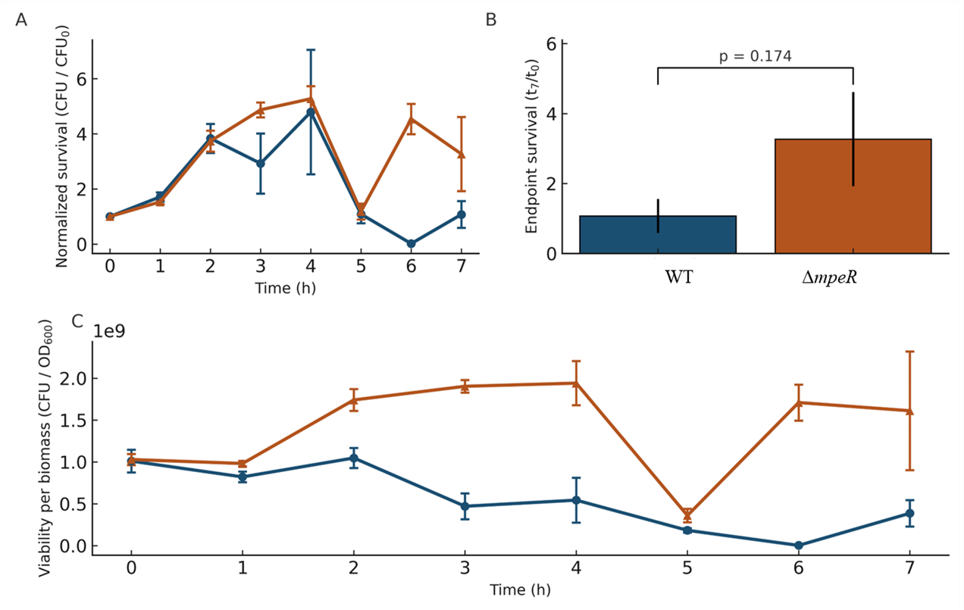
Figure 4.3. Growth and survival dynamics of WT and ΔmpeR under iron-depleted conditions. Normalized survival of WT and ΔmpeR (A) was expressed as CFU relative to the initial inoculum (t₀) over a 7 h time course. Endpoint survival (B) was calculated as the ratio of CFU at 7 h to CFU at t₀ for WT and ΔmpeR, with bars showing mean ± SEM and p-value determined by a two-sample t-test. Viability per biomass (C) was assessed as CFU normalized to OD₆₀₀ for WT and ΔmpeR during the same time course. Data represent the mean ± SEM from five independent biological replicates (n = 5), each with three technical replicates.

4.2.3 Growth and Survival Dynamics of WT and ΔmpeR Under Iron Limitation
Because OD₆₀₀ and CFU trajectories diverged, we further compared biomass and viability under iron depletion. CFU values normalized to t₀ showed that WT viability declined after 5 h, whereas ΔmpeR remained relatively stable across 7 h (Fig. 4.3A). Endpoint survival (t₇/t₀) was higher in ΔmpeR than in WT, though not statistically significant (p = 0.174; Fig. 4.3B). CFU normalized to OD₆₀₀ revealed higher CFU per unit biomass in WT, indicating that biomass increases were coupled to viable output. ΔmpeR, by contrast, maintained OD₆₀₀ increases but yielded proportionally fewer viable cells (Fig. 4.3C).
Taken together, OD₆₀₀ data showed that ΔmpeR accumulates less biomass under both iron conditions, while CFU assays revealed greater viability under prolonged iron depletion. These measures are not directly proportional: WT converts biomass into viable cells more efficiently, but ΔmpeR sustains viability longer when iron is limited. To determine the transcriptional mechanisms underlying these phenotypes, we next performed temporal RNA-seq analysis of WT and ΔmpeR under iron-replete and iron-depleted conditions.

4.3 Temporal Transcriptomic Responses of WT and Δmper Strains to Iron Depletion.
To investigate how N. gonorrhoeae temporally adapts to iron limitation and to define the regulatory role of mpeR, we performed RNA sequencing (RNA-seq) over a 5 h time course. Cultures of WT and ΔmpeR strains were grown under iron-replete and iron-depleted conditions, and total RNA was extracted at 1 h intervals spanning early log to stationary phase (1–5 h). Strand-specific libraries were prepared from high-quality RNA and subjected to high-throughput sequencing. After quality filtering, reads were aligned to the N. gonorrhoeae FA1090 reference genome, and transcript abundance was quantified (McClure et al., 2013; Tjaden, 2015; Parkhill et al., 2003). Differentially expressed genes (DEGs) were defined as those with FDR ≤ 0.01 and |log₂FC| ≥ 1, where log₂FC represents expression in iron-depleted relative to iron-replete conditions.
To aid interpretation of the results, several terms are defined here. Differentially expressed genes (DEGs) refer to genes whose transcript levels change significantly between conditions. Upregulated and downregulated describe increases or decreases in gene expression, respectively. Premature indicates that a change occurs earlier in ΔmpeR compared to WT, while excessive refers to a greater number or magnitude of changes. Instability describes fluctuations in gene expression levels over time. Coordinated indicates that genes in related pathways or functions are regulated together, producing an integrated response. Transcriptional state denotes the overall profile of gene expression in a strain at a given time point. Buffering refers to the ability of a regulator, such as mpeR, to stabilize expression and reduce fluctuations.
At early and mid-time points (1–4 h), ΔmpeR displayed markedly more differentially expressed genes within the iron regulon compared to WT, with up to 373 upregulated and 499 downregulated genes at 2 h versus only 30 and 25, respectively, in WT. This pattern indicates that the loss of mpeR leads to premature and excessive transcriptional remodeling of iron-responsive loci. By 5 h, however, WT exhibited a pronounced surge (255 up, 275 down), resulting in totals that approached those observed in ΔmpeR. These dynamics suggest that while ΔmpeR is characterized by early instability, WT maintains a

delayed but more coordinated regulon activation in response to iron depletion.
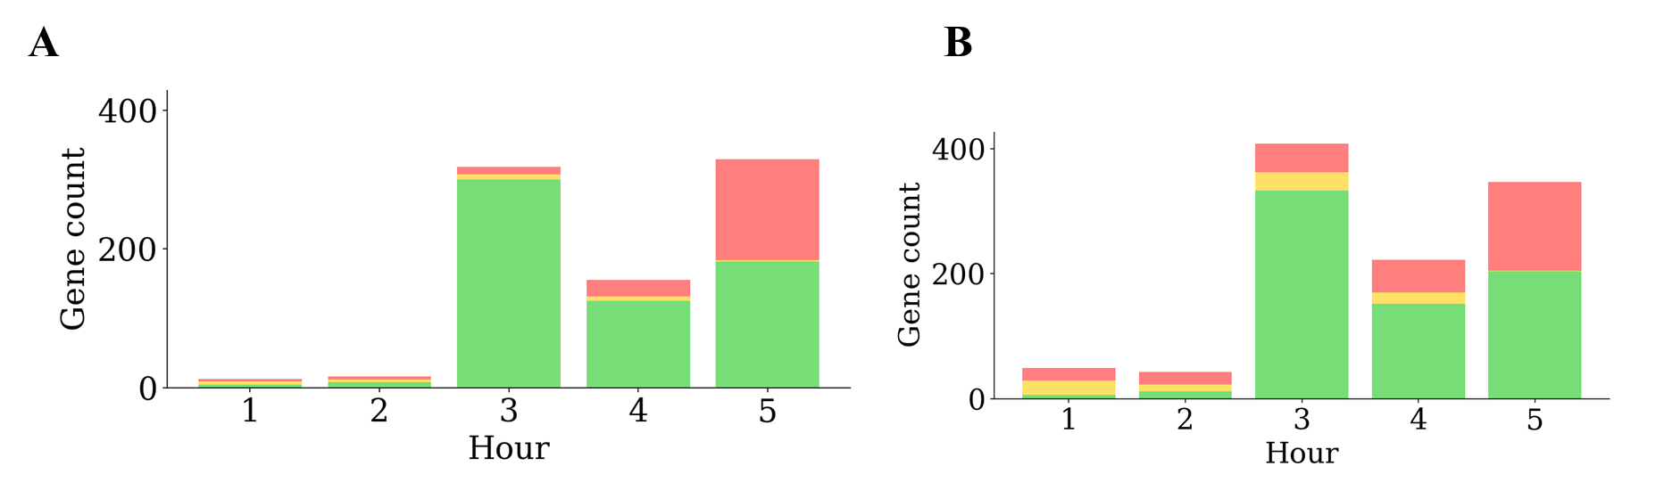
Figure 4.4. Iron regulon dynamics in N. gonorrhoeae WT and ΔmpeR.
(A) Numbers of upregulated (green) and downregulated (red) iron regulon genes across a 1–5 h iron depletion time course. (B) Temporal trajectories of differentially expressed genes (DEGs) in WT and ΔmpeR. (C) log₂ fold change (WT/ΔmpeR) for up- and downregulated genes.
Across the time course, both WT and ΔmpeR mounted dynamic transcriptional responses to iron limitation, with distinct temporal patterns of gene induction and repression. In WT, the largest wave of induction occurred within the first 2 hours of iron depletion, followed by a progressive decline through 5 hours (Figure 4.4A). Downregulated genes were fewer overall, with modest increases only at later time points (Figure 4.4B). In ΔmpeR, upregulation peaked more strongly at 2 h and remained elevated through 4 h before partially subsiding at 5 h (Figure 4.4A). ΔmpeR also exhibited an expanded set of downregulated genes at 5 h compared to WT, consistent with a role for mpeR in modulating transcriptional repression during prolonged iron starvation (Figure 4.4B). Together, these data indicate that N. gonorrhoeae mounts a rapid, induction-dominated transcriptomic response to iron limitation, and that mpeR influences both the magnitude and persistence of these changes across growth phases.
One Hour: Initiation of the Core Iron Starvation Program with Strain-Specific Differences.
At 1 h following iron depletion, both WT and ΔmpeR strains induced a well-characterized iron-starvation program. This included strong upregulation of iron acquisition systems (e.g., transferrin-binding protein tbpB, iron ABC transporter fbpA) and the iron–sulfur cluster regulator iscR, together with repression of iron storage genes (bfrA, bfrB) and selected NADH–quinone oxidoreductase subunits (nuoA–nuoF). These shared changes show that mpeR is not required for initiation of the core iron-starvation response.
Beyond this common pattern, the strains diverged. In WT, repression extended to additional NADH–quinone oxidoreductase subunits (nuoG–nuoL), transcriptional regulators (arsR, farR), and ribosomal biogenesis genes (rbfA–rbfC), consistent with an early energy-conservation strategy. In contrast, ΔmpeR repressed tricarboxylic acid cycle genes (sdhA–sdhD) and vitamin biosynthesis pathways (riboflavin ribA, vitamin B6 pdxA, thiamine (thiC), while upregulating ribosomal proteins (rplA–rplC, rpsD), chaperones (groEL/groES), and DNA repair machinery (recA, uvrB). This combination of reduced energy-associated transcripts with increased biosynthetic and repair activity produced a transcriptional profile that differed substantially from WT.
Two hours: Extension of Iron-Sparing Responses in WT and Broad Regulation in ΔmpeR
By 2 h, approximately 400 DEGs distinguished WT and ΔmpeR. WT extended its adaptive, iron-sparing strategy, while ΔmpeR displayed more heterogeneous changes.
WT induced additional resource acquisition systems, including the Fe³⁺ dicitrate transporter (fecA), and repressed at least six more NADH–quinone oxidoreductase subunits (nuoH–nuoN), reinforcing the reduction of respiration-associated transcripts. In contrast, ΔmpeR upregulated stress-related chaperones (groEL/groES), coenzyme and amino acid biosynthesis pathways, and DNA repair systems, while repressing ribosomal proteins and ATP synthase subunits (atpB, atpF). This pattern elevated stress and biosynthetic transcripts alongside reduced translation and energy production and marked a transcriptional state distinct from WT.
Three hours: WT Activates Fe–S Cluster and DNA Repair Pathways, while Δmper Broadly Represses Translation and Biosynthesis
At 3 h, both strains continued the shared iron-scavenging response, including strong upregulation of transferrin-binding proteins (tbpA, tbpB), TonB-dependent receptors (tbpC, tbpD), and ABC transporters (fbpA–C). Repression of respiration-associated genes also persisted, covering NADH–quinone oxidoreductase (nuoJ, nuoL, nuoA–F), nitrite reductase (nirB), and cytochrome c peroxidase (ccp).
WT additionally induced Fe–S cluster assembly genes (iscS, iscU, iscA) and DNA repair systems (recN, mutS), while continuing to repress oxidoreductase subunits, regulatory genes (arsR, farR), and ribosomal components (rplA, rplB).
ΔmpeR, by contrast, strongly repressed ribosomal genes (rplC–H), translation factors (tsf), tRNA modification enzymes (truA, trmB), the termination factor rho, and RNA polymerase α (rpoA). Repression extended further to amino acid biosynthesis (leuA, ilvD), nucleotide biosynthesis (purA, pyrC), and coenzyme biosynthesis (ribB), together with bacterioferritin (bfrA, bfrB). Only stress-associated chaperones (groEL/groES) and DNA repair machinery (recA) remained elevated, indicating reduced growth-related transcriptional activity.
Four hours: WT Sustains Acquisition and Repair, ΔmpeR Deepens Repression Of Growth Functions
WT showed continued induction of acquisition systems, including fecA and hpuB, together with upregulation of the regulator iscR. Repression extended to oxidoreductase subunits (nuoG–L), nitric oxide reductase (norB), and regulatory genes (arsR, farR). This combined sustained acquisition and repair activity with repression of energy-demanding pathways.
ΔmpeR repressed ribosome biogenesis (rplA–F), transcriptional machinery (rho, nusA, rpoA), ATP synthase (atpA, atpF), amino acid biosynthesis (ilvD, leuA), nucleotide metabolism (pyrC), and bacterioferritin (bfrA, bfrB). A smaller subset of transcripts remained elevated, including chaperones (groEL, groES, clpB), coenzyme and amino acid biosynthesis (pdxA, thiC, ribA), and cell envelope-associated genes (lptD, bamA).
Five hours: WT Combines Stress Mitigation with Partial Energy recovery; ΔmpeR Shows Broad Repression with Limited Stress Induction
At 5 h, both strains maintained the core iron-starvation response with induction of transferrin-binding proteins (tbpA, tbpB), TonB-dependent receptors (tonB, NGO2093), and ABC transporters (fbpA, NGO2090, NGO2092), together with repression of oxidoreductase (nuoA–F) and bacterioferritin (bfrA, bfrB).
WT uniquely induced proteostasis systems (lon, groEL/groES) and DNA repair enzymes (uvrA, mutS), while partially reactivating oxidoreductase subunits (nuoH–J) despite continued repression of succinate dehydrogenase (sdhB).
ΔmpeR exhibited widespread repression of ribosomal proteins (rplV, rplW, rplE, rpsC, rplF), translation factors, tRNA modification enzymes, transcriptional regulators (iscR, ihfB), and biosynthetic pathways for amino acids (hisA, leuA), nucleotides (purA, pyrC), and coenzymes. DNA replication and repair genes (recA, uvrD, mutL, dnaN) were also reduced. A limited set of stress-related transcripts, including recN, DNA polymerase III (dnaE), and thiamine biosynthesis (thiC), remained elevated.
The overall results show that WT and ΔmpeR respond differently to iron depletion over the 1–5 h time course. In the early phase (1–2 h), ΔmpeR exhibited stronger and earlier induction of iron acquisition genes, while WT showed a more moderate increase together with the repression of respiration and translation genes. In the later phase (4–5 h), WT sustained high expression of acquisition systems and integrated repression of storage and energy-consuming pathways, whereas ΔmpeR displayed reduced expression of acquisition and storage genes compared to WT. Analysis of temporal stability further indicated that acquisition gene expression fluctuated more in ΔmpeR, consistent with reduced buffering in the absence of mpeR. Collectively, these results indicate that WT maintains a progressive, coordinated adaptation across growth phases, while ΔmpeR mounts a stronger but less persistent response under prolonged iron limitation.

4.3.1 Temporal Regulation Of Iron Homeostasis by mpeR
To define how mpeR shapes the regulation of iron-responsive pathways, we focused on acquisition and storage genes. In WT, iron depletion elicited gradual induction of acquisition systems, including outer membrane receptors (NGO2093, tbpA, NGO2109) and ferric iron ABC transporter components (fbpA, fbpB, fecA), with the strongest expression at 4–5 h. The gene encoding the global iron-response regulator Fur was also modestly upregulated, consistent with feedback between Fur and MpeRin iron homeostasis.
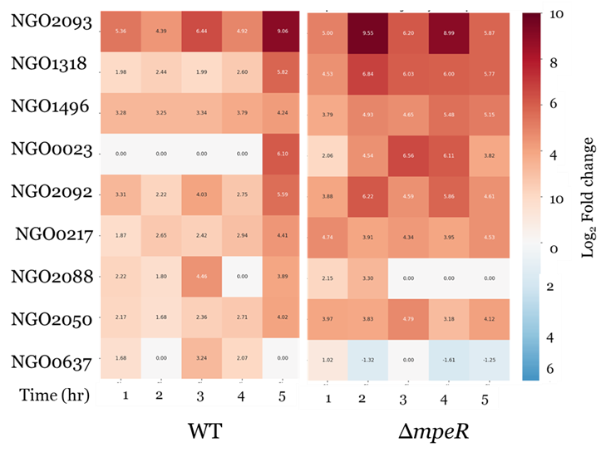
In contrast, ΔmpeR strain showed a markedly different trajectory. Iron acquisition genes such as fbpA were induced earlier and more strongly at 1 h, but the response was not maintained. By 4–5 h, the expression of key iron acquisition genes (fbpA, fetA, NGO2050, NGO2051) had declined relative to WT. Storage genes (bfrA, bfrB) were repressed in both strains, but more strongly in ΔmpeR. These dynamics highlight time -specific divergence: early premature induction in ΔmpeR versus moderated activation in WT, followed by sustained adaptation in WT and diminished responses in ΔmpeR. Temporal stability analyses further showed reduced stability of acquisition gene expression in ΔmpeR, suggesting that mpeR buffers fluctuations and maintains transcriptional memory (Supplementary Figure S4.1).
Figure 4.5. Temporal expression dynamics of iron metabolism genes in WT and ΔmpeR. A heatmap showing log₂ fold-change values (iron-depleted relative to iron-replete conditions) for iron acquisition and storage genes across a 5 h time course. WT (left) displayed gradual and sustained induction of outer membrane receptors and ferric ABC transporter components, together with consistent repression of storage genes. ΔmpeR (right) exhibited stronger early induction of acquisition systems that declined at later time points, with deeper repression of storage genes relative to WT. The color scale represents log₂ fold-change values.
In summary, WT cells exhibited progressive, coordinated adaptation integrating acquisition, storage, and Fur regulation, whereas ΔmpeR showed transient early induction followed by attenuated responses, reflecting dysregulated iron metabolism.
Early in iron depletion (1–2 h), ΔmpeR showed stronger and earlier induction of iron acquisition genes than WT, whereas WT exhibited a more moderate increase. At later time points (4–5 h), WT maintained sustained upregulation of acquisition systems and integrated repression of storage genes, while ΔmpeR showed reduced expression of key acquisition and storage genes compared to WT. Temporal stability analysis indicated that acquisition gene expression fluctuated more in ΔmpeR, consistent with a loss of regulatory buffering normally provided by mpeR (Supplementary Figure S4.4).
In summary, WT cells displayed a progressive and coordinated transcriptional responses across timepoints, integrating acquisition, storage, and Fur regulation, whereas ΔmpeR mounted an amplified early response that was not maintained, resulting in reduced transcriptional persistence during prolonged iron starvation.

4.4 Functional Characterization of the mpeR Regulon
To define the mpeR regulon, we compared gene expression ratios of ΔmpeR relative to WT under both iron-replete and iron-depleted conditions across the 5 h time course. Genes were considered part of the regulon if they were differentially expressed between ΔmpeR and WT (FDR ≤ 0.01, |Log₂FC| ≥ 1) under a given condition. This approach distinguished mpeR-dependent regulation from the broader iron-starvation response and allowed us to track how the regulon changed temporally. Comparative transcriptomic profiling showed that the mpeR regulon is highly dynamic and condition-specific, with patterns evolving across the time course. The regulon integrates control of DNA maintenance, translation, transport, metabolism, and stress responses, but the transcriptional trajectory differed depending on iron availability.
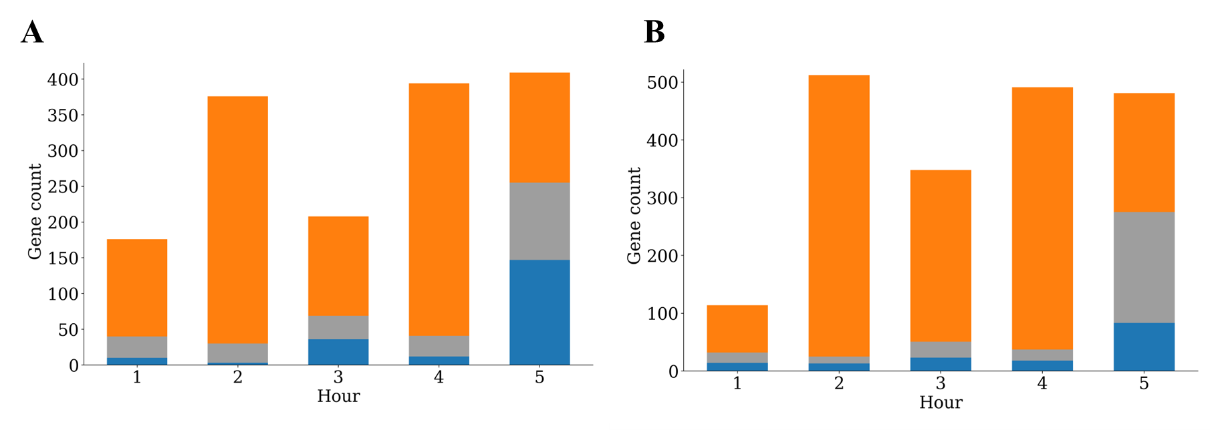
Figure 4.6. Differentially expressed genes defining the mpeR regulon over time.
Stacked bar plots showing the number of genes differentially expressed between ΔmpeR and WT (log₂ fold-change ΔmpeR/WT; FDR ≤ 0.01, |Log₂FC| ≥ 1) under iron-replete (left) and iron-depleted (right) conditions across a 5 h time course. Bars represent the total count of upregulated (ΔmpeR > WT, orange) and downregulated (ΔmpeR < WT, blue) genes, with gray indicating intermediate categories or functional annotations (where applicable). These counts summarize the scope of the mpeR regulon at each time point and highlight condition-specific differences in regulatory patterns.

4.4.2 Iron-depleted Conditions
Under iron limitation, the regulon followed a distinct trajectory. At 1 h, upregulation was limited to DNA maintenance genes (dam NGO0365, NGO0363–0364), toxin–antitoxin modules (mazE/mazF NGO0516–0517), and glycine cleavage system H (gcvH NGO1404), while broad repression dominated. Suppressed categories included tRNA modifying enzymes (rimM NGO0037, NGO1330), transporters (preQ₀ NGO1685, uracil permease uraA NGO0589, copper ATPase copA NGO0579), central metabolism (inositol monophosphatase suhB NGO0671), and stress proteins (paraquat-inducible pqiB NGO1320). By 2 h, transcriptional activity expanded. Upregulated genes included DNA polymerase (dnaE NGO0030), methyltransferase dam NGO0365, DNA-damage-inducible protein D (dinD NGO0405), ribosomal modification enzymes (rsmB NGO0031, rimO NGO0384), regulators (yafC NGO1474), cell division protein zipA (NGO0236), pilus biogenesis factor pilQ (NGO0094), and transporters (zinc transporter znuB NGO0169, histidine permease hisP NGO2016). Stress proteins (groES NGO2094, glutaredoxin grxA NGO0331) were also induced. Repression persisted for DNA repair enzymes (ruvB NGO0760), chaperones (dnaJ NGO1901), and central metabolism (fumarate hydratase fumC NGO1029, dihydrofolate reductase folA NGO1694).
At 3–4 h, the regulon displayed simultaneous induction of translation machinery, stress proteins, and transporters, alongside continued repression of DNA metabolism and select biosynthetic pathways. Activation included ribosomal proteins (L19p rplS NGO0171, S3p rpsC NGO1832, L31p rpmE NGO2126), elongation factor Ts (tsf NGO1974), stress proteins (thiol peroxidase tpx NGO0328, peptidyl-prolyl isomerase ppiB NGO0376), transporters (sulfate permease cysA NGO0445), and metabolic enzymes (succinate dehydrogenase sdhB NGO0921, cysteine synthase cysK NGO0340). Pili-associated genes (pilQ NGO0094, glycosylation NGO0085) and glutathione synthetase (gshB NGO1217) were also induced. However, repression continued for DNA metabolism (topoisomerase IV parC NGO1333, helicase rep NGO0739), ribosome biogenesis factors (rbgA NGO0316), sodium and ammonium transporters (NGO0606, NGO0198), stress proteins (macrophage infectivity protein mip NGO0887), and metabolic enzymes (chorismate mutase aroQ NGO1510).
By 5 h, the ΔmpeR strain displayed broad transcriptional activation. Upregulated genes spanned DNA replication (replicative helicase dnaB NGO1110, endonuclease NGO0364), regulators (lysR NGO1706, acrR NGO1366), ribosomal proteins (L19p rplS NGO0171, L25p rplY NGO0442, S2p rpsB NGO1975), translation factors (elongation factor Ts tsf NGO1974), cell division proteins (NGO1728), pilus biogenesis protein pilE (NGO1441), transporters (cystine ABC NGO0373–0374, methionine ABC NGO2138), and metabolic enzymes (ATP synthase NGO2146, lactate dehydrogenase ldhA NGO0904, ferrochelatase hemH NGO0293). Stress proteins (antidote–toxin NGO0517, paraquat-inducible protein B NGO1320) were also strongly induced. Some repression remained for DNA topoisomerase IV (parC NGO1333), chaperone dnaK (NGO1429), and metabolic checkpoints (pyruvate kinase pyk NGO1881).
Thus, under iron depletion, the ΔmpeR regulon progressed from early global repression through incremental activation of DNA synthesis, ribosomal machinery, pili, and stress responses, to a late-phase surge in transcriptional and metabolic activity.
In summary, the two iron conditions revealed opposite regulatory trajectories. Under iron-replete conditions, the ΔmpeR strain showed early activation of stress-associated pathways, transient induction of metabolic and division functions, and late widespread repression. In contrast, under iron-deplete conditions, the mutant began with broad repression but progressively activated replication, translation, transport, and biosynthesis pathways, culminating in late-phase induction. These outcomes indicate that mpeR contributes to maintaining iron-dependent transcriptional balance, and its absence results in condition-specific alterations in regulatory dynamics.

4.5 Operon Remodeling and Regulatory Architecture in N. gonorrhoeae
Bacterial operons are fundamental transcriptional units that coordinate the expression of functionally related genes, enabling rapid and efficient adaptation to environmental stress (Price et al., 2005; Mao et al., 2014). High-resolution transcriptomic studies have shown that operon boundaries are not static but undergo dynamic remodeling in response to nutrient stress and host interactions, reflecting a flexible regulatory architecture (Conway et al., 2014; Sorek & Cossart, 2010). For pathogens such as N. gonorrhoeae, this plasticity in operon organization provides an additional layer of transcriptional control, allowing the bacterium to balance resource allocation and stress adaptation during infection.
To investigate how operon organization contributes to transcriptional regulation in N. gonorrhoeae, operon structures were inferred across a five-hour iron under iron replete and depleted conditions in both WT and ΔmpeR strains. Here, we define an operon (or transcriptional unit) as a contiguous set of genes co-transcribed from a shared promoter, inferred from strand-specific RNA-seq read continuity and condition-specific expression dynamics (Conway et al., 2014; Mao et al., 2014). This working definition enables us to track how iron starvation and mpeR alter the structure and regulation of transcriptional units over time. This approach allowed us to define dynamic operon boundaries, identify a core iron-responsive regulon, and determine the contribution of mpeR to pleiotropic and condition-specific control.
Designation of Core Iron, mpeR-Dependent, and Conditional Regulons:
For clarity, operons were classified into three categories based on differential expression patterns across WT and ΔmpeR strains under iron-replete and iron-depleted conditions.
- Core iron-responsive regulon (mpeR-independent): Operons significantly regulated by iron availability (FDR ≤ 0.01, |log₂FC| ≥ 1) in both WT and ΔmpeR were assigned to this group, reflecting responses driven by iron status alone.
- mpeR-dependent regulon: Operons differentially expressed between ΔmpeR and WT under the same iron condition (FDR ≤ 0.01, |log₂FC| ≥ 1) were designated as under direct or indirect control of mpeR.
- Conditional iron+mpeR regulon (AND-gate): Operons showing significant regulation only when both iron depletion and functional mpeR were present (e.g., induced in WT Fe⁻ but not in ΔmpeR Fe⁻) were classified as conditionally regulated, reflecting integration of iron sensing with mpeR activity.
This framework distinguishes iron-driven from mpeR-driven effects and highlights the subset of adaptive programs that require crosstalk between the two signals.
A conserved iron-responsive regulon drives metabolic reprogramming.
Iron depletion triggered a transcriptional response encompassing hundreds of operons across both WT and ΔmpeR strains. Within this broad remodeling, a core regulon emerged that was consistently regulated by iron availability alone, independent of mpeR. This regulon extended beyond classical iron acquisition systems to include pathways in amino acid and vitamin biosynthesis, central metabolism, and energy production. For instance, operons involved in histidine (hisE), riboflavin (ribA), and thiamine (thiG) biosynthesis, as well as components of the TCA cycle (sdhB), were consistently induced. The coherence of this response highlights iron as a dominant cue that commits cells to extensive metabolic reprogramming, ensuring balanced allocation of biosynthetic resources during nutrient limitation.
Operon ID | Genomic Coordinates | Locus Tags / Gene Symbols | Key Functional Annotations
op_30 | 180925–186186 | NGO0178–hisE, tatA | Histidine biosynthesis; Twin-arginine transport
op_171 | 900581–904138 | NGO0919, sdhB, NGO0921–NGO0923 | Succinate dehydrogenase; TCA cycle
op_209 | 1078572–1079832 | NGO1133, ribA | Riboflavin biosynthesis
op_393 | 2138449–2143340 | NGO2162, fabG, guaA, NGO2165 | Fatty acid biosynthesis; GMP synthase
op_7 | 44215–47974 | carB, NGO0049 | Carbamoyl-phosphate synthase (pyrimidine/arginine biosynthesis)
op_357 | 1976689–1977750 | thiG, NGO2006 | Thiamine biosynthesis
Table 4.2. Core operons regulated by iron availability in N. gonorrhoeae.
Representative operons consistently regulated by iron across both WT and ΔmpeR strains. These operons constitute the mpeR-independent iron-stress regulon and include genes for iron acquisition, amino acid and vitamin biosynthesis, and central metabolism. Gene content and annotations are derived from predicted operon structures.

MpeR Functions as a Pleiotropic Regulator of Cellular Homeostasis
Loss of the transcriptional regulator mpeR revealed broad disruptions across protein quality control, DNA repair, and translation, underscoring its role as a global regulator. Operons encoding chaperonins (groES–groEL), proteolytic machinery (clpP), and DNA repair systems (uvrC, ruvA) were altered in the ΔmpeR strain. Moreover, secondary regulators, including members of the MarR and LysR families, displayed differential expressions, indicating that mpeR exerts hierarchical influence through downstream transcriptional cascades.

Operon ID | Genomic Coordinates | Locus Tags / Gene Symbols | Key Functional Annotations
op_384 | 2072506–2074522 | groES, groEL | Chaperonin complex; protein folding
op_112 | 578772–580795 | tig, clpP | Trigger factor; ClpP protease
op_109 | 564000–568118 | uvrC, NGO0579 | Excinuclease ABC subunit C; DNA repair
op_318 | 1690144–1693676 | ruvA, NGO1731–NGO1733 | Holliday junction helicase; DNA repair
op_30 | 180925–186186 | NGO0178–hisE, tatA | Histidine biosynthesis; Twin-arginine transport
op_121 | 632563–634447 | truB, NGO0643, rbfA | tRNA pseudouridine synthase; ribosome-binding factor A
Table 4. 3. Operons under mpeR-dependent regulatory control.
Representative operons whose expression or operon structure is significantly altered between WT and ΔmpeR. These include pathways in protein folding, proteolysis, DNA repair, and translation. The presence of secondary regulators within this set highlights the pleiotropic influence of mpeR on downstream transcriptional cascades.
Conditional integration of mpeR and iron signals establishes regulatory logic
A subset of operons displayed conditional regulation where a full transcriptional response required both iron limitation and functional mpeR. For instance, ArsR (NGO1562) and the anaerobic regulator NGO1579 exhibited stronger induction in wild-type iron-depleted condition (231 and 280 units) compared with ΔmpeR iron-depleted condition (382 and 473 units, respectively) (Table 4.4). This dependency reflects an AND-gate logic, where mpeR amplifies the iron signal to activate downstream networks only when both conditions are met. Such crosstalk ensures that costly adaptive programs are deployed selectively, with the greatest divergence between strains observed at later time points (e.g., 4 h). These dynamics suggest that the temporal commitment of transcriptional networks emerges as cells transition from early to sustained iron stress, with mpeR functioning as a conditional regulator within the broader iron regulon.

  WT (+Fe)
  WT (+Fe)
  WT (+Fe)
  WT (+Fe)
  WT (+Fe)
  WT (+Fe)
  WT (+Fe)
NGO0058 | – | MarR family regulator | 1002 | 1606 | 827 | 1324
NGO0090 | nrdR | NrdR family regulator | 12 | 16 | 13 | 16
NGO0393 | – | TetR family regulator | 123 | 89 | 108 | 79
NGO1221 | – | GntR family regulator | 98 | 101 | 82 | 89
NGO1294 | – | AsnC family regulator | 63 | 100 | 80 | 111
NGO1366 | mtrR | MtrCDE repressor | 196 | 158 | 160 | 135
NGO1407 | – | AsnC family regulator | 114 | 227 | 150 | 250
NGO1427 | – | Transcriptional regulator | 128 | 269 | 143 | 291
NGO1474 | – | LysR family regulator | 10 | 17 | 17 | 25
NGO1562 | – | ArsR family regulator | 113 | 231 | 213 | 382
NGO1578 | – | CysB-like regulator | 25 | 49 | 45 | 87
NGO1579 | – | Anaerobic regulator | 168 | 280 | 242 | 473
NGO1706 | – | LysR family regulator | 28 | 41 | 54 | 79
NGO1813 | – | LysR family regulator | 309 | 281 | 258 | 240
NGO2027 | – | Methionine regulator | 7 | 5 | 5 | 4
Table 4 4. Crosstalk between iron status and mpeR: differential expression of transcriptional regulators.
Expression patterns show that some regulators are only fully induced when both iron depletion and mpeR are present. This conditional regulation demonstrates how mpeR amplifies iron-dependent signaling to refine adaptive responses during sustained stress.

4.7 mpeR is Required for N. gonorrhoeae Adherence and Invasion Of Human Epithelial Cells
Deleting the mpeR gene led to differential expression of multiple pili and opacity-associated adhesin protein genes, which are essential for N. gonorrhoeae interactions with host tissues and play critical roles in colonization and persistence within epithelial cells (Matthias and Rest, 2014; Q. Yu et al., 2021; Quillin and Seifert, 2018).
To evaluate the role of mpeR in host cell interactions, the human cervical epithelial cell line Ect1 was infected with either WT or ΔmpeR strains for 2 h or 5 h. Gentamicin protection and CFU assays were used to quantify total cell-associated bacteria (adhered + intracellular) and intracellular bacteria alone.
At 2 h, there was a trend toward reduced association and internalization of the ΔmpeR strain compared to WT, but this difference did not reach statistical significance. At 5 h, the ΔmpeR strain showed a significant reduction in both total cell association and intracellular bacteria relative to WT (p < 0.05) (Fig. 4.4A, B).
These findings indicate that mpeR promotes the ability of N. gonorrhoeae to engage with and invade epithelial cells. Because the gentamicin protection assay measures both adherence and invasion, these results cannot fully distinguish whether the primary defect lies in initial attachment or subsequent entry. Combined with transcriptomic data showing that mpeR deletion disrupts the expression of key adhesins, these results support a model in which mpeR coordinates the regulation of surface structures necessary for epithelial colonization.

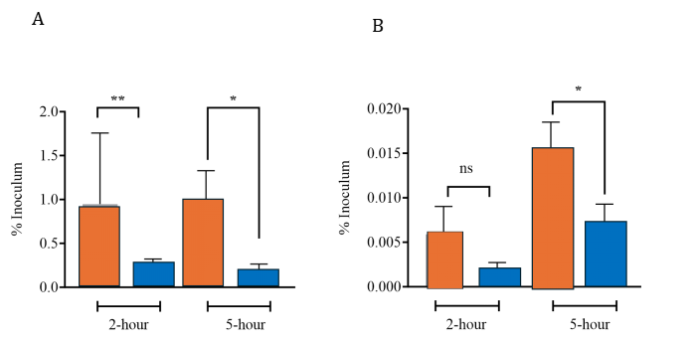
Figure 4.7. mpeR promotes N. gonorrhoeae association with and invasion of epithelial cells.
Ect1/E6E7 cervical epithelial cells were infected with WT or ΔmpeR strains for 2 h and 5 h at an MOI of 100. (A) Total cell-associated CFU (adhered + intracellular) and (B) gentamicin-protected intracellular CFU (invasion) were enumerated. All CFU values were normalized to the input inoculum to ensure comparability between strains. Only piliated colonies, identified by colony morphology, were used for inoculation. ΔmpeR showed reduced association and invasion compared with WT at 5 h (p < 0.05). Data represent mean ± SEM from three independent experiments.

4.8 Summary
In conclusion, this study highlights the pivotal role of MpeR, a transcriptional regulator, in Neisseria gonorrhoeae's ability to adapt to iron limitation and oxidative stress. The deletion of mpeR (ΔmpeR) revealed a complex phenotype: although the ΔmpeR strain exhibited impaired growth under both iron-replete and iron-depleted conditions, it demonstrated enhanced long-term survival during prolonged iron starvation. This suggests a growth-survival trade-off, where MpeR plays a key role in balancing the bacterium's growth and persistence in response to environmental stress.
Through transcriptomic analysis, it was revealed that MpeR governs a well-coordinated and temporal response to iron depletion. In contrast, ΔmpeR exhibited premature and excessive transcriptional changes, particularly in iron acquisition and stress response genes, highlighting MpeR’s role in stabilizing gene expression over time. Furthermore, MpeR regulates several critical processes, including iron acquisition, stress responses, and surface-expressed adhesins, which are essential for N. gonorrhoeae's ability to adhere to and invade human epithelial cells.
These findings provide significant insights into how MpeR integrates environmental signals to enable bacterial adaptation to host-imposed stresses, contributing to the persistence and virulence of N. gonorrhoeae. The study also underscores the importance of temporal regulation in bacterial stress responses and introduces MpeR as a key player in modulating this balance. Overall, this research lays a strong foundation for future studies into the molecular mechanisms underlying MpeR’s function in N. gonorrhoeae, with implications for developing novel strategies to combat gonococcal infections.

