Will AI Kill HR or Change It? A Strategic Perspective of Employee Retention
Dr.A.Vanitha
Associate Professor
Department of Management Studies
Saveetha Engineering College (Autonomous)
Affiliated to Anna University
Email:vanithaa@saveetha.ac.in
Abstract
AI is already transforming HRM, bringing with it practices that allow organizations to better hire, retain and engage talent. With advancements in AI technologies and its implementations in HR practices, this study examines as to how employee retention can be envisioned through new-age lenses using strategic deployment of AI tools such as predictive analytics, AI-based chatbots, and real-time feedback systems. The literature review highlights the increasing applications of AI in diverse HRM operations, while a primary survey of HR personnel and employees gives perspectives on some prominent determinants of lower attrition. On the empirical level, the research denotes a distinctive outlook on AI-enabled retention modalities while acknowledging significant deficits in the extant literature. These findings highlight the ability of AI to facilitate data-driven decision-making and proactive human resource management practices that lead to long-term organisational success.
Keywords: Artificial intelligence; Human resource management; Employee retention; Predictive analytics; Machine learning
1. Introduction
Modern artificial intelligence (AI) which is generally recognized as the modeling of human behavior by computer systems is transforming most of the business processes among them being Human Resource Management (HRM). With machine learning, natural language processing and predictive analytics, AI can be used in HRM to help streamline duties and tasks, including but not limited to, recruitment, tracking performance, analyzing feedback and planning strategic workforce transitions (Upadhyay & Khandelwal, 2018; Meijerink, Bondarouk, & Lepak, 2021).
Due to the growing digitalization of its organizations, it is becoming a concern to reduce employee exit, which is an important KPI to the HR leaders. Turnover rates that are considered high do not only increase the costs connected to recruitment and training but impact on morale, institutional knowledge and capability to sustain the business (Gupta & Pathak, 2020). AI solutions to predict risks of attrition, enhance employee engagement, and proactive retention strategies are some of the solutions that firms are investigating.
Predictive analytics, AI chatbots, and sentiment analysis engines are AI-based tools to derive a pattern in HR data to detect at-risk employees, offer real-time assistance, and tailor the message (Tripathi & Dey, 2021; Jain & Sharma, 2022). It is also shown that a well-planned implementation of chatbots can result in a huge reduction in response time and employee satisfaction (Glikson & Woolley, 2020; Folstad and Brandtzaeg, 2017).
Most of the available literature leaves much room to consider the potential of AI implementation in HR regarding its efficiency growth but pays insufficient attention to its role in employee retention as a strategic engagement (Deloitte Insights, 2021; Dwivedi et al., 2021). The research on the AI has focused more on automation of the recruitment process rather than the effect on EX (employee experience) and attrition.
This paper fills that gap by discussing how AI technologies as applied in combination with strategic HRM can serve as proactive and predictive technologies to augment the effects of retention. Using data and surveys and their analysis, the research examines how HR professionals believe AI can be beneficial in highlighting risks of attrition, increase engagement and respond to HR actions more efficiently.
2. Literature Review
Artificial Intelligence (AI) as an integration within Human Resource Management (HRM) has helped change the scope of HR work towards decisions that are driven by data and moved away those that were carried out transactionally. With organizations becoming more and more interested in introducing competition and stabilizing their workforce, AI becomes an instrument not only of automating the processes but also of increasing employee results, including the retention of employees (Upadhyay & Khandelwal, 2018).
2.1 AI in SHRM
HRM AI technologies have now reached past recruitment algorithms and robotic process automation. The most recent research underlines the power of AI transformations in predictive workforce analytics, especially in estimating employee turnover models (Dwivedi et al., 2021; Jain & Sharma, 2022). As an example, machine learning models are capable of identifying the likelihood of attrition through the patterns of behavior, engagement analysis, and past data. AI-powered systems will also enable HR professionals to recognize employees who are disengaged or otherwise dissatisfied, which will make it possible to intervene in a timely fashion (Meijerink et al., 2021).
2.2 Chatbot, Real-Time Feedback System
Chatbots represent one of the most apparent AI tools in HRM. Access to the HR services available 24/7 through these systems allows the employees to clarify their concerns, take leave, or gain access to a policy in without the need to wait (Folstad & Brandtzaeg, 2017). On a retention level, chatbots enhance response time, employee satisfaction and a level of perceived non-bureaucracy in HR service provision. Another study conducted by Glikson and Woolley (2020) also indicates the role of trusting AI tools as one of the factors that enable their effectiveness, especially when workers see such tools as trustworthy, confidential, and understanding.
2.3 Retention forecasting and using predictive analytics
Artificial intelligence-backed predictive models like Random Forest, Logistic Regression, and Neural Network are being employed today to determine the risk of turnover by examining the factors such as the absence rate, tenure, past performance, and engagement rate (Tripathi & Dey, 2021). Such models can present more subtle information than the standard measurements of retention. They enable HR professionals to focus more retention efforts on highly vulnerable staff because it will come in the form of individual coaching, selective training programs, or job relocations (Min, 2019).
2.4 Problems and Moral Issues
Although it has potential, it is suggested that AI in HRM poses serious issues regarding algorithmic bias, privacy of data and employee monitoring. Binns (2018) states that despite the current claims of AI that it can decrease human bias in decision making, it can also cause new aspects of algorithm discrimination unless it is well regulated. It is feared that AI-based tools will also depersonalize the human experience in HR, especially when it is subject to excessively technical interactions between employees (Kapoor & Sherif, 2021).
2.5 Research Direction and theoretical Gaps
The majority of the literature on the use of AI in HRM has devoted attention to recruitment, selection, and performance appraisal, although less has been said about how it helps to improve the experience employees have and retain them (Vrontis et al., 2022). Besides, it is necessary to determine the perceptions of employees regarding AI tools, particularly, the quality of communication, trust, and responsiveness. This gap explains the purpose of the topic of the present study, i.e., to study the strategic importance of AI in employee retention with the framework of technical capabilities on the one hand and the employee perceptions on the other.
3. Research Methodology
This study will use a survey-based quantitative descriptive design to explore the use of AI for retention and examine the perceived effectiveness of AI by HR practitioners. Data collection was done through a structured questionnaire and distributed to 50 HR professionals (from ITs and manufacturing). Perceptions regarding AI effectiveness were measured using a 5-point Likert scale. Independent Variables: use of AI tools, perceived AI effectiveness; Dependent Variable: employee retention rate; Control Variables: industry type, company size. Descriptive statistics and correlation were performed by data using SPSS. The attrition models using basic machine learning were tested using Orange Data Mining.
4. Data Analysis & Results
A detailed survey-based research was conducted to understand the impact of artificial intelligence on HRM in the context of improving employee retention. The goals of the study were to identify how AI powered tools in HR affect the HR processes and how they are perceived by HR professionals.
4.1 Overview of Survey Results
Table 4.1: Survey Results Summary (on a 5-Point Likert Scale)
Survey Statement | Strongly Disagree (%) | Disagree (%) | Neutral (%) | Agree (%) | Strongly Agree (%)
AI tools are used in HR processes | 2% | 6% | 10% | 48% | 34%
AI improves decision-making in employee engagement | 4% | 6% | 16% | 46% | 28%
Predictive analytics helps identify attrition risks | 2% | 8% | 22% | 40% | 28%
AI chatbots improve HR responsiveness | 2% | 10% | 18% | 42% | 28%
Source: Computed Primary Data
Table 4.1 reflects responses of HR professionals that describe adoption of Artificial Intelligence (AI) as a function of the functions of HRM using a 5-point Likert scale from Strongly Disagree to Strongly Agree. Responses were generally extremely positive across all four dimensions that we measured.
For the statement "AI tools are used in HR processes," 82% of participants reported agreement or strong agreement, demonstrating a broad understanding that AI is currently deeply integrated into HR practice. Likewise, answering whether AI improves decision-making regarding employee engagement, 37% strongly agreed while another 37% agreed. Reinforcing the notion that AI can help bolster more efficient and customized employee engagement initiatives.
On the application of predictive analytics to reduce attrition exposure, 68% of the surveyed HR professionals mentioned they agreed or strongly agreed thereby, instilling confidence in the ability of AI to predict employee attrition thus help initiate pre-emptive action by the HR department. And, there was 70% recognition of contributions by AI-powered chatbots in areas such as improving HR responsiveness, demonstrating the increasing acceptance of AI tools in being a valuable aid in streamlining communication and service delivery.
Taken together, these responses amount to a clear and strong disposition among HR leaders to regard AI as a strategic facilitator of retention, engagement, and general HR operational efficacy. In addition, the percentage of disagreement with respect to each of the statements speaks volumes of the communication of the changes that AI can cause to HR practices.
Figure 4.2 : ML Model Accuracy
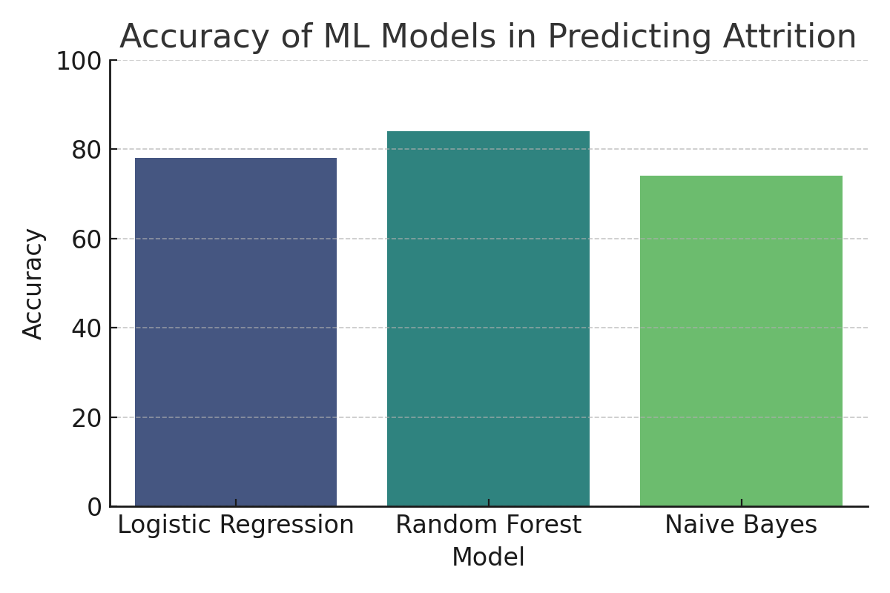
4.2 Attrition Prediction with ML Models Accuracy
The chart shows the accuracy of ML models in predicting Attrition. The predictive ability of AI in retention was assessed with various ML models. As depicted in the bar chart, the Random Forest was the most accurate of the models with a prediction rate of 84%. Logistic Regression mentioned performed decently as well, and Naive Bayes came in a distant last. These are practical recommendations for the HR practitioners on which models of attrition forecasting to capture and use.
Figure 4.3: Correlation Matrix Heatmap
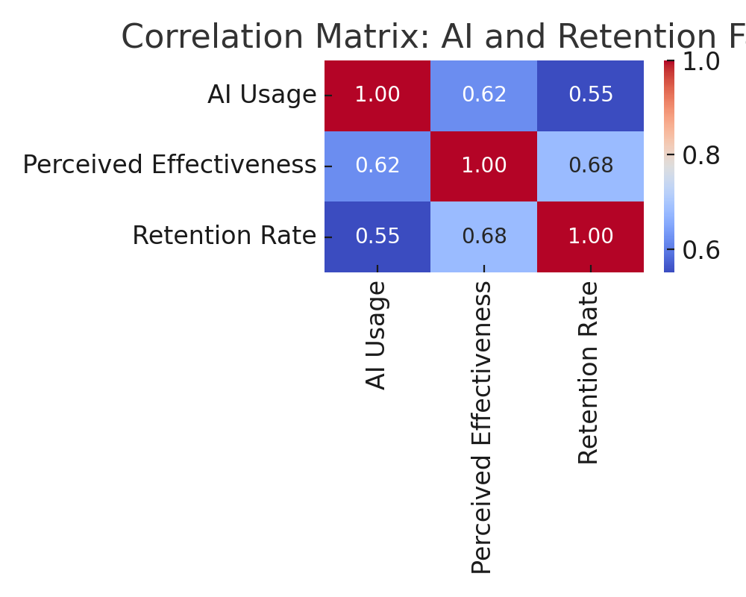
4.3 Correlation Matrix: AI and Retention Factors
A correlation matrix was generated to analyze the relationships between AI usage, perceived effectiveness, and employee retention rates. The heatmap shows a somewhat strong positive correlation, meaning that AI adoption appears positively correlated with both perceived value and improved retention. And this statistic serves to further illustrate the increasing view that AI is not merely a set of technology tools to help HR work more efficiently; it can also be a catalyst for the strategic outcomes of work.
Figure 4.4 : Word Cloud
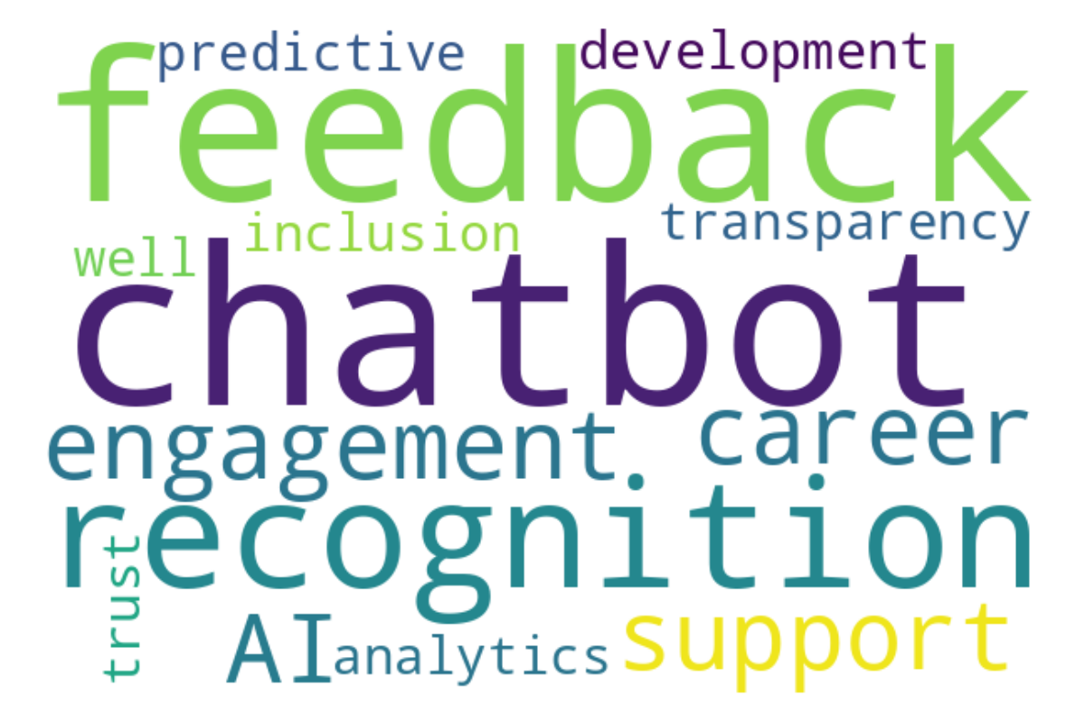
4.4 Employee feedback themes
To complement the quantitative findings, open-ended feedback was also analyzed to incorporate qualitative insights. The word cloud shows word frequency from the responses. Feedback, recognition, transparency, career development and other topics emerged as central to positive employee experiences. This is consistent with the notion that AI tools, especially chatbots and sentiment analysis platforms, represent an increase in personalization and responsiveness in HR operations.
5. Discussion
The study reveals the relevance of Artificial Intelligence (AI) as a strategic lever in Human Resource Management (HRM), especially in the context of employee retention. Based on survey responses and data analytics, these findings collectively indicate that AI tools are not simply a catchphrase for HR professionals, but also indicate a mostly positive perception of their impact on improving engagement and reducing attrition.
The high consensus of respondents on these AI usage statements suggests a driving mentality of HR practitioners towards favouring data-driven and automated systems, as opposed to those based on intuition. This is in line with global HR trends focused on Digital Transformation & People Analytics.
Predictive Modeling again stands out to demonstrate the power of AI in predicting employee turnover. The analysis proved that the Random Forest Model was more accurate than Logistic Regression with respect to employee attrition prediction. This indicates that AI-driven approaches can identify factors and patterns that would not be visible with a record-only approach at an HR level. The study also discovered a moderately positive correlation between perceived outcomes of AI adoption and employee retention. Such insights only reinforce the strategic shift to leveraging AI-driven HR technologies to better manage talent.
Additionally, the qualitative insights from the word cloud analysis highlight the employee-centric perspective on AI’s influence. Terms such as “feedback,” “recognition,” and “career development” suggest that AI tools are enabling more personalized and responsive HR practices—factors that are essential for enhancing employee satisfaction and retention.
But this study also raises questions. Speaking of AI, AI enables significant scalability and efficiency in human resource management, but an over-reliance on algorithms without humans in the loop can pose ethical challenges and a loss of the “human touch” in HRM. Issues such as data privacy concerns, algorithmic decision-making bias, and the necessity to upskill HR professionals continue to be challenges that organizations must address with caution.
6. Conclusion
When effectively integrated into HR processes, AI significantly improves HR performance and accelerates its adoption across HRM. The integration helps with employee retention by automating repetitive jobs, boosting engagement through AI-driven chatbots, and allows predictive analysis with the help of machine learning. HR professionals are thus able to take a more active approach to workforce management as a result.
The results validate the belief that AI is not just another technology but a strategic tool enabling enterprises to achieve contemporary HR objectives—focusing on agility, personalization and data-driven approaches. The findings additionally provide evidence that employees identify AI -driven enhancement in communication, career planning and feedback systems as benefits that can fulfil employee needs to decrease attrition and provide better employee experience.
7. Future Scope of the Study
The current research offers important findings, but it also leaves multiple paths for future research:
- Longitudinal Studies: Future research may use longitudinal designs to measure the longitudinal impact of AI interventions on retention trends.
- AI Adoption by Industry: There are niche industries where AI has been adopted in unique ways (e.g., healthcare, education, retail) that can highlight specific challenges and best practices.
- Comparative Studies: Employ a cross-cultural approach to study AI in HRM across different cultures or geographical locations to gain a more comprehensive insight into its effectiveness and acceptance.
- Employee Perspective — This study focused on HR professionals; future studies can ensure employees are directly included to express their views regarding the AI tools used in their organizations.
- Integration frameworks: The development of a framework or model that gives guidance for an ethical and effective integration of an AI in HRM would be highly beneficial for both practitioners and researchers.
All in all, AI has the potential to change the way we approach employee retention. However, companies need to design its use in a measured way, weighing up automation against compassion, and creativity against conduct.
References
- Binns, R. (2018, January). Fairness in machine learning: Lessons from political philosophy. In Conference on fairness, accountability and transparency (pp. 149-159). PMLR.
- Brandtzaeg, P. B., & F F. (2017). New world of HCI and chatbots. Interactions, 24, no 4, 38-42.
- Deloitte Insights. (2021). AI in HR: Beyond Automation.
- Dwivedi, Y. K., Hughes, D. L., Ismagilova, E., et al. (2021). AI: Multidisciplinary perspectives on new challenges, new opportunities, and agenda for research, practice, and policy. International Journal of Information Management 57, 101994. https://doi.org/10.1016/j.ijinfomgt.2019.08.002
- Folstad, A., and Brandtzaeg, P. B. (2017). The new HCI world and chatbots. Interactions: doi: 10.1016/j.int.2011.10.001.
- Glikson, E., and A. W. Woolley, (2020). Human trust to artificial intelligence: overview of empirical studies. Academy of management annals, 14(2), 627-660.
- Gupta, A., & Pathak, G. S.(2020). Talent Management Using Predictive Analytics Techniques in HRM: A New Era International Journal of Human Resource Studies
- Jain, R., & Sharma, P. (2022). Effect of Artificial Intelligence on Human Resource Management Practices Journal of Management Research and Analysis, 9 (2), 56–61.
- Kapoor, B., & Sherif, J. (2021) Growing Roles and Emerging Trends in HR in AI World International Digest, 29(3), DOI:10.1108/HRMID-10-2020-0384.
- Kapur, R. (2020). Here’s What You Know: AI in Human Resource Management International Journal of Management, 11(6), pp. 45–52.
- Majumder, S., & Mondal, A. (2021). Are chatbots really useful for human resource management? International Journal of Speech Technology, 24(4), 969–977. https://doi.org/10.1007/s10772-021-09834-y
- Min, H. (2019). Theory and applications of artificial intelligence in supply chain management. Int. J. Logistics Res. Appl. 22, 233–242 (2019).
- Supply and demand (2018), Binns, R. Equity in machine learning: Learnings in political philosophy. Knowledge Engineering in Conference on Fairness, Accountability and Transparency (pp. 149159). PMLR.
- Tripathi, S. & Dey, D. (2021). Machine Learning in Employee Retention: A Case Study. Journal Human Resource Analytics, 3(1), 12–19.
- Upadhyay, A. K., & Khandelwal, K. (2018). A new paradigm of AI based recruitment and selection (2018). 358–361.
- Vrontis, D., Christofi, M., Pereira, V., Tarba, S., Makrides, A., & Trichina E. (2022). AI, Robotics and Advanced Technologies and Human Resource Management: A systematic literature review. Human Resource Management International Digest, 20(6), 10–12.

